43rd International CIB W78 Conference
IT in Construction
New Delhi, India

A BIM-Enabled Digital Prefabrication Readiness Assessment Framework for Industrialized Construction Using Rule-Based Design Intelligence
Trivedi J ¹ , Agarwal A ² , Chawda A ³
¹ Cept University Ahmedabad, Ahmedabad Gujarat, India
² CEPT University, Ahmedabad Gujarat, India
³ Vconstruct, Pune Maharastra, India

ABSTRACT

Prefabricated and modular construction systems are increasingly adopted in industrialized construction due to their advantages in quality, productivity, sustainability, and reduced construction duration. However, the identification and assessment of prefabrication opportunities during the design stage remain largely dependent on manual expertise, fragmented workflows, and non-standardized decision-making processes. This study proposes a BIM-enabled Digital Prefabrication Readiness Assessment Framework (DPRAF) integrating Building Information Modelling (BIM), rule-based logic systems, and Dynamo-based automation for evaluating building designs for prefabrication suitability.
The framework establishes a parameter-constraint-based assessment mechanism that converts geometric, logistical, manufacturing, transportation, and site-related design attributes into computable BIM intelligence. The framework categorizes assessment criteria into primary and secondary parameters and develops rule-based logic diagrams for identifying prefabrication opportunities across wall panels, modular units, staircases, ceilings, elevators, hybrid systems, and multi-trade racks.
A pilot BIM model developed in Autodesk Revit was integrated with Dynamo scripts to automate prefab element identification, quantity extraction, isolated visualization, and Engineer-to-Order (ETO) tagging. The framework demonstrates how BIM-driven digital workflows can support design-stage prefab decision-making, reduce manual assessment effort, improve coordination, and facilitate industrialized construction planning.
The proposed framework contributes toward digital transformation in offsite construction by enabling automated design intelligence for prefabrication feasibility assessment and supports future integration with Digital Twins, AI-based optimization, and lifecycle-based project controls.

Keywords:

BIM, Prefabrication, Industrialized Construction, Dynamo, Rule-Based Automation, Modular Construction, Design Intelligence, Digital Construction

1. INTRODUCTION
The increasing adoption of industrialized construction methods has accelerated the implementation of prefabrication and modular construction technologies across residential, healthcare, commercial, and infrastructure sectors. Prefabrication improves construction quality, minimizes site waste, enhances safety, and reduces project timelines through offsite manufacturing and onsite assembly.
Despite these benefits, the assessment of prefabrication opportunities within building designs is still heavily dependent on manual interpretation of drawings, expert judgment, and fragmented coordination workflows. Designers and contractors often face challenges in identifying which building elements are suitable for prefabrication and determining whether the design satisfies manufacturing, transportation, lifting, installation, and site constraints.
Current assessment practices involve manual review of floor plans, quantity take-offs, and isolated prefab feasibility studies, which are time-consuming and inconsistent. The absence of automated design-stage assessment mechanisms limits early decision-making and reduces the efficiency of industrialized construction implementation.
Building Information Modelling (BIM) presents opportunities for integrating digital design intelligence into prefab assessment processes. Through parameter-driven data environments and programmable workflows such as Dynamo, BIM models can support automated identification and evaluation of prefab-compatible building elements.
This research proposes a Digital Prefabrication Readiness Assessment Framework (DPRAF) that integrates BIM, Dynamo scripting, and rule-based logic systems for evaluating building designs for prefab implementation readiness.

2. LITERATURE REVIEW

The off-site manufactured prefabricated building systems based on the degree of work of the construction is categorized into the following levels(Kamali & Hewage, 2016).
- Component subassembly: The small-scale pre-cut elements and many complicated sub-assemblies that are assembled in factory environments (e.g., windows).
- Panelised Construction: The manufacturing of flat panel units that are assembled in factory environments to form non-volumetric units which are then transported to the site to be assembled to form a complete structure.
The accurate setting out and installation of foundations is a key factor to achieve rapid assembly of the panels and to obtain the maximum efficiency of the construction process(Grubb et al., 2015).
- Modular construction is most cost-effective where large productions runs are possible for the same basic configuration of the modular unit. Its because prototyping and set-up costs, which are essentially independent of scale, can be shared across many units(Grubb et al., 2015). The full modular building can be dismantled and reused that maintain its asset value(Lawson et al., 2012).
- Hybrid Prefab Construction: Hybrid modular construction has been defined as a combination of onsite traditional structural technologies and offsite modular technologies(Di Pasquale et al., 2020). The semi-volumetric preassembly of an off-site facility combines both panelised and modular methods. The prefab structures can be built out of various materials such as steel, timber, concrete or a combination of these. The major benefits of prefab construction in place of the traditional method of construction is the speed of construction, improved quality as well as accuracy in manufacture and reduced labour. Prefabricated building systems offer several benefits, such as eco-friendly, flexibility, reduced site disruption, Reduces site labour costs, and financial savings, owing to which they are tremendously used in the construction of residential and non-residential buildings(Tam et al., 2007).
Every prefabrication assembly is required to consider several key parameters or significant constraints that limit the adoption of prefab products in construction projects before arriving at their viable modular or panel dimensions and their arrangement(Gunawardena, 2022).
In this study, the constraints are divided into two categorised the one related to design category and quantitative related and the other is related to the incorporation of general category of prefab in the project in perspective of the client and cost-related.
Design categories are inclusive of architectural constraints,transportation limitations,lifting and handling, MEPF services,Minimum Order Quantity.
To address the constraints and limitations mentioned there is a study done and various mitigation strategies have been proposed in which a large number of studies proposed to use information technologies such as Building Information Modelling (BIM), 3D visualization and product information model be used to overcome information-related challenges in the implementation of offsite construction projects and to improve coordination and facilitate communication among project stakeholders(Hwang et al., 2018). The transportation restraint can be encountered by fabricating and assembling proximal to the construction site to avoid additional transportation efforts.
The major research gaps identified include: Lack of BIM-integrated automated prefab assessment mechanisms, Dependence on manual expertise for prefab opportunity identification.,Absence of standardized rule-based prefab assessment criteria.Limited integration of geometric and logistical constraints into BIM workflows.,Inadequate digital support for design-stage prefab decision-making., Minimal automation for identifying Engineer-to-Order (ETO) components.
Therefore, a need exists for a digital framework capable of transforming building design information into computable prefabrication intelligence.

2.1 Aim-Objectives

To develop a BIM-enabled digital framework for assessing prefabrication readiness of building designs using rule-based automation and parametric design intelligence divided into following sub-objectives:
- To identify critical parameters influencing prefabrication feasibility.
- To classify prefab constraints into computable BIM-based rule sets.
- To develop logic-driven assessment mechanisms using Dynamo.
- To automate prefab identification and quantity extraction from BIM models.
- To validate the framework using pilot BIM models and prefab design scenarios.

3. RESEARCH METHODOLOGY
The main data research and collection was to find the design parameters and their specific constraints that affect the prefabrication of building design. The constraints help to find out the quantitative value of the parameter. Literature has been reviewed and presented in the previous chapter to get an overview of the prefabricated products knowledge on the research. Key highlights in this process as given in figure-1 will be experimenting with the tools on the case study prefab projects to gather inputs of the issues that are faced, analysing and resolving them in the tool. The approach would be the preparation of the tool in Dynamo.

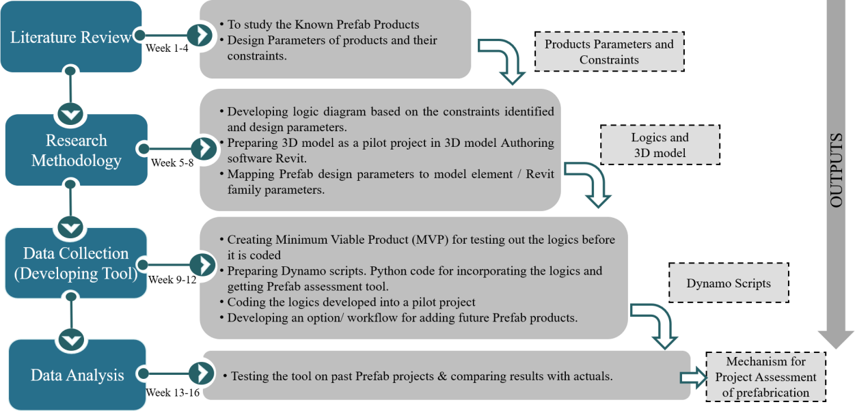
Figure 1 Research Methodology Flowchart

3.1 Product Parameters and Logic Diagrams

The different prefab products were studied and their design parameters with specific constraints were identified; these constraints were used to find the values which is based on while designing the prefabricated panels or modules. The values were also used for developing the logic diagrams for the scripts that are been prepared in the Dynamo software.
The logic diagrams can be used to illustrate credibly possible reasons, conditions, and events to assist in determining the cause scenario. They can point to specific additional information or input that might be gathered in order to confirm a possible scenario. Logic can be used to present the cause scenario and illustrate conditions and events to follow a complex situation. The logic highlights the information that is inconsistent or contradicts the proposed scenario(Logic Diagram - an Overview | ScienceDirect Topics, 2022).
The logic applied in this research is iteratively to identify what conditions and actions were present or needed for the design of prefabricated products to be executed in the project. The initial logic diagram may contain several speculated ‘OR’, ‘AND’, scenarios and where the information currently available varies according to the values of specifications and that may be inputted as a variable in the diagram to be changed as per the project’s requirement.

3.2 Script built-in Dynamo
Dynamo for Revit extends building information modelling with the data and logic environment of a graphical algorithm editor. Its flexibility, coupled with a robust Revit database, offers a new perspective for BIM. Dynamo is a visual programming tool that works with Revit. Dynamo extends the power of Revit by providing access to the Revit API (Application Programming Interface) in a more accessible manner. Instead of inputting code, with Dynamo, you create scripts/programmes by manipulating graphic elements called “nodes”( What Is Dynamo and 5 Reasons You Should Be Using It - ArchSmarter -, 2018). It’s an approach to a programming style that’s better suited for visually thinker types, like architects, designers, and engineers. A specific task is performed by each node. Nodes have inputs and outputs. The outputs from one node are connected to inputs on another using “wires”. The program or “graph” flows from node to node through the network of wires. The result is a visual representation of the actions needed to achieve the outcome(What Is Dynamo? | The Dynamo Primer, 2022). The benefits of incorporating Dynamo in the preparation of tool for this research study is –Automate repetitive tasks - Calculate the prefab panel or module quantity instead of manual counting the quantities in 2D drawings.
Accessing the Building Data – The data from the Revit 3D model is extracted of the building that which part of the structure can be ETO (Engineer to Order) based on the logic inputted in the dynamo scripts. Exploring Multiple options – It’s difficult to visually imagine the complex structure in 2D drawings so while working in a 3D model along with dynamo programs; this process helps to process explicitly identify the prefab elements with automatic tasks. The multiple design structure can be generated using the rules with Dynamo.

3.3 3D - Modelling Software

Whilst there are considerable advances observed in CAD software such as AutoCAD, Revit, SketchUp, and ArchiCAD, AEC designers have been utilizing all this software as per the requirement of modelling. The model for this study was developed using Revit 2020 because here we are using Building Information Model as a part of an integration with Dynamo. Revit provides a wide range of applicability to project stakeholders for working collaboratively to execute integrated project delivery.
For this study, a pilot project sample 3D model of a hotel tower of 5 floors is prepared and is considered for the Dynamo scripts running and checking. The pilot project is designed as per the typical hotel building with typical floors and rooms repetitive in nature. The design as given in the case study of a common building pilot project case study as given in figure 3 & 4 is been planned accordingly as a common prefabricated building with areas that are repetitive like rooms, washrooms, so as to identify and calculate quantities for the volumetric units. In case of validating the mechanism for the project assessment of Prefabrication in the construction designing domain the dynamo, scripts were run through the pilot project first and then is run through a case study of past prefab project of the company and comparison of result would be done with the actuals. The software used is Revit and the plugin version is Dynamo 2.3.0 are used for creating a pilot project and scripts respectively.

  - Framework Application
The framework was tested on repetitive hotel building typologies due to their suitability for modular construction. Automated Outputs Generated was on an pilot use case study.
The framework produced:Prefab-compatible wall isolation, Quantity schedules, Repetitive unit identification, Visualization of prefab opportunities, Automated ETO classification as the study validation is on a pilot use Case: Wall Panel Assessment
The wall panel logic evaluated:Wall length,Height,Thickness,Structural type,Surface area, MEP openings and Transportation feasibility for Walls satisfying predefined criteria were automatically isolated and tagged as prefab-ready.

4. DATA COLLECTION & FINDINGS

This chapter aims to address the data collected for the research from secondary sources and the experimental study to further analyze it.

4.1 Logistics Bulding

As per the process mentioned in the research methodology, the development of a dynamo script requires a particular sequence with a proper framework in place, consisting of interlinked steps. The script is a mix of logic, nodes, packages. To find out the logics the values were calculated of each of the quantitative parameters with the help of their respective constraints found. These values were further used for making logic keeping in mind that it is practically possible and is done on the field. The details values and logic are attached in Annexure.

4.2 Dynamo Scripts Development

For the mechanism and tool development, many scripts were built and used to develop the final product of the identification of prefabricated elements.
There was a scripts library for each product separately that will directly run through the Dynamo player and provide the details – Isolated View in Revit, Schedules and Total Quantity. The scripts were run manually in the pilot project and the results are shown here. For the final outcome, there are parts in the script library to run. The section below shows the scripting of the dynamo tool used for unit conversion,addition of parameter

4.2.1 Part – 1 – Units Conversion
The default units used for preparing logic is in feet so converting it into default Project units in Revit which results into before and after unit conversion as part of scripting.
The project units are changed automatically in the Revit of all the categories before and after script run.

4.2.2 Part -2 -Addition of Parameter
An additional Project Parameter is added named Engineer to Order (ETO) that will depict which element can be prefab as given in result figure-2

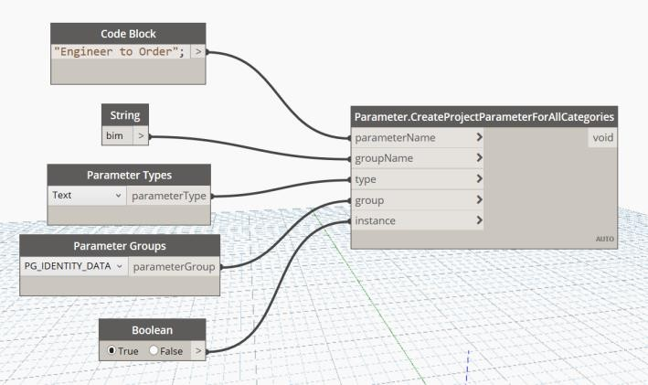
Figure 2 Addition of Parameter Script
Result
The parameter is added under the Identity data section as shown in figure-2.

4.2.3 Par t-3 – Wall Panels Script of Figure-3 result
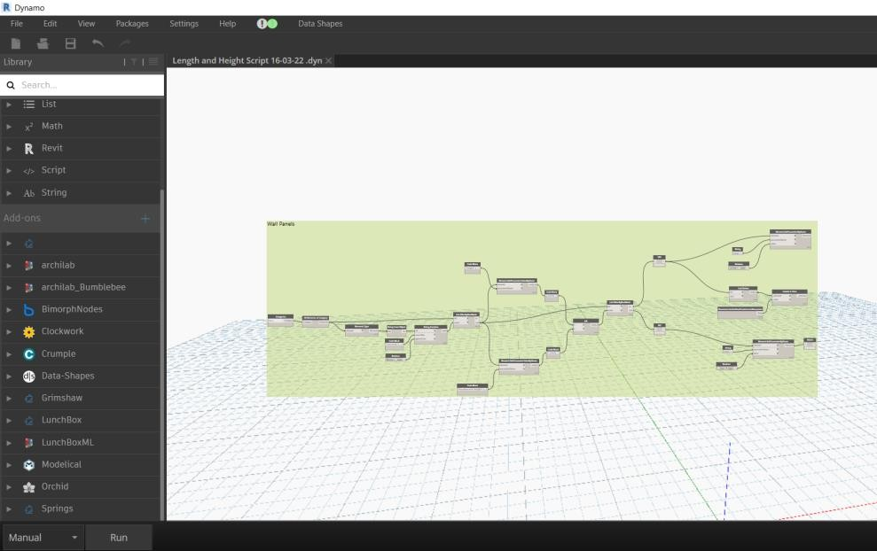
Result – The output is the isolated view of walls that satisfy the logics can be prefabricated shown in figure-4 & 5.
Figure 3 Wall Panels Script

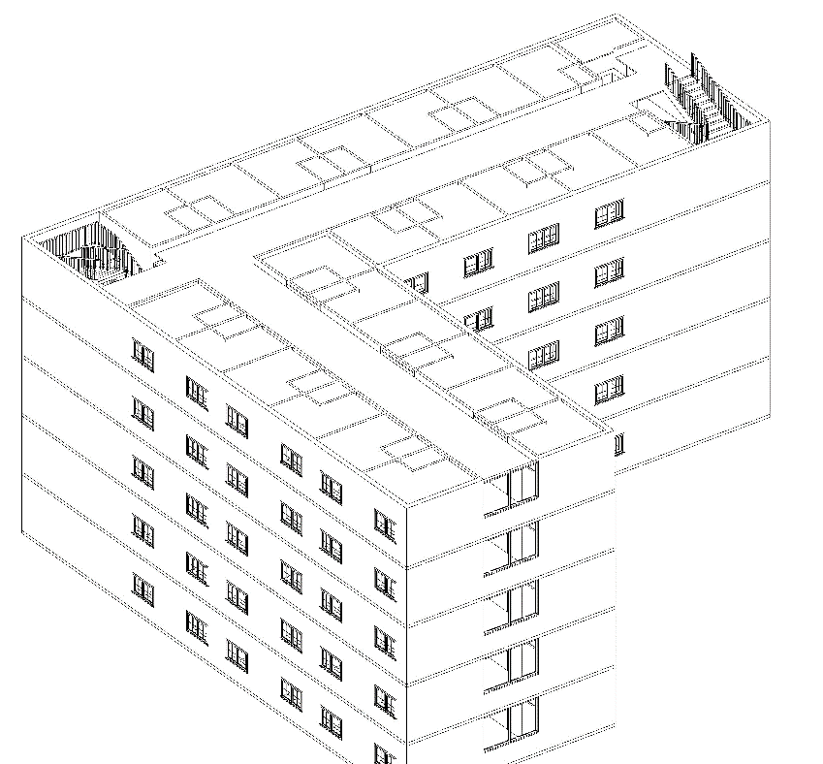
Figure 4 View before script is RUN
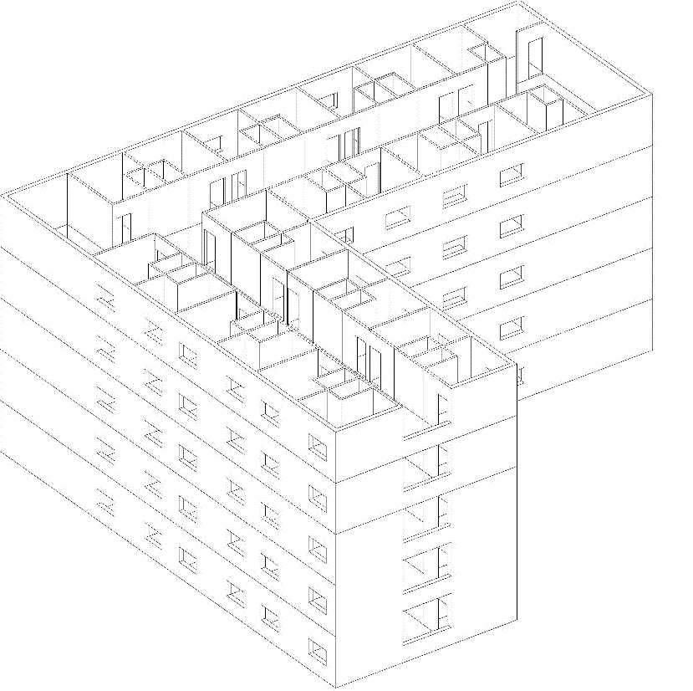
Figure 5 Isolated views of walls after the script is RUN

The proposed framework demonstrates the capability of BIM-enabled automation in transforming prefab assessment workflows from manual decision-making to digital intelligence systems.
Key Contributions towards the study includes: Digital Design Intelligence.
The framework converts design data into rule-based prefab intelligence., Automation of Manual Processes Traditional quantity take-offs and prefab identification are automated. Gives Improved Coordination.,The framework supports early-stage coordination between design, manufacturing, and construction teams.,Industrialized Construction Readiness
The methodology aligns with Industry 4.0 and digital construction transformation. The solution overcomes the challenges of Dependence on BIM model quality,Variability in manufacturer constraints,Transportation regulation differences and states the need for standardized prefab data libraries.It also further suggests prefabrication unit readiness.
Prefabrication Unit Readiness (PUR) = Σ (Wi × Ri)
where Wi = weight assigned to each rule category and Ri = percentage of rules successfully satisfied by the prefabrication unit the proposed prefabrication readiness final classification could be:
- 0–40: Low readiness
- 41–60: Developing
- 61–80: Ready with modifications
- 81–100: High prefabrication readiness
Table-1 is a reference quantifiable performance metric that can be compared across PEB, precast and composite cases and directly demonstrates what the proposed framework adds beyond conventional BIM/readiness assessment.
Table-1: Prefabrication Readiness Metric
Dimension | Metric | Conventional assessment | Proposed rule-based system
Unit standardisation | % units conforming to predefined rules | 40–60% | 80–100%
Design compatibility | % units satisfying geometry/interface rules | 50–70% | 85–100%
Discipline coordination | % rule checks successfully passed | 50–65% | 80–95%
Manufacturability | % units satisfying factory constraints | 55–70% | 80–95%
Transportation feasibility | % units satisfying size/weight/logistics rules | 60–75% | 85–95%
Assembly readiness | % units satisfying site-installation rules | 50–70% | 80–95%
Rule compliance | Passed rules / total rules × 100 | Manual/partial | 85–100%
Readiness score | Weighted score across dimensions | — | 0–100

5. CONCLUSIONS AND FURTHER RESEARCH
This study proposed a BIM-enabled Digital Prefabrication Readiness Assessment Framework integrating BIM, Dynamo automation, and rule-based logic systems for evaluating prefab suitability in building designs. The framework successfully demonstrates: Automated prefab opportunity identification, Constraint-based design assessment, BIM-driven decision support and Integration of design intelligence with industrialized construction workflows
The study contributes toward digital transformation in prefabricated construction and supports the advancement of computational design assessment mechanisms.
Future extensions of the framework may include:AI-enabled prefab optimization,Machine learning-based prefab prediction, ntegration with Digital Twin platforms, Real-time logistics monitoring, BIM-IoT integration, Multi-objective optimization, Lifecycle carbon assessment, Predictive project controls
The framework provides a foundation for next-generation intelligent prefabrication ecosystems,prefabrication readiness metrics which aligned with digital construction transformation agendas.

6. REFERENCES
Aye, L., Ngo, T., Crawford, R. H., Gammampila, R., & Mendis, P. (2012). Life cycle greenhouse gas emissions and energy analysis of prefabricated reusable building modules. Energy and Buildings, 47, 159–168. https://doi.org/10.1016/j.enbuild.2011.11.049
Base4. (2022). https://www.base-4.com/modular-elevators/
Campbell, R. (1998). Design, Fabrication, and Installation of Engineered Panelized Walls: Keio Journal of Medicine, 47, A91–A93. https://doi.org/10.2302/kjm.47.supplement2_A91
CEILING SYSTEMS - SKYCON. (2022). https://www.skyconproducts.com/ceiling- systems.html
Di Pasquale, J., Innella, F., & Bai, Y. (2020). Structural Concept and Solution for Hybrid Modular Buildings with Removable Modules. Journal of Architectural Engineering, 26(3), 04020032. https://doi.org/10.1061/(asce)ae.1943-5568.0000423
Floating Stair Systems, Installation, Kits and Parts | Viewrail. (2022). https://www.viewrail.com/floating-stairs/
Franco-Duran, D. M., & Mejia A, G. (2016). Construction Research Congress 2016 2039. PROCEEDINGS Construction Research Congress 2016, 2039–2049. https://doi.org/10.1061/9780784479827.203
Grubb, P. J., Gorolewski, M. T., & Lawson, R. M. (2015). Light Steel Framing in Residential Construction. In SCI Publication P301.
Gunawardena, T. (2022). Prefabricated Building Systems — Design and Construction. 70–95.
Hwang, B., Shan, M., & Looi, K. (2018). Key constraints and mitigation strategies for prefabricated pre fi nished volumetric construction. Journal of Cleaner Production, 183, 183–193. https://doi.org/10.1016/j.jclepro.2018.02.136
Kamali, M., & Hewage, K. (2016). Life cycle performance of modular buildings : A critical review. Renewable and Sustainable Energy Reviews, 62, 1171–1183. https://doi.org/10.1016/j.rser.2016.05.031
Lawson, R. M., Ogden, R. G., & Bergin, R. (2012). Application of Modular Construction in High-Rise Buildings. Journal of Architectural Engineering, 18(2), 148–154. https://doi.org/10.1061/(asce)ae.1943-5568.0000057
Logic Diagram - an overview | ScienceDirect Topics. (2022). https://www.sciencedirect.com/topics/engineering/logic-diagram
Min Luo and Deyi Chen. (2018). Application of BIM Technology in Prefabricated Building.
2018, 263–267.
Modular Elevator Systems - Resolute Elevator. (n.d.). Retrieved March 19, 2022, from https://resoluteelevator.com/products/modular-elevator-systems/
Prefabricated commercial stairs and landings for construction. (2022). https://www.lapeyrestair.com/products/commercial-egress-stairs#modular-construction
Products - Digital Building Components. (2022). https://www.digitalbuilding.com/products
Skanska. (2022). Multi-Trade Prefabrication. https://www.american.edu/buildingAU/upload/Pre-fabrication-Summary.PDF
Tam, V. W. Y., Tam, C. M., Zeng, S. X., & Ng, W. C. Y. (2007). Towards adoption of prefabrication in construction. Building and Environment, 42(10), 3642–3654. https://doi.org/10.1016/j.buildenv.2006.10.003
Time, S., & Modular, W. (n.d.). BATHROOM PODS.
Types of staircases | Davibois. (2022). https://davibois.com/en/content/types-staircases
What is Dynamo? | The Dynamo Primer. (2022). https://primer.dynamobim.org/01_Introduction/1-2_what_is_dynamo.html
What Is Dynamo and 5 Reasons You Should be Using It - ArchSmarter -. (2018). https://archsmarter.com/what-is-dynamo-revit/
What Is Modular Construction? | Modular Building Institute. (2022). https://www.modular.org/HtmlPage.aspx?name=why_modular
Z Modular Care & Control Units - Z Modular. (2022). https://www.z-modular.com/articles/z- modular-care-control-unit

