Building Spatial Design Simulation and Optimisation with Structural and Daylight Objectives
TESSA EZENDAM¹ QUIMARA VAN DEN HOEVEN¹ HERM HOFMEYER¹ MARIËLLE AARTS¹

¹Eindhoven University of Technology, Eindhoven, The Netherlands

ABSTRACT:

The inevitable interdependencies and trade-offs between structural and daylight disciplines are rarely researched in multi-disciplinary design simulation and optimisation. As such, this paper presents a development of simulations of co-evolutionary design processes used for optimisation. The simulations entail an iterative process to delete or split spaces of a Building Spatial Design (BSD) according to its structural or daylight performance. Three types of co-evolutionary processes are investigated, i.e. (i) spatial-structural; (ii) spatial-daylight; and (iii) alternately (i) and (ii). Besides, an academic case study is carried out, where a variety of window sizes is considered while performing structural and daylight simulations. As a result, the general tendencies for structural and daylight objectives, their trade-offs, and the conflicts between optimising for structural or daylight performance are showcased. Furthermore, it is noted that co-evolutionary design simulations, if used for optimisation, show large improvements in just a few iterations.

KEYWORDS: Building Spatial Design, Structural design, Daylight Performance, Co-evolutionary Design, Design Computing

1. INTRODUCTION
The design of sustainable and energy-efficient buildings involves the handling of multiple and often conflicting objectives between various disciplines. For example, structural objectives are related to building safety, durability, and functionality, while daylight objectives serve visual comfort, energy efficiency, and the well-being of occupants. An example of conflicting objectives is the use of large daylight openings to accommodate user well-being, resulting in less structural mass that can be positioned, which may compromise structural performance.
Although design systems exist to support the design team with these kinds of challenges, they often provide support for single disciplines, e.g., for daylight or structural design. Additionally, they require quite sophisticated building information models to allow for the numerical prediction of objectives. Consequently, the inevitable interdependencies and trade-offs between disciplines are missed. This issue may be solved by a system that considers multiple disciplines simultaneously. And preferably, using less sophisticated building information models, as common in a preliminary design process. An example of such a system simulates co-evolutionary design processes for spatial-structural-thermal objectives (Boonstra, S., et al., 2018). A review paper exists for combined domain support systems (Wang, Z., Akbarzadeh, M., & Aviv, D., 2024), with a specific section on combining structural and daylight objectives: The paper informs that these systems are rare, and generally use a quite restrictive, dedicated representation, for example related to a skylight roof system (Yi, Y.K, et al., 2021); perforated concrete shell structures (Emami, N., Giles, H., & Von Buelow, P., 2020); or a building massing study, neglecting the interior layout (Bernet, A., Kral, K., & Dogan, T., 2021). Consequently, these representations are limited for their design space, not including commonly seen representations, such as a collection of (rectangular) spaces.
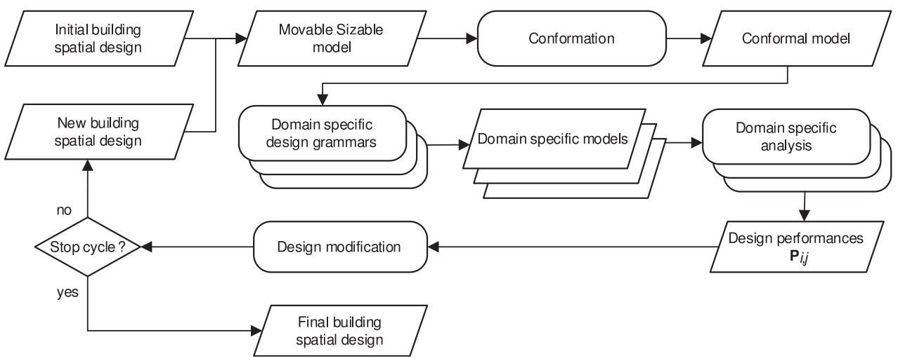
In this paper, simulations of co-evolutionary design processes are studied, to optimise building spatial designs, simultaneously for structural and daylight objectives, for commonly used representations in preliminary design. As such, the contributions of this paper are: (a) an exploration of the development of simulations of coevolutionary design processes with structural and daylight objectives; (b) an investigation on whether these simulations provide insight into the relationship between structural and daylight performance.
Figure 1: Co-evolutionary design process simulations (Boonstra, S. et al., 2018).

2. METHODOLOGY
An existing C++ so-called ‘BSO toolbox’ is used, which provides all the functionality to simulate co-evolutionary spatial-structural-thermal design processes (Boonstra, S. et al., 2018). Simulations of co-evolutionary design processes are explained in Section 2.1, and a new daylight model for the toolbox is presented in Section 2.2. For reference, the existing structural model is briefly explained in Section 2.3, for which more details can be found in (Boonstra, S. et al., 2018). The software used for this paper, naturally including all details for reproducibility, is available open-source (Van den Hoeven, Q.M., 2024a).

2.1 Simulations of co-evolutionary design processes
In the toolbox, simulations start with the definition of a Building Spatial Design (BSD). It is transformed into discipline-related models, which are assessed, and consequently the spatial design is modified, all in an iterative fashion, Figure 1. In this figure, as a first step, the initial BSD, defined as a so-called movable sizable model, is represented as a collection of orthogonal rectangular spaces. These spaces are defined via an origin vector o=[x,y,z], representing the minimal x, y, and z values, and a dimension vector d=[w,d,h], where w is the width in x-direction, d is the depth in y-direction, and h is the height in z-direction.
In a next step, the BSD is decomposed into two sets of geometric entities which are collectively defined as the conformal model: (1) the building conformal model, which is a direct decomposition of the BSD’s spaces in the entities spaces, surfaces, edges, and points, and (2) the geometry conformal model which represents the BSD in a conformal geometry, decomposed in the entities cuboids, rectangles, lines, and vertices. A conformal geometry is characterized by only allowing the vertices of entities to intersect; see Figure 2. It is very useful for discipline-related models. For example, when in a BSD two spaces with varying dimensions are connected, one of their intersecting surfaces is partly interior and partly exterior, but related properties, e.g. thermal resistance or wind load, can only be assigned to the complete surface. However, the rectangles of the related geometry conformal model are partitioned such that each rectangle fits a specific property. For a daylight objective, the conformal model should also consider partitions for the windows. As such, in this paper, more partitions are made than necessary for only defining a conformal geometry itself, explained in Section 2.3.
In the third step, the conformal model is used to define domain-specific models for the daylight and structural simulations via grammars, i.e. sets of conditional rules, further explained in Sections 2.2 and 2.3.
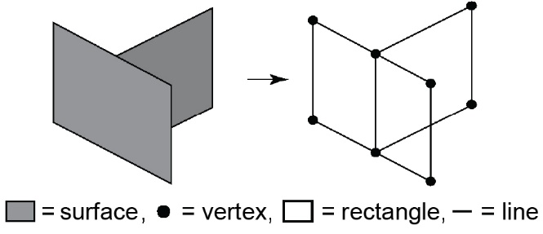

Figure 2: Two surfaces (left) and their conformal representation (right).
Next, the domain-specific models are analysed to obtain performances for the BSD and per space. These performances are stored in a matrix F indexed by space i and discipline j. F is normalized into matrix P using equation 1:
P_{ij} = (F_{ij}-min_{j}) /(max_{j}-min_{j}) (1)
where P_{ij} is the normalized performance of space i and discipline j; min_{j} is the minimum value in row i; max_{j} – is the maximum value in column j.

In step five, the BSD is modified according to its performance for a single discipline j. First, the spaces are sorted in ascending order for P_{ij}. Second, as a default setting, the worst-performing 25% of spaces are removed. By definition, for all objectives, lower values indicate better performance. Third, the spaces with the largest width/depth in either the x- or y-axis are split in half until the original number of spaces is restored. Lastly, the BSD is scaled equally along the x and y-directions to obtain the original floor area. These two latter operations result in a modified BSD, which serves as a starting point for the next iteration.
The iterative loop is halted following a criterion, in this paper, the number of five iterations, whereafter results can be analysed.
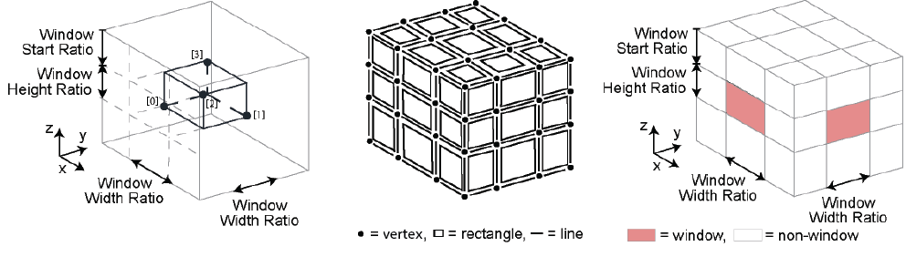
Figure 3: A single space, left: window vertices [0] to [3], middle: conformal geometry, right: rectangle definitions.
2.2 Daylight model and analysis
The new daylight model and analysis are based on EN 17037:2018 guidelines to use the Daylight Factor (DF) as a performance indicator (NEN, 2022). The DF is a measure of the amount of daylight in a space, compared to that available outdoors. However, it is limited by the assumption of a typical overcast sky, where sky luminance does not vary with azimuth (about the z-axis), making it unaffected by orientation, time, and location. It also excludes direct sunlight. As such, it makes the DF less adaptable to real-world lighting variations (Alrubaih, M.S., et al., 2013; Mardaljevic, J., 2012). However, despite its limitations, it provides a daylight estimate in a computationally efficient way, which is considered sufficient in the preliminary design phase. The DF is predicted with the help of illuminance values resulting from a lighting simulation. For this, Radiance (Ward, G., 2025) has been selected, since it is validated through extensive testing, including CIE (International Commission on Illumination, 2006) test cases, is open-source, and can handle large-scale simulations, e.g. entire 3D buildings.
Before defining the Radiance model, a definition of daylight openings, i.e. windows, is required. As explained in Section 2.1, the conformal model represents the geometry of the BSD such that for each discipline, only one property can be assigned to a single rectangle or surface. Therefore, in the case of daylight openings, the rectangles in the geometry conformal model should be generated such that if they are either a window or not a window, this corresponds with the intended building design.
For this reason, the standard geometry conformal model is partitioned further by adding four so-called ‘window vertices’ per space, see Figure 3 on the left, before generating the conformal geometry. In the case of a single space, this subdivides each surface into nine rectangles with their line segments and vertices, as shown in Figure 3 in the middle. Note that also inner rectangles, cuboids, lines, and vertices are created, not shown here. Locations of the window vertices depend on user-defined window ratios: Window Width Ratio (WWR) in x and y-directions, and Window Height Ratio (WHR) in the z-direction, see Figure 3 on the right. Vertexes along the width are symmetrically centred, while window height depends on the Window Start Ratio (WSR), a percentage of the total height. This allows users to choose a window’s relative position over the height of the space, which influences the illumination distribution, and so daylight performance (Diepens, J., 2000). Note that all above ratios are expressed as a percentage to ensure proportional consistency among spaces, and to avoid errors due to misfitting fixed numbers.
The daylight simulation by Radiance needs specific input. For this an assembly of rectangles of the geometry conformal model is made, with for each rectangle default unitless properties of: reflectance (i.e. ceiling: 0.70, floor: 0.2, wall: 0.5), roughness (0.0), specularity (0.00), and transmittance (0.75), dependent on whether a rectangle represents a window or is closed. Daylight conditions are defined by an outdoor illuminance equal to 14000 lx and a reflectance of the exterior ground at z = 0 equal to 0.20. A grid with points for which the DF is predicted is defined at a reference height of 0.85 m, following EN17037:2018, subsection B2 (NEN, 2022). The Radiance simulations result in, among others, illuminance values E_{indoor} for all grid points, such that for each grid point, a DF can be obtained:
DF = (E_{indoor} /E_{outdoor}) * 100% (2)
where DF- Daylight Factor; E_{indoor} - indoor illuminance (lx); E_{outdoor} – outdoor illuminance (lx).
Subsequently, these DFs are utilised in two different assessment methods for the daylight performance of a space or a complete BSD.
For the first method, according to EN17037:2018 (NEN, 2022), a space is considered lit well if the DF meets both the target daylight factor (DF_{target}), calculated with E_{indoor} = 300 lx, and minimum target daylight factor (DF_{mintarget}), calculated with E_{indoor} = 100 lx, over 50% of the grid points. Here, E_{outdoor} is defined as 14000 lx, resulting in a DF_{target} of 2.14% and a DF_{mintarget} of 0.71%. Note that in the simulation by Radiance, the overcast sky is defined also with E_{outdoor} = 14000 lx, for the zenith brightness, to ensure consistency. Reflecting this criterion, for the simulations equation (3) is defined, applicable to each space:
P_{x} = (n_{pos} / n_{total}) * 100% (3)
where P_{x} - target achievement; with x either ‘target’ of ‘mintarget’; n_{pos} – number of grid points with DF ≥ DF_{x}; n_{total} – total number of grid points; DF_{x} - daylight factor with x either ‘target’ of ‘mintarget’.
Each target is considered as achieved if larger than 50%. Secondly, a score S_{target} for each space is defined, which equals 0 if both P_{target} and P_{mintarget} are achieved; 0-5 if only P_{target} is met; and 5-10 if neither target is met, the latter two linearly interpolated based on the proximity to P_{mintarget}. The sum of these scores over all spaces renders the value B_{target}, i.e. the building-level performance of the BSD, for which holds that the lower the score, the better the BSD performs for daylight.
The second method is needed because if all spaces meet both targets, they all score S_{target} = 0, and differences in daylight performance between spaces cannot be determined. However, this is required to steer the co-evolutionary design process, as mentioned in Section 2.1. As such, the second method first calculates the Average Daylight Factor (ADF) by averaging the DF of all the grid points in a space. Then, it takes the inverse of the ADF value, which is defined as S_{ADF}, the space performance value. Finally, the building-level performance B_{ADF} is obtained by the summation of all S_{ADF} values over all spaces. Note that the B_{ADF} suggest that a higher ADF corresponds to better performance, which is debatable if glare would be considered. Therefore, the above B_{target} is still predicted as well, to provide users with an indication of performance according to EN 17037:2018 (NEN, 2022).

2.3 Structural model and analysis
This section provides a brief explanation of the structural model and its Finite Element Method (FEM) analysis. More details can be found in (Boonstra, S. et al., 2018).
The structural model is defined by adding structural components to the rectangles of the geometry conformal model, see Figure 4. In all cases, flat shell components are defined for horizontally oriented rectangles, i.e. floors. For the other rectangles, two options are used. For so-called structure type ‘one’, a wall-identified rectangle gets beam components positioned along the line segments of the rectangle, and a window-identified rectangle (see for its definition Section 2.2) will be given a low-stiffness flat shell, also defined as ‘load panel’, to only transfer exterior loads to surrounding structural components. This also applies to structure type ‘two’, but there a wall-identified rectangle gets a flat shell. All flat shells resemble concrete, having a thickness equal to 150 mm, a Young’s modulus of 30000 N/mm², and a Poisson’s ratio equal to 0.3. All beam components have the same material properties, and a square cross-section 150 × 150 mm. The low-stiffness flat shells are 150 mm thick and have a Young’s modulus of 0.03 N/mm², with a Poisson’s ratio equal to 0.

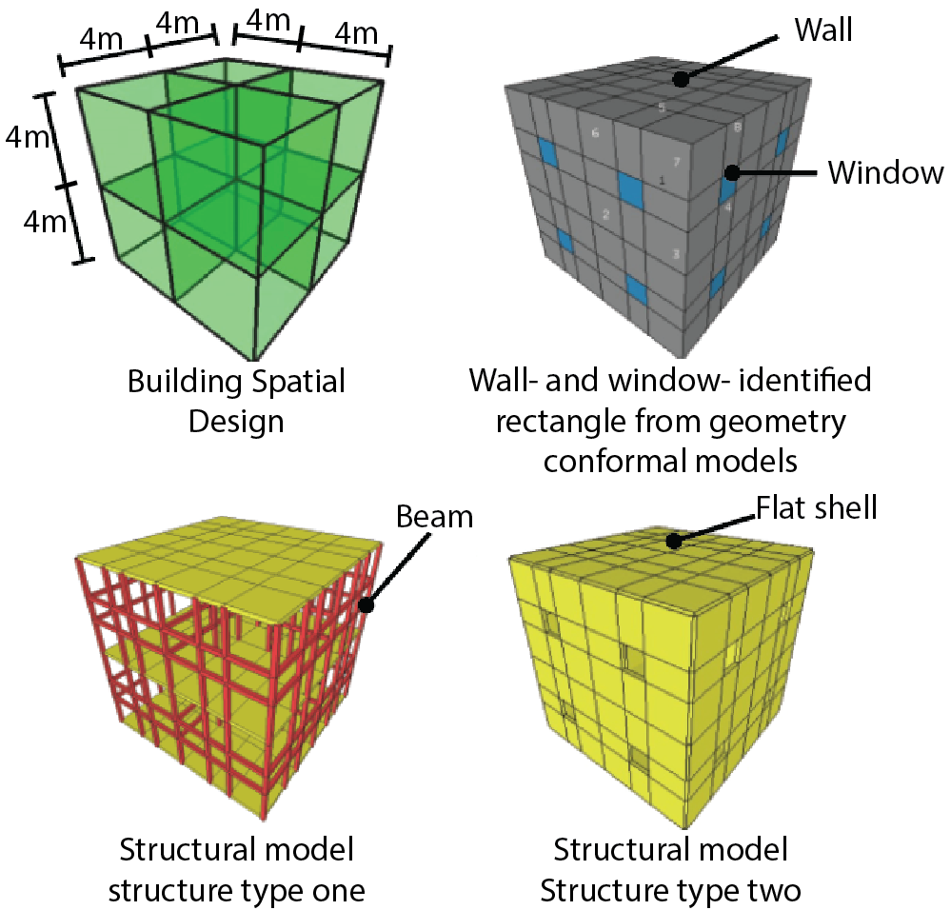
Figure 4: Structure types ‘one’ and ‘two’ as based on the spatial design and conformal geometry at the top row.
Four wind load cases, in the +x, +y, -x, and -y directions, and a live load case are applied to the structural components. On all exterior rectangles, i.e. a rectangle belonging to only one space and not on ground level, for each wind load case, loads are applied as function of the wind direction, i.e. 1.0 kN/m² for pressure, 0.8 kN/m² for suction, and 0.4 kN/m² for shear. On all floor structural components, i.e., horizontal rectangles belonging to multiple spaces or at ground level, a live load in negative z-direction is placed equal to 5.0 kN/m². Similarly, for the roof structural components, a live load is placed equal to 1.0 kN/m². With respect to boundary conditions, all components are fixed for all displacements at z = 0, representing the foundation.
A FEM model is developed based on the structural model (Boonstra, S. et al., 2018). Solving the FEM model’s system of equilibrium equations, the nodal displacements and strain energy (Nmm) for each finite element are obtained. Then, the performance of a space is defined by the summation of the strain energy of all finite elements on all its rectangles. Note that for space-separating rectangles, the strain energy of their finite elements is thus used twice, namely for both spaces. Therefore, for the performance of the whole BSD, not the sum of the energy of spaces is used, but the sum of energy of all finite elements.

3. RESULTS
To ensure correct results, first a verification of the new daylight model and analysis is carried out in Section 3.1. This is followed by an academic study on the interdependency between structural and daylight objectives, related to window size, Section 3.2. Lastly, three types of co-evolutionary design process simulations, i.e. (i) spatial-structural; (ii) spatial-daylight; (iii) alternate (i) and (ii), are studied in Section 3.3.

3.1 Light analysis verification
A verification of the new (BSO toolbox) light analysis was carried out, by using four existing single space cases (Diepens, J., 2000), four other similar cases (Vaisi, S. & Kharvari, F., 2019), and four academic cases with a deep or wide space, typical for output from the co-evolutionary design process simulations. The twelve cases were simulated by Velux Daylight Visualizer (Velux, 2025) and the BSO toolbox, both using Radiance to perform the lighting simulation with ray tracing. As the settings for this ray tracing (‘rTrace’ in Radiance) are the most influential, these were studied with a separate convergence and runtime study. Investigated settings were: ambient bounces [ab]; divisions [ad]; resolutions [ar]; accuracy [aa]; and super samples [as], these settings are explained in Radiance’s documentation (Kharvari. F., 2020).
In the above studies, the BSO toolbox predicted higher ADF values than Velux, the latter predicting the literature cases (Diepens, J., 2000; Vaisi, S. & Kharvari, F., 2019) well. However, since for the four academic cases, toolbox and Velux predictions were similar, the high predictions are probably due to different simulation settings, for these were not reported for the literature cases. Besides, for all cases, the toolbox predictions correlate well with the literature and Velux, with a Pearson correlation coefficient larger than 0.89. The correlation coefficient confirms a correct trend and order of magnitude of toolbox predictions, including changes in window size and position. Therefore, the performance of the toolbox was decided to be sufficient within the scope of this research, although future research is required. Since the different ray tracing settings investigated did not significantly influence the results, a specific set of settings was selected as advised in literature (Kharvari, F., 2020), with the additional notion that accuracy [aa] should be set to 0, bounces [ab] to a minimum of 8, divisions [ad] to at least 64, and super samples [as] and resolution [ar] to at least 0. Further details can be found in the related MSc thesis (Van den Hoeven, Q.M., 2024).

3.1 Structural versus daylight objectives
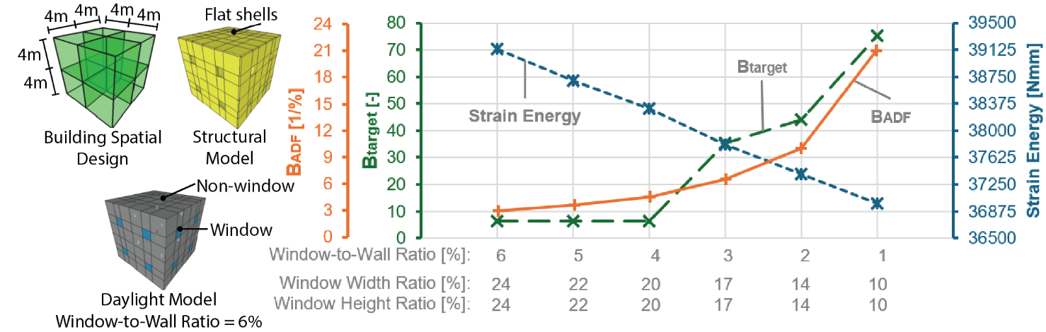
To investigate the interdependency between structural and daylight objectives, the influence of the window size, defined by WHR and WWR (see Section 2.2), on structural and daylight performance is researched. Structure type ‘two’ is used, which, as mentioned earlier in Section 2.2, contains only structural flat shells or windows, as shown by the structural model in Figure 5 on the left. Therefore, the trade-off between daylight openings and structural stiffness can be analysed since the window size directly influences the structural component dimensions and thus the stiffness. Differently, for structure type ‘one’, only the position of the structural beams varies as a function of the window size. The flat shell finite elements are based on thin plate theory with L/h > 10, where L is the plate’s characteristic length and h is its thickness (Zienkiewicz, O.C., Taylor, R.L., & Zhu, J.Z., 2013). Therefore, flat shell components are set to a thickness of 75 mm, with each a mesh 2 × 2 elements. Figure 5 presents the BSD and results for simulations with different so-called Window-to-Wall Ratios (WWR), achieved by equally varying WWR and WHR values while maintaining a constant WSR of 37.5%. This ensures that all flat shell elements meet the thin plate theory. As shown by Figure 5, reducing the WtWR simultaneously improves structural performance (the strain energy decreases) and negatively affects daylight, as B_{ADF} and B_{target} both increase: a clear trade-off.
Figure 5: Given the design on the left, the decrease of window sizes improves the structural objective but negatively affects daylight performance.

3.2 Spatial-structural-daylight co-evolutionary design process simulations
With verified daylight simulations, and understanding the trade-off between structural and daylight objectives, co-evolutionary design process simulations can be studied, involving (i) spatial-structural; (ii) spatial-daylight; and (iii) alternate (ii) and (i) interactions. Note that in these simulations, the geometry of the building spatial design evolves, which is fundamentally different from the simulations in Section 3.1, where the building geometry is fixed, and only the façades change. Five realistic BSDs from literature (Boonstra, S. et al., 2021; Hofmeyer, H. & Delgado, J.M., 2015) are used as an initial design, shown in Figure 6.
Using the BSO toolbox, the co-evolutionary design process is run for five iterations, with 25% of spaces removed each iteration, and if daylight is involved, for different WHRs: 15%, 30%, 60%, and 100%. In this paper, only WHR = 30% is presented, and others can be found in the related MSc thesis (Van den Hoeven, Q.M., 2024).
The spatial-structural simulation in Figure 7 on the left shows a positive reduction of strain energy, except for design 3. In that latter case, due to the design being a single story, spaces removed expose more surfaces to wind loads, leading to higher strain energy values. All other designs have multiple levels, and the evidenced removal of top levels shortens the load path towards the ground support, thus reducing strain energy. Finally, design A shows a little increase of energy during the last iteration, since it is flattened to a two-story building and removed spaces increase the strain energy, again due to the increased surface subject to wind.
Figure 7 in the middle and at the right shows the spatial-daylight simulations, for WHR = 30%. For the first two iterations, a significant improvement can be seen, which also holds for WHR = 15% (not presented). Design 2 has a constant B_{target} of zero, since it contains a large number of exterior surfaces and thus windows. At higher WHRs, i.e. 60% and 100%, all designs have a B_{targer} of zero for all iterations, except for design 3. Also more general observations can be made: interior spaces underperform due to limited daylight penetration, and are thus often removed, resulting in O and U-shaped BSDs, which are also commonly seen in literature (Hu, H., et al., 2023; Ratajczak, J., Siegele, D., & Niederwieser, E., 2023). Furthermore, trends in B_{target} and B_{ADF} confirm that higher WHRs, 60% and 100%, yield more optimal daylight performance, aligned with other research on Window-to-Wall ratios for daylight performance (Ochoa et al., 2012). Also, better daylight performance is observed in designs with more exterior windows, confirming existing findings (Hu, H., et al., 2023; Ratajczak, J., Siegele, D., & Niederwieser, E., 2023). Finally, the modification of a space by splitting results in elongated spaces, which negatively affects daylight distribution (Costanzo, V., 2017). Splitting also creates interior spaces that rely more on adjacent spaces for daylight, thus further reducing performance. In conclusion, spatial-daylight co-evolutionary design process simulations steer the building spatial design as expected by current insights in research and literature. However, future research is needed to develop alternative modification techniques, different from deleting and splitting spaces.
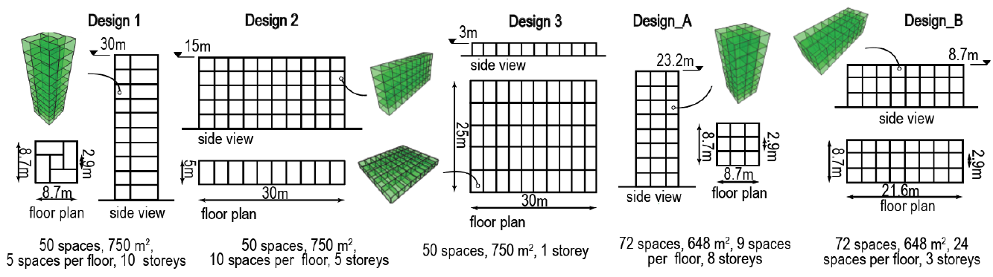
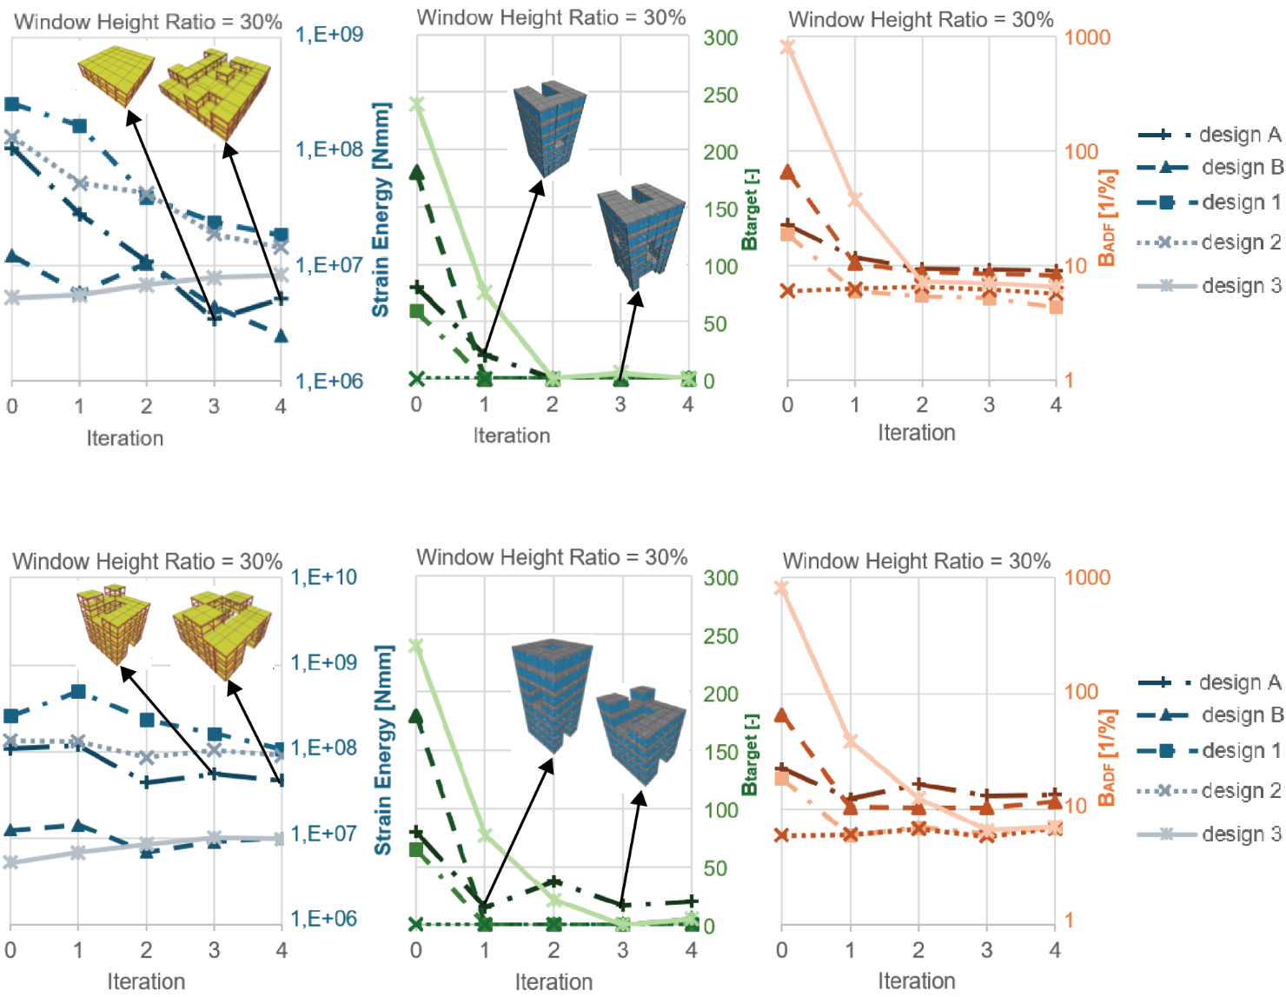
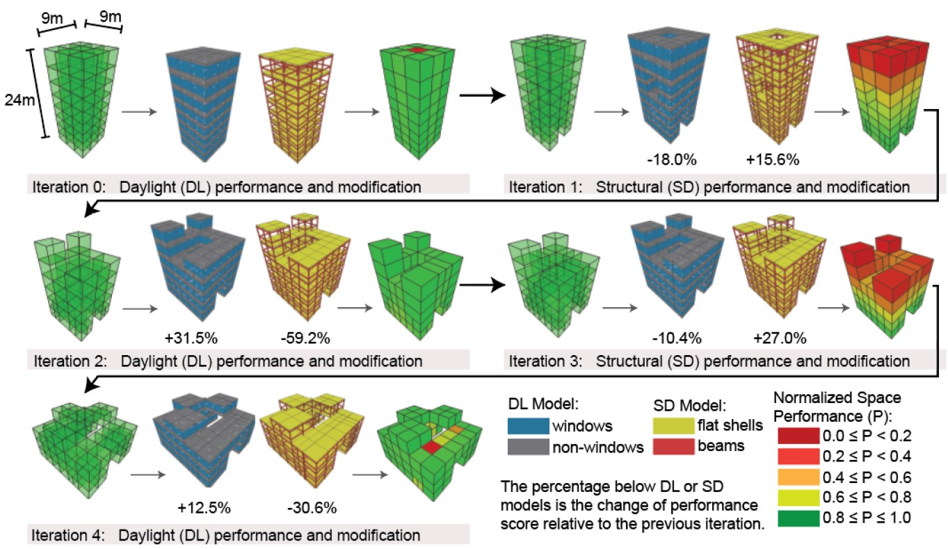
Lastly, results of alternate spatial-daylight and spatial-structural co-evolutionary simulations are shown in Figure 8. Only results starting with a spatial-daylight iteration are presented, as similar results can be observed when a start is made with a spatial-structural iteration. Following the trade-off discovered in Section 3.1, often the first iteration shows increased daylight and reduced structural performance, the second iteration decreased daylight and increased structural performance, etc. More specifically, across all simulations, this is the case for 74% of the iterations, independent of the selected WHR and the initial BSD. For individual designs, this is the case for design A for 100% of the iterations; design B: 56%; design 1: 75%; and designs 2 and 3: 69%. Across WHRs, this daylight-structural trade-off is visible for 60% of the iterations with a WHR equal to 15%; 75% at WHR 30%; and 80% at WHR 60% and 100%. Hence, this indicates that improving the BSD regarding daylight performance very often results in deteriorating the structural performance and vice versa, as is shown in Figure 9, which visualizes the evolution of design A along spatial-daylight and spatial-structural iterations. After five iterations, a compromised BSD is achieved. It is characterized by a flatter structure, as earlier seen in the spatial-structural run from Figure 7 left, and an O-shaped BSD as earlier seen in the spatial-daylight run from Figure 7 in the middle. For design A, the final structural performance is the best across all iterations, while B_{ADF} remains relatively stable (3.91 to 5.56) and B_{target} = 0 across the iterations.
Figure 6: BSDs for co-evolutionary design process simulations.

Figure 8: Simulations with alternate spatial-daylight and spatial-structural iterations.
Figure 7: Left: spatial-structural design simulations, middle and right: spatial-daylight simulations.
Figure 9: Typical alternate daylight-structural and structural-daylight simulation, Design A.
Table 1 lists the final performances of the (i) spatial-structural; (ii) spatial-daylight; and alternate (ii) and (i) co-evolutionary design processes for a WHR = 30%. As can be seen, daylight performance (B_{target} and B_{ADF}) optimisation is very similar for spatial-daylight and alternate simulations. However, a comparison of Figures 7 and 8 shows that similar performance is obtained later in the process for the alternate runs than for the spatial-daylight runs, as expected since in the former daylight optimisation takes place more frequently. Different from daylight optimization, the good optimisation achieved by spatial-structural simulations is not matched by the alternate simulations. This can be due to less frequent structural optimisations for the alternate simulations, although that was not an argument for daylight. More plausible causes could be that (a) the daylight objective has the tendency to increase the exterior surface by removing inner spaces, which increases wind load on the structure; (b) the modification technique of removing and splitting spaces does not allow to reverse this structurally unfavourable deletion at (a).
In conclusion, also in (simulations of) co-evolutionary design processes, a trade-off can be seen between daylight and structural objectives. Nevertheless, large improvements can be made for both objectives, highlighting the usefulness of the simulations.

4. CONCLUSIONS AND OUTLOOK
Spatial-structural-daylight co-evolutionary design process simulations were presented. These allow for a study of interdependencies between structural and daylight objectives in (simulated) design processes.
To enable the design process simulations, a new daylight model and analysis for the BSO toolbox had to be developed. Its verification showed that predicted ADF values were too high compared to other software and literature. However, this was probably due to different simulation settings. On a positive note, a strong correlation was found between the toolbox predictions and all other references. This confirmed correct predictions of trends and orders of magnitude for changes in window size and position relative to the illumination distribution, and thus for the ADF.
Table 1 Change of performance (%) from initial BSD to fifth iteration BSD for WHR=30%.

Three co-evolutionary design process simulation types were studied: (i) spatial-structural; (ii) spatial-daylight; (iii) alternate (ii) and (i).
Spatial-structural simulations reduced strain energy for four out of five designs and, on average, by 60% for WHR = 30%. The four optimised designs saw a reduced number of elevations, creating a shortened load path towards the foundation, whereas the non-optimised design was a single-story building from the start, where the removal of spaces exposed more surface area to the wind load.
For spatial-daylight simulations, lower WHRs (15% and 30%) in general positively reduced B_{target} and B_{ADF} up to the second iteration, whereas most higher WHRs (60% and 100%) already led to a B_{target} equal to zero at the start. Furthermore, it was shown that, evidently, interior spaces performed the worst due to limited daylight penetration, as such often removed in early iterations, resulting in O and U-shaped BSDs.
The alternate simulations showed for 74% of the iterations, independent of the WHR and initial BSD selected, a clear trade-off between the daylight and structural objectives, i.e. when optimizing for daylight, B_{ADF} successfully decreases but structural strain energy increases, and vice versa. For daylight optimisation, the alternate simulations perform as well as the dedicated spatial-daylight simulations. Differently, the good optimisation achieved by spatial-structural simulations is not matched by the alternate simulations. This can be due to less frequent structural optimisations for the alternate simulations, although that was not an argument for daylight. More plausible causes could be that (a) the daylight objective has the tendency to increase the exterior surface by removing inner spaces, which increasing wind load on the structure; (b) the modification technique of removing and splitting spaces does not allow to reverse this structurally unfavourable deletion at (a).
In conclusion, a co-evolutionary spatial-structural-daylight design process (simulation) can optimise both daylight and structural objectives well, despite their conflicting character.
For future work, it is recommended to explore alternative spatial modification techniques, since the current deletion and splitting of spaces do not always function well. For example, for daylight, the splitting of a space can result in unfavourable narrow spaces, worsening daylight performance (Costanzo, V., 2017). Furthermore, the assumption that a higher DF improves performance may not be correct, for certain levels of daylight may mitigate glare issues, also influenced by the orientation of the building. As such, glare, building orientation, and direct sunlight are all recommended to be included in further studies. For this, EN17037:2018 proposes a Daylight Glare Probability (DGP) based method to asses glare under a cloudless sky, and provides recommendations for optimizing sunlight exposure. Alternatively, a simplified DGP method, named DGPs, could be used. This DGPs method correlated well with DGP evaluations, while being less computationally intensive (Giovannini et al., 2018), thus making it more suitable for the preliminary design phase as regarded in this paper. But note that the DGPs excludes direct sunlight. Lastly, the work in this paper is a precursor for research on spatial-structural-daylight-thermal co-evolutionary design process simulations. Thereby combining even more disciplines than is commonly the case, possibly showcasing complex and intricate trade-offs and interdependencies.

ACKNOWLEDGEMENTS
This work was carried out as an MSc thesis project, supporting the Dutch NWO-OTP project ‘Excellent Buildings’, which partly financed the supervision of student Quimara van den Hoeven.

REFERENCES
Alrubaih, M.S. et al. (2013). Research and development on aspects of daylighting fundamentals. Renewable and Sustainable Energy Reviews, 21, pp. 494–505.
Bernett, A., Katharina, K., & Dogan, T., (2021). Sustainability evaluation for early design (SEED) framework for energy use, embodied carbon, cost, and daylighting assessment. Journal of Building Performance Simulation, 14, pp. 95-115.
Boonstra, S. et al. (2021). Hybridization of an evolutionary algorithm and simulations of co-evolutionary design processes for early-stage building spatial design optimization. Automation in Construction, 124, 103522.
Boonstra, S. et al., (2018). Toolbox for super-structured and super-structure free multi-disciplinary building spatial design optimization. Advanced Engineering Informatics, 36, pp. 86-100.
Constanzo, V., Evola, G., & Marletta, L., (2017). A Review of Daylighting Strategies in Schools: State of the Art and Expected Future Trends. Buildings, 7(2), 41.
Diepens, J., (2000). Daylight Design Variations book. Available: http://jandiepens.nl/varbook/ index.htm [3 March 2025].
Emami, N., Giles, H., & Von Buelow, P., (2020). Structural, daylighting, and energy performance of perforated concrete shell structures. Automation in Construction, 117, p.103249.
Giovannini, L., et al., (2018). A Simplified Approach for the Annual and Spatial Evaluation of the Comfort Classes of Daylight Glare Using Vertical Illuminances. Buildings, 8(12), 171.
Hofmeyer, H., & Delgado, J.M., (2015). Coevolutionary and genetic algorithm based building spatial and structural design. Artificial Intelligence for Engineering Design, Analysis and Manufacturing, 29 (4): pp. 351-370.
Hu, H., et al., (2023) Evaluation and Design of Parameterized Dynamic Daylighting for Large-Space Buildings. Sustainability, 15(14), 10773.
International Commission on Illumination (CIE), (2006). CIE 171:2006, Test cases to assess the accuracy of lighting computer programs. Vienna, Austria: CIE.
Kharvari, F., (2020). An empirical validation of daylighting tools: Assessing radiance parameters and simulation settings in Ladybug and Honeybee against field measurements. Solar Energy, 207: pp. 1021–1036.
Mardaljevic, J. (2012). Daylight, Indoor Illumination, and Human Behavior. Encyclopedia of Sustainability Science and Technology, New York: Springer, pp. 2804–2846.
NEN, (2022). NEN-EN 17037:2018+A1:2022 nl. Available at: https://www.nen.nl/nen-en-17037-2018-a1-2022-nl-291727 [31 March 2025].
Ochoa, C.E., et al., (2012). Considerations on design optimization criteria for windows providing low energy consumption and high visual comfort. Applied Energy, 95, pp. 238-245.
Ratajczak, J., Siegele, D., & Niederwieser, E., (2023). Maximizing Energy Efficiency and Daylight Performance in Office Buildings in BIM through RBFOpt Model-Based Optimization: The GENIUS Project. Buildings, 13(7), p. 1790.
Vaisi, S., & Kharvari, F., (2019) Evaluation of Daylight regulations in buildings using daylight factor analysis method by radiance. Energy for Sustainable Development, 49: pp. 100–108.
Van den Hoeven, Q.M., (2024a). TUe-excellent-buildings/MSc_2024_van_den_Hoeven. Available: https://github.com/TUe-excellent-buildings/MSc_ 2024_van_den_Hoeven [3 March 2025].
Van den Hoeven, Q.M., (2024b). Building Spatial Design Simulation and Optimization for Structural Design and Daylight. Master thesis. Eindhoven University of Technology, The Netherlands. Available:https://research.tue.nl/files/352317100/Hoeven_van_den_1375210_ABP_Hofmeyer_MSc_thesis.pdf [3 March 2025].
Velux, (2025). Velux Daylight Visualiser. Available: https://www.velux.com/what-we-do/digital-tools/daylight-visualizer [3 March 2025].
Wang, Z., Akbarzadeh, M., & Aviv, D., (2024) Multi-objective design exploration for integrated structural-environmental performance of buildings: A review. Energy and Buildings, 322, 114638.
Ward, G., (2025). Radiance 5.4. Available: https://radsite.lbl.gov/radiance/ [3 March 2025].
Yi, Y.K., et al., (2021). Multi-objective optimization (MOO) of a skylight roof system for structure integrity, daylight, and material cost. Journal of Building Engineering, 34, p. 102056.
Zienkiewicz, O.C., Taylor, R.L., & Zhu, J.Z., (2013). The Finite Element Method: Its Basis and Fundamentals. Oxford: Butterworth-Heinemann, pp. 407-466.

