EVCAR: Multi-Agent Reinforcement Learning for Electric Vehicle Charging Network Recovery
A Multi-District Approach to Post-Outage Quality of Service Restoration
MOHAMED ABDELFATTAH^{,1} NAN LI,² TIMO HARTMANN¹

¹Technische Universität Berlin, Berlin, Germany
² Tsinghua University, Beijing, China

ABSTRACT:

We introduce EVCAR, a system for Electric Vehicle charging Quality of Service (QoS) Recovery post prolonged service disruption, utilizing Twin Delayed Deep Deterministic Policy Gradient with Multi-Agent learning (TD3-MADDPG). The system combines specialized agent types: district-level agents manage local charging strategies, while a central redistribution agent allocates EVs across districts to prevent congestion and balance grid load. Using TD3-MADDPG, the framework learns spatially adaptive policies that improve voltage stability, reduce waiting times, and enhance charging success rates. Compared to traditional fuzzy logic and fixed partial charging methods, EVCAR achieves faster and more reliable recovery. While computationally more intensive, the framework’s performance suggests strong potential for real-world applications with scalable abstractions.

KEYWORDS:

Electric Vehicle Charging Networks Recovery, Prolonged Service Disruption, Grid Stability, Multi-Agent Reinforcement Learning.

1. INTRODUCTION
The rapid adoption of electric vehicles (EVs) worldwide has introduced both opportunities and challenges for urban mobility and energy infrastructure. EVs represent a significant opportunity to mitigate environmental impact and diversify energy sources in transportation (Zou et al., 2022). However, the reliance of electric vehicle charging networks (EVCNs) on the power grid makes them highly susceptible to disruptions caused by catastrophic events such as floods, earthquakes, and hurricanes. Such events can cause extensive damage to power infrastructure, leading to prolonged outages and severe disruptions to charging services (Tang et al., 2023).
Historical occurrences of large-scale power outages have highlighted the vulnerability of EVCNs. For instance, the 2019 Berlin Treptow-Kopenick power outage lasted 31 hours, affecting approximately 35,000 residents, including critical infrastructure. Catastrophic events not only disrupt local charging services but also trigger large-scale migration of EVs to adjacent districts, causing congestion at functional fast charging stations (FCSs) and destabilizing the power grid (Ucer et al., 2019). During the 2019 planned power outages in Northern California, EV charging networks faced significant service disruptions, leaving vehicles stranded at FCSs (Cheng et al., 2014). Similarly, Shenzhen experienced a major EVCN outage in 2018, impacting approximately 2,700 electric taxis and 4,000 drivers, leading to severe congestion at nearby charging stations (Wei et al., 2019). As a consequence, demand surges in unaffected districts often lead to increased waiting times, reduced charging availability, and local grid overload (Huang et al., 2015). Addressing this issue requires robust recovery strategies that optimize EV redistribution while maintaining power system stability (Liu et al., 2022).
To address these challenges, this study proposes an EV charging Quality of Service Recovery System (EVCAR) based on Multi-Agent Deep Reinforcement Learning (MARL) following service disruption. The system models a multi-district urban setting, where local charging facilities experience unexpected demand surges due to the failure of charging stations in an affected district. Intelligent agents dynamically manage charging operations and vehicle redistribution to prevent grid overload while ensuring efficient charging service.

2. LITERATURE REVIEW
Research on EV charging QoS during power outages has highlighted the vulnerability of charging networks when large-scale power disruptions occur. Tang et al. (2023) examined spatial-temporal QoS impacts in EVCNs, finding that EV migration to peripheral districts often leads to congestion and service delays. Similarly, Zhang et al. (2024) developed a reinforcement learning-based scheduling model to manage demand surges by optimizing charging time distribution, effectively reducing peak load stress.
Studies have also focused on multi-agent reinforcement learning (MARL) for EV charging optimization. Li et al. (2023) proposed a decentralized MARL framework where agents independently adjust charging schedules while accounting for local transformer constraints. Their results showed that MARL outperforms centralized scheduling in responding to dynamic EV demand. Zhao and Lee (2022) extended this by integrating dynamic pricing strategies, allowing stations to adjust prices in real-time based on congestion, encouraging balanced charging demand distribution.
Beyond MARL, auction-based and incentive-driven charging models have been explored as alternatives. Zou et al. (2022) introduced a multi-agent deep reinforcement learning approach combined with auction mechanisms to allocate charging slots efficiently, particularly in urban prosumer communities. This method improved charging station utilization and prevented local congestion. Price-based demand regulation has also been studied, with Sheng et al. (2019) demonstrating that dynamic tariffs can prevent overloading by incentivizing off-peak charging.
While these studies provide valuable insights into charging optimization, they primarily address normal operating conditions or planned load balancing. Few have explicitly examined EVCN recovery following catastrophic events, particularly how EV migration patterns influence grid stability. This study aims to bridge this gap by proposing a MARL-based framework that dynamically adjusts charging policies and EV redistribution strategies to restore QoS while preventing power system overloads. This leads to the central research question: Can multi-agent reinforcement learning coordinate EV charging and redistribution across urban districts to enable rapid recovery of charging networks quality of service after prolonged outages?

3. METHODOLOGY
Figure 1 presents the integrated framework of our proposed EVCAR system for EV charging network quality of service recovery following district power outages. The visualization illustrates the six-district urban environment (left) with Node 3 experiencing a 31-hour outage, causing displaced EVs (shown as small vehicles on red dotted lines) to migrate to operational districts. The EVCAR methodology employs two coordinated agent types: District Agents responsible for local charging policies by assigning different charging levels (100%, 80%, 50%, or 0%) based on EV state-of-charge clusters, and a central Redistribution Agent that allocates displaced EVs across operational districts by percentage to prevent congestion. These agents are implemented using the TD3-MADDPG framework (right), which incorporates twin critics to reduce overestimation bias, delayed policy updates, and prioritized experience replay to enhance learning stability. The entire system aims to restore charging quality of service by bringing key metrics—including grid stability, charging station utilization, queue length, and critical SoC percentages—below specified thresholds for successful recovery. The following subsections detail each component of this framework and their integration into a cohesive multi-agent learning system.

3.1 TD3-MADDPG framework
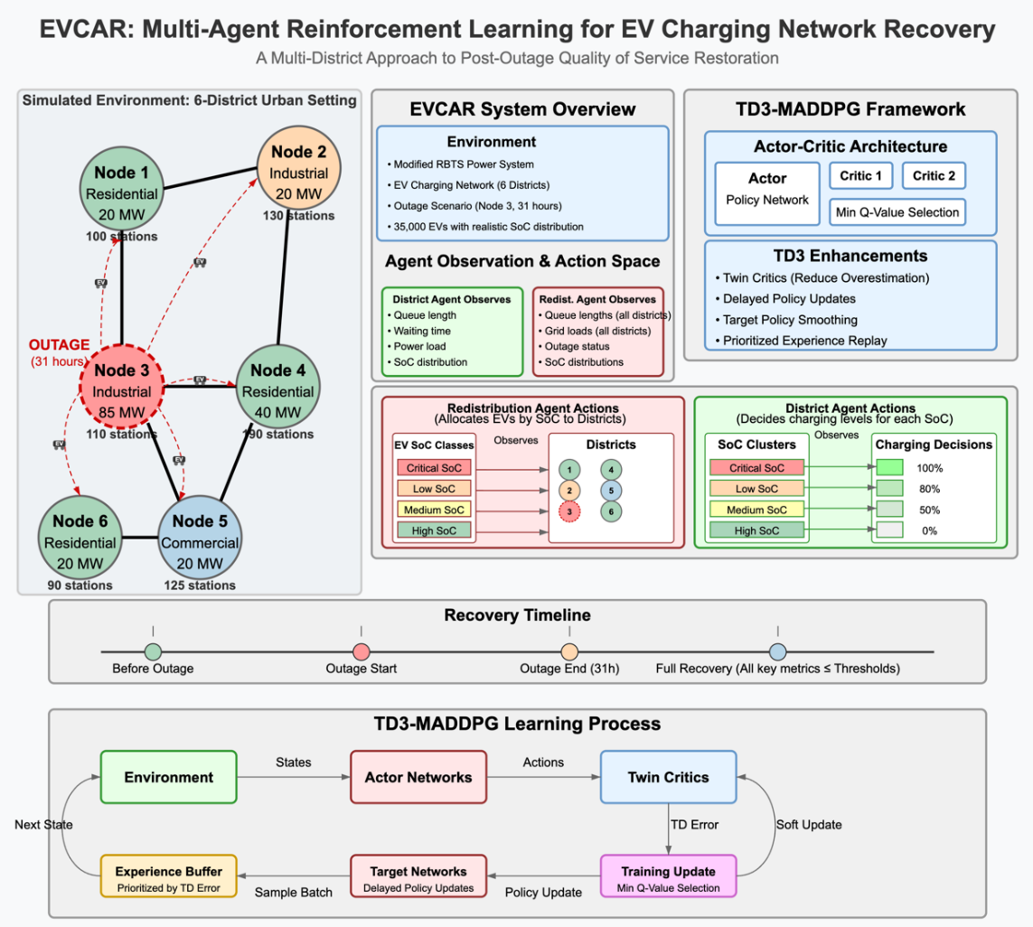
The EVCAR system employs Twin Delayed Deep Deterministic Policy Gradient with Multi-Agent learning (TD3-MADDPG), an extension of the original MADDPG algorithm introduced by Lowe et al. (2020). We chose TD3-MADDPG for its robustness in handling continuous action spaces and its stability in multi-agent environments. This approach enhances the original MADDPG by incorporating twin critics for more accurate value estimation and delayed policy updates to reduce overestimation bias. Each agent independently selects actions based on its local observations, but during training, the critic networks have access to global information to improve gradient estimation.
Figure 1: TD3-MADDPG Framework for Electric Vehicle Charging Network Recovery Following District Outage

The TD3-MADDPG algorithm consists of actor networks ${μ }_{θ_{i}}$ that map local observations to continuous actions and twin critic networks $Q_{ϕ_{i},1}$ and $Q_{ϕ_{i},2}$ that estimate Q-values by considering all agents’ actions. The actor update follows the deterministic policy gradient:
$∇_{θ_{i}}J\left(θ_{i}\right)=E_{s,a∼D}\left[∇_{θ_{i}}μ_{θ_{i}}\left(o_{i}\right)∇_{a_{i}}Q_{ϕ_{i},1}\left(o,a_{1},…,a_{N}\right)\right]$(1)
The critic networks are updated using the Bellman equation with the minimum value from both critics to reduce overestimation:
$L\left(ϕ_{i}\right)=E_{\left(s,a,r,s^{'}\right)∼D}\left[{\left(Q_{ϕ_{i},j}\left(s,a_{1},…,a_{N}\right)-y\right)}^{2}\right]$ (2)
where the target value is:
$y=r_{i}+γ\min_{j=1,2}Q_{ϕ_{i},j^{'}}(s^{'},a_{1^{'}},…,a_{N^{'}})$ (3)
We implement target policy smoothing by adding clipped noise to the target actions:
$a_{i^{'}}=\text{clip}(μ_{θ_{i^{'}}}(o_{i^{'}})+ϵ,-c,c),ϵ∼N(0,σ)$ (4)
where $ϵ$ is noise with standard deviation $σ$ and clipping range $[-c,c]$. The policy updates are delayed every $d$ steps to reduce variance and improve stability. This formulation enables coordinated agent behavior, allowing District Charging Agents and the EV Redistribution Agent to learn policies that adaptively restore QoS while maintaining grid stability.

3.2 Recovery definition and parameters
Recovery refers to restoring the charging QoS to pre-outage (or near-optimal) conditions while maintaining grid stability and preventing further bottlenecks. We track multiple metrics that collectively form a Recovery Index used for evaluation and (indirectly) in the reward function.
Let $t$ be the discrete time index for each step in the simulation. We define:
- Traffic Intensity ($ρ$): The ratio of arrival rate to service capacity:
$$ρ(t)=\frac{λ(t)}{μ⋅c}$$ | (5)
where $λ(t)$ is the arrival rate of EVs, $μ$ is the service rate per charger, and $c$ is the number of chargers.
- Utilization Factor: The proportion of chargers in use across districts:
$$U\left(t\right)=\frac{1}{N}\sum_{i=1}^{N}{\frac{{\text{EVs charging}}_{i}\left(t\right)}{{\text{Number of chargers}}_{i}}}$$ | (6)

- where $N$ is the number of districts.
- Congestion Level: We track average congestion by queue lengths at stations. For district $i$, let $q_{i}(t)$ be the queue length normalized by number of chargers:
$$QL(t)=\frac{1}{N}\sum_{i=1}^{N}{\frac{q_{i}(t)}{{\text{Number of chargers}}_{i}}}$$ | (7)

- Waiting Time: The average waiting time for EVs across districts:
$$WT(t)=\frac{1}{N}\sum_{i=1}^{N}{w_{i}}(t)$$ | (8)

where $w_{i}(t)$ is the average waiting time for an EV in district $i$.
- Grid Stability: We measure grid stability through two components:
- (1) Voltage stability based on loading:
$$VS(t)=1-\frac{L(t)}{C_{g}}$$ | (9)

where $L(t)$ is the total load from all active chargers and $C_{g}$ is the grid’s capacity threshold.
- (2) Normalized voltage deviation:
$${\text{NVD}}_{i}(t)=\frac{||V_{i}^{t}|-|V_{i}||}{|V_{i}|}$$ | (10)

- with accepted NVD range between 0–0.03 with 1 p.u. as the minimum voltage magnitude. The combined grid stability metric is:
$GS\left(t\right)=\frac{1}{2}\left(VS\left(t\right)+\left(1-\frac{1}{N}\sum_{i=1}^{N}{{\text{NVD}}_{i}}\left(t\right)\right)\right)$ (11)
- Critical SoC Percentage: The proportion of EVs with critically low charge:
$$\text{CritSoC}\left(t\right)=\frac{\text{Number of EVs with SoC}<5\%}{N_{\text{EV}}}$$
(12)
- where $N_{\text{EV}}$ is the total number of EVs in the system.
For evaluation, we define a Recovery Index that aggregates these normalized metrics:
$\text{Recovery}(t)=\hat{U}(t)+\hat{GS}(t)-\hat{QL}(t)-\hat{WT}(t)-\hat{\text{CritSoC}}(t)$ (13)
where $\hat{X}$ denotes the normalized version of metric $X$ scaled to a common range. Positive terms represent metrics where higher values indicate better recovery, while negative terms represent metrics where lower values are preferred. A higher overall value means better system recovery at time $t$.

3.3 Simulation environment
The system models a multi-district urban setting with six districts (nodes) representing three different district types: Residential, Commercial and Industrial, adopted from the modified Roy Billinton test power system (RBTS), represented in Tang et al., (2023). Local charging facilities in each district experience unexpected demand surges due to the failure of charging stations in an affected district. In response, intelligent agents dynamically manage charging operations and vehicle redistribution to prevent grid overload while ensuring efficient charging service.
The environment is characterized by:
- District Types: Each district is classified as residential (R), industrial (I), or commercial (C) with corresponding demand patterns, based on the National Household Travel Survey data (Zhou and Wang, 2014).
- Charging Infrastructure: Districts have varying numbers of fast charging stations (36 kW) based on local demand.
- EV Population: 35,000 EVs are distributed across districts with realistic state-of-charge (SoC) distributions. We process EV arrivals in batches based on district type and time of day with realistic SoC distribution.
- Time Resolution: 30-minute timesteps to capture daily charging patterns.
The simulation models realistic daily arrival patterns for different district types, EV charging behaviors, and grid load calculations. To ensure reproducibility, we designed the environment to capture key characteristics of urban EV charging networks:
- Spatial Relationships: Districts are spatially arranged with calculated distances that affect EV redistribution.
- Temporal Patterns: Time-of-day arrival rates vary by district type.
- Battery Dynamics: EV battery consumption is modeled with realistic parameters (60 kWh capacity, varying SoC distributions).
- Charging Behavior: Charging times vary based on initial SoC, charging level, and time-of-day congestion.
3.4 Agent design and decision framework
The recovery problem is formulated as a Partially Observable Markov Decision Process (POMDP) represented by:
$$M=(S,O,A,T,r,γ)$$ | (14)

where:
- $S$ is the global state space, representing the full system status, which is not directly observed by agents.
- $O$ is the local observation space for each agent.
- $A$ is the set of available actions.
- $T$ is the transition function, which updates the environment state after each action.
- $r$ is the reward function, balancing local and global recovery objectives.
- $γ$ is the discount factor, governing the importance of future rewards.
The system consists of two distinct agent types: District Charging Agents and an EV Redistribution Agent, implemented using the TD3-MADDPG approach. Each agent interacts with the environment by observing its local state and selecting actions through its actor network. After executing the action, the environment updates, and the agent receives a corresponding reward based on its immediate performance and contribution to the global QoS recovery goal.
3.4.1 District charging agents
Each of our six districts is managed by a District Charging Agent responsible for regulating charging policies in response to local conditions. The primary goal of this agent is to control charging operations to minimize congestion and waiting times while maintaining grid stability.
Each District Charging Agent receives local observations comprising:
$$\begin{matrix}o_{i}^{d}(t)=\{q_{i}(t),SC_{i}(t),WT_{i}(t),L_{i}(t),EV_{\text{incoming},i}(t), \\ outage_status,critical_soc_pct, \\ low_soc_pct,med_soc_pct,high_soc_pct\} (15)\end{matrix}$$
where $q_{i}(t)$ represents the current queue length, $SC_{i}(t)$ is the successful charging attempts, $WT_{i}(t)$ is the waiting time, $L_{i}(t)$ is the power load, $EV_{\text{incoming},i}(t)$ tracks incoming EVs, $outage_status$ indicates outage conditions, and $critical_soc_pct$, $low_soc_pct$, $med_soc_pct$, and $high_soc_pct$ represent the percentage of EVs in each State of Charge (SoC) category.
The action space consists of cluster-specific charging policies, where the agent assigns different charging strategies to each SoC cluster:
$a_{i}^{d}(t)=\{a_{i,s}^{d}(t)∣s∈\{\text{critical},\text{low},\text{medium},\text{high}\}\}$ (16)
For each SoC cluster $s$, the charging policy is a probability distribution over four charging options:
$a_{i,s}^{d}(t)∈\left\{\begin{matrix}p_{s,\text{full}}⋅\text{Full Charging (100\%)} \\ p_{s,\text{partial80}}⋅\text{Partial Charging (80\%)} \\ p_{s,\text{partial50}}⋅\text{Partial Charging (50\%)} \\ p_{s,\text{none}}⋅\text{No Charging (0\%)}\end{matrix}\right.$ (17)
where $∑p_{s,*}=1$ for each SoC cluster. This design enables more sophisticated control, allowing the agent to prioritize critical SoC vehicles for full charging while potentially deferring service for high SoC vehicles during congestion periods.
The reward function for each District Charging Agent balances multiple objectives with cluster-specific weighting:
rid(t)=0.8s​ws⋅(SCi,s(t)-QLi,s(t)-WTi,s(t))-Li(t)+0.2⋅rglobal(t) (18)
where $SC_{i,s}(t)$ incentivizes successful charging for each SoC cluster $s$ with priority weights $w_{s}$ (where $w_{\text{critical}}>w_{\text{low}}>w_{\text{medium}}>w_{\text{high}}$), $QL_{i,s}(t)$ penalizes excessive queues per cluster, $WT_{i,s}(t)$ discourages long waiting times with higher penalties for critical SoC vehicles, $L_{i}(t)$ prevents overloading inside the local district, and $r_{\text{global}}(t)$ ensures contribution to overall system recovery.
The District Charging Agent’s actor network maps its observations to a probability distribution over the four charging policies. We implement this with a neural network architecture consisting of:
- Input layer matching observation dimension (9)
- Two hidden layers with 256 neurons each
- Output layer with 3 neurons (one for each action)
- ReLU activations and tanh for final output
The critic networks evaluate action-state pairs to guide policy improvement with a similar structure but larger hidden layers (384 neurons) to accommodate the joint state-action space.

3.4.2 Redistribution agent
A single central Redistribution Agent allocates disrupted EVs across operational districts. This agent determines the percentage of EVs sent to each district to prevent congestion and optimize grid utilization. The agent’s observation space includes:
$$\begin{matrix}o^{r}(t)=\{q_{k}(t), L_{k}(t), EV_{\text{disrupted}}(t), C_{k}, is_outage_k, \\ {\text{crit_soc}}_{k}(t), {\text{low_soc}}_{k}(t), {\text{med_soc}}_{k}(t), {\text{high_soc}}_{k}\left(t\right)\}\end{matrix} (19)$$
where $q_{k}(t)$ represents queue lengths across districts, $L_{k}(t)$ denotes grid loads, $EV_{\text{disrupted}}(t)$ captures the total number of displaced EVs, $C_{k}$ is the charging capacity, $is_outage_k$ identifies districts with outages, and ${\text{crit_soc}}_{k}(t)$, ${\text{low_soc}}_{k}(t)$, ${\text{med_soc}}_{k}(t)$, ${\text{high_soc}}_{k}(t)$ respectively represent the number of EVs in each SoC category per district.
The action space defines a percentage-based allocation strategy for SoC-based EV classes:
ar(t)={ps,k}, s​k=1Nps,k=1 | (20)

where $p_{s,k}$ represents the proportion of EVs in SoC class $s$ (critical, low, medium, high) assigned to district $k$. The variation in allocations is restricted to $±0.1$ (10%) per SoC group and district, preventing drastic shifts in routing behavior. For instance, if district 1 has outage, an action in a timestep can be 0.2 of critical EVs goes to district 2, 0.3 of low SoC EVs goes to districts 3 and 4, and 0.1 of medium/high SoC to districts 5 and 6.
The reward function for the EV Redistribution Agent is structured to minimize congestion disparities and optimize EV allocation efficiency while incorporating global recovery objectives:
$\begin{matrix}r^{r}\left(t\right)=0.8⋅\left(\begin{aligned}-\sum_{k=1}^{N}{Q}L_{k}\left(t\right)-\sum_{k=1}^{N}{L_{k}}\left(t\right) \\ +\sum_{k=1}^{N}{S}C_{k}\left(t\right)\end{aligned}\right) \\ +0.2⋅r_{\text{global}}(t)\end{matrix}$ (21)
where $QL_{k}(t)$ discourages congestion, $L_{k}(t)$ prevents overloading, $SC_{k}(t)$ promotes successful charging, and $r_{\text{global}}(t)$ aligns with global recovery goals.
The EV Redistribution Agent uses a more complex neural network architecture:
- Input layer matching the combined district observations (31 dimensions for 6 districts + global state)
- Two hidden layers with 384 neurons each (larger than district agents to handle the more complex task)
- Output layer with N neurons (one for each district)
- Softmax activation to ensure valid probability distribution
3.4.3 Shared learning framework
All agents share a common learning framework with prioritized experience replay to improve sample efficiency. The prioritized replay buffer assigns higher sampling probabilities to experiences with large TD errors, calculated as:
$TD_error=|r+γ\min_{j=1,2}Q_{ϕ,j}(s^{'},a^{'})-Q_{ϕ,1}(s,a)|$ (22)
We use importance sampling weights to correct the bias introduced by prioritized sampling:
$$w_{i}={\left(\frac{1}{N}⋅\frac{1}{P(i)}\right)}^{b}$$ | (23)

where $P(i)$ is the probability of sampling transition $i$ and $b$ is an annealing parameter that increases from 0.4 to 1.0 throughout training.
To evaluate EVCAR’s performance, we implemented the TD3-MADDPG framework with carefully tuned hyperparameters as summarized in Table 1. These parameters balance training stability and convergence speed while enabling effective coordination between district and redistribution agents.
Table 1: Hyperparameters for EVCAR Implementation
Hyperparameter | Value
Learning Rate (Actor & Critic) | $${10}^{-4}$$
Discount Factor ($γ$) | 0.99
Batch Size | 64
Replay Buffer Size | 100,000
Exploration Noise | $$N(0,0.2)$$
Target Network Update Rate ($τ$) | 0.005

3.5 Simulation configuration
The simulation runs for 5000 episodes, with each episode termination when the recovery metrics reach their threshold with a maximum of 672 timesteps per episode (two weeks). This configuration captures both the immediate and cumulative effects of agent decisions under varying conditions of demand and grid constraints. Table 2 provides an overview of all simulation assumptions and calculations.

Table 2: EVCAR simulation configuration parameters
Parameter | Value
Environment Setup
Number of districts | 6
District types | Residential (Districts 0, 3, 5), Industrial (Districts 1, 2), Commercial (District 4)
District coordinates | District 0: (5, 15), District 1: (20, 25), District 2: (5, 5), District 3: (15, 5), District 4: (10, 0), District 5: (10, -10)
District maximum loads | 20 MW, 20 MW, 85 MW, 40 MW, 20 MW, 20 MW
Number of charging stations per district | 100, 130, 110, 190, 125, 90
Charger type | Fast chargers (36 kW)
Outage Scenario
Initial outage | Present in district 3 (Node 3)
Outage duration | 62 timesteps (31 hours) starting from 10 am next day of simulation
Battery and Charging Settings
EV battery capacity | 60 kWh
Initial State of Charge (SoC) | Randomized (Critical: 5%, Low: 25%, Medium: 50%, High: 20%)
Recovery Thresholds
Successful Charging Rate | $≥90\%$ of EVs charge within a rolling window of 3 timesteps
Utilization Factor | at least 0.85 but not more than 1
Nodal Voltage Deviation | 0.02
Queue Length | $<2$ EVs per station for 5 consecutive timesteps
Waiting Time | $<1$ timestep (0.5 hour) average waiting time per EV
Grid Stability | $≥0.9$ for 10 consecutive timesteps
EVs Below Critical SoC | $<5\%$ of total EVs have SoC $<5\%$ for 10 consecutive timesteps

4. RESULTS
4.1 Training convergence and learning dynamics
Overall, the training results demonstrate a good learning progression in the TD3-MADDPG approach, with convergence of the global reward occurring around episode 3764. As shown in figure 2, the redistribution agent faced difficulties in almost the first 1000 episodes to improve in comparison to the districts agents. This reflects the more complex observation and action spaces with highest reward of around 43 at convergence. The district agents exhibit distinct learning patterns, with District 3 (the outage district) demonstrating the slowest convergence, confirming the complexity of managing charging post-outage. Adjacent districts (Districts 5, 4 and 1) show intermediate convergence rates, while more distant districts converge faster. This pattern confirms the spatial impact of power outages on the charging network.

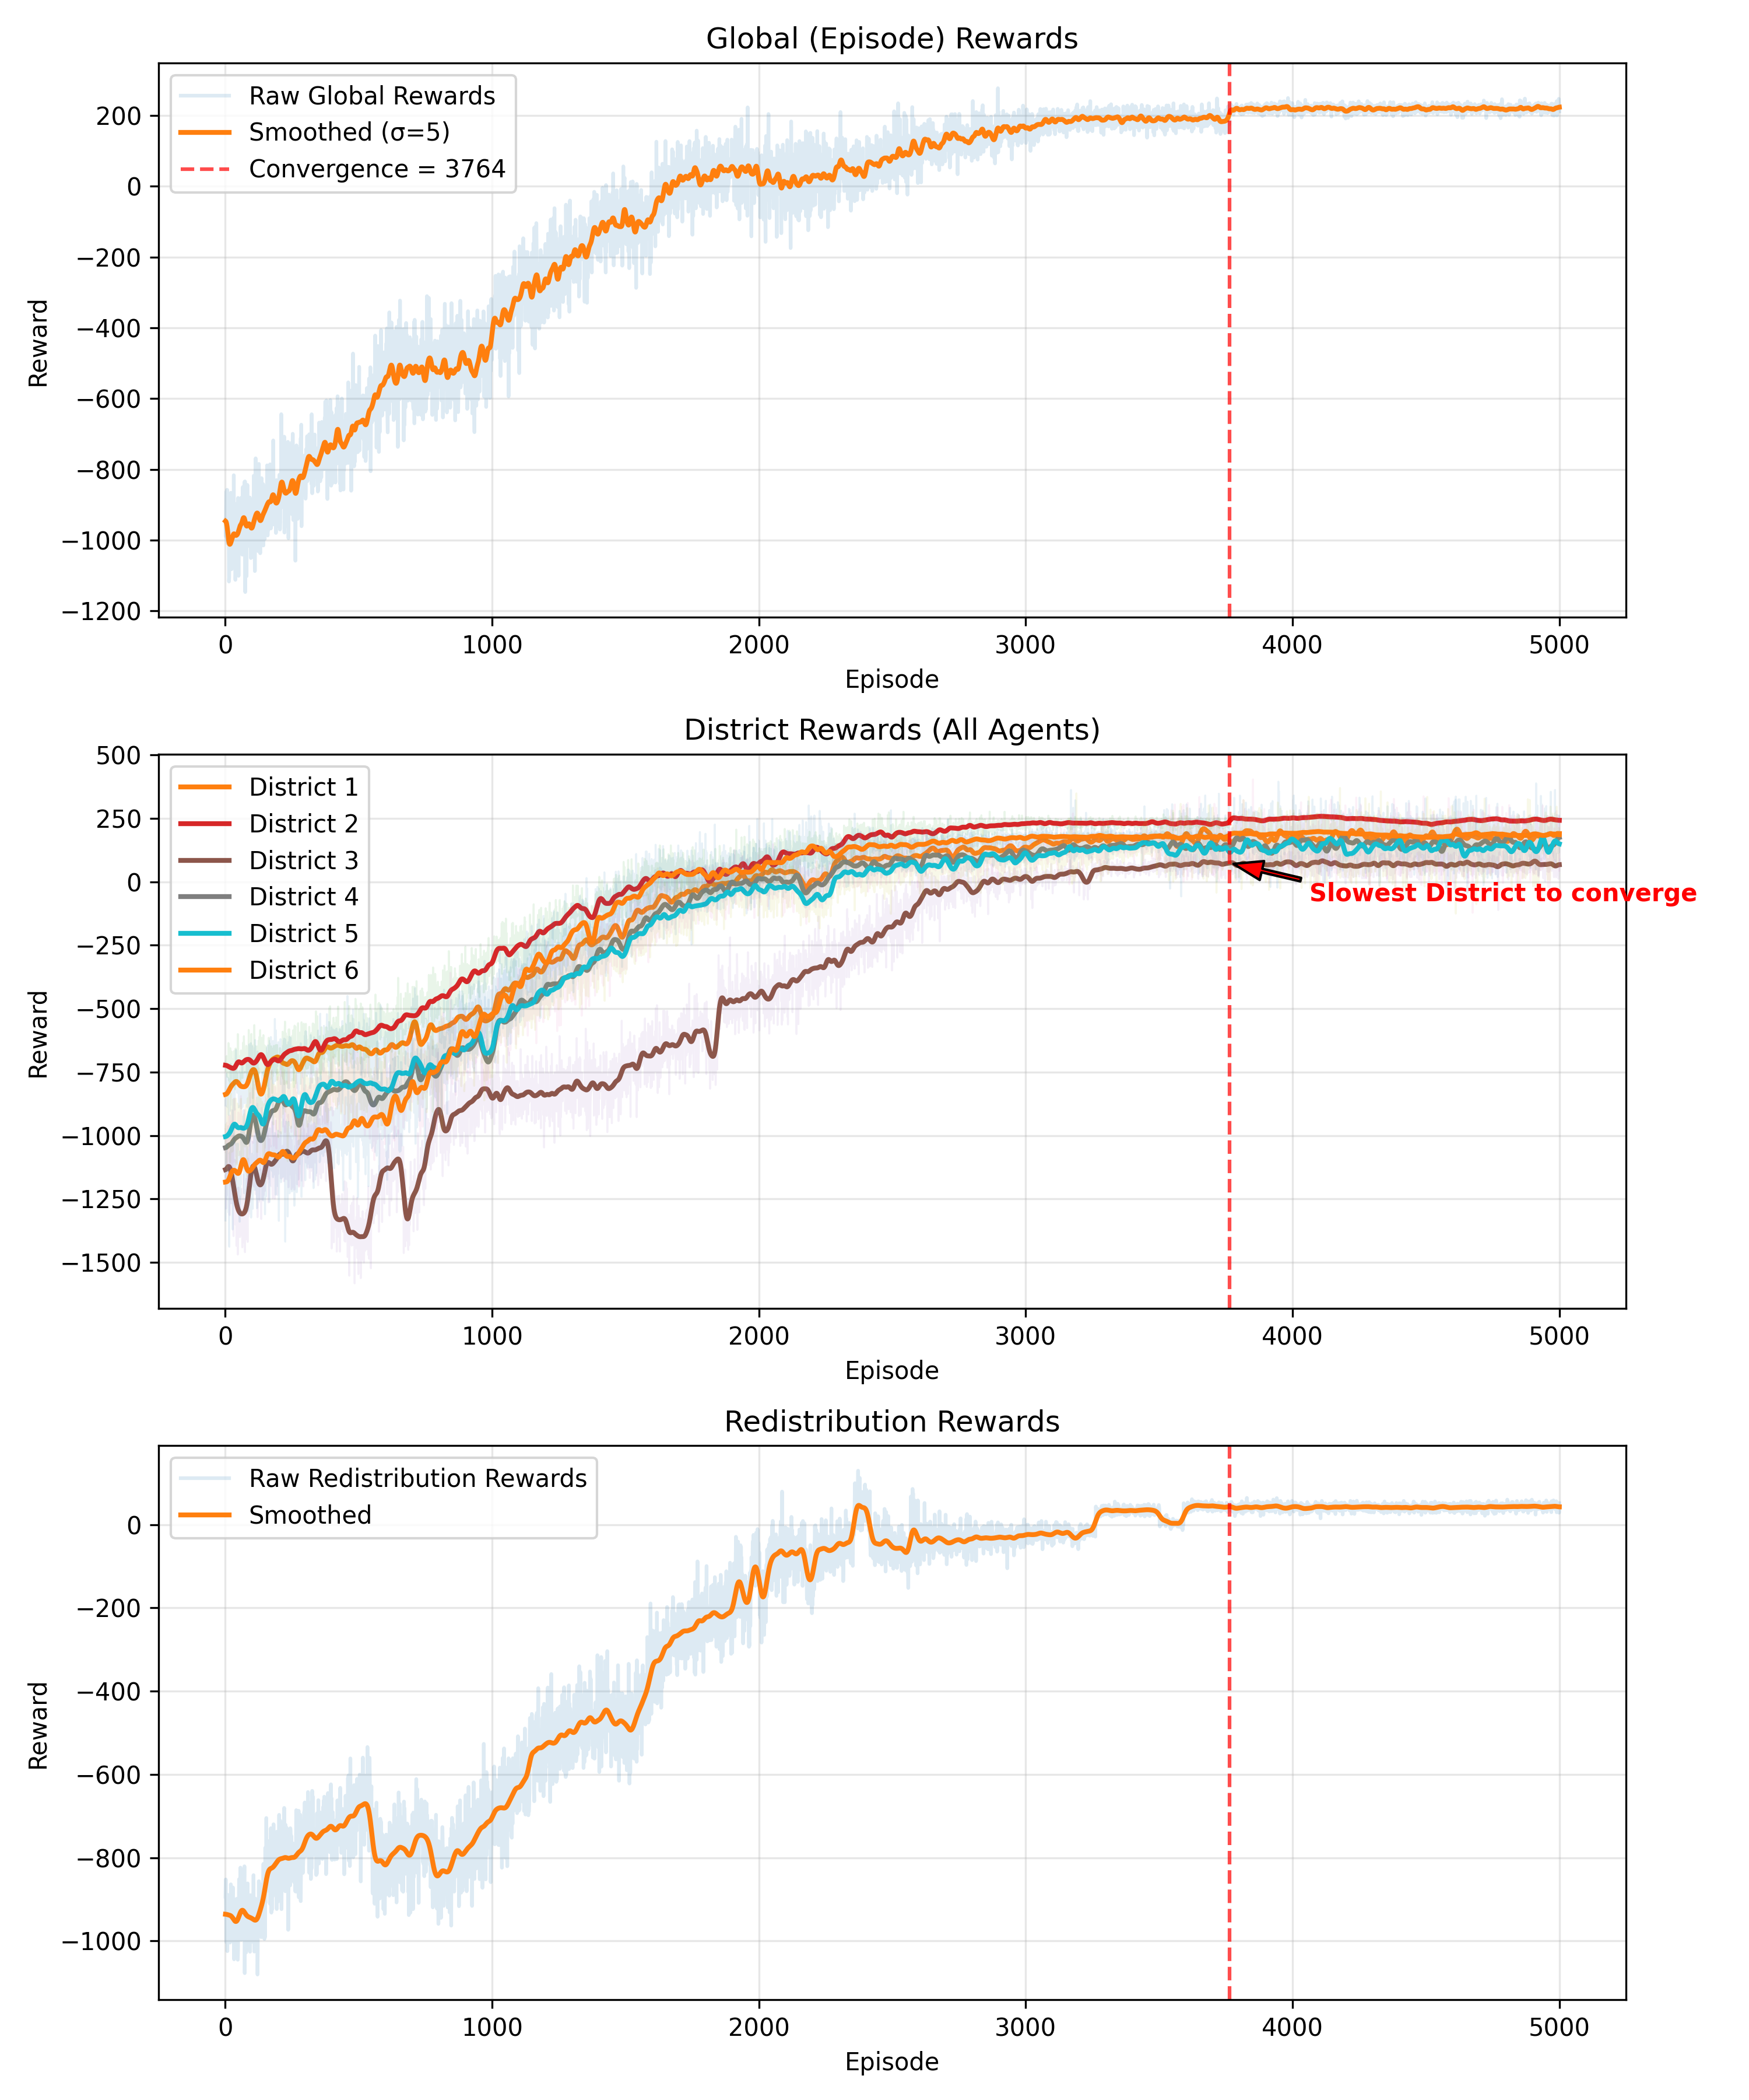
Figure 2: Episodic Rewards for Agents and Global Reward

4.2 Recovery metrics over episodes
Figure 3 illustrates the progression of the maximum values of performance metrics throughout the training episodes. Significant improvements are observed across all subsystems. In terms of grid stability, the maximum EV load on the power grid decreased from over 22 MW to approximately 12 MW, accompanied by a reduction in the nodal voltage deviation (NVD) from approximately 0.045 to 0.031. EVCN operational metrics show a consistent decline in both maximum station utilization (from above five to around two) and traffic intensity almost stable at around one, indicating improved load distribution and reduced congestion. Queue metrics reveal a sharp reduction in the maximum queue length (from approximately 15 to fewer than three vehicles) and the maximum waiting time (from approximately six to fewer than two hours), reflecting enhanced station efficiency. Lastly, the charging success rate improved steadily, converging from an initial rate of approximately 30% to over 90%, demonstrating effective policy learning and increased service reliability. Figure 4 explains the same maximum values post-outage period, showing reaching recovery thresholds at episode 3764.
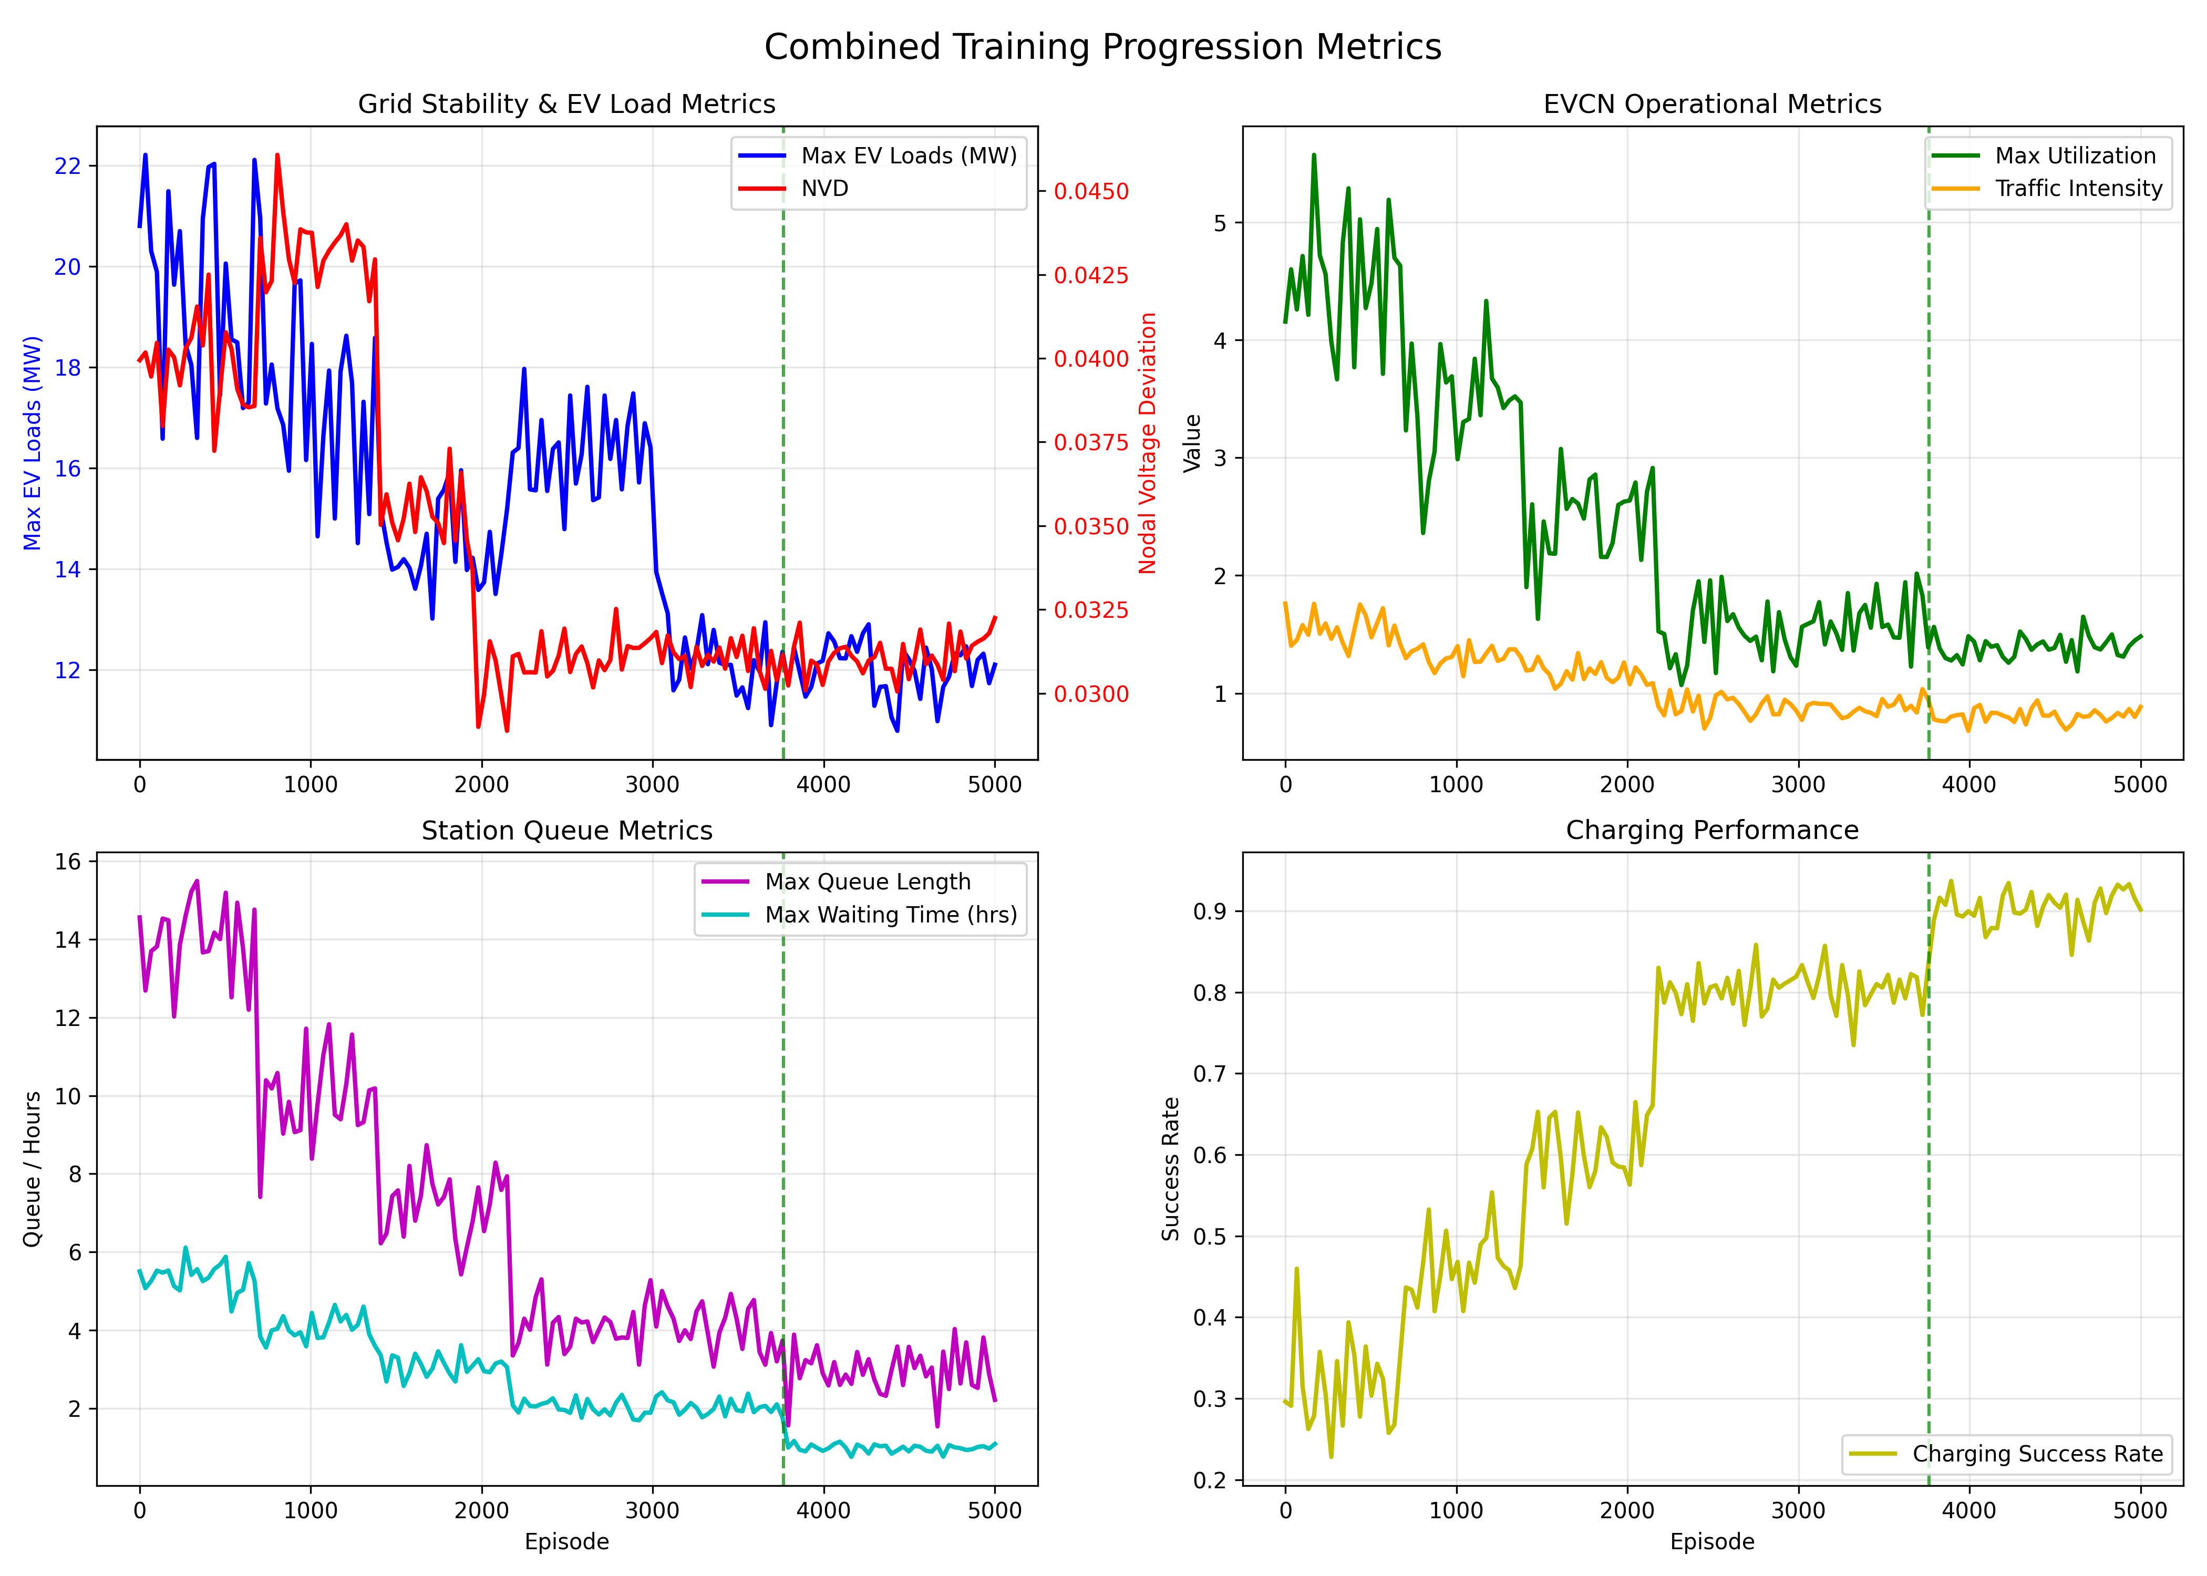
Figure 3: Maximum Values of Comprehensive Recovery Metrics during Outage Period across Episodes
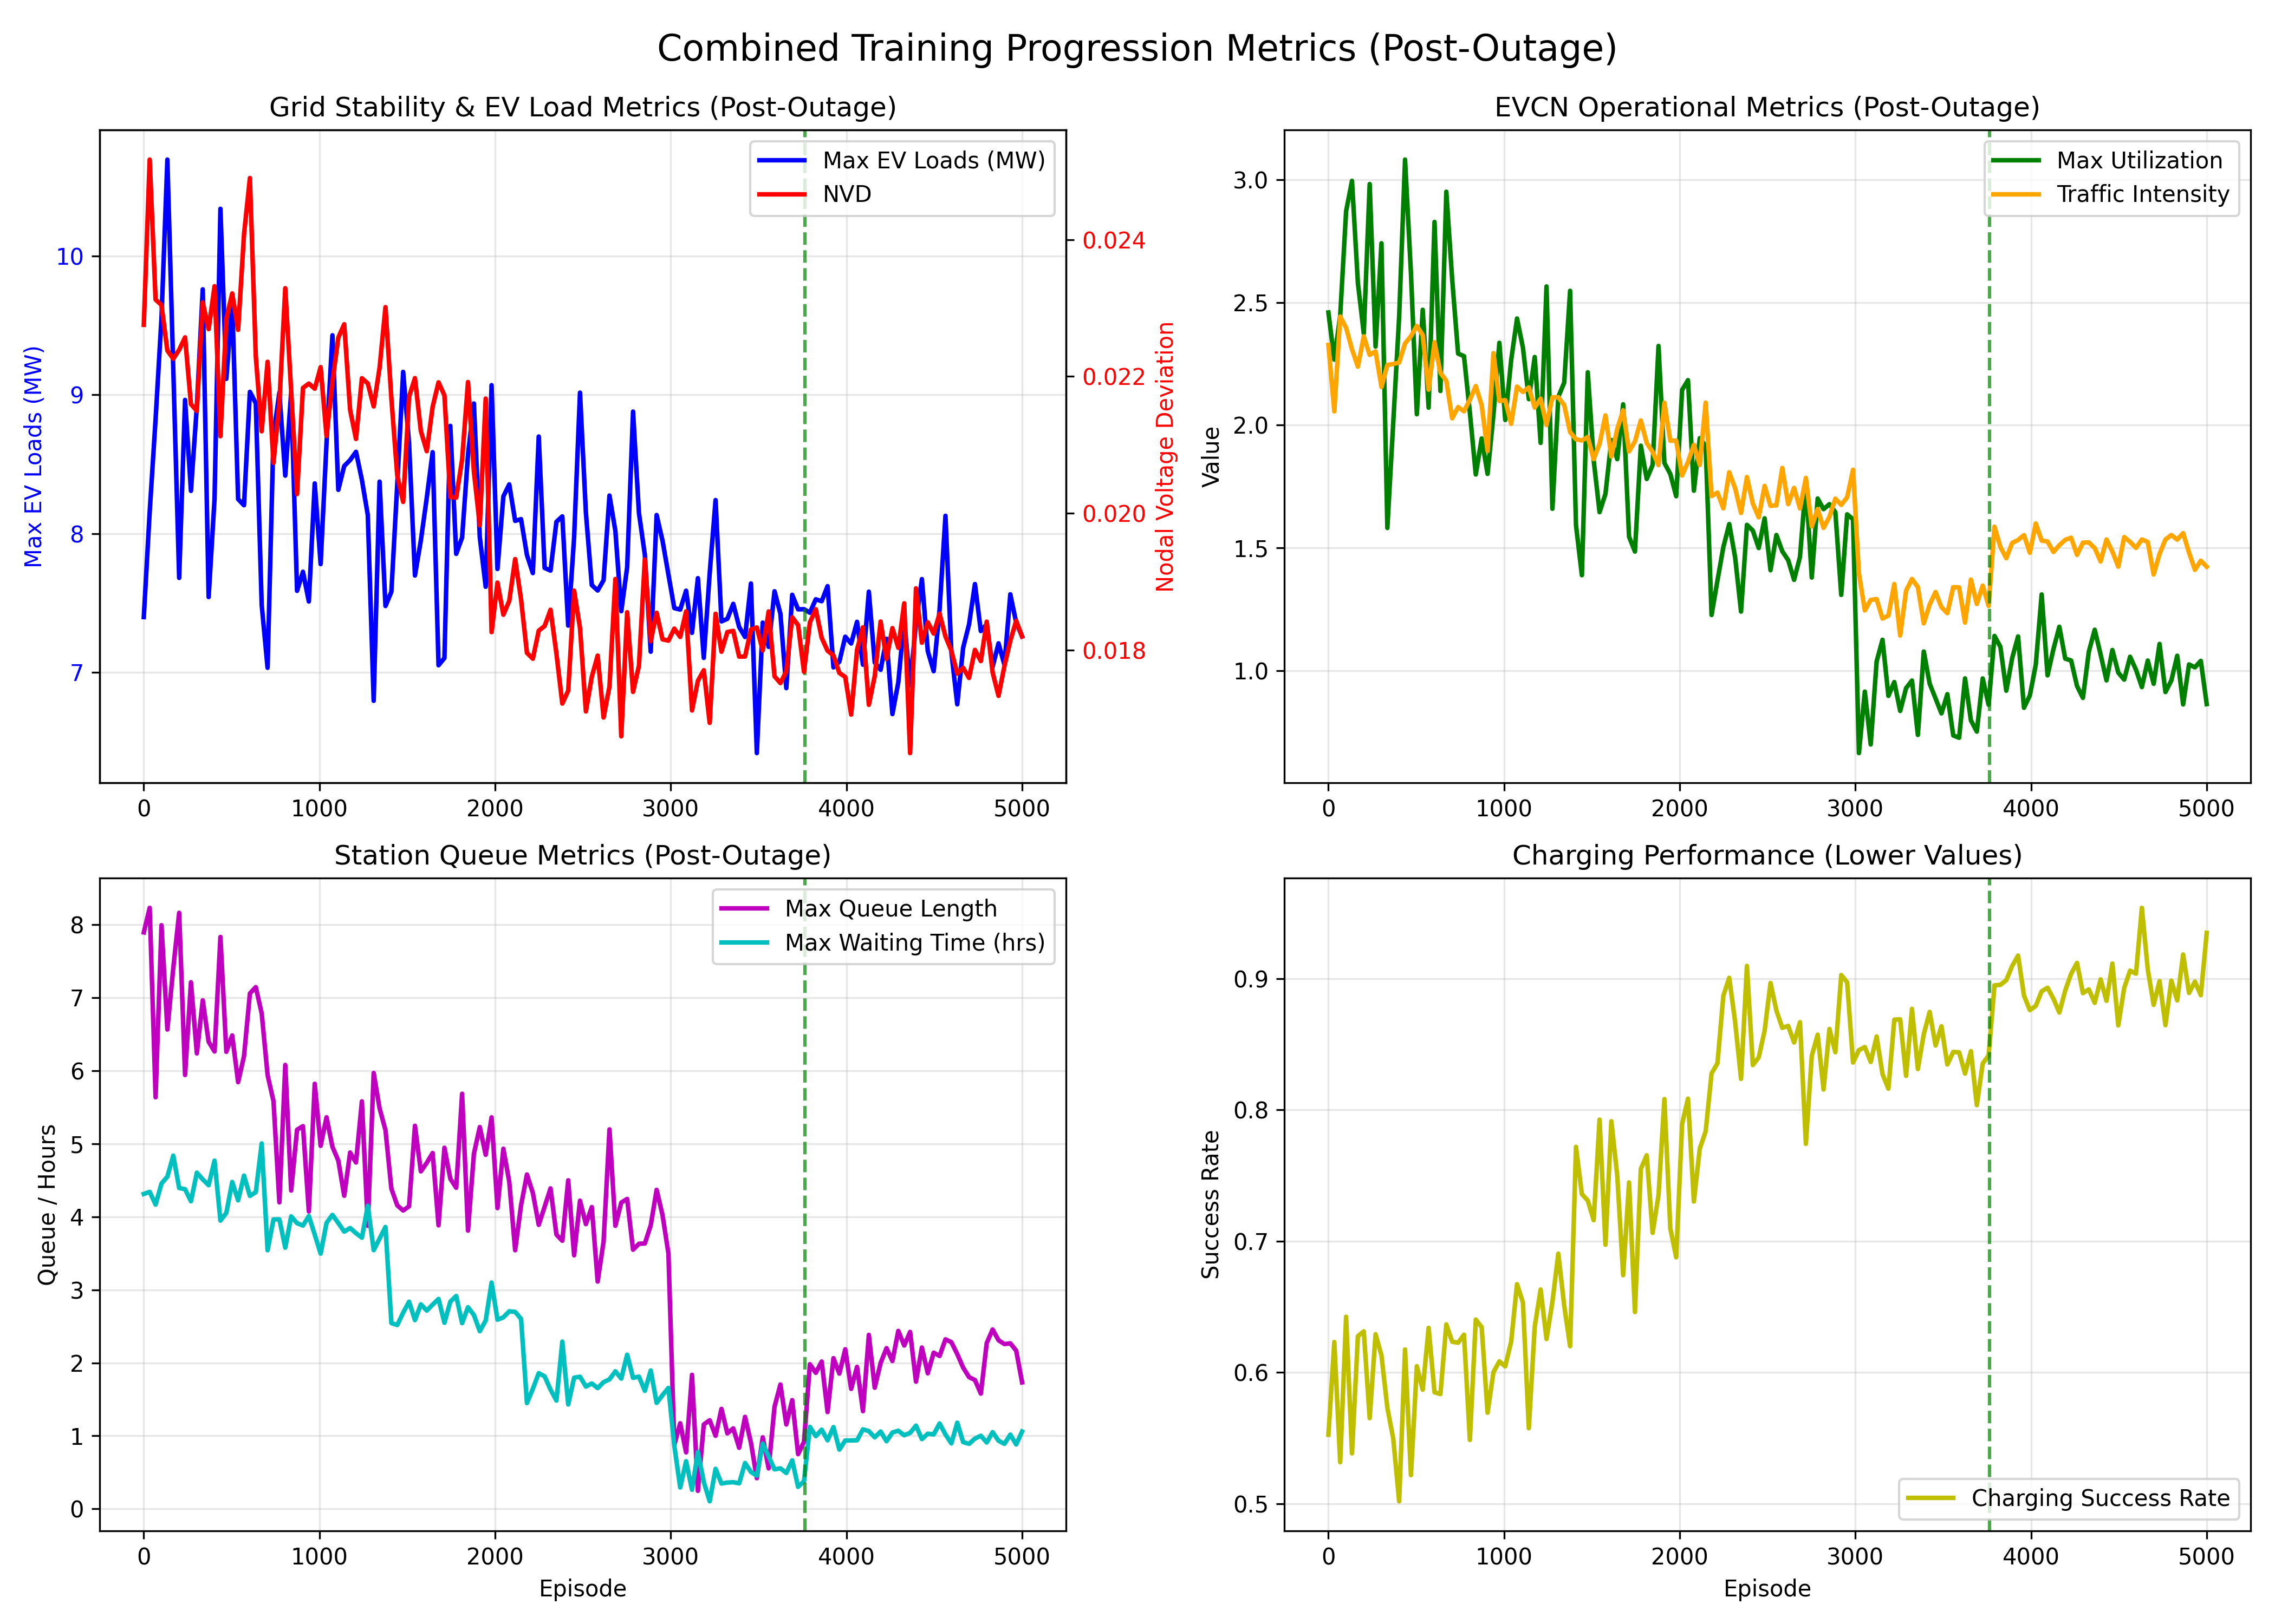
Figure 4: Maximum Values of Comprehensive Recovery Metrics Post-Outage Period across Episodes
4.3 Policy evolution over episodes
Figure 5 illustrates the temporal evolution of the redistribution agent’s policy across three different stages until convergence: early (episode 500), mid (episode 1500), and late training (episode 3000). In the early phase, redistribution appears erratic and uncoordinated, with no clear prioritization of districts during outages. Noting that during the first 937 episodes, run ended at the maximum allowed timestep (672) because of the failure to meet recovery points. Mid-training shows improved consistency, though recovery still requires over four days post-outage but it was still difficult to understand specific strategy. By episode 3000, the agent demonstrates a more optimized strategy: in the beginning of outage, redistribution is maximized toward neighbor districts 4 and 1 but very minimal to the closest neighboring district (District 5) at the onset of the outage. Then almost half outage time, closest neighbor got more redistribution with the totally remote districts 2 and 6. Then the trend at the outage start is repeated again but slightly different. Post-outage, a smooth reallocation back to the outage node (District 3) is delayed almost 10 hours post-outage. Full recovery is achieved within approximately 43 hours, and a more stable, equitable redistribution policy is observed. Interestingly, the agent at times prioritizes remote districts (Districts 2 and 6) over neighbors, indicating strategic flexibility in its learned policy.
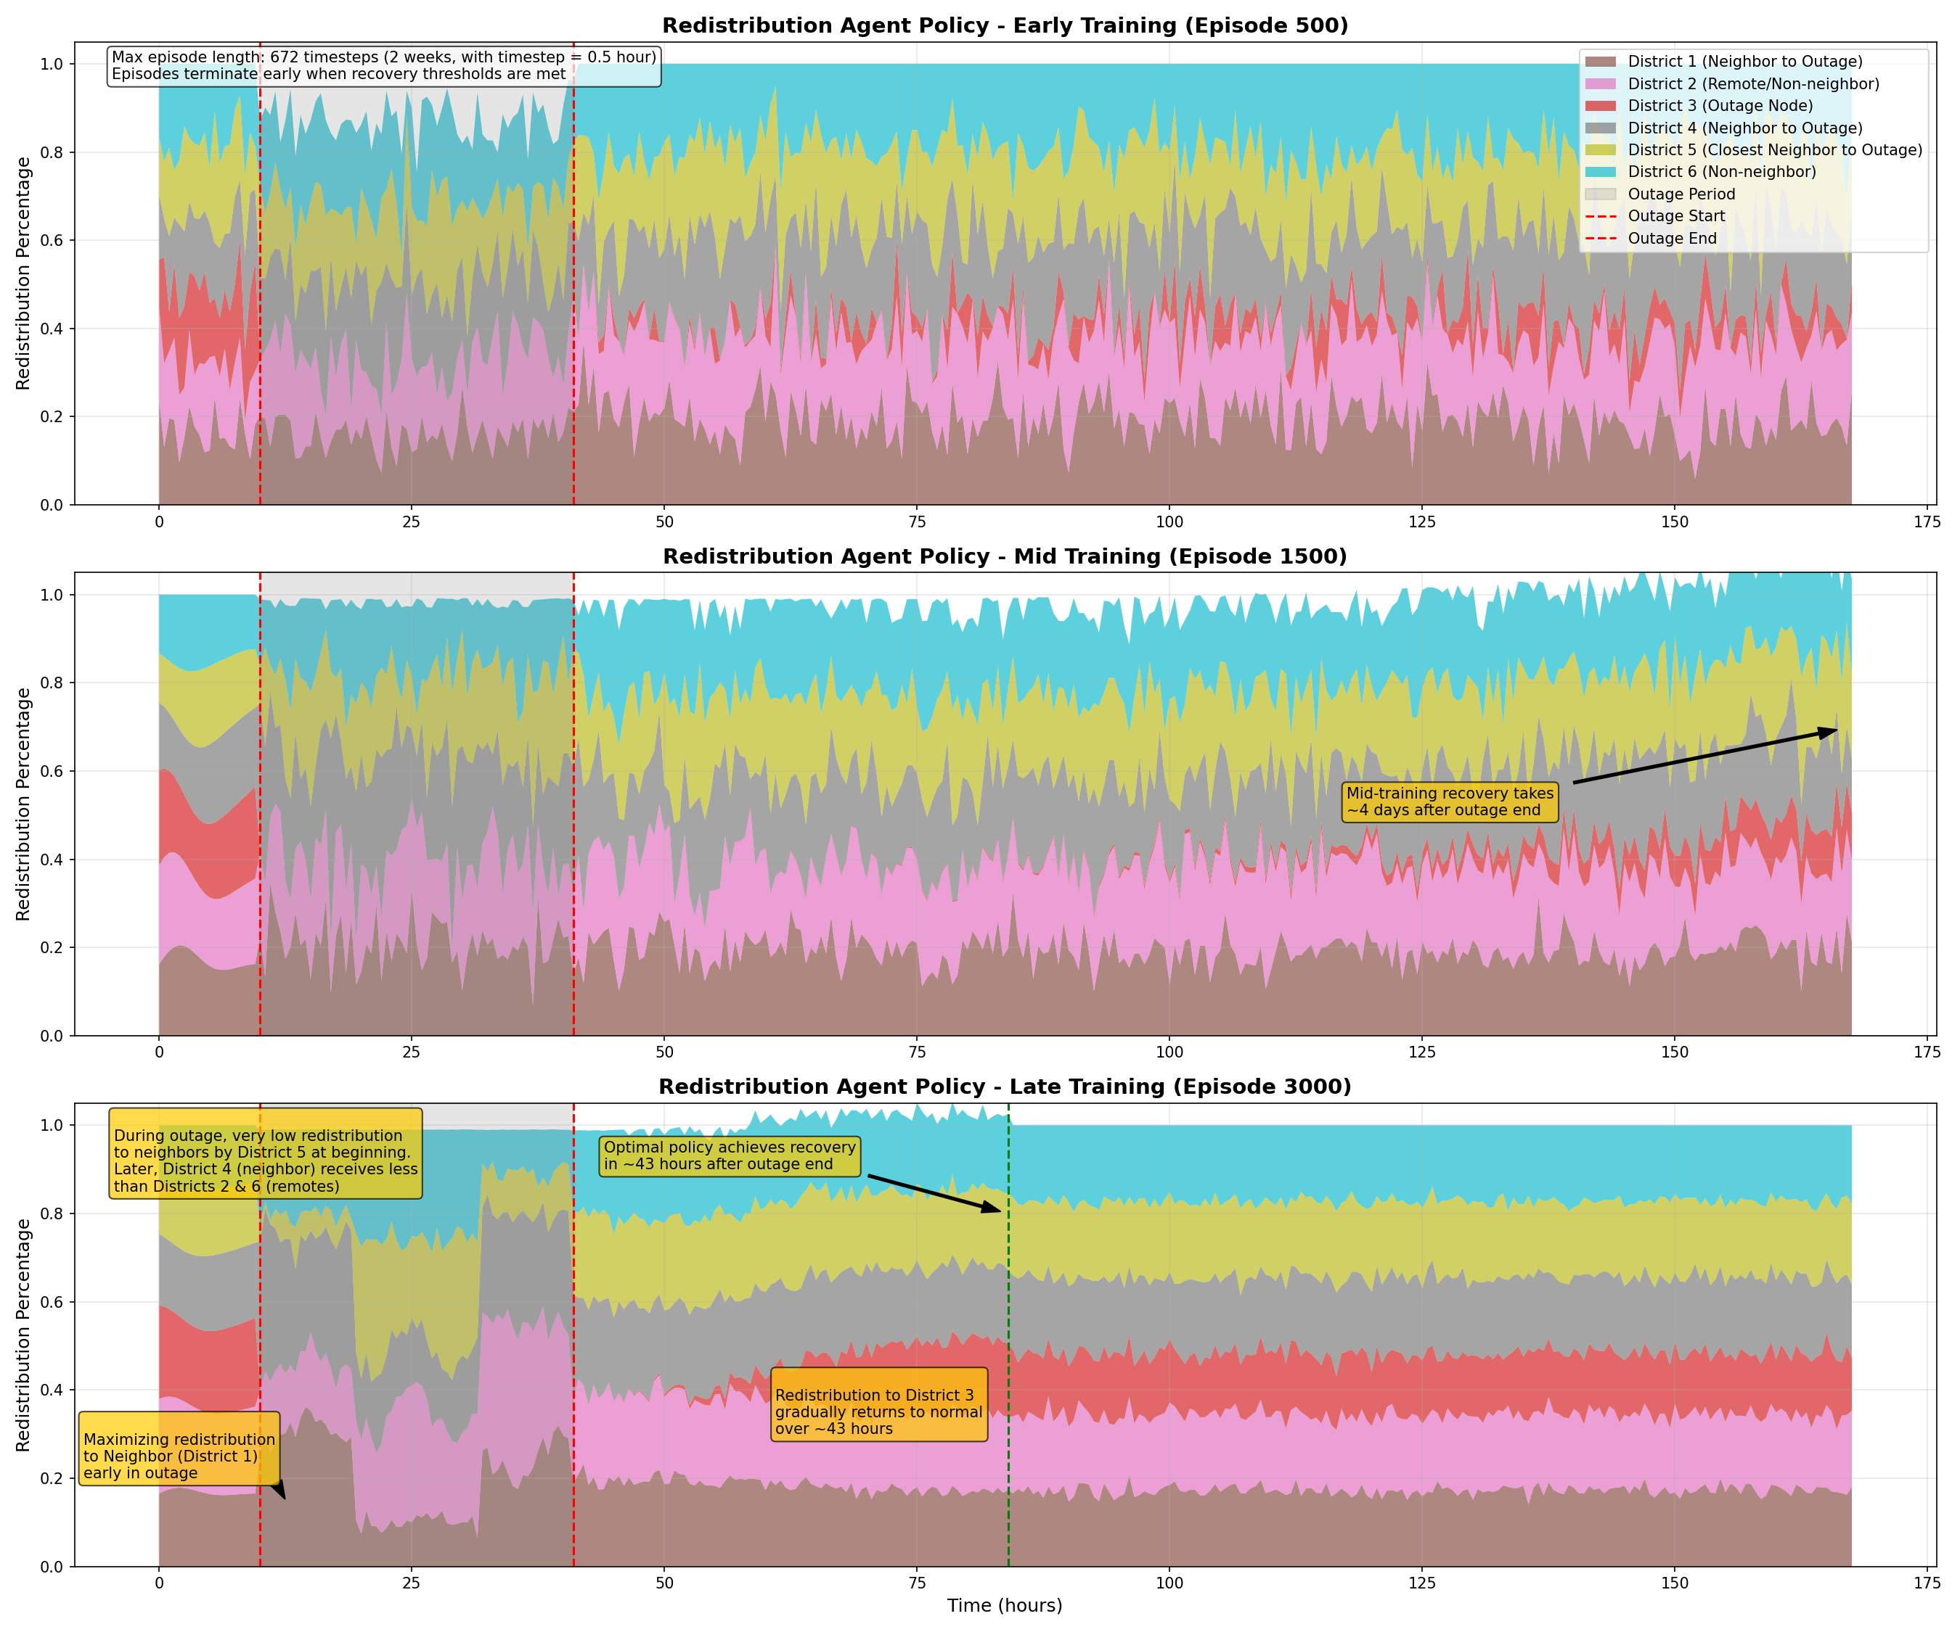
Figure 5: Redistribution Agent Policy Evolution over training episodes
Figure 6 shows the evolution of charging strategies for high SoC cluster in district 5, which is the nearest district to the outage district 3. In early training, the system demonstrates an undeveloped policy with a little bias toward full charging regardless of grid conditions. This shows an almost equal treatment for all EVs regardless their SoC. As learning progresses to mid-training, we observe the emergence of a more nuanced approach, with the system beginning to experiment with selective charging rejection during grid stress periods but rejection continues during the simulation, showing failure to optimize policy for successful charging. By late training (from episode 3000), the system has developed a sophisticated optimization strategy characterized by significant rejection rates (>75%) of high SoC vehicles during network outages. This represents an intelligent load management approach where vehicles with substantial remaining charge are strategically deferred during periods of grid constraint, prioritizing critical and low SoC vehicles instead. Particularly noteworthy is the sustained rejection policy that continues after the outage period until reaching recovery thresholds (around 43 hours post-outage), allowing the grid to gradually return to normal operations while maintaining stability. This evolved strategy demonstrates how reinforcement learning can discover non-intuitive but highly effective grid management policies that balance individual vehicle needs with system-wide resilience.
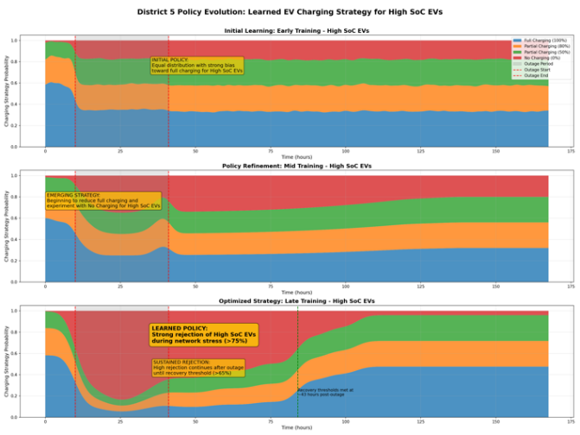
Figure 6: District 5 Agent Policy Evolution over training episodes for high SoC cluster
4.4 Method validation
4.4.1 Grid Stability and utilization performance
We compared our TD3-MADDPG methodology to four other methods for validation: the baseline with no intervention, Fuzzy logic integrated with Markov Decision Process as implemented in Tang. et al, (2023), two fixed partial charging scenarios at 50% and 80%. Figure 7 compares the five strategies in terms of maximum nodal voltage deviation (NVD) and maximum station utilization factor during and after a prolonged power outage. For voltage stability, the Fixed 50% Charging method shows the fastest recovery, reducing NVD below the 0.02 p.u even before the outage end time. TD3-MADDPG follows with recovery at threshold within 4.5 hours after the outage ends, followed by fixed 80% strategy at 11.5 hours, exhibiting smooth convergence and low post-recovery oscillations. Fuzzy Logic reaches the threshold later at 26 hours, but with greater variability in its response. The No Control strategy reached recovery after 80.5 h. These results underscore the effectiveness of controlled charging—even static partial strategies—in supporting voltage recovery, while highlighting the risks of uncoordinated demand.
In terms of charging station utilization, although fixed policies and TD3-MADDPG showed similar good pattern during putage, TD3-MADDPG delivers the best performance post-outage, reducing the utilization factor below the critical threshold of 1.0 within ten hours and maintaining stable, balanced usage thereafter. The No Control strategy remains overutilized until day six with maximum value of 3.6 two hours post-outage, reflecting persistent system congestion and poor load distribution. Overall, while Fixed 50% Charging excels in voltage recovery, TD3-MADDPG showed the fastest and most simultaneous stabilization of both voltage and utilization.
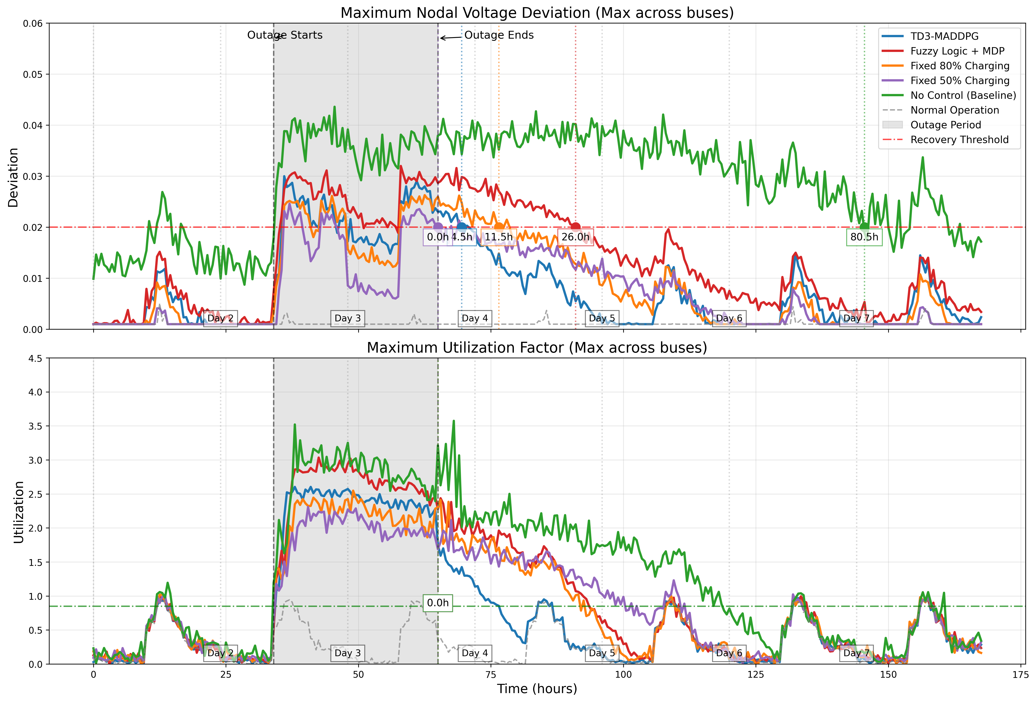
Figure 7: Comparison between convergence episode of TD3-MADDPG and other methods
4.4.2 User experience metrics
Figure 8 (top) compares the maximum number of vehicles in queue across different control strategies. The recovery threshold is set at two vehicles. TD3-MADDPG demonstrates the fastest recovery, reducing the queue length below the threshold within 43.0 hours after the outage ends. Fuzzy Logic follows at 60.0 hours, while Fixed 50% Charging and Fixed 80% Charging take 72.0 hours and 84.0 hours, respectively. The No Control strategy fails to recover throughout the first seven days of the simulation, with queue lengths remaining well above the acceptable range. These results confirm the advantage of dynamic coordination in rapidly resolving congestion during high-demand periods.
The bottom plot tracks the percentage of vehicles in a critical SoC state (below a defined threshold), with a recovery target of 5%. TD3-MADDPG maintains the lowest critical SoC percentage throughout the recovery process and drops below the threshold at 12.0 hours post-outage. Fixed 50% Charging and Fuzzy Logic follow at around 25.0 for both. Fixed 80% Charging and No Control require over 48.5 and 102 hours, respectively. The consistently low SoC risk under TD3-MADDPG reflects its superior ability to prioritize vulnerable vehicles and allocate charging efficiently across the network.
4.4.3 Computational considerations
Despite the superior performance of the TD3-MADDPG framework, its implementation incurs significantly higher computational costs compared to simpler control strategies. Empirical runtimes across multiple platforms—including a MacBook Pro M2, an iMac 27” with a 3.6 GHz 10-Core Intel Core i9 processor, and a Lenovo ThinkPad P1—indicate that training the proposed model requires approximately six to nine hours, in contrast to 20 to 40 minutes for the baseline fuzzy logic approach. This disparity highlights a trade-off between solution quality and computational efficiency.
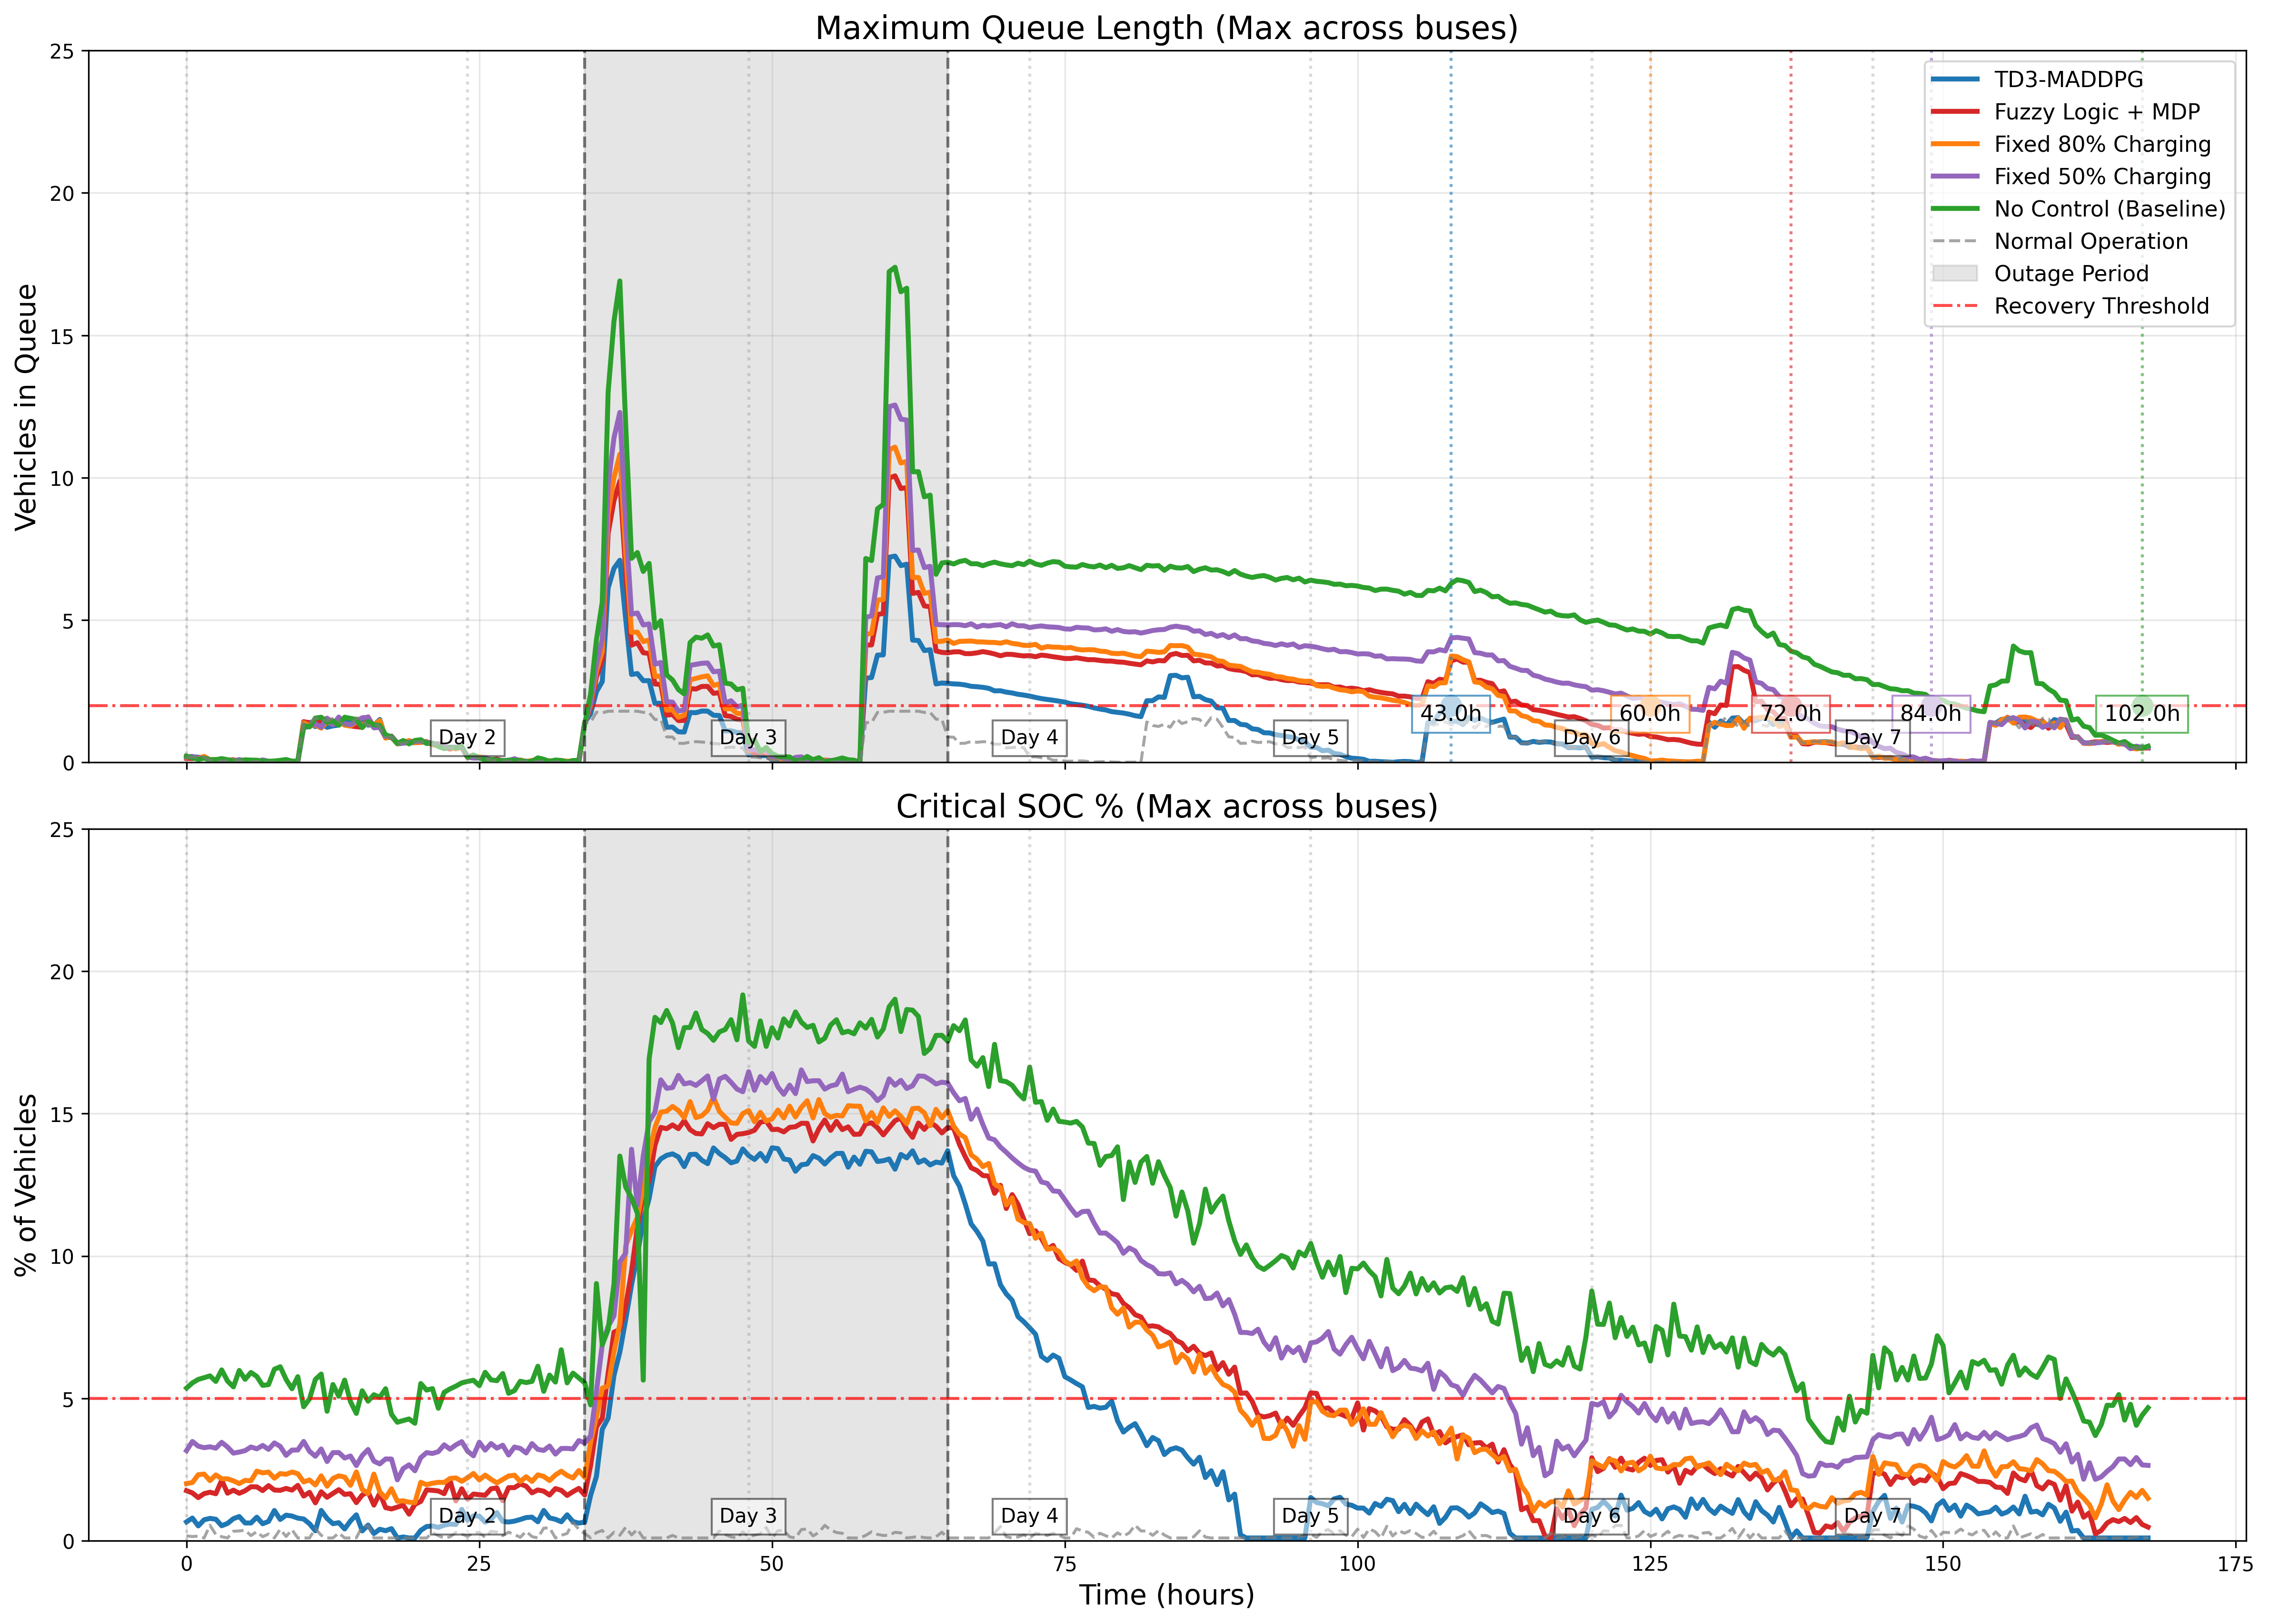
Figure 8: Comparison between methods for user experience metrics
The current implementation adopts a high-level abstraction, which significantly reduces the dimensionality of the problem and enables tractable training. However, it does not capture the granularity of individual EV behavior. A fully disaggregated approach, modeling each EV as an independent agent, would dramatically increase the complexity and computational burden, potentially limiting its feasibility for practical QoS recovery scenarios.

5. CONCLUSION
This study presented a multi-agent TD3-MADDPG reinforcement learning framework for coordinated recovery of Electric Vehicle Charging Networks (EVCNs) post-prolonged outages. The developed method achieved notable improvements in grid stability, station utilization, congestion management, and user-centric metrics compared to existing strategies. Results demonstrated the model’s ability to adapt strategically, sometimes making non-intuitive redistribution decisions, reflecting advanced learning capabilities. However, these advantages require higher computational resources, emphasizing a crucial balance between complexity and performance. Future research should investigate computational optimizations and explore real-world deployment feasibility for scaling agent-based models. Next steps of our work are to explore hybrid approaches that balance model fidelity with scalability, possibly through hierarchical or cluster-based agent representations.

REFERENCES
Tang, D., Liu, X., Zhao, T., & Wang, Q. (2023). Spatial–temporal QoS assessment of the EV charging network considering power outages. Frontiers in Energy Research, 11, 1112169. https://doi.org/10.3389/fenrg.2023.1112169
Zhang, A., Liu, Q., Liu, J., & Cheng, L. (2024). CASA: Cost-effective EV charging scheduling based on deep reinforcement learning. Neural Computing and Applications, 36, 8355-8370. https://doi.org/10.1007/s00521-024-09530-3
Li, H., Han, B., Wang, K., & Xu, J. (2023). Decentralized collaborative optimal scheduling for EV charging stations based on multi-agent reinforcement learning. IET Generation, Transmission & Distribution, 18, 1172-1183. https://doi.org/10.1049/gtd2.13047
Zhao, Z., & Lee, C. K. M. (2022). Dynamic pricing for EV charging stations: A deep reinforcement learning approach. IEEE Transactions on Transportation Electrification, 8(2), 2456-2467. https://doi: 10.1109/TTE.2021.3139674
Zou, L., Munir, M. S., Tun, Y. K., Kang, S., & Hong, C. S. (2022). Intelligent EV charging for urban prosumer communities: An auction and multi-agent deep reinforcement learning approach. IEEE Transactions on Network and Service Management, 19(4), 4384-4399. https://doi.org/10.1109/TNSM.2022.3160210
Ucer, E., Koyuncu, I., Kisacikoglu, M. C., Yavuz, M., Meintz, A., & Rames, C. (2019). Modeling and analysis of a fast charging station and evaluation of service quality for electric vehicles. IEEE Transactions on Transportation Electrification, 5(1), 215-225. https://doi.org/10.1109/TTE.2019.2897088
Cheng, L., Chang, Y., Wu, Q., Lin, W., & Singh, C. (2014). Evaluating charging service reliability for plug-in EVs from the distribution network aspect. IEEE Transactions on Sustainable Energy, 5(4), 1287-1296. https://doi.org/10.1109/TSTE.2014.2348575
Wei, W., Wu, D., Wu, Q., Shafie-Khah, M., & Catalao, J. P. S. (2019). Interdependence between transportation system and power distribution system: A comprehensive review on models and applications. Journal of Modern Power Systems and Clean Energy, 7, 433-448. https://doi.org/10.1007/s40565-019-0516-7
Lowe, R., Wu, Y., Tamar, A., Harb, J., Abbeel, P., & Mordatch, I. (2020). Multi-Agent Actor-Critic for Mixed Cooperative-Competitive Environments. arXiv preprint arXiv:1706.02275. https://doi.org/10.48550/arXiv.1706.02275
Huang, S., Wu, Q., Oren, S. S., Li, R., & Liu, Z. (2015). Distribution locational marginal pricing through quadratic programming for congestion management in distribution networks. IEEE Transactions on Power Systems, 30(4), 2170–2178. https://doi.org/10.1109/TPWRS.2014.2359977
Sheng, Y., Guo, Q., Yang, T., Zhou, Z., & Sun, H. (2019). A potential security threat and its solution in coupled urban power-traffic networks with high penetration of electric vehicles. CSEE Journal of Power and Energy Systems. https://doi.org/10.17775/CSEEJPES.2020.01460

