Smart Multimodel Containers: AI Supported automatic linking

Nidhal Al-Sadoon¹, Ibrahim Al-Iedani² and Raimar J. Scherer¹

¹Institute of Construction Informatics, TU Dresden, Dresden, Germany
²Faculty of Engineering, Üsküdar University, Istanbul, Türkiye

ABSTRACT:

This paper presents a novel framework for AI-supported semantic querying and automatic link generation within ISO 21597-compliant multimodel containers (MMCs). The proposed system enables intuitive interaction with Building Information Modeling (BIM) data through a natural language interface (NLI) that supports non-technical users in exploring, querying, and linking complex construction-related datasets. The framework combines ontology-guided natural language processing, intent classification, and unit-aware querying to dynamically interpret user queries and extract relevant data from Industry Foundation Classes (IFC) models. Furthermore, the system generates semantic links between BIM elements and heterogeneous data sources without modifying the original models. A layered architecture is adopted, integrating modules for ontology mapping, IFC querying, and ICDD-compliant link generation. The framework is validated through an exemplar use case in which users interact with a BIM model and IoT sensor data, demonstrating the system’s ability to retrieve relevant building elements and generate dynamic links to their associated time-series data. Results show that the proposed approach enhances data accessibility, traceability, and interoperability in digital construction environments, laying the foundation for more dynamic and intelligent multimodel container systems.

KEYWORDS:

Multimodel container, BIM, semantic linking, natural language querying, ICDD.

1. INTRODUCTION
The Architecture, Engineering, and Construction (AEC) industry has undergone significant digital transformation in recent years, driven by the adoption of Building Information Modeling (BIM) and other digital tools. BIM has emerged as a cornerstone for managing complex construction projects, enabling stakeholders to create, share, and manage digital representations of physical and functional characteristics of buildings (Azhar, 2011). However, despite the widespread adoption of BIM, the industry continues to face challenges related to data interoperability and integration across multidisciplinary teams. The heterogeneous nature of data generated by various stakeholders, including architects, engineers, contractors, and facility managers, often leads to fragmented information silos, hindering effective collaboration and decision-making (Volk et al., 2014).
To address these challenges, the concept of the Multimodel container was introduced, providing a standardized framework for organizing and linking diverse data sources. The Information Container for Linked Document Delivery (ICDD), standardized under ISO 21597, offers a structured approach to managing and exchanging linked data across different domains (ISO 21597, 2020). The Multimodel approach enables the creation of explicit "Linkmodels," which facilitate the connection of model elements from different application domains, levels of detail, and versions (Scherer and Schapke, 2011). These Linkmodels help track dependencies and ensure consistency between various models without altering the original specialized models. However, the current implementation of ICDD uses query languages, such as SPARQL and MMQL, to retrieve information required to create links and manipulate the container information (Fuchs & Scherer, 2017; Hagedorn et al., 2023). While these query languages are powerful, they require specialized technical expertise, making the process time-consuming and inaccessible to non-technical users. This limitation becomes particularly evident in large-scale projects where the volume and complexity of data demand more dynamic, scalable, and user-friendly solutions.
The increasing complexity of construction projects, coupled with the growing adoption of digital twins and IoT (Internet of Things) technologies, has further highlighted the need for more advanced data management solutions. Digital twins, which are virtual replicas of physical assets, require real-time data integration and dynamic linking capabilities to provide accurate and up-to-date representations of building performance (Tao et al., 2018). However, the reliance on query languages like SPARQL and MMQL in the current Multimodel container framework limits its ability to support such dynamic environments. The manual process of writing and executing queries to retrieve and link data is inefficient, especially in real-time collaboration scenarios, and can lead to inconsistencies and redundancies.
This paper proposes an AI-enhanced dynamic multimodel container framework that addresses these limitations by enabling automatic semantic linking of heterogeneous data sources. By integrating AI and natural language processing (NLP) technologies, the proposed framework aims to reduce the dependency on manual query-based processes and provide a more intuitive interface for non-technical users. This approach will enhance cross-disciplinary collaboration and information exchange in the AEC industry, making advanced data management tools more accessible and efficient for all stakeholders.

2. LITERATURE REVIEW
2.1 Digitalization and Data Interoperability in the AEC Industry
The AEC industry has undergone significant digital transformation through the widespread adoption of Building Information Modeling (BIM) and complementary digital tools. The digital transformation extends beyond BIM to include cloud-based collaboration platforms (e.g., Autodesk Construction Cloud, Bentley's iTwin), reality capture technologies (e.g., laser scanning, photogrammetry), and emerging applications of artificial intelligence for design optimization and construction monitoring (Deng et al., 2021). This shift represents a fundamental change from traditional 2D CAD workflows to data-rich, model-based approaches that enable greater collaboration and information management throughout the project lifecycle (Volk et al., 2014). While BIM has enhanced project visualization and coordination, fundamental challenges remain in achieving true interoperability across heterogeneous software platforms and data formats (Sacks et al., 2018). The National Institute of Standards and Technology (NIST) estimates that poor interoperability costs the U.S. capital facilities industry $15.8 billion annually, primarily due to manual data re-entry and error correction (Gallaher et al., 2004). This fragmentation is particularly acute in infrastructure projects where geometric, temporal, and asset management data must coexist (Costin et al., 2018). The complexity of modern construction projects necessitates solutions that can bridge multiple domains without requiring complete data homogenization. Industry Foundation Classes (IFC) have emerged as the dominant open standard for BIM data exchange, yet studies demonstrate that IFC alone cannot resolve all interoperability challenges, particularly when integrating non-BIM data sources like IoT sensor networks or GIS systems (Borrmann et al., 2018).
Emerging approaches focus on metadata frameworks and reference ontologies to preserve semantics across domain boundaries. The Building Topology Ontology (BOT) developed by the W3C Linked Building Data community provides one such solution for cross-domain model integration (Rasmussen et al., 2017). However, practical implementation barriers remain, particularly regarding toolchain integration and the need for specialized technical expertise in semantic web technologies (Pauwels & Terkaj, 2016).

2.2 Multimodel Approaches and ICDD Standardization
The construction industry faces significant challenges due to the heterogeneity of its information systems, which hinder collaboration among stakeholders such as building owners and contractors. Existing software solutions are often tailored for specific tasks within individual disciplines and lack interoperability, making it difficult to efficiently share and reuse information across different project phases and participants. This lack of interoperability leads to inefficiencies and miscommunication. Additionally, the temporary nature of construction supply chains and the involvement of numerous stakeholders necessitate effective information management at each project stage. (Amin et al., 2022). The concept of "Multimodels" emerged as a solution to the limitations of single, centralized building models. Multimodels allow for the integration of specialized models from different disciplines (structural, architectural, MEP, cost, schedule) through "link models" that establish relationships between model elements. This approach enables a more flexible and distributed way to manage project information, allowing stakeholders to work with their preferred tools and data formats while still maintaining a cohesive view of the project (Fuchs and Scherer 2017). Several frameworks have operationalized this principle through Multimodel Containers (MMCs). These containers enable the packaging of various models with references that define their interrelations without modifying the internal structures of each model. For instance, the Multimodel Template (MMT) mechanism allows flexible definition of container compositions, facilitating configuration-based reuse and exchange across project phases and disciplines (Hilbert & Scherer, 2012). Similarly, linked multimodel approaches have been developed for tunneling, inspection workflows, and simulation-based planning (Nityantoro & Scherer, 2013; Schuler et al., 2024). Despite their usefulness, early MMC frameworks often lacked standardized semantic linking, making automated reasoning and integration difficult. This gap led to the development of a more formalized and machine-readable solution: the Information Container for Linked Document Delivery (ICDD).
Standardized under ISO 21597, the ICDD provides a specification for the semantic interlinking of digital models and documents using web technologies, particularly the Resource Description Framework (RDF). The standard defines a structured container format that enhances previous MMCs by embedding both data and linking semantics in a portable package. The ICDD consists of three main components:
- Container Metadata (Container.rdf): Describes the contents of the container, including included files, creation context, and metadata.
- Linksets (Linkset.rdf): RDF-based files that express semantic relationships between elements across models (e.g., linking an IFC wall element to a PDF design note).
- Content Files: These include model files (e.g., .ifc, .xml), documents (e.g., .pdf, .docx), or datasets referenced by the linksets.
This structure facilitates context-aware navigation and query execution across diverse datasets, empowering applications such as digital twins, compliance validation, and model-based collaboration (Hagedorn et al., 2023). Although the ICDD standard provides a robust framework for semantic linking, its reliance on formal query languages such as SPARQL and MMQL presents a significant usability barrier. These languages require specialized knowledge of RDF syntax, ontology structures, and semantic reasoning, making them inaccessible to many AEC practitioners without advanced technical training. Authoring and maintaining linksets manually not only increases the risk of inconsistency but also limits scalability, especially in data-rich environments where automation is crucial. Furthermore, studies show that the time-intensive nature of SPARQL-based workflows slows down the deployment of linked data models in practice, particularly for dynamic digital twin applications (Castillo et al., 2010). Addressing this challenge is imperative for realizing the full potential of multimodel containers and for facilitating the widespread adoption of linked data technologies across diverse stakeholder groups within the industry.

2.3 Previous Approaches to NLP in AEC
The integration of Natural Language Processing (NLP) into the AEC domain has gained traction in recent years as the industry seeks to make digital tools more accessible, intuitive, and user-friendly. Given the complexity and technicality of data representations such as IFC schemas and construction ontologies, NLP offers a promising means to lower the barrier to data interaction and facilitate information retrieval, question answering, and automation in semantic workflows. These technologies aim to bridge the gap between unstructured textual information and structured digital models, thereby enhancing automation, decision-making, and user accessibility in construction workflows.
One prominent area of NLP application is in the automated analysis of construction contracts, where traditional manual reviews are both time-consuming and error prone. Jafari et al. (2021) developed a Model-based Ontology Population and Semantic Parsing (MOP-SP) method to enable natural language querying of Building Information Models (BIMs). This involves first establishing an IFC Natural Language Expression (INLE) ontology that complements the ifcOWL ontology with natural language terms for IFC concepts and relationships. Subsequently, a Model-based Ontology Population (MOP) process automatically enriches this ontology with project-specific named entities extracted directly from BIM models. Then, an ontology-based semantic parser uses Natural Language Processing (NLP) techniques to translate natural language queries (NLQs) into structured SPARQL queries by aligning the NLQs with the populated ontology, considering logical connections, semantic relationships, and value restrictions. These generated SPARQL queries are then executed against the RDF-based representation of the BIM model to retrieve the desired information.
Kruiper et al. (2024) present a platform-based NLP-driven strategy aimed at automating regulatory compliance processes in the built environment. The authors design a modular architecture that leverages natural language processing to extract, interpret, and structure building regulations, enabling automatic mapping to project-specific requirements. Their system integrates NLP pipelines with ontologies and knowledge graphs to facilitate rule formalization and compliance reasoning.
Yin et al. propose an ontology-aided, natural language-based approach for querying Building Information Modeling (BIM) models under multiple constraints. Their framework allows users to pose complex, multi-constraint queries in natural language, which are then translated into formal query structures using a hybrid pipeline that integrates ontology reasoning and natural language processing. The system leverages a domain-specific BIM ontology to interpret user intents and resolve ambiguities in query terms, ensuring semantic alignment with model data.
Ding et al. (2022) presents a comprehensive review of how Natural Language Processing (NLP) is being used within the AEC industry. The authors conduct a scientometric analysis of 91 relevant research articles to map the field's evolution, identify key research clusters like document management, safety, compliance, and BIM, and pinpoint influential publications. By examining datasets, technologies, and specific applications, the study reveals current challenges such as data scarcity and the need for more sophisticated, cross-disciplinary approaches, ultimately aiming to provide a thorough understanding of NLP's role and future directions in advancing construction intelligence.
Wu et al. (2022) present a comprehensive review of the application of Natural Language Processing (NLP) techniques within the construction industry to facilitate smart construction (Construction 4.0). The authors highlight that unstructured text data dominates construction projects, accounting for over 80% of the total data, making NLP increasingly significant for mining this data for smart construction purposes. They discuss the role of NLP in the framework of smart construction, emphasizing its direct contribution to digitalization by effectively handling unstructured text data and its indirect facilitation of AI-enabled decision-making and BIM-based management.

3. METHODOLOGY
The framework, as a first step of development, will be designed to facilitate automatic linking between building elements and documents in the container. The growing adoption of Building Information Modelling (BIM) necessitates intuitive tools to query complex Industry Foundation Classes (IFC) datasets. Traditional methods require expertise in IFC schemas and query languages, limiting accessibility for non-technical users. To overcome the limitations of manual link creation in ISO 21597-based multimodel containers, the proposed methodology introduces a modular, AI-enhanced framework for semantic querying and automatic link generation in Multimodel Containers (MMCs) following the ISO 21597 standard. The system addresses limitations in current static multimodel approaches by enabling intuitive user interaction through natural language while dynamically creating semantic relationships among heterogeneous data entities. The design is structured around three primary subsystems: the user-facing interface, the semantic query interpretation core, and the backend multimodel processing engine (Figure 1).
At the front-end, the User Interface integrates a conversational chat interface alongside traditional multimodel interaction tools. This interface allows domain experts and non-technical users to engage with building models and documents intuitively, using natural language rather than formal query syntax. When a user submits a query—such as requesting the height of external walls or identifying doors with fire ratings—the system dispatches the input for semantic interpretation and structured processing.
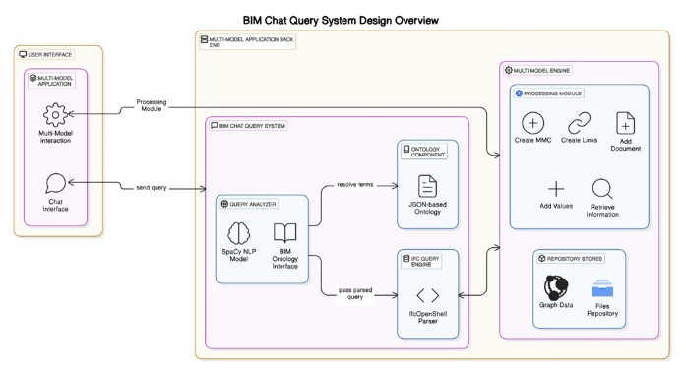
Figure 1: System Architect.

The central component, the BIM Chat Query System, interprets and transforms user queries into actionable commands. Within this subsystem, the Query Analyzer first interprets the query intent (e.g., counting, listing, comparing, or filtering) and identifies relevant entities, properties, units, and relationships. It leverages a trained classification model that maps unstructured phrases to defined operational categories using contextual language patterns. This intent recognition is coupled with semantic parsing, which identifies elements such as building components (e.g., walls, columns) and associated conditions (e.g., height greater than three meters).
To ensure accurate semantic understanding, the Ontology Component plays a critical role. A domain-specific ontology, structured according to BIM concepts and multimodel semantics, provides standardized definitions of entities, property names, unit associations, and synonyms. The system resolves terminology ambiguities using this ontology, ensuring that diverse user expressions—such as “pillar” or “column”—are correctly mapped to their canonical representations. Furthermore, default unit systems are applied to normalize numerical expressions across different measurement conventions, ensuring consistency during processing.
Once the terms and intent are clarified, the query is passed to the IFC Query Engine, which acts upon structured building model data. This engine retrieves relevant elements from the underlying digital building models and applies filtering, relationship traversal, and unit-aware value comparisons based on the semantic analysis. For example, a query involving “external doors wider than 1 meter” is processed by identifying all doors marked as external, filtering them by width, and ensuring the values are correctly interpreted based on standardized units. The engine also handles spatial or functional relationships, such as identifying components supported by a particular beam or those bounded by a specified space.
Following successful data retrieval and interpretation, the information is routed to the Multimodel Engine, which encompasses two core functions: the Processing Module and the Repository Store. The Processing Module facilitates multimodel container operations, including creating containers, adding documents, inserting values, retrieving information, and most notably, generating semantic links. These links are structured in alignment with the Information Container for Linked Document Delivery (ICDD) format, particularly using Container.rdf and Linkset.rdf schemas. Based on the interpreted relationships and metadata—such as spatial containment, support structures, or property associations—the system automatically constructs RDF-based semantic links between model elements, ensuring that the multimodel container remains dynamic and semantically enriched without altering the source data.
Meanwhile, the Repository Store manages persistent data storage, including graph-based representations and attached file documents. This ensures that all linked elements and documents are consistently accessible and versioned as part of the broader multimodel framework.
Overall, the system operates as a closed semantic loop. Natural language queries are semantically interpreted and mapped to formal representations using an integrated ontology. These representations are executed against structured building model data, and the results are used to enrich the container with dynamic, standards-compliant links. This approach not only enhances data accessibility but also promotes interoperability, consistency, and collaboration across disciplines by enabling real-time semantic interactions in digital built environments

4. FRAMEWORK VERFICATION
To validate the functionality and usability of the proposed AI-enhanced multimodel container framework, an exemplar use case was implemented using a real IFC model and a sensor dataset. The purpose of this scenario was to simulate a typical workflow in which an end user queries building model elements enriched with IoT sensor data and dynamically creates semantic links between them—all without requiring technical knowledge of query languages or model structures. In the verification scenario, the user interface was used to upload two data sources into the multimodel container environment: (1) an architectural building model in IFC format, and (2) a spreadsheet containing sensor readings over time, such as temperature and air quality metrics. Both files were loaded into the container through the platform’s file management module (Figure 2), which automatically registered them and prepared them for semantic processing.

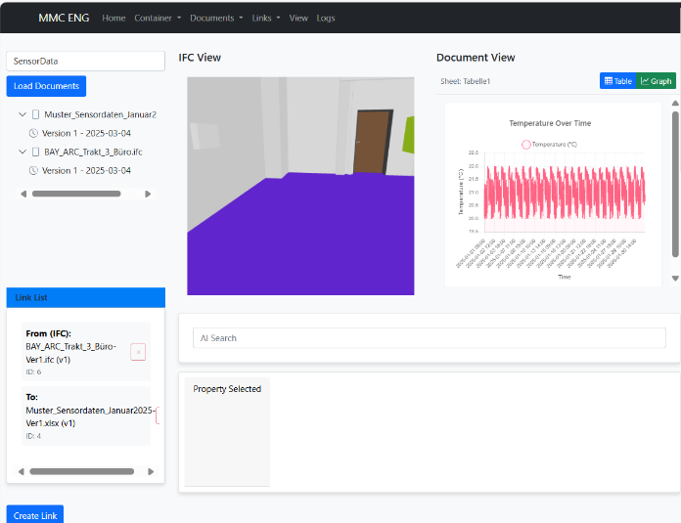
Figure 2: The User Interface.

The user then issued a natural language query via the chat interface: “Show me all sensors”. Upon receiving the query, the system’s query analyzer interpreted the user's intent as a list operation and recognized the term “sensors” as referring to building elements associated with sensing devices. This interpretation was guided by the underlying ontology, which mapped the query term to known element types and property values (e.g., ObjectType, Reference) related to sensors. The parsed query was forwarded to the IFC Query Engine, which retrieved all relevant building components from the IFC model whose metadata included keywords or property values linked to sensor functions. As shown in Figure 3, the system returned a list of elements (e.g., Luftsensor ISBE) complete with identifiers, object types, and descriptive attributes. These results were displayed to the user in an interactive table and visually highlighted within the 3D IFC viewer.

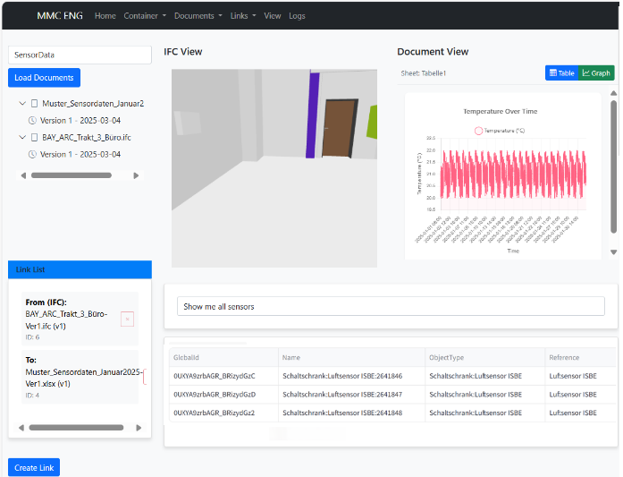

Figure 3: User query and response.

Following the query result, the user initiated a linking process between each sensor element and its corresponding data entry in the spreadsheet. By selecting sensor entries from both the IFC model and the sensor dataset, the user utilized the platform’s linking interface to establish semantic connections. These links were generated as RDF triples and stored within the container as standardized ICDD Linkset.rdf entries. Importantly, this linking operation did not modify the underlying IFC or spreadsheet files, preserving their integrity while enriching the container with cross-referential knowledge.
This use case confirms the framework’s capability to (1) parse and interpret domain-specific natural language queries, (2) semantically resolve terminology using ontological structures, (3) execute targeted model queries with unit- and property-awareness, and (4) generate ICDD-compliant links that support traceability and data integration. The streamlined interaction—from query to result to link creation—demonstrates the practical utility of the proposed system for dynamic model enrichment and cross-disciplinary collaboration. By enabling non-technical users to explore BIM data and create meaningful links to related documents or datasets using natural language, this verification scenario illustrates how the system can be deployed in real-world digital twin or facility management environments, significantly lowering the barrier to linked data adoption.

5. CONCLUSION
This research introduces a robust and extensible framework that enhances multimodel containers with AI-supported natural language querying and dynamic semantic linking. By integrating ontology-based reasoning, intelligent query parsing, and standards-compliant data exchange, the system addresses key challenges in information accessibility and interoperability within BIM-centric workflows. The proposed architecture enables end-users to intuitively retrieve and link data across diverse datasets—such as IFC models and external sensor files—using everyday language, thereby eliminating the need for specialized technical skills or manual RDF editing.
The framework’s ability to automatically interpret user intent, resolve semantic references, execute unit-aware filters, and generate ICDD-compliant links positions it as a valuable tool for collaborative digital construction and facility management applications. The use case verification demonstrates the practical viability of the approach, highlighting its seamless integration of BIM data with real-world sensor information. It confirms the system’s capacity to support dynamic model enrichment, traceability, and cross-domain knowledge integration in a scalable manner.
As a future enhancement, we envision embedding an AI agent within the multimodel engine to facilitate intelligent linking of heterogeneous data sources. This agent will analyze the documents in the multimodel container and automatically propose semantic link candidates between building elements and other data sources. Leveraging natural language processing (NLP) and graph-based reasoning, the AI agent will formulate SPARQL-like queries or Cypher templates that target specific types of relationships (e.g., schedule-to-building element, measurement-to-sensor, requirement-to-system). This approach reduces manual effort, supports non-expert interaction, and accelerates the enrichment of digital twin models. Moreover, it would pave the way for AI-supported compliance checking, progress monitoring, and automated documentation generation in future extensions of the framework. The long-term vision is to transform multimodel containers into intelligent, self-organizing knowledge hubs for the digital built environment.

ACKNOWLEDGEMENTS
The authors would like to thank the Institute for Construction Informatics at TU Dresden for providing academic support. This research received no specific grant from any funding agency in the public, commercial, or not-for-profit sectors.

REFERENCES
Azhar, S., 2011. Building information modeling (BIM): Trends, benefits, risks, and challenges for the AEC industry. Leadership and management in engineering, 11(3), pp.241-252.

Volk, R., Stengel, J. and Schultmann, F., 2014. Building Information Modeling (BIM) for existing buildings—Literature review and future needs. Automation in construction, 38, pp.109-127.

ISO 21597. (2020). Information Container for Linked Document Delivery (ICDD). International Organization for Standardization.

Scherer, R.J. and Schapke, S.E., 2011. A distributed multi-model-based management information system for simulation and decision-making on construction projects. Advanced Engineering Informatics, 25(4), pp.582-599.

Fuchs, S. and Scherer, R.J., 2017. Multimodels—Instant nD-modeling using original data. Automation in Construction, 75, pp.22-32.

Hagedorn, P., Senthilvel, M., Schevers, H. and Verhelst, L., 2023. Towards usable ICDD containers for ontology-driven data linking and link validation. In LDAC (pp. 35-46).

Tao, F., Cheng, J., Qi, Q., Zhang, M., Zhang, H. and Sui, F., 2018. Digital twin-driven product design, manufacturing and service with big data. The International Journal of Advanced Manufacturing Technology, 94, pp.3563-3576.

Deng, M., Menassa, C.C. and Kamat, V.R., 2021. From BIM to digital twins: A systematic review of the evolution of intelligent building representations in the AEC-FM industry. Journal of Information Technology in Construction, 26.

Sacks, R., Eastman, C., Lee, G. and Teicholz, P., 2018. BIM handbook: A guide to building information modeling for owners, designers, engineers, contractors, and facility managers. John Wiley & Sons.

Michael P. Gallaher, Alan C. O’Connor, John L. Dettbarn, Jr., and Linda T. Gilday, 2004. Cost analysis of inadequate interoperability in the US capital facilities industry. National Institute of Standards and Technology (NIST), pp.223-253.

Costin, A., Adibfar, A., Hu, H. and Chen, S.S., 2018. Building Information Modeling (BIM) for transportation infrastructure–Literature review, applications, challenges, and recommendations. Automation in construction, 94, pp.257-281.

Borrmann, A., König, M., Koch, C. and Beetz, J., 2018. Building information modeling: Why? what? how? (pp. 1-24). Springer International Publishing.

Rasmussen, M.H., Pauwels, P., Lefrançois, M., Schneider, G.F., Hviid, C.A. and Karlshøj, J., 2017. Recent changes in the building topology ontology.

Pauwels, P. and Terkaj, W., 2016. EXPRESS to OWL for construction industry: Towards a recommendable and usable ifcOWL ontology. Automation in construction, 63, pp.100-133.

Amin, F., Khan, K.I.A., Ullah, F., Alqurashi, M. and Alsulami, B.T., 2022. Key Adoption Factors for Collaborative Technologies and Barriers to Information Management in Construction Supply Chains: A System Dynamics Approach. Buildings, 12(6), p.766.

Fuchs, S. and Scherer, R.J., 2017. Multimodels—Instant nD-modeling using original data. Automation in Construction, 75, pp.22-32.

Hilbert, F. and Scherer, R.J., 2012. Context-specific Multi-model-template Retrieval. In Collaborative Networks in the Internet of Services: 13th IFIP WG 5.5 Working Conference on Virtual Enterprises, PRO-VE 2012, Bournemouth, UK, October 1-3, 2012. Proceedings 13 (pp. 234-241). Springer Berlin Heidelberg.

Nityantoro, E. and Scherer, R.J., 2013. Ontology supported recombination of multi-models. In Collaborative Systems for Reindustrialization: 14th IFIP WG 5.5 Working Conference on Virtual Enterprises, PRO-VE 2013, Dresden, Germany, September 30–October 2, 2013, Proceedings 14 (pp. 257-264). Springer Berlin Heidelberg.

Schuler, P.C., Mirboland, M., Voigt, C. and Koch, C., 2024, August. Using Linked Data Containers for BIM Based Structural Inspection Workflows. In International Conference on Computing in Civil and Building Engineering (pp. 398-409). Cham: Springer Nature Switzerland.

Hagedorn, P., Pauwels, P. and König, M., 2023. Semantic rule checking of cross-domain building data in information containers for linked document delivery using the shapes constraint language. Automation in Construction, 156, p.105106.

Castillo, R., Rothe, C. and Leser, U., 2010. RDFMatView: Idexing RDF Data for SPARQL Queries.
Jafari, P., Al Hattab, M., Mohamed, E. and AbouRizk, S., 2021. Automated extraction and time-cost prediction of contractual reporting requirements in construction using natural language processing and simulation. Applied Sciences, 11(13), p.6188.

Kruiper, R., Kumar, B., Watson, R., Sadeghineko, F., Gray, A. and Konstas, I., 2024. A platform-based Natural Language processing-driven strategy for digitalising regulatory compliance processes for the built environment. Advanced Engineering Informatics, 62, p.102653.

Ding, Y., Ma, J. and Luo, X., 2022. Applications of natural language processing in construction. Automation in Construction, 136, p.104169.

Wu, C., Li, X., Guo, Y., Wang, J., Ren, Z., Wang, M. and Yang, Z., 2022. Natural language processing for smart construction: Current status and future directions. Automation in Construction, 134, p.104059.

