BIM-Driven Sustainable Building Design based on Life-Cycle Analysis
Arnab Kumar Bora, Amrata Mishra*, Santu Kar

Indian Institute of Technology Guwahati, Guwahati, India
*Corresponding email: amrata@iitg.ac.in

ABSTRACT
The building sector is a major contributor to global energy consumption and greenhouse gas emissions, underscoring the need for integrated sustainability assessment during early design. Although Building Information Modelling (BIM) has been widely adopted for building performance analysis, most studies evaluate energy, carbon emissions, and life-cycle cost independently, limiting holistic decision-making. This study developed a BIM-based workflow to assess a representative residential building in a hot, humid climate using life-cycle energy, carbon, and cost analyses. A baseline model was developed in Revit and tested in Autodesk Insight to evaluate the effect of orientation, wall material, roof configuration, roof overhangs, window sill level, and fly ash brick substitution. Twelve alternatives were assessed over a 50-year period and ranked using the Simple Additive Weighting (SAW) method under different stakeholder-priority scenarios. The optimal configuration, comprising Autoclaved Aerated Concrete (AAC) walls, roof overhangs, a fully pitched roof, and a higher window sill, reduced life-cycle energy by 18.31% and life-cycle carbon emissions by 16.73% compared with the baseline. The proposed BIM-based workflow provides a transparent, repeatable framework for selecting balanced residential designs compatible with local construction practices.
Keywords
BIM, Energy Performance, Life Cycle Assessment, Life Cycle Cost, Life Cycle Carbon Emission

- INTRODUCTION

1.1. Background and motivation
The building sector is one of the largest consumers of global energy and a major contributor to climate change, accounting for approximately 36% of global energy consumption and nearly 40% of greenhouse gas (GHG) emissions (Liu, Y., et.al., 2022). Residential buildings alone are responsible for nearly one-third of global GHG emissions, highlighting the need for sustainable design strategies (Gan, V.J.L., et.al., 2018). While operational carbon has traditionally been the primary focus of building decarbonization, embodied carbon is becoming increasingly significant as buildings achieve higher energy efficiency (Lützkendorf, T. & Balouktsi M., 2022). Since embodied and operational carbon involve inherent trade-offs, both should be evaluated together through a life-cycle assessment to support effective decarbonization (Liang,Y., et.al., 2023). This challenge is particularly critical in rapidly urbanizing hot and humid regions, where growing cooling demand amplifies the environmental and economic impacts of residential buildings. In such climates, early design decisions—including building orientation, envelope systems, and material selection—strongly influence long-term energy use, carbon emissions, and life-cycle cost. However, these performance indicators are often assessed independently, limiting informed decision-making. Therefore, an integrated and repeatable early-stage framework that simultaneously evaluates life cycle energy, carbon, and cost is needed to support sustainable residential building design in hot and humid climates.

1.2. Literature Review
Building Information Modelling (BIM) enables early-stage energy assessment by linking digital models with simulation tools. Autodesk Revit and Autodesk Insight have been used to evaluate orientation, window-to-wall ratio, HVAC systems, and operating schedules, demonstrating that iterative design improves building energy performance (Deepa,S., et.al., 2019). Revit integrated with Insight 360 and Green Building Studio further showed that orientation and envelope materials influence both energy use and operating costs (Maglad, A.M., et.al., 2023). Studies across different climates confirmed that climate and envelope thermal properties strongly affect residential electricity demand (González, J., et.al., 2021). Envelope assemblies have the greatest influence on energy performance because the building envelope accounts for most heat transfer, while shading and orientation have comparatively smaller effects(Kumar, D., et.al., 2020; Tushar, Q., et.al., 2021). Overall, envelope materials remain a key factor in improving building energy efficiency.
BIM has evolved beyond operational energy analysis by integrating life-cycle assessment (LCA) to quantify embodied and operational carbon. BIM-LCA has been applied to evaluate envelope alternatives for low-carbon building design (Gan, V.J.L., et.al., 2018). Similar applications for Indian residential buildings assessed embodied, operational, maintenance, and end-of-life emissions, identifying operational energy as the largest contributor while emphasizing low-carbon materials (Kumar, D., et.al., 2025). Recent studies further integrated optimization and circular economy principles to balance embodied and operational emissions through environmentally efficient material selection (Gan, J., et.al., 2023; Mowafy, N., El Zayat M., & Marzouk, M., 2023).
Life-cycle cost (LCC) analysis evaluates construction, operation, maintenance, and end-of-life costs over a building's service life (Kneifel, J. & Webb D., 2025; ISO 15686-5:2017). BIM-based frameworks have integrated LCC with life-cycle carbon assessment to support sustainable design decisions using Net Present Value analysis (Heydari, M. & Heravi G., 2023).
Furthermore, multi-criteria decision-making (MCDM) methods help balance energy, carbon, and cost objectives. Studies highlighted that the Simple Additive Weighting (SAW) method can help in comparative assessment, providing reliable and consistent rankings with low susceptibility to rank reversal, making it suitable for sustainable building design evaluation (Hosseini Dehshiri, S.S. & Firoozabadi B., 2025).
Existing studies mainly assess design parameters individually or in limited combinations. A unified BIM-linked framework that simultaneously evaluates building orientation, wall system, roof configuration, shading devices, and sill height together based on energy performance, life-cycle cost, and environmental impacts remains underexplored for low-rise residential buildings in hot and humid climates.

1.3. Objective
The objectives of this study are: (1) to develop BIM-based models of a representative residential building in a hot, humid climate by systematically varying the building orientation, envelope configuration, and construction materials, (2) to evaluate the developed models through life-cycle energy, carbon emissions, and cost analyses to quantify their environmental and economic performance, and (3) to identify the most suitable design alternative by assessing stakeholders' priorities using varying weightages assigned to energy consumption, carbon emissions, and cost.
The scope of this study excludes passive climate control strategies, such as natural and cross-ventilation, because their assessment requires dedicated airflow modeling or computational fluid dynamics (CFD) simulations. Accordingly, the Autodesk Insight-based thermal analysis was restricted to heat transfer and solar heat gain assessments and did not account for the effects of wind-driven airflow on indoor thermal comfort or cooling energy demand.

- Methodology
The study adopted a BIM-linked workflow, with Autodesk Revit as the central platform for model development, quantity extraction, and energy simulation, and Microsoft Excel for all downstream lifecycle calculations and SAW-based multi-criteria ranking. As illustrated in Figure 1, the workflow comprises five stages: (1) developing the baseline and twelve design alternatives in Revit (2) extracting material quantities (3) simulating operational energy in Autodesk Insight to obtain the Energy Use Intensity (EUI) (4) calculating life-cycle energy, carbon, and cost over a 50-year period in Excel and (5) ranking the alternatives using the SAW method. The clearly defined inputs and outputs at each stage make the workflow transparent, reproducible, and adaptable to similar residential projects.
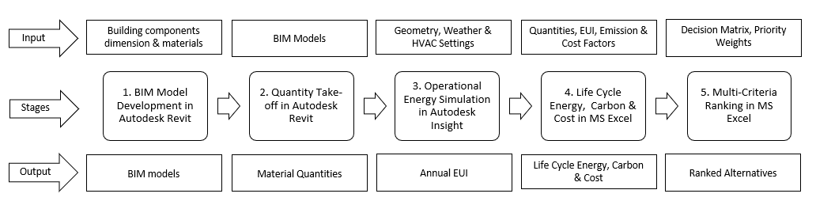
Figure 1: Five-stage BIM-based LCA and MCDM workflow

2.1 BIM Model Development
A representative two-storey residential building for Guwahati, Assam (warm–humid climate) was developed in Autodesk Revit as a theoretical reference model. Rather than replicating an existing dwelling, the model was based on the reference-building approach widely adopted in building performance studies, where geometry and design parameters are derived from documented sources to represent typical building stock (Corgnati, S.P., et.al., 2013; de Vasconcelos, A.B., et.al., 2015; Bhatnagar, M., Mathur J., & Garg, V., 2019). The floor plan was defined using two criteria: regulatory compliance and representativeness. It complies with the GMDA Building Construction Byelaws (2014) for plot coverage, floor area ratio, setbacks, and height, while its size and occupancy reflect Guwahati's average household characteristics reported in the Census of India (2011) and standard residential design practices in Northeast India. The reference building has a rectangular plan measuring approximately 9.23 m × 15.39 m, with a gross floor area of 253.62 m². Its longer axis is oriented east–west to reduce solar heat gain from the east and west façades while supporting effective daylighting, consistent with recommended design practice for warm–humid climates. The ground floor comprises the primary living spaces, whereas the first floor accommodates additional bedrooms, a family living area, toilets, and circulation spaces, as illustrated in Figure 2.
The baseline model was assigned material properties from the Rachna Handbook (Ministry of Housing Affairs, Govt. of India), with 230 mm clay-brick external walls, a Polyurethane Foam (PUF)-insulated Pre-Painted Galvanized Iron (PPGI) pitched roof, and single-glazed tinted windows. Twelve alternatives were then developed by systematically modifying a single or combined set of design variables, orientation, wall material, roof type, roof overhangs, window sill level, and fly ash brick substitution, producing thirteen configurations in total for comparative analysis. Table 1 summarises the material properties across all alternative groups.
For the operational energy simulation, custom analytical spaces were configured in Revit to reflect residential usage patterns in a hot and humid climate, replacing the default commercial presets as shown in Figure 3. Key input parameters included: building location set to Guwahati, Assam (weather station code 755705); building type: single family; HVAC system: Residential 17 SEER/9.6 HSPF Split HP; cooling setpoint: 28°C (threshold for AC activation); heating setpoint: disabled (0°C); and analytical floor area: 155.16 m², which covers the air-conditioned habitable spaces only. The balconies, toilets, and the stairwell were excluded from the energy analysis but included in the carbon and cost calculations. Figure 2 shows the selected Revit models of the baseline and its alternatives.
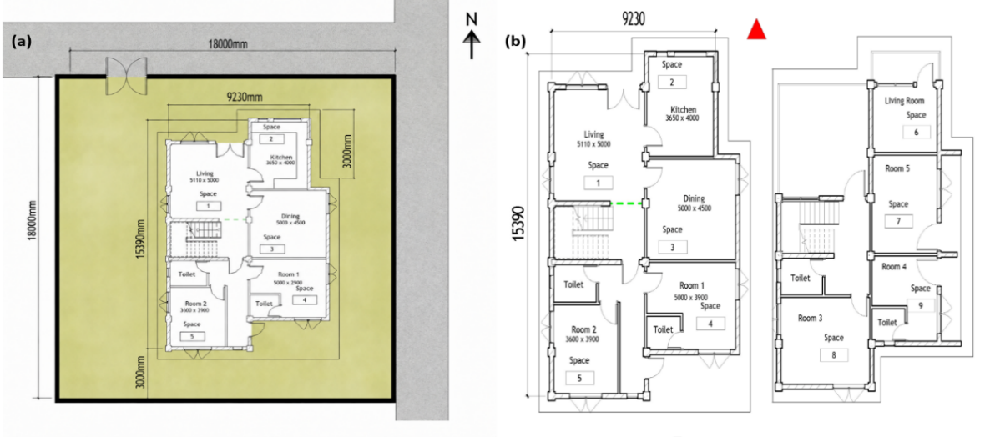
Figure 1: Building plans (a). Site Plan, (b). Ground and First floor plans

2.2 Life-Cycle Energy Analysis
The life-cycle energy assessment was conducted over a 50-year study period and comprised two components: embodied energy and operational energy. Operational energy for each alternative was obtained from Autodesk Insight 360 using the Revit-Insight real-time connection, in which the energy analytical model was generated directly from the Revit geometry and transmitted to the cloud for EUI simulation, consistent with the BIM–BEM interoperability approach (Deepa, S., et al., 2019; Maglad, A.M., et al., 2023). Embodied energy was calculated by multiplying the material quantities extracted from Revit by the corresponding embodied energy factors from the India Construction Materials Database (IFC, 2017), expressed in MJ/kg and converted to kWh, following a cradle-to-gate lifecycle boundary consistent with ISO 14040, ISO 14044, and EN 15804. The life-cycle energy was obtained by summing embodied and operational energy across the 50-year period.
Table 1: Analytical Properties of Materials
Component | Baseline, 1, 6, 7, 9 | Alternatives 2, 3, 4, 8, 10, 12 | Alternative 5 | Alternative 11
Wall thermal conductivity (W/m·K) | 0.56 (Clay brick) | 0.1600 (AAC Block) | 0.56 (Clay brick) | 0.6 (Clay brick)
Windows (SHGC) | 0.31 | 0.31 | 0.31 | 0.31
Roof (Structure) U-Value (W/m²·K) | 0.253 (PPGI + PUF) | 0.253 W (PPGI + PUF) | 2.7 W (flat RCC) | 0.253 (PPGI + PUF)
Door thermal conductivity (W/m·K) | 0.18 (Plywood) | 0.18 (Plywood) | 0.18 (Plywood) | 0.18 (Plywood)
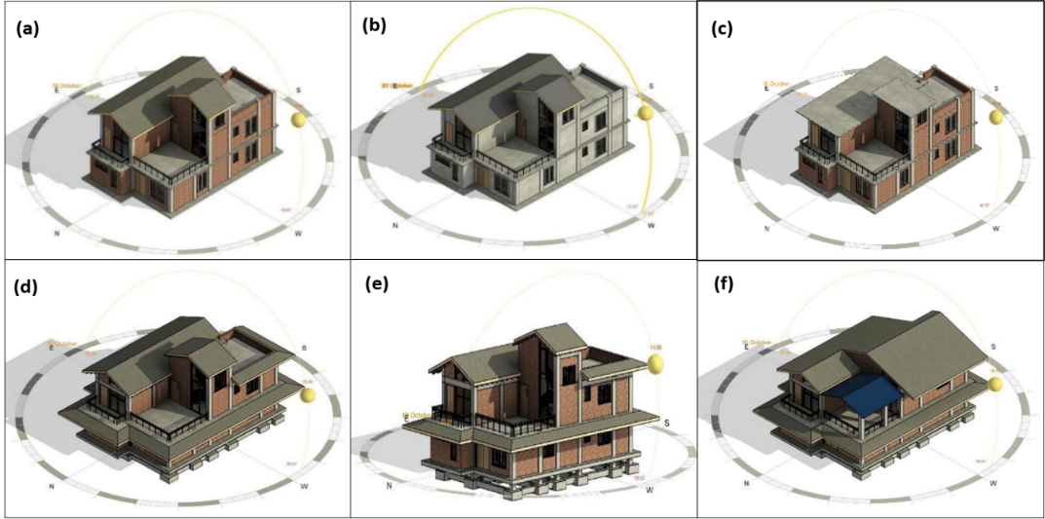
Figure 2: Autodesk Revit 3D models for (a). Baseline, (b). Alt 2 - AAC wall envelope, (c). Alt 5 – flat RCC roof, (d). Alt 6 - Roof overhangs, (e). Alt 7 – Alt 6 + high sill level, (f). Fully pitched roof system
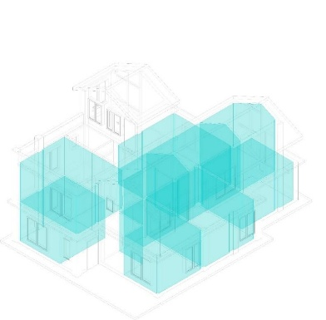

Figure 3: Analytical spaces with energy settings defined to be simulated in Autodesk Insight.

2.3 Life-Cycle Carbon and Cost Analysis
Life-cycle carbon was assessed over 50 years across five components: embodied, transportation, construction, operational and demolition carbon. Embodied carbon was calculated by applying Global Warming Potential (GWP) factors from IFC-2017, expressed in kgCO₂e/kg, to material quantities extracted from Revit. Transportation emissions were estimated using the European Network of Construction Companies for Research and Development (ENCORD) Construction CO₂e Measurement Protocol, based on material weight, truck capacity, one-way travel distance of 20 km, fuel efficiency of 6.5 km/litre, and a diesel emission factor of 2.69 kgCO₂e/litre as recommended by United States Environmental Protection Agency (USEPA). Construction emissions were calculated from the energy demand of major equipment powered by a diesel generator using the same ENCORD protocol. Operational carbon was derived from the annual EUI, analytical floor area, and the Indian grid emission factor of 0.823 tCO₂/MWh (CEA, 2023). Demolition carbon was calculated using emission factors per square metre (kgCO₂e/m²) for reinforced concrete, brick/AAC, and wood components, following Cha & Park (2025). Life-cycle cost analysis included four components: construction cost (Revit quantity take-off × CPWD Delhi Analysis of Rates), operational cost (EUI × floor area × APDCL tariff structure), maintenance cost (CPWD Maintenance Manual, gross floor area basis, converted to present value), and demolition cost (CPWD DAR dismantling rates, discounted to present value using discount and inflation rates per National Institute of Standards and Technology (NIST) Handbook 135, 2020). All future costs were converted to present value using the discounted cash flow framework of ISO 15686-5 (2017).

2.4 SAW Ranking Framework
The alternatives were ranked using the Simple Additive Weighting (SAW) method, a multi-criteria decision-making technique in which the normalized value $R_{ij}$ for each alternative $A_{i}$ under criterion $C_{j}$ is expressed in Eq. (1). The equation is developed in a way that the lower is the better the alternative.
$R_{ij}=\frac{min\left(x_{ij}\right)}{x_{ij}}$ (1)
The final preference score $V_{i}$ for each alternative is then calculated using Eq. (2).
$V_{i} = Σ_{j=1}^{n}\left(W_{j}× R_{ij}\right)$ (2)
where $x_{ij}$ is the original (unnormalized) value of the i^{th} design alternative (A_{i}) with respect to the j^{th} evaluation criterion (C_{j}), and min(x_{ij}) is the minimum value of criterion C_{j} among all alternatives and $W_{j}$ is the assigned weight of criterion (Arsyah, R.I., et al., 2021). Lower values represent superior sustainable performance for all three criteria: life-cycle energy, life-cycle carbon, and life-cycle cost. Three priority scenarios were evaluated by assigning a weight of 0.70 to energy, carbon, or cost, with the remaining 0.3 equally distributed between the other two criteria. A dynamic Excel-based SAW tool enabled real-time weight adjustment and automatic updating of normalized scores and rankings for all 13 models.

- RESULTS

3.1 Life-Cycle Energy
Table 2 summarizes the consolidated life-cycle energy for all alternatives. The baseline recorded an EUI of 98.70 kWh/m²/year from Autodesk Insight simulation, yielding a total life-cycle energy of 1,131.29 MWh over 50 years. Alternative 10 (AAC walls, overhangs, full-pitched roof, high sill) achieved the lowest EUI at 80.86 kWh/m²/year, an 18.07% reduction, and the lowest total life-cycle energy at 924.16 MWh. Alternative 5 (flat RCC roof) was the sole configuration to perform worse than the baseline, recording an EUI of 110.91 kWh/m²/year, 12.37% more than the baseline, confirming that replacing the PUF-insulated pitched roof with an uninsulated concrete slab significantly amplifies solar heat gain in a hot and humid climate. Orientation-only changes (Alt. 1) produced a negligible EUI reduction of 0.03%, while AAC wall substitution alone (Alt. 2) achieved 8.38% reduction under identical orientation, establishing envelope thermal resistance as the primary driver of cooling load reduction.
Table 2: Combined Life-Cycle Energy, Cost, and Carbon across all alternatives
Alternative | Energy (MWh) | Cost (INR) | Carbon (tCO₂e)
Baseline | 1131.29 | 1,09,45,115.75 | 748.42
Alternative 1: Rotating Baseline by 90° | 1130.98 | 1,09,43,420.85 | 748.16
Alternative 2: AAC blocks replacing clay bricks in walls with the original baseline orientation | 959.62 | 1,05,96,028.42 | 673.21
Alternative 3: AAC blocks replacing clay bricks in walls, and rotating baseline orientation by 180° | 992.13 | 1,07,73,568.63 | 699.96
Alternative 4: AAC blocks replacing clay bricks in walls, and rotating baseline orientation by 90° | 984.45 | 1,07,31,619.99 | 693.64
Alternative 5: Flat RCC roof replacing the pitched roof in the baseline model and the original baseline orientation | 1198.76 | 1,11,65,233.30 | 820.29
Alternative 6: Adding overhangs to the baseline model | 1121.08 | 1,10,22,291.19 | 733.13
Alternative 7: Adding roof overhangs and increasing the window sill height in the baseline model | 1103.16 | 1,10,22,292.19 | 718.39
Alternative 8: AAC blocks replacing clay bricks in the walls, combined with roof overhangs and an increased window sill height | 956.53 | 1,08,62,317.54 | 655.43
Alternative 9: Adding roof overhangs, a fully pitched roof system, and an increased window sill height to the baseline model | 1067.05 | 1,11,90,854.32 | 679.17
Alternative 10: AAC blocks replacing clay bricks in the walls, combined with roof overhangs, a fully pitched roof system, and an increased window sill height | 924.16 | 1,10,03,205.72 | 623.17
Alternative 11: Fly ash brick walls replacing clay brick walls in the baseline model | 1073.32 | 1,10,23,677.69 | 720.33
Alternative 12: AAC blocks replacing clay bricks in the walls, combined with roof overhangs, a fully pitched roof system, an increased window sill height, and a 90° rotation of the baseline orientation | 991.96 | 1,13,62,954.79 | 678.97

3.2 Life-Cycle Carbon and Cost
As summarized in Table 2, the baseline life-cycle carbon was 748.42 tCO₂e, of which operational carbon accounted for 630.18 tCO₂e (84.2%). Alternative 10 achieved the lowest total carbon at 623.17 tCO₂e (−16.73%), while Alternative 11 (fly ash bricks) recorded the lowest embodied carbon at 87.72 tCO₂e but delivered no operational carbon benefit. Alternative 5 was the worst performer at 820.29 tCO₂e (+9.60%). The baseline LCC was ₹1,09,45,116. Alternative 2 achieved the lowest LCC at ₹1,05,96,028 (−3.19%), with higher AAC wall costs offset by ₹3.50 L savings in 50-year electricity cost. and Alternative 12 incurred the highest LCC at ₹1,13,62,955 (+3.82%).
Table 3: SAW rankings under energy-priority, cost-priority, and carbon-priority scenarios
Alternative | Energy-Priority |  | Carbon-Priority |  | Cost-Priority
Alternative | Score | Rank | Score | Rank | Score | Rank
Baseline | 0.842 | 12 | 0.851 | 12 | 0.925 | 11
Alternative 1: Rotating Baseline by 90° | 0.842 | 11 | 0.851 | 11 | 0.925 | 10
Alternative 2: AAC blocks replacing clay bricks in walls with the original baseline orientation | 0.963 | 3 | 0.942 | 3 | 0.983 | 1
Alternative 3: AAC blocks replacing clay bricks in walls, and rotating baseline orientation by 180° | 0.933 | 5 | 0.910 | 7 | 0.962 | 5
Alternative 4: AAC blocks replacing clay bricks in walls, and rotating baseline orientation by 90° | 0.940 | 4 | 0.918 | 5 | 0.967 | 4
Alternative 5: Flat RCC roof replacing the pitched roof in the baseline model and the original baseline orientation | 0.796 | 13 | 0.790 | 13 | 0.894 | 13
Alternative 6: Adding overhangs to the baseline model | 0.849 | 10 | 0.863 | 10 | 0.924 | 12
Alternative 7: Adding roof overhangs and increasing the window sill height in the baseline model | 0.861 | 9 | 0.877 | 9 | 0.929 | 9
Alternative 8: AAC blocks replacing clay bricks in the walls, combined with roof overhangs and an increased window sill height | 0.965 | 2 | 0.957 | 2 | 0.970 | 3
Alternative 9: Adding roof overhangs, a fully pitched roof system, and an increased window sill height to the baseline model | 0.886 | 7 | 0.914 | 6 | 0.930 | 7
Alternative 10: AAC blocks replacing clay bricks in walls, combined with roof overhangs, a fully pitched roof system, and an increased window sill height | 0.994 | 1 | 0.994 | 1 | 0.974 | 2
Alternative 11: Fly ash brick walls replacing clay brick walls in the baseline model | 0.877 | 8 | 0.879 | 8 | 0.932 | 6
Alternative 12: AAC blocks replacing clay bricks in the walls, combined with roof overhangs, a fully pitched roof system, an increased window sill height, and a 90° rotation of baseline orientation | 0.930 | 6 | 0.922 | 4 | 0.930 | 8

3.3 SAW Ranking
The consolidated life-cycle energy, carbon, and cost values (Table 2) served as the decision matrix for the SAW ranking across three stakeholder priority scenarios, each assigning a weight of 0.70 to the dominant criterion and distributing the remaining 0.30 equally across the other two. The resulting SAW scores and rankings for the three stakeholder-priority scenarios are presented in Table 3. Under the energy-priority scenario ($W_{energy}$= 0.7), Alternative 10 ranked first with a weighted score of 0.994, followed by Alternative 8 (0.965) and Alternative 2 (0.963). Under the carbon-priority scenario ($W_{carbon }$= 0.7), Alternative 10 again ranked first (0.994), with Alternative 8 second (0.957). Under the cost-priority scenario ($W_{cost}$= 0.7), Alternative 2 ranked highest (0.983), followed by Alternative 10 (0.974) and Alternative 8 (0.970). Score differences below 0.001 were considered equivalent. Accordingly, the Baseline and Alternative 1 were equivalent across all scenarios, while Alternatives 9 and 12 were equivalent under the cost-priority scenario. Alternative 5 consistently ranked last, demonstrating that stakeholder priorities influence design selection.
4. DISCUSSION
The results establish three findings of practical significance. First, wall material selection exerted a substantially greater influence on EUI than orientation did. AAC substitution alone (Alt. 2) reduced EUI by 8.38%, whereas 90° rotation alone (Alt. 1) achieved only 0.04% reduction. This supports the findings of Tushar, Q., et.al., (2021), confirming that improving envelope thermal performance is more effective than changing orientation in hot and humid climates. Second, the integration of multiple passive envelope interventions, including AAC walls, overhangs, a full-pitched roof, and an increased sill height (Alt. 10), achieved the lowest life-cycle energy and carbon emissions. Rotating the same configuration by 90° (Alt. 12) produced the highest life-cycle cost because the altered orientation reduced the effectiveness of the roof overhangs while retaining their additional construction cost, consistent with Palmero-Marrero, A.I. & Oliveira A.C., (2010). Third, the SAW scenario analysis confirmed that the preferred alternative is inherently stakeholder-dependent, shifting between Alt. 10 (energy/carbon priority) and Alt. 4 (cost priority), which underscores the practical value of the dynamic multi-criteria ranking tool developed in this study.

5. CONCLUSION
This study presented a BIM-linked workflow integrating Autodesk Revit, Autodesk Insight, life-cycle assessment (LCA), life-cycle costing (LCC), and the Simple Additive Weighting (SAW) method to evaluate thirteen residential building configurations over a 50-year service life in a hot, humid climate. The results demonstrated that wall material, roof configuration, and shading features are the most influential early-stage design parameters, with the combined implementation of AAC walls, roof overhangs, a fully pitched roof, and a higher window sill reducing life-cycle energy by 18.31% and life-cycle carbon emissions by 16.73% compared with the conventional baseline. Furthermore, the SAW analysis showed that the preferred design alternative varies according to stakeholder priorities, highlighting the importance of multi-criteria decision-making in sustainable building design. The study contributes a transparent, reproducible BIM-driven decision-support framework that integrates energy, carbon, cost, and multi-criteria assessment into a single workflow using Indian databases, standards, and construction practices, enabling informed early-stage sustainable design decisions.

REFERENCES
Arsyah, U.I. et al. (2021) 'Analysis of the simple additive weighting method in educational Aid Decision making,' Turkish Journal of Computer and Mathematics Education (TURCOMAT), 12(14), pp. 2389–2396. https://turcomat.org/index.php/turkbilmat/article/view/10664.
Central Electricity Authority (CEA) (2023) 'CO₂ baseline database for the Indian power sector: user guide. version 19.0,' New Delhi: ministry of power, government of India. Available at: https://cea.nic.in/wp-content/uploads/baseline/2024/01/User_Guide__Version_19.0.pdf
Cha, G.-W. and Park, C.-W. (2025) 'Development of an optimal machine learning model to predict CO2 emissions at the building demolition stage,' Buildings, 15(4), p. 526. https://doi.org/10.3390/buildings15040526.
Deepa, K. et al. (2019) 'Energy analysis of buildings,' International Research Journal of Engineering and Technology (IRJET), ' e-ISSN: 2395-0056. https://www.irjet.net/archives/V6/i1/IRJET-V6I1310.pdf.
Gan, V.J.L. et al. (2018) 'Holistic BIM framework for sustainable low carbon design of high-rise buildings,' Journal of Cleaner Production, 195, pp. 1091–1104. https://doi.org/10.1016/j.jclepro.2018.05.272.
International Finance Corporation (IFC) (2017), 'India construction materials database of embodied energy and global warming potential: methodology report,' Washington, DC: International Finance Corporation. Available at: https://edgebuildings.com/wp-content/uploads/2022/04/IFC-India-Construction-Materials-Database-Methodology-Report.pdf
ISO (2017), 'ISO 15686-5:2017, buildings and constructed assets-Service life planning-Part 5: Lifecycle costing,' ISO. Available at: https://www.iso.org/standard/61148.html
Kumar, D. et al. (2025) 'A Whole-Life carbon assessment of a Single-Family house in North India using BIM-LCA integration,' Buildings, 15(13), p. 2195. https://doi.org/10.3390/buildings15132195.
Liu, Z. et al. (2022) 'Building information modelling (BIM) driven carbon emission reduction research: a 14-year bibliometric analysis,' International Journal of Environmental Research and Public Health, 19(19), p. 12820. https://doi.org/10.3390/ijerph191912820.
Maglad, A.M. et al. (2022) 'Bim-based energy analysis and optimization using insight 360 (case study),' Case Studies in Construction Materials, 18, p. e01755. https://doi.org/10.1016/j.cscm.2022.e01755.
G, N. and L, K. (2022) 'Optimization and performance analysis of residential building for sustainable energy design through BIM,' Journal of Engineering Research. https://doi.org/10.36909/jer.acmm.16297.
Kneifel, J. and Webb, D. (2025) 'Life cycle costing manual for the federal energy management program.' https://doi.org/10.6028/nist.hb.135e2025.
Starynina, J. and Ustinovichius, L. (2020) 'A multi-criteria decision-making synthesis method to determine the most effective option for modernising a public building,' Technological and Economic Development of Economy, 26(6), pp. 1237–1262. https://doi.org/10.3846/tede.2020.13398.
Ministry of Housing and Urban Affairs (MoHUA) (2022) 'Innovative Construction Technologies & Thermal Comfort in Affordable Housing: Handbook,' New Delhi: Ministry of Housing and Urban Affairs, Government of India. Available at: Innovative Construction Technologies & Thermal Comfort for Affordable Housing | NFS
Central Public Works Department (CPWD) (2023) 'Delhi Analysis of Rates (DAR) 2023. Volume I,' New Delhi: Ministry of Housing and Urban Affairs, Government of India. Available at: https://indianrailways.gov.in/railwayboard/uploads/directorate/civil_engg/2025/CPWD_AOR_Vol_I_2023.pdf
Central Public Works Department (CPWD) (2023) 'Delhi analysis of rates (DAR) 2023. Volume II,' New Delhi: Ministry of Housing and Urban Affairs, Government of India. Available at: https://cpwd.gov.in/Publication/CPWD_DAR_Vol_II_14092023_Civil.pdf
Gan, J., Li, K., Li, X., Mok, E., Ho, P., Law, J., Lau, J., Kwok, R. and Yau, R., 2023. Parametric BIM-based lifecycle performance prediction and optimisation for residential buildings using alternative materials and designs. Buildings, 13(4), p.904. https://doi.org/10.3390/buildings13040904
González, J. et al. (2021) “BIM and BEM Methodologies Integration in Energy-Efficient Buildings Using Experimental Design,” Buildings, 11(10), p. 491. Available at: https://doi.org/10.3390/buildings11100491
Heydari, M. and Heravi, G. (2023) “A BIM-based framework for optimization and assessment of buildings’ cost and carbon emissions,” Journal of Building Engineering, 79, p. 107762. Available at: https://doi.org/10.1016/j.jobe.2023.107762
Hosseini Dehshiri, S.S. and Firoozabadi, B. (2025) “Optimizing building energy solutions: A guideline for choosing proper multi criteria decision making methods in energy problems,” Energy, 317, p. 134598. Available at: https://doi.org/10.1016/j.energy.2025.134598
Kumar, D. et al. (2020) “Comparative analysis of building insulation material properties and performance,” Renewable and Sustainable Energy Reviews, 131, p. 110038. Available at: https://doi.org/10.1016/j.rser.2020.110038
Liang, Y. et al. (2023) “Decarbonization potentials of the embodied energy use and operational process in buildings: A review from the life-cycle perspective,” Heliyon, 9(10), p. e20190. Available at: https://doi.org/10.1016/j.heliyon.2023.e20190
Lützkendorf, T. and Balouktsi, M. (2022) “Embodied carbon emissions in buildings: explanations, interpretations, recommendations,” Buildings and Cities, 3(1), pp. 964–973. Available at: https://doi.org/10.5334/bc.257
Mowafy, N., El Zayat, M. and Marzouk, M. (2023) “Parametric BIM-based life cycle assessment framework for optimal sustainable design,” Journal of Building Engineering, 75, p. 106898. https://doi.org/10.1016/j.jobe.2023.106898.
Tushar, Q. et al. (2021) “An integrated approach of BIM-enabled LCA and energy simulation: The optimized solution towards sustainable development,” Journal of Cleaner Production, 289, p. 125622. https://doi.org/10.1016/j.jclepro.2020.125622.
Corgnati, S.P., Fabrizio, E., Filippi, M. and Monetti, V., 2013. Reference buildings for cost optimal analysis: Method of definition and application. Applied energy, 102, pp.983-993. https://doi.org/10.1016/j.apenergy.2012.06.001
de Vasconcelos, A.B., Pinheiro, M.D., Manso, A. and Cabaço, A., 2015. A Portuguese approach to define reference buildings for cost-optimal methodologies. Applied Energy, 140, pp.316-328. https://doi.org/10.1016/j.apenergy.2014.11.035
Bhatnagar, M., Mathur, J. and Garg, V., 2019. Development of reference building models for India. Journal of Building Engineering, 21, pp.267-277. https://doi.org/10.1016/j.jobe.2018.10.027
Guwahati building construction (regulation) byelaws,2014. https://gmda.assam.gov.in/documents-detail/building-byelaws
Palmero-Marrero, A.I. and Oliveira, A.C., 2010. Effect of louver shading devices on building energy requirements. Applied energy, 87(6), pp.2040-2049. https://doi.org/10.1016/j.apenergy.2009.11.020

