Reinforcement learning task planner for construction task, assisted by LLM

MIGUEL GUZMÁN-MERINO¹, JÖRN PLÖNNIGS¹

¹Rostock University, Rostock, Germany

ABSTRACT:

Construction sites are non-deterministic environments where traditional tasks planning techniques for multi-robot systems do not work well for long term actions. Constant changes in the environment force a continuous update and evaluation of the state of the system. The paper proposes a reinforcement learning agent assisted by multi-modal foundation model agents to target tasks planning in construction sites. A natural language user request involving tools, consumables, locations and actions is used to command a robot system in the environment. The foundation model agents assist in the identification of relevant information in the user request, the selection of actions, and the object identification. The goal of the system is to execute the desired task at the proper location with the necessary tools and consumables. The proposed system is able to perform in environments with different number of locations and under user requests containing different number of tools, consumables and actions.

KEYWORDS:

Reinforcement learning, Foundation Models, Large Language Model, Construction robotics, Task planning.

1. INTRODUCTION
Robotic applications on construction sites face the problem of environments with high uncertainty as tools, objects and obstacles change non-deterministically. This has restricted the applications of robots to surveillance tasks in most of the cases (Davila Delgado, J. M. & Oyedele, J., 2022) where no interaction with the environment is necessary or applications in controlled environments like laboratories or prepared working areas under human supervision (Zeng, L., et.al., 2024). To expand the applications of robots on construction sites, the systems require higher autonomy (Xu, X. & García del Soto, B., 2020). One step into that direction are multi-robot system that increase the flexibility of executable tasks by introducing specialized robot that collaborate on complex tasks with their unique skills (Krizmancic, M., et.al., 2020).
However, the combination of robot skills is even increasing the complexity of task planning in addition to the remaining uncertainty of construction sites. It is necessary to establish an appropriate framework to command the actions of the robots through the emerging changes. Traditional a-priory task planning techniques are able to solve the task planning problem in environment without external changes (Fu, B., et.al., 2023). Nevertheless they become infeasible to command robot systems in non-deterministic environments. Previous works (Ceola, F., et.al., 2019) have also shown that Reinforcement Learning (RL) techniques can solve simple planning problems and derive optimal task plans, but they do not scale well to complex cooperative scenarios due the combinations explosion resulting from interacting tasks. Recently, also Large Language Models (LLM) have been also proposed to solve the task planning problem (Joublin, F., et.al., 2024) (Huang, W., et.al., 2022). They worked well in simple scenarios, but cannot deduce complex constrained plans due to the reasoning inabilities of LLMs. Kannan et al. solve in (Sundar Kannan, S., et.al., 2024) a more complex task by generating Python pseudo-code and, thus, forcing the LLM into sequential problem solving. However this approach is validated in known environments with previous information about objects. In (Ahn, M. et.al., 2022), the authors stress the importance of connecting the LLM with the real-world scenario to solve the reasoning inabilities of LLM.
We introduce here an approach to the task planning problem for a heterogeneous multi-robot system, deployed in an unknown environment with emerging constraints. Thanks to the identification of the relevant information in the user requests, we are able to establish a discrete scenario and create an appropriate action framework for each situation proposed to the system. In our work we use different multi-modal Foundation Models agents for different purposes. Foundation Models (FM) supersede LLM and also allow to process multi-modal content like language or images. In consequence, our agents not only focus on the information processing from the user request. They also support the RL agent in the action selection during the training phase as suggested in (Cao, Y., et.al., 2024). This support provides an extra source of information and helps to avoid some problems derived from random and probabilistic results used in conventional reinforcement learning techniques. An additional FM agent is proposed for object identification during the test phase. To validate our approach, we perform multiples simulations of various scenarios. We will illustrate the capability of the approach to solve complex planning tasks that are unsolvable by common RL approaches.

2. SYSTEM WORKFLOW
Starting with a user request, the goal of the system is to derive a task execution plan for the robots in a real non-deterministic environment. Figure 1 presents the general workflow of the system. The user request is captured in the system and analysed by a speech-based FM, the information assistant. This assistant is tasked to identify the relevant input information from the request: objects, locations and actions. The objects on the requests are classified into tools and consumables. This input data is used to create a discrete scenario that represents the information of interest of the continuous real environment. On the other hand, the action space models the potential actions of the robots in the system. Both the state space and the action space are used by the RL agent to compute an optimal task plan. The RL agent is executed in two phases: the training phase and the test phase. During training, several simulations are performed to identify and learn the best strategies in form of a Q-table. For this the RL agent uses an environment model that returns rewards for actions.
This is supported by an LLM, the action assistant. The task of this assistant is to support the RL in making tactical decisions on the next best action. At the end of the training phase, the RL agent should have learned the best strategies in form of an action framework to support the action planning of the robots during the test phase. During the test phase the action selection is just based on the acquired strategies and no update of the training is performed. A visual Foundation Model, the recognition assistant, is used to identify locations from the images collected by the robots from the real environment and updates this information in to the system. The action sequence finishes successfully when the desired action is executed in the desired location with the proper tool and consumable.

3. REINFORCEMENT LEARNING AGENT
A Reinforcement Learning Agent has been chosen to create the action framework (Q-Table). The RL agent executes two different phases: the training phase and the test phase. The RL agent is assisted by the different LLM assistants during the different phases. The construction of the Q-Table is based on the rewards structure associated with the action on the action space.

3.1 Training phase
In this section we introduce the details for the RL workflow. We start by introducing the general training workflow for an RL agent to derive the requirements for specifying the environmental model of the RL agent. The core element of the RL agent to derive and store the best solution strategies is the Q-Table. A Q-Table is an $N_{A} × N_{S}$-matrix spanned by the state space $S$ the action space $A$ and stores the expected future reward $Q\left(s,a\right)$ for taking action $a∈A$ in state $s∈S$. The RL agent learns those expected rewards $Q\left(s,a\right)$ by try-and-error those actions in the environment for which it will receive a reward (or punishment) $R\left(s,a\right)$ from the environment and update the Q-table according to the selected ML approach. In the beginning the $Q\left(s,a\right)$ is empty and the RL agent has to learn the best strategies. It does by selecting actions in each state $s$ due to two traditional approaches:
- Random Exploration: an action $a_{R}$ is randomly selected from the action space $A$ to explore new options with Equation (1).
$$\begin{aligned}a_{R}=rand\left(A\right)\#\left(1\right)\end{aligned}$$
- Best action: the action $a_{Q}$ with the highest expected reward from the Q-Table is selected to verify and converge on good strategies via Equation (2).
$$\begin{aligned}a_{Q}=\arg{\max{Q\left(s,a\right)}} a∈A\#\left(2\right)\end{aligned}$$
The challenge with this approach is that the random selection can pick actions that are unreasonable in a certain state. Particular in complex multi-robot scenarios the number of actions and states is high, with a low number of applicable actions in each state and, consequently, a low probability to pick those. In addition, in collaborative scenarios the sequence of coordinated actions between robots is very important, resulting in conditioned probabilities, that potentiate this issue and make it unlikely that a workable strategy is found. To avoid this situation, we propose to use an LLM assistant instead.
- Tactical Exploration: the LLM action assistant is asked to propose the next-best action $a_{L}$ (Equation (3)) given the state of the system $s$ as context to derive.
$$\begin{aligned}a_{L}= LLM\left(s,a\right)\#\left(3\right)\end{aligned}$$
The notion is that the LLM will either propose a better action for the given context situation or at least not constantly a worse one than the random selection. In consequence, the expected reward ${Q_{L}\left(s,a_{L}\right) }_{≈}^{>} Q_{R}\left(s,a_{R}\right)$should tend to outperform the random selection while still supporting exploration of alternative tactical decisions in emerging situations and faster convergence on those actions.
Two parameters control the action selection approach. Traditionally, epsilon $0 ≤ϵ≤1$ gives the probability of exploration, i.e. selecting an action randomly. We introduce the parameter $β ≤ϵ$ to give the probability of selecting tactical exploration instead of the random exploration. The action is, thus, selected in each training step according to Equation (4):
$$\begin{aligned}a= \left\{\begin{matrix}a_{L} \\ a_{R} \\ a_{Q}\end{matrix} \begin{matrix}r≤ β \\ r > β ∧ r ≤ ϵ \\ r > ϵ\end{matrix}\right. \#\left(4\right)\end{aligned}$$
with the random number $r=rand(1)$.
The training process iterates through multiple of those steps until the ultimate target state $s_{T}$ is reached or a maximum number $N$ of tries was executed. This is repeated over multiple episodes $O$ to learn the best strategies. Modern RL approaches, update over these episodes the parameters $ϵ$ in an annealing process to enforce an exploration policy at the beginning of the training with a larger $ϵ$ as no or little information is known and switch to a convergence policy with a small $ϵ$ once a good strategy has established.
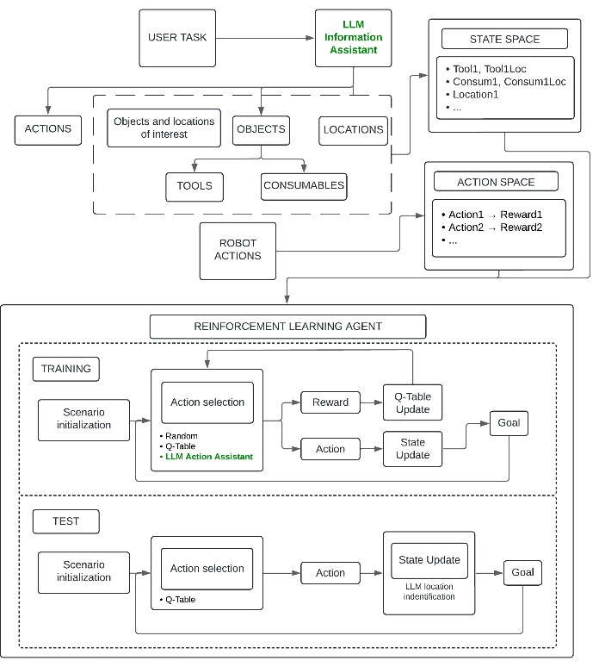
Figure 1: Workflow diagram of the system. Starting with the user request, the diagram shows the treatment of the information as well as the internal processes of the different parts of the system. The Information Assistant and the Action Assistant are green highlighted in the process workflow.

3.2 Test phase
The test phase uses the same workflow as the training phase. However, in this phase the action selection is only using the best strategy from the Q-Table, thus, $a= a_{Q}$. No random or LLM action assistant actions are explored and the Q-Table is no longer updated. $N$ and $Q$ are the only parameters that limit the simulations in the test phase. In contrast to the training phase, a multi-modal FM for image processing is used as assistant in this phase.

4. ENVIRONMENT MODEL
The benefit of RL is that it can be trained and tested in theory on the continuous real world and does not require explicit training data. The real-world continuous environment is where the robots perform the actions by navigating through the different locations and interact with the objects to collect information. For the current discussion, we propose a fully communicated construction site environment where the robots can change their location without restrictions.
However, it is usually infeasible to train an RL agent in the continuous real world due to the high number of training episodes and action executions required. Instead, an RL agent is usually trained (or at least pre-trained) on a discrete model of the environment. This environment model basically encodes, which rewards $R\left(s,a\right)$ are returned in each given state $s$ for an action $a$. It is to note that the environment may contain additional hidden states that are unobservable by the RL agent, so the discrete environmental state space $D ⊇S$.
To train the RL agent, we need to define this environment model. Therefore, we analysed the continuous real-world scenario. The real-world environment is composed as $E= \left\{L,O,V\right\}$ of locations $L$, objects $O$ and object attribute value $V$. Objects are either targets $X$, consumables $C$, robots $R$, or tools $T$, thus $O=X ∪C ∪ R ∪ T$. Each object $o∈O$ is associated to exactly one location $l_{o }∈L$ by the tuple $\left(o,l_{o}\right)$. An object also can have attribute values, like a color. For simplicity we assume a tagging approach, meaning a superset of all tag values $V$ exists and each object $o$ can be assigned one or multiple tags $v ∈V$ by the tuples $\left(o,v_{1},…v_{n}\right)$. This set of location and tags tuples describe the current environmental state. We can discretize the state by introducing the binary association variables $d_{o,v}∈ \left(0,1\right)$ representing with 1 that the object $o$ $\left(either x,c,r,t\right)$, is in location $l$ or 0 if not; and $d_{o,v}∈ \left(0,1\right)$ defining that object $o$ has tag $v$. The environmental state $D$ is spanned by this binary association $N_{o}×\left(N_{L}+N_{V}\right)$-matrix. As each thing can only be in one location, we can state the constraint that $\sum_{l∈L}{b_{o,l}=1} , ∀_{o}∈O$. Each action $a$ executed by a robot may change this state. In other words, an action either moves an object to a new location, alters a tag, or does nothing in the current state.

5. INFORMATION IDENTIFICATION
The main information for the system proceeds from the user request. The request is a complex task done via a natural language prompt. We consider complex tasks requests that contains information about tools, consumables, locations and actions. The proper identification of the relevant information is essential for the subsequent steps. For that matter the request is communicated to a LLM information assistant that identifies and extracts the relevant information. The identification process identifies Tools ($T$), Consumables ($C$), Locations ($L$) and Actions ($A$) in the request.
It is assumed that all the objects exist in the environment. Therefore, every object has a location associated in the scenario. It is also assumed that the actions can be executed in the scenario. An action is always associated with a tool, a consumable or a location. An action ai associated with the tool $t_{i}$ will take place in the tool location $k_{i}$.

6. STATE SPACE
The appropriate discretization of the continuous real environment $E$ allows the correct construction of the discrete scenario $K$. $K$ contains the relevant and necessary information for the task. This information proceeds from the objects and locations of interest identified in the user request. The tools, consumables, locations and actions have information associated. The information about each of the elements defines the state of the element. For instance, a tool can be equipped, and a consumable picked. The combination of the states of the elements composed the state space.
Multiple tools, consumables and locations can be identified from the user request. The state space is therefore created according to the identified information. A state space example for a one tool, one consumable and a task location is shown in the left side of the Table1 and an example for two tools, two consumables and a task location in the right side. These two examples are a representation of how reinforcement learning techniques increase rapidly in complexity when large state spaces are presented. In the scenario proposed in the left side of the Table 1, 6 variables will compose the space state, while 11 will be necessary to compose the state space in the right side scenario. To ensure higher simplicity, locations in the request and locations of consumables and objects are taken into account during execution but do not take part in creation of the state space.
Table 1: Elements in the system and variables that represent their state
SCENARIO 1 |  |  | SCENARIO 2
ELEMENT | STATE |  |  | ELEMENT | STATE
Tool |  | Found | Tool1 |  | Found
 |  | Equipped |  |  | Equipped
Consumable |  | Found | Tool2 |  | Found
 |  | Picked |  |  | Equipped
 |  | Placed | Consumable1 |  | Found
Location |  | Found |  |  | Picked
Action |  | Executed |  |  | Placed
 |  |  | Consumable2 |  | Found
 |  |  |  |  | Picked
 |  |  |  |  | Placed
 |  |  | Location |  | Found
 |  |  | Action |  | Executed

The discretization approach here presented allows the creation of the proper state space for each proposed task and environment. As show in Table 1 the information of every element is represented in a different way. The state of a tool is defined by two binary variables while it is necessary to used three to define the state of a consumable. Restrictions in the creation of the state space ensure that only possible states are taken into account. For instance, it is not possible to place a consumable if it has not been previously picked. The final state space is composed by the combination of all the possible combination of the states of each element. For the Scenario 1 in Table 1, 128 variables combinations lead to 22 possible states while the Scenario 2 presents 4096 variable combinations.

7. ACTION SPACE
The action space is composed by the actions of the robots in the system. By performing actions the robots update the information about the continuous environment $E$. In other words the actions update the state of the discrete scenario $K$. In the proposed system all the actions can be chosen in every state. However not all the actions can be executed in every state and therefore not all the actions ensure a change of the state. Depending on the action, it is possible to update the state of the system, change the location of the robots in the scenario, both or none of them. Since the locations are not included part of the state space, a change in the location of the robots is not consider as an update of the state.

8. LARGE LANGUAGE MODEL ASSISTANTS
Different LLM agents are proposed to assist the reinforcement learning agent during the training and the test phase. The used of specific LLM assistant for each of the problems, ensures more reliable responses. The proposed assistants are focus on: 1. Identify the information from the user request, 2. Proposed actions during the training phase and 3. Identify elements in the real-environment during the test phase.
LLM assistant for information identification. The LLM assistant is used to identify the relevant information in the user request. GPT 4.1 is used for this task. The user request is prompt to Chat GPT. Thanks to the proper context the LLM assistant identifies the tools, consumables, location and actions in the request.
LLM assistant for action selection. The LLM assistant for action selection is one of the three possible ways to propose an action during the training phase. To get an appropriate response, the state of the system is used as context information for the LLM assistant, and the possible actions are requested as responses. The context provided as discrete information reduces the possibility of hallucinations.
LLM assistant for object identification. The LLM assistant for object identification is proposed as a complement during the test phase. When the robots change locations, it is necessary to check if the new location is a location of interest. A picture taken by a robot is sent to the assistant. The assistant is requested to identify a tool, consumable or location in the picture. If the answer is positive, the location is levelled as a location of interest and the state is updated.

9. RESULTS
To demonstrate the influence of the LLM action assistant different experiments were conducted with and without the assistant. We propose a scenario like the Scenario 1 in Table 1 to conduct all the experiments in this section. Every simulation presents a different initial configuration and the corresponding parameters are set to the proper value from the beginning of the simulation. The configurations of the parameters are just applied during the training phase. The test phase is just limited to a maximum of 100 steps for simulation sanity reasons. The main parameters involved in the simulations are Epsilon (exploration ratio), gamma (future reward influence ratio) and alpha (new information influence ratio).
The first experiment is conducted using a constant decay for the epsilon parameter and constant alpha and gamma parameters. 10000 scenarios are simulated (10000 epochs) with a maximum number of 100 steps/actions per epoch. Figure 2 shows the results successful simulations under this configuration for the training phase (80%) and test phase (40%). During the training phase the number of actions converge to less than 20 steps. However there is high variance is presented during the training. Successful simulations during test phase present less variance in the number of actions per epoch, but higher than desired.
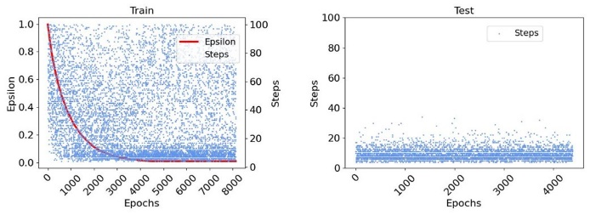
Figure 2: Base scenario simulation. 100 steps per epoch. 10000 epochs. Epsilon decay from 1.0 to 0.1. Success ratio 80% in training phase and 40% in test phase.
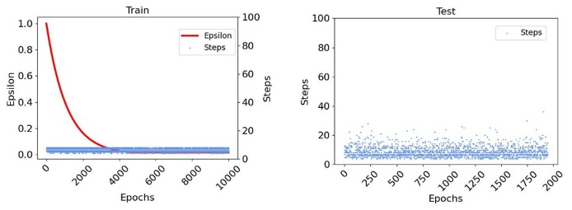
An experiment was performed to find the optimal number of steps necessary to solve the proposed tasks (Figure 3). In this experiment just actions that cause a change on the state of the system were allowed. When a proposed action did not change the state of the system an alternative action was requested. This experiment results in a 100% of success ratio during training phase but less than 30% during test phase. Due to the experiment restrictions, just the necessary actions were taken into account during the training and no real exploration was done. Therefore, the system was not properly trained. According to this experiment, it is necessary to solve the task with less number of actions than the ones presented in Figure 2 while keeping a high success ratio.
Figure 3: Simulation to find the minimum number of steps to solve to tasks. 100% of success ratio in the training phase and 4-8 steps. 20% of success ratio in the test phase.
To properly train the model and reduce the number of actions per epoch, we conducted an experiment implementing a decay factor to control the number actions. Figure 4 shows the results for this implementation. The rest of the parameters remains like in the experiment in presented in Figure 2. The training phase presents a lower success ratio (67%) what also influence the success ratio of the test phase. However the test phase presents reduction in the dispersion of the number of steps and a general reduction on the number of steps.
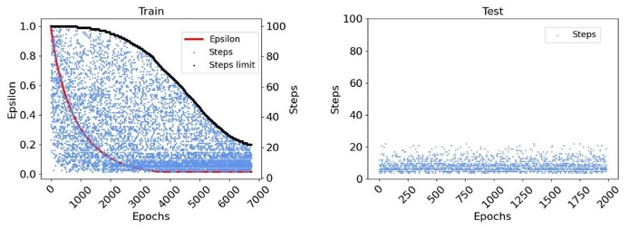
Figure 4: Simulation limited by maximum number of actions and steps. Repetition limit decay from 20 to 2. 67% success ratio in training phase and 20% in test phase.
A third experiment was conducted limiting how many times an action or a state could be repeated consecutively. During the action selection, if the same action or state is repeated more than a certain amount of times, the simulation ends. This approximation tries to avoid training on not useful action selection. It is important to stress that the number of actions per epoch is limited to 100 steps in this experiment.
In this case the number of steps rapidly converge to less than 20 steps. However, the success ratio in the training and the test phases are lower than the ones presented in the previous experiments. It can be concluded that the limitation of steps during the training phase has a negative impact in the success ratio during training and test.
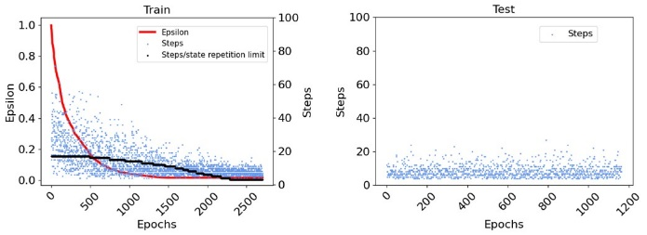
Figure 5: Simulation with decay limited number of actions and state repetition from 20 to 3 (black line). 100 steps per epoch. 10000 epochs. 27% success ratio in training phase and 11% success ratio in test phase.
To reduce the number of steps while keeping a high success ratio, the LLM action assistant is used. For this experiment all the parameters are set like in the experiment presented in Figure 2.
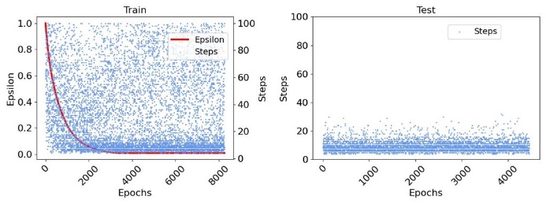
Figure 6: Simulation using LLM action assistant. 83% success ration in training phase and 45% in test phase.
Figure 6 shows the results of the simulations over 10000 epochs and a limit of 100 steps per epoch, employing the LLM action assistant during the training phase. In this case the results are similar to the base scenario with less dispersion in the number of steps during the test phase. Table 2 contains the experiments results of the presented experiments. The number of steps in every experiment includes the minimum and maximum number of steps used in all epochs of the experiments. For better understanding of the distribution see the graph of the experiments.
Table 2: Results of the experiments
EXPERIMENT | TRAIN |  |  |  | TEST
 | Success (%) |  |  | Steps | Success (%) | Steps
Base |  | 82 | 4-100 |  | 43 | 4-40
Optimal actions |  | 100 | 4-8 |  | 20 | 4-30
Limited actions |  | 68 | 4-20 |  | 20 | 4-22
Limited action / states repetition |  | 27 | 4-20 |  | 12 | 4-25
LLM action assistant |  | 83 | 4-100 |  | 45 | 4-30

10. CONCLUSIONS
With the different experiments it has been demonstrated the complexity of creating a reliable action framework for a non-deterministic environment. In addition to the task decomposition problem, a robust system should be able to solve the task using just the necessary actions. The proposed system presents an alternative with high degree of abstraction and adaptation. Thanks to the proper identification of the information in the user request and the discretization of the environment, it is possible for the system to perform over different non-deterministic scenarios and complex tasks. Although the system cannot provide a framework to solve the complex tasks with just the necessary actions, the used of LLM assistants has been proved beneficial to reduce the total number of steps. Future works will be focus on the improvement of the LLM agents as well as the flexible environment discretization.

REFERENCES
Ahn, M. et al., (2022). Do As I Can, Not As I Say: Grounding Language in Robotic Affordances. Arxiv, Available: https://arxiv.org/abs/2204.01691 [24 March 2025].
Cao, Y., Zhao, H., Cheng, Y., Shu, T., Liu, G., et al., (2024). Survey on Large Language Model-Enhanced Reinforcement Learning: Concept, Taxonomy, and Methods. IEEE Transactions on Neural Networks and Learning Systems, p. 1–21. DOI: 10.1109/tnnls.2024.3497992
Ceola, F., Tosello, E., Tagliapietra, L., Nicola, G., Ghidoni, S., (2019). Robot Task Planning via Deep Reinforcement Learning: a Tabletop Object Sorting Application. In 2019 IEEE International Conference on Systems, Man and Cybernetics (SMC). Bary, Italy, October 06-09.
Davila Delgado, J. M. & Oyedele, L., (2022). Robotics in construction: A critical review of the reinforcement learning and imitation learning paradigms. Advanced Engineering Informatics, 54. DOI: https://doi.org/10.1016/j.aei.2022.101787.
Fu, B., Smith, W., Rizzo, D. M., Castanier, M., Ghaffari, M. & Barton, K., (2023). Robust Task Scheduling for Heterogeneous Robot Teams under Capability Uncertainty. IEEE transactions on robotics, 39(2): p. 1087-1105. DOI: https://doi.org/10.1109/TRO.2022.3216068.
Huang, W., Abbeel, P., Pathak, D. & Mordatch, I., (2022). Language Models as Zero-Shot Planners: Extracting Actionable Knowledge for Embodied Agents. In 39th International Conference on Machine Learning. Baltimore, Maryland, USA. July 17-23
Joublin, F., Ceravola, A., Smirnov, P., Ocker, F., et al., (2024). CoPAL: Corrective Planning of Robot Actions with Large Language Models. In 2024 IEEE International Conference on Robotics and Automation (ICRA). Yokohama, Japan. May 13-17.
Krizmancic, M., Arbanas, B., Petrovic, T., Petric, F.,Bogdan, S., (2020). Cooperative Aerial-Ground Multi-Robot System for Automated Construction Tasks. IEEE Robotics and Automation Letters, 5(2): p. 798-805. DOI: 10.1109/LRA.2020.2965855
Kwon, G., Kim, B. & Kwon, N. K., (2024). Reinforcement Learning with Task Decomposition and Task-Specific Reward System for Automation of High-Level Tasks. Biomimetics, 9(4): p.1-19. DOI: 10.3390/biomimetics9040196.
Shin, J., A. Badgwell, T., Liu, K.-H. & H. Lee, J., (2019). Reinforcement Learning – Overview of recent progress and implications for process control. Computers and Chemical Engineering, 127(2019): p. 282-294. DOI: https://doi.org/10.1016/j.compchemeng.2019.05.029
Stroupe, A., Huntsberger, T., Okon, A., Aghazarian, H., Robinson, M., (2005). Behavior-based multi-robot collaboration for autonomous construction tasks. In 2005 IEEE/RSJ International Conference on Intelligent Robots and Systems. Edmonton, AB, Canada, August 02-06.
Sundar Kannan, S., L. N. Venkatesh, V. & Min, B., (2024). SMART-LLM: Smart Multi-Agent Robot Task Planning using Large Language Models. In 2024 IEEE/RSJ International Conference on Intelligent Robots and Systems (IROS). Abu Dhabi, UAE. October 14-18.
Xu, X. & Garcia de Soto, B., (2020). On-site Autonomous Construction Robots: A review of Research Areas, Technologies, and Suggestions for Advancement. In International Association for Automation and Robotics in Construction (IAARC). Kitakyushu, Japan. October 27-28.
Zeng, L., Guo, S., Wu, J. & Markert, B., (2024). Autonomous mobile construction robots in built environment: A comprehensive review. Developments in the Built Environment, 19(2024): p. 1-16. DOI: https://doi.org/10.1016/j.dibe.2024.100484

