Agentic AI efficiency in improving whole building life cycle assessment: a comparative study between Reinforcement Learning and Agentic AI

Morteza Ghasemi*, Tamer El-Diraby

Dept. of Civil and Mineral Engineering, Univ. of Toronto, 35 St. George St. Toronto, ON, Canada, M5S 1A4.
*Corresponding email: morteza.ghasemi@mail.utoronto.ca

ABSTRACT
The building sector accounts for approximately 37% of global CO₂ emissions, with embodied carbon projected to exceed half of the carbon footprint of new construction between 2020 and 2050. Material selection represents a significant leverage decision while whole building life cycle assessment (wbLCA) lacks automated decision-support tools capable of resolving the competing objectives of cost, embodied carbon, thermal performance, and durability simultaneously. This study presents a direct comparison between Reinforcement Learning (RL) and Agentic AI for optimal wall assembly material selection within wbLCA context. Using the Academic Tower at University of Toronto as a case study, both frameworks work on an identical problem comprising 29 wall slots, four candidate assemblies per slot and a unified multi-objective reward function. Within the RL framework, Tabular Q Learning and Deep Q Network (DQN) methods are implemented and compared. The Agentic AI framework employs three deterministic analytical tools, a majority vote synthesis stage, and a large language model (LLM) orchestrator that reasons over trade-offs and produces a justified final wall assembly. Results show that Tabular Q Learning and DQN achieve best rewards of 0.650 and 0.655, respectively, reducing GWP by 62% relative to the baseline while maintaining cost reductions of 22.8% and 17.2%. The Agentic AI framework achieves a superior composite reward pf 0.700, reducing GWP by 85% and improving thermal R-value to 13.21 m².K/W, completing optimization in 17 seconds with only 7 reward evaluations compared to 1,500 training episodes required by RL methods. Furthermore, the Agentic AI framework produces per-slot natural language rationale directly suitable for integration into wbLCA reports and design documentation, addressing the persistent explainability deficit of RL-Based design optimisation. These findings highlight that Agentic AI is better aligned with professional wbLCA practice for performance-led sustainability objectives, while RL remains appropriate for budget-constrained cases where training cost is still acceptable.
1. INTRODUCTION
The building and construction sector is the largest contributor to green house gas (GHG) emissions, accounting for approximately 37 percent of global energy-related carbon dioxide emissions (UNEP, 2023). Of this share, building operations represent roughly 28 percent, while production and assembly are responsible for the remaining 9 percent, known as embodied carbon (World Green Building Council, 2019). As operational emissions decline through energy-efficient design, the relative contribution of embodied carbon is projected to grow exceeding half of the carbon footprint of new construction between 2020 and 2050 (Röck et al., 2020). Recent global projections further indicate that the carbon footprint of the construction sector has doubled over the past three decades and is expected to be more than double again by 2050, threatening the achievement of the Paris Agreement targets (Li et al., 2025). Material selection therefore represents one of the highest leverage decisions available to the design team during the early stages of a building project.
Whole building life cycle assessment (wbLCA), standardised under ISO 14040 and ISO 14044, is the dominant analytical method to evaluate the cradle to grave environmental impact of construction materials (Hollberg et al., 2016). However, material selection in practice demands not only environmental aspect but also capital cost, thermal performance and durability which often conflict with one another (Szalay, 2024). Multi-objective optimisation has been widely applied to resolve these competing objectives, but explicit problem formulation and significant computational resources limit their accessibility to practitioners during time-constrained schematic design phase.
Reinforcement learning (RL) has recently gained traction for sequential design problems to accelerate and automate material decisions in wbLCA through iterative interaction within the defined environment like low carbon reinforced concrete beam design (Hosseinzadeh & Dehestani, 2025). Despite these advances, RL decision policies are opaque as Q tables and neural networks compress remarkable number of weight updates into numerical structures that cannot be explained by domain experts (Cheng et al., 2025). Although Explainable Reinforcement Learning (ERL) techniques have been proposed to extract concepts from agent policies (Dazeley et al., 2023), these post-hoc explanations remain incomplete and rarely sufficient to direct further steps based on logic rather than numerical recommendations in material selections. The result is a persistent gap between numerical performance and professional usability.
Agentic AI based on Large Language Models (LLMs) addresses the explainability gap in RL methods from an entirely different direction. Rather than learning a policy through environmental interaction, agentic frameworks decompose a problem into specialised sub-tasks executed by orchestrated LLM agents that reason over pre-computed analytical data and produce justified outputs in natural language (Wang et al., 2024). A systematic review of LLMs in smart construction identifies rapid adoption across efficiency, safety and sustainability applications (Gao et al., 2025). Nevertheless, the application of Agentic AI specifically to material selection within wbLCA context and direct comparison against established RL methods on the same dataset and reward function has been recognised as an existing gap in the literature. Without such a controlled comparison, practitioners and researchers have no principled basis on which to choose between the two paradigms, nor any clear understanding of where each paradigm’s strengths and weaknesses lie within wbLCA context. Furthermore, the practical trade-offs between training time, interpretability and the ability to integrate domain knowledge remain anecdotal rather than empirically demonstrated.
To address this gap, this study presents a slide-by-slide comparative investigation of RL and Agentic AI for the selection of optimal wall assembly materials within a wbLCA decision support context. The Academic Tower at university of Toronto is used as the case study, with 29 distinct wall slots and four candidate assembly options per slot, corresponding to approximately 288 trillion possible combinations. Within the RL framework, both Tabular Q Learning and Deep Q Network (DQN) methods are implemented to enable internal comparison within the numerical paradigm. The Agentic AI framework comprises three deterministic tools to assess environmental, economic or performance criteria of each wall assembly slot, a majority vote synthesis stage, and an LLM orchestrator that reasons over the candidates and produces a justified final assembly. Both frameworks operate on an identical context to ensure that any observed performance difference is attributable solely to the methodology rather than the evaluation criterion.
The contributions of this work are twofold. First, the study presents the first direct comparison between numerical RL and logical Agentic AI for wbLCA material selection on a common testbed and quantifies the trade-offs between the two paradigms across composite reward, cost, embodied GWP, thermal R-value and durability. Second, it demonstrates the Agentic AI’s structured reasoning capability identifies the global optimum of the multi-objective reward function within seconds and a small number of evaluations, whereas the RL methods converge slowly to local optima reflecting their stochastic exploration. This paper highlights a qualitative advantage that numerical metrics alone do not capture as the per slot rationale generated by the Agentic AI framework can be directly incorporated into wbLCA reports and design review documentation, addressing the long standing explainability deficit of RL based design optimisation in the building sector.
The remainder of this paper is organised as follows. Section 2 presents the methodology, including the case study, problem formulation, and implementation of RL methods and Agentic AI framework; Section 3 reports and discusses the comparative results across both quantitative performance and qualitative explainability dimensions; and Section 4 concludes the study’s findings, acknowledged limitations, and recommended directions for future research.
2. METHODOLOGY
This study utilizes reinforcement learning (RL) and Agentic AI as two alternative frameworks to select building construction materials. Thus, these frameworks are compared by operating on an identical problem definition, dataset and reward formulation to ensure a fair evaluation in highlighting their pros and cons. Therefore, the methodology is structured based on four stages: Case study definition and data preparation, problem formulation as a Markov Decision Process (MDP), implementation of the RL framework, and implementation of the Agentic AI framework. The methodology flowchart is shown in Figure 1 along with comparison strategy between RL and Agentic AI.
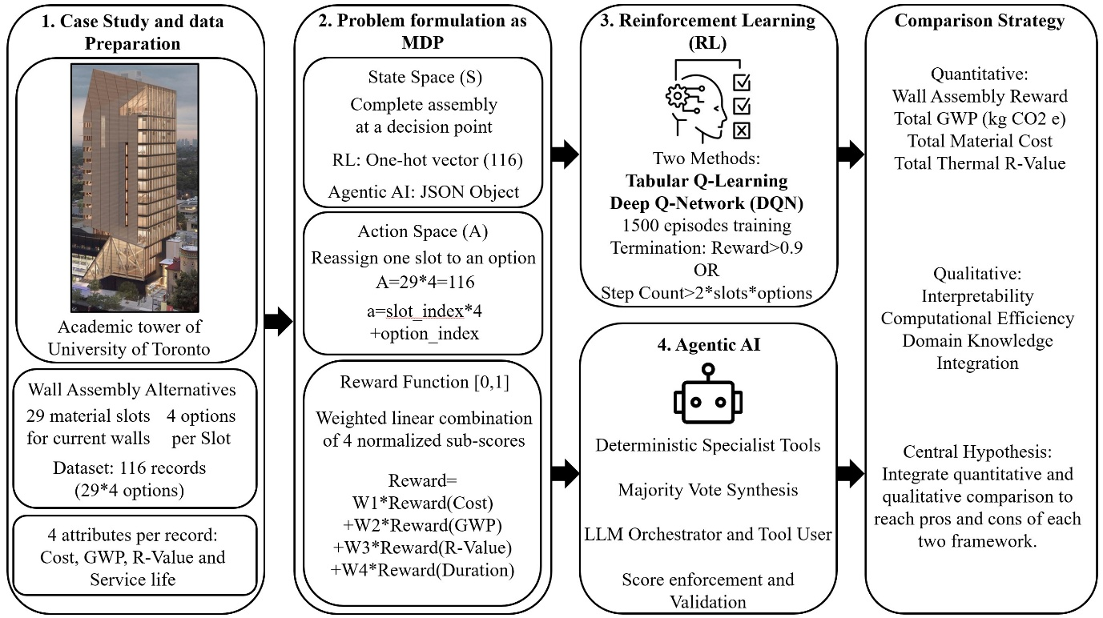
Figure 1: Methodology Flowchart
2.1. Case study and data preparation
The Academic tower at university of Toronto is used as the case study which was investigated by RDH building science company for whole building life cycle assessment (wbLCA) purpose. RDH has derived the bill of materials (BoM) of this building which this study utilizes the corresponding BoM of walls only. There are 29 distinct wall slots, and each slot represents a layer of the wall system such as insulation, cladding, air barrier and finishing materials. Four alternative materials are assigned to each slot as available options which are the baseline (existing), cost effective, low GWP or high performance (thermal resistance and service life) options. Therefore, there are 116 materials in total, and the challenge is to pick the best out of four materials for each of 29 wall slots. The final wall assembly is supposed to outperform its counterparts in terms of cost, GWP and performance.
2.2. Problem formulation as a Markov Decision Process (MDP)
The materials selection problem is formulated as a finite Markov Decision Process (MDP) shared by both RL and Agentic AI. An MDP is defined by the tuple $(S,A,R,γ)$ where S is the state space, A is the action space, R is the reward function, and $γ$ is the discount factor.
2.2.1. State Space
A state represents a complete wall assembly configuration at a given decision point. For the RL framework, this is encoded as one hot binary vector of length 116 $(116 slots×4 options)$ with one active bit per slot. For the Agentic AI framework, the state is represented a s a structured JSON object passed through the LLM context window.
2.2.2. Action Space
A single action consists of reassigning one material slot to a specific option index. The action space is therefore discrete by 29 slots with 4 options each. Accordingly, each action is decoded as a $(slot_{index}, option_index)$ pair and is formulated based on Equation 1.
$$a=slot_{index}×n_{options}+option_{index} slot_{index}ϵ\left\{0,…,28\right\} and option_{index}ϵ\left\{0,…,3\right\} (1)$$
Where, $a$ is the action point, $slot_{index}$ is the number of slots that should be passed to reach the action point, $n_{options}$ is the number of options in each slot, $option_{index}$ is the number of options after the last slot to reach the action point.
2.2.3. Reward Function
A unified reward function $R(s)ϵ[0,1]$ is applied identically to both frameworks, ensuring that any performance difference observed in the results is attributable solely to the framework of RL or Agentic AI rather than the evaluation criterion. The reward is a weighted linear combination of four normalised sub-scores and is represented in Equation 2.
$$R\left(s\right)=W_{1}R_{Cost}\left(s\right)+W_{2}R_{GWP}\left(s\right)+W_{3}R_{R-Value}+W_{4}R_{servicelife} (2)$$
Where $R\left(s\right)$ is calculated reward of wall assembly at state $s$, $R_{Cost}$, $R_{GWP}$, $R_{R-Value}$ and $R_{servicelife}$ are min-max normalized reward of cost, GWP, R-value and service life, respectively [N.B., cost and GWP rewards are inverted as lower raw value yields higher score.] and $W_{1}$, $W_{2}$, $W_{3}$ and $W_{4}$ are the corresponding weights of rewards. The reward normalization is done based on the bounds of four pure assemblies which are the best only in cost, GWP, R-value or service life. The assigned weights are assumed based on Table 1.
Table 1: Corresponding weights of reward function in Equation 2.
Objective | Symbol | Weight | Direction
Material Cost | $$R_{Cost}$$ | 0.30 | Minimise
GWP (kg CO2 e) | $$R_{GWP}$$ | 0.35 | Minimise
Thermal R-Value | $$R_{R-Value}$$ | 0.20 | Maximise
Service Life | $$R_{servicelife}$$ | 0.15 | Maximise

The 35 percent weight assigned to GWP reflects the research main objective of reducing building sector greenhouse gas emissions, consistent with the LCA-driven focus of this study. Cost is weighted second by 30 percent to represent the practical constraint of budget feasibility. Thermal performance and service life are treated as secondary optimisation targets.
2.3. Reinforcement Learning (RL)
The RL framework applies two methods of Tabular Q-Learning and Deep Q-Network (DQN) to enable internal comparison within the numerical optimisation paradigm.
2.3.1. Environment
The environment encodes the current assembly as the one-hot state vector described in section 2.2.1. At each timestep, the agent selects one of the 116 discrete actions, swapping one material slot to a new option. The environment computes a shaped step reward to guide learning based on Equation 3.
$$R\left(step\right)=R\left(s^{'}\right)+2×\max\left(0, R\left(s^{'}\right)-R\left(s\right)\right) (3)$$
Where $R\left(step\right)$ is the reward of a step, $R\left(s'\right)$ and $R\left(s\right)$ are the calculated reward of the state after and before swapping the option, respectively and based on Equation 2. Doubling the maximum of zero and the difference between new and old state rewards incentivises improvements over the prior state which drives the RL algorithm to actively seek upward moves rather than accepting lateral transitions. An episode terminates when the wall assembly reward of a step reaches 90 percent or when the step count exceeds two times of multiplication of number of slots into number of options which in this case is 232 steps which is known as truncation.
2.3.2. Tabular Q-Learning
The Tabular Q-Learning method maintains a dictionary of mapping every visited state tuple to a vector of 116 action values. Policy selection follows $ε_{greedy}$ strategy representing the probability of taking a random action by exploration; otherwise, the greedy action is taken based on the best option in the stored mapped states by exploitation. The Q-table is updated after each transition using bellman formula as displayed in Equation 4.
$$Q(s,a)=Q(s,a)+α\left[r+γ×\max{Q\left(s^{'},a^{'}\right)}-Q\left(s,a\right)\right] (4)$$
Where $Q(s,a)$ is the Q-value of state $s$ and action $a$ which is updated continuously, $r$ is the reward of action $a$ in state $s$, $\max{Q(s^{'},a')}$ is the Q-value of the best possible future actions based on what is learned so far to complete a wall assembly after action $a$ is state $s$, $α$ and $γ$ are hyperparameters representing learning rate and discount factor which are assumed to be 0.15 and 0.92 in this study. The $ε_{greedy}$ decreases from 1 to 0.05 with the rate of 0.003 per episode to switch from exploration to exploitation as mentioned before.
The Tabular Q-Learning method provides a transparent, computationally light baseline that is fully interpretable through its Q-value table.
2.3.3. Deep Q-Network (DQN)
The DQN method replaces the lookup table with a fully connected neural network $Q_{θ}(s, a)$ parametrized by weights of $θ$. The architecture consists of an input layer of 116 units, two hidde3n layers of 128 units each, and an output layer of 116 units producing Q-value estimates for all potential actions by switching each material simultaneously. Two stabilisation mechanisms are employed:
- Experience replay: All transitions are stored in a circular replay buffer of capacity 10000 and mini batches of 64 transitions are sampled uniformly at random for each gradient update. This approach breaks temporal correlations that would mislead training of the weights to local optimal answers.
- Target network: While the policy network is continuously updated in terms of weights by advancing through episodes, the weights of the network are already being used to update the weights themselves. This condition causes following a moving target by updating the weights in each episode. To resolve this issue, the target network is needed as a periodically frozen copy of the policy network so that to follow the target network by updating the policy network weights and then update the target network after several episodes to be a hard copy of the trained policy network.
The loss function between predicted and target Q-values are shown in Equation 5.
$$L\left(θ\right)=δ(r+γ×\max{Q_{θ^{'}}\left(s^{'}.a^{'}\right)-Q_{θ}\left(s,a\right)) (5)}$$
Where $L\left(θ\right)$ is the loss function based on weights set of $θ$, $Q_{θ}\left(s,a\right)$ is current policy network’s predicted Q-value for state $s$ and action $a$ using the neural network with weights set of $θ$, $\max{Q_{θ^{'}}(s^{'},a^{'})}$ is the Q-value of the best possible future actions based on the frozen target network weights set of $θ^{'}$, $r$ is the reward of action $a$ in state $s$, and $γ$ is the discount rate.
The DQN generalises across state combinations it has not explicitly visited which makes it better suited for large combinatorial spaces than Tabular Q Learning method.
2.4. Agentic AI
The Agentic AI framework follows a different approach by using a semantic structure to choose optimal materials for the wall assembly rather than numerical learning approach of RL for the same purpose. Instead of discovering optimal selections through environmental interactions, the Agentic AI provides pre-computed analytical knowledge to a large language model (LLM) orchestrator that reasons over trade-offs and produces a justified final assembly. This framework comprises three sequential phases.
2.4.1. Deterministic tool Analysis
Three independent tools analyse 116 records and produce an optimal per-slot selection according to each objective criterion:
- Environmental tool: Selects the option with the minimum total embodied GWP per slot, including negative values representing biogenic carbon sequestration.
- Economic tool: Selects the option with the minimum total material cost per slot, without regard to environmental or performance consequences.
- Performance tool: Selects the option maximising a composite thermal-durability score by assigning weights of 0.6 and 0.4 to the normalised R-value and durability variables.
Each tool selection is immediately scored using the unified reward function of $R(s)$ in Equation 2. Three candidate assemblies are therefore chosen with deterministically composite rewards.
2.4.2. Majority-Vote Synthesis
For each of the 29 slots, the three tool votes are aggregated by majority. The option receiving at least two of three votes is adopted for that slot. In the case that each tool recommends a different option, the environmental option is chosen by default reflecting the study’s primary emphasis on embodied GWP reduction in wbLCA. This synthesis produces a candidate assembly based on most of the vote result which serves as the guaranteed performance floor for the subsequent LLM orchestration stage.
2.4.3. LLM Orchestration
The LLM orchestrator agent receives the structured data containing the three tools selection, their per-metric sub-scores, the majority vote candidate, and the baseline assembly scores. The orchestrator is instructed to do the following tasks.
- Review all four candidate assemblies and their pre-computed performance metrics.
- Apply multi-objective reasoning to identify any slot where an alternative would improve the composite reward.
- Confirm whether the alternative outperforms the previous best choice by evaluating their rewards.
- Return a structured output comprising the 29-integer selection vector, per slot rationale up to 30 words, an executive summary, and an ordered reasoning trace.
The LLM is permitted a maximum of five tool calls and eight conversational turns as Agentic AI architectural hyperparameters. The target is to achieve a composite reward exceeding that of the majority-vote result. Four LLM backends are supported which are OpenAI GPT-4o, Google Gemini 2.0 Flash, Anthropic Claude Sonnet, and Meta LLaMA 3.3-70B via Groq.
2.4.4. Score Enforcement and Validation
LLMs are known to produce unreliable numeric computations. To avoid this issue, this study has developed an enforcement layer to re-score the LLM’s chosen selection using the same reward function as shown in Equation 2. If the LLM gives a composite reward lower than the majority-vote candidate by more than 0.001, the deterministic majority-vote result is substituted. This design ensures the framework is robust to LLM failure while preserving the LLM’s ability to improve upon the deterministic baseline when it reasons correctly.
3. RESULT & DISCUSSUON
3.1. Reinforcement Learning Results
Both methods of Tabular Q Learning and DQN are trained over 1500 episodes using the same $ε_{greedy}$ decaying from 1.00 to 0.05 with a rate of 0.003 per episode, discount rate factor $γ=0.92$, and the shaped step reward of Equation 3. The convergence training curves are shown in Figure 2.
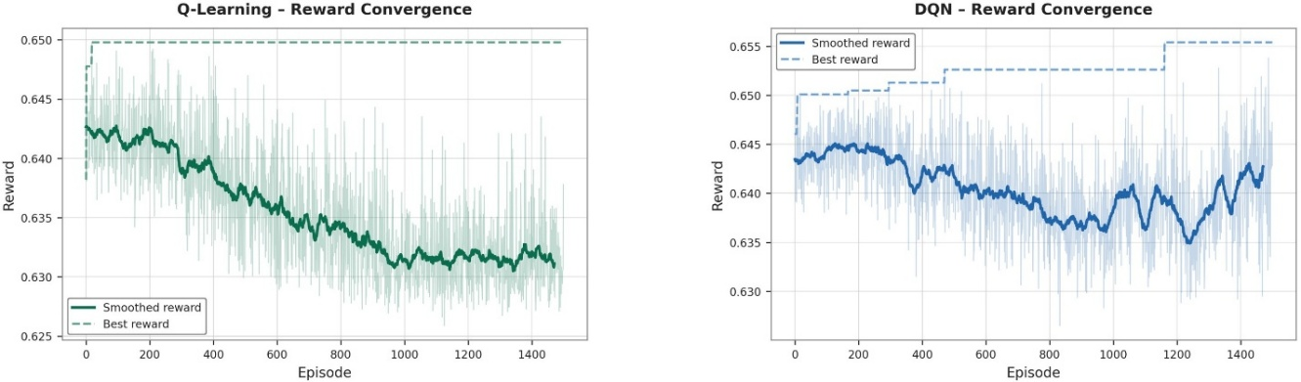
Figure 2: Reward convergence of Tabular Q Learning and DQN methods
Tabular Q Learning achieves a best composite reward of 0.650 reducing material cost by 22.8% to 1,541,627 CAD and embodied GWP by 62.4% to 545,420 kgCO₂e relative to the baseline. Moreover, the thermal R-value improves from 4.29 to 8.01 m²K/W. Figure 2 shows that Tabular Q Learning reaches its peak within the first 50 episodes and then faces a smoothed average reward declining slightly across 1500 episodes. The reason is exploring suboptimal states throughout training rather than converging firmly to the best-known option. As the space grows, the Q-table accumulates entries for distant states whose values are rarely updated, causing unstable episode-level performance even when the global best solution is already captured.
The DQN method achieves a marginally higher best composite reward of 0.655 with the total cost of 1,654,070 CAD which is 17.2% less than the baseline and GWP of 549,680 kgCO₂e which is 62.1% less than the baseline. Also, the R-value improves further to 10.21 m²K/W. Unlike Tabular Q Learning, DQN represents continued gradual improvement through episodes 400 to 1200 reflecting the neural network’s capacity to generalise across unvisited state combinations. The head-to-head comparison illustrates that DQN surpasses tabular Q Learning’s peak around episode 200 and continues to improve in discrete steps through episode 1200, reaching a final best reward of 0.655 compared to Tabular Q Learning’s 0.650.
Both RL methods favour cost as a primary driver with similar GWP reductions of approximately 62% with neither approaching the deeper decarbonisation achievable by full high-performance substitution. The R-value improvements are also meaningful but remain below what is achievable under a performance-led strategy. This reflects the inherent tension in the reward function with cost and GWP dominating 65% of the overall impact on final reward versus 20% R-value weight. Furthermore, RL resolves this through stochastic exploration rather than multi-objective reasoning.
3.2. Agentic AI Results
The Agentic AI framework achieves the highest composite reward of 0.700, completing its optimization in 17 seconds which is approximately 200 times faster than RL methods in convergence speed. This progress is shown in Figure 3.
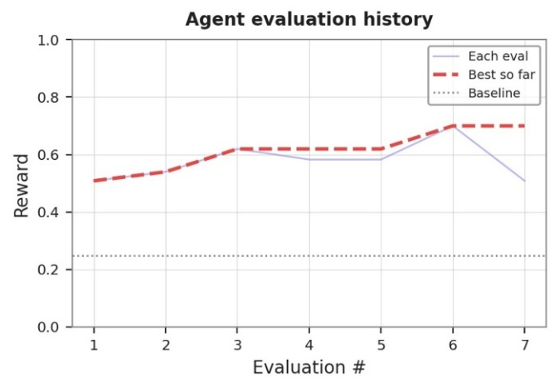
Figure 3: Reward convergence of Agentic AI framework
The LLM orchestrator reasons over the multi-objective trade-offs without requiring iterative environmental interactions. It determines that high-performance assembly which maximises R-value and durability, produces the highest composite reward under the given weight assignments. It assigns 28 out of 29 slots to high-performance option with only slot 19 (Mineral Wool batt, medium density) retained at baseline to balance cost efficiency. This near uniform selection results in a total cost of 3,663,483 CAD which is 83.3% more than baseline, a GWP of 218,155 kgCO₂e which is 85% less than baseline, a total R-value of 13.21 m²K/W, and an average service life of 59 years. While the cost in Agentic AI’s optimal wall assembly is higher than its alternatives in RL methods, it’s outperforming in carbon reduction, thermal R-value, and durability.
3.3. Comparative Discussion
The comparative results of RL methods and Agentic AI framework is shown in Table 2.
Table 2: Comparative results of RL methods and Agentic AI framework
Metric | Q-Learning | DQN | Agentic AI | Best Performer
Composite Reward | 0.650 | 0.655 | 0.700 | Agentic AI
Total Cost (M CAD) | $1.54M | $1.65M | $3.66M | Q-Learning
Total GWP (t CO₂e) | 545 | 550 | 218 | Agentic AI
Thermal R-Value (m²·K/W) | 8.01 | 10.21 | 13.21 | Agentic AI
Avg. Durability (yrs) | 45.0 | 44.2 | 59.0 | Agentic AI
Δ GWP vs Baseline | −62.4% | −62.1% | −85.0% | Agentic AI
Δ Cost vs Baseline | −22.8% | −17.2% | +83.3% | Q-Learning
Evaluations to Best | 1,500 ep. | 1,500 ep. | 7 calls | Agentic AI
Requires GPU | Yes | Yes | No | Agentic AI

Comparing RL methods with Agentic AI framework, a critical difference lies in how the two paradigms interpret the multi-objective trade-off. The RL methods operating through shaped rewards with higher weight of cost and GWP reduction, consistently favour assemblies with lower cost and moderate GWP reduction reflecting the combined pull of these two dominant weights during stochastic exploration. The Agentic AI correctly identifies that the reward function reaches its maximum value when carbon reduction, thermal R-value, and durability scores are maximised and this global maximum corresponds to the high-performance assembly despite its cost premium. This distinction between local optimum discovery through exploration and global optimum identification through structured reasoning is the primary source of the performance gap between RL and Agentic AI. This interpretability advantage distinguishes the Agentic AI from the RL methods, whose policy emerges implicitly from millions of numerical updates and cannot be easily reinterpreted post-training.
4. CONCLUSION
As the building sector accounts for up to 37% of GHG emissions, this study aims to fill the gap of wbLCA decision-supportive system to choose optimal construction materials in terms of cost, GWP and performance for a building wall assembly. Using RL methods and Agentic AI framework, numerical optimization and semantic reasoning are compared within wbLCA context.
Regarding explainability and design process integration, the agentic AI framework provides a qualitative advantage that numerical metrics alone, do not capture. Each wall assembly slot selection in the Agentic AI framework is accompanied by a rationale which can be directly incorporated into design review documentation or LCA reports, whereas RL outputs require post-hoc interpretation. In wbLCA context where justification is as critical as performance optimization, this explainability advantage positions the agentic AI framework more aligned with professional practice.
While this study made meaningful progress in highlighting difference between RL and Agentic AI within wbLCA context, there are limitations that are recommended for future research. First, the academic tower might not be representative to generalise the results of this study. Second, choosing materials of wall assemblies contribute to only a small portion of wbLCA context which justifies further study over more comprehensive scope in this regard. Finally, Agentic AI has a significant number of alternative architectures along with corresponding orchestrators, tools, handoffs and guardrails which has remarkable potential to investigate their difference within wbLCA context.
5. REFERENCES
Building Materials And The Climate: Constructing A New Future | UNEP - UN Environment Programme. (n.d.). Retrieved May 28, 2026, from https://www.unep.org/resources/report/building-materials-and-climate-constructing-new-future
Cheng, Z., Yu, J., & Xing, X. (2025). A Survey on Explainable Deep Reinforcement Learning. https://arxiv.org/pdf/2502.06869
Dazeley, R., Vamplew, P., & Cruz, F. (2023). Explainable reinforcement learning for broad-XAI: a conceptual framework and survey. Neural Computing and Applications, 35(23), 16893–16916. https://doi.org/10.1007/S00521-023-08423-1/FIGURES/7
Embodied Carbon - World Green Building Council. (n.d.). Retrieved May 28, 2026, from https://worldgbc.org/climate-action/embodied-carbon/
Gao, Y., Yiu, T. W., Shen, X., & Tam, V. W. Y. (2025). Large language models in smart construction: a systematic review of implementation strategies, applications and future directions. Engineering, Construction and Architectural Management, 33(15), 159–181. https://doi.org/10.1108/ECAM-10-2025-1668
Hollberg, A., Ruth, J., & Hollberg alexanderhollberg, A. (2016). LCA in architectural design—a parametric approach. The International Journal of Life Cycle Assessment 2016 21:7, 21(7), 943–960. https://doi.org/10.1007/S11367-016-1065-1
Hosseinzadeh, A., & Dehestani, M. (2025). Intelligent low carbon reinforced concrete beam design optimization via deep reinforcement learning. Scientific Reports 2025 15:1, 15(1), 33143-. https://doi.org/10.1038/s41598-025-18543-4
Li, C., Pradhan, P., Chen, G., Kropp, J. P., & Schellnhuber, H. J. (2025). Carbon footprint of the construction sector is projected to double by 2050 globally. Communications Earth & Environment 2025 6:1, 6(1), 831-. https://doi.org/10.1038/s43247-025-02840-x
Röck, M., Saade, M. R. M., Balouktsi, M., Rasmussen, F. N., Birgisdottir, H., Frischknecht, R., Habert, G., Lützkendorf, T., & Passer, A. (2020). Embodied GHG emissions of buildings – The hidden challenge for effective climate change mitigation. Applied Energy, 258, 114107. https://doi.org/10.1016/J.APENERGY.2019.114107
Szalay, Z. (2024). A parametric approach for developing embodied environmental benchmark values for buildings. The International Journal of Life Cycle Assessment 2024 29:9, 29(9), 1563–1581. https://doi.org/10.1007/S11367-024-02322-W
Wang, L., Ma, C., Feng, X., Zhang, Z., Yang, H., Zhang, J., Chen, Z., Tang, J., Chen, X., Lin, Y., Zhao, W. X., Wei, Z., & Wen, J. (2024). A survey on large language model based autonomous agents. Frontiers of Computer Science 2024 18:6, 18(6), 186345-. https://doi.org/10.1007/S11704-024-40231-1

