Deep Learning-Based Automated Damage Assessment for RC Double-Column Piers
HAIRONG DENG¹, HAIJIANG LI^{2*}, LUEQIN XU^{1*}, ZHEWEN DENG¹

¹Chongqing Jiaotong University, Chongqing, China
²Cardiff University, Cardiff, UK

ABSTRACT:

Reinforced concrete (RC) double-column piers, essential bridge substructures, are highly susceptible to earthquake damage. Traditional damage assessment methods primarily depend on visual inspection and structural analysis, which are often subjective and inefficient. This study proposes a Hybrid Structural-Visual Damage Evaluation (HSVDE) framework integrating structural analysis and deep learning-based computer vision. The structural analysis provides an initial classification of performance levels using material strain and drift ratio. To enhance evaluation accuracy and enable rapid post-earthquake assessment, a modified DeepLabv3+ model is employed to identify concrete spalling and exposed rebar. Finite element analysis was utilised to determine drift ratio thresholds for each performance level. The modified DeepLabv3+ model significantly improved rebar detection accuracy, achieving an IoU of 42.80% compared to 33.37%, with only a slight decrease in spalling detection accuracy. The proposed HSVDE framework enhances the accuracy, reliability, and efficiency of seismic damage evaluation, supporting timely emergency response and recovery.

KEYWORDS:

RC Double-Column piers, Damage Assessment, Semantic Segmentation, Computer Vision, Earthquake Engineering.

1. INTRODUCTION
Bridges are vital components of transportation infrastructure, serving as essential lifelines for ensuring road network safety and efficiency. Among them, piers play a crucial role in supporting bridge superstructures and are typically classified as single-column or double-column structures. Due to their superior overturning resistance and low sensitivity to foundation deformations, RC double-column piers are extensively utilised in mountain bridges and urban viaducts (Xiang et al., 2019). However, in recent decades, frequent large earthquakes such as the 2008 Wenchuan earthquake (Yuan, 2008), the 2016 Kumamoto earthquake (Yamashita et al., 2022), and the 2023 Pazarcik earthquake (Memisoglu et al., 2024), have caused severe damage to bridge piers, exposing their vulnerability to earthquake-induced forces. Various methodologies have been developed to facilitate the rapid post-earthquake assessment and restoration of bridges. Traditional assessment methods primarily rely on visual inspections and structural analysis, which, although effective, are often time-consuming and subjective.
With the advancement of deep learning and computer vision, convolutional neural networks (CNNs) have been increasingly adopted in structural damage detection (Fan et al., 2022; Zou et al., 2022; Settou et al., 2022). Several studies have employed CNNs for the identification and classification of damage in RC structures, leveraging object detection methods (e.g., YOLO, SSD, Faster R-CNN) and semantic segmentation models (e.g., FCN, U-Net, DeepLabv3+). For instance, Paal et al. (2015) proposed an automatic detection framework for RC piers using computer vision techniques. Rubio et al. (2019) developed an FCN-based model incorporating a VGG-16 backbone to detect concrete delamination and rebar exposure, achieving an average detection accuracy of 89.7% and 78.4%, respectively. Tazarv et al. (2022) proposed a CNN-based approach to quantify damage states and assess structural serviceability. Additionally, Luo and Paal (2019) developed a machine learning approach to predict the drift capacity of RC piers based on visual damage features. Krishnan et al. (2025) conducted a comparative analysis of various deep learning models, including CNN, U-Net, and DeepLabv3+, to assess the performance in crack detection within RC structures. However, the majority of existing research has primarily focused on single-column piers, resulting in the post-earthquake damage assessment of double-column piers remaining largely unexplored. Furthermore, although deep learning models have shown promising results in general crack detection and surface damage classification, research focusing on concrete spalling and rebar exposure, which are two critical indicators of structural integrity in RC piers, remains limited.
To address this research gap, this study proposes a Hybrid Structural-Visual Damage Evaluation (HSVDE) framework, which integrates structural analysis with deep learning-based computer vision to facilitate damage assessment of RC double-column piers. The structural analysis component provides an initial classification of performance levels based on material strain and drift ratio. To enhance evaluation precision and enable rapid post-earthquake assessment, the computer vision component employs a modified DeepLabv3+ semantic segmentation model to detect and quantify local damage features, including concrete spalling and rebar exposure, which are frequently overlooked in conventional deep learning approaches. The proposed method is expected to enhance the accuracy and efficiency of damage assessment, providing valuable guidance for bridge maintenance and rehabilitation planning.

2. METHODOLOGY
The HSVDE framework is proposed in this study, integrating structural analysis and computer vision techniques to enhance the accuracy and intelligence of damage assessment for RC double-column piers. The composition and functionality of each layer within the HSVDE framework are first introduced, followed by a detailed explanation of the research implementation process, ensuring scientific rigour, systematisation, and reproducibility throughout the evaluation procedure.

2.1 HSVDE framework
The HSVDE framework comprises three key components (Fig. 1): (1) the Input Layer, (2) the Analysis Layer, and (3) the Output Layer. The components are described as follows:
- Input Layer (shaded in grey). This layer primarily collects post-earthquake damage data of the bridge pier, including structural monitoring data and visual damage data. Structural monitoring data are acquired from on-site sensors, manual inspections, and measurement instruments, capturing key parameters such as strain, displacement, and crack propagation, which indicate the pier's mechanical response and damage extent during seismic events. Visual damage data are primarily derived from post-earthquake site images, videos, experimental datasets, and publicly available datasets, which are employed to identify and quantify damaged regions. The collected data are standardised and pre-processed before serving as the foundation for subsequent analysis.
- Analysis Layer (shaded in gold). This layer processes input data to define assessment indicators and quantify damage through structural analysis and computer vision techniques. Thresholds for concrete strain (ɛ_{c}), rebar strain (ɛ_{s}), and drift ratio (D_{D} = pier-top displacement/pier height) under different performance levels are determined through quasi-static tests and numerical simulations in the structural analysis component. These thresholds are subsequently compared with data from on-site monitoring to evaluate the current status of the pier. Within the computer vision component, a modified DeepLabv3+ model is employed for precise segmentation of damaged regions in RC double-column piers, specifically detecting concrete spalling and rebar exposure. The model’s lightweight design is optimised in this study to enhance segmentation accuracy and computational efficiency. However, appropriate thresholds for spalling area ratio (R_{A}) and rebar exposure density (R_{D}) remain under investigation and have not been incorporated into the final decision-making process in this study. Future work will refine R_{A} and R_{D} computation based on experimental data and statistical analysis to enhance evaluation accuracy. Results from the analysis layer provide the data foundation for the output layer, ensuring reliable damage assessment.
- Output Layer (shaded in green). This layer integrates the analysis results to classify performance levels. Initially, the performance level is preliminarily classified based on structural analysis indicators, including strain thresholds and drift ratio, into four performance levels: Immediate, Service Limited, Service Disruption, and Life Safety. The classification is then refined by incorporating concrete spalling area ratio and rebar exposure density. For instance, if visual damage indicators exceed a predefined threshold (e.g., the mean value of a given level (μ) + 1.5 standard deviations (σ)) even if structural analysis indicators remain within a lower performance level, the performance level may be adjusted upward for a more accurate assessment. The final output consists of the pier performance classification results, damage mask images, and quantified damage indicators.
The multi-level damage assessment strategy in the HSVDE framework integrates mechanical analysis and computer vision, enhancing post-earthquake damage evaluation accuracy and reliability for RC double-column piers.

2.2 Method
In this study, the proposed approach consists of the following key steps:
(1) Data Preprocessing. The dataset employed in this study was derived from quasi-static tests conducted by the authors. Structural data are normalised and examined for outliers to ensure the validity of material strain and drift ratio thresholds. Meanwhile, to enhance the model’s generalisation ability, image data are pre-processed through background removal, contrast enhancement, and data augmentation techniques. Notably, the structural analysis component has been extensively discussed in previous studies; therefore, only the key findings from structural analysis are incorporated into this study to support the HSVDE framework.
(2) Model Training and Optimisation. A total of 305 images were selected for training and evaluation of the modified DeepLabv3+ model. The dataset was split into 90% for training and 10% for testing, corresponding to 274 training images and 31 testing images. The DeepLabv3+ model was optimised using deep learning techniques to accurately detect concrete spalling and rebar exposure and generate prediction masks. Compared to traditional manual inspection methods, integrating computer vision analysis significantly enhances damage identification automation and improves quantitative evaluation accuracy.
Within the HSVDE framework, the structural analysis component is initially employed to classify the performance levels of RC double-column piers according to predefined thresholds. The effectiveness of the modified DeepLabv3+ model in detecting damage in RC double-column piers has been validated, establishing a strong foundation for implementing the HSVDE framework. Future research will focus on determining appropriate thresholds for R_{A} and R_{D} and comparing assessment results with experimental data and images to further validate the applicability of the HSVDE framework in post-earthquake damage evaluation of RC double-column piers.

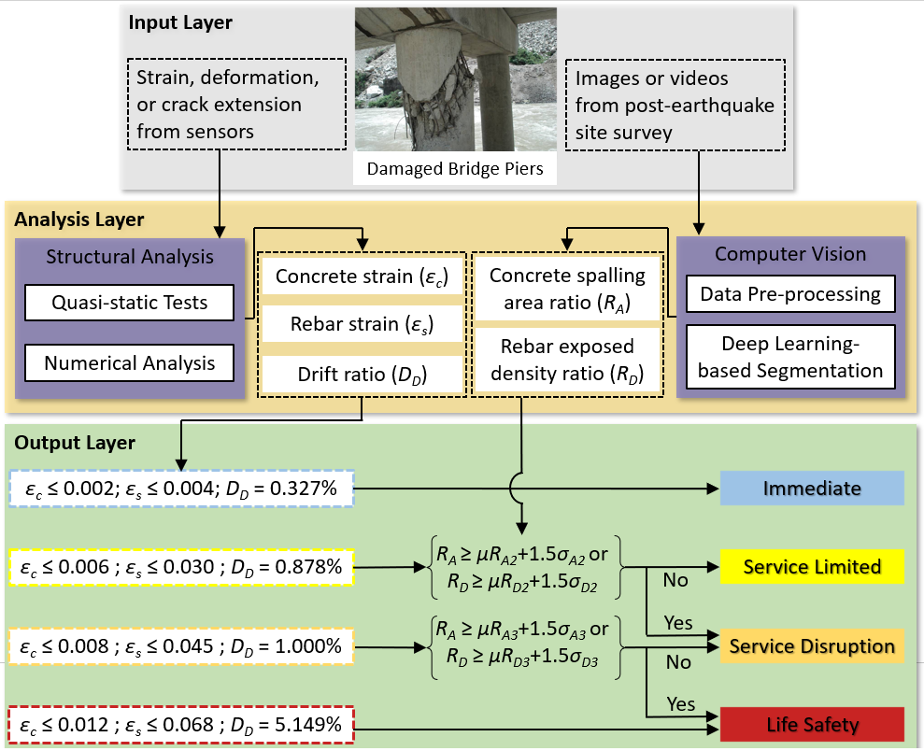
Figure 1: Hybrid Structural-Vision Damage Evaluation Framework.

3. HYBRID STRUCTURAL-VISION DAMAGE EVALUATION
To quantify post-earthquake damage in RC double-column piers, this section provides a comprehensive explanation of the structural analysis methodology, derived from experimental and numerical simulations, and elaborates on the modifications made to the DeepLabv3+ model to enhance its segmentation performance for concrete spalling and rebar exposure.

3.1 Structural analysis
The CAS S6-19 (CSA, 2019) standard defines four performance levels—Immediate, Service Limited, Service Disruption, and Life Safety—based on seismic exceedance probability and bridge importance classification. Each performance level corresponds to specific damage states and evaluation criteria. This study adopts the four-tier performance classification outlined in CAS S6-19, considering macroscopic structural failure due to material degradation. Based on quasi-static test strain data and observed damage phenomena, the correlation between the performance levels of RC double-column piers and the strain limits of both concrete and rebar has been established, as summarised in Table 1.

Table 1: Classification of performance levels of RC double-column piers.

Performance level | Concrete strain limits | Rebar strain limits
Immediate | ɛ_{c} ≤ 0.002 | ɛ_{s} ≤ 0.004
Service limited | ɛ_{c} ≤ 0.006 | ɛ_{s} ≤ 0.030
Service disruption | ɛ_{c} ≤ 0.008 | ɛ_{s} ≤ 0.045
Life Safety | ɛ_{c} ≤ 0.012 | ɛ_{s} ≤ 0.068

In performance-based seismic design, pier deformation is widely considered a more reliable indicator of seismic performance and damage state compared to strength-based criteria. Currently, the drift ratio at the pier top is one of the most commonly used indicators for assessing RC pier damage, as expressed in Equation (1):
D_{D} = Δ/H (1)
where D_{D} - Drift ratio at the top of the pier;
Δ - Maximum displacement of the top of the pier;
H - pier height.
A fibre-based finite element model of the RC double-column pier was developed in OpenSees, as depicted in Fig. 2. The Displacement-Based Beam-Column Element was utilised to simulate the hysteretic behaviour of the pier columns, while the Elastic Beam-Column Element was employed to represent the cap beam. The fibre model was discretised into three material categories: unconfined concrete, confined concrete, and reinforcing steel. The constitutive models for these materials were established using Concrete 01 (Scott et al., 1982), Concrete 02 (Mander et al., 1988), and ReinforcingSteel (Kunnath et al., 2009), respectively.
To account for parameter variability, the Monte Carlo sampling technique was employed to generate 500 sets of random parameter combinations, each representing an independent finite element model of an RC double-column pier. Through iterative cyclic analyses on these 500 finite element models, the four drift ratio thresholds were derived based on the strain limits of concrete and rebar, as defined in Table 1:
- Immediate: D_{D}=0.327%;
- Service limited: D_{D}=0.878%;
- Service disruption: D_{D}=1.000%;
- Life safety: D_{D}=5.149%.

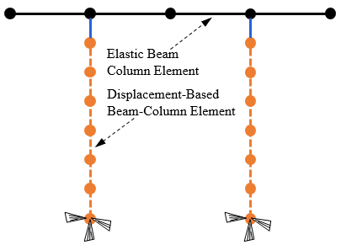
Figure 2: RC Double-column pier modelling information.

3.2 DeepLabv3+ model
The DeepLab series was developed as an extension of Fully Convolutional Networks (FCN) (Long et al., 2015) to improve its effectiveness in image segmentation tasks. The DeepLabv3+ model employs an encoder-decoder architecture, integrating an additional decoder module into DeepLabv3 to facilitate the fusion of low-level and high-level features, enhancing segmentation boundary accuracy, as illustrated in Fig. 3.
The encoder component consists of a backbone feature extraction network and an Atrous Spatial Pyramid Pooling (ASPP) module. The backbone network may be chosen from Xception (Chollet, 2017), the ResNet series (Chen et al., 2025), or the MobileNet series (Peng et al., 2024).
- Xception extracts both high- and low-level semantic information. The high-level feature maps undergo further refinement via ASPP, while the low-level feature maps are transmitted to the decoder.
- The ResNet series has fewer parameters than Xception, thereby reducing computational complexity while maintaining adequate feature extraction capabilities, rendering it well-suited for resource-constrained applications.
- The MobileNet series is designed as a lightweight network, making it optimal for applications that demand high computational efficiency and fast inference speeds.

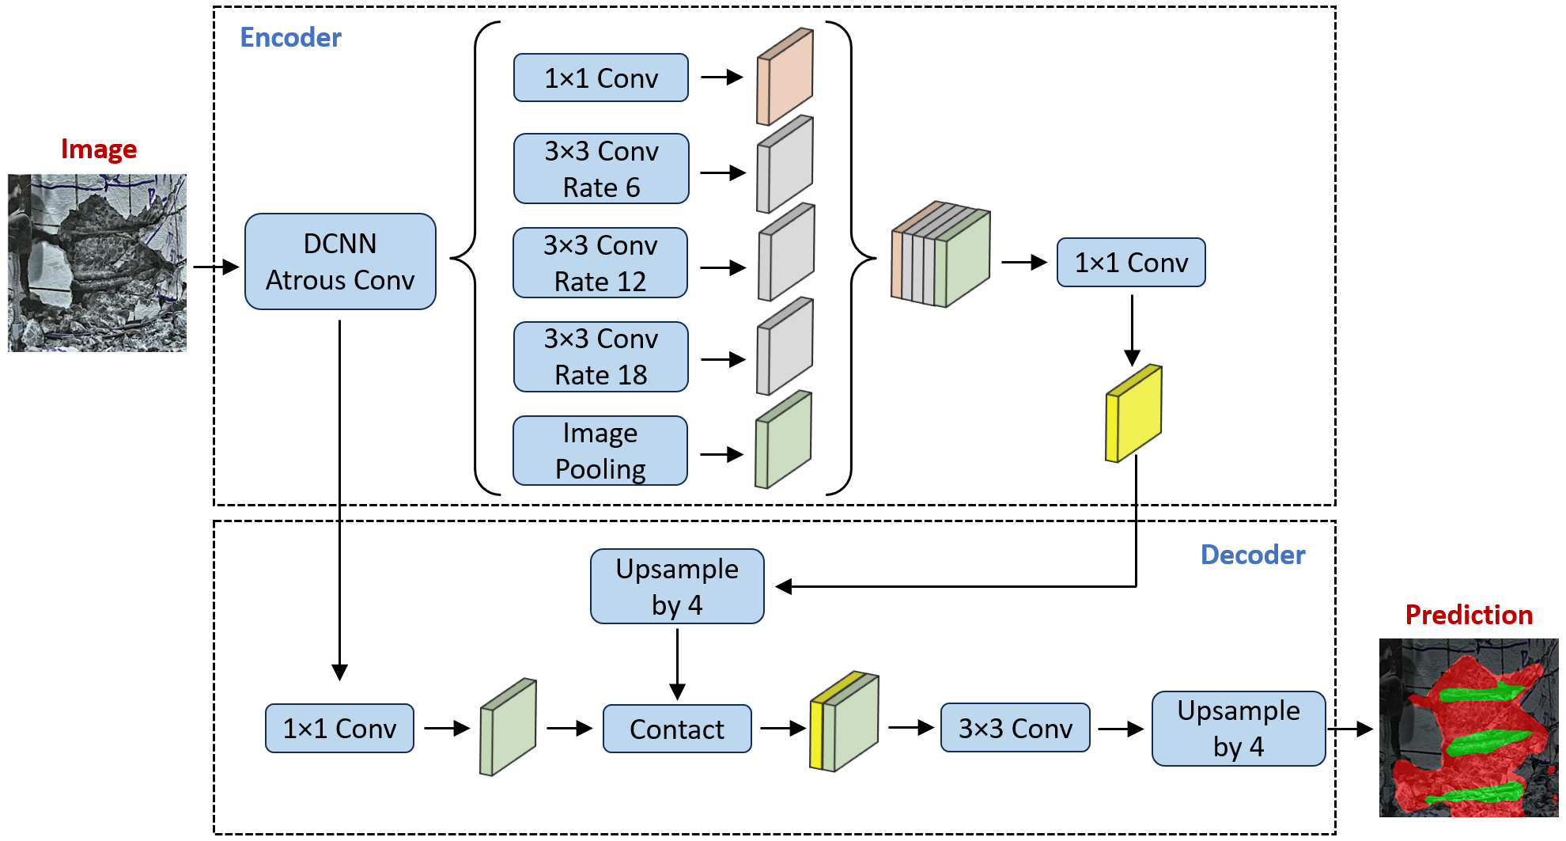
Figure 3: The structure of Deeplabv3+.

The ASPP module enhances multi-scale feature extraction by applying a 1×1 convolutional layer, three 3×3 convolutional layers, and a global average pooling layer to the backbone network output. Features at four distinct scales are concatenated along the channel dimension, compressed via a 1×1 convolutional layer, and subsequently forwarded to the decoder module.
The decoder component processes both low-resolution, high-level semantic features and high-resolution, low-level spatial details obtained from the encoder component. The high-level feature maps are upsampled and concatenated with low-level feature maps after dimensionality reduction. Finally, the extracted features are refined using 3×3 convolutional layers, which reconstruct the original image resolution and enhance segmentation accuracy.

3.3 DeepLabv3+ model architecture and modification
In this study, computer vision analysis was performed in two stages: object detection and semantic segmentation. Initially, the YOLO11 model was trained and fine-tuned to accurately differentiate between target columns and background environments, thereby enabling the rapid identification of specific damage types (i.e., concrete spalling and rebar exposure), as illustrated in Fig. 4.

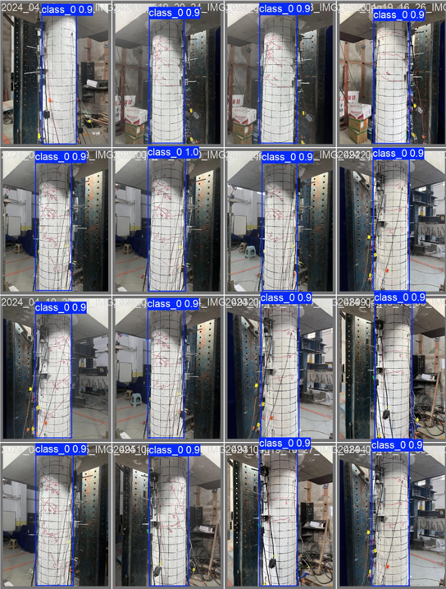
Figure 4: Target detection test results.

The detailed quantitative evaluation of concrete spalling and rebar exposure has been largely absent in existing damage detection methods for RC double-column piers. To address this gap, a modified DeepLabv3+ model for damage detection was proposed.
To balance model accuracy with lightweight deployment, MobileNetv3-Large was selected as the backbone network, rendering the model suitable for rapid post-earthquake assessment applications. However, the original network exhibited notable limitations in processing fine-grained features (e.g., spalling boundaries) and elongated targets (e.g., exposed rebar) during training. The main challenges included inadequate feature extraction, blurred segmentation boundaries, and reduced sensitivity to small objects.
To address these limitations, a multi-branch feature enhancement module was developed while preserving the original backbone network, as illustrated in Fig. 5. This module comprises two parallel processing branches: (1) a detail enhancement branch, utilising two successive 3×3 convolutional layers to extract fine-grained features through small receptive fields; (2) a spatial attention branch, which generates attention weight maps to adaptively highlight critical regions within the image. The outputs of these branches were fused through a feature aggregation module, facilitating effective multi-scale feature integration. This approach preserved high-level semantic information while maintaining detailed spatial features, which led to enhanced segmentation accuracy for both concrete spalling and rebar exposure.

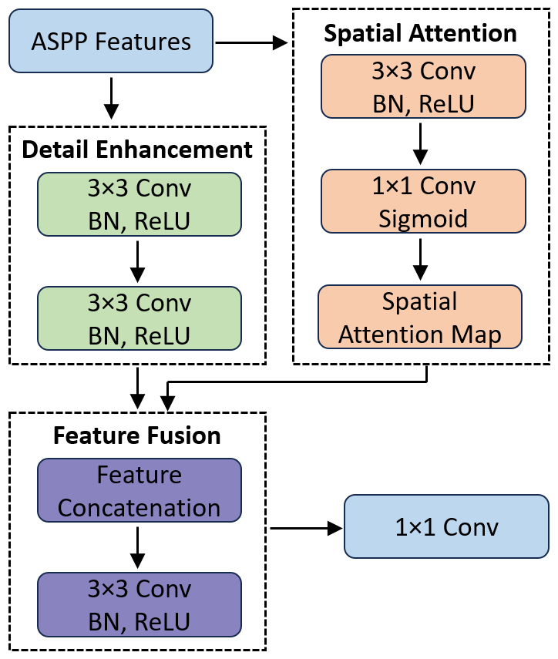
Figure 5: A multi-branch feature enhancement module.

A novel weighted composite loss function was proposed to address the challenges in loss function design. Given the class imbalance in RC structure damage detection—where background pixels are most prevalent, followed by concrete spalling and sparsely represented rebar exposure—a differentiated weight ratio of 1:2:4 was applied. The loss function was formulated as a weighted combination of Cross-entropy loss, Dice loss, and Focal Tversky loss, with corresponding weight coefficients set to 0.3:0.5:0.2. Cross-entropy loss ensures fundamental classification accuracy, Dice loss improves overall segmentation performance, and Focal Tversky loss—with α and β set to 0.7 and 0.3, respectively—balances false positives and false negatives. Additionally, the γ parameter (set to 1.3) enhanced the model’s capacity to learn from hard-to-detect samples. This multi-component loss function design significantly improved the model’s recognition performance, particularly enhancing its capacity to detect rebar exposure, which remains a more challenging task.
In terms of training strategies, a differentiated learning rate and dynamic scheduling mechanism were employed to optimise model convergence. Specifically, a lower learning rate (1e-5) was applied to the pre-trained backbone network to preserve feature stability, while a higher rate (1e-4) was assigned to the newly introduced enhancement module to accelerate convergence. Furthermore, a learning rate scheduling strategy combining a warm-up phase with cosine annealing was implemented. The warm-up phase mitigated early-stage training instability, whereas cosine annealing facilitated more effective exploration of optimal solutions during later training stages.

3.4 Model evaluation metrics
To evaluate the performance of the modified DeepLabv3+ model in detecting concrete spalling and rebar exposure, intersection over Union (IoU), Precision (P), Recall (R), and F1-score (F1) were adopted as evaluation metrics and calculated based on Equations (2) – (5):
IoU = TP / (TP + FN + NP) (2)
P = TP / (TP + FP) (3)
R = TP / (TP + FN) (4)
F1 = 2 × P × R / (P + R) (5)
where TP - true positive;
FP - false positive;
FN - false negative.
IoU reflects the overlap between predicted and actual damage regions, P indicates the reliability of damage detection, and R represents the completeness of the identified damage areas. Given the inverse relationship between P and R, where gains in one may reduce the other, the F1 is adopted as a balanced evaluation metric, with higher values representing improved segmentation accuracy.
The dataset was utilised to train both the original DeepLabv3+ model and the modified DeepLabv3+ model, while the validation set was employed to compare their performance. The results are summarised in Table 2. For rebar exposure detection, the IoU increases to 42.80%, representing a 28.3% improvement. Precision and recall increased to 56.90% and 63.33%, respectively, while F1 improved from 44% to 59.94%. These results suggest that the enhanced feature extraction mechanism was more effective in capturing elongated structures such as rebar. Moreover, the attention mechanism improved feature localisation, and the optimised loss function facilitated the learning of rebar-specific features.
For concrete spalling detection, in comparison with the original DeepLabv3+ model, the IoU decreased from 79.61% to 73.81%, indicating a 5.80% reduction, while precision and recall dropped to 82.52% and 87.48%, respectively. The F1 declined from 88.25% to 84.93%, representing a decrease of 3.32%. This outcome suggests that the modified model adopted a more conservative strategy for concrete spalling detection, resulting in reduced boundary precision and omission of minor spalling regions. The observed decline in F1 can be primarily attributed to the trade-off between precision and recall, which resulted from modifications to the feature extraction process aimed at improving rebar detection. Given that exposed rebar signifies more severe structural deterioration, the modified DeepLabv3+ model was designed to prioritise improvements in rebar detection. Although the performance of concrete spalling detection slightly decreased, the trade-off is considered acceptable in practical engineering scenarios.
Fig. 6 presents segmentation results for representative damage images from the testing set, including the input, ground-truth masks, and corresponding model predictions. The strong alignment between model predictions and the ground-truth masks further validates the effectiveness of the proposed enhancements.

Table 2: Comparison of test results between the improved model and the original DeepLabv3+ model.

Metrics | Traditional model |  | Modified model
Metrics | Concrete spalling | Rebar exposure | Concrete spalling | Rebar exposure
IoU | 79.61% | 33.37% | 73.81% | 42.80%
P | 85.27% | 53.23% | 82.52% | 56.90%
R | 92.21% | 39.85% | 87.48% | 63.33%
F1 | 88.25% | 44.00% | 84.93% | 59.94%

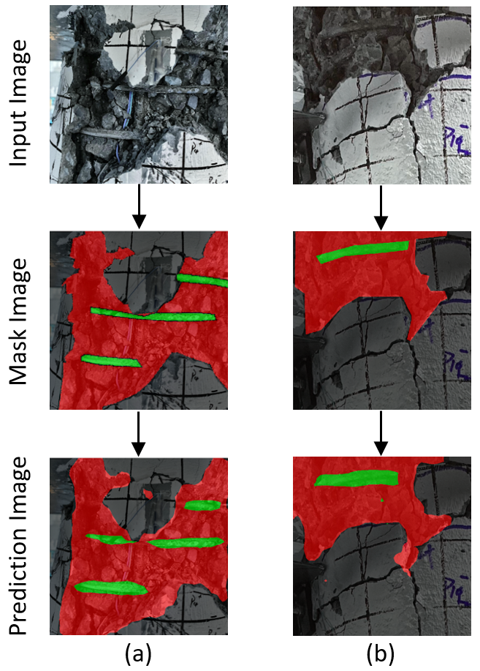
Figure 6: Modified DeepLabv3+ model prediction performance results.

4. CONCLUSION
This study introduces the HSVDE framework, which integrates structural analysis with deep learning for the post-earthquake damage assessment of RC double-column piers. The structural analysis component utilises quasi-static tests and numerical analysis to preliminarily establish material strain and drift ratio thresholds, providing a foundational basis for performance classification. By analysing 500 finite element models, four drift ratio thresholds were identified: Immediate Occupancy (0.327%), Limited Serviceability (0.878%), Service Disruption (1.000%), and Life Safety (5.149%).
To enable rapid and more accurate post-earthquake evaluation, the computer vision component utilises a modified DeepLabv3+ model. This model substantially improves the detection of rebar exposure, achieving an IoU of 42.80% (+28.3%), with precision increasing to 56.90% and recall reaching 63.33%, effectively mitigating limitations observed in previous segmentation methods. Although the IoU for concrete spalling detection exhibits a slight decrease from 79.61% to 73.81%, the overall segmentation performance remains robust.
Future research will focus on refining the decision-making process, improving segmentation accuracy, and integrating larger datasets to enhance model generalisation. The HSVDE framework supports intelligent, efficient, and data-driven seismic damage evaluation and repair decision-making.

ACKNOWLEDGEMENTS
This work is supported by the Fundamental Research Funds for the National Natural Science Foundation of China (Grant No. 52378482), the China Scholarship Council under Grant CSC 202308500247, the Chongqing Talent Plan Project (Grant No. cstc2022ycjh-bgzxm0133), Research and Innovation Program for Graduate Students in Chongqing (Grant No. CYS240453), BIM for Smart Engineering Centre in Cardiff University, UK. The author would like to thank them for their support.

REFERENCES
Xiang, N., Goto, Y., Obata, M. and Alam, M.S., (2019). Passive seismic unseating prevention strategies implemented in highway bridges: A state-of-the-art review. Engineering Structures, 194, pp.77-93.
Yuan, Y., (2008). Impact of intensity and loss assessment following the great Wenchuan Earthquake. Earthquake Engineering and Engineering Vibration, 7, pp.247-254.
Yamashita, K., Tanaka, S. and Yamaguchi, T., (2022). Active fault investigation and slope stability evaluation for Aso Bridge in Japan. Proceedings of the Institution of Civil Engineers-Forensic Engineering, 176(1), pp.16-21.
Memisoglu Apaydin, N., (2024). Earthquake Response of the Transportation Infrastructure in the Region Affected by the Feb. 6 Türkiye Earthquakes’’Part II-Bridges and Tunnels. Journal of Earthquake Engineering, pp.1-14.
Fan, C.L. and Chung, Y.J., (2022). Design and optimization of CNN architecture to identify the types of damage imagery. Mathematics, 10(19), p.3483.
Zou, D., Zhang, M., Bai, Z., Liu, T., Zhou, A., Wang, X., Cui, W. and Zhang, S., (2022). Multicategory damage detection and safety assessment of post‐earthquake reinforced concrete structures using deep learning. Computer‐Aided Civil and Infrastructure Engineering, 37(9), pp.1188-1204.
Settou, T., Kholladi, M.K. and Ben Ali, A., (2022). Improving damage classification via hybrid deep learning feature representations derived from post-earthquake aerial images. International Journal of Image and Data Fusion, 13(1), pp.1-20.
Paal, S.G., Jeon, J.S., Brilakis, I. and DesRoches, R., (2015). Automated damage index estimation of reinforced concrete columns for post-earthquake evaluations. Journal of Structural Engineering, 141(9), p.04014228.
Rubio, J.J., Kashiwa, T., Laiteerapong, T., Deng, W., Nagai, K., Escalera, S., Nakayama, K., Matsuo, Y. and Prendinger, H., (2019). Multi-class structural damage segmentation using fully convolutional networks. Computers in Industry, 112, p.103121.
Tazarv, M., Won, K., Jang, Y., Hart, K. and Greeneway, E., (2022). Post-earthquake serviceability assessment of standard RC bridge columns using computer vision and seismic analyses. Engineering Structures, 272, p.115002.
Krishnan, S.S.R., Karuppan, M.N., Khadidos, A.O., Khadidos, A.O., Selvarajan, S., Tandon, S. and Balusamy, B., (2025). Comparative analysis of deep learning models for crack detection in buildings. Scientific Reports, 15(1), p.2125.
Luo, H. and Paal, S.G., (2019). A locally weighted machine learning model for generalized prediction of drift capacity in seismic vulnerability assessments. Computer‐Aided Civil and Infrastructure Engineering, 34(11), pp.935-950.
CSA (Canadian Standards Association). (2019). Canadian highway bridge design code. CSA S6. Rexdale, ON, Canada: CSA.
Scott, B.D., Park, R. and Priestley, M.J., (1982), January. Stress-strain behavior of concrete confined by overlapping hoops at low and high strain rates. In Journal Proceedings (Vol. 79, No. 1, pp. 13-27).
Mander, J.B., Priestley, M.J. and Park, R., (1988). Theoretical stress-strain model for confined concrete. Journal of Structural Engineering, 114(8), pp.1804-1826.
Kunnath, S.K., Heo, Y. and Mohle, J.F., (2009). Nonlinear uniaxial material model for reinforcing steel bars. Journal of Structural Engineering, 135(4), pp.335-343.
Long, J., Shelhamer, E. and Darrell, T., (2015). Fully convolutional networks for semantic segmentation. In Proceedings of the IEEE Conference on Computer Vision and Pattern Recognition (pp. 3431-3440).
Chollet, F., (2017). Xception: Deep learning with depthwise separable convolutions. In Proceedings of the IEEE Conference on Computer Vision and Pattern Recognition (pp. 1251-1258).
Chen, X., Wang, S., Dinavahi, V., Yang, L., Wu, D. and Shen, M., (2025). Landslide Recognition Based on DeepLabv3+ Framework Fusing ResNet101 and ECA Attention Mechanism. Applied Sciences, 15(5), p.2613.
Peng, H., Xiang, S., Chen, M., Li, H. and Su, Q., (2024). DCN-Deeplabv3+: A novel road segmentation algorithm based on improved Deeplabv3+. IEEE Access.

