Spatio-Temporal Symbolic Planning for Multi-Robot Coordination in Construction Environments
AIDDL-Based Task Scheduling and Workspace Reservation for Modular Deconstruction
Pranav Shevkar^{1,2}, Görkem Can Ertemli^{1,2}, Chu Han Wu^{1,2}, Emre Ergin^{1,2}, Carsten Kamp^{1,2}, Sigrid Brell-Cokcan^{1,2}

¹ Cluster of Excellence CARE, TU Dresden and RWTH Aachen, Germany
² Chair of Individualized Production, RWTH Aachen University, Aachen, Germany
*Corresponding email: shevkar@ip.rwth-aachen.de

ABSTRACT
Construction and deconstruction sites are dynamic, process-intensive environments where heterogeneous robots must share constrained workspaces while respecting task precedence, resource dependencies, and time-dependent safety restrictions. Most robotic systems handle navigation, perception, and execution locally, leaving this higher-level coordination informally specified. This paper presents a spatio-temporal symbolic planning framework that treats physical site zones as schedulable temporal resources rather than static map regions. The framework combines hierarchical task network decomposition with simple temporal problem reasoning inside a single declarative model expressed in the Artificial Intelligence Domain Definition Language (AIDDL). Decomposition expands a construction scenario into timed actions, the temporal solver places them in time, and workspace availability is then automatically derived from the solved schedule and merged with the site geometry into a Map of Dynamics. The same map drives a zone-aware scan route for an independent inspection robot that works concurrently with the deconstruction team. The approach is demonstrated in a modular steel-beam deconstruction scenario, where it achieves conflict-free coordination and dispatches the transport robot just in time via constraint propagation. The planned schedule is validated against an optimisation baseline and executed on a heterogeneous physical robot team, demonstrating that the coordination is realisable on hardware.

- INTRODUCTION
Construction and deconstruction sites are increasingly seen as domains for robotic automation, where mobile robots, manipulators with specialised end effectors, and cranes carry out transport, assembly, disassembly, inspection, and heavy lifting. These agents do not operate in isolation. They share constrained physical spaces, follow structured construction processes, and must coordinate with human workers, equipment, and evolving safety requirements. Most robotic systems, however, focus on local autonomy such as navigation, manipulation, and obstacle avoidance. These capabilities are essential but do not solve the higher-level coordination problem in construction, where a robot may reach a target safely yet find the zone needed by another robot blocked by a lifting operation or unavailable until a prerequisite task finishes. Construction robotics therefore needs planning that reasons jointly about task logic, time, space, and resources.
This paper addresses spatio-temporal symbolic planning for heterogeneous robot teams in construction. The central claim is that treating site zones as schedulable temporal resources, rather than static map regions, enables a planner to derive workspace-availability constraints directly from the robot schedule, thereby removing conflicts before execution and supporting secondary tasks such as inspection routing. The planner automatically derives blocked windows from scheduled action intervals and propagates them to any robot that shares those zones. The framework is implemented in the Artificial Intelligence Domain Definition Language (AIDDL), a modular representation for AI problems and solver pipelines, where scenario data are encoded as an AIDDL domain model and converted into Simple Temporal Problem (STP) constraints whose solution yields the zone reservations, inspection routes, and robot dispatch commands.
The paper makes three contributions. First, a unified declarative formulation in AIDDL that couples hierarchical task decomposition with simple temporal problem reasoning, so a single model expresses the construction workflow and produces its schedule. Second, a spatio-temporal zone-management method that derives workspace availability automatically from the solved schedule and merges it with the site geometry into a Map of Dynamics (MOD), a temporal site map that records when each zone is occupied or free. Third, a zone-aware scan-scheduling method that routes an independent inspection robot around the schedule-derived reservations, demonstrating their reusability by a separate agent. The framework is demonstrated end-to-end on a modular steel-beam deconstruction scenario, including a physical run with a heterogeneous robot team.

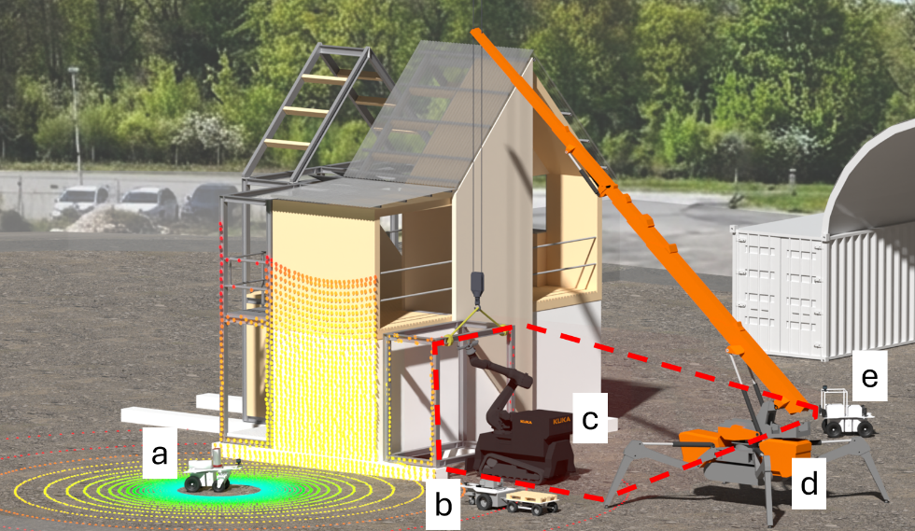
Figure 1: Agents in the deconstruction scenario - (a) an inspection robot, (b) transport robot, (c) mobile manipulator, (d) mobile crane, and (e) safety monitoring robot.

- RELATED WORK

2.1 Construction and deconstruction robotics
Construction robotics has shifted from isolated single-task automation toward collaborative systems that share spaces and dependencies with workers and other machines. Coordination, rather than task-level control, is now the defining challenge (Parascho, 2023). Deconstruction is especially demanding as robots must cope with structural uncertainty, hazardous debris, and access dependencies fixed by the disassembly order (Lee and Brell-Cokcan, 2023). Recent scan-to-BIM deconstruction-sequence planners connect scanning, structural models, crane operations, and human tasks within a single optimisation, but they treat workspace restrictions as static consequences of structural topology rather than deriving zone availability from the robot schedule itself (Ostapska et al., 2025).
2.2 Multi-robot task allocation and scheduling
Formally, construction coordination is a cross-schedule task-allocation problem involving single-task robots, single-robot tasks, time-extended assignment, and precedence and shared-space constraints that link the schedules of different robots (the class XD[ST-SR-TA] of Korsah et al., 2013; formalised in Section 3). The established way to solve it is temporospatial scheduling over a Simple Temporal Network (STN), where an allocation step determines who does what, and the temporal network enforces precedence and spatial mutual exclusion while computing timing. This pattern holds across exact, heuristic, and learned solvers, including mixed-integer allocation with STP dispatch (Gombolay et al., 2018), distributed metaheuristics (Arbanas Ferreira et al., 2024), and graph-learned policies over an extended network (Wang et al., 2020). These methods resolve spatial conflicts internally for the scheduled team. What none of them does is export the schedule's spatial footprint as reusable zone reservations that a separate agent or planning layer can consume.

2.3 Symbolic and temporal task planning
Construction planning has long treated work zones as time-varying resources, and 4D and BIM-linked tools enable managers to resolve work-zone conflicts and address access constraints before execution (Ardila & Francis, 2020). These tools are built for human crews, with reservations entered by hand, whereas autonomous robots need the same reasoning, with reservations derived automatically from the robot schedule. The proposed framework combines hierarchical task decomposition with temporal constraint reasoning. Hierarchical Task Network (HTN) planning expands compound tasks into ordered primitives through domain methods, which suits construction work already organised into nested, trade-specific procedures. The temporal layer is the Simple Temporal Problem (STP) of Dechter et al. (1991), which represents task time points as variables and inter-task relations as difference constraints solvable in polynomial time by shortest-path computation. Qi et al. (2017) couple an HTN planner with a Simple Temporal Network to guide search toward minimum makespan. The present framework adopts this HTN-over-STN architecture but derives spatial zone reservations from the solved schedule rather than treating resources only as abstract capacities.
Ontologies have long served as a semantic knowledge layer for planning, giving a planner structured, queryable domain knowledge. In construction and manufacturing, established ontologies now describe processes (Kirner et al., 2024), machine capabilities and skills (Köcher et al., 2023), and voxel-based site space (Wu et al., 2026). The framework reuses such ontologies to formalise tasks, agents, and site space, so the HTN planner can select decomposition methods, instantiate task parameters, and link high-level construction processes to executable robotic actions.
We realise this composition in the Artificial Intelligence Domain Definition Language (AIDDL) (Köckemann, 2025), whose ontology, scenario, and constraint modules can be replaced or extended independently. No existing approach, however, combines a symbolic construction ontology, automatic derivation of zone reservations from the robot schedule, and an independent inspection agent running concurrently with the team, a gap this paper closes.

- PROBLEM FORMULATION AND SCENARIO
We evaluate the framework on a modular steel-beam deconstruction scenario from a previous project, in which a single structural steel roof beam, secured by four bolts, is removed by a team of four heterogeneous agents, with a fifth agent, a mobile inspection robot, performing the secondary scan-routing task as described in Table 1. We use this scenario throughout to make the general coordination problem concrete.

Table 1: Roles of the agents in the deconstruction scenario.
Agent | Operation Family
Mobile manipulator | Bolt removal, inspection
Safety robot | Safety monitoring
Transport robot with trailer | Beam transport
Mobile crane | Beam lifting and placement
Mobile inspection robot | Inspection scan routing

3.1 Problem definition
We consider a heterogeneous team of robots on a deconstruction site. Each robot has a set of capabilities and a starting zone, and the site is divided into symbolic zones, each a polygon or circle in metric coordinates, with optionally pre-specified blocked windows indicating when it is unavailable. Each task requires a capability, occupies one or more zones, has a minimum duration, may depend on other tasks, and is subject to per-robot travel times between zones. By the taxonomy of Korsah et al. (2013), this is an instance of class XD[ST-SR-TA] (Section 2.2), with single-task robots, single-robot tasks, time-extended assignment, and cross-schedule dependencies, so a task's precedence may involve tasks assigned to other robots.
Solving the problem means assigning each task to a capable robot and producing start and end times that satisfy four conditions. Every task runs for at least its minimum duration. A task starts only after all its precedences end. A task cannot use a zone before that zone's pre-declared window has closed. And tasks on the same robot do not overlap, with travel time inserted between consecutive tasks at different locations. The objective is the makespan, the total time from the schedule's start to the last task's completion. Once decomposition fixes the tasks and assignment fixes the allocation, the STP computes the time-optimal schedule in polynomial time. Unlike mixed-integer and constraint-programming schedulers that search over allocations and orderings for a global optimum (Gombolay et al., 2018), it returns the minimum-makespan schedule consistent with the given decomposition and allocation.
A secondary problem is scan scheduling. While the deconstruction proceeds, a mobile inspection robot must capture scan data at inspection targets across the site, for example to monitor progress and update the structural model. Because it shares the workspace, it cannot enter a zone another task has reserved. Given the solved schedule and target coordinates, it visits every target, scanning each as soon as its zone is free and deferring any still reserved, so inspection overlaps the deconstruction rather than following it.
3.2 Site configuration
The site is partitioned into five symbolic zones, namely the Unbolting zone (the beam work area), the Crane zone (the crane's operational zone), the Monitoring zone (the safety robot's observation point), the Loading zone (the trailer loading area), and the Storage Yard (the beam storage area). The crane permanently occupies the Crane zone, marked as initially blocked in the configuration. Figure 2 shows the layout. Each zone is also linked to a voxelised description of the physical space it covers, so the planner can reason about the actual volumes that robots enter, avoid, or reserve, and a zone's availability is time-dependent, free at some points in the schedule and reserved at others, which lets the planner keep one robot out of a space while another uses it.
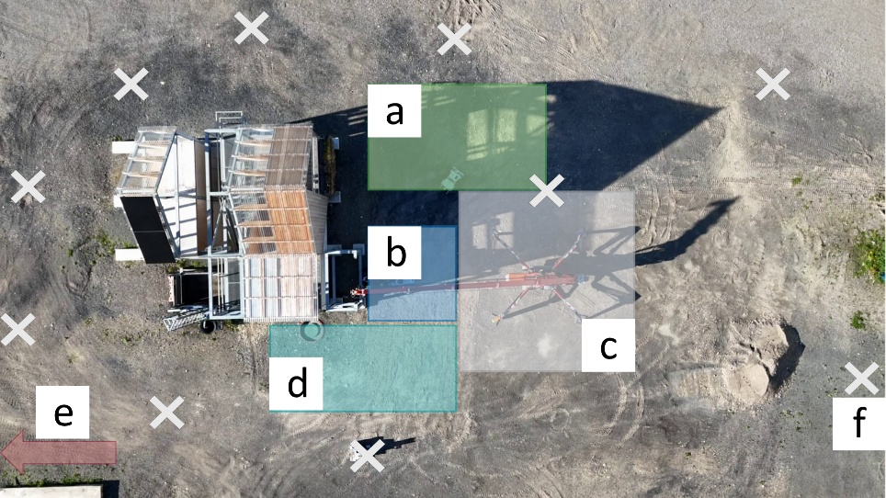
Figure 2: Site layout with (a) the Monitoring zone, (b) the Unbolting zone, (c) the Crane zone, (d) the Loading zone, (e) the Storage Yard, and (f) the inspection robot waypoints.

- AIDDL-BASED PLANNING FRAMEWORK
The framework has two connected planning layers. The first produces a task schedule for the deconstruction team by expanding the declarative scenario instance, the structure, agents, zones, and operation templates of Section 4.1, into STP constraints and solving them as shown in Figure 3. The second uses the zone reservations from that schedule, collected in the Map of Dynamics (MOD), to plan a conflict-free route for the inspection robot, an independent agent that runs concurrently with the team. The layers are sequential only in planning order, since the MOD must exist before the scan route can be planned. Every representation is an AIDDL module, so each layer consumes the previous layer's output through a shared typed container.
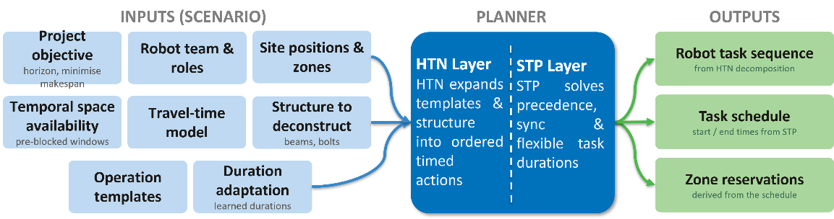
Figure 3: Overview of the proposed HTN–STP planning framework, showing the scenario inputs, the HTN decomposition and STP scheduling layers, and the resulting robot task sequence, task schedule, and zone reservations.

4.1 Domain ontology and action expansion
The framework separates a reusable domain model from the scenario instance, both as typed AIDDL terms. The domain model defines the entity types for modular steel deconstruction and one template per operation family, each specifying its capability, occupied zones, and nominal duration, as well as the relation types linking operations (after, startAfterStartOf, endAtEndOf, endAfter). These capabilities, process relations, and the voxelised site space are stored in a semantic knowledge base built on the IoC process ontology (Kirner et al., 2024) and the CVX voxel ontology (Wu et al., in press), which the planner queries to instantiate tasks (Figure 4). The ontology serves as a semantic knowledge source rather than the planning model itself. During scenario generation, the planner queries the ontology to retrieve the relevant process definitions, capabilities, operation templates, and spatial information, which are instantiated as typed AIDDL terms before HTN decomposition and temporal reasoning begin. A scenario instance specifies only what is particular to a job: the beam and its four bolts, the five zones, and the agents in Table 1, so a different structure or robot team is modelled by editing it alone.
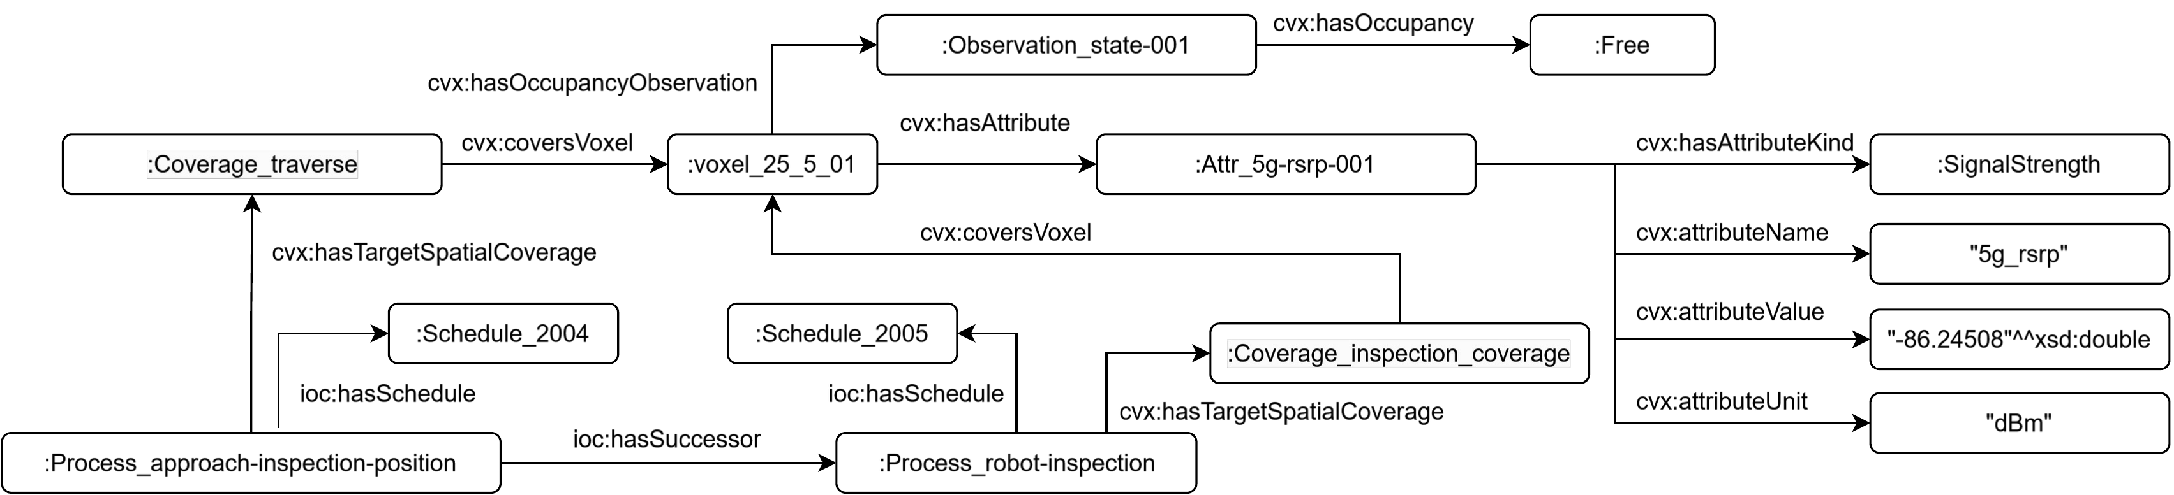
Figure 4: A fragment of the semantic knowledge base, linking a construction process (IoC) to its schedule and to voxelised site space (CVX), where voxels carry occupancy and sensor attributes.

The pipeline then expands this scenario into timed actions, applying the operation-family templates in order, positioning the manipulator and safety robot, adding bolt-removal steps per bolt, then harness attachment, crane placement, and transport. To cut inspection overhead, full beam inspection runs only at the start of each two-bolt pair, since geometry does not change between consecutive bolts on a connection. The safety-monitoring task is flexible, with interval [0, ∞) and an endAfter constraint tying it to the final transport, and synchronisation groups start the manipulator and safety robot together regardless of travel differences.

4.2 STP constraint encoding
Each action is a pair of time points, a start and an end, and four temporal constraints cover every workflow relationship. Precedence (after) requires a task to start after another ends. Parallel start (startAfterStartOf) requires a task to start no earlier than another task starts, used to keep safety monitoring active before manipulation begins. Synchronised end (endAtEndOf) forces two tasks to end together, used to dispatch the transport robot so it reaches the Loading zone exactly when the final bolt removal completes. Minimum end (endAfter) requires a task to end no earlier than another, used for the flexible safety-monitoring action. Pre-specified zone restrictions serve as lower bounds on start times, so a task cannot begin before its zone's blocked window closes. The network is solved with the AIDDL STP solver, a Bellman-Ford shortest-path computation over the difference-constraint graph that returns the earliest feasible time for every point or reports infeasibility.
A representative STP fragment for a single action and its safety-monitoring dependency reads:
(^NamedSimpleTemporalProblem@STP generated-schedule
({t0 safety-monitoring-start safety-monitoring-end
bolt-1-approach-start bolt-1-approach-end}
{(safety-monitoring-start safety-monitoring-end 0 INF)
(bolt-1-approach-start bolt-1-approach-end 50 50)
(safety-monitoring-start bolt-1-approach-start 0 INF)}))

The bound 50 50 sets the bolt-1-approach duration to 50 ticks (0.5 minutes at 100 ticks per minute), while INF is an infinite upper bound that leaves the safety-monitoring duration flexible.

4.3 Zone reservation and the Map of Dynamics
Once the schedule is produced, each action contributes to its required zones and time interval as raw blocked windows, and overlapping windows for the same zone are merged into the maximal interval. Combined with the base zone geometry, these form the Map of Dynamics (MOD), in which each zone carries its shape and its schedule-derived blocked windows, each stored as a temporal restriction linked to the action, the zone, the responsible agent, and its times, yielding a queryable spatio-temporal structure. The MOD is the output of the first layer and the main input to the second. Pre-specified windows constrain the schedule and serve as STP lower bounds, while schedule-derived windows describe its consequences for other agents and stay in a separate map, so the schedule can be replanned without mixing inputs and outputs. Unlike a manually entered deadline, each window is computed from the solved schedule and represented spatially as a zone reservation.

4.4 Execution: navigation, dispatch, and duration learning
During execution, the same reserve-and-respect principle applies to the dynamic space occupied by moving robots. Each mobile robot has a unique priority rank and publishes bounding-box reservations for the remaining part of its path. Lower-ranked robots register higher-ranked reservations as temporary keep-out regions in their Nav2 costmap and replan around them, so right-of-way follows priority, and unique ranks prevent cyclic conflicts, as seen in Figure 5. The dispatch module then converts the solved schedule into executable robot commands, which are sent over a configurable transport layer, with hardware addresses stored in a separate configuration. The observed start and end times of each action are logged, and a duration model is updated using an exponential moving average that shifts each estimate by a fixed fraction from its previous value toward the latest observation. Updated estimates feed the next planning run, closing a feedback loop between execution and planning.
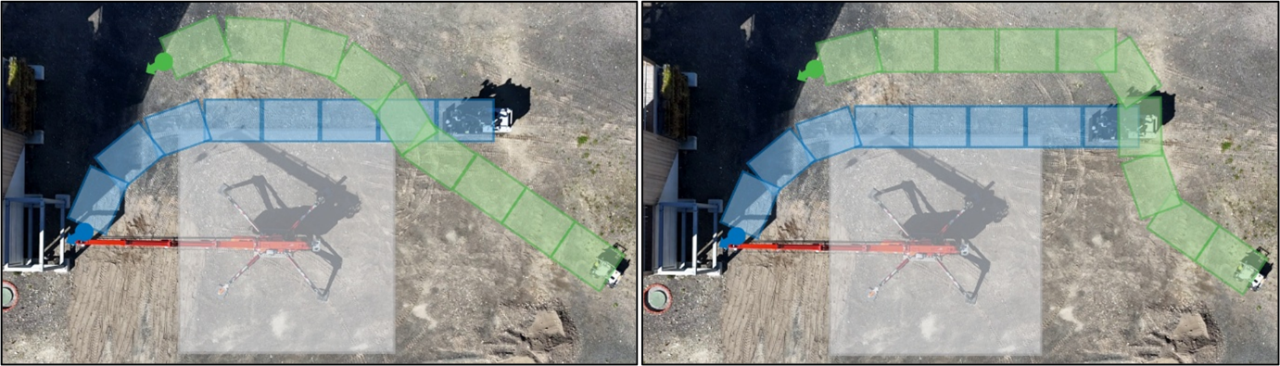
Figure 5: Priority-based zone reservation for multi-robot navigation. Left: initial planned path reservations represented as oriented bounding-box reservations for two mobile robots. Right: updated reservations after priority-based replanning, where the lower-priority robot replans around the higher-priority robot’s reserved path to maintain the assigned right-of-way hierarchy.

- EVALUATION AND RESULTS

5.1 Planning results
Applying the framework to this scenario produces a consistent STP with a total schedule makespan of 34 minutes. The manipulator begins work at minute 5 (after travel) and completes the four-bolt removal sequence by minute 15, for a total of about 10 minutes of active manipulation. The transport robot begins navigating at minute 12 and arrives at the Loading zone at minute 14, precisely aligned with the end of the final unbolting action via the synchronised-end constraint. An exact CP-SAT formulation of the same scenario yields the same 34-minute makespan, a check that the STP returns the optimal schedule for this decomposition. The zone reservation windows derived from this schedule are as follows. The Unbolting zone is blocked from minutes 0–15 and 15–27 (consecutive manipulator and human tasks), the Crane zone for the full duration 0–32 (crane occupancy plus harness and placement), the Loading zone from 12–34, and the Monitoring zone from 0–34. These windows form the MOD used by the scan route planner for the inspection robot.
5.2 Physical execution
The schedule was dispatched to the physical robot team and executed once on site, as a demonstration that the planned coordination is realisable on hardware rather than only in simulation. The team completed all six operation families without manual intervention, and no zone conflicts occurred, confirming that the schedule-derived reservations held during real operation. The measured makespan was 36.3 minutes against the planned 34.0 minutes, about 7% longer, with the difference accumulating from small per-phase overruns rather than from any single failure. The largest single deviation was 0.8 minutes for the manual harness attachment, the phase with human variability.
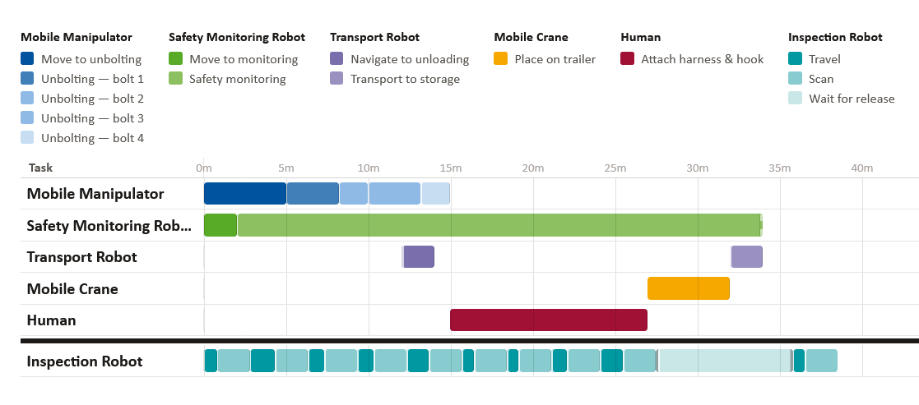
Figure 6: Task schedule generated by the HTN–STP planner for the modular steel-beam deconstruction scenario, showing the concurrent execution of the inspection robot.

5.3 Duration learning from execution
This run also provides the first measurements for the duration-learning loop. Applying the exponential moving average of Section 4.4 with α = 0.7, each estimate moves 30% of the way toward the observed value, so the harness estimate updates from 12.00 to 12.24 minutes against an observed 12.8. Table 2 applies the update to every phase. Re-solving with the updated estimates raises the predicted makespan from 34.00 to 34.69 minutes, moving the prediction toward the measured execution while staying damped against a single noisy run. Over repeated executions, the model would converge toward the durations of the specific equipment and site.
Table 2: Planned, observed, and updated phase durations.
Phase | Prior estimate (min) | Observed (min) | Updated estimate (min)
Setup and positioning | 5.00 | 5.3 | 5.09
Bolt removal (4 bolts) | 10.00 | 10.6 | 10.18
Harness attachment | 12.00 | 12.8 | 12.24
Crane placement | 5.00 | 5.4 | 5.12
Transport to storage | 2.00 | 2.2 | 2.06
Makespan | 34 | 36.3 | 34.69

This is a single physical execution and is reported as a feasibility demonstration of the planning-to-execution loop, not a statistical validation. A larger execution campaign to allow the duration model to converge is left to future work.
- DISCUSSION
The results show that a single declarative model can drive both forms of reasoning without an external glue layer. Hierarchical decomposition turns the deconstruction goal into grounded actions, the STP solver places them in time, and both are AIDDL terms in the same representation. Encoding coordination as temporal relations rather than hand-tuned offsets, such as the endAtEndOf dispatch of the transport robot and the endAfter that keeps safety monitoring active, lets the schedule adjust on its own when an upstream duration changes, which makes the duration-learning loop usable. The spatial consequences of the schedule are likewise computed rather than entered by hand, since each action contributes a blocked window to its zone, and these windows form the MOD that downstream agents can query, keeping the constraints on the robot schedule separate from the restrictions it imposes on others. The physical run shows that the planned coordination is realisable on hardware. As a single execution, it should be read as a proof of concept rather than a statistical result, but it confirms that the framework's coordination is technically feasible on real robots.
Several limitations point to future work. The temporal relations and the pairing of process actions to machine skills are currently defined by hand and matched by simple string matching. This is laborious and brittle beyond this use case, so empirical preselection of values and AI-based capability matching that tolerates variations and combinations of skills are natural next steps. Spatial reasoning is currently two-dimensional and should be extended to three dimensions to encompass all site processes. Finally, the duration model gives reasonable first estimates but can diverge under outliers, so a larger study of process times together with process-specific buffer times, larger for human-centred than machine-centred tasks, would make the predictions robust.

- CONCLUSIONS
This paper presented a declarative planning framework for multi-robot modular steel deconstruction that combines hierarchical task network decomposition with simple temporal problem reasoning inside a single AIDDL model. The framework expands a declarative scenario into timed actions, encodes the workflow through four temporal relation types, solves the resulting network for an earliest feasible schedule, and derives a spatio-temporal map of zone reservations from the solution. In the studied scenario, the schedule matches the exact CP-SAT optimum, and a physical run with a heterogeneous robot team completed the full operation with a makespan about 7% longer than planned, while respecting the derived zone reservations. The work also closes a feedback loop in which observed durations update the planning model for later runs. The implementation used in this study is publicly available on Zenodo (Shevkar et al., 2026).
Future work will extend the evaluation from a single beam to structures with several elements and competing resource choices, where the benefit of combining decomposition and temporal reasoning over a fixed schedule should become measurable. A larger execution campaign is needed to allow the duration model to converge, and the greedy scan route can be replaced with an optimal formulation folded into the same temporal representation. Comparing the integrated planner against alternative coordination methods on these larger scenarios is a natural next step.

ACKNOWLEDGEMENTS
This work is funded by the euROBIN Horizon Europe project (Grant Agreement No. 101070596) through its 1st Open Call subgrant INCOST (Agreement No. euROBIN_1OC_CP_9), and by the Deutsche Forschungsgemeinschaft (DFG, German Research Foundation) under Germany's Excellence Strategy (EXC 3115, 533767731).

REFERENCES
Arbanas Ferreira, B., Petrović, T., Orsag, M., Martínez-de-Dios, J.R. & Bogdan, S., (2024). Distributed allocation and scheduling of tasks with cross-schedule dependencies for heterogeneous multi-robot teams. IEEE Access, 12. https://doi.org/10.1109/ACCESS.2024.3404823
Ardila, F. & Francis, A., (2020). Spatiotemporal planning of construction projects: a literature review and assessment of the state of the art. Frontiers in Built Environment, 6: 128. https://doi.org/10.3389/fbuil.2020.00128
Dechter, R., Meiri, I. & Pearl, J., (1991). Temporal constraint networks. Artificial Intelligence, 49(1–3): p. 61–95. https://doi.org/10.1016/0004-3702(91)90006-6
Gombolay, M., Wilcox, R. & Shah, J., (2018). Fast scheduling of robot teams performing tasks with temporospatial constraints. IEEE Transactions on Robotics, 34(1): p. 220–239. https://doi.org/10.1109/TRO.2018.2795034
Kirner, L., Oraskari, J., Wildemann, P. & Brell-Cokcan, S., (2024). Internet of Construction Process Ontology (ioc), version 0.5. Zenodo. https://doi.org/10.5281/zenodo.10592283
Köcher, A., Belyaev, A., Hermann, J., Bock, J., Meixner, K., Volkmann, M., Winter, M., Zimmermann, P., Grimm, S. & Diedrich, C., (2023). A reference model for common understanding of capabilities and skills in manufacturing. at – Automatisierungstechnik, 71(2): p. 94–104. https://doi.org/10.1515/auto-2022-0117
Köckemann, U., (2025). AIDDL: the AI Domain Definition Language for integrated AI systems. SoftwareX, 31: 102259. https://doi.org/10.1016/j.softx.2025.102259
Korsah, G.A., Stentz, A. & Dias, M.B., (2013). A comprehensive taxonomy for multi-robot task allocation. The International Journal of Robotics Research, 32(12): p. 1495–1512. https://doi.org/10.1177/0278364913496484
Lee, J. & Brell-Cokcan, S., (2023). Towards controlled semi-autonomous deconstruction. Construction Robotics, 7: p. 253–263. https://doi.org/10.1007/s41693-023-00111-9
Ostapska, K., Hingorani, R., Tecław, W., Kaufmann, F., Gradeci, K. & Rüther, P., (2025). Automated robotic deconstruction sequence planning from scan-to-BIM data for reinforced concrete structure reuse. Automation in Construction, 180: 106548. https://doi.org/10.1016/j.autcon.2025.106548
Parascho, S., (2023). Construction robotics: from automation to collaboration. Annual Review of Control, Robotics, and Autonomous Systems, 6: p. 183–204. https://doi.org/10.1146/annurev-control-080122-090049
Qi, C., Wang, D., Muñoz-Avila, H., Zhao, P. & Wang, H., (2017). Hierarchical task network planning with resources and temporal constraints. Knowledge-Based Systems, 133: p. 17–32. https://doi.org/10.1016/j.knosys.2017.06.036
Shevkar, P., Ertemli, G.C. & Brell-Cokcan, S., (2026). INCOST – Intelligent Construction Site Task Scheduler. Zenodo. https://doi.org/10.5281/zenodo.22750823
Wang, Z. & Gombolay, M., (2020). Heterogeneous graph attention networks for scalable multi-robot scheduling with temporospatial constraints. In Proceedings of Robotics: Science and Systems (RSS). https://doi.org/10.15607/RSS.2020.XVI.094
Wu, C.H., Shevkar, P. & Brell-Cokcan, S., (2026). Towards semantic voxel-based reasoning for robotic fleet management in construction. In Proceedings of the European Conference on Computing in Construction (EC3), Corfu, Greece. https://doi.org/10.35490/EC3.2026.402

