CrossMEP: A Tiered Synthetic Dataset of Multi-Trade MEP Cross-Sections
A support-design problem distribution for learning-based Structural Support Assembly synthesis
Lavinia Pedrollo^{1,*}, David Gvadzabia², Torben Graeber³, Martin Fischer¹
¹ Stanford University, Stanford, CA, USA
² Lafayette College, Easton, PA, USA
³ Hilti AG, Schaan, Liechtenstein
*Corresponding email: laviniap@stanford.edu
ABSTRACT
Learning-based synthesis of Structural Support Assemblies (SSAs) requires a distribution of realistic input problems: the Mechanical, Electrical, and Plumbing (MEP) services a support must carry, and the surface it mounts to. To our knowledge, no public dataset of support-design contexts exists: project models are proprietary, and any single project samples a narrow slice of the design space. This paper presents CrossMEP, a synthetic dataset of multi-trade MEP cross-sections stratified into eight tiers by exact element count, from single-element supports to congested eight-element racks combining pipes, cable trays, ducts, and electrical conduits across up to three stacked levels on ceiling and wall surfaces. The generator is deterministic and rule-based, with no learned or generative model, and encodes documented coordination practice (standard nominal pipe, tray, duct, and conduit sizes, service banking, code-based insulation schedules, vertical tiering of bulky services, and clearance rules), with every physical constant traced to a standard, manufacturer engineering table, or published datum, and layout statistics verified against measurements from two discipline models of an open IFC project. Contexts deliberately contain no support-assembly information; paired with a rule set instantiating the canonical SSA formulation, the dataset yields a complete reinforcement-learning environment in which constraints generate the learning signal, without labels: because feasible support assemblies are non-unique and catalog-dependent, each context poses a problem to solve, not a solution to reproduce, a scenario on which an agent learns to satisfy the design rules. Three experiments are reported: congestion metrics confirming difficulty rises with element count; a distribution comparison showing that sampling gaps from a measurement-fitted distribution places generated spacing 41 mm (Wasserstein-1) from the built project, comparable to the 50 mm distance between the project’s own two discipline models; and a catalog stress test showing a released two-bin clamp catalog covers only 12% of generated pipes and none of the trays, ducts, or conduits, quantifying the catalog extension the task requires. CrossMEP is released with canonical splits on disjoint seeds, the deterministic generator, a compositional filtering and custom-generation interface, a validation suite, verification scripts, a datasheet, and an interactive gallery.

1. INTRODUCTION
Every pipe, duct, and cable tray in a building hangs from a Structural Support Assembly (SSA): a set of catalog components (anchors, rods, channels, attachments) selected and configured to carry the services to the structure. Designing these assemblies is repetitive, constraint-heavy work, and a natural target for automation: a single large hospital project (≈200,000 sq-ft) requires on the order of 10,000 assemblies, each taking 20 minutes to 2 hours to design by hand, together roughly a quarter of all MEP design effort and on the order of $600K in engineering cost (approximate practitioner estimates confirmed with a Hilti MEP support-design engineer).
SSA synthesis is the task posed in practice as follows: given a fixed manufacturer catalog and an MEP context (the trades to carry and the mounting surface), produce a feasible assembly that carries those services to the structure. Recent work formalizes this as a constrained sequential decision process in which feasibility collapse (the irreversible loss of solvability under locally constraint-valid decisions) is a structural property of the design space rather than a post hoc validation outcome (Pedrollo et al., 2026); learning-based solvers approach this with policy-gradient reinforcement learning under invalid-action masking (Schulman et al., 2017; Huang & Ontañón, 2022), where an agent assembles a support component-by-component for a given MEP scene.
Such methods are trained and evaluated on distributions of input problems, and the realism of that distribution matters twice: an unrealistic training distribution wastes capacity on scenes that never occur, and an unrealistic evaluation distribution misstates practical performance. Yet for the input side of this problem, the MEP scene itself, no public dataset exists at all, to our knowledge. Synthetic generation is here a necessity rather than a fallback, for three reasons.
- Scarcity: support-design problems live inside proprietary project models and manufacturer engineering records; the few open building models are not organized around support design and often export no element data (Section 4).
- Coverage: even an accessible project samples one narrow, biased slice of the design space (one building type, one trade mix), so a method developed against it measures fit to that project, not competence on the problem class; the first formal treatment requires controlled variation across the axes that drive difficulty.
- Control: a seeded generator yields unlimited problems with a known distribution, supports curriculum training (Bengio et al., 2009) and stratified evaluation by construction, and can oversample the rare congested configurations where feasibility collapse matters most.
The contributions are:
- The dataset itself: CrossMEP, the first public problem distribution for SSA synthesis, whose method-agnostic problem schema deliberately excludes all support-assembly information.
- A deterministic, rule-based generator, with no learned or generative model, that encodes documented MEP coordination practice rather than sampling free parameters.
- An eight-tier count-stratified difficulty structure (each tier holds exactly its index in elements, with composition marginalized), plus a compositional interface for filtering and generating scenes to a user-specified mix.
- A verification methodology tracing every physical constant to its source and comparing generated layout statistics with measurements from two discipline models of an open IFC project.
- An empirical characterization of the dataset: congestion metrics confirming difficulty rises with element count, a distribution match placing generated layout within the variation between two real discipline models, and a catalog stress test quantifying the catalog extension that multi-trade synthesis requires.
CrossMEP is the direct next step from that canonical formulation (Pedrollo et al., 2026), which formalizes SSA synthesis but presupposes a distribution of input problems to learn over. By supplying those problems, CrossMEP completes the missing half of that reinforcement-learning environment: because feasible assemblies are non-unique and catalog-dependent, it needs no labeled solutions, and the constraints, defined up front by an SSA designer or engineer, supply the reward.

2. BACKGROUND
Synthetic data with controlled variability is an established strategy when real data is scarce, most prominently through domain randomization in robotics (Tobin et al., 2017); the closer the synthetic distribution sits to deployment conditions, the smaller the transfer gap, so engineering conventions are encoded explicitly rather than randomized freely. The conventions themselves are documented: nominal pipe dimensions follow the international DN series (CEN, 2002; CEN, 2004); support spacing and per-support loads for water-filled steel pipe follow North American ASME B31.1 and MSS SP-58 practice (ASME, 2024; MSS, 2025); cable trays and electrical conduit follow the international IEC 61537 (IEC, 2023) and IEC 61386-1 (IEC, n.d.), and rectangular ducts the European EN 1505 (CEN, 1997); pipe functions follow the Hilti PROFIS MSE pipe-function vocabulary (the deployment tool; Hilti, n.d.), reinforcing the small transfer-gap argument. CrossMEP applies these standards as widely-adopted MEP coordination conventions rather than binding to a single jurisdiction, with layout realism calibrated to the open IFC project used for verification (Section 4). MEP coordination and its cost have been studied since early CIFE work on multi-trade coordination (Tatum & Korman, 1999), and BIM-based coordination demonstrably reduces clashes and rework (Khanzode et al., 2008); reinforcement learning in construction has so far targeted scheduling and resource problems rather than component-level synthesis (Asghari et al., 2022). Automated support design itself has been approached with BIM-based optimization, genetic-algorithm partitioning of corridor MEP runs followed by hanger-layout optimization on a given model (Zhao et al., 2026), but such methods optimize placement over a fixed catalog for one project rather than learning a synthesis policy across a distribution of problems, and like commercial placement tools they presuppose the coordinated model that CrossMEP samples. Coordination practice commonly tiers bulky ventilation ducts nearest the slab, cable containment below, and piping beneath, with wider separation between trades than within a service bank, and prefabricated multi-trade racks with exactly this organization are routine on site (MaRS BIM, 2025; Mike Holt Forum, 2024). For verification we use two discipline models of the Duplex Apartment (its MEP and Plumbing exports), an openly licensed IFC dataset of a built residential project (buildingSMART International, n.d.), parsed with the open-source IfcOpenShell toolkit (Krijnen, n.d.).
3. DATASET DESIGN
3.1 What a context is, and where it comes from in practice
In practice, support design begins only after MEP coordination: the designer receives the full coordinated services model (e.g., an IFC or Revit model) and then selects discrete support locations along the runs, spaced per code requirements or trade-handbook rules, at each of which one assembly must hold the local portion of the MEP in place. Commercial workflows make this two-step structure explicit: placement tools analyze the modeled systems and distribute hanger and trapeze assemblies at locations along pipes, ducts, cable trays, and conduits, including directly from IFC models (Autodesk University, 2016; AGACAD, n.d.). At each such location, what the assembly must carry is exactly the set of services crossing that point. Accordingly, each CrossMEP context is a single 2-D cross-section taken perpendicular to the run direction at one support location (Figure 1): it contains every MEP element present in that plane, with its geometry, service, insulation, load, and position, together with the mounting surface. The dataset thus samples the per-location design problem that remains after routing and support spacing have been decided.
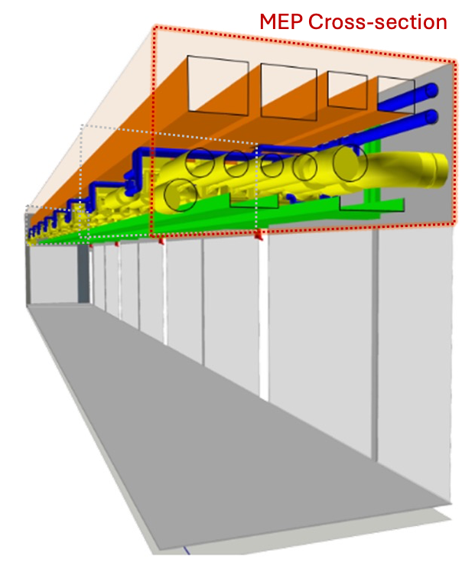 (a) Full MEP route | 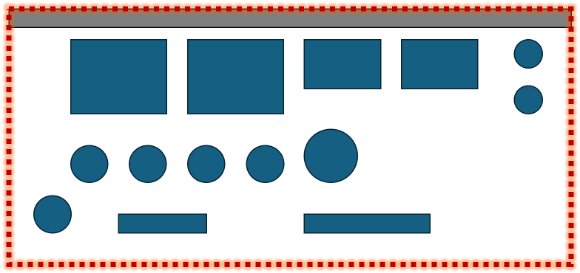  (b) One CrossMEP context
Figure 1: From route to context. (a) A complete multi-trade MEP run (pipes, cable trays, ducts) threads the corridor on modular supports spaced at intervals along its length; the highlighted box marks one cross-section plane (BIM model). (b) CrossMEP samples that plane: a single 2-D cross-section perpendicular to the run at one support location, containing every MEP element present (in blue) plus the mounting surface (in grey), each element carrying not only geometry but its service, insulation, and load (full schema in Section 3.3), which together constitute one context.
3.2 Problem–solution separation and the absence of labels
A context describes only what a support designer is given: the complete set of MEP elements to carry, each with its full properties (geometry, service, insulation, load, and position), together with the mounting surface to fix to. It contains nothing about the support assembly itself, no channel lengths, rod positions, attachment points, or topology, since those are properties of a solution, so a reinforcement-learning agent, a constraint solver, and a human designer all consume the same problem. The canonical formulation (Pedrollo et al., 2026) defines four problem inputs: (i) a local MEP cross-section, (ii) the supporting structural element, (iii) allowable attachment locations, and (iv) a manufacturer catalog; each context supplies inputs (i) and (ii) exactly, while (iii) and (iv) are deliberately excluded as solution-side and method-specific. A direct consequence is that CrossMEP is deliberately unlabeled: feasible assemblies are non-unique and catalog-dependent (a “correct” assembly under one catalog is invalid under another), and the intended consumers do not require labels. In learning-based use, supervision arises from the downstream environment (feasibility, capacity, and collapse signals) rather than from annotations; expert-designed reference assemblies are an evaluation resource, and curating such a set is future work.
3.3 Schema and encoded realism
Each context holds a tuple of elements and a mounting surface. An element carries: kind (pipe, cable tray, duct, conduit), service and trade, shape, bare width and height (mm), insulation per side (mm), a per-support-point operating load (kN), the longitudinal support span it was derived at and the corresponding distributed load (kN/m), surfaced so a downstream method may treat support spacing as a decision variable, and continuous cross-section coordinates (offset along the surface; standoff out from it), plus a generative row index documented as metadata, not a physical invariant. The surface records ceiling or wall, substrate, and thickness. The substrate is surface-aware and gates which anchor family is admissible (ceilings: concrete or steel deck; walls also masonry or drywall-on-stud), with non-structural substrates assigned only to scenes light enough to carry them; no anchor capacity is encoded. Pipes follow the Hilti PROFIS MSE pipe model as function × material: four functions (heating, refrigeration, ventilation, sprinkler) crossed with four materials (carbon steel, copper, stainless steel, plastic), each sized from its published standard (EN 10255, EN 1057, EN 10312, EN 1329) with loads derived as dry mass plus water fill for liquid functions; ventilation is modeled as small air pipes, ducts are rectangular only, and gravity drainage is out of scope because slope cannot be represented in one perpendicular section. The encoded conventions include: standard DN pipe diameters, tray widths 150–600 mm, rectangular duct sizes from the EN 1505 preferred series, and electrical conduits at IEC 61386-1 metric trade sizes (Ø20–50 mm) routed in parallel groups of two to six; pipes grouped into service banks the way trades run (heating supply+return loops, refrigeration banks, uninsulated sprinkler mains); insulation following a code-grounded (service × DN) schedule, the GEG Anlage 8 rule for heating lines (GEG, 2020) and a 30/50 mm condensation-control schedule for refrigeration (UNOG, 2008), kept explicit because the attachment method on insulated lines (bare-pipe clamp versus rigid load-bearing insert) is service-dependent; vertical tiering of bulky services with half-normal height stagger calibrated to measured in-bundle elevation spread; on walls, electrical containment is kept above wet services (drip avoidance), verified violation-free on the benchmark; clear gaps sampled from a lognormal fitted to gaps measured above the published 25 mm pipe-rack clearance minimum (μ = 5.018, σ = 0.848, Kolmogorov–Smirnov p = 0.53); and surface-aware geometry that rotates the section between ceiling and wall. Per-support loads are grounded in published engineering data: pipe masses from the published material standard for each material (EN 10255 carbon steel, EN 1057 copper, EN 10312 stainless steel, EN 1329 plastic) plus water fill for liquid functions, scaled by ASME B31.1 water-service spans (e.g., DN50 carbon steel: 7.25 kg/m × 3.0 m ≈ 0.21 kN); rectangular-duct masses from a manufacturer duct-weight engineering table including flange and bracing allowance (Walraven, 2019); tray loads on a design-for-full-fill basis; and conduit loads as steel tube (BSI, 1970) plus the IEC 40%-of-bore cable fill. The release includes a verification log that records each constant, its source, and its status. Tier probabilities and trade-mix frequencies are design choices for the benchmark; they are not claimed to reflect measured frequencies.
3.4 Difficulty tiers and splits
Difficulty is stratified by element count: tier Cn contains exactly n elements (C1–C8), with composition (kinds, trades, services, surfaces, and stacking) marginalized within each tier. Element count is used as the primary tiering variable because it is directly observable, catalog-independent, and increases the number of potential element interactions, clearance relationships, attachment choices, and ordering conflicts a synthesis method may have to resolve. Scene archetypes therefore emerge from the generator rather than being imposed; Figure 2 shows representative contexts at C1, C5, and C8. C1 covers the most common support in practice: a lone pipe of any service, a single tray, duct, or conduit. Difficulty here means scene complexity, not solver hardness, which must be measured downstream. Table 1 summarizes the design. Release v3.4 provides canonical splits on disjoint seeds: train (5,000 contexts, 22,500 elements, seed 1000), validation (500 contexts, 2,242 elements, seed 2000), test (500 contexts, 2,242 elements, seed 3000), and a 1,000-context benchmark (seed 42, 125 per tier; 4,500 elements: 2,668 pipes, 962 conduits, 576 trays, 294 ducts); the generator reproduces all splits deterministically, and a compositional interface filters or generates scenes to a user-specified mix (e.g., exactly three pipes and one tray).
Tier composition. Each tier is defined by an exact element count; levels and stagger amplitude are derived from that count, while load and bundle width emerge from the sampled elements. Across all tiers, element kinds are drawn from {pipes, cable trays, ducts, conduits} (C1 = any single kind), pipe sizes span DN15–100 (steel series), with plastic up to 125 mm, and the surface mix is held at ≈78% ceiling / 22% wall. Ranges below are observed over the v3.4 training split (5,000 contexts).
Table 1: Count-stratified tiers. Tier Cn holds exactly n elements; composition is marginalized within tier.
Tier | Elements | Levels | Stagger (mm) | Total load (kN) | Bundle width (mm) | Ceiling/Wall
C1 | 1 | 1 | none | 0.0–2.2 (med 0.1) | 70–1050 | 78 / 22
C2 | 2 | 1–2 | 75 | 0.0–4.3 (med 0.2) | 77–2208 | 78 / 22
C3 | 3 | 1–2 | 75 | 0.0–4.4 (med 0.4) | 174–2413 | 79 / 21
C4 | 4 | 1–2 | 75 | 0.1–6.0 (med 0.8) | 290–3242 | 78 / 22
C5 | 5 | 1–2 | 75 | 0.1–8.6 (med 1.0) | 364–4014 | 78 / 22
C6 | 6 | 1–3 | 120 | 0.1–7.6 (med 1.3) | 401–3265 | 79 / 21
C7 | 7 | 2–3 | 120 | 0.1–9.3 (med 1.6) | 472–3728 | 77 / 23
C8 | 8 | 2–3 | 120 | 0.2–10.0 (med 1.8) | 550–4177 | 81 / 19
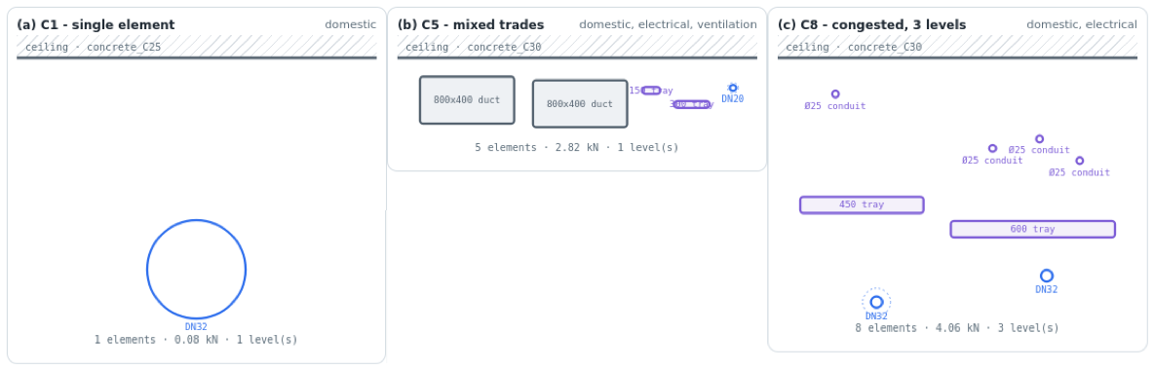
Figure 2: Representative contexts. (a) C1 ceiling: a single pipe. (b) C5 ceiling: mixed trades. (c) C8 ceiling: eight elements across three staggered levels. Dashed rings denote insulation envelopes.
4. VALIDATION AND VERIFICATION
Every released context passes a validator enforcing physical sensibility: a pairwise clearance check requiring any two elements to be separated along the surface or in standoff by at least their combined half-extents plus the clearance floor (robust to stagger), and per-row centering. Encoded conventions were then verified in two steps. First, against documented practice: tiering order, multi-trade rack organization, and clearance magnitudes match coordination literature. Second, against measurement: both Duplex discipline models were parsed with IfcOpenShell (MEP: 427 flow segments; Plumbing: 231, all sized), every segment meshed, and each segment’s axis and position recovered from geometry to compute layout statistics of horizontal parallel runs. Table 2 summarizes the comparison: three generator properties were confirmed (size mix, run multiplicity, in-bundle elevation spread) and one corrected: measured clear gaps are irregular rather than modular (MEP IQR 25–279 mm; Plumbing 19–202 mm), so the generator samples gaps from a lognormal fitted to the above-floor measured population. The measured upper range partly reflects distributed residential branch piping that shares no support; rack-mounted services are deliberately packed tighter, so the generator sits at the tight end of the measured band (Figure 3c).
Table 2: Layout statistics measured on the open Duplex Apartment IFC model versus generated.
Layout statistic | Measured (Duplex) | Generated (v3.4) | Outcome
Dominant pipe sizes | DN25, DN40, DN15 | DN15–100, small-bore dominant | match
Parallel pipes per run | 2–4 (typical) | 2–6 by tier | match
Mixed sizes within a run | yes | yes (banked) | match
In-bundle elevation spread | median 79 mm, p75 282 mm | stagger 40–100 mm | match
Clear gap, adjacent runs | median 108, IQR 25–279 mm | lognormal-fitted (median 150 mm) | fitted
Second model (Plumbing) | gaps median 54, IQR 19–202; sizes DN25/40/15 | consistent | match
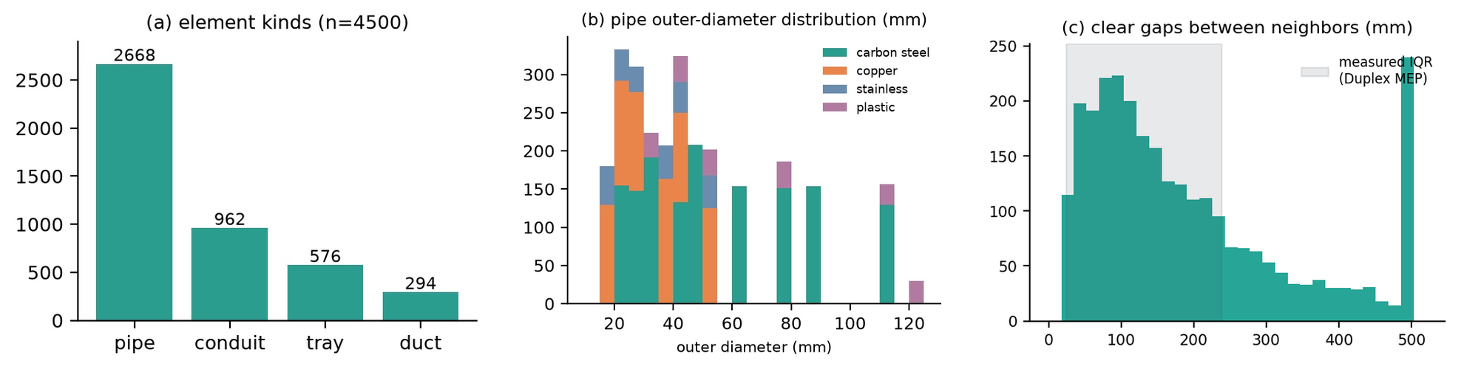
Figure 3: Benchmark-split statistics (n = 1,000). (a) Element kinds. (b) Pipe outer-diameter distribution by material. (c) Clear gaps; the shaded band is the IQR measured on the Duplex MEP model.
5. EXPERIMENTS
5.1 Are the tiers actually ordered?
Element count per tier is exact by construction, so ordering is verified on the remaining congestion metrics. All three congestion metrics trend with element count. Median minimum pairwise clearance falls from 120 mm (C2) to 61 mm (C8) (C1 contains no element pairs); median total load rises from 0.12 kN (C1) to 1.55 kN (C8); and median bundle width widens with element count. The trends are near-monotone in the means but not strictly monotone in the medians, which show small-sample non-monotonicity at mid-to-high tiers (e.g., total load dips C7→C8, clearance is roughly flat C5–C7), reflecting composition marginalized within each tier at 125 contexts per tier (Figure 4a–b). Element count, the controlled difficulty axis, is exact by construction. Difficulty is thus carried jointly by count, congestion, load, and stacking, with count as the controlled axis.
5.2 Quantitative distribution verification
Gap realism is quantified as the Wasserstein-1 distance between generated and measured clear-gap distributions (gaps below 600 mm, the shared-support-plausible range). Against the MEP discipline model (99 gaps), fixed modular gaps score 139 mm and the released fitted-lognormal generator 41 mm; against the Plumbing model, 89 mm; against the pooled sample, 59 mm. For context, the two real discipline models of the same building are 50 mm apart from each other; the synthetic-to-real distance is comparable to the real-to-real variation.
5.3 Catalog stress test
Finally the dataset is connected to the synthesis task it serves. The companion SSA codebase releases a safe-to-share catalog whose clamp family has two diameter bins (48–54 mm at 2.5 kN and 108–114 mm at 4.0 kN, reflecting real configurations). Per element, coverage is tested using the bare outer diameter for uninsulated services and the insulated diameter for insulated lines, where practice requires clamping over a rigid insert. Coverage is 11.5% of pipes overall and, because composition is marginalized within tiers, roughly uniform across counts (8.4–13.2%, Figure 4c): the dominant gap is not size but kind: coverage is zero for the 1,832 trays, ducts, and conduits, for which the catalog defines no attachment family, and small-bore pipe sizes fall below the smallest released bin. Loads are never binding; diameter and kind coverage are. The dataset thus quantifies precisely which catalog extensions multi-trade synthesis requires (small-bore clamp bins first, then tray, duct, and conduit attachments), turning “generalize the catalog” from an aspiration into a measured requirement.
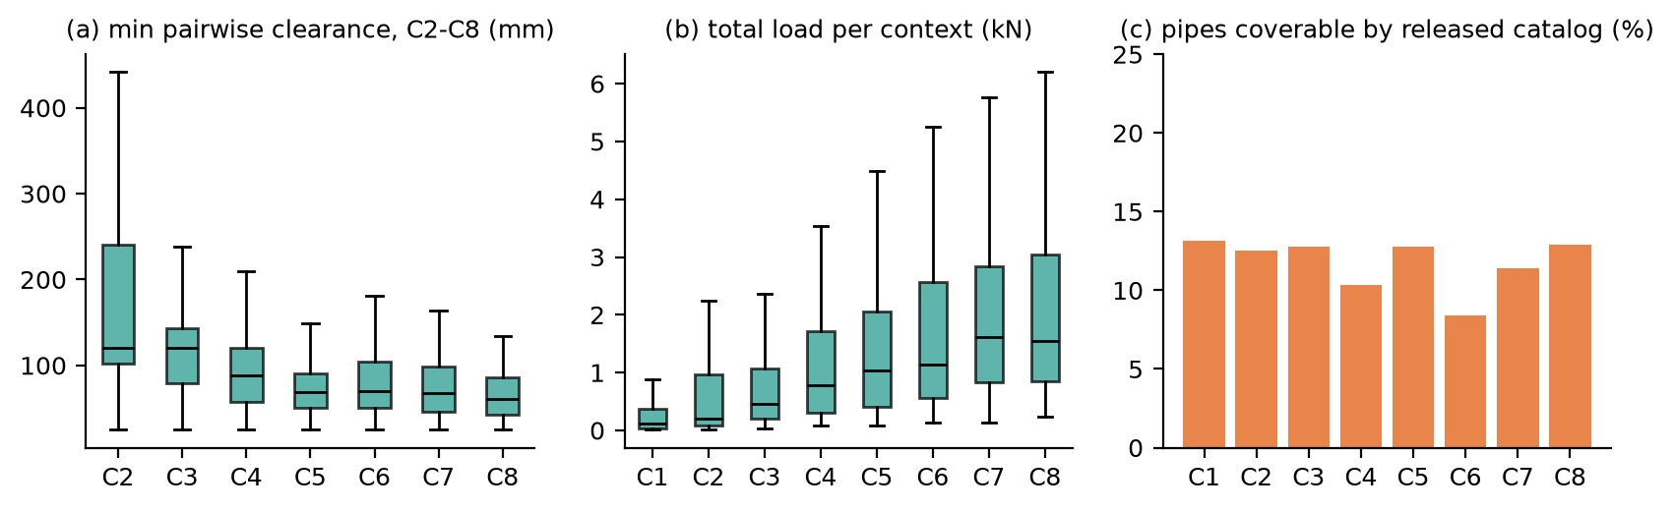
Figure 4: Experiments on the benchmark split. (a) Minimum pairwise clearance falls with element count (C2–C8). (b) Total load rises with element count (C1–C8). (c) Share of pipes coverable by the released two-bin clamp catalog.
6. INTENDED USE AND LIMITATIONS
CrossMEP is designed as the input distribution for SSA synthesis research: curriculum training over element counts C1→C8, success-versus-count curves reporting per-tier success and feasibility-collapse rates, held-out testing with unseen seeds, and compositional probes built with the filtering and custom-generation interface. Because contexts carry no assembly information, the same files serve masked reinforcement learning, constraint-programming baselines, and human benchmarking without modification. Limitations are stated plainly. Each context is a single cross-section; routing along the run, branches, and elevation changes are out of scope, as is support spacing; the per-support load embeds a typical-span assumption, and v3.4 surfaces that span (and the distributed load) explicitly so a downstream method may expose it as a variable. Verification rests on two discipline models of one open residential project, which directly validate small-bore statistics; congested high-count scenes are grounded in coordination practice and standards rather than measurement, because available open commercial models did not export element sizes. Custom-generated compositions are construction-valid by the same rules, but realism verification attaches to the natural distribution. Trade-mix frequencies are plausible rather than surveyed. The dataset is synthetic, contains no personal or project-identifying information, and must not be used for the structural design of real installations.
7. CONCLUSION
CrossMEP provides, to our knowledge, the first public problem distribution for Structural Support Assembly synthesis: count-stratified, verified against two discipline models of a built project with every physical constant source-traced, deliberately unlabeled, and released as plain JSON with canonical splits, a deterministic single-file generator, a compositional filtering and custom-generation interface, a 56-check quality-gate suite, IFC-measurement scripts, an interactive gallery, and a datasheet following Gebru et al. (2021). The release is available at https://github.com/lavinia-ped/CrossMEP_Dataset. Together with the canonical formulation it completes a reinforcement-learning environment in which constraints generate supervision. Future work includes per-tier feasibility-collapse measurement with a multi-element synthesis environment, expert plausibility review of generated scenes, verification against commercial corridor models, and a curated expert reference set for evaluation.
ACKNOWLEDGEMENTS
This work was conducted at the Center for Integrated Facility Engineering (CIFE), Stanford University, in collaboration with Hilti AG, which supports the first author's doctoral research and provided access to its PROFIS Modular Supports Engineering software.
REFERENCES
AGACAD, (n.d.). MEP Hangers: distributing hangers and supports along ducts, pipes, cable trays and conduits in Revit and from IFC, [Online], Available: https://agacad.com [9 June 2026].
Asghari, V., Wang, Y., Biglari, A.J., Hsu, S.-C., & Tang, P., (2022). Reinforcement learning in construction engineering and management: a review. Journal of Construction Engineering and Management, 148(11): 03122009.
ASME, (2024). ASME B31.1 Power Piping, Table 121.5. American Society of Mechanical Engineers, New York, USA.
Autodesk University, (2016). Revit plug-in: automated hanger and seismic bracing layout and design for MEP systems, [Online], Available: https://www.autodesk.com/autodesk-university [9 June 2026].
Bengio, Y., Louradour, J., Collobert, R., & Weston, J., (2009). Curriculum learning. In Proceedings of the 26th International Conference on Machine Learning (ICML), Montreal, Canada, p. 41–48.
BSI, (1970). BS 4568-1: Specification for steel conduit and fittings with metric threads of ISO form for electrical installations. British Standards Institution, London.
buildingSMART International, (n.d.). Duplex Apartment open IFC dataset (Common BIM Files), [Online], Available: https://github.com/buildingsmart-community [9 June 2026].
CEN, (1997). EN 1505: Ventilation for buildings, sheet metal air ducts and fittings with rectangular cross-section, dimensions. European Committee for Standardization, Brussels.
CEN, (2002). EN 10220: Seamless and welded steel tubes, dimensions and masses per unit length. European Committee for Standardization, Brussels.
CEN, (2004). EN 10255: Non-alloy steel tubes suitable for welding and threading. European Committee for Standardization, Brussels.
Gebru, T., Morgenstern, J., Vecchione, B., Wortman Vaughan, J., Wallach, H., Daumé III, H., & Crawford, K., (2021). Datasheets for datasets. Communications of the ACM, 64(12): p. 86–92.
GEG, (2020). Gebäudeenergiegesetz, Anlage 8: Anforderungen an die Wärmedämmung von Rohrleitungen. Federal Republic of Germany (as amended).
Hilti, (n.d.). PROFIS Modular Supports Engineering: modular support design software, [Online], Available: https://profismse.hilti.com [9 June 2026].
Huang, S. & Ontañón, S., (2022). A closer look at invalid action masking in policy gradient algorithms. In Proceedings of the 35th International FLAIRS Conference, Hutchinson Island, USA.
IEC, (2023). IEC 61537: Cable management, cable tray systems and cable ladder systems. International Electrotechnical Commission, Geneva.
IEC, (n.d.). IEC 61386-1: Conduit systems for cable management, general requirements. International Electrotechnical Commission, Geneva.
Khanzode, A., Fischer, M., & Reed, D., (2008). Benefits and lessons learned of implementing building virtual design and construction (VDC) technologies for coordination of mechanical, electrical, and plumbing (MEP) systems on a large healthcare project. Journal of Information Technology in Construction, 13: p. 324–342.
Krijnen, T., (n.d.). IfcOpenShell: an open source software library for working with Industry Foundation Classes, [Online], Available: https://ifcopenshell.org [9 June 2026].
MaRS BIM, (2025). Optimizing mechanical, electrical & plumbing systems with BIM coordination, [Online], Available: https://www.marsbim.com [9 June 2026].
Mike Holt Forum, (2024). Cable tray trapeze supports and process piping, [Online], Available: https://forums.mikeholt.com [9 June 2026].
MSS, (2025). ANSI/MSS SP-58: Pipe hangers and supports, materials, design, manufacture, selection, application, and installation. Manufacturers Standardization Society, Vienna, VA, USA.
Pedrollo, L., Graeber, T., & Fischer, M., (2026). Feasibility-aware sequential synthesis of structural support assemblies: a canonical formulation for automated MEP support design. In Proceedings of the International Symposium on Automation and Robotics in Construction (ISARC), Singapore.
Schulman, J., Wolski, F., Dhariwal, P., Radford, A., & Klimov, O., (2017). Proximal policy optimization algorithms, [Online], Available: https://arxiv.org/abs/1707.06347 [9 June 2026].
Tatum, C.B. & Korman, T., (1999). MEP coordination in building and industrial projects. CIFE Working Paper No. 54, Stanford University, Stanford, USA.
Tobin, J., Fong, R., Ray, A., Schneider, J., Zaremba, W., & Abbeel, P., (2017). Domain randomization for transferring deep neural networks from simulation to the real world. In Proceedings of IEEE/RSJ IROS, Vancouver, Canada, p. 23–30.
UNOG, (2008). Standard for insulation of chilled water, heating, cold water piping. United Nations Office at Geneva, facilities engineering requirement.
Walraven, (2019). Air duct dimensions and weights, data sheet. Walraven Group, Mijdrecht, Netherlands.
Zhao, X., Li, J., Yang, Q., Fan, X., Liu, S., Cao, L., Wang, Y., & Zhang, Z., (2026). Corridor MEP pipeline integration and hanger-layout optimization using BIM-based genetic partitioning and performance analysis. Journal of Intelligent Construction, 4(1): 9180114.

