A Combined Transfer Learning Physics Informed Interpretable Machine Learning Approach to Modelling the Shear Strength of Concrete Walls
Jacob Dylan Murphy¹, Stephanie German Paal¹
¹Texas A&M University, United States of America
jacob70920@tamu.edu

ABSTRACT

Data scarcity is a persistent challenge in civil engineering, especially for emerging materials and uncommon structural configurations. This study presents a novel, interpretable machine learning framework combining Transfer Learning (TL) and Physics-Informed Machine Learning (PIML) using Genetic Expression Programming (GEP). Physical knowledge, based on ACI shear strength equations, is injected through feature engineering, while the 2M2P algorithm enables knowledge transfer from common wall geometries to less common ones with limited data. Results show that the TL-PIML models often outperform both traditional data-driven models and existing code equations, particularly under severe data constraints. The approach yields interpretable, physically consistent models that achieve higher utilizing limited training data. This work demonstrates the effectiveness of combining TL and PIML for improving predictive modelling in structural engineering and offers a robust strategy for extending machine learning applications to data-sparse scenarios.

KEYWORDS

Machine Learning, Transfer Learning, Physis Informed Machine Learning, Reinforced Concrete Walls, Shear Strength

1. INTRODUCTION
Civil engineering is a domain that suffers from a lack of data in many of its different disciplines, especially in regard to emerging materials and methods. The reason for the scarcity of data within civil engineering is the cost and time associated with carrying out the required experimental tests to construct a sufficient database (Pak and Paal 2022, Li, Zhu et al. 2024). In recent years both transfer learning (TL), and physics-informed machine learning (PIML) have gained traction and have been successfully employed in a myriad of domains, many of which are related to issues arising from data scarcity.
TL offers a promising approach for modelling complex structural behaviour when data is scarce. Inspired by the way humans apply past experiences to new tasks, TL enhances predictive accuracy by transferring knowledge from a related source domain to a target domain (Pan and Yang 2010). Unlike traditional ML methods that train solely on a single dataset, TL enables models to leverage external knowledge, improving performance even with limited target data. Reducing the resources needed for modelling and analysis lowers the barrier to entry for individuals, institutions, and companies to explore innovative solutions and address engineering challenges. This broader accessibility encourages greater contributions to the understanding and design of civil infrastructure
Similar to TL, PIML is a machine learning method that leverages existing physical knowledge to improve the performance of a model without necessitating an increase in data. Instead of utilizing data driven methods, PIML integrates established physical laws into the training process of machine learning models, offering a hybrid approach that combines data-driven techniques with domain knowledge. Unlike traditional ML methods that rely entirely on data, PIML incorporates physical insights to improve model performance, especially in scenarios with sparse or noisy datasets. This fusion allows PIML to generalize better, reduce overfitting, and maintain robustness in complex systems where conventional ML might struggle.
In civil and structural engineering, where high-quality data is often limited due to cost and logistical challenges, PIML offers a practical solution by using physics to compensate for data scarcity (Raissi, Perdikaris, and Karniadakis 2019). It can be used to adapt to the available data: increasing reliance on physics when data is scarce and vice versa when data is abundant. This flexibility makes it well-suited for real-world engineering problems (Vadyala et al. 2022; Xu et al. 2023). Moreover, by embedding physical laws into the model, PIML enhances interpretability, addressing the black-box problem common in traditional ML (Gilpin et al. 2018). This transparency builds trust among practitioners and facilitates adoption in high-stakes decision-making settings (Tan and Luo 2023).
Feature engineering is a PIML method that injects physics knowledge into the training process through the formulation and inclusion of new features for the dataset. Unlike traditional machine learning, where features solely consist of experimental measurements, feature engineering leverages domain knowledge, such as conservation laws, constitutive relationships, and governing equations to inform the feature space. Effective feature engineering can enhance model generalizability, reduce overfitting, and enable learning from limited datasets, making it a powerful approach in scientific and engineering applications where data is often scarce but physical laws are well-established. This method has been successfully implemented in various civil engineering applications including in cable vibration estimation (Yang, Sanchez et al. 2019), creep fatigue life predictions for steel (Zhang, Gong et al. 2021), and bridge deck rebar degradation (Li, Zhou et al. 2023). These previous successful applications span a wide range of civil engineering domains and utilize engineered features for both input features and response features, highlighting the flexibility and general applicability of this method.
Alongside the issue of data scarcity within civil engineering there is also the issue of interpretability. ML algorithms are powerful tools that allow researchers to analyse complex datasets and obtain accurate predictions of behaviour on unseen data. A drawback to ML models is their form, as the most widely used and powerful algorithms are black-box models. Black-box models are those which, once provided the requisite inputs, provide an output without having the intermediary steps feasibly understood (Ljung 2001, Guidotti, Monreale et al. 2018). Black-box models are less desirable in the field of civil engineering as its highly beneficial for engineers to fully understand the models they are implementing. To address this issue a white-box model, one who’s intermediary steps between input and output are clearly exhibited in a manner amenable to human comprehension, is utilized in this research.
Given the persisting data scarcity problem within the domain of civil engineering and the abilities of both TL and PIML to address these issues, a combined TL-PIML method utilizing an interpretable ML algorithm for a civil engineering application will be presented and analysed in this paper. The chosen application is the ultimate shear of reinforced concrete walls. The ACI code equation for reinforced concrete wall nominal shear strength estimation for design will be utilized as the physical knowledge to inform the training process. The novel TL-PIML machine learning algorithm, the experimental set up, and the results and discussion will be presented in the following sections.

2. Methodology
The proposed combined TL and PIML algorithm is built on the genetic expression programming (GEP) algorithm (Ferreira 2001) due to the high level of interpretability provided. GEP models are in the form of simple mathematical equations identical in form when compared to those currently utilized within ACI-318-19. This level of similarity to existing accepted methods when compared to highly utilized models such as artificial neural networks, random forests, and support vector machines presents GEP as an attractive choice.
Ferreira (2001) introduced GEP as an advancement over traditional Genetic Programming (GP), aiming to overcome structural limitations. Both are evolutionary algorithms that follow a similar process, seen in Fig 1: generating an initial population, evaluating individuals, and iterating through selection and reproduction until termination criteria are met. GP uses evolutionary principles to evolve programs that approximate a target output (Koza 1994), but it often suffers from excessive growth in program size without performance gains, known as code bloat, reducing interpretability. Since interpretability is central to this study, GEP is preferred for its ability to control code bloat effectively.
GEP distinguishes itself by separating genotype and phenotype. A fixed-length linear chromosome (genotype) maps to an expression tree (phenotype) that can be translated into an equation. Its structure includes noncoding regions that may become active through mutation. This design enables GEP to model complex behaviours while avoiding code bloat due to size constraints. GEP’s key advantages include guaranteed valid expressions, variable-length trees, and improved interpretability over traditional GP.

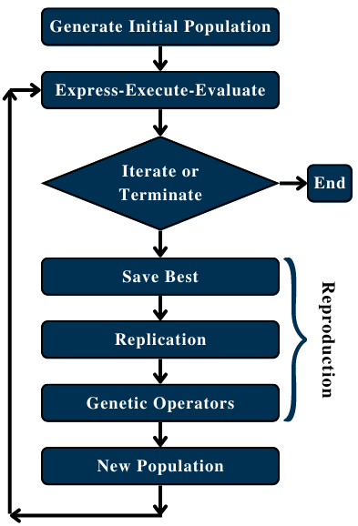
Figure 1: Evolutionary algorithm flow chart

The proposed algorithm is comprised of two parts, physics injection and pretraining and fine tuning. The physics injection takes place in the data processing step. Based on the ACI 318-19 (Committee 1995) provisions for calculation of nominal shear in a reinforced concrete wall, specifically Equation 11.5.4.3, seen in Equation (1) below, a new feature is generated using the corresponding features from the existing source and target datasets.

$V_{n}=(α_{c}λ\sqrt{f_{c}^{'}}+ρ_{t}f_{yt})A_{cv}$ (1)
where $V_{n}$ – Nominal Shear (lb);
$α_{c}$ – relative contribution of concrete strength to nominal wall shear strength);
$λ$ – modification factor for lightweight concrete;
$f_{c}^{'}$compressive strength of concrete (psi);
$ρ_{t}$ – reinforcement ratio;
$f_{yt}$ – yield strength of transverse reinforcement (psi); and,
$A_{cv}$ – gross area (in²).

$$α_{c}=\left\{\begin{aligned}3 for\frac{h_{w}}{l_{w}}≤1.5 \\ 2 for\frac{h_{w}}{l_{w}}≥2.0 \end{aligned}\right.$$
where $h_{w}$ – Height of wall;
$l_{w}$ – length of wall.

This new feature, denoted p0 through p4, is added to the dataset and is used to inform training. A model that utilizes this single variable can be seen as the simplest solution without undergoing any training; however, as the GEP algorithm iterates, it will improve upon the performance of this provided knowledge. Furthermore, alongside the entirety of Equation (1) being utilized as the injected physical knowledge, the specific terms of Equation (1) will also be evaluated.
Building upon this physics-informed foundation, a range of features incorporating varying degrees of prior knowledge will be generated and utilised in training. The results will be analysed to assess the impact of different levels of physics injection. The considered features are presented in Table 1 and were derived from the terms in Equation 1, with the inclusion or exclusion of multiplication by $A_{cv}$.

Table 1: Considered physical features

The quantity of target training data will be systematically varied across three distinct scenarios: mild, moderate, and severe. By exploring the interaction between different magnitudes of physics-informed knowledge injection and varying levels of available target data, this study seeks to provide an understanding of how these factors influence model performance. The findings will offer insight into the conditions under which the integration of physics-based knowledge yields the greatest advantages and helps establish guidelines for their most effective and appropriate application in data-driven modeling. The data cases and their associated data distributions can be seen in Table 2.

Table 2: Data availability cases

2.1 2M2P Algorithm
To achieve transfer learning a parameter transfer (Pan and Yang 2010) strategy, Mutated Multiple Partitioned Population GEP (2M2P), is employed. A source dataset is utilized to pretrain a set of GEP models known as a population. This pretrained population is then taken as the starting point for training on the target dataset. Before training begins on the target dataset the pretrained population is subjected to a forced uniform mutation to ‘break’ them as they are likely to be highly fit to the source data. After the completion of training on the target dataset the model for shear strength of reinforced concrete walls is obtained.
The 2M2P framework was developed to address key challenges in knowledge transfer when data availability is severely limited. This approach specifically targets three issues: (1) crowding and early convergence, (2) selection of an effective transfer mechanism, and (3) reintroducing genetic diversity to the transferred population. To mitigate crowding, which can reduce genetic diversity, the framework incorporates partitioning, where the population is divided into independent batches to prevent premature convergence. Population transfer is achieved through the Single Partition Initial Population method (SPIP), which selects the best individuals from a single partition. These strategies ensure that the transfer population is optimally formed to enhance knowledge retention and application. The hyperparameters of the model can be seen in Table 3.

Table 3: Hyperparameters
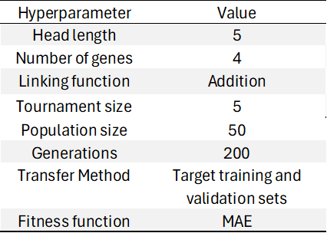

The primary novelty of the 2M2P algorithm is the forced evolutionary layer. To further maintain genetic diversity, the Forced Evolutionary Layer (FEL) is employed to mutate individuals without reproduction, preventing overfitting to the source dataset while preserving critical learned knowledge.
Pretrained individuals are often highly specialized to the source dataset, with limited genetic diversity. Their mathematical relationships tend to be so finely tuned that even minor mutations greatly degrade performance, reducing their chances of reproduction. Additionally, since the best-fit individual is always excluded from mutation, it propagates unchanged through generations, reinforcing convergence and limiting exploration. To counteract this, the FEL was introduced to increase diversity without reproduction, allowing the algorithm to escape local minima while preserving core knowledge from the source task.
FEL applies a predetermined mutation operator uniformly to all individuals, bypassing selection mechanisms such as tournament reproduction. In this work, two-point recombination is chosen for its ability to introduce variation while retaining key information from the source task. This operator swaps segments of equal length between two genotypes, inducing variation without introducing new genetic material.
The 2M2P algorithm integrates the aforementioned techniques and GEP to facilitate efficient knowledge transfer. The framework follows a structured process: training on a source dataset, evaluating performance on target datasets, applying forced evolution to enhance genetic diversity, and subsequently using the evolved population as the initial population for the transfer model, seen in Fig 2. The model undergoes training and validation on the target dataset, with the best-performing individual selected using the training and validation sets after the predetermined number of generations pass.

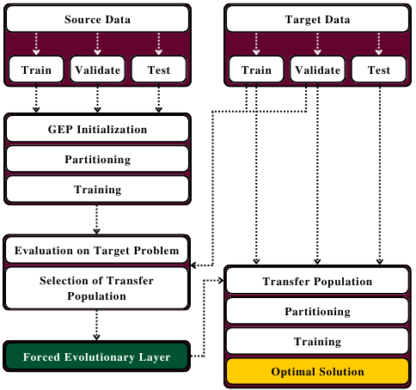
Figure 2: 2M2P algorithm outline

2.2 Dataset
The dataset utilized in this study is comprised of 481 reinforced concrete wall specimens of various shapes (Usta, Pujol et al. 2017). The dataset contains geometric, material, design, and experimental data as well as the response variable of ultimate shear strength. The datapoints in this dataset were gathered from existing literature published between 1960 and 2017 for monotonically and cyclically loaded beams. The features utilized in this study can be seen in Table 4. Concrete walls of the most numerous shapes such as I and R will be utilized as the source dataset to provide the adjacent knowledge for walls with more uncommon shapes such as C, G and T, which will be employed in the target dataset.

Table 4: Feature Description 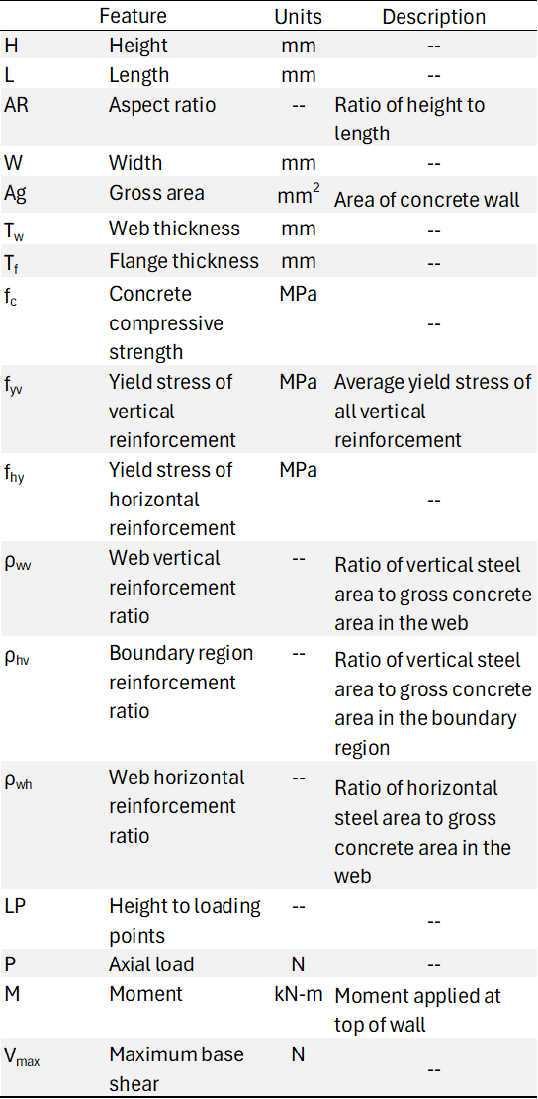

Following data processing and feature selection the source dataset contains 374 datapoints and the target dataset contains 30 datapoints.

3. Results and Discussion
The TL-PIML-generated models are presented in Tables 5–7, with the highest-performing model highlighted in bold within each table. Alongside the 5 physics informed features a case with no additional physics is examined (None), which is a conventional application of transfer learning. Across the majority of target data availability scenarios, the TL-PIML models consistently outperform those trained exclusively on either the source or target datasets. In the None case, where no physics informed features are available, the source model outperforms or nearly matches both the target-only and TL-PIML models. This result is attributable to the absence of embedded physics knowledge in the target-trained and TL-PIML models, which limits their ability to generalize without target-specific information. In the few remaining instances where the source model marginally outperforms the TL-PIML model, the performance differences are minimal. Notably, the inclusion of the physics-informed variables p0 and p3 consistently enhances model performance, surpassing the baseline models in all cases.

Table 5: Source model R² Scores
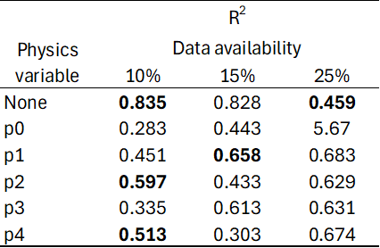

Table 6: Target model R² Scores 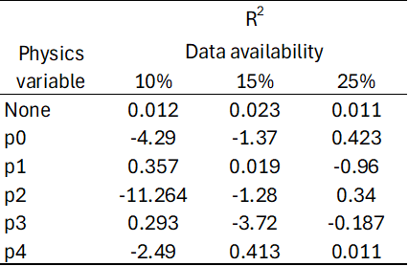

Table 7: TL-PIML model R² Scores 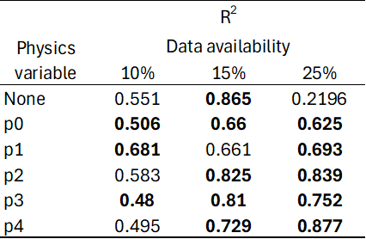

The inclusion of the variable Acv in the physics-informed features p2​ and p4​ did not lead to a consistent improvement in predictive performance when compared to p1 and p3​, respectively. While p2 significantly outperforms p1​ at the 15% and 25% target data availability levels, p4​ demonstrates performance comparable to p3​ under the same conditions. Interestingly, the feature p0, which contains all of Equation (1)​, did not produce the highest gains in predictive accuracy across all levels of data availability. This suggests that a smaller, more adaptable physics-informed feature may be more effective for achieving robust performance in PIML applications within this context.

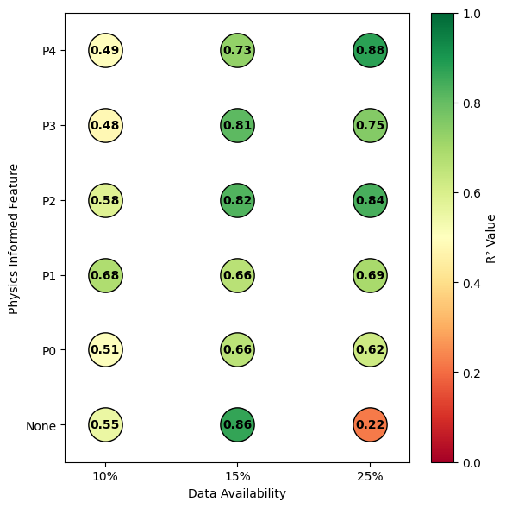
Figure 3: TL-PIML R² Scores across data availability and physics informed features

The anticipated trend of improved model performance with increasing target data availability is evident in Fig 3. However, the corresponding expectation that incorporating more physics-informed features would lead to higher model performance is not clearly observed. Instead, enhanced performance appears to be associated with the individual components comprising p0. Notably, p0 outperforms some of the less complex engineered features at the 10% data availability level. This outcome is likely due to the challenges the model faces when training on such limited data, where the relatively inflexible but moderately accurate p0 feature contributes more significantly to the final prediction.
The resulting model predictions also demonstrate superior performance compared to the existing ACI equation for wall shear (Equation (1)), which yields an R² value of –7.53. However, this comparison is not entirely appropriate, as the model is trained on a relatively small dataset and may be highly tuned to the specific feature distributions present within it. In contrast, the ACI equation is designed to be broadly applicable and intentionally conservative to ensure safety across a wide range of scenarios.
The models corresponding to some of the combinations of data availability and physics knowledge are presented in Equations (2)–(3). These models demonstrate a significantly higher degree of interpretability when compared to more complex and widely adopted machine learning techniques, such as neural networks or random forests. While such models often achieve strong predictive performance, their black-box nature poses challenges in engineering applications. In contrast, the use of GEP enables the generation of mathematical expressions that can be readily examined, validated, and implemented by domain experts. By incorporating PIML and TL strategies, the predictive performance of GEP-based models can be substantially enhanced, even in scenarios characterized by limited training data. This integrated approach offers a promising compromise among the competing demands of accuracy, interpretability, and data efficiency, making it particularly well-suited for applications in civil engineering and other domains.

$V_{n}=(-2*H+L+ρbv*(2*Ag+2*HLP+P*ρwh+fyh+{ρbv}^{2}*(Ag*L+P)))/ρbv$ (2)

$V_{n}=(AR*fyv*\left(M-ρwh\right)*\left(Ag-HLP+M*ρwh\right)+AR*fyv*\left(AR*W+ρwh*\left(M-ρwh\right)\right)+AR*\left(M-ρwh\right)*\left(Ag*fyv+P*\left(Tf-fc\right)\right)+fyv*\left(M-ρwh\right)*\left(W+fc*fyv*ρbv*\left(Tw+W\right)\right))/(AR*fyv*\left(M-ρwh\right))$ (3)

Interestingly the engineered features do not show up in either of these equations. It is possible that they play an intermediate role during training before being mutated out or replaced with other features. The Target model is trained for the sum of the generations of the source and TL-PIML models, so the increased performance is not based on having a greater number of generations to train on. Similarly, the models where there are no engineered features present generally do not perform well, with the lowest performing model being in this category.

4. Conclusion
Despite the extremely limited availability of experimental data for C, G, and T-shaped structural wall configurations, the proposed physics-informed 2M2P model demonstrates notable improvements in predictive performance. By effectively integrating prior knowledge from other, more extensively studied wall geometries, alongside established principles of shear behaviour in RC walls, the model exhibits a strong capacity for data-efficient learning. This approach not only enables accurate predictions under data-constrained conditions but also produces models that retain interpretability, an essential feature for engineering applications where transparency and physical plausibility are critical. The results underscore the utility of physics-informed modelling frameworks in extending the applicability of data-driven approaches to previously underrepresented structural configurations, thereby enhancing the robustness and generalizability of predictive tools in structural engineering contexts.
The findings further highlight that the injection of physics-based knowledge into the modelling process yields the greatest benefit under conditions of limited data availability, precisely the scenarios in which such injection is most critical. By providing physics-based features the model is guided toward physically consistent solutions even when empirical data is sparse. This not only improves model stability and generalization but also reinforces the role of physics-informed approaches as a powerful tool for addressing the inherent limitations of data-driven modelling in structural engineering, particularly in cases where acquiring additional data is impractical or cost-prohibitive.

4.1 Future Work
A logical progression for future work involves the integration of multiple physics-informed features into a single dataset. Given the findings of this study, which suggest that smaller, more flexible engineered features tend to yield superior predictive performance compared to larger, more rigid features encapsulating all available physics knowledge, it is plausible that incorporating several smaller features could further enhance model performance. This approach to embedding domain knowledge may offer greater adaptability and allow the model to selectively leverage relevant physics under varying data conditions.
In parallel, it is important to investigate the lower bound of physics incorporation, specifically, to determine how minimal the embedded physics content in an engineered feature can be while still providing a measurable performance benefit. Understanding this threshold could inform guidelines for constructing efficient physics-informed features, particularly in data-scarce environments where maximizing predictive utility with minimal information is critical. Such exploration would contribute to a greater understanding of the trade-offs between feature complexity and model performance in PIML frameworks.

REFERENCES

Committee, A. C. I. (1995). Building code requirements for structural concrete : (ACI 318-95) ; and commentary (ACI 318R-95), Farmington Hills, MI : American Concrete Institute, [1995] ©1995.
Ferreira, C. (2001). "Gene Expression Programming: A New Adaptive Algorithm for Solving Problems." Complex Syst 13.
Gilpin, L. H., D. Bau, B. Z. Yuan, A. Bajwa, M. Specter, and L. Kagal. 2018. "Explaining Explanations: An Overview of Interpretability of Machine Learning." In 2018 IEEE 5th International Conference on Data Science and Advanced Analytics (DSAA), 80-89.
Guidotti, R., A. Monreale, S. Ruggieri, F. Turini, F. Giannotti and D. Pedreschi (2018). "A Survey of Methods for Explaining Black Box Models." ACM Comput. Surv. 51(5): Article 93.
Karniadakis, G. E., I. G. Kevrekidis, L. Lu, P. Perdikaris, S. Wang and L. Yang (2021). "Physics-informed machine learning." Nature Reviews Physics 3(6): 422-440.
Koza, John R. 1994. 'Genetic programming as a means for programming computers by natural selection', Statistics and Computing, 4: 87-112.
Li, X., Z. Zhu, Y. Zhou, Z. Zhou, L. Zhang and C. Chen (2024). "Combining transfer learning and statistical measures to predict performance of composite materials with limited data." Computer-Aided Civil and Infrastructure Engineering.
Li, Z., J. Zhou, H. Nassif, D. Coit and J. Bae (2023). "Fusing physics-inferred information from stochastic model with machine learning approaches for degradation prediction." Reliability Engineering & System Safety 232: 109078.
Ljung, L. (2001). Black-box models from input-output measurements. IMTC 2001. Proceedings of the 18th IEEE Instrumentation and Measurement Technology Conference. Rediscovering Measurement in the Age of Informatics (Cat. No.01CH 37188).
Pak, H. and S. G. Paal (2022). "Evaluation of transfer learning models for predicting the lateral strength of reinforced concrete columns." Engineering Structures 266: 114579.
Pan, S. J. and Q. Yang (2010). "A Survey on Transfer Learning." IEEE Transactions on Knowledge and Data Engineering 22(10): 1345-1359.
Raissi, Maziar, Paris Perdikaris, and George E Karniadakis. 2019. 'Physics-informed neural networks: A deep learning framework for solving forward and inverse problems involving nonlinear partial differential equations', Journal of Computational physics, 378: 686-707.
Tan, Rui, and Wenjie Luo. 2023. "Physics-Informed Machine Learning Model Generalization in AIoT: Opportunites and Challenges." In Proceedings of Cyber-Physical Systems and Internet of Things Week 2023, 170–76. San Antonio, TX, USA: Association for Computing Machinery.
Usta, M., S. Pujol, A. S. 445B, A. Puranam, C. Song and Y. Wang (2017). ACI 445B Shear Wall Database.
Vadyala, Shashank Reddy, Sai Nethra Betgeri, John C. Matthews, and Elizabeth Matthews. 2022. 'A review of physics-based machine learning in civil engineering', Results in Engineering, 13: 100316.
Xu, Yanwen, Sara Kohtz, Jessica Boakye, Paolo Gardoni, and Pingfeng Wang. 2023. 'Physics-informed machine learning for reliability and systems safety applications: State of the art and challenges', Reliability Engineering & System Safety, 230: 108900.
Yang, Y., L. Sanchez, H. Zhang, A. Roeder, J. Bowlan, J. Crochet, C. Farrar and D. Mascareñas (2019). "Estimation of full-field, full-order experimental modal model of cable vibration from digital video measurements with physics-guided unsupervised machine learning and computer vision." Structural Control and Health Monitoring 26(6): e2358.
Zhang, X.-C., J.-G. Gong and F.-Z. Xuan (2021). "A physics-informed neural network for creep-fatigue life prediction of components at elevated temperatures." Engineering Fracture Mechanics 258: 108130.

