INTEGRATED SYSTEMS MODELLING FRAMEWORK MAPPING ESG METRICS TO SDG OUTCOMES IN CONSTRUCTION
Ramish Abdali¹, Erawati Ravindra Kadam¹, and Ann Francis Ph.D¹
¹ Indian Institute of Technology Delhi, New Delhi, India
*Corresponding email: Erawati.Kadam@civil.iitd.ac.in
ABSTRACT
The construction sector is a major contributor to greenhouse gas emissions, resource consumption, and environmental impacts, underscoring the need for sustainability assessment. In response, Environmental, Social, and Governance (ESG) reporting is becoming essential for assessing sustainability in the construction industry, as companies align their strategies with the United Nations Sustainable Development Goals (UN SDGs). However, existing ESG reporting frameworks often lack systematic integration with SDG outcomes and fail to capture the complex interdependencies inherent in construction systems. This study proposes a framework that integrates system dynamics (SD) and life-cycle data to map causal relationships between ESG indicators and SDG outcomes. The research identifies ESG indicators for the construction industry, focusing on project-level environmental, social, and governance aspects. These indicators are subsequently mapped based on theoretically grounded causal relationships and translated into causal loop diagrams (CLDs) capturing feedback mechanisms and system interactions. The CLDs are further converted into stock–flow diagrams (SFDs), enabling quantitative modelling of ESG–SDG linkages and simulation of sustainability performance over a project lifecycle. To support model parameterisation, normalised life cycle assessment (LCA) data are integrated, ensuring unit consistency and realistic representation of material, energy, and emission flows. Results show that the integrated model structure captures interconnected pathways through which ESG indicators can influence multiple SDG outcomes. The LCA-based parameterisation improves the quantification of environmental effects and their systemic impact assessment of project-level decisions. The proposed framework addresses limitations in static reporting by linking ESG performance to SDG targets in an organised and quantifiable manner. It provides a foundation for construction decision-support tools and integrated sustainability reporting.

- INTRODUCTION
The construction sector is centre of the global sustainability challenge, driving economic development, but contributes extensively to environmental degradation (Francis & Thomas, 2022), Growing regulatory pressures, climate commitments, and investor expectations have transformed Environmental, Social, and Governance (ESG) performance from a voluntary disclosure practice into the core of corporate resilience and long-term value creation (Celoza & Owens, 2025; Gong et al., 2024). Despite the proliferation of global reporting frameworks such as the Global Reporting Initiative (GRI), the Sustainability Accounting Standards Board (SASB) standards, and the Task Force on Climate-related Financial Disclosures (TCFD), the construction industry continues to grapple with fragmented ESG interpretations, inconsistent measurement practices, and the absence of project-level standardisation.
Furthermore, the UN Sustainable Development Goals (UN SDGs) have emerged as a universal blueprint for sustainable development, through measurable environmental, social, and economic targets. Although the conceptual alignment between ESG and SDG frameworks is widely acknowledged (Markopoulos et al., 2024). ESG indicators are assessed at organisational and project levels, whereas SDGs measure progress at national and global scales. As a result, direct, traceable linkages between ESG indicators and SDG outcomes remain underdeveloped, particularly in construction, where sustainability impacts arise from complex material flows, long supply chains, multi-stakeholder interactions, and extended building lifecycles. This misalignment represents a critical knowledge and methodological gap in translating construction project-level sustainability actions into measurable contributions toward global sustainability ambitions.
Despite progress in systems-based environmental assessment and risk modelling, an approaches linking construction-sector ESG indicators to SDG targets through SD remains insufficiently developed (Agustin & Koestoer, 2025; Wang & Xue, 2023). Current ESG frameworks largely remain checklist-based, lacking mechanisms to trace how improvements in one metric (e.g., water recycling rate, accident frequency, workforce diversity) cascade into multiple SDG outcomes. Similarly, SDG reporting rarely identifies the project-level actions driving measurable progress, limiting its usefulness for practitioners, policymakers, and investors seeking integrated sustainability assessments. Therefore, this study responds to the above gaps by developing a systems-thinking framework that explicitly links project-level ESG indicators to relevant SDG sub-targets, specifically for the construction sector. By synthesising consolidated ESG metrics, identifying causal relationships, and modelling feedback loops through CLDs and a pilot SFD, the research establishes a holistic, dynamic, and quantifiable basis for integrating ESG and SDG performance. Such a framework serves not only as a diagnostic tool for understanding sustainability interdependencies but also as a foundational step toward performance-driven ESG reporting, climate-resilient construction project planning, and circular-economy transitions in the built environment

- Literature Review
Leading ESG reporting frameworks (such as GRI, SASB) have each defined metrics relevant to construction and real estate companies. However, these frameworks often provide broad indicators that companies must interpret for their context. Recent research by Celoza and Owens (2025) specifically addressed the gap by identifying ESG metrics material to the Engineering & Construction (E&C) industry. In their study, the authors consolidated recommendations from SASB, TCFD, and GRI into a list of 69 ESG metrics spanning environmental, social, and governance categories. The study also highlighted how the construction sector is failing to report on these ESG metrics as part of their annual sustainability reports. A similar study by (Cruz et al., 2023) emphasises ESG metrics considered material to the construction sector and compiles several literature in this domain.
Despite the availability of multiple ESG metrics, the literature consistently points to misalignment and inconsistency in their application within construction projects. Gong et al. (2024) note that ESG data requirements at the project level remain largely undeveloped and that the sector lacks a dedicated assessment framework suited to contemporary construction practices. As a result, organisations frequently adapt broad corporate ESG guidelines to their own project contexts, leading to varied interpretations and considerable reporting discrepancies across the industry.
Recent studies in sustainability systems have emphasised that ESG characteristics do not operate in isolation; instead, they generate reinforcing or balancing feedback loops that shape broader socio-environmental outcomes (Chen, 2024; Iyer et al., 2021) For example, reducing operational energy consumption can strengthen environmental performance, improve community health through reduced pollution, and enhance governance performance by lowering regulatory risk, thereby demonstrating the inherently dynamic and interconnected nature of ESG interventions. Traditional linear analyses are unable to capture such complexity, exposing the need for systems-thinking approaches, particularly CLDs and SFDs, which enable representation of interdependencies, non-linearities, time delays, and emergent behaviours within construction sustainability systems. There is a strong conceptual overlap between ESG criteria and the UN SDGs, as both frameworks ultimately address sustainability, albeit at different scales (Bekaert et al., 2023; Soni, 2023). While ESG indicators provide measurable information on project-level sustainability performance, the SDGs provide broader sustainability outcomes against which such performance can be aligned. However, despite this potential for alignment, construction projects continue to operate within fragmented decision-making environments, where environmental, social, and governance considerations are treated as parallel workstreams rather than interdependent components of a unified system.
Therefore, a systems thinking approach is required to understand how interventions in one domain may amplify, counteract, or reshape impacts in others (Filatova et al., 2014; Shrubsole et al., 2019). Systems thinking provides a structured way to map these interactions, reveal feedback loops and unintended consequences, and support more integrated ESG decision-making across the project life cycle(Chen, 2024). However, there are limited studies in this domain that highlight the integration of ESG metrics with UN SDGs while mapping them as quantifiable commitments. This study attempts to bridge this gap by proposing a systems-thinking approach to develop an integrated framework that links project-level ESG indicators to UN SDGs.

- Methodology
The study is framed in the geographical context of India. The methodology consists of four sequential stages: (i) identification of relevant ESG indicators for the construction sector in India, (ii) mapping indicators to SDGs through causal reasoning, (iii) developing CLDs and a preliminary SFDs, and (iv) integrating normalised life-cycle data to support model formulation as shown in Figure 1. CLDs and elements of SD modelling were employed to analyse interactions among ESG variables and their linkages to SDGs. Vensim was used to develop the CLDs and translate them into preliminary SFDs. The methodology is demonstrated using a representative single-dwelling residential building as the reference case for life-cycle parameterisation and SD modelling. The following subsections describe each stage in detail.
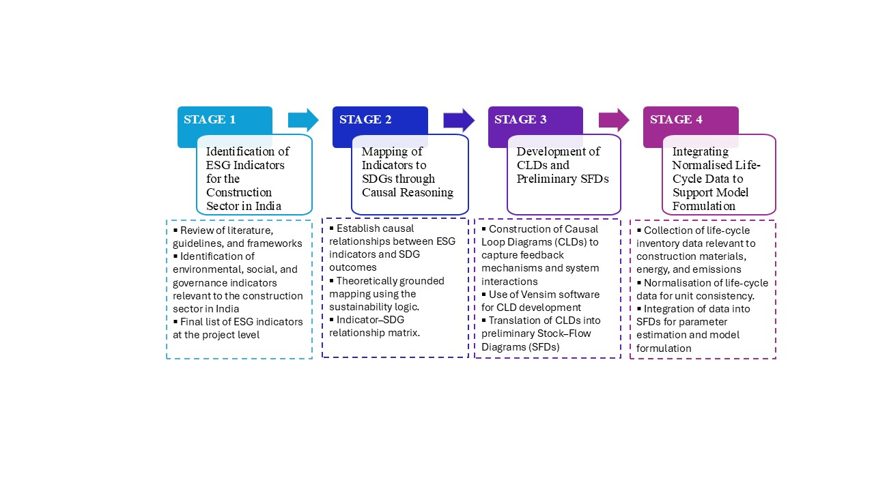
Figure 1: Methodology Overview (Geographical Context: India)

3.1 Identification of Indicators material to the construction Industry:
The first stage involved the systematic identification and definition of ESG variables relevant to India's construction sector. A comprehensive review of academic literature, industrial guidelines, and sectoral reports was conducted to assemble an initial pool of potential ESG metrics. These potential metrics were then screened against the four inclusion criteria defined below through contextual analysis of Indian construction projects. Table 1 summarises the final set of ESG indicators selected for construction projects. Four primary criteria guided the inclusion of each metric:-Materiality: does the metric substantially affect sustainability outcomes in construction (as evidenced by literature or data)?; Measurability: can it be quantified or at least qualitatively assessed with reasonable confidence?; Causality: is there a clear causal link from this metric to one or more SDGs that can be justified with evidence?; and Project relevance: is this something that can vary or be influenced at the project level?. For this study, only those SDG sub-targets that are materially relevant to construction projects were considered. These include poverty and access-related dimensions (SDG 1.2, 1.4, 1.5), health outcomes linked to air pollution and road safety (SDG 3.6, 3.9), gender representation in leadership (SDG 5.5), water access, treatment and stress (SDG 6.1, 6.3, 6.4), access to electricity (SDG 7.1), labour informality and occupational safety (SDG 8.3, 8.8), industrial efficiency and carbon intensity (SDG 9.2, 9.4), housing adequacy and urban air quality (SDG 11.1, 11.6), material use and hazardous waste generation (SDG 12.2, 12.4, 12.6), total greenhouse gas emissions (SDG 13.2), marine ecosystem acidity (SDG 14.3), and land-related biodiversity aspects (SDG 15.1).
Table 1: Summary of ESG metrics considered in this study
ESG Indicator | Short Definition | Units
Scope 1 GHG Emissions | Direct onsite emissions (fuel, machinery) | tCO₂e
Scope 2 GHG Emissions | Indirect emissions from purchased electricity | tCO₂e
Energy Consumption | Total project energy use (fuel + electricity) | MWh / GJ
Water Withdrawal | Freshwater used in project activities | m³
Non-Hazardous Waste | Non-hazardous construction waste generated | tons
Hazardous Waste | Hazardous or chemically contaminated waste | tons
Renewable Energy Use | Share of renewable energy in operations | % / kWh
Environmental Non-Compliance | Number of environmental violations | count
Embodied Carbon | Carbon embodied in materials (e.g., steel, cement) | tCO₂e
C&D Waste Diversion Rate | % of construction waste recycled/reused | %
Dust/PM Emissions | Particulate matter from site activities | µg/m³ / tons
Water Recycling Rate | % of water demand met by recycled sources | %
Biodiversity Offset Ratio | Ecological restoration vs. disturbance | ratio / count
TRIR (Total Recordable Incident Rate) | Recordable incidents per 200,000 work hours | rate
LTIFR Lost Time Injury Frequency Rate ) | Lost-time injuries per 200,000 work hours | rate
Workforce Diversity | % women/minorities in workforce | %
Employee Turnover Rate | Annual % workforce leaving | %
Labour Rights Violations | Count of labour/rights breaches | count
Community Investment | Spending on community programmes | INR / USD
3.2 Mapping of Indicators based on causal relationships:
In the second stage, each ESG indicator identified in Step 1 was systematically mapped to the relevant SDG sub-targets using causal reasoning. This process analysed the directionality, strength, and evidence supporting causal relationships between project-level ESG indicators and SDG outcomes. For each indicator, theoretical and empirical literature were reviewed to establish causal pathways that explain how changes in an ESG variable influence a specific SDG outcome.
3.3 Development of CLDs and SFDs:
In the third stage, the indicator–SDG relationships from Step 2 were translated into CLDs that represent the feedback structures and interdependencies within the ESG–SDG system. The diagrams were developed using Vensim, an SD software suitable for visualising causal structures and preparing models for quantitative simulation. Each causal link was assigned a polarity to identify reinforcing and balancing feedback loops. Auxiliary variables were added where necessary to maintain conceptual coherence and to connect ESG indicators with broader system outcomes. Selected portions of the CLDs were then developed into preliminary SFDs by defining stocks, flows and governing equations.
Environmental indicators primarily capture material, energy, water, emissions, and ecological impacts within the construction project system. An increase in Energy Consumption drives higher Scope 2 GHG emissions, expressed as:
$$\begin{aligned}Scope 2 GHG=Energy Consumption ×\left(1- Renewable Fraction\right)×Grid Emission Factor\#(1)\end{aligned}$$
showing that emissions rise with total energy use but decrease when renewable energy contributes more to the supply. Within direct emissions, increases in Scope 1 GHG emissions are positively linked to dust and particulate emissions, scaled by PM and CO₂ emission factors, indicating that higher combustion on-site raises particulate pollution. Greater Hazardous Waste leads to higher incineration-related GHG emissions, according to
$Incineration GHG=Hazardous Waste×Incineration Fraction×Incineration EF$ (2) Similarly, higher Embodied Carbon in materials increases both the Material Footprint (via carbon intensity) and contributes to upstream Scope 1 GHG emissions associated with material transport and processing. In turn, increasing Water Withdrawal raises Water Stress, defined relative to basin water availability and competing uses:
$Water Stress=\frac{Other Basin Use+Withdrawal}{Basin Water}x 100$ (3)
Water withdrawal also influences pumping-related GHG emissions, proportional to diesel usage, and reduces Water Use Efficiency, which declines as consumption grows. Waste-related impacts extend to changes in basin stress; greater Non-Hazardous Waste increases water stress through leachate contamination. Dust emissions increase ambient PM₂.₅ concentrations based on the dispersion volume. Insufficient biodiversity offsets increase environmental non-compliance.
Social causal relationships describe the interaction between workforce conditions, safety performance, labour practices, and social well-being. The foundational safety metric, TRIR, drives the LTIFR according to:
$$\begin{aligned}LTIFR=TRIR×Lost-Time Fraction\#(4\end{aligned})$$
More training improves safety outcomes; Training Hours reduce TRIR through an exponential decay function. Where α represents the effectiveness of training in reducing incident rates (TRIR).
$$\begin{aligned}TRIR={TRIR}_{o }X e^{(-∝ X Training Hours)}\#(5)\end{aligned}$$

Workforce experience plays a regulatory role; higher Employee Turnover lowers experience, thereby increasing TRIR, while TRIR itself increases turnover by diminishing perceived workplace safety. Training also reduces turnover by strengthening engagement, again captured via an exponential term. where γ represents how strongly perceived safety influences turnover.
$$\begin{aligned}Turnover=\frac{{Turnover}_{0}}{e^{(-γ X TRIR)}}\#(6)\end{aligned}$$
Higher TRIR and informal employment increase occupational injuries. Labour conditions interact with inclusion and retention. Labour Rights Violations reduce the Diversity Index and increase turnover. Improvements in Women in Managerial Roles enhance diversity, while greater Informal Employment increases violation frequencies, creating reinforcing cycles of poor labour outcomes.
Governance mechanisms influence how organisational decisions translate into risk management, ethical conduct, and downstream social outcomes. In the model, Board Independence is used as a proxy for governance strength. A more independent board enhances oversight and accelerates adoption of climate-aligned strategies, reducing exposure to transition risks. Board independence also shapes internal organisational behaviour, particularly diversity outcomes. Strong governance typically enforces equitable hiring, anti-discrimination policies and inclusive leadership pipelines. Financial governance enters the model through the treatment of Corruption Losses, which reduce the resources available for community-facing investment. The relationship is expressed as:
$$\begin{aligned}CommunityInvest=\left(Profit-CorruptionLoss\right)x r\#(7\end{aligned})$$
Where “r” is the proportion of available funds allocated to social development. Community investment then acts as a leverage point for multiple SDG-aligned outcomes. Investment in local welfare programmes reduces poverty levels and improves access to essential services such as water, sanitation, and electricity. Similarly, investment in housing upgrades or resettlement programmes lowers the proportion of residents in slum-like conditions. Investment in transport safety (e.g., lighting, signage, road improvements) reduces road-related fatalities. Collectively, these relationships show that governance quality strengthens organisational performance and community resilience.
3.4 Integrating normalised life-cycle data to support model formulation:

Figure 2: Case Study: Residential Building
After developing the SD model, a cradle-to-grave LCA was undertaken to parameterise the SFD. These LCA outputs were then normalised to a consistent functional unit so that they could be directly incorporated as parameter values and baseline quantities in the stock-and-flow diagrams. Only the indicators relevant to the model structure were extracted, and these normalised values were used to initialize environmental stocks and calibrate selected flow equations. This step ensured that the SFD was grounded in realistic project-level data rather than relying solely on qualitative or assumed values.
A key challenge in this stage was the availability and consistency of numerical data. Many parameters required for model calibration, such as average household electricity consumption or material-specific emission factors, vary significantly by building type, location and scale. Using values drawn from different typologies (e.g., a multi-storey apartment block versus a single-dwelling unit) would result in inconsistent system boundaries and incomparable impact metrics. Therefore, the representative residential building (Figure 2) was adopted as the reference case for LCA parameterisation and SD model formulation.
- Results
  - Integrated CLD: System Structure and Interactions
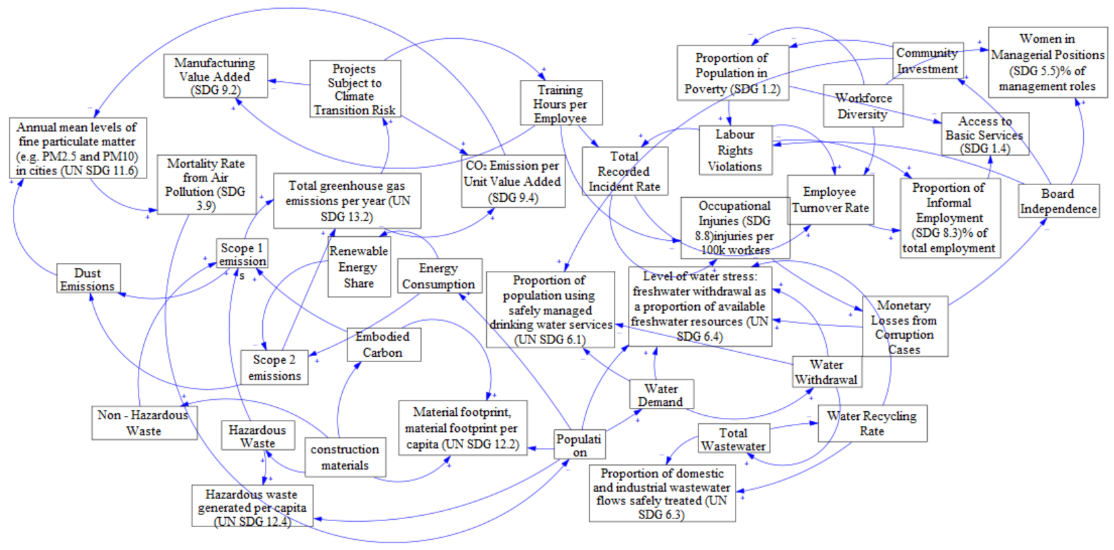
Figure 3: Integrated CLD: Consolidated ESG metrics and UN SDGs
Figure 3 presents the integrated CLD combining the environmental, social and governance subsystems developed in the methodology. On the environmental side, energy consumption drives Scope 1 and Scope 2 emissions, which amplify climate impacts and particulate concentrations (SDG 11.6 and SDG 13.2). Social dynamics emerge through loops linking safety TRIR, workforce experience and turnover. Governance indicators, such as board independence, corruption losses and community investment, produce cross-domain linkages, influencing both environmental and social outcomes. Overall, the integrated CLD shows that sustainability performance in construction is governed by system-wide interactions, where changes to one ESG factor propagate across multiple SDG-linked outcomes.
4.2 Translating the CLD into a Stock–Flow Diagram
While the CLD captures qualitative directionality, Figure 4 presents the corresponding SFD, which operationalises these relationships into a quantitative, simulation-ready structure. The SFD shows that the construction system is organised around three tightly interacting subsystems:
- Energy–emissions subsystem, where renewable and non-renewable energy use influence Scope 1 and Scope 2 emissions and total GHG emissions (SDG 13.2).
- Materials–waste subsystem, linking construction materials to embodied carbon, material footprint (SDG 12.2), hazardous and non-hazardous waste flows (SDG 12.4), and downstream emissions.
- Water–sanitation subsystem, where water demand and withdrawal influence water stress (SDG 6.4), wastewater generation and recycling performance (SDG 6.3).
The SFD reveals cross-couplings, such as how waste incineration affects emissions or how water stress links back to population and material processes that cannot be observed through static ESG scorecards. This translation from CLD to SFD provides the structural foundation for subsequent quantitative analysis.
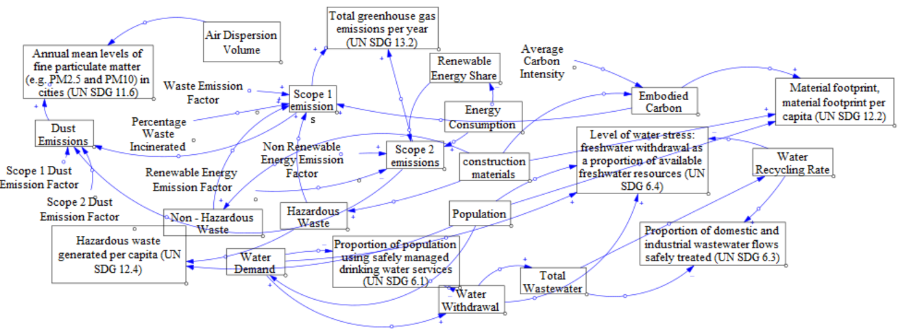
Figure 4: SFD representing ESG–SDG linkages and system interactions
4.3 LCA-based Parameterisation of the SFD
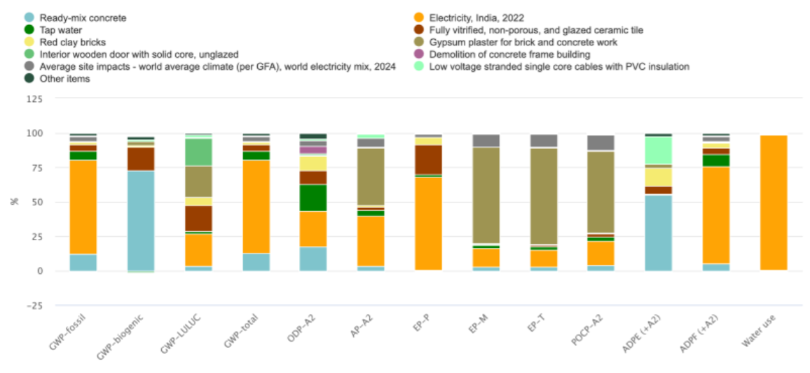
Figure 5: Distribution of environmental impacts across materials and life-cycle stages
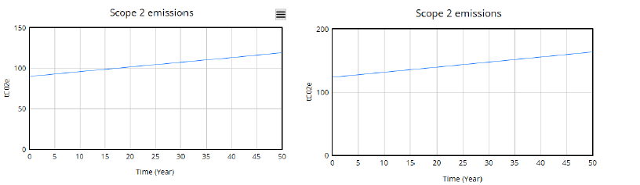
Figure 6: Comparative analysis of the outputs of the SFD
To ground the SFD in realistic project-level data, a cradle-to-grave LCA was undertaken for a reference single-dwelling building. Figure 5 summarises the one-click LCA results, showing the distribution of environmental impacts across materials and life-cycle stages. Because LCA results across different building typologies are not directly comparable, all outputs were normalised to a consistent functional unit. These normalised values of embodied carbon, energy intensities, waste factors and water-related coefficients were then used to initialise stocks and calibrate model parameters within the SFD. Figure 6 illustrates how changes in model parameters propagate through the SFD to produce corresponding changes across interconnected ESG indicators. The integration ensures that the model represents not only causal direction but magnitude, allowing scenario testing and sensitivity analysis. The LCA-SFD coupling strengthens the model’s ability to represent environmental performance, enabling the results in Figure 5 and Figure 6 to reflect realistic dynamics rather than assumed values.
- Discussions
The results demonstrate that integrating ESG indicators with SDG outcomes through a systems-thinking approach provides a significant improvement over existing ESG reporting practices in the construction sector. Prior literature has noted that most ESG frameworks, such as GRI, SASB, BRSR and TCFD, function as static disclosure tools that do not represent the dynamic and interdependent nature of sustainability performance (Betti et al., 2018; Krueger et al., 2024). The consolidated CLD developed in this study supports this critique by showing that environmental, social and governance metrics behave as interconnected subsystems. Changes in one domain create effects in others, which cannot be captured through traditional indicator lists. work advances this understanding by transforming these qualitative causal relations into a quantitative stock flow structure. By integrating LCA within a systems model, our research provides deeper insight. The model shows not only which materials are impactful but also how those impacts shape other indicators such as emissions and waste flows. These findings support recommendations from the UN Global Compact and the World Business Council for Sustainable Development, which call for the next generation of ESG disclosures to incorporate SDG linkages and systems-based analysis. The present study provides a preliminary model that demonstrates how such an approach can be operationalised for construction projects. This research offers a methodological bridge between systems thinking, life-cycle assessment and ESG-SDG integration. By showing how LCA-derived values can be embedded into an SD structure, the study demonstrates an approach that captures both quantitative environmental impacts and the structural drivers that influence them. This combined method aligns with the emerging academic consensus that hybrid frameworks are better suited for addressing sustainability challenges in the construction sector

- Conclusions
This study demonstrated that integrating ESG indicators with SDG outcomes through a systems-thinking approach can provide a more coherent and realistic understanding of sustainability performance in construction projects. By combining CLDs, an SFD, and normalised life-cycle data, the research showed that ESG indicators behave as interconnected variables rather than standalone metrics. The resulting framework highlights how changes in materials, energy sources or governance decisions propagate across multiple environmental and social outcomes, underscoring the need for dynamic rather than static ESG assessment approaches.
The model represents an early operationalisation of a systems-based ESG–SDG reporting framework, but is constrained by its reliance on a single dwelling reference project and the limited availability of empirical data for social and governance parameters. Future work should extend the analysis to multiple building typologies, incorporate primary project-level datasets and test the framework under different regulatory or market scenarios. Strengthening the empirical foundations of the model would allow it to evolve into a practical decision-support tool for project teams, regulators and investors who require transparent, SDG-aligned ESG reporting.

REFERENCES
Agustin, N. & Koestoer, R.H., (2025). Achieving sustainable construction through the integration of lean construction and ESG: A critical review. Journal of Placemaking and Streetscape Design, 3(1): p. 23–38.
Bekaert, G., Rothenberg, R. & Noguer, M., (2023). Sustainable investment–Exploring the linkage between alpha, ESG, and SDGs. Sustainable Development, 31(5): p. 3831–3842.
Betti, G., Consolandi, C. & Eccles, R.G., (2018). The relationship between investor materiality and the sustainable development goals: A methodological framework. Sustainability, 10(7): p. 2248.
Celoza, A. & Owens, V., (2025). Perspectives on ESG materiality in the engineering and construction industry: An exploratory study. Journal of Legal Affairs and Dispute Resolution in Engineering and Construction, 17(2): p. 05025001.
Chen, Y.-T., (2024). A systematic approach to ESG integration and crisis management systems in supply chains: A theoretical framework and mathematical models. Supply Chain and Sustainability Research: SCSR: p. 56–87.
Cruz, P.L., Ávila, L.V., Dinis, M.A.P. & Baggio, D.K., (2023). Environmental, social and governance (ESG) and innovation in the construction sector: Systematic literature review. Revista de Administração da UFSM, 16(4): p. e1.
Filatova, T., Moghayer, S.M., Arto, I., Belete, G.F., Dhavala, K., Hasselmann, K., Kovalevsky, D.V., Niamir, L., Bulavskaya, T. & Voinov, A., (2014). Dynamics of climate-energy-economy systems: Development of a methodological framework for an integrated system of models. 37.
Francis, A. & Thomas, A., (2022). A framework for dynamic life cycle sustainability assessment and policy analysis of built environment through a system dynamics approach. Sustainable Cities and Society, 76: p. 103521. DOI: 10.1016/j.scs.2021.103521.
Gong, X., Tao, X., Zhang, M., Xu, Y., Kwok, H.H.L., Dai, J. & Cheng, J.C.P., (2024). Secure environmental, social, and governance (ESG) data management for construction projects using blockchain. Sustainable Cities and Society, 114: p. 105582.
Iyer, H.S., DeVille, N.V., Stoddard, O., Cole, J., Myers, S.S., Li, H., Elliott, E.G., Jimenez, M.P., James, P. & Golden, C.D., (2021). Sustaining planetary health through systems thinking: Public health's critical role. SSM-Population Health, 15: p. 100844.
Krueger, P., Sautner, Z., Tang, D.Y. & Zhong, R., (2024). The effects of mandatory ESG disclosure around the world. Journal of Accounting Research, 62(5): p. 1795–1847.
Markopoulos, E., Markopoulos, P., Nandi, A., Wu, T., Zhao, K., Samkova, M. & Huang, M., (2024). Using the UN SDGs and the ESG Index towards the development of a unified building information modelling language and culture for sustainable construction. In Sustainable Construction in the Era of the Fourth Industrial Revolution, 149: p. 1–10.
Shrubsole, C., Hamilton, I.G., Zimmermann, N., Papachristos, G., Broyd, T., Burman, E., Mumovic, D., Zhu, Y., Lin, B. & Davies, M., (2019). Bridging the gap: The need for a systems thinking approach in understanding and addressing energy and environmental performance in buildings. Indoor and Built Environment, 28(1): p. 100–117. DOI: 10.1177/1420326X17753513.
Soni, T.K., (2023). Demystifying the relationship between ESG and SDG performance: Study of emerging economies. Investment Management & Financial Innovations, 20(3): p. 1.
Wang, J. & Xue, F., (2023). Emerging trends of ESG in the construction sector: A promising pathway to sustainable and responsible development. In International Symposium on Advancement of Construction Management and Real Estate: p. 2033–2044.

