Formalizing Information Requirements for Semantic Modelling of Energy Optimization in Building Digital Twins
Gary Chang¹, Olli Vigren², J.J. McArthur¹

¹ Toronto Metropolitan University, Toronto, Canada
² KTH Royal Institute of Technology, Stockholm, Sweden
*Corresponding email: gary.chang@torontomu.ca

ABSTRACT
Digital twins (DT) are increasingly promoted as key enablers of building decarbonization. However, this proposition often assumed that buildings already contain high-fidelity datasets, such as detailed building information models (BIMs). In reality, many buildings are far less digitally mature, with only limited building automation system (BAS) data or incomplete BIM data available. This creates a gap between digital twin ambitions and the practical feasibility of implementation, contributing to low DT adoption rates in the construction sector. This study addresses this fragmentation by presenting an ‘Information Delivery Manual to Knowledge Graph’ (IDM-to-KG) pipeline for creating semantic models in the built environment, using a case study of a central cooling plant in Canada as an example. The findings formalize the datasets required to support future research on automated semantic modelling in the built environment.

- INTRODUCTION
Digital twins (DTs) are central to optimizing building performance and achieving large-scale decarbonization of the built environment (Ohueri, et al., 2024). This study focuses on online energy optimization (Mariano-Hernández et al., 2021), which extends traditional commissioning processes with online analytics and monitoring to ensure optimal building performance and facilitates real-time adjustment of building systems to minimize energy use, costs, and carbon emissions (Romaios, et al., 2025).
However, the deployment of these applications presupposes the availability of rich, high-fidelity datasets from sources such as building automation systems (BAS), which is often not the case in practice (Saloux, et al., 2023). Another challenge for DTs is bridging the semantic gap between machine-generated data and human reasoning. This challenge can be addressed through semantic modelling, leveraging ontologies to provide the contextual metadata necessary for logical data inference (Karabulut, et al., 2024). However, current processes for developing semantic models for DTs remain highly manual and labour-intensive (Chamari, et al., 2025). The absence of harmonized building datasets necessitates substantial human intervention to achieve the semantic interoperability required for DT applications (Yang, et al., 2024). Combined with the lack of established guidelines or standards, these challenges have resulted in low DT adoption rates within the architecture, engineering, construction, and operations (AECO) sector (Opoku, et al., 2023). Therefore, scalable and standardized approaches to semantic modelling that reduce data and labour requirements are needed to enable wider DT adoption.
This study aims to address this gap by developing formalized information requirements (IRs) and information exchange requirements (IERs) for online energy optimization, specifically for the co-optimization of central chiller plant equipment. IRs specify the information required for such optimization, while IERs define the technical protocols and formats for transferring that information between systems (Wix & Karlshøj, 2010). A structured ‘Information Delivery Manual to Knowledge Graph’ (IDM-to-KG) pipeline is presented to distil the IRs and IERs into a machine-interpretable schema, providing a repeatable methodology for deriving semantic models for smart building applications. The overall goal of the study is to support the autonomous creation of semantic models using large language models (LLMs), thereby advancing the implementation of DTs in the built environment.

- BACKGROUND
DTs in the built environment are typically conceptualized as digital representations of physical assets that are continuously updated with operational data to support building construction, monitoring, simulation, and optimization (Boje, et al., 2020). They are closely related to BAS, which collect and control operational data from HVAC, lighting, and other subsystems. While a BAS provides real-time sensor data, alarms, and control signals, DTs integrate these data streams with contextual information, such as geometry, topology, equipment specifications, and performance models (Lu, et al., 2020).
However, building data are typically fragmented across heterogeneous sources, including BASs, BIM, equipment, energy meters, and proprietary vendor systems. These sources often employ inconsistent naming conventions, data schemas, metadata, and temporal granularities, which limit interoperability. This fragmentation highlights the need for structured semantic integration.
Recent advances in DTs, ontologies, semantic modelling, and LLMs offer new opportunities for more data-driven, precise, and timely optimization. Ontology-driven approaches such as Brick and RealEstateCore (Boje, et al., 2020; Brick Consortium Inc., 2024; Fierro, et al., 2020) demonstrate how semantic standardization can bridge fragmented building data sources. Semantic models encode the meaning of elements. For example, they can define that a temperature sensor measures the water supply temperature of a specific chiller. Building on these developments, this paper proposes a methodology that leverages semantic modelling and structured information requirements to operationalize online energy optimization, even in contexts characterized by incomplete or heterogeneous datasets.
Functional decomposition refers to breaking down a complex system into hierarchically organized functions and subfunctions. Process analysis complements this approach by mapping the operational workflows, control loops, and information flows necessary to achieve optimization objectives. Within this structure, IRs define the specific data elements needed to perform a given function, while IERs specify how and when these data must be exchanged between systems, actors, or software components to support real-time decision-making (Wix & Karlshøj, 2010).
To operationalize these requirements, knowledge graphs, which represent entities and their relationships in a machine-interpretable form, can be used to encode semantic relationships between equipment, sensors, control points, and processes (Hogan, et al., 2021). In this context, functional decomposition defines what needs to be optimized, IRs and IERs define what information is required and how it is exchanged, and knowledge graphs provide the semantic backbone that connects data sources to optimization functions in a structured and interoperable manner.
Chiller plants provide a particularly relevant case for this approach, as they are among the most electricity-intensive subsystems in commercial and institutional buildings. Consequently, they represent an important target for efficiency improvements and operational optimization. Prior research has extensively examined advanced HVAC control and modelling approaches to enhance system design and performance (Afram & Janabi-Sharifi, 2014). However, progress in this area is constrained by system complexity, limited availability of high-fidelity operational data, a lack of consistent ontologies, and limited interoperability between information exchange protocols.

- METHODOLOGY
The research methodology adopts a multi-stage approach, as illustrated in Figure 1. The first stage involves a functional decomposition analysis of the online optimization use case to identify the key variables, control logic, and temporal requirements necessary for its execution. The second stage focuses on developing the IRs and IERs to support the creation of process maps that detail the end-to-end workflow of the use case. The final stage involves creating of a knowledge graph that leverages the inputs and outputs identified in the previous stages to formulate a semantic model for online energy optimization of chiller plants.

Stage 1 - Functional Decomposition Analysis
Top-Down Approach
Distil all IR and IER as well as mapping of the inputs and outs

Stage 2 - Process Map Formalization
Develop an end-to-end workflow mapping of the use case process
Illustrate key stakeholders and information exchange flows to enable successful implementation

Stage 3 - Knowledge Graph Creation
Map identified IR and IER with the Brick Ontology
Develop knowledge graph showing end-to-end data dependencies and information flow

Figure 1: Methodology Overview

3.1 Case Study Area
To ground the theoretical framework in real-world complexity, this research draws on a case study of a healthcare facility located in Vancouver, Canada (Kandil, et al., 2025). The central cooling plant provides cooling to meet the facility’s intensive needs, including those associated with trauma care. Central cooling plants are typically composed of chillers, chilled water distribution systems, condenser water systems, and heat rejection equipment. The energy optimization component of this case study focused on optimizing the condenser water loop. Therefore, the semantic modelling is limited to this subsystem. Data from previous projects were used to inform the results of this study, with sensitive information redacted to protect the confidentiality of the hospital. As these results were independently verified in prior work, they serve as a validation layer for the IRs and IERs extracted in this research.

3.2 Functional Decomposition Analysis
The functional decomposition analysis stage of the research focuses on simplifying the use case into its key components to streamline the semantic modelling of the workflow (Bonyadi, et al., 2025). Hospital cooling networks are complex systems with interconnected subsystems and dependencies, resulting varying requirements depending on the spaces they serve. A top-down approach was used to analyse the system, beginning with the highest level – the cooling plant – and progressively decomposing its relationships. From there, subsystems were identified based on their relevance to energy optimization, resulting in three main components: chillers, condenser and chilled water pumps, and cooling tower. Each subsystem was further segmented into data points based on their relationship to the optimization process and their importance for the operational control of the plant. Variables were identified based on thermodynamic principles derived from previous research (Kandil, et al., 2025). The final output establishes a structured list of dependencies required to implement online energy optimization in chiller plants, while also providing guidance for the process mapping and knowledge graph creation stages.

3.3 Process Mapping Formalization
The second stage adopts the Information Delivery Manual (IDM) methodology defined in ISO 29481 to formalize process maps and link the IRs and IERs (Jeon, et al., 2021). Following the principles of ISO 29481, the Business Process Model and Notation (BPMN) format is used to map the end-to-end workflow of online energy optimization in cooling plants. The IRs for this study encompass elements relevant to cooling plant operations and the subsequent optimization of energy performance. These elements were identified through the functional decomposition conducted in the first stage and subsequently distilled to include only the key variables. For example, factors such as chilled water mass flow rates were included, while details like maintenance schedules were omitted, as they were not applicable to this specific use case.
The IERs define the entities required to support the exchange of information between systems and end users. The IERs focus on specifying data sampling rates from the chiller and cooling towers, as well as methods for extracting the required weather data. BAS and weather data were sampled at approximately 10-minute intervals. Data were not streamed in real time due to site security concerns; therefore, this research approaches online energy optimization from a near-real-time perspective. The results of the process mapping were validated against field tests conducted in the previous study (Kandil, et al., 2025) to ensure that the formalized process accurately reflects the complexities of building systems.

3.4 Knowledge Graph Creation
The final stage of the methodology focuses on semantic formalization and ontology mapping using the Resource Description Framework (RDF) for the identified IRs, IERs, and process maps. The purpose of this step is to translate the gathered information into explicit semantic relationships, enabling structured querying and data reuse (Li & Wang, 2026). Knowledge graphs comprise networks of nodes that represent entities and their relationships within a system. Ontologies are typically used to standardize terminology across datasets and ensure that terms have consistent meanings. This standardization is particularly important for BAS data, given the lack of standardization in this domain, which often results in inconsistent naming conventions across buildings (Yang, et al., 2024).
Entities are derived from the IRs, which detail the relevant BAS points and weather data necessary to achieve energy optimization of chiller plants. The IERs inform the relationships used to develop predicates between entities, specifying the direction of data exchange, triggering conditions, and temporal context of the use case. The Brick ontology is leveraged to provide standardized naming conventions for BAS points (Fierro, et al., 2020). Specifically, Brick version 1.4, which has been harmonized with the RealEstateCore ontology (Brick Consortium Inc., 2024), was used. In this version, RealEstateCore serves as the primary model for representing location-related concepts that were previously handled directly within Brick prior to version 1.4. The Shapes Constraint Language (SHACL) was used to validate the completeness of the knowledge graph. This approach clarifies the large number of BAS points stored, filtering and organizing them to provide meaningful insight into actual operations. Figure 2 shows an example knowledge graph built for the Toronto Metropolitan University Campus. In addition, a completeness check was conducted to further validate model by evaluating whether the modelled subsystems correctly represented the necessary points and their relationships required to implement the energy optimization use case derived from the functional decomposition.

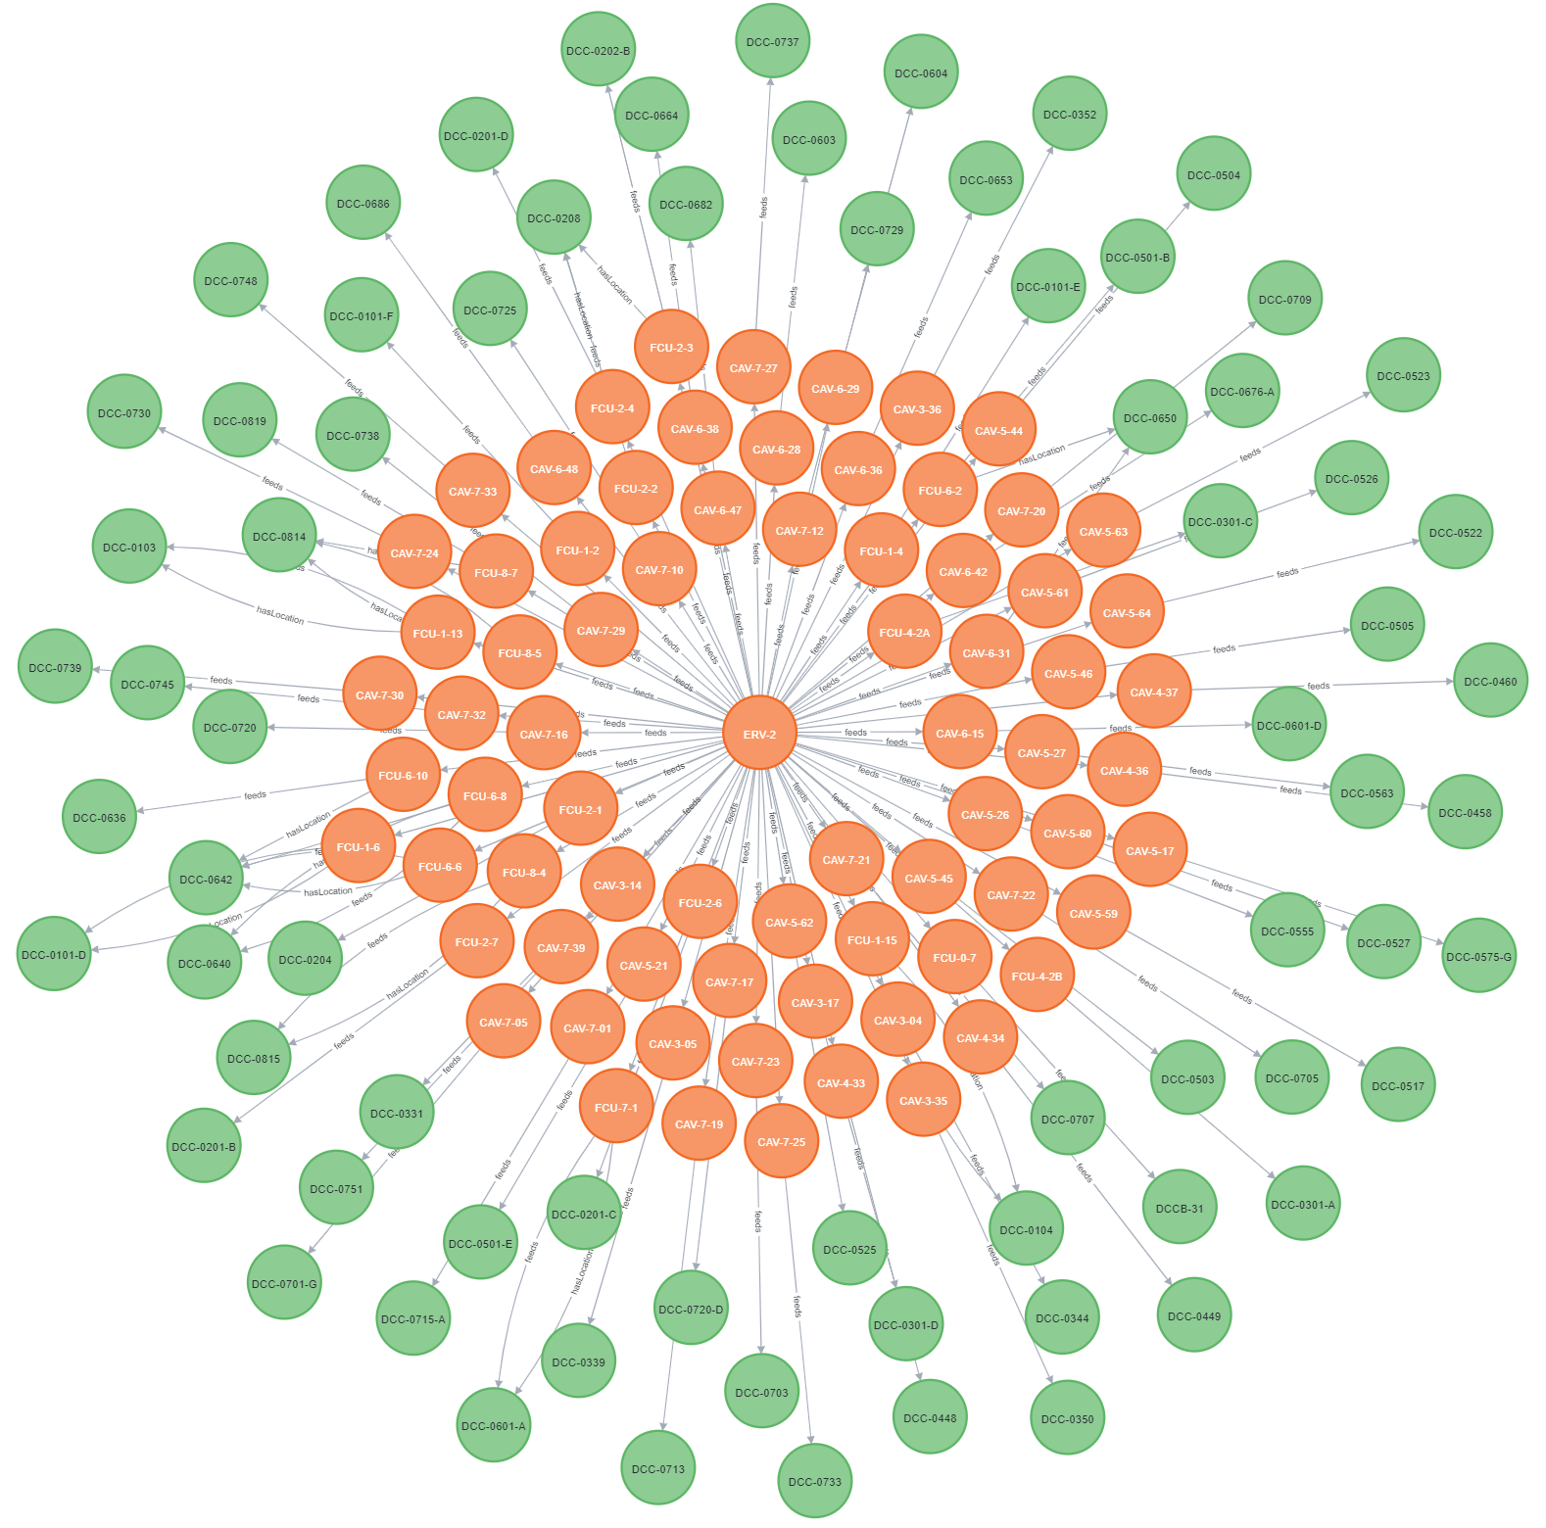
Figure 2: Example of Knowledge Graph from TMU Campus
The resulting knowledge graph establishes a deterministic search space to support reasoning tasks. By distilling the IRs, IERs, and process maps into formalized semantic relationships, it reduces ambiguity in semantic interpretation and supports consistent retrieval of operational knowledge for online energy optimization of cooling plants. The final knowledge graph also serves as a training and testing dataset to support LLM agents in future research on automated semantic modelling applications.

- RESULTS
This section presents the results of the analysis on the energy optimization of the central cooling plant case study. The findings from the functional decomposition, process mapping, and knowledge graph creation illustrate the structural relationships and data dependencies within the condenser water loop. The results are presented below in the sequence in which the analyses were performed.

4.1 Functional Decomposition Analysis
The overall goal of online energy optimization for cooling plants is to minimize the system’s energy consumption by optimally configuring operational parameters to meet performance objectives. While various methods can be used to optimize chiller systems (Jia, et al., 2021), this research focuses on optimizing the cooling tower approach temperature. By adjusting the cooling tower fan speed based on cooling demand and ambient wet-bulb temperature, the condenser water temperature can be maintained at an optimal setpoint. This approach reduces the load on the condenser pump, shifting a greater proportion of the cooling work to the cooling tower fans and reducing the overall power consumption of the system.
From a functional decomposition standpoint, the condenser water loop consists of the condenser, cooling tower, and condenser water pump as its core entities. The input to the optimization process is represented by the cooling tower fan speed, while the output is the overall power consumption of the central cooling plant. Weather conditions are also relevant to the system, as they impact the cooling tower’s ability to reject heat and provide information about potential cooling loads to meet building demands. Table 1 presents the results of the functional decomposition of the online energy optimization use case.
Table 1: Functional Decomposition of Online Energy Optimization of the Central Cooling Plant
Component | Data Point | Description
Central Cooling Plant | Total Power (kW) | Provides insight into the overall energy consumption of the central cooling plant.
Condenser | Water Supply Temperature (°C) | The water temperature exiting the condenser.
Condenser | Water Return Temperature (°C) | The water temperature entering the condenser.
Condenser | Water Flow Rate (L/s) | The flow rate of water within the heat-rejection loop.
Cooling Tower | Fan Speed (%) | The cooling tower fan speed as a percentage of max speed.
Outdoor Environment | Relative Humidity (%) | Percentage of water vapour in outdoor air relative to the theoretical maximum.
Outdoor Environment | Dry Bulb Temperature (°C) | The ambient air temperature measured by the weather station.
Outdoor Environment | Wet Bulb Temperature (°C) | The temperature that air would reach if water were evaporated into it until saturation. This is calculated as a function of dry-bulb temperature and relative humidity.

4.2 Online Energy Optimization of Cooling Plants Process Map
The development of the process map for the online energy optimization use case focused on the functional requirements needed for the process and the steps required to achieve the optimization objectives. Key participants in this process include BAS, data lake, energy analytics engine, and digital twin. Figure 3 illustrates the process map for the use case.
From BAS to Data Lake: The workflow begins with the collection of BAS data based on the physics-based analysis described in the functional decomposition of the use case. These data are typically stored in a BAS database and can be extracted through static data dumps or real-time streaming. Data are then streamed into a data lake, which may be hosted locally, in the cloud, or using a hybrid approach, depending on operational constraints and project goals. Data are subsequently ingested into a time-series database, which is best suited to BAS data applications (Shah, et al., 2022).
From Data Lake to DT and Energy Analytics: The next phase operates in parallel. One path maps the required elements onto the DT to provide information to the technical property manager in the facilities management team, while the other path feeds data into the energy analytics engine. Within the Energy Analytics swim lane, cooling demand and wet-bulb temperature are calculated to determine whether the cooling tower fan speed is operating within the optimal range. If the fan speed is already within this range, the process ends. If it falls outside the optimal range, an alert is sent from the DT to notify the technical property manager. The end user and FM system then evaluate the alert to determine whether it is a false alarm. Based on this assessment, the cooling tower fan speed is adjusted accordingly to ensure optimal operating conditions.

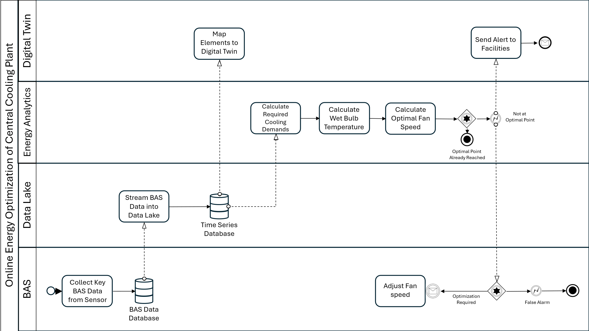
Figure 3: Process Map of Online Energy Optimization of the Central Cooling Plant

4.3 Knowledge Graph for Formalization
Figure 4 depicts the formalized knowledge graph created for the online energy optimization case study. The model follows the inputs and outputs identified through the functional decomposition and divides them into three major entities: the building, the weather station, and the heat-rejection loop within the central cooling plant. As the focus of this case study was specifically on the heat-rejection loop, other components within the central cooling plant were not modelled in order to simplify the overall representation. Each component was modelled to illustrate its upstream and downstream equipment, as well as key associated points relevant to the online energy optimization process. Points were generally described using the ‘brick:isPointOf’ relationship, whereas downstream relationships between equipment were represented using ‘brick:hasPart’.
Within the heat-rejection loop, the condenser, condenser pump, and cooling tower were connected through the ‘brick:feeds’ relationship, which describes the flow within the water loop. The building entity acted as the connector between the central cooling plant and the weather station through ‘brick:isPartOf’ relationship. This structure also creates opportunities to further extend the interoperability of the knowledge graph by leveraging the geographic aspects of the building relationship hierarchy to connect different systems across the built environment.
Validation was conducted using Brick’s built-in schema validator, which confirmed that all modelled entities and relationships conformed to the ontology. The SHACL validation results indicated that the knowledge graph contained no violations and conformed to the Brick ontology as expected. A completeness check was also conducted to evaluate whether the necessary points and relationships were present in the semantic model, based on the points derived from Table 1. The check verified the inclusion and correct mapping of all necessary data points, classes, and relationships between systems.
For example, the condenser water pump needed to be correctly assigned to the ‘brick:Condenser_Water_Pump’ class, have a ‘brick:isPartOf’ relationship with the condenser water system, ‘brick:isFedby’ relationships with the cooling tower, a ‘brick:feeds’ relationship with the chiller condensing unit, and ‘brick:hasPoint’ relationships with each of the BAS points listed in the table. When the condenser water pump was removed from the semantic model, a completeness error was raised, indicating that the model no longer contained all the necessary IRs and IERs to support the cooling plant energy optimization use case.

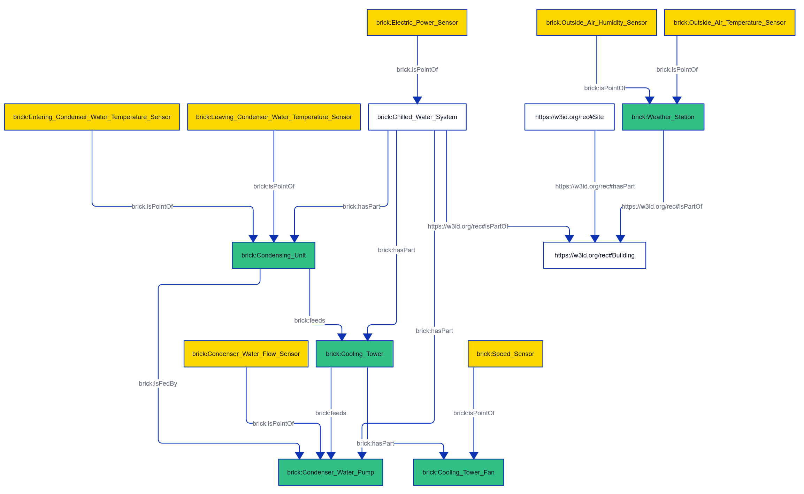Figure 4. Knowledge Graph of the Online Energy Optimization Case Study
In addition to the completeness check, the semantic model was traversed using SPARQL queries to evaluate its information retrieval capabilities. For example, a query was made for the ‘brick:Condenser_Water_Flow_Sensor’ to retrieve the associated BAS point ID, which was then used to query the time-series database and determine whether the correct information was retrieved. The trials successfully demonstrated the semantic model’s ability to retrieve relevant information associated with the modelled central cooling plant.

- DISCUSSION
The successful formalization and validation of the knowledge graph depicting online energy optimization for a central cooling plant demonstrate the viability of leveraging Brick as the semantic modelling backbone for BAS data. The semantic modelling was intentionally limited to maintain a focus on the key aspects required to enable implementation of the use case. By identifying the key data points and processes through functional decomposition analysis and process mapping, the study established clear definitions of the IRs and IERs necessary for inclusion in the semantic model. This also opens a pathway for future work to broaden the model and incorporate additional elements into a more comprehensive optimization system.
The study was limited to a single hospital case, with the central cooling plant serving as the primary system for optimization. Future research could extend this work by modelling additional optimization strategies for central cooling plants, as well as other types of building systems. Such studies would help assess the generalizability of the approach. By formalizing and validating a structured methodology for deriving IRs and IERs from a real-world case study, this work establishes a replicable foundation that can be extended to support alternative optimization strategies with varying information dependencies. A preliminary assessment was also conducted on the central heating plant in the Centre for Urban Innovation (CUI) building located on the TMU campus. Key input and output points for the central heating plant were derived from system schematics and manually mapped into a semantic model following the Brick ontology. The completeness check was adapted to account for the different parameters relevant to boilers and heating applications. Although the specific IRs and IERs vary across use cases and systems, the underlying procedure for deriving the semantic model remains consistent and can be extended to systems beyond central cooling applications.
Although the methodology was implemented manually in this study, it was designed to enable a rapid and systematic approach to semantic modelling by identifying the key system components and their information requirements. Manual approaches are valuable during the proof-of-concept phase because they ensure that details are appropriately modelled; however, they limit scalability when applied to larger systems or multiple facilities. Future research will therefore focus on expanding this approach and developing the datasets necessary to develop and validate fully automated semantic modelling methods.
Semantic modelling provides a structured framework for integrating heterogeneous building data into DTs in the built environment; however, its role in enabling semantic interoperability has already been extensively studied (Boje et al., 2020; Lu et al., 2020). Therefore, the key contribution of this study does not lie in the semantic model itself, but in the IDM-to-KG pipeline, which provides a traceable method for distilling IRs and IERs to support semantic model creation. This approach shows promise for generalizability across applications in the built environment, as demonstrated by the central cooling plant case study and the evaluation of the CUI central heating plant.

- CONCLUSION
The presented case study demonstrates the rigorous information requirements necessary for DT integration. It provides insight into the practical challenges of bridging theoretical DT aspirations with implementation feasibility. The formalized IRs and IERs developed for online energy optimization of building energy systems offer a valuable framework for establishing broader standardized guidelines for DTs within the AECO industry. In doing so, this work addresses a recognized research gap (Opoku, et al., 2023).
The IDM-to-KG pipeline presents a methodology for linking the information needs of building operations with the machine-interpretable representation in knowledge graphs. The workflow provides a traceable and replicable foundation for creating semantic models and clarifying the data preparation and labour requirements. Future research can build on the proposed methodology by reducing reliance on manual effort and exploring automated methods for semantic model creation, thereby enabling wider adoption of DTs within the AECO industry.

REFERENCES
Afram, A. & Janabi-Sharifi, F., 2014. Theory and applications of HVAC control systems–A review of model predictive control (MPC). Building and environment, Volume 72, pp. 343-355.
Boje, C., Guerriero, A., Kubicki, S. & Rezgui, Y., 2020. Towards a semantic Construction Digital Twin: Directions for future research. Automation in Construction, Volume 114, p. 103179.
Bonyadi, N., Talami, R. & Lee, B., 2025. Breaking-down building design problems with decomposition approaches: A review. Energy and Built Environment, p. S266612332500042X.
Brick Consortium Inc., 2024. Using Brick and RealEstateCore Together. [Online]
Available at: https://docs.brickschema.org/extra/brick-rec.html [Accessed 23 February 2026].
Chamari, L., Walker, S., Petrova, E. & Pauwels, P., 2025. Towards portable model predictive control-based applications for demand side management in buildings. Energy and Buildings, Volume 347, p. 116257.
Fierro, G. et al., 2020. Formalizing Tag-Based Metadata With the Brick Ontology. Frontiers in the Built Environment, Volume 6.
Hogan, A. et al., 2021. Knowledge Graphs. ACM Computing Surveys, 54(4), p. 71:1–71:37.
Jeon, K. et al., 2021. A relational framework for smart information delivery manual (IDM) specifications. Advanced Engineering Informatics, Volume 49, p. 101319.
Jia, L., Wei, S. & Liu, J., 2021. A review of optimization approaches for controlling water-cooled central cooling systems. Building and Environment, Volume 203, p. 108100.
Kandil, M. S., Chang, G. & McArthur, J., 2025. Symbolic regression for cooling load forecasting: addressing data efficiency and cold start challenges. Porto, EC3/CIB w78 Conference on IT in Construction.
Karabulut, E., Pileggi, S. F., Groth, P. & Degeler, V., 2024. Ontologies in digital twins: A systematic literature review. Future Generation Computer Systems, Volume 153, pp. 442-456.
Li, M. & Wang, Z., 2026. BuildingGPT: Query building semantic data using large language models and vector-graph retrieval-augmented generation. Building and Environment, Volume 287, p. 113855.
Lu, Q. et al., 2020. Developing a Digital Twin at Building and City Levels: Case Study of West Cambridge Campus. Journal of Management in Engineering, 36(3), p. 05020004.
Ohueri, C. C., Masrom, M. A. N. & Seghier, T. E., 2024. Digital twin for decarbonizing operating buildings: A systematic review and implementation framework development. Energy and Buildings, Volume 320, p. 114567.
Opoku, D.-G. J.et al., 2023. Barriers to the Adoption of Digital Twin in the Construction Industry: A Literature Review. Informatics, 10(1), p. 14.
Romaios, A. et al., 2025. Simulation‐Based and Machine Learning Methodologies for Energy Optimization in Buildings. Wiley Interdisciplinary Reviews: Energy and Environment, 15(1), p. e70021.
Saloux, E., Zhang, K. & Candanedo, J. A., 2023. A Critical Perspective on Current Research Trends in Building Operation: Pressing Challenges and Promising Opportunities. Buildings, 13(10).
Shah, B., Jat, P. M. & Sasidhar, K., 2022. Performance Study of Time Series Databases. International Journal of Database Management Systems, 14(5), p. 1–13.
Wix, J. & Karlshøj, J., 2010. Information Delivery Manual Guide to Components and Development Methods, buildingSmart.
Yang, Z. et al., 2024. Digital Twins in Construction: Architecture, Applications, Trends and Challenges. Buildings, 14(9).

