Simplexity in Construction IT: An Open-Access Design-to-Fabrication Framework for Upcycled Cable-Net Shading Infrastructures
Carl T.¹, Harun Faizi²
¹ Frankfurt University of Applied Sciences, Frankfurt, Germany
² University of Kassel, Kassel, Germany

ABSTRACT

Urban heat stress increases the need for temporary, adaptable, and resource-efficient shading infrastructures in public spaces. Cable-net systems offer an alternative to continuous textile membranes by separating structural support from climate-responsive infill elements, but their application is constrained by material costs, specialist knowledge, and complex design-to-fabrication workflows. This research presents an open-access, web-based framework that translates specialist knowledge of form-finding, material constraints, fabrication, assembly, and verification into an accessible information-based process for upcycled cable-net structures. The methodology combines physics-based form-finding, material and tensile testing, iterative prototyping, fabrication-oriented data generation, client-side web-tool implementation, and AR-supported spatial comparison. A key technical contribution is a length-stable patterning strategy in which element lengths are preserved while angular variation is transferred to flexible joints, allowing planar textile elements made from reused truck tarpaulin to form a doubly curved structure through controlled pre-tensioning. The framework was evaluated through computational benchmark comparisons, physical testing, iterative prototyping, and the construction of a 6 × 6 m demonstrator. The results show that cable-net complexity can be operationalised through constrained parameters, fabrication data, joint logic, and assembly information, making adaptable lightweight structures more accessible without reducing their geometric complexity.

- INTRODUCTION
Urban heat stress increases the need for temporary, adaptable, and resource-efficient shading infrastructures in public spaces such as streets, courtyards, and urban plazas. For such systems to have an impact, they must not only reduce solar exposure and improve outdoor thermal comfort, but also respond to limited material resources, irregular urban sites, and the need for implementation by non-expert stakeholders.
Traditional shading typologies, such as textile sun-sails, can reduce solar exposure and influence the sky view factor, an important parameter for assessing the relationship between urban geometry and pedestrian thermal comfort (Shata et al., 2021). However, when designed as continuous membrane surfaces, they may limit porosity, air movement, and geometric adaptability in complex urban morphologies. They can also reduce sky exposure, which is relevant for night-time long-wave radiative exchange and urban heat-island effects (Oke, 1981).
Cable-net structures offer an alternative lightweight typology. By separating the load-bearing network from climate-responsive infill elements, they allow variable shading density, openness, replaceable components, and the possible integration of additional functions such as photovoltaics (Carl and Schein, 2019) or evaporative cooling. In this sense, cable nets do not replace textile sun-sails as more efficient membranes; rather, they introduce a differentiated structural-infill logic that can support airflow, modular adaptation, and site-specific configuration.
However, the adoption barrier for cable-net shading systems is twofold. It concerns not only material cost, for example in stainless-steel cable systems, but also the specialist knowledge required for form-finding, patterning, node logic, fabrication planning, assembly sequencing, and geometric verification. Advanced computational methods for tensile and cable-net structures already support form-finding and patterning, but they are typically embedded in expert-facing modelling environments and specialist workflows (Gale and Lewis, 2016). At the same time, research on digital fabrication has shown that non-expert users require computational support for both design generation and design evaluation (Ulu, 2020).
In this paper we outline how specialist cable-net design knowledge can be translated into an open-access, web-based design-to-fabrication workflow for temporary, resource-efficient shading structures. It asks which geometric, material, fabrication, and assembly parameters are required to make upcycled cable-net shading structures configurable, affordable, buildable, and verifiable through an accessible digital interface.

2. STATE OF THE ART
Cable-net and tensile structures differ from conventional geometric design objects because their final form depends on force equilibrium, prestress, boundary conditions, material behaviour, and connection detailing. Their design therefore requires form-finding rather than the direct modelling of a predefined shape (Lewis, 2003). Established computational approaches, including dynamic relaxation and force-density-based methods, support the generation of equilibrium geometries for tensile and cable-net systems. Kangaroo Physics, for example, translates such physics-based principles into an interactive Grasshopper environment for architectural form-finding (Piker, 2013). Gale and Lewis (2016) demonstrate how dynamic relaxation and discrete element modelling can be used for the patterning of tensile fabric structures.
Hybrid cable-net and fabric systems have also been explored for complex shell construction, demonstrating the potential of cable-net systems while showing their reliance on precise planning, specialist fabrication, and expert-led assembly (Veenendaal and Block, 2014; Méndez Echenagucia et al., 2019). Stürz et al. (2020) further show that architectural cable-net systems require active geometric control because material behaviour, fabrication tolerances, and frame tolerances can lead to deviations between intended and realised geometry. For temporary upcycled shading structures, this creates a specific challenge: the design task is not limited to generating a spatial net geometry, but includes the coordination of anchor positions, element lengths, joint movement, material limits, pre-tensioning, fabrication tolerances, and assembly sequences.

2.1 Accessibility of form-finding knowledge
Existing computational methods are well established for expert users and are often embedded in parametric modelling environments such as Grasshopper, Kangaroo, Blender, or specialist structural analysis software. They allow precise control of geometry, simulation, and fabrication data, yet their use requires knowledge of modelling logic, numerical parameters, and fabrication constraints. The barrier is therefore not only geometric complexity, but the accessibility of the digital knowledge required to manage it.
Research on digital fabrication has shown that non-expert users require computational support for both design generation and design evaluation (Ulu, 2020). This is particularly relevant for temporary urban interventions, where implementation may involve students, local initiatives, municipalities, or other stakeholders without expertise in tensile structures or computational design. Web-based platforms offer one possible response to this gap, because they can expose selected parameters while embedding expert-level constraints in the computational backend. Hagedorn et al. (2022) show how web-based integration platforms can structure digital toolchains and support interoperability in construction workflows.
In this paper, the shift from expert workflow to accessible interface is framed as Simplexity: geometric and design complexity is retained, while system setup, fabrication data generation, and assembly information are simplified through constrained parameters and automated outputs.

2.2 Digital-to-physical feedback and AR verification
For flexible and tensioned systems, the transfer from digital model to physical realisation cannot be evaluated through fabrication data alone. Built geometry may deviate from the simulated model due to material behaviour, joint rotation, pre-tensioning, fabrication tolerances, and assembly sequence. Verification therefore requires a feedback mechanism that compares the intended digital geometry with the constructed result.
In materially dynamic construction processes, Augmented Reality (AR) can support spatial understanding, assembly guidance, and the comparison between digital information and physical construction tasks. Prior work has shown how AR can act as an interface between digital models, manual actions, and adaptive assembly processes (Jahn, Newnham and van den Berg, 2022; Alexi et al., 2024). In previous work by the authors, XR and 3D scanning were also used to establish feedback loops between digital 3D models, physical models, and comparative evaluation of accuracy and fidelity (Blahut, Faizi and Harnoncourt-Fuchs, 2024). In the present research, AR is therefore positioned not as a visualisation tool, but as a qualitative verification layer within the design-to-fabrication workflow.

2.3 Contribution
The research contribution is threefold. First, the paper reframes the design and construction of upcycled cable-net shading structures as an information-based process. In a traditional analogue process, geometry, fabrication data, labelling, and assembly information are typically generated and transferred through separate manual steps, with specialist knowledge residing largely in individual actors. In contrast, the proposed framework operationalizes these dependencies as linked digital data, so that geometric changes can propagate consistently into fabrication and assembly outputs. It translates knowledge about form-finding, material constraints, fabrication logic, assembly sequencing, and verification into an accessible digital system.
Second, the paper presents a length-stable patterning logic for cable-net structures made from reused textile materials. Instead of fixing angular relationships between all net elements, the system stabilises element lengths, while angular variation is absorbed through flexible joints. The final doubly curved form is achieved through pre-tensioning during assembly.
Third, the framework is evaluated across digital and physical stages through benchmark comparisons, material and tensile tests, iterative prototyping, assembly, and a 6 × 6 m demonstrator. AR-supported qualitative comparison is used to assess the relationship between simulated geometry and built structure.
The core claim is that cable-net complexity becomes more accessible when translated into an open-access, web based parametric framework.

3. METHODOLOGY: COMPUTATIONAL DESIGN-TO-FABRICATION FRAMEWORK
This research develops and tests a computational design-to-fabrication framework for upcycled cable-net shading structures. The framework translates specialist knowledge about form-finding, material behaviour, patterning, fabrication, assembly, and verification into a simplified digital workflow. It combines parametric modelling, physics-based form-finding, material and joint testing, preliminary FEM-based structural feedback, length-stable patterning, automated fabrication data generation, web-based tool operationalisation, and AR-supported verification.
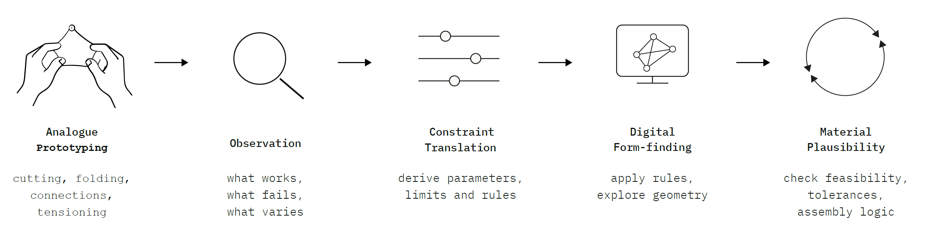
Figure 1: Analogue–digital design methods
The methodology follows an iterative digital–physical process. Digital models were used to define form-found geometry, geometric and structural constraints, and fabrication data. Physical tests and assembly trials were used to evaluate material behaviour, joint logic, and construction feasibility. These findings were fed back into the computational model and finally operationalised in the open-access web tool.

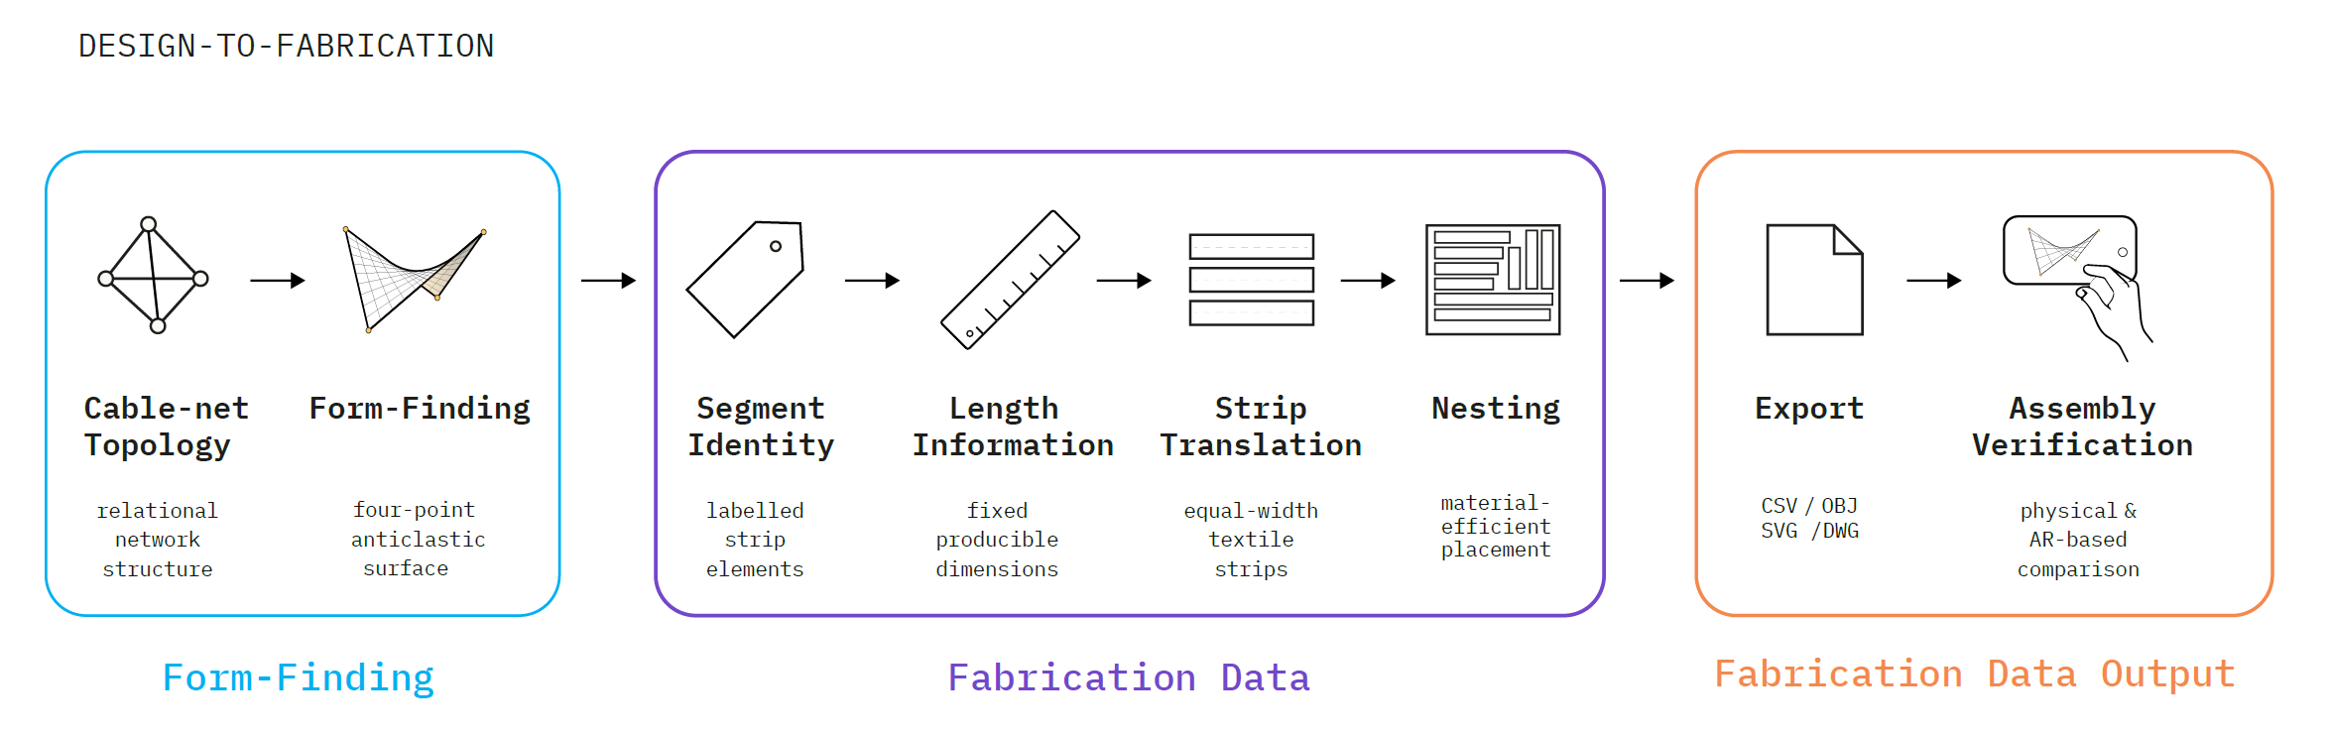

Figure 2: Web-tool operationalisation
3.1 Knowledge and constraint model | Relevant design parameters
The first methodological step was to identify which aspects of cable-net design had to become explicit parameters within the framework. The system was based on the geometric principle of a four-point tensile structure with two high and two low anchor points. This typology provides a simple starting point for non-expert users, while allowing spatial curvature through height differences, sag, and pre-tensioning.
A site-specific digital model was established as a reference for the construction of the 1:1 prototype. Façade edges, possible fixing points, height differences, distances, and spatial boundaries defined the initial design frame. Within this frame, the main adjustable parameters included anchor-point position, span, sag, net density, element length, material properties, joint rotation, pre-tensioning, fabrication limits, labelling, and assembly sequence.
Unlike conventional steel cable-net systems, which typically rely on continuous cables and industrially manufactured connection details, the proposed system uses discrete linear textile-based segments connected through flexible joints. These joints allow angular change and rotation during assembly. While this reduces structural capacity compared with engineered steel cable-net systems, it also lowers cost, fabrication complexity, and dependency on industrial prefabrication. The approach is therefore positioned as a low-barrier alternative for temporary, lightweight, and upcycled shading structures.
The design problem was consequently not treated as one fixed form, but as a set of adjustable constraints that could be tested in relation to geometry, material behaviour, fabrication, and assembly.

3.2 Parametric form-finding and material calibration
The computational model was first developed in Rhinoceros3D and Grasshopper. Four main anchor points defined the boundary of the cable-net system and could be adjusted in plan and height. Additionally, parameters controlled curvature, mesh density, span, sag, and pre-tensioning behaviour. Kangaroo Physics was used for form-finding, modelling the net through spring behaviour, boundary conditions, and length constraints. The geometry was therefore not modelled as a fixed surface, but generated through simulation.
In parallel, physical material tests were carried out with reused truck tarpaulin. Cutting tests, tensile tests, folded-strip mock-ups, and joint studies examined deformation, edge stability, load behaviour, and connection possibilities. These tests showed that the reused material could not be treated as a standard membrane material. Its behaviour depended on folding, local reinforcement, joint detailing, and balanced pre-tension.
The tensile tests showed that the reinforced folded strip detail could carry a tensile load of approximately 2.0 kN, with local bearing stress at the eyelet hole being the critical condition. The results informed the digital model by defining limits for element length, joint movement, and fabrication tolerances.
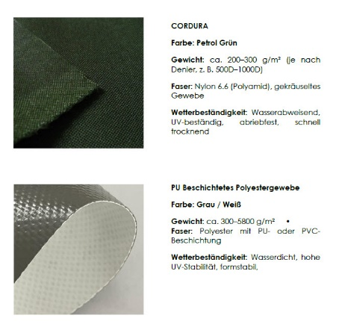
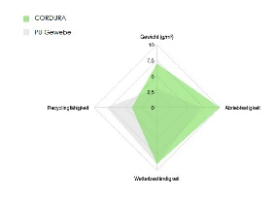
Figure 3: Identification and evaluation of reused textile materials

3.3 Preliminary structural feedback
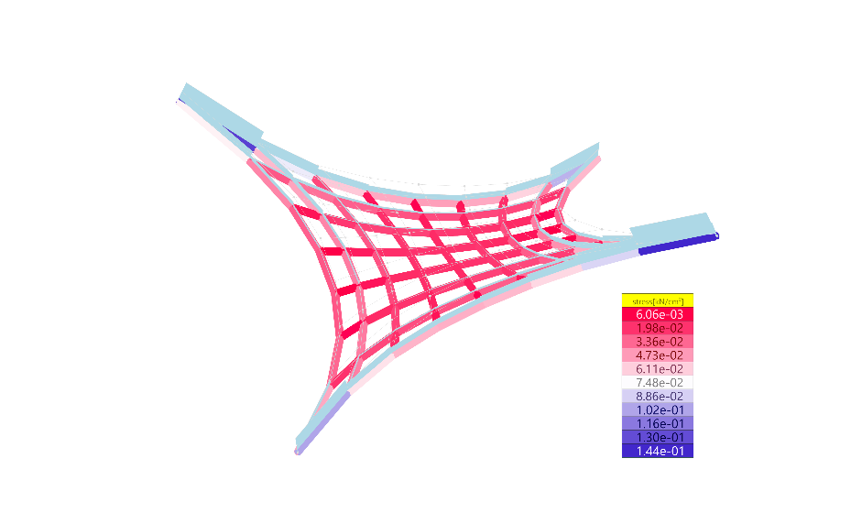
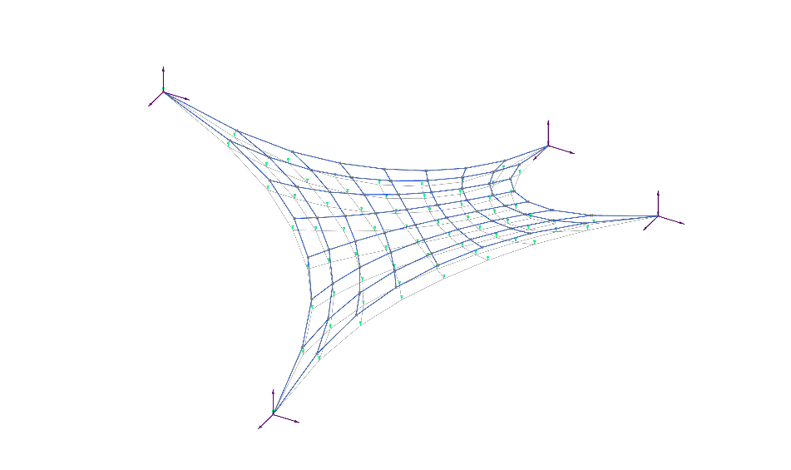
Karamba3D was used in Grasshopper as a preliminary structural feedback layer within the parametric workflow. The form-found cable-net geometry was translated into a line-based structural model with defined support conditions, point-load and initial-strain inputs, and material assumptions for the upcycled truck-tarpaulin segments. The relevant outputs were the reaction forces at the four anchor points, interpreted as indicative pre-tensioning values, and the axial normal forces in the textile segments.

Figure 4: Deformation under load and distribution of normal forces in the cable-net model

In the analysed configuration, the listed segment normal forces remained in the sub-kilonewton range and below the experimentally observed tensile load capacity of the reinforced folded strip detail. The results were used to identify force concentrations, under-tensioned areas, and plausible load ranges before full-scale assembly. Since the reused tarpaulin strips and flexible joints do not behave like calibrated steel cables, the Karamba3D simulation was not treated as final structural proof, but as engineering feedback interpreted together with tensile tests, joint tests, and observations from the demonstrator assembly.

3.4 Length-stable patterning and fabrication output
The central computational step is the translation of the simulated 3D net into planar fabrication elements. Rather than flattening a continuous membrane surface, the framework converts the cable-net geometry into length-stable textile elements. The lengths of individual elements are preserved, while angular variation is transferred to flexible joints. The final doubly curved form is produced through the interaction of fixed element lengths, movable joints, and pre-tensioning during assembly. This approach builds on previous research into linear photovoltaic lightweight carrier systems (Carl and Schein, 2019).
This strategy shifts geometric complexity from surface flattening to the coordination of length constraints, joint behaviour, fabrication data, and assembly logic. The Grasshopper definition operates as the expert layer of the system. To make the workflow accessible, this logic is reduced to a limited set of controllable parameters. The framework generates the 3D cable-net model, planar elements, cutting information, labels, and assembly data for CNC-based or analogue fabrication.
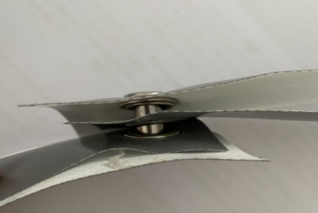
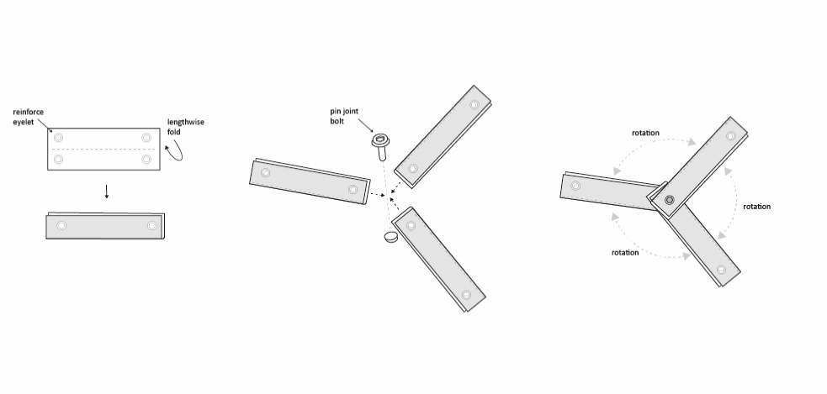
Two unfolding strategies were tested: a Kangaroo-based unrolling process and a Blender cloth-relaxation model used as a counter-check. The resulting length deviations were evaluated before fabrication and used to define acceptable tolerance ranges for the unfolded textile strips.

Figure 5: Assembly process and joint articulation

3.5 Web-based tool operationalisation and software architecture
The identified design and fabrication knowledge was operationalised in the Simplexity Tool, a browser-based design-to-fabrication prototype for early-stage cable-net exploration. The aim was to translate selected parts of the expert workflow into an accessible interface without requiring Rhino, Grasshopper, ShapeDiver, or server-based computation. In contrast to server-dependent parametric web platforms, the tool is implemented as a static client-side application using HTML, CSS, SVG, and standard JavaScript. It can therefore be accessed directly through a web link, runs locally in the browser on standard devices, and remains open-access without platform-specific licensing or usage fees.
The tool represents the cable-net system as a discrete network of nodes, edges, and faces. This data model connects the four-point net geometry with downstream operations such as labelling, length extraction, flat strip generation, nesting, and export. Users interact with a reduced set of parameters, including boundary dimensions, anchor positions, corner heights, mesh subdivision, curvature, sagging tendency, strip width, material presets, and production sheet dimensions. More specific rules, such as length stability, joint rotation, hole placement, fold allowances, nesting logic, and tolerance warnings, remain embedded in the background logic of the system.
The computational pipeline follows the project’s design-to-fabrication sequence: generation of the four-point cable-net geometry, extraction of node IDs, segment IDs, and true segment lengths, translation into flat strip layouts and nested production sheets, and export of interoperable data formats. These include OBJ and JSON for geometry exchange, CSV for node and segment data, and DXF-oriented outputs for CNC-based fabrication.
The tool also includes simplified previews for load, tension, sagging, and utilisation tendencies. These previews are used only as design-stage indicators and communication aids. They do not constitute structural verification and do not replace FEM analysis, CFD simulation, Eurocode-based calculation, or professional engineering assessment. The methodological contribution of the web tool lies in geometry generation, data structuring, labelling, unrolling, nesting, and fabrication-oriented export.


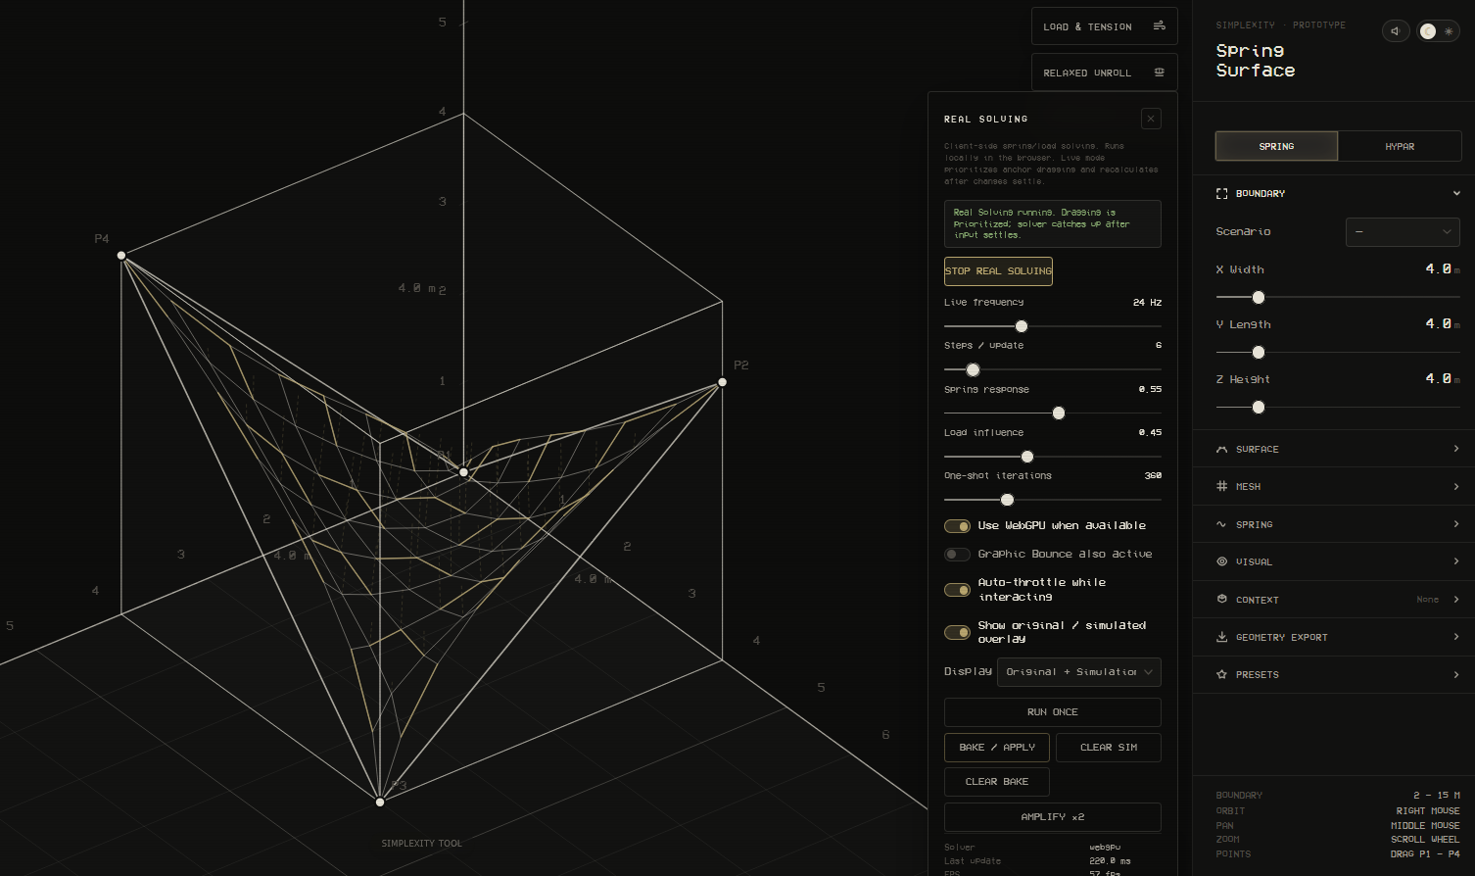

Figure 6: Simplexity web-tool interface and QR link to the tool

3.6 Validation workflow
The framework was evaluated through a design-and-build validation process centred on the assembly of a 6 × 6 m demonstrator. The demonstrator was built with a group of Master’s students representing users with intermediate subject knowledge rather than specialist cable-net expertise. This tested whether the digital model, length-stable patterning logic, cutting information, labelling system, flexible joints, and assembly sequence could operate together at full scale.
In addition, the reliability of the length-stable patterning process was evaluated through a Python script embedded in the Grasshopper definition. The script compared the element lengths of the form-found 3D geometry with the corresponding lengths of the unfolded fabrication data. It measured length deviations, reported critical differences, and visualised them directly within the computational model. Since the physical joint detail allows angular adaptation during pre-tensioning, the benchmark focused on length preservation rather than angular correspondence.

An Augmented Reality (AR) workflow was used as a qualitative geometric comparison layer within the design-to-fabrication process. The simulated cable-net model was overlaid with the built demonstrator to compare the spatial correspondence between computational geometry, fabrication output, and realised form. The comparison focused on anchor-point alignment, scale, boundary lines, global curvature, and sagging behaviour. These features were selected because they indicate whether the form-found geometry is retained after fabrication and assembly. The AR overlay was not used for metric deviation measurement. No independent ground-truth dataset was established; therefore, no quantitative claims regarding AR accuracy are made. Future research should include an independent ground-truth dataset to enable quantitative assessment of geometric deviations and AR registration accuracy.
From a design methodology perspective, AR was therefore used not as a visualisation tool alone, but as a qualitative feedback mechanism. It made spatial discrepancies between the intended digital geometry and the physical structure visible in real space and helped identify where material behaviour, joint rotation, pre-tensioning, or assembly tolerances affected the final geometry.

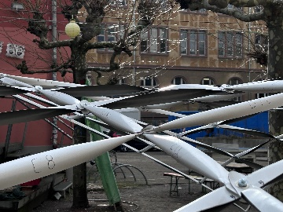
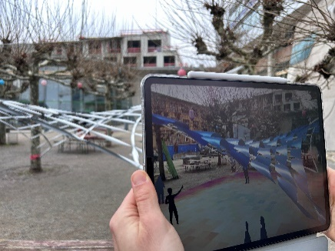
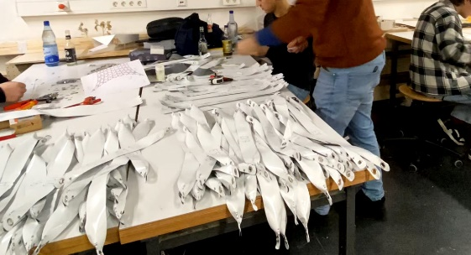

Figure 7: Segment fabrication, full-scale demonstrator, and AR-supported geometric overlay

4. RESULTS AND DISCUSSION
The main result is not a single geometric configuration of a cable net made from reused materials, but an operational open-access design-to-fabrication workflow. The framework translates expert decisions into a sequence that can be followed by non-expert stakeholders and adapted to different urban morphologies: defining boundary points, adjusting geometry, inspecting the spatial configuration, selecting material parameters, generating planar elements, nesting them on available material sheets, exporting cutting information, labelling parts, cutting elements from reused materials, and assembling the structure according to the unfolded layout and pre-tensioning logic.
This supports the central research claim that cable-net complexity does not need to be removed in order to become accessible. Instead, complexity is distributed across parameter limits, element lengths, joint movement, labels, fabrication data, and verification. Users do not need to understand every computational operation, but can interact with the consequences of these operations through a reduced interface.

4.1 Material behaviour, joint rotation, and pre-tensioning
The material tests and mock-ups showed that reused truck tarpaulin can perform as a robust material for folded textile elements in temporary cable-net structures. However, its behaviour depends strongly on local detailing and correct pre-tensioning. Reinforced eyelet connections through folded elements were essential for transferring forces across the cable-net system. In tensile tests, the reinforced folded strip detail reached a load capacity of approximately 2.0 kN.
At the same time, the joints had to allow angular movement. This flexibility is not a weakness of the system, but a necessary condition for fabricating and transforming planar segments into a doubly curved spatial structure. The mock-ups and full-scale assembly showed that the final geometry depends on sufficient and balanced pre-tension at all anchor points. Where pre-tension was too low, individual strips sagged and the structure deviated from the simulated geometry. Highly tensioned strips remained flatter and more stable, while less tensioned strips tended to reopen along the fold. These observations indicate that the digital workflow must not only generate accurate element lengths, but also communicate assembly logic and pre-tensioning requirements. The correct positioning of the four anchor points in three-dimensional space proved particularly challenging for non-expert users.

4.2 Digital-to-physical transfer and assembly tolerance
The demonstrator showed that the relevant measure of accuracy is not the preservation of every simulated angle. Instead, the workflow depends on stable element lengths, readable labels, flexible angular adaptation, and controlled pre-tensioning. The built structure is therefore best understood as a negotiated result between simulated geometry, material behaviour, joint movement, and assembly force. This finding shifts the evaluation from geometric precision alone to assembly tolerance. The nesting and labelling system must not only produce correct cutting data; it must also support construction by making element identity, direction, length, and joint relation clear. In this sense, fabrication information becomes part of the structural logic of the system.
AR-supported qualitative comparison helped assess the relationship between the simulated geometry and the built demonstrator. Rather than functioning as a visualisation tool only, AR acted as a qualitative comparison layer within the design-to-fabrication workflow. It made spatial discrepancies between the digital target geometry and physical realisation visible and provided feedback on where material behaviour, pre-tensioning, or assembly tolerances affected the final form. AR may further support the positioning and evaluation of climate-responsive infill elements.

5. CONCLUSION AND OUTLOOK
The physical demonstrator provides a proof of concept for the central claim of the paper: cable-net complexity can become accessible to non-expert stakeholders when translated into an open-access parametric workflow connecting form-finding, fabrication data, joint logic, assembly information, and spatial verification. The contribution is not limited to the built structure, but lies in the operationalisation of specialist cable-net knowledge into a low-barrier design-to-fabrication process with low material cost and a reuse-based material strategy. Material and parts for the demonstrator amounted to approximately 180 € for an area of 36 m², or 5 €/m².
A key aspect of this accessibility is the implementation of the web tool as a computationally lightweight, client-side browser application. It runs locally on standard mobile devices, including tablets, without Rhino, Grasshopper, ShapeDiver, server-based computation, or platform-specific fees. This broadens access beyond expert modelling environments and allows non-expert stakeholders to interact with simulation, geometry generation, fabrication data, and assembly information through a standard web browser.
The design-and-build process with Master’s students showed that the system can be understood and assembled by users positioned between expert and non-expert knowledge. However, broader empirical testing with municipalities, community groups, or fully non-expert stakeholders is still required. The system should be further evaluated in terms of usability, interface optimisation, error patterns, decision-making, and assembly clarity.
Several technical limitations remain. The system is currently validated as a temporary lightweight shading structure and does not replace professional structural design for permanent or safety-critical applications. Correct positioning and pre-tensioning of the four anchor points proved challenging and requires clearer guidance. Future research will extend the framework with a material library for upcycled sheet and strip materials, climate-responsive infill elements, and geometries beyond the current four-point sail typology. Additional tensile tests, hole-bearing tests, fatigue tests, and full-scale assembly trials will be required to refine tolerance ranges, pre-tensioning guidance, and structural assumptions.
Beyond its technical contribution, the framework opens an architectural argument for site-specific reuse. Following the notion of genius loci, the project does not treat place as a fixed historical essence, but as a situated condition shaped by material provenance, traces of use, local availability, and construction logic (Norberg-Schulz, 1980). This also resonates with critical regionalist arguments that architecture can resist placeless standardisation through attention to tectonics, climate, materiality, and context (Frampton, 1983). The reused truck tarpaulin is therefore not only a low-cost substitute for industrial cable-net components. Its colouration, ageing, repairs, folds, and eyelets become part of the architectural expression. The resulting structure develops a contemporary, material-based sense of place in which local reuse, computational form-finding, and visible structural behaviour are linked.
In conclusion, the research demonstrates how a computationally lightweight, browser-based, open-access workflow can make the design and fabrication of upcycled cable-net shading structures more accessible. Rather than reducing geometric complexity, the framework translates it into constrained parameters, length-stable fabrication data, flexible joint logic, assembly information, and AR-supported verification.

ACKNOWLEDGEMENTS
The authors thank the dedicated Master’s students for their commitment throughout the design-and-build process. We also gratefully acknowledge Prof. Dr.-Ing. Agnes Weilandt and Edoardo Sesti for their invaluable structural engineering support in setting up and refining the FEM simulation.

REFERENCES
Alexi, E.V., Kenny, J.C., Atanasova, L., Casas, G., Dörfler, K., & Mitterberger, D., (2024).
Cooperative Augmented Assembly (CAA): Augmented Reality for On-Site Cooperative Robotic Fabrication. Construction Robotics, 8: Article 28.
Blahut, S., Faizi, H., & Harnoncourt-Fuchs, M.-T., (2024). Hybrid Workflow for Feedback using
Extended Reality and 3D Scanning Systems. Proceedings of eCAADe 2024, Data-Driven Intelligence, 2: p. 675-684.
Carl, T., & Schein, M., (2019). A Parametric Framework for Solar Tensile Structures – Bridging the Gap between Conception and Construction. In: Thomsen, M.R., Tamke, M., Gengnagel, C., Faircloth, B., & Scheurer, F. (eds.), Impact: Design with All Senses. Cham: Springer.
Frampton, K., (1983). Towards a Critical Regionalism: Six Points for an Architecture of Resistance. In: Foster, H. (ed.), The Anti-Aesthetic: Essays on Postmodern Culture. Seattle: Bay Press.
Hagedorn, P., Block, M., & Zentgraf, S., (2022). Toolchains for Interoperable BIM Workflows in a Web-Based Integration Platform. Applied Sciences, 12(12): 5959.
Jahn, G., Newnham, C., & van den Berg, N., (2022). Augmented Reality for Construction from Steam-Bent Timber. Proceedings of CAADRIA 2022, 2: p. 191-200.
Lewis, W.J., (2003). Tension Structures: Form and Behaviour. London: Thomas Telford.
Gale, S., & Lewis, W.J., (2016). Patterning of Tensile Fabric Structures with a Discrete Element Model Using Dynamic Relaxation. Computers & Structures, 169: p. 112-121.
Méndez Echenagucia, T., Pigram, D., & Liew, A.C., (2019). A Cable-Net and Fabric Formwork System for the Construction of Concrete Shells: Design, Fabrication and Construction of a Full Scale Prototype. Structures, 18: p. 72-82.
Norberg-Schulz, C., (1980). Genius Loci: Towards a Phenomenology of Architecture. New York: Rizzoli.
Oke, T.R., (1981). Canyon Geometry and the Nocturnal Urban Heat Island: Comparison of Scale Model and Field Observations. Journal of Climatology, 1(3): p. 237-254.
Piker, D., (2013). Kangaroo: Form Finding with Computational Physics. Architectural Design, 83(2): p. 136-137.
Shata, R.O., Mahmoud, A., & Fahmy, M., (2021). Correlating the Sky View Factor with the Pedestrian Thermal Environment in a Hot Arid University Campus Plaza. Sustainability, 13(2): 468.
Stürz, Y.R., Morari, M., & Smith, R.S., (2020). Control of an Architectural Cable Net Geometry. IEEE Transactions on Control Systems Technology, 28(4): p. 1378-1392.
Ulu, N.G., (2020). Computational Design and Evaluation Methods for Empowering Non-Experts in Digital Fabrication. arXiv:2006.05921.
Veenendaal, D., & Block, P., (2014). Design Process for Prototype Concrete Shells Using a Hybrid Cable-Net and Fabric Formwork. Engineering Structures, 75: p. 39-50.

