43rd CIB W78 Conference on IT in Construction, 6-8 October 2026, IIT Delhi, New Delhi, India
Logistics and Schedule Optimised Module-Size Selection for PPVC Construction: A Dynamic Scheduling and AI-Enabled Decision Support System
Pawan Pandey
Department of Civil & Environmental Engineering, IIT Delhi
pvn@civil.iitd.ac.in
ABSTRACT
Prefabricated Prefinished Volumetric Construction (PPVC) can improve productivity, quality and safety by shifting substantial building work from variable site conditions to controlled factory production. Its performance, however, depends on a project-specific choice of module size. In logistics-constrained contexts, module dimensions and mass cannot be treated as architectural preferences or imported standards because they govern route feasibility, permits, crane reach, ground bearing, site access, factory release, installation rhythm, interface complexity and rework exposure. This concept paper develops a logistics-sensitive, module-size- and dynamic-scheduling framework for PPVC projects in which the factory and site are separated by distance. It recognises three factory-site configurations: a collocated factory and site, a distant dedicated factory serving one site, and a centralised factory serving multiple sites. The last two configurations require the strongest logistics control and form the main focus. The proposed design-science artefact has three layers. Layer 1 rejects infeasible candidates through hard transport, crane, site, factory and assembly filters. Layer 2 generates small, medium and large options within the feasible envelope and compares them using normalised cost, time, risk, environmental impact and standardisation terms. Layer 3 tests the preferred option through dynamic fabrication, fit-out, inspection, transport, buffer and installation scheduling. The paper presents a truncated but rigorous mathematical formulation, an AI-enabled human-in-the-loop decision-support architecture and a staged validation roadmap. It defines the decision logic, variables and data requirements needed to convert PPVC module sizing from qualitative feasibility discussion into measurable and explainable project control.
Keywords: PPVC; modular construction; module-size optimisation; construction logistics; dynamic scheduling; AI-enabled decision support; design science.

1. INTRODUCTION
Sustained economic growth requires faster, cleaner and more reliable delivery of repetitive building types such as housing, hostels, hotels, healthcare facilities and institutional accommodation. PPVC responds by transferring substantial structural, finishing, services and quality-control work from variable sites to controlled factory production. Its value does not arise from prefabrication alone; it emerges when design, manufacturing, transport and installation are planned as one production system (Jaillon and Poon, 2008; Kamali and Hewage, 2016; Building and Construction Authority, 2017; Liu et al., 2023).
Module size is the pivotal decision variable in this system. Larger modules can reduce trips, lifts, joints, service interfaces and site operations, but they may exceed route geometry, require escorts or night movement, demand larger cranes, raise rigging risk, reduce manoeuvrability and overload site buffers. Smaller modules are easier to transport and lift, but they multiply interfaces, installation cycles, waterproofing joints and coordination points. The optimum is therefore not the largest possible unit or an imported standard; it is the module family that remains feasible and valuable under the actual route, crane, factory, site, regulatory and assembly conditions of the project.
The operational gap is clear. Prior studies have identified PPVC benefits and barriers, but barrier lists do not tell a project team which dimensions are feasible, how to compare small, medium and large alternatives, how to synchronise factory release with movement windows and crane slots, or how to revise a decision when the schedule shows excessive waiting or storage. The research problem is therefore not only whether PPVC should be adopted, but how a project-specific module-size decision can be measured, tested and updated.
The paper is positioned as a design-science concept paper. It contributes a decision artefact, not a fully calibrated optimiser. The artefact makes assumptions explicit, exposes data requirements and creates a pathway for empirical calibration through completed projects, option simulation, schedule validation and AI shadow pilots (Peffers et al., 2007). Section 2 synthesises the literature by decision parameter. Section 3 presents the framework. Section 4 develops the mathematical and scheduling logic. Section 5 presents the AI-enabled architecture. Sections 6 discuss validation, implications and limitations. The last section covers contribution and conclusions.

2. LITERATURE REVIEW AND PARAMETER-WISE SYNTHESIS
PPVC is a form of volumetric modular construction in which a three-dimensional building unit is manufactured off site, substantially completed with structure, finishes and services, transported to the project location and assembled into the final building. The method is most suitable when repetition allows early design freeze, standardised production and predictable installation. Hostels, hotels, residences, hospitals and institutional accommodation are therefore common candidates. Its value comes from parallelisation of factory and site work, but the benefits appear only when design, production, logistics, quality assurance and installation remain synchronised.
Table 1 organises the literature by parameters that directly affect module-size selection and scheduling. The table does not treat the literature as a generic adoption review. It translates each evidence pattern into an operational implication so that project suitability, transport envelope, route geometry, crane reach, site storage, factory capacity and interface tolerance become measurable inputs to the framework. The synthesis in Table 1 shows that logistics is a binding integrator rather than one parameter among many. Module width and height affect route feasibility; length affects swept path and site manoeuvring; mass affects trailer payload, permits, crane selection and ground bearing; and all dimensions affect module count, jointing, service alignment, factory handling and storage demand. A module-size decision therefore propagates across the entire PPVC delivery chain.
Table 1. Parameter-wise synthesis of PPVC findings relevant to module size and scheduling
Parameter | Evidence pattern | Module-size and scheduling implication | Indicative references
Project suitability and repetition | PPVC performs best in repetitive accommodation-type buildings where layouts can be frozen and produced in batches. | Generate module families around repeatable unit typologies and repetition count rather than isolated architectural preference. | BCA 2017; Liu et al. 2023
Early design freeze and stakeholder integration | Late changes disrupt production, services coordination, transport preparation and installation sequence. | Freeze module size using architecture, structure, MEP, factory, logistics, crane and site inputs. | Hwang et al. 2018; BCA 2017
Material system and module weight | Concrete, steel and hybrid systems differ in weight, durability, fire, acoustic and maintenance requirements. | Treat module mass as a hard constraint checked against trailer, permit and crane limits at actual working radius. | Balasbaneh and Ramli 2020; Chourasia et al. 2023
Transport envelope | Width, height, length and mass are governed by road width, overhead clearance, bridge limits, trailer height and permits. | Apply dimensional and mass checks before cost or time optimisation. | BCA 2017; Liu et al. 2023; Ibrahim et al. 2022
Route geometry and congestion | The governing segment may be a junction, gate, turn, slope, market area or urban bottleneck. | Base the feasible envelope on the weakest route segment, not the nominal factory or highway dimension. | Hwang et al. 2018; Choi et al. 2019; Tazikova 2021
Permits and movement windows | Oversized or heavy modules may require escorts, restricted timings and route control. | Model transport as a time-window scheduling problem rather than a simple haulage-cost problem. | BCA 2017; Ibrahim et al. 2022
Crane reach and lifting safety | Crane suitability depends on module mass, rigging, centre of gravity, radius, ground conditions and lift sequence. | Check mass at actual pick-and-place radius with rigging and safety factor. | BCA 2017; Wong Seng et al. 2021
Site storage and just-in-time delivery | PPVC reduces site work but requires trailer access, holding area, direct-lift strategy or nearby buffer yards. | Size the delivery buffer from site storage capacity and crane productivity. | Jaillon and Poon 2008; Liu et al. 2023
Factory capacity and sequencing | Factory production improves quality but can create bottlenecks, mould constraints, QA gates and release-rate limits. | Compare factory release rate with installation demand and account for multi-site capacity allocation. | Arashpour et al. 2016; Mullens, 2011
Jointing, tolerance and MEP continuity | Interface alignment, waterproofing, grouting, service crossings and survey control affect quality and rework. | Balance fewer joints from larger modules against tolerance, lifting deformation and connection-access risk. | Wong Seng et al. 2021; BCA 2017; Chourasia et al. 2023
Cost, scale and sustainability | PPVC may have cost premiums but can reduce duration, labour, waste and rework when repetition and logistics are controlled. | Minimise delivered-and-installed cost and lifecycle impact, not manufacturing or transport cost alone. | Kamali and Hewage 2016; Tambichik et al. 2022
Digital and AI decision support | BIM, scheduling optimisation, tracking and route intelligence can support offsite logistics. | Encode module-size selection as a constraint-checking, scenario-testing and learning problem. | Sacks et al. 2010; Arashpour et al. 2016

The literature also points to a methodological requirement wherein each barrier or success factor must be translated into a measurable decision rule if the framework is to be tested. Table 2 converts the parameter-wise literature synthesis into design requirements for the proposed artefact. It also explains why the paper separates feasibility, optimisation and scheduling. PPVC projects can fail when these decisions are mixed too early. A large module may look efficient because it reduces joint count, but it should never enter value scoring if it fails a route, crane, site, factory or assembly constraint.
The final implication of the review is that digital and AI support should be built on a deterministic engineering core. BIM, route data, GPS tracking, computer vision and predictive analytics are valuable only when they are connected to hard feasibility rules and auditable scheduling logic. The literature on digital decision support therefore justifies the AI-enabled architecture in this paper, but it does not remove the need for explicit equations and transparent human approval.
Table 2. Scientific deduction from literature evidence to framework requirements
Evidence pattern | Scientific deduction | Framework requirement | Construct
PPVC benefits depend on coordinated design, production, logistics and installation. | PPVC is a system integration problem. | Integrate design, factory, transport, crane and installation in one decision flow. | Integrated decision chain
Module dimensions are constrained by route, permits, lifting and site access. | Logistics is the binding feasibility layer. | Check width, height, length and mass before optimisation. | Feasible envelope
Larger modules reduce joints and lifts but increase transport, lifting and permit complexity. | Module size is a multi-objective trade-off variable. | Compare feasible options by cost, time, risk, environmental impact and standardisation. | Option selection
Just-in-time delivery is necessary on constrained sites. | Time is a constraint, not only an outcome. | Synchronise transport arrival, site buffer and crane slot. | Dynamic schedule
Factory quality depends on tolerance, protection and inspection. | Quality benefit is not automatic. | Introduce QA gates before release, loading, lift and post-installation. | Quality-gated flow
A centralised factory serving several sites creates sequencing conflicts. | Factory-site configuration changes scheduling complexity. | Model resource allocation across sites. | Multi-site scheduling
Digital records support route checking, tracking and prediction. | AI should improve adaptation without overriding safety. | Use prediction and scenario testing with human approval. | AI-enabled support

3. PROPOSED LOGISTICS-SENSITIVE SOLUTION FRAMEWORK
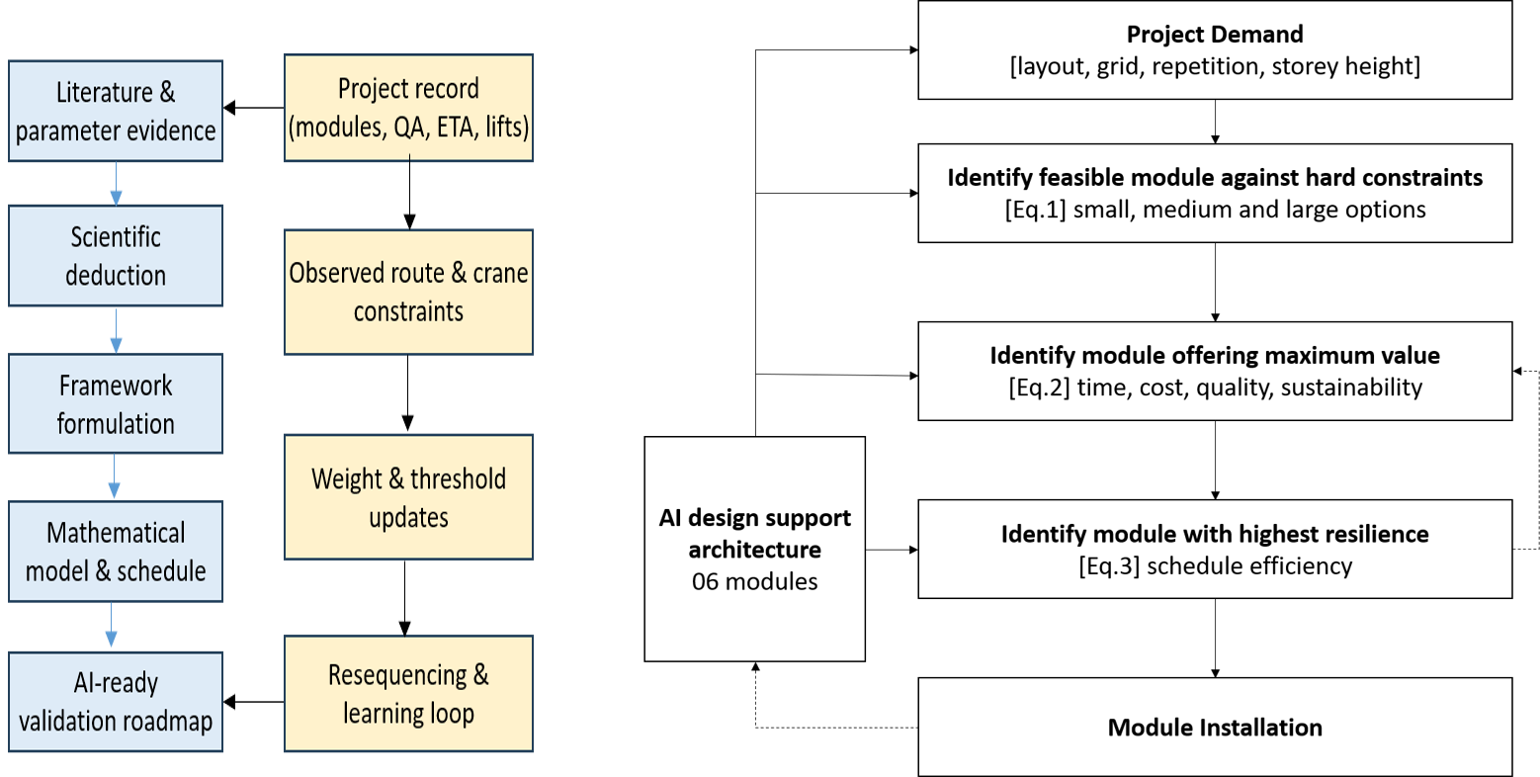
The proposed framework transforms the deductions in Table 2 into a decision workflow. The output is a project-specific set of small, medium and large options generated within a feasible envelope and tested through scheduling. This design is important because module sizing is a constrained optimisation problem. A dimension that performs well in one project may fail in another because the governing route, crane, factory or site condition is different. Figure 1 shows the research design behind the framework and operational workflow is explained through Figure 2.
Figure 2. PPVC module-size selection framework
Figure 1. Research design and feedback loop for deriving and testing the PPVC module-size framework

Table 3 below translates the workflow into decision questions, information requirements, computations and outputs. It bridges the conceptual framework and implementation. A project team can populate the fields in a spreadsheet using route surveys, crane charts, factory constraints and site layout drawings; the same logic can then be encoded in a solver or dashboard.
Table 3. Operational basis for selecting small, medium and large PPVC module-size options
Layer | Decision question | Required information | Computation | Output
Building demand | What repeatable module family can satisfy the layout? | Room layout, grid, storey height, riser positions and repetition count. | Generate candidate module families and count modules, lifts and joints. | Initial small, medium and large candidates.
Transport envelope | Can the module move legally and physically? | Dimensions, trailer height, route width, clearance, turning radius and bridge limits. | Check width, height, length, swept path and mass against the weakest route segment. | Transport-feasible range.
Permit and movement windows | Can movement occur without unacceptable delay? | State rules, permits, escort needs, local approvals, congestion and event restrictions. | Convert conditions into time-window and penalty constraints. | Permitted delivery slots.
Crane and lifting | Can the module be lifted at actual radius? | Mass, rigging, centre of gravity, lifting frame, crane type and working radius. | Check mass against crane chart and ground-bearing capacity. | Maximum liftable mass and lift plan.
Site access and storage | Can trailers access the site and can modules wait safely? | Gate width, turning area, laydown space, direct-lift feasibility and holding yard. | Calculate buffer, site inventory and direct-lift requirement. | Buffer strategy.
Factory and supply chain | Can modules be fabricated and released in sequence? | Factory capacity, moulds, cycle time, QA capacity, fit-out line and suppliers. | Compare release rate and factory resource demand with installation demand. | Batch plan and release sequence.
Interface and quality | Can modules align, connect and remain watertight? | Joint details, tolerances, survey plan, MEP crossings, waterproofing and QA gates. | Check installation readiness, access and rework risk. | Interface risk flags.
Value and sustainability | Which feasible option improves overall performance? | Cost, time, crane cost, transport cost, rework, emissions, waste and productivity. | Multi-objective comparison and sensitivity testing. | Preferred option with risk range.

4. DYNAMIC SCHEDULING AND MODULE-SIZE FORMULATION

4.1 Modelling purpose, scope and assumptions
The purpose of the mathematical model is to convert the conceptual framework into a realistic planning tool. The model organises the decision sequence: generate candidates, reject infeasible modules, create small, medium and large options, compute normalised performance scores and test the selected option through dynamic scheduling. This sequence matters because PPVC performance depends on the compatibility of dimensions, mass, route, crane, factory, site buffer and installation sequence.
The model applies most directly to a distant dedicated factory serving one project and to a centralised factory serving several sites. The base formulation is deterministic. It uses expected process durations, known route constraints, available crane capacity, defined permit windows and planned production resources. Once project data are available, uncertainty in transport time, factory release, inspection clearance and crane productivity can be layered on through stochastic modelling, rolling-horizon rescheduling or AI-based prediction.
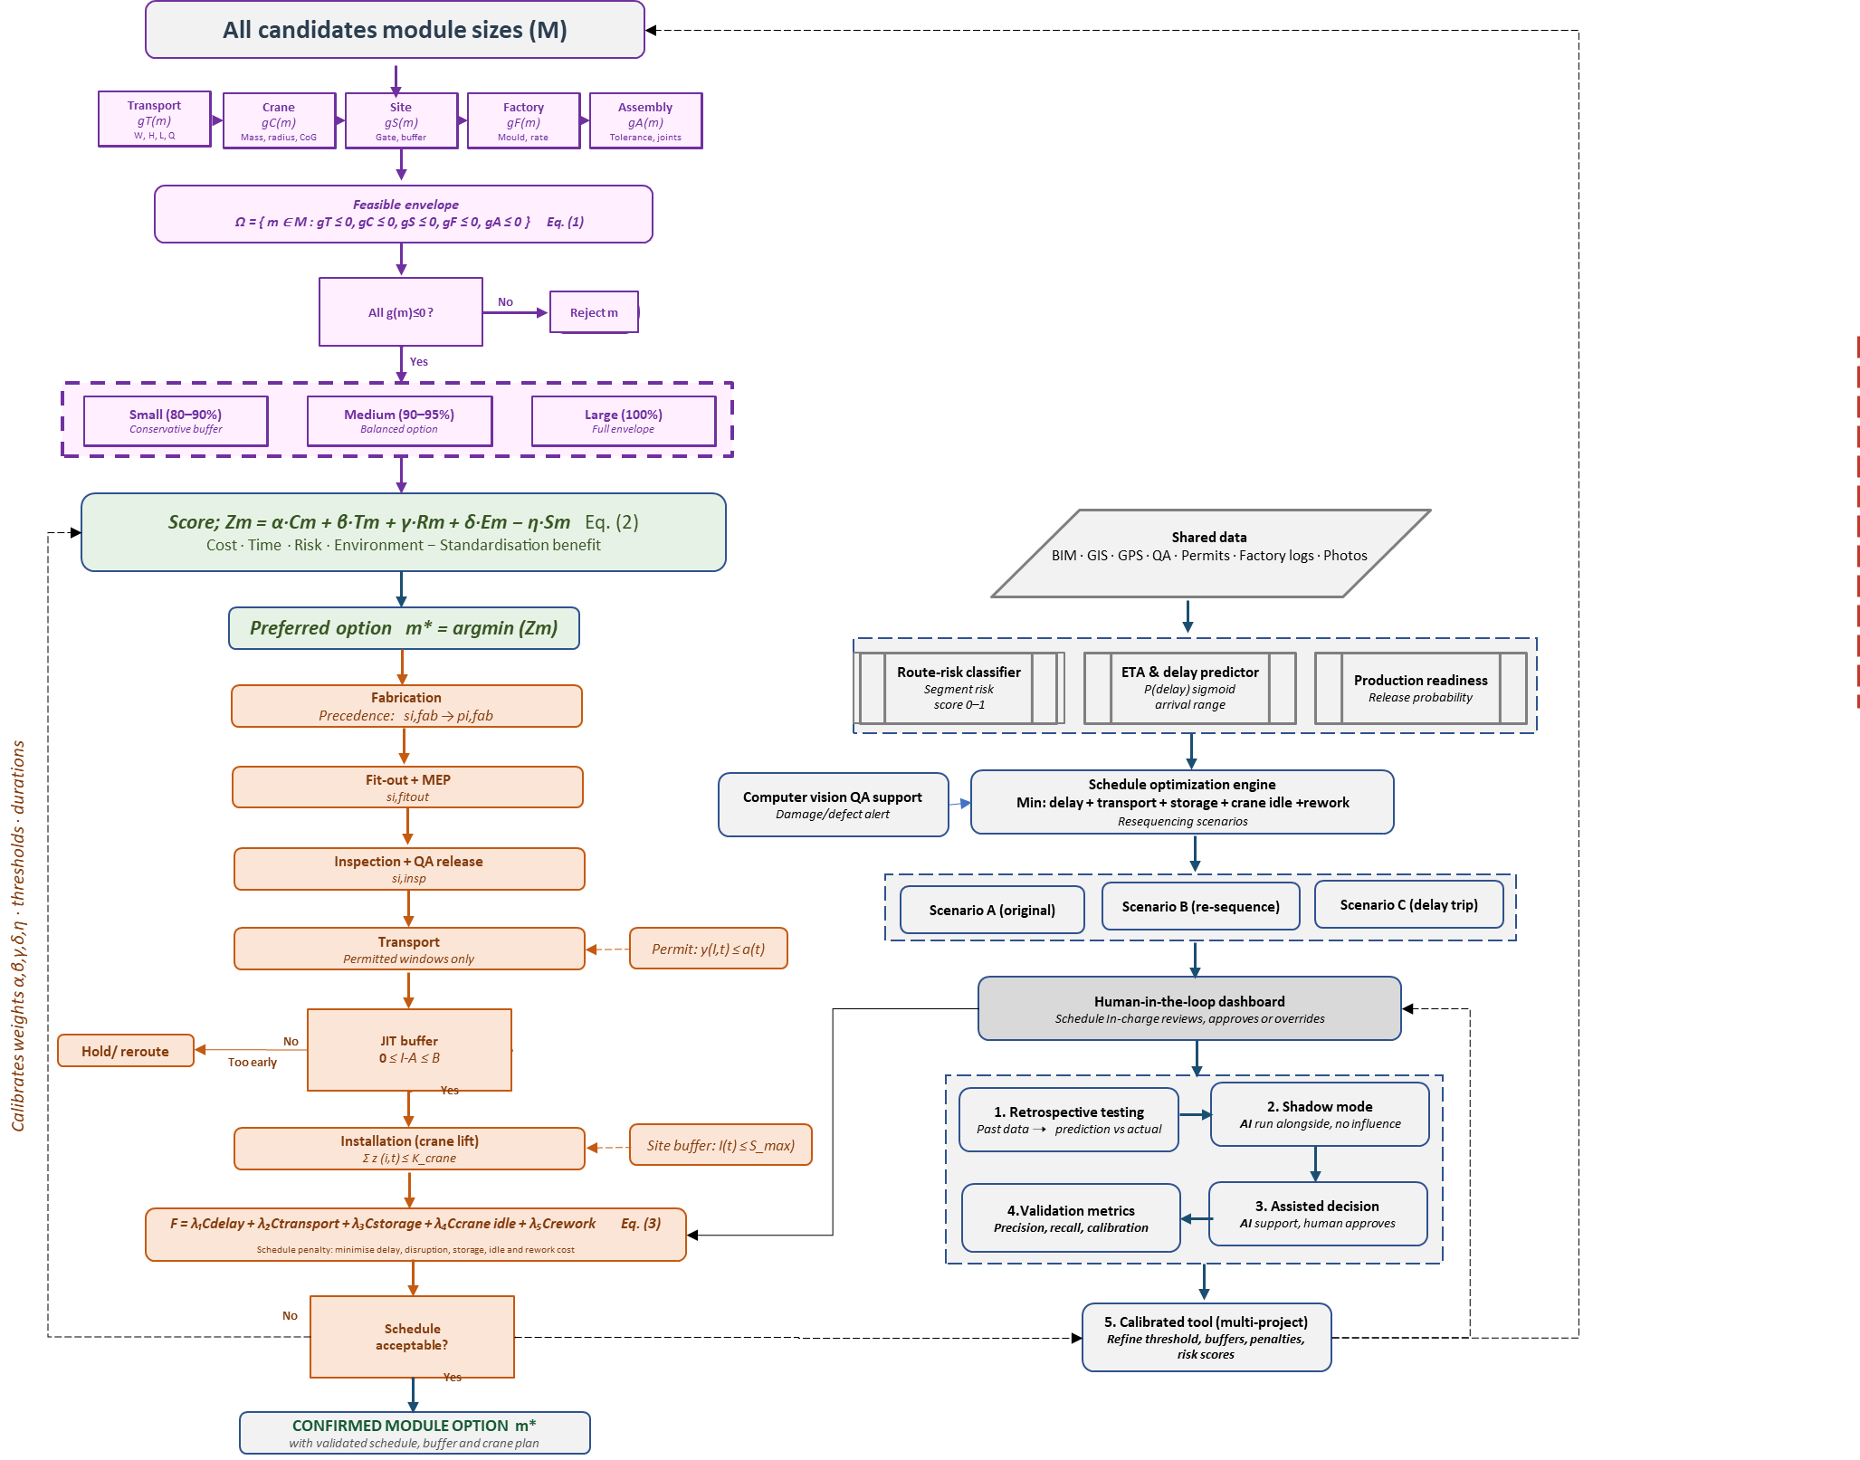
The main index sets are modules m in the candidate set M, feasible modules in Ω, stages k for fabrication, fit-out, inspection, transport and installation, time periods t for movement and resource allocation, and sites j for the multi-site factory case. Start times and lateness are continuous variables. Option selection, transport-window assignment and crane-slot assignment are binary variables. Site inventory and resource use are integer or non-negative count variables. Time is discretised only where resource allocation is required, such as transport windows, crane slots and factory capacity periods.
Figure 3. Integrated PPVC module-size selection, scheduling, AI support and validation flow
The integrated flow of feasibility filtering, option scoring, dynamic scheduling, AI support and validation is explained through Figure 3. The left-hand sequence shows how the preferred module option moves into fabrication, fit-out, inspection, transport, just-in-time buffer and crane lift. The feedback arrow indicates that a schedule rejected by buffer, crane or delay penalties returns to option selection or resequencing. The right-hand sequence shows how AI support and validation are connected to the deterministic scheduling core without replacing it. The staged validation roadmap at the base of the right column closes the learning loop: retrospective reconstruction, option simulation, schedule validation, AI shadow pilots and practitioner review progressively calibrate weights, thresholds and process durations so that the framework evolves from a concept-stage artefact into a data-driven decision-support tool.

4.2 Layer 1: feasibility filter
The first layer applies non-negotiable constraints. Transport feasibility checks width, height, length and mass against the weakest route segment, not against nominal standards. A route may satisfy most segments but fail at one junction, cable, bridge, gate or market stretch; that governing point controls the envelope. The height check includes trailer deck height because the route sees the loaded vehicle, not the module alone. The length check is a swept-path problem because a straight road can be feasible even when the site gate or access turn is not.
Crane feasibility is checked after transport feasibility because a module that reaches the site must still be lifted safely at the actual pick-and-place radius. The mass check includes rigging. The radius check recognises that crane capacity falls as radius increases. The centre-of-gravity check is important in PPVC because bathroom pods, facade elements or uneven MEP fit-out can shift the lifted load. Ground-bearing pressure is also included because a crane that is adequate on its chart can still be unsafe if the outrigger mat, temporary platform or soil condition cannot support the lift.
Site, factory and assembly constraints complete the feasibility envelope. Site access determines whether the trailer can enter, turn and wait without congestion. Factory constraints determine whether the module fits moulds, bays, doors and gantries and whether the release rate matches site demand. Assembly constraints determine whether the module can be positioned, bolted, welded, grouted, sealed, waterproofed and connected to services within tolerances. The final feasible width, height, length and mass are therefore governed by the most restrictive condition across the five constraint groups. Equation (1) expresses this hard-filter logic.
Ω = { m ∈ M : g_{T}(m) ≤ 0, g_{C}(m) ≤ 0, g_{S}(m) ≤ 0, g_{F}(m) ≤ 0, g_{A}(m) ≤ 0 } | (1)
Here, M is the set of all candidate modules generated from the architectural layout and modularisation strategy. Ω is the subset of candidates that satisfies all hard constraints. The functions g_T, g_C, g_S, g_F and g_A represent transport, crane, site, factory and assembly constraint groups respectively. The notation g(m) ≤ 0 indicates that the corresponding group is satisfied. If any constraint group fails, the candidate is excluded before scoring. This prevents a low-cost or high-standardisation module from being promoted if it cannot move legally, be lifted safely, enter the site, be produced by the factory or be assembled within tolerance.

4.3 Layer 2: option generation and multi-objective scoring
Once the feasible envelope is known, the model generates small, medium and large options. The small option intentionally reserves dimensional and mass buffer and is appropriate when route surveys are uncertain, permits are restrictive, the site is congested, crane availability is limited or the project has low tolerance for logistics risk. The medium option uses more of the feasible envelope but retains contingency. It is often the practical balance between productivity and robustness. The large option uses the full feasible envelope and minimises module count, lifts and joints, but is sensitive to small deviations in route condition, crane radius, permit timing and site access.
The model then derives module count, trips, lifts and joint complexity because these quantities translate module size into project performance. Cost is computed as delivered-and-installed cost rather than factory-only cost. It includes fabrication, fit-out, transport, permits, escorts, route management, crane lifting, rigging, installation labour, storage, delay and rework. Time exposure includes both duration and waiting effects such as lateness and crane idle time. Risk combines transport, crane, site, factory and assembly exposure. Environmental impact reflects transport distance, lifting energy, material intensity, storage and rework. Standardisation is treated as a benefit because repetition, batch production, QA readiness and interface simplicity reduce project complexity.
Equation (2) gives the final normalised scoring expression. Cost, time, risk and environmental impact enter as penalties; standardisation and quality readiness enter as a benefit and are therefore subtracted. The weights allow the project team to express priorities. A hospital may assign more weight to time certainty and risk, while affordable housing may assign more weight to cost and repetition. A constrained urban project may increase the weight on transport and site risk. The weights should later be calibrated using project data, but making them explicit already prevents an implicit preference for either the largest or the cheapest module.
Z_{m} = αC_{m} + βT_{m} + γR_{m} + δE_{m} − ηS_{m} | (2)
In Equation (2), Z_m is the score for module option m; C_m is normalised delivered-and-installed cost; T_m is normalised time or schedule exposure; R_m is logistics and installation risk; E_m is environmental impact; S_m is standardisation and quality-readiness benefit; α, β, γ, δ and η are non-negative weights reflecting project priorities. The selected static option m* is the feasible option with the lowest score before schedule stress testing.

4.4 Layer 3: dynamic fabrication-transport-installation scheduling and feedback
The third layer tests whether the selected option can actually flow through the factory-site chain. PPVC modules pass through fabrication, fit-out, inspection, protection, release, loading, transport, site gate, holding or direct lift, final installation and post-installation QA. These activities are not independent. A delayed factory inspection can miss a transport permit window. A module that arrives too early may occupy scarce site buffer. A module that arrives late may idle the crane and disrupt the installation sequence. A lift delayed by high wind, ground condition or interface rework may create a queue of trailers. The schedule model therefore treats time, buffer and crane capacity as constraints rather than after-the-fact outcomes.
The precedence equations maintain the order of work for each module. Time-window equations assign transport to legal movement periods and lifts to available crane slots. Capacity equations prevent overloading of factory resources, QA teams, trailers, cranes and installation crews. Site inventory equations enforce just-in-time discipline by keeping arrivals aligned with installations. The schedule objective converts delay, transport disruption, unplanned storage, crane idle time and rework into a comparable penalty, as expressed through Equation (3). If these costs are expressed in monetary terms, the coefficients λ1 to λ5 can be set as monetary multipliers. If not, the coefficients express the decision-maker's priorities.
F = λ₁C_{delay} + λ₂C_{transport} + λ₃C_{storage} + λ₄C_{crane idle} + λ₅C_{rework} | (3)
In Equation (3), F is the combined schedule penalty; C_delay measures penalty from late installation or missed milestones; C_transport measures disruption from permit-window violations, waiting, route delay or convoy inefficiency; C_storage measures penalty from holding modules beyond safe or planned site capacity; C_crane_idle measures penalty from crane waiting or under-use; and C_rework measures penalty from interface correction, damage or QA non-closure. The coefficients λ1 to λ5 indicate the relative severity of each penalty category.
The option with the best static score may still be rejected after scheduling if it creates too much waiting, requires site storage beyond the safe maximum, causes repeated crane idling or produces excessive sensitivity to transport windows. In that case, the team returns to Layer 2, tests another option, changes the buffer plan, adjusts the delivery sequence or revises the factory release rhythm. The model is intended to be run iteratively and transparently, not as a black-box single run.

5. AI-ENABLED DECISION-SUPPORT ARCHITECTURE
AI is proposed as a decision-support layer, not as an autonomous approval system. Phase D of Figure 3 illustrates the AI-enabled layer. It begins with a shared data environment that connects BIM geometry, route surveys, permits, factory progress, GPS tracking, crane plans, site readiness and QA photographs. The six functional modules are then connected to the deterministic model. The route-risk classifier identifies difficult route segments. The ETA and delay predictor estimates arrival ranges and late-arrival probabilities. The production-readiness predictor estimates whether a module will be ready for dispatch. Computer-vision QA support flags visible damage, missing protection or unsafe loading for human inspection. The schedule optimisation engine tests resequencing under deterministic constraints. The dashboard presents warnings, alternatives and reasons for planner approval.
Table 4 explains how each AI module would be implemented and validated. The table is intentionally conservative. In early PPVC applications, interpretable models and rule-based checks are preferable to opaque deep learning unless sufficient labelled data are available. Operational value should be measured by reduced crane idle time, reduced unplanned storage, fewer premature releases, improved QA closure and clearer scenario decisions, not only by statistical accuracy.
Table 4. AI modules, model choices and validation approach
AI module | Data inputs | Output | Early-stage model choice | Validation and operational value
Route-risk classifier | GIS route, road width, turns, clearances, congestion, bridge restrictions, photos and local constraints. | Segment-level risk score or low, medium, high class. | Decision tree, logistic model or gradient boosting compared with route-risk checklist. | High-risk segment hit rate, false alarms and reduction in manoeuvring delay.
ETA and delay predictor | GPS logs, departure time, route distance, weather, permits, congestion, event calendar, module size and vehicle type. | Arrival range and probability of early or late arrival. | Regularised logistic regression or gradient boosting benchmarked against planned ETA. | Calibration, mean absolute error, precision-recall and reduction in crane idle time.
Production-readiness predictor | Fabrication progress, fit-out percentage, MEP status, QA checklist, supplier status, labour and rework notices. | Release probability and readiness warning. | Interpretable classifier with small-sample regularisation. | Readiness accuracy and avoidance of premature transport booking.
Computer-vision QA support | Photos or videos at factory completion, loading, site gate and pre-lift inspection. | Damage, labelling, protection or rigging alert for human inspection. | Rule-based image tagging initially; CNN only after labelled data are sufficient. | Precision-recall for defects and match with non-conformance reports or rework logs.
Schedule optimisation engine | Module sequence, crane slots, movement windows, site buffer, factory release and ETA risks. | Alternative delivery and installation sequences. | MILP or heuristic solver linked to deterministic constraints. | Reduced gate waiting, unplanned storage, crane idle time and resequencing stress.
Human-in-the-loop dashboard | All model outputs, constraints, alerts and decision logs. | Scenario comparison, approval record and override reason. | Planner review with reason capture. | Usability, trust, decision clarity and data for future calibration.

6. DISCUSSION
The proposed framework shifts PPVC research from adoption advocacy to operational decision quality. Much of the existing discussion correctly identifies barriers such as cost, transport, supply-chain immaturity and lack of standardisation. The framework is intended to be calibrated through project records rather than asserted as a universal optimisation engine. The proposed artefact should therefore be tested through a staged validation programme as summarised in Table 5.The principal limitation is that the model is not yet empirically calibrated. The option factors, weights, thresholds and risk scores are structured but not universal. They must be tuned using project records from a PPVC project. The paper therefore contributes a design-science artefact and validation roadmap, not a final calibrated engine. This limitation is acceptable at the current stage because the absence of a measurable decision structure is itself a barrier to empirical learning. The model focuses on module-size and schedule decisions and does not replace detailed structural design, connection design, temporary works design, lifting-plan approval, statutory transport approval or contractual risk allocation. It also assumes that project teams can obtain reasonably reliable route surveys, crane charts, factory records and site plans. Where these data are incomplete, the framework still helps by making uncertainty visible, but the results should be treated as preliminary and updated as measurements improve.
Table 5. Validation roadmap for testing and calibrating the proposed framework
Stage | Purpose | Data required | Method | Expected output and learning
Single-case reconstruction | Explain the actual module size and sequence used in a completed project. | Module register, BIM geometry, route survey, permits, crane chart, factory and site records. | Pattern matching and constraint tracing. | Governing constraints, missing data fields and initial feasibility thresholds.
Option simulation | Generate small, medium and large alternatives from the same project context. | Feasible envelope, unit costs, process durations, route and crane limits. | Scenario comparison and sensitivity testing. | Revised option factors, weights and trade-off interpretation.
Schedule validation | Compare modelled module flow with actual fabrication, transport and installation records. | Factory release, QA dates, GPS logs, site arrival, crane use, installation completion and buffer records. | Back-testing of precedence, capacity, inventory and penalty equations. | Calibrated durations, buffer limits, crane idle penalty and storage threshold.
AI shadow pilots | Test prediction modules without allowing them to control decisions. | Historical ETA, route delay, production readiness, photos, non-conformance reports and rework logs. | Train-test split, calibration and comparison with baseline rules. | Validated predictors, warning thresholds and false-alarm rates.
Practitioner validation | Assess usability, interpretability and decision quality. | Planner decisions, dashboard outputs, override reasons and feedback interviews. | Workshops, scenario exercises and decision log review. | Improved interface, governance rules and calibration priorities.

7. CONCLUSIONS
This paper developed a logistics-sensitive module-size and dynamic scheduling framework for PPVC construction. The central thesis is that PPVC module size must be selected as a project-system decision because it connects design, factory production, transport, permits, crane selection, site storage, installation sequence, interface quality, cost, risk and sustainability. Imported dimensional standards or qualitative preferences are insufficient where route conditions, permits, crane availability, factory capability and site access vary across projects.
The first contribution is a three-layer decision model. Layer 1 filters module candidates through transport, crane, site, factory and assembly feasibility. Layer 2 generates small, medium and large options within the feasible envelope and compares them using normalised cost, time, risk, environmental impact and standardisation terms. Layer 3 tests the selected option through dynamic fabrication, fit-out, inspection, transport, site buffer, crane and installation scheduling. This structure ensures that infeasible options are never scored and that attractive static options are checked against operational flow.
The second contribution is a compact mathematical formulation suitable for a conference concept paper. Equations (1) to (3) specify the feasible set, multi-objective score and schedule penalty. The formulation is deliberately truncated, but it remains auditable and data-ready. It allows project teams to begin with transparent spreadsheet implementation before moving to optimisation solvers or digital dashboards.
The third contribution is an AI-enabled, human-in-the-loop decision-support architecture. AI is used for route-risk classification, ETA prediction, production-readiness forecasting, QA support, schedule scenario testing and dashboard-based review. It does not override deterministic safety, engineering or statutory constraints. This distinction is essential for responsible implementation in construction logistics.
The fourth contribution is a staged validation roadmap. Future work should reconstruct completed PPVC projects, simulate alternative module options, validate schedule predictions against module-level records, pilot AI modules in shadow mode and test practitioner usability. These steps will calibrate weights, thresholds, durations, risk scores and warning rules. The framework therefore provides a pathway for moving PPVC planning from qualitative feasibility discussion to measurable, explainable and continuously improving project-control practice.
The immediate practical implication is that PPVC module sizing should be documented as a traceable decision record. The record should state the feasible envelope, rejected candidates, scoring weights, selected option, dynamic schedule result, assumptions used and conditions under which resequencing would be triggered. Such a record would support client review, regulatory coordination, contractor planning and post-project learning.

REFERENCES
Arashpour, M., Wakefield, R., Abbasi, B., Arashpour, M., and Hosseini, M. R. 2016. Off-site construction optimisation: sequencing multiple job classes with time constraints. Automation in Construction, 71, 262-270.
Balasbaneh, A. T., and Ramli, M. Z. 2020. A comparative life cycle assessment of concrete and steel prefabricated prefinished volumetric construction structures in Malaysia. Environmental Science and Pollution Research, 27, 43186-43201.
Building and Construction Authority. 2017. Prefabricated Prefinished Volumetric Construction Guidebook. BCA, Singapore.
Choi, J. O., Chen, X. B., and Kim, T. W. 2019. Opportunities and challenges of modular methods in dense urban environment. International Journal of Construction Management, 19(2), 93-105.
Chourasia, A., Singhal, S., and Manivannan. 2023. Prefabricated volumetric modular construction: a review on current systems, challenges and future prospects. Practice Periodical on Structural Design and Construction, 28(1).
Hwang, B. G., Shan, M., and Looi, K. Y. 2018. Key constraints and mitigation strategies for prefabricated prefinished volumetric construction. Journal of Cleaner Production, 183, 183-193.
Ibrahim, F. S., Esa, M., Rahman, R. A., and Nawi, M. N. M. 2022. The transportation and cost issues in modular construction. IOP Conference Series: Earth and Environmental Science, 1022, 012016.
Jaillon, L., and Poon, C. S. 2008. Sustainable construction aspects of using prefabrication in dense urban environment. Construction Management and Economics, 26(9), 953-966.
Kamali, M., and Hewage, K. 2016. Life cycle performance of modular buildings: a critical review. Renewable and Sustainable Energy Reviews, 62, 1171-1183.
Liu, Y., van Nederveen, S., and Hertogh, M. 2023. Prefabricated and prefinished volumetric construction: assessing implementation status, perceived benefits and performance risks. Journal of Management in Engineering, 39(6), 04023045.
Mullens, M. A. 2011. Factory Design for Modular Homebuilding. Constructability Press, Orlando.
Peffers, K., Tuunanen, T., Rothenberger, M. A., and Chatterjee, S. 2007. A design science research methodology for information systems research. Journal of Management Information Systems., 24(3), 45-77.
Sacks, R., Koskela, L., Dave, B. A., and Owen, R. 2010. Interaction of lean and building information modeling in construction. Journal of Construction Engineering and Management, 136(9), 968-980.
Tambichik, M. A., et al. 2022. Comparative study of PPVC and IBS construction methods. IOP Conference Series: Earth and Environmental Science, 1022, 012016.
Tazikova, A. 2021. The impact of logistics on the cost of prefabricated construction. Engineering for Rural Development, 20.
Seng, W., Huat, H. K., Mui, M. L. G., Hooi, T. T., Chuan, C. K., & Lin, T. C. (2021). Case study: The use of concrete prefabricated prefinished volumetric construction for two blocks of 40-storey residential flats (the Clement Canopy) Singapore. Engineering and Applied Sciences, 6(6), 111-124.

