Semi-Automated Generation of 3D As-is Models from 3D Laser Scans Using a custom-developed Dynamo Script
A contribution to the automatization of the Scan-to-BIM workflow

VOLLAND, VIVIEN¹; ZULUAGA, MARIA²; SCHMIDT, JAKOB¹; EICHHORN, ANDREAS¹

¹Technical University of Darmstadt, Institute of Geodesy, Geodetic Measuring Systems and Sensors, Darmstadt, Germany
² Wayss und Freytag Ingenieurbau AG, Frankfurt am Main, Germany

ABSTRACT:

Scan-to-BIM technology offers significant benefits for modelling as-is buildings, enabling accurate digital representations of existing structures for modernisation, analysis, and facility management. Automating the modelling in Scan-to-BIM workflows is increasingly necessary, resulting in improved efficiency, accuracy and time savings. Existing gaps are identified, particularly in time-consuming manual interventions, emphasizing the need for workflows incorporating increased automation. This work addresses this need by developing a customized Dynamo script for generating 3D models from 3D laser scans captured with the Zoller+Fröhlich Imager 5016. As part of this work, a case study on sections of a building is conducted to compare the developed approach using the customized Dynamo script with an alternative approach based on existing software solutions. Deviation analyses indicate that the Dynamo-based approach achieves a more accurate representation of the building structures. The results highlight the advancements in Scan-to-BIM automation, identify areas for improvement and outline future research directions.

KEYWORDS:

Scan-to-BIM, 3D-modelling, automation, Dynamo, laser scanning

1. INTRODUCTION
Building Information Modeling (BIM) has become an essential tool for digitalizing the architecture, engineering, and construction (AEC) industry, offering significant advantages in planning, construction, and facility management. The Scan-to-BIM process, which converts laser-scanned point cloud data into structured digital models, is a decisive part when it comes to as-is-models. The resulting models enable e.g. renovation, structural analysis, and maintenance planning in an efficient way, which did not exist before. By digitalizing building data, this approach supports sustainability efforts by promoting the efficient use of resources throughout the building's lifecycle, from design and construction to operation and maintenance (Borrmann et al., 2018).
Automating the generation of BIM models from point cloud data has the potential to significantly enhance efficiency and accuracy while reducing modeling time. The creation of BIM models remains largely manual, requiring individual modeling and data input for various building systems (e.g., architectural, structural, MEP). While software like Revit, ArchiCAD, Allplan, and SketchUp offer some semi-automated tools, challenges persist, particularly in extracting geometric features, interpreting point cloud data, and ensuring reliable model accuracy. Consequently, the process remains labor-intensive, impacting efficiency and productivity (Wang, Guo and Kim, 2019), (Borrmann et al., 2018).
Additionally, modeling based on point clouds presents further challenges, requiring specific user expertise. The quality of point cloud data is a crucial factor, as are the methods used to process and interpret it, which have a direct impact on the accuracy and efficiency of the BIM modeling process (American Surveyor, 2024), (LIDAR Magazine, 2023). Consequently, existing gaps in automating the modeling phase based on point clouds have been identified, emphasizing the need for improved workflows.
At the core of this research lies the development of a Dynamo-based semi-automation workflow designed to contribute to bridge the gap between raw point cloud data and structured BIM elements, to enhance the automatization of the Scan-to-BIM process. The customized Dynamo script processes manually generated planes and floorplans based on point clouds of 3D laser scans, automatically generating a 3D model. By leveraging recurring structural patterns across multiple levels, the approach accelerates the modelling process and reduces manual effort. Additionally, it mitigates Revit’s performance limitations with point clouds by enabling measurements in Autodesk AutoCAD, ensuring precise element placement in the BIM model.
This research presents a case study conducted on selected parts of a building at TU Darmstadt. To facilitate the study, laser scanning data from multiple rooms and hallways was captured to generate a uniform point cloud, serving as the basis for automated processing. The effectiveness of the proposed approach is assessed by comparing it to an existing software-based method implemented using BIM software, representing semi-automated processes that necessitate preliminary manual pre-processing. A deviation analysis assesses the accuracy of both models against the original point cloud data.
The study contributes to the ongoing development of automation in Scan-to-BIM workflows by demonstrating the potential of customized scripting solutions. It identifies key challenges, highlights areas for improvement, and provides insights for future advancements in automated BIM modeling.

3. RELATED WORK
As BIM holds significant potential for several purposes throughout its lifecycle, e.g. optimizing the energy performance of eco-homes, the lack of BIM models presents a major challenge (Bormann et al., 2018, Changsaar et al., 2022). Scan-to-BIM utilizes laser-scanned point clouds to represent the current building state. However, these lack semantic information and require further processing to generate BIM models (Martens and Blankenbach, 2023). Additionally, manual modelling often relies on architectural floor plans of the buildings.
The extraction of floor plans is frequently performed manually with annotations. Alternatively, semantic segmentation can be applied to generate simple floor plans. Tang et al. (2024) propose two methods for the 2D semantic segmentation of a building. On the one hand, they create 2D density feature maps, followed by instance segmentation to create a semantically partitioned 2D map of a building. On the other hand, they use geometric features to extract vertical structures and distance maps to subdivide the building. An alternative method for generating floor plans involves merging the projection of multiple horizontal slices onto a ground plane. Continuous segments within this grid define individual walls, which are further refined by merging parallel segments in close proximity (Fotsing et al., 2024). Stojanovic et al. (2019) present a boundary representation approach for basic 2D floor plan creation, using a combination of primary concave boundary detection and secondary k-means clustering. He et al. (2025) propose a method leveraging AI to generate semantically enriched floor plans based on floor plan drawings, followed by a Dynamo script to generate building models.
Revit is commonly used for 3D building modelling. Therefore, some Scan-to-BIM approaches are implemented within Revit, e.g. with the help of visual computing in the form of Dynamo. Tong et al. (2024) illustrate how Scan-to-BIM can be applied to pipeline networks using a Dynamo script. Similarly, Rocha and Mateus (2024) introduce an automated approach for generating BIM models from point clouds, also leveraging Dynamo. Their method follows a structured sequence in which building profiles as well as the dimensions (height and width) of architectural elements are defined, forming the basis for the subsequent creation of BIM components. Alternatively, Chen and Gentes (2021) and Chen (2022) present a fully automatic Scan-to-BIM approach using gradient-based maximum likelihood to extract walls, windows, and doors directly from raw point clouds – without training data or deep learning. The generation of BIM elements is accomplished through Dynamo scripts, with the integration of radiation measurements for enhanced visualization. While this approach demonstrates robust-ness, even with low-quality scans, it assumes a Manhattan geometry and is currently constrained to supporting lower Levels of Detail (LOD) models.
BIM models from Scan-to-BIM generation require comprehensive evaluation in terms of their dimensional accuracy. Esfahani et al. (2021) assess the dimensional accuracy of Scan-to-BIM models, comparing manual and semi-automated approaches. Their findings indicate that accuracy, especially for primary objects (e.g. walls), can be significantly improved through the training of modellers and the implementation of standardization processes. While semi-automated tools increase precision and efficiency, manual modelling continues to play a crucial role for detailed secondary elements (e.g. MEP). A hybrid method is recommended to balance accuracy, recall, and time efficiency.
Recent research highlights growing interest in leveraging semantic segmentation and floor plan generation for creating building models from point clouds, as well as the effectiveness of Dynamo scripts in automatic Scan-to-BIM processes. Due to the unique shapes and components of buildings, the fully automated generation of BIM models remains a significant challenge. Despite advancements in automated BIM generation, no existing method achieves the completeness and accuracy of manual annotation in architectural floor plans. This research aims to reduce manual intervention by proposing a semi-automatic approach based on manually extracted floor plans from point clouds in combination with a customized Dynamo script for the automated generation of BIM models.

4. METHODOLOGY
The following section outlines the steps taken to enhance the automation of the Scan-to-BIM process, detailing the process from point cloud acquisition to the automated generation of BIM models based on manually created floor plans, followed by the subsequent evaluation through deviation analysis. Figure 1 presents the complete workflow applied in this case study, providing a comprehensive overview of the individual steps undertaken.

4.1 Point Cloud Data Acquisition
The point cloud data is acquired using a terrestrial laser scanner, capable of high-resolution capturing. Multiple scanning positions are strategically placed to ensure comprehensive coverage of the building parts, capturing rooms, corridors, and vertical transitions such as staircases. The scanning process is conducted without the use of control points or targets, relying instead on automatic registration techniques.
To ensure high-quality data, the scan settings are configured to achieve a balance between resolution and efficiency while adhering to the recommended accuracy standards of the scanning system. A total of 67 separate point clouds are measured and registered into a single dataset for further data processing.

4.2 Data Pre-processing and Preparation
The data pre-processing and preparation for modeling involve multiple steps.
Initially, the laser scans are registered into a unified point cloud, followed by the removal of unwanted data and artifacts. The collected point cloud is exported in E57 format and ‘.rcp’ format, providing a structured dataset for further processing and model generation.
The next step involves manual segmentation of the point cloud into distinct parts and components, using CAD software. For each building level a 2D floor plan is created, and structured layers are assigned, with each layer representing a specific class within the model (e.g., walls, doors). The utilization of 2D floor plans as a simplified representation is driven by two primary objectives. Firstly, this approach serves to minimize the computational complexity. Secondly, it is grounded in the recognition that 2D planes and floor plans frequently serve as the foundational basis for 3D modeling in software such as Revit.
The resulting 2D floor plans serve as the basis for the Dynamo script to generate the 3D as-is model.

4.3 Design and Implementation of the Dynamo Script
After thorough research, it was concluded that Revit is the most commonly used 3D modeling software, leading to the selection of Dynamo, a Revit plugin, for the automation process.
A Dynamo script is developed to automate the modeling of building elements of each level, ensuring a structured and efficient generation of the 3D as-is model. The pre-processed floor plans determine the specific design of the Dynamo script. At the same time, the script is intended to be transferable to additional floors or buildings with similar structural characteristics.
Additionally, 3D building elements are created to represent the building elements according to the layers defined in the pre-processing.

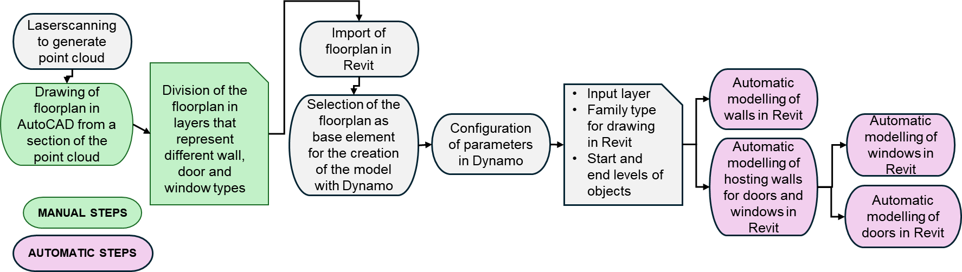

Figure 1: Workflow of the semi-automated Scan2BIM-Process of the case study

4.4 3D Model Generation
The 3D model is automatically generated by the developed Dynamo script, using the provided 2D floor plans in combination with the created 3D building elements as input. The automated modelling focuses on the reconstruction of walls, doors and windows.
Additionally, the Revit plugin PointCab Origins was selected as a comparative method for modelling the same as-is model. PointCab is a well-established software solution widely adopted in professional practice for point cloud processing and semi-automated modeling within Revit. This renders it a suitable reference point for the evaluation of the efficiency and accuracy of the proposed approach.

4.5 Deviation Analyses
Both models undergo a deviation analysis based on the Level of Accuracy (LOA) with Autodesk Point Layout to evaluate their accuracy and the suitability of the methods for the Scan-to-BIM process. Point Layout performs the comparison by analysing deviations between the generated 3D model and the point cloud.

5. CASE STUDY
The case study is conducted on two levels of Building L5|01 at the Technical University of Darmstadt. The complete workflow applied in this case study is presented in the following section. Figure 1 provides a visual overview of the individual steps of the workflow. Subsequently, each step is described and discussed in detail

5.1 Point Cloud Data Acquisition
The point cloud data is acquired using the terrestrial laser scanner Zöller+Fröhlich Imager 5016 with 67 scanning positions, without the usage of control points or targets, to capture 6 rooms, the corridor, and transition parts of the staircase, extending over two levels of the building (refer to in Fig. 2).

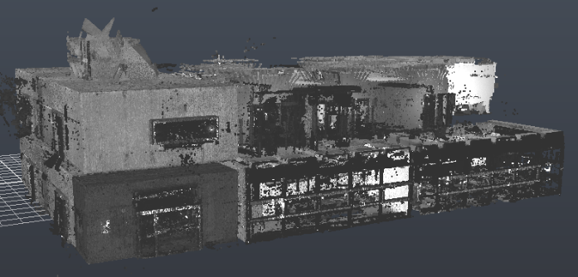
Figure 2: Point cloud data of level 0 and level 1.

The scan settings are configured to ensure high resolution and meet the recommended quality standards of the laser scanner. The scanner has a field of view of 320° × 360°, capable of capturing 1 million points per second and provides a measurement accuracy of ≤ 1 mm + 10 ppm/m and a maximum range of up to 365 m (Zöller + Fröhlich GmbH, 2021).

5.2 Data Pre-processing and Preparation
The data processing and preparation for modeling encompass point cloud registration and refinement, as well as the creation of floor plans.
The 67 individual laser scans are registered into a unified point cloud using the software Z+F Lasercontrol and Scantra. Z+F Lasercontrol employs cloud-to-cloud algorithms, whereas Scantra conducts plane-to-plane registration through plane detection. Both software systems function semi-automated. The captured data is exported in ‘E57’ format for further processing. To refine the dataset, unwanted data and artifacts are removed using Autodesk Recap. The point of origin in Recap is set to a reference corner on the lower level of the building, ensuring a consistent coordinate system throughout all processing steps. Maintaining a uniform point of origin is essential for reliable model evaluation against the original point cloud. Additionally, the refined point cloud is exported in ‘.rcp’ format, which is specifically required for Autodesk Revit.
To create the necessary floor plans, the point cloud is segmented into two distinct building levels using Autodesk AutoCAD. To maximize the extracted information, the segmentation is performed at a height that ensures all relevant structural details being captured within the cross-section for each level. For each existing class, different layers are assigned to structural elements such as walls, doors, and windows. These layers encompass all individual types of walls, doors and windows. For walls scanned from only one side, plausible assumptions are made regarding the wall thickness. This results in 16 layers for level 0 and 19 layers in level 1 (refer to in Fig. 3), including duplicated layers for recurring element types (e.g., walls of the same type).
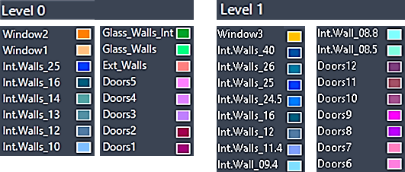
Figure 3: Layers of the building elements.

The resulting 2D floor plans, in ‘.dwg’ format, (refer to in Fig. 4) of each level serve as the input data for Dynamo to generate the 3D as-is model.
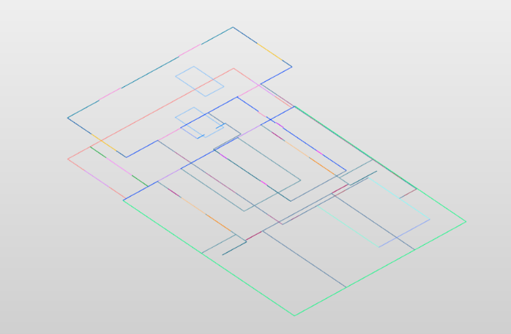
Figure 4: Floor plans for level 0 and level 1.

5.3 Design and Implementation of the Dynamo Script
The custom-developed Dynamo script comprises two analogous sections, one for each building level. The script's structure is designed to be scalable, allowing for replication across an arbitrary number of building levels as required. For simplification, the following general description refers to a single level, as the structure and process remain identical for both.
The script reads the ’dwg’-file of the floor plan and extracts geometries based on the corresponding layer names of each building element. The placement of the floor plans is described in chapter 5.4.
For each building element nodes are implemented within the script, connected to nodes defining the starting and ending levels of each element. These selectable levels correspond to those existing within the Revit project.
The script is structured into three main sections: walls, doors, and windows.
For each wall the script takes the respective layer and 3D building element type – referred to as “families” in Revit – as input so that the predefined building elements are placed using the extracted linework as reference. The output in this case is a wall element that is directly generated within the Revit project at the correct position on the floor plan. The corresponding 3D building elements are created by duplicating similar existing families in Revit and adjusting their geometric dimensions. Measurements for these adjustments can be taken using AutoCAD or Recap. Both software programs offer better performance than Revit when working with point clouds, particularly in terms of processing speed and responsiveness.
Doors and windows follow a similar scripting approach. To ensure correct placement, these elements require hosting walls, which correspond to the walls adjacent to the door or window location. The script positions each door or window precisely at the centre of the corresponding layer line, making it essential to verify the centre alignment of families within Revit. The key difference for windows is that they are placed at a predefined height. Figures 5 to 7 illustrate the workflows for walls, doors, and windows, representing the processes as they are implemented within the Dynamo script.

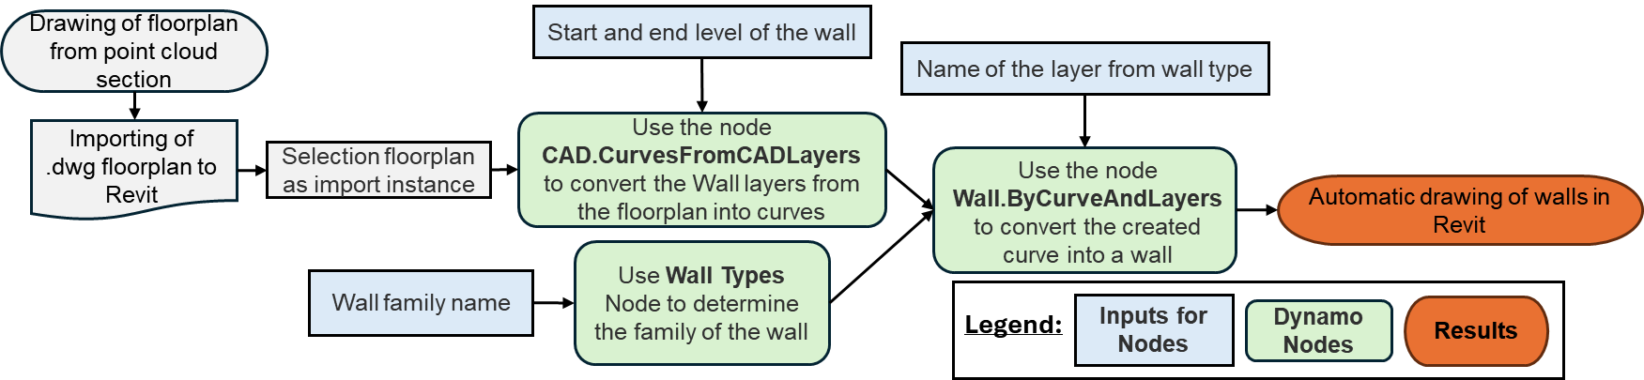
Figure 5: Dynamo Script – Walls

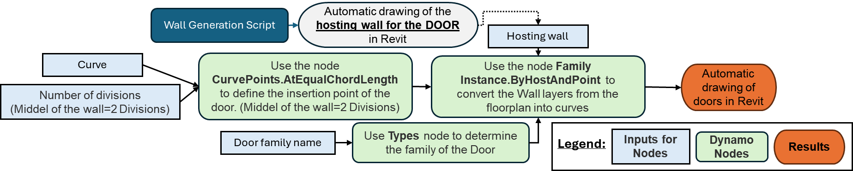

Figure 6: Dynamo Script – Doors

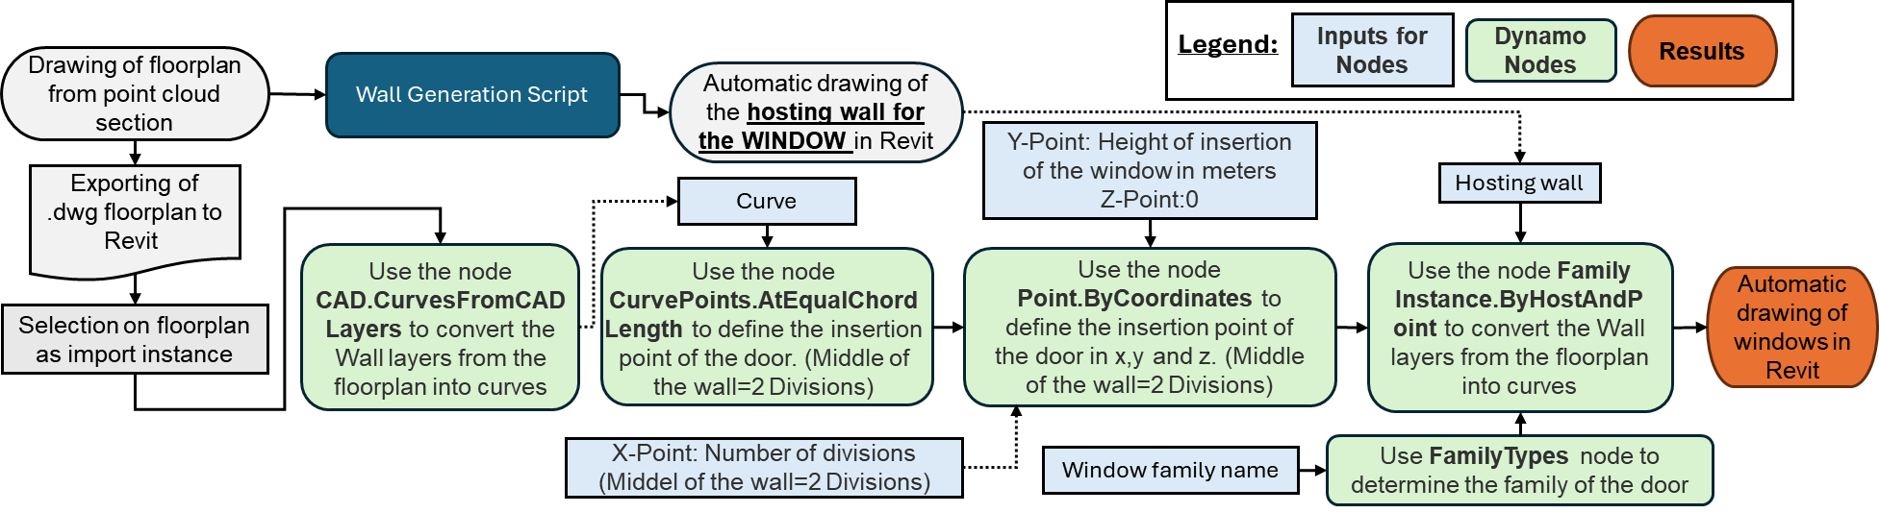
Figure 7: Dynamo Script – Windows

5.4 3D Model Generation
The generated 2D floor plans serve as input for levels 0 and 1, respectively. The ‘.dwg’ floor plans are imported into Revit and aligned to the appropriate planes (refer to Fig 4).
Prior to executing the script, essential parameters must be configured to ensure reliable modelling. The automated process focuses on the generation of walls, doors, and windows. For each element type, the corresponding layer from the floor plans and the appropriate Revit family are selected.
Upon execution of the Dynamo script, the 3D model is generated within seconds. Floors, ceilings, and staircases are manually modelled and are considered for future research. The resulting 3D model, referred to as Model 1, is illustrated in Figure 8 to 10. Fine architectural details and specialized elements fall outside the scope of this study but may be relevant for specific applications (e.g. fire extinguishers for emergency response plans).
To evaluate the effectiveness of the custom-developed Dynamo script for semi-automated modelling, a comparative approach is conducted using PointCab Origins (hereafter referred to as PointCab), a Revit plug-in. Due to the significant time required for model generation with PointCab, the comparison is limited to level 0, ensuring feasibility within the given research constraints. The corresponding model created with PointCab is referred to as Model 2. To maintain consistency, the properties of the initial as-is model (Model 1) are transferred to Model 2, ensuring identical level definitions and a shared point of origin.
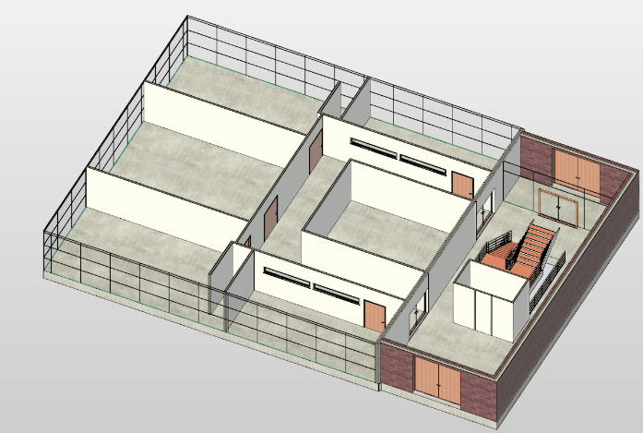
Figure 8: Model 1 – Level 0.

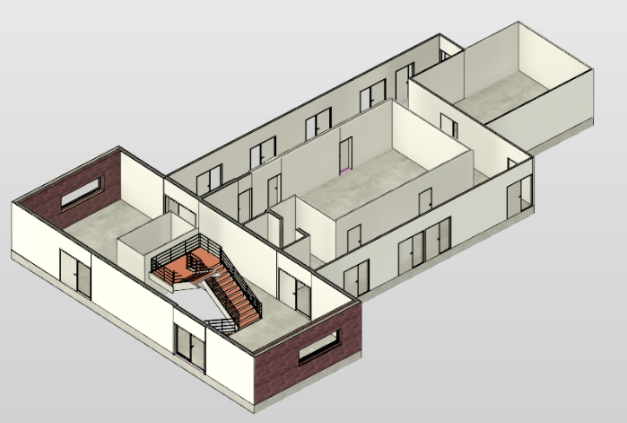
Figure 9: Model 1 – Level 1.
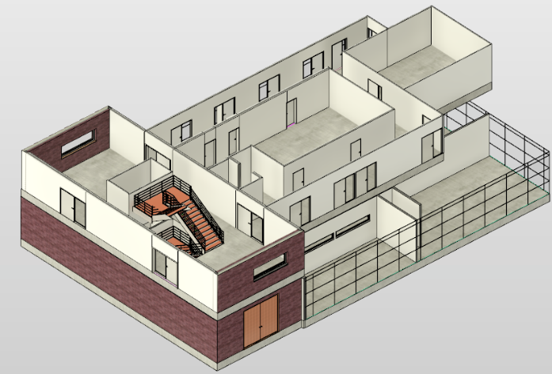
Figure 10: Model 1 – Both levels.

The point cloud of Level 0 is imported into PointCab, where a top-view section is generated to guide wall placement in Revit. Wall placement requires manually drawing lines aligned with the intended wall positions. While the software claims that precise start and end points are unnecessary due to automatic wall connection for closed and open rooms, subsequent alignment adjustments are required (refer to Figure 11). It is important to note that while PointCab is a plugin for Revit, the drawing of the lines is done in the PointCab software itself. However, unlike Revit, PointCab does not have advanced tools for precisely positioning the lines in the center of the wall, which can affect the accuracy of the placement. In addition to drawing the guiding lines, users must specify the wall type, thickness, and the corresponding levels.

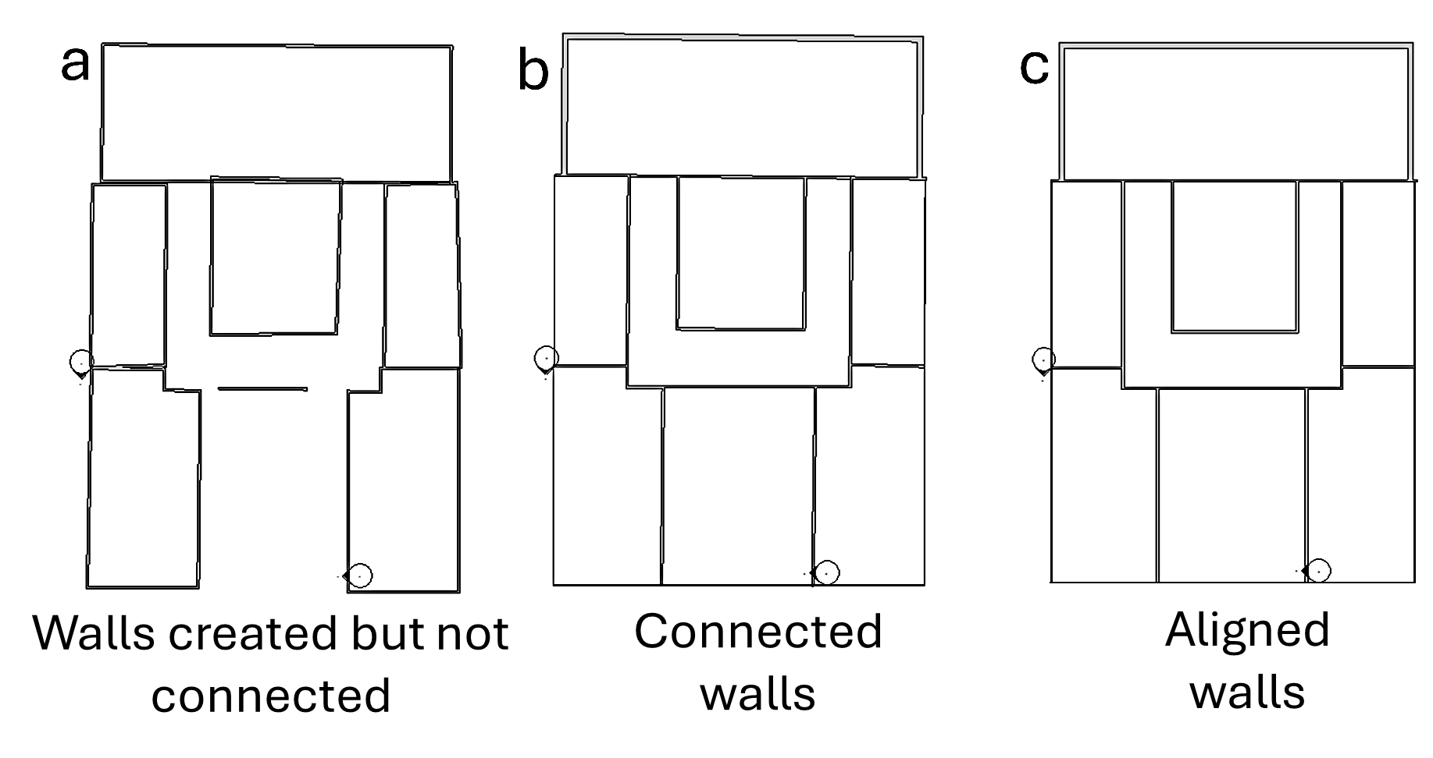
Figure 11: Wall creation with PointCab Origins (a: Non-connected walls; b: Connected walls; c: Aligned walls).

Doors and windows are modeled using manually created section layouts, which allow for their identification and placement within the as-is model. For each door and window, two diagonal points are selected to define the top and bottom corners. Once these reference points are established, the width is specified, and the appropriate Revit family is selected. The height of windows is automatically derived from the reference points' locations. To ensure consistency between both models, the same custom-created Revit families used in Model 1 are applied in Model 2. The final 3D model of level 0, generated using PointCab, is depicted in Figure 12.

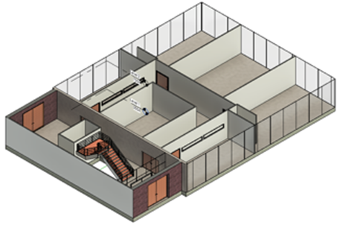
Figure 12: Model 2 – created with PointCab Origins.

It can be stated that the model generation using the custom-developed script takes approximately 5 to 10 minutes per building level, primarily due to the time required for selecting the starting and ending levels, as well as the corresponding layers and families. In contrast, the model generation with PointCab takes more than 30 minutes per level. Although the creation of the floor plan currently requires some additional time, this step is expected to be optimized or automated in future research.

5.5 Deviation Analyses
Both models are subjected to a deviation analysis to assess their accuracy and the suitability of the applied methods for the Scan-to-BIM process. The analysis is conducted using Autodesk Point Layout, a Revit plug-in designed for accuracy assessment. The deviations are evaluated based on the Level of Accuracy (LOA); a standard developed by the United States Institute of Building Documentation (USIBD) to ensure industry-wide consistency (U.S. Institute of Building Documentation, 2016). For this study, LOA 20 was selected, which is met when deviations range between 15 mm and 5 cm. The more precise LOA 30 (5 mm – 15 mm) was deemed unnecessary for typical building modelling applications.
Point Layout performs the comparison by conducting a face-by-face analysis of deviations between the generated 3D models and the point cloud. The maximum point distance from a face was set to 60 mm, and a maximum of 500,000 points were considered for analysis per selected face. A customized heatmap visualizes the deviations across different model sections. Deviations exceeding ±50 mm are highlighted in red, while deviations up to ±30 mm are considered acceptable and shown in green. Intermediate deviations are represented in shades of yellow and orange. The subsequent section outlines the deviation analysis results obtained for Model 1 (covering levels 0 and 1) and Model 2 (level 0). Using Point Layout, the accuracy analysis is conducted by selecting each area to be evaluated. Walls scanned from only one side were evaluated solely based on the scanned side.
The results of the deviation analysis indicate an overall good performance for level 0 of Model 1, with only a few higher deviations observed (refer to Figure 13).

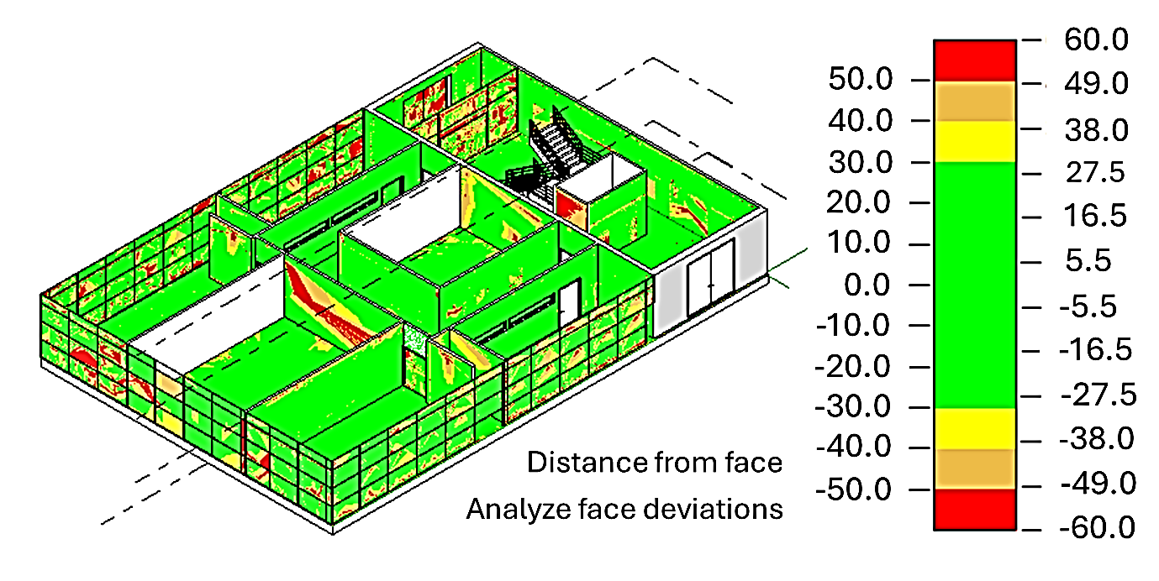
Figure 13: Model 1, level 0 – Deviation analysis [mm].

The same analysis is performed for Model 2, revealing noticeably poorer results with a greater number of red-highlighted areas, indicating higher deviations (refer to in Figure 14).

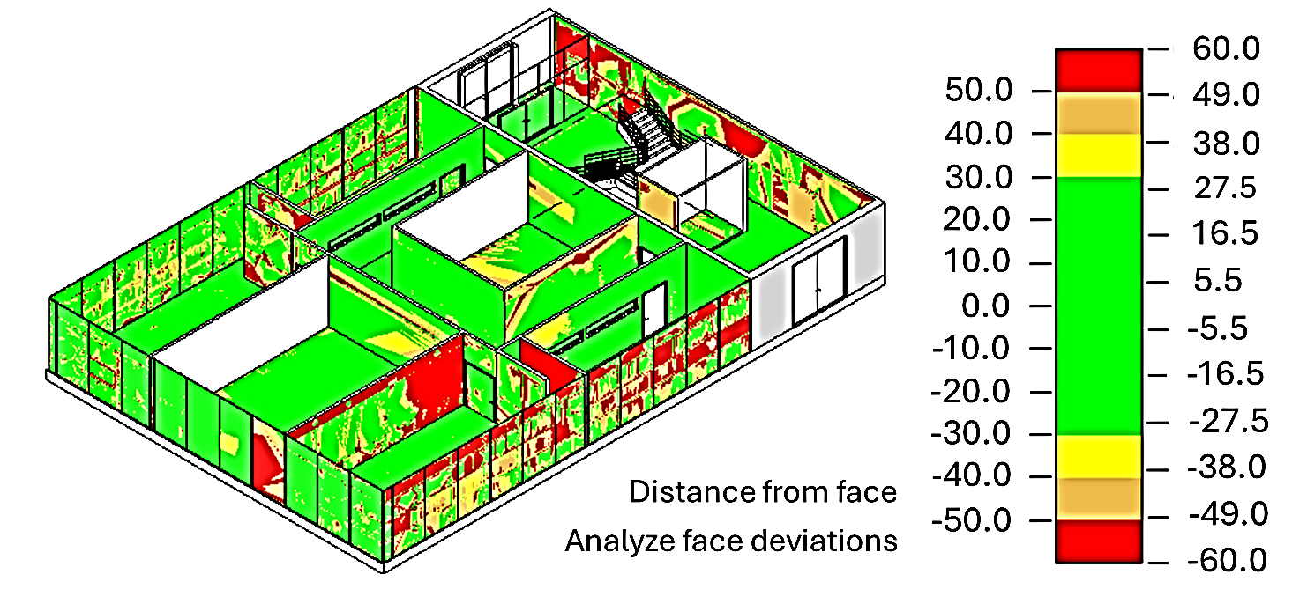
Figure 14: Model 2, level 0 – deviation analysis [mm].

The deviation analysis is additionally performed for level 1 of Model 1. The objective was to assess the results on a second level of the building to further validate the proposed modeling approach. The heatmap demonstrates overall good accuracy, with only a few areas showing higher deviations (refer to Figure 15). As previously noted, Level 1 modeling was not performed for Model 2. Consequently, a comparative deviation analysis for level 1 between the two models is not conducted.

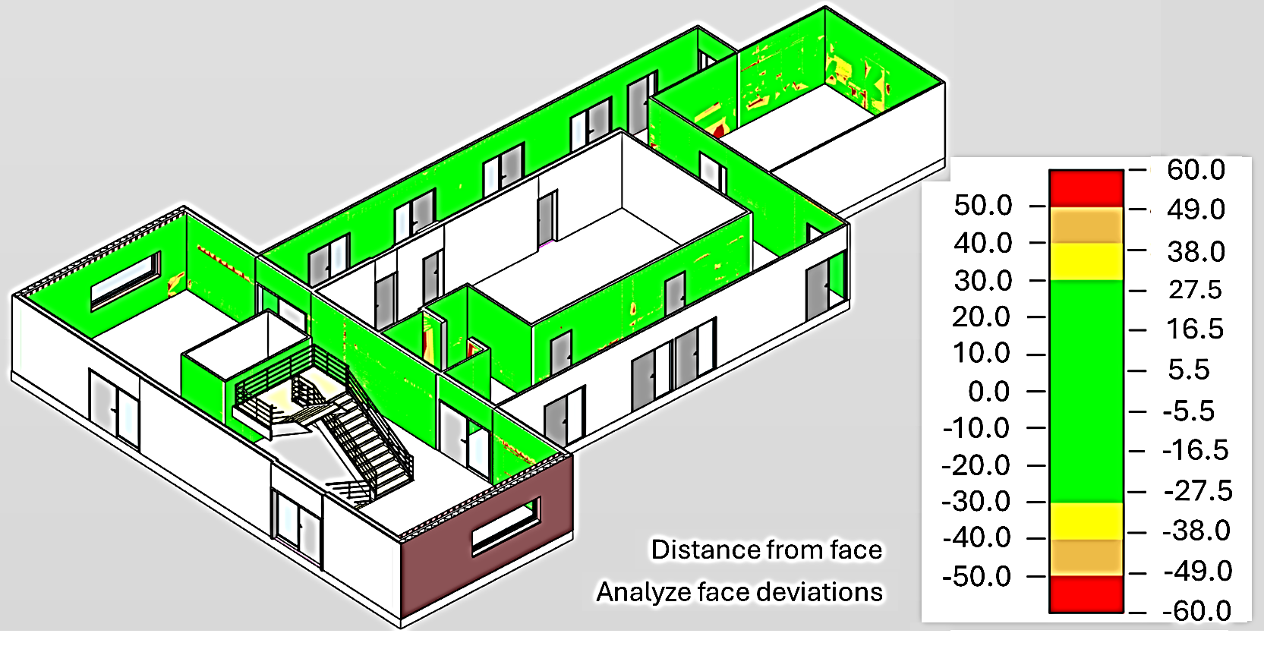
Figure 15: Model 1, level 1 – deviation analysis [mm].

6. KEY CONTRIBUTIONS, FINDINGS AND RESULTS
To evaluate the results of the deviation analyses, the heat maps for each part the model are individually assessed. Model 1 is examined both independently and in comparison with Model 2 at level 0. Figure 16 presents an example of the differences between the deviation analyses of both models, demonstrating that Model 1 achieves significantly higher accuracy than Model 2.

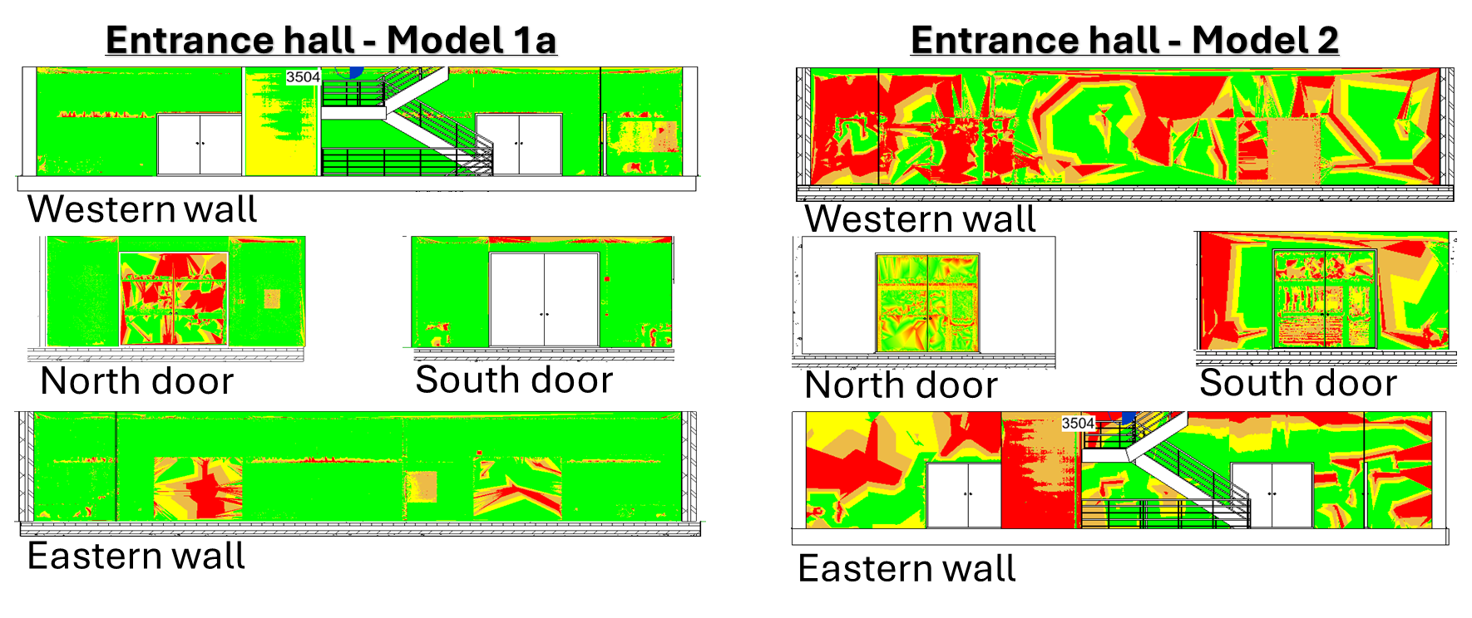
Figure 16: Comparison of the heatmaps of the deviation analysis – Model 1 vs. Model 2.

The larger deviations observed in Model 1 can be attributed to elements that were not modelled, such as the fire hose cabinet and wall-mounted lights (refer to in Figures 16 and 17). Another critical factor is the presence of glass surfaces. For physical reasons, specifically reflection properties, the laser scanner has difficulties in correctly detecting glass areas. Consequently, deviations in these regions are more likely to result from inaccuracies in the point cloud rather than from errors in the model itself.

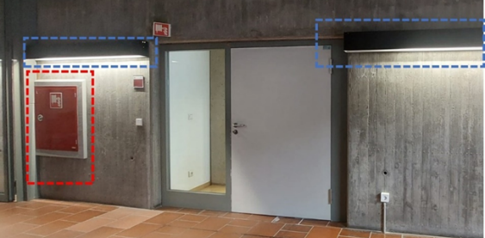
Figure 17: Examples for non-modelled elements leading to higher deviations.

Further analyses are conducted regarding the maximum deviations and overall percentage accuracy of both models. Multiple deviation analyses are performed, considering different threshold values. The results consistently demonstrate that Model 2 exhibits more higher deviations than Model 1. Deviations did not exceed 1000 mm and primarily affected non-modelled elements.
For level 1 of Model 1, the higher deviations can similarly be attributed to non-modelled objects and limitations of the point cloud in narrow spaces, as was the case on level 0.
The overall accuracy of all models, including both levels of Model 1, is assessed by calculating the total areas with deviations exceeding 50 mm. Due to limitations in Autodesk Point Layout, this evaluation has to be performed manually. To achieve this, true-to-scale screenshots are imported into AutoCAD, where the affected areas are traced using polylines. The summed deviations are then compared to the total model area. Glass surfaces are excluded from the analysis, as their inherent inaccuracies would have distorted the results.
Table 1 presents the accuracy values for Model 1 (Level 0 and Level 1) and Model 2 (Level 0). Model 1 shows similar accuracy results on both levels, with approximately 99 % on level 1 and 97 % on level 0. In contrast, Model 2 reaches an accuracy of 87 % on level 0, representing a difference of 10 % compared to Model 1.
The results further validate that the approach presented in this study yields reliable results and even surpasses existing software solutions in accuracy.

Table 1: Accuracy levels of all models [%]

Model 1  Level 1 | Model 1  Level 0 | Model 2  Level 0
98,73% | 96,86% | 87,23%

One significant advantage of the proposed approach is the accelerated reconstruction of buildings that share similar structural elements across multiple levels. By leveraging recurring patterns, the modeling process can be significantly streamlined, reducing both time and effort in creating digital representations of complex structures.
The utilization of two-dimensional floor plans entails the potential for compromising the three-dimensional accuracy of the original point cloud, thereby potentially resulting in the loss of certain spatial nuances, particularly regarding vertical or irregular geometries. This, in turn, could necessitate manual correction. However, the findings of the case study demonstrated that this was not a substantial issue in the specific instance.
Furthermore, working with point clouds in Revit was found to be less efficient, making crucial modeling tasks like taking precise measurements or aligning elements more time-consuming. This limitation affects efficiency, particularly when dealing with large-scale point cloud datasets. However, this issue can be circumvented with the proposed approach, as measurements can be taken in AutoCAD, which handles point clouds significantly more efficiently. The Dynamo script in combination with generated floor plans ensure the correct placement of all elements in Revit, thereby mitigating the performance drawbacks of working directly with point clouds in that environment.

7. CONCLUSION AND OUTLOOK
This study presents an approach which successfully contributes to the automation of the Scan-to-BIM process. At its core is a custom-developed Dynamo script that processes pre-extracted planes and interprets 2D floor plans derived from laser-scanned point clouds, enabling rule-based modelling within Revit. The approach enhances modelling efficiency, particularly for recurring structural patterns across multiple building levels.
The case study conducted on a university building, examining two levels, demonstrates the effectiveness of the proposed workflow compared to conventional, predominantly manual, modelling techniques. The deviation analysis confirms the high accuracy of the generated models, surpassing existing semi-automated solutions in terms of precision and reliability, while demonstrating increased time efficiency when pre-existing floor plans are available. A key advantage of the presented methodology lies in its high degree of transferability to other building levels and structurally similar environments, supporting its applicability across a broader range of use cases. This deems the method especially useful for large-scale projects or buildings with repetitive layouts.
Challenges, like certain inaccuracies inherent in the point cloud data, particularly in areas with glass surfaces, remain unavoidable due to the fundamental limitations of laser scanning technology. While terrestrial laser scanning represents the most precise method currently available for time efficient dense spatial data acquisition, achieving extremely high accuracy would require supplementary measurements using instruments such as total stations at critical locations – an aspect beyond the scope of this research.
Additionally, the study highlights key challenges, such as the limited performance of Revit when handling point clouds, which can hinder efficient modelling. This limitation is mitigated by integrating CAD software into the workflow, enabling more responsive measurements while ensuring precise element placement in Revit through predefined floorplans.
Future research aims to further enhance automation within the Scan-to-BIM workflow. At present, the creation of floorplans still requires manual effort, a step that is planned to be automated through advanced semantic point cloud segmentation. Moreover, upcoming investigations will explore the automated generation of Revit families to further streamline the modelling process. The Dynamo script is also being further developed to include elements such as floors, ceilings and stair transitions. By refining the workflow, the reliance on manual intervention can be further reduced while maintaining high accuracy in building reconstruction.
This study contributes to Scan-to-BIM automation by presenting a structured and adaptable methodology that improves efficiency, precision, and usability, offering a valuable and solid foundation for future developments in digital building reconstruction.

ACKNOWLEDGEMENTS
I would like to express my sincere gratitude to Sophie Schleiermacher for her valuable support in the data pre-processing and preparation phase of this research. Her assistance in generating the CAD floor plan and contributing to the creation of Revit families has been greatly appreciated.

REFERENCES
American Surveyor, (2024). Point cloud to BIM: Transforming legacy buildings into digital assets, [Online], Available at: https://amerisurv.com/2024/07/10/ point-cloud-to-bim-transforming-legacy-buildings-into-digital-assets/ [30 January 2025].
Borrmann, A., König, M., Koch, C., Beetz, J., (2018). Building Information Modeling: Why? What? How?. Building Information Modeling, 1–24. Cham: Springer International Publishing.
Changsaar, C., Abidin, N. I., Khoso, A. R., Luenhui, L., Yaoli, X., Hunchuen, G., (2022). Optimising energy performance of an Eco-Home using Building Information Modelling (BIM). In: Innov. Infrastruct. Solut. 7 (2), S. 1–14. DOI: 10.1007/s41062-022-00747-6.
Chen, Z., Gentes, S. (2021). From Point Cloud to as-built BIM: Semi-automated Wall Reconstruction for Dismantling of Nuclear Power Plants. Available at: https://mediatum.ub.tum.de/doc/1688407/c2iz2t7ph0o2hobsoxu13vn4k.Chen%202022.pdf [31 March 2025].
Chen, Z. (2022). From Point Cloud to as-built BIM: automated Detection of Openings in existing Buildings. Available at: https://mediatum.ub.tum.de/doc/1688407/c2 iz2t7ph0o2hobsoxu13vn4k.Chen%202022.pdf [31 March 2025].
Esfahani, M. E., Rausch, C., Sharif, M. M., Chen, Q., Haas, C., Adey, B. T. (2021). Quantitative investigation on the accuracy and precision of Scan-to-BIM under different modelling scenarios. In: Automation in Construction 126, S. 103686. DOI: 10.1016/j.autcon. 2021.103686.
Fotsing, C., Tchuitcheu, W. C., Besong, L. I., Cunningham, D. W., Bobda, C. (2024). A Specialized Pipeline for Efficient and Reliable 3D Semantic Model Reconstruction of Buildings from Indoor Point Clouds. In: Journal of imaging 10 (10), S. 261. DOI: 10.3390/ jimaging10100261.
He, Z., Wang, Y., Zhang, J. (2025). Generative AIBIM: An automatic and intelligent structural design pipeline integrating BIM and generative AI. In: Information Fusion 114, S. 102654. DOI: 10.1016/ j.inffus.2024.102654.
Jiang, T., Luo, F., Wu, Z. (2024). A 3D Modeling Method Integrating BIM and Point Cloud Data. In: 5th International Conference on Computer Science and Management Technology, Xiamen Guangdong China, Association for Computing Machinery, p. 1271–1275.
LIDAR Magazine, (2023). Point cloud to 3D BIM modeling: Ensuring precision of point cloud data to build robust 3D BIM models, [Online], Available at: https://lidarmag.com/2023/09/28/point-cloud-to-3d-bim-modeling-ensuring-precision-of-point-cloud-data-to-build-robust-3d-bim-models/ [30 January 2025].
Martens, J., Blankenbach, J. (2023). VOX2BIM+ - A Fast and Robust Approach for Automated Indoor Point Cloud Segmentation and Building Model Generation. In: PFG 91 (4), p. 273–294. DOI: 10.1007/s41064-023-00243-1.
Rocha, G., Mateus, L. (2024). Using Dynamo for Automatic Reconstruction of BIM Elements from Point Clouds. In: Applied Sciences 14 (10), p. 4078. DOI: 10.3390/app14104078.
Stojanovic, V., Trapp, M., Richter, R.; Döllner, J. (2019). Generation of Approximate 2D and 3D Floor Plans from 3D Point Clouds. In: VISIGRAPP. Available at: https://api.semanticscholar.org/CorpusID:88494903 [30 March 2025].
Tang, S., Huang, J., Cai, B., Du, H., Zhou, B., Zhao, Z. (2024). Back to geometry: Efficient indoor space segmentation from point clouds by 2D–3D geometry constrains. In: International Journal of Applied Earth Observation and Geoinformation 135, p. 104265. DOI: 10.1016/j.jag.2024.104265.
U.S. Institute of Building Documentation, (2016). USIBD Level of Accuracy (LOA) Specification Guide, [Online], Available at: https://cdn.ymaws.com/www. nysapls.org/resource/resmgr/2019_conference/handouts/hale-g_bim_loa_guide_c120_v2.pdf [30 March 2025].
Wang, Q., Guo, J. and Kim, M-K., (2019). An application-oriented Scan-to-BIM framework. Remote Sensing, 11: p. 365. DOI: 10.3390/rs11030365
Zöller + Fröhlich GmbH, (2021). Z+F IMAGER® 5016 Datasheet, [Online], Available at: https://zf-usa.com/wp-content/uploads/2021/06/ZF-IMAGER-5016_Datasheet-E_compr.pdf [30 March 2025].

