A Hybrid Deterministic-Neural Framework for Regulatory Compliance Verification in the Pre-Design Stage: TerraLogic.ai

Keywords: Automated code compliance; hybrid AI; GIS-BIM integration; digital twin; building code; LLM accuracy limitations; pre-design; TerraLogic.ai
Abdul Quader^{1, *}

¹ Jawaharlal Nehru Architecture and Fine Arts University (JNAFAU), Hyderabad, India
*Corresponding email: abdulquaderhunk@gmail.com

ABSTRACT
Building code compliance verification remains a primary bottleneck in the Architecture, Engineering, and Construction (AEC) industry. Large Language Models (LLMs) are increasingly proposed as compliance assistants. But recent studies show they struggle with jurisdiction-specific numerical thresholds. This study presents TerraLogic.ai, a pre-design regulatory verification platform using a Hybrid Deterministic-Neural Compliance Engine (HDNCE). This research asks a simple question: can architects and builders check compliance at the pre-design stage, before mistakes become expensive? The platform uses a digital twin and AI to give them real-time compliance feedback. The framework encodes Telangana (RCBR 2012) and National Building Code (NBC 2016) provisions as deterministic logic. LLMs are restricted to advisory roles within a unified 3D digital twin workflow. In a two-round evaluation against 60 synthetic Hyderabad site configurations, the deterministic engine initially agreed with mathematical ground truth on 58.3% of sites (35/60). Analysis showed this was due to the system ignoring the width of adjacent roads. Once updated, a second test of the same 60 sites resulted in 100% accuracy (60/60). Because the same data was used for both rounds, these results indicate successful bug fixing rather than broad adaptability. Independent held-out testing remains necessary future work. Early user reviews were positive, suggesting the need for more formal validation studies.

- INTRODUCTION
The AEC sector generates roughly 13% of the world's GDP but is slow to adopt digital tools (Bhattacharya and Momaya, 2021). Regulatory compliance verification constitutes one of the industry’s most persistent inefficiencies. In Hyderabad, India, design-stage compliance requires the simultaneous cross-referencing of the National Building Code of India 2016 (NBC 2016) and the Telangana Revised Common Building Rules (RCBR 2012). Which together specify hundreds of interdependent provisions governing setbacks, floor area ratio (FAR), ground coverage, fire safety, and structural clearances. The scale of resulting non-compliance and enforcement pressure is acute in this jurisdiction. For example, in early 2026, the newly established Hyderabad Disaster Response and Asset Protection Agency (HYDRAA) undertook massive demolition drives against unauthorised structures, reclaiming approximately 87.83 acres of encroached land within the Full Tank Level (FTL) and buffer zones of city lakes (PropNewz, 2026). This complements existing enforcement pressures reported by Greater Hyderabad Municipal Corporation (GHMC) officials, who note that 40–50% of citizen complaints received through its weekly grievance redressal programme relate to unauthorised construction, and approximately 250,000 writ petitions concerning unauthorised structures were filed in the Telangana High Court over the preceding five years (Munsif Daily, 2024).
Large Language Models (LLMs) have attracted considerable research interest as candidate compliance assistants (Zhang, 2023; Nakhaee et al., 2024; Madireddy et al., 2025). However, existing evaluations report accuracy limitations specific to jurisdiction-dependent numerical thresholds, with documented error rates for tasks of this category (Lu and Zhu, 2026). Al Nama and Mahmud (2024) report comparable performance gaps for interpretive regulatory queries even following domain-specific fine-tuning, based on an analysis of ChatGPT-4 and Gemini across question categories in engineering regulations; this finding is reported here as described in the related study (Al Nama et al., 2026) and has not been independently re-verified by the present author.
Prior research integrating GIS with 3D spatial modeling addresses spatial interoperability and urban digital twins but lacks real-time compliance feedback within a unified interface (Karan and Irizarry, 2015). Recent reviews identify hybrid rule-based and machine learning approaches as the most promising direction for automated code compliance (Amor and Dimyadi, 2021). TerraLogic.ai fills this gap by incorporating OpenStreetMap (OSM)-based context modeling, 3D digital twins, and deterministic compliance verification into a single browser-accessible pre-design workflow.
This paper presents TerraLogic.ai and its Hybrid Deterministic-Neural Compliance Engine. The architecture responds directly to the LLM accuracy limitations described above, while also addressing the GIS-compliance integration gap. While situated within the broader academic paradigm of GIS-BIM integration, the current iteration of TerraLogic.ai focuses specifically on the pre-design stage. It uses 3D geospatial massing as a lightweight, browser-accessible precursor to full Building Information Modeling (BIM).
The purpose of this research is to investigate whether binding compliance determinations can be produced by deterministic rule logic while LLMs remain confined to advisory roles. The terralogic.ai platform serves as the instrument for this investigation. It allows architects and builders to test massing decisions at the pre-design stage against encoded RCBR 2012 and NBC 2016 provisions.
Primary research question: Can a hybrid architecture that separates deterministic compliance determination from neural advisory functions reduce the accuracy limitations reported for LLM-only compliance verification, while remaining usable by non-specialist practitioners at the pre-design stage?

- BACKGROUND AND RELATED WORK

2.1 Automated Code Compliance
Automated code compliance (ACC) checking has been investigated for two decades. Early implementations such as Singapore's CORENET ePlanCheck and the US SMARTcodes initiative established the first digital review paradigms (Eastman et al., 2009). Rule-based, ontology, and machine learning approaches have all been explored. Yet research prototypes have consistently failed to reach practitioner adoption (Amor & Dimyadi, 2021). The two major obstacles preventing widespread adoption of ACC systems are the difficulty of integrating them into existing workflows and the lack of a unified pre-design interface.
2.2 LLM-Based Compliance
Early work on LLMs for building code compliance noted baseline accuracy limits alongside potential for accelerating ACC (Zhang, 2023). Hybrid frameworks combining knowledge graphs with LLMs were proposed to improve scalability (Nakhae et al., 2024). In applied BIM contexts, multiple LLM agents were embedded in Revit workflows. Efficiency gains were realized, but accuracy problems persisted on jurisdiction-specific numerical parameters (Madireddy et al., 2025). (Lu and Zhu., 2026) report a similar pattern in structural compliance checking, where zero-shot prompting reached only 57.35% accuracy. Similar gaps appear when LLMs handle interpretive queries in engineering law (Al Nama & Mahmud, 2024). A fine-tuned Custom GPT model achieved high factual accuracy on its training set but still struggled with interpretive provisions and dynamic code updates (Al Nama et al., 2026). The pattern is clear. LLM-only compliance verification is not yet reliable enough for professional work. That is why this paper explores a hybrid approach.

- PROPOSED METHODOLOGY: TERRALOGIC.AI ARCHITECTURE

The methodology proceeds in five stages, summarised in Fig. 1: site input, geospatial context generation, structured metric extraction, compliance evaluation, and output.

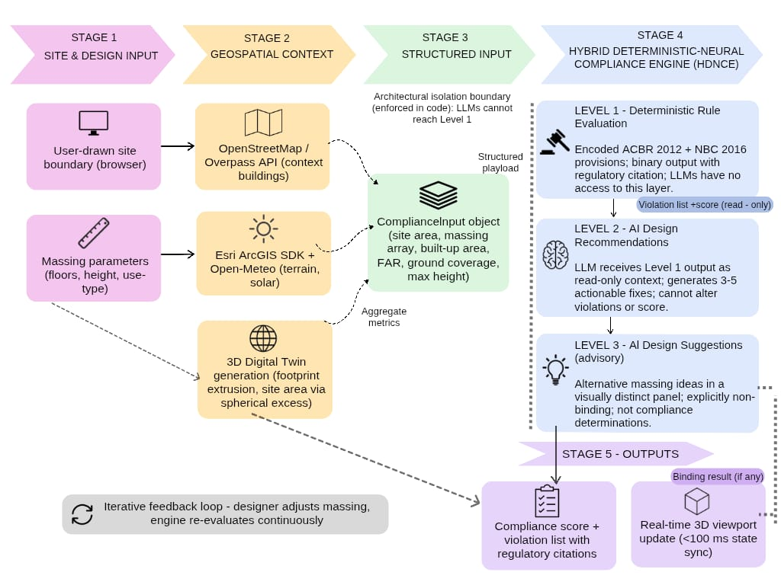
Fig. 1: Overarching methodology of TerraLogic.ai — five-stage pipeline from site input through geospatial context generation and structured metric extraction to the three-level Hybrid Deterministic-Neural Compliance Engine (HDNCE) and real-time compliance feedback. The dotted boundary marks the architectural isolation between the deterministic Level 1 and the LLM layers.

  - System Topology and Isolated Execution Protocol
The system is implemented as a browser-accessible three-tier web architecture, avoiding dependence on licensed BIM environments that are not consistently accessible to students, sole-practitioner firms, or government review officers. LLM integration is governed by a three-level framework. The goal is simple: keep every binding compliance determination tied to the encoded provisions of RCBR 2012 and NBC 2016.
- Level 1 — Deterministic Rule Evaluation. Exact conditional logic encoding RCBR 2012 and NBC 2016 provisions executes synchronously on every massing state change. The module receives a ComplianceInput object containing site area, massing array, and computed metrics and returns an NbcRuleResult object within 5 ms in all tested configurations. Output is binary, with a precise regulatory citation. LLMs have no access to this layer.
- Level 2 — AI-Generated Design Recommendations. The LLM receives the Level 1 result the violation list, severity ratings, and composite score as read-only context and generates 3–5 actionable design recommendations for improving the massing. The system prompt explicitly instructs the model not to contradict the rule engine's findings; it cannot modify the violation array, severity ratings, or the composite compliance score.
- Level 3 — AI Design Suggestion. The LLM proposes design alternatives, displayed in a visually distinct panel and framed explicitly as advisory rather than as compliance determinations.

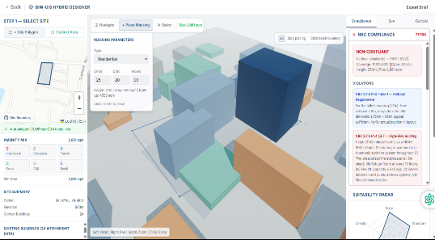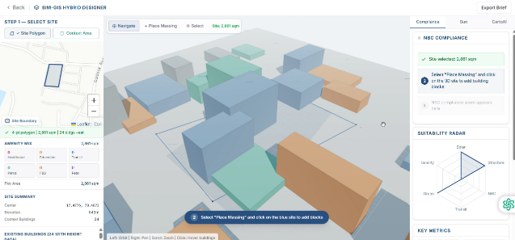
Fig. 2: TerraLogic.ai COMPLIANCE CHECKING Fig. 3: TerraLogic.ai initial Digital Twin state guided workflow panel and site context active violation populated from OSM-derived building data. Hyderabad (17.4776°N, 78.4973°E.

Implementation notes: The platform runs in the browser without local software installation. Geospatial context is sourced from OpenStreetMap (via Overpass), Esri ArcGIS Maps SDK (terrain and solar), and Open-Meteo (irradiance); 3D massing is rendered with Three.js. LLM inference uses Google Gemini 2.5 Flash and OpenAI GPT-4o-mini. Neither model has programmatic access to the deterministic compliance module; this separation is enforced in code, not in configuration.

4.AUTOMATED COMPLIANCE ENGINE IMPLEMENTATION

4.1 Deterministic Spatial Rule Mapping
The deterministic module encodes the RCBR 2012 setback schedule in two forms: discrete conditional branches for buildings up to 45 m, and a continuous function above that threshold. Equation (1) gives the high-rise setback.

Setback = 12.0 + [(H − 45) / 3] (1)

Floor area ratio (FAR) limits are drawn from GO Ms. No. 168 (2012) and cover six use-type classifications. Ground coverage is a five-tier schedule indexed by site area. High-rise fire safety requirements are encoded verbatim from NBC 2016 Part 4 §3.7 and trigger at 24.0 m. Table 1 presents the full setback schedule.

Table 1: Encoded RCBR 2012 setback schedule — GO Ms. No. 168 (2012).
Height (m) | Front Setback (m) | Rear/Side Setback (m) | Reference
≤ 7 | 1.5 | 1.5 | RCBR 2012 Table H-1
≤ 12 | 4.5 | 3.0 | RCBR 2012 Table H-1
≤ 21 | 6.0 | 5.0 | RCBR 2012 Pt.3 §3.5
≤ 24 | 7.0 | 5.0 | RCBR 2012 Pt.3 §3.5
≤ 36 | 9.0 | 9.0 | RCBR 2012 High-Rise §H-2
≤ 45 | 10.0 | 10.0 | RCBR 2012 High-Rise §H-2
> 45 | 12.0 + ⌊(H−45)/3⌋ | 12.0 + ⌊(H−45)/3⌋ | RCBR 2012 §H-2

Rule outputs are converted into a single compliance score, initialised at 100. CRITICAL violations — setback deficiency, FAR excess, coverage excess — deduct 20–30 points. WARNING violations deduct 5–10 points. INFORMATIONAL flags, such as a fire NOC trigger or a high-rise notice, deduct nothing but appear as mandatory pre-permit considerations. Scoring runs synchronously and completes within 5 ms of each massing change. It is coupled to the 3D viewport, so the score updates continuously as the design changes rather than at fixed checkpoints. For a 9-floor, 27 m residential massing on a 2,861 sqm site, the engine returns NON-COMPLIANT (77/100) with a CRITICAL setback violation and a HIGH-RISE classification trigger. (Fig.2)

4.2 Constrained AI Recommendation Generation
Once the deterministic engine (§4.1) computes a violation list and compliance score, this result is passed to Google Gemini 2.5 Flash as read-only context. The system prompt frames the rule engine's output as authoritative. The model's only task is to generate 3–5 concise design recommendations. It is not asked to explain why a violation occurred. It has no mechanism to alter the violation list, severity ratings, or score. The API route structure enforces this separation: the deterministic result and the model-generated recommendations are returned as distinct fields, so the recommendation text cannot overwrite the compliance determination.
A separate deterministic component handles natural-language query routing for the GIS interface. A rule-based classifier scores incoming user messages against fifteen topic categories (transit, flood, soil, solar, infrastructure, and others) using keyword and pattern matching, then activates the corresponding map layer. Quantitative evaluation of this classifier is left to future work.

- GEOSPATIAL DATA INTEGRATION AND DIGITAL TWIN PIPELINE

5.1 Automated Site Ingestion via Overpass/OSM APIs
Site context is gathered automatically from OpenStreetMap. Queries are bounded to a user-defined zone. An Overpass API call retrieves surrounding building footprints, height attributes, and use-type tags within a buffered bounding box.
This data is used only to populate the environmental context; no commercial suitability scores are generated. For the Hyderabad test site (17.4776°N, 78.4973°E), the ingestion layer recorded 42 educational facilities, 91 healthcare facilities, and 41 transit nodes within a 3 km radius. The site boundary area is then computed using the spherical excess formula. That area becomes the basis for FAR and ground coverage evaluation.

5.2 3D Spatial Mesh Generation and Coordinate Synchronization
Two-dimensional footprint arrays are extruded into a 3D massing model using Three.js. A WebGL-based solar simulation is parameterized by site latitude, longitude, date, and time. For the Hyderabad site, 24 OSM-derived contextual buildings were rendered at their mapped heights.

6. EXPERIMENTAL EVALUATION AND VALIDATION

6.1 Experimental Metrics and Evaluation Framework
The evaluation used 60 synthetic Hyderabad site configurations, split into three groups of 20. The first group was clearly compliant. The second was borderline: a single parameter was shifted to just inside or just outside a regulatory threshold. The third was clearly non-compliant: a single parameter was pushed to a definite violation. Configurations were generated by a dedicated script that encodes the GHMC / TS-bPASS / G.O. Ms. No. 168 (2012) rule tables, including their dependence on abutting road width. Mathematical ground truth was computed from these same tables at zero tolerance, independently of the application under test.
Ground truth was reviewed consultatively by a licensed architect at JNAFAU with working knowledge of Hyderabad bylaws. This was not a blinded, independent re-derivation; a fully blinded protocol is recommended for follow-up work.

6.2 Two-Round Testing Protocol
All 60 sites were submitted to the running application, not to a standalone copy of the rule logic. Each configuration was POSTed to the live /api/bim/compliance endpoint via a dedicated test harness. This exercised the deployed deterministic rule engine followed by its downstream AI recommendation pass, in the same sequence an end user would trigger. No request bypassed any part of the application's own processing path. Testing ran in two rounds. Round 1 evaluated the engine as originally implemented. Divergences from mathematical ground truth were analysed to identify their cause (§6.3), which led to a targeted revision of road-width handling. Round 2 resubmitted the identical 60 configurations to the revised application.
This design has a limitation that should not be understated. Round 2 was evaluated on the same 60 configurations used to diagnose the Round 1 failure that motivated the fix. It therefore shows that the specific defect was corrected, not that the revised engine generalises to configurations it was not tuned against. Independent testing on a held-out configuration set is necessary before any general accuracy claim can be supported.
The AI recommendation pass at this endpoint is advisory by construction. The application's code comments state that it must not override violations or the final score. Both rounds therefore measure the deterministic mathematics; they do not validate the neural/advisory layer. That requires a separate evaluation once real, rather than fallback, model responses are consistently available.

6.3 Root Cause of Round 1 Divergence and Road-Width Revision
Round 1 diverged from the mathematical ground truth on 25 of 60 sites (58.3% agreement). Inspection of the rule engine traced this to a single missing input: the engine never received the width of the road a plot fronts onto, even though GHMC regulations scale several thresholds by road width. This one gap produced three distinct failure modes.
First, FAR was encoded as a flat 2.0 regardless of road width, while GHMC grants a higher FAR allowance on wider roads (18–30 m). This incorrectly flagged compliant wide-road sites as exceeding FAR. Second, setbacks were drawn from a table indexed by building height alone, while GHMC also scales setbacks by plot area bracket. This was the largest error source. It produced 23 false setback violation flags on small compliant plots. In the opposite direction, it under-required the setback on at least one mid-sized plot enough to let a genuine violation pass with a perfect score. Third, open space was checked against a blanket 30% minimum, while GHMC permits reduced open space on plots under 300 sq. m. This produced false open-space violations on small compliant plots.
All three defects shared the same root cause and the same fix. Road width was added as an explicit input to the relevant rule functions, and each of the three thresholds was made to scale with it as GHMC's tables specify.

6.4 Results
Table 2 summarises application verdicts against the mathematical ground truth for both rounds; Table 3 gives the same comparison broken down by stratum.
Metric | Round 1 (baseline) | Round 2 (post-revision)
Overall accuracy vs. ground truth | 58.3% (35/60) | 100.0% (60/60)
Violations passed as compliant (false negatives) | 5.0% (3/60) | 0.0% (0/60)
Compliant sites flagged as violations (false positives) | 36.7% (22/60) | 0.0% (0/60)
Mean compliance score | 77.1 / 100 | 80.6 / 100
Table 2: Application verdicts vs. mathematical ground truth, round 1 (baseline) vs. Round 2 (post road-width revision), n = 60 both rounds.
Stratum | n | R1 matching maths | R1 mean score | R2 matching maths | R2 mean score
Compliant | 20 | 8 (40%) | 86.7 | 20 (100%) | 97.2
Borderline | 20 | 9 (45%) | 76.8 | 20 (100%) | 85.0
Non-compliant | 20 | 18 (90%) | 68.0 | 20 (100%) | 59.5
Table 3: Per-stratum agreement with mathematical ground truth, round 1 vs. Round 2.
The improvement landed where the diagnosis predicted. Round 1's over-flagging hurt the compliant and borderline groups the most. Both moved from 40–45% agreement to 100%. The non-compliant stratum was already at 90% in Round 1 and reached 100% in Round 2. Its mean score fell from 68.0 to 59.5, consistent with the revised engine now catching road-width-dependent violations it previously missed, rather than with any loosening of the rule set. Read alongside the Round 1 diagnosis, this is evidence that a specific defect was fixed correctly, within the same-test-set limitation stated in §6.2.
The Round 1 result of 58.3% agreement is broadly consistent with the 57.35% zero-shot accuracy reported by Lu and Zhu (2026) for pure LLM prompting on compliance tasks, though the two figures come from different domains and rule systems. After the road-width revision, the deterministic engine reached 100% agreement on the same test set.
No formal comparison against LLM baselines (GPT-4o, Gemini-1.5-Flash) on this system's own test configurations has yet been conducted. Such a comparison, together with a held-out generalisation test, is necessary future work (§7).

7. DISCUSSION AND CRITICAL REFLECTION

7.1 Limitations of OpenStreetMap (OSM) Spatial Data
The primary system limitation is the uneven coverage of OpenStreetMap in peri-urban Indian contexts (Herfort et al., 2021). Outside established urban cores, OSM data becomes sparse, and relying on it alone risks inaccurate ground coverage calculations. The development roadmap therefore prioritizes integration of authoritative cadastral APIs from GHMC and the Telangana State Remote Sensing Applications Centre (TRSAC) before any institutional deployment.

7.2 Future Work: Held-Out Validation and LLM Baseline Comparison
Two evaluation gaps take priority over further feature development. First, Round 2's 100% agreement was measured on the same 60 configurations used to diagnose the Round 1 defect. A freshly generated, held-out set evaluated without further code changes in response to its results — is needed before a general accuracy claim can be supported. Second, no author-run comparison against LLM baselines (GPT-4o, Gemini) on this system's own test configurations has yet been conducted. Prior literature suggests a deterministic layer will outperform a purely generative one on exact numerical compliance, but this paper has not measured the size of that gap.

7.3 Future Work: IFC/Revit Integration for Micro-Level Spatial Assessment
While TerraLogic.ai successfully addresses macro-level massing parameters (e.g., FAR, ground coverage, site setbacks), future iterations will target micro-level spatial assessments. Guided by practitioner feedback during the validation phase, subsequent research will focus on bidirectional integration with Industry Foundation Classes (IFC) and Autodesk Revit environments. This extension will enable the deterministic evaluation of interior compliance metrics such as precise door clearances and compartment-level fire safety provisions directly within mature Building Information Modelling (BIM) workflows.

8. CONCLUSION
This paper presented Terralogic.ai, a pre-design regulatory compliance platform built around a Hybrid Deterministic-Neural Compliance Engine. It investigated whether a unified GIS-BIM platform can deliver deterministic compliance feedback while mitigating the accuracy limitations of large language models on jurisdiction-specific numerical provisions. The answer proposed is architectural rather than parametric. Binding decisions come from deterministic encodings of RCBR 2012 and NBC 2016 — nothing else. LLMs stay in advisory roles, behind an isolation boundary enforced in code. We tested against 60 synthetic site configurations in two rounds. Round 1 agreed with ground truth on 58.3%. After a targeted fix to road-width handling, round 2 reached 100%. Evaluation latency stayed under 5 ms per state change. Because both rounds used the same configuration set, Round 2's result confirms the diagnosed defect was corrected rather than establishing general accuracy. Independent held-out testing and a formal comparison against LLM baselines remain necessary future work.
These results should be read within the study's stated limits. Round 2's 100% agreement was measured on the same configuration set used to diagnose and motivate the Round 1 fix, not on an independent held-out sample. It therefore demonstrates a specific defect was corrected, not general accuracy. No author-run LLM baseline comparison has yet been conducted. Stakeholder feedback is preliminary and qualitative. Geospatial coverage depends on OpenStreetMap completeness, which is uneven in peri-urban Indian contexts.
The platform's contribution is best understood as a demonstrated architectural pattern for AI deployment in regulated settings — one in which neural systems advise and deterministic systems decide. It also demonstrates a working integration of OSM-derived digital twin generation and deterministic code compliance in a single browser-accessible workflow.
Future work proceeds in three directions. First, a structured stakeholder validation study with a defined sample, instrument, and methodology. Second, integration of authoritative cadastral data sources (GHMC and TRSAC APIs) to address the OSM data-desert limitation. Third, IFC/Revit integration to extend deterministic checking from macro-level massing parameters to micro-level provisions such as door clearances and compartment-level fire safety. As regulatory digitisation accelerates, hybrid architectures of this kind offer a pragmatic path toward compliance tools that are both accessible to non-specialists and defensible to regulators.

9. DATA AND CODE AVAILIBILITY

The 60 synthetic site configurations used in this evaluation are available from the corresponding author upon reasonable request, along with the generation script, the application test harness, and the recorded results for both rounds. The platform is an internal research prototype, and its full source code is not currently publicly released. To support reproducibility, the complete encoded rule set is specified in §4.1 and Table 1, the high-rise setback function is given in Equation (1), and the scoring protocol is described in §4.1 and §6.2.

ACKNOWLEDGEMENTS
I thank Ar Lavanya Das for her research mentorship, and the faculty and staff of Jawaharlal Nehru Architecture and Fine Arts University (JNAFAU), Hyderabad, for their institutional support. Geospatial data came from OpenStreetMap contributors and Open-Meteo. Large Language Models were used only for language editing during manuscript preparation. All research findings, empirical datasets, and architectural framework designs are my own original work.

REFERENCES

Al Nama, E., and Mahmud, M., (2024). Building the blueprint for AI-powered compliance checking: Analyzing the performance of ChatGPT-4 & Gemini by question category in engineering regulations. Proceedings of ICCCBE 2024.

Al Nama, E., Mahmud, M., and Al Madhoob, H., (2026). Enhancing regulatory compliance in AEC industry via LLM-powered decision frameworks. Journal of Information Technology in Construction (ITcon), 31, pp. 201–224. DOI: 10.36680/j.itcon.2026.009

Amor, R., and Dimyadi, J., (2021). The promise of automated compliance checking. Developments in the Built Environment, 5, p. 100039. DOI: 10.1016/j.dibe.2020.100039

Bhattacharya, S., and Momaya, K., (2021). Actionable strategy framework for digital transformation in AECO industry. Engineering, Construction and Architectural Management.

Eastman, C., Lee, J.M., Jeong, Y.S., and Lee, J.K., (2009). Automatic rule-based checking of building designs. Automation in Construction, 18(8), pp. 1011–1033. DOI: 10.1016/j.autcon.2009.07.002

Herfort, B., Lautenbach, S., Porto de Albuquerque, J., Anderson, J., and Zipf, A., (2021). The evolution of humanitarian mapping within the OpenStreetMap community. Scientific Reports, 11, p. 3037. DOI: 10.1038/s41598-021-82404-z

Karan, E., and Irizarry, J., (2015). Extending BIM interoperability to preconstruction operations using geospatial analyses and semantic web services. Automation in Construction, 53, pp. 1–12.

Lu, X.Y., and Zhu, J.W., (2026). A role-specialized retrieval-augmented generation framework for automated compliance checking in structural engineering. Advanced Electromagnetics, 15(3), pp. 10917–10925. DOI: 10.7716/aem.v15i3.4301

Madireddy, S., Gao, L., Din, Z.U., Kim, K., Senouci, A., Han, Z., and Zhang, Y., (2025). Large language model-driven code compliance checking in Building Information Modeling. Electronics (Switzerland), 14(11). DOI: 10.3390/electronics14112146

Munsif Daily (2024) 'Telangana High Court writ petitions concerning unauthorised structures', 15 March. Available at: https://munsifdaily.in (Accessed: 19 June 2026).

Nakae, A., Elshani, D., and Wortmann, T., (2024). A vision for automated building code compliance checking by unifying hybrid knowledge graphs and large language models. Design Modelling Symposium Berlin, pp. 445–457.

PropNewz, (2026). HYDRAA FTL Buffer Zone Hyderabad Guide. PropNewz, 15 June. Available at: https://www.propnewz.com/blog/hydraa-ftl-buffer-demolition-buyer-caution-hyderabad-2026-06-15 (Accessed: 9 September 2026).

Zhang, J., (2023). How can ChatGPT help in automated building code compliance checking? Proceedings of ISARC 2023, pp. 63–70. DOI: 10.22260/ISARC2023/0011

