Graph Neural Networks for Structural Engineering:
Improving BIM Workflows and IFC Model Exchange

TONI NABROTZKY¹

¹HTWK Leipzig, Leipzig, Germany

ABSTRACT:

Model-based planning is a fundamental component of the BIM-supported design process. In structural engineering, architectural models must be transformed into analytical models, a task typically performed by rule-based converters. However, these converters often reach their limits, especially when handling geometries with complex details, necessitating manual adjustments.

This paper explores the application of Graph Neural Networks (GNNs) to support automated model conversion. Structural models are represented as analytical graphs, where nodes correspond to building components with their attributes, and edges describe the load transfer between them. An algorithm first extracts the load-bearing elements from an IFC model and generates an unconnected graph. Subsequently, a GNN classifies the edges to predict the connections and reconstruct the load flow. Training and validation are conducted on a parametrically generated IFC dataset.

The analysis demonstrates that GNNs achieve high accuracy in edge classification, although further optimization is necessary. The findings confirm the suitability of GNNs for model conversion and highlight future research directions to enhance interoperability between different geometric representations.

KEYWORDS:

Graph Neural Networks (GNN), Building Information Modeling (BIM), Industry Foundation Classes (IFC), Model Exchange, Structural Planning

1. INTRODUCTION
The ongoing digitalization has led to significant advancements through the introduction of Building Information Modeling (BIM), particularly in the planning and modeling of complex construction projects. A key aspect of this process is the conversion of architectural models into analytical models, which serve as the foundation for structural calculations based on the Finite Element Method (FEM).
Traditional approaches, such as manual model adjustments or rule-based converters, often reach their limitations when handling complex geometries. The manual development of an analytical model is a time-intensive process that must be laboriously updated whenever changes occur in the architectural model. Meanwhile, rule-based converters are often prone to errors, as parameters are usually fixed values that do not adapt to discrepancies in thicknesses and floor heights particularly around intricate geometric details, depending on the building structure (Kepplin, R., 2017; Ceter, S., 2024).
To address these challenges, this study proposes the application of Graph Neural Networks (GNNs) to support automated model conversion. The fundamental idea behind using graph representations and GNNs is that a graph can effectively describe the essential relationships between components while remaining independent of specific geometric representations. One advantage of GNNs lies in their ability to leverage not only geometric but also contextual information about building elements. To apply the GNN it is proposed to represent structural models as analytical graphs, where nodes denote building components and edges describe the load transfer between them. In this analytical graph, the edges explicitly represent the relationships between components – in this case, the structural load-bearing connections.
The generated analytical graph is intended to serve as a tool for supporting automated model conversion processes. One possible application would be the direct export of analysis models in a desired exchange format. Alternatively, such a graph could also be utilized to repair existing analysis models. By leveraging the inferred knowledge about load paths, an additional algorithm could reposition elements to generate a continuously connected finite element (FE) mesh, eliminating erroneous gaps and ensuring structural consistency. The study is based on the hypothesis that utilizing an analytical graph can further automate the model conversion process. By doing so, the need for manual post-processing is reduced, enabling more precise structural analyses and enhances interoperability across different software platforms (Wang, Z., et al., 2023; Bloch, T., et al, 2024).
The objective of this paper is to evaluate the performance of GNNs in predicting the connections between structural components and to demonstrate their potential for optimizing the BIM-supported design process. The evaluation of GNN-based edge classification is conducted as an initial validation to illustrate the potential for automation and, consequently, the improvement of BIM workflows.

2. RELATED WORK
The integration of Building Information Modeling (BIM) and Artificial Intelligence (AI) has become a significant focus in construction research, with studies examining both theoretical benefits and practical applications. Salehi et al. (2018) systematically analyzed the application of Machine Learning (ML), Pattern Recognition (PR), and Deep Learning (DL) to structural problems in their review. They identified AI as a key technology for automating design processes and managing uncertainties in complex models. These findings serve as the foundation for modern approaches such as Graph Neural Networks (GNNs), which are increasingly used for graph-based structural analysis (Salehi, H. & Burgueño, R., 2018).
The implementation of BIM in structural engineering was critically examined by Kepplin (2017), who highlighted issues such as inconsistent data formats and manual rework required when converting architectural models. Recent graph-based approaches address these challenges: Collins et al. (2021) demonstrated that Graph Convolutional Neural Networks (GCNs) could classify Industry Foundation Classes (IFC) based on geometric features with 85% accuracy, reducing errors in BIM data exchange. Kiavarz et al. (2022) showed that GraphSAGE algorithms could identify critical energy zones in buildings by incorporating spatial topologies, proving the suitability of graph-based ML methods for model interpretation. Bloch (2023) extended these approaches with graph-based learning methods for automated code checking. In a subsequent study, Bloch (2024) demonstrated how graph-based semantics could enhance interoperability across different BIM tools (Kepplin, R., 2017; Collins, F.C, et al., 2021; Kiavarz, H, Jadidi, M., 2022; Bloch, T., et al., 2023).
GNNs are increasingly being established as an alternative tool to traditional processes in structural analysis. Chang et al. (2020) applied graph-based DL architectures to predict optimal cross-sections for columns and beams, achieving results comparable to genetic algorithms but with reduced computational effort. More recently, Schäfer et al. (2024) expanded this approach by employing GNNs for the preliminary design of reinforced concrete components. Fisch et al. (2023) developed an AI-based co-pilot for the structural design of a steel frame hall, integrating machine learning-assisted calculations. Forster (2024) developed a theoretical framework for structural optimization using the redundancy matrix method, which can be effectively combined with GNN-based approaches (Chang, K-H., Cheng, C-Y., 2020; Fisch, R., et al., 2023; Forster, D., et al., 2023; Schäfer, N. et al., 2024).

3. METHODOLOGY
The methodology describes the process of automating the conversion of IFC data into analytical graphs and predicting load connections using a Graph Neural Network (GNN). To automate the model conversion, the GNN must be trained on labeled data to predict connections between components. The process is shown in Fig. 1:

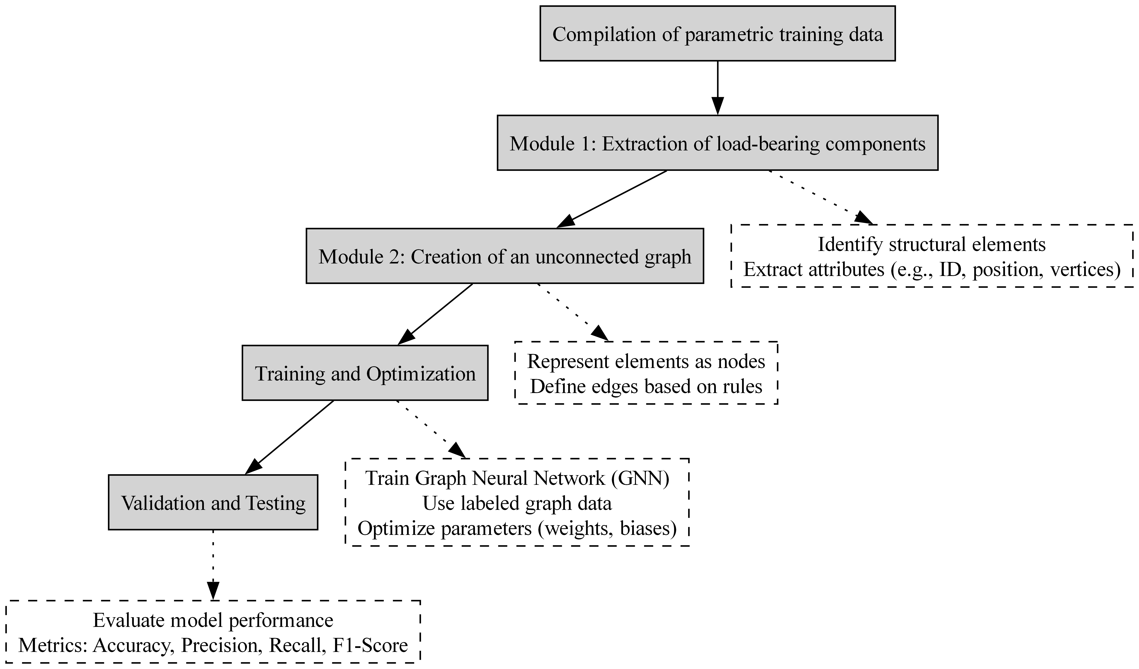
Figure 1: Workflow for the automatic conversion of IFC models into analytical graphs. First, parametric training data is compiled. During preprocessing, all load-bearing components and their attributes are extracted to construct an unconnected graph. Labeled edges are then generated based on predefined metrics. A Graph Neural Network (GNN) is trained to predict structural connections, and the results are subsequently evaluated.

3.1 Compilation of Parametric Training Data
To systematically train and evaluate the GNN, this study employs parametric models as the foundation for dataset generation. A parametric model is a computational representation of a structure in which key geometric and structural properties – such as column positions, slab thicknesses, and floor heights – are defined by a set of parameters rather than fixed values. This approach allows for the automated generation of numerous model variations by adjusting these parameters within predefined ranges.
Using the Python library ifcopenshell, we generated a dataset consisting of synthetic IFC models with controlled variations in their geometric and structural properties. This method offers several advantages:
- Controlled Complexity: The models remain simple enough for visual inspection, allowing clear identification of fundamental challenges in the conversion process.
- Automated Labeling: Because each model is generated from predefined rules, labeled training data can be created without extensive manual effort.
- Scalability: Once key limitations in model conversion have been addressed, the dataset can be expanded to include additional component types and more complex geometries (discussed further in Section 4.2).

The parametric models were created by defining a grid-based structural system. The grid consists of a set of points where corner, edge, and interior columns, as well as floor slabs at specific heights, are placed. The structure can be extended to multiple stories by varying the floor count parameter. The full set of adjustable parameters and their ranges is shown in Table 1:

Table 1: Set of adjustable parameters and their ranges
Parameter | Range | Parameter | Range
grid_x_n | [2, 4] | grid_y_n | [3, 5]
grid_x_size | [5, 8] | grid_y_size | [7.5, 10]
grid_x_offset | [0, 4] | grid_y_offset | [0, 3]
floors | [2, 4, 5] | floors_height | [2.8]
slab  thickness | [0.3] | foundation  thickness | [0.6]
corner  columns | [True, False] | edge  columns | [True, False]
inner  columns | [True, False] | column  profile | [rectengular 20x30 cm]

To simulate realistic planning errors, random modifications were introduced, such as:
- Scaling slabs in the X and Y directions.
- Adjusting column heights.
- Randomly omitting structural elements to create gaps in connectivity.
These modifications ensure that not all components are automatically connected, allowing the GNN to learn how to predict structural relationships despite geometric inconsistencies in the data. An exemplary IFC model from the generated dataset is presented in Fig. 2:
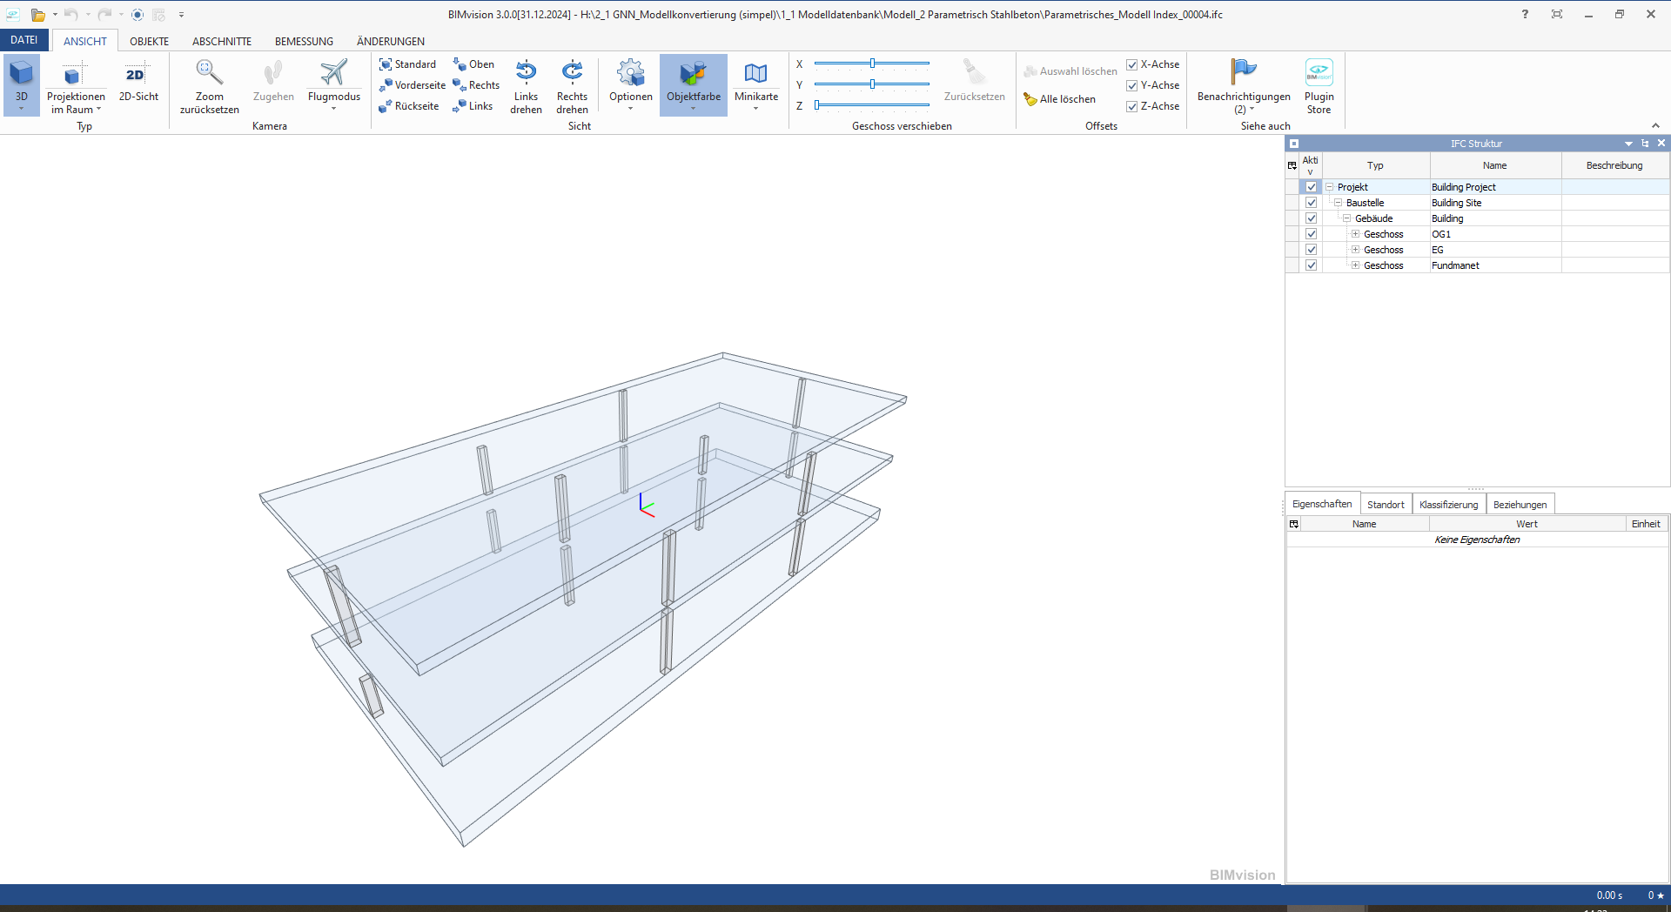
Figure 2: Exemplary IFC model from the generated dataset. It comprises edge and inner columns, with randomly selected columns modified in their height to simulate typical geometric deviations.

3.2 Extraction of Load-Bearing Components from IFC-Models
In the step Module 1 all load-bearing components such as columns, walls, and slabs are identified based on their properties (e.g., "LoadBearing" = True) and their alphanumeric and geometric information is extracted including:
- ID: Object ID for later identification;
- IFC class: IFC type (e.g., IfcWall, IfcSlab, IfcColumn);
- Position: Tuple containing (X, Y, Z) coordinates of the component's origin;
- Global vertices: Coordinates of vertices in the global coordinate system;
- Edges: Edges of the component described by indices of vertices as start and end points

3.3 Creation of an Unconnected Graph
In Module 2, the extracted structural components are represented as nodes within a spatial graph, implemented using the Python library networkx. This transformation allows the relationships between elements to be systematically analyzed. Formally, the graph is defined as:

G = (V, E), (1)
where V is the set of nodes, each corresponding to a structural component and
E is the set of edges, which define the load-bearing relationships between these components.

However, in its initial state, this graph is unconnected, meaning that no explicit relationships between the components have been established yet. To generate a labeled dataset for GNN training, we must first introduce edges that represent the structural connections within the model. This labeling process is based on predefined rules derived from the building’s topology:
- Slabs are connected to columns on the same floor level;
- Columns are linked to slabs on the floor below;
- Randomized modifiers are used to override the default metric-based connectivity, thereby preventing full automatic linkage between all components.
After applying these rules, we obtain a graph where edges indicate structural connections. To train the GNN effectively, we must distinguish between valid and invalid connections. Therefore, edges are assigned binary labels, where
- positive edges (Label = 1) represent valid structural connections and
- negative edges (Label = 0) denote components that are close in space but structurally unconnected.
From all parameter combinations mentioned earlier, a total of 1,536 possible IFC model combinations were generated for training purposes. These graphs contain approximately 63,488 nodes and 92,273 positive edges (connections). However, considering all possible edge combinations without duplication yields approximately 2,046,976 edges in total, resulting in an average positive edge ratio between 5,23 – 12,86%, depending on the structural model. This significant class imbalance presents a challenge for GNN training, requiring specialized techniques such as weighted loss functions to ensure robust model performance. Finally, these labeled graphs were saved as JSON-files for further processing. An example of such a graph is shown in Fig. 3, representing the same model depicted in Fig. 2 for comparison.
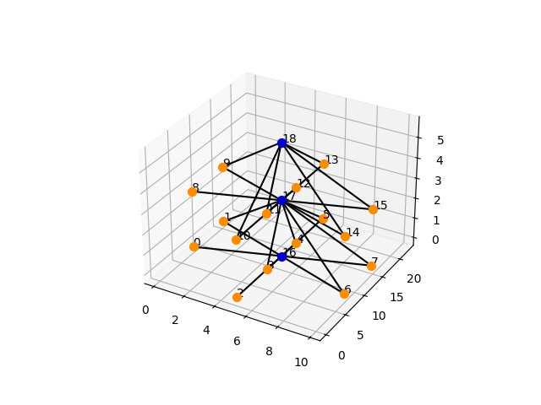
Figure 3: Analytical graph representation of the structural model shown in Figure 2. Nodes represent structural components (blue = slabs, orange = columns). The position feature is used to place the nodes in 3D space, creating a spatial graph for improved visualization. Edges indicate predicted load transfer connections between components. Columns with a modified height remain disconnected from the slab above, reflecting the lack of structural continuity.

3.4 Training Process
To achieve optimal performance for the GNN model, various architectural configurations were tested. These included model type (e.g., Graph Convolutional Network (GCN), Graph Attention Network (GAT), GraphSAGE), number of hidden layers and neurons per layer, batch size, loss function type (e.g., Binary Cross Entropy), activation functions (e.g., ELU), learning rate strategies (e.g., SGD with momentum) and dropout regularization rates p = 0.2 (Fig. 4).
The best-performing architecture was selected for evaluation and is formally described by:

h_{v}^{(l+1)} = σ (W^{(l)} ∙ AGG({h_{u}^{(l)}: u ∈ N(v)}) + b^{(l)}), (2)
where h_{v}^{(l+1)} represents the node v at layer l;
N(v) is the neighborhood of node v;
AGG is the aggregation function;
W^{(l)} is the weight matrix at layer l;
b^{(l)} is the bias term at layer l; and
σ is the activation function.

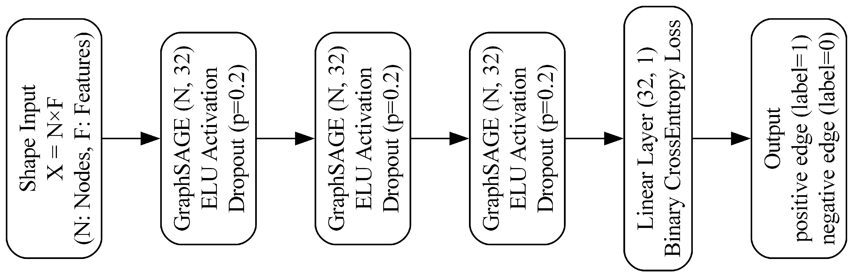
Figure 4: GraphSAGE neural network architecture for edge classification. The network processes N nodes per graph, where each node is described by its three-dimensional position and F additional features.

For the evaluation of the results, we use a GraphSAGE-based architecture with three hidden layers, each containing 32 neurons. The input layer takes the node features of Equation (3):

(Χ ∈ R^{NxF}), (3)
with N the number of nodes and
the number of features F per node.

Each hidden layer updates its node representations h_{v}^{(l+1)} using:

h_{v}^{(l+1)} = ELU (W^{(l)} ∙ MEAN(h_{u}^{(l)}: u ∈ N(v) ∪ h_{v}^{(l)}) + b^{(l)}), (4)
with MEAN as the aggregation function and
ELU as the activation function.

To prevent overfitting, we apply dropout regularization after each layer, randomly setting input values to zero. Additionally, L2 regularization is incorporated into the model.
The edge classification task is performed by concatenating node representations at both endpoints of an edge as in:

h_{(u,v)} = CONCAT(h_{u}, h_{v}). (5)
A linear layer then predicts edge labels via:

y_{(u,v)} = W_{edge ∙} h_{(u,v)} + b_{edge} (6)
where W_{edge} is the weight matrix for edge classification and
b_{edge} is the bias term for edge classification.

To address class imbalance due to fewer positive labels compared to negative ones during training we assigned higher weights to positive samples using weighted Binary Cross Entropy loss. This ensures that underrepresented classes receive adequate attention during optimization.

4. RESULTS AND DISCUSSION

4.1 Accuracy of the GNN Models in Predicting Load Connections
To evaluate the suitability of different GNN architectures for automated model conversion, three models - GCN, GAT, and GraphSAGE - were compared based on their ability to predict correct load connections. For each model various performance metrics (Table 2) and the confusion matrices were determined (Table 3).

Table 2: Performance metrices of GNN model types
Performance | GCN | GAT | GraphSAGE
Accuracy | 16.76 % | 90.03 % | 90.03 %
L2-Loss | 1.21 | 0.24 | 0.24
Precision | 5.35 % | 33.29 % | 33.29 %
Recall | 94.17 % | 100 % | 100 %
F1-Score | 10.13 % | 89.51 % | 89.51 %

Table 3: Confusion Matrices of GNN model types
 | Labels | Predicted = 0 | Predicted = 1
GCN | True = 0 | 29,714 | 204,069
GCN | True = 1 | 713 | 11,524
GAT | True = 0 | 209,257 | 24,526
GAT | True = 1 | 0 | 12,237
Graph  SAGE | True = 0 | 209,258 | 24,525
Graph  SAGE | True = 1 | 0 | 12,237

The analysis reveals that the GCN model achieves an accuracy of only 16.76%, misclassifying 204,069 edges as false positives, resulting in a precision of just 5.35%. However, since most positive connections are correctly classified, the model achieves a recall of 94.17%. Additionally, the consistently high loss values of approximately 1.21 suggest that GCN is unable to capture contextual relationships in sparsely connected graphs.
In contrast, the GAT and GraphSAGE models exhibit nearly identical performance. Both achieve an accuracy of 90.03% and correctly classify 209,258 edges as true negatives. Their precision is 33.29%, and both models attain a recall of 100%. Furthermore, the loss function decreases steadily and stabilizes at around 0.24 after three epochs. Notably, in all models, early stopping typically occurs after 25 to 30 epochs, as the loss function plateaus after 5 to 10 epochs, converging to the aforementioned values.
As the proposed approach for identifying structural connections using Graph Neural Networks (GNNs) represents a novel research direction, no directly comparable reference values are available in the existing literature. However, for other graph-based classification tasks, accuracies ranging from 85 % to 96.8 % have been reported, providing a rough benchmark for evaluating the results obtained in this study. The architectures examined here - GraphSAGE and GAT - perform within a similar range (Collins, F.C, et al., 2021; Schäfer, N. et al., 2024).
Rule-based conversion methods could serve as an additional point of comparison. However, their relevance is limited in the present context: Since deliberately simple, parametrically generated models were used for training - as detailed in Sections 3.1 and 4.2 - typical sources of error that occur in more complex, real-world IFC models (and that motivate the use of learning-based approaches) do not arise in this scenario. Consequently, rule-based converters achieve nearly perfect results on the current models, with accuracies of up to 100 %. A direct comparison with GNN-based methods is therefore of limited significance, as the intended application - robust generalization to complex, error-prone models - has not yet been fully addressed in the current experimental setup. Nevertheless, the achieved model accuracies of over 90 % demonstrate promising performance and provide a solid foundation for future investigations involving more complex model configurations.

4.2 Advantages and Challenges of the GNN Approach
Advantages: The results highlight the significant potential of GraphSAGE and GAT architectures for automated model conversion. Their high accuracy in predicting connections between structural elements encourages further exploration of this workflow. A key advantage of the graph-based representation of structural models is its ability to serve as a central interface between different geometric representations. This facilitates data exchange between software platforms and enhances interoperability.
Limited complexity: At the same time, the analysis reveals critical challenges. The current experiments are based on simplified models containing only IfcColumn and IfcSlab classes. While this simplifies model generation, error injection and labeling, it also presents a limitation. Real-world structures typically feature more complex configurations, including additional relevant building element classes such as IfcBeam, IfcFoundation, and IfcWall, each with varying geometries.
Static feature vector length: A key challenge in the approach is defining a fixed feature vector length. Current methods extract features like IFC class, position, and corner points, assuming homogeneous geometries with a uniform number of vertices. This limits applicability to more complex, heterogeneous models with varying geometries. Surface-based representations (e.g., bounding boxes) can standardize input size but reduce geometric detail. As a compromise, elements could be split into subcomponents with homogeneous geometry during preprocessing and later re-aggregated in postprocessing. Alternatively, PCA-based dimensionality reduction may help encode heterogeneous shapes into fixed-size vectors suitable for GNN input.
Class Imbalance: The low proportion of positive edges (5.23 – 12.86%) leads to class imbalance and biased GNN predictions. While weighted loss functions help, they do not fully prevent overfitting. Reducing potential negative edges – e.g., by excluding edges across floor levels or through preliminary clash detection – could improve label distribution and computational efficiency.
Feature Relevance: Another aspect concerns the relevance of the extracted features. An initial feature importance analysis, conducted by successively excluding individual features as well as using all features in combination, revealed only marginal differences in model performance. This suggests that the current task setup may be too simplistic, as the model achieves comparable results regardless of the selected input features.

5. CONCLUSION AND OUTLOOK

5.1 Summary of Findings
The presented results underscore the potential of graph-based approaches for BIM model conversion, particularly due to their ability to capture contextual relationships between structural elements. As a platform-independent interface, they mitigate conflicts between architectural and analytical model representations, thereby reducing the need for manual post-processing. The evaluation of different GNN architectures for automated model conversion demonstrates that both GAT and GraphSAGE are well-suited for this task.

5.2 Outlook
Future research should explore if the challenge of fixed feature lengths in GNNs could be addressed through surface-based representations or by subdividing complex elements into simpler subcomponents that are re-aggregated postprocessing.
To mitigate class imbalance and improve computational efficiency, preliminary clash detection could reduce the number of non-relevant edge candidates during preprocessing. Alternative learning strategies such as semi-supervised learning or reformulating the task as an edge detection problem may further enhance model performance.
In view of the current findings on feature relevance, future research should investigate whether this pattern persists in more complex scenarios or if the inclusion of additional parameters – such as material properties, topological information or spatial distance – can contribute to improved predictive accuracy.
Once these challenges are addressed, the GNN will be applied to more complex IFC scenarios involving diverse structural classes. In this context, a comparative analysis will be conducted between rule-based conversion results and the graph predictions generated by the trained GNN. For the rule-based approach, selected models will be manually reviewed to identify both incorrectly connected and missing connections. The same procedure will be applied to the GNN-derived graphs, enabling a direct comparison of erroneous or missing edge predictions for each IFC-model. The resulting data will then be statistically evaluated to asses differences in performance and to determine the practical added value of the proposed learning-based method.

ACKNOWLEDGEMENTS
This research was funded by the European Union and by the Saxon State Parliament.



REFERENCES
Kepplin, R., Schnellenbach‐Held, M. and Held, M. (2017) ‘Building Information Modeling - Umsetzung in der Tragwerksplanung’, Bautechnik, 94(4), pp. 220–226. DOI: 10.1002/bate.201700003.
Çeter, S. (2024) ‘Automated BIM Model Annotation via Graph Neural Networks: Bridging the Gap Between Design and Documentation’. Available at: https://mediatum.ub.tum.de/1742936 [14 March 2025].
Bloch, T. et al. (2024) ‘Leveraging Graph Based Semantic Enrichment for Enhanced Automated Code-Checking’, in. EC3 Conference 2024, European Council on Computing in Construction (Computing in Construction). DOI: 10.35490/EC3.2024.247.
Wang, Z. et al. (2023) ‘CBIM: A Graph-based Approach to Enhance Interoperability Using Semantic Enrichment’. arXiv. DOI: 10.48550/arXiv.2304.11672.
Salehi, H. and Burgueño, R. (2018) ‘Emerging artificial intelligence methods in structural engineering’, Engineering Structures, 171, pp. 170–189. DOI: 10.1016/j.engstruct.2018.05.084.
Collins, F.C. et al. (2021) ‘Assessing IFC classes with means of geometric deep learning on different graph encodings’, in. 2021 European Conference on Computing in Construction, pp. 332–341. DOI: 10.35490/EC3.2021.168.
Kiavarz, H. and Jadidi, M. (2022) ‘IFC-BIM-Based Critical Energy Consumption Zones Identification in Buildings’, Transforming Construction with Off-site Methods and Technologies [Preprint]. DOI: 10.57922/tcrc.621.
Bloch, T., Borrmann, A., Pauwels, P., 2023. Graph-based learning for automated code checking – Exploring the application of graph neural networks for design review. Advanced Engineering Informatics 58, 102137, DOI: 10.1016/j.aei.2023.102137.
Chang, K.-H. and Cheng, C.-Y. (2020) ‘Learning to Simulate and Design for Structural Engineering’, in Proceedings of the 37th International Conference on Machine Learning. International Conference on Machine Learning, PMLR, pp. 1426–1436.DOI: 10.48550/arXiv.2003.09103.
Schäfer, N., Köhle, J.-F. and Díaz, J. (2025) ‘Data-Driven Predimensioning: Applying Graph Neural Networks to Reinforced Concrete Design’, in A. Francis, E. Miresco, and S. Melhado (eds) Advances in Information Technology in Civil and Building Engineering. Cham: Springer Nature Switzerland, pp. 181–190. DOI: 10.1007/978-3-031-87364-5_15.
Fisch, R., Stecker, E. and Kraus, M.A. (2023) ‘Maschinelles Lernen beim Entwurf und der Bemessung von Stahlrahmenhallen’, Stahlbau, 92(6), pp. 332–344. DOI: 10.1002/stab.202200054.
Forster, D., Baker, W.F. and Bischoff, M. (2024) ‘Structural Analysis Using the Redundancy Matrix and Graph Theory’. Available at: https://app.iass2024.org/
files/IASS_2024_Paper_222.pdf.
IfcOpenShell - The open source IFC toolkit and geometry engine (2025). Available at: https://ifcopenshell.org/ [28 March 2025].
NetworkX - NetworkX documentation (2025). Available at: https://networkx.org/ [28 March 2025].

