Automated Bridge Modeling for Digital Twins
Parametric Modeling vs. Surface Modeling Techniques for Geometric-semantic Model Creation

ABSTRACT:

Building Information Modeling (BIM) is transforming construction practices, but its application to existing assets remains challenging due to discrepancies between original designs and as-is conditions. Moreover, also Digital Twins require accurate geometric-semantic as-is models, which are traditionally labor-intensive to create. This paper presents a fully-automated approach for generating as-is models of bridges by comparing parametric and surface modeling techniques using semantically segmented 3D point cloud data. The methodology employs Evolutionary Strategy optimization for parametric modeling and RANSAC-based quadratic fitting for surface modeling, focusing on capturing complex geometries like horizontally curved bridges. As expected, our comparative analysis reveals that surface modeling achieves much better accuracy with 60% lower RMSE (0.05m vs. 0.126m) in our case study and requires 90% less processing time (1.2 minutes vs. 12 minutes) than parametric modeling. Both approaches successfully generate Industry Foundation Class (IFC) models, providing standardized geometric-semantic representations suitable for lifecycle BIM and Digital Twin applications.

KEYWORDS:

Building information modeling, bridge infrastructure, digital twin, parametric modeling, surface modeling

1. INTRODUCTION
Bridges are integral components of transportation infrastructure, enabling connectivity and the carriage of people and goods across networks. While many bridges in the European Union’s national road systems were constructed within the past five decades, a significant number remain considerably older (Woodward, R et.al., 2001). The aging process has led to a marked rise in deterioration and failures among these bridges. For instance, in Germany, a recent and dramatic illustration occurred with Dresden’s Carolabrücke collapse in 2024, where investigations determined that hydrogen-induced stress corrosion cracking combined with traffic-related fatigue caused critical structural failure (ZDF, 2024). To ensure the ongoing structural integrity and safety of these bridges, it is imperative to maintain up-to-date models, which are indispensable for effective facility management for Bridges (Saback de Freitas Bello et.al., 2021).
Building Information Modeling (BIM) has emerged as a transformative concept that revolutionizes how physical structures are designed, maintained, and optimized through digital replicas (Hagedorn et al., 2023). Research demonstrates that BIM implementation in infrastructure projects, particularly bridge construction, can achieve cost reductions of 5-9% by minimizing change orders and rework (Fanning et al., 2015). However, while BIM adoption in new construction is relatively straightforward, its application to existing infrastructure presents significant challenges, including missing design documentation, discrepancies between original designs and actual construction, and structural deformations due to aging (Abbondati et al., 2020).
To address these challenges, Scan-to-BIM (Scan2BIM) techniques are increasingly used to generate geometric-semantic as-is models, which form also a crucial foundation for Digital Twins (DTw) (Kellner et al., 2024). A DTw can be formally defined as a virtual representation of a physical entity or process in the real world with a close connection between the two representations for data and information exchange (Grieves, 2014).
Applied to the construction industry, a DTw can be seen as the next evolutionary step after traditional BIM, which virtually mirrors a real asset and links it closely to its physical counterpart. Digital Twins can be used to understand, predict and optimize the performance of the asset in the virtual world and transfer the knowledge gained back to the real-world entity. The continuous synchronization between physical and virtual representation enables advanced analytics, predictive maintenance, and real-time decision-making throughout the asset’s lifecycle (e.g., BS, 2020; Smarsly et al., 2024). Furthermore, (Ammar et al. 2022) characterize the DTw of a construction project as a digital model linked throughout the project lifecycle, maintaining a bi-directional relationship with the physical counterpart through IoT, CPS, AI, and sensors, enriched with real-time semantic data including geometric specifications, drawings, schedules, and financial reports.
However, it is important to note that there is not THE Digital Twin of an asset, as there can be multiple (linked) DTw for different use cases. This also means that the required data and models of a DTw as well as their resolution and accuracy always depend on the intended use case and the functional requirements.
The Scan2BIM process, or in the context of DTw perhaps better referred to as the Scan2Twin process, usually begins with reality capture data acquisition such as 3D laser scanning or photogrammetry to survey the existing physical conditions of infrastructure, resulting mostly in 3D Point Cloud Data (PCD) upon which all subsequent modeling steps depend. Once this high-resolution spatial data is acquired, the process continues with two main analytical steps: semantic (instance) segmentation to identify structural components in the PCD, followed by geometric modeling to align 3D shapes with the segmented PCD (Mansour, Martens & Blankenbach, 2024). However, despite these technological advances, the Scan2BIM process remains labour-intensive, time-consuming, and requires significant manual input.
This contribution addresses the challenges of manual modeling by comparing two automated approaches: parametric modeling, which describes structures with design parameters, and surface modeling, which is better suited towards true-to-deformation modeling. By evaluating both techniques for representing as-is bridge conditions, we aim to identify how their respective strengths can enhance bridge management systems.
The following section examines current research in DT generation through Scan2BIM, highlighting limitations in automated modeling workflows and establishing the context for our methodology while identifying critical research gaps this study addresses.

2. RELATED WORK
Geometric-semantic as-is model (as-is BIM model) generation through Scan2BIM processes remains a bottleneck in infrastructure management despite its critical importance. While data acquisition via laser scanning or photogrammetry is rapid, the subsequent 3D modeling process can extend from days to months depending on project complexity (Fumarola & Poelman, 2011). Current commercial solutions offer only partial automation, requiring extensive manual intervention that dominates project timelines. In Revit-based infrastructure projects, modeling professionals spend up to 95% of their time on tedious manual adjustments rather than value-adding activities (Lu & Brilakis, 2017). This inefficiency creates a significant barrier to widespread adoption of DT for existing bridges and other critical infrastructure.
To address these limitations, an effective automated workflow for Scan2BIM technology is essential for processing point cloud data into fully annotated as-is BIM models that incorporate both semantic and geometric information. The automation of this process necessitates advancements in two key phases: semantic (instance) segmentation and geometric modeling. While semantic segmentation is already addressed in current research (e.g., Mansour, Martens & Blankenbach, 2024; Vassilev, Laska & Blankenbach 2024), automatic geometric modeling remains a significant challenge that requires further investigation.
This geometric modeling phase encompasses various shape representation approaches extensively studied in literature (Tang et al., 2010). Researchers distinguish between parametric representations, which describe shapes with a small set of parameters, and non-parametric representations using triangle meshes (Rausch, Zhao & Haas, 2020). Additionally, classifications differentiate between explicit and implicit shape representations (Berger et al., 2017). Explicit representations encode shapes directly, with common approaches including Boundary Representation (B-rep), which describes geometry through vertices, edges, and faces (Valero, Adán & Cerrada, 2012). Also implicit geometry representations span a wide range. Constructive Solid Geometry (CSG) as a widely used geometry representation for BIM builds complex objects by combining simple geometric primitives through boolean operations (Wu, Xu & Wang, 2018). The geometric primitives, however, are often described implicitly by parameters (e.g., width, length, height, radius) although these can (theoretically) also be described explicitly in principle. Another sophisticated variant of implicit geometry representations, on the other hand, encode shapes indirectly as level sets of mathematical functions (e.g., f(x,y,z) = 0). These functions define where points lie relative to the surface, with common examples including algebraic surfaces for representing primitives such as planes and cylinders (Schnabel, Wahl & Klein, 2007). Unlike CSG, which explicitly stores construction history and primitive information, these implicit methods define shapes through mathematical equations without storing geometric elements. These various representation schemes serve as the foundation upon which different modeling techniques can be developed to generate 3D geometric models.
Researchers have extensively investigated automatic 3D geometric modeling of bridge infrastructure recently to generate models that represent the geometry of physical assets. Research has evolved along two primary modeling approaches: parametric and surface modeling. In parametric modeling, Mafipour Vilgertshofer & Bormann (2023) developed a metaheuristic optimization approach for fitting 2D Parametric Models (PM) to noisy point cloud data by defining a robust objective function and extruding the optimized PM along the longitudinal bridge direction to create 3D geometric models. However, their investigation so far did not address bridges with curvature alignments nor the manual creation of various PMs with different girder variations for girder bridge types. Similarly, Qin et al. (2021) proposed an automated parametric BIM workflow but limited their scope to simple bridge pier geometries. In surface modeling, Lu & Brilakis (2019) employed a 2D Concave Hull α-shape algorithm to define the 2D profile of bridge decks before sweeping the profile along the bridge curvature alignment to generate Industry Foundation Class (IFC) models. While their method successfully captures bridge curvature, it assumes that the point cloud data possesses a high degree of spatial accuracy, which is not always achievable in practice. Finally, Shu et al. (2024) advanced this approach with improved α-shape concave hull algorithms to define key points in the 2D profile of box girder bridges, subsequently sweeping the cross-section along the longitudinal bridge direction. Nevertheless, their approach remains sensitive to noise when extracting key points.

2.1 Areas for further investigations
Current parametric modeling approaches lack integration of discrete parameters, such as girder count, necessitating increased manual effort for creating models of girder bridges with varying configurations, a key limitation given the prevalence of these structures in infrastructure networks. Concurrently, existing surface modeling techniques remain predominantly confined to simple geometries and have not been sufficiently investigated for modeling complex bridge structures such as curved girders. Of particular significance is the absence of comparative analyses between parametric and surface modeling approaches in capturing the as-is geometry of bridges, a critical gap that prevents informed methodology selection based on specific project requirements. This contribution addresses these limitations by introducing a comprehensive comparative analysis of both modeling methods, evaluating their respective capabilities in terms of geometric accuracy and computational efficiency when applied to bridge infrastructure modeling.

3. METHOD
The methodology automates the modeling of bridge infrastructure elements from semantically segmented 3D point clouds, focusing particularly on curved bridge girders as the most geometrically complex components in the case study. This is accomplished through different modeling approaches, parametric and surface modeling techniques, culminating in the generation of IFC models.
To establish a robust foundation for our methodology, data acquisition was conducted using a geodetic terrestrial laser scanner (Riegel VZ-400) with ±3-5 mm accuracy and around 600 m maximum range. This dataset underwent semantic segmentation into six distinct classes utilizing a Support Vector Machine (SVM) algorithm (Mansour, Martens & Blankenbach, 2024). Figure 1 provides a visual representation of the investigated dataset and its classified bridge elements.
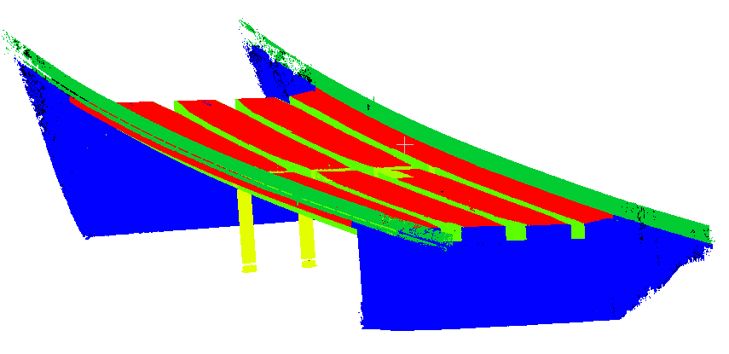Figure 1: Investigated dataset with 6 bridge elements

3.1 Parametric modeling
The parametric modeling approach begins with defining a 2D PM representing the cross-sectional profile of bridge deck, described using parameters such as dimensions and angles. This PM is aligned with 2D PCD through a Model-to-Cloud fitting process, which employs an optimization algorithm to minimize fitting error and find optimal parameters.
For this study, we defined a PM of the bridge deck incorporating 17 parameters to capture geometric features including sidewalk dimensions, road characteristics, and girder configurations. Figure 2 illustrates the created PM. A symmetry assumption is made about the origin point ($P_{1},P_{2}$). Parameters $P_{3}$ through $P_{16}$ define the geometric characteristics of the sidewalk and road, including lengths, heights and angles representing the slope of these elements. We introduce a novel discrete parameter p₁₇ that controls the overall structural configuration to estimate the number of girders. Parameter p₁₆, representing half the road width, is calculated from other parameters using Equation (1).
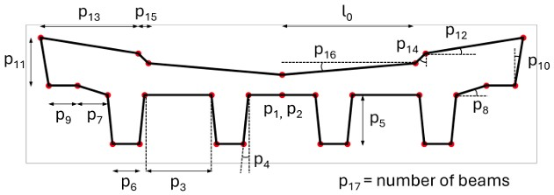
Figure 2: 2D parametric model with 17 parameters

$l_{0}=P_{3}.\frac{P_{17}-1}{2}+P_{5}.\tan\left(P_{4}\right).P_{17}+P_{6}.\frac{P_{17}}{2}+P_{7}+{ P}_{9}+{ P}_{11}.\tan\left(P_{10}\right)-P_{13}-P_{15}$ (1)
Due to the inherent non-linearity in the PM, which operates on multiple parameters and constraints, the system generates complex interactions and numerous local minima. Traditional gradient-based optimization algorithms prove ineffective in such environments, as they typically converge to these local minima rather than identifying the global optimum solution. Therefore, we employ an Evolutionary Strategy (ES) (Vent & Rechenberg 1975) as a stochastic optimization algorithm known for its ability to handle non-linear and discontinuous parameter interactions. The algorithm maintains a population of solutions that evolve over multiple generations, with both parent (µ) and offspring (λ) competing for survival. Mutation serves as the primary operator, introducing controlled random variations to parent solutions, Equation (2).

$X_{Offspring}$ = $X_{Parent}$ + σ* N (0, s²) (2)
Where σ is the step size in the search space and N (0, $s^{2}$) represents Gaussian random variation, with s² as the variance. Building upon previous investigations into fixed step size configurations for exploring and exploiting the search space (Mansour & Blankenbach, 2024), the present methodology introduces an adaptive step size to balance search space characteristics, successfully exploring the search space and exploiting optimal solutions for faster convergence. We implement Rechenberg's 1/5 Success Rule (Vent & Rechenberg 1975) to adaptively adjust the step size. The process continues iteratively until reaching a predefined number of generations, with each iteration potentially combining parameters through intermediate dual recombination before mutation. The population structure maintains a 10:90 ratio between parents and offspring, ensuring both stability and innovation in the search process.
A cost function quantifies the accuracy of the model's fit to the PCD, guiding the optimization algorithm in determining the optimal parameter set that best represents the bridge's 2D profile. This function calculates the shortest distance between each point in the PCD and the closest edge of the PM. This comprehensive distance measurement is then used to compute the Root Mean Square Error (RMSE) as expressed in Equation (3).

$RMSE=\sqrt{\frac{1}{n}\sum_{i=1}^{n}{{(min d_{i})}^{2} }}$ (3)
Where $n$ denotes number of points in the PCD and $min d_{i}$ is the minimum distance from each point to its closest PM edge. To ensure practical and realistic solutions, the optimization process incorporates parameter constraints derived from geometric bounds using the bounding box around the extracted 2D points and design standards. For instance, parameter p₁₆ (half road width) for two-way traffic on regional German highways is constrained between 3.5 and 5.5 m based on standard design specifications of road cross-sectional profile RQ11 (Straßenwesen, 1970), as shown in Figure 3.
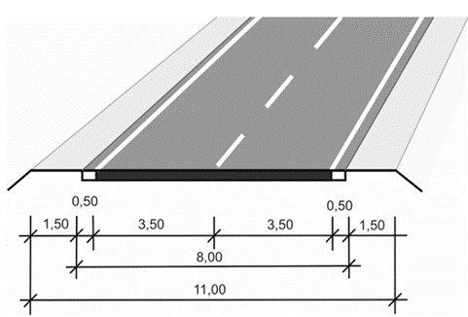
Figure 3: Cross-section Road profile RQ11

Once the optimal parameter set is identified, it is used to generate vertices that form a closed profile, which is subsequently swept along the horizontal curvature of the bridge to construct the complete 3D geometric models. These vertices are connected using IfcPolyline to create an IfcArbitraryClosedProfile, which is then swept along a path described as an IfcCurve with a sweeping depth equal to the bridge deck length, resulting in a comprehensive geometric representation in the Industry Foundation Class schema.

3.2 Surface modeling
The surface modeling approach employs implicit shape representations described by mathematical formulations to fit 3D point data. Since both the bridge deck and its supporting girders follow a second-degree parabolic curvature, we fit a 3D quadratic surface equation to the curved bridge girders represented by (x, y, z) coordinates. The implicit representation of general quadratic surface, illustrated in Equation (4), is expressed as:

Ax² + By² + C z² + Dxy + Exz + Fyz + Gx + Hy + Iz + J = 0 (4)
The equation comprises several coefficient groups with distinct geometric interpretations: quadratic terms with coefficients (A, B, C) capture the surface curvature along the x, y, and z axes; cross-product terms with coefficients (D, E, F) control the surface rotation and capture dimensional interactions; linear terms with coefficients (G, H, I) regulate the surface slope; and the constant term (J) determines the surface intercept.
The fitting process of the 3D quadratic surface employs RANSAC (Random Sample Consensus) to robustly estimate model parameters in the presence of outliers (Bolles & Fischler, 1981). By reformulating the general quadratic equation to isolate the z-coordinate, we transform it into a regression problem as shown in Equation (5).
Ax² + By² + Dxy + Gx + Hy + J = z (5)
In this formulation, z-coordinates serve as regression targets, while polynomial features generated from x and y coordinates function as predictor variables. This approach enables RANSAC's iterative sampling methodology to efficiently distinguish between inliers and outliers while determining the optimal surface parameters. Figure 4 illustrates the derived polynomial features that capture the curvature of the bridge girders.
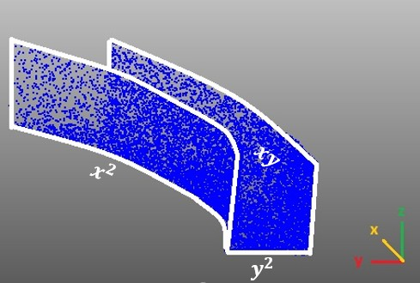
Figure 4: Polynomial features of quadratic surface

The implementation of our surface modeling approach begins with a critical pre-processing step to address the geometric complexity of curved bridge girders. Since each girder comprises three distinct surfaces, we employ a two-phase clustering technique to isolate these surfaces prior to individual fitting, as shown in Figure 5. Initially, Gaussian Mixture Model (GMM) clustering (Reynolds, 2009) is applied to the z -coordinate distribution, effectively separating the bottom surface from the side surfaces. Subsequently, DBSCAN (Density-Based Spatial Clustering of Applications with Noise) clustering (Ester et al., 1996) is implemented to distinguish between the right and left side surfaces based on their spatial distribution.

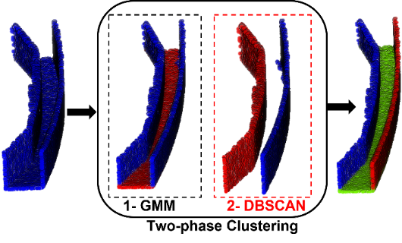
Figure 5: Two-phase clustering to separate surfaces

Following segmentation, we apply RANSAC-based fitting to each surface independently, employing the reformulated quadratic equation, Equation (5), to accurately approximate their curved geometries. For reliable assembly of these three surfaces, accurate boundary determination of the bottom surface is critical. We establish these boundaries by projecting the side surfaces onto the xy-plane and fitting 2D quadratic curves to each projection, thereby creating well-defined intersection curves. The xy-coordinates of these boundaries are then complemented with z-values derived from the fitted quadratic surface equation of the bottom surface, ensuring geometric continuity at all surface intersections. This integrated approach maintains structural coherence while appropriately accounting for longitudinal curvature, resulting in a mathematically robust model with seamless transitions between adjoining surfaces.

4. EXPERIMENT
In this section, we present a comprehensive evaluation of both modeling approaches applied to the curved bridge infrastructure case study. The performance of parametric and surface modeling techniques is assessed and compared in terms of geometric accuracy and computational efficiency in capturing the as-is conditions of curved bridge girders.

4.1 Parametric modeling
The proposed parametric modeling approach was evaluated on a bridge deck with four curved girders. The extracted 2D profile of the bridge deck, comprising 300 points, was fitted to the created 2D PM using the ES algorithm. The fitting process achieved a RMSE of 0.016 m with a total computational time of 3.1 minutes over 100 iterations, which was determined empirically as sufficient after observing convergence plateaus with negligible improvements (<0.1% change in objective function) beyond approximately 80 iterations. Our approach successfully estimated the correct number of girders in the bridge deck, as represented by the discrete parameter p₁₇. As illustrated in Figure 6, the optimization process initiated with an initial estimate of 5 girders (RMSE = 0.6 m) and converged to the correct girder configuration after approximately 4 iterations. From iteration 11 onward, the algorithm exhibited gradual convergence, incrementally optimizing the remaining parameters until reaching the optimal parameter set at iteration 100. Additional testing with extended iterations (up to 150) showed no significant improvement in RMSE while increasing computational cost by approximately 50%, confirming that 100 iterations provide an optimal balance between accuracy and computational efficiency for this specific parametric modeling problem.
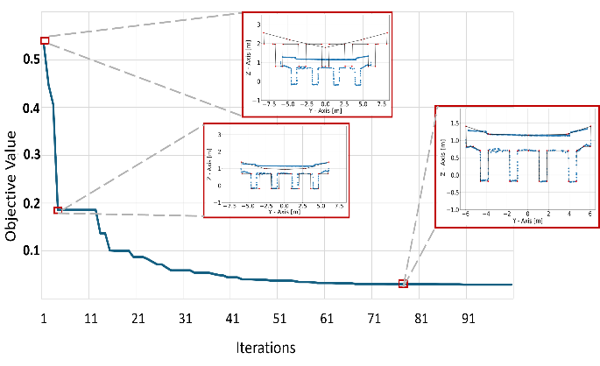
Figure 6: Convergence to correct bridge configuration (four girders) during optimization process.

Following determination of the optimal 2D PM representing the bridge deck cross-section, we employed a sweeping operation along the bridge's curvature to generate the IFC geometric model. The bridge's horizontal alignment was captured by fitting a second-degree parabola to the centerline of the bridge deck point cloud projected onto the xy-plane. Figure 7 illustrates both the fitted curve to the bridge deck and the resulting IFC model.
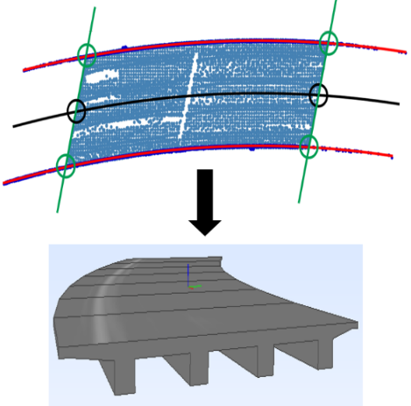
Figure 7: Generating IFC model for bridge deck

4.2 Surface modeling
The Implementation of the surface modeling methodology for curved bridge girders yielded IFC geometric models through a systematic approach. Following the two-phase clustering technique described in section 3.2, we applied quadratic surface fitting using RANSAC to each clustered side surface to obtain optimized coefficients. The RANSAC algorithm was configured with a residual threshold of 0.01 m and a maximum of 100 iterations (max_trials) to ensure reliable convergence. Figure 8 illustrates the fitting results for one representative curved girder from the four presents along the bridge span.
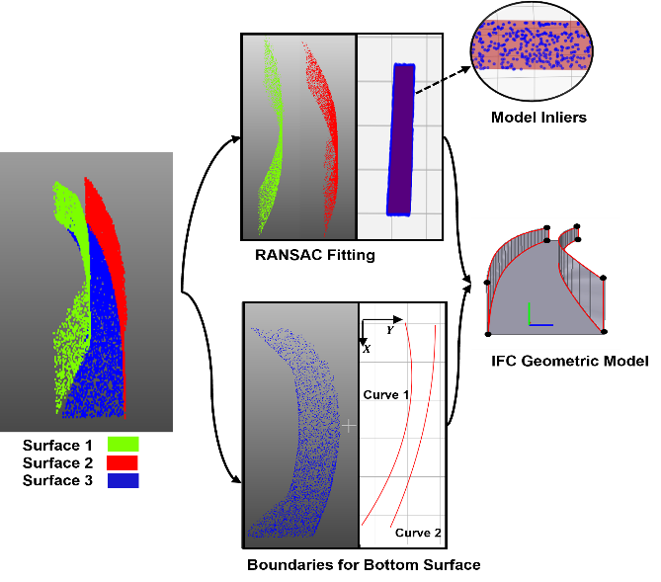
Figure 8: Surface modeling for bridge girders
Figure 10: Cloud-to-cloud distance analysis of surface modeling, showing distance histogram and spatial deviation map of bridge girders (RMSE = 0.05 m)
Figure 9: Cloud-to-cloud distance analysis of parametric modeling, showing distance histogram and spatial deviation map of bridge girders (RMSE = 0.126 m)
For IFC geometric model generation, we employed the IfcFacetedBrep schema, describing each surface by its boundaries. Vertices for each surface were extracted based on minimum and maximum xy coordinate values and incorporated as IfcCartesianPoint entities. The quadratic edges represented by these vertices were subdivided along their paths into IfcFace elements, each comprising two triangles formed by three points as IfcPolyLoop. Finally, an IfcClosedShell was createdfrom all faces, constituting the complete IfcFacetedBrep representation of the curved girder.

The quadratic surface fitting performance across the three constituent surfaces of the girder is summarized in Table 1.

Table 1: Analysis of RANSAC fitting to a bridge curved girder; Inlier ratio (%), R² score (R²)

Girder 1 | (%) | RMSΕ(m) | R² | Iterations
Surface 1 | 60 | 0.14 | 0.90 | 89
Surface 2 | 100 | 0.006 | 0.99 | 1
Surface 3 | 80.7 | 0.013 | 0.75 | 15
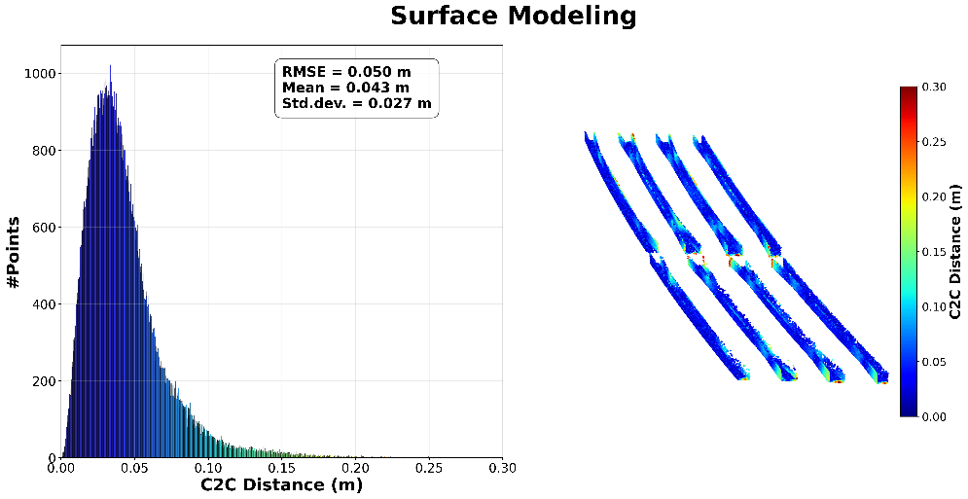
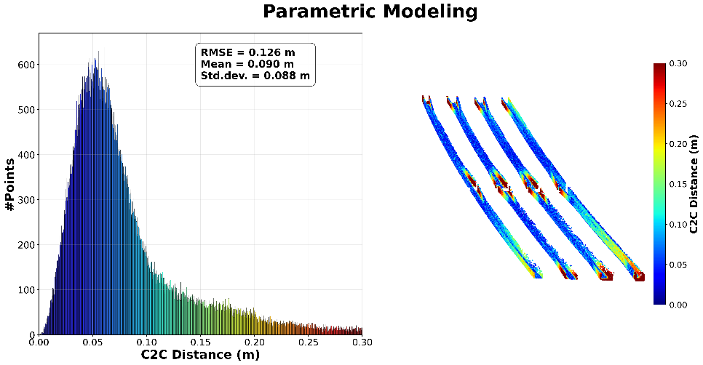
The metrics reveal varying degrees of surface complexity and fitting accuracy. The inlier ratio indicates the percentage of points considered valid for the model, where higher values suggest better representation of the true surface geometry. The coefficient of determination (R² score) measures how well the model explains the variance in data, with values closer to 1.0 indicating enhanced predictive capability. The iteration count represents the algorithmic convergence behaviour, indicating the number of sampling iterations required to either reach the predefined maximum (max_trials) or satisfy the early termination criterion (0.99 probability of finding the optimal model). Surface 2 exhibited optimal compatibility with the quadratic representation, while surfaces 1 and 3 presented greater geometric challenges, requiring more iterations and yielding lower quality metrics.

5. DISCUSSION
The experimental results illuminate the distinctive strengths of both modeling approaches. In parametric modeling, parameter p₁₇, which estimates the number of girders, proved pivotal in determining structural configuration despite being discrete rather than dimensional. This highlights the potential significance of discrete parameters in capturing complex structural arrangements in bridge modeling, such as varying numbers of piers, expansion joints, or support configurations. Surface modeling demonstrated remarkable capacity to capture as-is geometry, particularly for surface 2 with an RMSE of 6 mm. Both surfaces 1 and 3 deviate from perfect quadratic form, though in different ways. Surface 1 exhibits strong geometric irregularities at girder-pier cap connections, as evidenced by its low inlier ratio of 60%. While the surface fitting for inliers shows strong correlation (R² = 0.90), the RMSE calculated using all points including outliers is relatively high (0.14 m), reflecting the substantial impact of outliers on the overall fit accuracy. In contrast, surface 3 presents a different pattern: it has a very low RMSE (0.013 m) when all points are considered, yet a moderate coefficient of determination (R² = 0.75). This seemingly contradictory result can be explained by surface 3's more consistent, almost planar configuration along the XY plane, where the minimal curvature means that even a moderately correlated model can achieve small absolute errors.
In order to compare both modeling approaches for capturing the as-is condition of bridges quantitatively, the IFC models generated from both methods were converted into mesh representations. For parametric modeling, four cross-sectional slices were extracted along the bridge curvature to account for variations in the girder profiles before generating the final IFC model. Points were then subsampled from these mesh surfaces, and cloud-to-cloud distance measurements were calculated against the original point cloud data. The comparison metrics include RMSE, mean distance, and standard deviation of distances, providing a comprehensive evaluation of the overall geometric accuracy between the parametric and surface modeling approaches. As shown in Figure 9, parametric modeling achieved an RMSE of 0.126 m, with a mean distance of 0.090 m and standard deviation of 0.088 m. The histogram displays a right-skewed distribution, indicating the presence of larger systematic deviations where the modeling approach inadequately represents certain areas of the actual structure. Figure 10 illustrates that surface modeling delivered better accuracy with an RMSE of 0.05 m, a mean distance of 0.043 m (52.2% improvement), and a standard deviation of 0.027 m (69.3% improvement), indicating not only better overall accuracy but also more consistent representation across the entire structure. This histogram shows a significantly improved distribution compared to Figure 9, with only slight right skewness, demonstrating that the chosen modeling approach better represents the actual structure, although improvement potential still exists in some areas. The distance distribution histograms and corresponding color-coded visualizations further demonstrate that surface modeling effectively minimizes extreme deviations. Additionally, the visualization reveals that parametric modeling exhibits higher deviations particularly at connection points and girder ends, while surface modeling maintains more uniform accuracy throughout the structure.

6. CONCLUSION
This paper explored two techniques to automate the modeling of curved girder bridges and generate IFC models with geometric and semantic properties. Both approaches significantly reduce manual modeling effort. Parametric modeling describes bridge girders with adjustable parameters, beneficial for applications with lower geometric accuracy requirements, but struggles at connection points despite using multiple cross-sectional slices. The optimal number and positioning of slices remain challenging and directly impacts modeling time (currently 12 minutes for 4 slices). Surface modeling achieved better accuracy through global quadratic surface fitting while requiring significantly reduced processing time (1.2 minutes), rendering it suitable for applications demanding high geometric precision. However, this approach does not directly yield parametric descriptors of the girder components and exhibits limitations in capturing localized geometric variations, potentially necessitating the implementation of patch-based quadratic modeling along complex surface regions.
While this work shows promising results for both parametric and surface modeling approaches, it should be noted that the focus of this study was on developing the methodology and therefore only data from a single bridge was used. Future work needs to investigate the generalizability of our approach to bridges with different geometric complexity, construction type or regional design standards. Furthermore, we will explore parameterized NURBS forms to capture various surface deformations and integrate them in geometry-informed neural networks constrained by geometric topology to further improve surface modeling's capability to represent as-is conditions.

REFERENCES
Abbondati, F., Biancardo, S.A., Palazzo, S., Capaldo, F.S. and Viscione, N., 2020. I-BIM for existing airport infrastructures. Transportation Research Procedia, 45, pp.596–603.
Ammar, A., Nassereddine, H., AbdulBaky, N., AbouKansour, A., Tannoury, J., Urban, H. and Schranz, C., 2022. Digital twins in the construction industry: a perspective of practitioners and building authority. Frontiers in Built Environment, 8, p.834671.
Berger, M., Tagliasacchi, A., Seversky, L.M., Alliez, P., Guennebaud, G., Levine, J.A., Sharf, A. and Silva, C.T., 2017, January. A survey of surface reconstruction from point clouds. Computer Graphics Forum, 36(1), pp.301–329.
Bolles, R.C. and Fischler, M.A., 1981, August. A RANSAC-based approach to model fitting and its application to finding cylinders in range data. In IJCAI (Vol. 1981, pp.637–643).
BS, 2020. Enabling an Ecosystem of Digital Twins. A buildingSMART International Positioning Paper. URL: https://www.buildingsmart.org/wp-content/uploads/2020/06/Enabling-Digital-Twins-Positioning-Paper-Final.pdf
Ester, M., Kriegel, H.P., Sander, J. and Xu, X., 1996, August. A density-based algorithm for discovering clusters in large spatial databases with noise. In KDD (Vol. 96, No. 34, pp.226–231).
Fanning, B., Clevenger, C.M., Ozbek, M.E. and Mahmoud, H., 2015. Implementing BIM on infrastructure: Comparison of two bridge construction projects. Practice Periodical on Structural Design and Construction, 20(4), p.04014044.
Fumarola, M. and Poelman, R., 2011. Generating virtual environments of real-world facilities: Discussing four different approaches. Automation in Construction, 20(3), pp.263–269.
Grieves, M., 2014. Digital Twin: Manufacturing Excellence through Virtual Factory Replication. White Paper
Hagedorn, P., Liu, L., König, M., Hajdin, R., Blumenfeld, T., Stöckner, M., Billmaier, M., Grossauer, K. and Gavin, K., 2023. BIM-enabled infrastructure asset management using information containers and semantic web. Journal of Computing in Civil Engineering, 37(1), p.04022041.
Kellner, M., Vassilev, H., Busch, A., Blaskow, R., Cervantes, M.F., Poku-Agyemang, K.N., Schmitt, A., Weisbrich, S., Maas, H.-G., Neitzel, F., Reiterer, A. and Blankenbach, J., 2024. Scan2BIM – A Review on the Automated Creation of Semantic-Aware Geometric as-is Models of Bridges. Allgemeine Vermessungs-Nachrichten (AVN), 131(3). DOI: 10.14627/avn.2024.3.4.
Lu, R. and Brilakis, I., 2017. Recursive segmentation for as-is bridge information modelling.
Lu, R. and Brilakis, I., 2019. Digital twinning of existing reinforced concrete bridges from labelled point clusters. Automation in Construction, 105, p.102837.
Mafipour, M.S., Vilgertshofer, S. and Borrmann, A., 2023. Automated geometric digital twinning of bridges from segmented point clouds by parametric prototype models. Automation in Construction, 156, p.105101.
Mansour, M. and Blankenbach, J., 2024. Advancing Scan2BIM Automation: Metaheuristic Optimization in 3D Modeling of Bridges. In: 31st International Workshop on Intelligent Computing in Engineering (EG-ICE 2024), Vigo, Spain, 3–5 July 2024, pp.393–403. ISBN 979-8-3313-0349-5.
Mansour, M., Martens, J. and Blankenbach, J., 2024. Hierarchical SVM for semantic segmentation of 3D point clouds for infrastructure scenes. Infrastructures, 9(5), p.83.
Qin, G., Zhou, Y., Hu, K., Han, D. and Ying, C., 2021. Automated reconstruction of parametric BIM for bridge based on terrestrial laser scanning data. Advances in Civil Engineering, 2021(1), p.8899323.
Rausch, C., Zhao, Y. and Haas, C., 2020. Parametric or non-parametric? Understanding the inherent trade-offs between forms of object representation. In: ISARC. Proceedings of the International Symposium on Automation and Robotics in Construction, Vol. 37, pp.248–255. IAARC Publications.
Reynolds, D.A., 2009. Gaussian mixture models. Encyclopedia of Biometrics, 741(659–663), p.3.
Saback de Freitas Bello, V., Popescu, C., Blanksvärd, T. and Täljsten, B., 2021. Framework for facility management of bridge structures using digital twins. In: IABSE Congress 2021: Structural Engineering for Future Societal Needs, Ghent, Belgium, September 22–24, 2021, pp.629–637.
Schnabel, R., Wahl, R. and Klein, R., 2007, June. Efficient RANSAC for point‐cloud shape detection. Computer Graphics Forum, 26(2), pp.214–226.
Shu, J., Zeng, Z., Li, W., Zhou, S., Zhang, C., Xu, C. and Zhang, H., 2024. Automatic geometric digital twin of box girder bridge using a laser-scanned point cloud. Automation in Construction, 168, p.105781.
Smarsly, K., Ahmad, M.E., Peralta, P., Al-Zuriqat, T., Al-Nasser, H., Dragos, K. and Geck, C.C., 2024, August. Digital twins, architectures, and elements in civil engineering–A multivocal literature review. In International Conference on Computing in Civil and Building Engineering (pp. 507-518). Cham: Springer Nature Switzerland.
Straßenwesen, F., 1970. Richtlinien für die Anlage von Landstraßen.
Tang, P., Huber, D., Akinci, B., Lipman, R. and Lytle, A., 2010. Automatic reconstruction of as-built building information models from laser-scanned point clouds: A review of related techniques. Automation in Construction, 19(7), pp.829–843.
Valero, E., Adán, A. and Cerrada, C., 2012. Automatic method for building indoor boundary models from dense point clouds collected by laser scanners. Sensors, 12(12), pp.16099–16115.
Vassilev, H., Laska, M. and Blankenbach, J., 2024. Uncertainty-aware point cloud segmentation for infrastructure projects using Bayesian deep learning. Automation in Construction, 164, p.105419.
Vent, W., 1975. Rechenberg, Ingo, Evolutionsstrategie—Optimierung technischer Systeme nach Prinzipien der biologischen Evolution. Stuttgart: Frommann‐Holzboog‐Verlag.
Woodward, R., Cullington, D.W., Daly, A.F., Vassie, P.R., Haardt, P., Kashner, R., Astudillo, R., Velando, C., Godart, B., Cremona, C. and Mahut, B., 2001. Bridge Management in Europe (BRIME) – Deliverable D14 – Final Report.
Wu, Q., Xu, K. and Wang, J., 2018, August. Constructing 3D CSG models from 3D raw point clouds. Computer Graphics Forum, 37(5), pp.221–232.
ZDF, 2024. Warum die Carolabrücke in Dresden einstürzte.

