Integrating Multi-Source Visual Synthetic Data for Multi Road Defect Detection
PERCY LAM¹, WEIWEI CHEN^{1,2}, LAVINDRA DE SILVA¹, IOANNIS BRILAKIS¹

¹University of Cambridge, Cambridge, United Kingdom
² University College London, London, United Kingdom

ABSTRACT:

While technology captures raw data of on- and off-road assets, prepared data remains insufficient for effective defect detection across multiple road assets. Despite extensive research on detecting defects on the pavement and applying synthetic data in different industries, the creation of synthetic defects for multiple road assets remains an open question. This research aims to create synthetic defects for the pavement and road signs from multiple visual data sources, including local road capture and generative art solutions. Our solution first includes transforming source and destination images into orthonormal or elevation views to eliminate perspective differences. The transformed source images will be annotated with the assistance of auto-annotation tools adapted from Segment Anything and pixel intensity thresholds. The annotated source instances are cropped and can align with the style of destination images with FastPhotoStyle, before inserting onto the destination image with an object mask. This introduces defects unseen in the pavement and panoramic images in the CAM Dataset and lays the groundwork for a comprehensive road defect detector spanning major road assets. The work on synthetic data can be advanced to capture textural changes on road assets and environmental changes in the road scene.

KEYWORDS:
synthetic data, dataset generation, defect detection, road defects, generative AI

1. INTRODUCTION
Efficient logistics and economic prosperity are supported by uninterrupted connectivity. With heavy pressure on sustaining the current condition of roads amid their expensive maintenance costs, digitizing road maintenance is considered viable for meeting future challenges of road infrastructure. An example of the digitization initiative can be seen in improving the inspection frequency on roadside structures (National Highways, 2021) and signs (National Highways, 2020) from the current once every two years by adopting mobile scanning and remote inspection solutions. Mobile scanning solutions such as Trimble MX9 (Trimble Inc., 2022) can capture images and point clouds to automatically record the road and roadside scenery. The data collected at selected road sections may however be insufficient to build a road classifier because there may not be enough defective road assets and the categories of defects may be incomplete in the scanned road sections. In addition to using real defect data, synthetic data is important to supplement the inadequate data for building a defect detector for different road assets.
This research aims to explore methods to integrate visual data from multiple sources to build up synthetic data for defects on multiple road assets. While this research mainly focuses on using visual data in the form of images, their varied sources of generation, particularly images from generative models, require different processing before becoming useful. The collected raw data have to be transformed and processed in order to be integrated into our original road imagery to become an artificially curated synthetic dataset for future defect detector training. Depending on the nature and the documentation practice of recording the targeted defects, the defect detector may need to locate, classify or produce descriptions of defects identified from the road asset. The future defect detector is targeted to inspect multi-defects from multiple road assets, hence the need to create a vast range and amount of data. This research concretely targets to make the following contributions:
- Create adequate defect samples in preparation for constructing a defect detector for multiple road assets, particularly for off-road assets
- Utilise SOTA pretrained generative art models in creating instances suitable for multiple defect detectors with editing as appropriate
- Address the perspective problems when applying synthetic data to assets captured in real-life road footage by inverse perspective transform (pavement) and segmentation, sorting and warping (road sign)
- Produce the synthetic data with the available compute on desktop computers

2. LITERATURE REVIEW
Researchers in various disciplines have investigated applying synthetic data to improve daily operations. Synthetic data can be generated by various Generation Adversarial Networks (GANs) and diffusion models and some research specifically tackles the multi-view problem. The state of research on detecting pavement non-crack defects or road defects beyond the pavement is also examined for the future construction of a multi-defect detector.

2.1 Landscape of synthetic data adoption
The most pertinent to our study was research on synthetic data on road objects and defects. Synthetic data were generated by various GANs or inpainting methods on general road objects (Kumar and Muhammad, 2023; Lis et al., 2024) and traffic signs (Dewi et al., 2021, 2022). Artificially creating pavement distresses is also possible by applying different GANs on datasets with pavement defects (Maeda et al., 2021; Cano-Ortiz et al., 2024; Jakubec et al., 2024) or synthesizing from other types of cracks (Branikas, Murray and West, 2023).
Synthetic data were equally useful for other industrial or infrastructure inspections. Niu (Niu et al., 2020) and Jain (Jain et al., 2022) used GAN to generate extra industrial defects for their defect detectors. Synthetic data could also be produced by augmenting the viewpoint and environmental conditions of a real industrial defect on visualization engines such as Blender, Unreal Engine and Nvidia Omniverse Replicator (Boikov et al., 2021; Damian et al., 2023; Docca and English, 2023; Mohanty, Su and Ho, 2023). Beyond industrial applications synthetic data were also employed in finding defects in concrete bridges (Zhang et al., 2021) and sewers (Siu, Wang and Cheng, 2022) and bespoke features such as crack textures (Eliseev, 2023).

2.2 Techniques in generating synthetic data
GANs and diffusion models were generally capable of producing new samples by replicating the trained instances. Researchers thus trained GANs on real defect datasets to obtain extra defect samples as synthetic data (Niu et al., 2020; Dewi et al., 2022; Jain et al., 2022; Cano-Ortiz et al., 2024). Some models such as StyleGAN (Karras et al., 2021) or CycleGAN (Zhu et al., 2017) could also translate the style of an image to another, facilitating synthetic data generation by augmenting a style of imaging to another for domain-specific applications such as medical sciences (Song and Chong, 2024; Zhong et al., 2024). Latest advancements in style transfer included modifying diffusion models and pretraining a vast amount of styles to infer images of new styles without test-time tuning (Gao et al., 2024).
Generating multi-view synthetic images may be of interest to our research. Multi-view synthetic data can be created from 3D meshes (Acharya et al., 2021), multi-view images (Yu et al., 2023) or parametric rules (Schoepflin et al., 2021). They mainly focused on using visualisation engines to create images of different views by adjusting the camera positions and lighting conditions.

2.3 Defect classifiers for pavement non-crack defects or non-pavement defects
In parallel with the quest to create multi-view synthetic images with various generation techniques for domain-specific applications, research was ongoing in detecting defects of non-traditional on-road and off-road distresses. Research conducted on road marking defects may commence with street-view or on-road captures (Maeda et al., 2018; Chen and Chiu, 2023; Liu et al., 2023), where some (Kong et al., 2022; Chen et al., 2024) would first transform images from the drivers’ perspective into orthonormal views and proceed with data preparation and defect detection. Others (Ruiz and Alzraiee, 2020; Bu, Zhu and Ma, 2022) who embarked with drone or satellite images may require other kinds of image processing. In finding defective road signs, some researchers (Prakash, 2021; Trpković, Šelmić and Jevremović, 2021) relied on convolutional neural networks to extract features and detect signs. Jabal (Jabal et al., 2024) built a multi-defect classifier with YOLO, using smartphone videos taken from the drivers’ perspective.
Reviewing the gaps in knowledge, using synthetic data for building a multi-road defect detector, particularly for off-road assets, remained an open question. Research on using computer vision to defect off-road defects was inherently limited. Existing research on on-road defect classifiers was different where detector training usually did not require synthetic instances. Synthetic data for defects of multiple road assets also differentiated from ongoing research on other infrastructure and industries because there would be multiple assets in the footage to be inspected.
Besides the problem of having multiple assets in the same image, most research on synthetic data generation did not consider the perspective differences. Images, and therefore the applied synthetic data, for industrial or infrastructure applications were usually captured without significant perspective changes in their controlled environments. Other research that considered the multi-view problem usually commenced with a curated dataset of 3D meshes or a series of images that could be converted into ones. In this research, however, there would not be ready-made meshes or curated images for individual roadside objects.
A further pressing question beyond the multi-asset and perspective problem would be the availability of data. The state-of-the-art (SOTA) diffusion models may generate generic instances such as graffiti but not the more niche defects such as alligator cracks. For those that can be generated, researchers rarely adopted them as synthetic data for training. For those that cannot be generated, there were no suitable trainable instances to start any finetuning. The combination of lacking research on defects of multiple road assets, perspective issues on using synthetic data and the extent of using SOTA generative art models led to the current research with the following research questions:
- In the absence of adequate defect samples, how can a defect detector for multiple road assets be constructed?
- To what extent could SOTA pretrained generative art models create instances suitable for multiple defect detectors?
- For different avenues of defect data collection, how could the synthetic data appear real when visualised, particularly in addressing the perspective problems?

3. METHODOLOGY
This research proposes a solution to prepare data for defects on multiple road assets by collecting and preparing data from multiple visual data sources. Researchers acknowledge the need to first identify the types of defects that would appear on different road assets, starting from road maintenance manuals or assorted taxonomy of road defects (Lam, Chen and Brilakis, 2023). Data for different targeted defect types are pursued by separate pathways, to be discussed in this section.
The framework for preparing each type of defect includes data collection, preparation, annotation, style transfer and insertion into the images containing an actual road asset (“destination images”). The process begins by collecting the raw visual data, referred to as “external images” or “external defects”. The external images are typically not taken from the perspective of the destination images, hence requiring appropriate transforms on both images for further processing. The external images will then be annotated, automated where possible, to extract the desired external defects.
After extracting external defects, the defects likely appear distinct from the destination images. Subject to whether aligning the styles is necessary, the external defect can merge its style with the destination image. The style-transferred defect can then be inserted into the destination image with an object mask and alpha channel.

3.1 On-pavement defects
The authors first pursued adding external defects of alligator cracks and worn lane marks onto pavement images. This task aims to incorporate images collected from local roads by an action camera (AKASO V50X) mounted on a bicycle, with GPS locations recorded by a mobile phone (Samsung S21 FE), to a curated orthonormal pavement image dataset (CAM Dataset (Marie D’avigneau et al., 2024)). The process is summarised in Figure 1.
Data collection begins by recording videos from the action camera mounted on a bicycle cycling around Cambridge, United Kingdom. Local roads are mostly paved with asphalt, so the distress found on local roads such as alligator cracks and potholes may also be found on motorways overlain with similar asphalt materials. The use of an action camera, which can potentially be substituted by dash cameras or similar, demonstrates the ability to assemble datasets with accessible equipment. The camera records videos at 4K resolution to maximise the image quality and is set at an angle to view the pavement as well as the surroundings, such as the original road image in Figure 2, for easier feature matching in data preparation.
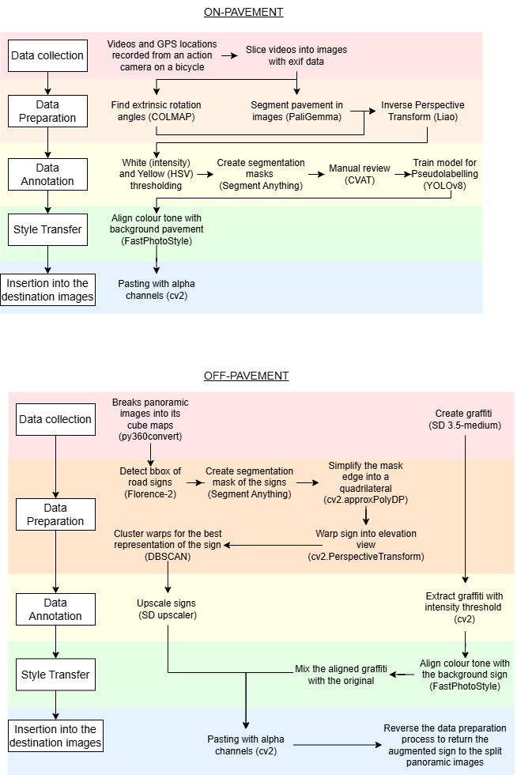
Figure 1: Process to synthesise on-pavement defects
The raw video footage is sliced into individual image frames for onward data preparation. After slicing the video with python package opencv, the algorithm records the geolocation of each frame by interpolating between GPS readings, recorded every second by GPS Logger (BasicAirData, 2024) on the smartphone. COLMAP (Schonberger and Frahm, 2016; Schonberger et al., 2016) extracts and matches the features between image frames and estimates the extrinsic rotation angles (yaw, pitch and roll) of the action camera. The rotation angles can then be manually adjusted by trial and error to cater for the movements of the bicycle that the camera is mounted on.
The local road images require perspective transform to eliminate the perspective differences when inserted into destination images. The ortho-rectified mosaic in the destination CAM Dataset is sliced into individual squares in the direction of travel by ArcGIS. The local road images are transformed by inverse perspective mapping with Liao’s repository (Liao, 2019) as shown in Figure 3. In addition to the camera intrinsic parameters and extrinsic rotations, Liao’s mapping requires inputs of the boundary of the pavement in the image. This research adds automation by estimating a segmentation mask of the pavement from a text prompt input “segment pavement” in Google PaliGemma (Beyer et al., 2024). The required top, bottom, left and right boundary points of the pavement are then standardised across images for the entire road section.
Following the perspective transformations, the images are annotated to facilitate cropping of the desired external defects. Annotations could be done by humans with labelling tool CVAT (CVAT.ai Corporation, 2022). The authors reduce manual annotation with various pseudo-labelling methods for different external defects. For worn lane marks, the authors adopted colour thresholding and Segment Anything (Kirillov et al., 2023) for preliminary pseudo-labelling as Figure 2. Segment Anything requires an input location to find the segmentation mask of the object. This research inputs the centroid of the lane mark by thresholding bright pixels from the greyscale image and rejecting yellow pixels with Hue, Saturation and Value thresholds in the opencv package. The algorithm then clusters the white points by DBSCAN to find centroids that are at least 300 pixels apart to avoid duplicating pseudo-labels. The algorithm then filters out oversized or minuscule pseudo-labels that are likely to be wrong. For the alligator cracks, owing to their complicated shapes part of the dataset is first labelled. A YOLOv8 model (Jocher and Ultralytics, 2024) is then trained to infer pseudo-labels for the rest of the images. The pseudo-labels are then reviewed to crop the interested external defects.
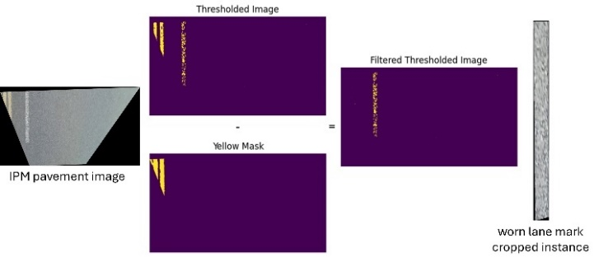
Figure 2: Annotating lane marks by intensity thresholds
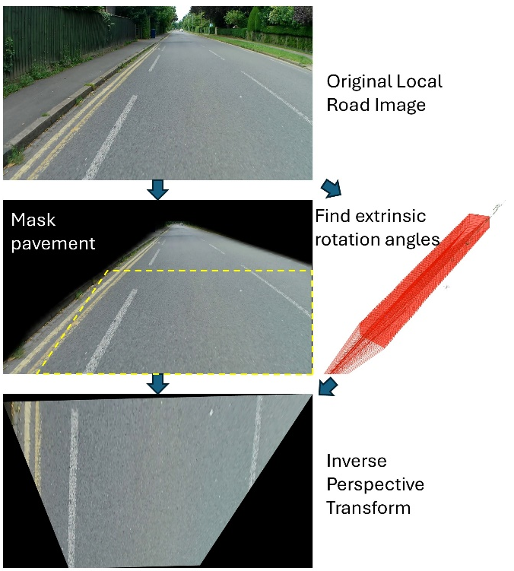
Figure 3: Data preparation for on-pavement defects
Unlike a common approach to directly paste external defects onto destination images, this research also sought to merge the styles of both images where desirable by style transfer. This is because the section of pavement where the defect is extracted may look different, such as having a different grey colour, from the road section in the destination image. The style transfer method must preserve the texture of the defects to ensure they appear authentic and consistent with their real-world physical characteristics. FastPhotoStyle (Li et al., 2018) enables a change of colour tones without destroying the feature details, such as lane markings breaking into spots or alligator cracks and potholes to keep their appearance as captured.
The style transfer is concretely achieved by transferring the style of a pavement crop in the destination image to the content of the external defect as shown in Figure 4. The style transfer is completed by adjusting its strength.
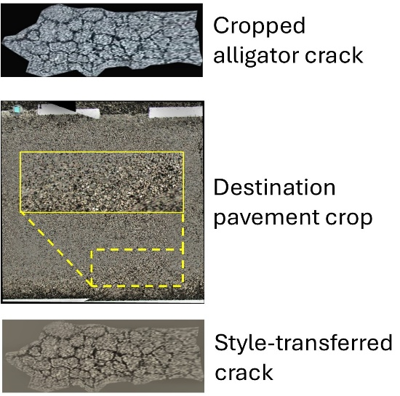
Figure 4: Illustration of style transfer by FastPhotoStyle
The style-transferred external defects are finally inserted into the destination pavement image. For worn lane markings, the real lane marks on the destination pavement images are first thresholded with brightness intensity, similar to the previous annotation. The worn lane mark will be inserted inplace. For alligator cracks and potholes, the algorithm creates an alpha-channel mask of the targeted object at a random location and pastes the prepared external defect instance in the mask.

3.2 Off-pavement defects
Defect data for off-pavement assets are generated to extend detection capabilities beyond traditional pavements. At this research stage, the authors adopt a similar pipeline to insert graffiti as defects on road signs summarised in Figure 6.
Instead of embarking on collecting graffiti from real roads, existing generative AI solutions, commonly used for arts, provide ample samples for creating a dataset. This research uses Stable Diffusion 3.5 (Esser et al., 2024), a SOTA model for creating realistic images. The medium version of the model provided by Hugging Face’s diffuser package (Stability AI, 2024) fits well within the VRAM budget of a desktop computer. With a text prompt that specifies one object in an image on a white background from the top-down view, the model can produce many samples of graffiti and stickers as raw external defects for road signs and the pavement.
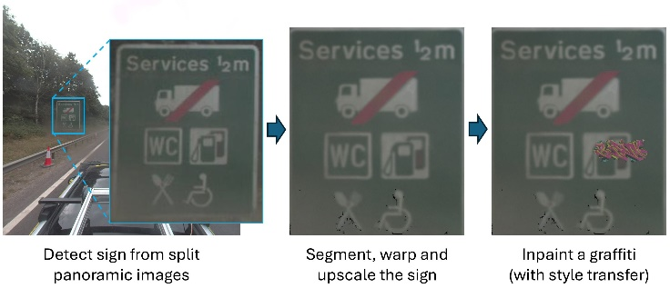
Figure 5: Processes to crop and augment a road sign
Figure 6: Process to synthesise off-pavement defects
The destination images containing road signs require significant processing and transformation before use. This research uses the panoramic images of motorways in the CAM Dataset. The algorithm first breaks panoramic images into its cube map with py360convert (Sun, 2019). It then incorporates several open-set detection and segmentation techniques to automate the transformation of a forward-looking road image into a road sign image in elevation view. Figure 5 illustrates the processing pipeline.
The algorithm first detects bounding boxes (bbox) of road signs from the forward-looking view by entering a text prompt in Florence-2 (Xiao et al., 2023). Detecting bbox with text prompts negates the need for manual annotation and returns more reliable results than seeking an instance segmentation mask directly. After cropping the detected bbox, the algorithm segments the sign from its background by Segment Anything (Kirillov et al., 2023) with the image centre as the input location. The mask is then simplified into a polygon (cv2.approxPolyDP) covering the sign by opencv. The sign polygon will then be warped with opencv (cv2.PerspectiveTransform) into a flat face using the polygon corners as the input points and the image corners as output points.
By using the series of automated detection and segmentation tools, one may expect some incorrect predictions or duplications of road signs. The algorithm attempts to sort output images into individual signs by two rounds of clustering by DBSCAN. The first round compresses images into feature embeddings with ResNet-50 in torchivision and clusters embeddings by their similarity. This likely separates the incorrect predictions (such as the back of a truck) from the correct signs, however, some different signs such as directional signs may appear similar in the embedding space. The second round thus further clusters by geolocations of the images to ensure only similar signs in proximity are sorted together. The sorted results are then manually checked before being processed further.
Annotation of the defect is relatively simple upon the request for a white background and top-down view when generating the defects. The graffiti or sticker can then be extracted with an intensity threshold in opencv. For the destination road signs, the best image of a sign is chosen and upscaled with Stable Diffusion upscaler (Rombach et al., 2022) for inserting defects.
Inserting graffiti on a flat-face road sign is similar to sticking pavement distresses on a flat pavement image. After inserting with object masks, the data preparation process is reversed to return the edited road sign to the forward-looking road image. The algorithm resizes the edited image back to its original resolution, perspective warps back to the orientation of the panoramic image and sticks the unwarped image to the bbox where the sign is cropped.

4. RESULTS AND DISCUSSIONS
As illustrated in Section 3, this research gathers defects from different sources and inserts them onto destination images in the CAM Dataset (Marie D’avigneau et al., 2024). This section elaborates on the experimental setup and presents the visual outputs with metrics quantifying the effect of style transfer in the added defect.

4.1 Dataset
This research uses the pavement orthomosaic and panoramic images in A12 Mountnessing as the destination images. The section of the motorway is composed of reinforced concrete overlain with asphalt. Multiple types of visual data, including pavement images and panoramic images, were collected from the Trimble MX9 mobile scanning solution (Trimble Inc., 2022) mounted on the top of a vehicle travelling at lane speed. The CAM Dataset (Marie D’avigneau et al., 2024) illustrated the processes to refine the raw collected images to the inputs of this research.
The authors further prepared the inputs to the experimented forms with steps shown in Sections 3.1 and 3.2. The pavement orthomosaic is sliced into squares of approximately 3.8m per side (except slip roads), totalling 8108 orthonormal pavement images. The annotations were also sliced and limited to 4 representative categories, resulting in 2428 positive images with real defects. On-pavement defects were then synthesised and added to randomly chosen positive images.
The road capture returned 9623 panoramic images. After dividing them into respective cube maps, the forward-looking face is taken for road sign detection and warping. The mechanism distils forward-looking images into 419 images across 25 real signs. Whilst most bigger signs were directional signs, some warning signs were also captured.
As for the external defects, real data was collected from several cycling trips in Cambridge, United Kingdom. 127 instances of alligator cracks were collected from two outings on the Tennis Court Road. 265 instances of worn lane marks were collected from one outing on Grange Road and Pemberton Terrace. These roads, designated with residential speed limits and lacking separate cycling tracks, were safer for cyclists while still providing opportunities to collect real road defect data. Note that every real crack or worn lane mark may be captured by multiple image frames, hence multiple instances.
Raw graffiti was collected from Stable Diffusion 3.5-medium. 200 images were requested but some generations may not be suitable. For example, instead of having one graffiti in the middle of the image, the model may generate multiple overlapping graffiti on the sides of the image. Even after cropping, graffiti having straight edges made them unrealistic and had to be discarded. 172 graffiti remained after filtering.

4.2 Experimental setup
This research mainly demonstrates the ability to generate useful synthetic data from different visual sources. The experiment synthesised in total 573 alligator cracks, 523 worn lane marks, 523 graffiti on the pavement images and 25 graffiti on 25 road signs. For testing the realism of modified images, a testing set of 70 images with alligator cracks, 57 with graffiti and 79 with worn or cracked lane marks were randomly chosen from the modified pavement images. All 25 road signs with graffiti were tested.
The first way to evaluate the results was to present them visually for human examination. The visual inspection judged whether there were significant distortions and loss of information in the synthesised destination images. For example, humans could see if the inserted alligator cracks looked foreign or aligned awkwardly from the pavement, or if graffiti on road signs appeared real as if looking from an angle in the driving lane.
The second way to evaluate the results was to demonstrate machines’ ability to read the defects. The generated images would be fed into a multi-modal model, in the experiment Gemini-2.0-flash (Google, 2025) and be prompted with a warmup question to look for general defects before asking “are there any {defect} in this image?”. The questions returned a binary answer yes/no, where the accuracy would be evaluated.
The impact of style transfer in preserving realism can be determined by the Fréchet Inception Distance (FID). As an example of using FID, the experiments compared graffiti on road signs with and without style transfer. The lower the FID score, the more similar to the original dataset (without defects) they are.
This research also aims to deliver synthetic data with the compute accessible on desktop computers. The VRAM usage during resource-intensive algorithms was recorded. All synthesis and experiments were performed on a desktop computer with Intel i9 CPU and Nvidia RTX 3080Ti (12GB VRAM) graphics card.

4.3 Results
Visual inspection results: Figure 7 shows the visual outputs of synthesised pavement defects and graffiti. The end results generally looked promising, that cracks and worn lane marks appeared reasonably harmonious with the background pavement. The modified signs with graffiti also pasted back to the panoramic split reasonably well.

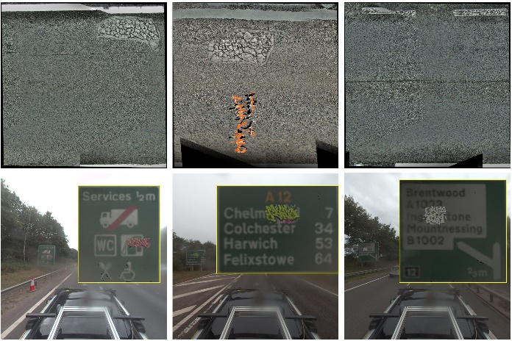
Figure 7: Visual outputs of synthesised alligator crack, graffiti and worn lane marks on pavement images (up) and graffiti on signs (down)
Table 1: Accuracy of identifying defects
Defect | Avg. (%) | S.D.(%)
Pavement defects
Alligator crack | 41 | 3
Graffiti | 89 | 3
Worn lane marking | 10 | 2
Graffiti on signs
With style transfer | 99 | 2
Without style transfer | 96 | 2

Machine readability: Table 1 shows the accuracy of identifying the on- and off-pavement defects from the inputted images. Each image was queried 10 times and the average and standard deviation of accuracy were shown.
Results showed that while graffiti was generally well recovered from pavement and road signs, alligator cracks and worn lane marks suffered from lower accuracies. Looking into the textual justifications given beside the yes/no answer, many failed cases in alligator cracks identified crack features or broken asphalt surface but returned “no” because the cracks were not interconnected enough or were identified as potholes with surrounding cracks. These may potentially be taken as alligator cracks in inspections.
Lane marks were poorly classified because the model could not detect the lane mark in the first place. Humans may find the lane marks and consider them “worn” because we foresaw where the marking should be and the features looked more broken than expected. It may be difficult for machines to determine with confidence that the feature was indeed a lane mark just from the defective view. When using a more sophisticated multi-modal model with reasoning capability (Gemini-2.0-thinking-exp-01-21), the accuracy dramatically rose to 72%.

FID metrics: The setup of 25 signs with style-transferred graffiti returned a FID score of 88.4, compared with 128.0 for signs with original graffiti without style-transfer. The FID showed that even for just 25 signs, aligning the colour tone with the background significantly reduced the abruptness of the insertion. This reinforced the visual observation that defects after style transfer appeared more harmonious to the background and less artificial.

Computing resources: Table 2 and Table 3 showed the VRAM consumption and the average processing time (in seconds) per image when generating defects on and off the pavement. Results showed that they could generally be performed within 12GB VRAM in a reasonable timeframe (besides occasional spikes or file in/out processes).

Table 2: VRAM consumption and inference time for on-pavement defects
Process | VRAM (GB) | s/img
Break videos into images | 1.1 | 0.3
COLMAP | 5.4 | 3.8
Create mask [PaliGemma] and rotate [IPM-master] | 11.6 | 29.8
Thresholding + SAM auto segment | 3.5 | 1.4
FastPhotoStyle | 2.8 | 7.6

Table 3: VRAM consumption and inference time for off-pavement defects
Process | VRAM (GB) | s/img
SD - create graffiti | 7.5 | 31.2
Detect signs with self-verification [Florence-2] | 6.1 | 0.7
Segment sign [SAM-2], simplify edge and warp image [cv2] | 3.5 | 1.4
Cluster images [DBSCAN] | 1.5 | 0.1
Upscale images [SD upscaler] | 9.4 | 4.0

4.4 Discussions
This research was an opening attempt to use various sources of visual data to generate synthetic data for different road assets. It addressed two concerns that led to limited research beyond the pavement, namely a lack of data and the difficulty of collecting data, given the sparse and unknown distribution of defective road assets. It may be easy to find street signs or barriers in our neighbourhoods but they may be intact or not contain our desired defects. There were also few publicly available records of where defective road signs or barriers were located. With this production pipeline, the authors supplemented alligator cracks that were underrepresented in the CAM dataset. It also addressed the lack of defect annotation beyond the pavement and provided extra defect categories such as graffiti and worn lane marks absent in the dataset. The proposed methodology enabled data to be prepared for training any visual detector models.
The research also revealed a dilemma in increasing the adoption of common visual data and generative art. It was intuitive on one hand to utilise existing tools or easily accessible data sources to create defects (or whatever targets) to reduce the cost of acquiring data. On the other hand, this research also showed that generated arts required significant adaptations before use. The authors highlighted the problem of misaligned perspective, which was one of the obvious bottlenecks that the authors identified and made serious attempts to rectify. Using multiple accessible visual sources raised questions and opened new avenues to address challenges.
Result evaluation was one of the issues in researching data generation. As the research focused on the new dataset, common benchmarks and metrics were not suitable for comparison. The authors assessed the quality of outputs by human and machine interpretation, accompanied by some common metrics to evaluate relevant parts of the data generation pipeline.
A key takeaway from the machine-readability evaluation was that aside from evaluating synthetic data accuracy, multi-modal models also revealed their potential to serve as defect detectors. Future research may involve using multi-modal models to identify defects on different road assets, subject to the level of precision road maintenancers required. If the specification requires textual descriptions, such as to mimic written records for a walk-through inspection, multi-modal models may complete the task. If however precise locations of the defect were required, more precise tools with better grounding capability such as object detectors trained with supervised learning may be required. Some multi-modal models (such as Florence-2 for road signs) showed a glimpse of hope in localising defects without specific fine-tuning but their performance in detecting defects remained to be investigated.
Research on supplementing data should continue as there were more scopes to explore. The variety of defect types (or diseases as called in Lam) yet to be explored urged for more data and detectors in order to ultimately automate road inspections. Further data synthesis may explore defects concerning textural changes such as dirty, fading or rusty signs, and defects on other types of assets such as metallic and concrete barriers. For more adaptable defect detectors, visualisation engines may create synthetic data for different lighting and environmental conditions.

5. CONCLUSION
This research explores methods to create synthetic data to overcome the societal problem of not having enough road defect data to automate inspections. The method fills the gaps in knowledge of creating visual defect data of multiple road assets with considerations to perspective issues, in an attempt to supplement research on detecting non-conventional pavement distresses and defects of off-road assets. The proposed method integrates visual raw data collected from multiple sources and inserts the processed defects onto the destination road asset images. The processing involves data collection, preparation and transformation, annotation, style transfer and insertion into destination images. Data was first collected from accessible camera footage or generative art tools such as Stable Diffusion 3.5. They were transformed into the same perspective as the destination images and annotated with the assistance of text-vision models such as Paligemma, Florence-2 and Segment Anything. Some defects could also be style-transferred to align the style with the destination images, using a lightweight FastPhotoStyle solution. The experiments adopted the method to generate synthetic data of niche on-road defects including alligator cracks, worn lane marks and graffiti, as well as graffiti on road signs. Results from both human inspection and machine interpretation suggested that the signs were successfully inserted into the images of the desired assets. The topic of synthetic road defect data could be further explored by expanding the types of defects, introducing textural changes and adopting visualisation engine for different environment effects.

ACKNOWLEDGEMENTS
The author (P Lam) is funded by the UK Engineering and Physical Sciences Research Council (EPSRC) Centre for Doctoral Training in Future Infrastructure and Built Environment: Resilience in a Changing World (FIBE2) [grant number EP/S02302X/1] and sponsored by the National Highways, Costain and Trimble Solutions. This work is supported by the Digital Roads, UK EPSRC [grant number EP/V056441/1]. The research by author W Chen is supported by the Horizon Europe project (Project 101122357 — D-HYDROFLEX).

REFERENCES
Acharya, P. et al. (2021) ‘Using Synthetic Data Generation to Probe Multi-View Stereo Networks’, in Proceedings of the IEEE International Conference on Computer Vision. Institute of Electrical and Electronics Engineers Inc., pp. 1583–1591. Available at: https://doi.org/10.1109/ICCVW54120.2021.00183.
BasicAirData (2024) GPS Logger, Google Play. Available at: https://play.google.com/store/apps/details?id=eu.basicairdata.graziano.gpslogger&hl=en_GB (Accessed: 3 December 2024).
Beyer, L. et al. (2024) ‘PaliGemma: A versatile 3B VLM for transfer’. Available at: http://arxiv.org/abs/2407.07726.
Boikov, A. et al. (2021) ‘Synthetic data generation for steel defect detection and classification using deep learning’, Symmetry, 13(7). Available at: https://doi.org/10.3390/sym13071176.
Branikas, E., Murray, P. and West, G. (2023) ‘A Novel Data Augmentation Method for Improved Visual Crack Detection Using Generative Adversarial Networks’, IEEE Access, 11, pp. 22051–22059. Available at: https://doi.org/10.1109/ACCESS.2023.3251988.
Bu, T., Zhu, J. and Ma, T. (2022) ‘A UAV Photography–Based Detection Method for Defective Road Marking’, Journal of Performance of Constructed Facilities, 36(5). Available at: https://doi.org/10.1061/(asce)cf.1943-5509.0001748.
Cano-Ortiz, S. et al. (2024) ‘Improving detection of asphalt distresses with deep learning-based diffusion model for intelligent road maintenance’, Developments in the Built Environment, 17. Available at: https://doi.org/10.1016/j.dibe.2023.100315.
Chen, D.R. and Chiu, W.M. (2023) ‘Deep-learning-based road crack detection frameworks for dashcam-captured images under different illumination conditions’, Soft Computing, 27(19), pp. 14337–14360. Available at: https://doi.org/10.1007/s00500-023-08738-0.
Chen, T. et al. (2024) ‘Road marking defect detection based on CFG_SI_YOLO network’, Digital Signal Processing: A Review Journal, 153. Available at: https://doi.org/10.1016/j.dsp.2024.104614.
CVAT.ai Corporation (2022) Computer Vision Annotation Tool (CVAT), GitHub. Available at: https://github.com/opencv/cvat?tab=readme-ov-file (Accessed: 6 February 2024).
Damian, A. et al. (2023) ‘Experimental Results on Synthetic Data Generation in Unreal Engine 5 for Real-World Object Detection’, in 2023 17th International Conference on Engineering of Modern Electric Systems, EMES 2023. Institute of Electrical and Electronics Engineers Inc. Available at: https://doi.org/10.1109/EMES58375.2023.10171761.
Dewi, C. et al. (2021) ‘Yolo V4 for Advanced Traffic Sign Recognition with Synthetic Training Data Generated by Various GAN’, IEEE Access, 9, pp. 97228–97242. Available at: https://doi.org/10.1109/ACCESS.2021.3094201.
Dewi, C. et al. (2022) ‘Synthetic Data generation using DCGAN for improved traffic sign recognition’, Neural Computing and Applications, 34(24), pp. 21465–21480. Available at: https://doi.org/10.1007/s00521-021-05982-z.
Docca, A. and English, M.T. (2023) How to Train a Defect Detection Model Using Synthetic Data with NVIDIA Omniverse Replicator. Available at: https://developer.nvidia.com/blog/how-to-train-a-defect-detection-model-using-synthetic-data-with-n...
Eliseev, M. (2023) Introducing Supervisely Synthetic Crack Segmentation Dataset. Available at: https://supervisely.com/blog/introducing-supervisely-synthetic-crack...
Esser, P. et al. (2024) ‘Scaling Rectified Flow Transformers for High-Resolution Image Synthesis’. Available at: http://arxiv.org/abs/2403.03206.
Gao, J. et al. (2024) ‘StyleShot: A Snapshot on Any Style’. Available at: http://arxiv.org/abs/2407.01414.
Google (2025) Quickstart: Generate text using the Vertex AI Gemini API, Google Cloud Generative AI Documentation. Available at: https://cloud.google.com/vertex-ai/generative-ai/docs/start/quickstarts/quickstart-multimodal (Accessed: 19 February 2025).
Jabal, A.A. et al. (2024) ‘StreetLens: An In-Vehicle Video Dataset for Public Facility Monitoring in Urban Streets’, in MMSys 2024 - Proceedings of the 2024 ACM Multimedia Systems Conference. Association for Computing Machinery, Inc, pp. 415–421. Available at: https://doi.org/10.1145/3625468.3652188.
Jain, S. et al. (2022) ‘Synthetic data augmentation for surface defect detection and classification using deep learning’, Journal of Intelligent Manufacturing, 33(4), pp. 1007–1020. Available at: https://doi.org/10.1007/s10845-020-01710-x.
Jakubec, M. et al. (2024) ‘Pothole detection in adverse weather: leveraging synthetic images and attention-based object detection methods’, Multimedia Tools and Applications [Preprint]. Available at: https://doi.org/10.1007/s11042-024-19723-6.
Jocher, G. and Ultralytics (2024) Ultralytics YOLO, Github. Available at: https://github.com/ultralytics/ultralytics?tab=readme-ov-file (Accessed: 3 December 2024).
Karras, T. et al. (2021) ‘Alias-Free Generative Adversarial Networks’, in Proceedings of the 35th International Conference on Neural Information Processing Systems. Red Hook, NY, USA: Curran Associates Inc., pp. 852–863. Available at: https://doi.org/https://doi.org/10.48550/arXiv.2106.12423.
Kirillov, A. et al. (2023) Segment Anything. Available at: https://segment-anything.com.
Kong, W. et al. (2022) ‘Automatic Detection and Assessment of Pavement Marking Defects with Street View Imagery at the City Scale’, Remote Sensing, 14(16). Available at: https://doi.org/10.3390/rs14164037.
Kumar, D. and Muhammad, N. (2023) ‘Object Detection in Adverse Weather for Autonomous Driving through Data Merging and YOLOv8’, Sensors (Basel, Switzerland), 23(20). Available at: https://doi.org/10.3390/s23208471.
Lam, P.H., Chen, W. and Brilakis, I. (2023) ‘Analysing the Conditions of Road Assets with a Network Thinking’, in M. Kassim et al. (eds) Proceedings of the 2023 European Conference on Computing in Construction and the 40th International CIB W78 Conference. Heraklion, Greece. Available at: https://doi.org/10.35490/EC3.2023.169.
Li, Y. et al. (2018) ‘A Closed-form Solution to Photorealistic Image Stylization’, in Computer Vision – ECCV 2018. Munich, Germany: Springer, pp. 468–483. Available at: https://github.com/NVIDIA/FastPhotoStyle.
Liao, J. (2019) Inverse Perspective Mapping, Github. Available at: https://github.com/JamesLiao714/IPM-master (Accessed: 3 December 2024).
Lis, K. et al. (2024) ‘Detecting Road Obstacles by Erasing Them’, IEEE Transactions on Pattern Analysis and Machine Intelligence, 46(4), pp. 2450–2460. Available at: https://doi.org/10.1109/TPAMI.2023.3335152.
Liu, Y. et al. (2023) ‘HE-YOLOv5s: Efficient Road Defect Detection Network’, Entropy, 25(9). Available at: https://doi.org/10.3390/e25091280.
Maeda, H. et al. (2018) ‘Road Damage Detection and Classification Using Deep Neural Networks with Smartphone Images’, Computer-Aided Civil and Infrastructure Engineering, 33(12), pp. 1127–1141. Available at: https://doi.org/10.1111/mice.12387.
Maeda, H. et al. (2021) ‘Generative adversarial network for road damage detection’, Computer-Aided Civil and Infrastructure Engineering, 36(1), pp. 47–60. Available at: https://doi.org/10.1111/mice.12561.
Marie D’avigneau, A. et al. (2024) ‘CAMHighways: The Cambridge Highways Dataset’, Preprint [Preprint]. Available at: https://ssrn.com/abstract=4912430 (Accessed: 24 October 2024).
Mohanty, S., Su, E. and Ho, C.-C. (2023) ‘Reinforcement learning optimized digital twin based synthetic data generation for defect detection of titanium spacer’, in. SPIE-Intl Soc Optical Eng, p. 6. Available at: https://doi.org/10.1117/12.2673529.
National Highways (2020) ‘CS 125 Inspection of Traffic Signs’, in Design Manual for Roads and Bridges. United Kingdom.
National Highways (2021) ‘CS 450 Inspection of Highway Structures’, in Design Manual for Roads and Bridges. United Kingdom.
Niu, S. et al. (2020) ‘Defect Image Sample Generation with GAN for Improving Defect Recognition’, IEEE Transactions on Automation Science and Engineering, 17(3), pp. 1611–1622. Available at: https://doi.org/10.1109/TASE.2020.2967415.
Prakash, K. (2021) A Deep Convolutional Neural Network for Traffic Sign Classification and Detection with Voice Recognition, Turkish Journal of Computer and Mathematics Education Research Article.
Rombach, R. et al. (2022) ‘High-Resolution Image Synthesis with Latent Diffusion Models’, in 2022 IEEE/CVF Conference on Computer Vision and Pattern Recognition (CVPR). New Orleans, LA, USA, pp. 10674–10685. Available at: https://github.com/CompVis/latent-diffusion.
Ruiz, A.L. and Alzraiee, H. (2020) ‘Automated Pavement Marking Defects Detection’, in International Symposium on Automation and Robotics in Construction. Kitakyushu, Japan: The International Association for Automation and Robotics in Construction, pp. 67–73.
Schoepflin, D. et al. (2021) ‘Synthetic Training Data Generation for Visual Object Identification on Load Carriers’, in Procedia CIRP. Elsevier B.V., pp. 1257–1262. Available at: https://doi.org/10.1016/j.procir.2021.11.211.
Schonberger, J.L. et al. (2016) ‘Pixelwise View Selection for Unstructured Multi-View Stereo’, in B. Leibe et al. (eds) Computer Vision – ECCV 2016. Springer International Publishing (Lecture Notes in Computer Science), pp. 501–518. Available at: https://doi.org/10.1007/978-3-319-46487-9.
Schonberger, J.L. and Frahm, J.M. (2016) ‘Structure-from-Motion Revisited’, in Proceedings of the IEEE Computer Society Conference on Computer Vision and Pattern Recognition. IEEE Computer Society, pp. 4104–4113. Available at: https://doi.org/10.1109/CVPR.2016.445.
Siu, C.F., Wang, M. and Cheng, J.C.P. (2022) ‘A framework for synthetic image generation and augmentation for improving automatic sewer pipe defect detection’, Automation in Construction, 137. Available at: https://doi.org/10.1016/j.autcon.2022.104213.
Song, Y. and Chong, N.Y. (2024) ‘S-CycleGAN: Semantic Segmentation Enhanced CT-Ultrasound Image-to-Image Translation for Robotic Ultrasonography’. Available at: http://arxiv.org/abs/2406.01191.
Stability AI (2024) Stable Diffusion 3.5 Medium , Hugging Face. Available at: https://huggingface.co/stabilityai/stable-diffusion-3.5-medium (Accessed: 4 December 2024).
Sun, C. (2019) Python implementation of convertion between equirectangular, cubemap and perspective, Github. Available at: https://github.com/sunset1995/py360convert (Accessed: 4 December 2024).
Trimble Inc. (2022) Trimble MX9 Mobile Mapping Solution. USA. Available at: www.trimble.com.
Trpković, A., Šelmić, M. and Jevremović, S. (2021) ‘Model for the Identification and Classification of Partially Damaged and Vandalized Traffic Signs’, KSCE Journal of Civil Engineering, 25(10), pp. 3953–3965. Available at: https://doi.org/10.1007/s12205-021-1796-9.
Xiao, B. et al. (2023) ‘Florence-2: Advancing a Unified Representation for a Variety of Vision Tasks’. Available at: http://arxiv.org/abs/2311.06242.
Yu, X. et al. (2023) ‘MVImgNet: A Large-scale Dataset of Multi-view Images’, in Proceedings of the IEEE International Conference on Computer Vision. Institute of Electrical and Electronics Engineers (IEEE), pp. 9150–9161. Available at: https://doi.org/10.1109/cvpr52729.2023.00883.
Zhang, G. et al. (2021) ‘Defect-GAN: High-Fidelity Defect Synthesis for Automated Defect Inspection’, in 2021 IEEE Winter Conference on Applications of Computer Vision (WACV). Waikoloa, HI, USA, pp. 2523–2533.
Zhong, Y. et al. (2024) ‘Performance of Medical Image Fusion in High-level Analysis Tasks: A Mutual Enhancement Framework for Unaligned PAT and MRI Image Fusion’. Available at: http://arxiv.org/abs/2407.03992.
Zhu, J.Y. et al. (2017) ‘Unpaired Image-to-Image Translation Using Cycle-Consistent Adversarial Networks’, in Proceedings of the IEEE International Conference on Computer Vision. Institute of Electrical and Electronics Engineers Inc., pp. 2242–2251. Available at: https://doi.org/10.1109/ICCV.2017.244.

