Digital Twin and Multimodal Neural Networks for Automated Coastal Railway Bridge Maintenance
ALI KHUDHAIR^{,1} XIAOFENG ZHU^{,1} HAIJIANG LI^{,1} REZA AHMADIAN^{,1} MUJIB ADEAGBO^{,1} JIUCAI LIU^{,1}

¹School of Engineering, Cardiff University, Cardiff, Wales

ABSTRACT:
Coastal railway bridges are exposed to accelerated deterioration due to harsh marine environments, making their inspection and maintenance both costly and complex. This paper proposes a semi-automated framework that integrates Digital Twin (DT) technology with a Multimodal Neural Network (MNN) to generate natural language repair strategies directly from visual inspection data. The system combines an EfficientNet-based convolutional encoder with a Transformer decoder, trained on a domain-specific dataset of corroded bridge components annotated by experts. Unlike conventional damage detection pipelines, the proposed model outputs actionable, human-readable maintenance recommendations that are programmatically embedded into Industry Foundation Classes (IFC)-based BIM models as structured property sets. This enables seamless integration into Building Information Modelling (BIM)-based DT environments, supporting downstream decision-making and lifecycle asset management. Experimental results show that the model achieves a semantic similarity score of 0.7285 and a BLEU-3 score of 0.4193, indicating strong alignment with expert-authored strategies. While exact match accuracy is limited to 24.18%, this reflects the inherent linguistic variability in valid maintenance descriptions. The system also incorporates expert feedback to support human-in-the-loop learning and continuous improvement. These findings demonstrate the feasibility of combining DL and openBIM standards to enable scalable, automated, and semantically enriched maintenance planning for coastal railway infrastructure.

KEYWORDS:
Digital Twin, Industry Foundation Classes (IFC), Multimodal Neural Network, Infrastructure Maintenance, Image Captioning, Bridge Corrosion.

1. INTRODUCTION
The structural integrity of ageing railway infrastructure is critical to the safety and reliability of national transportation systems. In the United Kingdom, and particularly in coastal regions such as Wales, many railway bridges are operating beyond their intended design lifespan. According to the RAC Foundation (2023), over 4.6% of Wales’s 8,632 bridges are classified as substandard, with estimated restoration costs exceeding £47.3 million. Coastal railway bridges are particularly vulnerable due to prolonged exposure to salt-laden air, high humidity, and thermal cycling, all of which accelerate corrosion and compromise their structural integrity.
Maintaining these high-risk assets poses significant challenges. Traditional inspection workflows rely on manual, labour-intensive surveys conducted under hazardous or difficult-to-access conditions, such as bridge piers, track beds, and elevated superstructures. While these inspections yield valuable field data, the subsequent documentation, interpretation, and integration into asset management systems remain fragmented and time-consuming. As a result, maintenance decisions are often made reactively rather than proactively, leading to increased lifecycle costs, operational delays, and reduced service reliability.
Recent advances in deep learning (DL) and computer vision have enhanced the efficiency of damage detection using visual data. Convolutional Neural Networks (CNNs), object detectors, and Unmanned Aerial Vehicle (UAV)-based imaging systems have been applied to tasks such as crack detection (Dung et al., 2019) and corrosion identification (Li et al., 2023). However, these technologies are primarily limited to condition classification. The critical task of translating inspection data into actionable repair strategies remains manual and disconnected from digital asset workflows. This gap limits the potential of Artificial Intelligence (AI)-driven automation to support proactive infrastructure maintenance.
To address this challenge, this paper investigates the following research question: How can digital twin (DT) technology and Multimodal Neural Networks (MNNs) be combined to automatically generate and semantically embed maintenance strategies from bridge inspection imagery?
To this end, this paper proposes an integrated framework that leverages a DL architecture, comprising an EfficientNet-based image encoder and a Transformer decoder, to generate natural language repair recommendations from corrosion images. These recommendations are then programmatically embedded into Industry Foundation Classes (IFC)-based DT models using the IfcOpenShell library, enabling direct integration with Building Information Modelling (BIM)-driven asset management platforms.
Unlike conventional approaches that treat damage detection and repair planning as discrete stages, the proposed system establishes a unified, semi-automated pipeline that links visual condition assessment to semantic BIM enrichment. The model is trained on a domain-specific dataset of annotated corrosion imagery, supporting a human-in-the-loop mechanism for expert feedback and continual learning.
This work contributes an interface between DL and DT technologies, enabling not only the detection of structural degradation but also the generation, structuring, and semantic embedding of prescriptive maintenance intelligence. The integration of AI-generated outputs with openBIM standards represents a significant step toward scalable, interoperable, and proactive infrastructure maintenance planning.
The paper is structured as follows: Section 2 reviews related work on structural health monitoring, DTs, and AI-based maintenance systems. Section 3 outlines the proposed framework, which includes data collection, model architecture, and IFC integration. Section 4 presents experimental results and performance evaluation. Section 5 discusses key implications, limitations, and future directions. Section 6 concludes the paper.

2. RELATED WORK

2.1. Visual Inspection and Damage Detection
Computer vision has transformed the way bridge infrastructure is inspected. Traditional methods, which require manual inspection, are being increasingly replaced by DL models, particularly convolutional neural networks (CNNs), for detecting surface damage such as cracks, corrosion, and spalling (Luo et al., 2023; Duan et al., 2019; Lee et al., 2020). UAV-enabled systems have further increased the efficiency of data collection, enabling high-resolution image acquisition in inaccessible locations (Li et al., 2023). For example, Dung et al. (2019) developed a CNN for detecting cracks in gusset plates, while Duan et al. (2019) proposed a spatial-spectral CNN for damage identification in tied-arch bridges. These models demonstrate high accuracy and efficiency, but their outputs are typically limited to damage classification or localisation, offering little support for subsequent repair decision-making.

2.2 Decision Support and Maintenance Planning
To augment inspection results, several systems have been developed to support maintenance decision-making. Early examples include rule-based decision support systems for bridge deck maintenance (Yehia et al., 2008), while more recent studies leverage AI to prioritise interventions based on condition scores, traffic load, and cost (Zhang & Yuen, 2022; Sun et al., 2020; Karaaslan et al., 2021; Merschman et al., 2020).
However, these systems depend heavily on structured inputs, typically derived manually from inspection reports, which include image annotations, damage types, and severity levels. With the growing volume of inspection imagery, manually interpreting and translating this data into actionable repair steps remains a significant challenge.

2.3. BIM and Digital Twin Integration
BIM and DTs present structured environments for integrating inspection data with maintenance processes. BIM enables the representation of geometric and semantic bridge data, while Industry IFC allow interoperability between tools (Isailović et al., 2019; Nguyen et al., 2022).
Although research has explored BIM-enhanced inspection and long-term bridge network management (Karaaslan et al., 2021), current workflows often depend on manual entry of inspection and repair data. There is limited research on automatically embedding repair intelligence into BIM through AI-generated outputs. This disconnect impedes the use of real-time or historical inspection data for proactive maintenance planning.

2.4. Multimodal Deep Learning for Condition Assessment
Multimodal deep learning techniques, which combine image and text data, are increasingly used in structural health monitoring (SHM) to generate natural language descriptions from visual inputs. Chun et al. (2022) proposed an image captioning model that can generate detailed explanations of bridge damage. Dinh & Ahn (2023) extended this approach to produce condition descriptions of structural components using a combination of CNN and recurrent neural network (CNN-RNN) architectures.
These systems demonstrate the feasibility of automatically generating text from damage imagery, potentially reducing the need for manual report writing. However, two key limitations persist: (1) existing models focus on descriptive captioning rather than prescriptive repair generation; and (2) domain-specific datasets for training such models are scarce, particularly those aligned with real-world repair practices (Cornia et al., 2022).
These studies demonstrate strong progress in automated damage detection, decision support, and BIM integration. However, they also highlight a critical gap: (1) no existing model can automatically generate detailed bridge repair recommendations based on unstructured image data; and (2) there is no established pipeline for semantically embedding these repair recommendations into IFC-based DTs, where they can support maintenance planning.
This paper addresses these challenges by proposing a framework that generates repair strategies from bridge damage images. It further introduces a method to semantically integrate these outputs into a DT using IFC standards, advancing the automation of bridge maintenance workflows.

3. METHODOLOGY
This research adopts a Design Science Research (DSR) methodology to guide the development, implementation, and evaluation of a semi-automated framework for maintaining coastal railway bridges. DSR is particularly well-suited for addressing real-world engineering challenges through the creation and evaluation of innovative artifacts. In this study, the DSR process is structured into three iterative phases: (1) problem identification, (2) artifact design and development, and (3) evaluation. Each phase contributes to the creation of a functional pipeline that integrates DL with DT technologies to support condition assessment and the automated generation of repair strategies for infrastructure maintenance. Fig. 1 illustrates the full architecture of the proposed system, including the three DSR phases and the flow from inspection data to IFC export.

3.1. Problem Identification
The problem identification phase is grounded in the observation that coastal railway bridges are highly vulnerable to corrosion due to prolonged exposure to aggressive marine environments. Existing inspection workflows for such structures are predominantly manual, relying on labour-intensive visual surveys that are time-consuming, hazardous, and reactive rather than preventative. Furthermore, even when damage is detected, translating inspection findings into actionable repair strategies remains a largely manual and expert-driven process, introducing variability and inefficiency into decision-making.
To address these limitations, this study aims to develop a semi-automated system that enhances the resilience and efficiency of bridge maintenance planning by coupling DT technologies with an MNN capable of generating domain-specific repair recommendations from visual inspection data.

3.2. Artifact Design and Development
The core artifact developed in this study is a framework composed of three interdependent components: (1) a DT platform for semantic modelling and data integration; (2) an MNN for image-based repair strategy generation, and (3) a semantic integration module that embeds AI-generated outputs into IFC-compliant models.

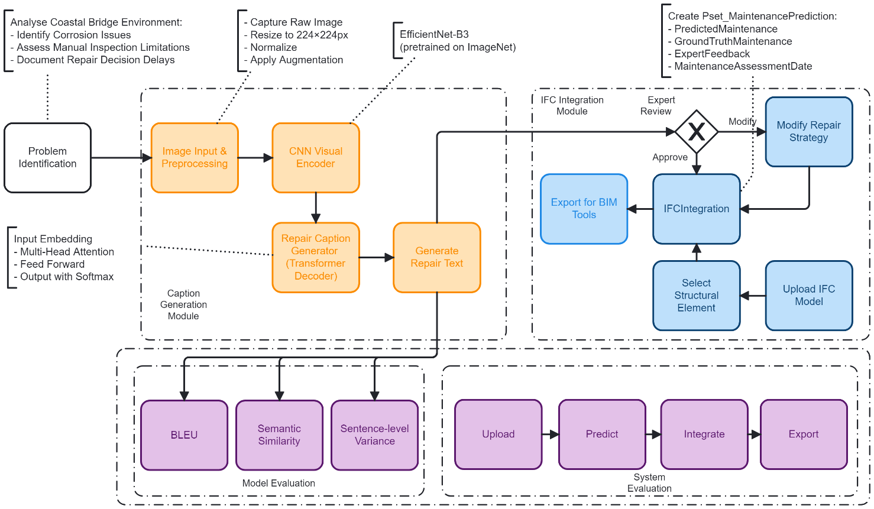
Figure 1: System overview of the DT-MNN framework.

3.2.1 Digital Twin Platform
The DT is implemented using the IFC schema, an openBIM standard that supports semantic representation of built infrastructure. This model serves as a comprehensive digital replica of the physical bridge, functioning as the central environment for integrating inspection data, AI-generated maintenance strategies, and asset metadata.
Custom property sets are defined within the IFC schema to associate each structural component with its condition state and the corresponding repair recommendation. This semantically enriched model supports interoperability with existing BIM tools, facilitating informed decision-making throughout the asset lifecycle.

3.2.2. Multimodal Neural Network (MNN)
The second component is a multimodal neural network designed to generate natural language repair strategies from visual inspection data. The architecture consists of:
- A visual encoder: a pre-trained EfficientNet-B3 CNN, fine-tuned on a domain-specific dataset of corroded bridge components to extract high-level visual features.
- A text decoder: a Transformer-based model trained to generate domain-aligned repair descriptions.
The training dataset comprises image-caption pairs, where each image is annotated with expert-authored maintenance strategies. Images are resized to 224×224 pixels and normalised, while captions are tokenised and truncated to a maximum of 50 tokens. The model is trained using a cross-entropy loss function with label smoothing, over 40 epochs, with early stopping based on validation performance. This component enables a direct and automated transition from raw visual input to prescriptive maintenance output, significantly reducing the reliance on manual interpretation.

3.2.3. IFC Integration Module
The final component of the proposed framework enables interactive, semantic integration of AI-generated repair strategies directly into a DT environment. This is achieved through a web-based interface that allows users to upload an IFC model, parse its contents, and browse the structural elements within it. Each element, such as IfcColumn, IfcBeam, or IfcSlab, is represented with its Globally Unique Identifier (GUID), name, and type, enabling users to select specific components for embedding maintenance recommendations.
Once an element is selected, the system invokes the IfcOpenShell Python API to insert a custom property set, named Pset_MaintenancePrediction, into the corresponding IFC object. This property set contains several fields, including the AI-generated maintenance recommendation (PredictedMaintenance), the original ground truth or expert label (GroundTruthMaintenance), user feedback (ExpertFeedback), and a timestamp (MaintenanceAssessmentDate) indicating when the prediction was generated. These properties are embedded as IfcPropertySingleValue objects, ensuring that the data is both machine-interpretable and human-readable.
The integration process is executed programmatically, and a new version of the IFC file is saved with a unique filename to preserve the original data and ensure traceability. This approach enables the selective and contextual embedding of information, allowing users to maintain full control over which components receive AI-generated annotations, thereby preserving engineering judgment where necessary. The enriched IFC model remains fully compliant with the IFC standard, ensuring interoperability with common BIM tools, including Revit, and BIMvision.
By embedding prescriptive maintenance strategies directly within the DT, the system supports advanced querying, visualisation, compliance checking, and long-term asset lifecycle management. This module thus bridges the gap between AI-generated insights and actionable, semantically structured building information.

3.3. Evaluation
The proposed framework is evaluated through a two-tiered process that assesses both the technical performance of the MNN and the practical utility of the full end-to-end system. The first tier focuses on evaluating the language generation capabilities of the MNN model, which is designed to generate natural language repair strategies from visual inspection images. Three key metrics are used to assess the quality of the generated outputs.
Firstly, the BLEU-3 score is used to measure n-gram overlap between the AI-generated repair captions and the expert-authored ground truth strategies. This metric captures the syntactic similarity of short phrases, providing insight into how closely the model follows expert phrasing. Secondly, semantic similarity is computed using sentence embeddings to assess the conceptual alignment between the model output and the reference captions. This metric is particularly important in cases where different textual formulations may still convey the same maintenance recommendation. Finally, exact match accuracy is calculated to determine the proportion of generated repair strategies that match the expert reference captions verbatim. While this metric is strict and sensitive to linguistic variation, it serves as a useful indicator of the model’s ability to replicate expert language patterns precisely.
Beyond automated metrics, a qualitative review is conducted in collaboration with domain experts, who assess a representative sample of the model's outputs. These evaluations focus on the clarity, technical correctness, and practical relevance of the generated repair recommendations. This expert feedback also supports the human-in-the-loop learning mechanism embedded in the framework, allowing for iterative refinement of the model over time.
The second tier of evaluation addresses the system-level functionality of the proposed framework. A working prototype is developed to validate the full pipeline, from image input to IFC output. Users can upload IFC models, select structural components, apply AI-generated repair strategies, and export semantically enriched IFC files. The prototype is tested on a representative model of a coastal railway bridge, demonstrating the feasibility and usability of the approach in a real-world infrastructure maintenance scenario.

4. EXPERIMENTS AND RESULTS
This section presents the evaluation of the proposed framework, which encompasses both the performance of the bridge image captioning model and the successful semantic embedding of maintenance predictions into IFC-based DT models. The evaluation is divided into two parts: (1) model-level performance metrics and (2) system-level IFC integration results.

4.1. Image Captioning Model Evaluation
The bridge image captioning model was evaluated on a held-out test set comprising 2,430 annotated image-caption pairs. Each instance included a corrosion-related defect image and a corresponding expert-authored maintenance recommendation. To thoroughly assess model performance, three categories of metrics were employed: exact match accuracy, BLEU scores at multiple n-gram levels, and semantic similarity using sentence embeddings. The model achieved an Exact Match Accuracy of 0.2418, indicating that 24.18% of the generated captions matched the reference text exactly after normalisation for punctuation and case (Table 1). This result reflects the inherent linguistic variability present in valid maintenance descriptions; while multiple phrasings may convey the same repair intent, only identical matches are counted toward this metric.
To evaluate the lexical and syntactic fidelity of the model’s output, BLEU scores were calculated at unigram through 4-gram levels. The model achieved BLEU-1 scores of 0.3476, BLEU-2 scores of 0.3939, and BLEU-3 scores of 0.4193, indicating a strong ability to reproduce relevant domain-specific terminology and short repair phrases. BLEU-4 dropped to 0.2772, suggesting that the model has more difficulty generating longer, syntactically precise sequences. This is expected in the context of domain-specific language, where minor variations in word order or phrasing may not detract from meaning but do affect n-gram precision.
In addition to lexical metrics, semantic similarity was evaluated using the cosine similarity of Sentence-BERT embeddings between the generated and ground-truth captions. The model achieved a mean semantic similarity score of 0.7285, demonstrating a high degree of alignment in meaning, even when the exact wording differed. This result confirms that the model is often able to convey the correct repair strategy, even when paraphrasing occurs. Sentence-level BLEU scores revealed substantial variability, with a mean of 0.4822 and standard deviation of 0.4200, suggesting the model performs well on common defect types but exhibits inconsistency in less frequently observed or more complex cases.

Table 1: Performance Metrics of the Bridge Image Captioning Model.
Metric | Score | Interpretation
Exact Match Accuracy | 0.2418 | Proportion of captions exactly matching reference
BLEU-1 | 0.3476 | Unigram precision
BLEU-2 | 0.3939 | Bigram precision
BLEU-3 | 0.4193 | Trigram precision
BLEU-4 | 0.2772 | 4-gram precision
Sentence-Level BLEU (Mean) | 0.4822 | Mean of sentence BLEU scores
Sentence-Level BLEU (Std) | 0.4200 | Standard deviation of sentence BLEU scores
Semantic Similarity | 0.7285 | Cosine similarity of sentence embeddings

4.2. IFC Integration and System-Level Evaluation
To evaluate the practical utility and real-world applicability of the proposed DT-MNN framework, a comprehensive system-level assessment was conducted using the Neath Swing Bridge as a case study. This operational coastal railway bridge, currently undergoing steelwork repairs due to corrosion, serves as a representative example of aging infrastructure. The objective was to demonstrate the feasibility of constructing a semantically enriched DT for a historic asset that is fully compliant with IFC standards and aligned with openBIM principles of vendor-neutral, interoperable data exchange.
Constructed in 1882 and designated as a Grade II listed structure, the Neath Swing Bridge comprises six spans, including a riveted bowstring swing span and five simply supported approach spans. Due to incomplete historical documentation, a series of on-site structural surveys were conducted to capture accurate geometric and material data. These surveys informed the reconstruction of missing components and ensured that the DT accurately reflected the bridge’s current structural condition.
A 3D finite element model of the bridge was developed using ABAQUS 2019, with a focus on primary load-bearing elements, including steel trusses, cross girders, and cylindrical piers. Non-structural details were intentionally excluded to streamline the model for structural analysis and sensor integration. The finalised model was exported to IFC 4.3 format to ensure compatibility with the semantic integration pipeline and downstream BIM tools.
The conceptual structure of the DT-MNN framework is illustrated in Fig. 2, which shows how the physical asset (the bridge) and its digital counterpart are connected through a data-driven feedback loop. This loop enables the simulation of behaviour in the digital environment based on real-world observations, monitoring, and measurement data. The framework replicates physical behaviour in the digital domain to support predictive maintenance and lifecycle asset management.
To validate the semantic enrichment process, a full-system demonstration was performed, showcasing the end-to-end integration of AI-generated maintenance strategies into an IFC-based BIM model. As illustrated in Fig. 3, the process begins with the upload of corrosion imagery through a web-based interface, which triggers the automatic generation of captions by the DT-MNN model. Users can review the output, provide expert feedback, and assign the maintenance prediction to specific structural elements within the IFC model.
Once confirmed, the prediction is embedded into the model as part of a custom property set, Pset_MaintenancePrediction. The updated IFC model can then be downloaded and opened in standard BIM tools such as BIMvision, where both geometric and semantic data remain fully intact.
To support this integration, the IfcOpenShell Python API was used to interface directly with the IFC schema. The enriched models were validated for schema compliance and semantic interoperability. Importantly, round-trip integrity was preserved—no data was lost or corrupted during the embedding process, and all original content remained intact.
The ability to review and approve predictions prior to embedding enhances engineering oversight and increases trust in the system. These findings demonstrate that the DT-MNN framework not only produces linguistically and contextually appropriate maintenance captions but also enables their seamless integration into BIM workflows. While exact match accuracy remains modest due to natural language variability, evaluation metrics such as BLEU-3 and semantic similarity confirm the relevance and quality of the generated outputs. The successful IFC integration confirms the framework’s readiness for deployment in proactive, data-driven infrastructure maintenance systems.
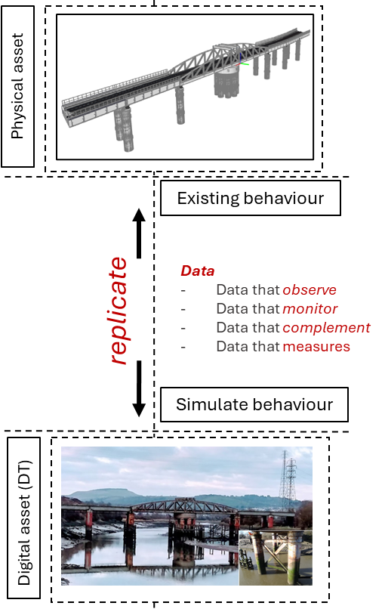
Figure 2: Conceptual overview of the DT-MNN framework illustrating the relationship between the physical asset and its digital counterpart.

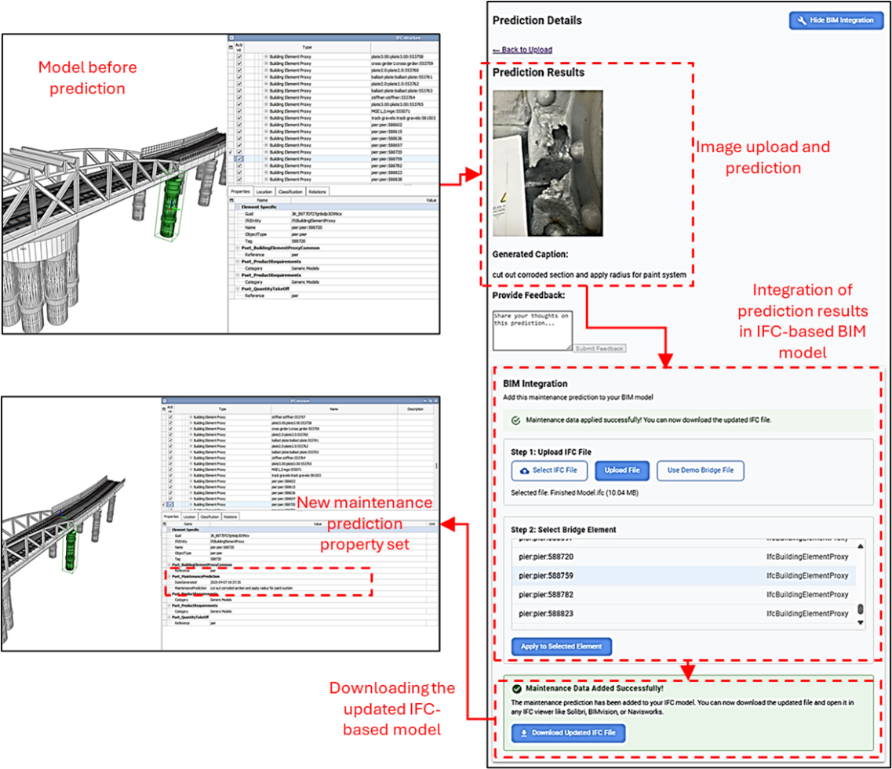
Figure 3: End-to-end integration of AI-generated maintenance predictions into an IFC-based BIM model using the DT-MNN framework

5. DISCUSSION AND LIMITATIONS
The experimental results and case study presented in Section 4 demonstrate the promise and practical feasibility of the proposed DT-MNN framework for automating bridge maintenance planning based on visual inspection data. By combining a DL-based image captioning model with a web-based IFC integration module, the system establishes a semi-automated pipeline for generating and embedding maintenance strategies into DTs. While the proposed approach shows strong potential for improving efficiency, traceability, and semantic interoperability in infrastructure asset management, several limitations and challenges remain, as discussed below.

5.1. Domain-Specific Language and Evaluation Metrics
The relatively low exact match accuracy (24.18%) observed in model evaluation highlights the difficulty of generating verbatim maintenance instructions, which in practice are highly structured, technical, and context-sensitive. This challenge is exacerbated by the constrained vocabulary and syntactical expectations common in civil infrastructure documentation. Unlike general-purpose captioning tasks, where linguistic variation is acceptable, infrastructure maintenance demands a higher degree of terminological consistency.
Although the model achieved a BLEU-3 score of 0.4193 and a BLEU-4 of 0.2772, these metrics tend to penalise valid paraphrases or alternative sentence constructions. As such, they may underrepresent the model’s practical utility in supporting engineering decision-making. The higher semantic similarity score of 0.7285, calculated using sentence embeddings, offers a more meaningful measure of alignment with expert intent. These findings suggest that future evaluations should incorporate domain-tuned metrics or human-in-the-loop assessments to better reflect real-world applicability.

5.2. Dataset Coverage
The dataset used in this study, while expert-annotated and domain-specific, exhibits certain limitations in coverage and balance. Corrosion-related cases dominate the dataset, whereas other failure modes, such as fatigue cracking, joint misalignment, or concrete spalling, are underrepresented. This imbalance likely contributes to the observed variance in sentence-level performance metrics, particularly in less common or structurally complex scenarios.
Moreover, the current one-to-one mapping between images and captions limits the model’s ability to learn from natural linguistic variation. Incorporating multi-reference captions, data augmentation techniques, or synthetically generated maintenance descriptions could help improve robustness and generalisation. Future work should also explore the use of multimodal datasets that combine imagery with metadata such as defect severity, component location, or inspection history.

5.3. Model Architecture and Inference Constraints
The current model architecture, based on EfficientNet-B3 and a Transformer decoder, offers a balance between performance and inference efficiency. However, it remains relatively lightweight and may not fully capture complex spatial or contextual relationships present in bridge imagery. For example, occlusions, lighting variations, or background clutter can impact prediction quality, especially in heterogeneous environments like coastal infrastructure.
To enhance contextual awareness, future iterations of the framework could incorporate multimodal transformers (e.g., ViLBERT, BLIP) or attention-based fusion mechanisms that leverage both visual and semantic cues. Additionally, integrating uncertainty quantification or confidence scoring could help flag ambiguous predictions for human review, supporting safer deployment in critical asset management pipelines.

5.4. IFC Integration and Real-World Applicability
A key contribution of this work is the semantic integration of AI-generated maintenance strategies into IFC-based DT models. The web interface and IfcOpenShell-based embedding pipeline demonstrated full schema compliance, successful round-trip validation, and interoperability with established BIM tools. This capability enables AI-generated insights to be embedded directly into existing engineering workflows, enhancing transparency, traceability, and downstream decision-making.
The case study on the Neath Swing Bridge illustrated that even legacy infrastructure with limited historical records can be digitised and semantically enriched using the proposed framework. By combining visual inspection data, AI-generated recommendations, and openBIM standards, the system bridges the gap between condition assessment and actionable planning within a digital ecosystem.

5.5. Practical Considerations and Human-in-the-Loop Use
Despite its advantages, the system is not intended to replace expert engineers but rather to augment their workflows. Given the safety-critical nature of bridge maintenance, human-in-the-loop verification remains essential, particularly for high-risk components or novel defect types. The framework should be adopted as a decision support tool, offering recommendations that engineers can review, validate, and refine.
In practice, the automated generation and embedding of maintenance actions could reduce documentation time, improve inspection consistency, and support predictive maintenance strategies. However, robust deployment will require integration with mobile inspection platforms, quality assurance protocols, and continuous feedback loops to refine model performance over time.

6. CONCLUSION
This paper introduced a framework that integrates DT technologies with an MNN to automate the generation and semantic embedding of bridge maintenance strategies from visual inspection data. By bridging computer vision, natural language processing, and BIM, the proposed DT-MNN system addresses a key gap in infrastructure asset management: the translation of unstructured visual evidence into actionable, machine-readable repair intelligence.
The framework consists of two main components. First, a deep learning model converts corrosion imagery into human-readable maintenance descriptions, achieving a BLEU-3 score of 0.4193 and a semantic similarity score of 0.7285. These results demonstrate the model’s capacity to generate domain-relevant and semantically accurate outputs, despite the inherent linguistic variability of infrastructure maintenance language. Second, the system embeds these AI-generated recommendations directly into IFC-compliant DT models as structured property sets, enabling seamless integration with openBIM workflows.
A key contribution of this work lies in its demonstration of real-world applicability through a case study on the Neath Swing Bridge—a Grade II listed coastal railway structure. Despite limited historical documentation, a 3D geometric model was developed, semantically enriched, and validated using the proposed pipeline. This case study confirms the framework’s adaptability to legacy infrastructure and its potential to inform predictive maintenance, inspection planning, and lifecycle decision-making.
While the results are promising, several limitations remain. The current dataset is skewed toward common defect types, and the model architecture does not yet account for multimodal context such as defect severity, location, or environmental conditions. Furthermore, BLEU-based metrics may underrepresent practical performance due to their sensitivity to surface-level phrasing. These limitations motivate several directions for future research.
Future work will focus on expanding the dataset by incorporating multiple expert-annotated references per image and on integrating additional data modalities, including geolocation, material properties, and environmental metadata. Enhancing the model architecture with multimodal transformers and attention-based fusion mechanisms may improve contextual understanding. Finally, integrating uncertainty estimation and human-in-the-loop validation will be critical for ensuring safe deployment in real-world engineering workflows.
In summary, this study contributes a scalable, AI-augmented framework that operationalises the principles of semantic interoperability, predictive maintenance, and intelligent infrastructure management. By linking deep learning with open standards, the DT-MNN system offers a foundation for more responsive, data-driven maintenance strategies across the lifecycle of critical civil infrastructure.

DATA AVAILABILITY
The bridge image test set used in this paper is part of a confidential infrastructure asset management project and cannot be shared publicly due to data use agreements.

REFERENCES

RAC Foundation (2023). Bridge maintenance Wales. [pdf] Available at: https://www.racfoundation.org/wp-content/uploads/RAC_Foundation_Bridge_Maintenance_Wales_2023.pdf [Accessed 03-04-2025].

Hurt, M.A. and Schrock, S.D. (2016). Highway bridge maintenance planning and scheduling. Oxford: Butterworth-Heinemann. https://doi.org/10.1016/B978-0-12-802069-2.00001-5

Duan, Y., Chen, Q., Zhang, H., Yun, C.B., Wu, S. and Zhu, Q. (2019). ‘CNN-based damage identification method of tied-arch bridge using spatial-spectral information’, Smart Structures and Systems, 23(5), pp. 507–520. https://doi.org/10.12989/sss.2019.23.5.507

Dung, C.V., Sekiya, H., Hirano, S., Okatani, T. and Miki, C. (2019). ‘A vision-based method for crack detection in gusset plate welded joints of steel bridges using deep convolutional neural networks’, Automation in Construction, 102, pp. 217–229. https://doi.org/10.1016/j.autcon.2019.02.013

Li, R., Yu, J., Li, F., Yang, R., Wang, Y. and Peng, Z. (2023). ‘Automatic bridge crack detection using unmanned aerial vehicle and Faster R-CNN’, Construction and Building Materials, 362, 129659. https://doi.org/10.1016/j.conbuildmat.2022.129659

Luo, K., Kong, X., Zhang, J., Hu, J., Li, J. and Tang, H. (2023). ‘Computer vision-based bridge inspection and monitoring: A review’, Sensors, 23(18), 7863. https://doi.org/10.3390/s23187863

Lee, K. and Byun, N. (2020). ‘A damage localization approach for rahmen bridge based on convolutional neural network’, KSCE Journal of Civil Engineering, 24(1), pp. 1–9. https://doi.org/10.1007/s12205-019-1395-9

Yehia, S., Abudayyeh, O., Fazal, I. and Randolph, D. (2008). ‘A decision support system for concrete bridge deck maintenance’, Advances in Engineering Software, 39(3), pp. 202–210. https://doi.org/10.1016/j.advengsoft.2007.02.002

Zhang, Y. and Yuen, K.V. (2022). ‘Review of artificial intelligence-based bridge damage detection’, Advances in Mechanical Engineering, 14, 16878132221122770. https://doi.org/10.1177/16878132221122770

Sun, L., Shang, Z., Xia, Y., Bhowmick, S. and Nagarajaiah, S. (2020). ‘Review of bridge structural health monitoring aided by big data and artificial intelligence: From condition assessment to damage detection’, Journal of Structural Engineering, 146(5), 04020073. https://doi.org/10.1061/(ASCE)ST.1943-541X.0002535

Merschman, E., Doustmohammadi, M., Salman, A.M. and Anderson, M. (2020). ‘Postdisaster decision framework for bridge repair prioritization to improve road network resilience’, Transportation Research Record, 2674(3), pp. 81–92. https://doi.org/10.1177/0361198120908870

Karaaslan, E., Bagci, U. and Catbas, F.N. (2021) ‘A novel decision support system for long-term management of bridge networks’, Applied Sciences, 11(13), 5928. https://doi.org/10.3390/app11135928

Nguyen, D.C., Jin, R., Jeon, C.H. and Shim, C.S. (2022). ‘BIM-based mixed-reality application for bridge inspection and maintenance’, Construction Innovation, 22(3), pp. 487–503. https://doi.org/10.1108/CI-04-2021-0069
Isailović, D., Petronijević, M. and Hajdin, R. (2019). ‘The future of BIM and bridge management systems’, in Proceedings of the IABSE Symposium: Towards a Resilient Built Environment – Risk and Asset Management, Guimarães, Portugal, 27–29 March 2019. Zurich: IABSE, pp. 1673–1680. https://doi.org/10.2749/guimaraes.2019.1673

Chun, P.J., Yamane, T. and Maemura, Y. (2022). ‘A deep learning-based image captioning method to automatically generate comprehensive explanations of bridge damage’, Computer-Aided Civil and Infrastructure Engineering, 37(11), pp. 1387–1401. https://doi.org/10.1111/mice.12793

Cornia, M., Baraldi, L. and Cucchiara, R. (2022). ‘Explaining transformer-based image captioning models: An empirical analysis’, AI Communications, 35(2), pp. 111–129. https://doi.org/10.3233/AIC-210172

Dinh, N.N.H. and Ahn, Y.H. (2023). ‘A deep learning-based image captioning for automated description of structural components condition’, in Proceedings of the Third International Conference on Sustainable Civil Engineering and Architecture. Singapore: Springer, pp. 213–220. https://doi.org/10.1007/978-981-99-7434-4_23

