Content-based Classification of Construction Drawings
A Comparative Study of Vision Transformers and Graph Attention Networks
ANDREA CARRARA^{1,2} STAVROS NOUSIAS^{1,2} ANDRÉ BORRMANN^{1,2}
¹Chair of Computing in Civil and Building Engineering, Munich, Germany
² TUM Georg Nemetschek Institute, Munich, Germany

ABSTRACT:

Automated classification of construction drawings is essential for improving efficiency and reducing errors in Architecture, Engineering, and Construction (AEC) workflows. While Convolutional Neural Networks (CNNs) and Vision Transformers (ViTs) have shown success in image-based tasks, they often fall short in capturing the relational and symbolic structures inherent in technical drawings. This paper presents a comparative study of Vision Transformers and Graph Attention Networks (GAT) using a real-world dataset of 450 professional construction drawings, each labeled in four standardized categories: Project Phase, Discipline, Representation, and Level. Drawings are represented in two formats: rasterized images and structured vector-based graphs and processed through dedicated deep learning pipelines. Experimental results reveal that GNNs outperform ViTs in overall accuracy, particularly in structure-sensitive categories like Level, by leveraging spatial and topological relationships. While pretrained ViTs demonstrate strong performance, particularly in visually distinct categories, and offer faster training throughput, GNNs provide superior generalization and interpretability. The study highlights the trade-offs between accuracy, computational efficiency, and practical deployment, offering valuable insights for integrating deep learning into real-world AEC classification systems.

KEYWORDS:

Construction drawing classification, Graph Neural Networks (GNNs), Vision Transformer (ViT), transformer-based models, comparative analysis.

1. INTRODUCTION
Despite the increasing adoption of Building Information Modelling (BIM), technical drawings remain the primary medium for conveying design and construction intent in the Architecture, Engineering, and Construction (AEC) industry. These drawings encode important information about spatial configurations, structural elements, and system layouts. However, in large-scale projects comprising thousands of such documents, manual classification remains the norm, a laborious process prone to human error and inefficiency (Borrmann et al. 2018).

Effective classification is crucial for organizing, retrieving, and managing project documentation. Today, this task is typically performed manually during document upload, leading to inconsistencies and delays that affect downstream processes. A robust, automated classification system could reduce these risks and streamline AEC workflows.

Deep learning methods like Convolutional Neural Networks (CNNs) and Vision Transformers (Vaswani et al. 2017) have achieved state-of-the-art results in image classification tasks. However, their reliance on pixel-based representations limits their ability to capture the symbolic and relational aspects of technical drawings - such as overlapping lines, interdependent symbols, and spatial hierarchies.

Graph Neural Networks (GNNs) provide a good alternative by modelling technical drawings as vector-based graphs. Geometric elements such as lines and symbols are represented as nodes, while edges encode spatial or semantic relationships. This structure aligns with the inherent relational nature of technical plans and offers improved interpretability. However, graph-based models require more complex preprocessing and are computationally more demanding.

This paper presents a comparative study between ViT-based and GNN-based approaches for automated drawing classification using a real-world dataset of 450 construction plans. Drawings are labelled across four standard categories - Project Phase, Discipline, Representation, and Level - reflecting formal conventions in the German AEC industry.

To this end, we introduce a dual-modal dataset of construction drawings, represented both as raster images and vector-based graphs. We implement and benchmark two deep learning pipelines - a ViT model and a GAT model - under identical training conditions to ensure a fair comparison. The classification task - predicting the full descriptive title of a drawing across four semantic categories - serves as a meaningful benchmark for evaluating model performance. Since this task requires the extraction of structural layout, symbolic context, and spatial hierarchy, it provides a shared ground for assessing how well each model interprets the overall content of a technical plan. By comparing their ability to derive these title components from visual or relational input, we gain insight into the fundamental strengths and limitations of each approach. Finally, we analyse trade-offs in accuracy, interpretability, and computational cost, with a focus on the practical implications for deploying automated classification systems in AEC workflows.

2. RELATED WORK
Automating the classification of construction drawings intersects multiple research domains, including technical document analysis, deep learning on structured visual data, and representation learning using graphs. This section expands on recent advancements in the use of Convolutional Neural Networks (CNNs), Graph Neural Networks (GNNs), and hybrid frameworks for understanding and classifying architectural plans and other engineering schematics.
2.1 Convolutional Neural Networks for Technical Drawing Analysis
CNNs have been instrumental in processing architectural floor plans and schematic drawings due to their powerful pattern recognition capabilities. Xu et al. (2024) introduced a multi-scale object detection model for architectural floor plans, optimizing CNNs to identify fine-grained details and object hierarchies in construction images. CNNs have also been used for recognizing architectural elements in scanned CAD images and converting them into digital formats for BIM workflows.
However, the pixel-based nature of CNNs limits their capacity to interpret symbolic interactions and spatial hierarchies - core attributes of technical drawings. Jamieson et al. (2024) reviewed deep learning strategies for engineering document digitization and highlighted CNNs’ struggle with overlapping and ambiguous symbols in complex designs.
The adoption of Vision Transformers (ViTs), which integrate self-attention with CNN-like architecture, has improved interpretability of layout features. Yet, even pretrained ViTs, as shown by Wang et al. (2024), underperform in extracting relational semantics unless backed by significant annotated data.
2.2 Graph Neural Networks (GNN) in Structural Drawing Interpretation
GNNs have emerged as a promising alternative for structural understanding. By converting technical plans into graph structures - where lines, shapes, and symbols are nodes - GNNs effectively model spatial and semantic relations.
Carrara et al. (2024) showed how GNNs can recognize construction components through graph-based representations of drawings. Similarly, Ko and Lee (2025) applied GAT models to architectural detail drawings for both classification and error detection, noting improved generalization over CNNs for small datasets.
Yi et al. (2024) proposed a hybrid curvature-aware GCN model for fault classification, and their findings highlight the robustness of graph embeddings in handling geometric data. Cao et al. (2024) developed a topology-aware visualizer that combines graph layout learning and classification, relevant for architectural schematics.
These studies collectively suggest that GNNs outperform visual models in tasks where the encoding of spatial hierarchy and relationships is essential.

2.3 Comparative and Hybrid Approaches
Only a few studies have directly compared CNNs and GNNs on full-document classification. Genossar et al. (2024) proposed SHIKI, a hybrid model that integrates self-supervised GNNs with MLPs, boosting classification performance in structured layout data.
Wang et al. (2024) fused CNNs and GCNs for hyperspectral image classification, showing that combining visual and structural cues improves accuracy in pixel-labelled datasets - a finding transferable to drawing classification.
Zhang et al. (2024) proposed a temporal GNN-based model for analyzing architectural sequences (e.g., project stages), where attention to design evolution over time enables better contextual reasoning.

2.4 Gaps in Literature and Motivation for This Study
Most prior studies either focus on symbol detection, synthetic datasets, or curated tasks. A comprehensive benchmark comparing CNN and GNN pipelines for multi-label classification of real-world construction drawings is still lacking. Our study fills this gap by evaluating these methods on authentic, multi-class architectural documents following professional standards such as HOAI and DIN.

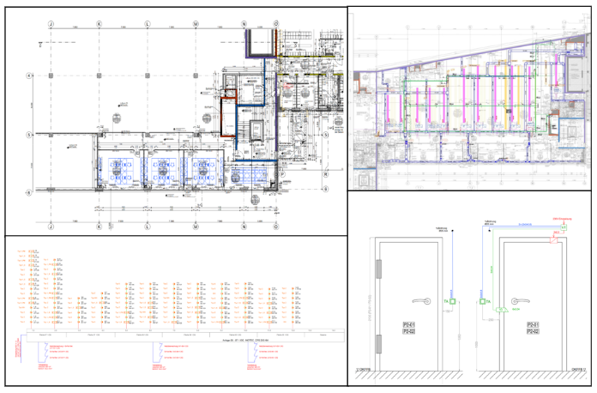
Figure 1: Example of technical drawings used in the study.

3. METHODOLOGY
This section describes the dataset, label structure, preprocessing workflows for both image-based and graph-based representations, feature extraction procedures, and the training setup for multi-label classification.

3.1 Dataset Overview and Label Structure
The dataset comprises 450 technical drawings collected from real-world construction projects spanning residential, commercial, and industrial domains. Each drawing is annotated using four orthogonal classification labels: Project Phase, Discipline, Representation, and Level. These labels are parsed directly from structured filenames and mapped via dictionaries to ensure consistency and semantic clarity.

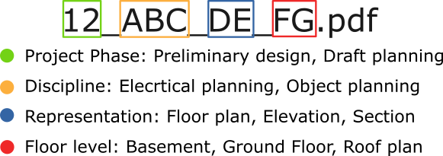
Figure 2: Label extraction from filename.

Notably, the label structure is not arbitrary; it aligns closely with widely accepted conventions and formal standards in the German AEC (Architecture, Engineering, Construction) industry. For example, the Project Phase label follows the official HOAI (Honorarordnung für Architekten und Ingenieure) regulation, which defines standardized planning stages (e.g., Preliminary Design, Draft Planning, Execution Planning, and Documentation).

The Discipline label reflects trade-specific responsibilities and is grounded in DIN 276 cost groups and professional planning practices, especially for technical building equipment (TGA).

The Representation and Level labels adhere to German norms for technical documentation and building structure. Representation types such as floor plan, section, or site plan are consistent with DIN 1356-1, which governs drawing categorization and designation. Similarly, floor and vertical level annotations - like “Basement” (UG), “Ground Floor “(EG), and “Roof Plan” (DA), follow the conventions of DIN 277, a key standard for spatial structuring and area calculation. These labelling conventions are widely adopted in professional CAD workflows, BIM models, and document management systems used across German-speaking countries. As such, the label schema used in this dataset is not only robust and interpretable but also generalizable: it reflects common industry practice and is applicable to a wide range of architectural and engineering projects beyond this specific dataset.

3.2 Data Characteristics and Challenges
Due to the diverse typologies of representations included in the dataset, and the inherently detailed nature of construction drawings from large-scale projects, the image-based dataset exhibits significant variability in both aspect ratios and spatial resolution. As illustrated in Figure 3, the dataset comprises a wide range of aspect ratios, while Figure 4 highlights the high dimensionality of the input images, which span from a minimum of 2,000 pixels up to 20,000 pixels along one or more axes.
Furthermore, given the schematic and line-based nature of technical drawings, the images exhibit a high proportion of background pixels. This combination of heterogeneous image sizes, unconventional aspect ratios, and pixel imbalance introduces unique challenges for the learning process, particularly in terms of efficient representation learning and model generalization.
The label distribution in our dataset is inherently unbalanced, as displayed in Figure 5. We deliberately retain this imbalance without applying normalization or reweighting techniques, under the assumption that it reflects the natural frequency of drawing types encountered in real-world construction projects. This choice ensures that the model is trained and evaluated under realistic conditions, aligning with the practical distribution of technical documents in architectural and engineering workflows.
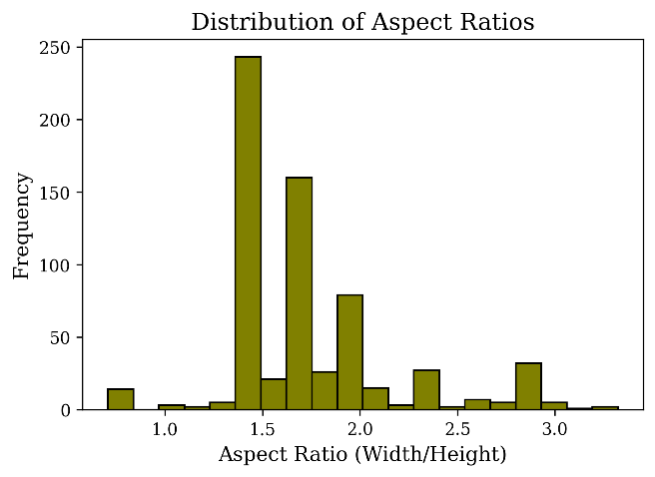
Figure 3: Distribution of aspect ratios

In parallel, the graph-based representation also introduces several domain-specific challenges. Since construction drawings differ significantly in complexity, the resulting graphs vary widely in size, ranging from fewer than 100 to several thousand nodes per sample. This variability reflects the number of geometric primitives present in each plan and results in uneven memory requirements during training. Additionally, the structured vector data must first be extracted from vector files and converted into learning-ready graph objects, a process that includes geometry parsing, feature computation, and spatial indexing. This preprocessing step is notably more time-consuming than rasterization, especially for densely annotated or irregular vector drawings. Despite offering a compact and interpretable encoding, the graph modality thus requires additional preparation effort and poses unique constraints on batching and scalability within graph neural network training.
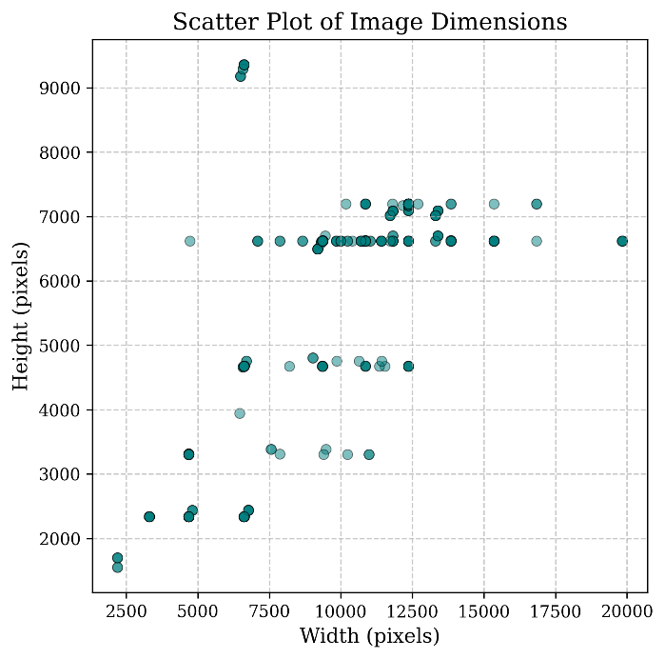
Figure 4: Imagine dimensions in the dataset

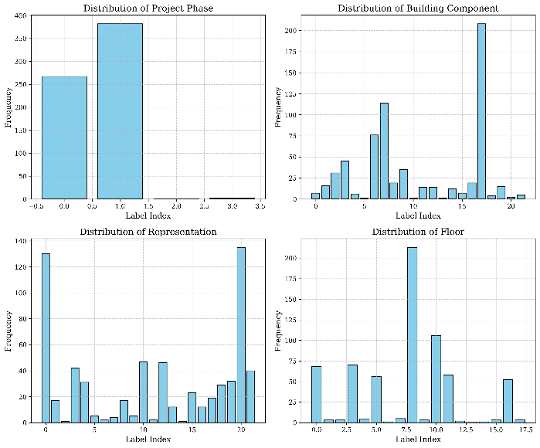Figure 5: Label distribution for the four classes

Given the combinatorial nature of the label space, we employ a stratified sampling approach based on joint label combinations rather than individual labels. This ensures that both common and rare co-occurrence patterns across label categories are preserved in the data split. First, we count the frequency of each unique label combination in the full dataset. Then, we allocate files to the test set proportionally to their combination frequency, guaranteeing at least one sample per non-zero combination to ensure diversity. The remaining files are assigned to the training set. If the target test size is not fully met due to rounding effects, additional samples are randomly selected from the remaining pool to complete the test set. This process results in a balanced and representative partitioning of the dataset, typically using an 80-20 split ratio.

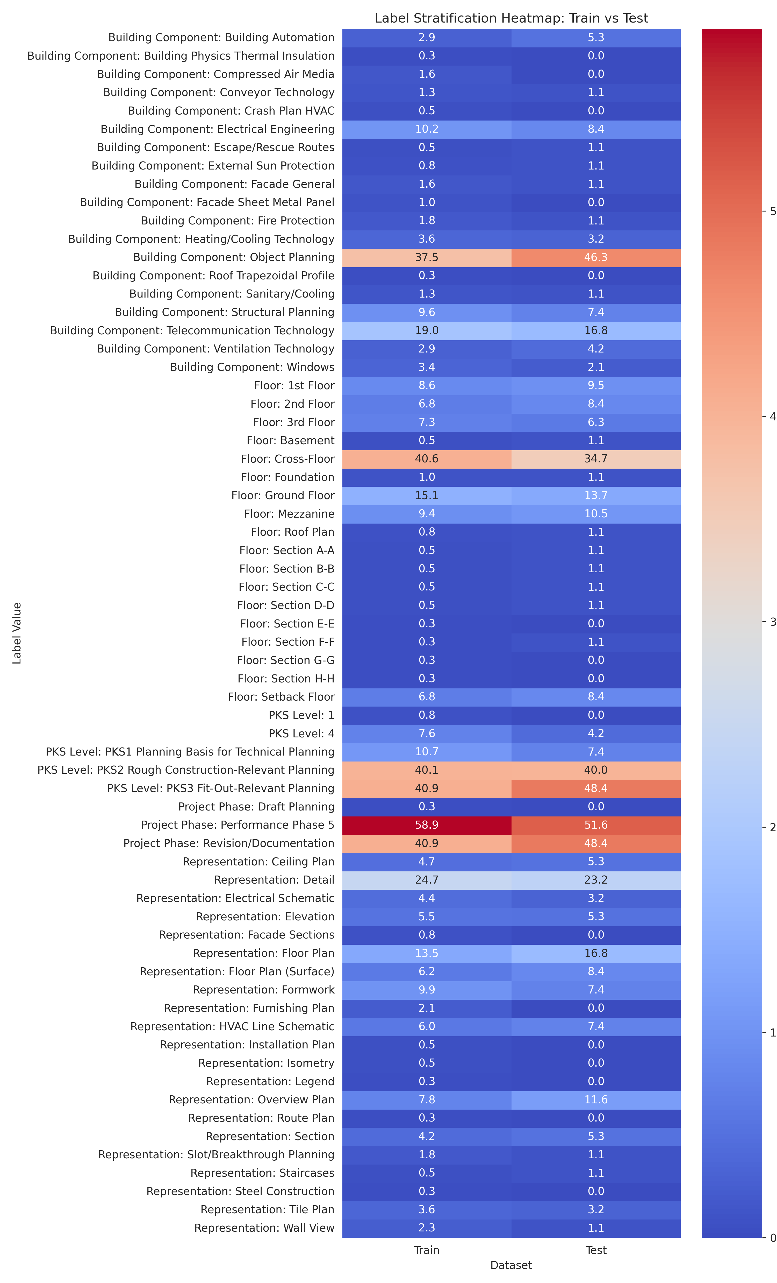
Figure 6: Label extraction from filename

3.3 Data Modalities and Preprocessing Pipelines
The objective of this study is to evaluate which representation is better suited for the automated analysis of construction drawings: the vector information inherently available in the original files, or the rasterized pixel-based representations processed by visual neural networks.

To enable pixel-based analysis, we first convert the original PDF-based technical drawings into high-resolution images. Prior to this conversion, we programmatically remove all textual annotations from the drawings. This ensures that the neural networks focus exclusively on the underlying geometry, rather than being influenced by potentially misleading or unevenly distributed text. By removing text, we encourage the model to learn patterns based on spatial and structural layout - such as symbols, lines, and their spatial relationships - rather than relying on labels or shortcuts that may not generalize well across projects or document types.

In parallel, we develop a dedicated graph construction pipeline that leverages the original vector representation to build structured graph data. This pipeline captures both geometric (e.g., alignment, adjacency) and semantic (e.g., object types, layout context) relationships between drawing elements. The resulting graph-based representation provides an interpretable and compact encoding of technical plans, enabling effective reasoning via graph neural networks (GNNs).
We introduce a fully automated method to transform line-based drawings into structured graph representations, enabling semantic segmentation based solely on geometric information. The process comprises three stages:
Data Preparation: PDF drawings are converted to SVG to access all the vector information. A dedicated post-processing step flattens transformations and removes nested structures, ensuring a transformation-invariant representation. Each element is treated as a distinct geometric entity.
Node Feature Extraction: Each SVG line becomes a graph node, enriched with both stylistic (e.g., stroke colour, fill, width) and geometric attributes. Geometric features include path closure, length, area, number of commands, curvature estimates, and median spatial location. Additionally, we embed each path into a fixed-length tensor, converting the tokenized SVG commands into a numerical representation suitable for learning directly from the markdown representation of the geometries.
Feature | Format
Normalized coordinates | {0,1}
Bounding Box Coordinates | [x₁, ..., x₄], x ∈ ℝ
Fill Value | x ∈ ℝ
Normalized stroke value (RGB) | [x₁, x₂, x₃], x ∈ ℝ
Stroke width | x ∈ ℝ
Closed Path Flag | {0,1}
Closed Path Area | x ∈ ℝ
Length | x ∈ ℝ
Number of Commands (m, l, c, h,) | [x₁, ..., x₆], x ∈ ℝ
Curvature approximation | [x₁, ..., x₁₀], x ∈ ℝ
SVG Tensor Representation | [x₁, ..., x₅₄], x ∈ ℝ
Table 1: Node features of the graph

Edge Feature Extraction: Nodes are connected using a K-nearest neighbours (KNN) approach based on spatial proximity, ensuring connectivity while avoiding full graph density. Edge features capture topological relationships such as relative length ratios, angle between segments, containment (for closed paths), intersection count (via sampled point comparison), and stylistic similarity. Random long-range edges are optionally added to improve generalization by encoding non-local relationships

Feature | Type / Format
Proximity Index | {0,1}
Length Equivalence | {0,1}
Minimal Separation Distance | x ∈ ℝ
Topological Intersection | {0,1}
Attribute Homogeneity | {0,1}
Path Inclusion | {0,1}
Contiguity Measure | {0,1}
Angular Similarity | x ∈ ℝ
Length Ratio | x ∈ ℝ
Table 2: Edge features of the graph

This representation captures both fine-grained geometric features and overall spatial layout. It serves as the input for the graph neural network.

3.4 Training Objective and Optimization
The task is defined as a multilabel classification problem, where the input is the entire drawing, and the neural network learns to classify its overall content across four independent label categories.
The training setup follows a multi-loss optimization strategy, where a shared backbone is trained end-to-end, and the overall loss is computed as the joint contribution of each classification head. This enables the network to update its weights in a way that supports concurrent learning across all label dimensions, capturing diverse semantic signals present in the document.

3.5 Model Architectures
To compare image-based and vector-based representations, we implement two tailored deep learning models: a Vision Transformer (ViT) and a Graph Attention Network (GAT). Both are trained under identical conditions and share a common multi-head output module for consistent multi-label classification.

3.5.1 Vision Transformer
The base of the visual transformer (ViT) employed in this study follows the standard architecture proposed by Dosovitskiy et al. (2021) where input images are first split into fixed-size patches and then linearly embedded, preserving spatial information through positional encoding. These embeddings are processed by a series of transformer encoder layers, each consisting of multi-head self-attention mechanisms and feed-forward networks with residual connections and layer normalization. For our experiments, we adopt a modified ViT implementation optimized for classification of high-resolution construction plans, in which the full-resolution image is first tiled into smaller patches (800×800 pixels).
The choice of 800×800 pixels per tile is motivated by the need to balance computational efficiency and contextual completeness. Construction drawings typically contain fine-grained symbols, linework, and textual annotations dispersed across large spatial extents. Processing the entire image at once is computationally prohibitive due to GPU memory constraints and input size limitations of the ViT model. Conversely, using excessively small patches risks omitting crucial semantic relationships and spatial dependencies that span larger regions. The 800×800 resolution provides a practical compromise - large enough to preserve local architectural context and layout patterns within each tile yet sufficiently constrained to allow batch processing of pre-tokenized tensors during training and inference. These tiles are pre-processed into fixed-size tensors and passed through the transformer model, with final predictions obtained via a global aggregation head across patch-level representations.
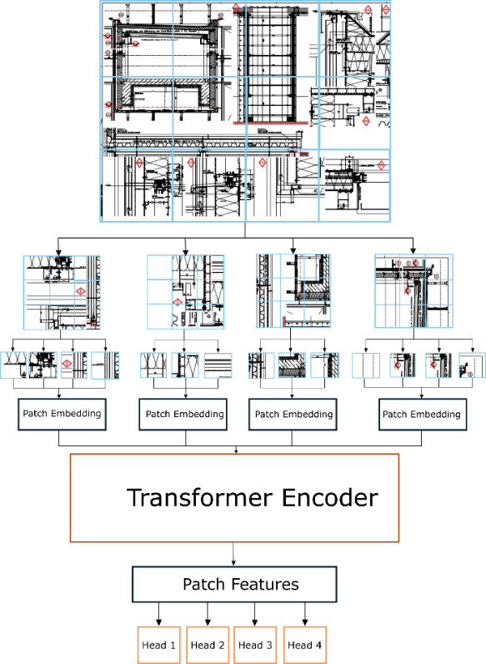
Figure 7: Model architecture for Visual Transformers

3.5.2 Graph Attention Network
For the graph-based modality, we employ a Graph Attention Network v2 (GAT) Brody et al. (2022) as the core architecture. This model enhances the original GAT formulation by allowing attention coefficients to be computed on the raw input features before linear transformation, resulting in more expressive and stable representations, particularly beneficial in sparse and heterogeneous graph structures such as those extracted from construction drawings. Each input graph is constructed from pre-processed plan data, where nodes represent semantic components (e.g., room labels, structural symbols), and edges encode spatial and contextual relations. The node and edge attributes are encoded as learned features and passed to the GAT layers, which aggregate neighbourhood information using dynamic attention weights. The resulting node embeddings are pooled via a readout function to produce multi-label predictions corresponding to the document’s class annotations.
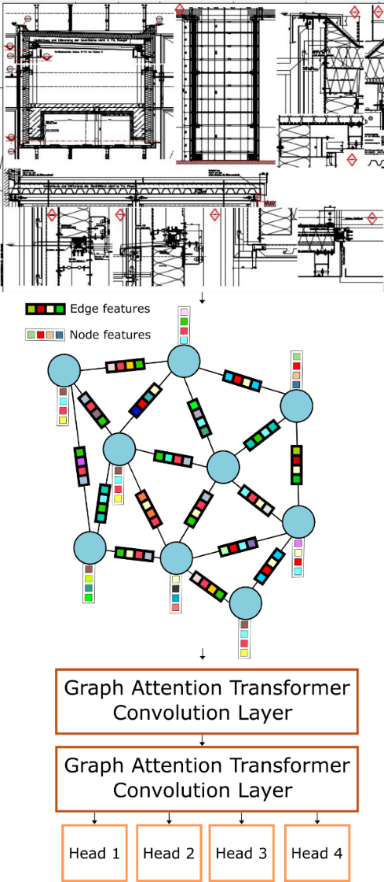
Figure 8: Model architecture for Graphs Attention Transformer

3.6 Classification Head and Comparative Design
To ensure a consistent comparison between the two modalities, both the image-based and graph-based architectures share an identical multi-head classification head. Specifically, the output of the final transformer (ViT or GAT) is passed through a shared prediction module composed of a feed-forward linear layer followed by four independent sigmoid-activated outputs, each corresponding to one of the target classification heads: project phase, scale annotation presence, legend presence, and orientation type.
This design enables independent gradient flows per classification task while encouraging the backbone to learn generalizable representations across all output heads. The total training loss is computed as the sum of the four individual cross-entropy losses, optimized using the Adam optimizer with regularization and dropout to mitigate overfitting.

4. RESULTS
The models compared in this study include a Graph Attention Network (GAT), a Vision Transformer (ViT) trained from scratch, and a pretrained Vision Transformer fine-tuned on our dataset. All models were trained using the same optimization settings, including identical learning rate schedules, batch sizes, and loss functions, to ensure a fair comparison. Model performance was evaluated based on the best test accuracy achieved during training. Accuracy across the four classification heads was used as the primary metric to assess each model’s ability to understand and represent the semantic content of construction drawings.

The GAT model consistently outperformed both the pretrained and randomly initialized ViT models in average accuracy, excelling especially in the Level category, where spatial layout and geometric hierarchies are crucial. Its attention mechanism over sparse graph structures allowed it to effectively capture intricate inter-object relationships that are otherwise difficult to infer from pixels alone.

Conversely, the Pretrained ViT performed best on Project Phase, Discipline, and Representation, highlighting the benefit of transfer learning on raster inputs. The strong performance in these categories suggests that pretrained visual models can generalize well to technical drawings, particularly when fine-tuned with domain-specific data. However, the drop in Level classification (0.600) indicates that positional or contextual cues - often embedded in spatial arrangements - may be less interpretable in purely image-based formats.

Model | Best avg. accuracy | Project Phase | Discipline | Representation | Level | Parameters | Avg. time per epoch
GAT | 0.853 | 0.895 | 0.884 | 0.895 | 0.737 | 238’000 | 21 s
Pretrained  VIT | 0.847 | 0.937 | 0.937 | 0.916 | 0.6 | 85’846’000 | 219 s
VIT | 0.674 | 0.853 | 0.8 | 0.642 | 0.4 | 85’921’000 | 220 s
Table 3: Accuracy, parameters and time per epochs on test set

The non-pretrained ViT struggled across all categories, particularly Representation and Level, emphasizing the need for either a large dataset or pretrained weights when applying deep visual transformers to highly structured documents like technical drawings.

While the ViT models have significantly higher parameter counts (~85M compared to 238K for GAT), they also require 10 times more training time per epoch. This reinforces a key trade-off: CNN/ViT models benefit from hardware-optimized operations and existing pretrained weights, but GNNs offer a more lightweight and structure-aware solution with better generalization from limited data.

It is important to note that, in addition to training time, the graph-based pipeline incurs a significant preprocessing cost. Specifically, the construction of each graph - including SVG parsing, node and edge feature extraction, and tensor serialization - takes on average 111 seconds per drawing, ranging from 3 seconds for the simplest to 1,510 seconds for the most complex cases. While this preprocessing is a one-time cost during dataset preparation, it introduces a non-negligible bottleneck when scaling to larger datasets. In contrast, the image-based preprocessing pipeline (including text removal and rasterization) is considerably faster, typically requiring only a few seconds per drawing. This highlights a practical trade-off: the graph modality provides superior accuracy and interpretability, but at the expense of significantly higher computational overhead in both preprocessing and training However, one practical advantage of the graph-based pipeline is its compatibility with CPU-based processing. Since much of the preprocessing workload - such as SVG parsing and feature extraction - can be efficiently executed on CPUs, it aligns well with the current hardware landscape in the AEC industry, where CPUs are more commonly available than high-performance GPUs. This makes the graph-based approach potentially more adaptable in real-world AEC workflows, minimizing the need for specialized equipment.

4. CONCLUSION AND FUTURE WORK
This study conducted a comparative evaluation of Vision Transformers (ViTs) and Graph Attention Networks (GAT) for content-based classification of construction drawings, with a focus on four industry-relevant categories: Project Phase, Discipline, Representation, and Level. Using a dual-modal dataset comprising both rasterized images and vector-based graphs from 450 real-world architectural drawings, we explored the capabilities and trade-offs of each modality and model architecture in interpreting the semantic and spatial complexity inherent in Architecture, Engineering, and Construction (AEC) documents.

Our findings demonstrate that Graph Neural Networks consistently outperform ViTs in capturing relational and spatial hierarchies, especially for categories like Level, where structural context is critical. GNNs leverage geometric and topological cues more effectively, offering higher interpretability and robustness, particularly under limited data scenarios. Conversely, pretrained ViTs showed strong performance in visual pattern recognition tasks, notably excelling in categories such as Project Phase and Discipline, indicating the value of transfer learning for raster-based approaches.

Despite their lower computational efficiency and more complex preprocessing requirements, GNNs present a compelling solution for tasks requiring deeper structural understanding, aligning well with the symbolic and interconnected nature of technical drawings. On the other hand, ViTs benefit from GPU-optimized training pipelines and are faster to deploy, especially when leveraging pretrained models.

In conclusion, the choice between CNN/ViT and GNN architectures should be guided by the specific demands of the application scenario - with GNNs being more suited for structure-sensitive tasks and ViTs offering practical advantages in speed and scalability. This research provides a valuable benchmark for future work on automated drawing classification and highlights the growing relevance of graph-based learning in the digital transformation of the AEC industry.

Future work will explore hybrid architectures that combine graph-based and image-based features to leverage both spatial context and structural relationships in construction drawings. Additionally, we plan to investigate pretraining strategies for graph models to enhance generalization in data-scarce settings. Expanding the dataset to include more diverse project types and integrating the classification pipeline into real-world BIM or CAD environments will also be prioritized to support practical deployment in AEC workflows.

ACKNOWLEDGEMENTS
The research presented in this paper has received funding from the Bayerisches Verbundforschungsprogramm (BayVFP) des Freistaates Bayern - Förderlinie "Digitalisierung", grant number DIK0336/01

REFERENCES
Borrmann, A., König, M., Koch, C., & Beetz, J. (2018). Building Information Modeling: Why? What? How? In Building Information Modeling, Springer Verlag, pp. 1–24.
Brody, S., Alon, U., & Yahav, E. (2022). How attentive are graph attention networks? In International Conference on Learning Representations (ICLR).
Cao, T., Wang, Y., Li, Y., Fu, Q., & Lu, Y. (2024). Topology-aware Visualization for Interactive Graph Structure Exploration. IEEE Smart World Conference.
Carrara, A., Nousias, S., & Borrmann, A. (2024). Employing graph neural networks for construction drawing content recognition. In i3CE 2024: ASCE International Conference on Computing in Civil Engineering.
Dosovitskiy, A., Beyer, L., Kolesnikov, A., Weissenborn, D., Zhai, X., Unterthiner, T., Dehghani, M., Minderer, M., Heigold, G., Gelly, S., Uszkoreit, J., & Houlsby, N. (2021). An image is worth 16x16 words: Transformers for image recognition at scale. In International Conference on Learning Representations (ICLR).
Genossar, B., Vainblat, R., & Gal, A. (2024). SHIKI: Self-Supervised Heuristic for Improving MLPs' Knowledge by Integrating GNNs. OpenReview.
Jamieson, L., Moreno-García, C. F., & Elyan, E. (2024). A review of deep learning methods for digitisation of complex documents and engineering diagrams. Artificial Intelligence Review, 57(6), 1–37.
Ko, J., & Lee, D. (2025). Graph neural networks for classification and error detection in 2D architectural detail drawings. Automation in Construction, 170, 105936.
Vaswani, A., Shazeer, N., Parmar, N., Uszkoreit, J., Jones, L., Gomez, A., Kaiser, Ł., & Polosukhin, I. (2017). Attention is all you need. In Proceedings of the 31st International Conference on Neural Information Processing Systems, pp. 6000–6010. Curran Associates Inc.
Wang, Q., Huang, J., Jin, P., & Gu, Y. (2024). Differential Feature-Enhanced Fusion Network for Hyperspectral Image Classification. IGARSS 2024.
Xu, Z., Jha, N., Mehadi, S., & Mandal, M. (2024). Multiscale object detection on complex architectural floor plans. Automation in Construction, 165, 105486.
Yi, C., Wang, Y., Liu, Y., & Xiao, H. (2024). ResNet50-3Cur-HGCN: A hybrid curvature space GNN model for bearing fault diagnosis. Measurement Science and Technology.
Zhang, Y., Wang, D., Wang, G., Xu, P., & Zhu, Y. (2024). Data-driven building load prediction with architectural design and GNNs. Energy and Buildings, 138, 1174.

