Mixed-Methods Evaluation of Critical Data Requirements for Heat Pump Product Configuration
Malte Junge ¹, Noemi Kremer ¹, Jakob Beetz ¹
¹ RWTH Aachen University, Aachen, Germany
*Corresponding email: junge@dc.rwth-aachen.de

ABSTRACT
Efficient planning for construction projects requires appropriately detailed and semantically rich digital representations of Mechanical, Electrical and Plumbing (MEP) systems. However, MEP product selection and integration of digital product data into building models are labour-intensive processes complicated by fragmented, inconsistently structured manufacturer data that are neither easily comparable nor aligned to practitioners’ needs. An internationally standardised digital product catalogue format is under development, but prior work has focused on representational and computational capabilities rather than practitioners’ operational information needs. This paper identifies essential selection criteria and technical attributes for heat pump configuration and evaluates them empirically through a mixed-methods study comprising 16 semi-structured expert interviews with architects and MEP engineers and a quantitative online survey in which 46 heat pump properties were rated for importance and assigned to planning phases. Findings indicate that the hierarchical structure of existing catalogue formats does not reliably reflect perceived planning relevance. Information needs are concentrated in the conceptual design and design development phases and planners strongly favour functional geometry representations over visual or constructive detail.

INTRODUCTION
Selecting and integrating Mechanical, Electrical and Plumbing (MEP) products into Building Information Models (BIM) is a complex, multi-disciplinary process in which the required depth and granularity of product information vary substantially across planning phases and stakeholder roles. A central structural problem is the mismatch between what manufacturers publish and what planners actually need: product catalogues are predominantly distributed as static PDFs or in proprietary formats that prioritise geometric representation over semantic richness (Kebede et al., 2022). As a result, practitioners routinely resort to manual cross-referencing, direct manufacturer contact, and redundant data entry, which impedes planning efficiency (Wagner et al., 2022).
An IFC-based, open catalogue format for building services equipment has been standardised in DIN EN ISO 16757-1 (2019), but prior work on its practical implementation focussed mostly on how technical properties and possible product variations can be mapped, rather than on which properties practitioners actually need during the product selection and configuration process (Kremer et al., 2024). We address this gap through the following research questions:
- RQ1: Which heat pump properties do architects and MEP planners require in BIM-based projects, and at which planning stages?
- RQ2: How do practitioners obtain product information in practice, and which sources and formats do they use?
- RQ3: How do practitioners assess the quality and usability of currently available product data?

We report a mixed-methods study combining semi-structured expert interviews with German-speaking architects and MEP engineers and a quantitative online survey, focusing on heat pumps as an MEP product class that is both highly relevant to Germany’s energy transition (Schill, 2026) and technically complex enough to serve as a representative test case.

STATE OF THE ART
Partl et al. (2019) propose a process model for BIM-based MEP design of a geothermal heat pump system, linking a structured set of heat pump properties to individual process steps and design stages. Their model, validated with four MEP experts, explicitly indicates in which design phase product class-specific attributes, such as heat source type and flow temperature, are required, providing an important precedent for use-case-oriented information requirements of MEP products, albeit at the level of a single, expert-designed process model rather than a broader empirical study of everyday practice and data sources.
Jochems et al. (2024) conduct a scoping literature review and case study on product data provision from manufacturers, showing that BIM objects and digital catalogues often omit key technical attributes or contain inconsistencies when compared to specification sheets. Furthermore, they point out that product 3D models often over-invest in geometric detail at the expense of semantic richness, suggesting that manufacturers struggle to balance data richness, file size, and maintainability.
In Germany, the VDI 3805 series provides national standards for digital MEP product catalogues (Verein Deutscher Ingenieure e.V., 2022). It defines a machine-readable data structure for product properties and geometry representations across a broad range of product classes, including a dedicated heat pump sheet (Verein Deutscher Ingenieure e.V., 2019). VDI 3805 catalogues organise properties into hierarchical record types, distinguishing high-level selection characteristics (e.g. application, heat source) from more granular product element data (e.g. refrigerant type) and dynamically calculated performance data that vary with operating conditions (e.g. heating output as a function of heat source temperature, supply temperature and load). Although its purpose-built catalogue structure is an advantage, the VDI format remains nationally scoped and loosely connected to BIM authoring environments, limiting integration into model-centric workflows.
ISO 16757 generalises VDI 3805 into an international standard for the exchange of open IFC-based catalogue files, including parametric dependencies and geometry specification (DIN EN ISO 16757-1, 2019). Prototype implementations have evaluated the format's capabilities for specific product classes. For heat pumps, Kremer et al. (2025) examine how dependent performance data from VDI catalogues can be transferred into IFC, while Kremer et al. (2026) map essential selection requirements to the open information specification formats IDS and LOIN.

METHODOLOGY
We conducted a mixed-methods study combining qualitative expert interviews and a quantitative online survey to investigate practitioners’ information needs and data practices in BIM-based MEP planning. In the scope of this paper the interviews primarily address RQ2 and RQ3 (data practices and quality assessments), while the survey quantifies RQ1 (property importance and timing) and contributes to RQ2 and RQ3 through additional modules on data sources and formats.

Expert interviews
Between February and September 2025, we conducted 16 semi-structured interviews with architecture firms (3) and MEP planners (11), as well as integrated design offices that combined both disciplines in-house (2). Architecture firms and integrated planners were recruited via direct email; MEP engineering offices via a mailing list of a consulting engineers' association. Interviews lasted 60 to 90 minutes, were conducted in German (online or in person), and involved one to three employees per company, including planners, project leads, BIM coordinators and managing directors. Companies selected participants themselves based on the interview description; no role requirements were enforced.
The interviews covered: (1) BIM-based planning workflows and product information needs at different stages; (2) interdisciplinary information exchange between architects, MEP planners and other actors; and (3) use of manufacturer portals, BIM content libraries, and product data formats, such as VDI 3805. All interviews were audio-recorded with consent and fully transcribed. Interview transcripts were analysed in MAXQDA 26 (VERBI Software, 2026), using qualitative content analysis with inductive category development. An initial coding frame, derived from the interview guide and relevant standards for electronic product catalogues (VDI 3805, ISO 16757), was applied to the transcripts and iteratively refined, resulting in a hierarchical code tree capturing product information needs, planning phases, information flows, and experiences with data sources and formats. For this paper, we focus on code clusters directly addressing heat pump information needs and their timing, interaction with manufacturers and data sources, and perceived quality of available product data. These were aggregated into higher-order themes forming the basis of the qualitative results below.

Online survey
To complement and broaden the interview findings, we designed a quantitative online survey using SoSci Survey (Leiner, 2026), which was distributed to expert practitioners between April and September 2026, using the same recruitment channels as for the interviews. The questionnaire targeted architects and MEP planners with experience in BIM-based planning of building services that include heat pumps. Survey participation was anonymous; no identifiable data were collected.
The survey’s main focus was two core blocks of heat pump-related questions: importance of heat pump properties (46 properties rated on six-point Likert scales) and timing of information needs (the same properties assigned to the German HOAI planning phases via a card-sorting task along a continuous timeline). The property list was derived from VDI 3805-22 (selection characteristics, product element data and dynamic performance data) and from Partl et al. (2019), who curated 36 high-importance attributes for geothermal heat pumps based on expert ratings. These sources were consolidated into a harmonised set of 46 properties and internally reviewed with industry experts, MEP software developers and heat pump manufacturers from our project stakeholders.
For the findings reported in this paper, we used descriptive statistics to calculate response frequencies, medians and means for the Likert-scale importance ratings of individual properties and cross-tabulated these with the continuous time scale data of the planning phase question block. To reduce survey fatigue and improve response validity, respondents first self-assessed their heat pump planning experience and could skip the heat pump property block if they had little or no relevant experience. The following question blocks covering geometry detail levels, product data formats and data sources are also reported descriptively. Analysis of further survey modules on respondent background and experience with standardised catalogue formats is outside the scope of this paper. The reported analysis set comprises 36 valid responses (24 MEP planners, 10 architects, 2 other). Most question blocks were voluntary to reduce respondent burden and minimise low-engagement responses, so the effective sample size varies by question block.

RESULTS
The interview participants, when asked to describe their BIM‑based planning workflows in recent projects, mentioned a range of planning tasks that directly involved the selection and specification of heat‑pump products. Most frequently named were: energy concept development (11/16 interviews), heating and cooling load calculation (7/16), space planning for plant rooms and equipment (5/16), sizing and selection of components (4/16), and tendering (3/16). Across companies and roles, participants reported that early-phase tasks, such as energy concept development and load estimation can be supported with a comparatively compact set of heat pump properties, such as type and heat source, nominal heating output, indicative efficiency values, and basic assumptions on installation location and unit configuration. By contrast, component sizing, tendering and building energy simulation typically rely on more extensive and detailed information, like dynamic performance data and connection port geometry.

Heat pump properties
Figure 1 presents the combined results of the importance rating and phase assignment blocks for all 46 evaluated heat pump properties. Properties are sorted by mean importance on the y-axis; the x-axis maps to HOAI phases LP1-LP8. Participants placed each property card freely along this scale, allowing placement within or between phases. For each property, the box spans the interquartile range (IQR) of all phase placements (the middle 50%) with a tick marking the median; whiskers extend to 1.5× the IQR. The colour scale encodes mean importance, ranging from red (very unimportant) to blue (very important).
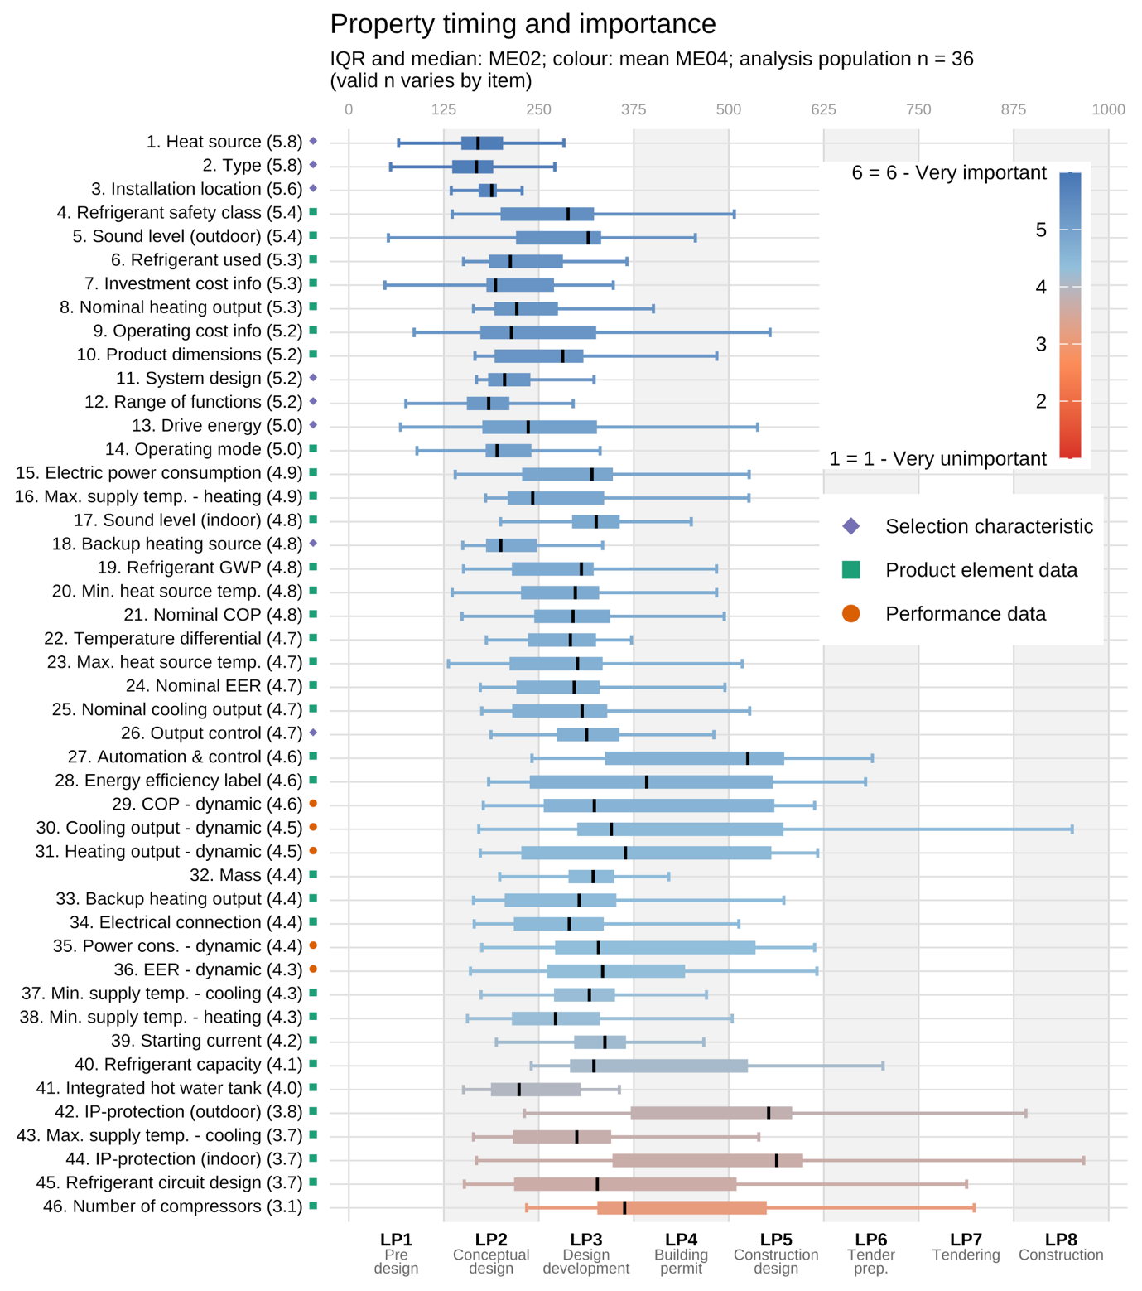
Importance ratings are concentrated in the upper half of the six-point scale: only 6 of 46 properties fall below the midpoint, reflecting the expert composition of the sample and the pre-curated property set. The results should therefore be interpreted in terms of relative importance rather than as a filter into “important” and “not important” groups. Phase distribution is also strikingly concentrated: 42 of 46 properties show a median placement in LP2 (conceptual design) or LP3 (design development), with 14 and 28 properties respectively. Only four properties have medians outside this range: energy efficiency label (LP4), IP-protection (indoor and outdoor), and automation and control systems (all LP5). No median falls in LP1 or LP6–8. Spread is nonetheless considerable; for several properties whiskers extend up to three phases beyond the IQR, with higher-importance properties tending to be needed earlier and lower-importance properties showing both later medians and greater spread.
Figure 1: Importance ratings and phase assignments for 46 heat pump properties, sorted by mean importance (n = 23).
The two highest-ranked properties are the VDI 3805 selection characteristics heat source and type, both with a mean importance of 5.8. However, the ranking does not exactly align with the VDI tree structure. Refrigerant safety class (rank 4, mean 5.4) and sound level (outdoor) (rank 5, mean 5.4) are both leaf-level product element data, yet rank among the five most important properties overall. Overall, product element data account for seven of the top ten positions. Dynamic performance data properties show a median in LP3 and cluster around importance values from 4.3 to 4.6. Installation location (rank 3, mean 5.6) is the only property whose full box plot falls within a single phase (LP2), indicating a strong consensus on the early-phase importance of this property. Automation and control systems, by contrast, have a median in LP5, reflecting that detailed control specifications, while important, become relevant only during construction design.

Geometry data
Figure 2 compares importance ratings for selected types of geometry data (level of geometric detail, 3D connection data, and clearance space) between architects and MEP planners.
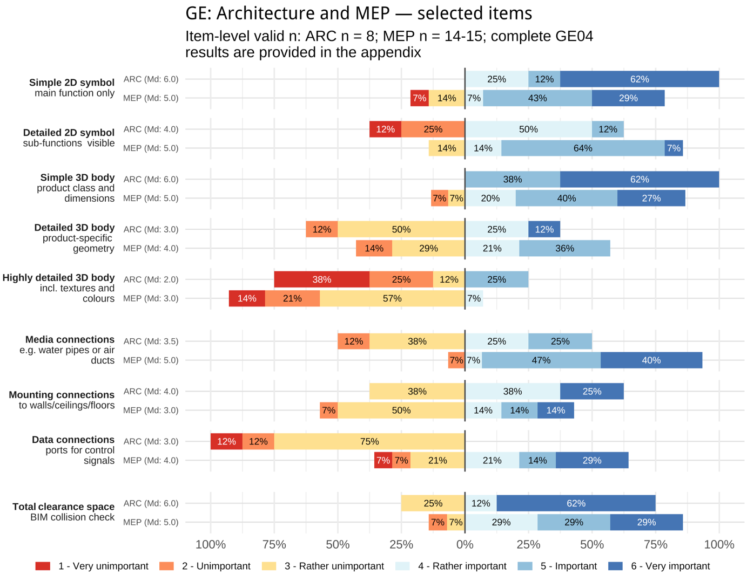
Across respondent groups, simpler geometry representations are generally rated as more important than more detailed ones. Results indicate that practitioners generally see little planning value in realistically rendered product geometry. However, there is still a considerable gap between groups. The largest differences concern connection geometry: data connections received positive ratings from 64% of MEP respondents but none of the architects, resulting in median (Md) ratings of 4 – rather important and 3 – rather unimportant, while media connections were rated positively by 93% and 50%, respectively (Md: 5 vs 3.5). Architects rated simple 2D and 3D representations and total clearance space higher (Md: 6 vs 5). Mounting connections showed the same tendency (Md: 4 vs 3). Both groups assigned little value to highly detailed 3D geometry including textures and colours (Md: 2 vs 3). Overall, MEP respondents prioritised product class differentiation and service-specific connections, whereas architects placed greater emphasis on basic spatial representations. While these comparative results are in line with the qualitative interviews, they must be considered descriptive due to the unequal sample sizes between groups.
Figure 2: Importance ratings for different types of product geometry, split between architects (ARC, n= 8) and MEP planners (MEP, n = 15).

Product data sources, formats and quality
Interview participants frequently described MEP product data as being obtained and exchanged through a diverse and fragmented mix of sources and formats. This is reflected in the results of the survey questions reported in Figure 3, which asked respondents to list the sources and formats commonly used in their projects. Manufacturer portals were the most frequent source (75%), followed by exchanges with other project participants (50%) and in-house libraries (42%). Early planning relies on generic or manufacturer-neutral objects and approximate values but during design development and tender preparation, practitioners shift to manufacturer-informed assumptions or reference products to obtain realistic dimensions, performance values, clearances and connection information. Nevertheless, public projects usually have to maintain vendor neutrality throughout the tendering and procurement phases.
PDF datasheets and catalogues remain central for performance curves, electrical data, maintenance clearances and safety information. Later-stage coordination relies more on structured model-based exchange, with 75% of surveyed practitioners reporting IFC use. In many cases, published product data do not fulfil all information needs and planners repeatedly have to rely on personal manufacturer contact when specific product variants, BIM objects or required parameters are unavailable or ambiguous.
In the interviews, criticism of available product data quality was mostly focussed on practical usability issues in everyday planning workflows, which occurred in 11 of 16 interview cases. The most frequent complaint was unnecessarily detailed geometry leading to large file sizes and decreased model performance (9 cases). Other issues included missing semantic information (6 cases), complicated and impractical use (4 cases) and incorrect data (3 cases).
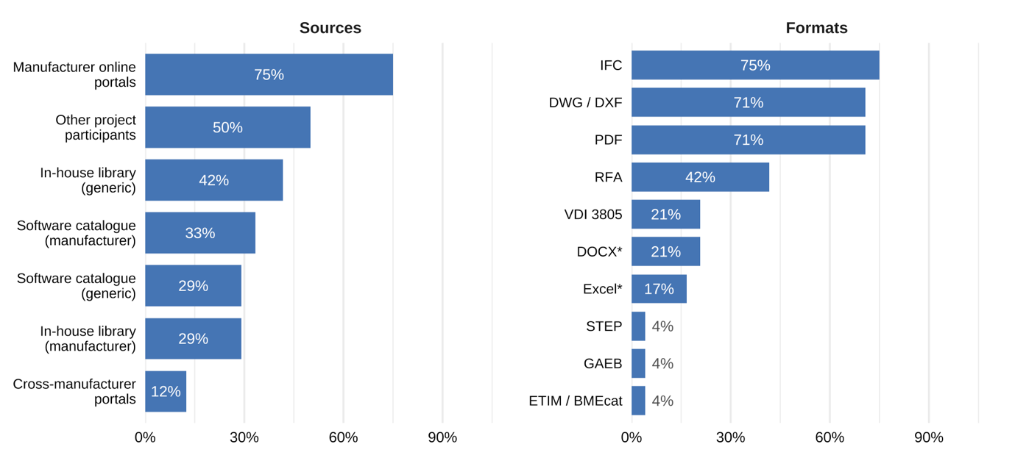
* or similar open formats
Figure 3: Common product data sources and formats by share of survey respondents using them (n = 24).

DISCUSSION
Our results indicate a mismatch between the structural logic of existing product catalogue formats and how practitioners actually use product data in planning. This becomes evident when comparing the importance rankings shown in Figure 1 with the specification of heat pump properties in the VDI 3805-22 product data standard. Although selection characteristics sit at the top of the VDI format’s hierarchy, they occupy only three of the top ten positions. Meanwhile, several critically important properties, such as refrigerant safety class and nominal heating output, are located deeper in the VDI 3805-22 record type hierarchy, below the product selection level. The selection characteristics / product element data distinction is therefore not a reliable proxy for practitioner-perceived planning relevance. ISO 16757-compliant tools should therefore support filtering and retrieval across all property types and hierarchy levels, not only at the top of the catalogue structure. The phase assignments further show that the critical window for product selection and configuration properties is narrow and early: expert interviews explain this concentration by showing that most heat-pump-related decisions are part of energy concept development, load estimation, plant-room sizing and high-level design development rather than later-stage construction design. The practical implication for manufacturers and software developers is that front-loading critical selection data may deliver more planning value than fully comprehensive technical documentation. Nevertheless, flexible catalogue interfaces should still accommodate project- and role-specific workflows.
Geometry results point in the same direction. Figure 2 shows that practitioners primarily value geometry that supports spatial coordination, clearance checking and connection routing, while visually detailed product geometry is of limited planning relevance. This confirms the interview finding that simple placeholders, clearance spaces and connection points are more useful for coordination than appearance-grade manufacturer objects, which were repeatedly associated with large file sizes and reduced model performance. For ISO 16757, which specifies a parametric CSG-based geometry model and prioritises low to intermediate detail levels (DIN EN ISO 16757-2, 2019), our results suggest that the standard’s geometry approach is broadly aligned with practitioner needs.
The reported data quality issues indicate that the usefulness of product data depends less on maximum data richness than on whether relevant information can be found, trusted and integrated into planning workflows. Missing semantic information, fragmented distribution across various proprietary and open formats, usability issues and occasionally incorrect data all reduce the planning value of currently available product data. Together with the geometry findings, this suggests that digital product catalogues should prioritise reliable technical parameters, transparent semantics, functional geometry and clear connection information over visually detailed objects or exhaustive late-stage documentation.
The presented findings should be interpreted in light of several limitations. The expert interview evaluation was conducted by a single coder without formal inter-coder reliability assessment. While targeted recruitment and participant self-assessment were employed to improve response quality in the online survey, the resulting sample is relatively small and unbalanced, limiting the reliability of practitioner group comparisons. Additionally, the present study is grounded in German planning practice, the HOAI phase model and the nationally scoped VDI 3805, which may limit the direct transferability of findings to other national contexts.

CONCLUSION
This paper investigated heat-pump property requirements, timing, information sources and product-data quality in BIM-based planning. The results show that information needs are concentrated in the conceptual design and design development phases, and that practitioner-perceived relevance does not map reliably onto the hierarchical structure of existing catalogue formats. Practical use of currently available product data is hindered by fragmentation across sources and formats, as well as impractical geometry representations, inconsistent semantic information and cumbersome integration into planning workflows. These findings provide an empirically grounded basis for prioritising properties and geometry levels in ISO 16757 catalogues and highlight the need for flexible, phase- and role-aware filtering in compliant software tools. Future work will analyse the full interview and survey datasets in greater depth, including how practitioners move between generic, manufacturer-informed and manufacturer-specific product data as planning decisions become more concrete. This will further clarify how standardised catalogues can support not only technically complete product descriptions, but also the situated, phase-dependent decisions through which products are actually selected in practice.

ACKNOWLEDGEMENTS
This work is part of the research project Parametric BIM for the heat transition — International market launch of EN ISO 16757. The project was funded by the Federal Institute for Research on Building, Urban Affairs and Spatial Development on behalf of the Federal Ministry for Housing, Urban Development and Construction, using funds from the Zukunft Bau research funding programme. We thank our project partners for their versatile support.

REFERENCES
DIN EN ISO 16757-1:2019-10, Datenstrukturen für elektronische Produktkataloge der Technischen Gebäudeausrüstung_- Teil_1: Konzepte, Architektur und Modelle (ISO_16757-1:2015); Deutsche Fassung EN_ISO_16757-1:2019. (2019). DIN Media GmbH.
DIN EN ISO 16757-2:2019-10, Datenstrukturen für elektronische Produktkataloge der Technischen Gebäudeausrüstung_- Teil_2: Geometrie (ISO_16757-2:2016); Deutsche Fassung EN_ISO_16757-2:2019. (2019). DIN Media GmbH.
Jochems, B., Johansson, P., Kebede, R., & Moscati, A. (2024). Product Data Provision from Manufacturers to the Construction Industry: A Scoping Literature Review and Case Study Analysis. Proceedings of the 41st International Conference of CIB W78.
Kebede, R., Moscati, A., Tan, H., & Johansson, P. (2022). Integration of manufacturers’ product data in BIM platforms using semantic web technologies. Automation in Construction, 144, 104630. https://doi.org/10.1016/j.autcon.2022.104630
Kremer, N., Beetz, J., & Hjelseth, E. (2024). Use case-based evaluation of a standardised product catalogue format for configuration. Proceedings of the 41st International Conference of CIB W78.
Kremer, N., Junge, M., & Beetz, J. (2026). Critical Information Requirements for Building Service Product Selection: An Evaluation of Open Information Specification Formats. Proceedings of the 16th European Conference on Product and Process Modeling (ECPPM), in press.
Kremer, N., Junge, M., Beetz, J., & Domme, E. (2025). Integration of Parametric Product Catalogue Requirements in IFC. 2025 European Conference on Computing in Construction. https://doi.org/10.35490/EC3.2025.343
Leiner, D. J. (2026). SoSci Survey (Version 3.8.04) [Computer software]. SoSci Survey GmbH. https://www.soscisurvey.de
Partl, R., Hauer, S., & Monsberger, M. (2019). Process model for BIM-based MEP design. IOP Conference Series: Earth and Environmental Science, 323(1), 012045. https://doi.org/10.1088/1755-1315/323/1/012045
Schill, W.-P. (2026). Energy Transition Monitor: Momentum Is Still Insufficient for the Expansion of Renewables, Electrification, and Storage (DIW Weekly Report 30/31 / 2026, pp. 231–239). DIW Berlin — Deutsches Institut für Wirtschaftsforschung e. V. https://doi.org/10.18723/diw_dwr:2026-30-1
Verein Deutscher Ingenieure e.V. (2019). VDI3805-22, Product data exchange in the building services — Heat pumps.
Verein Deutscher Ingenieure e.V. (2022). VDI 3805-1, Product data exchange in the building services — Fundamentals.
Wagner, A., Sprenger, W., Maurer, C., Kuhn, T. E., & Rüppel, U. (2022). Building product ontology: Core ontology for Linked Building Product Data. Automation in Construction, 133, 103927. https://doi.org/10.1016/j.autcon.2021.103927
VERBI Software. (2026). MAXQDA (Version 26) [Computer software]. https://www.maxqda.com

The property list, raw survey data, selected analysis scripts, and figures/tables for all survey question blocks, including those not reported in this paper, are available at https://github.com/Design-Computation-RWTH/2026-cib-w78-heat-pump-properties.

