Autonomous operation of a robot dog for point-cloud data acquisition
PANAGIOTIS PETROPOULAKIS^{1*}, MOHAMMAD REZA KOLANI^{1*}, ANDRÉ BORRMANN¹

¹ Chair of Computing in Civil and Building Engineering, TUM Georg Nemetschek Institute,
Technical University of Munich, Germany

* These authors contributed equally to this work

ABSTRACT

This paper presents the development of an autonomous operation for a robot dog, the Unitree Go1, to acquire a detailed point cloud of a building’s interior, from simulation to real-world experiments. The system integrates a 3D LiDAR, an RGB-D camera, and a mini-PC, enabling the Go1 to autonomously navigate, avoid obstacles, and collect data. The process includes developing the solution inside a simulation environment within the Robot Operating System (ROS) to simulate the Go1 movement in a building model. Real-Time Appearance-Based Mapping (RTAB-Map) has been adapted for the robot's 3D localization. In addition, real-world experiments were conducted to validate the pipeline. Our proposed framework provides valuable insights for the construction community, outlining current limitations and suggesting directions for future work. To promote transparency and enable reproducibility, we have made the code used and developed in our experiments publicly available at: https://github.com/MooKol/unitree_go1.

KEYWORDS

Legged robot, Point-cloud acquisition, Autonomous navigation, Construction Robotics, LiDAR

1. INTRODUCTION
Accurate 3D mapping and point cloud data acquisition are vital for various applications in architecture, construction, and digital twin modeling. The collected point cloud data can then be processed for high precision 3D reconstruction, digital twin creation, quality assessment, progress monitoring, safety enhancement and structural analysis (Wang et al., 2020, Kim et al., 2022).
Autonomous robots equipped with advanced sensing capabilities have become valuable equipment to capture spatial data efficiently with minimal human intervention (Alatise and Hancke, 2020). Legged robots are gaining increasing interest across multiple research domains due to their unique capabilities. Quadruped-legged robots, also called robot dogs, such as the Unitree Go1, offer significant advantages over traditional wheeled or aerial platforms, as they can traverse complex terrains, adapt to dynamic environments, and navigate stairs within buildings (Halder and Afsari, 2023). Robot dogs demonstrate superior mobility and stability in locomotion (Biswal and Mohanty, 2021). Compared to wheeled robots, they exhibit enhanced performance in navigating cluttered terrains, as well as complex and hazardous environments (Biswal and Mohanty, 2021). These capabilities make them well-suited for deployment in construction sites. However, studies exploring their practical applications in building environments remain limited.
This paper presents the potential applications of robot dogs in building environments by introducing an autonomous system that utilizes the low-cost Unitree Go1 robot and a modular sensor setup for point cloud data acquisition with minimal human intervention. The framework developed on ROS ecosystem, enabling real-time navigation, obstacle avoidance, and efficient data collection. The proposed autonomous solution aims to improve efficiency in digital modeling workflows through an automated scanning process. Experimental evaluations confirm the system’s capability to produce precise and comprehensive point clouds.
The remainder of the paper is structured as follows: Section 2 reviews the state-of-the-art in robotic data acquisition. Sections 3 and 4 describe the methodology and the implementation of the robot dog framework, first in simulation and then through real-world testing. Section 5 discusses the results and outlines directions for future research. Finally, Section 6 presents the conclusions of the study.

2. RELATED WORKS
Recent advancements in autonomous legged robots have significantly enhanced their capabilities in environmental perception and 3D mapping (Bellicoso et al., 2018). (Torres and Pfitzner, 2024) Investigated the feasibility of utilizing robot dogs on construction sites, examining their technical specifications, data acquisition requirements, and practical deployment in real-world construction settings.
Many studies have explored the potential of using mobile robots for 3D mapping of indoor and outdoor environments (Borrmann et al., 2014). (Wolf et al., 2005) introduced a method using a Segway RMP robot equipped with a laser rangefinder to scan urban environments. The approach combines local point cloud scans with data from the robot’s odometry, IMU, GPS, and range sensors, and then generates a global point cloud by aligning planar surfaces.
In addition, previous research has examined the use of legged robots for progress monitoring and safety management, with a particular focus on tracking scaffolding (Kim et al., 2022, Chung et al., 2025). (Kim et al., 2022) introduced a deep learning-based approach for automated 3D reconstruction using a quadrupedal robot. In their work, the robot was remotely controlled to navigate around the scaffold, adjusting its scanning motion dynamically based on the scaffold's relative position.
Furthermore, (Hu et al., 2023) proposed an integrated approach that combines SLAM with robot motion control and path planning to improve 3D mapping capabilities. Their method enhances the quality of the generated point clouds by employing scanning fitness metrics and a grid-based algorithm for optimized data acquisition. Additionally, they incorporated ResPointNet++, a deep learning model, to perform semantic segmentation, enabling their module to classify and label different elements within the mapped environment accurately. (Yin et al., 2022) presented a BIM-based localization approach utilizing the Iterative Closest Point (ICP) algorithm (Segal et al., 2009). Their results demonstrated that this pipeline achieves lower localization errors compared to traditional SLAM techniques, highlighting its effectiveness and feasibility for precise indoor positioning.

3. METHODOLOGY
Developing an autonomous system for point cloud acquisition requires both simulation-based validation and real-world experimentation. The simulation phase provides a safe and repeatable environment to verify navigation performance, sensor integration, and data acquisition processes before deploying the robot into real-world scenarios.

3.1 System architecture
The simulation of the Unitree Go1 was implemented using the Robot Operating System (ROS) and Gazebo as the physics-based simulator. The model of the Unitree Go1 was integrated into the simulation environment, allowing for realistic testing of autonomous navigation and sensor-driven data collection.
2D localization is often inadequate in long corridors, as these environments typically feature repetitive architectural elements—such as long, flat walls and uniform textures—with few distinguishable landmarks. This lack of unique visual or structural cues makes it challenging for localization algorithms to accurately determine the robot’s position. With 2D data, many parts of the corridor look identical from a top-down view. The robot may recognize that it is in a corridor but struggle to determine its precise location within it.
In our work, we integrate the Real-Time Appearance-Based Mapping (RTAB-Map) (Labbé and Michaud, 2019), a graph-based SLAM pipeline, to facilitate 3D localization and improve navigation performance. This approach leverages point cloud registration techniques to enhance localization accuracy. The system also enriches environmental representation by acquiring high-density point clouds, which enable more precise real-time object detection. By capturing a large number of points that accurately represent surfaces and objects, the dense 3D data records even subtle variations in geometry and texture. As a result, it provides detailed information about the shape, size, and position of objects, significantly improving detection accuracy during real-time navigation.
Additionally, the Iterative Closest Point algorithm (Segal et al., 2009) was used to align consecutive point clouds and estimate the robot’s movement trajectory. Simulation results confirmed the system’s capability to autonomously explore its environment, capture 3D point cloud data, and generate a detailed 2D occupancy map for navigation.

3.2 Implementation
Our framework is built on ROS 2 and Navigation2 (Nav2) (Macenski et al., 2020) for autonomous navigation, providing capabilities such as path planning, obstacle avoidance, and behavior trees for managing complex navigation tasks. Nav2 often relies on Adaptive Monte Carlo Localization (AMCL) for localization. However, our system replaces it with a 3D localization module tailored to our sensor setup and unstructured environments. This implementation captures fine geometric details, allowing the system to detect even minor variations in surfaces and objects. During navigation, point cloud registration aligns new sensor data with the existing map, ensuring accurate and reliable estimation of the robot’s current position.
In this setup, Nav2 primarily contributes its robust navigation controllers and behaviour tree (BT) framework to manage obstacle avoidance. The BT framework coordinates multiple ROS nodes for path planning, obstacle handling, and conditional checks, allowing the robot to adapt dynamically to its surroundings. Detailed parameter configurations for the BT navigator, controller server, and local and global costmaps are documented and available in our code repository.
A frame transformation is required from the map frame to the odometry frame and subsequently to the robot's base (typically positioned at the robot’s body center) for proper operation. To support these transformations and enable mapping and localization, our system employs RTAB-Map (Labbé and Michaud, 2019), which builds maps from sensor data while continuously estimating the robot’s position in real time. RTAB-Map enhances map accuracy and minimizes localization drift by detecting loop closures, where the robot revisits previously mapped areas. The framework supports various odometry techniques—including visual, LiDAR-based, or hybrid approaches—however our implementation relies solely on 3D LiDAR. Localization and mapping are performed in 3D space, while the navigation stack relies on a 2D occupancy grid for navigation, as we assume the robot will operate on planar surfaces.
RTAB-Map employs a point-to-plane variant of the Iterative Closest Point (Segal et al., 2009) algorithm to align successive point clouds with robust accuracy. In this formulation, the algorithm minimizes the error between each point in the source cloud and the tangent plane (defined by the normal) at its corresponding point in the target cloud. The cost function is defined as:

$\min_{R,t}{\sum_{i=1}^{N}{{\left(\left(Rp_{i}+t-q_{i}\right)⋅n_{i}\right)}^{2}}}$ (1),

where:
$p_{i}$ represents a point in the source cloud, $q_{i}$ is the corresponding point in the target cloud, $n_{i}$ is the normal vector at $q_{i}$. $R$ is the rotation matrix, and $t$is the translation vector.

The ICP process is describes as follows:
- Find Correspondences: Match each point in the source cloud to its nearest point in the target cloud.
- Outlier Rejection: Discard point pairs that exceed predefined thresholds, using criteria such as distance limits and normal compatibility.
- Estimate Transformation: Compute the optimal rotation matrix $R$and translation vector $t$—for example, using Singular Value Decomposition (SVD)—to minimize the alignment error.
- Apply Transformation: Update the source point cloud using the previous transformation.
- Check for Convergence: Repeat until the error change is below a defined threshold.

ICP algorithm is employed to align the current LiDAR scan with the previous one, enabling precise estimation of the robot's motion. This alignment computes a transformation that maintains a consistent and accurate spatial relationship among the map, odometry, and robotic base frames, which is essential for reliable navigation and localization.
Additionally, several parameters were fine-tuned to enhance mapping accuracy and obstacle detection. Thresholds were configured to exclude floor and ceiling data from the map, and a minimum obstacle detection range was defined to prevent the robot’s own structure from being erroneously interpreted as an obstacle in the LiDAR scans.

4 EXPERIMENTS AND RESULTS
This section outlines the experimental setup used to evaluate the performance of the proposed autonomous point cloud acquisition system in the simulation environment as well as real-world environments. The tests were conducted in an indoor building environment that includes architectural features such as long corridors, open spaces, and structural obstacles. The goal was to validate the robot’s ability to autonomously navigate, avoid obstacles, and capture accurate 3D point cloud data in real time.

4.1 Simulation Environment
The simulation phase provides a safe and controlled environment for testing navigation, sensor integration, and data acquisition, helping to ensure system reliability before deployment in real-world scenarios.

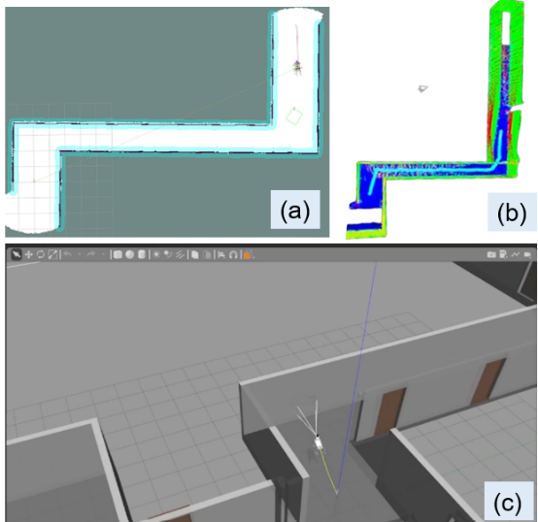
Figure 1: (a) 2D occupancy grid for navigation; (b) RTAB-Map SLAM visualization; (c) Robot dog operating in a simulation environment.

4.1 Real-World Setup
Real-world experiments were conducted to evaluate the system’s performance in an actual environment. The Unitree Go1 is equipped with an Ouster LiDAR and a RealSense camera as a modular sensor setup installed on top of the robot as shown in Figure 2.
In our platform configuration, the LiDAR sensor is connected to the Mini-PC via an Ethernet interface and powered by a dedicated 24V battery, while the Mini-PC itself is powered independently by a 19V battery and connected to the robot through a separate Ethernet link. This setup ensures that both components operate on isolated power supplies, avoiding reliance on the robot’s main battery and enhancing the overall robustness.

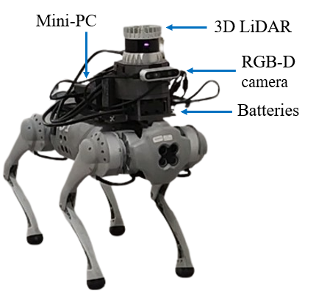
Figure 2: The Unitree Go1 is equipped with an Ouster LiDAR and an Intel RealSense camera, mounted using a custom-designed support system.

To streamline network initialization, we followed the official Ouster ROS 2 driver documentation and developed a custom script that automates the process. This script flushes existing IP addresses, assigns a static IP to the sensor, and modifies firewall settings to ensure uninterrupted communication. Once the network is configured, the sensor driver is launched, and its data stream is visualized using the ROS visualization tool (RViz), confirming proper initialization. Furthermore, a static transform between the sensor’s mount frame and sensor frame is established using tf2_ros, accurate alignment of the captured data. This automated startup ensures that all system components initialize seamlessly and are immediately ready for data acquisition.
Remote desktop access to the Mini-PC was configured using XRDP (X Remote Desktop Protocol) and Remmina, providing secure and efficient remote connectivity. XRDP is an open-source implementation of the Microsoft Remote Desktop Protocol (RDP) that allows users to access Linux-based systems through standard RDP clients. Remmina is a versatile remote desktop client that supports multiple protocols, including VNC, and SSH, making it well-suited for managing and monitoring devices from various platforms. Together, these tools enable remote control of the Mini-PC, eliminating the need for direct physical access.
To monitor the ROS topics externally, an additional laptop was used with the same ROS_DOMAIN_ID as the Mini-PC and configured with Cyclone DDS (Data Distribution Service). Although Cyclone DDS is not the default middleware in ROS 2, it demonstrated superior performance for Navigation2 (Nav2) in our tests—offering more stable communication, lower latency, and improved handling of large data throughput compared to alternatives.
This unified configuration across devices facilitates seamless communication and robust integration within the system, particularly when processing high-bandwidth data from the 3D LiDAR sensor. Additionally, the remote laptop can be used to launch ROS files that initialize all necessary SLAM and navigation nodes, allowing real-time command execution and system monitoring without requiring direct physical access to the robot.

4.2 Experiments Description
Our pipeline supports two distinct modalities for capturing point cloud data in unknown environments, namely navigation mode and inspection mode.

4.2.1 Navigation Mode
In navigation mode, unlike previous approaches that relied on teleoperation—for instance, joystick-based control for point cloud acquisition (Kim et al., 2022)—our system employs Navigation2 to enable fully autonomous exploration. Once the robot is initialized and all required nodes are launched, a local map of the surrounding environment is generated and visualized in RViz on a remotely connected laptop. This real-time visualization allows the operator to identify unexplored regions and define navigation goals, which are then transmitted to the navigation stack for autonomous path planning.
To evaluate the system's obstacle avoidance capabilities, various obstructions such as boxes were deliberately placed in corridors. The robot consistently succeeded in avoiding these obstacles and reached the specified goal positions. As the robot traverses the environment, an ICP-based registration technique is used to incrementally construct a detailed map from the acquired point cloud data. This fully automated approach enables reliable, real-time mapping and navigation in complex and dynamic environments, even when operating on a resource-constrained Mini-PC.

4.2.2 Inspection Mode
In navigation mode, the robot begins exploration without a predefined map, simultaneously navigating and constructing one.
In contrast, inspection mode assumes prior knowledge of the environment, where the inspection points—typically represented as two-dimensional coordinates—can be derived from the Building Information Modeling (BIM) data of the building. Although these 2D coordinates are essential for identifying specific inspection points, a full 3D map is not strictly required for the inspection process. Instead, the necessary spatial locations can be acquired in one of two ways: either by direct measurement using a laser scanner, or by constructing a 3D map during the robot’s autonomous exploration in navigation mode. This flexible approach allows the system to leverage existing BIM data or to quickly generate a spatial representation on-the-fly, ensuring that the critical inspection points are accurately obtained without the overhead of full 3D mapping when it is not needed.
The process begins with the robot positioned at a known location within a map, while continuously updating the local map—an essential capability in dynamic environments such as construction sites, where new objects may appear, and completed sections require updated mapping for further navigation and inspection. This increased level of autonomy eliminates the need for an operator during both inspection and point cloud acquisition.

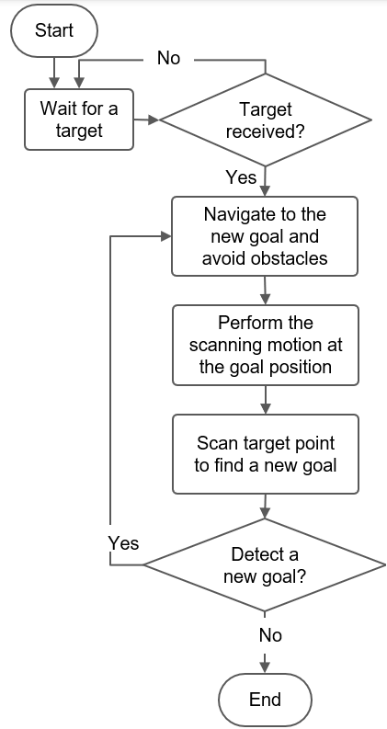
Figure 3: Flowchart of inspection mode

More formally, the complete inspection workflow follows a structured decision-making sequence, illustrated in Figure 3. Initially, the robot is positioned at the origin (0,0,0) relative to the known 2D inspection points and waits for a target assignment. In our implementation, target coordinates are stored in a file and retrieved sequentially, although dynamic assignment is also supported. Once a target is received, the robot autonomously navigates to the specified location while actively avoiding obstacles. During navigation, localization is maintained, and the environment map is continuously updated.
Upon reaching the goal, the robot executes a scanning motion that includes upward and downward head movements. During this scan, it attempts to detect a numerical identifier (e.g., a tag or marker) that may indicate the next inspection target. If a new goal is identified—either from the visual input or as the next entry in the file—the robot updates its target and begins a new navigation cycle, again prioritizing obstacle avoidance and localization accuracy.
This iterative process continues until all inspection targets are visited. Once the list of goals is finished and no new targets are detected, the inspection mission concludes, completing the autonomous data acquisition task. The structured nature of this workflow enables efficient autonomous exploration and inspection, making it particularly well-suited for applications such as industrial site monitoring, infrastructure inspection, and search-and-rescue operations.

4.3 Experimental Results
Our experiments demonstrate that the ICP-based registration method generally operated smoothly, effectively aligning successive point clouds to construct a coherent 3D map. However, occasional artifacts appeared in the scans, primarily due to sensor noise and the presence of sparse feature in long corridors. Simple filtering techniques were applied to reduce noise and eliminate these artifacts, thereby preserving essential structural details.
Figure 4 presents a point cloud representation of a corridor acquired during our experiments. The processed data clearly outlines key features, such as individual office doors, demonstrating the effectiveness of our reduction approach in maintaining critical mapping information.

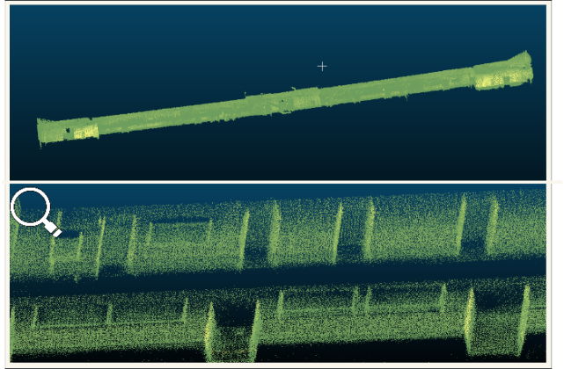Figure 4: Example Scan – Top: Full point cloud of our laboratory environment; Bottom: Zoomed-in view of the office section.

Figure 5 illustrates our inspection demonstration, where the target has been detected using an object detection algorithm and is highlighted in red. The image depicts the robot actively navigating the environment, with the highlighted region indicating the precise location of the next inspection point. This demonstration validates the system's ability to dynamically adapt to its surroundings while maintaining reliable detection and response capabilities for target-driven inspection tasks.

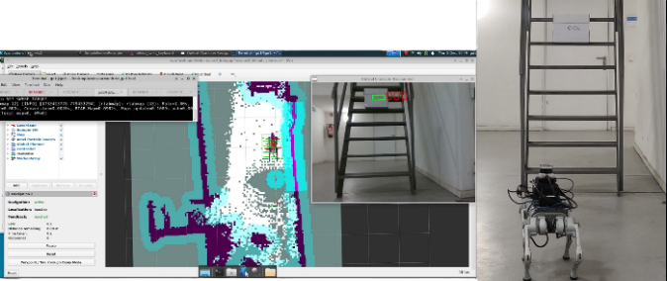
Figure 1: The robot (right) detects an inspection target, alongside the RViz panel (left) displaying the map.

Overall, the experimental results validate our system's capability for real-time 3D mapping and inspection in complex environments. While occasional artifacts due to sensor noise remain a challenge, the integration of robust ICP registration and effective filtering techniques provides a solid foundation for further refinement and real-world application.

5. DISCUSSION AND FUTURE WORK
The proposed pipeline is designed to support the construction and inspection sectors in integrating quadruped robots for autonomous navigation in unstructured environments, efficient point cloud data acquisition, and task-specific inspection operations.
Our current experiments were conducted on nearly planar surfaces. However, for deployment in real construction sites, where the terrain may be uneven, the leg controllers will need to be updated. Advanced control frameworks, such as Free Gait (Fankhauser et al., 2016), are specifically designed for legged robots and offer enhanced stability and adaptability on complex terrains. Additionally, while the ROS 2 Navigation Stack (Nav2) is primarily tailored for mobile robots, it may produce less smooth paths when applied to quadrupeds. Incorporating specialized path planners like the ART Planner (Wellhausen and Hutter, 2023) could significantly improve navigation performance for legged robots.
The primary processing was carried out on an ASRock 4x4 BOX-4800U Mini-PC. While this hardware proved sufficient for our experiments, integrating more energy-efficient, GPU-powered platforms (e.g., NVIDIA Orion) could offer significant advantages by supporting updated components and improved processing capabilities.
Additionally, an area that could be improved is the localization and mapping system. For example, integrating a method such as KISS-SLAM (Guadagnino et al., 2025) could enhance localization accuracy and further reduce artifacts in the generated maps by utilizing robust scan matching techniques.
Improving the text recognition and object detection capabilities within the inspection module would significantly boost its reliability. This could be achieved by leveraging foundational models like pre-trained vision transformers (e.g., DINO (Caron et al., 2021) or CLIP (Radford et al., 2021)), which offer adaptable recognition. Fine-tuning these models with domain-specific data—along with integrating techniques such as panoptic segmentation (Kirillov et al., 2019)—could increase semantic understanding and improve overall inspection accuracy.
Operational safety in construction environments is another crucial consideration. To ensure operators can maintain a safe distance from the robot, the system should include long-range communication solutions, such as additional antennas or a dedicated network, to establish a connection between the robot and an external remote laptop.
Future experiments should incorporate additional performance metrics to thoroughly evaluate system stability and mapping accuracy. For instance, using markers to measure the Absolute Trajectory Error (ATE) can provide quantitative insights into localization performance across diverse terrains and dynamic environments.
In summary, these enhancements—spanning improved hardware, localization algorithms, control frameworks, and communication strategies—will further refine the capabilities of robot dogs in complex, real-world construction and inspection scenarios.

6. Conclusion
In this study, we demonstrated a fully autonomous point cloud data acquisition framework using a low-cost quadrupedal robot (Unitree Go1) equipped with a 3D LiDAR sensor and an RGB-D camera. Through both simulation and real-world experiments, the robot successfully detected new target positions, autonomously navigated complex environments while avoiding obstacles, and continuously acquired high-quality point cloud data. The Ouster OS1-32 LiDAR sensor and RTAB-Map SLAM algorithm enabled accurate mapping and localization, supporting real-time navigation and environment reconstruction with minimal human intervention. Our experiments provide practical insights for the construction community, demonstrating how affordable legged robotic platforms can improve productivity, reduce safety risks, and streamline digital twin creation through automated scanning processes. This approach not only offers a time-efficient and cost-effective alternative to manual data collection but also lays the groundwork for future advancements in autonomous construction site monitoring and inspection. By making our codebase publicly available, we aim to help researchers and practitioners to further explore and extend the capabilities of quadrupedal robots in real-world construction environments.

The official codebase for our robot dog setup is publicly available at:
https://github.com/MooKol/unitree_go1

Acknowledgment
The research presented in this paper has received funding from the Deutsche Forschungsgemeinschaft as part of Research Unit 5672, "Digital Backbone of Robotized Construction", in project no 517965147. In addition, the authors thank the TUM Innovation Network "CoConstruct."

REFERENCES
ALATISE, M. B. & HANCKE, G. P. 2020. A review on challenges of autonomous mobile robot and sensor fusion methods. IEEE Access, 8, 39830-39846.
BELLICOSO, C. D., BJELONIC, M., WELLHAUSEN, L., HOLTMANN, K., GÜNTHER, F., TRANZATTO, M., FANKHAUSER, P. & HUTTER, M. 2018. Advances in real‐world applications for legged robots. Journal of Field Robotics, 35, 1311-1326.
BISWAL, P. & MOHANTY, P. K. 2021. Development of quadruped walking robots: A review. Ain Shams Engineering Journal, 12, 2017-2031.
BORRMANN, D., NÜCHTER, A., ÐAKULOVIĆ, M., MAUROVIĆ, I., PETROVIĆ, I., OSMANKOVIĆ, D. & VELAGIĆ, J. 2014. A mobile robot based system for fully automated thermal 3D mapping. Advanced Engineering Informatics, 28, 425-440.
CARON, M., TOUVRON, H., MISRA, I., JÉGOU, H., MAIRAL, J., BOJANOWSKI, P. & JOULIN, A. Emerging properties in self-supervised vision transformers. Proceedings of the IEEE/CVF international conference on computer vision, 2021. 9650-9660.
CHUNG, D., KIM, J., PAIK, S., IM, S. & KIM, H. 2025. Automated system of scaffold point cloud data acquisition using a robot dog. Automation in Construction, 170, 105944.
FANKHAUSER, P., BELLICOSO, C. D., GEHRING, C., DUBÉ, R., GAWEL, A. & HUTTER, M. Free gait—An architecture for the versatile control of legged robots. 2016 IEEE-RAS 16th International Conference on Humanoid Robots (Humanoids), 2016. IEEE, 1052-1058.
GUADAGNINO, T., MERSCH, B., GUPTA, S., VIZZO, I., GRISETTI, G. & STACHNISS, C. 2025. KISS-SLAM: A Simple, Robust, and Accurate 3D LiDAR SLAM System With Enhanced Generalization Capabilities. arXiv preprint arXiv:2503.12660.
HALDER, S. & AFSARI, K. 2023. Robots in inspection and monitoring of buildings and infrastructure: A systematic review. Applied Sciences, 13, 2304.
HU, D., GAN, V. J. & YIN, C. 2023. Robot-assisted mobile scanning for automated 3D reconstruction and point cloud semantic segmentation of building interiors. Automation in Construction, 152, 104949.
KIM, J., CHUNG, D., KIM, Y. & KIM, H. 2022. Deep learning-based 3D reconstruction of scaffolds using a robot dog. Automation in Construction, 134, 104092.
KIRILLOV, A., HE, K., GIRSHICK, R., ROTHER, C. & DOLLÁR, P. Panoptic segmentation. Proceedings of the IEEE/CVF conference on computer vision and pattern recognition, 2019. 9404-9413.
LABBÉ, M. & MICHAUD, F. 2019. RTAB‐Map as an open‐source lidar and visual simultaneous localization and mapping library for large‐scale and long‐term online operation. Journal of field robotics, 36, 416-446.
MACENSKI, S., MARTÍN, F., WHITE, R. & CLAVERO, J. G. The marathon 2: A navigation system. 2020 IEEE/RSJ International Conference on Intelligent Robots and Systems (IROS), 2020. IEEE, 2718-2725.
RADFORD, A., KIM, J. W., HALLACY, C., RAMESH, A., GOH, G., AGARWAL, S., SASTRY, G., ASKELL, A., MISHKIN, P. & CLARK, J. Learning transferable visual models from natural language supervision. International conference on machine learning, 2021. PmLR, 8748-8763.
SEGAL, A., HAEHNEL, D. & THRUN, S. Generalized-icp. Robotics: science and systems, 2009. Seattle, WA, 435.
TORRES, M. A. V. & PFITZNER, F. 2024. Investigating Robot Dogs for Construction Monitoring: A Comparative Analysis of Specifications and On-site Requirements. arXiv preprint arXiv:2409.15253.
WANG, Q., TAN, Y. & MEI, Z. 2020. Computational methods of acquisition and processing of 3D point cloud data for construction applications. Archives of computational methods in engineering, 27, 479-499.
WELLHAUSEN, L. & HUTTER, M. 2023. Artplanner: Robust legged robot navigation in the field. Field Robotics, 3, 413-434.
WOLF, D., HOWARD, A. & SUKHATME, G. S. Towards geometric 3D mapping of outdoor environments using mobile robots. 2005 IEEE/RSJ International Conference on Intelligent Robots and Systems, 2005. IEEE, 1507-1512.
YIN, H., LIEW, J. M., LEE, W. L., ANG JR, M. & YEOH, J. K. Towards BIM-based robot localization: A real-world case study. ISARC. Proceedings of the International Symposium on Automation and Robotics in Construction, 2022. IAARC Publications, 71-77.

