A Point Cloud-based Floor Flatness Evaluation Method for Ensuring the Safety of Indoor Service Robot Operation
Seungha Seo¹, Hojeong Jeong¹, Yoonho Jang¹, Sungjin Kim^{1,*}

¹ Hanbat National University, Daejeon, South Korea
*Corresponding email: sungjinkim@hanbat.ac.kr

ABSTRACT
Population aging and labor shortages have led to the increasing use of service robots in hospitals, public facilities, commercial buildings, and other indoor environments. Although building floors are generally designed to be sufficiently flat for human walking, localized surface irregularities, level differences, finishing transitions, and joints may affect the navigation stability and safe operation of wheeled service robots. However, existing floor flatness evaluations have mainly been conducted for construction quality control and finishing inspection, and they have limitations in assessing floor conditions along planned robot navigation routes before operation. Therefore, this study proposes a point cloud-based pre-evaluation method for identifying floor flatness conditions that may influence indoor service robot navigation. Floor geometry data are acquired along planned robot navigation routes using a LiDAR sensor, and a flatness analysis procedure consisting of noise removal, floor region extraction, reference plane estimation, point-to-plane deviation calculation, and threshold-based classification is applied. The calculated deviations are visualized as a color-based flatness map, enabling localized uneven areas and level differences that are difficult to identify through visual inspection to be examined in both visual and quantitative forms. Application results using indoor floor point cloud data show that the proposed method can represent floor conditions at the level of robot navigation routes and pre-identify areas that may require further inspection before robot deployment. This study presents a preliminary analysis method for evaluating floor flatness from the perspective of robot operation. However, it does not include full validation of navigation performance through actual robot driving experiments; future research will quantitatively analyze the relationship between floor flatness deviations and robot navigation stability indicators.

- INTRODUCTION
Population aging and the resulting decline in the labor force have been identified as significant social challenges on a global scale (United Nations, 2020). In response to these changes, the adoption of service robots as substitutes for or supplements to human labor has been accelerating across various service sectors. In particular, service robots have increasingly been deployed in indoor environments such as hospitals, public facilities, and commercial buildings for tasks including guidance, delivery, and cleaning (Elara, Rojas & Chua, 2014). As the use of these robots expands, ensuring stable and safe navigation in built environments has become an important issue.
Indoor service robots are affected not only by their hardware, control algorithms, and sensor perception performance, but also by the physical conditions of the environments in which they operate. Although indoor floors are generally designed to be sufficiently flat for human circulation, localized surface irregularities, level differences, slopes, joints, and finishing transitions may still affect wheeled service robots. These floor conditions can change the contact relationship between the wheels and the floor, causing reduced driving stability, vibration, path deviation, or even interruption of navigation. In particular, recent research on robot inclusivity in buildings has suggested that surface unevenness can be considered an environmental factor for assessing the suitability of indoor spaces for mobile service robot operation (Borusu et al., 2024). Previous studies on robot-inclusive spaces and uneven indoor navigation have also indicated that floor conditions can influence robot coverage, navigable area recognition, path planning, sensing, localization, and driving stability (Elara, Rojas & Chua, 2014; Wang et al., 2017; Wang et al., 2019; Borusu et al., 2024). Therefore, floor flatness needs to be examined not only as a construction quality criterion, but also as an environmental condition that may affect indoor robot operation.
However, current floor flatness evaluations are primarily conducted for construction quality control and verification of finishing conditions. Standards such as ASTM E1155/E1155M provide methods for determining FF floor flatness and FL floor levelness numbers from the perspective of construction quality management (ASTM International, 2023). While such approaches are useful for evaluating floor surfaces as building elements, they have limitations in assessing localized floor conditions along planned robot navigation routes. In particular, conventional floor flatness evaluation methods do not sufficiently address whether local unevenness, level differences, or finishing transitions may affect service robot navigation before robot deployment.
This study proposes a point cloud-based pre-evaluation method for assessing floor flatness along planned indoor service robot navigation paths. Floor geometry data are acquired using a LiDAR sensor, and floor regions are analyzed to identify localized unevenness and level differences that may affect robot navigation. By visualizing and quantifying floor flatness conditions at the route level, the proposed method aims to support the prior identification of potentially problematic areas and provide foundational information for assessing the suitability of indoor spaces for service robot operation.

- LITERATURE REVIEW
2.1 Floor Flatness Evaluation in the Built Environment
Floor flatness is one of the key indicators used to assess construction quality and usability of buildings, and various criteria and measurement methods have been proposed to evaluate floor finishing conditions after construction. To quantitatively assess floor flatness, standards such as ASTM E1155 have been established (ASTM International, 2023), and based on these standards, methods for calculating floor flatness (FF) and floor levelness (FL) as statistical indices have been studied. Such index-based evaluations have primarily been applied for quality control of floors in industrial and warehouse facilities; however, they have been criticized for involving complex measurement procedures and for maintaining a high level of dependence on manual data collection processes (ASTM International, 2023).
To overcome these limitations, studies on floor flatness evaluation using three-dimensional measurement technologies such as Terrestrial Laser Scanning (TLS) have been conducted. TLS enables the acquisition of point cloud data representing floor surfaces, allowing continuous analysis of floor geometry and more efficient flatness measurement compared to conventional manual methods (Li et al., 2020). Some studies have utilized TLS-based point cloud data to visualize floor conditions in a digital environment and have proposed algorithms for automatically detecting localized unevenness and level differences on floor surfaces (Li et al., 2024). Such approaches have been applied to support construction quality inspection and repair processes by visualizing flatness evaluation results for large floor areas in the form of color maps or pass rates (Bosché & Guenet, 2014).
In addition, tools have been proposed to automatically segment concrete slab regions from point cloud data and to automatically calculate FF and FL values in accordance with the ASTM E1155 standard (Hayes et al., 2024). These studies demonstrate that the automation of floor flatness and levelness evaluation can significantly improve the efficiency of construction quality management. However, such studies primarily focus on quality assessment at the floor-wide or slab level, and their analysis results are largely presented as indicators for determining compliance with construction standards, with an emphasis on post-construction quality inspection.
In summary, existing studies on floor flatness evaluation have been primarily conducted with a focus on construction quality management. While these studies emphasize automation and improved measurement accuracy through TLS and point cloud–based technologies, they mainly interpret and assess floors as construction elements. As a result, there are limitations in extending such approaches to interpret floor flatness from the perspective of architectural finishes and environments for service robot navigation, or to apply them as pre-validation methods at the level of robot navigation paths.

2.2 Wheeled Indoor Service Robots and Floor Conditions
Wheeled locomotion systems are widely adopted in indoor service robots because they offer practical advantages in terms of structural simplicity, energy efficiency, and mobility on generally flat indoor floors. Indoor environments such as hospitals, logistics facilities, and public buildings are typically characterized by relatively flat and continuous circulation surfaces, making wheeled locomotion suitable for service robot operation in these spaces (Elara, Rojas & Chua, 2014; Siegwart, Nourbakhsh & Scaramuzza, 2011). Figure 2 presents examples of wheel-driven indoor service robots.

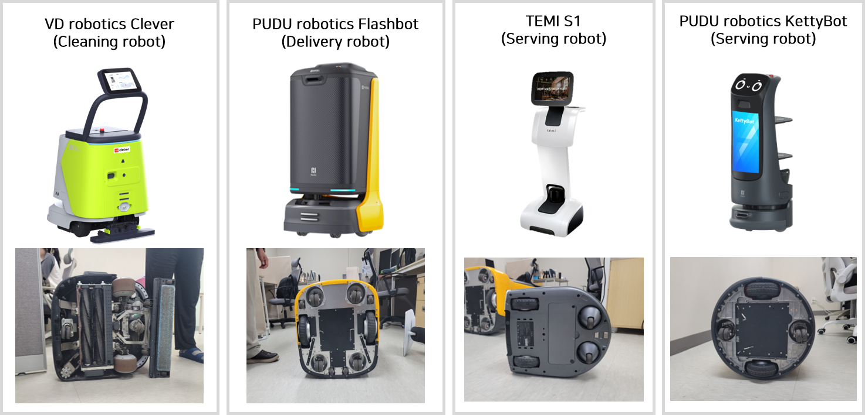
Figure 2. Example of wheel-driven indoor robots
However, the navigation performance and stability of wheeled indoor service robots are influenced not only by sensor perception, path planning, and control algorithms, but also significantly by the physical conditions of the floor surfaces on which they operate. Because wheeled robots remain in continuous contact with the floor during movement, surface unevenness and level differences can alter wheel–floor contact conditions and affect driving performance and motion stability. In particular, floor irregularities such as slopes, level differences, surface unevenness, finishing transitions, and joints have been identified as factors that may restrict navigable areas and lead to reduced driving stability and degraded navigation performance (Elara, Rojas & Chua, 2014; Wang et al., 2019).
Previous studies have addressed mobile robot navigation in indoor environments, highlighting floor conditions such as ramps and level differences as key constraints for robot navigation. These studies propose methods for determining navigable areas and planning paths based on three-dimensional environmental perception and terrain analysis, and demonstrate that even in indoor environments, the uniformity of floor geometry directly affects robot driving stability and the path planning process (Wang et al., 2017; Wang et al., 2019).
Meanwhile, studies have also been reported that analyze the impact of floor conditions on robot navigation performance from an architectural perspective. These studies quantitatively examine how vibrations induced by surface irregularities can affect the quality of robot sensor data and driving stability. Furthermore, by indexing floor unevenness to evaluate the robot inclusivity of buildings, they suggest the potential of floor conditions as a key factor for assessing the suitability of built environments for robot operation (Elara, Rojas & Chua, 2014; Ng et al., 2022).
Conventional built environments have traditionally been designed primarily for the safety and convenience of human occupants, while environmental conditions for indoor robot operation have received comparatively limited consideration. Studies on robot-inclusive built environments suggest that robot navigation issues should not be addressed solely through improvements in control algorithms or sensor performance, but should also consider the physical environments in which robots operate as objects of design and assessment. From this perspective, floor conditions can be regarded as environmental factors that should be examined prior to robot operation rather than addressed only after navigation problems occur.
These previous studies commonly emphasize that physical floor conditions, such as level differences, slopes, and surface unevenness, have a significant impact on robot navigation and driving performance. However, they primarily focus on how robots perceive, detect, and respond to floor conditions during operation, while discussions on methods for pre-validating the floor conditions of planned navigation routes to assess navigability during the robot operation planning stage remain limited.

2.3 Floor Flatness for Robot Navigation
In the field of architecture, floor flatness has been used not only as a criterion for construction quality control but also as an important consideration for ensuring safe and accessible circulation within buildings. In particular, floor level differences and slopes in circulation areas such as lobbies, corridors, and entrances are considered important design factors for wheeled users, including wheelchair users and strollers (Steinfeld & Maisel, 2012). From this perspective, floor flatness can be interpreted not only as a finishing quality criterion but also as an environmental condition related to the stable movement of wheeled agents, including indoor robots.
Similar to other wheeled users, indoor service robots can also be affected by localized level differences, surface irregularities, and discontinuities in floor surfaces. However, existing floor flatness and accessibility criteria have primarily been established for construction quality or human users and therefore have limitations in directly reflecting the characteristics of robot navigation routes and repetitive robot operation.
Accordingly, this study reinterprets floor flatness from the perspective of indoor robot navigation. Rather than applying conventional flatness evaluation solely as a criterion for determining compliance with construction standards, the proposed approach examines floor conditions along planned robot navigation routes prior to operation to identify localized surface irregularities and level differences. By focusing on route-level floor conditions, the approach provides a basis for pre-assessing indoor environments from the perspective of service robot navigation.

- METHODOLOGY

3.1 Research Framework
This study proposes a point cloud-based methodology for pre-evaluating floor flatness along planned indoor service robot navigation routes. The purpose of the methodology is to identify localized floor unevenness and level differences that may affect robot navigation before robot deployment. Unlike conventional floor flatness evaluations that mainly focus on construction quality control, the proposed approach focuses on route-level floor conditions from the perspective of indoor service robot operation.
As shown in Figure 1, the proposed methodology consists of three main stages: data acquisition, point cloud-based floor flatness analysis, and visualization of the analysis results. In the first stage, floor geometry data are acquired using a LiDAR sensor along planned robot navigation routes, such as corridors, lobbies, and other continuous circulation areas. The measurement target is limited to areas where indoor service robots are expected to travel, so that the analysis can focus on floor conditions directly related to robot operation.
In the second stage, the acquired point cloud data are processed to extract the floor region and analyze floor flatness. Basic noise filtering is first performed to reduce measurement errors and irrelevant points. Then, the floor region is extracted from the point cloud, and a reference floor plane is estimated. Based on this reference plane, point-to-plane height deviations are calculated for individual floor points. These deviations are used to identify localized surface irregularities and level differences that may influence wheeled robot navigation.
In the third stage, the calculated deviations are classified using predefined threshold ranges and visualized as a color-based flatness map. Areas with relatively small deviations are represented as stable floor regions, while areas with larger deviations are highlighted as locations requiring further inspection. Through this process, the proposed methodology enables floor flatness conditions to be examined at the level of planned robot navigation routes and supports the prior identification of potentially problematic areas before robot operation.

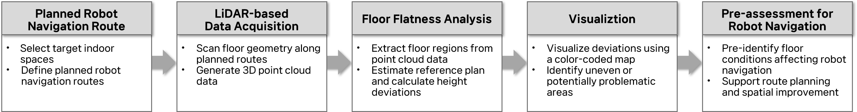
Figure 1. Methodology

3.2 Proposed Floor Flatness Analysis Algorithm
The floor flatness analysis algorithm used in this study was implemented to evaluate floor surface conditions from LiDAR-based point cloud data. The algorithm identifies localized unevenness and level differences by estimating a reference floor plane and calculating the deviation of each point from this plane. As shown in Figure 3, the overall process consists of point cloud data input, SOR-based noise removal and floor point extraction, reference plane estimation using RANSAC, distance calculation from the reference plane, threshold-based classification, and visualization of the analysis results.
First, the input point cloud data are preprocessed using Statistical Outlier Removal (SOR) to reduce the influence of noise and isolated points. This process helps remove points that may have been generated by objects other than the floor surface or by measurement errors. After preprocessing, a reference floor plane is estimated using the RANSAC algorithm. RANSAC is applied to robustly estimate the representative floor plane by reducing the influence of local irregularities and remaining outliers.
After estimating the reference plane, the distance between each point and the reference plane is calculated. This distance is interpreted as the height deviation of the floor surface and is used to identify localized surface irregularities and level differences. The calculated deviations are then classified based on a predefined reference threshold. In this study, a reference value of 10 mm was adopted based on the Korean Construction Specification KCS 14 20 10, which specifies a standard flatness value of 10 mm over a 3 m length for concrete surfaces requiring relatively good flatness and identifies substrates for tile, carpet, and waterproofing finishes as applicable examples (Ministry of Land, Infrastructure and Transport, 2024). The threshold in the proposed algorithm is not fixed and can be adjusted according to the applicable construction specification, floor condition, and assessment purpose.
The classified results are visualized as a color-coded flatness map, allowing the spatial distribution of floor conditions to be intuitively examined along planned robot navigation routes. In this study, the algorithm is not intended to replace conventional construction quality control standards, but rather to support route-level pre-assessment of floor conditions from the perspective of indoor service robot navigation.
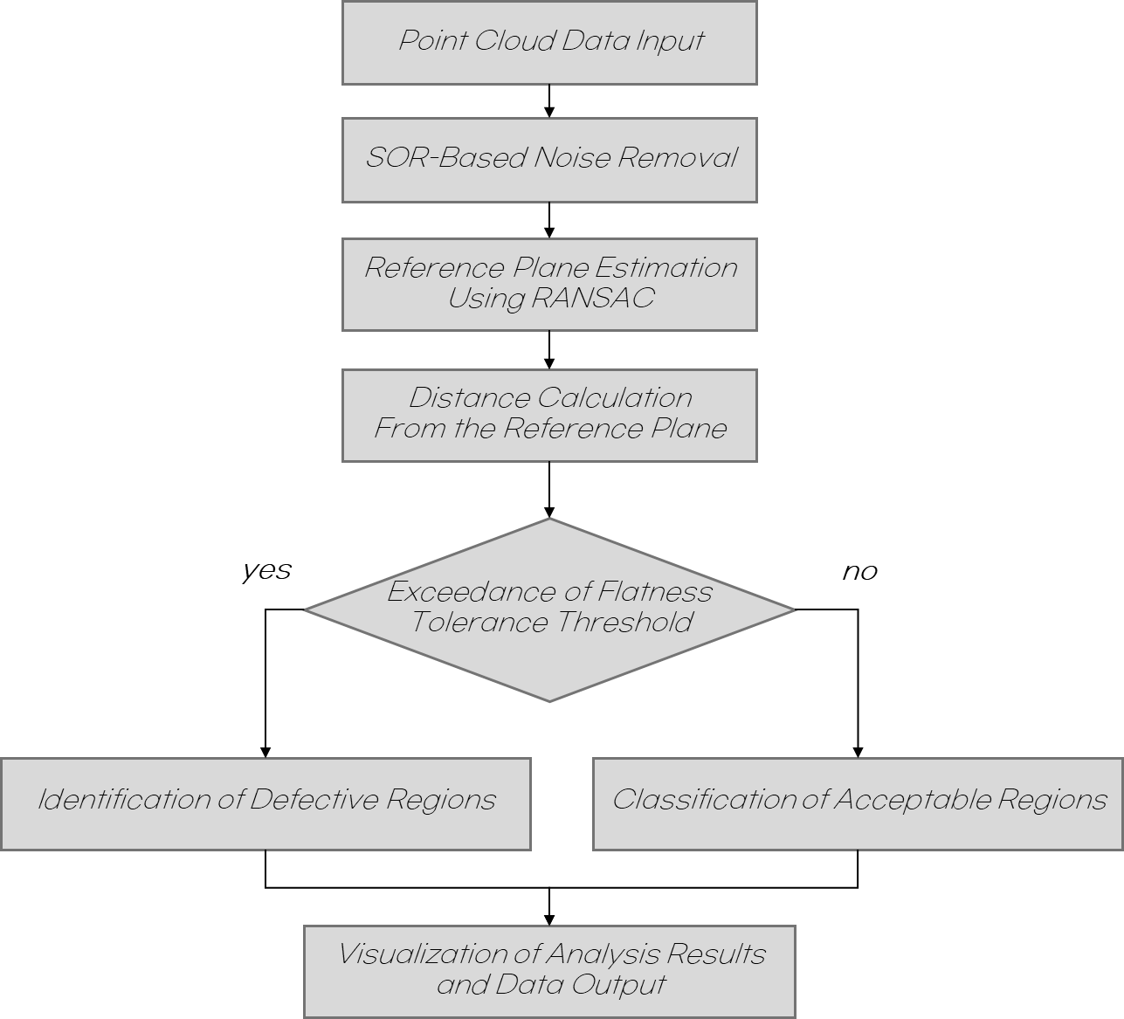
Figure 3. Floor flatness analysis pipeline

- DEMONSTRATION OF FLOOR FLATNESS PRE-ASSESSMENT FOR INDOOR NAVIGATION
This section demonstrates the applicability of the proposed floor flatness analysis algorithm by applying it to real indoor floor point cloud data. The objective is to examine the potential of the proposed method for pre-assessing floor conditions prior to indoor service robot operation by visually representing the spatial distribution of floor height deviations. The analysis is intended as a demonstration of the proposed method rather than a quantitative validation of robot navigation performance.
Using the indoor floor point cloud data, the proposed algorithm calculates height deviations of floor points with respect to the estimated reference plane and visualizes the results as a color-coded flatness map. As shown in Figure 4, areas with relatively small deviations are represented in green, while areas with larger deviations are highlighted in yellow or red. In this visualization, red regions indicate potentially uneven areas that may require further inspection before indoor service robot operation.
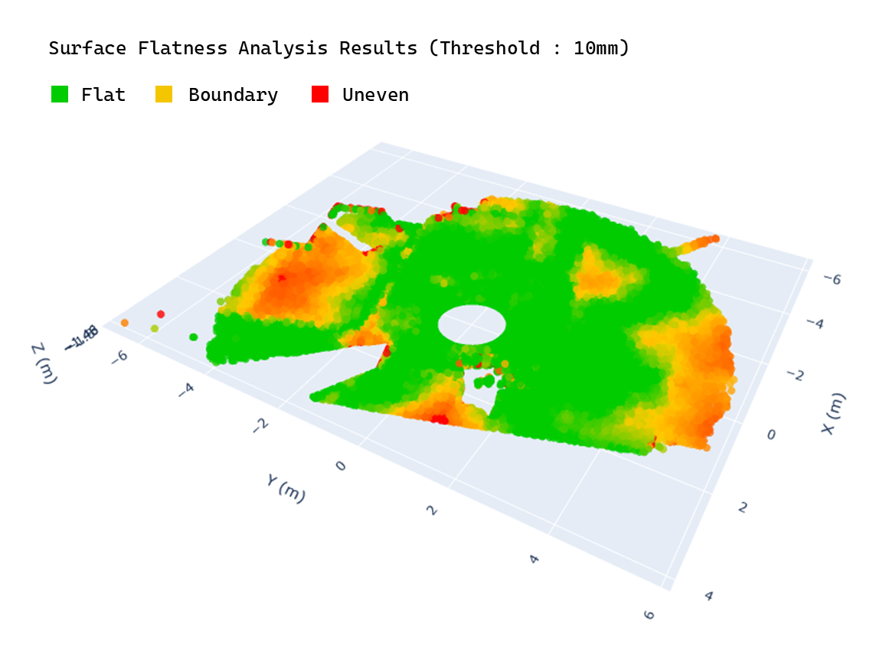
Figure 4. Floor flatness visualization
The visualization results allow floor conditions to be examined spatially along planned robot navigation routes, rather than being interpreted only through a single numerical value. This makes it possible to identify localized unevenness or level differences that may be difficult to recognize through visual inspection alone. Although this result does not directly validate robot driving performance, it demonstrates that the proposed method can support route-level pre-assessment of floor conditions and provide useful information for robot deployment planning, navigation route adjustment, and spatial maintenance decisions.

- DISCUSSION AND CONCLUSION
This study focuses on the need for pre-assessing the navigation stability of service robots operating in indoor environments from an architectural perspective and presents floor flatness as an indicator for evaluating robot navigability. Unlike previous studies that have primarily concentrated on robot hardware and software aspects, this study emphasizes the importance of examining the built environment in which robots operate as a critical factor for robot navigation.
To this end, the conventional concept of floor flatness—originally defined for construction quality control and pedestrian accessibility—is reinterpreted from the perspective of indoor robot navigation. This study proposes an analytical approach for identifying localized surface irregularities and level differences along actual robot navigation routes and introduces a flatness analysis algorithm to support this interpretation. In addition, by applying the proposed method to indoor floor geometry data acquired using a LiDAR sensor, this study illustrates the potential to intuitively represent floor conditions and to pre-identify areas that may affect robot navigation performance.
This approach is meaningful in that it shifts the focus from reactive responses to navigation issues encountered during robot operation to proactive examination of the built environment prior to robot deployment. The proposed method can serve as foundational information to support decision-making in robot navigation route planning, indoor space design, maintenance, and renovation processes. Furthermore, the findings of this study have the potential to be extended into an environmental evaluation framework for robot-inclusive buildings in future research.
However, this study does not extend to quantitatively validating the performance of the flatness algorithm or evaluating navigation stability through actual robot driving experiments. Future research will focus on quantitatively analyzing the relationship between floor flatness and navigation performance through driving experiments involving various types of robots, and on deriving flatness criteria tailored to different robot types.

ACKNOWLEDGEMENTS
This work is supported by the Korea Agency for Infrastructure Technology Advancement (KAIA) grant funded by the Ministry of Land, Infrastructure and Transport under the Smart Building R&D Program (Grant Number: RS-2025-02532980)

REFERENCES
ASTM International, (2023). Standard test method for determining FF floor flatness and FL floor levelness numbers. ASTM E1155/E1155M-23. ASTM International, West Conshohocken, PA, USA.
Bosché, F. & Guenet, E., (2014). Automating surface flatness control using terrestrial laser scanning and building information models. Automation in Construction, 44: p. 212–226. DOI: 10.1016/j.autcon.2014.03.028.
Borusu, C.S.C.S., Yeo, M.S.K., Zeng, Z., Muthugala, M.A.V.J., Budig, M., Elara, M.R. & Wang, Y., (2024). Evaluating the robot inclusivity of buildings based on surface unevenness. Applied Sciences, 14(17): 7831. DOI: 10.3390/app14177831.
Elara, M.R., Rojas, N. & Chua, A., (2014). Design principles for robot inclusive spaces: A case study with Roomba. In Proceedings of the 2014 IEEE International Conference on Robotics and Automation (ICRA). Hong Kong, China, p. 5593–5599. DOI: 10.1109/ICRA.2014.6907681.
Hayes, N.W., Maldonado, B.P., Tang, M. & Hun, D., (2024). Flat and Level Analysis Tool (FLAT) for real-time automated segmentation and analysis of concrete slab point clouds. In Proceedings of the 41st International Symposium on Automation and Robotics in Construction (ISARC). Lille, France, p. 838–846. DOI: 10.22260/ISARC2024/0109.
International Federation of Robotics, (2023). World Robotics 2023 – Service Robots. International Federation of Robotics, Frankfurt am Main, Germany.
Ministry of Land, Infrastructure and Transport. (2024). KCS 14 20 10: General Concrete. Korean Construction Specification, Ministry of Land, Infrastructure and Transport, Republic of Korea.
Li, D., Liu, J., Feng, L., Zhou, Y., Liu, P. & Chen, Y.F., (2020). Terrestrial laser scanning assisted flatness quality assessment for two different types of concrete surfaces. Measurement, 154: 107436. DOI: 10.1016/j.measurement.2019.107436.
Li, X., Li, H., Jiao, T., Chi, C. & Huang, M., (2024). Flatness detection of super-flat emery floor based on terrestrial laser scanning. Vibroengineering Procedia, 54: p. 186–192. DOI: 10.21595/vp.2024.23883.
Ng, Y.J., Yeo, M.S.K., Ng, Q.B., Budig, M., Muthugala, M.A.V.J., Samarakoon, S.M.B.P. & Mohan, R.E., (2022). Application of an adapted FMEA framework for robot-inclusivity of built environments. Scientific Reports, 12: 3408. DOI: 10.1038/s41598-022-06902-4.
Siegwart, R., Nourbakhsh, I.R. & Scaramuzza, D., (2011). Introduction to Autonomous Mobile Robots, 2nd ed. The MIT Press, Cambridge, MA, USA.
Steinfeld, E. & Maisel, J., (2012). Universal Design: Creating Inclusive Environments. John Wiley & Sons, Hoboken, NJ, USA.
United Nations, (2020). World Population Ageing 2020 Highlights. United Nations, New York, USA.
Wang, C., Meng, L., She, S., Mitchell, I.M., Li, T., Tung, F., Wan, W., Meng, M.Q.-H. & de Silva, C.W., (2017). Autonomous mobile robot navigation in uneven and unstructured indoor environments. In Proceedings of the 2017 IEEE/RSJ International Conference on Intelligent Robots and Systems (IROS). Vancouver, BC, Canada, p. 109–116. DOI: 10.1109/IROS.2017.8202145.
Wang, C., Wang, J., Li, C., Ho, D., Cheng, J., Yan, T., Meng, L. & Meng, M.Q.-H., (2019). Safe and robust mobile robot navigation in uneven indoor environments. Sensors, 19(13): 2993. DOI: 10.3390/s19132993.

