GPlanDes: A Two-Approach Tool for Automated Layout Generation Across Different Design Scenarios
Nikita Soni^{1,*}, Krishnendra Shekhawat ¹, Rishabh Pal¹, Kush Natani

¹ Birla Institute of Technology and Science Pilani, Vidya Vihar, India
*Corresponding email: p20230057@pilani.bits-pilani.ac.in

ABSTRACT
This paper presents a computational tool for automated floor plan generation that combines two complementary methodologies, enabling it to address a broader range of design scenarios than tools built around a single approach. The first uses graph-theoretic principles to generate dimensioned layouts within a rectangular plot from a user-specified room adjacency graph. The second is an optimization-based method designed for more general rectilinear plots that may contain fixed regions and additional non-adjacency requirements; it places rooms through an iterative stochastic search and refines the resulting layout using a multi-stage spatial optimization procedure. Together, the two methodologies allow the tool to move between regular, topology-driven layouts and irregular, constraint-heavy ones within a single platform. The proposed tool offers a flexible, constraint-aware approach to early-stage floor plan generation for both regular and irregular plot configurations, and is available via a web-based interface that offers access to both methodologies.

- INTRODUCTION
Due to the substantial expertise and effort required by the manual floor-planning process, there has been increased adoption of computational design methods in the Architecture, Engineering, and Construction (AEC) domain. Consequently, automated layout generation has emerged as a promising approach to assist designers in the early stages of design.
Many researchers have advanced automated floor plan generation over the last four decades, categorizing methods into graph-based, optimization-based, and learning-based approaches. Graph-theoretic methods treat rooms as vertices and their relationships as edges. Dual-graph techniques enable the reproduction and customization of floor plans while maintaining connectivity (Wang et al., 2018), and mathematical models translating adjacency graphs into dimensioned layouts have proven robust and scalable, generating thousands of designs (Bisht et al., 2022). Tools like GPLAN generate dimensioned layouts from adjacency requirements by combining graph theory and linear optimization (Shekhawat et al., 2021). Recent slicing-tree methods enable the creation of non-rectangular boundaries that can be partitioned into dimensioned blocks and rooms, resulting in comprehensive floor plans (Pinki et al., 2024). These methods ensure adjacency preservation, making them ideal for topology-driven designs.
Optimization-based methods use techniques such as simulated annealing, evolutionary algorithms, and mixed-integer programming for layout generation. Mixed-integer programming effectively combines various constraints (Keatruangkamala & Sinapiromsaran, 2005; Wu et al., 2018). Hybrid evolutionary and greedy algorithms have proven effective in real-world applications (Nisztuk & Myszkowski, 2019), and genetic optimization has been used for apartment layouts with polygonal envelopes (Laignel et al., 2021). Recently, a self-organizing multi-agent system paired with Monte Carlo tree search has been employed for adaptive layout generation in high-rise residential designs (Su et al., 2024). These methods excel in handling complex constraints but often require higher computational costs.
Learning-based methods for floor plan synthesis use deep learning and generative models to synthesize designs from existing designs. Techniques like graph-constrained generative adversarial networks (Nauata et al., 2020) and bubble-diagram generation (Aalaei et al., 2023) improve layout generation, while Transformer-based encoders (Tang et al., 2024) enhance room relations. Alternatives such as Graph2Plan (Hu et al., 2020) map layouts directly to dimensioned plans without adversarial training, and a diffusion model used by Hong et al. (2024) achieves similar results. Despite creating visually appealing layouts, these methods may lack geometric feasibility and strict constraint satisfaction, limiting their effectiveness in contexts requiring such adherence.
Existing methods struggle to preserve topological structure and geometric precision, often failing across various floor-planning configurations. Graph-based methods adhere strictly to given adjacencies, as well as rectangular rooms and boundaries. On the other hand, existing optimization-based approaches can effectively handle rectilinear boundaries and adjacencies, but they are computationally intensive and may not satisfy adjacency requirements. Learning-based methods are less affected by plot geometry but do not guarantee geometrically feasible outputs or adherence to constraints. This paper introduces a tool that integrates a constraint-driven, graph-based method for rectangular plots with an efficient optimization-based method for rectilinear plots with fixed spacing, enabling flexible and effective automated floor-plan generation (see Figure 1 for an input-output overview). Moreover, a web-based interface has been developed for accessing both methodologies and is available at http://app.gplan.in.

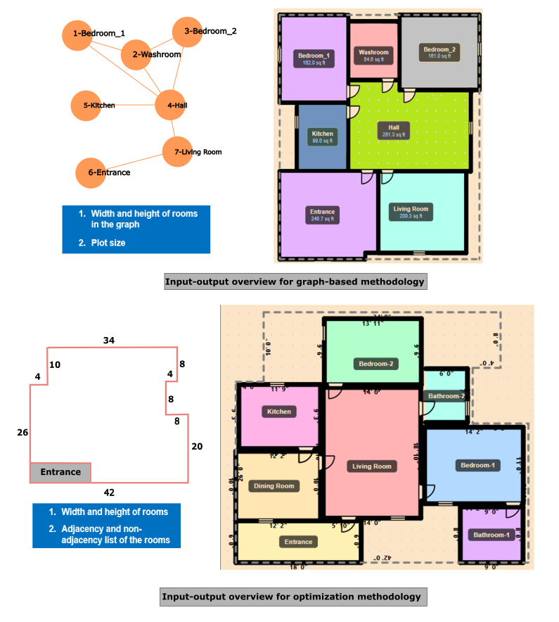
Figure 1: Figure containing input-output overview for both methodologies.

Terminology
  - Graph and Floor Plans
A graph $G(V, E)$ consists of a non-empty finite set of vertices $V$and a set of edges $E ⊆ V × V,$ where an edge $(u, v)∈E$ represents a relation between $u$ and $v$. In the context of floor plan generation, vertices represent rooms and edges indicate adjacency. Its plane drawing is known as plane graph, dividing the plane into regions called faces: the unbounded face is the outer (exterior) face, remaining faces termed interior, and edges and vertices on the outer face are likewise termed exterior, all others interior. A plane graph in which every interior face is a triangle (a 3-cycle) is a plane triangulated graph (PTG); whenever two 3-cycles in a PTG share an edge, the four vertices involved form a 4-cycle.
A path is a sequence of vertices in which each consecutive pair is joined by an edge, and a graph is biconnected if removing any single vertex still leaves every remaining pair of vertices connected by such a path. For instance, deleting a vertex 6 from the PTG in Figure 2(a) disconnects the graph, whereas the graph in Figure 2(b) has no such vertex.

  - Properly Triangulated Plane Graph (PTPG) and Rectangular Floor Plan (Bhasker, J., & Sahni, S., 1986)
A biconnected, PTG without a 3-cycle that has an interior vertex is termed a Properly Triangulated Plane Graph (PTPG). A floor plan in which all rooms and the outer boundary are rectangular is termed a rectangular floor plan (RFP). PTPGs represent a complete topological neighborhood structure for RFPs: adjacent rooms sharing a triangular face indicate a feasible arrangement of rectangular rooms. For instance, in the PTPG shown in Figure 2(b), adjacent vertices 2 and 6 share triangular faces, suggesting a layout of rectangles 2, 7, 1, and 6 that eliminates vacant spaces and ensures accessibility within the corresponding RFP.
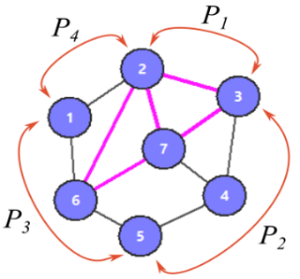
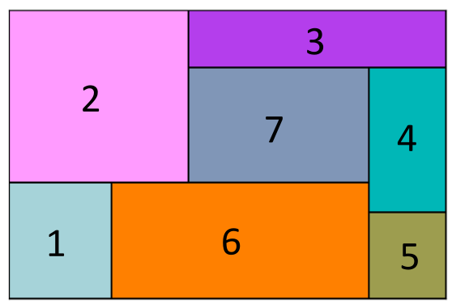
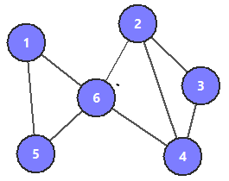
Let $B = \{P₁, P₂, P₃, P₄\}$ be a set of consecutive paths on the outer cycle, then $P₁, P₂, P₃,$ and $P₄$ represent the north, east, south, and west walls of the RFP, respectively, termed as boundary paths. Figures 1(b) and 1(c) show a PTPG and its RFP, with the paths marked according to the walls.
(b)
(a)
(c)
Figure 2: (a) PTG having vertex 6 whose deletion disconnects the graph, (b) PTPG with the boundary paths for the corresponding RFP shown in (c), and (c) RFP corresponding to the PTPG in (b).

  - Tutte Embedding (Tutte, W. T. 1963)
The Tutte embedding (or barycentric embedding) of a 3-connected planar graph is a planar straight-line drawing that positions outer face vertices at convex locations and places interior vertices at the barycenter of their neighbors.

  - Constraint Graphs for Wall Placement (Schwarz, A., Berry, D.M., & Shaviv, E., 1994)
Given an RFP, the horizontal and vertical wall positions are encoded as two weighted directed graphs, termed wall constraint graphs. The horizontal constraint graph $G_{x} \left(V_{x}, E_{x}, W_{x}\right)$ captures ordering constraints between horizontal walls (parallel to the y-axis): each vertex $u∈V_{x}$represents a horizontal wall, and a directed edge $\left(u,v\right)∈E_{x}$ with non-negative weight $w$ indicates that the wall $v$ must lie at least w units above wall u, while a negative weight w′ indicates that $v$ must lie at most $w'$ units above $u$. And graph $G_{y}(V_{y}, E_{y}, W_{y})$ captures the corresponding ordering constraints between vertical walls (parallel to the x-axis), defined analogously, with the right wall replacing the above wall.

- CONSTRAINT-DRIVEN GRAPH-BASED LAYOUT GENERATION
The method uses a list of rooms and their dimensions, a graph $(D)$ of the given rooms, and the rectangular plot size to generate layouts. It consists of two phases: (1) Multiple PTPG generation and (2) PTPG-to-multiple layout generation. Phase 1 uses a PTPG derived from the given graph $D$, which can be derived from adjacency matrices commonly used in practice. Then, using the base PTPG from the graph $D$ as a base, it derives multiple PTPG variants by applying structural transformations. Phase 2 then processes these PTPGs one at a time to generate layouts. The following sections discuss the overview of the phases.
3.1 Phase 1: Multiple PTPG generation
Multiple PTPGs are generated to explore various floor plan layouts. The process starts with a base PTPG and applies biconnectivity, triangulation, and the removal of separating triangles processes in the graph $D$, as described in (Lohani, et al., 2025), which serves as the reference graph for producing additional variants. A PTPG features an outer cycle for exterior rooms and remaining nodes representing interior rooms. Since identifying interior and exterior nodes directly from the graph is not trivial, a Tutte embedding is computed once for the base PTPG to obtain a planar drawing, thereby enabling automatic identification of the outer face and classification of all vertices as interior or exterior. Additional PTPG variants are produced by recursively applying two structural transformations that adhere to the PTPG requirements and adjacency constraints imposed by D.

3.1.1 Exterior edge deletion
Let $(a,b)$ be an edge on the outer cycle of the base graph $G$. Since every exterior edge in a PTPG belongs to exactly one triangular face, the vertices $a$ and $b$ have a sole common neighbor. This common neighbor can occur in one of two cases
- It lies on the outer cycle, deleting the edge $(a,b)$, creates a configuration $G'$ in which no valid edge can be added to restore the graph to a PTPG. Therefore, such exterior edges are excluded from consideration.
- It is an interior vertex of the PTPG, removing the edge $(a,b)$ expands the outer cycle by introducing an additional boundary edge and vertex, while the resulting graph $G'$ continues to satisfy the properties of a valid PTPG. Hence, these edges are eligible for deletion when generating new variants.

3.1.2 Four-cycle diagonal flip
Consider $(u, a, v, b)$ be any four-cycle. Then, deleting the edge $(u,v)$ and adding edge $(a,b)$ will not create a separating triangle, making the resulting graph G’ a PTPG if the vertices $a$ and $b$ have exactly two common neighbors, which are the vertices $u$ and $v$. Under this condition, the diagonal flip preserves the required graph properties and yields a valid PTPG variant. To find the other variants, all eligible four-cycle configurations are considered, and the transformation is recursively applied to each newly generated PTPG. To prevent the same pair from being reversed, transformed cycles are marked as forbidden during iterations.

3.2 Phase 2: PTPG-to-multiple layouts generation
This phase reviews each PTPG from Phase 1 and examines all feasible boundary assignments. It then checks the corresponding RFPs for dimensional feasibility through a nested process.

3.2.1 Boundary feasibility
A PTPG contains an outer cycle graph that defines the sequence of exterior rooms along a plot's boundary. When room dimensions are provided, not every set of boundary paths can necessarily be accommodated on the corresponding plot wall. Assuming fixed room orientations, rooms on horizontal walls contribute their width, while those on vertical walls contribute their height. The feasibility of assigning a boundary path $P$ to a plot wall $W_{i}, i∈\left\{1,2,3,4\right\}$, can therefore be evaluated by comparing the total length contributed by the rooms in $P$ with the length of $W_{i}$. Three cases may arise: overfitting, exact fitting, and underfitting. An overfit path, where the room length exceeds the wall length, is infeasible; an exact fit is always feasible. For underfitting, we introduce a non-negative tolerance parameter that limits the amount of unoccupied space on a plot wall. A path is feasible if the unoccupied length is within this tolerance. Therefore, a boundary assignment is globally feasible if all four paths meet this condition for their respective walls.

    - Constraint graph construction and finding feasible room coordinates
This stage uses the set of feasible boundaries generated in the boundary feasibility stage to generate a set of dimensionless RFPs, $R$, using the study presented in (Bhaskar, J., & Sahani, S.,1987). This set $R$ have characteristics that the boundary of each RFP is feasible, and the adjacency of rooms within it satisfies the input PTPG. Then, selecting an RFP $R$ from $R$ generates two constraint graphs corresponding to horizontal and vertical walls, capturing constraints from door adjacencies and width requirements, room adjacency, room dimensions, allowed expansion in room sizes, and wall arrangement in the RFP. These constraint graphs are further evaluated to compute the longest-path values using the algorithm presented in (Schwarz, A., Berry, D.M., & Shaviv, E., 1994). If both graphs return the longest-path values, then we will have placement functions that map the nodes of the corresponding graphs to real values, yielding placement coordinates on the corresponding axes in the plane for both horizontal and walls, thereby yielding the coordinates of each room and our desired layout.

- OPTIMIZATION-BASED LAYOUT GENERATION FOR RECTILINEAR PLOTS
This section presents the proposed optimization-based constraint-based floor plan generation approach. The methodology is organized into three main phases: (i) input representation and constraint formulation, (ii) iterative room placement through stochastic search, and (iii) multi-stage layout optimization. An overview of the complete methodology is provided in the following subsections.

4.1 Input Representation and Constraint Formulation
This floor plan generation problem is defined within a bounded plot area, which may be rectangular or rectilinear. When the plot boundary is rectilinear, the available area is divided into several non-overlapping rectangular sub-regions $R₁, R₂, …, Rₙ$. These sub-regions fully cover the original plot area and define the space available for room placement, such that:
$$R_{1}∪R_{2}∪⋯∪ R_{n} = B, R_{i}∩ R_{j} =∅;∀ i≠ j$$
Each room $rᵢ∈R$ is characterized by a tuple $(nᵢ, wᵢ, hᵢ, fᵢ)$, where $nᵢ$ denotes the room label, $wᵢ$ and $hᵢ$ represent its width and height dimensions, respectively, and $fᵢ∈\{0, 1\}$ is a binary flag indicating whether the room position is user-fixed ($fᵢ=1$) or system-determined ($fᵢ=0$). Room placement is done through an iterative search process that satisfies the specified constraints and evaluates different layout arrangements. At the start of every layout generation, all rooms except fixed rooms are reset, and all assigned positions are cleared, so that every search attempt starts from a common initial state.
Rooms marked as fixed are placed before the layout generation process begins and serve as predetermined positional references maintained throughout the process. All remaining rooms are assigned positions automatically by the system.

The relationships between rooms are represented using two sets of adjacency constraints:
- Required adjacency constraints ($A⁺$): pairs of rooms that are required to share a common wall in the final layout.
- Non-adjacency constraints ($A⁻$): pairs of rooms that must not share a wall.
These two sets show how the user's room choices should be arranged in relation to one another and the user's preferences. Moreover, they guide the generation of feasible floor plan layouts.

4.2 Iterative Room Placement Through Stochastic Search
Room placement is performed through an iterative search process that satisfies the specified constraints and inspects different layout arrangements. At the start of each layout generation, all non-fixed rooms are reset, and all assigned positions are cleared, ensuring that every search attempt starts from a common initial state.

4.2.1 Room Prioritization and Orientation Sampling
Prior to placement, rooms are assigned a priority order based on their required adjacencies. Rooms with high priority are scheduled first for placement. When priorities are the same, the larger room takes precedence. Fixed rooms are not included in this ordering, as they are pre-positioned before the search process begins. To encourage layout diversity across iterations, each movable room is randomly assigned an orientation by rotating its dimensions at the start of each iteration.

4.2.2 Candidate Position Generation and Constraint Evaluation
Rooms are placed sequentially according to the established priority order. For each room $rᵢ$, a set of candidate placement positions $Pᵢ$is generated by (i) enumerating positions adjacent to already-placed rooms that satisfy required adjacency relationships, and (ii) supplementing these with a set of randomly sampled positions drawn uniformly from the valid floor area. Each candidate position $p∈Pᵢ$ is evaluated against the following admissibility conditions:
- Boundary containment: the room footprint must lie entirely within the plot boundary $B$.
- Non-overlap: the room must not intersect with any previously placed room.
- Non-adjacency compliance: the room must not share a wall with any room specified in the non-adjacency constraint set $A⁻$.
Candidate positions failing any of these conditions are discarded, and the remaining are ranked according to the number of required adjacency constraints in $A⁺$. A position is selected stochastically from the top-ranked set; if no admissible position exists for room $rᵢ$, after evaluating both possible orientations, the current iteration is abandoned, and an attempt is made for a new search.

4.2.3 Layout Evaluation and Best Layout Selection
After successful placement of all rooms, the layout is evaluated by assessing the total number of satisfied required adjacency constraints. If this count surpasses the current best layout, the new layout is considered the current solution. The search process continues until the predefined number of iterations. If a layout that satisfies all required adjacency constraints is identified before this limit is reached, the search is stopped early because it represents an optimal solution.

4.3 Multi-Stage Spatial Optimization
Once the best layout has been identified through the stochastic search process, it undergoes several optimization stages to improve overall layout quality. In the first optimization stage, each room is gradually moved toward the bottom-left corner of the plot. This step brings scattered empty spaces together to make the starting setup more compact. In the second optimization stage, selected rooms are moved towards the right corner of the plot when sufficient free space is available there, thereby improving the overall distribution of rooms and preventing over-clustering along one corner of the plot. In the third optimization stage, to utilize the remaining vacant space from earlier optimizations, rooms are moved upward to improve vertical space utilization. After these positional optimizations, a fourth optimization stage enforces the adjacency constraints by adjusting room locations to ensure rooms are adjacent, as required. This stage increases the number of satisfied adjacency constraints. In the fifth optimization stage, progressive room expansion is performed, in which each non-fixed room is expanded in all four cardinal directions, one unit at a time; each expansion operation is evaluated against the placement constraints: boundary containment, non-overlap, and non-adjacency. If all required adjacency constraints cannot be satisfied simultaneously, it returns the best-performing layout identified during the search, based on the number of satisfied constraints.

- RESULTS AND DISCUSSION
The proposed tool was evaluated across different design scenarios to assess its effectiveness. A residential case was used as input to a graph-based methodology, generating a base PTPG and two PTPG variants (as shown in Table 1). These variants were processed by the tool to generate feasible floor plans with the allowed expansion range of the room set to 100% and $ε=0.2$. The doors were placed manually in the generated plans using the developed web-based prototype. The quality of these layouts was assessed by comparing specified constraints with actual characteristics, as shown in Table 2. While no room was below its specified size, some areas, particularly the WC, Bath2, and Kit in Variant 2, showed significant deviations. Satisfaction levels of adjacency relationships across twelve layouts ranged from 60% to 100%, with only the second layout of the base PTPG meeting all required adjacencies. This demonstrates the method's ability to produce a range of feasible floor plans by altering given adjacencies and to handle enumerations of boundaries and wall graphs.
A test case with an L-shaped rectilinear plot and a fixed entrance position was conducted to evaluate the second method (see inputs in Figure 3). With allowing room expansion and for the specified room dimensions, adjacency, and non-adjacency requirements, the resulting layouts satisfy the required non-adjacency constraints: the Kitchen is placed away from the Bathroom and the Entrance, and the Entrance connects to the Living Room rather than to the Kitchen or Bathroom, while all adjacency requirements are fulfilled in both layouts. Moreover, dimensional requirements are satisfied. The generated layouts are further tailored by manually placing doors and windows using editing tools in the web-based prototype. This test case demonstrated the tool’s effectiveness in managing non-rectangular plots and resolving fixed-position constraints while meeting both adjacency and non-adjacency needs.

  - Limitations
The graph-based method is limited by its inability to handle rectilinear plots and room orientations, and by its reliance on a fixed tolerance parameter ε for boundary feasibility, which must be chosen carefully. As new PTPG variants are generated recursively, the number of potential graphs can grow rapidly with the number of rooms, limiting scalability. Conversely, the optimization-based method is stochastic and may not satisfy all adjacency constraints, defaulting to the best layout found within the iteration limit. Its multi-stage optimization enlarges rooms by single units, which can leave irregular spaces near non-rectangular edges. Additionally, the order of room placement follows a predetermined priority list, impacting the final layout and its global optimality.

Table 1: Inputs and outputs with the intermediate multiple PTPGs phase results from the graph-based approach
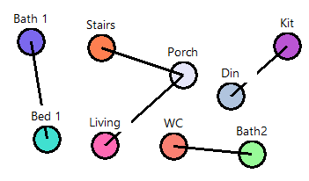
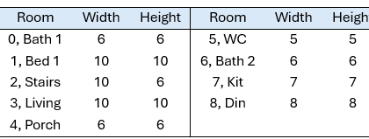
Inputs for adjacency and dimension of rooms:

PTPG variants (Phase 1) | Output layouts on placing doors manually with their plot sizes
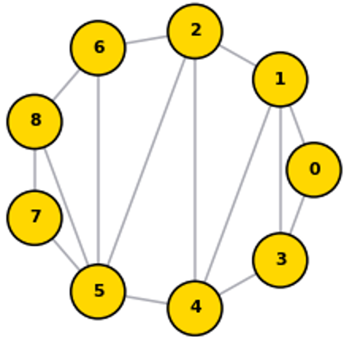  Base PTPG | 35 $×$ 22  22 $×$ 35  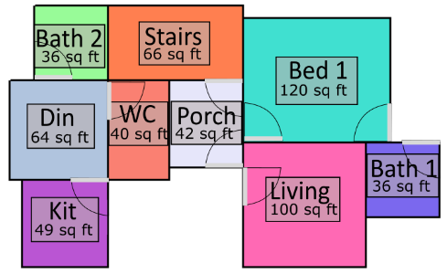  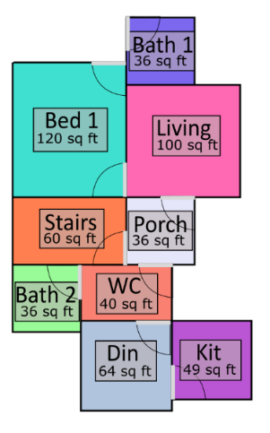
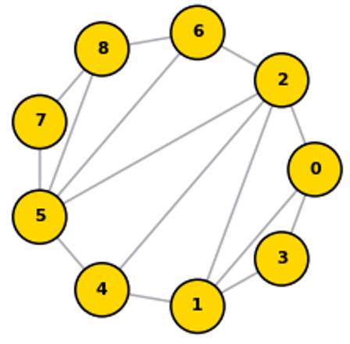  Variant 1 | 16 $×$ 30  16 $×$ 30  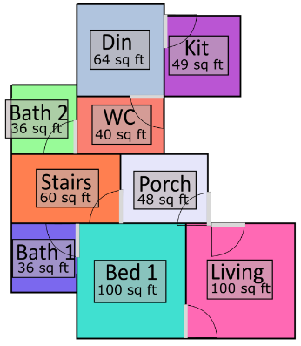  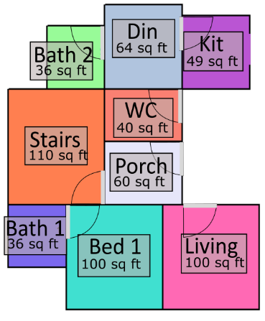
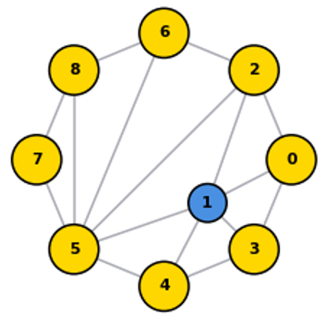  Variant 2 | 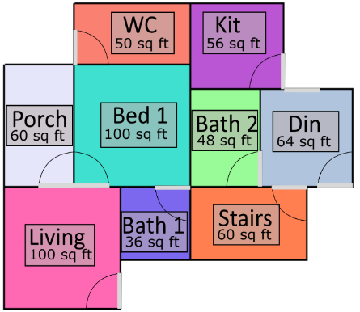  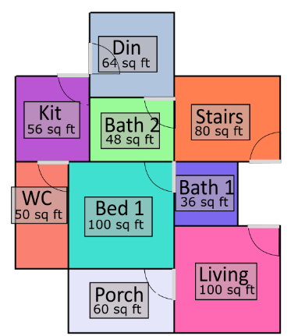  30 $×$ 25  25 $×$ 30

Table 2: Room-Wise Area Deviation and Adjacency Constraint Satisfaction Across Generated Layouts
Variant | Layout | Deviation in Room Areas |  |  |  |  |  |  |  |  | Adjacency  Satisfied out of 5
Variant | Layout | Bath1 | Bed1 | Stairs | Living | Porch | WC | Bath2 | Kit | Din | Adjacency  Satisfied out of 5
Base PTPG | L1 | +0% | +20% | +10% | +0% | +17% | +60% | +0% | +0% | +0% | 3
Base PTPG | L2 | +0% | +20% | +0% | +0% | +0% | +60% | +0% | +0% | +0% | 5
Variant 1 | L1 | +0% | +0% | +83% | +0% | +67% | +60% | +0% | +0% | +0% | 4
Variant 1 | L2 | +0% | +0% | +0% | +0% | +25% | +60% | +0% | +0% | +0% | 4
Variant 2 | L1 | +0% | +0% | +0% | +0% | +67% | +50% | +25% | +14% | +0% | 3
Variant 2 | L2 | +0% | +0% | +25% | +0% | +67% | +50% | +25% | +14% | +0% | 3
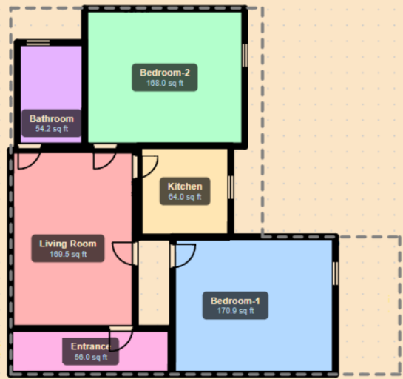
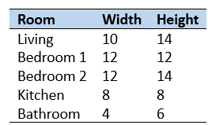
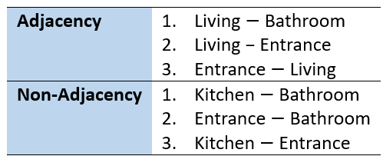
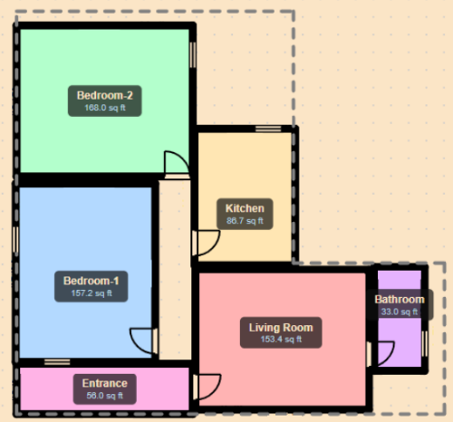
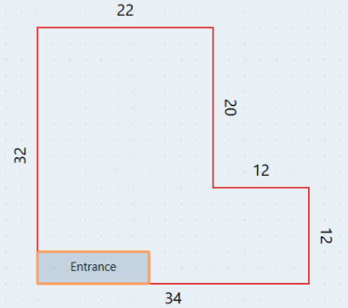
Figure 3: Test case for optimization-based method

- CONCLUSION
This paper presented a computational tool for automated floor plan generation that combines two complementary methodologies. The graph-based method generates a range of layouts within a rectangular plot following the specified room adjacencies and dimensions; the optimization-based method extends this to more complex plot inputs, including fixed spaces and additional non-adjacency requirements, using stochastic search and spatial optimization. As shown in Section 5, the graph-based method produces diverse layouts by performing multiple PTPG generations that relax adjacencies and use room expansion within a defined limit to fit within a rectangular plot. While the optimization-based method offers greater flexibility in handling complex plot geometries and spatial constraints. Together, the two methods support a broader range of floor planning scenarios than either could address alone.

References
Wang, X. Y., Yang, Y., & Zhang, K., (2018). Customization and generation of floor plans based on graph transformations. Automation in Construction, 94: p. 405-416.
Bisht, S., Shekhawat, K., Upasani, N., Jain, R.N., Tiwaskar, R.J., & Hebbar, C., [2022]. Transforming an adjacency graph into dimensioned floorplan layouts. Computer Graphics Forum, 41(6): p. 5-22.
Shekhawat, K., Jain, R.N., Bisht, S., Kondaveeti, A., & Goswami, D., (2021). Graph-based approach for enumerating floorplans based on users specifications. AI EDAM, 35(4): p. 438-459.
Pinki, P., Shekhawat, K., Goswami, D., & Jain, U., (2024). Generation of dimensioned floor plans for a given boundary layout. Journal of Soft Computing in Civil Engineering, 8(3): p. 87-106.
Keatruangkamala, K., & Sinapiromsaran, K. (2005). Optimizing Architectural Layout Design via Mixed Integer Programming. In: Martens, B., Brown, A. (eds) Computer Aided Architectural Design Futures 2005. Springer, Dordrecht.
Wu, W., Fan, L., Liu, L., & Wonka, P., (2018). MIQP-based layout design for building interiors. Computer Graphics Forum, 37: p. 511-521.
Nisztuk, M. & Myszkowski, P. B., (2019). Hybrid evolutionary algorithm applied to automated floor plan generation. International Journal of Architectural Computing, 17(3): p. 260-283.
Laignel, G., Pozin, N., Geffrier, X., Delevaux, L., Brun, F., & Dolla, B., (2021). Floor plan generation through a mixed constraint programming-genetic optimization approach. Automation in Construction, 123: p. 103491.
Su, P., Lin, X., Lu, W., Xiong, F., Peng, Z., & Lu, Y., (2024). Generative design for complex floorplans in high-rise residential buildings: A Monte Carlo tree search-based self-organizing multi-agent system (MCTS-MAS) solution. Expert Systems with Applications, 258: p. 125167.
Nauata, N., Chang, K.-H., Cheng, C.-Y., Mori, G., & Furukawa, Y., (2020). House-GAN: Relational generative adversarial networks for graph-constrained house layout generation. In Computer Vision – ECCV 2020: 16th European Conference. Glasgow, UK, August 23-28. p. 162-177.
Aalaei, M., Saadi, M., Rahbar, M., & Ekhlassi, A., (2023). Architectural layout generation using a graph-constrained conditional Generative Adversarial Network (GAN). Automation in Construction, 155: p. 105053.
Tang, H., Shao, L., Sebe, N., & Van Gool, L., (2024). Graph Transformer GANs with graph masked modeling for architectural layout generation. IEEE Transactions on Pattern Analysis and Machine Intelligence, 46(6): p. 4298-4313. DOI: 10.1109/TPAMI.2024.3355248
Hu, R., Huang, Z., Tang, Y., Van Kaick, O., Zhang, H., & Huang, H., (2020). Graph2Plan: learning floorplan generation from layout graphs. ACM Transactions on Graphics, 39(4): p. 118.
Hong, S., Zhang, X., Du, T., Cheng, S., Wang, X., & Yin, J., (2024). Cons2Plan: Vector floorplan generation from various conditions via a learning framework based on conditional diffusion models. In Proceedings of the 32nd ACM International Conference on Multimedia. Melbourne, VIC, Australia, p. 3248-3256. DOI: 10.1145/3664647.3680681
Bhasker, J., & Sahni, S., (1986). A linear algorithm to find a rectangular dual of a planar triangulated graph. Algorithmica, 1(1–4), 467–483.
Tutte, W. T. (1963). How to draw a graph. In Proceedings of the London Mathematical Society, s3-13(1), 743–768.
Lohani, R., Soni, N., Shekhawat, K., & Shiksha, S., (2025). A Software for Generating Dimensioned Layouts for Given Adjacencies. In Proceedings of the 13th International Conference of the Arab Society for Computation in Architecture, Art and Design. Riyadh, Saudi Arabia, March 6-24.
Schwarz, A., Berry, D.M., & Shaviv, E., 1994. Representing and solving the automated building design problem. Computer-Aided Design, 26(9), 689–698.

