Global Readiness Index for Analysis of Leading Technologies in the Field of Land, Infrastructure, and Transport
JAEHYUN HWANG¹, JOONWOO BAIK¹, GYUEUN LEE², MINJU KIM³,
DOHYUN YANG¹, and SEOKHO CHI¹

¹Department of Civil and Environmental Engineering, Seoul National University, Seoul, South Korea
²Department of Construction Engineering & Management, Construction & Economy Research Institute of Korea,
Seoul, South Korea
³Department of Industrial Policy Research, Construction & Economy Research Institute of Korea, Seoul, South Korea

ABSTRACT

Addressing global challenges increasingly requires enhanced international collaborations, especially in advancing technological innovation within the land, infrastructure, and transport sectors. This research presents the Global Technology Readiness Index (GTRI), a structured and data-driven method designed to objectively assess and analyze the national technological capabilities. The GTRI measures national readiness across four clearly defined dimensions, technology, people, governance, and impact, utilizing various indicators ensuring reliability and diversity. In this research, the GTRI was applied specifically to the domain of smart construction technology, an emerging area contributing significantly to sustainable development. Through evaluating 12 countries, the GTRI identified notable disparities in technological maturity. Furthermore, by conducting a SWOT analysis, countries’ strengths, weaknesses, opportunities, and threats were distinguished providing a deeper understanding for strategic international collaboration. The GTRI enables policymakers and researchers to better align national strategies with global innovation objectives, thereby promoting accelerated sustainable development through informed decision-making and effective cross-border partnerships.

KEYWORDS: International Collaboration, Global Technology Readiness Index, Technology Levels, Technology Competitiveness, Smart Construction

1. INTRODUCTION
In an increasingly interconnected world, international collaboration has emerged as a critical necessity to address the complex and evolving global challenges. Issues such as the COVID-19 pandemic, climate change, and the depletion of finite resources transcend national boundaries demanding collective action and cooperation among nations. The urgency and scale of world challenges necessitate a global approach, where countries collaborate on expertise, resources, and innovations to develop effective and sustainable solutions (WEF, 2024). Technology, as a key solution to the problems, acts as a catalyst for innovation, which underscores the need for a deeper understanding of technological capabilities and competitiveness across nations (Science Europe, 2014).
Analysis of each country’s technology levels provides insights into the global technological advantages and challenges (Archibugi, D. & Coco, A., 2005), which foster strategic partnerships and accelerate innovation toward shared goals. To fulfill the needs, many researchers have approached to evaluate the technology levels in various areas. Previous studies have primarily utilized survey assessment methods, such as Delphi, which incorporates expert opinions (Ciarli, T., et al., 2015; Suominen, A., et al., 2022). However, Delphi methods are inherently dependent on the subjective judgments of a limited number of experts, which increases the likelihood of biased outcomes (Fink-Hafner, D., et al., 2019). As an alternative, some studies have evaluated technology level using relevant data and developed corresponding indexes. Yet, most existing indexes were narrowly focused on specific technologies, limiting the application across broader domains. The absence of a unified evaluation framework has led to the creation of separate methodologies for each technological area (Marti, L., & Puertas, R., 2023; Wei, Z., et al., 2025). Furthermore, relying solely on numerical indicators or expert-based summaries of technological differences offered limited value in identifying the most suitable partner countries for international collaboration. To support more strategic and informed decisions, a detailed analysis of each country’s specific attributes, such as technological capabilities, economic conditions, and international relations, was essential (Greif, L., et al., 2024).
To overcome the limitations, this research proposes a comprehensive Global Technology Readiness Index (GTRI) designed to evaluate the advancement level of diverse technologies objectively based on data. The index illustrates a structured and standardized method to understand technological readiness and capability at a national level. Then, by applying the index to smart construction as an application practice, an emerging technology in the field of Land, Infrastructure, and Transport with significant potential for sustainable development, the research provides technological maturity rankings, competitiveness of different countries, and SWOT analysis eventually, including strengths, weaknesses, opportunities, and threats of the evaluated countries for guidance of strategic international collaborations.

2. METHODOLOGY
The research was structured with two main procedures. The development of the GTRI and application of the index to one of the leading technologies in the engineering field, smart construction, as seen in Fig. 1.

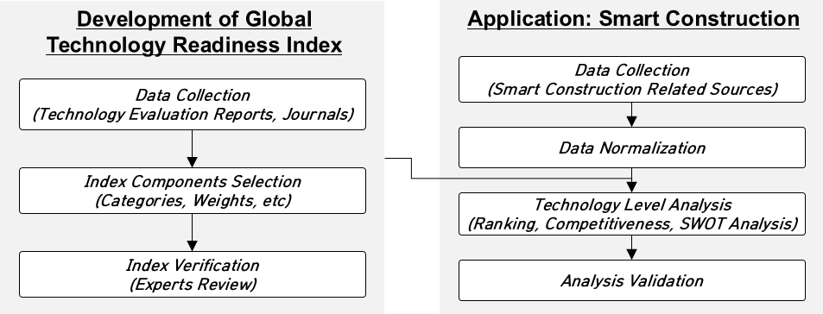
Figure 1: Research framework

2.1 GTRI Development
The initial stage involved gathering relevant and comprehensive data to establish a robust foundation for the index. A total of 10 technology evaluation reports and journals from the United Nations (UN), European Commission, European Research Area (ERA) World Intellectual Property Organization (WIPO), Organization for Economic Co-operation and Development (OECD), Oxford Insights, and other scholarly publications were collected for data analysis as seen in Table 1. The sources were selected based on relevance, credibility, and accessibility, which ensure diverse and reliable datasets representing current trends and standards.

Table 1: Technology evaluation reports and journals
Number | Institution  /Organization | Title
1 | UN | Technology and Innovation Report
2 | European Commission | European Innovation Scoreboard
3 | ERA | ERA Scoreboard
4 | WIPO | Global Innovation Index
5 | OECD | Guidelines for Collecting and Reporting Data on Research and Experimental Development
6 | Portulans Institute | Network Readiness Index
7 | KPMG | Air Taxi Readiness Index
8 | Oxford Insights | Government AI Readiness Index
9 | Nicolas  et al. | Quantifying the Dynamic Effects of Smart City Development Enablers using Structural Equation Modelling
10 | Debackere  et al. | Measuring Progress and Evolution in Science and Technology – II The Multiple Uses of Technometric Indicators

After the data collection process, the data were analyzed determining the core components of GTRI, which include identifying relevant categories and assigning appropriate weights to each category. The selection process involved analyzing patterns in the collected data to confirm the essential key aspects of technology evaluation. As a result, four common categories, including the level of technology outcomes, people (networking) and industry size, governance drive, and technological impacts to society and economy, were identified, in which other infrequent or irrelevant factors were omitted. The category weights were determined based on the frequency and importance of the factors.
To verify the categories and weights of the GTRI, expert reviews were conducted by conducted by two experts affiliated with the Korean government-funded research institutes, each with expertise in global technology evaluation. The experts have been involved in the development and assessment of the 12 National Strategic Technologies, covering areas such as future mobility and robotics, as well as the evaluation of the 17 Carbon Neutrality Key Technologies. Both experts evaluated the relevance, accuracy, and comprehensiveness of the proposed GTRI and offered insights into the suitability of the selected categories and weights, ensuring the index was both practically applicable and academically rigorous.
As a result, GTRI integrated 19 key sub-subcategories, which were indexed into four major categories and 10 subcategories, for evaluating technologies in various aspects as seen in Figure 2. The technology category, which evaluates the key outcomes of the technology, such as journals, patents, related hardware and software infrastructure, capabilities, and adaptability, was assigned the highest weights with 50%. The other three main categories that support the technology development were given the weights of 15% for people, 20% for governance, and 15% for impact.

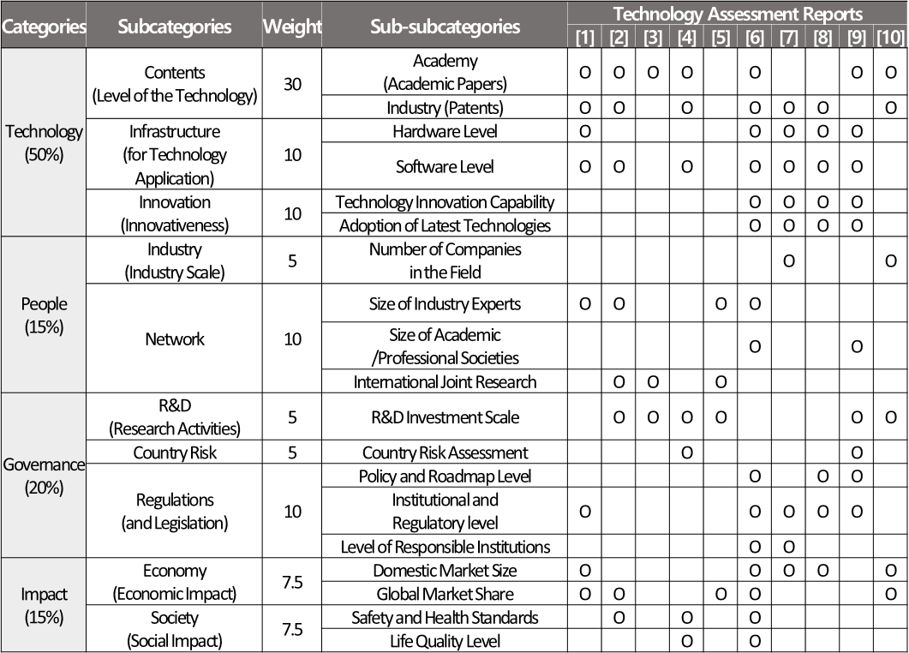
Figure 2: Global Technology Readiness Index (GTRI)
2.2 Application for Smart Construction
The application process of the GTRI began with the collection of relevant data specific to smart construction. A total of 29 smart construction related indicator data, as seen in Figure 3, were collected and analyzed from various sources, which included academic research papers, industry reports, patents, and databases from reliable global associations such as World Economic Forum (WEF), Ministry of Foreign Affairs, Web of Science, CISCO, and OECD. The data were affirmed to obtain comprehensive and high-quality data reflecting the smart construction’s key technologies (i.e., IoT sensors, drones, automation tools, and sustainable practices).
To ensure comparability and consistency, the collected data underwent a normalization process addressing variability in data formats, scales, and units across different sources. Data normalization was carried out using the min-max scaling, one of the most common statistical techniques, as seen in Equation (1). The min-max normalization method allowed all the data to be aligned on the scale of 0 to 100 despite the different ranges and scales of each category’s data source. The normalization process allowed for accurate integration of diverse datasets into the evaluation index.

$$\begin{aligned}{\text{Z}}_{\text{score}}\text{ = }\frac{\text{X - }{\text{Y}}_{\text{min}} }{{\text{Y}}_{\text{max}} \text{-} {\text{Y}}_{\text{min}}} \text{·}\text{ 100}\end{aligned}$$ | (1)
where, Z_{score} – normalized score;
X – raw data of the source;
Y_{max} – maximum score of the raw data;
Y_{min} – minimum score of the raw data.

The normalized data was then implemented into the developed index to determine the smart construction technology levels of various countries. This step involved assessing technologies based on the performance of each defined category of the index. The index facilitated rankings of different countries’ technology levels and competitiveness of each country, which encountered competitive advantages and challenges based on the index results. Furthermore, a SWOT analysis was conducted comparing South Korea, as an example for this research, with each of the top five countries to inform the strengths, weaknesses, opportunities, and threats during the collaboration process, as seen in Table 2. The SWOT analysis highlighted the strengths of each country in relation to South Korea, identified specific gaps or weaknesses that could pose challenges for technological advancement, explored emerging opportunities for effective international partnerships, and addressed potential threats that might influence successful collaboration outcomes (Karadzhov, V., 2025). The insights derived from the SWOT analysis provided guidance
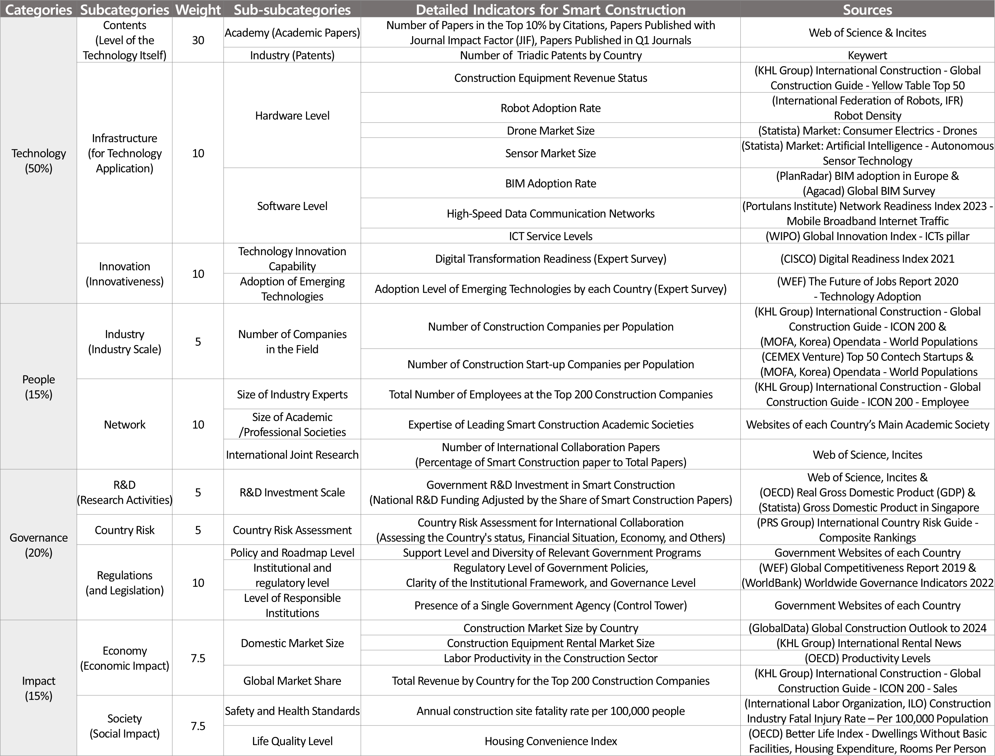
Figure 3: Global Technology Readiness Index for smart construction
for selecting the optimal countries for future collaborative efforts from the perspective of South Korea.

Table 2: Definition and examples of SWOT analysis
Indicator | Definition | Example
Strength  (S) | Focus on What Both Countries Already Possess | Advanced technology areas
Weakness (W) | Internal flaws or deficiencies that both countries currently have, and areas requiring internal improvement for effective collaboration | Regulations and cultural differences
Opportunity (O) | Positive external factors that could arise and what the two countries could additionally gain through collaboration in the future | Market growth and government interest
Threat  (T) | Negative external factors that could arise and external challenges that the two countries need to address collaboratively | Political changes

To ensure the credibility and applicability of the analysis results, including smart construction level rankings, competitiveness assessments, and the SWOT analysis, structured expert reviews were conducted from five specialists in the field of smart construction. The five experts had an average of 25 years of experience in the smart construction field, with diverse backgrounds spanning academia, government-funded research institutes, and the construction industry. Each expert independently evaluated the preliminary findings derived from literature and data analysis. The expert feedbacks were synthesized and used to refine the results in three key areas, 1) the level rankings and indicator classifications were reviewed for logical consistency and technical relevance, 2) the interpretability of country-specific findings were validated, and 3) additional insights into each country’s strengths, weaknesses, opportunities, and threats were incorporated into the SWOT analysis, reflecting expert knowledge of current national initiatives and industry trends. Minor discrepancies and overly broad interpretations in the initial analysis were also corrected. The iterative expert validation process significantly enhanced the contextual depth, accuracy, and practical relevance of the final results.

3. RESULTS AND DISCUSSION
Applying the index to the realm of smart construction, technology level rankings and competitiveness of different countries were achieved. Additionally, SWOT analysis was conducted for strategic and effective international collaborations.

3.1 Technology Level Rankings
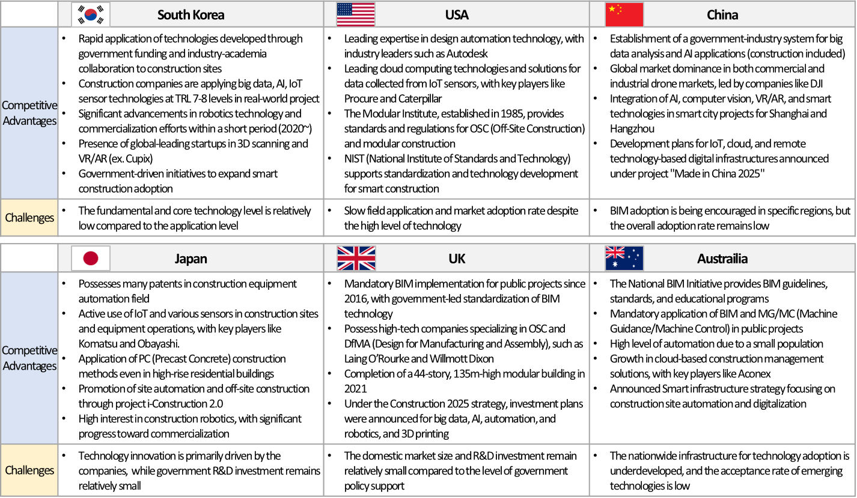Utilizing the smart construction data sources and the index, technology level rankings of different countries were investigated as seen in Fig. 4. Among the 12 developed countries that were selected for the evaluation, the USA, China, Japan, United Kingdom (UK), and Australia ranked the top five countries, with the score of 59.19, 56.92, 42.45, 40.38, and 38.94, respectively. Meanwhile, the selected comparative country, South Korea, ranked 7th in the middle range with a score of 35.94. Singapore, Canada, Netherlands were also placed in the middle range with scores of 37.97, 35.64, and 34.36, respectively.
Figure 5: Technology competitiveness of South Korea and top five countries for smart construction

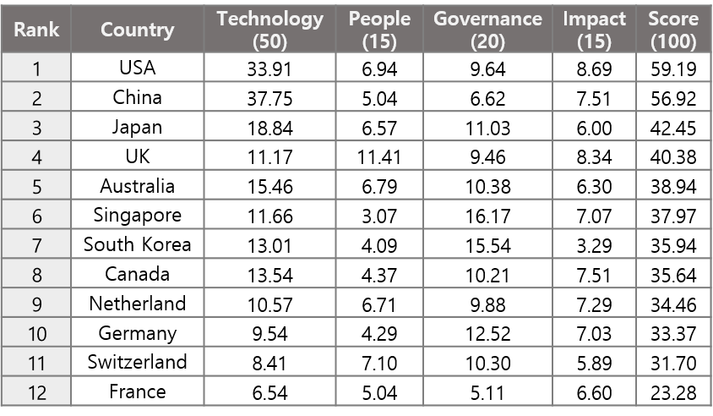
Figure 4: Smart construction technology level rankings

3.2 Technology Competitiveness
Based on the index ranking results, the technological advantages and challenges of South Korea and the top ranked countries were analyzed, as shown in Figure 5. South Korea demonstrated strong capabilities in rapidly applying technologies such as AI, big data, IoT sensors, robotics, and VR/AR, supported by government funding and industry-academia collaboration. However, the core technology development remained relatively weak compared to the application efforts. The United States led in design automation and cloud-based construction solutions, with support from institutions like the National Institute of Standards and Technology (NIST), but faced slow market adoption despite the high technological maturity. China showed strong integration of AI and smart technologies, especially in smart city projects, under the “Made in China 2025” initiative, yet the nationwide BIM adoption rate remains low. Japan possessed expertise in construction equipment automation and robotics, though technology developments were primarily driven by private companies with limited government R&D support. The United Kingdom was advantageous from mandatory BIM policies, a strong presence of off-site construction (OSC) and design for manufacturing and assembly (DfMA) firms, and national strategies for technological investment. Thus, the relatively small domestic market and limited R&D funding posed challenges. Australia promoted BIM and digital construction practices through national initiatives and demonstrated high automation, however, faced challenges due to underdeveloped infrastructure supporting technology and the low acceptance rate of emerging technologies. The analysis of technological competitiveness provided a comprehensive understanding of the current technology levels among leading countries. The competitiveness results were also considered in the SWOT analysis.

3.3 SWOT Analysis
For an effective international collaboration, a deeper understanding of the countries’ technology levels was essential. Thus, SWOT analysis was carried out comparing South Korea and each of the leading countries as seen in Fig. 6 below.

United States of America
The SWOT analysis of South Korea and the USA revealed various collaboration strengths and opportunities. Both nations benefit from numerous collaboration channels, facilitated by long-standing diplomatic ties, including the 70th anniversary of the Korea-USA alliance. The friendly relationship between the two countries can foster inter-governmental cooperation in the future. Moreover, the USA and South Korea share high technological capabilities for smart construction through initiatives like the "Smart Cities Initiative" and "Construction 4.0." Likewise, the United States holds a strong advantage, with high technology levels across nearly all domains of smart construction, which has positioned the country as a global leader in smart construction technologies. On the opportunity aspect, the USA’s diplomatic push to regain global leadership can create foundations for enhanced international collaboration, especially with allied countries like South Korea. Collaboration with the USA can enable South Korea to take a leading role in smart construction standards and proactive applications, further reinforcing leading position in the global market.
However, weaknesses in the partnership may emerge, particularly in the realm of inter-governmental collaboration systems, where efforts to minimize federal market intervention in the USA can lead to challenges. Additionally, despite the low adoption or commercialization rate, the USA holds a relative technological advantage, which may hinder collaboration with South Korea. The differences in legal regulations, compounded by strict U.S. government policies such as the Inflation Reduction Act, may also complicate cooperation. Likewise, threats also persisted, including shifts in bilateral relations or policy changes, especially following the new presidential change in the USA, which may disrupt the collaboration framework. Also, the USA being the leader in smart construction technology, competition from different countries may intensify, creating obstacles for executing international joint research.

China
The strategic collaboration between South Korea and China in the smart construction sector offers many compelling advantages. South Korea can capitalize on China’s strong price competitiveness in sensors, components, and related hardware, which allows for more cost-effective smart construction product development and deployment. Similarly, drones being one of the most important vehicles in the smart construction technology, China’s dominance of the global drone market in both commercial and industrial aspects, led by companies like DJI, was another noted advantage. Korea’s extensive experience with smart city pilot projects, implemented in up to approximately 900 cities, has yielded a wealth of practical knowledge and a mature infrastructure foundation, making it well positioned to engage in large scale, technology-driven collaboration. Furthermore, the geographical proximity between the two countries serves as a logistical strength, supporting more efficient communication, resource exchange, and coordination compared to partnerships with more distant countries such as the USA and Europe. Many opportunities have emerged for collaboration between China and South Korea. China’s growing smart construction market and the broad international cooperation channels presented an attractive platform for Korean firms and research institutions to expand global footprints.
Regardless of the strengths and opportunities, several risks also exist. China’s relatively weak data privacy regulations contrast with South Korea’s stringent standards, creating barriers to effective and legally compliant data sharing, an essential element for the deployment of digital construction technologies. At the same time, China’s domestic economic strategies posed potential threats. The dual circulation policy, aimed at improving internal supply chains, may lead to restricted exports of key resources. Coupled with the ambiguity and variability of China’s trade agreements, the uncertainty must be carefully managed and settled in long-term collaboration planning.

Japan
Among the countries evaluated for potential collaboration in the smart construction sector, Japan presented notable strengths for partnership with South Korea. Geographically, Japan was the closest to South Korea among the top ranked countries, offering logistical advantages and lower barriers to regular communication and exchange. Moreover, since the launch of proactive policy initiatives such as i-Construction, Japan has steadily developed a robust technological foundation and innovation ecosystem within the construction sector. As a result, Japan has cultivated a high level of expertise in off-site construction (OSC) and robotic construction technologies, areas in which South Korea has also shown increasing interest. The shared focus created opportunities for synergy in automated construction, particularly in advanced prefabrication methods and digital site operations. Furthermore, the potential for meaningful collaboration between Japan and South Korea remains strong. Japan’s continued investment in R&D, provision of tax incentives, and support for the commercialization of smart construction technologies were likely to accelerate the adoption of innovative solutions, creating a conducive environment for South Korea to engage in technology exchange and early stage cooperation. Short-term prospects for collaboration were especially favorable in the field of construction automation, particularly through joint seminars, technical exchanges, and bilateral research programs.
For the weakness sector, both countries have produced relatively limited joint scientific and technological outputs, such as journal publications or patents, which may restrict the formation of strong research performance synergies. Furthermore, Japan’s relatively mature domestic market and firm in-house R&D infrastructure recently reduced the urgency or incentive for government-led international collaboration efforts. In detail, to diminish the threats, external risks must be managed, especially the potential for political and economic instability between the two nations. Moreover, both countries face structural challenges, such as shrinking construction labor force, reduced working hours, and low productivity levels. The shared demographic and economic pressures emphasized the need for joint initiatives focused on advancing the next generation of construction technologies.

United Kingdom
The potential for collaboration between South Korea and the United Kingdom in the smart construction sector was supported by a strong foundation of mutual government interest and institutional engagement. Both countries have demonstrated active commitment through policy support and sustained investment, building a conducive environment for bilateral cooperation. In particular, the UK’s national innovation agency, Innovate UK, has signed a bilateral R&D memorandum of understanding with South Korea’s major research organizations, such as the Korea Institute for Advancement of Technology (KIAT) and The Korea Agency for Infrastructure Technology Advancement (KAIA). The agreements have facilitated the development of resilient cooperative networks and strategic interest in advancing construction innovation. Furthermore, the UK’s advancement of Building Information Modeling (BIM) adoption and practical experiences in implementing construction technologies provided a solid basis for knowledge exchange. The UK government’s ongoing pursuit of international partnerships related to BIM complements Korea’s technological strengths, offering clear opportunities for joint initiatives in digital construction and smart infrastructure. Along with the strength of the SWOT analysis, important opportunities emerged as well. The UK’s agile legislative environment and responsive policy framework were likely to facilitate the commercialization of emerging technologies. Moreover, pressures arising from the COVID-19 pandemic, inflation, and evolving corporate safety regulations have amplified the demand for improved productivity and safety in construction sites, which was aligned with the adoption of smart construction solutions.
Meanwhile, several contextual limitations hindered the collaboration. The UK’s domestic market was relatively limited in scale compared to the global leaders, such as the United States and China, possibly restricting the broader commercialization and deployment of smart construction technologies. Although the UK government has shown commitment to smart construction, the public R&D output, including academic publications and patents, remains comparatively low. The UK’s recent economic deterioration has contributed to heightened political, economic, and social uncertainty, potentially affecting the stability of public investment in research and innovation. For example, energy price volatility resulting from the Russia-Ukraine conflict indicated the importance of incorporating risk-resilient strategies into future collaboration.

Australia
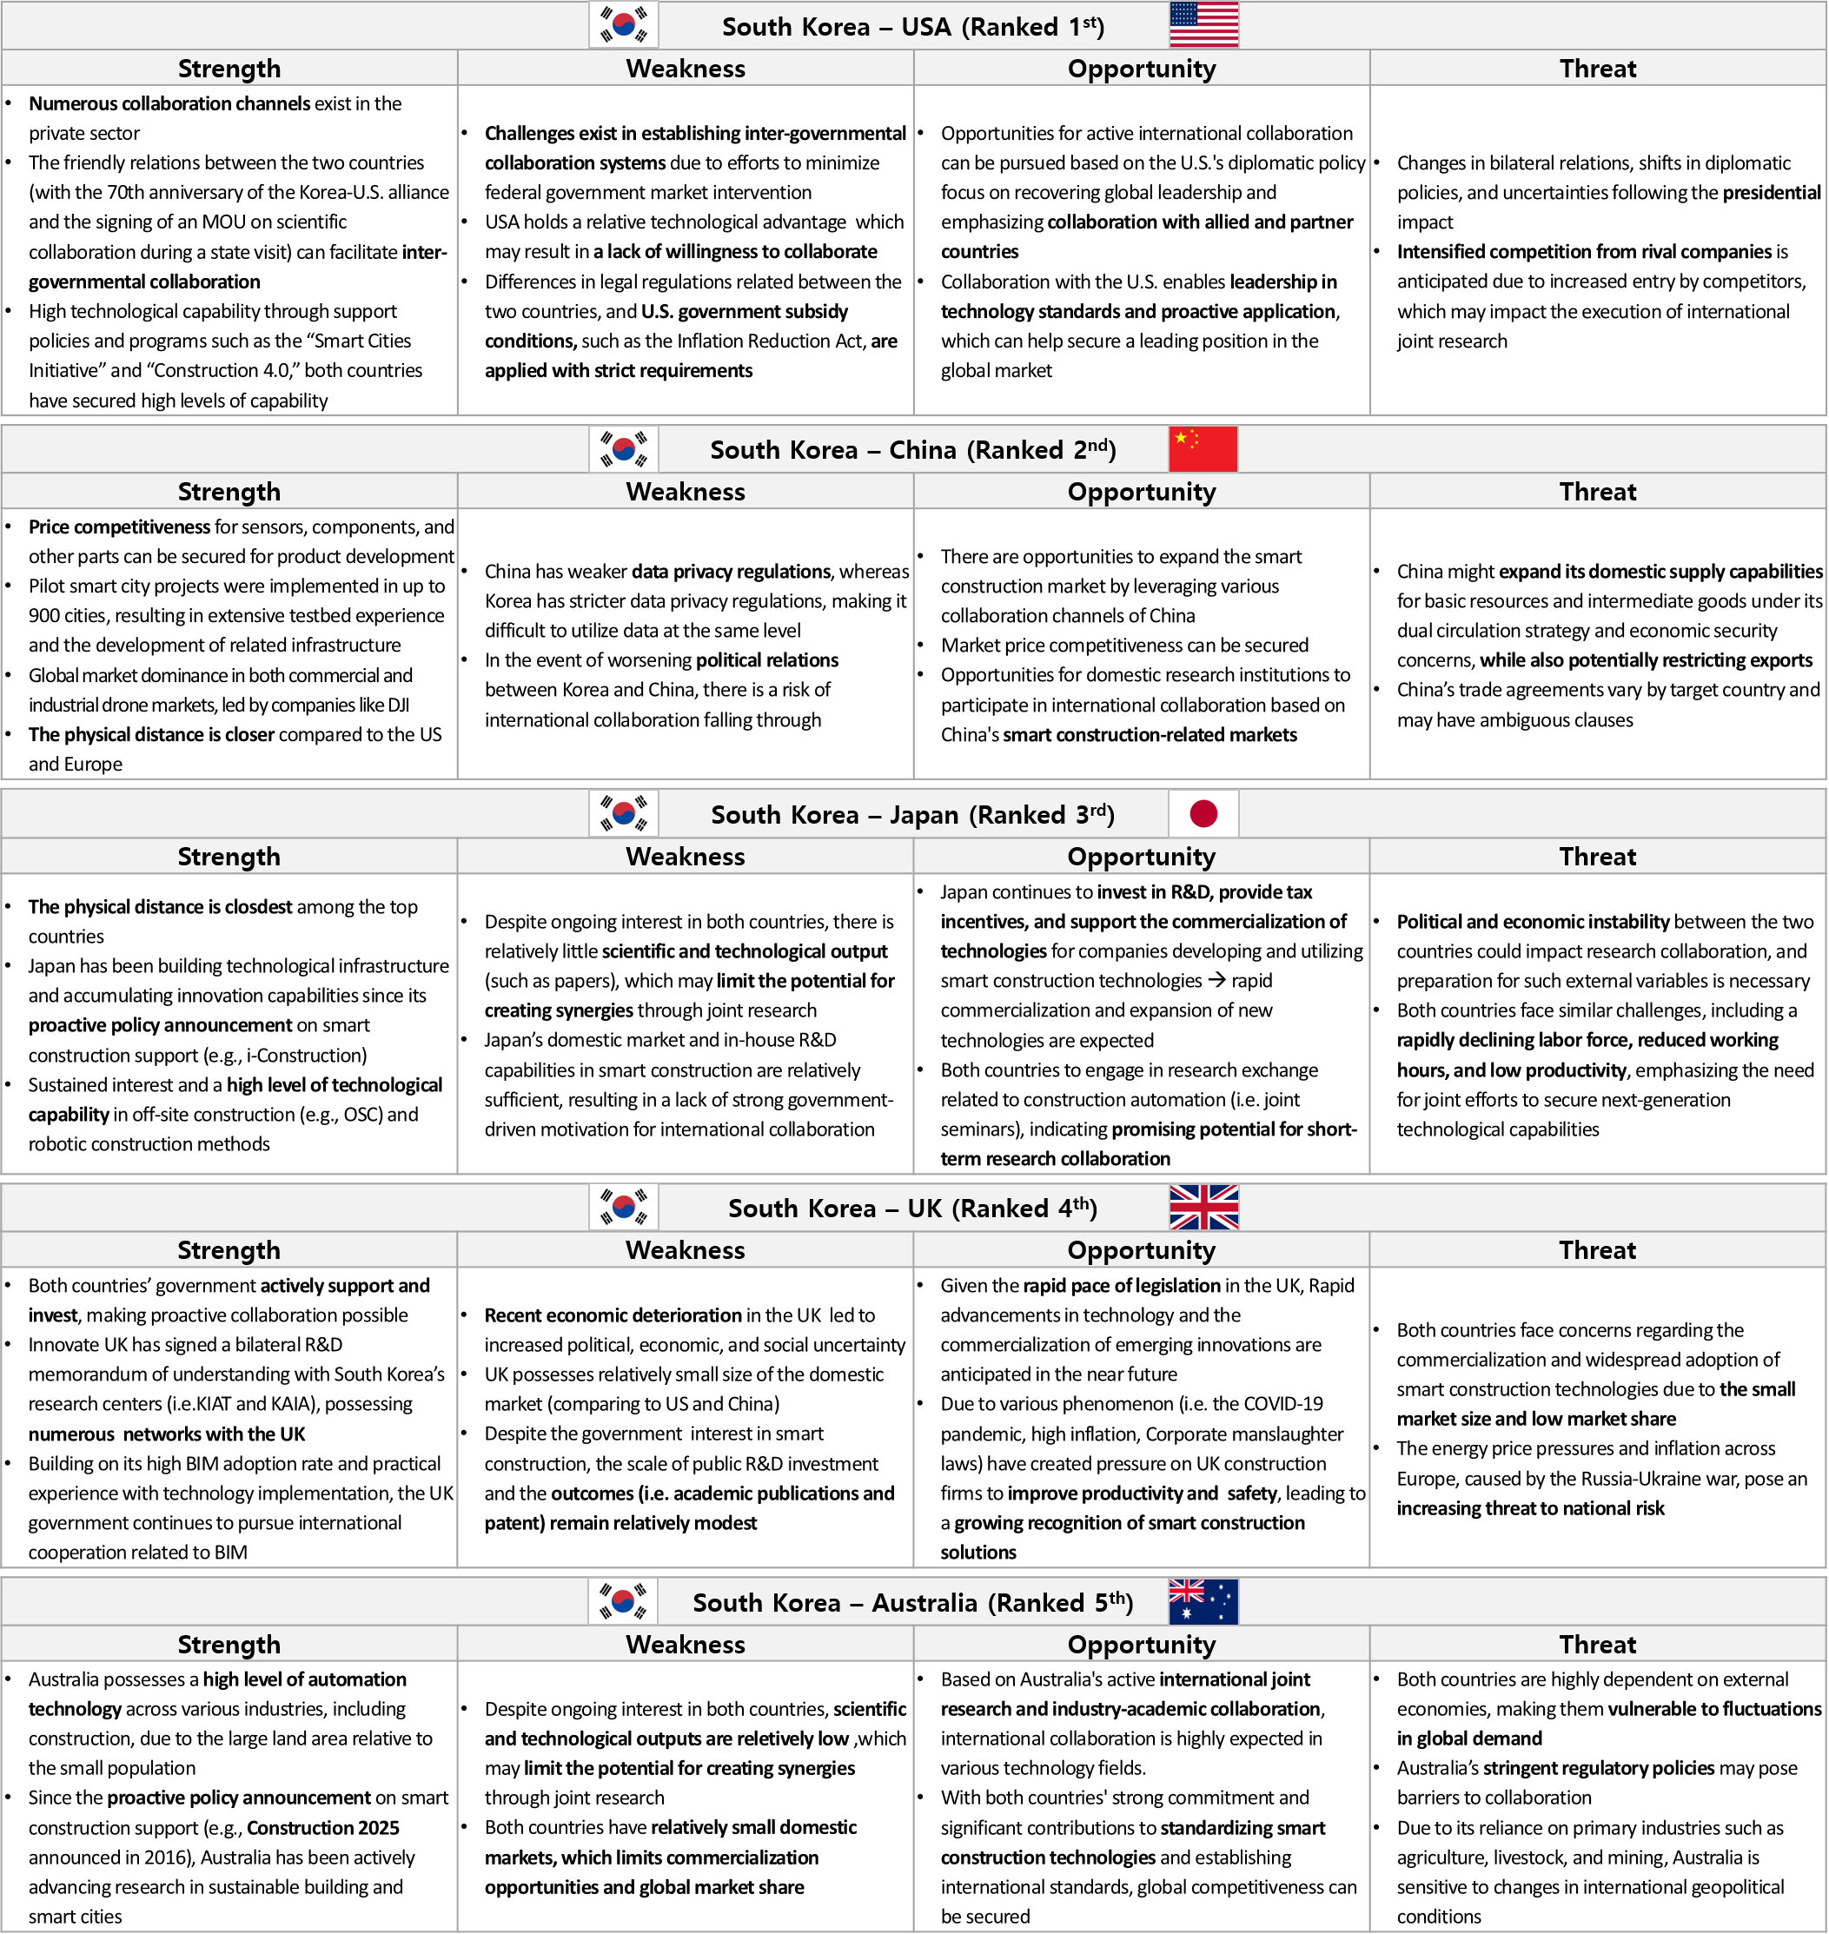The collaboration potential between South Korea and Australia in the smart construction sector was supported by complementary strengths and a shared policy-driven commitment to innovation. Australia’s advanced automation capabilities, developed in response to the vast geography relative to the small population, have allowed a major position as a leader in deploying technology solutions in construction. The launch of Australia’s “Construction 2025” initiative in 2016 marked a clear policy shift toward promoting smart and sustainable construction practices. The efforts closely aligned with South Korea’s innovation agenda created a fertile ground for collaboration in areas such as digital infrastructure, off-site construction, and sustainable urban development. Furthermore, Australia’s active participation in international joint research as well as the strong culture of industry and academic collaboration denoted the openness to global partnerships. Both countries have also demonstrated leadership in the standardization of smart construction technologies, indicating an opportunity not only for bilateral advancement but also for enhancing their collective influence on the global stage. Similarly, the shared pursuit of standardization offers a strategic pathway to international relevance, particularly in shaping emerging norms around sustainability and automation.
Figure 6: SWOT analysis result of South Korea and the top five countries in smart construction

Nonetheless, weaknesses and threats remained for South Korea and Australia collaborations. While both nations exhibit interest in smart construction, the lack of scientific outcomes may restrict the development of high-impact and research-driven synergies. Similar to the threats of the UK and Japan, the limited size of domestic construction markets may lead to high dependency on global economic conditions, being vulnerable to fluctuations in international demand. Also, Australia's strict regulatory environment, while important for safety and quality assurance, may introduce procedural complexity and delays in cross-border collaboration. Moreover, Australia’s economic reliance on primary sectors, such as agriculture and mining, increased the susceptibility to external geopolitical factors, posing potential risks for long-term collaboration.
In summary, the SWOT analysis across five potential partner countries, the USA, China, Japan, the United Kingdom, and Australia, for South Korea revealed a diverse range of collaborative strengths, opportunities, constraints, and contextual risks in the advancement of smart construction. While each country presents unique strengths, ranging from technological maturity and cost competitiveness to policy-driven innovation and international networks, the analysis also highlighted common challenges, such as regulatory misalignment, modest R&D output, political uncertainties, and market size limitations. Importantly, countries like the USA and China offered access to extensive markets and commercialization channels, whereas Japan, the UK, and Australia provided deep expertise in automation and a strong foundation in construction technology standardization. The findings suggested that South Korea’s international collaboration strategies should be carefully planned for each country's structural characteristics and geopolitical context to leverage strengths and seize opportunities while mitigating weaknesses and potential threats for a successful and sustainable collaboration.

4. CONCLUSION
The research proposed a structured framework for the development and application of a GTRI. By integrating data-driven approaches with literature-based metrics, the proposed comprehensive index offered an objective alternative to the traditional expert survey methods, which were often constrained by subjectivity, as well as to prior technology-specific indexes, which tended to lack consistency and broader applicability. The framework consisted of two core phases, the creation of the index and application to the realm of smart construction technology. When applied to smart construction, the index enabled a comparative analysis of technology readiness levels across key developed countries, supporting national rankings and revealing relative competitiveness advantages and challenges. The application stage further included a country-level SWOT analysis, which offered practical insights into South Korea’s collaboration potential with global partners. The SWOT analysis contributed to identifying distinct strengths, weaknesses, opportunities, and threats across top ranked countries, including the USA, China, Japan, the UK, and Australia. The results served as an input for developing effective cooperation strategies in international smart construction initiatives.
The outcomes are expected to provide a replicable and adaptable framework for technology evaluation, bridging the gaps between quantitative technology indicators and strategic policy planning. The index results can also contribute as guidance to policymakers, researchers, and industry leaders by helping to identify suitable future partners and areas for targeted investment or collaboration.
Future research will focus on advancing the index by evaluating the specific technologies into sub-levels or specific life cycle stages. For instance, smart construction can be broken down into technologies in the design, construction, and maintenance phases. The sub-level analysis can allow for a more precise assessment of technology levels and specifically pinpoint the international collaboration partners’ demands.

ACKNOWLEDGEMENTS
This work is supported by the Korea Agency for Infrastructure Technology Advancement (KAIA) grant funded by the Ministry of Land, Infrastructure and Transport (RS-2024-00417877) and also supported by the National Research Foundation of Korea (NRF) grant funded by the Korea government (MSIT) (No. 2021R1A2C2003696).

REFERENCES
Agacad, (2021). Global BIM Survey. Available: https://agacad.com/blog/category/survey.
Archibugi, D. & Coco, A., (2005). Measuring technological capabilities at the country level: A survey and a menu for choice. Research Policy, 34(2).
DOI: https://doi.org/10.1016/j.respol.2004.12.002.
CEMEX ventures, (2024). Top 50 Contech Startups report 2024. Available: https://www.cemexventures. com/top-50/.
Ciarli, T., Coad, A., & Rafols, I., (2015). Quantitative analysis of technology futures: A review of techniques, uses and characteristics. Science and Public Policy, 43(5). DOI:10.1093/scipol/scv059.
CISCO, (2021). Digital Readiness Index. Available: https://www.cisco.com/c/m/en_us/about/corporate-social-responsibility/research-resources/digital readiness-index.html#/.
Debackere, K., Verbeek, A., Luwel, M., & Zimmermann, E., (2003). Measuring progress and evolution in science and technology – II_The multiple uses of technometric indicators. International Journal of Management Reviews, vol. 4, no. 3, pp. 213-231.
DOI: https://doi.org/10.1111/1468-2370.00085
European Commission, (2023). ERA Scoreboard, European Research Area. DOI: https://doi.org/10.2777/674915.
European Commission, (2023). European Innovation Scoreboard 2023 Methodology Report. Available: https://research-and-innovation.ec.europa.eu/knowledge-publications-tools-and-data/publications/all-publications/european-innovation-scoreboard-2023_en.
Fink-Hafner, D., Dagen, T., Doušak, M., Novak, M., & Hafner-Fink, M. (2019). Delphi method: strengths and weaknesses. Advances in Methodology and Statistics, 16(2): p. 1-19.
Globaldata, (2020). Global Construction Outlook to 2024. Available: https://www.swm.aco/fileadmin/swm.aco/ documents/Research/GlobalData_GlobalConstructionOutlookto2024Q22020_160720.pdf.
Greif, L., Kimmig, A., Bobbou, E. S., Jurisch, P., & Ovtcharova, J., (2024). Strategic view on the current role of AI in advancing environmental sustainability: a SWOT analysis. Discover Artificial Intelligence, 4(45).
DOI: https://doi.org/10.1007/s44163-024-00146-z
International Federation of Robotics (IFR), (2022). Robot Density Data by International Federation of Robotics reveal. Available: https://ifr.org/ifr-press-releases/news /global-robotics-race-korea-singapore-and-germany-in-the-lead.
International Labour Organization (ILO), (2021). Occupational Safety and Health Statistics. Available: https://ilostat.ilo.org/data/.
Karadzhov, V., (2025). How to Create the Best SWOT Analysis. International Journal of Research and Review, 12(1). DOI: https://doi.org/10.52403/ijrr.20250110.
KHL Group, (2022). Global Construction Guide. Available: https://digimag.internationalconstruction.com /magazine/reader/237533?pageNumber=13.
KHL Group, (2023). Rating the World's top 100 rental companies. Available: https://www.internationalrental news.com/.
KPMG, (2022). Air Taxi Readiness Index 2022. Available: https://assets.kpmg.com/content/dam/kpmg/ie/pdf/2022/10/ie-air-taxi-readiness-2022.pdf.
Marti, L. & Puertas, R., (2023). Analysis of European competitiveness based on its innovative capacity and digitalization level. Technology in Society, 72.
Ministry of Foreign Affairs, Republic of South Korea, (2024). Population, Opendata. Available: https://open data.mofa.go.kr/lod/countryAnalysis_population.do.
DOI: https://doi.org/10.1016/j.techsoc.2023.102206.
Nicolas, C., Kim, J., & Chi, S., (2020). Quantifying the dynamic effects of smart city development enablers using structural equation modeling. Sustainable Cities and Society, vol. 53, pp. 101916.
DOI: https://doi.org/10.1016/j.scs.2019.101916.
OECD, (2015). Frascati Manual 2015: Guidelines for Collecting and Reporting Data on Research and Experimental Development. The Measurement of Scientific, Technological and Innovation Activities, OECD Publishing.
DOI: https://doi.org/10.1787/9789264239012-en.
OECD, (2022). OECD Productivity Statistics. Available: https://www.oecd-ilibrary.org/employment/data/oecd-productivity-statistics_pdtvy-data-en.
OECD, (2024). OECD Data Explorer – Archive - Better Life Index. Available: https://data-explorer.oecd.org/vis?tenant=archive&df[ds]=DisseminateArchiveDMZ&df[id]=DF_BLI&df[ag]=OECD&dq=USA%2BGBR%2BCHE%2BNLD%2BKOR%2BJPN%2BDEU%2BFRA%2BCAN%2BAUS.HO_NUMR%2BHO_HISH%2BHO_BASE..&to[TIME]=false&vw=tb&ly[cl]=INDICATOR&ly[rw]=LOCATION.
OECD, (2024). Real Gross Domestic Product(GDP). Available: https://www.oecd.org/en/data/indicators/real-gross-domestic-product-gdp.html.
Oxford Insights, (2023) Government AI Readiness Index 2023. Available: https://oxfordinsights.com/ai-readiness/ai-readiness-index/.
PlanRadar, (2021). BIM adoption in Europe: 7 countries compared. Available: https://www.planradar.com/bim-adoption-in-europe/.
Portulans Institute, (2023). Network Readiness Index 2023. ISBN: 979-8-89238-367-7.
PRS Group, (2024). The International Country Risk Guide(ICRG). Available: https://www.prsgroup.com/ explore -our-products/icrg/.
Science Europe, (2014). Life, Environmental and Geo Sciences Committee Opinion Paper. Available: https://scienceeurope.org/our-resources/importance-of-international-collaboration-for-fostering-frontier-research/.
Statista, (2022). Research and Development(R&D) Expenditure as a Proportion of Gross Domestic Product (GDP). Available: https://www.statista.com/statistics /732269/worldwide-research-and-development-share-of-gdp-top-countries/.
Statista, (2024). Autonomous & Sensor Technology, Statista Market Insights. Available: https://www.stat ista.com/outlook/tmo/artificial-intelligence/autonomous-sensor technology/worldwide? currency=USD.
Statista, (2024). Drones, Statista Market Insights. Available: https://www.statista.com/outlook/cmo/consu mer- electronics/drones/worldwide#revenue.
Suominen, A., Hajikhani, A., Ahola, A., Kurogi, Y., & Urashima, K., (2022). A quantitative and qualitative approach on the evaluation of technological pathways: A comparative national-scale Delphi study. Futures, 140. DOI: https://doi.org/10.1016/j.futures.2022.102967.
United Nations Trade and Development(UNCTAD), (2023). Technology and Innovation Report. ISBN: 978-92-1-113085-0.
Wei, Z., Wang, Y., Cheng, R., & Wen, G., (2025). Research on the Construction of the Evaluation Index System of Digital Rural Construction, Take Pujiang County in Chengdu City as an Example. Proceedings of the 4th International Conference on Culture, Design and Social Development (CDSD 2024), p. 456 – 462.
DOI: https://doi.org/10.2991/978-2-38476-380-1_51
World Bank, (2024). Worldwide Governance Indicators. Available: https://www.worldbank.org/en/publication/ worldwide-governance-indicators.
World Intellectual Property Organization(WIPO), (2023). Global Innovation Index 2023: Innovation in the face of uncertainty, 16th Edition.
DOI: https://doi.org/10.34667/tind.48220.
World Economic Forum, (2019). The Global Competitiveness Report 2019. ISBN: 978-2-940631-02-5.
World Economic Forum, (2020). The Future of Jobs Report 2020. Available: https://www.weforum.org/ publications/the-future-of-jobs-report-2020/in-full/.
World Economic Forum, (2024). Global Risks Report 2024. Available: https://www.weforum.org/publications‌/global-risks-report-2023/digest/.

