An End-to-End and High Accuracy Solution of Cable Catenary Using Dual-Parameter Optimized Physics-Informed Neural Networks

KUNYAO LI ¹，HAIJIANG LI ¹，ALI KHUDDAIR ¹，YI DONG ²，JUNJIE WANG ²
¹School of Engineering, Cardiff University, Cardiff CF24 3AA, UK
² School of Mechanics and Aerospace Engineering, Dalian University of Technology, Dalian, 116024, China

ABSTRACT:

Cable-stayed bridges are complex structures requiring precise determination of cable shape parameters for design, analysis, and construction management. With increasing bridge spans, geometric nonlinearities complicate the resolution of catenary equations. Traditional methods demand high expertise and involve intricate calculations, creating barriers to practical implementation. This study introduces a Cable-Catenary Physics-Informed Neural Network (CC-PINN) as an end-to-end, high-precision method for solving cable catenary problems. The proposed approach features a dual-parameter optimization strategy that simultaneously updates neural network parameters and catenary characteristic angle parameters with different learning rates, addressing unique challenges in cable modelling. Numerical experiments compare CC-PINN with traditional Newton and Secant methods across various cable configurations. Results demonstrate that CC-PINN achieves higher terminal accuracy than Newton's method and matches the precision of the Secant method at boundary conditions. Statistical analysis confirms no significant differences in characteristic angle calculations between CC-PINN and traditional approaches. Analysis shows a learning rate of 0.01 for angle parameters achieves optimal performance, balancing stability and convergence speed—especially for longer cables, where efficiency improves by up to 54.9%.By lowering technical barriers while maintaining analytical rigor, CC-PINN enables broader application of advanced modeling techniques in practical bridge engineering, contributing to more efficient design and construction of cable-stayed bridges.

KEYWORDS: Cable-stayed bridges; Catenary equation; Physics-Informed Neural Networks; Dual-parameter optimization.

1. INTRODUCTION
Cables are integral to the structural integrity of cable-stayed bridges, serving as critical load-bearing elements. Precise determination of their shape parameters is essential for the foundational processes of design, analysis, and construction management (Wu et al., 2015). As bridge engineering has advanced, the expansion in span lengths has introduced unique challenges related to geometric nonlinearity, complicating the resolution of the catenary equation. Traditional approaches, laden with intricate derivation and integration steps, demand high expertise and are not easily accessible, necessitating a simpler and highly accurate method for bridge construction.
The catenary equation, first derived by James Bernoulli in 1691, poses significant computational challenges due to its transcendental functions. With advancements in computational techniques, numerical methods such as the secant method, the Levenberg-Marquardt method, and Newton's method have been employed to solve the catenary equation (Abelson and diSessa, 1981; Dennis and Schnabel, 1996; Marquardt, 1963). However, these methods are complex, requiring expertise and not easily accessible. This limits their practical use in engineering. Hence, there is an imperative need for an approach that is both simple and highly accurate to facilitate the construction of bridges.
To develop an end-to-end, high-precision method for solving the catenary equation of cable-stayed bridges, this paper proposes a Cable-Catenary Physics-Informed Neural Network (CC-PINN) adapted for catenary equation solutions. The main contributions of this research are as follows:
1) Based on the catenary theory of cable-stayed bridges, the transcendental catenary equation is derived, and its boundary conditions are defined. A CC-PINN is constructed to solve this equation, thus realizing an end-to-end solution method.
2) A novel self-learning method for solving transcendental equations, specifically aimed at determining the catenary characteristic parameter, has been established. This innovative approach enhances the traditional Physics-Informed Neural Network (PINN) framework through the implementation of an asynchronous learning strategy. As a result, the method enables rapid learning of catenary characteristic parameter.

2. Related work

2.1 Traditional methods
In modern bridge design and construction, the catenary equation is applied to analyze and design the cable systems of bridges. Irvine's work laid the foundation for the application of the catenary equation in the design of cable-stayed bridges (Connor and Faraji, 2013). Building on Irvine's research, Jayaraman and colleagues were the first to propose a method for constructing elastic catenary cable elements (Jayaraman and Knudson, 1981). Song et al. (Song et al., 2020) conducted in-depth research on the catenary problem using an improved secant method and proposed a new iterative algorithm for calculating the unstressed length of long cables, significantly improving the stability and efficiency of the computation. Smith and Johnson utilized the Levenberg-Marquardt algorithm to study the relationship between the vertical force components at the cable ends and the unstressed cable length, proposing a new nonlinear iterative solution technique (Bergou et al., 2020). In recent years, further advancements have been made in the numerical solutions of the catenary equation for bridge applications. Cao et al. (Cao et al., 2022) have proposed a new method for finding the catenary line shape of bridges within a special cable surface, improving the traditional segmented catenary method and enhancing computational accuracy. Recent advances in suspension bridge cable modelling have progressed from traditional approaches to sophisticated computational methods, including improved particle swarm optimization (Song et al., 2024), explicit analytical iterative techniques based on elastic catenary theory (Cao, Hongyou et al., 2017). These developments have significantly enhanced modelling accuracy, providing more precise representations of actual cable geometries and system behaviours. However, the field continues to be hindered by inherent computational complexity and laborious iteration processes, creating a substantial gap between theoretical capabilities and practical engineering implementation. This disconnect highlights the pressing need for a streamlined, end-to-end catenary solution algorithm that maintains analytical rigor while dramatically reducing the technical expertise required for application, thereby enabling broader adoption of advanced cable analysis in real-world bridge engineering projects.

2.2 Recent Advances in Numerical Methods
Recent studies have indicated that more advanced numerical methods, such as those based on Physics-Informed Neural Networks (PINNs) and deep learning techniques, are beginning to be explored for solving various engineering problems. PINNs are new machine learning technologies for solving Partial Differential Equations (PDEs) in recent years (Cuomo et al., 2022; Guo and Fang, 2023; Mao and Meng, 2023). The core idea of PINNs is integrating the prior knowledge of control differential equations and adding the PDEs’ residual loss term representing the initial conditions, boundary conditions and internal collocation points to the traditional loss function. Unlike traditional numerical methods for solving PDEs, Physics-Informed Neural Networks (PINNs) reframe the problem by transforming the solution of control equations into an optimization task focused on minimizing a loss function. This innovative approach streamlines the computational process and offers a more efficient pathway to solving complex PDEs.
In 2017, Raissi et al. proposed the PINNs in two papers, and then published a merged version in 2019 (Raissi et al., 2019). The paper introduced and demonstrated the use of PINNs to solve Schrodinger, Allen Cahn, and Burgers equations, which can solve both forward and inverse problems within the same framework. So far, many studies have adopted the PINNs to solve PDEs. It has become one of the most popular research fields in computational mechanics. Haghighat et al. (Haghighat et al., 2021) solved the displacement and stress of elastic and elastic-plastic problems using PINNs. Samaniego et al. (Samaniego et al., 2020) used PINNs to solve solid mechanics from an energy perspective. In their work, the principle of minimum potential energy was adopted as the physical law of the problem, and different optimizers were used to find the minimum value of total potential energy. Raissi and Karniadakis (Raissi and Karniadakis, 2018) demonstrated the effectiveness of the PINNs for solving Navier-Stokes, Schrödinger, Kuramoto Sivashinsky and time-dependent linear fractional equations. Mao et al. (Mao et al., 2020) demonstrated the correctness of the PINNs in solving forward and inverse problems in high-speed flow. Tartakovsky et al. (He et al., 2020) presented the PINNs for estimating hydraulic conductivity in saturated and unsaturated flows governed by Darcy's law.
It is crucial to recognize that while the PINNs have demonstrated significant potential in various domains of computational mechanics and solving PDEs, their application to catenary problems, particularly in solving catenary lines, remains an unexplored frontier. This gap in knowledge presents a compelling research opportunity. The challenge is further compounded by the fact that catenary equations are transcendental in nature, characterized by their deceptively simple form yet notoriously difficult to solve. Traditional PINNs frameworks struggle to directly address these equations, as they are fundamentally different from the differential equations that PINNs typically handle. Exploring how PINNs can be adapted and applied to solve catenary equations not only represents a significant technical challenge but also holds the promise of delivering novel insights and solutions in bridge engineering and related fields. Such advancements could potentially revolutionize our approach to designing and analysing cable-stayed structures, marking a significant leap forward in structural engineering practices.

3. Methods

3.1 Cable-stayed Catenary Theory

3.1.1 Fundamental Assumptions
The fundamental assumptions for the catenary shape of cable-stays under self-weight are as follows:
1) Flexibility Assumption: The cable-stay is considered an ideal flexible cable that cannot resist lateral bending in the absence of tension.
2) Linear Elasticity Assumption: The cable-stay is assumed to be a linearly elastic material, conforming to Hooke's law.
3) Homogeneity Assumption: The cable-stay is treated as a homogeneous body with a constant cross-section. This means that changes in the cable's cross-section before and after deformation are not considered, and its self-weight intensity remains constant along the length of the cable.
4) Load Assumption: The cable-stay is assumed to be subjected only to a uniformly distributed vertical downward load along its length, apart from the support reactions at both ends.
These assumptions form the basis for analysing the catenary shape of cable-stays in bridge engineering, providing a simplified yet effective model for understanding their behaviour under self-weight.

3.1.2 Catenary Equation
The Cartesian coordinate system is presented in Figure 1, with its origin located at point A. The tension at the left end is T_{i}, which can be decomposed into horizontal force component H_{i} and vertical force component V_{i}. Similarly, the tension at any point (x, y) of the stay cable is T, which can be decomposed into horizontal force component H and V vertical force component. $β$ and $α$ are the angles of tension forces T_{i} and T, respectively. m_{cb} is the weight of the cable per unit length.
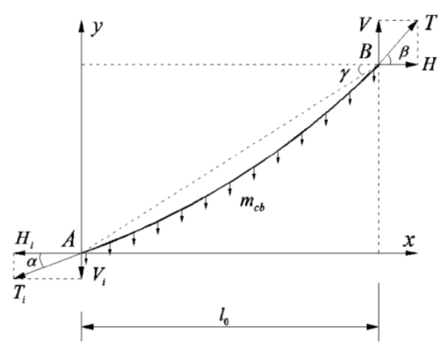
Figure 1. Schematic diagram of force analysis for stay cable.
According to equilibrium conditions, the equilibrium equation can be established:
$$\begin{aligned}\sum{M_{A}}=0:-Hy+Vx-\int_{0}^{x}{\left(1+y'^{2}\right)dx}=0\#\left(1\right)\end{aligned}$$
$$\begin{aligned}\sum{F_{x}}=0:H-H_{i}=0\#\left(2\right)\end{aligned}$$

$$\begin{aligned}\sum{F_{y}}=0:V-V_{i}-\int_{0}^{x}{m_{cb}\sqrt{1+y'^{2}}}dx=0\#\left(3\right)\end{aligned}$$
Solve H and V respectively from equations (2) and (3), and substitute them into equation (1) to obtain:
$$\begin{aligned}-H_{i}y+\left(V_{i}+\int_{0}^{x}{m_{cb}\sqrt{1+y'^{2}}dx}\right)x\#\#\#\#-\# \\ \int_{0}^{x}{m_{cb}x\sqrt{1+y'^{2}}dx}=0\#\left(4\right)\end{aligned}$$
Taking the derivative of x on both sides of equation (4) yields
$$\begin{aligned}-H_{i}y^{'}+V_{i}+\int_{0}^{x}{m_{cb}\sqrt{1+y'^{2}}dx}=0\#\left(5\right)\end{aligned}$$
Again taking the derivative of x on both sides of equation (5) yields the final catenary equation
$$\begin{aligned}-H_{i}y^{''}+m_{cb}\sqrt{1+y'^{2}}=0\#\left(6\right)\end{aligned}$$
Solving the above equation can be solved as follow
$$\begin{aligned}y=\frac{H_{i}}{m_{cb}}\cosh\left(\frac{m_{cb}x}{H_{i}}+C_{1}\right)+C_{2}=0\#\left(7\right)\end{aligned}$$
Where C₁ and C₂ are constants. In order to obtain a unique solution to the catenary equation, boundary conditions need to be given:
$$\begin{aligned}y\left(l_{0}\right)=l_{0}\tan{γ}\#\left(9\right)\end{aligned}$$
$$\begin{aligned}y^{'}\left(0\right)=\tan{α}\#\left(10\right)\end{aligned}$$
This study aims to improve the PINNs’ structure by utilizing neural networks to learn the control equations and boundary conditions of cable-stay catenary. The goal is to train an appropriate neural network that can replace the conventional catenary equation. Unlike traditional PDEs, the boundary conditions in this case contain unknown parameters. In other words, during the learning process, the neural network must not only learn its internal parameters but also the angular characteristic parameter $α$.
To address this challenge, the angular characteristic parameter is incorporated as learnable parameters. These parameters are optimized and updated jointly with the internal parameters of the neural network through gradient-based methods. This end-to-end approach to solving the cable-stay catenary equation circumvents the complexity inherent in traditional numerical methods that require indirect solutions, thereby significantly reducing the difficulty of the problem.

3.2 Cable-Catenary Physics-Informed Neural Networks Algorithm
Regarding the problem of solving the cable catenary equation, this study improves upon the classic PINNs framework (Karniadakis et al., 2021) and proposes a CC-PINN algorithm. The specific implementation method is shown in Figure 2. Firstly, a uniform sampling method is applied to the feasible domain of the catenary, forming datasets used to optimize both the physics-constrained loss and the data-driven loss. Here, $θ$ represents the set of neural network parameters, while $α$ represents the learned catenary characteristic parameters.
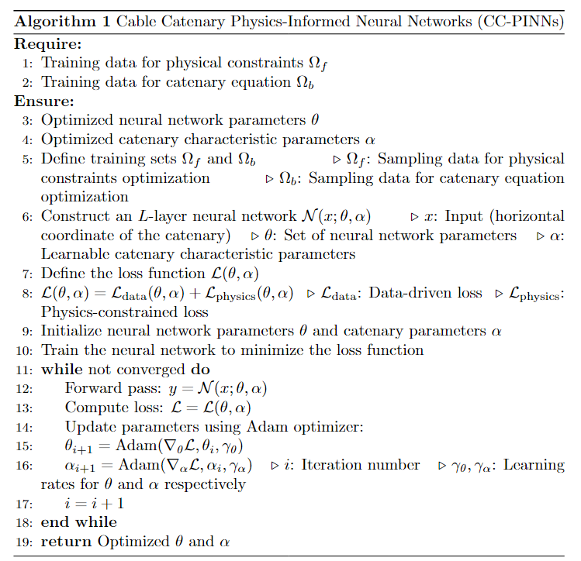
Figure 2. Pseudocode for CC-PINN
As shown in Figure 3, a neural network$N(x;θ，α)$ is then constructed with the cable-stay catenary position $x$ as input and the cable-stay line $y$ as output. The main difference between the CC-PINN and classic PINN lies in the additional self-learning parameters. These parameters are not directly related to the main neural network but participate in parameter updates during gradient backpropagation.
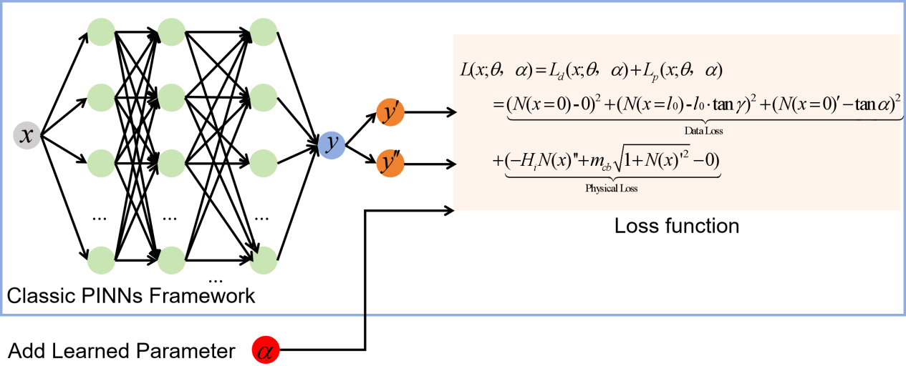
Figure 3. The CC-PINN framework
Based on the catenary theory formulas (6), (8), (9) and (10), an overall loss function can be constructed:
$L\left(x;θ，α\right)=L_{\text{data}}\left(x;θ，α\right)+L_{\text{physics}}\left(x;θ，α\right)$ $=\underset{\text{Data Loss}}{\underbrace{(N(x=0)-0)^{2}+(N(x=l0)-l_{0}⋅\tan{γ})^{2}+(N(x=0)^{'}-\tan{α})^{2}}}$ $\begin{aligned}+\underset{\text{Physical Loss}}{\underbrace{\left(-H_{i}N{\left(x\right)}^{''}+m_{cb}\sqrt{1+N\left(x\right)'^{2}}-0\right)}} \#\left(11\right)\end{aligned}$
The loss function is composed of two parts: the data-driven loss $L_{\text{data}}$ and the physics-informed loss $L_{\text{physics}}$. The data-driven loss primarily incorporates known boundary conditions, such as the position coordinates of the catenary endpoints. Additionally, there are unknown boundary conditions, as the catenary characteristic parameter $α$ is initially unknown and require continuous updating and iteration throughout the learning process. Notably, the catenary characteristic parameter $θ$ is also part of the loss function construction, which distinguishes it from classic PINNs equation. On the other hand, the physics-informed loss is derived from the catenary equation. The key distinction from traditional solution methods lies in the substitution of the catenary function y with a neural network representation.
The optimization process necessitates the simultaneous adjustment of two classes of parameters: the neural network parameters $θ$ and the catenary characteristic parameter $α$. To accommodate this dual optimization, distinct learning rates are established for each parameter class. The specific steps are as follows:
Step 1: Initially, the gradient is computed for each set of parameters:
$$\begin{aligned}g_{t,u}=∇_{u}L\left(u_{t-1},angl{\text{e}}_{t-1}\right)\#(12)\end{aligned}$$
$\begin{aligned}g_{t,angle}=∇_{\text{angle}}L\left(u_{t-1},angl{\text{e}}_{t-1}\right)\#(13)\end{aligned}$

$L$ represents the loss function, while $u_{t-1}$ and $\text{angl}{\text{e}}_{t-1}$ denote the model parameters and angle parameters from the previous iteration, respectively. The algorithm proceeds to update the first-order and second-order moment estimates based on the gradients, applies bias correction, and ultimately updates the parameters.
Step 2: Update parameters:
$$\begin{aligned}θ_{t}=θ_{t-1}-\frac{λ_{θ}}{\sqrt{{\hat{v}}_{t,θ}}+ϵ}{\hat{m}}_{t,θ }\#\left(14\right)\end{aligned}$$
$$\begin{aligned}α_{t}=α_{t-1}-\frac{λ_{α}}{\sqrt{{\hat{v}}_{t,α}}+ϵ}{\hat{m}}_{t,α}\#\left(15\right)\end{aligned}$$

$λ_{θ}$ and $λ_{α}$ represent the learning rates for the model parameters and angle parameters, respectively. ${\hat{m}}_{t,θ}$ and ${\hat{m}}_{t,α}$ are the bias-corrected values for the first-order moments, while ${\hat{v}}_{t,θ}$ and ${\hat{v}}_{t,α}$ are the bias-corrected values for the second-order moments. $ϵ$ is a small positive number used to prevent division by zero errors.
Due to the complexity and unique nature of the CC-PINN, setting different learning rates for the model parameters and additional parameters enhances the flexibility and efficiency of parameter updates during model training. This differentiated parameter update strategy provides an effective solution for addressing specific challenges in complex model training processes, thereby enhancing training stability and optimization efficiency.

Numerical Experiments
To ensure generality, this study employs conventional stay cable specifications and arrangement forms for validation. The specific parameters are presented in Table 1. As evident from Table 1, the cable lengths from C1 to C4 gradually increase, representing the typical progression from short to long cables encountered in engineering practice. These design parameters possess significant engineering representativeness. This study will initially compare the accuracy of solutions obtained through the Newton's method and the Secant method—both commonly used in engineering—with the proposed CC-PINN.

Table 1. Design Parameters of Cables
Cable Number | Deck Anchor Coordinates |  | Tower Anchor Coordinates |  | Cable Specification | Linear Weight / (kN·m⁻¹) | Cable Force / kN
Cable Number | x_{i} / m | y_{i} / m | x_{i} / m | y_{i} / m | Cable Specification | Linear Weight / (kN·m⁻¹) | Cable Force / kN
C1 | 0 | 0 | 20.259 | 43.964 | PES7-121 | 0.389 | 2392.6
C2 | -35.100 | -0.175 | 20.166 | 54.201 | PES7-139 | 0.448 | 2997.8
C3 | -78.100 | -0.390 | 20.103 | 66.553 | PES7-199 | 0.632 | 3947.8
C4 | -122.100 | -0.610 | 20.073 | 80.326 | PES7-241 | 0.761 | 4984.2

  - Accuracy Analysis
Whether employing traditional methods such as Newton's method and the Secant method, or the novel CC-PINN approach, the primary objective is to solve the catenary equation. Consequently, the solution process must satisfy the equation's boundary conditions. Therefore, in the comparative analysis, the three boundary conditions and the linear function of results are crucial metrics for evaluating the solution accuracy. Table 2 presents the boundary condition solutions for four representative cables, obtained using Newton's method, the Secant method, and CC-PINN. The accuracy of the results at x=0 is consistent across all three methods. However, at x=L, Newton's method exhibits slightly lower precision compared to the Secant method and CC-PINN.
Regarding the third boundary condition $y'(0)=\tan{α}$, since there is no target value for alpha, it is not possible to directly assess the error. Given that the Secant and Newton methods have been extensively studied in both academic and industrial contexts, a hypothesis testing approach was introduced to more scientifically evaluate the degree of difference between CC-PINN and traditional methods. A paired t-test was employed to analyze the disparities in angle calculations among CC-PINN, the Secant method, and Newton's method. The null hypothesis posited that there were no significant differences between CC-PINN and the Secant method, as well as between CC-PINN and Newton's method in angle calculations. The resulting p-values were 0.40964 for CC-PINN versus the Secant method, and 0.4250 for CC-PINN versus Newton's method. As both p-values substantially exceed 0.05, the null hypothesis cannot be rejected. In other words, from a statistical perspective, although there are slight variations in angle calculations among CC-PINN, the Secant method, and Newton's method—with a maximum difference of 0.039 degrees—there is no statistically significant difference among the three methods. This demonstrates that CC-PINN possesses comparable capability in angle calculation to the established methods. Meanwhile, Figures 5(a)-(d) illustrate the cable profiles for parameters C1-C4, respectively, as computed by the three methods. It is evident that the cable shapes derived using CC-PINN align closely with those obtained through traditional methods.

Table 2. Calculation results for different models
Boundary Conditions |  | Target value | Secant method | Newton's method | CC-PINN
$$y(0)=0$$ | C1 | 0 | 0 | 0 | 0
$$y(0)=0$$ | C2 | 0 | 0 | 0 | 0
$$y(0)=0$$ | C3 | 0 | 0 | 0 | 0
$$y(0)=0$$ | C4 | 0 | 0 | 0 | 0
$$y(l_{0})=l_{0}\tan{γ}$$ | C1 | 43.964 | 43.964 | 43.987 | 43.964
$$y(l_{0})=l_{0}\tan{γ}$$ | C2 | 54.376 | 54.376 | 54.409 | 54.376
$$y(l_{0})=l_{0}\tan{γ}$$ | C3 | 66.943 | 66.943 | 66.971 | 66.943
$$y(l_{0})=l_{0}\tan{γ}$$ | C4 | 80.936 | 80.936 | 80.962 | 80.936
$$α$$ | C1 | / | 65.165 | 65.176 | 65.169
$$α$$ | C2 | / | 44.299 | 44.316 | 44.291
$$α$$ | C3 | / | 33.832 | 33.843 | 33.857
$$α$$ | C4 | / | 29.031 | 29.039 | 29.000
- C1 Profile | - C2 Profile
- C3 Profile | - C4 Profile
Figure 5. Cable Catenary Profiles Solved by Different Methods

Although CC-PINN achieves end-to-end solution of cable catenary equations, simplifying the solving process and lowering the barrier to use, the separate updating of characteristic angle parameters means that different learning rates can have a significant impact.
(a) Angle learning process of C1 | (b) Angle learning process of C2
(c) Angle learning process of C3 | (d) Angle learning process of C4
Figure 6. Learning process of self-learning angle parameter with different learning rates
According to the CC-PINN algorithm proposed in this study, the uncertainty of characteristic angles brings great difficulty to model optimization. Thus, the focus is on analyzing rapid learning methods for characteristic angles. Figure 6 shows the angle learning process for C1-C4 cables' parameters under angle learning rates of 0.001, 0.01, and 0.1.
Larger learning rates result in greater fluctuations during the optimization process. When the angle learning rate is set to 0.1, the angle optimization does not show a stable trend towards equilibrium. This is mainly because the high learning rate causes excessive correction of angle parameters in each epoch during optimization. The characteristic angle parameters of the catenary require high-precision fine-tuning during the learning process. However, when the learning rate is too low, set at 0.001, the angle learning process is more stable compared to the 0.1 learning rate. The angle gradually stabilizes from the initial value as learning progresses, but the learning speed is relatively slow. When the angle learning rate is set to 0.01, it compensates for both the convergence difficulty of high learning rates and the slow convergence of low learning rates. It can be seen that a learning rate of 0.01 converges to the target accuracy in less time.
More notably, the advantage of the 0.01 learning rate is more pronounced when solving more challenging long cables. For cable C3, this learning rate improves learning efficiency by 24.1% and 30.6% compared to learning rates of 0.1 and 0.001, respectively. For cable C4, it improves efficiency by 32.5% and 54.9% compared to rates of 0.1 and 0.001. Therefore, choosing an angle learning rate of 0.01 is more appropriate, enabling rapid convergence.

4. CONCLUSION
Due to the complexity of traditional methods, this study proposes a high-precision, end-to-end solution for cable catenary problems. CC-PINN was established, along with an analysis of its key parameters in the context of stay cables. The following conclusions were drawn:
- This study proposes the CC-PINN, featuring a dual-parameter optimization approach that simultaneously updates both neural network parameters and catenary characteristic angle parameters with different learning rates. This innovative method effectively addresses the unique challenges in cable catenary modeling.
- The CC-PINN achieves higher terminal accuracy than Newton's method and matches the precision of the Secant method at boundary conditions. For the characteristic angle parameter, despite minor fluctuations between methods, statistical analysis (p-values > 0.05) confirms no significant differences between CC-PINN and traditional methods.
- The learning rate of 0.01 for angle parameters provides optimal performance, balancing the instability of higher rates (0.1) and the slow convergence of lower rates (0.001). This optimization is especially important for longer cables, improving efficiency by up to 54.9%.
By providing an end-to-end solution framework, CC-PINN effectively lowers the technical barriers to accurate cable catenary analysis, potentially enabling broader application of advanced modelling techniques in practical bridge engineering projects without sacrificing analytical rigor.

ACKNOWLEDGEMENTS
This work is part of the knowledge transfer partnerships (KTP) project – DIGIBRIDGE: BIM and Digital Twins in support of Smart Bridge Structural Surveying. The project receives funding from Innovate UK with reference number 10003208; The China Scholarship Council under Grant CSC 202408420030.

REFERENCES
Abelson, H., diSessa, A., (1981). Turtle Geometry: The Computer as a Medium for Exploring Mathematics. The MIT Press. https://doi.org/10.7551/mitpress/6933.001.0001
Bergou, E.H., Diouane, Y., Kungurtsev, V., (2020). Convergence and Complexity Analysis of a Levenberg–Marquardt Algorithm for Inverse Problems. Journal of Optimization Theory and Applications 185, 927–944. https://doi.org/10.1007/s10957-020-01666-1
Cao, Hongyou, Zhou, Yun-Lai, Chen, Zhijun, Wahab, Magd Abdel, (2017). Form-finding analysis of suspension bridges using an explicit Iterative approach. Structural Engineering and Mechanics 62, 85–95. https://doi.org/10.12989/SEM.2017.62.1.085
Cao, Q., Deng, J., Feng, Z., Yang, P., Yuan, G., Du, K., (2022). A New Method for Finding the Shape of the Main Cable in the Special Cable Plane. Applied Sciences 12, 11913. https://doi.org/10.3390/app122311913
Connor, J.J., Faraji, S., (2013). Cable Structures, in: Connor, J.J., Faraji, S. (Eds.), Fundamentals of Structural Engineering. Springer, New York, NY, pp. 443–488. https://doi.org/10.1007/978-1-4614-3262-3_5
Cuomo, S., Di Cola, V.S., Giampaolo, F., Rozza, G., Raissi, M., Piccialli, F., (2022). Scientific Machine Learning Through Physics–Informed Neural Networks: Where we are and What’s Next. Journal of Scientific Computing 92, 88. https://doi.org/10.1007/s10915-022-01939-z
Dennis, J.E., Schnabel, R.B., (1996). Numerical Methods for Unconstrained Optimization and Nonlinear Equations, Classics in Applied Mathematics. Society for Industrial and Applied Mathematics. https://doi.org/10.1137/1.9781611971200
Guo, X.-Y., Fang, S.-E., (2023). Structural parameter identification using physics-informed neural networks. Measurement 220, 113334. https://doi.org/10.1016/j.measurement.2023.113334
Haghighat, E., Raissi, M., Moure, A., Gomez, H., Juanes, R., (2021). A physics-informed deep learning framework for inversion and surrogate modeling in solid mechanics. Computer Methods in Applied Mechanics and Engineering 379, 113741. https://doi.org/10.1016/j.cma.2021.113741
He, Q., Barajas-Solano, D., Tartakovsky, G., Tartakovsky, A.M., (2020). Physics-informed neural networks for multiphysics data assimilation with application to subsurface transport. Advances in Water Resources 141, 103610. https://doi.org/10.1016/j.advwatres.2020.103610
Jayaraman, H.B., Knudson, W.C., (1981). A curved element for the analysis of cable structures. Computers & Structures 14, 325–333. https://doi.org/10.1016/0045-7949(81)90016-X
Karniadakis, G.E., Kevrekidis, I.G., Lu, L., Perdikaris, P., Wang, S., Yang, L., (2021). Physics-informed machine learning. Nature Reviews Physics 3, 422–440. https://doi.org/10.1038/s42254-021-00314-5
Mao, Z., Jagtap, A.D., Karniadakis, G.E., (2020). Physics-informed neural networks for high-speed flows. Computer Methods in Applied Mechanics and Engineering 360, 112789. https://doi.org/10.1016/j.cma.2019.112789
Mao, Z., Meng, X., (2023). Physics-informed neural networks with residual/gradient-based adaptive sampling methods for solving partial differential equations with sharp solutions. Applied Mathematics and Mechanics 44, 1069–1084. https://doi.org/10.1007/s10483-023-2994-7
Marquardt, D.W., (1963). An Algorithm for Least-Squares Estimation of Nonlinear Parameters. Journal of the Society for Industrial and Applied Mathematics 11, 431–441. https://doi.org/10.1137/0111030
Raissi, M., Karniadakis, G.E., (2018). Hidden physics models: Machine learning of nonlinear partial differential equations. Journal of Computational Physics 357, 125–141. https://doi.org/10.1016/j.jcp.2017.11.039
Raissi, M., Perdikaris, P., Karniadakis, G.E., (2019). Physics-informed neural networks: A deep learning framework for solving forward and inverse problems involving nonlinear partial differential equations. Journal of Computational Physics 378, 686–707. https://doi.org/10.1016/j.jcp.2018.10.045
Samaniego, E., Anitescu, C., Goswami, S., Nguyen-Thanh, V.M., Guo, H., Hamdia, K., Zhuang, X., Rabczuk, T., (2020). An energy approach to the solution of partial differential equations in computational mechanics via machine learning: Concepts, implementation and applications. Computer Methods in Applied Mechanics and Engineering 362, 112790. https://doi.org/10.1016/j.cma.2019.112790
Song, C., Xiao, R., Sun, B., (2020). Improved Method for Shape Finding of Long-Span Suspension Bridges. International Journal of Steel Structures 20, 247–258. https://doi.org/10.1007/s13296-019-00283-7
Song, Y., Lu, X., Yin, Y., Liu, Y., Liu, Z., (2024). Optimization of Railway Pantograph-Catenary Systems for Over 350 km/h Based on an Experimentally Validated Model. IEEE Transactions on Industrial Informatics 20, 7654–7664. https://doi.org/10.1109/TII.2024.3361485
Wu, J., Frangopol, D.M., Soliman, M., (2015). Geometry control simulation for long-span steel cable-stayed bridges based on geometrically nonlinear analysis. Engineering Structures 90, 71–82. https://doi.org/10.1016/j.engstruct.2015.02.007
.

