Decentralised Monitoring of Rail Traffic using Extended Reality:

An Approach to Improving the Resilience of Critical Infrastructures
LARS WAGENBACH¹, PASCAL MOSLER¹, NILS SCHÄFER¹, MATHIAS RHIEL², UWE RÜPPEL¹

¹Technical University of Darmstadt, Darmstadt, Germany
²DB Fernverkehr AG, Frankfurt, Germany

ABSTRACT
Trains are currently monitored and dispatched from centralised control centres. The workstations required for these tasks are equipped with a limited number of monitors, but an even larger display area is preferred due to the large amount of software being used simultaneously. This article uses a case study from the field of rail traffic dispatching in Germany to discuss the extent to which multi-desktop-based workflows such as monitoring and dispatching can be transferred to XR with the help of an XR headset. For this purpose, the current human-human interaction and human-machine interaction are analysed and a concept for a transition into an XR environment is developed. To evaluate the concept and compare it with the status quo, a real, desktop-based workflow is emulated in the XR environment. Our XR-based approach enables remote work and the ability to display a virtually unlimited workspace for the operator. It also facilitates location-independent decentralised monitoring, which can improve the resilience of critical railway infrastructure.

KEYWORDS:
Extended Reality, Monitoring, Dispatching, Railway Traffic, Critical Infrastructures

1. INTRODUCTION
Railway traffic monitoring and dispatching are critical components of transportation infrastructure, ensuring efficient train movement, passenger safety, and operational reliability. The resilience and efficiency of railway networks is crucial to minimize significant disruptions caused by natural disasters, targeted attacks, pandemics or other reasons for inaccessibility of the control centres. In Germany, railway traffic monitoring and dispatching rely heavily on regionally centralized control centres equipped with extensive hardware, requiring physical presence of the operators. Dispatchers monitor and coordinate railway traffic using multiple software tools displayed on a limited number of physical monitors. This centralized approach, while being efficient, generates single points of failure and limited adaptability during crises. Especially the physical presence requirement limits flexibility.
Decentralisation can contribute significantly to improving system resilience by reducing single points of failure and enabling more adaptive responses during disruptions (Bešinović & Quaglietta, 2024), (Dollevoet & Huisman, 2004), (Helmrich, A., Markolf, S., Li, R., Carvalhaes, T., Kim, Y., Bondank, E., Natarajan, M., Ahmad, N., & Chester, M., 2021). In the context of this research decentralisation means decoupling control operations from the physical presence at designated control centres and instead act remotely. This spatial distribution and location-independence, as shown in Fig.1, can contribute to a solution to the identified challenges. The large circles in Fig.1 represent control centres and the combination of a small circle with a rectangle inside and outside the large circles represents a person monitoring and dispatching at a work desk. The number and location of control centres as well as the number of operators or supervisors do not precisely reflect reality. The purpose of the illustration is to show the concept of decentralisation.
However, traditional remote-monitoring solutions in home offices have limited flexibility and are impractical due to the number of physical monitors required for a dispatcher’s workplace. This is where Extended Reality (XR) presents an innovative opportunity. XR, which encompasses virtual and augmented reality technologies, offers flexible work environments that can simulate or potentially enhance physical workspaces (Alstom, 2023), (Inglobe Technologies, 2023). XR facilitates better visualization and interactions, as it has been observed in smart building management, where XR enhances human performance in technical tasks and decision-making (Casini, 2022). Operators can access a virtual control centre with an unlimited number of virtual screens from any location and by enabling decentralised remote-controlled XR workflows, the reliance on physical infrastructure is reduced. As multiple operators can monitor from different locations, redundancy is increased, and control centre functions can be maintained in the event of an emergency. On the other hand, this approach gives rise to new challenges that are also analysed in this research. Our case study investigates how existing workflows in control centres can be transported to an XR environment to contribute to a digital transformation in monitoring and dispatching railway traffic.

2. OBJECTIVES AND RESEARCH GAP
Despite the growing interest in both decentralised control systems and XR applications in industrial monitoring, research on their combined use for railway traffic management remains limited. The main objective of this research is to point out how XR can support the flexibility and decentralisation of railway traffic monitoring and dispatching processes. To achieve this, this paper addresses the following questions:
- What are the critical components and workflows involved in current railway traffic dispatching systems?
- To what extent does a location-independent XR workstation contribute to enhancing resilience, particularly in the context of railway traffic monitoring?
- How can current workflows be effectively transferred to an XR environment without compromising performance or usability?

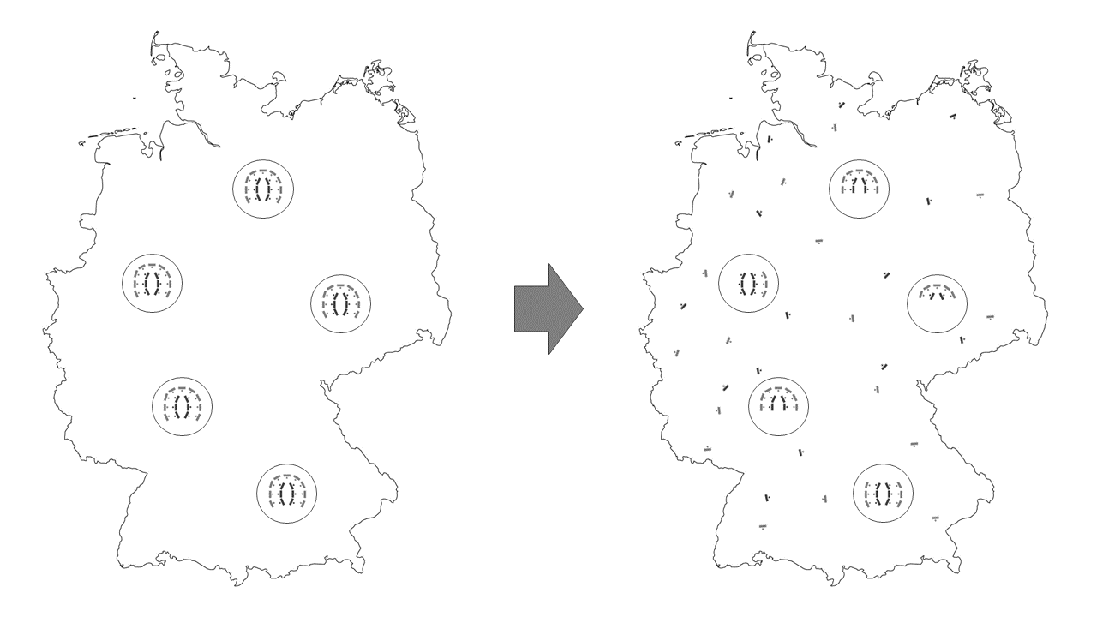
Figure 1: Transformation from centralised to decentralised location-independent railway traffic monitoring in Germany
(Outline Map of Germany by Vemap.com).

Additionally, we aim to assess the potential risks associated with this approach and identify the necessary requirements that must be met to ensure a secure and effective deployment. Finally, we present an application that emulates real-world dispatching workflows in XR as a demonstrator. A SWOT analysis has been conducted to assess both the application and the underlying concept. In the future, further testing of the XR application can lead to a replacement of conventional workstations and thus enable more decentralised monitoring.

2.1 Problem context and operator observations
Current railway traffic control in Germany is managed through centralised regional control centres. Each operator typically works at a fixed workstation equipped with multiple physical monitors, a standard keyboard and mouse, and access to a variety of specialized software tools. These tools include timetable displays, real-time train tracking systems, incident reporting platforms, and communication interfaces.
During our preliminary observations at a regional dispatching centre, the physical workspace was arranged in a circular formation, known as the "monitoring circle," with operators seated around the perimeter and a supervisor station positioned centrally. The operators desk arrangement is shown schematically in Fig. 2. It consists of a monitoring circle (light grey) with a supervisor island in the middle (dark grey). This setup allows flexible communication between operators (1:1 communication) and from a supervisor to the operators (1:n communication). Additionally, the dispatchers use telephones to speak to e.g. the personnel in the trains or emergency services. The communication must be fast and precise. Each dispatcher uses a computer with keyboard, mouse and multiple monitors. Sometimes, pieces of information are noted with a pen on paper. Most software tools are either web applications or function both as standalone and web applications, e.g. Microsoft Outlook and Microsoft Teams. Among others, the applications show the train network, train timetables, passenger information, a ticker system for disruptions and provide chat tools. Operators report that more screens would be useful, but limited space prevents adding more monitors.
Operators expressed that their current monitor setups were often insufficient, with screen space becoming a bottleneck for effective multitasking. Despite a desire for more screens, physical constraints prevent further expansion. This limitation highlights a critical usability issue that impedes situational awareness and operational efficiency.
The high dependency on physical infrastructure and co-location of personnel presents a systemic vulnerability—especially in crises such as pandemics, natural disasters, or cyber-attacks. Furthermore, traditional remote-working setups do not scale well to the complex, multi-screen workflows typical of railway traffic dispatching, limiting the feasibility of decentralisation.
These observations underline the need for a resilient and flexible monitoring solution—one that supports complex workflows, enhances user experience, and enables remote accessibility without sacrificing operational quality. In the following sections, we present a methodological framework for addressing these challenges using extended reality (XR) technologies.

Figure 2: Monitoring circle with supervisor island.

3. METHODOLOGY
This study adopts a design science research approach to explore how XR can support decentralized monitoring and dispatching in railway operations. Following the guidelines of design-oriented research (Hevner et al., 2004), our approach includes problem identification, conceptual design, technical implementation, and evaluation. The methodology combines qualitative data gathering from operators and experts with iterative prototype development. A case study was carried out with an industry partner in railway traffic dispatching.

3.1 Workflow analysis
To identify the critical components and workflows of the operators a work shadowing and interviews with operators took place in a regional control centre. A detailed assessment of human-human and human-machine interactions in existing rail control centres was conducted. We documented the operators’ workflows and the hardware setup including the desk arrangement. The results were used to identify critical components and analyse strengths and weaknesses.
3.3 XR concept development
Using the insights gathered from the workflow analysis, we developed a conceptual XR platform to replicate dispatcher tasks in a virtual environment. The design preserves existing workflows while integrating XR-specific capabilities, such as flexible screen arrangements and immersive interfaces. The concept prioritizes usability and ease of transition for dispatchers, including concepts for human-human and human-machine interactions.

3.4 XR implementation and technical setup
The XR environment was built using Unity and the Vuplex 3D WebView plugin. The prototype allows operators to access all essential web-based applications within the virtual space and lesser used standalone applications in the real environment on a monitor The setup uses a Varjo XR-4 Focal Edition headset and standard input devices, such as mouse, keyboard and XR controllers, to maintain familiarity.

3.5 Evaluation procedure
To evaluate the system, a representative dispatching workflow was emulated in our XR environment. Expert feedback was collected through guided testing sessions during three workshops with our industry partner to refine the concept and results. The number of workshop participants varied from two to ten people, who are all subject matter experts in strategic positions but had no prior exposure to XR.

4. RESULTS AND DISCUSSION
The following section presents the outcomes of the XR concept implementation and evaluates its performance based on usability, technical feasibility, and resilience implications. Results are derived from testing the prototype in a representative dispatching workflow, as well as feedback gathered from expert users. The focus lies on demonstrating how conventional dispatching tasks can be transferred into an XR environment without loss of functionality, and where additional potential for improvement exists.
We begin by outlining the technical foundation of the XR platform, followed by architectural considerations, interaction models, and regulatory challenges. These results are then assessed in light of human factors and operational requirements.

4.1 Platform model
We have created a modular and hybrid platform model, as shown in Fig. 4. It is hybrid, as it allows the integration of virtual elements while preserving the possibility for conventional interactions with the computer. The operator can utilise the same web application on either a physical or virtual screen. The platform is further characterised by its modular nature, with its division into three modules, each of which are interchangeable. The first module is the XR headset, here the Varjo XR-4 Focal Edition, which is utilised by the dispatcher. The framework is designed to accommodate the use of alternative devices such as the Meta Quest 3.
Secondly, the human-machine interaction of the operator with his real and virtual environment is addressed. In addition to the conventional analogue interaction with keyboard and mouse, the XR environment offers a variety of alternatives, including XR-controllers, gesture control and speech recognition.
The third and last module of this platform is the software environment. To use the XR headset, it is necessary to run a game engine on the computer. With the game engine Unity, we developed a virtual environment mainly using the Vuplex 3D WebView plugin, which is a library designed for integrating a web browser in virtual environments (Vuplex, 2025).

4.2 System architecture
The architectural design of the proposed approach bridges the real and virtual environments to support seamless interaction across both spaces. This XR-based dispatching environment is presented in Fig. 5. The central element of the setup is a laptop, which acts as the main processing unit and interface between physical and virtual components. The user is wearing the XR headset to see the real and virtual environment simultaneously. The virtual components are created and managed using the game engine Unity as the development environment. Within Unity, the plugin Vuplex enables the rendering of web applications directly within the virtual space. The functionalities of the virtual browser tabs are the same as a Chromium browser. The initial setup of the virtual screens in the Unity development interface is shown in Fig. 3.

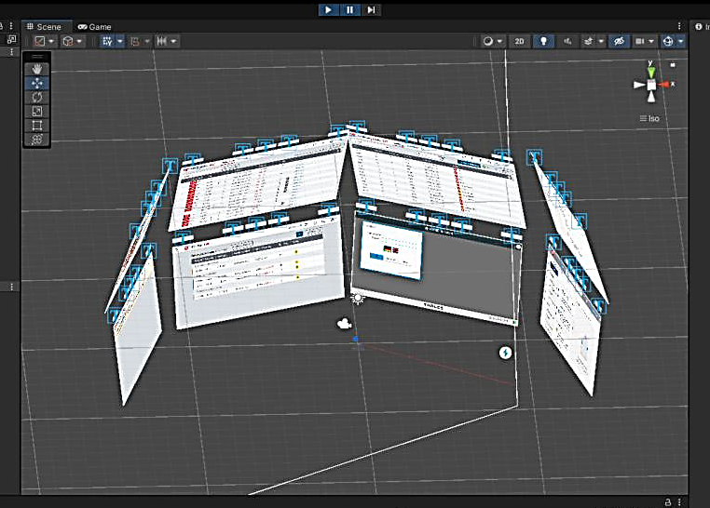
Figure 3: Unity development interface with initial XR setup

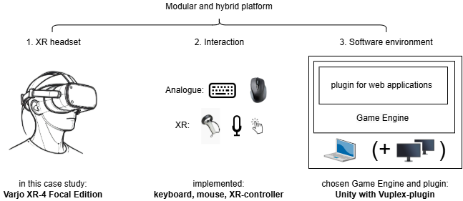
Figure 4: Hybrid platform model with three modules for the integration of XR in current workflows.

The screens have a fixed distance from the XR headset on a spherical surface. There is no limit to the number of new screens that can be opened, and each screen can be moved around and closed. In the real environment, the operator uses the keyboard and mouse to interact with the laptop and monitor(s) for non-web-based standalone applications. In the virtual environment, we chose to use an XR-controller with the keyboard to interact with the virtual screens. The implementation of gesture control and speech recognition has been withheld to avoid unintentional incorrect entries due to interpretation inaccuracies. In essence, the XR-controller serves as a replacement for the mouse in the virtual environment, facilitating the transition and familiarisation process for dispatchers due to the minor adjustments made to the control scheme.
In summary, the system architecture combines traditional desktop computing with immersive XR experiences, aiming for a flexible and extensible approach that integrates existing tools while paving the way for more intuitive, natural interaction methods.

4.3 Communication concept
In the context of the XR environment, a communication concept was developed to support both group interactions and focused, individual exchanges. The idea is based on two different modes of auditory communication. By default, all participants are located in a shared virtual space, the "main room", where 1:n communication applies similar to the situation in a physical control centre. This setting is intended to simulate an open environment where general information can be shared and heard by all participants, resembling informal team discussions or shift briefings.
To address the need for more focused, private conversations, the concept includes a secondary 1:1 communication mode. This is facilitated through a virtual "side room", allowing users to temporarily leave the main room for a more concentrated exchange, such as a quick consultation between colleagues or a conversation with a supervisor. The concept also anticipates technical mechanisms such as muting in the main room or using external voice communication tools, as well as the integration of a telephone function.
The concept includes a virtual dashboard. On this dashboard, users can see which rooms other users are in and, in the case of an urgent matter, can broadcast to any person in any room, similar to shouting out loud at the control centre.
Overall, the proposed auditory spatial model aims to replicate familiar patterns of workplace communication, enabling fluid transitions between open and private dialogue. Although not implemented, the concept provides a framework for designing more natural and context-sensitive interactions in future XR environments.

4.4 Regulatory challenges
The integration of XR technologies into railway operations introduces not only technical and organizational innovations but also significant regulatory implications. As rail transport constitutes critical infrastructure under both European and national legal frameworks, the deployment of XR systems—especially in decentralized environments such as remote or home offices—must comply with a range of cybersecurity and operational resilience requirements. In particular, the EU’s NIS2 Directive and Germany’s KRITIS (Critical Infrastructure Protection) regulations are central to ensuring lawful

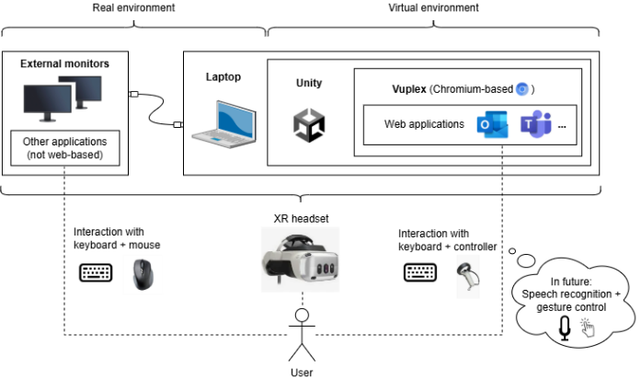
Figure 5: System architecture of the combined real and virtual environment of the user

and secure adoption (BSI, 2004), (European Union, 2022). Under the Directive (EU) 2022/2555 (NIS2), railway operators are designated as essential entities (European Union, 2022). Consequently, any XR systems integrated into the IT or OT architecture of rail services fall within the directive’s scope. This includes both hardware (e.g., XR headset, XR-controllers) and software components (e.g., XR-based maintenance or dispatching tools).
While regulatory frameworks define mandatory requirements for digital technologies in critical infrastructure environments, the use of XR systems introduces additional complexities—particularly when such systems are deployed independently of centralized infrastructure and beyond the controlled environment of a traditional control centre. As outlined earlier in this paper, the envisioned XR setup enables dispatchers and personnel to operate remotely using immersive, haptic interfaces. This shift toward location-independent workflows opens new possibilities for flexibility and responsiveness, but also exposes the system to novel vulnerabilities. In such decentralized settings, XR applications create new attack surfaces and operational uncertainties with respect to information security and business continuity. The specific requirements imposed on XR systems—ranging from secure transmission paths and network topologies to fallback infrastructure and internal emergency procedures—are highly implementation-dependent and often rely on proprietary knowledge internal to the operator. As such, these parameters fall outside the direct scope of this work. To address this, a scenario-based analytical framework was adopted.
This approach allows for a structured examination of XR usage in critical contexts without presuming access to internal systems or architectures. Based on the concrete assumptions regarding a remote, headset-based XR system, seven representative scenarios were identified, each highlighting different technical and organizational challenges:
- Power outage
- Instability or failure of internet connection
- Physical damage or theft of XR equipment
- Pandemic-induced large-scale remote work
- Targeted cyberattack against XR systems
- Technical malfunction of XR devices
- Natural disaster (e.g., flooding or earthquake)
While each scenario reveals potential vulnerabilities, Scenario 4 (Pandemic) and Scenario 7 (Natural Disaster) in particular, also showcase the resilience-enhancing potential of XR technologies in critical infrastructure environments. In the context of a pandemic, XR systems enable operational continuity by allowing dispatchers and infrastructure personnel to work safely from home, thereby minimizing infection risk and ensuring availability of key staff. Similarly, in the case of large-scale disasters that may impair physical access to centralized control centres, XR-enabled remote workflows can help maintain essential functions and improve response times. More broadly, XR solutions offer additional systemic advantages, including:
- Operational continuity under crisis conditions
- Risk mitigation in public health contexts
- Scalability and adaptive capacity
- Improved interaction, through immersive data visualizations that support intuitive decision-making in complex operational environments.
In summary, while the decentralisation of critical infrastructure functions through XR introduces new risk vectors, it also offers significant potential for increasing the robustness, flexibility, and responsiveness of operations — particularly in times of crisis.

4.6 XR considerations and ergonomic limits
The current XR implementation focuses on emulating existing desktop workflows within a virtual environment. While this approach ensures familiarity, it may underutilize the full potential of XR. Flat virtual screens mirror physical monitors, but XR-specific user experience features - such as 3D spatial data visualisation, gaze-based selection, and immersive dashboards - remain unexplored in this prototype version.
Future iterations should explore interface elements designed natively for XR, aiming to reduce visual clutter and improve cognitive mapping. Potential improvements include adaptive screen placement based on task priority, multimodal interactions (gesture, speech), and haptic feedback to enhance situational awareness.
While XR enables flexible display configurations, human cognitive capacity and physical comfort impose practical limitations. Preliminary user feedback noted concerns about prolonged use of headsets, including visual fatigue and headset weight. Though test participants found the interaction intuitive, long-term usability remains a concern. Future development in XR headsets might solve this potential issue.
The ergonomics of using our XR setup for longer than one to two hours was not explored in the scope of this study but may cause discomfort. Testers have reported fatigue after using the headset. In general, taking regular breaks is recommended when using XR headsets. Furthermore, there are cognitive limits to the number of simultaneously monitored screens, regardless of available display space. These constraints must guide future design adaptations and work-rest cycle recommendations.

4.7 XR demonstrator and SWOT analysis
To assess the concept’s feasibility, a desktop-based dispatcher workflow was replicated in XR using web-accessible tools. Testing was conducted with subject matter experts in strategic positions but minimal exposure to XR technologies.
Participants evaluated the setup using guided task walkthroughs and provided verbal feedback. All applications in the workflow functioned correctly in XR, and users adapted to XR controllers within minutes. Feedback highlighted the intuitive nature of XR interaction but raised questions about long-term comfort and visual clarity as well as potential fatigue over time.
To discuss the transferability of current workflows to an XR environment, a typical desktop-based dispatcher workflow was captured on screen. Every application used in this workflow can be accessed through a browser via VPN connection. This workflow was recorded in XR as well, using the web applications within the virtual environment. Fig. 6 and Fig. 7 show screenshots of the XR headset during the XR workflow. Testing the XR headset with different users lead to the feedback, that operating in the virtual environment with the XR controller was intuitive and easy to learn, also for users with an aversion towards technology. Furthermore, no loss of time due to the use of XR could be determined.
To assess the feasibility and implications of transferring conventional railway dispatching workflows to an XR environment, a SWOT analysis was conducted. This structured approach identifies internal strengths and weaknesses of the proposed concept, as well as external opportunities and threats that may influence its successful implementation. The analysis is based on findings from the case study, expert feedback, and observations from the XR prototype. It provides a condensed overview of the key factors that must be considered when evaluating XR as a resilient alternative to traditional, location-bound control centre operations. We summarized the results of the SWOT analysis in Table 1. The analysis highlights XR’s potential to improve operational flexibility and reduce physical infrastructure dependency. However, successful deployment depends on addressing current technical limitations and ensuring user acceptance. In particular, long-term ergonomics and regulatory compliance in critical infrastructure contexts remain key challenges.

5. CONCLUSION AND FUTURE WORK
This research explores the potential of XR technology to rethink rail traffic dispatching and monitoring. By enabling decentralised location-independent operations, XR offers a promising
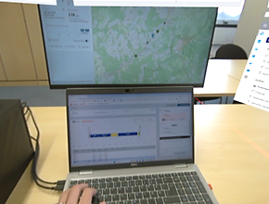
Figure 6: Screenshot during the XR workflow looking mainly at the real environment of the laptop and monitor.
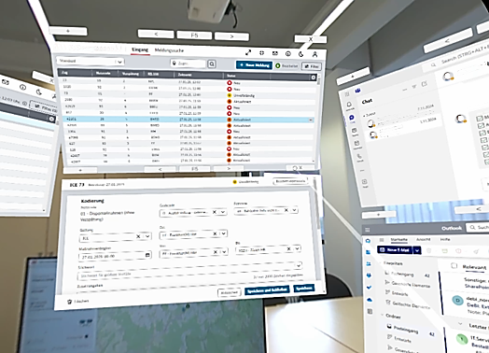
Figure 7: Screenshot during the XR workflow looking mainly at virtual screens.

Table 1: SWOT analysis of using XR for decentralised monitoring and dispatching of rail traffic.
Strengths:  - High scalability of the display area  - Comparable efficiency to desktop workflow  - Preserves existing workflows with added interactivity  - Enables remote work  - Potential ergonomic benefits | Weaknesses:  - Uncertainty around wearing comfort (weight, concentration)  - Reliable hardware interaction needed for productive use
Opportunities:  - Long-term cost savings (office space, hardware expenses)  - XR headset not limited to a single use case  - Platform concept allows flexibility  - Possibility of AI integration (e.g., process mining, decision support) | Threats:  - Potential lack of user acceptance  - Compliance with critical infrastructure requirements (e.g., KRITIS)

solution to enhance the resilience of critical infrastructures. One key advantage is the ability to work with an unlimited number of virtual screens, overcoming the spatial constraints of physical monitors. Moreover, XR enables remote accessibility, eliminating the need for operators to be physically present in centralized control centres.
This location-independent decentralisation enhances flexibility and ensures continued operations during emergencies. Another important potential benefit of the utilisation of XR is cost efficiency. By reducing reliance on physical infrastructure and space, it can lower operational costs over time while maintaining or even improving service quality. While the findings of this case study highlight several benefits, further work is required to address technical, ergonomic, and security challenges, such as the need for reliable XR hardware, potential user fatigue during prolonged use, and limitations related to remote operations. Addressing these issues is critical to the successful deployment of XR in monitoring and dispatching processes.
Future research will focus on refining the XR concept based on further operator feedback in a piloting phase. Later, the integration of advanced technologies such as artificial intelligence (AI) and predictive analytics can be explored. The integration of XR with AI has been explored in recent studies, highlighting its potential to enhance real-time decision-making (di Summa et al., 2022). Additionally, spatial interfaces in XR have the potential to offer a more immersive and intuitive understanding of traffic conditions, enabling quicker and more informed decision-making.
Ultimately, the overarching objective of this case study is to contribute to a more resilient and adaptive train operation on the critical infrastructure of railways. The transferability of this approach to analogous monitoring and dispatching processes in other domains, such as operations control centres for aircrafts or power grid monitoring, is also a potential avenue for future research.

REFERENCES
Alstom, 2023. Extending Your Rail Reality. XR Use Cases in Operations & Maintenance. Alstom. Available at: https://www.alstom.com/alstom-talk-extending-your-rail-reality-xr-use-cases-operations-maintenance [Accessed 07 Jan. 2025].
Bešinović, N. & Quaglietta, E., (2024). Decentralised Multi-Agent Coordination for Real-Time Railway Traffic Management. Available at: https://arxiv.org/abs/2502.08324 [Accessed 23 Mar. 2025].
BSI, 2024. IT-Sicherheitsgesetz 2.0 [IT Security Act 2.0]. Bonn: BSI. Available at: https://www.bsi.bund.de/dok/6617366 [Accessed 29 Mar. 2025].
Casini, M., 2022. Extended Reality for Smart Building Operation and Maintenance: A Review. Energies. 15, p.3785. DOI: https://doi.org/10.3390/en15103785
di Summa, M., Reno, V., Dibari, P., Pernisco, G., Sacco, M., & Stella, E., 2022. Extended Reality and Artificial Intelligence: Synergic Approaches in Real World Applications. Roadmapping Extended Reality: Fundamentals and Applications, 183-192. DOI: https://doi.org/10.1002/9781119865810.ch8
Dollevoet, T. & Huisman, T., (2004). Stability of RYNSORD – A Decentralized Algorithm for Railway Networks Under Perturbations. DOI: https://doi.org/10.1109/25.917947
European Union, 2022. Directive (EU) 2022/2555. Official Journal of the European Union. Available at: https://eur-lex.europa.eu/ [search "Directive 2022/2555"].
ELI: http://data.europa.eu/eli/dir/2022/2555/oj
Helmrich, A., Markolf, S., Li, R., Carvalhaes, T., Kim, Y., Bondank, E., Natarajan, M., Ahmad, N., & Chester, M. (2021). Centralization and decentralization for resilient infrastructure and complexity. Environmental Research: Infrastructure and Sustainability, 1(2): p. 021001. DOI: https://doi.org/10.1088/2634-4505/ac0a4f
Hevner, A. et al., 2024. Design Science in Information Systems Research. Management Information Systems Quarterly. 28. 75-.
Inglobe Technologies, 2023. Augmented Reality in the Rail Industry. Benefits and Use Cases.
Inglobe Technologies. Available at: https://www.inglobetechnologies.com/augmented-reality-in-the-rail-industry-benefits-and-use-cases/ [Accessed 05 Jan. 2025].
Vuplex, 2025. WebView for Unity Overview. Vuplex. Available at: https://developer.vuplex.com/webview/overview [Accessed 16 Mar. 2025].

