Main Title: AI-Based Extraction and Management of Text and View Information from 2D Bridge Engineering Drawings

Mengyan Peng^{,1} Angran Cui^{,1} Chongjie Kang^{,1} Steffen Marx^{,1}

¹Institute of Concrete Structures, Technical University Dresden, Dresden, Germany

ABSTRACT:

As bridge infrastructure continues to age globally, the need for efficient maintenance and digital documentation becomes increasingly urgent. 2D engineering drawings remain a primary source of information for bridge assessment, yet extracting semantic content from these documents remains a manual, time-consuming task. This study proposes an AI-based method for automating the extraction and structuring of information from 2D bridge engineering drawings. The approach integrates YOLOv7-based object detection, Handprint-based OCR, and a post-processing pipeline to identify view regions, recognize textual content, and match view titles with corresponding views. The system outputs semantically annotated views, enabling the generation of machine-readable view directories. Experimental results demonstrate high accuracy in detecting views and recognizing both printed and handwritten text, with minimal manual input. This work contributes to digital workflows in bridge documentation and sets the foundation for integration into broader Bridge Information Modeling (BrIM) systems to support infrastructure lifecycle management.

KEYWORDS:

Object detection, Optical character recognition (OCR), Post-processing, Bridge engineering drawings, Clustering, Digitalization

1. INTRODUCTION
In Germany, railway bridges have an average age of around 80 years (Naraniecki & Marx, 2019), while the majority of highway bridges were constructed from 1960 to 1985 (Bundesministerium für Digitales und Verkehr, 2022; Kang et al., 2024). In the United States, more than 42% of the 617,000 bridges are over 50 years old, highlighting the increasing issue of infrastructure aging (ASCE, 2021). According to the 2021 ASCE report, the rate of bridge deterioration exceeds that of repair, maintenance, and replacement. At the same time, most processes related to bridge inspection, condition assessment, and quality assurance still heavily rely on manual effort. The shortage of skilled professionals further impedes the acceleration of these workflows. Therefore, automating the entire process—or at least the labor-intensive and time-consuming steps—can significantly contribute to speeding up the rehabilitation, maintenance, and replacement of infrastructure.
Two-dimensional (2D) engineering drawings play a critical role in these processes, as they convey construction designs using a graphical language of lines, symbols, and annotations. Within the engineering workflow, extracting text, view, and component information from 2D engineering drawings to support decision-making is one of the time-consuming and expertise-intensive tasks. Efficient analysis, management, and information extraction from such engineering drawings can greatly accelerate bridge rehabilitation efforts. This study proposes an AI-based method to analyze 2D bridge engineering drawings and extract key information for more efficient management and interpretation of these documents.
This paper is organized as follows: Section 2 reviews related work on the digitalization of engineering drawings, including both image processing and deep learning-based methods. Section 3 introduces the proposed method, which combines object detection, OCR, and post-processing algorithms. Section 4 presents the experimental results, and evaluation. Section 5 concludes the paper and outlines directions for future work.

2. BACKGROUND
To enable the digitalization of technical or engineering drawings, researchers have proposed a variety of methods, which can generally be categorized into two groups: traditional image processing techniques and more recent deep learning approaches.
In image processing, text extraction and symbol recognition are two fundamental tasks. Fletcher and Kasturi (1988) proposed a text extraction algorithm that utilizes connected component generation and the Hough transform to detect text strings and characters. Symbol recognition, as a subtask of text recognition, has also been widely studied. Most existing methods rely on rule-based databases that can adaptively recognize new symbols (Or et al., 2005). These image processing techniques have been partially or fully applied in the interpretation of traditional 2D drawings. For example, Lewis and Séquin (1998) generated 3D building models from drawings using line detection algorithms and connectivity rules. Akanbi and Zhang (2022) proposed a framework that transforms tagged information from multiple bridge views into a 3D shell model for generating IFC models of bridges. Lu et al. (2020) employed a clustering algorithm to identify special symbols in architectural CAD drawings for BIM model generation.
In contrast, deep learning methods offer the advantage of automatic feature learning, eliminating the need for manually defined features or thresholds. These models have demonstrated strong adaptability and flexibility in drawing interpretation tasks. In recent years, deep learning has been widely applied to enrich technical drawings through tasks such as object detection, instance segmentation, scene text detection, and OCR. Vilgertshofer et al. (2020) used convolutional neural networks (CNNs) to detect symbols and infrastructure elements in railway technical drawings. Elyan et al. (2018) applied random forest (RF), support vector machine (SVM), and CNN models to classify symbols in technical drawings. Nguyen et al. (2021) combined a Fast R-CNN model with OCR techniques to detect objects and text in large-format engineering drawings. Van Daele et al. (2021) employed the DBSCAN clustering algorithm to segment drawing elements, which were then classified using a CNN model.
Beyond algorithmic approaches, some researchers have developed integrated systems to automatically extract and organize information from technical drawings. Ondrejcek et al. (2009) developed a prototype system called File2Learn, which processes engineering drawings and 3D CAD models through text detection and cropping, OCR using ABBYY FineReader, data cleansing, metadata encoding, storage, and ultimately, visualization and quality control in a custom browser. Ahmed et al. (2012) used Tesseract OCR to automate room detection and labeling in floor plans. Their approach involved extracting room labels, aligning and merging characters, and matching them to a predefined room title dictionary using Levenshtein distance, thereby improving both recognition accuracy and semantic analysis. Gimenez et al. (2016) demonstrated a BIM process using Qgar OCR to recognize characters and their bounding boxes from binarized text images extracted from floor plans. Gölzhäuser et al. (2023) proposed an AI-based OCR approach specifically for the title block of 2D bridge engineering drawings, aiming to extract textual information and convert it into a semantic data model to support digital twins and maintenance management of existing bridges. The method for extracting information from the title block in Gölzhäuser et al. (2023) will continue to be used in this study. Building upon it, the present study incorporates object detection and introduces new post-processing algorithms, with a central focus on managing views in bridge engineering drawings.

3. METHODS
2D engineering drawings primarily consist of both geometric and non-geometric information, providing detailed visual representations, annotations, and title blocks that are essential for bridge design and construction (Ostrowsky, O., 1989). Annotations and title blocks primarily consist of textual information, while visual representations mainly contain geometric data from various views. Accordingly, information extraction can be divided into three parts: (1) object detection using an AI-based model to localize views, (2) text recognition via OCR, and (3) post-processing to structure and classify the extracted information.

3.1 Object detection
YOLO (Jiang et al., 2022) is employed for object detection in bridge engineering drawings. According to the comparative study by Yung et al. (2022), YOLOv7 outperforms YOLOv5 and YOLOv6 in terms of detection accuracy. Therefore, YOLOv7 is selected in this work to perform object detection tasks. The model is trained to efficiently detect views, such as top view and side views, within engineering drawings.
Detection results are visualized using colored rectangular bounding box, green boxes for views (see Fig. 1) and are also saved in TXT files as shown in Fig. 2. Each row contains a class label (0 for view) and four normalized values: center x, center y, width, and height. YOLOv7 uses a normalized coordinate system from (0,0) at the top-left to (1,1) at the bottom-right, allowing consistent spatial representation across images and enabling further processing.

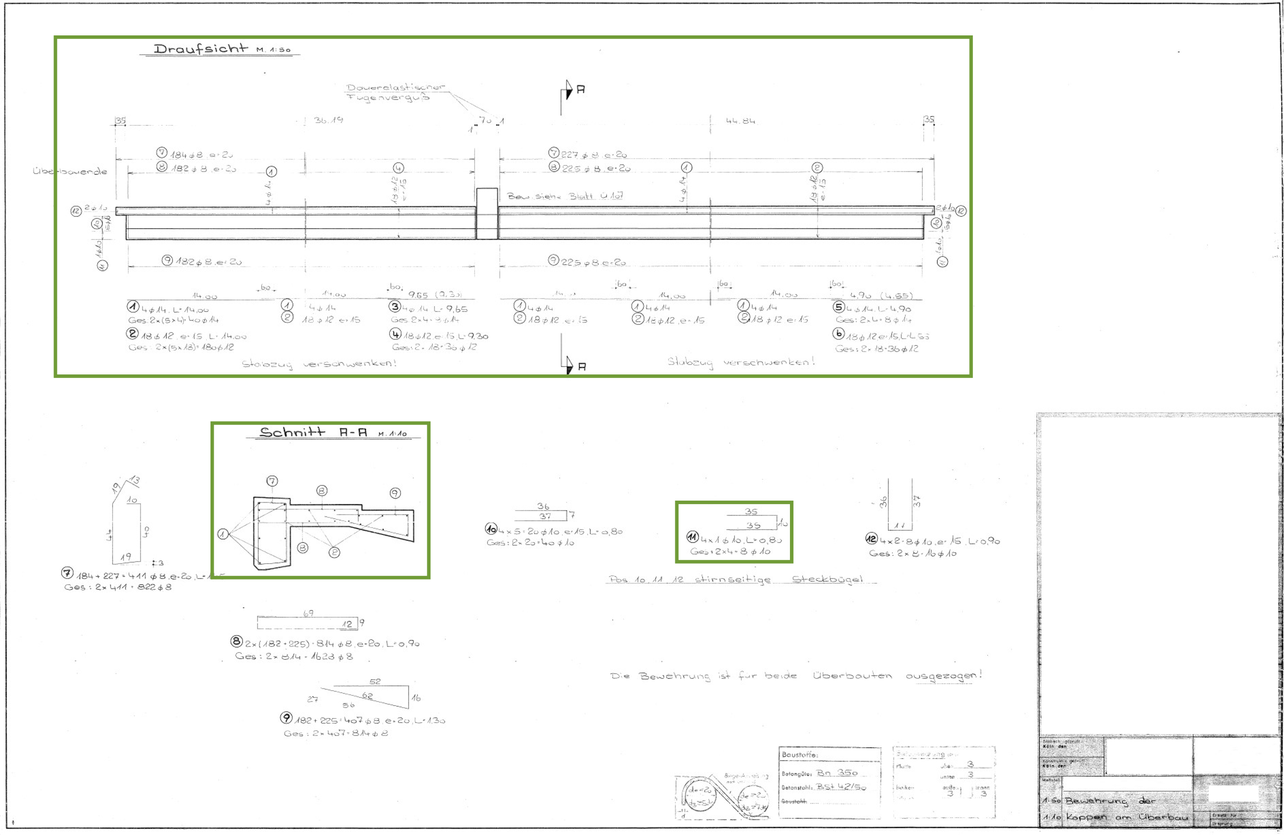
Figure 1: An example of detection results from YOLO.

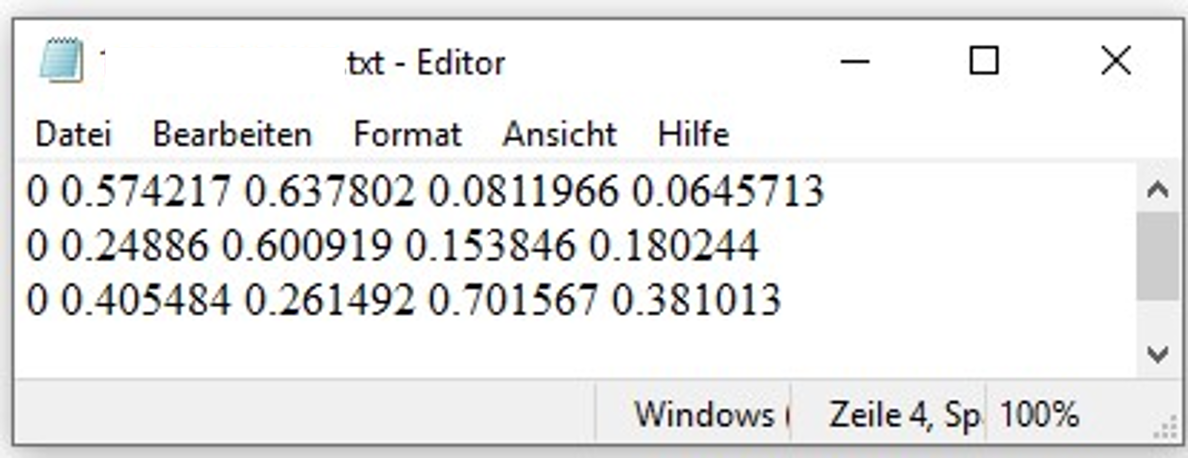
Figure 2: Examples of the TXT file with object detection results from YOLOv7.

3.2 OCR
OCR generally consists of two main stages: text detection, which identifies the location of text elements, and text recognition, which converts text in image format into a digital string representation (Wang et al., 2021). According to the comparative study by Peng et al. (2023), the OCR tool Handprint (Caltechlibrary, 2025) outperforms tools like Tesseract (Smith R., 2007), EasyOCR (JaidedAI, 2025), PaddleOCR (PaddlePaddle, 2025), and handwriting-ocr (Breta01, 2025) when processing textual fragments from real engineering drawings. Therefore, Handprint is adopted in this study for text recognition.
The output of Handprint is provided in JSON format. The JSON files include detailed coordinates and information for each word or line, along with the dimensions of the resized image used during OCR processing. This resized image, generated during Handprint’s pre-processing, maintains the original aspect ratio while reducing resolution, and all coordinate values correspond to this scaled version of the image. The coordinate system in the JSON files originates at the top-left corner (0, 0), with the x-axis extending to the right and the y-axis extending downward.
Each text element in the JSON output contains the following key information:
- boundingBox: Eight values representing the coordinates of the four vertices of the text bounding box.
- confidence: The OCR confidence score for the recognized text.
- text: The recognized textual content.

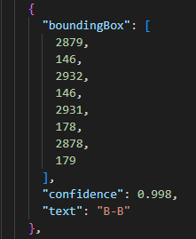
Figure 3: An example of the JSON file content.

As illustrated in Fig. 3, the boundingBox defines a rectangle using four points: top-left (x1, y1), top-right (x2, y2), bottom-right (x3, y3), and bottom-left (x4, y4). The example shows the coordinates (2879, 146), (2932, 146), (2931, 178), and (2878, 179) forming a complete bounding box. This box precisely marks the location of the text content “B-B”.

3.3 Post-processing
The information extracted through object detection (YOLOv7) and OCR (Handprint) lacks semantic structure. Specifically, it is unclear whether a detected region (views in the engineering drawings) corresponds to an abutment or foundation, or whether extracted text originates from annotations or title blocks. To address this, three post-processing algorithms (outlined in section 3.3.1, 3.3.2 and 3.3.3) are developed to categorize the extracted information, generate view directories for engineering drawings and assign the views to its respective components.

3.3.1 Title block information extraction
Title blocks in engineering drawings contain key metadata such as drawing names. Within a set of engineering drawings, the layout of the title block typically remains consistent (DIN EN ISO 5457, 2017). Therefore, this study adopts an interactive semi-automated extraction approach. On the first page of each drawing set, the user interactively selects two points to define a rectangular region that marks the target location of the title block. This user-defined reference position provides the initial spatial template for identifying title block contents on subsequent pages. Based on this template, specific content, such as drawing names, can be consistently extracted across all pages within the set. The detailed procedure follows the method described in Section 4.1 of Gölzhäuser et al. (2023).

3.3.2 Title identification
In engineering drawing practices, texts of the same hierarchical level are typically presented using a consistent font size to ensure clarity and visual uniformity. The font heights on a given drawing are usually limited to a discrete set of standard values rather than forming a continuous distribution (DIN EN ISO 3098-2, 2000). This characteristic allows for the use of clustering algorithms to identify the number of distinct font height levels. Moreover, view titles often appear among the largest text elements on a drawing. Based on this observation, the largest cluster can be considered a potential candidate for view titles.
In this study, the k-means clustering algorithm (Likas et al., 2003) is used to identify view titles from Handprint’s OCR output. K-means is a widely used unsupervised clustering algorithm that partitions a dataset into k clusters by minimizing intra-cluster variance. Given a set of vectors x₁, ..., xₙ, the algorithm seeks a clustering C = {C₁, ..., Cₖ} that minimizes the following objective:
$$\begin{aligned}min_{C}\sum_{i=1}^{k}{\sum_{x∈C_{i}}{|x}}-μ_{i}|^{2}\#(1)\end{aligned}$$
where μᵢ is the mean of cluster i for i = 1 to k.
In the implementation of this research, the algorithm evaluates different cluster counts using the silhouette coefficient, a metric that measures how similar an object is to its own cluster compared to other clusters. This helps determine the optimal number of clusters. The cluster with the largest average font height is identified as representing the view titles, and its mean height is selected as the optimal title font height. Furthermore, the upper bound (UB) and lower bound (LB) are calculated based on a user-defined matching range (MaRa), with a default of ±20%:
$$\begin{aligned}UB/LB=Optimal height ×(1± MaRa)\#(2)\end{aligned}$$
These bounds define the acceptable font height range for identifying titles from Handprint outputs, enhancing the algorithm’s flexibility in handling various drawing formats while maintaining recognition accuracy. The use of a percentage-based dynamic range, rather than fixed pixel values, ensures greater adaptability across different image resolutions and styles.
In addition to font height constraints, two heuristic rules are applied based on observations from a large number of real German bridge engineering drawings: (1) the text line must exceed a predefined character length (default: 10 characters), and (2) the first letter must be capitalized. These additional rules help improve the precision of title identification.

3.3.3 Matching view titles with detected views
In Section 3.1, the views are detected by YOLOv7, and in Section 3.3.2, potential view titles are identified. By correctly matching these two sets of information, semantic annotations can be assigned to each detected view, essentially enriching each view with its corresponding title label.
The matching process adopts a multi-criteria approach to ensure accurate associations between views and titles. For each detected view, the system evaluates potential view title matches based on the following three spatial relationship criteria:
- Containment check: Determines whether a title is completely enclosed within the bounding box of a view, which typically indicates a direct labeling relationship.
- Intersection analysis: If the bounding boxes of a title and a view overlap, they are considered spatially related and are likely to form a semantic pair.
- Distance calculation: If neither containment nor intersection exists, the system calculates the Euclidean distance between the center points of the title and view bounding boxes to find the closest title.
The matching process applies these criteria in a prioritized sequence—starting with containment, followed by intersection, and finally proximity. Once a match is found through containment or intersection, the system immediately assigns the title to the view, skipping further distance calculations. This hierarchical matching strategy ensures that the most visually evident relationships are captured first.

4. RESULTS

4.1 Object detection with YOLOv7
The YOLOv7 model was trained on 2,000 real-world 2D bridge engineering drawings, all manually annotated. The dataset was split into 80% for training and 20% for validation, and the training was conducted over 200 epochs. The training used a batch size of 16, the OneCycle learning rate (Smith L. N., 2018) policy, and the Adaptive Moment Estimation (Adam) (Kingma & Ba, 2014) optimizer. As shown in Fig. 4, the training loss rapidly decreased from an initial value of approximately 0.085 to around 0.060 within the first 60 epochs, and subsequently showed a gradual and stable decrease, reaching approximately 0.048 by epoch 200. This indicates efficient convergence with continued, albeit slow, improvement throughout training.

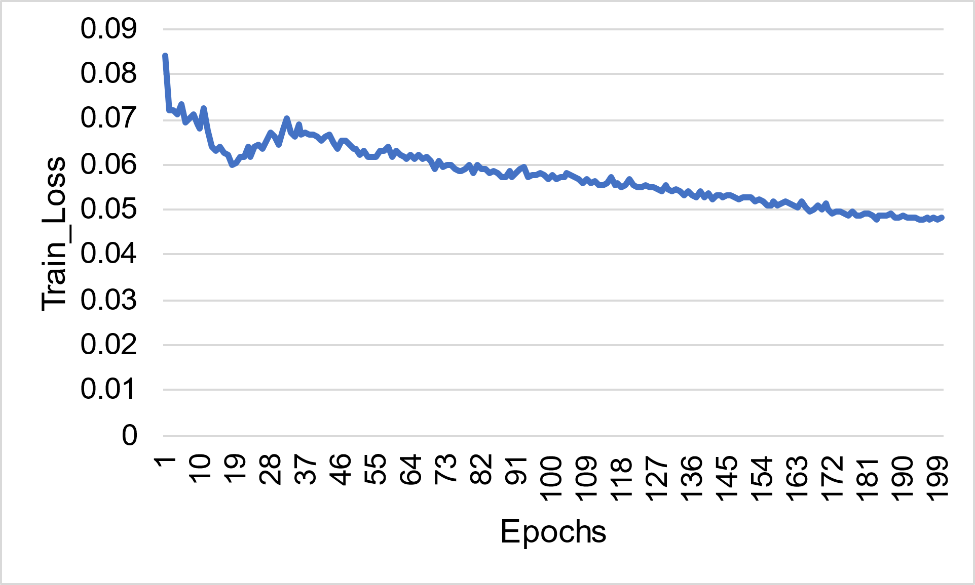
Figure 4: Training Loss over epochs.

Evaluation metrics on the validation dataset exhibited fluctuating performance in early stages but stabilized significantly after 120 epochs. Specifically, the mAP@.5 metric progressively improved, ultimately reached approximately 0.92 by the end of training (see Fig. 5). Likewise, the more stringent mAP@.5:.95 metric showed consistent improvement, stabilizing between 0.64 and 0.68 (Fig. 6), indicating that further improvements remain possible.
Overall, towards the later stages of training, the loss decreased slowly while validation metrics stabilized and showed slight improvements, indicating that the model had approached an optimal state. Additionally, no significant overfitting was observed, suggesting that the model capacity, training dataset size, and task complexity were appropriately balanced. This balanced performance demonstrates that the YOLOv7 model effectively detects views in bridge engineering drawings and is suitable for practical applications. Future work may include additional data augmentation, refined annotation quality, and higher-resolution input images to further boost localization precision.

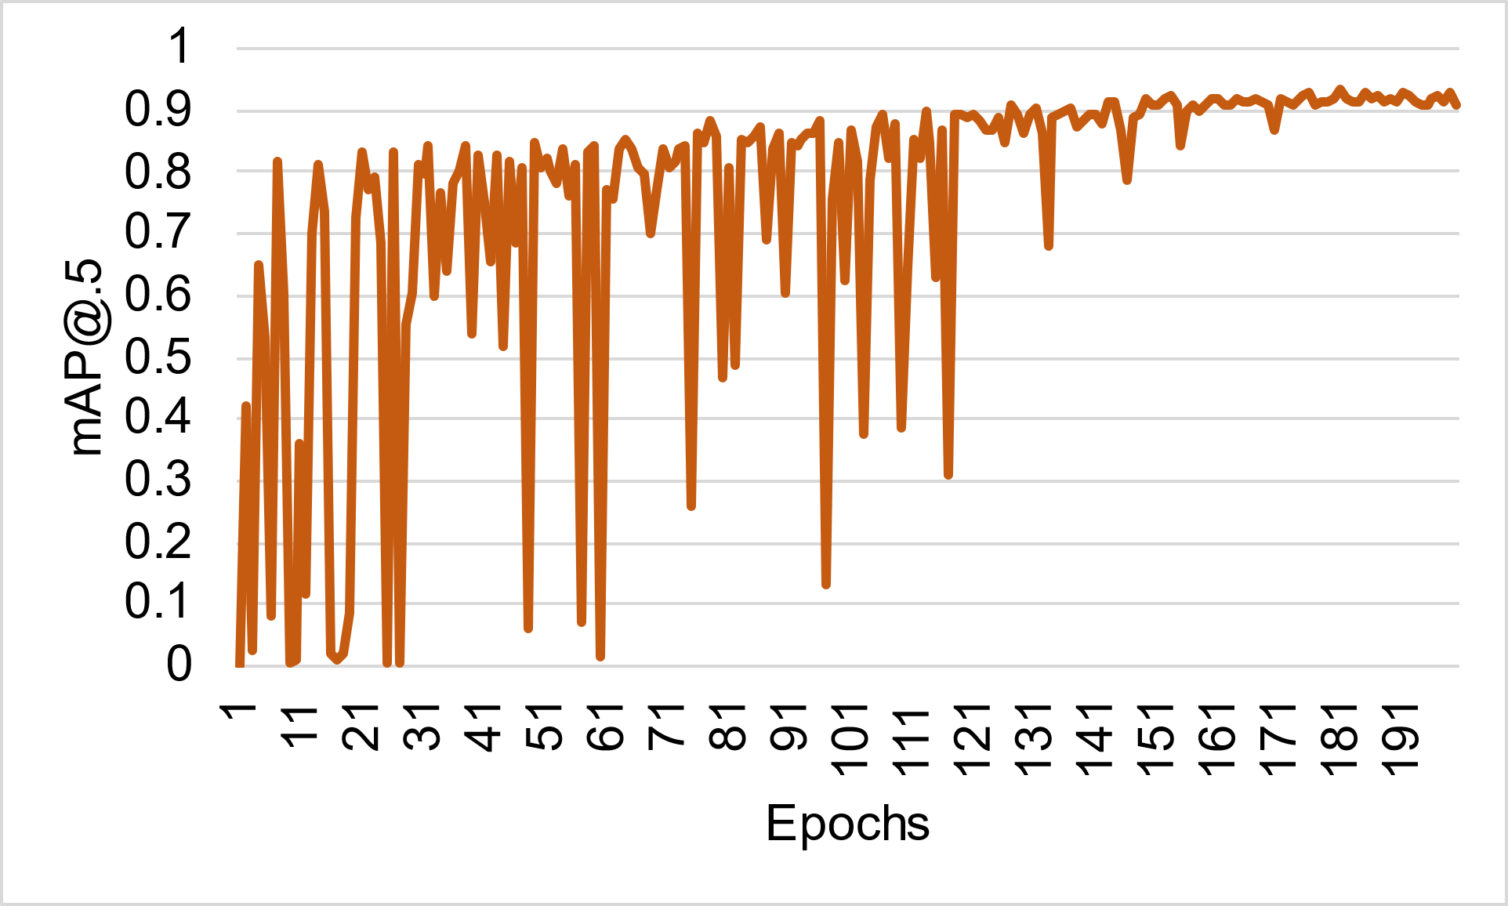
Figure 5: Validation mAP@0.5 over epochs.

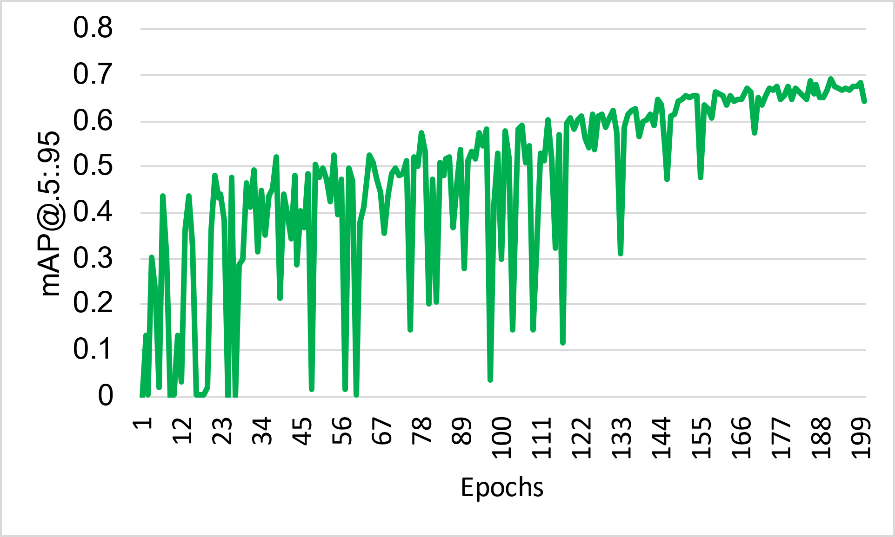
Figure 6: Validation mAP@0.5:0.95 over epochs.

4.2 OCR with Handprint
Handprint is a well-established pre-trained OCR tool. For bridge engineering drawings, the recognition accuracy based on Levenshtein distance is approximately 99% for printed text and 98% for handwritten text (Peng, et al., 2023). Fig. 7 illustrates the recognition results of Handprint for handwritten text in engineering drawings.

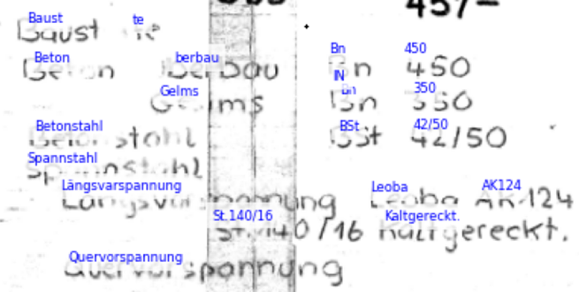
Figure 7: An example of handwritten text recognition from Handprint.

4.3 Post-processing
The post-processing algorithms described in Section 3.3 were successfully implemented and tested on real bridge engineering drawings. These algorithms effectively transform the raw detection and recognition outputs into semantically structured information. The following subsections present the results for each of the three key post-processing algorithms.

4.3.1 Title block information extraction
Fig. 8 demonstrates the extraction of the drawing name from the title block after applying the title block information extraction process described in Section 3.3.1 to an engineering drawing.

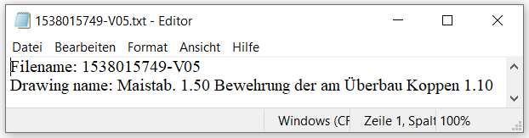
Figure 8: An example of title block information extraction.

In this example, "Bewehrung der am Überbau Koppen" refers to the reinforcement drawing of the bridge caps in the superstructure.

4.3.2 Title identification
Fig. 9 illustrates the results after applying the title identification process outlined in Section 3.3.2 to an engineering drawing, where eight potential view titles are identified. The same results are also provided in TXT format by the title identification algorithm, as shown in Fig. 10.
Notably, the two correct view titles—Draufsicht (representing the top view) and Schnitt A-A (indicating the sectional view along A-A)—are successfully identified. However, the other potential view titles are incorrect, and the subsequent matching process helps further eliminate these false positives.
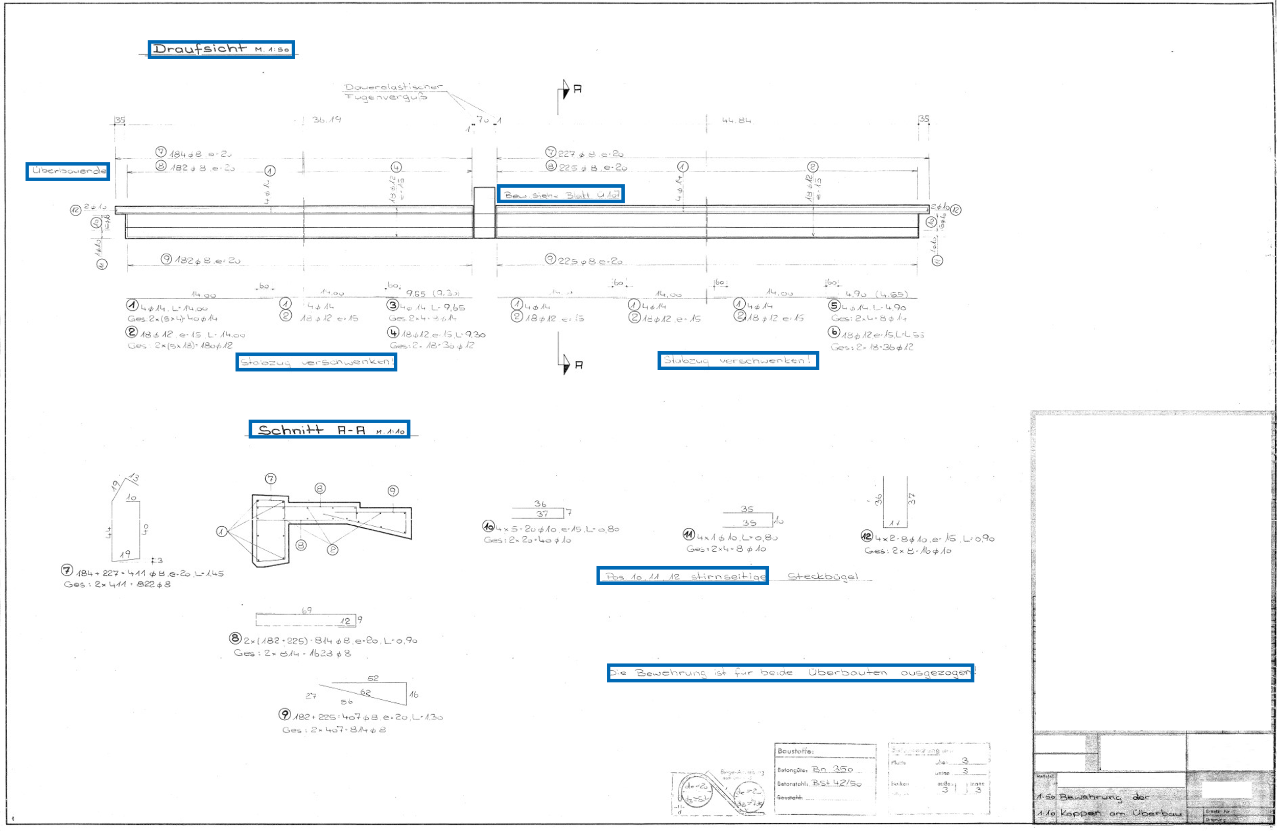
Figure 9: Schematic illustration of identified potential view titles.

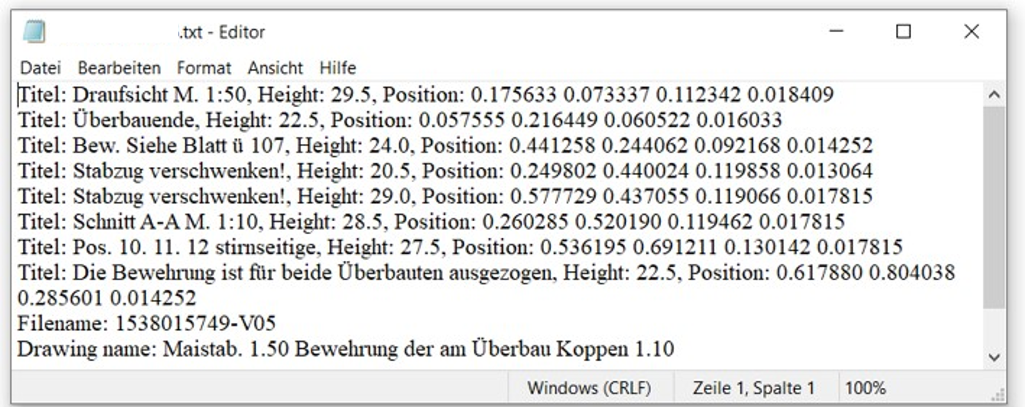
Figure 10: Examples of identified potential view titles in TXT format.

4.3.3 Matching view titles with detected views
The results of the matching process described in Section 3.3.3 are saved and visualized in a structured format, as shown in Fig. 11.
The detected views are cropped and saved as individual JPG files. Each JPG file is named according to its corresponding matched view title, such as Draufsicht M. 1 50 (Top view, scale 1:50). In addition, a semantic description file is automatically generated for each JPG and saved in TXT format. As shown in Fig. 12, this TXT file contains the matched view title as well as relevant information extracted from the title block. This semantic file serves as a crucial link between textual information and drawing geometry, enabling the establishment of semantic associations. For example, when a view title such as "top view" is identified through OCR and post-processing, the system can, based on corresponding information from the title block, interpret this top view as representing the reinforcement layout of bridge caps in the superstructure. This machine-readable association between geometric regions and structural meaning allows for automated interpretation of drawing content and supports downstream tasks such as structured directory generation and targeted information retrieval.

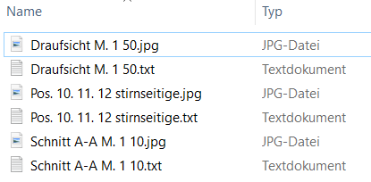
Figure 11: Schematic illustration matching view titles and views

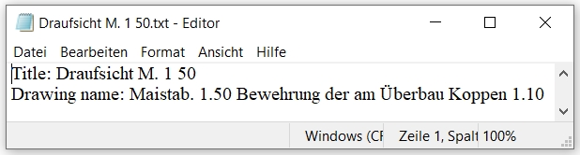
Figure 12: An example of semantic description in TXT file for a view.

As shown by the comparison between Fig. 10 and 11, the filtering and matching process effectively reduces the number of candidate titles, with only three valid view titles remaining, two of which are correct, demonstrating the robustness of the approach. Based on these refined results, a structured view directory of the engineering drawing can be generated (Fig. 13). This directory acts as a valuable navigational aid for engineers, enabling efficient access to specific regions within a drawing and facilitating the rapid retrieval of relevant views for downstream analysis. For example, a keyword-based search function could be developed, where entering terms like "top view," "bridge cap," or "reinforcement" would directly retrieve and display the corresponding views containing relevant semantic information. This demonstrates how the interaction between textual content and geometric content in the engineering drawings can be made more seamless and efficient.

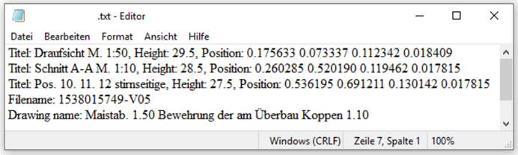
Figure 13: An example of directories for views within an engineering drawing.

5. CONCLUSIONS AND OUTLOOKS
This study presents an AI-based method for extracting and semantically structuring information from 2D bridge engineering drawings. The proposed approach integrates object detection using YOLOv7, OCR via Handprint, and a series of post-processing algorithms to automatically detect views, recognize text, and establish semantic associations between views and view titles.
Experimental results demonstrate the effectiveness of the YOLOv7 model in accurately localizing view regions in complex bridge drawings, achieving high detection precision without signs of overfitting. The OCR module based on Handprint achieves excellent recognition performance for both printed and handwritten text. Through post-processing, target information is semi-automatically extracted from title blocks, such as drawing names. View titles are automatically identified using clustering techniques and heuristic rules, and then matched with detected view regions to create structured, machine-readable outputs. These outputs include semantically enriched view image files, which facilitate the generation of comprehensive drawing directories and support further digital workflows in bridge documentation and analysis.
Looking ahead, several directions can be pursued to enhance this framework. First, expanding and diversifying the training dataset, particularly with older and handwritten drawings, can further improve detection robustness. Second, incorporating more advanced text semantics and context-aware algorithms may increase title identification accuracy and reduce false positives. Third, system functionality could be extended to support multilingual text recognition and component-level annotation. Regarding component-level annotation, we plan to perform instance segmentation on the extracted views to identify and extract component contours. These contours will then be refined through post-processing, and associated with textual data to enable the linkage of geometric dimensions with structural components. Finally, integrating this automated pipeline into a larger BrIM system could support full lifecycle management of bridge structures, contributing to the digital transformation of civil infrastructure maintenance and design.

ACKNOWLEDGEMENTS
We express our gratitude to the German Federal Ministry for Digital and Transport (BMDV) for supporting this research as part of mdfBIMplus (Partially automated creation of object-based inventory models using multi-data fusion of multimodal data streams and existing inventory data, project number 19FS2021C) and HyBridGen project (Hybrid Bridge Generator: AI-based bridge generator with knowledge and experience data and early public participation, project number 19FS2067A).

REFERENCES
Ahmed, S., Liwicki, M., Weber, M., & Dengel, A. (2012). Automatic Room Detection and Room Labeling from Architectural Floor Plans. In 10th IAPR International Workshop on Document Analysis Systems, IEEE, pp. 339–343. https://dx.doi.org/10.1109/DAS.2012.22.
Akanbi, T., & Zhang, J. (2022). Semi-automated generation of 3D bridge models from 2D PDF bridge drawings. In Construction Research Congress 2022 (pp. 1347-1354). https://doi.org/10.1061/9780784483961.141.
ASCE. (2021). Infrastructure Report Card.
Breta01, handwriting-ocr, 2025, https://github.com/Breta01/handwriting-ocr, visited 2025-03-25.
Bundesministerium für Digitales und Verkehr (BMDV). (2022). Brücken an Bundesfernstraßen: Bilanz und Ausblick. https://bmdv.bund.de/SharedDocs/DE/Anlage/K/presse/bruecken-an-bundesfernstrassen-bilanz-und-ausblick.pdf?__blob=publicationFile.
Caltechlibrary, Handprint, 2025, https://github.com/caltechlibrary/handprint, visited 2025-01-28.
DIN. (2000). DIN EN ISO 3098-2:2000-11: Technical product documentation – Lettering – Part 2: Latin alphabet, numerals and marks. Deutsches Institut für Normung (DIN).
DIN. (2017). DIN EN ISO 5457:2017-10. Technical product documentation – Sizes and layout for drawing sheets (ISO 5457:1999 + Amd. 1:2010); German version EN ISO 5457:1999 + A1:2010. Deutsches Institut für Normung (DIN).
Elyan, E., C. M. Garcia, et al. (2018). Symbols classification in engineering drawings. 2018
International Joint Conference on Neural Networks (IJCNN), IEEE. https://doi.org/10.1109/IJCNN.2018.8489087.
Fletcher, L. A. and R. Kasturi (1988). "A robust algorithm for text string separation from mixed
text/graphics images." IEEE transactions on pattern analysis and machine intelligence 10(6): 910-918. https://doi.org/10.1109/34.9112.
Ghorbel, A. (2012). Interprétation interactive de documents structurés: application à la rétroconversion
de plans d'architecture manuscrits, INSA de Rennes.
Gimenez, L., Robert, S., Suard, F., & Zreik, K. (2016). Automatic reconstruction of 3D building models from scanned 2D floor plans. Automation in Construction 63: 48–56. https://dx.doi.org/10.1016/j.autcon.2015.12.008.
Gölzhäuser, P., Peng, M., Jäkel, J. I., Klemt-Albert, K., & Marx, S. (2023). Approach to generate a simple semantic data model from 2D bridge plans using AI-based Text Recognition. In Proceeding of the 33rd European Safety and Reliability Conference (Vol. 3, pp. 2023-07). http://dx.doi.org/10.3850/978-981-18-8071-1_P424-cd
JaidedAI, EasyOCR, 2025, https://github.com/JaidedAI/EasyOCR, visited 2025-03-25.
Jiang, P., Ergu, D., Liu, F., Cai, Y., & Ma, B. (2022). A Review of Yolo algorithm developments. Procedia computer science, 199, 1066-1073. https://doi.org/10.1016/j.procs.2022.01.135.
Kang, C., Walker, M., & Marx, S. (2024). Advances of Digital Twins in Bridge Structures Maintenance. Procedia Structural Integrity, 64, 1232-1239. https://doi.org/10.1016/j.prostr.2024.09.191.
Kingma, D. P., & Ba, J. (2014). Adam: A method for stochastic optimization. arXiv preprint arXiv:1412.6980.
https://doi.org/10.48550/arXiv.1412.6980.
Lewis, R. and C. Séquin (1998). "Generation of 3D building models from 2D architectural plans."
Computer-Aided Design 30(10): 765-779. https://doi.org/10.1016/S0010-4485(98)00031-1.
Likas, A., Vlassis, N., & Verbeek, J. J. (2003). The global k-means clustering algorithm. Pattern recognition, 36(2), 451-461. https://doi.org/10.1016/S0031-3203(02)00060-2.
Lu, Q., L. Chen, et al. (2020). "Semi-automatic geometric digital twinning for existing buildings based
on images and CAD drawings." Automation in Construction 115: 103183. https://doi.org/10.1016/j.autcon.2020.103183.
Naraniecki, H., & Marx, S. (2019). Zustandsentwicklung und -prognose von Eisenbahnbrücken, Hannover: Institutionelles Repositorium der Leibniz Universität Hannover. https://doi.org/10.15488/5532.
Nguyen, M. T., V. L. Pham, et al. (2021). Object detection and text recognition in large-scale technical
drawings. ICPRAM 2021. https://doi.org/10.5220/0010314406120619.
Ondrejcek, M., Kastner, J., Kooper, R., & Bajcsy, P. (2009). Information extraction from scanned engineering drawings. National Center for Supercomputing Applications, University of Illinoisat Urbana-Champaign, Image Spatial DataAnalysis Group, 1.
Or, S.-h., K.-H. Wong, et al. (2005). "Highly automatic approach to architectural floorplan image
understanding & model generation." Pattern Recognition: 25-32.
Ostrowsky, O. (1989). Engineering Drawing with CAD applications. London: Routledge. https://doi.org/10.4324/9781315745640.
PaddlePaddle, PaddleOCR, 2025, https://github.com/PaddlePaddle/PaddleOCR, visited 2025-03-25.
Peng, M., Kang, C., & Marx, S. (2023). Text Recognition for 2D Bridge Plans Using OCR‐Algorithms. Ce/papers 6: 661–666. https://doi.org/10.1002/cepa.2077.
Smith, L. N. (2018). A disciplined approach to neural network hyper-parameters: Part 1--learning rate, batch size, momentum, and weight decay. arXiv preprint arXiv:1803.09820. https://doi.org/10.48550/arXiv.1803.09820.
Smith, R. (2007). An Overview of the Tesseract OCR Engine In Ninth International Conference on Document Analysis and Recognition (ICDAR 2007) Vol 2, IEEE, pp. 629–633. http://dx.doi.org/10.1109/ICDAR.2007.4376991.
Van Daele, D., N. Decleyre, et al. (2021). An automated engineering assistant: Learning parsers for
technical drawings. Proceedings of the AAAI Conference on Artificial Intelligence. https://doi.org/10.1609/aaai.v35i17.17783.
Vilgertshofer, S., D. Stoitchkov, et al. (2020). "Recognising railway infrastructure elements in videos
and drawings using neural networks." Proceedings of the Institution of Civil Engineers-Smart
Infrastructure and Construction 172(1): 19-33. https://doi.org/10.1680/jsmic.19.00017.
Wang, H., Pan, C., Guo, X., Ji, C., & Deng, K. (2021). From object detection to text detection and recognition: A brief evolution history of optical character recognition. Wiley Interdisciplinary Reviews: Computational Statistics, 13(5), e1547. https://doi.org/10.1002/wics.1547.
Yung, N. D. T., Wong, W. K., Juwono, F. H., & Sim, Z. A. (2022, October). Safety helmet detection using deep learning: Implementation and comparative study using YOLOv5, YOLOv6, and YOLOv7. In 2022 International Conference on Green Energy, Computing and Sustainable Technology (GECOST) (pp. 164-170). IEEE. https://doi.org/10.1109/GECOST55694.2022.10010490.

