A Unified Web-Based Digital Twin Platform for Integrating Fragmented Public Sector Data: A Brussels Prototype
Susheel Nath ^{1*}, Grégory Lewkowicz ²

¹ FARI – AI for the Common Good Institute, Vrije Universiteit Brussel, Brussels, Belgium
² FARI – AI for the Common Good Institute, Université Libre de Bruxelles, Brussels, Belgium

*Corresponding email: susheel.nath@vub.be

ABSTRACT
Digital twins are increasingly adopted across public and private sectors as tools for representing, monitoring, and analysing physical and urban systems. Recent European smart-city initiatives have used digital twins to support data-driven urban planning and sustainable city management. However, most operational urban digital twins remain organized by sector (mobility, energy, infrastructure), whereas public-sector policy questions cut across sectors and rely on datasets that are dispersed across institutions, formats, update frequencies and spatial scales. This paper asks whether such fragmented public-sector data can be integrated and explored within a single browser-based digital twin environment organized around policy questions rather than sectors. Following a design-science approach, we derive six recurring adoption challenges from the literature, translate them into design requirements, and propose a unified web-based platform built on a four-level spatial structure (region and municipality, neighbourhood, infrastructure and assets, building). The approach is demonstrated through a Brussels prototype that integrates open administrative, demographic, socio-economic, housing, environmental and real-time mobility data from eleven institutional sources within one interface. The demonstration supports the feasibility of the integration approach and illustrates how fragmented public-sector datasets can be brought together into an integrated spatial evidence environment for urban governance.

Keywords: Digital Twin; Public Sector Data; Open Data; Urban Governance; Web-Based Platform

- INTRODUCTION
Public information silos remain a persistent challenge in government, with data fragmented across agencies, systems, and formats, constraining data sharing, integration, and reuse (Curtis and Edward, 2019; Hassan et al., 2020; Valli Buttow and Weerts, 2024). These silos can hinder interoperability and make it more difficult to coordinate public services, collaborate across agencies, and support evidence-informed decision-making (Curtis and Edward, 2019; Hassan et al., 2020). Digital twins, broadly understood as virtual representations of physical entities, environments, or systems, have increasingly been explored as mechanisms for integrating heterogeneous data. In public-sector contexts, they have the potential to address some of these limitations by combining real-time and contextual data from multiple sources, supporting cross domain analysis and, where suitable models are available, simulation, and providing a shared information environment for coordination across departments and agencies (Coenen et al., 2025; Richter et al., 2025).

1.1 Public Sector Digital Twins Use
The term “digital twin” covers a spectrum of maturity, from static 3D city models and data dashboards to bidirectionally coupled, simulation-capable systems (Ketzler et al., 2020; Shahat et al., 2021). Several public-sector programmes illustrate this spectrum. In the United Kingdom, national digital twin initiatives have emphasised secure data sharing, interoperability, and information management to support infrastructure planning and management (GOV.UK, 2021). This responds to the fragmentation of transport, energy, buildings, utilities, and other infrastructure data, which is often managed by separate organisations (GOV.UK, 2024). Singapore’s Virtual Singapore initiative, as shown in Figure 1, further illustrates the integration of IoT data, 3D city modelling, and simulation for urban planning and management (GovTech Singapore, 2017). The digital twin enables planners to examine existing urban conditions and explore how proposed changes or future scenarios may affect the city before interventions are implemented (GovTech Singapore, 2017). At the European level, initiatives including Living-in.EU, the European Data Space for Smart Communities, and the EU Local Digital Twin Toolbox have supported the development of interoperable data spaces, local digital twins, and scalable digital tools for urban planning, governance, and public service delivery (European Commission, 2025; Living-in.EU, 2026). The DUET project provides an earlier European example of this direction, proposing a framework for developing interoperable and trusted digital twins for smart cities by integrating heterogeneous urban data and supporting evidence-based exploration of policy interventions (Raes et al., 2022). Alongside these government-led initiatives, recent studies indicate that digital twins are increasingly being applied across urban visualisation, risk management, energy systems, urban mobility, and public decision support (Bawany & Zainab, 2025; Do et al., 2026).
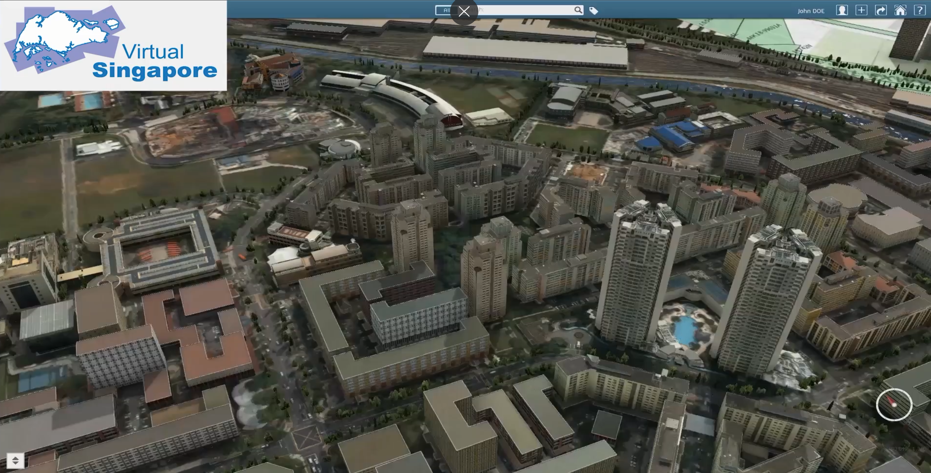
Figure 1: Demo visualization of neighbourhood buildings (GovTech Singapore, 2017)
These examples provide important foundations for policy-based digital twins. Virtual Singapore demonstrates how urban information can be integrated and explored within a shared digital environment, while the UK approach demonstrates how information from different systems and organisations can be connected through interoperability. Nevertheless, most of these initiatives are organised around a sector (transport, energy, infrastructure) or around the built environment as an object. Even cross-domain frameworks such as the LDT Toolbox are structured by sectoral simulation models and data layers, leaving the policy question to be composed by the user. Public administrations, by contrast, must answer questions that typically span several sectors and several levels of government. We argue that the mismatch between sector-organised twins and the cross-sector, multi-level questions that public administrations must answer is one concrete obstacle to their adoption in government, and it is this gap that the paper addresses.
1.2 Role of IoT and Sensors in Public Sector Digital Twins
IoT and sensor data can complement spatial, historical, and administrative datasets by providing more current information on changing conditions in the physical environment (Thelen et al., 2022; Fuller et al., 2020). This can support more timely planning, targeted action, and evaluation of interventions. Their value increases when combined with contextual information on locations, assets, populations, or administrative areas, allowing live observations to be interpreted alongside other evidence (Afif Supianto et al., 2024). For the proposed platform, live feeds such as air quality and public-transport vehicle positions are therefore linked to the same spatial units as static administrative and socio-economic data rather than treated as separate layers.
1.3 Identified Challenges
The examples mentioned above demonstrate the growing recognition of digital twins as practical instruments for managing complex public, urban, and industrial systems. However, public-sector adoption continues to face fragmented implementation, uneven data governance, and persistent interoperability challenges. Many initiatives remain focused on specific sectors, such as energy, infrastructure, manufacturing, or urban development, rather than functioning as integrated environments through which information from multiple public-sector domains can be accessed and analysed together. Based on the reviewed literature, six recurring challenges in public-sector digital twin adoption were identified:
- Fragmented implementation: Many digital twin initiatives are developed as isolated pilots, sector-specific systems, or research prototypes rather than as integrated public-sector environments (Kogut & van der Heijden, 2025; Richter et al., 2025)
- Data fragmentation and interoperability: Public-sector digital twins often require the integration of heterogeneous datasets across agencies, formats, domains, and spatial scales. Such integration remains difficult because of inconsistent standards, data structures, semantics, and governance arrangements (Arin et al., 2023).
- Technical complexity and resource demand: The development and operation of digital twins can require specialised technical expertise, computational infrastructure, and institutional capacity, potentially limiting their adoption and routine use within public organisations (Arin et al., 2023; Arvindhan et al., 2024)
- Privacy, security, and legal concerns: Public-sector digital twins raise issues related to data protection, cybersecurity, regulatory compliance, accountability, and lawful data reuse, particularly when integrating sensitive information or datasets from multiple administrative domains (Jørgensen & Ma, 2025; Kuštelega et al., 2024).
- Organisational resistance and governance barriers: Adoption can be constrained by institutional silos, unclear responsibilities and ownership, limited incentives for data sharing, and difficulties in translating technical prototypes into routine public-administration practices (Richter et al., 2025)
- Limited inclusion and public accessibility: Although digital twins have the potential to support more participatory forms of urban governance, their practical value may be constrained when platforms require specialist expertise, are difficult for non-technical users to navigate, or when broader digital divides restrict participation (Dembski et al., 2019).
Taken together, these challenges call for public-sector digital twin approaches that improve interoperability, lower the barriers to accessing and interpreting heterogeneous data, accommodate governance requirements, and connect information across administrative and policy domains.

1.4 Research question and contribution: A Unified Web-Based Platform
Building on these challenges, this paper proposes a platform-oriented approach to public-sector digital twin that responds to several of the identified limitations. The research follows a design-science research approach, in which an artefact is built to address a documented problem, its design is justified against explicit requirements, and the artefact is then demonstrated and evaluated.
It addresses the research question of whether heterogeneous public sector datasets, differing in institutional origin, format, update frequency and spatial scale, can be integrated and explored within a single browser-based digital twin environment that is organised around policy questions rather than sectors. The question is operationalized through design propositions that the platforms is intended to satisfy and that can be tested empirically concerning integration, accessibility and policy orientation. The present paper reports the design and a functional prototype that demonstrates that a four-level spatial structure combined with a common coordinate reference system and open geospatial standards is sufficient to integrate the administrative, socio-economic, environmental, mobility and building datasets available for Brussels without dataset-specific interfaces.
Two hypotheses are in the process of being tested with stakeholders: (a) that delivering the environment through a standard web browser, with interactive 2D/3D maps and thematic panels, allows non-specialist public-sector users to explore and compare the integrated data without local GIS or BIM software and without prior training; (b) that organising the integrated data by policy theme, spatial level and reference year, rather than by source or sector, supports cross-domain comparison that is relevant to actual policy questions of the Brussels-Capital Region.
The contribution is thus threefold: (i) an explicit mapping from documented adoption challenges to design requirements and design elements (2.1.); (ii) a multi-level spatial organisation for policy-oriented public-sector digital twins (2.2.); and (iii) a working prototype integrating Brussels open data from eleven institutional sources (3). The platform was developed in the Brussels academic context of FARI, the AI for the Common Good Institute of the Vrije Universiteit Brussel (VUB) and the Université Libre de Bruxelles (ULB). The paper concludes with a summary of the findings and the evaluation under way.
- Web Based Digital Twin Platform: Concept and Design
This section explains how the platform design responds to the challenges identified in the preceding section, using figures to illustrate the relationship between identified challenges and corresponding design responses (2.1.). It then presents the data integration approach and the multi-level spatial organisation developed (2.2.).

2.1 Platform Rationale: Responding to Public-Sector Digital Twin Challenges
The proposed platform operates as an integration layer that brings fragmented public-sector data into a unified environment where it can be visualised, compared, and interpreted. The aim is to support public-sector users in moving beyond isolated datasets towards a shared spatial understanding of urban conditions, relationships across policy domains, and relevant decision contexts.
The rationale for the proposed platform is derived from the challenges identified in Section 1.3. Accordingly, Table 1 summarises how the proposed platform design addresses these challenges.

Public-Sector Digital Twin Challenge | Derived Design Requirement | Platform Design Element | Platform Design Rationale
Fragmented data sources | Bring heterogeneous information together for joint exploration | A single integrated spatial environment | Spatial integration brings heterogeneous datasets and services into a shared environment for consistent use and interpretation
Data Interoperability issues | Enable consistent integration and exchange of data across different systems. | Common spatial references and standards | Common reference systems, metadata, and geospatial standards support interoperability and data exchange across systems and agencies
Technical complexity | Make the platform easier to access and use for non-specialist users. | Browser-based platform | Browser-based access reduces reliance on locally installed software and makes spatial data easier to explore for non-specialist users
Privacy, security, and legal concerns | Support appropriate use of public and non-sensitive data | Open and public data | Using published open data supports transparency and reuse, while restricted or personal data require additional governance safeguards
Organisational resistance | Minimise disruption to established institutional processes | Gradual adoption using existing workflows | Incremental implementation complements existing public-sector systems and workflows, reducing barriers to adoption
Limited accessibility | Make complex information understandable and explorable by non-specialists | Visual interactive and intuitive interface | Interactive maps and visual analytics make complex spatial information easier to interpret and use for non-specialist users.
Table 1: Public Sector Digital Twin Challenges and Platform Design Responses

2.2 Data Integration Logic and multi-level spatial structure
The platform integrates heterogeneous public-sector datasets within a common spatial framework. As the datasets differ in format, spatial scale, and level of detail (Manso-Callejo et al., 2009), they are first processed into compatible formats and aligned to a common spatial reference. Data are then linked to relevant geographic units, infrastructure assets, or building features using their spatial location. This allows information from different domains to be viewed and compared within the same geographic context, supporting analysis across otherwise separated datasets.
In addition to administrative and spatial datasets, real-time information is integrated through APIs and other continuously updated sources. In the current prototype, this is demonstrated using AQI data from OpenWeather and real-time public-transport information from STIB/MIVB, SNCB, De Lijn, and TEC. AQI data are linked to geographic locations, while public-transport data are associated with vehicle positions, routes, and service information across the Brussels transport network. This information can be examined alongside demographic, infrastructure, environmental, and other policy-relevant datasets.
The present study implements this integration approach through the Brussels prototype, establishing an initial basis for combining heterogeneous data sources within a common spatial environment. Further research will extend the current implementation through a more detailed examination of the platform’s technical architecture, data integration workflow, and interoperability mechanisms.
The platform is intended to integrate fragmented public-sector information and support its exploration across different policy domains. As this information is produced and represented at different spatial scales, a multi-level structure was required to organise datasets from broad administrative areas to individual physical assets and buildings. Similar multi-scale approaches have been explored in previous digital twin studies (Ali et al., 2024). In the context of this study, the four spatial levels were defined to reflect how public-sector information is organised and used across different geographic scales.
Accordingly, four platform-defined spatial levels were established: regional and municipal (L0), representing broad administrative and socioeconomic information, neighbourhood (L1), capturing more localised conditions and variations, infrastructure and asset (L2), representing transport networks, public facilities, environmental features, and other physical assets, and building (L3), providing more detailed building- and BIM-level information. These levels define the spatial scope of the current study, from regional context to individual buildings, and allow information at different scales to be organised and explored within the same digital twin environment, as shown in Table 2.

Level | Characteristics | Data types
L0 – Regional and municipal | Provides the broadest spatial overview of the study area and supports comparisons across municipalities. | Administrative boundaries, regional indicators, demographic and socioeconomic data, housing data, and major infrastructure networks.
L1 - Neighbourhood | Provides more detailed information at the municipal level and reveals local spatial variations. | Neighbourhood boundaries, population and income data, housing conditions, environmental indicators, and accessibility data.
L2 -Infrastructure and assets | Represents public services, infrastructure networks, public facilities, and environmental features. | Transport stops and routes, road networks, schools, public facilities, parks, utility infrastructure, and flood-risk zones, air-quality sensor data, and mobility sensor data.
L3 - Building and BIM | Provides the highest level of spatial detail, focusing on individual buildings and associated public assets. | Building footprints, building attributes, BIM models, floor-level information, asset data, and building performance data.
Table 2. Characteristics and Data Types of the Multi Level Spatial Structure

3. The FARI Prototype
A functional web-based prototype was developed to test the proposed platform design and examine its feasibility within an operational browser-based environment. The prototype demonstrates the platform’s structure, user interface, data visualisation approach, and multi-level spatial organisation. It examines whether heterogeneous datasets spanning four spatial levels can be integrated and presented within a common environment, allowing users to navigate between broader administrative contexts and more detailed neighbourhood, infrastructure, and building-level information.
Brussels was selected as the case study because of the availability of diverse public and open datasets across multiple policy domains and spatial scales. Its governance structure also means that responsibilities and information are distributed across regional, municipal, and local levels, providing a relevant context for examining how fragmented public-sector information can be brought together within a shared spatial environment.
The prototype is not intended to represent a fully operational digital twin. Rather, it serves as a proof of concept for the proposed platform approach, with particular emphasis on heterogeneous data integration, multi-scale spatial organisation, browser-based accessibility, and cross-domain exploration. Advanced operational functions, including more extensive real-time data integration, predictive modelling, scenario simulation, and detailed interoperability mechanisms, remain areas for subsequent development and evaluation. Table 3 summarises the datasets included at each spatial level, together with their respective sources.

Level | Representation in Platform | Data Resolution and Sources
L0 | 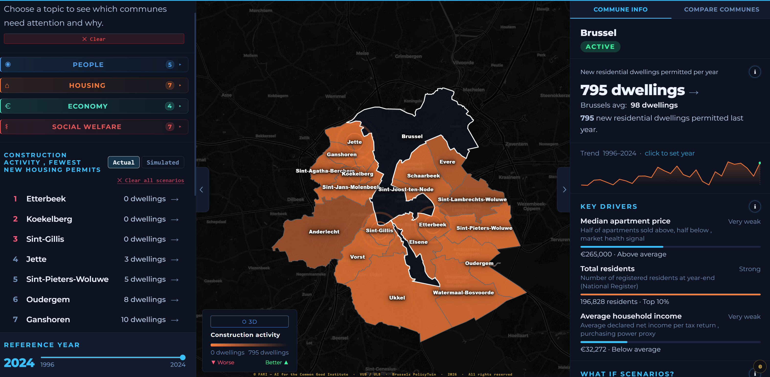 | 19 Communes, regional statistical datasets
L1 | 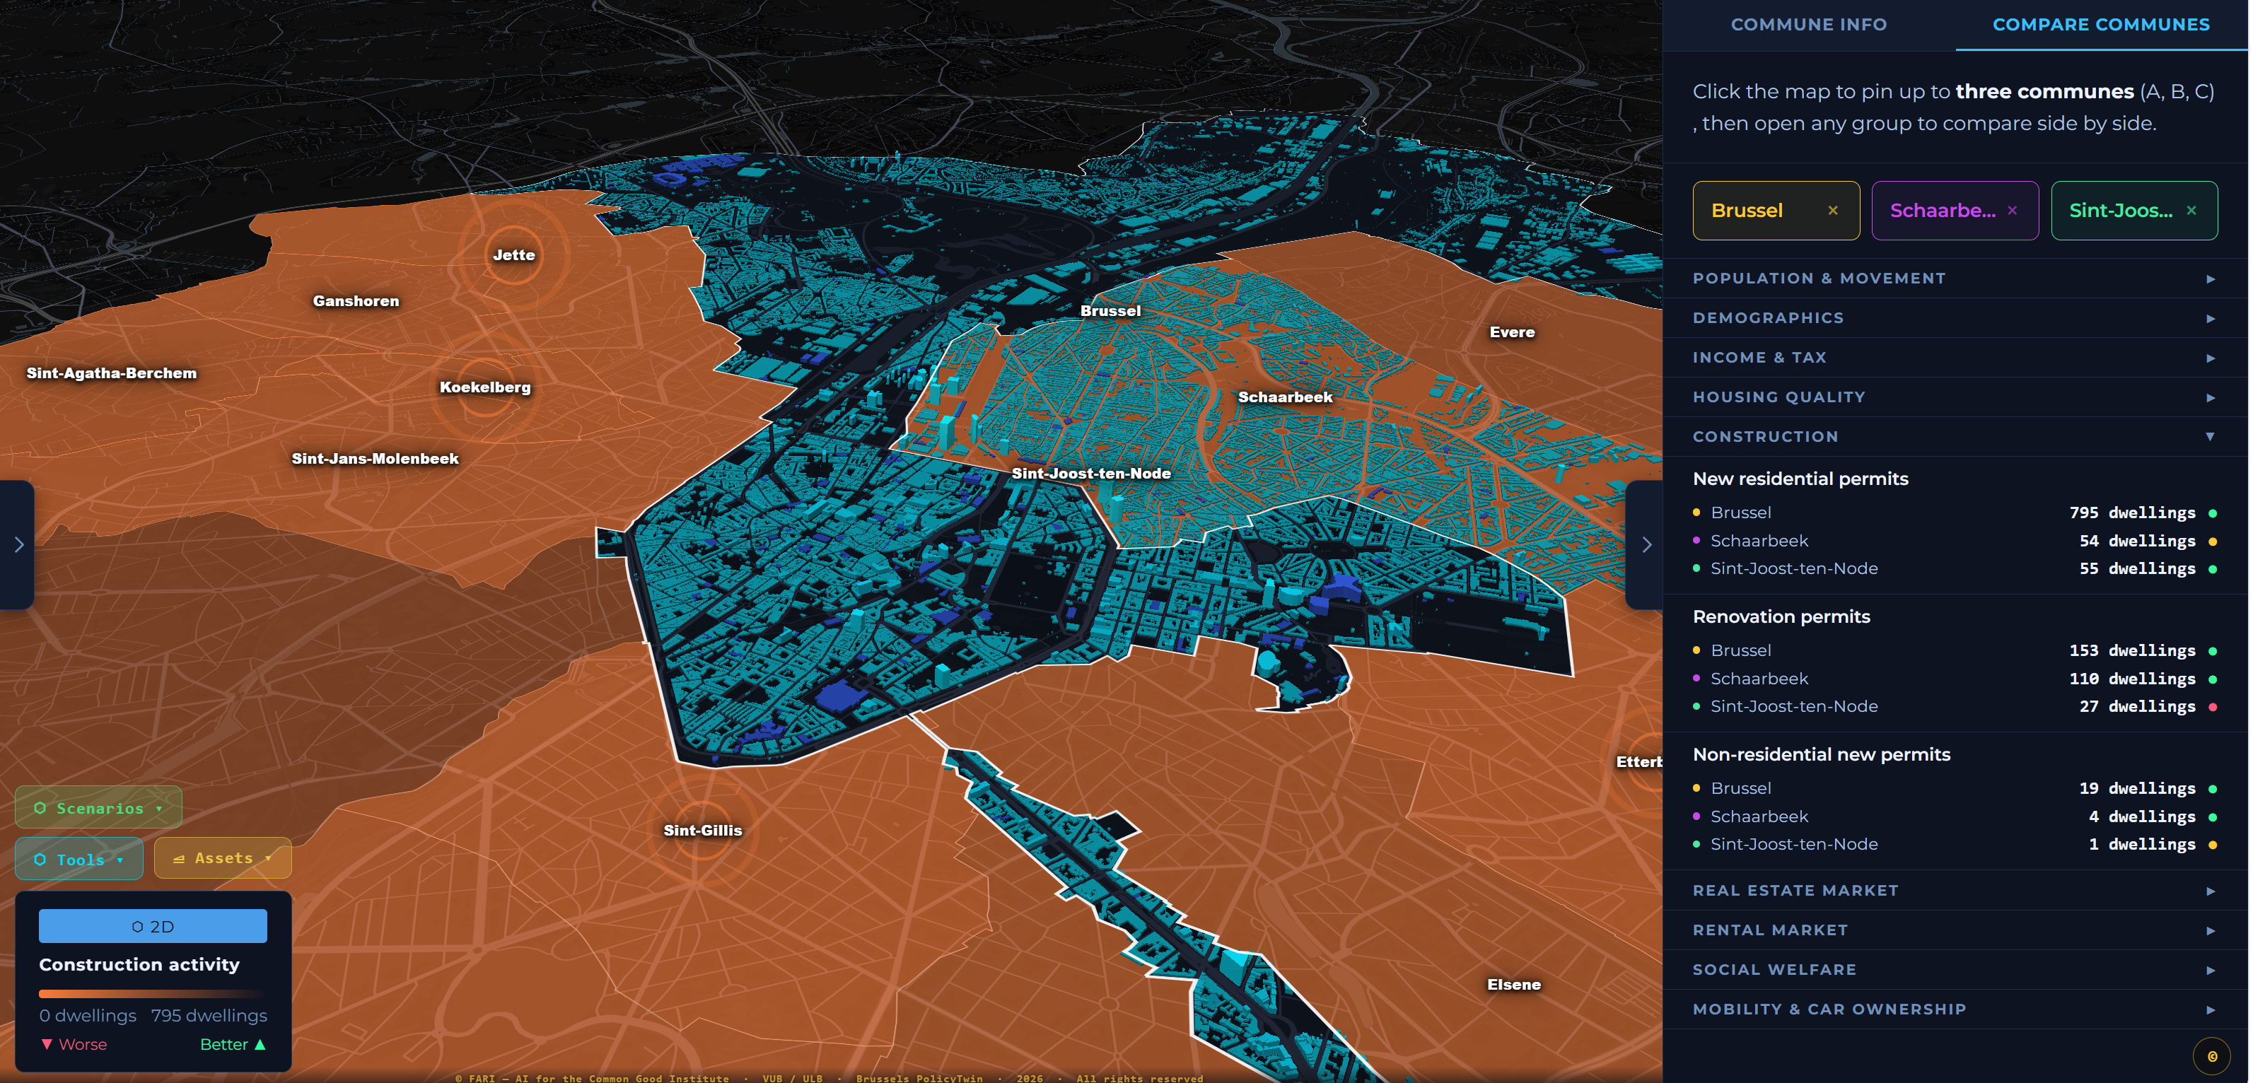 | 56 Monitoring districts, 39 per-commune indicators
L2 | 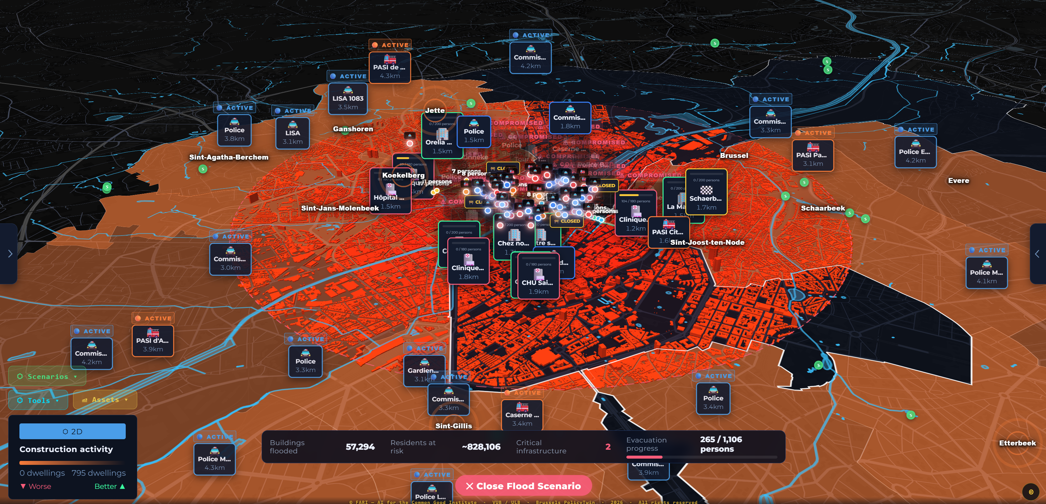 | Building Footprints, Flood zones, Noise pollution data, road network, rail network, AQI monitoring data, and vehicle sensor data
L3 | 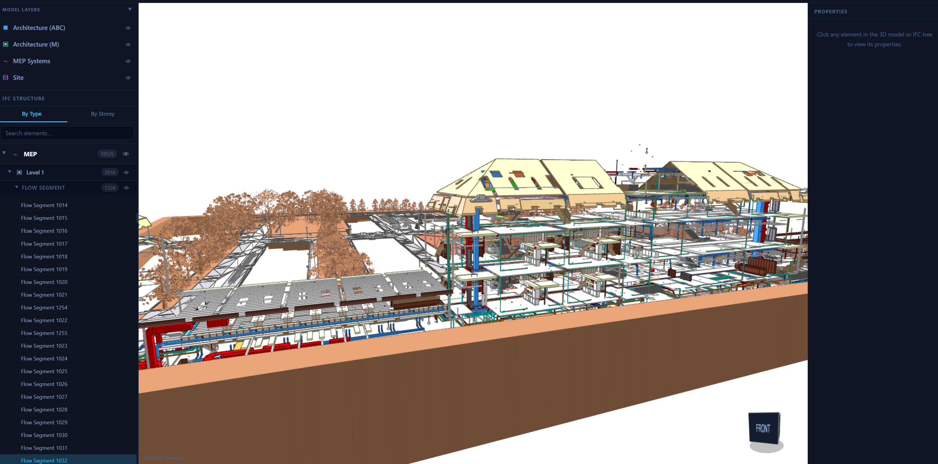 | BIM-level visualizations of selective locations
Table 3: Brussels Open Data Prototype
Brussels provides a diverse and institutionally distributed public-data environment, making it a relevant context for examining the integration of heterogeneous datasets within a shared spatial environment. Datasets of housing observatories, and municipal building-information initiatives are combined with dynamic mobility and environmental information obtained through external data services. The mobility layer integrates public-transport information, providing vehicle-position and service-update information, while air-quality data are retrieved through open API sources. These dynamic sources enable changing mobility and environmental conditions to be examined alongside relatively static demographic, infrastructure, housing, and administrative datasets. The prototype therefore demonstrates how datasets differing in update frequency, spatial scale, and institutional origin can be brought together within a common spatial interface, enabling information to be examined across policy domains and spatial scales.
3. Conclusion
This paper proposes a unified web-based digital twin platform in response to key challenges in public-sector digital twin adoption, with a Brussels-based prototype demonstrating the integration of heterogeneous public datasets within a common spatial environment.
The research introduces a set of design responses to common challenges in public-sector digital twins. The platform responds to data fragmentation by integrating multiple datasets within a common spatial environment, supports interoperability through shared spatial references and established standards, reduces technical barriers through browser-based access, and aims to lower barriers to data exploration through interactive visualisation. The prototype further demonstrates the potential of open public data to support multi-level and cross-domain spatial analysis.
The project commenced in March 2026 and is currently in its initial development and evaluation stages. The present study therefore focuses primarily on platform design and prototype implementation, while a broader empirical evaluation is underway and will continue through Q4 2026 into early 2027. This evaluation combines qualitative and quantitative measures, including policy-oriented workshops, usability testing with public-sector stakeholders, and technical performance metrics. Relevant public-sector and urban digital twin initiatives will also provide comparative reference points for accessibility, interoperability, and cross-domain data integration. The findings will support further refinement and validation of the framework and its practical relevance to public-sector decision-making.

ACKNOWLEDGEMENTS
This research was supported by Vrije Universiteit Brussel (VUB) and Université libre de Bruxelles (ULB). The authors also acknowledge the Brussels-Capital Region and its public-sector organisations for providing the open datasets used to develop the prototype presented in this study.

REFERENCES
Afif Supianto, A., Nasar, W., Margrethe Aspen, D., Hasan, A., Karlsen, A. S. T., & Torres, R. D. S. (2024). An Urban Digital Twin Framework for Reference and Planning. IEEE Access, 12, 152444–152465. DOI: 10.1109/ACCESS.2024.3478379
Ali, M.E., Cheema, M.A., Hashem, T., Ulhaq, A. & Babar, M.A., (2024). Enabling spatial digital twins: Technologies, challenges, and future research directions. PFG – Journal of Photogrammetry, Remote Sensing and Geoinformation Science, 92(6): p. 761-778. DOI: 10.1007/s41064-024-00301-2.
Arin, I.A., Meyliana, Warnars, H.L.H.S. & Murad, D.F., (2023). A systematic literature review of recent trends and challenges in digital twin implementation. In 2023 10th International Conference on ICT for Smart Society (ICISS). Bandung, Indonesia, September 6-7, p. 1-10. DOI: 10.1109/ICISS59129.2023.10291219.
Arvindhan, M., Nivetha, S., Mishra, R.A. & Daniel, A., (2024). Navigating the complexities of digital twin implementation: Challenges and strategies for success. In Daniel, A., Sriramulu, S., Partheeban, N. & Jayagopalan, S. (eds.), Digital Twin Technology and Applications. Boca Raton, FL: Auerbach Publications, p. 171-186. DOI: 10.1201/9781003469612-7.
Bawany, N.Z. & Zainab, H., (2025). Application of digital twin technology for disaster management in smart cities. In Nguyen, T.A. (ed.), Digital Twin and Blockchain for Sensor Networks in Smart Cities. Elsevier, p. 443-453. DOI: 10.1016/B978-0-443-30076-9.00024-8.
Coenen, T., Chantillon, M., Croket, I. & Raes, L., (2025). Local digital twins: A central urban integrator to break down the silos. In Raes, L., Ruston McAleer, S., Croket, I., Kogut, P., Brynskov, M. & Lefever, S. (eds.), Decide Better: Open and Interoperable Local Digital Twins. Cham: Springer, p. 59-86. DOI: 10.1007/978-3-031-81451-8_4.
Curtis, S. & Edwards, J., (2019). Improving public services by sharing the right information. Public Money & Management, 39(5): p. 355-358. DOI: 10.1080/09540962.2019.1611238.
Dembski, F., Wössner, U. & Yamu, C., (2019). Digital twin, virtual reality and space syntax: Civic engagement and decision support for smart, sustainable cities. In Proceedings of the 12th International Space Syntax Symposium. Beijing, China, July 8-13, p. 1230-1242.
Do, B.K.L., Nguyen, T.H., Quang, N.H., Nguyen-Ngoc, D. & El Ghaoui, L., (2026). A digital twin framework for decision-support and optimization of EV charging infrastructure in localized urban systems. Computers, Environment and Urban Systems, 127: Article 102422. DOI: 10.1016/j.compenvurbsys.2026.102422.
Fuller, A., Fan, Z., Day, C., & Barlow, C. (2020). Digital Twin: Enabling Technologies, Challenges and Open Research. IEEE Access, 8, 108952–108971. DOI: 10.1109/ACCESS.2020.2998358
GovTech Singapore, (2017) 5 things to know about Virtual Singapore, [Online], Available: https://www.tech.gov.sg/technews/5-things-to-know-about-virtual-singapore/ [10 July 2026].
Hassan, N.H.M., Ahmad, K. & Salehuddin, H., (2020). Diagnosing the issues and challenges in data integration implementation in public sector. International Journal on Advanced Science, Engineering and Information Technology, 10(2): p. 529-535. DOI: 10.18517/ijaseit.10.2.10271.
Jørgensen, B.N. & Ma, Z.G., (2025). Digital twins under EU law: A unified compliance framework across smart cities, industry, transportation, and energy systems. Electronics, 14(24): Article 4881. DOI: 10.3390/electronics14244881.
Ketzler, B., Naserentin, V., Latino, F., Zangelidis, C., Thuvander, L. and Logg, A. (2020). Digital twins for cities: A state of the art review. Built Environment, 46(4), 547–573. DOI: 10.2148/benv.46.4.547;
Kogut, P. & van der Heijden, R., (2025). Digital twins for urban governance: General desires, expectations, challenges. In Raes, L., Ruston McAleer, S., Croket, I., Kogut, P., Brynskov, M. & Lefever, S. (eds.), Decide Better: Open and Interoperable Local Digital Twins. Cham: Springer, p. 9-31. DOI: 10.1007/978-3-031-81451-8_2.
Kuštelega, M., Mekovec, R. & Shareef, A., (2024). Privacy and security challenges of the digital twin: Systematic literature review. Journal of Universal Computer Science, 30(13): p. 1782-1806. DOI: 10.3897/jucs.114607.
Manso-Callejo, M.-Á., Wachowicz, M. & Bernabé-Poveda, M.-Á., (2009). Towards an integrated model of interoperability for spatial data infrastructures. Transactions in GIS, 13(1): p. 43-67. DOI: 10.1111/j.1467-9671.2009.01143.x.
Raes, L., Michiels, P., Adolphi, T., Tampere, C., Dalianis, A., McAleer, S. and Kogut, P. (2022). DUET: A framework for building interoperable and trusted digital twins of smart cities. IEEE Internet Computing, 26(3), 43–50. DOI: 10.1109/MIC.2021.3060962
Richter, F., Campbell, K. & Riedl, J., (2025). Lost in translation: Why digital twins thrive in research but falter in politics and public administration. Data & Policy, 7: e71. DOI: 10.1017/dap.2025.10027.
Shahat, E., Hyun, C.T. and Yeom, C. (2021). City digital twin potentials: A review and research agenda. Sustainability, 13(6), 3386. DOI: https://doi.org/10.3390/su13063386
Thelen, A., Zhang, X., Fink, O., Lu, Y., Ghosh, S., Youn, B. D., Todd, M. D., Mahadevan, S., Hu, C., & Hu, Z. (2022). A comprehensive review of digital twin - Part 1: Modeling and twinning enabling technologies. Structural and Multidisciplinary Optimization, 65(12), 354. DOI: 10.1007/s00158-022-03425-4
Valli Buttow, C.V. & Weerts, S., (2024). Managing public sector data: National challenges in the context of the European Union's new data governance models. Information Polity, 29(3): p. 261-276. DOI: 10.3233/IP-230003.

