Proposal and Evaluation of a Rebar Inspection Method
Using 3D Gaussian Splatting
Yorikazu Kobayashi¹, Takeshi Takai², Satoshi Kubota³, Yoshihiro Yasumuro^{3 *}

¹ Graduate School of Science and Engineering, Kansai University, Suita, Japan
² Takenaka Corporation, Inzai, Japan
³ Faculty of Environmental and Urban Engineering, Kansai University, Suita, Japan
*Corresponding email: yasumuro@kansai-u.ac.jp

ABSTRACT
This study proposes a method for generating inspection images using 3D recording and reconstruction via 3D Gaussian Splatting (3DGS) applied to rebar placement at construction sites. Rebar inspection requires verifying the number of rebars, their orientation, spacing, and diameter; however, on-site constraints, such as shooting angles and the placement of measuring scales, can make it difficult to obtain adequate photographic records. In this method, the rebar scene is reconstructed as a 3DGS model from a set of images captured by a high-resolution camera and a 360-degree camera, and inspection images are generated in a game engine using orthographic projection, virtual rulers, and virtual inspection boxes. The virtual ruler is used to verify dimensional relationships, while the virtual inspection box is used to define the inspection area and conduct a comprehensive visual inspection. In verification tests using a rebar mock-up, inspection images were generated for both slab and column reinforcement. For slab reinforcement, the virtual ruler enabled us to verify the rebar spacing and diameter against the drawing values directly in the images. Furthermore, the diameters and spacings of the main reinforcement and stirrups were verified. Additionally, using virtual inspection boxes clearly defined the inspection area, allowing a comprehensive overview of the reinforcement configuration. These results demonstrate the feasibility of generating inspection images to support dimensional and configuration checks at representative locations in a rebar mock-up. Future work will quantitatively evaluate measurement accuracy, reproducibility, and applicability to actual construction sites.

- INTRODUCTION
In Japan, labor shortages in the construction industry are becoming increasingly severe due to the declining birthrate and aging population. The number of people employed in the construction industry and the number of skilled construction workers are on a downward trend, making it necessary to conduct quality control on construction sites with limited personnel. Furthermore, since the 2005 earthquake resistance falsification scandal, quality control for structures has become stricter, and the burden of inspection work—including rebar inspections—has increased. Against this backdrop, the Ministry of Land, Infrastructure, Transport and Tourism (MLIT) is promoting “i-Construction” to improve productivity and reduce labor requirements by introducing ICT to construction sites.

Reinforcement inspections for reinforced concrete structures are a critical quality-control process conducted before concrete placement. During these inspections, the number of reinforcing bars, their diameters, orientations, spacings, cover thicknesses, and spacers are verified. Since these items are difficult to verify directly after concrete placement, pre-placement inspection and documentation are essential. However, on construction sites, work often proceeds to the next phase shortly after rebar placement, requiring inspections and photographic documentation to be completed within a limited timeframe. Furthermore, taking photographs for quality records requires securing a viewpoint where the inspection subject is clearly visible while including reference scales in the frame, which places a significant workload on workers.
In recent years, research has focused on inspection methods using 3D point clouds derived from image measurements and depth data to streamline rebar inspections. These methods are effective for measuring the positions and spacings of rebar visible on the surface. On the other hand, because rebar is slender and has a uniform surface pattern and color, it is difficult to obtain sufficient feature points for image matching. In particular, in areas where rebar is densely arranged—such as beams and columns—or where it is obscured by rebar in the foreground, scaffolding, or formwork, it may not be possible to adequately reconstruct the rebar arrangement in the background or interior.
In this paper, we investigate a method for generating inspection images using a reconstructed rebar scene created by 3DGS, as a complementary approach to address situations where point cloud acquisition via image triangulation is difficult. In this method, we reconstruct the rebar scene from a large set of on-site images and generate inspection images using orthographic projection, virtual rulers, and virtual inspection boxes within a game engine. The virtual ruler is used to verify dimensional relationships, such as rebar spacing and diameter, directly on the image. Meanwhile, the virtual inspection box is used to specify the target inspection area within the 3DGS space and to visually verify the rebar configuration from multiple directions. Using a rebar mock-up as a test subject, we demonstrate the applicability of the inspection images generated by this method.

- RELATED WORK
Qureshi et al. proposed a method for evaluating rebar spacing, diameter, number, and length using 3D point cloud models generated by photogrammetry. While this method is effective for streamlining rebar inspection, it requires significant time for point cloud generation, segmentation, and post-processing, and faces challenges in acquiring sufficient point cloud data in areas with densely arranged rebars or significant occlusion.
Song et al. proposed a method for automatically measuring rebar spacing from 3D point clouds by combining Rebar-YOLOv8-seg-based rebar-region extraction with depth data. While this method is effective for automatically measuring rebar spacing, the quality of the point cloud derived from depth data is highly susceptible to factors such as shooting distance, shooting angle, and occlusions, and acquisition conditions affect the accuracy of subsequent processing.
As described above, it has been demonstrated that rebar inspection methods based on 3D point clouds are effective for quantitatively evaluating the position and spacing of rebar visible on the surface. On the other hand, with photogrammetry-based methods, it is difficult to obtain sufficient feature points for image registration because the rebar is slender and has a uniform surface pattern and color. Furthermore, even with methods that use depth data, the quality of the point cloud used for post-processing may deteriorate at construction sites, where long shooting distances, shallow shooting angles, and obstructions are common. In particular, in areas where rebar is densely arranged—such as beams, columns, and double-layer reinforcement—or where the line of sight is obstructed by rebar in the foreground or surrounding members, it is difficult to properly capture rebar in the background or interior as a point cloud. Consequently, methods that rely solely on measuring the point cloud itself have limitations for inspecting the interior of rebar arrangements with poor visibility.
As a technology to complement inspection scenarios where image measurement and point cloud acquisition are difficult, a method utilizing Neural Radiance Fields (NeRF)—a technique for generating images from arbitrary viewpoints—has been proposed. NeRF is a method that, given multi-view images and camera position and orientation as input, learns the radiance distribution in 3D space and generates images from arbitrary viewpoints.
In applications to rebar inspection, it has been demonstrated that overlaying a virtual ruler onto rebar images reconstructed by NeRF allows for the verification of rebar placement from viewpoints that are difficult to observe with conventional photography. However, because NeRF is based on deep learning, it takes time to construct 3D scenes; furthermore, since it cannot display the occlusion relationships between the virtual ruler (represented by polygons) and the rebar (represented by NeRF), it has been difficult to align the ruler accurately.
To address these challenges, the authors have proposed a method for generating rebar inspection images using 3D Gaussian Splatting (3DGS) and virtual rulers. 3DGS is a technique that uses a sparse point cloud obtained via Structure from Motion (SfM) as an initial value, then optimizes the positions, shapes, colors, and opacity of 3D Gaussians to generate high-resolution free-viewpoint images. 3DGS enables faster image generation than NeRF, and because the 3D Gaussians are discretely distributed in space, it is easy to represent the front-back relationships with 3D objects such as virtual rulers. In previous research, we performed reconstruction using 3DGS on a single rebar cage and confirmed that, by using orthographic projection and virtual rulers, the method can be used to measure rebar diameter and spacing even when the shooting viewpoint is restricted.
However, previous studies did not account for obstacles surrounding the measurement target or limited access platforms, and they did not sufficiently address inspection targets that are difficult to verify on-site, such as column reinforcement or two-layer reinforcement. Furthermore, simply observing the 3DGS space from a free viewpoint results in inconsistent inspection ranges and shooting directions, making it difficult to organize the images into inspection images that are easy to verify in subsequent processes. Therefore, in this study, we focus on a rebar mock-up set up in an environment closely resembling a construction site to verify the applicability of an inspection image generation method that combines dimensional verification using virtual rulers with the specification of inspection ranges and multi-directional verification using virtual inspection boxes.

- METHOD
The method proposed in this study reconstructs rebar scenes as 3DGS models from image sets captured by high-resolution and 360-degree cameras, and generates inspection images using orthographic projection, virtual rulers, and virtual inspection boxes within a game engine. The process of the proposed method is shown in Fig. 1.
First, the rebar to be inspected is captured using a high-resolution camera and a 360-degree camera. Images from the high-resolution camera are used to record the rebar surface in high resolution. Meanwhile, the 360-degree video is used to supplement areas and blind spots that are difficult to cover using only the high-resolution camera, which has a limited field of view. From the acquired 360-degree video, segments where the rebar is prominently visible or where the camera viewpoint is close to the inspection target are extracted, and still images are captured at 0.2-second intervals. Furthermore, the extracted 360-degree images are divided into six directions—front, back, left, right, up, and down—with a field of view of 90 degrees for each direction, thereby generating a set of images that allow for inspection from multiple angles, including the vicinity of the rebar as well as the sides and rear.
Next, we perform SfM on the acquired image set to estimate the camera position and orientation, as well as a sparse point cloud from a set of tie points in the SfM process. A 1-meter scale bar is placed at the time of shooting to provide an actual-size scale for the SfM-reconstructed space. Subsequently, we reconstruct the rebar scene using 3DGS, using the SfM output results as initial values. The generated 3DGS data is loaded into a game engine, and inspection images are generated using orthographic projection.
Within the game engine, a virtual ruler is used to verify dimensions. The virtual ruler serves as auxiliary information for confirming dimensional relationships—such as rebar spacing and diameter—on the generated images. When combined with orthographic projection, this minimizes perspective distortion caused by the viewpoint, making it easier to read rebar spacing and diameter directly from the images.
Furthermore, in this study, a virtual inspection box refers to a rectangular virtual inspection area defined within the 3DGS space. The virtual inspection box defines the inspection target area, the capture direction, and the image output range. While the virtual ruler is used for local dimensional verification, the virtual inspection box specifies the inspection target area and serves as a reference for visually inspecting that area from multiple directions. This enables the systematic generation of inspection images for objects that require simultaneous verification of a specific area, such as slab or column reinforcement.

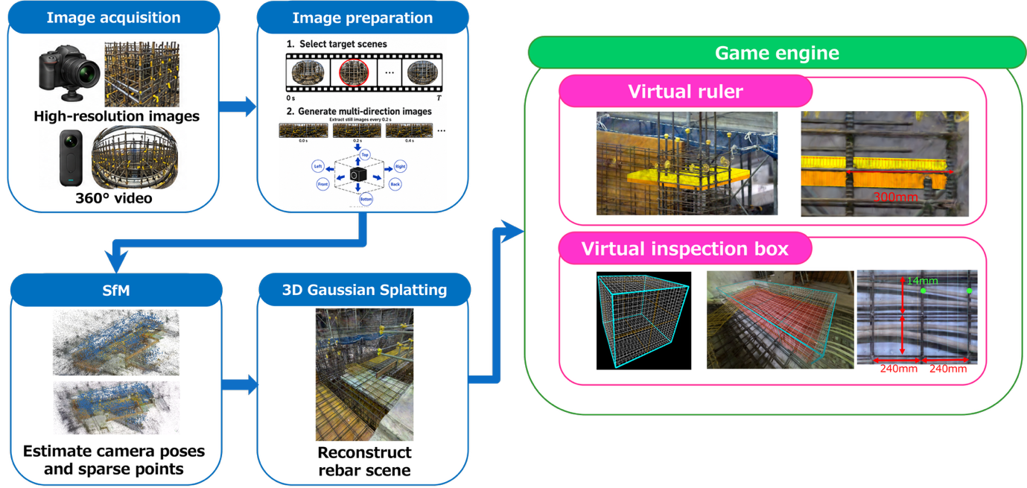
Figure 1: Workflow of the proposed method

4. IMPLEMENTATION
In this study, we used a GoPro HERO12 Black as the high-resolution camera and an Insta360 X4 to capture 360-degree video. Following the procedure described in the previous chapter, we performed SfM on the acquired image sets to estimate the camera’s position and orientation, as well as a sparse point cloud. In addition, we defined the actual-size scale of the reconstructed space using a 1-meter ruler placed at the time of filming. Subsequently, using the SfM output as initial values, we reconstructed the rebar scene using 3DGS and imported the generated 3DGS data into the Unity game engine.
In Unity, the rebar scene reconstructed by 3DGS was displayed using orthographic projection, and a virtual ruler was overlaid near the inspection target. The virtual ruler is used to verify dimensional relationships, such as rebar spacing and rebar diameter. Furthermore, to enable simultaneous verification of items such as the inspection target's rebar spacings, a virtual inspection box was implemented. The virtual inspection box is a rectangular prism-shaped region defined by its center, orientation, width, height, and depth. By adjusting the position and size of this region, the user specifies the inspection range for objects such as slabs, beams, and columns. The virtual inspection box serves as a reference for specifying the inspection area, determining the imaging direction, and defining the output range of the inspection images. Fig. 2 shows the configuration of the virtual inspection box.
For generating inspection images, the directions of each face of the virtual inspection box are defined as six—Front, Back, Left, Right, Top, and Bottom—and an orthographic camera is positioned for each direction. In this implementation, images are generated from the outside of the virtual inspection box toward the inside. Specifically, orthographic cameras are positioned on the outer surfaces of each face of the virtual inspection box and capture images directed toward the box’s center.
Additionally, to provide an at-a-glance view of the rebar configuration, a process was implemented to highlight the 3D Gaussian distribution within the virtual inspection box in red. This feature is used to verify the inspection area and reconstruction status before capturing images. In this study, we use a virtual ruler to verify the dimensional relationships, such as rebar spacing and rebar diameter, and a virtual inspection box to organize the inspection area and imaging direction, generating an overview inspection image.
Grid lines based on an actual-size scale were added to the saved images. In this implementation, one pixel on the image corresponds to 0.00025 m in real space, and grid lines spaced 5 mm apart were drawn on the inspection image. Since this method generates inspection images via orthographic projection, it is not affected by perspective distortion; thus, even when grid lines are superimposed during post-processing, the actual-size scale is maintained on the images. These grids are used as scale references when verifying the reinforcement bar layout and dimensional relationships within the inspection area.

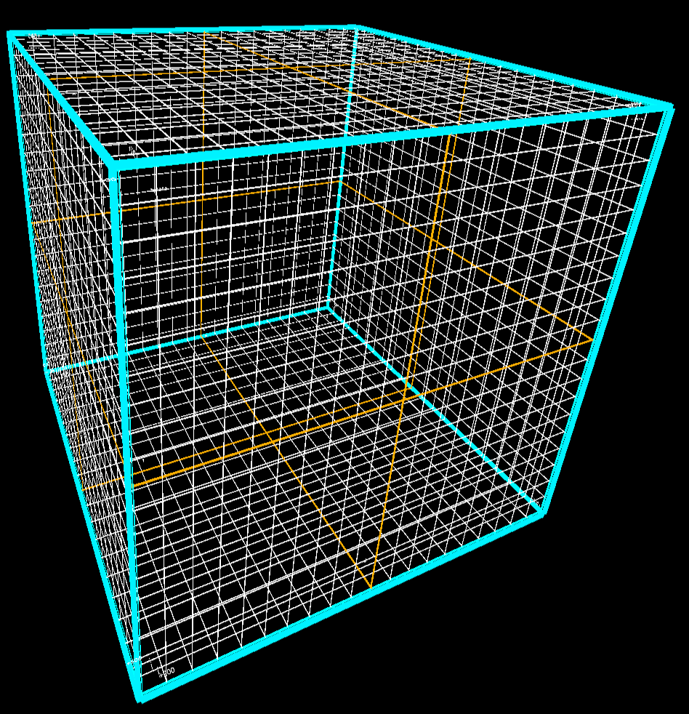
Figure 2: Configuration of the Virtual Inspection Box

5. RESULTS
In this chapter, we apply the proposed method to a rebar mock-up and verify whether the rebar scene reconstructed using 3DGS can be used as rebar inspection imagery. In this verification, rather than comprehensively measuring all reinforcing bars within the target area, we conducted visual inspection and verification tests on the generated images for representative inspection items. We selected slab reinforcement, column reinforcement, spacers installed at various locations, and concrete cover as the subjects for verification.
5.1 Verification of Reinforcement Dimensions Using a Virtual Ruler
First, we conducted a verification using a virtual ruler, focusing on the slab reinforcement. The slab reinforcement consists of two layers, and we verified the reinforcement spacing, reinforcement diameter, cover thickness, and spacers for each layer. Fig. 3 shows an example of verifying the reinforcement spacing and diameter in the slab reinforcement. Using orthographic projection images and a virtual ruler, we verified the reinforcement spacing against the drawing values directly on the images. Compared to the drawing value of a 200 mm pitch, the spacing was measured at approximately 193 mm in the upper layer and approximately 195 mm in the lower layer. Furthermore, regarding the rebar diameter, a section corresponding to D10 was measured at approximately 10 mm. These results confirm that, by combining orthographic projection and a virtual ruler with the rebar layout scene reconstructed using 3DGS, it is possible to verify the rebar spacing and diameter in the slab reinforcement directly on the image.
Fig. 4 shows an example of verifying the cover thickness in slab reinforcement. In areas where the rebar and the reference plane below were reconstructed relatively clearly, the distance between the rebar and the reference plane could be verified using a virtual ruler. In Fig. 4, the cover thickness was determined to be approximately 30 mm, demonstrating the potential to verify cover thickness using 3DGS images. On the other hand, since the verification of cover thickness depends on the clear reconstruction of the boundaries between the rebar and surrounding members, improving the quality of reconstruction is necessary for reliable dimensional verification.
Fig. 5 shows an example of verifying spacers in slab reinforcement. For spacers clearly visible in the captured images, their installation positions could also be confirmed on the 3DGS images. Furthermore, by using a virtual ruler in conjunction with the images, it was possible to determine the spacer sizes in some locations. These results indicate that even small components such as spacers can be verified using 3DGS images and a virtual ruler, provided they are sufficiently visible in the captured images.
Next, we examined the reinforcement in the columns, verifying the main bars, stirrups, and spacers around them. Fig. 6 shows an example of this verification for column reinforcement. In column reinforcement, the main bars and stirrups are densely arranged, making it difficult to determine the relative positions of the individual members from a standard camera angle. In the generated images, we confirmed that the main bars had a diameter equivalent to D22, and that the stirrups had a diameter of D10 and a spacing of approximately 100 mm. These results confirm the potential to apply dimensional verification using 3DGS images and virtual rulers not only to slab reinforcement but also to column reinforcement.
Fig. 7 shows an example of verifying spacers around column reinforcement. For spacers installed around the column, their positions and sizes could be confirmed on the 3DGS images. This demonstrates that not only rebar spacing and diameter but also small components such as spacers can be verified on inspection support images, provided they are clearly visible in the captured images.

5.2 Specification of the Inspection Range and Overview Confirmation Using the Virtual Inspection Box
We verified whether a virtual inspection box can be used to visually inspect the reinforcement configuration. The virtual inspection box is not intended to directly verify dimensions; instead, it encloses the target inspection area and serves as a reference for inspecting that area from multiple directions.
Fig. 8 shows an example of a virtual inspection box set for slab reinforcement. By setting a virtual inspection box for the slab reinforcement, we clearly specified the target reinforcement area as a rectangular prism. Fig. 9 shows an inspection image of the slab reinforcement generated using the virtual inspection box as a reference. By generating an orthographic projection image of the specified area, we visually verified the orientation, position, and number of reinforcing bars at a glance.
Similarly, for column reinforcement, we enclosed the target inspection range and established a reference for verifying reinforcement status from each surface. Based on these results, we confirmed that the virtual inspection box effectively complements localized dimensional verification using a virtual ruler and serves as a useful tool for organizing the inspection scope. In other words, it provides a practical way to visually confirm reinforcement status across the inspection area. Overall, these results indicate that the virtual inspection box is effective for visually inspecting reinforcement configurations and organizing inspection scope.

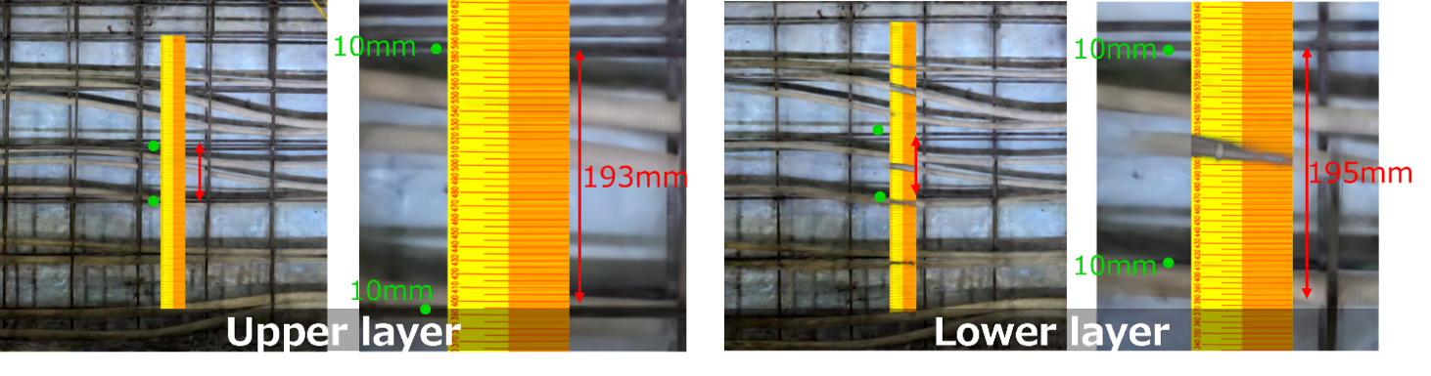
Figure 3: Confirmation of rebar spacing and diameter in slab reinforcement

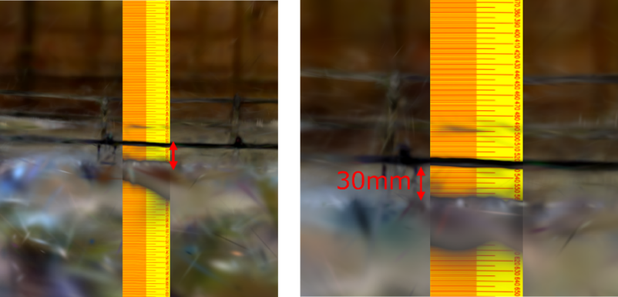
Figure 4: Confirmation of concrete cover in slab reinforcement using the virtual ruler

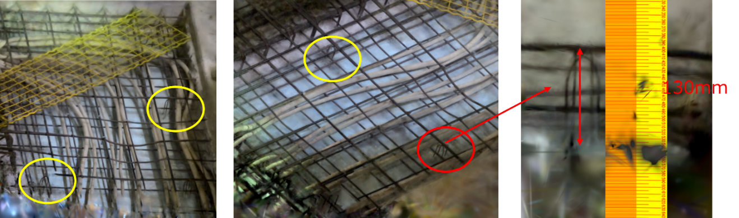
Figure 5: Confirmation of spacer size in slab reinforcement using the virtual ruler

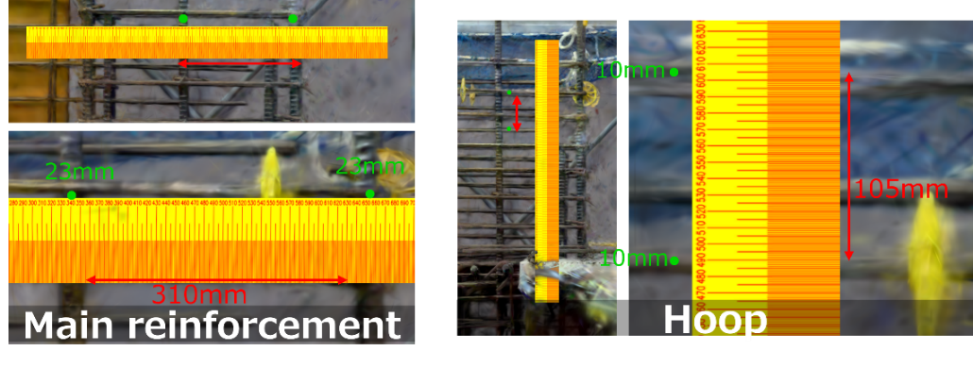
Figure 6: Confirmation of rebar spacing and diameter in column reinforcement

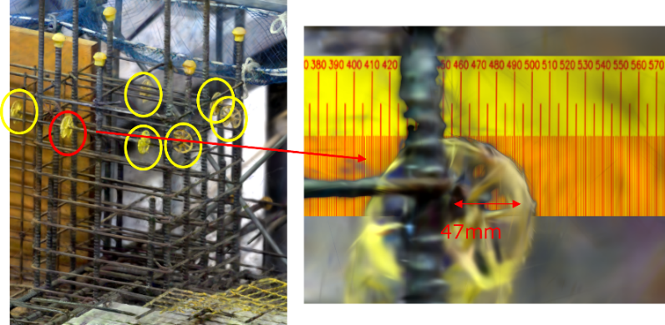
Figure 7: Confirmation of spacer position and size in column reinforcement

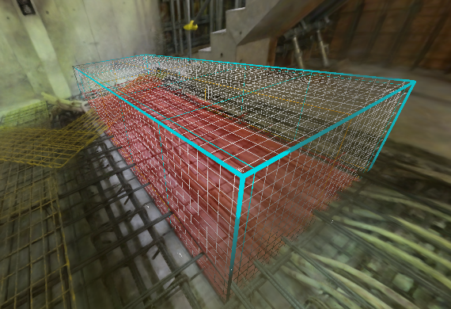
Figure 8: Virtual Inspection Box setup for slab reinforcement

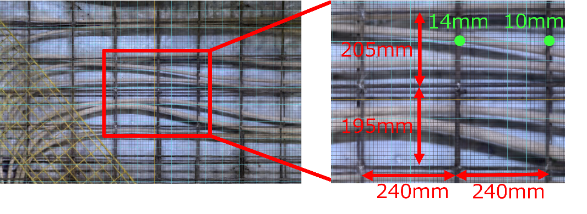
Figure 9: Inspection example of slab reinforcement using the Virtual Inspection Box

6. DISCUSSION
In this study, we used a rebar mock-up as the subject and verified whether rebar scenes reconstructed using 3DGS could serve as rebar inspection images. The results showed that a virtual ruler could verify rebar spacing and diameter for both slab and column reinforcement in the generated images. Furthermore, in areas clearly visible in the captured images, the results indicated the potential to verify the positions and dimensions of spacers and cover thickness using the virtual ruler. Additionally, a virtual inspection box could specify the inspection area, providing a comprehensive overview of the slab rebar layout.
The virtual ruler proved effective for verifying local dimensional relationships, such as rebar spacing and diameter. Combined with orthographic projection, it became easier to read rebar spacing and diameter on the generated images. Furthermore, spacers and cover thickness could also be verified on the generated images when the target member and surrounding reference surfaces were clearly reconstructed. Based on these findings, the virtual ruler is considered effective not only for rebar spacing and diameter but also as supplementary information for understanding dimensional relationships related to multiple verification items in rebar inspection.
Virtual inspection boxes proved effective for specifying the inspection range and verifying the condition of the rebar placement. By using virtual inspection boxes, the target inspection range could be specified as a cuboid region, and inspection images could be generated using that region as a reference. This made it easier not only to verify local dimensions but also to grasp the overall placement status of the inspection target.
In summary, this method constructs a 3DGS space from on-site images and, in a subsequent process, generates rebar inspection images by setting a virtual ruler, an orthographic projection, and a virtual inspection box. While conventional on-site photographs are constrained by conditions at the time of capture, such as the position of the scale bar and the direction of the shot, this method allows adjustment of the viewpoint, scale bar, and inspection range within the virtual space. Consequently, this method can be described as a unique rebar inspection support technique for the virtual space, in which inspection images are generated after on-site photography.
Future work will evaluate absolute and percentage errors in rebar spacing, diameter, and cover thickness by comparing readings with physical reference measurements at multiple inspection locations, as well as the reproducibility of readings across users and capture conditions. We will also measure processing and reconstruction times and compare the method with conventional inspection methods and applications at actual construction sites to clarify its usefulness for inspection support, the reconstruction quality required for dimensional checks, and its applicability limits.

ACKNOWLEDGEMENTS
This research was supported in part by the Organization for Promotion of Advanced Science and Technology, Kansai University, and Japan Construction Information Center Foundation.

REFERENCES
Ministry of Land, Infrastructure, Transport and Tourism., Trends in construction investment, the number of licensed construction companies, and the number of workers in the construction industry, [Online], Available: https://www.mlit.go.jp/road/road_e/pdf/i-Construction2019.pdf
Ministry of Land, Infrastructure, Transport and Tourism., Summary of the White Paper on Land, Infrastructure, Transport and Tourism in Japan, [Online], Available: https://www.mlit.go.jp/en/statistics/content/001717675.pdf
Qureshi, A. H., Alaloul, W. S., Murtiyoso, A., and Hussain, S. J., (2024). Smart rebar progress monitoring using 3D point cloud model. Expert Systems with Applications, 249, 123562.
Song, J., Liao, T., Zhu, Q., et al., (2025). Automatic measurement of rebar spacing based on 3D point cloud segmentation using Rebar-YOLOv8-seg and depth data. Measurement, 242, 116111.
Mildenhall, B., Srinivasan, P. P., Tancik, M., Barron, J. T., Ramamoorthi, R. and Ng, R., (2022). NeRF: Representing scenes as neural radiance fields for view synthesis. Communications of the ACM, 65(1), 99–106.
Yasumuro, Y., Kubota, S. and Takai, T., (2025). Proposal of the use of differential render in rebar inspections. Proceedings of The Sixth International Conference on Civil and Building Engineering Informatics (ICCBEI 2025).
Kerbl, B., Kopanas, G., Leimkühler, T. and Drettakis, G., (2023). 3D Gaussian Splatting for real-time radiance field rendering. ACM Transactions on Graphics, 42(4).
Kobayashi, Y., Yasumuro, Y., Kubota, S., (2026). REBAR INSPECTION IMAGE GENERATION USING 3D GAUSSIAN SPLATTING AND VIRTUAL RULERS. Japanese Journal of JSCE. Volume 82 Issue 22 Article ID: 25-22005

