Optimizing Disassembly Planning for Aluminium-Framed Windows through Automation and Collision Analysis
Begum Aktas¹, Timo Hartmann¹

¹ Technische Universität Berlin, Department of Civil Systems Engineering, Berlin, Germany

ABSTRACT:

Due to increasing economic competition and growing environmental concerns, the construction industry faces pressure to reduce its environmental footprint in material production and building processes. Disassembly planning has emerged as a key strategy to advance circular construction practices by facilitating material recovery at the end-of-life (EoL) stage. However, disassembly remains complex, requiring strategic planning to maximize material recovery, reduce waste, and minimize embodied energy consumption. The introduction of matrix-based representations offers a promising solution to this complexity. These representations enable efficient disassembly sequence generation, overcoming previously mentioned limitations and providing more efficient means for computers to generate disassembly sequences while reducing algorithmic complexity. This study represents collision test-based adjacency matrix constructions as tools for capturing geometric precedence relations of window parts. It also identifies key factors, dependencies, and challenges associated with disassembling matrix-based multi-layered and multi-material window systems.

KEYWORDS

Material Recovery, Disassembly Sequence Planning, Collision Test, Adjacency Matrix, Adjacency Graph.

1. INTRODUCTION
Comprehensive disassembly planning for material recovery is essential for advancing circular economy (CE) principles in the construction industry. Aluminium-framed windows, due to their widespread use and high material value, play a pivotal role in circular construction through material recovery for reuse and recycling. Despite their potential, current End of Life (EoL) practices often fail to recover their full material value due to inefficient disassembly processes and the absence of standardized recovery methodologies. Implementing effective material recovery strategies that focus on disassembly, reuse, and recycling can significantly reduce waste while retaining economic value. By improving disassembly strategies, we can address material scarcity, reduce embodied energy, and minimize operational waste.
Closing the material and energy loop plays a critical role in accelerating the transition from linear to circular economic systems (Eckelman & Laboy, 2020) by providing solutions to resource scarcity, environmental degradation, and waste reduction. Material re-circulation opportunities alone contribute 60% to CO2 emissions of industrial production within the EU (Kullmann et al., 2021). CE offers great potential by enabling material value reuse and recycling at the End-of-Life (EoL) stage by several advancements in disassembly planning. However, while product industry has broadly studied disassembly methodologies for items ranging from ballpoint pens to laptops (Güler et al., 2024), the construction industry lacks standardized disassembly models specifically designed for building components (Sanchez et al., 2023).
Unlike smaller products, building components present distinct challenges for disassembly due to larger scale, multi-material composition, and integration with building layers, systems and subsystems. Windows, in particular, are complex assemblies characterized by multi-material construction, structural integration, and varying levels of physical degradation over their average lifespan of 20-25 years. Physical deterioration, aesthetic and technological obsolescence reduce the service value of the facade and windows, often turning them into waste (Deniz & Dogan, 2014).
Aluminium-framed windows, for instance, involve intricate assemblies of glass, aluminium, and insulation, all of which demand careful planning for effective disassembly. A visual representation of the disassembly process serves as a powerful tool for illustrating the assembly and disassembly structure of EoL products and generating possible disassembly plans (Zhao et al., 2021; De Fazio et al., 2021) via precedence relations which are determined by the geometrical, technical, and economic dependencies.

2. POINT OF DEPARTURE
Disassembly is a critical enabler of CE, particularly for high-value building products, which often end up as waste due to inadequate and inefficient demolition, deconstruction and disassembly planning. In essence, the disassembly process is a progressive dismantling of the core into its individual components and subassemblies through a sequence of tasks (Li et al., 2024). Despite extensive research on disassembly methodologies in the product manufacturing industry, its application to building products remains underdeveloped, primarily because these products are not typically designed with disassembly in mind.
This lack of design considerations poses challenges in the built environment. Unlike smaller, more standardized products, building components are generally larger in scale, composed of multiple materials, and intricately integrated within architectural layers, systems, and subsystems. Among these, windows stand out as particularly complex assemblies due to their multi-material production, structural integration, and varying levels of physical degradation over their average lifespan of 20-25 years. Aluminium-framed windows, for instance, involve intricate assemblies of glass, aluminium, and insulation, all of which demand careful planning for effective disassembly.

2.1 Problem description
This study aims to demonstrate the feasibility of the proposed computational disassembly modelling approach using relatively simple construction products. As noted in the literature, most newly developed disassembly methods are first tested on basic products, such as the ballpoint pen, initially studied by Bourjault (1984), which consists of six parts. Ballpoint pens and similar mechanical products have frequently served as benchmarks in disassembly research (De Fazio & Whitney, 1987; Ishii & Lee, 1996; Tian et al., 2018; Prioli et al., 2022; Iwase, 2024).
To support disassembly planning, CAD (Computer Aided Desing) files offer geometric design information that can be used to model the precedence relationships between window components, representing parts as nodes and their connection as edges. In this context, each part is modelled as a node (n) and forming a graph structure that underpins the sequence of disassembly operations.
Node and node relationships can be captured in matrix form, which serves both as a disassembly feature representation and as input for computational algorithms. Thus, before executing algorithms to facilitate disassembly planning within computational disassembly modelling, relations and connections of all windows parts must be defined. Once these geometric precedence relations are established, computational models can generate disassembly features and determine optimized sequences for disassembly.
To explore and validate this approach, this paper employs a case study focused on aluminium-framed windows with eight components, using their geometric precedence relations as the foundation for disassembly sequence planning. Additionally, elements such as gaskets, glazing, insulation, and fasteners (e.g., screws) are excluded from the scope of this analysis.

3. METHODOLOGY
The disassembly process not only requires parts relationships such as matrices and graphs but also geometric precedence relationships to generate a feasible and robust disassembly sequence planning. The key aspect of geometric precedence relationships is to determine parts and edges relationships can be captured in matrix and graph forms as an input for mathematical tools and methods such as automatic or semi-automatic disassembly sequence generations. CAD files can provide disassembly knowledge when accessing geometric design information (Prioli et al., 2022) and topological data with mates’ attributes between parts (Kheder et al., 2016). Additionally, a visual representation of the disassembly process can be a powerful tool when making design decisions that illustrate the assembly and disassembly structure of the EoL product and generate all possible disassembly plans (Zhao et al., 2021; De Fazio et al., 2021). The search for precedence relations is indispensable for proper modelling, because those relations have to be known before establishing the set of basic constraints that must be met by the feasible subassemblies (Lambert, 2003). To define the geometric precedence relationships between parts and edges in this study, the methodology is encapsulated in three main sections. The first section of the methodology extracts CAD data to generate 3D representation of the assembled window. The second part of the methodology is the Adjacency matrix generation through collision test between window parts (Fig. 1).

3.1 CAD data extraction for parametric window modelling

This section outlines parametric window modelling in the Rhinoceros-Grasshopper environment. The method employs parameters, variables, and constraints to enable dynamic and flexible window generation which allows users to produce multiple design variations through real-time adjustment. The framework starts with defining the window type and followed by embedding a cross-section drawing in .dwg format into curve node, which contains two polylines referred to as inner and outer frames in this study (Fig. 2).
In parametric window modelling, an adjustable rectangle is constructed using sliders, enabling users to control the overall dimensions of the window. Number sliders allow modification of both the width and height of the rectangle, as well as positioning of its defining points. This parametric flexibility allows for rapid prototyping of window variants sharing the same section details, which is essential for adapting robotic disassembly paths to different configurations. Additionally, this framework supports 3D window modelling with varying section details.
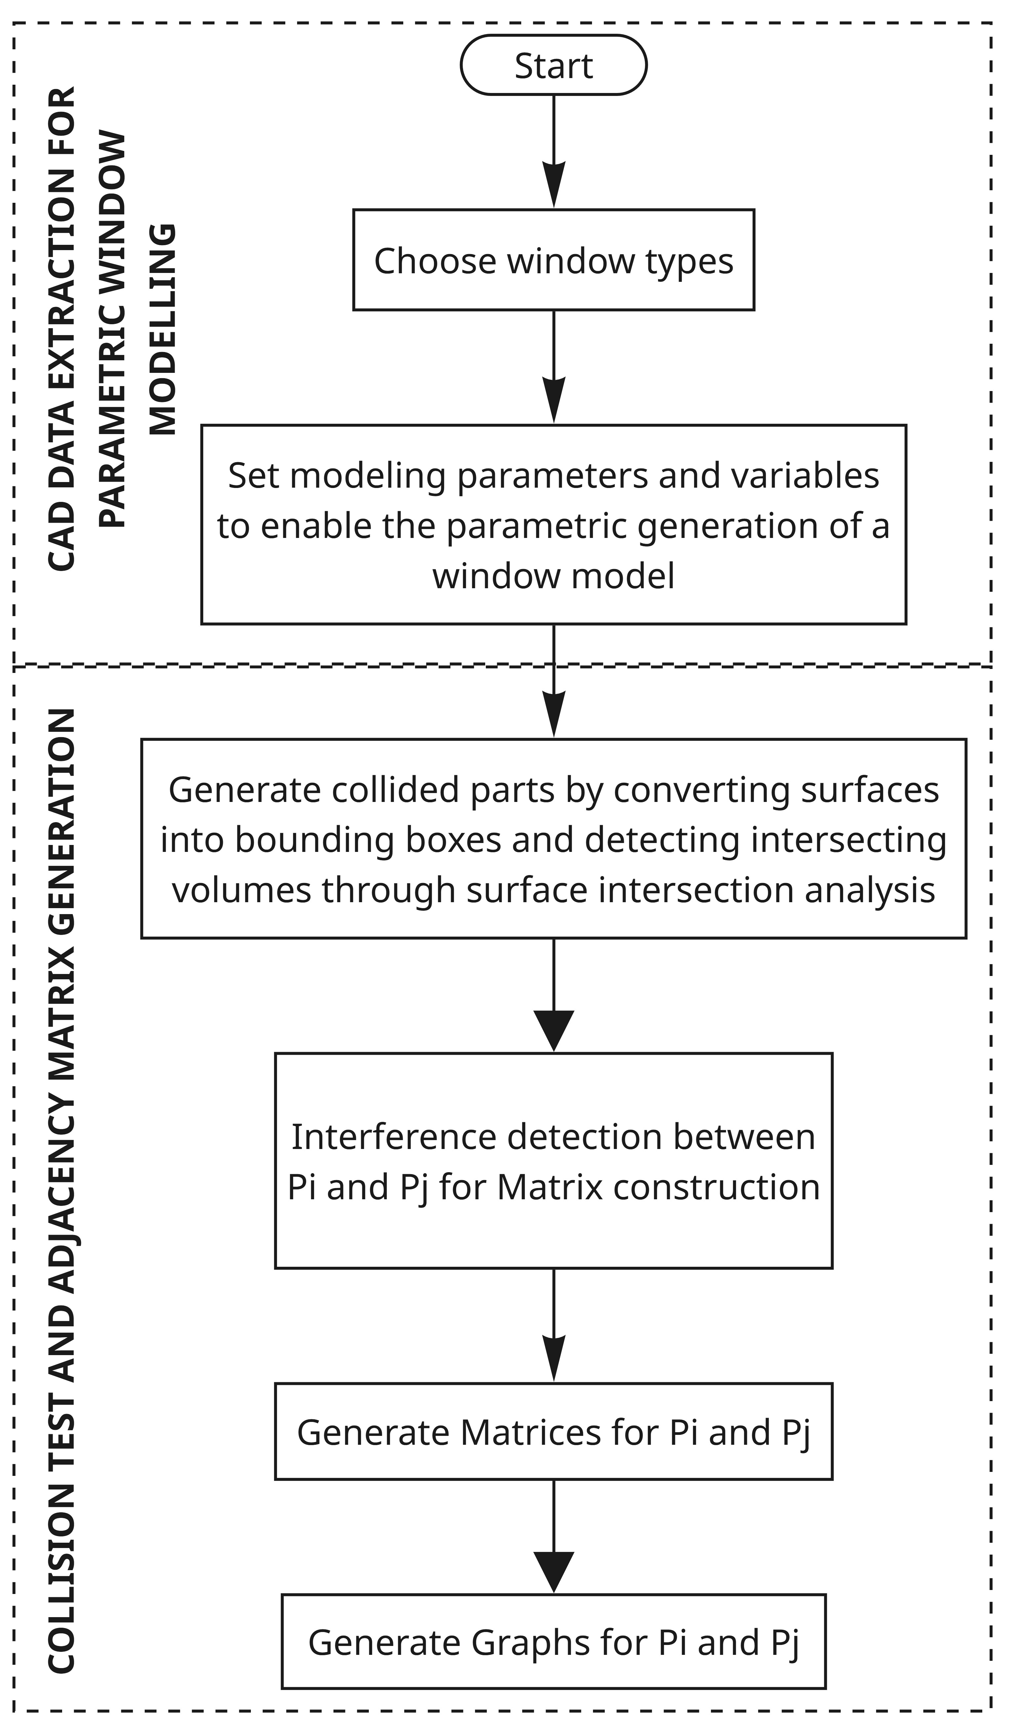
Figure 1: Framework of computational disassembly planning modelling for aluminium-framed windows

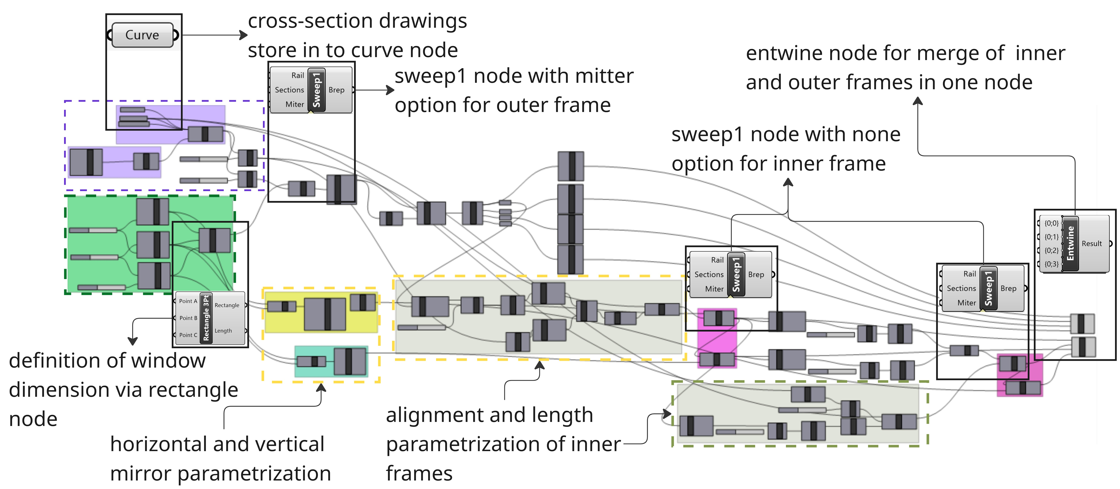
Figure 2: Parametric window modelling grasshopper script.

The window frames are generated using a single-rail (Sweep1) operation with ‘mitter’ feature set to none and trim option enabled. The use of 45-degree corner connection details allows the outer frame to be modelled within Sweep1 node using the “trim” setting. The inner frame is created by setting ‘mitter’ feature to “none” which aligns with the connection detail required for inner frames (Fig. 3). The modelling process follows with the creation of the bottom inner frame (named P4), which is then horizontally mirrored by using the “Mirror” node to generate P6. Subsequently, the remaining two parts (P5 and P7) are constructed by aligning and rotating the cross-section geometry between P4 and P6. This entire process is parametrized for 3D window modelling which ensuring consistent control across this inner frame generation. This parametrical workflow generates Brep geometries for entire window in assembled model which are subsequently organized using the Entwine node and provided as input collision testing.

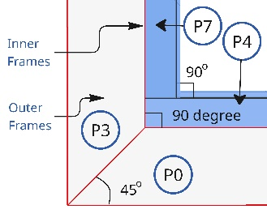
Figure 3: Corner connection details of frames

3.2 Adjacency matrix generation through collision test
Geometric collision data is generated to develop adjacency matrix, which are essential inputs for disassembly sequence planning. To ensure parts can be disassembled without interference, collision-free precedence relationships must first be established. This evaluation is carried out using the 3D assembled window model, where collisions between components are computed based on spatial relationships and distances between parts. The goal is to extract interference data that indicates geometric feasibility. Figure 4 shows the flowchart of the collision test process for whole window parts.
In this context, collision is tested based on the minimum distance between two parts in which an object has superficial contact with another; it has minimal distance equal to zero, which is also assigned to an object that interpolates another (Prioli et al., 2022). If one part intrudes into the geometric boundary of another, that overlap is defined as a collision.

Additionally, the collision test is applied through the following two key points:
(1) A value of 1 indicates hard interference (spatial adjacency) between parts, which is interpreted as a valid adjacency. In contrast,
(2) A value of 0 indicates, no interference is considered non-adjacent (Figure 5).

To enhance sensitivity to neighbouring parts, bounding boxes are slightly scaled as 0.001 in this study.
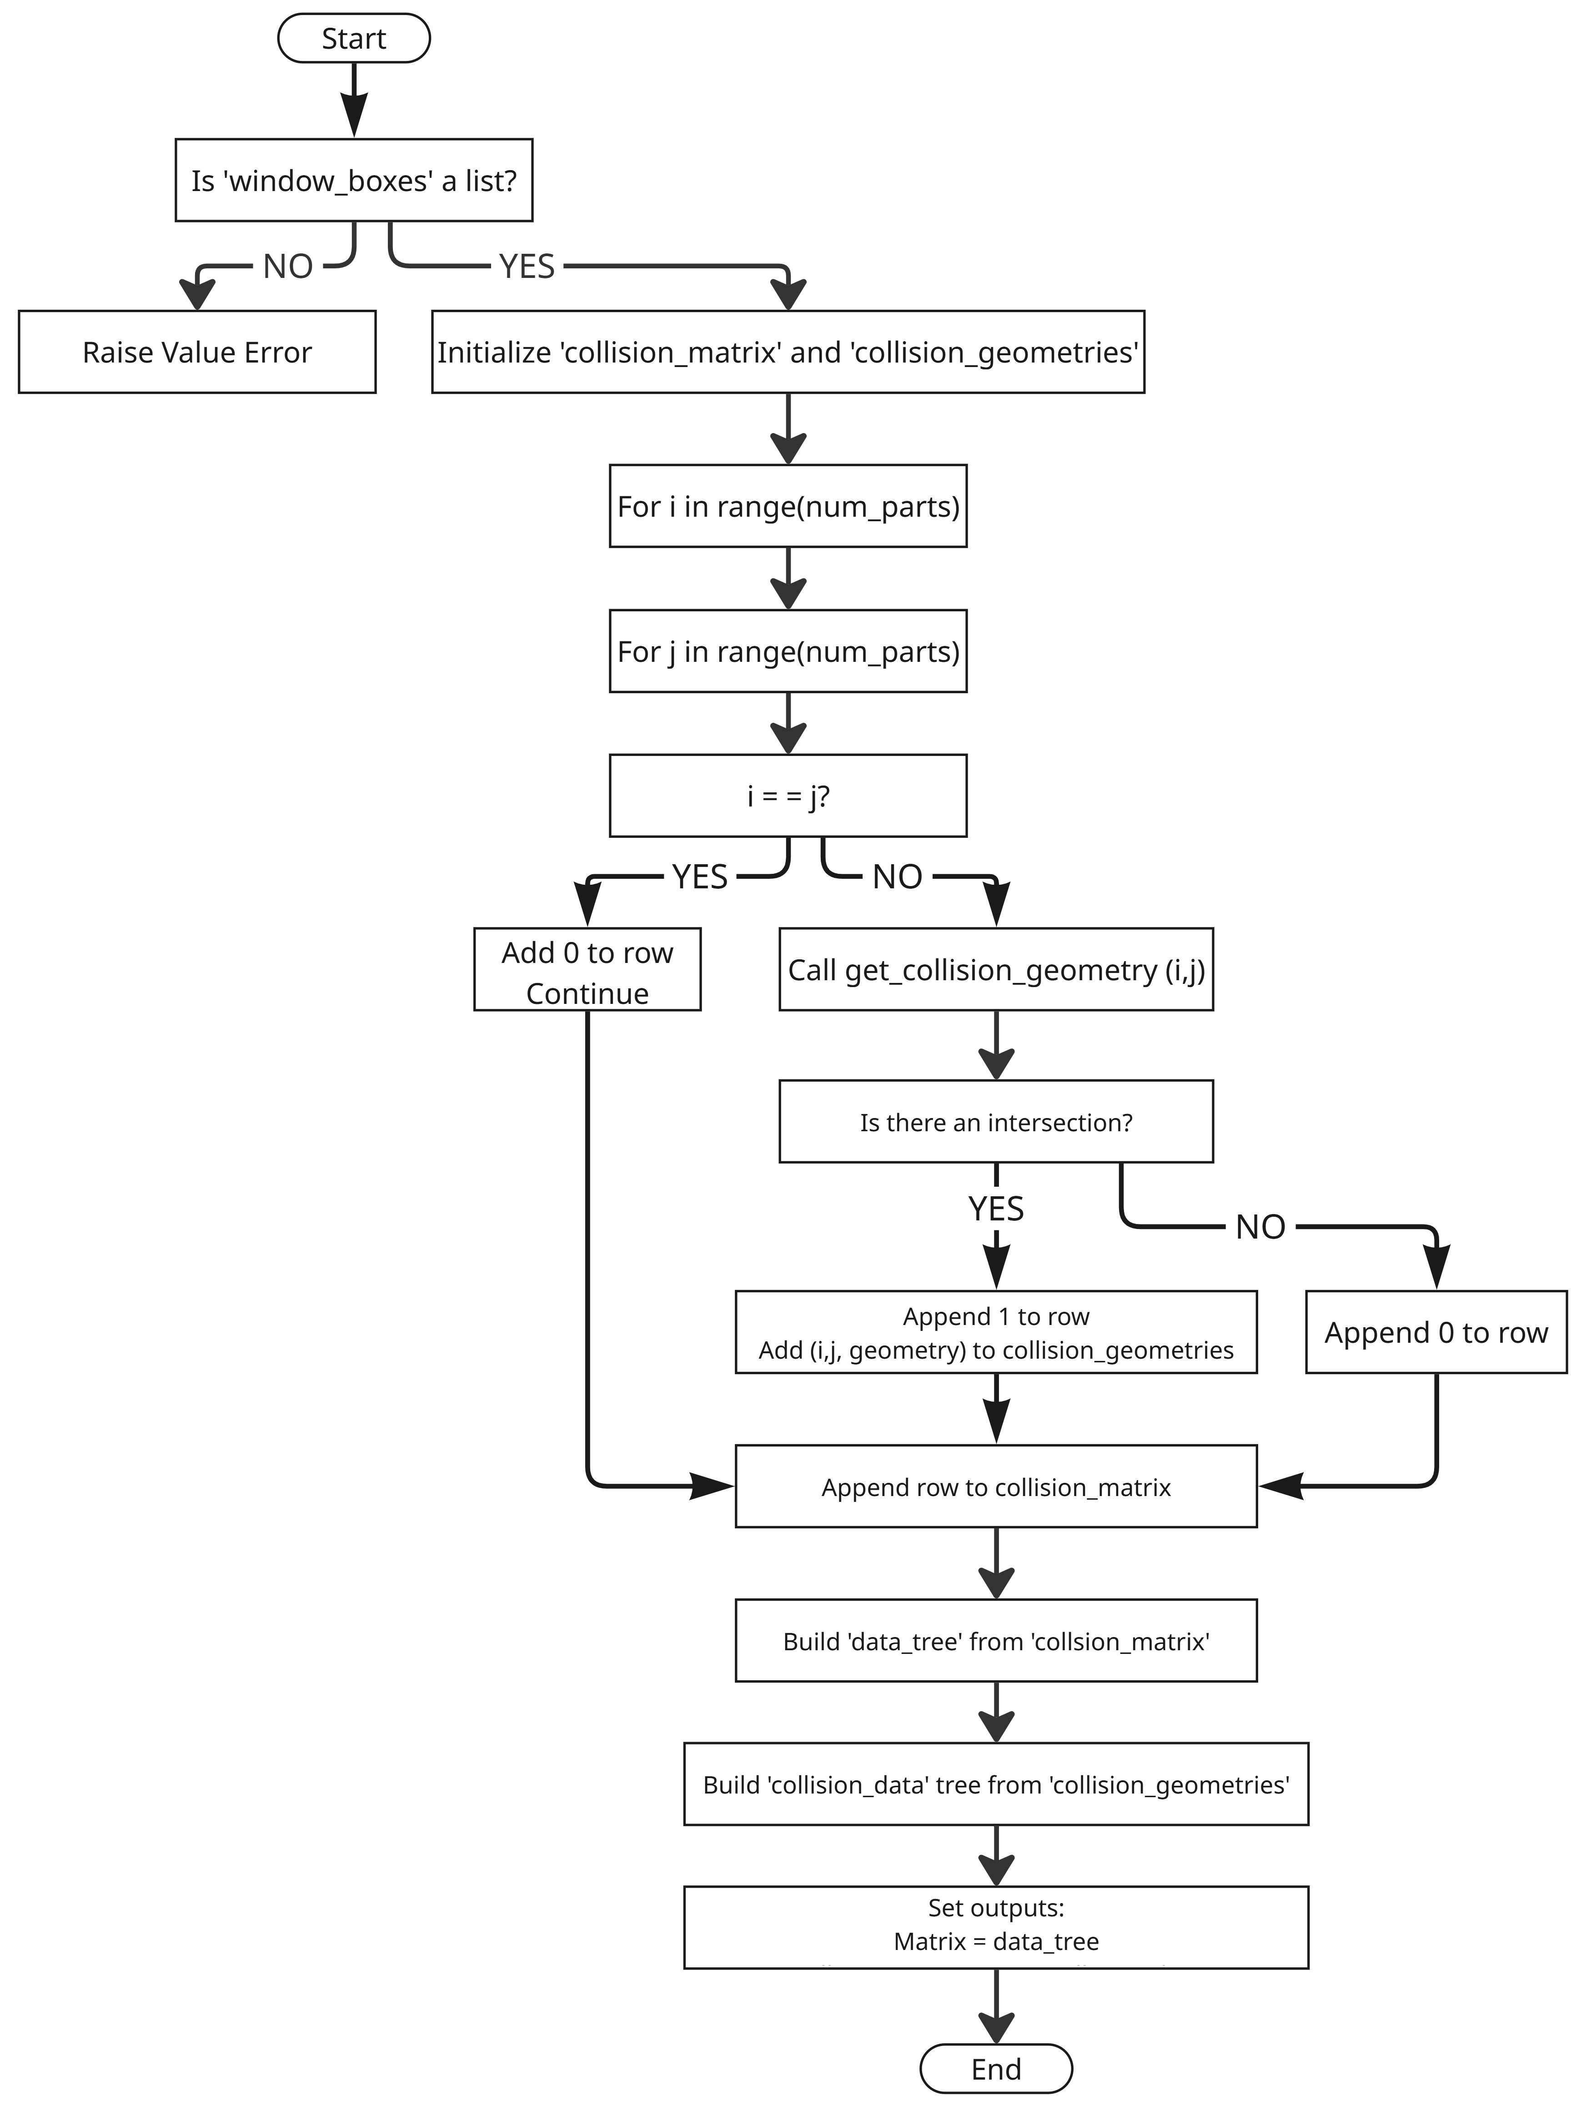
Figure 4: Flowchart of the collision test to construct matrix and graph data

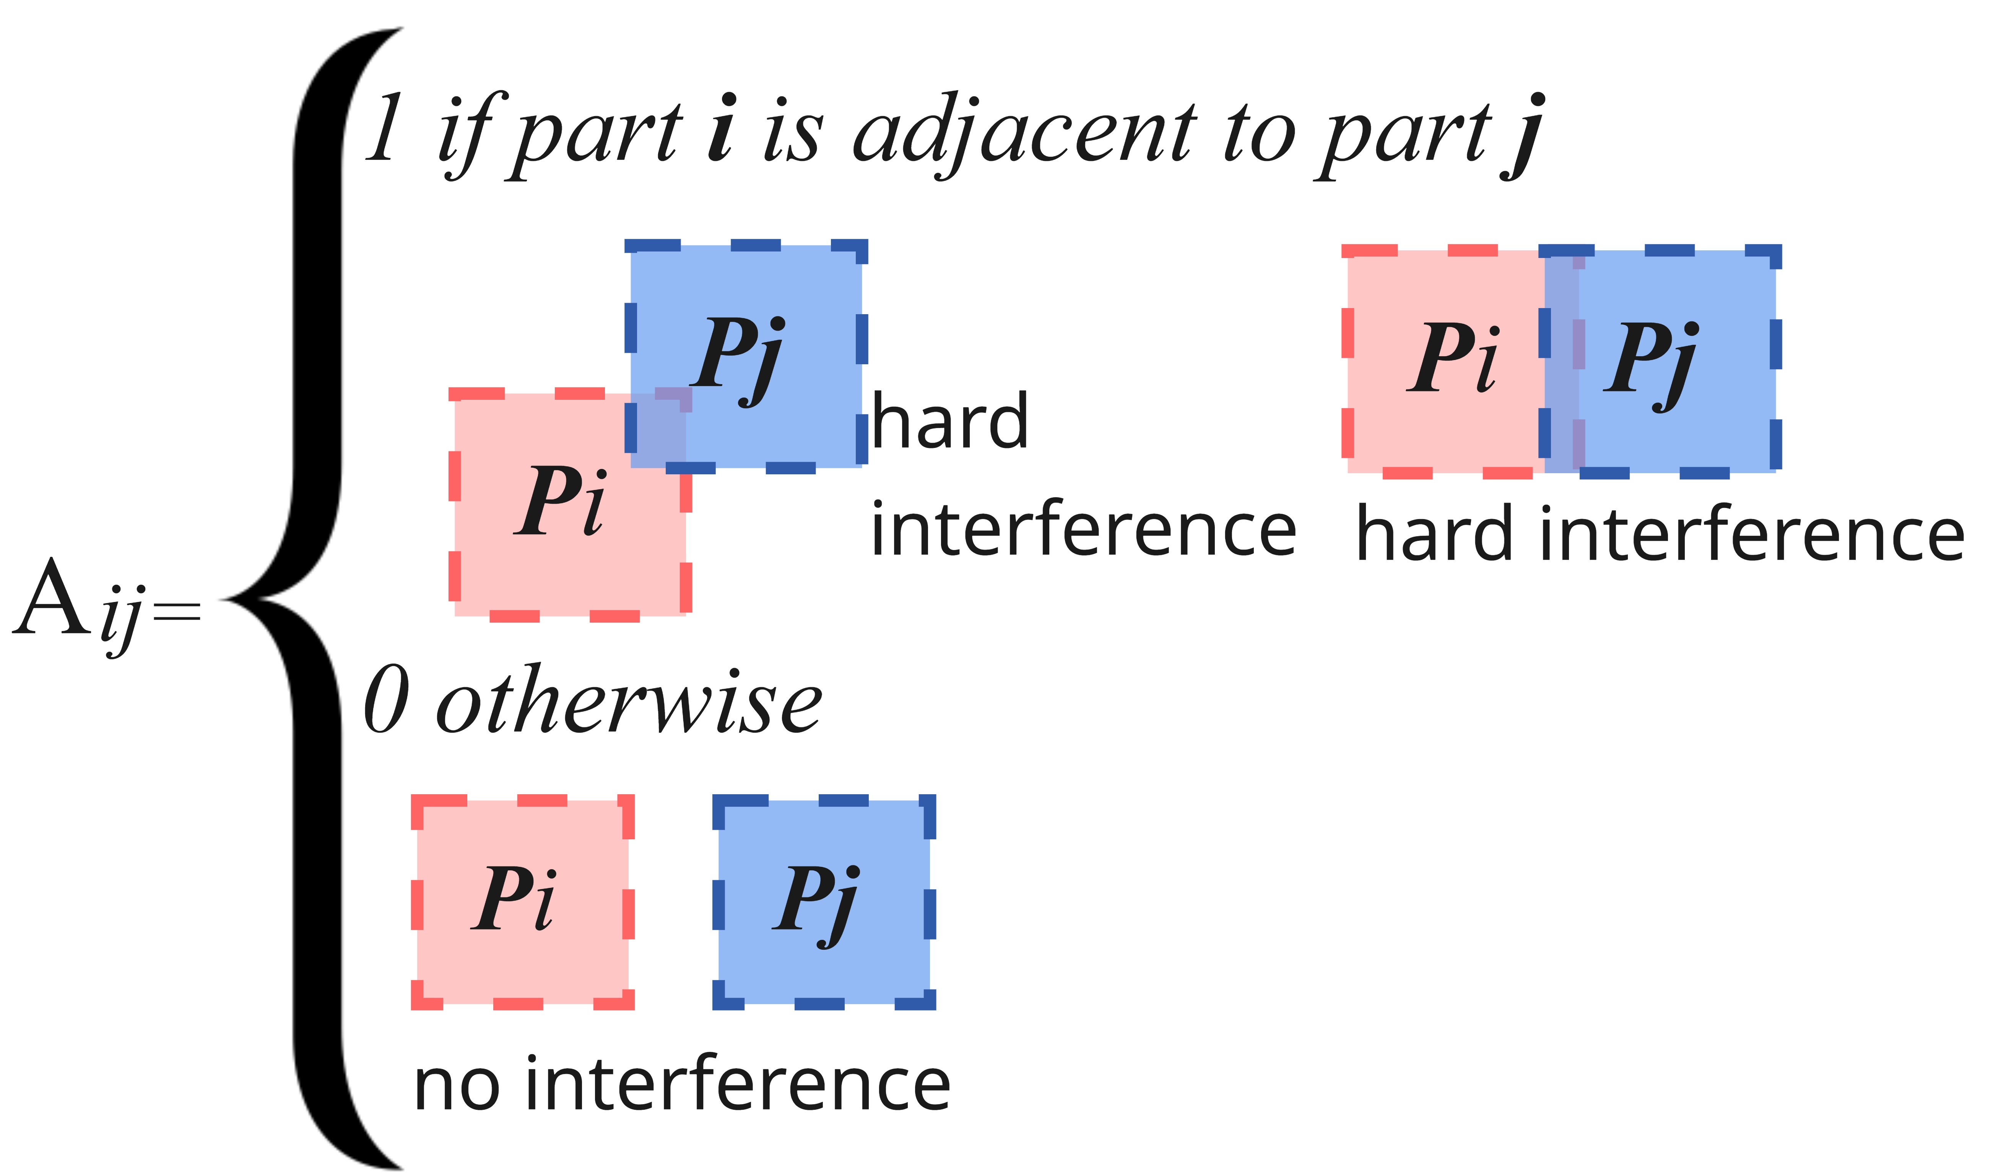
Figure 5: Interference relations rules between parts

Cross-sectional drawings provided in .dwg format serve as the basis for constructing the parametric 3D window model used for collision testing. These cross-sections offer critical design insights that are otherwise hidden in external views. However, the detailed nature of aluminium frame sections increases the complexity of both 3D modelling and collision detection.
The complexity stems from the translation of intricate 2D cross-sections into volumetric geometries, which require more advanced algorithms and greater computational resources. As a simplification strategy, preliminary collision test can be performed between simplified bounding volumes containing the complex objects to be tested (Dai et al., 2006). A bounding box volume is a simple geometry enclosing the object, a pair of objects are impossible to collide if their bounding volumes do not intersect (Zhang et al., 2016).
To streamline the collision test process, the detailed frame geometries are converted into bounding boxes which serve as input into a Python scripting node. The inner frames are converted into box geometry which is illustrated in red in figure 6 as well as the outer frames of window are shown by blue colour.
Figure 6: Converting cross section geometries to bounding box geometries

The output of this process, which leverages Boolean intersection operation, is a binary dataset representing the collision status between window parts through matrix where matrix elements indicate the relationship between parts through rows and columns. The numbers or letter in the rows and columns correspond to relevant parts. A zero indicates no geometric precedence relation, while a one represents the existence of such a relation as it is expressed in Adjacency Matrix (AM).
The Adjacency Matrix (AM) which is a square matrix (nxn) that captures direct node-to-node (part-to-part in this study) connections. It is primarily used for topological reasoning, such as analysing connectivity, node degree, clusters, or shortest paths. In literature, AM is also called as Precedence Matrix consists of an equal number of rows and columns corresponding to the number of unique components of an assembly (Prioli et al., 2022).
This binary output of the collision test feeds into the construction of an adjacency matrix, where each matrix is assigned to a 1 or 0. As a part cannot collide with itself, diagonal cells in the matrix which represent self-to-self relationships as P1-P1, P2-P2, P3-P3, P4-P4 and P5-P5 are always assigned as 0. This is visually indicated by the red diagonal line in Figure 7, where the matrix is manually constructed for five-part window to emphasize the diagonal zero values. For instance, part 1 (P1) does not interfere with itself, and its cell is marked as 0. In contrast, P1 collided with parts P2 and P4, which are shown as 1 in the matrix.

Figure 7: Adjacency matrix construction of 5-part window

Once the adjacency matrix was constructed, collided areas of window part was generated as a separated box geometries which are highlighted in red in figure 8. This visualization allows straightforward verification and interpretation of collision zones within data-driven and geometrically accurate information.
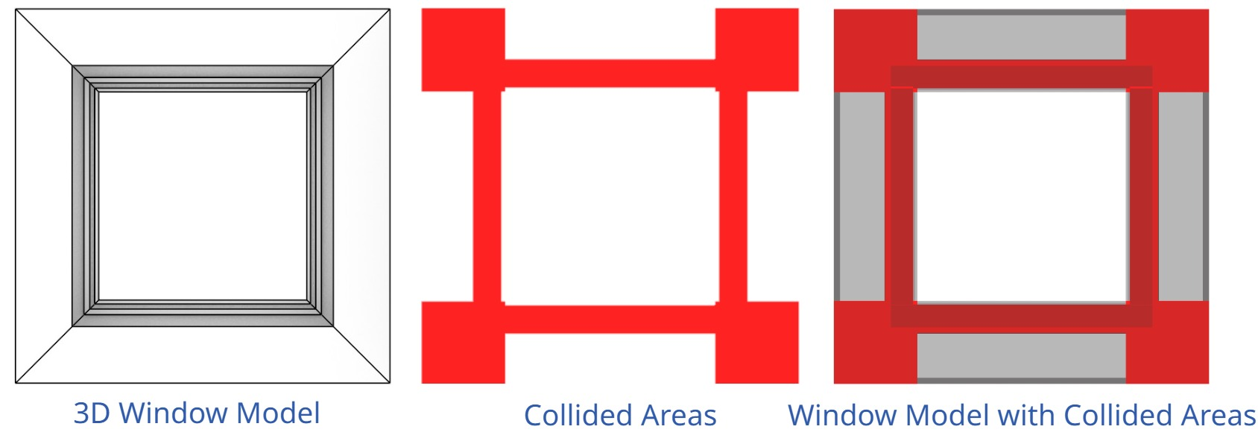
Figure 8: Collision geometries as outcome of the collision test.

The final step of the proposed methos is to construct adjacency graph to visually determine the relationships of whole window parts which is done with phyton-to-phyton node in the grasshopper environment where adjacency matrix is an input to graph construction.
Once the matrix is generated, the relationships between components are visualized as a graph, which serves as a visual representation of the window components and their interconnections. This graph visually conveys how parts are interconnected, supporting clearer interpretation of adjacency and precedence necessary for disassembly planning while providing a more intuitive understating of the window assembly and disassembly structure (Fig. 9). By conveying how parts are interconnected, the graph facilitates a more precise interpretation of the geometric precedence required for effective disassembly planning. However, adjacency graph illustration was not yet classified as directed or undirected graphs which is considered a future step of this study.

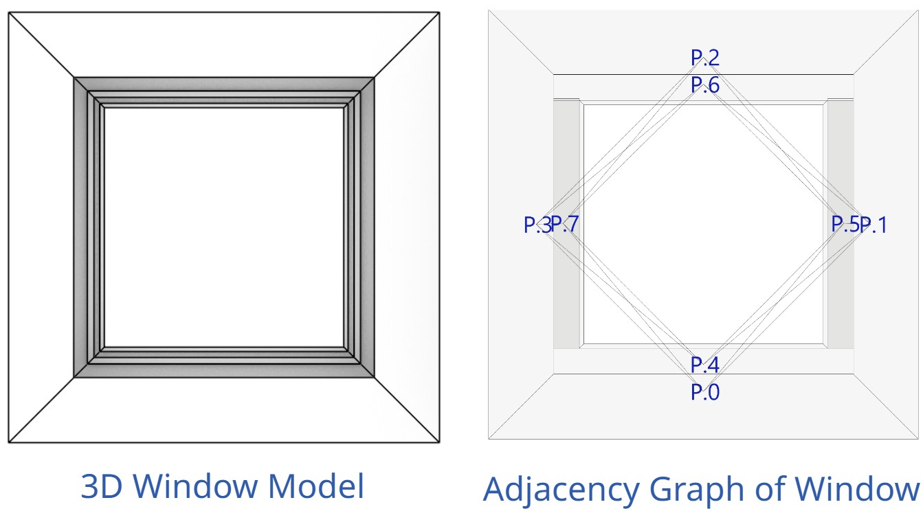
Figure 9: Adjacency graph construction for 8-part window in Grasshopper.

4. RESULT
The methodology proposed in the previous section is applied to two aluminium-framed windows in the parametric modelling environment in Rhinoceros-Grasshopper. Both windows consist of eight parts with distinct section details, comprising four inner and outer frames, which are used to represent disassembly features through adjacency matrices and corresponding graph structures. To validate the proposed methodology, results from the proposed computational model were compared against those derived from a conventional manual method. In the analogue approach, graphs were manually generated from the assembled 3D model by identifying and individually checking feasible subassemblies within Rhinoceros modelling environment.
Figures 10 and 11 present the full implementation of the proposed framework, detailing the matrix generation process and its transformation into adjacency graphs. Due to readability issues in the initial graph layout, the window dimensions were parametrically adjusted to enhance the clarity of the visual outputs. The left sides of Figures 9 and 10 are generated manually to compare with the automatically generated outcomes by the proposed methodology which facilitates direct comparison with manual outputs. Figure 9 illustrate results for window_type01, and Figure 10 corresponds to window_type02.

4.1 Adjacency matrix generation through collision test
By applying the same framework described in the methodology section, collision test results were generated for two different window types. The geometric variations in cross-section details resulted in difference in the extent and location of the collided areas. Window_type01 consists of two distinct aluminium frame profiles, where the inner frame occupies a small area relative to the outer frame, both in volume and spatial reach.
Figure 12 illustrates the logic behind the detected collision zones, as visualized in both the plan view of the 3D window and the corresponding section details for window_type01. Figure 13 presents the collision test results for window_type02.

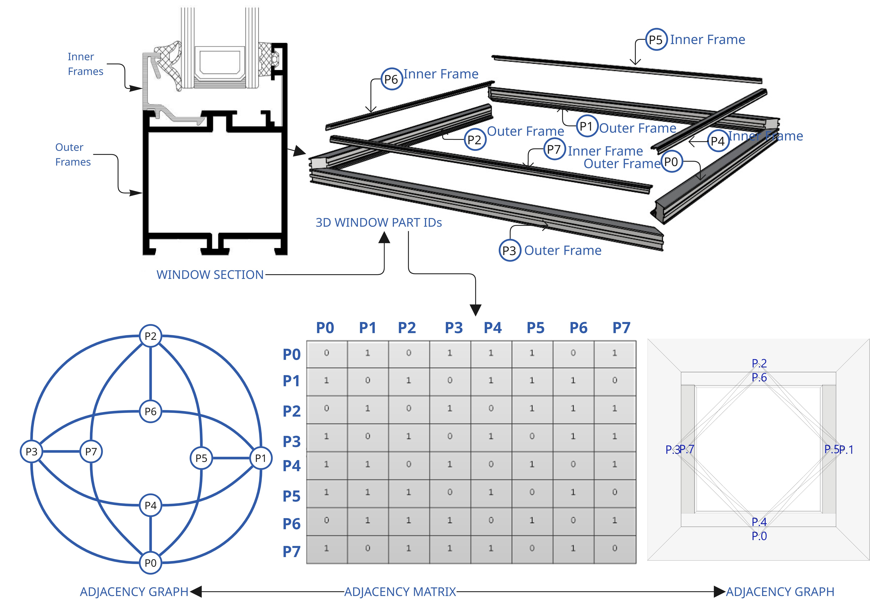
Figure 10: Outputs of the window_type01 derived from proposed methodology

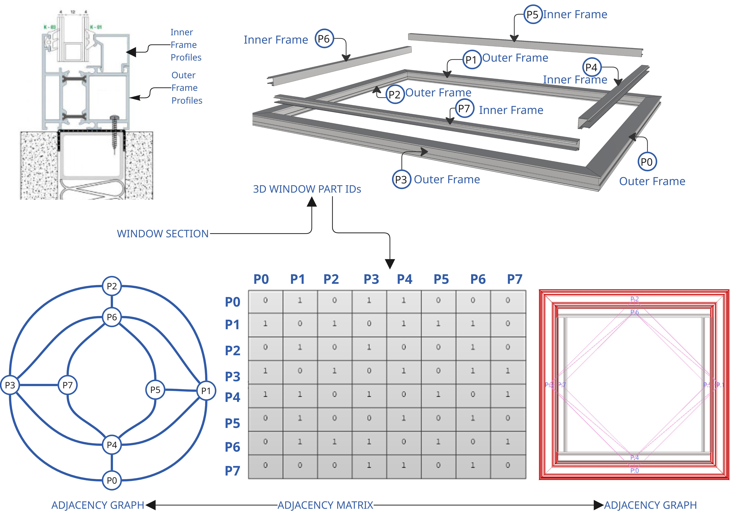
Figure 11: Outputs of the window_type02 derived from proposed methodology

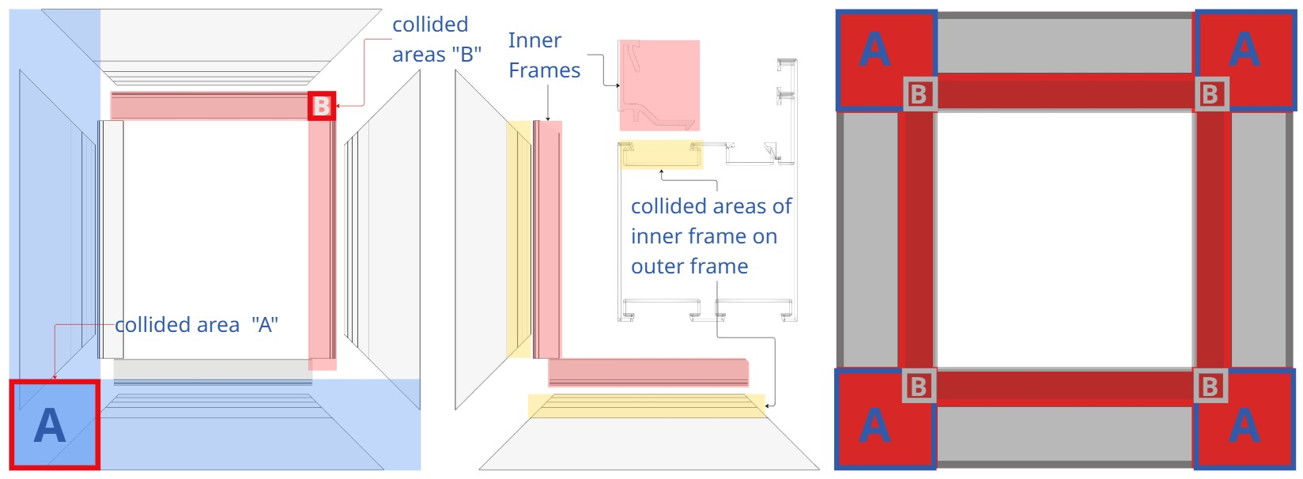
Figure 12: Collision test results for window_type01

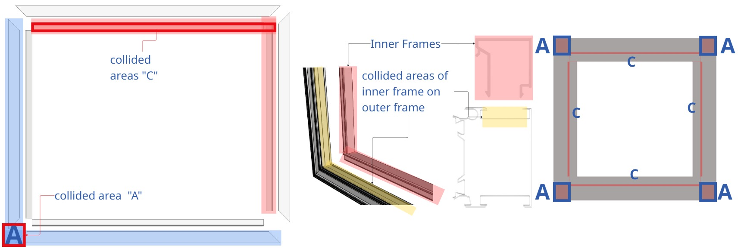
Figure 13: Collision test results for window_type02

The collision test outputs of window_type01 were then compared with window_type02 to assess consistency, highlight differences in connectivity patterns and further validating the method’s applicability to different window designs (Fig. 14).These visualizations highlight how bounding box geometry functions during the collision test process and demonstrate the alignment between automated results and manually derived outputs which confirms the accuracy and reliability of the proposed method.
Figure 14: Comparison of the collided areas
4.2 Adjacency matrix and graph development
The proposed framework generated adjacency matrices along with corresponding adjacency graphs, capturing geometric precedence relationships across different window types. Even though the corner connection details (shown in Fig 3), and part number remain consistent between the two models, variations in cross-section profiles lead to slightly distinct adjacency matrices, which are validated against manually constructed graphs. The results generated by the proposed method were compared with those from manual disassembly planning, where subassemblies were identified from 3D models and 2D section drawings based on CAD inspection. A high level of similarity was observed between the matrix and graph outputs of the proposed and those of the manual approach.
Figure 15 displays the adjacency matrix for window_type01. P0 and P4 highlighted to demonstrate their adjacency relationships within the window. P0 is adjacent to P1, P3, and P4 while it shows no interference between P2, P6, or P7. This result is also illustrated in the manually prepared adjacency graph. In contrast, P4 is connected to P0, P1, P3, P5 and P7. Likewise, it shows no interference with P2 and P6.
Figure 15: Adjacency matrix of window_type01

Figure 16 shows the adjacency matrix for window_type02, again emphasizing P0 and P4. In this case, P0 is adjacent to P1, P3, P4, P5 and P7 and has no adjacency with P2 and P6 which is also represented in the adjacency graph. Similarly, P4 which is adjacent to P0, P1, P3, P5 and P7, with no detected collision with P2 and P6.

Figure 16: Adjacency matrix of window_type02

5. CONCLUSION
This proposed disassembly framework is designed with a focus on computational efficiency and accuracy, enabling the analysis of the disassembly process's performance. By following the methodology outlines earlier, it provides a systematic and effective approach to disassembling aluminium-framed windows within integration of both geometric precedence logic and algorithmic computation.
One of the notable advantages of the proposed method is its ability to extract disassembly features directly from CAD data which eliminates the need to switch between software environments. This streamlines the workflow and demonstrates potential for more efficient and integrated disassembly planning.
To evaluate consistency, the results from window_type01 were then compared with window_type02, highlighting differences in part relationships while confirming the method’s adaptability to varied window types. Although both windows share the same part counts and corner connection details, variations in cross-section geometries led to measurable difference in collision zones, adjacency matrices, and resulting graphs. These outcomes align with the manually constructed results which highlight the proposed framework’s accuracy and reliability.
The main strength of the framework lies in its integration of collision detection for adjacency graph generation, offering a geometry-based insight into disassembly planning. However, an initial limitation of the proposed framework is the absence of graph classification into directed or undirected forms, which currently restricts the accurate disassembly of sequence planning development and part hierarchy. Furthermore, certain key window components such as gaskets, glazing, and fasteners were excluded in this study. Incorporating these elements and advancing toward graph-based sequence classification are future research of this study.

ACKNOWLEDGEMENTS
We gratefully acknowledge support from the European Union’s Horizon Europe research and innovation program under grant agreement No.101056773 for funding this work under the Reincarnate project.

REFERENCES
Bourjault, A. (1984). Contribution à une approche méthodologique de l'assemblage automatisé: élaboration automatique des séquences opératoires. These D'etat, Universite de Franche-Comte.
Dai, X., Li, Y., & Zhang, X. (2006). Contact mechanics in wearing garments. In Elsevier eBooks (pp. 125–144). https://doi.org/10.1533/9781845691486.2.125
De Fazio, T., & Whitney, D. (1987). Simplified generation of all mechanical assembly sequences. IEEE Journal on Robotics and Automation, 3(6), 640–658. https://doi.org/10.1109/jra.1987.1087132
De Fazio, F., Bakker, C., Flipsen, B. and Balkenende, R., 2021. The Disassembly Map: A new method to enhance design for product repairability. Journal of Cleaner Production, 320, p.128552.
Deniz, O. S. and Dogan, E. (2014) ‘Building Façade System for Deconstruction’, Journal of Sustainable Architecture and Civil Engineering, 8(3). doi: 10.5755/j01.sace.8.3.7231.
Eckelman, M. J. and Laboy, M. M. (2020) ‘LCAart: Communicating industrial ecology at a human scale’, Journal of Industrial Ecology, 24(4), pp. 736–747. doi: 10.1111/jiec.12978.
Güler, E., Kalayci, C.B., Ilgin, M.A., Özceylan, E. and Güngör, A., 2024. Advances in partial disassembly line balancing: A state-of-the-art review. Computers & Industrial Engineering, p.109898.
Ishii, K., & Lee, B. H. (1996, August). Reverse fishbone diagram: a tool in aid of design for product retirement. In International Design Engineering Technical Conferences and Computers and Information in Engineering Conference (Vol. 80494, p. V001T01A008). American Society of Mechanical Engineers.
Iwase, S. (2024). AND/OR graph generation for disassembly analysis: Deeply-nested subassemblies represented by a hypergraph. International Journal of Production Research, 1–29. https://doi.org/10.1080/00207543.2024.2416560
Kheder, M., Trigui, M., & Aifaoui, N. (2016). Optimization of disassembly sequence planning for preventive maintenance. The International Journal of Advanced Manufacturing Technology, 90(5–8), 1337–1349. https://doi.org/10.1007/s00170-016-9434-2
Kullmann, F., Markewitz, P., Stolten, D. et al. Combining the worlds of energy systems and material flow analysis: a review. Energ Sustain Soc 11, 13 (2021). https://doi.org/10.1186/s13705-021-00289-2
Li, D., Gao, K., Ren, Y., Zhang, R., & Fu, Y. (2024). Integrating meta-heuristics and a Sarsa algorithm for disassembly scheduling problems with cycle time and hazard coefficients. Green Manufacturing Open, 2(1). https://doi.org/10.20517/gmo.2023.091901
Prioli, J.P.J., Alrufaifi, H.M. and Rickli, J.L., 2022. Disassembly assessment from CAD-based collision evaluation for sequence planning. Robotics and Computer-Integrated Manufacturing, 78, p.102416.
Sanchez, B., Rausch, C., Haas, C. and Hartmann, T., 2021. A framework for BIM-based disassembly models to support reuse of building components. Resources, Conservation and Recycling, 175, p.105825.
Tian, G., Ren, Y., Feng, Y., Zhou, M., Zhang, H., & Tan, J. (2018). Modeling and planning for Dual-Objective selective disassembly using and/or graph and discrete artificial bee colony. IEEE Transactions on Industrial Informatics, 15(4), 2456–2468. https://doi.org/10.1109/tii.2018.2884845
Tseng, H. E., Huang, Y. M., Chang, C. C., & Lee, S. C. (2020). Disassembly sequence planning using a Flatworm algorithm. Journal of Manufacturing Systems, 57, 416-428.
Zhang, W., Ma, M., Li, H., & Yu, J. (2016). Generating interference matrices for automatic assembly sequence planning. The International Journal of Advanced Manufacturing Technology, 90(1–4), 1187–1201. https://doi.org/10.1007/s00170-016-9410-x

