Reality Capture-Based Digital Twin Framework for Sustainable Heritage Preservation: A Case Study of COEP Main Building
Bhavya Modi¹, Ayush Hadge¹, Saurabh E. Shinde¹, Dr. Gayatri S. Vyas^{1*}

¹ Department of Civil Engineering, COEP Technological University, Pune, Maharashtra, India, 411005
*Corresponding email: gsv.civil@coeptech.ac.in

ABSTRACT
This study examines the applications of Digital Twin (DT) technology in the construction industry, focusing on its role in sustainable heritage preservation and resilient asset management. Although DT systems theoretically support real-time monitoring and predictive maintenance, practical field execution often reveals critical deployment limitations. To evaluate these dynamics, this study investigates a noninvasive digital twin workflow integrated with Building Information Modeling (BIM) and Reality Capture on a prominent historical structure: the Neo-Gothic Main Building of COEP Technological University. Initial modeling attempts using standard 2D drawings in conventional BIM software exposed immediate geometric limitations, highlighting Reality Capture as a mandatory alternative. This paper details the implementation workflow using Bentley iTwin Capture Modeler, contrasting ground-based photogrammetry with drone-based aerial data collection. The field execution exposed severe environmental site challenges, where dense campus foliage generated data occlusions and incomplete mesh. Furthermore, processing high-fidelity heritage data exposes significant computational bottlenecks. Despite systematic troubleshooting, the cloud rendering engine encountered computational memory constraints during high-resolution model generation that prevented delivery of the final high-resolution model. Synthesizing these field outcomes with active literature, this study proposes a conceptual framework identifying critical success factors, including standardized data integrity, lifecycle management, and high-performance computing infrastructure, alongside practical data integration challenges. These insights provide an actionable benchmark for practitioners applying digital twins within the scope of digital heritage construction.
Keywords: Digital Twin · IoT · BIM · Heritage Preservation · Sustainability

- INTRODUCTION
The Architecture, Engineering and Construction (AEC) sector is gradually adopting Digital Twin technology to improve the way physical assets are recorded, analysed, and managed throughout their service life. A digital twin is a continuously updated virtual replica of a physical asset, developed by integrating Building Information Modelling (BIM), Internet of Things (IoT)-based data acquisition, and advanced reality capture techniques (Boje et al., 2020). Within infrastructure management, such interconnected digital environments improve the understanding of existing conditions, enhance decision-making processes, support efficient resource utilization, and assist in identifying potential deterioration mechanisms at early stages (Sacks et al., 2020).
Although the digital twin concept has matured rapidly across manufacturing and, more recently, construction research, most published studies emphasise conceptual architectures or post-implementation outcomes rather than the practical, field-level difficulties of building a digital twin for a real, geometrically irregular heritage asset. Section 2 reviews the digital twin concept, its core strengths, and its documented applications in construction and heritage conservation in greater depth, before situating the specific contribution of the present study.
While previous studies have established the potential benefits of digital twins, several practical barriers, including large-scale data handling, computational requirements, and interoperability limitations, continue to affect their real-world implementation (Revolti et al., 2024). Considering these challenges, the present study explores a non-invasive digital twin development workflow using Bentley iTwin Capture Modeller for the Neo-Gothic Main Building of COEP Technological University. The research analyses the practical issues observed during reality capture, including incomplete geometric information, field acquisition constraints, and computational processing limitations, and identifies key factors necessary for effective implementation of heritage digital twins under real-world conditions.

- LITERATURE REVIEW
2.1 The Digital Twin Concept and Its Core Strengths
The term digital twin originates from product lifecycle management research, where it was first proposed as a virtual counterpart that mirrors a physical asset across its entire lifecycle, linked to it through a continuous exchange of information between the physical and digital domains (Grieves and Vickers, 2017). Subsequent classification work distinguishes three levels of digital representation: a digital model, which involves no automated data exchange with its physical counterpart; a digital shadow, in which data flows automatically from the physical asset to the digital representation only; and a true digital twin, which requires a fully automated, bidirectional data flow so that a change of state in the physical asset updates the digital representation and, conversely, insights generated in the digital environment can inform interventions on the physical asset (Kritzinger et al., 2018). This bidirectionality is what distinguishes a digital twin from a static 3D model or a conventional, drawing-based BIM file.
In the built environment, this concept translates into three principal strengths. First, digital twins support continuous, near real-time situational awareness of an asset's condition rather than periodic, point-in-time inspection (Sacks et al., 2020). Second, by integrating geometric, semantic, and sensor-based information within a single environment, digital twins enable predictive analytics and simulation of future states, supporting proactive maintenance rather than reactive repair (Boje et al., 2020). Third, digital twins act as a persistent, lifecycle-long knowledge repository that connects design, construction, and operational data which would otherwise remain fragmented across disciplines and software platforms (Opoku et al., 2021). These strengths make digital twins particularly attractive for assets, such as heritage structures, that demand long-term, non-invasive monitoring.
2.2 Digital Twins in the Construction and Built Environment Sector
Within the AEC sector, digital twin adoption has progressed from BIM-centred asset documentation toward dynamically updated, sensor-integrated environments. Although BIM offers a structured repository of geometric and design information, it is largely static once construction is complete and offers limited support for post-occupancy monitoring or operational decision-making (Opoku et al., 2021). To address this gap, researchers have proposed digital twin architectures that connect individual building assets to city-scale infrastructure networks, using semantic information layers to fuse sensor data streams with BIM elements (Lu et al., 2020). Such frameworks have been shown to improve structural health monitoring, safety assessment, and maintenance scheduling across an asset's operational life (Zhang and Hu, 2021). More recent work frames digital twin adoption in construction projects as a socio-technical challenge, in which technology, process, and organisational readiness must be addressed jointly rather than treating the digital twin purely as a modelling exercise (Abdelmegid et al., 2024).
2.3 Digital Twins for Heritage and Historic Structures
Extending digital twin methods to heritage assets introduces demands beyond those typical of new-build construction. Historic structures are characterised by irregular, non-parametric geometries, undocumented structural alterations, and material degradation that accumulates unevenly over decades, none of which are well captured by conventional, drawing-based BIM workflows (Yang et al., 2024). Survey-based and scan-to-BIM methodologies, which reconstruct heritage geometry directly from point clouds and photogrammetric meshes rather than idealised parametric families, have been proposed as a more faithful alternative for documenting existing conditions (Brumana et al., 2020). Once such a reality-based model exists, it can serve as the foundation for on-going condition assessment: digital twins have been framed as a predictive-maintenance tool for existing buildings, using accumulated condition data to flag deterioration before it becomes structurally significant (Sobowale et al., 2023), while other work highlights that the reliability of such predictions depends heavily on the completeness and integrity of the underlying captured data (Jiang et al., 2024). Recent applications extending BIM-IoT integration toward lifecycle-oriented operation and maintenance further illustrate the direction in which heritage digital twins are expected to evolve (Liu et al., 2025).
Broader systematic reviews reinforce this trajectory: consolidating the wider literature on digital twins for built cultural heritage, Vuoto et al. (2024) identify structural health monitoring, preventive conservation, and stakeholder communication as the dominant application areas, while noting that interoperability between heritage-specific data formats and mainstream BIM/DT platforms remains only partially resolved. A parallel bibliometric review by Mazzetto (2024) similarly documents the accelerating convergence of digital twins with BIM, 3D laser scanning, and IoT sensing in heritage conservation, while flagging the absence of standardised information protocols as a persistent barrier to practice-ready deployment.
2.4 Research Gap
Collectively, the literature establishes both the conceptual promise of digital twins and the specific value of reality capture for heritage documentation. However, most published heritage digital twin studies report the outcome of a completed pipeline rather than the field-level friction encountered while building it; environmental occlusion, sensor and platform heterogeneity, and the computational cost of processing high-fidelity heritage meshes are rarely discussed in empirical detail, even though these practical barriers continue to affect real-world implementation (Revolti et al., 2024). This study addresses that gap by documenting, from a single field implementation, where and why a reality capture-based digital twin workflow succeeds or breaks down when applied to an irregular Neo-Gothic heritage structure, and by consolidating the resulting observations into a set of critical success factors for practitioners.
- METHODOLOGY
Building on the gap identified above, this study adopts a structured, non-invasive workflow for developing a heritage digital twin through BIM evaluation and reality capture techniques.
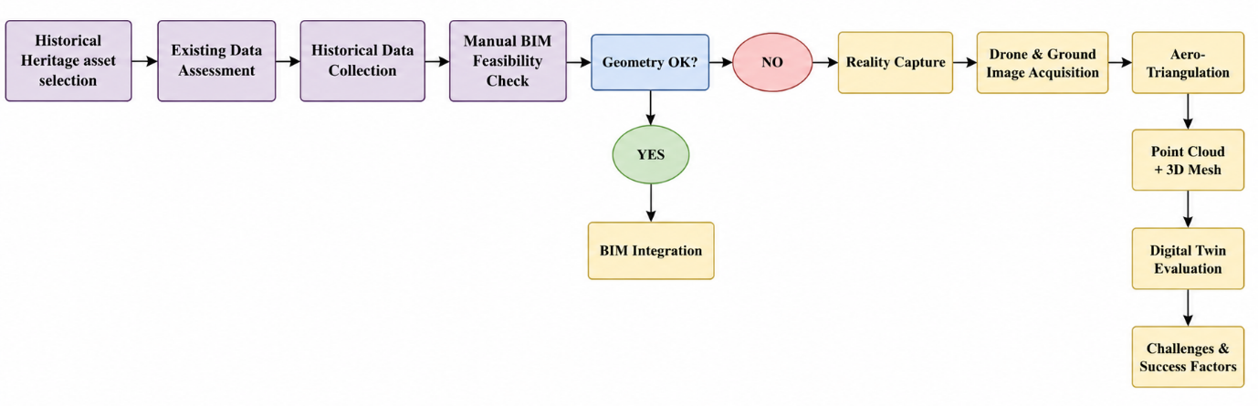
Figure 1: Block diagram of the heritage digital twin development workflow
As illustrated in Fig. 1, the process involves assessing existing data, conducting BIM feasibility analysis, acquiring field-based data, performing photogrammetric reconstruction, and evaluating implementation challenges. Integrating digital workflows with practical implementation strategies is essential for effective digital twin deployment in construction environments (Abdelmegid et al., 2024).

3.1 Baseline Assessment and BIM Modelling Evaluation
The initial phase involved evaluating available historical documentation, including drawings and existing records, to determine their suitability for digital model development. Conventional BIM modelling using Autodesk Revit was analysed to examine whether two-dimensional information could accurately represent the complex geometry of the selected heritage structure.
Although BIM provides a foundation for digital asset representation, modelling existing structures remains challenging due to incomplete information, irregular geometries, and data integration limitations (Zhang and Hu, 2021). Therefore, when traditional modelling methods could not achieve the required geometric accuracy, the workflow shifted toward reality capture-based documentation.

3.2 Reality Capture and Cloud-Based Reconstruction Workflow
To overcome manual modelling constraints, an image-based photogrammetry approach was implemented. Reality capture provides a practical approach for documenting existing structures by collecting visual and spatial information and converting it into a digital environment (Revolti et al., 2024). The collected image datasets were processed using Bentley iTwin Capture Modeller through three main stages:
3.2.1 Image Acquisition
Overlapping images were captured from ground and aerial viewpoints to document accessible and elevated architectural elements.
3.2.2 Aero-Triangulation
Feature-matching algorithms identified common reference points between images to determine camera positions, orientation, and spatial relationships.
3.2.3 Mesh and Texture Reconstruction
The processed spatial data was converted into a three-dimensional mesh, then texture-mapped to create the visual digital twin representation

4. CASE STUDY IMPLEMENTATION
4.1 Asset Selection: COEP Main Building
The historic Main Building of COEP Technological University in Pune, India, constructed circa 1865, was selected as the physical asset to validate the framework. The selected case study represents one of COEP Technological University's oldest heritage assets, characterised by Neo-Gothic architectural elements, stone masonry construction, arches, and tower features.
Over its 160-year lifespan, the structure has become increasingly vulnerable to environmental exposure, surface weathering, and material degradation. Because traditional asset inspection methods are periodic, highly subjective, and structurally invasive, this landmark represents an ideal candidate for implementing a continuous, non-invasive digital twin framework. Digital survey and scan-to-BIM methodologies have demonstrated significant potential for documenting heritage assets and supporting conservation-oriented management activities (Brumana et al., 2020).
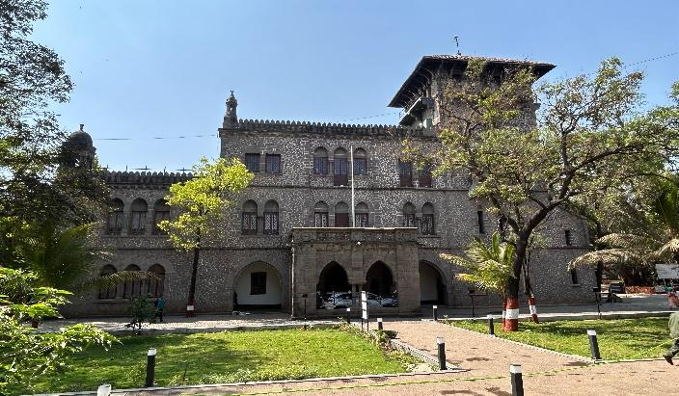
Figure 2: COEP Tech Main Building.
4.2 Field Data Collection and Data Constraints
The initial implementation stage attempted to model the building manually in Autodesk Revit using historical 2D drawings. This approach immediately failed due to severe data limitations and geometric non-standardisation:
Dimensional Limitations: The legacy blueprints completely lacked three-dimensional spatial depth data (z-axis), ignoring historical structural shifts and settlement variations.
Geometric Complexity: The highly customised stone carvings, ornamental cornices, and irregular Gothic arches proved completely impossible to replicate precisely using standard parametric BIM software families.
To resolve this, we collected field data using reality capture. A total of 255 high-resolution photographs were acquired using a multi-platform approach. Ground-level architectural details were recorded using mobile-based tracking (Apple iPhone), while the upper roof lines, vertical tower profiles, and inaccessible elevations were captured via aerial drone photogrammetry (DJI drone). These multi-angle datasets were georeferenced using embedded metadata positioning to establish the raw data foundation for cloud-based rendering.
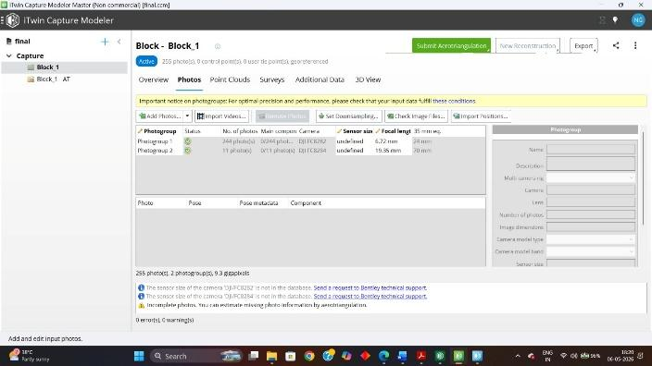
Figure 3: Photogrammetry data input stage showing multi-platform image acquisition in Bentley iTwin Capture Modeller.

5. RESULTS
The multi-platform data collection strategy successfully demonstrated that integrating varying reality capture methods is necessary to overcome individual hardware limitations on historic infrastructure. By compiling 255 high-resolution photographs, the project established a comprehensive spatial database of the asset.
5.1 Hybrid Geometric Data Density
The combination of close-range mobile tracking and high-angle drone photogrammetry successfully captured the extensive geometric layout of the COEP Main Building. The initial processing phases yielded the following successful outcomes:
Aero Triangulation Alignment: The software successfully matched overlapping pixel features across the heterogeneous image datasets. This allowed the engine to calculate precise camera coordinate positions (x, y, z) and lens orientation angles for every frame in the block.
Preliminary Spatial Boundaries: The system successfully reconstructed the point-cloud distribution and defined a 3D spatial reconstruction boundary within the iTwin environment.
Texture Mapping Foundation: Ground-based tracking provided highly detailed, pixel-level surface textures of the lower stone masonry facade and pointed arches, while aerial drone tracking mapped the vertical profiles of the Victorian Gothic tower and upper roof lines.
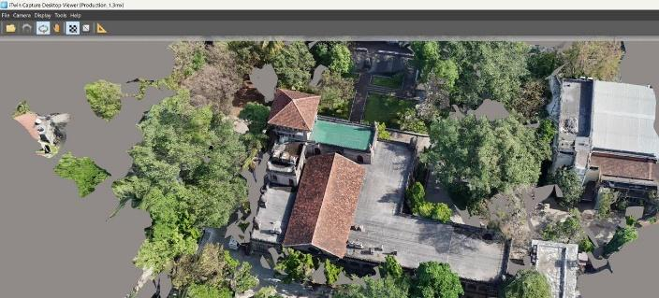
Figure 4: Generated reality model of COEP Main Building.
6. IMPLEMENTATION CHALLENGES AND DISCUSSION
Although the reality capture workflow successfully generated a detailed visual dataset of the heritage structure, several practical challenges were observed during implementation. Previous research indicates that digital twin deployment in construction projects is influenced not only by modelling capabilities but also by data management, interoperability, and technological infrastructure (Yang et al., 2024; Jiang et al., 2024).
6.1 Field Acquisition Limitations and Spatial Data Gaps
A major challenge identified during field implementation was environmental constraints that affected complete data acquisition. The effectiveness of a digital twin depends significantly on the accuracy and completeness of collected information, as missing data can influence the reliability of the final digital asset and future maintenance applications (Sobowale et al., 2023).
6.1.1 Ground-Based Capture Constraints
The ground-level image acquisition process provided detailed visual information for accessible portions of the structure, including facade elements and architectural details. However, limited viewing angles restricted capture of higher structural components, such as roof sections and elevated tower features.
6.1.2 Vegetation-Induced Occlusion
Dense tree coverage around the heritage structure interrupted the line of sight between the capture equipment and several parts of the building envelope. These physical barriers reduced the availability of continuous visual information required for complete reconstruction.
6.1.3 Incomplete Mesh Formation
Because of limited visibility in certain areas, the reconstruction algorithm could not identify enough overlapping feature points between image datasets. This resulted in localised discontinuities within the generated point cloud and affected the completeness of the final mesh output.
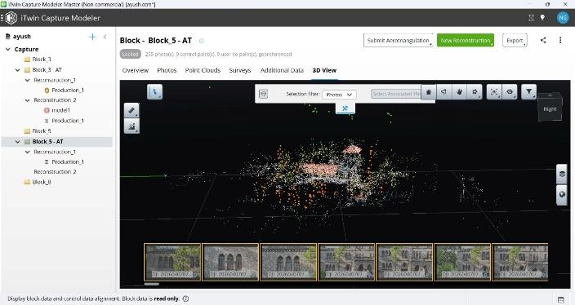
Figure 5: Mesh model.
6.2 Computational Limitations During Digital Twin Generation
During this study, handling large photogrammetry datasets created processing challenges because detailed mesh reconstruction demanded higher computing resources. Effective digital twin implementation therefore depends on adequate processing infrastructure and optimised data handling strategies (Jiang et al., 2024).
6.2.1 Processing Resource Requirements
The initial aero triangulation stage was successfully completed, confirming accurate image alignment and spatial referencing. However, the final reconstruction stage required substantially more computational resources to generate detailed geometry and texture-based outputs.
6.2.2 Memory Capacity Constraints
Despite systematic workflow optimisation and processing adjustments, memory-related limitations were encountered during the final model generation stage. This demonstrates that high-resolution heritage digital twin projects require suitable computational resources, including high-performance workstations or scalable cloud-based processing environments.
6.3 Critical Success Factors for Heritage Digital Twin Implementation
The observations from this study highlight that successful deployment of heritage digital twins requires a balanced combination of accurate data acquisition, interoperable modelling environments, and sufficient computational infrastructure. Integrating BIM-based models with real-time monitoring technologies can further improve asset management and predictive maintenance capabilities in future digital twin applications (Liu et al., 2025).
Category | Critical Success Factor | Technical Requirement / Mitigation Strategy
Data Integrity | Standardised Optical Parameters | Locking camera focal lengths during field acquisition to prevent pixel-to-point calculation errors.
Interoperability | Historic BIM (HBIM) Integration | Transforming raw reality meshes into parametric heritage assets across the ecosystem.
Asset Longevity | Lifecycle Material Passports | Establishing permanent digital repositories to track material degradation over decades.
Infrastructure | High-Performance Computing (HPC) | Deploying dedicated cloud clusters or high-RAM workstations to handle massive mesh rendering.
Table 1: Critical success factors for digital twin implementation in heritage structures.

7. CONCLUSION AND FUTURE SCOPE
This study demonstrates the potential of Digital Twin (DT) technology for sustainable heritage preservation through the integration of BIM and reality capture techniques. The implementation on the COEP Main Building showed that conventional BIM workflows based on two-dimensional records have limitations in accurately representing complex heritage structures with irregular geometries and architectural details.
The photogrammetry-based workflow enabled effective digital documentation of existing structural conditions; however, practical execution revealed challenges related to field acquisition constraints, vegetation-based occlusions, incomplete mesh generation, and computational requirements during high-resolution model processing. These findings indicate that successful heritage digital twin implementation requires accurate data acquisition strategies, efficient digital workflows, and adequate computational infrastructure.
The study provides practical insights for applying digital twin technology to heritage conservation and supports Sustainable Development Goal 11: Sustainable Cities and Communities by encouraging digital methods for protecting cultural heritage assets.
Future research should focus on integrating LiDAR with photogrammetry to improve data capture in visually obstructed regions. Further advancements can include cloud-based processing for large datasets and IoT-based sensor integration to enable continuous monitoring, predictive maintenance, and lifecycle management of heritage structures.

REFERENCES
Abdelmegid, M., Tezel, A., Osorio-Sandoval, C., Fang, Z. & Collinge, W., (2024). Conceptualizing digital twins in construction projects as socio-technical systems. Proceedings of the 41st International Symposium on Automation and Robotics in Construction (ISARC 2024), pp. 577–584.
Boje, C., Guerriero, A., Kubicki, S. & Rezgui, Y., (2020). Towards a semantic construction digital twin: Directions for future research. Automation in Construction, 114: 103179. DOI: 10.1016/j.autcon.2020.103179.
Brumana, R., Oreni, D., Barazzetti, L., Cuca, B., Previtali, M. & Banfi, F., (2020). Survey and scan to BIM model for the knowledge of built heritage and the management of conservation activities. Digital Applications in Archaeology and Cultural Heritage.
Grieves, M. & Vickers, J., (2017). Digital twin: Mitigating unpredictable, undesirable emergent behavior in complex systems. In: Kahlen, F.-J., Flumerfelt, S. & Alves, A. (eds.) Transdisciplinary Perspectives on Complex Systems. Cham: Springer, pp. 85–113. DOI: 10.1007/978-3-319-38756-7_4.
Jiang, Y., Su, S., Zhao, S., Zhong, R.Y., Qiu, W., Skibniewski, M.J., Brilakis, I. & Huang, G.Q., (2024). Digital twin-enabled synchronized construction management: A roadmap from construction 4.0 towards future prospect. Developments in the Built Environment, 19: 100512. DOI: 10.1016/j.dibe.2024.100512.
Kritzinger, W., Karner, M., Traar, G., Henjes, J. & Sihn, W., (2018). Digital twin in manufacturing: A categorical literature review and classification. IFAC-PapersOnLine, 51(11): 1016–1022. DOI: 10.1016/j.ifacol.2018.08.474.
Liu, Z., Li, M. & Ji, W., (2025). Development and application of a digital twin model for net zero energy building operation and maintenance utilizing BIM-IoT integration. Energy and Buildings, 328: 115170. DOI: 10.1016/j.enbuild.2024.115170.
Mazzetto, S., (2024). Integrating Emerging Technologies with Digital Twins for Heritage Building Conservation: An Interdisciplinary Approach with Expert Insights and Bibliometric Analysis. Heritage, 7(11): 6432–6479. DOI: 10.3390/heritage7110300.
Lu, Q., Parlikad, A.K., Woodall, P., Ranasinghe, G.D., Heaton, J., Schooling, J. & Konstantinou, E., (2020). Developing a digital twin at building and city levels: Case study of West Cambridge campus. Journal of Management in Engineering, 36(3).
Opoku, D.G.J., Perera, S., Osei-Kyei, R. & Rashidi, M., (2021). Digital twin application in the construction industry: A literature review. Journal of Building Engineering, 40: 102726. DOI: 10.1016/j.jobe.2021.102726.
Revolti, A., Gualtieri, L., Pauwels, P. & Dallasega, P., (2024). From building information modeling to construction digital twin: A conceptual framework. Production & Manufacturing Research, 12(1): 2387679. DOI: 10.1080/21693277.2024.2387679.
Sacks, R., Girolami, M. & Brilakis, I., (2020). Building information modeling, artificial intelligence, and construction digital twins. Automation in Construction, 115: 103198. DOI: 10.1016/j.autcon.2020.103198.
Sobowale, M., Elghaish, F. & Brooks, T., (2023). A systematic review of digital twin as a predictive maintenance approach for existing buildings in the UK. Proceedings of the 23rd International Conference on Construction Applications of Virtual Reality (CONVR 2023), pp. 1206–1218. DOI: 10.36253/979-12-215-0289-3.119.
Vuoto, A., Funari, M.F. & Lourenço, P.B., (2024). Shaping digital twin concept for built cultural heritage conservation: a systematic literature review. International Journal of Architectural Heritage, 18(11): 1762–1795.
Yang, Z., Tang, C., Zhang, T., Zhang, Z. & Doan, D.T., (2024). Digital twins in construction: Architecture, applications, trends and challenges. Buildings, 14(9): 2616. DOI: 10.3390/buildings14092616.
Zhang, J. & Hu, Z., (2021). BIM-based digital twin framework for smart construction project management. Advanced Engineering Informatics, 49: 101364.

