Multi Criteria Decision Making (MCDM) Integration for Prioritizing Delay and Cost Overrun Factors in High-Rise Construction Projects
Ankita Dudhane^{1*}, Dr. Sreyashrao Surapreddi²

¹ Mumbai University, Mumbai, India
² Veermata Jijabai Technological Institute, Mumbai, India
*Corresponding email: ardudhane_m24@ci.vjti.ac.in

ABSTRACT
Schedule delays and cost overruns continue to undermine the successful delivery of high-rise construction projects by affecting project duration, financial performance, and overall productivity. Although numerous studies have investigated the causes of these issues, most rely on expert opinions or questionnaire-based assessments, which introduce subjectivity and may not accurately represent actual project execution. To address this limitation, this study develops a project execution data-driven framework for identifying, prioritizing, and evaluating delay and cost overrun factors through the integration of Multi Criteria Decision Making (MCDM) techniques with probabilistic risk analysis. Planning and performance data were obtained from three high-rise residential construction projects managed using Primavera P6 and Microsoft Project. Measurable project indicators, including occurrence frequency, schedule impact, and cost impact, were extracted from project records and compiled into a structured database for analysis. The identified factors were evaluated using the TOPSIS, VIKOR, and GRA, and the outcomes of the three methods were combined to establish a consolidated priority ranking. The ranked factors were subsequently incorporated into Primavera Risk Analysis (PRA) through project risk registers and activity level risk assignments to quantify their influence on project schedules using Monte Carlo simulation. The findings indicate that design change, delayed drawings, and unforeseen site conditions are the most influential contributors to project delays. Consultant/design-related and contractor-related factors each represented approximately 26.7% of the recorded delay events, emphasizing the importance of effective coordination throughout project execution. The probabilistic analysis predicted an additional project duration of approximately 57–78 days beyond the deterministic schedule, while the implementation of targeted mitigation measures reduced the severity of major risks by up to 86% and lowered associated cost impacts by nearly 40%. The proposed framework offers an objective and practical approach for project-specific risk prioritization, supporting improved schedule reliability, cost control, and informed decision-making in high-rise construction projects.

Keywords: Construction Delays, Cost Overruns, MCDM, TOPSIS, VIKOR, GRA, Primavera P6, Primavera Risk Analysis (PRA), Risk Management, Risk Register, Risk Mitigation, High Rise Projects

- INTRODUCTION
The construction industry plays an important role in economic growth by delivering infrastructure such as residential buildings, commercial developments, transportation facilities, and public utilities. In recent years, high rise construction projects have become increasingly complex due to strict project deadlines, budget limitations, involvement of multiple stakeholders, and rapid technological advancements. Because of these complexities, delays and cost overruns continue to remain major concerns affecting project performance and successful delivery. These issues often lead to productivity losses, increased project expenditure, contractual disputes, and reduced stakeholder confidence. Construction delays and cost escalations occur due to several interrelated factors such as ineffective planning and scheduling, delayed approvals, material shortages, design changes, labour inefficiencies, financial constraints, and unforeseen site conditions. The impact of these factors varies from project to project, making their evaluation and prioritization difficult. Traditional approaches for identifying critical delay factors are generally based on questionnaire surveys or expert judgment, which may introduce subjectivity and inconsistencies in decision-making. Furthermore, such approaches often fail to represent the actual behaviour of projects reflected in real construction records and schedule data.
To overcome these limitations, this study proposes a data-driven framework for prioritizing delay and cost overrun factors in high-rise construction projects using MCDM techniques. The study utilizes actual project records obtained from three high-rise developments, referred to as Case Study 1 (CS1), Case Study 2 (CS2), and Case Study 3 (CS3), due to confidentiality requirements. Delay data extracted from Primavera P6 schedules, progress records, and Extension of Time claim documents are analysed using TOPSIS, VIKOR, and GRA. In addition, PIF and PA-RII are developed to integrate project specific data with literature-based importance values.

- LITERATURE REVIEW
Across construction sectors and geographies, delay and cost escalation remain two of the most persistent obstacles to project delivery. Recurring causes in the literature include ineffective planning, delayed approvals, material shortages, financial constraints, labour inefficiencies, and design modifications, each shown to affect project performance. Beyond extending schedules and inflating budgets, these issues often escalate into disputes, productivity losses, and reduced stakeholder confidence. This has driven research aimed at isolating and ranking the factors most responsible for delay and cost escalation. Variation orders, poor site management, and low design team experience have been identified as leading contributors in mega construction projects (Daoud, A.O., El Hefnawy, M., & Wefki, H., 2023). In Egypt, slow decision-making, design changes, and delayed payments have similarly been flagged as significant delay causes (Elhusseiny, H.O., Nosair, I., & Ezeldin, A.S., 2021). In India, poor planning, weak coordination, material shortages, and inadequate site management consistently emerge as the most influential delay factors (Sharma, S. & Gupta, A.K., 2021; Singh, S., et al., 2018; Doloi, H., et al., 2012).
The link between schedule slippage and cost escalation has also drawn attention. Financial constraints, design-related issues, and weak management practices have been shown to drive both (Le-Hoai, L., Lee, Y.D., & Lee, J.Y., 2008; Niazi, G.A. & Painting, N., 2017). More recently, Multi-Criteria Decision-Making (MCDM) techniques have been adopted to prioritize construction risks more systematically. TOPSIS has been used to rank delay risks tied to non-critical activities (Heravi, G. & Gerami Seresht, N., 2018), and an integrated AHP-VIKOR framework has evaluated delay risk in high-rise developments (Vahedi Nikbakht, M., et al., 2024). Even so, most of this evidence rests on questionnaire surveys and subjective expert judgement rather than factors drawn directly from completed projects. Few studies combine real project records with multiple MCDM techniques for delay prioritization, and the joint use of TOPSIS, VIKOR, and GRA on real project data remains largely untested. This study addresses that gap by proposing a data-driven framework combining project-specific delay data with multiple MCDM techniques for a more reliable and practical prioritization of delay and cost overrun factors in high-rise construction.

- METHODOLOGY
This study adopts a quantitative and data driven approach for prioritizing delay and cost overrun factors in high-rise construction projects using MCDM techniques. Unlike conventional studies that primarily rely on questionnaire surveys and expert opinions, the present research utilizes actual project records including Extension of Time (EOT) claim documents, Primavera P6 schedules, progress reports, and delay tracking records for extracting delay related information. The identified delay factors were evaluated using four criteria namely, Severity (C1), Time Impact (C2), Cost Impact (C3), and Mitigation Difficulty (C4). To incorporate project specific influence into the analysis, a PIF was calculated based on the impacted duration associated with each delay factor. In addition, PA-RII was developed by integrating literature based Relative Importance Index (RII) values with the calculated PIF values.
The prioritized evaluation of delay factors was carried out using three MCDM techniques, namely TOPSIS, VIKOR, and GRA. Each technique generated an independent ranking based on the selected evaluation criteria, and the obtained rankings were further aggregated to determine the final priority order of delay and cost overrun factors. The final ranked factors were integrated into PRA for development of the project risk register and probabilistic schedule risk assessment. Monte Carlo simulation was subsequently performed to evaluate the impact of identified risks on project completion. The simulation outputs and ranking results were further visualized using Microsoft Power BI to support interpretation of project risks and decision making, as illustrated in the flowchart presented in Figure 1.
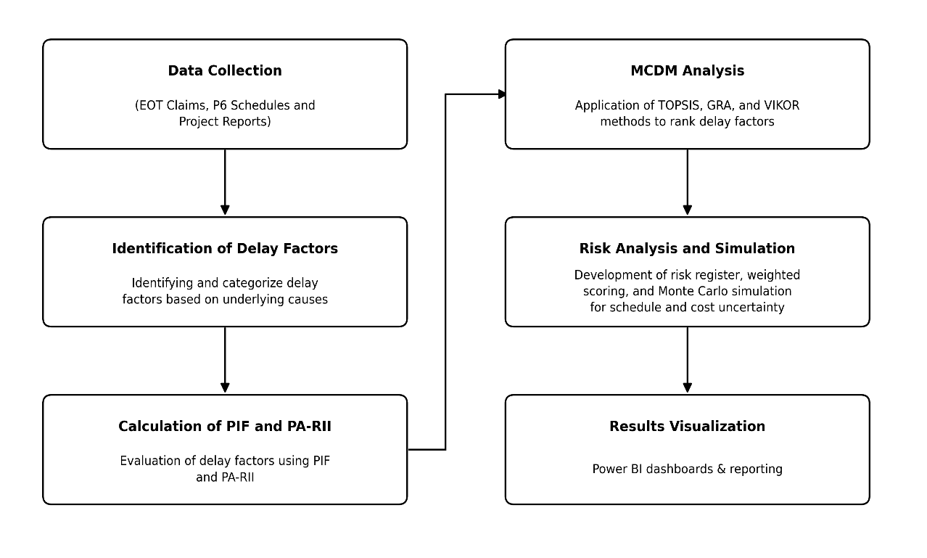
Figure 1: Flowchart of the proposed framework for delay factor prioritization and risk analysis

- DATA COLLECTION
The data used in this study were collected from project documentation associated with three high-rise construction developments referred to as CS1, CS2, and CS3. The primary sources of information included approved EOT claim records, Primavera P6 schedules, progress reports, and delay tracking records. These documents provided details regarding delay events, affected activities, impacted durations, and responsibility allocation during project execution. Literature-based RII values obtained from previous studies were also used to support the MCDM analysis. The use of actual project records ensured that the study was based on real project performance data and enabled the identification and evaluation of critical delay and cost overrun factors. As shown in Table 1, the selected case studies represent different high-rise construction projects with variations in project type, number of towers, and storey configurations.
Table 1: Project Summary
Case Study | Project Type | No. of Towers | Storeys
CS1 | High Rise Commercial | 9 | 25
CS2 | High Rise Residential | 6 | 70
CS3 | High Rise Residential | 2 | 55

- CASE STUDY
The framework was validated using data collected from three high rise construction projects. The identified delay events were classified into categories including design issues, delayed drawings, material supply issues, approval delays, quantity variations, coordination delays, workmanship issues, and external factors. The impacted durations associated dwith each delay event were analysed to evaluate their influence on project schedule performance. A consolidated delay event database was subsequently prepared using observations from all three case studies.
The Project Influence Factor (PIF) was then calculated to represent the relative contribution of each delay factor to the overall project delay based on the impacted durations observed in the project schedules. The PIF values were calculated using the relationship presented in Equation (1).
(1)
$$\text{PIF}=\frac{Impacted Duration of Delay Factor​(D_{f})}{Total Impacted Duration(D_{t})}$$
where $D_{f}$represents the impacted duration of a specific delay factor and $D_{t}$represents the total impacted duration of all delay factors.
To incorporate both literature-based knowledge and project-specific delay characteristics, a Project Assisted Relative Importance Index (PA-RII) was developed by integrating literature-based Relative Importance Index (RII) values with the calculated Project Influence Factor (PIF) values. The PA-RII values were evaluated for four criteria, namely C1, C2, C3, and C4. This approach enabled the incorporation of both published research findings and actual project delay characteristics into the evaluation process. The PA-RII values were calculated using Equation (2).
(2)
$$\text{PA-RII}=α({\text{RII}}_{\text{Literature}})+(1-α)(\text{PIF})$$
where PA-RII represents the Project Assisted Relative Importance Index, RII represents the literature based Relative Importance Index, PIF represents the Project Influence Factor, and α represents the weight assigned to the literature based RII value.
The value of $α$ was considered as 0.5 to provide balanced importance to both literatures based observations and actual project data, representing the midpoint between theoretical influence and project-specific influence.
Three MCDM techniques, namely TOPSIS, VIKOR, and GRA, were employed to prioritize the identified delay factors based on their influence on project performance. The evaluation was conducted using the calculated PA-RII values corresponding to the four selected criteria. Each technique produced an independent ranking of the delay factors using actual project datasets. As presented in Table 2, the impacted durations and corresponding PIF values for the identified delay categories were obtained from the selected case study projects. The rankings generated from TOPSIS, VIKOR, and GRA were subsequently aggregated using the arithmetic mean of the individual ranks to determine the final priority order of the delay factors. This integrated approach reduced dependence on a single MCDM technique and provided a more balanced and reliable prioritization of factors affecting project schedule performance.
Table 2: Impacted Durations and PIF Values for Identified Delay Categories
Category | Impacted Days |  |  | Total | PIF
Category | CS1 | CS2 | CS3 | Total | PIF
Design Issue | 17 | 0 | 0 | 17 | 0.006
Quality Issue | 6 | 65 | 47 | 118 | 0.043
Material Supply Issue | 195 | 137 | 42 | 374 | 0.138
Delayed Drawings | 51 | 114 | 227 | 392 | 0.144
Design Change | 455 | 16 | 0 | 471 | 0.173
Rainfall Delay | 184 | 21 | 0 | 205 | 0.075
Quantity Variation | 0 | 3 | 307 | 310 | 0.114
Site Access Delay | 0 | 1 | 96 | 97 | 0.036
Unforeseen Site Condition | 0 | 19 | 26 | 45 | 0.017
Regulatory / Government Action | 0 | 9 | 22 | 31 | 0.011
Approval Delay | 0 | 4 | 297 | 301 | 0.111
Specification Change | 0 | 0 | 124 | 124 | 0.046
Coordination Delay | 0 | 90 | 7 | 97 | 0.036
Handing Over Delay | 0 | 4 | 80 | 84 | 0.031
Workmanship Issue | 0 | 50 | 0 | 50 | 0.018

Based on the final ranking obtained from the combined MCDM analysis, the most significant delay factors were identified and incorporated into a structured risk register in PRA. The project schedules initially developed in Primavera P6 were imported into PRA to perform probabilistic schedule risk assessment. The identified delay factors, along with their corresponding weights, were integrated as activity-level risk events, while probability levels and impact ranges were assigned using project data and expert judgment. As presented in Table 3, the final ranking of delay factors was obtained by aggregating the results of the TOPSIS, VIKOR, and GRA techniques using the arithmetic mean method. A Risk Breakdown Structure (RBS) was further developed to categorize risks according to their primary sources and support systematic evaluation of schedule uncertainty under actual project conditions.
Table 3: Aggregated Ranking of Delay Factors Based on TOPSIS, VIKOR, and GRA
ID | Delay Events Details | GRA | TOPSIS | VIKOR | Average | Ranks
D1 | Design Issue | 13 | 13 | 9 | 11.67 | 13
D2 | Quality Issue | 9 | 10 | 6 | 8.65 | 8
D3 | Material Supply Issue | 6 | 7 | 12 | 8.90 | 9
D4 | Delayed Drawings | 5 | 4 | 2 | 3.67 | 2
D5 | Design Change | 1 | 1 | 1 | 1.00 | 1
D6 | Rainfall Delay | 15 | 15 | 15 | 15.00 | 15
D7 | Quantity Variation | 3 | 2 | 10 | 5.25 | 5
D8 | Site Access Delay | 14 | 14 | 13 | 13.67 | 14
D9 | Unforeseen Site Condition | 4 | 3 | 4 | 4.20 | 3
D10 | Regulatory / Government Action | 2 | 6 | 11 | 6.33 | 6
D11 | Approval Delay | 12 | 8 | 5 | 8.33 | 7
D12 | Specification Change | 11 | 9 | 14 | 11.33 | 12
D13 | Coordination Delay | 10 | 12 | 7 | 9.67 | 11
D14 | Handing Over Delay | 7 | 5 | 3 | 5.00 | 4
D15 | Workmanship Issue | 8 | 11 | 8 | 9.00 | 10
Qualitative and quantitative risk analyses were performed in PRA to evaluate the influence of prioritized delay factors on project performance. Initially, the identified delay factors were considered as project risks and assessed qualitatively based on parameters including probability of occurrence, schedule impact, cost impact, and performance impact. Based on predefined rating scales, the risks were categorized according to their severity levels, and appropriate mitigation measures along with associated mitigation costs were assigned. As shown in Figure 2, the identified risks and corresponding mitigation strategies were incorporated into the PRA risk register for systematic evaluation. Subsequently, quantitative risk analysis was carried out by assigning probability distributions to the identified risks and performing Monte Carlo simulation to estimate the potential variation in project completion dates. In addition, risk exposure costs were evaluated based on the probability of occurrence and associated cost impacts, enabling probabilistic assessment of schedule uncertainty and the effectiveness of the proposed mitigation measures.
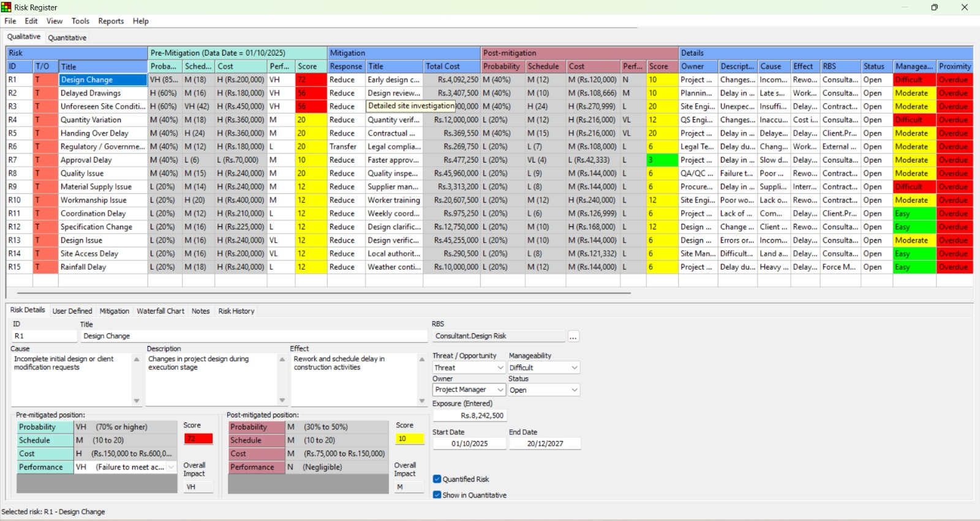
Figure 2: Integrated Risk Register for Schedule Risk Assessment in PRA
Schedule risk analysis was performed in PRA by integrating the developed risk register with the project schedule. Probability values and schedule impact ranges were assigned to the identified risks, and Monte Carlo simulation was conducted to evaluate schedule uncertainty and potential variation in project completion dates. As presented in Figure 3, pre- and post-mitigation simulations were performed to assess the effectiveness of the proposed mitigation measures in reducing project risk exposure. The simulation outputs, including probabilistic completion distributions and risk analysis reports, were used to evaluate the influence of delay factors on project schedule performance.
In the final stage, the outputs obtained from Primavera Risk Analysis were visualized using Microsoft Power BI through interactive dashboards, charts, and heatmaps to support interpretation of delay patterns and project risks.
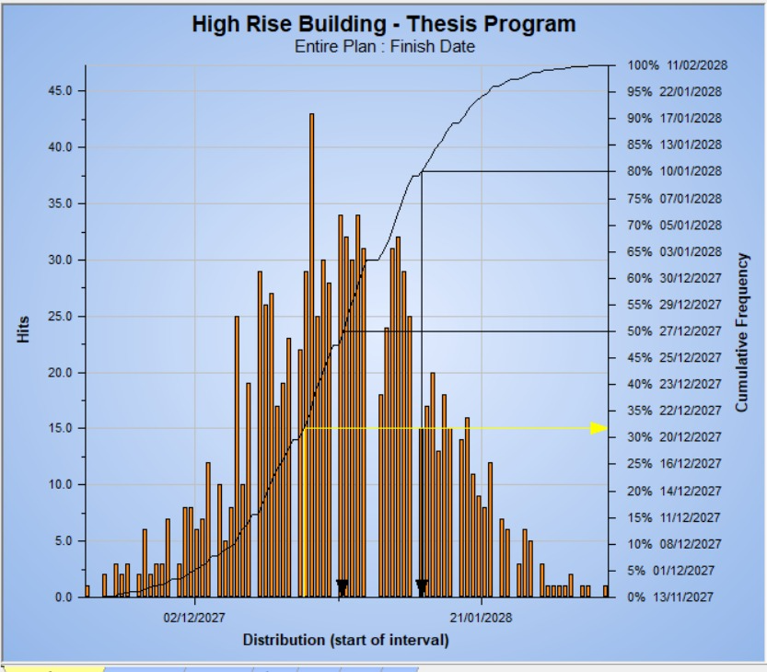
Figure 3: Probabilistic Distribution of Project Finish Date from Monte Carlo Simulation

- RESULTS AND DISCUSSION
The proposed framework was applied to the selected high rise construction projects to identify and prioritize the critical delay factors affecting project performance. The ranking analysis carried out using TOPSIS, VIKOR, and GRA identified design change and delayed drawings as the most significant delay drivers, indicating that design coordination and documentation management have major influence on project schedule performance. Unforeseen site conditions, handing over delays, and quantity variations were also identified among the critical contributors to project delays. In contrast, rainfall delay and site access delay were ranked among the least influential factors, indicating comparatively lower impact on project performance. The identified delay factors were further classified according to their primary source to evaluate stakeholder-wise contribution to project delays. Consultant/design related risks and contractor related risks each contributed approximately 26.7% of the identified delay events, making them the largest contributors to schedule delays. Client/approval related risks and operational risks contributed around 13.3% each, while external and natural risks accounted for approximately 20% of the identified risks. These findings indicate that management, coordination, and execution related issues have greater influence on project delays than external environmental conditions.
The probabilistic schedule analysis performed using PRA demonstrated that deterministic scheduling approaches underestimate project uncertainty. While the baseline schedule predicted project completion on 20 December 2027, the probabilistic analysis indicated later completion dates under risk conditions. The Monte Carlo simulation results showed that the project duration may increase by approximately 57–78 days, representing nearly 7–10% increase compared to the deterministic schedule. The duration distribution analysis further highlighted that the combined effect of multiple moderate risks can significantly affect project completion timelines and overall schedule reliability. The implementation of mitigation strategies significantly reduced both schedule and cost risk exposure associated with major delay factors. Risks related to design change, delayed drawings, and unforeseen site conditions showed substantial reduction in severity after implementation of mitigation measures. Similarly, the financial impact associated with these delay factors was considerably reduced in the post-mitigation scenario, demonstrating the effectiveness of proactive risk management approaches in improving project reliability and minimizing schedule uncertainty.
The analytical outputs generated through framework were further visualized using Microsoft Power BI dashboards to improve interpretation of delay patterns, probabilistic outcomes, and risk classifications. The graphical representation of results through charts, distributions, and heatmaps supported improved understanding of critical delay drivers and facilitated more effective decision making during project execution.

- CONCLUSION
This study presented a data-driven framework for prioritizing delay and cost overrun factors in high rise construction projects using MCDM techniques integrated with probabilistic risk analysis. Actual project records, including EOT claim documents, Primavera P6 schedules, and progress reports, were utilized to identify and evaluate critical delay factors affecting project performance.
The analysis identified design change, delayed drawings, material supply issues, approval delays, and unforeseen site conditions as the major contributors to project delays and cost escalation. The results further indicated that consultant/design related and contractor related risks had greater influence on project performance compared to external and environmental factors. The integration of PIF and PA-RII enabled incorporation of both literatures-based observations and project specific delay characteristics into the evaluation process, improving the reliability of delay prioritization. The application of TOPSIS, VIKOR, and GRA provided a systematic approach for ranking delay factors, while integration of Primavera P6 with PRA and Monte Carlo simulation enabled realistic assessment of schedule uncertainty under risk conditions. The probabilistic analysis demonstrated that deterministic schedules may underestimate project uncertainty and highlighted the importance of risk based scheduling approaches in construction planning.
The implementation of mitigation strategies significantly reduced both schedule and cost risk exposure associated with critical delay factors. In addition, visualization of analytical outputs using Microsoft Power BI improved interpretation of delay patterns and risk classifications, supporting more effective decision-making during project execution. Overall, the proposed framework provides a practical and reliable approach for improving delay analysis, schedule reliability, and risk-informed decision-making in high-rise construction projects.

- FUTURE SCOPE
The proposed framework can be further enhanced by incorporating larger datasets from different regions and project types to improve the reliability and generalizability of the results. Integration with real-time technologies such as Building Information Modelling (BIM), IoT-based monitoring systems, and digital site data collection can support dynamic delay tracking and proactive decision-making during project execution.
Future studies may also incorporate advanced analytical approaches such as Artificial Intelligence (AI) and Machine Learning (ML) for predictive identification of potential delay risks and automated risk assessment. In addition, the framework can be extended to include cost-risk integration, claim analysis, and contract management aspects to support more comprehensive project control and Extension of Time (EOT) evaluation in complex construction projects.

- REFERENCES

- Azzam, O.M., Saleh, A.M., & Eleshmawy, N., (2025). Delay analysis in construction contracts: Assessing claims and legal implications. Journal of Legal Affairs and Dispute Resolution in Engineering and Construction, 17(1): p. 04524032. DOI: https://doi.org/10.1061/JLADAH.LADR-1198
- Daoud, A.O., El Hefnawy, M., & Wefki, H., (2023). Investigation of critical factors affecting cost overruns and delays in Egyptian mega construction projects. Alexandria Engineering Journal, 83(): p. 326-334. DOI: https://doi.org/10.1016/j.aej.2023.10.052
- Devi, L.P., & Sindhu., (2025). Delay analysis of infrastructure construction projects in India. Journal of the Institution of Engineers (India) Series A. DOI: https://doi.org/10.1007/s40030-025-00899-5
- Dixit, S., Mandal, S.N., Thanikal, J.V., & Saurabh, K., (2019). Study of significant factors affecting construction productivity using relative importance index in Indian construction industry. E3S Web of Conferences, 140(): p. 09010. DOI: https://doi.org/10.1051/e3sconf/201914009010
- Doloi, H., Sawhney, A., Iyer, K.C., & Rentala, S., (2012). Analysing factors affecting delays in Indian construction projects. International Journal of Project Management, 30(4): p. 479-489. DOI: https://doi.org/10.1016/j.ijproman.2011.10.004
- Elhusseiny, H.O., Nosair, I., & Ezeldin, A.S., (2021). Systematic processing framework for analysing the factors of construction projects’ delays in Egypt. Ain Shams Engineering Journal, 12(2): p. 1501-1511. DOI: https://doi.org/10.1016/j.asej.2020.10.016
- Gebrehiwet, T., & Luo, H., (2017). Analysis of delay impact on construction project based on RII and correlation coefficient: Empirical study. Procedia Engineering, 196(): p. 366-374. DOI: https://doi.org/10.1016/j.proeng.2017.07.212
- Hansen, S., Fassa, F., & Wijaya, S., (2023). Factors influencing scheduling activities of construction projects. Journal of Legal Affairs and Dispute Resolution in Engineering and Construction, 15(1): p. 06522004. DOI: https://doi.org/10.1061/(ASCE)LA.1943-4170.0000594
- Heravi, G., & Gerami Seresht, N., (2018). A multi-criteria decision-making model for prioritizing the non-critical activities in construction projects. KSCE Journal of Civil Engineering, 22(10): p. 3753-3763. DOI: https://doi.org/10.1007/s12205-017-1275-5
- Le-Hoai, L., Lee, Y.D., & Lee, J.Y., (2008). Delay and cost overruns in Vietnam large construction projects: A comparison with other selected countries. KSCE Journal of Civil Engineering, 12(6): p. 367-377. DOI: https://doi.org/10.1007/s12205-008-0367-7
- Maddah, R., Tripathi, K.K., & Jha, K.N., (2026). Risk factors affecting the cost performance of international construction projects. Journal of Legal Affairs and Dispute Resolution in Engineering and Construction, 18(1): p. 04525070. DOI: https://doi.org/10.1061/JLADAH.LADR-1228
- Niazi, G.A., & Painting, N., (2017). Significant factors causing cost overruns in the construction industry in Afghanistan. Procedia Engineering, 182(): p. 510-517. DOI: https://doi.org/10.1016/j.proeng.2017.03.145
- Prasad, K.V., Vasugi, V., Venkatesan, R., & Bhat, N., (2019). Analysis of causes of delay in Indian construction projects and mitigation measures. Journal of Financial Management of Property and Construction. DOI: https://doi.org/10.1108/JFMPC-04-2018-0020
- Radman, K., Babaeian Jelodar, M., Ghazizadeh, E., & Wilkinson, S., (2021). Causes of delay in smart and complex construction projects. Journal of Legal Affairs and Dispute Resolution in Engineering and Construction, 13(4): p. 05021006. DOI: https://doi.org/10.1061/(ASCE)LA.1943-4170.0000501
- Sanyal, A.P., & Bhattacharya, S.P., (2018). A study of the causes of schedule overrun in Indian high-rise construction using relative importance index. GSTF Journal of Engineering Technology, 5(1).
- Sharma, S., & Gupta, A.K., (2021). Analysis of factors affecting cost and time overruns in construction projects. Lecture Notes in Civil Engineering, 143(): p. 55-63. DOI: https://doi.org/10.1007/978-981-33-6969-6_6
- Singh, S., Bala, A., Dixit, S., & Varshney, D., (2018). Critical analysis of causes of delay in residential construction projects in India. International Journal of Civil Engineering and Technology, 9(1): p. 330-345.
- Soundarya, M.K., Logeshkumaran, A., Chakravarthy, P.R.K., Elumalai, P.V., Baskar, S., Reddy, J.A., Prabhakar, S., & Liu, Y., (2025). An investigation study on residential buildings for cost overrun. Scientific Reports, 15(): p. 12655. DOI: https://doi.org/10.1038/s41598-025-95984-x
- Vahedi Nikbakht, M., Gheibi, M., Montazeri, H., Yeganeh Khaksar, R., Moezzi, R., & Vadiee, A., (2024). Identification and ranking of factors affecting the delay risk of high-rise construction projects using AHP and VIKOR methods. Infrastructures, 9(2): p. 24. DOI: https://doi.org/10.3390/infrastructures9020024

