Computer Vision–Based Construction Monitoring for Productivity Assessment: A Systematic Review of Research
Ridhin Jacob Karukayil^{1*}, Aritra Pal ², Mani Golparvar-Fard^{3,4}

¹ Doctoral Research Scholar, Department of Civil Engineering, Indian Institute of Technology Madras, Chennai-600036, Tamil Nadu, India; e-mail: jacobkarukayil13@gmail.com
² Assistant Professor, Department of Civil Engineering, Indian Institute of Technology Madras, Chennai-600036, Tamil Nadu, India; e-mail: aritrapal@civil.iitm.ac.in
³ Department of Civil and Environmental Engineering, University of Illinois at Urbana-Champaign, Urbana, IL, United States
⁴ Department of Computer Science, University of Illinois at Urbana-Champaign, Urbana, IL, United States
*Corresponding email: jacobkarukayil13@gmail.com

ABSTRACT
Construction productivity monitoring remains a persistent challenge in the industry owing to its reliance on manual observations like work sampling and periodic reporting methods, which offer limited real-time insight into site performance. Advances in computer vision (CV) have created opportunities to automate productivity monitoring through continuous analysis of site imagery. However, despite growing research activity, the extent to which CV-based systems progress beyond measurement toward explanation and decision-making remains unclear.
This study presents a systematic review of CV-based construction productivity monitoring literature published between 2012 and 2026. A Scopus search identified 1,103 records, screened via PRISMA to a final corpus of 30 studies. Each study was examined for what its system produced rather than the technique employed, yielding 128 evidence items coded inductively into 27 capability codes and eight higher-order themes. Six themes were found to presuppose one another, forming a cumulative sequence from which the Operational Understanding Maturity Framework (OUMF) is derived: Detection, Activity Recognition, Productivity Assessment, Attribution and Decision Support.
Classifying 25 studies against these stages reveals a sharp attenuation. All satisfy Detection and 72% reach Productivity Assessment, but only 36% produce an attribution and 12% support an operational decision. The review further shows that many studies labelled as productivity assessment quantify labour effort without measuring corresponding work output, thereby assessing resource utilisation rather than productivity.
The field has matured at measuring productivity but not at explaining it. Closing this gap will require interaction-centric productivity modelling, attribution mechanisms, and decision-oriented systems. The OUMF provides both a benchmark for existing research and a roadmap for that transition.

- INTRODUCTION
1.1 Background
Construction productivity has been a central challenge that the industry is struggling with for decades. By 2020, both labour productivity and total factor productivity in the US construction sector had fallen below their 1950 levels, while economy-wide labour productivity rose by 290% over the same period (Goolsbee and Syverson, 2023). Research also indicates that approximately 50-75% of the labour time spent on construction job sites is consumed by non-value added activities, against just over 10% in the manufacturing industry (Construction Industry Institute, 2014). This gap reflects a monitoring problem rather than workforce behaviour alone. Unlike manufacturing, where automated systems continuously track the production process, construction productivity monitoring still largely depends on manual observation and periodic reporting (Tsai et al., 2025). These methods are slow, tedious and incapable of generating continuous data (Gong and Caldas, 2011). Thus, there is a pressing need for systems capable of continuously monitoring construction sites and tracking productivity in real-time so that necessary interventions can be made on time.
Recent years have seen an explosion of visual data from construction sites, as the widespread adoption of CCTVs, UAVs, and site cameras enables imaging at a scale that was impractical a decade ago (Li et al., 2026). Yet ongoing monitoring practices remain largely manual and document-centric, leaving much of this potential underutilised. Computer Vision (CV), a domain of algorithms focused on enabling machines to interpret and derive information from visual data, presents a promising potential to address this challenge (Gong and Caldas, 2011). Unlike wearable sensors or IoT devices, CV operates non-intrusively from existing site infrastructure, making it well-suited to continuous monitoring of construction environments (Hwang et al., 2025). However, the extent to which CV-based research has matured in the field of applications remains unclear and needs investigation.
1.2 Research Gaps & Objectives
Despite growing interest, productivity-specific applications remain a comparatively small and underexplored segment of the broader literature. Existing reviews, such as Barbosa and Bastos Costa (2021), catalogue the methods and reported accuracies, but stop short of assessing how far the analytical pipeline actually advances. Thus, there exists no structured framework that assesses the maturity of the field and guides future research along a systematic progression.
To address this gap, this paper systematically reviews the CV-based construction productivity monitoring literature and, from the capabilities the reviewed systems deliver, derives an Operational Understanding Maturity Framework (OUMF) for assessing the analytical progression of CV-based productivity research.

- RESEARCH METHODOLOGY
2.1 Search Strategy
A systematic search was conducted on the Scopus database, selected for its comprehensive coverage of peer-reviewed engineering and construction literature. The search string combined visual sensing and learning-technology terms with construction monitoring and productivity keywords, applied to the title, abstract, and keyword fields:
(("computer vision" OR "CV" OR "vision-language model" OR "VLM" OR "supervised learning" OR "unsupervised learning" OR "deep learning" OR recurrent OR LSTM OR CNN OR "neural network" OR convolutional) AND construction AND (monitor OR track OR productivity))
The search was limited to publications from January 2012 to March 2026. The lower bound corresponds to the introduction of AlexNet, which marked the widespread adoption of deep convolutional neural networks for visual recognition and the foundation of most subsequent CV-based construction monitoring methods (Pal and Hsieh, 2021).
2.2 PRISMA Screening
The keyword-based search resulted in a corpus of 1,103 papers which further went through PRISMA screening (Figure 1) to filter the most relevant studies.

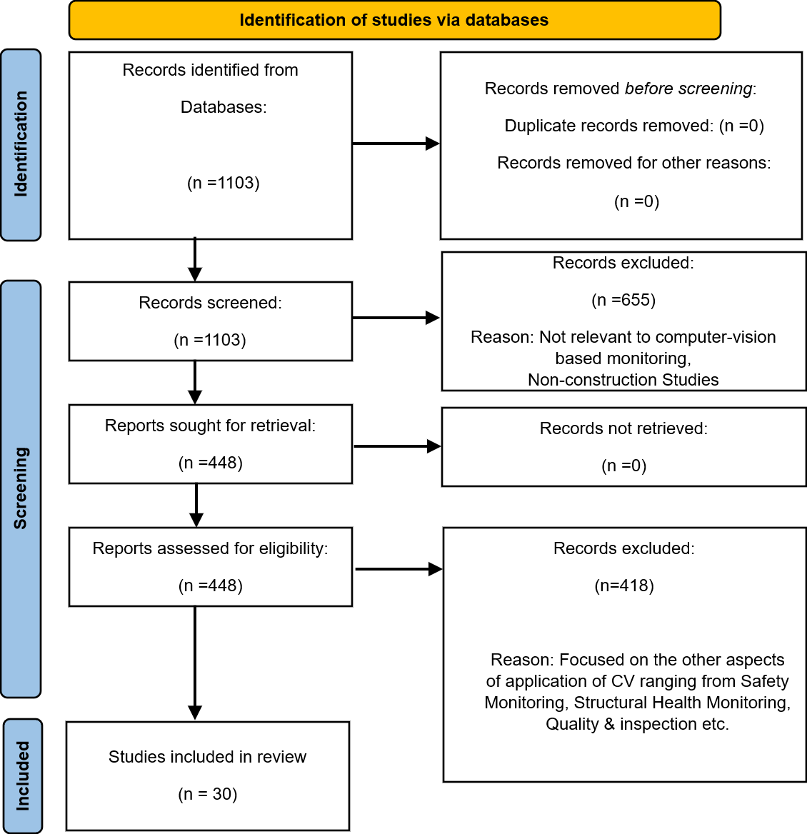
Figure 1: PRISMA Methodology
The 1,103 identified records were progressively screened to retain studies focused on construction productivity monitoring. Title and abstract screening first reduced the pool to 448 papers. Subsequent full-text review excluded studies addressing other CV applications in construction and thereby yielded a final corpus of 30 studies, which formed the basis for the subsequent analyses. The final corpus of 30 studies is available at https://doi.org/10.5281/zenodo.22695022.

- DESCRIPTIVE ANALYSIS OF LITERATURE
3.1 Publication Trends

Figure 2: Year-wise Publication Growth (2013-Mar 2026)
Figure 2 illustrates the annual publication trend in CV-based construction productivity monitoring from 2013 to March 2026. Publication activity remained limited during the early years but increased steadily after 2019, coinciding with the wider adoption of deep learning techniques in computer vision. The growth peaked in 2025, which contributed 10 of the 30 reviewed studies (33%). The overall trend line indicates a sustained upward trajectory, suggesting that CV-based productivity monitoring is transitioning from an exploratory to an actively pursued research area.
3.2 Keyword Co-occurrence Mapping
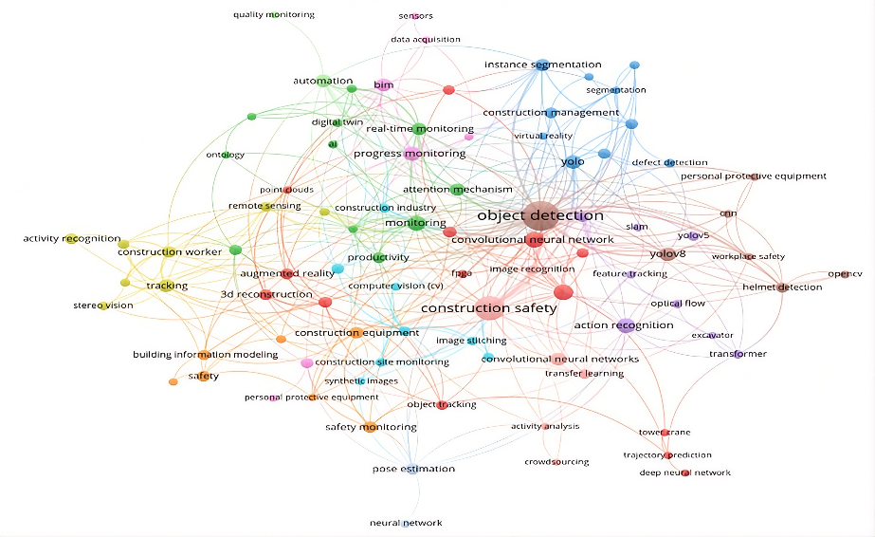
Figure 3: Keyword Co-Occurrence Map
Keyword co-occurrence analysis was performed in VOSviewer on the 448 papers retained after title and abstract screening to understand the dominance of different fields, with generic techniques and domain terms filtered out. Reading the map along two axes reveals a consistent pattern.
- At the technique level, the field is strongly perception-oriented. Object detection, realised through YOLO and convolutional neural network variants, together with feature tracking and action recognition, forms the largest and most densely connected cluster, reflecting a concentration on visual perception tasks.
- At the application level, safety monitoring dominates. Construction safety, personal protective equipment and helmet detection form a substantial cluster, while productivity occupies a smaller and more peripheral position.
The topology, therefore, shows a field concentrated on perceiving and interpreting construction activities, with little vocabulary for explaining or acting on what is observed. This motivates a structured examination of how visual observation translates into deeper operational understanding.
  - Technological Evolution
Early productivity monitoring systems relied on handcrafted features and rule-based classification, detecting entities in controlled conditions but too brittle to generalise across sites (Gong and Caldas, 2011). The advent of deep learning resolved this generalisation problem: single-stage YOLO detectors became dominant for real-time monitoring (Toledo, Lorca and Mora, 2025) while two-stage architectures offered higher accuracy, where pixel-level segmentation was required (Panahi et al., 2023). Temporal architectures then extended analysis from single frames to activity sequences and cycles (Cheng, Cao and Nuralim, 2023). Most recently, dual-stream transformer and graph-based models encode interactions as interdependent spatio-temporal processes (Baek et al., 2025; Tsai et al., 2025). Vision-language models, capable of semantic reasoning about site conditions, remain largely unexplored in productivity research, despite extensive study in other construction applications.
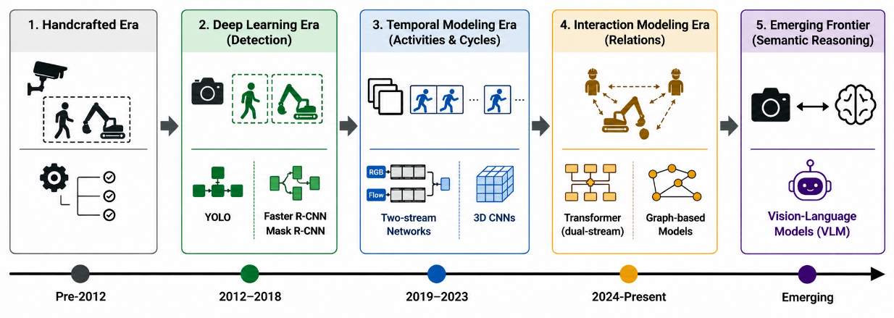
Figure 4: Technological Evolution of Computer Vision in Construction Productivity Monitoring
Architectural capability has therefore advanced substantially. Whether analytical output has advanced correspondingly cannot be determined from a technique narrative alone.

- OPERATIONAL UNDERSTANDING MATURITY FRAMEWORK
4.1 Derivation
Each of the 30 studies was examined for what its system produced rather than the technique it used. Each distinct capability was recorded as a separate evidence item and stated as an output. A study contributed as many items as it demonstrated capabilities, yielding 128 evidence items in total. These were coded inductively into 27 capability codes without reference to any predetermined scheme, and grouping the codes by function produced eight groups (Table 1).

Table 1: Capability codes grouped by function
Higher-Order Themes | Codes Clustered into | Count of evidence items within the cluster
Entity localisation & identification | Entity detection, Object-ID recognition, Object tracking, Cross-camera matching | 29
Activity & interaction recognition | Activity recognition, Interaction/crew recognition | 14
Temporal & effort accounting | Cycle-time measurement, Duration & idle-time measurement, Labour-utilisation measurement | 13
Output & productivity quantification | Progress/output quantification, Productivity computation, Planned-actual comparison, Impact quantification | 24
Diagnostic reasoning | Bottleneck identification, Cause attribution, Spatio-temporal reasoning, Knowledge representation | 9
Decision affordances | Monitoring & reporting, Problem feedback & alerting, Intervention recommendation, Worker guidance, Resource-allocation support | 11
Data & model enablers | Data acquisition, 3D reconstruction & registration, Detector/data development, Measurement refinement | 23
Non-pipeline (context/scope) | Knowledge synthesis | 5
4.2 From Groups to Stages
Two of the eight groups fall outside the analytical sequence. Data and model enablers support capability at any point rather than marking progress along it. The remaining six groups are not independent, each presupposing the one before it. Activity recognition operates on entities that have already been localised. A production rate requires both the quantity of work completed and the quantity of resources consumed. A cause can only be assigned to a rate that has been computed. A recommendation requires a cause to act on. The groups, therefore, form a sequence rather than a set of alternatives, and a system cannot occupy a later position without satisfying the earlier ones.
Two of the six groups occupy the same position within the sequence. Temporal and effort accounting quantifies the input side, comprising the effort expended, while output quantification quantifies the output side, comprising the progress achieved. As productivity is defined as progress per unit of effort, neither measurement alone yields a productivity value. The two groups therefore constitute a single stage rather than two successive ones.

Table 2: Clustered stages
Stage | Groups | What it delivers
Detection | Entity localisation & identification | Identifies and localises construction entities in the visual field
Activity Recognition | Activity & interaction recognition | Classifies what detected entities are doing over time
Productivity Assessment | Temporal & effort accounting; Output & productivity quantification | Converts visual observations into an explicit productivity measure
Attribution | Diagnostic reasoning | Links a measured productivity outcome to a named causal factor
Decision Support | Decision affordances | Generates a concrete operational recommendation

4.3 Classification of Literature & Key Findings
The stages defined in Table 2 are cumulative and were derived from the capabilities evidenced across the corpus. The 30 shortlisted studies were subsequently assessed against them, each being positioned at the highest stage its system output satisfies, thereby satisfying all preceding stages. Five studies could not be positioned, their capabilities falling within the two groups excluded in Table 1. The remaining 25 were mapped across the five stages (Figure 5).

Figure 5: Cumulative Maturity Funnel
The distribution attenuates sharply. All 25 studies satisfy Detection, 19 (76%) reach Activity Recognition, and 18 (72%) reach Productivity Assessment. Beyond this point the corpus thins abruptly: nine studies (36%) produce an attribution and only three (12%) deliver anything that supports a decision. Three findings emerged from this distribution.
- Research is heavily concentrated at the Productivity Assessment stage, which is where most studies stop.
- A pronounced gap exists beyond measurement. The share of studies halves at a single transition, from 72% at Productivity Assessment to 36% at Attribution, indicating that explaining productivity is substantially harder than measuring it.
- The prescriptive potential of the field remains largely unrealised. Only three studies generate output that supports a managerial decision, so existing work is directed at measuring rather than at acting on what is measured.
Taken together, the funnel indicates that the field's difficulty lies not in seeing construction work but in reasoning about it. The transition that matters is the one from measurement to explanation, and it is the point at which most pipelines stop.
4.4 Framework Development

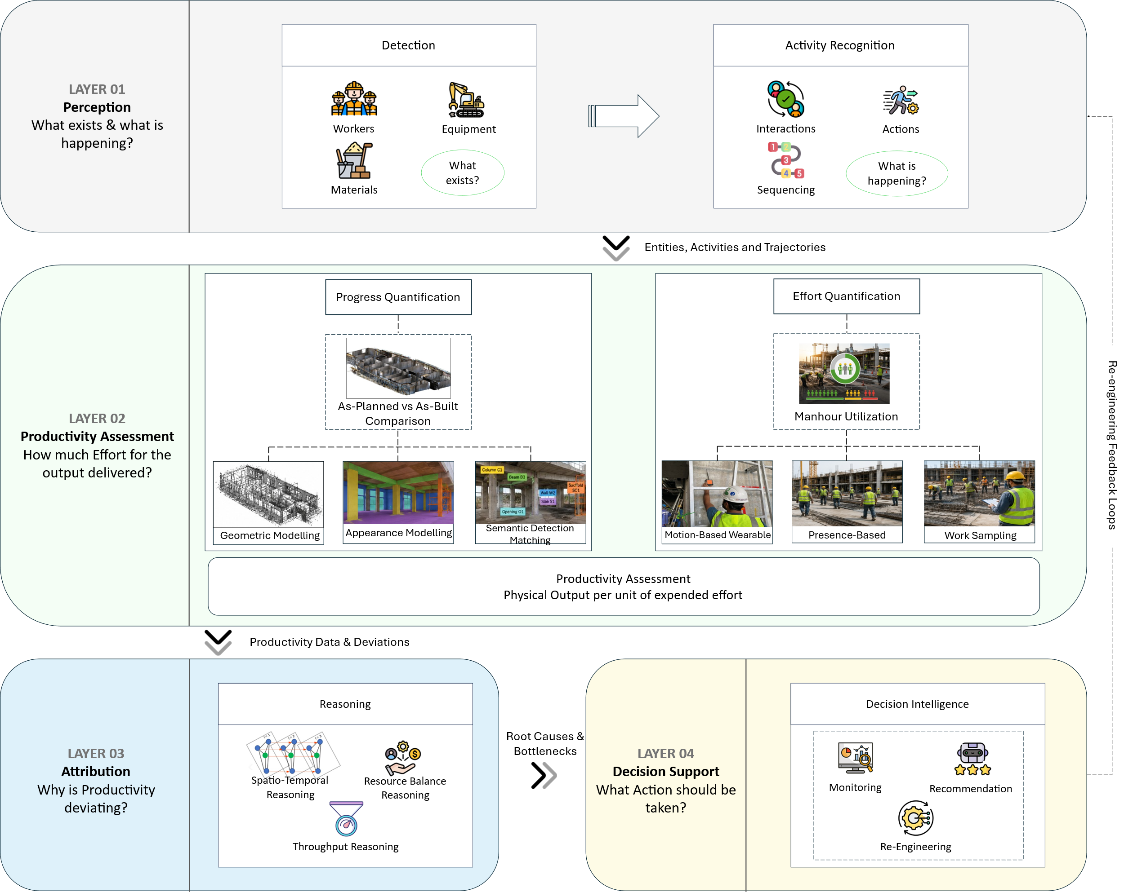
Figure 6: Operational Understanding Maturity Framework for Vision-Based Construction Productivity Monitoring.
Analysis of the corpus revealed that a single "productivity" label concealed markedly different levels of understanding. The Operational Understanding Maturity Framework (OUMF) formalises this distinction, organising the five cumulative stages — Detection, Activity Recognition, Productivity Assessment, Attribution and Decision Support (Figure 6). It is grounded on the principle that vision-based systems progress from describing what exists, to interpreting what is happening, to quantifying how efficiently work is delivered, to explaining why productivity deviates, and ultimately to recommending what action should be taken.
Layer 01, Perception, combines Detection and Activity Recognition to establish which entities are present and what they are doing, and outputs entities, activities, and trajectories. Layer 02, Productivity Assessment, converts these observations into a rate. Within the framework, productivity is defined as the ratio of measurable work output to the corresponding resource input. The layer therefore integrates two complementary measurements: progress quantification, which establishes output by comparing as-planned and as-built states through geometric modelling, appearance-based modelling, or semantic detection-matching, and effort quantification, which establishes input through man-hour estimation using presence-based monitoring, motion-based monitoring or work sampling. This definition exposes a recurring flaw in the literature. A substantial proportion of studies classified as productivity assessment quantify only labour effort without measuring the corresponding work output. Thus, such studies measure crew utilisation rather than productivity.
Layer 03, Attribution, goes beyond measuring productivity to identify the factors responsible for its variation. This can be achieved through spatio-temporal analysis, resource-balance analysis, or throughput analysis. Layer 04, Decision Support, builds on these causal insights to provide actionable information. This includes monitoring alerts that highlight potential issues, recommendations that suggest appropriate actions, and re-engineering strategies that propose changes to the work process. These actions can then feed back into the perception layer, creating a continuous cycle from observation to measurement, explanation, and action.
4.5 Implications from the Framework
The framework exposed two preconditions that a technique-level reading leaves implicit:
- Data Availability
Every stage in the framework rests on visual data collected from the site, and current algorithms require large-scale annotated workface assessment data to learn activity models that generalise across different construction activities. Shared corpora of this kind are scarce, and each reviewed study assembles and labels its own footage, which accounts for the 23 evidence items recorded under the data and model enablers group in Table 1. Liu and Golparvar-Fard (2015) show that this annotation burden can be distributed by engaging non-expert crowds at a scale individual research groups are unable to reach. Advancement along the upper stages, therefore, depends on the collaborative development of shared annotated datasets rather than on architectural improvement alone.
- Granularity of Analysis
Though the framework structures the analytical sequence of progress, it does not specify the level of detail each stage operates with. Vision-based performance monitoring broadly divides into project-level analysis (civil infrastructure and building elements) and operational-level analysis (equipment and workers) (Yang et al., 2015). Within each, the granularity that management requires remains unsettled. This challenge should be resolved with a bottom-up approach, deriving the granularity of the observation required from the decision artefact the analysis is intended to produce rather than from what a detector can conveniently resolve. In the case of construction productivity monitoring, the artefact is typically a Crew-Balance Chart (CBC), and thus the frequency and detail of measurement should follow from how often and in what detail the management requires it. An example of this is the distinction between a work sampling system and an activity analysis. While activity analysis (Construction Industry Institute, 2010) deals with breaking the work into activity levels, work sampling tries to find the proportion of direct, support and delay work in construction. The choice between such levels of granularity depends on managerial decision-making and thus requires a bottom-up approach.
- FUTURE RESEARCH DIRECTIONS
5.1 Towards Productivity Attribution
Future studies should develop attribution frameworks that integrate visual observations with spatial, temporal and operational context, distinguishing the influence of factors such as workflow interruptions, resource availability, workspace constraints, crew interactions and site layout on productivity outcomes. Knowledge graphs and spatio-temporal interaction models offer promising representational foundations, allowing causal relationships to emerge from observed interactions among entities. This marks the transition from descriptive measurement to diagnostic understanding.
5.2 Semantic and Multi-Modal Reasoning
Vision-Language Models (VLMs) offer a promising direction by generating context-aware natural-language explanations directly from visual observations, potentially bridging the attribution and decision-support stages in a single step. Vision alone, however, cannot capture every factor influencing productivity. Future systems should therefore fuse CV outputs with IoT sensor data, BIM models and project schedules, linking productivity variation not only to what the system sees but to contextual factors it can cross-reference, and should model resources jointly rather than in isolation.
5.3 Closed-Loop Autonomous Monitoring
Existing CV-based productivity systems function as passive observers that measure and report without influencing the monitoring process itself. Future research should explore closed-loop systems that adapt their monitoring behaviour in response to detected productivity patterns: adjusting camera attention to underperforming zones, triggering real-time alerts, or generating operational recommendations autonomously. This moves the field from passive measurement toward autonomous productivity management, closing the loop from sensing to action.

- CONCLUSIONS
This paper reviewed 30 studies on CV-based construction productivity monitoring and derived the Operational Understanding Maturity Framework (OUMF) from the capabilities those systems delivered. While 72% of studies reach Productivity Assessment, only 36% produce an attribution and 12% support a decision. Computer vision has therefore matured as a means of measuring productivity, yet its potential for explaining variation and supporting operational decisions remains largely underexploited. The review further shows that many studies labelled as productivity assessment quantify only labour effort without measuring the corresponding work output, and thus estimate resource utilisation rather than productivity. Positioning the corpus against the framework also brought two preconditions into view: scarcity of data and granularity of analysis.
Bridging the gap between assessment and the later stages will require systems that model interactions among workers, equipment, materials and workspace conditions rather than in isolation. Graph-based interaction modelling, VLMs and multi-modal fusion offer plausible pathways from measurement towards attribution and decision support. The OUMF thus provides both a benchmark for existing research and a roadmap for the next generation of vision-based productivity monitoring.
ACKNOWLEDGEMENT
The first author acknowledges MeitY, Government of India, for funding through the IndiaAI Scholarship Program. The authors also acknowledge financial support from Project #RB26270319CEGEWI009227 and the IITM Young Faculty Mobility Grant, which facilitated academic collaborations.
REFERENCES
Baek, J. et al. (2025) “Dual-stream transformer-based activity classification for off-site construction productivity analysis,” Automation in Construction, 180, p. 106505. Available at: https://doi.org/10.1016/j.autcon.2025.106505.
Barbosa, A. and Bastos Costa, D. (2021) “Productivity Monitoring of Construction Activities Using Digital Technologies: A Literature Review.” IGLC, p. 716. Available at: https://doi.org/10.24928/2021/0141.
Cheng, M.-Y., Cao, M.-T. and Nuralim, C.K. (2023) “Computer vision-based deep learning for supervising excavator operations and measuring real-time earthwork productivity,” The Journal of Supercomputing, 79(4), pp. 4468–4492. Available at: https://doi.org/10.1007/s11227-022-04803-x.
Construction Industry Institute (2010) Guide to Activity Analysis. Implementation Resource 252-2a. Austin, TX: University of Texas at Austin.
Construction Industry Institute (2014) Industrial engineering/manufacturing techniques for enhancing construction project performance. Research Summary. Austin, TX: University of Texas at Austin.
Gong, J. and Caldas, C.H. (2011) “An object recognition, tracking, and contextual reasoning-based video interpretation method for rapid productivity analysis of construction operations,” Automation in Construction, 20(8), pp. 1211–1226. Available at: https://doi.org/10.1016/j.autcon.2011.05.005.
Goolsbee, A. and Syverson, C. (2023) The Strange and Awful Path of Productivity in the U.S. Construction Sector. Cambridge, MA. Available at: https://doi.org/10.3386/w30845.
Hwang, J. et al. (2025) “Web-based multi-vision platform for earthwork productivity on construction sites using real-time model updating,” Frontiers of Structural and Civil Engineering, 19(6), pp. 1021–1040. Available at: https://doi.org/10.1007/s11709-025-1197-0.
Li, L. et al. (2026) “Automated construction monitoring based on computer vision: A comprehensive review,” Developments in the Built Environment, 25, p. 100832. Available at: https://doi.org/10.1016/j.dibe.2025.100832.
Liu, K. and Golparvar-Fard, M. (2015) “Crowdsourcing Construction Activity Analysis from Jobsite Video Streams,” Journal of Construction Engineering and Management, 141(11), p. 04015035. Available at: https://doi.org/10.1061/(ASCE)CO.1943-7862.0001010.
Pal, A. and Hsieh, S.-H. (2021) “Deep-learning-based visual data analytics for smart construction management,” Automation in Construction, 131, p. 103892. Available at: https://doi.org/10.1016/j.autcon.2021.103892.
Panahi, R. et al. (2023) “Bottleneck Detection in Modular Construction Factories Using Computer Vision,” Sensors, 23. Available at: https://doi.org/10.3390/s23083982.
Toledo, M.J., Lorca, M. and Mora, M. (2025) “Use of Computer Vision and Object Detection to Measure Construction Productivity Using Crew Balance Charts,” IGLC 33, pp. 810–821. Available at: https://www.iglc.net/Papers/Details/2360.
Tsai, C.Y. et al. (2025) “Multi-granular crew activity recognition for construction monitoring,” Automation in Construction, 179, p. 106428. Available at: https://doi.org/10.1016/j.autcon.2025.106428.
Yang, J. et al. (2015) “Construction performance monitoring via still images, time-lapse photos, and video streams: Now, tomorrow, and the future,” Advanced Engineering Informatics, 29(2), pp. 211–224. Available at: https://doi.org/10.1016/j.aei.2015.01.011.

