A Robust Multi-Objective Optimization and Decision-Making Framework for Construction Projects
Aman Shukla^{1,2*}, Sahil Garg ¹

¹ Indian Institute of Technology Delhi, New Delhi, India
²L&T Construction, Heavy Civil Infrastructure IC, Chennai, India
*Corresponding email: shukla99362@gmail.com

ABSTRACT
Construction project planning involves multiple conflicting objectives extending beyond traditional time–cost trade-offs to include quality, safety risk, environmental impact, and resource stability. Although many-objective optimization (MaOO) methods can generate diverse Pareto-optimal solutions, the selection of a single, reliable compromise solution remains a critical challenge due to method dependency and decision uncertainty. Existing studies are largely limited to five-objective frameworks and rely on subjective decision mechanisms, often lacking robustness verification.
Unlike previous approaches, this study proposes an integrated framework combining Opposition-Based Non-dominated Sorting Genetic Algorithm III (OBNSGA-III), entropy-based objective weighting, and two multi-criteria decision-making (MCDM) methods, namely TOPSIS and VIKOR. The framework simultaneously optimizes six project objectives: Project Completion Time (PCT), Project Cost (PCC), Quality Index (PQI), Safety Risk (PSR), Environmental Impact (PEI), and Resource Moment (PRM) under precedence and resource constraints and provides a structured mechanism for selecting a stable compromise solution.
The proposed approach is validated using a construction project case study comprising 26 activities and a search space exceeding 58 million alternatives. OBNSGA-III generates 69 Pareto-optimal solutions, which are subsequently ranked using entropy-weighted TOPSIS and VIKOR methods. The results show strong agreement between the two methods, with a Spearman correlation coefficient of 0.95 and identical selection of the optimal solution, resulting in zero performance gap. Sensitivity analysis further confirms the robustness of the selected solution under varying decision preferences.
The findings demonstrate that the proposed framework provides a consistent, objective, and robust decision-support tool for many-objective construction project planning.

- INTRODUCTION
Construction projects are inherently complex systems characterized by multiple interdependent activities and competing stakeholder objectives. Traditionally, project planning has been dominated by time–cost optimization, which oversimplifies the decision-making process and ignores critical dimensions such as quality, safety, environmental impact, and resource stability. (Afshar & Zolfaghar Dolabi, 2014). However, modern construction projects demand a more comprehensive approach that simultaneously addresses these multiple objectives to ensure sustainable and reliable project delivery (Ward, Curtis, & Chapman, 1991).
Early research established that focusing solely on time and cost leads to suboptimal decisions, particularly when uncertainties and operational constraints are considered. For instance, accelerated schedules often increase cost and compromise safety and quality. (Afshar & Zolfaghar Dolabi, 2014; Elbeltagi et al., 2016).
With the advancement of computational techniques, evolutionary algorithms such as NSGA-II enabled simultaneous optimization of multiple objectives by generating Pareto-optimal solution sets (Deb et al., 2002). However, as the number of objectives increases beyond three, conventional multi-objective algorithms face challenges in maintaining diversity and convergence. To address this limitation, NSGA-III was introduced with a reference-point-based selection mechanism, making it suitable for many-objective optimization problems (Deb & Jain, 2014).
Despite these advancements, two critical challenges remain. First, most studies are limited to three to five objectives, whereas real-world construction projects require simultaneous consideration of additional factors such as resource stability and environmental impact. Second, the output of many-objective optimization is a Pareto solution set, and selecting a single actionable solution often relies on subjective judgment, reducing reproducibility and reliability (Zhan et al., 2024).
To address these gaps, this study proposes an integrated framework combining OBNSGA-III for many-objective optimization, entropy-based objective weighting, and TOPSIS–VIKOR-based decision-making, along with robustness evaluation through sensitivity and comparison analysis

- LITERATURE REVIEW
Initial research in construction optimization focused on the time–cost trade-off (TCT) problem. Abbasnia et al. introduced fuzzy logic to model uncertainty in time–cost relationships (Abbasnia et al., 2008), while Zareei and Hassan-Pour incorporated resource constraints to improve scheduling feasibility (Zareei & Hassan-Pour, 2015). These studies demonstrated that deterministic approaches are inadequate for capturing real project complexity.
Subsequently, researchers recognized the importance of incorporating additional objectives. Afshar and Dolabi demonstrated that time–cost optimized schedules can increase safety risks (Afshar & Zolfaghar Dolabi, 2014). Environmental considerations were later incorporated, with Ozcan-Deniz et al. highlighting trade-offs between productivity and environmental impact (Ozcan-Deniz et al., 2012).
The introduction of evolutionary algorithms advanced construction optimization. NSGA-II became widely adopted due to its ability to generate diverse Pareto-optimal solutions (Deb et al., 2002). Applications of genetic algorithms and particle swarm optimization further expanded optimization scope to include safety, resources, and environmental constraints (Elbeltagi et al., 2016).
However, as the number of objectives increased, traditional algorithms struggled with loss of diversity and convergence. This limitation led to the development of NSGA-III, which uses reference-point-based selection to maintain diversity in high-dimensional spaces (Deb & Jain, 2014). Recent studies have successfully applied NSGA-III in construction planning. Behera et al. demonstrated its effectiveness in balancing multiple objectives including sustainability (Behera et al., 2025), while Zhan et al. highlighted its capability in generating well-distributed Pareto fronts (Zhan et al., 2024).
Recent research has moved towards many-objective optimization (MaOO) frameworks. Panwar and Jha developed a model integrating multiple objectives including resources and environment (Panwar & Jha, 2019). Sharma and Trivedi further extended this by incorporating safety and resource constraints (Sharma & Trivedi, 2022), while opposition-based NSGA-III approaches improved convergence and exploration (Sharma & Trivedi, 2023; Panthi & Hussain, 2025).
Despite these developments, most studies remain limited to five objectives, primarily due to computational complexity. Recent works emphasize the need to incorporate broader sustainability indicators and resource-based measures for realistic project planning (Behera et al., 2025; Panthi & Hussain, 2025).
A major limitation in existing literature is the selection of a single solution from Pareto-optimal sets. Most studies rely on subjective weighting or visual inspection, reducing reproducibility and decision reliability (Zhan et al., 2024).
Multi-criteria decision-making (MCDM) methods have been proposed to address this issue. Among these, TOPSIS evaluates alternatives based on distance to ideal and negative-ideal solutions, while VIKOR identifies compromise solutions by balancing group utility and individual regret (Opricovic & Tzeng, 2004). However, their integration with many-objective optimization frameworks in construction remains limited, particularly when combined with objective weighting techniques such as entropy.
Based on the above review, three key gaps are identified: (1) Most construction studies are limited to five-objective optimization frameworks, (2) Weak and often subjective decision-making mechanisms from Pareto fronts and (3) Lack of robustness and sensitivity analysis in existing approaches.
This study addresses these gaps by: (1) Development of a six-objective based multi-objective optimization model using OBNSGA-III (2) Integration of entropy-based objective weighting to ensure unbiased decision-making, (3) Applying TOPSIS and VIKOR for comparative ranking of pareto-optimal solutions and (4) Introducing robustness evaluation through sensitivity and stability analysis.

- METHODOLOGY
To address the limitations of existing optimization and decision-making approaches, this study develops an integrated framework for construction project planning that simultaneously considers six objectives: time, cost, quality, safety, environmental impact, and resource stability. The planning problem is formulated as a six-objective optimization model and solved using Opposition-Based Non-dominated Sorting Genetic Algorithm III (OBNSGA-III) to generate a diverse set of Pareto-optimal solutions. To support objective decision selection, entropy-based weighting is applied to determine criterion importance, and the resulting weights are incorporated into TOPSIS and VIKOR for alternative ranking and compromise solution identification. The robustness of the selected solution is evaluated through sensitivity analysis of the VIKOR strategy parameter v, together with rank correlation and performance gap analysis. The overall framework provides a systematic approach for identifying robust and reliable solutions for construction project planning. The project flowchart is shown in Figure 1.
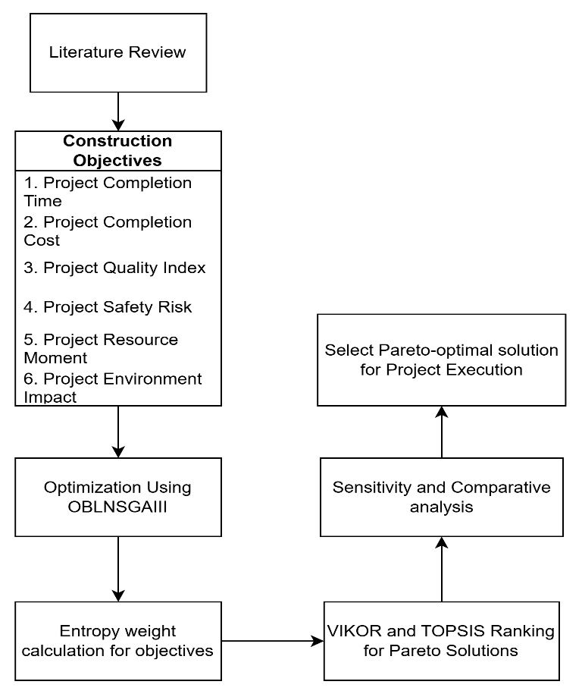
Figure 1: Flow Chart of Proposed Model
3.1 Many-Objective Optimization Mode
Constraint based Multimode Project activities
The construction project is represented as a precedence-constrained activity network comprising $n$activities. Each activity $A$ can be executed in multiple alternatives $m$ based on resource constraints (labour, material, Plant and machinery) and construction methods.
Objective Function Formulation
The proposed model simultaneously optimizes six project-level objectives that capture the key dimensions of construction performance. The mathematical formulations of these objectives are presented as follows:
Objective 1: Minimize Project Completion Time (PCT)
$$\begin{matrix} & PCT=\sum_{A∈CP}{AC}T_{A} & & \text{(1)}\end{matrix}$$
Where $CP$- set of activities on the critical path; $ACT_{A}$ - completion time of activity $A$. This objective represents the total project duration determined by critical path activities.
Objective 2: Minimize Project Completion Cost (PCC)
$$\begin{matrix} & PCC=\sum_{A=1}^{n}{D}C_{A}+(IDC×PCT) & & \text{(2)}\end{matrix}$$
Where $DC_{A}$- direct cost of activity $A$(labor, material, equipment), $IDC$- indirect cost per unit time, and $PCT$- project completion time. This formulation accounts for both direct and time-dependent indirect costs.
Objective 3: Maximize Project Quality Index (PQI)
$$\begin{matrix} & PQI=\frac{1}{n}\sum_{A=1}^{n}{AQ}I_{A} & & \text{(3)}\end{matrix}$$
Where $AQI_{A}$ - quality index achieved during first-time execution of activity $A$; $n$ - total number of activities.
Objective 4: Minimize Project Safety Risk (PSR)
$$\begin{matrix} & PSR=\sum_{A=1}^{n}{AS}R_{A} & & \text{(4)}\end{matrix}$$
Where $ASR_{A}$ - safety risk associated with activity $A$, including labor injury, material loss, and equipment-related risks.
Objective 5: Minimize Project Environmental Impact (PEI)
$$\begin{matrix} & PEI=\sum_{A=1}^{n}{AE}I_{A} & & \text{(5)}\end{matrix}$$
Where $AEI_{A}$ - environmental impact of activity $A$, expressed as CO2-equivalent emissions. This objective captures the total environmental footprint of the project.
Objective 6: Minimize Project Resource Moment (PRM)
$$\begin{matrix} & PRM=\sum_{A=1}^{n}{AR}M_{A} & & \text{(6)}\end{matrix} \\ \begin{matrix} & ARM_{A}=M_{x}+M_{y} & & \text{(7)}\end{matrix} \\ \begin{matrix} & M_{x}=∑(R_{t}^{k})^{2} & ; M_{y}=∑(R_{t}^{k}⋅t) & \text{ (8)}\end{matrix}$$
Where $ARM_{A}$ - resource moment of activity $A; R_{t}^{k}$- resource demand of type $k$at time $t$; $M_{x}$- measure of resource fluctuation; $M_{y}$ - measure of temporal distribution of resources. This formulation penalizes uneven resource allocation and large fluctuations over time, promoting smoother and more stable resource utilization.

    - 3.2 OBNSGA-III Optimization Model
The multi-objective optimization problem is solved using Opposition-Based NSGA-III (OBNSGA-III) (Panthi & Hussain, 2025).

    - 3.3 Normalization of Pareto Solutions
The Pareto-optimal solutions generated through OBNSGA-III represent trade-offs among multiple conflicting objectives. However, these objectives are expressed in different units (e.g., time in days, cost in currency, emissions in CO₂ units), and their optimization directions may differ (minimization vs. maximization). Direct comparison of such heterogeneous data is not meaningful. Therefore, a normalization step is required to transform all objective values into a comparable scale.
Let the Pareto solution set be represented as: $P=\{P_{1},P_{2},…,P_{m}\}$
Each solution is evaluated across $M$objectives, forming the decision matrix:
$F=[f_{ij}],i=1,2,…,m; j=1,2,…,M$, where $f_{ij}$denotes the value of the $j^{th}$objective for the $i^{th}$solution.
Normalization of Decision Matrix
To ensure consistency across objectives, the decision matrix is normalized using min–max transformation.
For cost-type objectives (to be minimized), lower values are preferred and For benefit-type objectives (to be maximized), higher values are preferred; hence normalization is defined as:
$$\begin{matrix} & Y_{ij}=\frac{∣f_{j}^{max}-f_{ij}∣}{f_{j}^{max}-f_{j}^{min}} & & \text{(9)}\end{matrix}$$
This transformation maps all objective values into the range $\left[0 , 1\right]$, where a higher normalized value $Y_{ij}$consistently indicates better performance regardless of the original objective type.

    - 3.4 Entropy-Based Objective Weighting
After normalization, the next challenge is determining the relative importance of each objective. Instead of relying on subjective judgment, this study adopts an entropy-based approach, which derives weights directly from the data distribution.
Step 1: Construction of Probability Matrix
The normalized values are converted into a probability distribution:
$$\begin{matrix} & p_{ij}=\frac{f_{ij}}{\sum_{i=1}^{m}{f_{ij}}} & & \text{(1}\text{0}\text{)}\end{matrix}$$
This step reflects the relative contribution of each solution to a given objective.
Step 2: Entropy Calculation: The entropy value for each objective is computed as:
$$\begin{matrix} & E_{j}=-\frac{1}{ln⁡(m)}\sum_{i=1}^{m}{p_{ij}}ln⁡(p_{ij}) & & \text{(1}\text{1}\text{)}\end{matrix}$$
Entropy measures the degree of dispersion. If values are similar across all solutions, entropy is high, indicating that the objective provides little discrimination. Conversely, higher variation results in lower entropy and higher importance.
Step 3: Determination of Objective Weights: The final weight of each objective is given by:
$$\begin{matrix} & w_{j}=\frac{1-E_{j}}{\sum_{j=1}^{M}{(1-}E_{j})} & & \text{(1}\text{2}\text{)}\end{matrix}$$
This ensures that objectives with greater variability are assigned higher weights, making the decision process entirely data-driven and reproducible.

    - 3.5 TOPSIS Ranking Method
The entropy-weighted Pareto-optimal solutions were ranked using the Technique for Order Preference by Similarity to Ideal Solution (TOPSIS) (Opricovic & Tzeng, 2004). TOPSIS evaluates each alternative based on its relative distance from the positive ideal solution and the negative ideal solution. An alternative closer to the ideal solution and farther from the negative ideal is considered more desirable. The final ranking is determined using the closeness coefficient:
$$\begin{matrix} & CC_{i}=\frac{S_{i}^{-}}{S_{i}^{+}+S_{i}^{-}} & & \text{(1}\text{3}\text{)}\end{matrix}$$
Where $CC_{i}$- closeness coefficient of alternative $i$; $S_{i}^{+}$- distance of alternative $i$ from the positive ideal solution; $S_{i}^{-}$- distance of alternative $i$from the negative ideal solution.
Alternatives are ranked in descending order of $CC_{i}$. A higher value indicates better overall performance.

  - 3.6 VIKOR Compromise Ranking
While TOPSIS focuses on distance-based ranking, VIKOR emphasizes compromise solutions by balancing overall performance and worst-case deviation (Opricovic & Tzeng, 2004).
The VIKOR method was employed to identify a compromise solution among the Pareto-optimal alternatives using the entropy-derived objective weights (Opricovic & Tzeng, 2004). VIKOR evaluates alternatives by simultaneously considering group utility and individual regret through the compromise index:
$$\begin{matrix} & Q_{i}=v\frac{S_{i}-S^{*}}{S^{-}-S^{*}}+(1-v)\frac{R_{i}-R^{*}}{R^{-}-R^{*}} & & \text{(14)}\end{matrix}$$
Where $Q_{i}$- compromise index of alternative $i$; $S_{i}$ - utility measure representing the overall deviation from the ideal solution; $R_{i}$ - regret measure representing the maximum individual deviation from the ideal solution; $S^{*}$and $S^{-}$- best and worst values of the utility measure, respectively; $R^{*}$and $R^{-}$- best and worst values of the regret measure, respectively; $v$- strategy parameter representing the weight assigned to group utility $\left(0 ≤ v ≤ 1\right)$ and balances group utility and individual regret.
The alternative with the lowest $Q_{i}$value is selected as the compromise solution.

  - 3.7 Sensitivity Analysis
To assess robustness, sensitivity analyses is conducted by varying the VIKOR parameter $v$:
$$\begin{matrix} & v∈\{0.25,0.5,0.75\} & & \text{(15)}\end{matrix}$$
This evaluates how sensitive the final decision is to changes in preferences.
  - 3.8 Comparison Framework
To rigorously evaluate the agreement, practical differences, and robustness of the rankings obtained from TOPSIS and VIKOR, a set of quantitative comparison metrics is employed. These include rank correlation measures, performance gap analysis, and stability assessment.
Spearman Rank Correlation:
Spearman’s rank correlation coefficient is used to measure the overall agreement between the rankings produced by TOPSIS and VIKOR:
$$\begin{matrix} & ρ=1-\frac{6\sum_{i=1}^{m}{d_{i}^{2}}}{m(m^{2}-1)} & & \text{(16)}\end{matrix}$$
Where $ρ$- Spearman correlation coefficient; $m$: number of alternatives (Pareto solutions) and $d_{i}=R_{i}^{T}-R_{i}^{V}$- difference between ranks assigned to alternative $i$by TOPSIS $\left(R_{i}^{T}\right)$and VIKOR $\left(R_{i}^{V}\right)$. The value of $ρ$lies in the range $\left[-1,1\right]$. A value close to $1$indicates strong agreement between the two ranking methods, while a value close to $0$suggests weak or no correlation.
Performance Gap Analysis:
To evaluate the practical significance of differences between the best solutions identified by TOPSIS and VIKOR, a performance gap is computed for each objective:
$$\begin{matrix} & Δ_{j}(\%)=\frac{f_{j}(x_{T}^{*})-f_{j}(x_{V}^{*})}{∣f_{j}(x_{V}^{*})∣}×100 & & \text{(17)}\end{matrix}$$
Where: $Δ_{j}$- percentage performance gap for objective $j$; $f_{j}(x_{T}^{*})$ - value of objective $j$for the TOPSIS-selected solution; $f_{j}(x_{V}^{*})$- value of objective $j$for the VIKOR-selected solution. This metric quantifies the relative difference in objective values between the two selected solutions. A small gap indicates that both methods lead to practically similar outcomes, even if rankings differ.

4. CASE STUDY, RESULTS AND DISCUSSION
The construction planning case study related to a construction project with 26 activities with various execution modes and having linear precedence relationships is considered for optimization and decision making. Each activity has multiple execution modes with attributes for time, cost, quality, safety risk, environmental impact, and resource usage.

  - 4.1 OBNSGA-III Optimization and Pareto Solutions
The case study project has 26 activities and combinatorial search space of over 58 million alternatives. Optimization of this project is done on OBNSGAIII model, and 69 Nos of pareto-optimal solutions are obtained. The OBNSGAIII model parameters are as Table 1.
Table 1: OBNSGAIII Model Parameters
Parameter | Value
Population Size | 462 (Adaptive to 6 Objectives)
Maximum Generations | 50
Crossover Probability (Pc) | 1
Distribution Index for SBX | 30
Mutation Probability (PM) | 1/n(act)= 0.04
Distribution Index for Mutation (nm) | 20
OBL Strategy | Probabilistic (P jump = 0.12)
Number of Objectives | 6

The Multi-Objective Trade-off based on normalized values is shown below Figure 2.

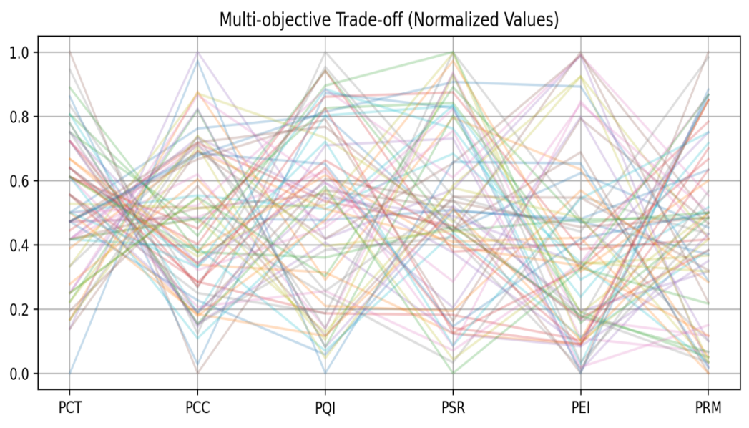
Figure 2: Multi-Objective Trade-off based on normalized values

The relationship between project objectives can be found out by this trade-off. Each line presents a solution set. As time increases cost and safety risk decreases and quality index of the project increases.

  - 4.2 Entropy-Based Weights
The OBNSGAIII model has converted 58 million alternatives into 69 pareto-optimal solutions. Now we will apply Multi-Criteria Decision Making (MCDM) to select single best solution for project.
The Entropy weights for project objectives are: PCT: 12 %, PCC: 14%, PQI: 20%, PSR: 22%, PEI: 16%, PRM: 16%.
Here, Project safety risk (22%) and Quality Index (20%) dominate, indicating higher information content (dispersion). Time and cost receive lower weights, implying less discriminatory power across Pareto solutions.

  - 4.3 VIKOR and TOPSIS Ranking of Pareto Solution
The output of both VIKOR and TOPSIS models is Pareto Index 9, same pareto optimal solution as the best solution.
For Pareto Index-9, selected modes of execution for 26 activities (A1-A2-…-A26) are: 1-2-1-1-1-1-3-3-2-3-3-1-1-2-1-2-2-1-2-3-1-1-2-1-1-1 and project objective values are: PCT: 244 days, PCC: 745600 Rs., PQI: 86.50, PSR: 78, PEI: 73.60, PRM 1853.

  - 4.4 VIKOR Sensitivity to Strategy Parameter $(v$)
The parameter $v∈\{0.25,0.5,0.75\}$ is varied to check the VIKOR result sensitivity.
The output shows same Pareto Index 9 as best solution for all 3 values of $v$. This shows the compromise solution is insensitive to decision strategy, indicating high robustness of VIKOR outcomes.

  - 4.5 Comparison Framework
Spearman Rank Correlation
The value of spearman correlation $ρ=0.95$which shows strong agreement. And the ranking comparison graph is shown as Figure 3. This result confirms that TOPSIS and VIKOR produce consistent ranking trends.
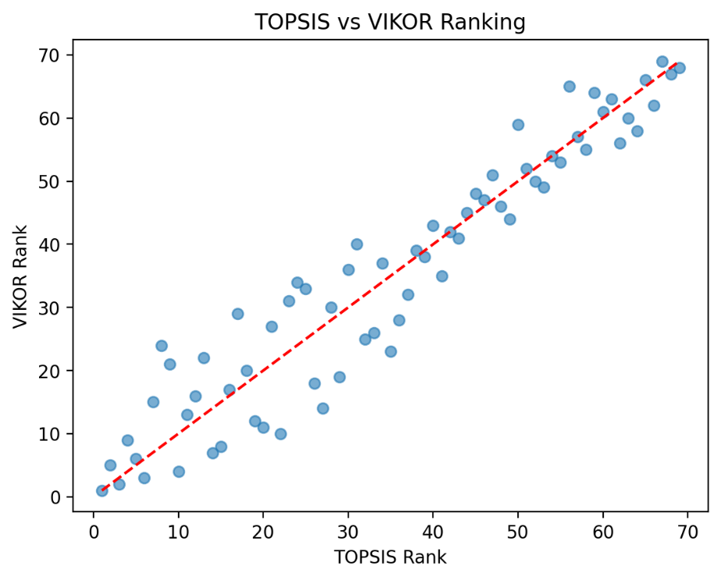
Figure 3: VIKOR and TOPSIS ranking comparison

Performance Gap Analysis: There is no performance Gap of VIKOR and TOPSIS solution. This indicates practical equivalence of the selected solution.

CONCLUSION AND FUTURE WORK
This study developed an integrated framework for construction project planning that combines many-objective optimization (OBNSGA-III), entropy-based objective weighting, and multi-criteria decision-making methods (TOPSIS and VIKOR). The framework was validated using a tunnel construction project consisting of 26 activities and a search space exceeding 58 million alternatives.
The OBNSGA-III algorithm effectively reduced the large solution space to 69 well-distributed Pareto-optimal solutions, capturing meaningful trade-offs among six objectives—time, cost, quality, safety risk, environmental impact, and resource moment. The entropy-based weighting approach revealed that safety risk (22%) and quality (20%) are the most influential criteria, indicating higher variability and importance in distinguishing optimal solutions, while time and cost exhibited comparatively lower discriminatory power.
Both TOPSIS and VIKOR consistently identified the same optimal solution (Pareto Index 9), demonstrating strong agreement between the methods. This is further supported by a high Spearman correlation coefficient (ρ = 0.95), indicating significant consistency in ranking patterns. The performance gap analysis showed zero difference between the selected solutions, confirming their practical equivalence. Additionally, sensitivity analysis of the VIKOR parameter ($v$) revealed that the optimal solution remains unchanged across different decision strategies, highlighting the robustness of the compromise solution.
Overall, the proposed framework not only generates optimal solutions but also ensures that the final decision is stable, consistent, and independent of the choice of decision-making method.
Future research may explore the integration of the proposed framework with digital construction platforms such as BIM or real-time data systems, digital twin, enabling continuous monitoring and decision support throughout the project lifecycle. And the framework can be applied to larger and more complex infrastructure projects to evaluate its scalability and computational efficiency.

REFERENCES
Ward, S. C., Curtis, B., & Chapman, C. B., (1991). Objectives and performance in construction projects. Construction Management and Economics, 9(4): p. 343–353. DOI: 10.1080/01446199100000027.
Deb, K., Pratap, A., Agarwal, S., & Meyarivan, T., (2002). A fast and elitist multiobjective genetic algorithm: NSGA-II. IEEE Transactions on Evolutionary Computation, 6(2): p. 182–197. DOI: 10.1109/4235.996017.
Deb, K. & Jain, H., (2014). An evolutionary many-objective optimization algorithm using reference-point-based nondominated sorting approach, Part I: Solving problems with box constraints. IEEE Transactions on Evolutionary Computation, 18(4): p. 577–601. DOI: 10.1109/TEVC.2013.2281535.
Abbasnia, R., Afshar, A., & Eshtehardian, E., (2008). Time–cost trade-off problem in construction project management, based on fuzzy logic. Journal of Applied Sciences, 8(22): p. 4159–4165. DOI: 10.3923/jas.2008.4159.4165.
Zareei, M. & Hassan-Pour, H. A., (2015). A multi-objective resource-constrained optimization of time–cost trade-off problems in project scheduling. Iranian Journal of Management Studies, 8(4): p. 653–675. DOI: 10.22059/ijms.2015.55006.
Afshar, A. & Zolfaghar Dolabi, H. R., (2014). Multi-objective optimization of time–cost–safety using genetic algorithm. International Journal of Optimization in Civil Engineering, 4(4): p. 433–450.
Ozcan-Deniz, G., Zhu, Y., & Ceron, V., (2012). Time, cost, and environmental impact optimization. Journal of Management in Engineering, 28(3): p. 265–272.
Elbeltagi, E., Ammar, M., Sanad, H., & Kassab, M., (2016). Overall multiobjective optimization of construction project scheduling using particle swarm optimization. Engineering, Construction and Architectural Management, 23(3): p. 265–282. DOI: 10.1108/ECAM-11-2014-0135.
Behera, A. P., Kumar, R., & Panwar, A., (2025). Optimizing the trade-off between time, cost, and carbon emissions in construction using NSGA-III: An integrated approach for sustainable development. Asian Journal of Civil Engineering, 26: p. 73–87. DOI: 10.1007/s42107-024-01153-w.
Zhan, Z., Hu, Y., Xia, P., & Ding, J., (2024). Multi-objective optimization in construction project management based on NSGA-III: Pareto front development and decision-making. Buildings, 14(7): p. 2112. DOI: 10.3390/buildings14072112.
Panwar, A. & Jha, K. N., (2019). A many-objective optimization model for construction scheduling. Construction Management and Economics, 37(12): p. 727–739. DOI: 10.1080/01446193.2019.1590615.
Sharma, K. & Trivedi, M. K., (2022). Latin hypercube sampling-based NSGA-III optimization model for multimode resource-constrained time–cost–quality–safety trade-off in construction projects. International Journal of Construction Management, 22(16): p. 3158–3168. DOI: 10.1080/15623599.2020.1843769.
Sharma, K. & Trivedi, M. K., (2023). Modelling the resource-constrained time–cost–quality–safety–risk–environmental impact trade-off using opposition-based NSGA-III. Asian Journal of Civil Engineering, 24: p. 3083–3098. DOI: 10.1007/s42107-023-00657-9.
Panthi, A. & Hussain, A., (2025). Integrated optimization of construction schedules: A five-objective approach for time, cost, quality, safety, and environmental sustainability using OBNSGA-III. Asian Journal of Civil Engineering. DOI: 10.1007/s42107-025-01528-z.
Opricovic, S. & Tzeng, G. H., (2004). Compromise solution by MCDM methods: A comparative analysis of VIKOR and TOPSIS. European Journal of Operational Research, 156(2): p. 445–455. DOI: 10.1016/S0377-2217(03)00020-1.

