Multi-modal prediction of building energy efficiency
using apartment listing data
ANDREW SONTA,¹ GILLES DE WAHA, ¹ MATTHEW MORVAN, ¹ SILVIA ROMANATO, ¹ HELENA HAUSER,² SÉBASTIEN HOUDE³, HARALD MAYR²

¹ ETHOS Lab, École Polytechnique Fédérale de Lausanne (EPFL), Fribourg, Switzerland
² University of Zurich, Zurich, Switzerland
³ University of Lausanne, Lausanne, Switzerland

ABSTRACT:

Predicting the energy efficiency of buildings at scale when detailed building data is limited remains a challenge. Tools for doing so can enhance our understanding of the building stock, which can be used for decision-making and policymaking related to building renovation for efficiency. Such tools, when applied in the residential context, could also enhance access to energy-related information for home renters and buyers when making decisions on where to live. In this work, we build a multi-modal machine learning model to predict the energy efficiency of residential units. We leverage a large dataset of tens of thousands of buildings in Switzerland that include tabular, text, and image data that can commonly be found in online apartment listing sites. After regressing out weather, occupancy, and energy price information, our model predicts the inherent energy efficiency fixed effects with about a 30% normalised root mean squared error. We explore the relative importance of each data modality and demonstrate how the multiple modalities can be integrated into an overall ensemble approach. This research shows how more information about inherent building energy efficiency can be disclosed through machine learning tools.

KEYWORDS:

Building energy prediction, urban energy simulation, multi-modal deep learning

1. INTRODUCTION
Today, buildings in Europe account for 40% of total energy consumption and 36% of greenhouse gas emissions (Directive 2024/1275, 2024). Renovation of buildings, particularly residential, has become a priority for the sustainable energy transition. Providing information on existing building energy performance can aid in decision-making for multiple actors, from policymakers to the buildings’ users. It could help utility companies, residents, facility managers, contractors, and public agencies identify inefficient buildings and deploy strategies for improving efficiency. However, the disclosure of energy-related performance indicators is often lacking or needs to be calculated manually through time-intensive methods.
At the same time, the development of online platforms to advertise rental apartments results in the generation of an extensive corpus of data. These data include detailed apartment attributes, textual descriptions, and visual representations of the interiors through images. This amount of data represents an opportunity to gain insights into the energy efficiency of buildings.
In this paper, we introduce a new perspective for predicting building energy consumption and efficiency. We leverage a novel dataset—tabular, text, and interior image data from an online apartment listing site—alongside a state-of-the-art multi-modal deep learning approach. This approach could improve the disclosure of energy-related information about residential buildings for both consumers and policy-oriented stakeholders. We also compare the impact of each modality on the prediction.

2. LITERATURE REVIEW
Researchers have explored a variety of different approaches to predict the energy efficiency of apartments using machine learning. One set of the literature has investigated tabular features for the prediction of building energy consumption and/or efficiency. Izonin et al. (2024) used support vector regression along with specific building engineering features (e.g., wall area, glazing area, orientation) to predict heating and cooling loads. While this study demonstrated the potential of leveraging machine learning for energy predictions, such an approach requires engineering-related features to be available, which becomes difficult at larger scales.
To scale up predictive power, researchers have turned to image datasets. Dougherty et al. (2021) leveraged satellite image data along with data on the social functions of nearby buildings to predict monthly energy consumption. Mayer et al. (2023) expanded this satellite image approach by incorporating street-view images to predict static energy efficiency labels (i.e., “A” to “G” on the European rating scale). Sun and Bardhan (2024) explored the use various data including street-view and aerial images to classify buildings as “hard to decarbonize” or not. Ghorbani et al. (2024) extracted features with convolutional neural networks (CNNs) applied to street-view images and integrated these features with other tabular features for energy prediction. Various other image-based remote sensing data has been shown to be useful in large-scale building energy prediction tasks (Dougherty and Jain, 2023). These studies have demonstrated the value in combining multiple data modalities (e.g., image, tabular) for the prediction of energy-related outcomes.
We note in our literature search that no existing studies have used large-scale data commonly available through apartment listing sites for this task. Such data involves a combination of images, text, and tabular features, which has the potential to offer a broad array of embedded features but involves the inherent challenge of multi-modal modelling. This is the core of our investigation in this paper.

3. METHODOLOGY
We introduce a novel building energy prediction pipeline leveraging data available through typical apartment listing sites. Within such apartment listing sites, three types of data are common: (1) tabular data, which contains categorical and numerical data that can be organized in a table, (2) text data, typically in the form of a description of the apartment, and (3) image data, including outdoor and indoor pictures of the apartment’s spaces. The outcome variable in our modelling approach is based on the annual energy bills for the apartments, and through standard regression we eliminate variation due to occupancy, weather, and pricing. Such data is typically not available to consumers. In this work, we develop an independent model for each data modality, as well as a multi-model model that predicts energy consumption using all three data modalities. In this way, we can explore the relative usefulness of each modality of data in predicting energy efficiency of apartments. The modelling details are discussed in the subsections below.

3.1. Dataset
We use data from one of the main real estate management companies in Switzerland and a Swiss real estate platform. The dataset covers 9,020 buildings and 45,554 apartment listings across Switzerland in the years 2016 to 2022. The dataset contains tabular, textual, and image data. It also includes billing information that details both overall and variable heating costs by fuel type (oil, gas, district heating, and others). The tabular data contains 36 features, which include information about the apartment price, as well as the characteristics and location of the listing. A full list of the tabular features can be found in the Appendix. The textual data consists of titles and descriptions of 45,554 listings in different languages. We identified 37,411 German, 7,154 French, and 994 Italian listings. The image dataset comprises 211,126 images associated with apartment advertisements, showing the visual representation of the apartments as presented to potential occupants.
In our modelling approach, we aim to predict the inherent energy efficiency of the building, excluding effects from weather, energy prices, and occupant behaviour. Given this definition of the energy efficiency metric, data cleaning focused on two critical variables: variable heating costs and the size of the apartments. We cleaned the raw data by removing unrealistically high values (costs above 3,500 CHF or apartments larger than 300 square meters) and null values. We then aggregated the variable heating costs and apartment size at the building level. Since individual households are also billed for the heating costs of common areas, we adjusted the property area by a factor of 1.25 to account for this.
Few residential buildings in Switzerland have cooling, so we focused on heating. We regressed the heating consumption (in kWh/m² of a building) on the energy price, heating degree days, and the vacancy rate, according to the following equation:

$$C_{i}=α+β∙P_{it}+γ∙{HDD}_{it}+δ∙V_{it}+η_{i}+ϵ_{it}$$

where $C_{i}$ is the energy consumption in building $i$, $α$ is a constant, $P_{it}$ is the building’s energy price in billing year $t$, ${HDD}_{it}$ is the heating degree days (a metric indicating by how many degree-days the building needs to be heated), $V_{it}$ is the vacancy rate, $η_{i}$ are property fixed effects, and $ϵ_{it}$ is the error term. These property-level fixed effects ($η_{i}$) represent inherent efficiency and constitute our outcome of interest.
We defined three error metrics to assess model performance. (1) Mean squared error (MSE) is a typical machine learning metric that measures the average of the squares of the difference between the predicted and actual efficiency. (2) Root mean squared error (RMSE) is the square root of the MSE. (3) Normalized mean bias error (NMBE) measures the average difference between the predicted and actual efficiency (without taking the absolute value), normalized by the average actual values. RMSE and NMBE are standard metrics used in building energy modelling.
The preprocessing pipeline consists of several steps to prepare the data for the prediction task:
- Drop features that are not correlated with the demand or that are equivalent to another feature
- Add the number of vacant apartments in the corresponding municipality as a feature
- For each categorical feature, add dummy variables to represent the feature as a set of booleans
- Split the date of creation of the advertisement into year, month, and day
- Add the number of days between the date of creation of the advertisement and the date of availability as a feature
- Add a boolean variable which indicates if the apartment has been renovated
- If the test data contains zip codes that are not in the training data, map them to the nearest zip code that is in the training data, based on the absolute difference.
- Remove all HTML formatting from textual data.

3.2 Tabular data modelling
We employ a Light Gradient Boosting Machine (LightGBM) approach for predicting energy efficiency from tabular data (Ke et al., 2017). LightGBM is an implementation of gradient boosting that uses tree-based learning algorithms. In this model, subsequent trees are trained to predict the residuals (errors) of previous trees, effectively improving the model's performance iteratively. Formally, the model combines the predictions of M individual trees as follows:
$${\hat{y}}_{i}=\sum_{m=1}^{M}{f_{m}(x_{i})}$$
where ${\hat{y}}_{i}$ represents the predicted value for the $i$th data point, $x_{i}$ is the feature vector, and $f_{m}$ is the prediction function of the $m$th tree. Each tree is trained to minimize the residual error from the previous model:
$$L=\sum_{i=1}^{n}{l(y_{i},{\hat{y}}_{i}^{\left(m-1\right)}+f_{m}\left(x_{i}\right))}$$
where $l$ is the loss function (such as mean squared error), $y_{i}$ is the true label, and ${\hat{y}}_{i}^{\left(m-1\right)}$ is the prediction from the ($m-1$)th iteration.
We use 5-fold cross validation (CV) to optimize the model's hyperparameters. 5-fold CV divides the data into five subsets, training the model on four subsets while validating it on the fifth. This process is repeated five times, with each subset used exactly once as the validation data. The hyperparameters tuned during this process include the learning rate, the maximum depth of trees, the maximum number of iterations, and the maximum number of leaves per tree. The grid search and selected parameters are shown in Table 1.

Table 1. LightGBM hyperparameter tuning.
Parameter | Grid
Learning rate | {0.05, 0.01, 0.001, 0.0001}
Max depth | {None, 50, 75, 100, 300, 800}
Max iterations | {75, 100, 150, 200, 300, 400, 500, 750, 1000}
Number of leaves | {20, 25, 30, 35, 40, 50, 60, 80, 100}

3.3 Text data modelling
The prediction model for the textual data is based on the Bidirectional Encoder Representations from Transformers (BERT) model (Devlin et al., 2019). BERT is a pretrained transformer model that leverages self-attention mechanisms to understand the context of words bidirectionally. It processes an input sequence by passing it through multiple layers of bidirectional transformer encoders. Each encoder layer consists of a multi-head self-attention mechanism and a position-wise fully connected feed-forward network. The key innovation in BERT is the usage of a masked language modelling (MLM) strategy for the pre-training of the model. During the MLM, some of the tokens are masked, and the model is then trained to predict the missing tokens. Through this training, the model gains an understanding of the importance of the context of a word.
All HTML formatting indicators were removed, and any empty listing descriptions were discarded. We refrained from further preprocessing steps, as language models benefit from the full range of features present in written text (Devlin et al., 2019).
We developed an expanded version of the BERT model (Figure 1) that incorporates keywords expected to be associated with energy consumption. We defined our own energy terms for this analysis and translated the terms into both German and French. The keywords are as follows: energy efficient, eco-friendly, solar, renewable, sustainable, green building, insulation, LED lighting, low energy, passive house, energy star, environmentally friendly, recycling, water conservation, wind power, geothermal, smart thermostat, double glazing, solar panels, energy saving, carbon footprint, sustainable materials, biodegradable, eco-conscious, green technology, low carbon, energy management, and zero emissions. To refine and expand our keyword list, we employed KeyBERT, a keyword extraction tool using the all-MiniLM-L6-v2 model. This process involved generating sentence embeddings for both the initial keywords and the descriptions using the SentenceTransformer model (Reimers and Gurevych, 2019). We calculated cosine similarity between these embeddings to identify terms most closely related to the initial keywords. From these results, relevant terms were extracted, and the keyword list was expanded to ensure comprehensive coverage of energy efficiency-related concepts. For the full list of expanded keywords, see the Appendix.

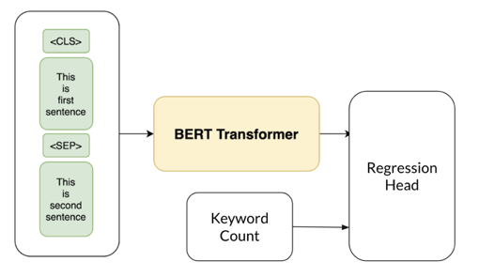
Figure 1. Expanded BERT model.

We then processed the text data using a pre-trained RoBERTa model and tokenizer from Barbieri et al. (2020). We created a text classification pipeline to categorize the apartment descriptions, with the text tokenized and, if necessary, split into manageable chunks to fit the model's maximum token length. This pipeline assigned topic labels based on the initial keywords, aggregating results to highlight the most relevant topics.
We split the data into training and test sets. We then tokenized the text using the BertTokenizer and transformed it into input IDs and attention masks. We used this data to train a BertRegressor model—a BERT model with a regression head. We selected the model’s hyperparameters (Table 2) using AdamW optimization with MSE as the loss function.

Table 2. BertRegressor hyperparameter tuning.
Parameter | Grid
Learning rate | {5e-5, 1e-5, 1e-4}
Dropout rate | {0.3}
Weight decay | {0.01, 0.005}

3.4 Image data modelling
The dataset comprises 211,126 images associated with property advertisements, showing the visual representation of the apartments as presented to potential renters. These images are linked to individual apartments, and apartment listings had between 1 and 13 images (mode of 4).
Two main technical challenges arise from this dataset. Firstly, the dataset presents a variable number of images per listing, making direct comparison across the listings complicated. This variability requires some preprocessing choices for the model to be able to accept the data. Secondly, the absence of labels identifying the content of each image (e.g., kitchen, bathroom, living room) complicates the framework. To address these challenges, we implemented an automated image clustering method using pre-trained CNN and the unsupervised clustering algorithm k-means.
A critical component of the pre-processing pipeline involves the classification of images corresponding to various areas within a house. Given the absence of labelled data, this classification task necessitates an unsupervised learning approach. To address this, images were processed using a pre-trained CNN for the purpose of feature extraction. The encoder selected for this task was VGG16, a model pre-trained on the extensively utilized ImageNet dataset (Simonyan and Zisserman, 2015). VGG16 is a deep learning model that has 16 weight layers consisting of 13 convolutional layers and 3 fully connected layers. This design allows it to capture fine-grained patterns in the images while maintaining manageable computational complexity. The pre-training on the ImageNet dataset, which contains over 14 million labelled images across 1,000 categories, enables VGG16 to extract rich and diverse features from new images, making it an effective tool for tasks like unsupervised image classification and feature extraction. A recent study proposed a VGG16 based model for image classification by extracting features from images with it. This combination achieved high accuracy in image classification tasks (Bakasa and Viriri, 2023).
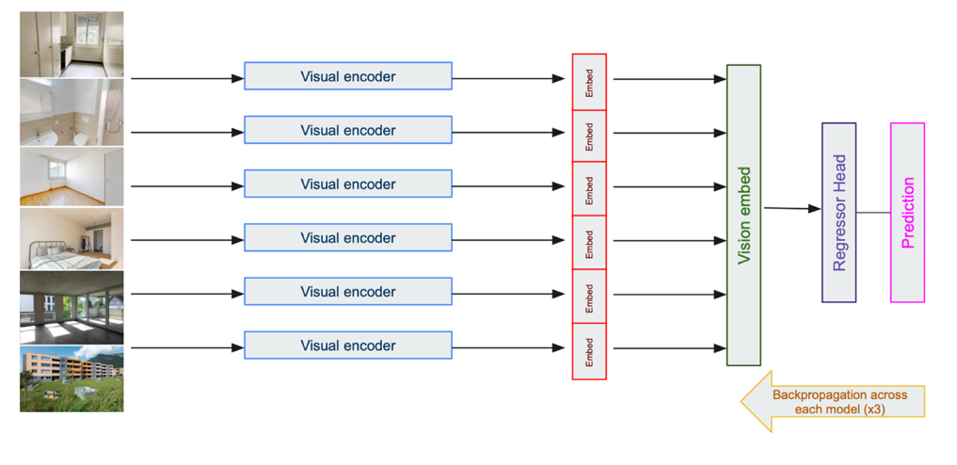
After inputting the images into this CNN, we were able to extract a set of features. These extracted features were subsequently processed using the k-means unsupervised clustering algorithm. The optimal number of clusters was determined using the elbow method, resulting in six distinct clusters. The elbow method involves plotting the sum of squared distances from each point to its assigned cluster centre for different numbers of clusters and choosing the number of clusters where this sum starts to decrease more slowly, forming an “elbow” shape in the plot. Consequently, each image was classified into one of these six categories. The count of the number of images found per cluster is found in Table 3. The table also shows the indicative visual assessment of what is represented in the clusters of images, which we manually assigned. The three most represented clusters are kitchens, bathrooms and empty rooms.
Figure 2. CNN model architecture.

Table 3. Image cluster descriptions.
Cluster | Type | Image count
1 | Kitchen | 16398
2 | Bathroom | 13179
3 | Empty room with window | 12536
4 | Living rooms and bedrooms | 9312
5 | Empty room | 9088
6 | Exterior | 7698

The subsequent stage of the preprocessing pipeline involves sampling one image per cluster for each apartment. If multiple images are available within a cluster, one image is randomly selected. In cases where no images exist for a particular cluster, a black placeholder image is used. This approach ensures an even and balanced representation of images for each property listing, thereby standardizing the dataset and mitigating potential biases introduced by uneven image distributions.
We ensured that each building has at least 2 images out of 6, allowing for a maximum of 4 black images per building. This approach resulted in a sizable dataset of 68,211 images, representing approximately 32.3% of the total. Requiring more images would decrease the dataset size and reduce the predictive power of other data types (text and tabular).
The architecture, which is summarized in Figure 2, processes each image through six separate vision encoders. We adopted the pre-trained CNN ResNet50 (He et al., 2016). Specifically, six instances of ResNet50 are employed, each independently processing an input image to generate a 512-dimensional embedding.
These six embeddings are then concatenated to form a single 3072-dimensional embedding that represents the entire set of six rooms in the house. This concatenated embedding is subsequently fed into a regression head model, which consists of a series of fully connected linear layers. The number and dimensions of the hidden layers have been left as hyperparameters to be tuned. Additionally, dropout layers have been added between the fully connected layers to prevent overfitting, and the probability of dropout has also been left as an hyperparameter.
The training involved learning rate scheduling with cosine annealing and overfitting preventive techniques like dropout and weight decay. The grid search of the best parameters was done on 30 epochs, and the best model were trained on 100 epochs, with early stopping techniques if the model was not improving for 8 epochs in a row. The best model was saved and decided based on the best validation loss (evaluated with MSE). Model evaluation was then performed on the test set to ensure robustness and generalizability of the predictions.
We performed a comprehensive grid search to identify the optimal hyperparameters for the full model testing on 30 epochs, which incorporated all six image categories. The grid search was done in different steps tuning each time one different parameter, the first one to be tuned was the learning rate, then the dropout, then the regression head composition and finally the weight decay (Table 4, with the optimal parameter combination indicated in bold). The regression head parameter refers to the composition of the neural network, with the value referring to the number of neurons in the layer(s) (multiple layers possible).

Table 4. Image CNN model hyperparameter tuning.
Parameter | Grid
Learning rate | {1e-3, 5e-4, 1e-4, 5e-5, 1e-5, 5e-6, 1e-6}
Dropout rate | {0.0, 0.1, 0.2, 0.3, 0.4, 0.5, 0.6}
Regression head | {1024, 1024-512, 1024-512-256, 512}

3.5 Model fusion with ensemble methods
We also develop an ensemble method to combine predictions from tabular data, text data, and image data, with the aim of enhancing the prediction accuracy. Ensemble methods, which combine multiple models, can be categorized into early fusion and late fusion. Early fusion involves integrating different data modalities at the feature level before making predictions, while late fusion combines predictions from separate models trained on different modalities (Dietterich, 2000).
The ensemble model's sample size was reduced as most samples did not have all modalities available. As such, for each fold, we had a train set of size 13,645, a validation set of size 2,067, and a test set of size 2,429.
We implemented a late fusion model that used predictions from text and image models, combined with metadata (such as word count and image count), as inputs to a LGBM model along with tabular features, in a similar manner as the tabular-only approach. However, compared to the tabular-only model, this approach leveraged additional context from the text and image predictions to enhance the final model (Figure 3).

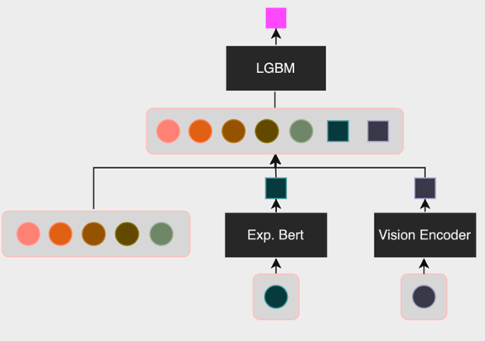
Figure 3. Late fusion ensemble model architecture.

We also implemented an early fusion method integrating embeddings from both the 6 categories of the images and BERT models. These embeddings were concatenated and fed into a regressor head alongside tabular features. This method aimed to capture richer semantic and contextual information from the different modalities, improving predictive performance (Figure 4).
Specifically, the architecture included a BERT layer concatenated with image embeddings, image counts, keyword count, and additional features, adding up to a concatenated embedding vector of 3,931 features. The regressor head was then made of a combination of dense layers and dropout layers which was tuned as a hyperparameter to choose the best performing combination. Finally, at the end a dense output layer for regression remains.
During training, we used the AdamW optimizer with a learning rate 10⁻⁵ and a weight decay of 10⁻², using MSE as the loss function.
Training involved the use of mixed precision to improve computational efficiency, gradient clipping to prevent exploding gradients, and learning rate scheduling with Cosine Annealing. The model was trained over 100 epochs, and the best-performing model, determined by the lowest validation loss, was saved. Model evaluation was performed on the validation and test sets to ensure robustness and generalizability of the predictions.

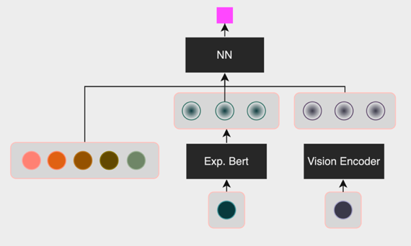
Figure 4. Early fusion ensemble model architecture.

A comprehensive grid search was conducted using a greedy approach, where one hyperparameter was tuned at a time and the best performing value was selected for the subsequent step. This process involved first tuning the learning rate and selecting the best parameter, then tuning the regression head, and finally tuning the dropout and weight decay parameters, following the same reasoning. The parameters that were evaluated are presented in Table 5, with the optimal combination highlighted in bold. Each grid search iteration was conducted for 20 epochs. The final selected model was trained for 100 epochs.

Table 5. Ensemble model hyperparameter tuning.
Parameter | Grid
Learning rate | {1e-3, 5e-4, 1e-4, 5e-5, 1e-5, 5e-6, 1e-6}
Dropout rate | {0.0, 0.1, 0.2, 0.3, 0.4}
Regression head | {1024, 1024-512, 1024-512-256, 1024-512-256-128, 512, 512-256, 256, 256-128, 128}

4. RESULTS AND DISCUSSION
In this section, we present the results for each of the model modalities. In general, it is not straightforward to make comparisons to other energy efficiency prediction approaches. This is because we are not aware of other proposed models that use the same datasets, as well as the fact that there is no agreed-upon set of metrics for benchmarking. Considering the context of energy modelling, the American Society of Heating, Refrigeration, and Air Conditioning Engineers (ASHRAE) suggests that a well-calibrated physics-based simulation model should have a normalized RMSE below 15% and an NMBE below 5% for monthly prediction. However, we note that such energy models are inherently different than our those used in our research. These physics-based energy models predict monthly energy consumption rather than energy efficiency fixed effects that exclude weather-driven and occupant-driven impacts. They also use costly and extensive data to model the heat flow dynamics in a building, including detailed information about building geometry, thermal properties, and energy systems.
To enable a comparison between our model results and existing studies, we highlight some key findings from recent literature on machine learning for energy efficiency prediction. Mayer et al. (2023) used street view images for the purpose of binary classification (i.e., distinguishing between “efficient” buildings with an energy performance label of A-D, and “inefficient” buildings with an energy performance label of E-G). Their proposed approach achieved a precision of 68.3% and an F1 score of 64.6%. While this was an improvement over the baseline, there remains a clear limitation to relying on the street view data alone, even for binary classification. Dougherty et al. (2021) leveraged satellite image data and used the L2 norm as the error metric, finding that their best model had a loss of 0.31 on normalized data—as a result, they found that their model would predict between 1598 and 3030 MWh for a building which consumes 2200 MWh (errors of up to 37%). In a more detailed machine learning approach for building energy prediction, which used geometrical building data and deep learning, the authors found that their model could produce an RMSE that was 28% of the target’s mean (Nutkiewicz et al., 2018). We consider this value as a good target baseline, as it demonstrates what can be achieved with data representing buildings’ thermal characteristics (e.g., size of windows), as opposed to apartment listing data as in our model.

4.1 Fixed effects model results
We present the results of the linear regression model to isolate the inherent energy efficiency fixed effects. The model results are shown in Table 6. The coefficients match engineering intuition: energy use decreases as energy prices increase, increases as more heating is required, and decreases when the apartments are not occupied. However, the low R² value indicates that much of the variation in energy consumption cannot be captured by a linear model with these variables alone, and therefore the remaining fixed effects can be interpreted as indicating the inherent efficiency of the apartment. The distribution of these fixed effects (our target variable) is shown in Figure 5.

Table 6. Fixed effects regression results.
Independent variable | Dependent variable: Heating consumption in kWh per square meter
Energy price | –407.424*** (13.553)
 | p<0.001
HDD | 0.016*** (0.001)
 | p<0.001
Vacancy rate | –0.107*** (0.007)
 | p<0.001
R² | 0.089

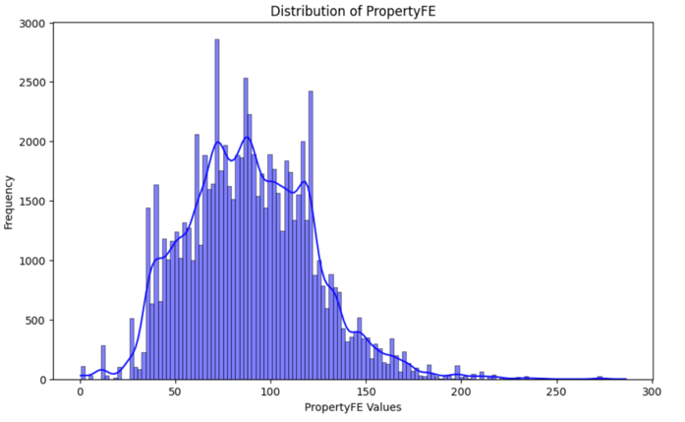
Figure 5. Distribution of energy efficiency fixed effects (the target variable for prediction).

4.2 Tabular LGBM model results
The cross-validation results for the LGBM model are summarized in Table 7. The MSE, RMSE, and NMBE were calculated for each fold. The average MSE across the folds was 897.32, with an average RMSE of 29.95. There was consistent performance across the different folds. The NMBE values indicate a slight bias in the model predictions, with an average NMBE of -0.16%, suggesting the model tends to slightly underpredict on average. The results demonstrate the model's ability to maintain relatively stable performance across different data splits, highlighting its generalizability and robustness.

Table 7. LightGBM CV results.
Fold | MSE | RMSE | NMBE
1 | 860 | 29.32 | -0.23%
2 | 965 | 31.07 | -0.12%
3 | 841 | 29.00 | -0.14%
4 | 914 | 30.23 | -0.21%
5 | 907 | 30.11 | -0.10%
Avg. | 897 | 29.95 | -0.16%

4.3 Text expanded BERT model results
The expanded BERT model's performance was also evaluated using 5-fold CV. The results are summarized in Table 8.
The BERT model's test MSE, RMSE, and NMBE varied across different folds, with the lowest MSE observed in fold 1 and the highest in fold 5. This variability highlights the potential impact of different data splits on model performance.

Table 8. BertRegressor CV results.
Fold | MSE | RMSE | NMBE
1 | 584 | 24.16 | -0.08%
2 | 959 | 30.96 | -0.13%
3 | 872 | 29.53 | -0.12%
4 | 1213 | 34.82 | -0.15%
5 | 1229 | 35.06 | -0.16%
Avg. | 971 | 30.91 | -0.13%

4.4 Image CNN model results
The results of 5-fold CV with the image model are shown in Table 9. The image model performs worse than the tabular and text models, indicating that it is difficult to capture a full representation of the building’s energy efficiency through image data without other contextual data.

Table 9. Image CNN CV results.
Fold | MSE | RMSE | NMBE
1 | 1229 | 35.06 | 0.95%
2 | 1263 | 35.54 | -10.4%
3 | 1155 | 33.99 | -1.90%
4 | 1455 | 38.15 | -11.8%
5 | 995 | 31.54 | -0.32%
Avg. | 1211 | 34.80 | -4.33%

To better understand the underlying dynamics of the image model, we also conducted an ablation study by selectively masking branches of the image model tree. This process involved removing specific categories of input images to evaluate the impact on model performance. The primary objectives were twofold: firstly, to determine if excluding certain image categories could enhance or degrade the overall model performance; and secondly, to gain insights into the relative importance of different image categories in influencing the model's predictions. This analysis provided a deeper understanding of the contribution of each image category to the predictive performance.
We masked each branch individually to measure the impact of each image category, with the results summarized in Table 10. These results show that by masking one branch, the prediction power decreases, and that different branches have different impact. The branches that have most impact (i.e., the ones that, once removed, decreases the performance the most), are category 2 (bathroom) and 1 (kitchen). Following this are 6 (exterior), 3 (empty room with window), 5 (empty room) and 4 (living room and bedroom). This matches intuition, as the characteristics of the bathroom and kitchen could indicate the period and style of construction, as well as whether the building has been remodelled.

Table 10. Results from image masking experiment.
Masked image category | MSE | RMSE | NMBE
1 | 1220 | 34.93 | -0.11%
2 | 1221 | 34.94 | -0.11%
3 | 1210 | 34.78 | -0.10%
4 | 1200 | 34.64 | -0.98%
5 | 1207 | 34.74 | -0.10%
6 | 1212 | 34.81 | -0.10%

4.5 Ensemble model results
The 5-fold CV ensemble model results are shown in Table 11. The summary comparison between the models for the individual modalities and the ensemble models is shown in Table 12. The early fusion model outperformed the late fusion model. This indicates that combining the predictions from the individual models is less effective than feeding the text and image embeddings in parallel with the tabular features to an overall regressor head. It could be inferred that the regressor head is able to capture richer semantic and contextual information when all the data modalities are considered at once.

Table 11. Ensemble model CV results.
Fold | MSE | RMSE | NMBE
Late fusion model
1 | 849 | 29.13 | 0.062%
2 | 637 | 25.24 | -0.009%
3 | 804 | 28.35 | 0.027%
4 | 1117 | 33.43 | -0.021%
5 | 914 | 30.23 | 0.017%
Avg. | 865 | 29.28 | 0.015%
Early fusion model
1 | 816 | 28.57 | 0.012%
2 | 723 | 26.89 | -0.001%
3 | 884 | 29.74 | 0.041%
4 | 945 | 30.75 | -0.067%
5 | 900 | 30.00 | -0.056%
Avg. | 854 | 29.22 | -0.019%

Table 12. Results summary.
Model | MSE | RMSE | NMBE
Tabular (LGBM) | 897 | 29.95 | -0.16%
Text (Expanded BERT) | 971 | 30.91 | -0.13%
Images (Multi-input) | 1211 | 34.80 | -4.33%
Late Fusion Ensemble | 865 | 29.28 | 0.02%
Early Fusion Ensemble | 854 | 29.22 | -0.02%

In general, the NMBE errors are small. The image model produces a larger NMBE, but this is still within ranges deemed acceptable for monthly modelling. This suggests that these machine learning models do not have systematic bias. Physics-based models may be expected to have larger bias as they are modelling the underlying processes rather than the data, which could systematically include an error. By focusing on the data itself, it is clear that it is possible to reduce bias.
The RMSE errors are on the order of 30% of the mean of the outcome efficiency variable (comparing with Figure 5). This value matches errors found in a more detailed machine learning approach for building energy prediction, which used geometric building data and deep learning for monthly energy prediction (Nutkiewicz et al., 2018). It could also be seen as an improvement over other image-based energy prediction models, though it is difficult to compare performance directly (Dougherty et al., 2021; Mayer et al., 2023). Our model also aims to predict the inherent energy efficiency of the building, excluding average weather effects, occupancy status, and price signals. As these variables are known to have important impacts on energy consumption, we would expect our prediction of the efficiency fixed effects to be lower. In future work, we aim to expand our analysis to understand how these efficiency fixed effects can be incorporated into an overall energy prediction.

5. CONCLUSION
In this paper, we introduce a new approach for predicting building energy efficiency using tabular, textual, and image data from online apartment listings. This approach offers a new opportunity for using open data from digitalization efforts for the prediction of building performance and management of the building stock.

ACKNOWLEDGEMENTS
We would like to thank the Enterprise4Society Center for funding this research. We would also like to thank Alexander Sternfeld and Marguerite Thery for their support in the early stages of this research.

REFERENCES
Bakasa, W., Viriri, S., 2023. VGG16 Feature Extractor with Extreme Gradient Boost Classifier for Pancreas Cancer Prediction. Journal of Imaging 9, 138. https://doi.org/10.3390/jimaging9070138
Barbieri, F., Camacho-Collados, J., Neves, L., Espinosa-Anke, L., 2020. TweetEval: Unified Benchmark and Comparative Evaluation for Tweet Classification. https://doi.org/10.48550/arXiv.2010.12421
Devlin, J., Chang, M.-W., Lee, K., Toutanova, K., 2019. BERT: Pre-training of Deep Bidirectional Transformers for Language Understanding, in: Burstein, J., Doran, C., Solorio, T. (Eds.), Proceedings of the 2019 Conference of the North American Chapter of the Association for Computational Linguistics: Human Language Technologies, Volume 1 (Long and Short Papers). Presented at the NAACL-HLT 2019, Association for Computational Linguistics, Minneapolis, Minnesota, pp. 4171–4186. https://doi.org/10.18653/v1/N19-1423
Dietterich, T.G., 2000. Ensemble Methods in Machine Learning, in: Multiple Classifier Systems. Springer, Berlin, Heidelberg, pp. 1–15. https://doi.org/10.1007/3-540-45014-9_1
Directive 2024/1275, 2024. Directive (EU) 2024/1275 of the European Parliament and of the Council of 24 April 2024 on the energy performance of buildings (recast) (Text with EEA relevance).
Dougherty, T.R., Huang, T., Chen, Y., Jain, R.K., Rajagopal, R., 2021. SCHMEAR: scalable construction of holistic models for energy analysis from rooftops, in: Proceedings of the 8th ACM International Conference on Systems for Energy-Efficient Buildings, Cities, and Transportation, BuildSys ’21. Association for Computing Machinery, New York, NY, USA, pp. 111–120. https://doi.org/10.1145/3486611.3486666
Dougherty, T.R., Jain, R.K., 2023. Invisible walls: Exploration of microclimate effects on building energy consumption in New York City. Sustainable Cities and Society 90, 104364.
Ghorbany, S., Hu, M., Yao, S., Wang, C., Nguyen, Q.C., Yue, X., Alirezaei, M., Tasdizen, T., Sisk, M., 2024. Examining the role of passive design indicators in energy burden reduction: Insights from a machine learning and deep learning approach. Building and Environment 250, 111126. https://doi.org/10.1016/j.buildenv.2023.111126
He, K., Zhang, X., Ren, S., Sun, J., 2016. Deep Residual Learning for Image Recognition. Presented at the Proceedings of the IEEE Conference on Computer Vision and Pattern Recognition, pp. 770–778.
Izonin, I., Tkachenko, R., Mitoulis, S.A., Faramarzi, A., Tsmots, I., Mashtalir, D., 2024. Machine learning for predicting energy efficiency of buildings: a small data approach. Procedia Computer Science, 14th International Conference on Emerging Ubiquitous Systems and Pervasive Networks / 13th International Conference on Current and Future Trends of Information and Communication Technologies in Healthcare (EUSPN/ICTH 2023) 231, 72–77. https://doi.org/10.1016/j.procs.2023.12.173
Ke, G., Meng, Q., Finley, T., Wang, T., Chen, W., Ma, W., Ye, Q., Liu, T.-Y., 2017. LightGBM: A Highly Efficient Gradient Boosting Decision Tree, in: Advances in Neural Information Processing Systems. Curran Associates, Inc.
Mayer, K., Haas, L., Huang, T., Bernabé-Moreno, J., Rajagopal, R., Fischer, M., 2023. Estimating building energy efficiency from street view imagery, aerial imagery, and land surface temperature data. Applied Energy 333, 120542. https://doi.org/10.1016/j.apenergy.2022.120542
Nutkiewicz, A., Yang, Z., Jain, R.K., 2018. Data-driven Urban Energy Simulation (DUE-S): A framework for integrating engineering simulation and machine learning methods in a multi-scale urban energy modeling workflow. Applied Energy 225, 1176–1189. https://doi.org/10.1016/j.apenergy.2018.05.023
Reimers, N., Gurevych, I., 2019. Sentence-BERT: Sentence Embeddings using Siamese BERT-Networks, in: Inui, K., Jiang, J., Ng, V., Wan, X. (Eds.), Proceedings of the 2019 Conference on Empirical Methods in Natural Language Processing and the 9th International Joint Conference on Natural Language Processing (EMNLP-IJCNLP). Presented at the EMNLP-IJCNLP 2019, Association for Computational Linguistics, Hong Kong, China, pp. 3982–3992. https://doi.org/10.18653/v1/D19-1410
Simonyan, K., Zisserman, A., 2015. Very Deep Convolutional Networks for Large-Scale Image Recognition. https://doi.org/10.48550/arXiv.1409.1556
Sun, M., Bardhan, R., 2024. Identifying Hard-to-Decarbonize houses from multi-source data in Cambridge, UK. Sustainable Cities and Society 100, 105015. https://doi.org/10.1016/j.scs.2023.105015

APPENDIX

Table A 1. Full list of tabular features.
Feature | Description | Type
Advertisement Id | Unique identifier for the advertisement | Integer
Advertisement Version Id | Identifier for the version of the advertisement | Integer
Are Pets Allowed | Indicates if pets are allowed in the property | Boolean
Category Idx | Categorical index for the type of property category | Categorical
Day of Advertisement Created | The day of the month when the advertisement was created | String
Day of Date Available From | The day of the month when the property is available from | Text
Floor | The floor level of the property | Integer
Geo Canton | Geographical canton where the property is located | Categorical
Geo City | Geographical city where the property is located | Categorical
Geo Zip | Geographical ZIP code of the property's location | Integer
Has Balcony | Indicates if the property has a balcony | Boolean
Has Cabletv | Indicates if the property has cable TV | Boolean
Has Elevator | Indicates if the property has an elevator | Boolean
Has Fireplace | Indicates if the property has a fireplace | Boolean
Has Garage | Indicates if the property has a garage | Boolean
Has Parking | Indicates if the property has parking facilities | Boolean
Is New Construction | Indicates if the property is newly constructed | Boolean
Is New Construction Potential | Indicates potential for new construction | Boolean
Is Tenant2Tenant | Indicates if the transaction is between tenants | Boolean
Is Wheelchairaccessible | Indicates if the property is wheelchair accessible | Boolean
Jahr | Year associated with the property, typically for construction or renovation | Integer
Leerwohnungsziffer | Vacancy rate indicator for the property | Float
Listing Description | Text description of the property listing | Text
Listing Title | Title of the property listing | Text
Livingspace | Living space area in square meters | Float
Number Of Rooms | Number of rooms in the property | Integer
Number Of Rooms Cleaned | Number of rooms cleaned | Integer
Number of Documents | Number of documents associated with the property | Integer
Number of Images | Number of images provided in the listing | Integer
Price Extra Normalized | Extra price normalized | Float
Price Gross Normalized | Gross price normalized | Float
Price M2 Normalized | Price per square meter normalized | Float
Price Net Normalized | Net price normalized | Float
Property Reference Id | Unique identifier for the property | Integer
Size M2 Normalized | Normalized size of the property in square meters | Float
Subcategory En Idx | Categorical index for the subcategory of the property | Categorical
Year Built | The year the property was built | Integer
Year Lastrenovated | The year the property was last renovated | Integer
Demand | Demand level or index associated with the property | Float
Language | Language used in the property listing | Categorical
PropertyFE | Property Feature Engineering, representing additional features | Float

Table A 2. Full list of expanded keywords used in expanded BERT model.
br wohnungen | water conservation | zimmerwohnungen | bahn | park
mitbenutzung | fahrradraum | solaranlage | geschirrspüler | grosszahl einkaufsmöglichkeiten
temperatura | keine parkplätze | geräumiger | et convivial | granitabdeckung
verschiedene wohnungen | tumbler br | nasszellen | green building | geräumiger eingangsbereich
br wohnzimmer | wohnbereich küche | plattenboden | passive house | steamer geschirrspüler
recyclingssystem br | sustainable materials | einbaubackofen | steamer | terrasse
bahnhof | bushaltestelle | recycling | lichtdurchflutetes | warmwasseraufbereitung
glaskeramikherd | greencity | energetisch optimiert | bahnhofs | 2021 oder
solar panels | spazieren grillieren | solar | windschutzverglasung | greencity bilden
sustainable | verbindungen nach | chipsystem | wind power | und warmwasseraufbereitung
recyclingsystem | eco-friendly | keramische bodenplatten | glaskeramikherd | lumineux

https://huggingface.co/sentence-transformers/all-MiniLM-L6-v2

