Requirements for Implementing Level of Information Need in Construction Production Planning Using Linked Data: A Case Study
Jonatan Lindholm^{1,*}, Peter Johansson¹, Ibrahim Yitmen¹

¹ Jönköping University, Jönköping, Sweden
*Corresponding email: jonatan.lindholm@ju.se

ABSTRACT
Despite decades of digitalization, construction information remains fragmented, and interoperability issues persist due to heterogeneous data formats and limited semantic integration. Knowledge graphs grounded in W3C semantic web standards and linked data principles have been proposed as a means to connect fragmented project information into coherent, machine-interpretable structures. However, their practical application requires a clearer understanding of how construction information should be structured and related. This study investigates how Level of Information Need (LOIN) can be used to create requirements for linked data solutions in construction production planning. Based on a case study of a medium-sized contractor, the study maps information flows and structures required for integrated, reusable data. The findings show that planning relies heavily on manually transferred and loosely connected information. Based on these observations, the paper proposes a set of guidelines for linked data–based production planning, emphasizing semantic connections between quantities, activities, resources, and milestones, aligned with LOIN principles. Conceptual information models illustrate the intended relationships, and a small illustrative linked data example demonstrates how such connections could be represented. The study contributes practical guidance for developing linked data solutions that support more integrated planning and form a building block toward a comprehensive project knowledge graph.

- INTRODUCTION
The construction industry continues to face challenges related to fragmented and poorly connected information, despite decades of digitalization. Studies have shown that deficiencies in information quality and availability from earlier project stages negatively affect production performance (Koch et al., 2018). To address these issues, several international standards have been developed, most notably the ISO 19650 series, which introduces concepts such as the Common Data Environment (CDE) as a structured approach to managing project information. However, practical implementation remains difficult, and information is often neither consistently structured nor delivered in a way that aligns with project needs (Lindholm et al., 2025b, Jaskula et al., 2024). The problems are not only related to the quality of information, but also whether the right information is available at the right time. Level of Information Need (LOIN) (ISO 7817-1, 2024), first introduced in ISO 19650-1 (2019), address this by providing a framework for defining information requirements for specific purposes at different stages of a project. However, LOIN is not yet widely implemented in practice, and current workflows often lack structures for managing such requirements across activities.
At the same time, knowledge graphs have emerged as approaches for representing and integrating heterogeneous data through semantically explicit relationships (Wang and Sacks, 2025). In construction, these approaches offer a way to connect fragmented information across tools, disciplines, and project stages (Sacks et al., 2022). However, their effective implementation depends on a clear understanding of how construction information should be structured and how different information entities are related in practice. This study therefore investigates information flows and requirements in construction production planning, using the workflow of a quantity surveyor as a case. By mapping activities and associated information dependencies, the study identifies the constraints that must be satisfied when designing knowledge graph-based solutions aligned with LOIN principles.

- RESEARCH DESIGN
The purpose of this paper is to map the information flow and requirements connected to the quantity surveyor’s workflow as a front-end activity for introducing knowledge graph-based information modelling. By identifying what information is needed for which activity, the study identifies key dependencies and constraints that a solution must satisfy to fit into existing workflows with minimal disruption. The research presented in this study is part of a larger project following the Design Research Methodology (DRM) (Blessing and Chakrabarti, 2009). This study is part of the Descriptive Stage I (DS-I) stage of DRM and takes the form of a case study, with observations as the main data gathering technique, as they allow for studying a phenomena in the environment it occurs (Säfsten and Gustavsson, 2020). The observations took place at a medium-sized contractor based in southern Sweden, where a researcher followed a quantity surveyor during their work in a construction project where a new section is added to an already existing building. The researcher observed them during various project meetings and took notes. The researcher also observed the quantity surveyor in their office, where workflows and used tools were demonstrated and explained to the researcher. Finally, to get a better overall understanding of the project, the researcher also reviewed various documents from the project CDE. An initial mapping was made after the first observation period, which lasted one week. One validation round was performed at a later stage. Here the quantity surveyor confirmed the correctness of the initial mapping and suggested some additions related to new tasks that were not performed at the earlier stage. The results of the observations consist of a mapped overview of information dependencies across key activities in the quantity surveyor’s workflow.

- THEORETICAL FRAMEWORK
3.1 Construction production planning and coordination
Production planning practices varies depending on contracting form. In design-build projects production usually starts before the design is finished, which can shorten project time but increases the demand for efficient coordination. Many design-build projects still exceed their initial budget and lead times (Liang et al., 2020, Chen et al., 2016), with unsuccessful coordination being the main cause of these issues (Ballesteros-Pérez, 2017). Production planning in construction projects is usually done by creating work breakdown structures. The structures can be based on classification systems and standards, such as ISO 12006-2 (2020), and are used to define the relationship between different parts of the building and the resources needed to perform the related activities (Schlenger and Borrmann, 2024). Information availability is crucial for production success, as it improves monitoring capabilities and enables anticipation and prediction of potential problems (Andújar-Montoya et al., 2023), as well as identification of downstream activities that may be affected by them (Garcia-Lopez and Fischer, 2024). However, many companies struggle to implement necessary technologies for performance measurement and improvement (Murguia et al., 2026). CDEs can be used for information sharing and progress monitoring, however, since they are not always used properly, some information may get lost along the way. Incomplete or low-quality information are the most common causes of defects and often lead to rework (Koch et al., 2018). Traditionally, Building Information Management (BIM) workflows mostly focused on individual information exchanges between individual disciplines (Khudhair et al., 2022), but if BIM models are not used on site, contained information, such as quantities, are lost and will have to be redone (Alhava et al., 2024).

3.2 Information requirements
LOIN is a method to define information requirements in construction projects. ISO 7817-1 (2024) states that LOIN-based information requirements should be specified based on purpose (why), milestone (when), actors (who), and objects (what). The purpose of defining information requirements is to enable decision making at different points in a project (ISO 19650-1, 2019). By aligning information exchanges with planned activities, the activities can act as a base for information requirement definitions using LOIN (Lindholm et al., 2025a). The activity-based planned information exchanges will then work as an agreement between two or more actors. Since some of the standards governing information exchange are still relatively new, most companies have not yet adopted them into their processes and workflows. However, studies highlight the significance of LOIN in streamlining production management. For example, implementing LOIN principles within a CDE facilitates collaborative information production, since it enables efficient gathering, analysis and sharing of information throughout the project lifecycle (Godager et al., 2022).
Existing literature showcases numerous challenges related to information management in construction projects, such as bulk information exchange, model coordination, versioning, and design review conformance to requirements (Borrmann et al., 2018). A more reliable information flow is therefore needed to address current production issues, and recent EU regulations, such as the Construction Product Regulation (CPR) (European Union, 2024) further increase the need for traceable and structured data. However, existing information structures are not always sufficiently robust. For example, environmental product declarations currently do not always provide fully specific data, meaning that additional information must be added manually if the declaration is to fulfil its legislative purpose (Erlandsson et al., 2024). This highlights a broader need, not only for more data, but for improved ways of representing and structuring product information so that it can be consistently interpreted and reused across contexts. In particular, data must be expressed in a form that enables traceability, integration and validation across organisational and system boundaries (Kebede et al., 2023). We therefore need a better representation of product data in the future. Knowledge graphs offer one such approach, providing a structured and semantically explicit representation of data that support these requirements, and can act as a foundation for systems using Artificial Intelligence (AI) (Pal et al., 2025, Sacks et al., 2022, Boje et al., 2020).

3.3 Knowledge graphs
In the Architecture, Engineering and Construction (AEC) domain, the design of a building is based on various functional, constructability and performance criteria (Wang and Sacks, 2025). Knowledge graphs describe objects of interest and the connections between them (Noy et al., 2019) and can therefore be used to create more meaningful representations of buildings as well as provide semantic linking between different objects (Sacks et al., 2022). Due to their open format, knowledge graphs could also aid in overcoming the interoperability issues that exist in the industry due to the many different software tools and file formats that are used in different disciplines (Pauwels et al., 2017). Knowledge graphs are based on ontologies, which are structured knowledge bases of concepts and their relationships (Hitzler, 2021). Several ontologies already exist for the built environment, such as the Building Topology Ontology (BOT) (Rasmussen et al., 2020), the LOIN, data template and property ontologies (Zentgraf et al., 2025), and the Construction Scheduling Ontology (CSO) (Schlenger and Borrmann, 2024). Through modular ontology modelling and ontology alignment, many ontologies could also be integrated through a domain model (Sabaa et al., 2024). Knowledge graphs could therefore be a potential solution for integrating information requirements with their respective activities and objects by using the LOIN framework (Lindholm et al., 2025a).

- Results
The study examined six interrelated activities in the contractor’s workflow: calculations (quantities and costs), purchasing, account summary, piecework basis, production time planning, and product registration. These activities are connected either directly or through shared information needs. In general, quantity and cost calculations form the foundation for all subsequent activities, as they contain information about materials, products, resources, and associated costs. This is visualised in Figure 1.
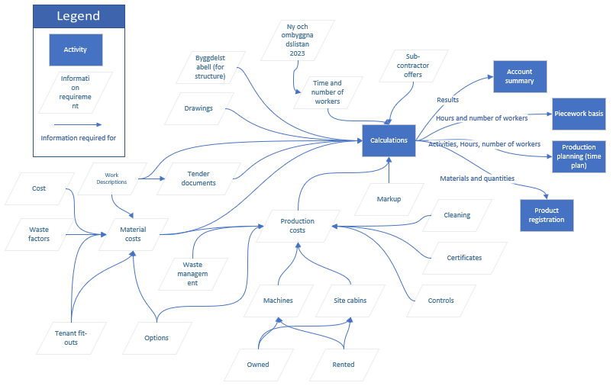
Figure 1: Map of information requirements and activities in relation to calculations.
Calculations are primarily based on manually extracted quantities from drawings rather than information-rich models, as those models are usually not complete enough for reliable quantities to be extracted at this stage. The Softwares Bluebeam and Bidcon are used to measure quantities and compile calculation sheets. The sheets are structured according to the “Byggdelstabell” from the Swedish BSAB 96 classification system (Svensk Byggtjänst, 1996). Although price lists and other external data sources can be integrated, significant manual adjustments are required, for example when applying specific supplier agreements or adapting input data. Waste factors are decided by the contractor themselves and are usually set to between five and ten percent of material costs based on experience. The amount of material and products needed is also affected by various tenant fit-outs and options that the contractor may be contractually obligated to fulfil. The tenant fit-outs and options also affect the production costs. After requesting offers from subcontractors, purchasing is done according to the Swedish construction industry’s business management system: BKMA (Byggbranschens KMA, n.d.). Information requirements and activities related to Purchasing is shown in Figure 2.
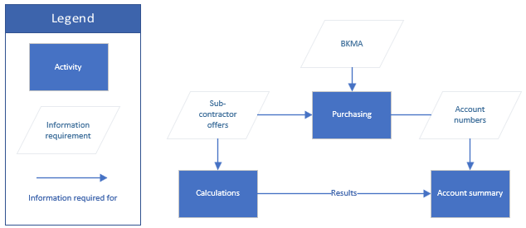
Figure 2: Information requirements and activities related to purchasing.
Production costs include costs for things needed to establish the construction site and constructing the building, such as machines and site cabins, which depends on whether the contractor owns or rent the equipment. Production costs also include various waste management costs associated with renting containers and their associated logistical services. Finally, production costs include cleanup services when the project is finished, as well as costs for various certificates that must be acquired and controls that must be carried out to ensure that the building is constructed in accordance with regulations and fulfil all requirements set by the contract.
Personnel costs are calculated using a list called “Ny- och ombyggnadslistan 2023” from the Swedish construction workers’ union (Byggnads, 2024). The hourly rates (and by extension, costs) for different types of workers are set by collective agreement. The list also includes rates for various productivity allowances that should be used for work in special conditions, which may increase the time needed to complete an activity. The piece-rate wage basis is based on the wages of workers that are enlisted to perform the various tasks on site. It is decided per project whether hours should count towards the piecework rate or not. Wages are based on agreements with the construction workers’ union (Byggnads) and differ only based on the title of workers. Information requirements related to the piecework basis is shown in Figure 3.
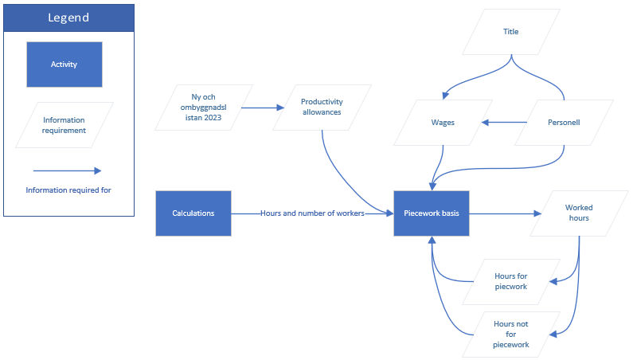
Figure 3: Information requirements for piecework basis.
Once all calculations are done, a markup is decided on. This is a percentage of all the calculated costs and determines how much the contractor will profit on the project. All purchases are connected to an account number. account summaries require manual mapping between purchases and internal accounting structures. Purchased products are also registered in the Swedish product register through a logbook service from Byggvarubedömningen (2026).
The completed calculations are also the foundation for the production time plan, which is made by the site manager in the software Powerproject. Integration between calculation and scheduling tools is limited, even though they are provided by the same software vendor. As a result, production schedules must be created and maintained manually using calculation outputs as reference data. Planning decisions are therefore based on interpreted and reformatted information rather than directly connected data structures. All subcontractors are given an opportunity to provide input on the time plan and confirm that their part of the work is represented correctly. However, the subcontractors do not always give these inputs, which makes accurate schedule prediction more difficult. The schedule is followed up every week during the project, and smaller parts representing the coming four weeks are discussed with lead fitters every week to avoid confusion and collisions. Information requirements related to the production planning is shown in Figure 4.
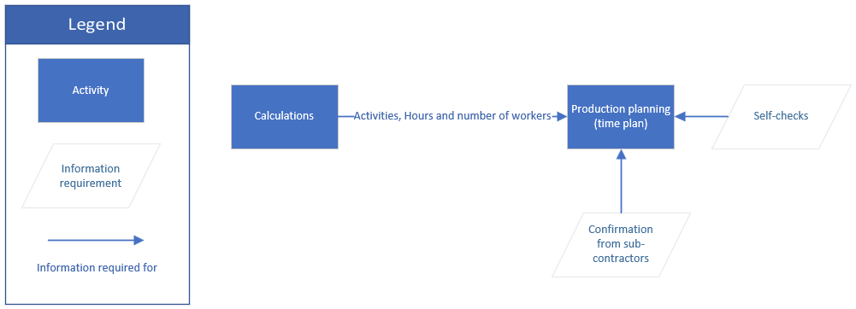
Figure 4: Information requirements related to production planning
All project information is shared through a CDE, where team members have instant access to uploaded documents and files. As in many cases in the industry, the project uses more than one solution for CDE functionalities. iBinder is used as the main document and file storage and sharing platform, while Dalux is used for model related tasks.

- Discussion
It is clear from the study that proper BIM-based workflows do not really exist to the extent that many people thought they would be at this point, at least not at all companies. The results exposed where automation could have occurred, but work is still done manually. In some cases, this was true even when transferring information between different software from the same provider. This is of course partially down to the providers themselves, but it showcases a main issue that can arise when relying on proprietary file formats and file-based information exchanges. The manual information transfers not only slow down the process but also increases the risk for information loss along the way. The use of CDE allows for sharing project information, but if file formats are not compatible or interpreted differently by different software, the risk for rework or information loss is not completely averted. Depending on how big these issues are, the CDE may not give the intended benefits as described by Godager et al. (2022), especially if information requirements are not properly structured using LOIN. The mapping made dependencies visible and showed how information flows in a project. This clarifies which information is needed for which activity and where that information originates from. The mapping could therefore act as a starting point for information requirement specifications using LOIN. The relationships shown in the map are also important for creating knowledge graphs that can accurately represent the project. More specifically, the output can be used to derive design constraints for a knowledge graph-based solution supporting a fully integrated digitalized workflow while keeping current work practices as intact as possible.
Due to compatibility issues that exist in file-based information exchange, open formats such as knowledge graphs are needed. Knowledge graphs can provide a structure for information requirements in construction projects, and many ontologies for representing information exchanges already exist, such as the LOIN and data template ontologies (Zentgraf et al., 2025). There are also several ontologies that can be used to represent buildings or products. However, the company in the case study has no prior experience or knowledge in such ontologies or knowledge graphs. The graphs must therefore be implemented through existing software interfaces to minimise disruption to current workflows. This means that information used and produced in current software tools must be converted into knowledge graphs from existing ontologies beforehand to be implemented with minimal disruption to current workflows. In a practical implementation, calculation data, schedules, product information, and external industry resources would first be transformed into graph representations based on existing ontologies. These graph resources could then be connected through shared identifiers and semantic relationships, enabling production planning applications to retrieve information from a common representation rather than from multiple disconnected files.
Since some of the information needed in certain processes are not produced by the company themselves, for example “Ny- och ombyggnadslistan 2023”, the information contained in these documents must also be translated into knowledge graphs for such a solution to work. By using knowledge graphs, these different types of information can then be connected. As there are a lot of different standards and lists used in the industry, the knowledge graph representation of these should be provided by the organization responsible for the respective standard or list. For example, a triple for an activity could look like this; ex:ActivityType_A ex:requiresPersonnel ex:PersonnelType_A and ex:ActivityType_A ex:hasPersonnelCost ex:PersonnelCost, where ex:PersonnelCost would be a resource maintained by the organisation behind “Ny-och ombyggnadslistan 2023” and its value would be based on the activity and personnel types referred to in the triples. In practice, a complete knowledge graph would enable semantic connections between all activities and their information requirements as shown in Figure 1. LOIN requirements could then be formalised as graph constraints and validated automatically using technologies such as SHACL (Shapes Constraint Language).
Knowledge graphs could improve information consistency by linking activities to shared information sources. This would in turn reduce rework when transferring information between the cost estimation and production planning activities. The use of knowledge graphs should therefore improve productivity in the industry (Schlenger and Borrmann, 2024, Rasmussen et al., 2020). It would also support assessment of design changes and early identification of information gaps. Finally, it also makes project information machine readable and ready for use with large language models and other AI tools (Pal et al., 2025).
Murguia et al. (2026) highlights that innovative solutions depend on the active contributions of all stakeholders. In construction this also extends to standardization bodies and other organizations that define information structures and guidelines used across projects. This is particularly important in cases like this, where new ways of representing and exchanging information is introduced, as their effectiveness depends on alignment across both project actors and standard-setting bodies.
This study provides a mapping of how information flows within a specific part of a project, identifying the information needed, where it originates and who is responsible. Such mapping is prerequisite for implementing an accurate knowledge graph, as the relationships between information and activities must be understood to accurately model it in a graph. Without this understanding, there is a risk of misinterpreting and misrepresenting the relationships, which in turn would result in an inaccurate, incomplete or faulty knowledge graph. The development of shared graph resources that can represent the built environment therefore requires coordinated efforts across standard organizations, regulatory bodies and companies. Since the full potential of knowledge graphs is only achieved through a unified industry effort, further development efforts in this area should include multiple actors from different parts of the industry. Data dictionaries, data templates and LOIN can then act as the base for digital product passports which are needed to fulfil the new CPR.
While this work provides a map of relationships between different activities and their information requirements, it does not cover how they should be represented in a knowledge graph or how information could be validated. Further work is therefore needed to investigate how industry knowledge graphs should be constructed and how information could be validated against requirements based on data templates using LOIN. The presented mapping reflects the specific processes and systems used in the studied case. As processes and systems differ between organisations, it is therefore recommended that a similar mapping is done before implementing knowledge graphs for these purposes at other companies or organizations.

- CONCLUSION
This study mapped the information flow and information requirements associated with a quantity surveyor’s workflow at a medium-sized contractor, with the aim of supporting development of an information structure based on knowledge graphs. The results show that, despite the use of digital tools and CDE, key information exchanges remain manual and file-based, leading to fragmented workflows, limited automation, and increased risk of rework. By making information dependencies explicit, clarifying what information is needed for which activities, the mapping provides a foundation for defining information requirements using LOIN principles. In this sense, the study demonstrates that systematic mapping of information requirements is a necessary front-end activity for solutions based on knowledge graphs. Without such mapping, the origins and relationships between information and activities cannot be reliably represented, increasing the risk of incomplete or inaccurate graphs.
The findings further highlight that successful adoption of knowledge graphs in construction production requires coordinated efforts beyond individual companies. While relevant ontologies exist, practical implementation depends on integration with existing tools and on external standards and industry lists being made available as graph resources. Although this study does not address knowledge graph construction or information validation, it establishes a foundation for future work by identifying information structures and constraints that such solutions must satisfy to fit existing workflows with minimal disruption. Following studies could then investigate the use of SHACL or other constraint languages for validation of the resulting information models.

ACKNOWLEDGEMENTS
The authors would like to thank Svenska Byggbranschens utvecklingsfond (SBUF) and Jönköpings Läns Byggmästareförening for funding the project in which this work took place. This work would not have been possible without their support.

REFERENCES
Alhava, O., Ruottinen, B., Peltokorpi, A., Siren, M., Aaltonen, A. & Pitkäranta, T. (2024). Advancing Digitalisation in Construction Through Automated Metadata Management and Machine Data Processing.
Andújar-Montoya, M. D., Pérez-delHoyo, R., Marcos-Jorquera, D. & Gilart-Iglesias, V. (2023). Construction Management Model Under a Lean Construction Approach Based on Business Process Management (BPM). Building Engineering Facing the Challenges of the 21st Century: Holistic Study from the Perspectives of Materials, Construction, Energy and Sustainability. Springer.
Ballesteros-Pérez, P. (2017). Modelling the boundaries of project fast-tracking. Automation in Construction, 84, 231-241.
Blessing, L. T. & Chakrabarti, A. (2009). DRM: A design reseach methodology, Springer.
Boje, C., Guerriero, A., Kubicki, S. & Rezgui, Y. (2020). Towards a semantic Construction Digital Twin: Directions for future research. Automation in Construction, 114.
Borrmann, A., König, M., Koch, C. & Beetz, J. (2018). Building information modeling: Why? what? how?, Springer.
Byggbranschens KMA. (n.d.). Bli Certifierad. Byggbranschens KMA. Available: https://bkma.se/bli-certifierad/ [Accessed 2026-04-17].
Byggnads. (2024). Tids- och prislistor. Byggnads. Available: https://www.byggnads.se/arbetsgivare/teckna-kollektivavtal-och-hangavtal/vad-ar-ett-kollektivavtal/kollektivavtalen/ [Accessed 2026-04-17].
Byggvarubedömningen. (2026). Loggbok. Byggvarubedömningen. Available: https://byggvarubedomningen.se/loggbok/ [Accessed 2026-04-17].
Chen, Q., Jin, Z. G., Xia, B., Wu, P. & Skitmore, M. (2016). Time and Cost Performance of Design-Build Projects. Journal of Construction Engineering and Management, 142.
Erlandsson, M., Görman, F., Thrysin, Å., Häkkinen, T., Eckerberg, K., Pesu, J., Dalborg, M., Asplund, J., Kaartinen, T., Shchiøtz, A., Dyrstad Petterson, T., Alam, A., Karlsson, P. E., Mattson, E., Miettinen, H., Mänttäri, M., Slivenius, F., Tuhkanen, E.-M., Vares, S., Linjama, J., Balouktsi, M., Francart, N., Kanafani, K., Oviir, A., Rønning, A. & Ögmundarson, Ó. (2024). Nordic view on data needs and scenario settings for full life cycle building environmental assessment. www.norden.org/publications: Nordic Concil of Ministers.
European Union (2024). Regulation (EU) 2024/3110 of the European Parliament and of the Council of 27 November 2024 laying down harmonised rules for the marketing of construction products and repealing Regulation (EU) No 305/2011 (Text with EEA relevance).
Garcia-Lopez, N. P. & Fischer, M. (2024). Managing On-Site Production Using an Activity and Flow-Based Construction Model. Journal of Construction Engineering and Management, 150.
Godager, B., Mohn, K., Merschbrock, C., Klakegg, O. J. & Huang, L. (2022). TOWARDS AN IMPROVED FRAMEWORK FOR ENTERPRISE BIM: THE ROLE OF ISO 19650. Journal of Information Technology in Construction, 27.
Hitzler, P. (2021). A review of the semantic web field. Communications of the ACM, 64, 76-83.
ISO 7817-1 (2024). Building information modelling - Level of information need - Part 1: Concepts and principles (ISO 7817-1:2024(en)). International Standards Organization.
ISO 12006-2 (2020). Building construction – Organization of information about construction works – Part 2: Framework for classification (SS-EN ISO 12006-2:2020). International Standards Organization.
ISO 19650-1 (2019). Organization and digitization of information about buildings and civil engineering works, including building information modelling (BIM) – information management using building information modelling – Part 1: Concepts and principles (SS-EN ISO 19650-1:2019 (E)). International Standards Organization.
Jaskula, K., Kifokeris, D., Papadonikolaki, E. & Rovas, D. (2024). Common Data Environments in construction: State-of-the-art and challenges for practical implementation. Construction Innovation.
Kebede, R., Moscati, A., Tan, H. & Johansson, P. (2023). Circular economy in the built environment: a framework for implementing digital product passports with knowledge graphs. EC3 Conference 2023. European Council on Computing in Construction.
Khudhair, A., Li, H., Bower, T. & Ren, G. (2022). A theoretical holistic decision-making framework supporting collaborative design based on common data analysis (CDA) method. Journal of Building Engineering, 46.
Koch, C., Shayboun, M., Manés, A. & Nordlund, T. (2018). Produktivitetsläget i Svenskt Byggande 2018. SBUF.
Liang, Y., Ashuri, B. & Sun, W. (2020). Analysis of the variability of project cost and schedule performance in the design-build environment. Journal of Construction Engineering and Management, 146, 04020060.
Lindholm, J., Jansson, T., Johansson, P. & Yitmen, I. (2025a). Integrating LOIN-driven information exchange connected to construction production planning. 2025 European Conference on Computing in Construction CIB W78 Conference on IT in Construction. Porto, Portugal.
Lindholm, J., Johansson, P. & Yitmen, I. (2025b). Toward a BIM information delivery framework based on common data environment. Construction Innovation, 25, 139-157.
Murguia, D., Soetanto, R., Szczygiel, M., Goodier, C. I. & Kavuri, A. (2026). Construction 4.0 implementation for performance improvement: an innovation management perspective. Construction Innovation, 26, 843-870.
Noy, N., Gao, Y., Jain, A., Narayanan, A., Patterson, A. & Taylor, J. (2019). Industry-scale Knowledge Graphs: Lessons and Challenges: Five diverse technology companies show how it’s done. Queue, 17, 48-75.
Pal, A., Murguia, D. & Middleton, C. (2025). AI-POWERED APPLICATION FOR CONSTRUCTION SCHEDULE MANAGEMENT USING NATURAL LANGUAGE. EC3 Conference 2025. European Council on Computing in Construction.
Pauwels, P., Zhang, S. & Lee, Y.-C. (2017). Semantic web technologies in AEC industry: A literature overview. Automation in construction, 73, 145-165.
Rasmussen, M. H., Lefrançois, M., Schneider, G. F. & Pauwels, P. (2020). BOT: The building topology ontology of the W3C linked building data group. Semantic Web, 12, 143-161.
Sabaa, S., Moscati, A., Jansson, T. & Johansson, P. (2024). Towards a harmonized information exchange in the construction industry: an approach using modular ontology modelling and loin. 41st International Conference of CIB W78.
Sacks, R., Wang, Z., Ouyang, B., Utkucu, D. & Chen, S. (2022). Toward artificially intelligent cloud-based building information modelling for collaborative multidisciplinary design. Advanced Engineering Informatics, 53, 101711.
Schlenger, J. & Borrmann, A. (2024). Advanced Process Representation for Semi-Automated Linking between Construction Schedules and IFC files. LDAC2024: Linked Data in Architecture and Construction Workshop. Bochum, Germany.
Svensk Byggtjänst. (1996). BSAB 96. Svensk Byggtjänst. Available: https://bsab.byggtjanst.se/ [Accessed 2026-04-17].
Säfsten, K. & Gustavsson, M. (2020). Research methodology: for engineers and other problem-solvers. Studentlitteratur AB.
Wang, Z. & Sacks, R. (2025). Building Information Graphs (BIGs): remodeling building information for learning and applications. Data-Centric Engineering, 6, e44.
Zentgraf, S., Filardo, M. M., Liu, L., Hagedorn, P., Melzner, J. & König, M. (2025). Update of the standard-based ontology network for information requirements in digital construction projects.

