BIM-Enabled Supply Chain Integration in Offsite Construction: Practices and Technical Mechanisms

Yiyao Gong¹, Tim Broyd¹, and Carlos Galera-Zarco¹

¹The Bartlett School of Sustainable Construction, UCL, London, United Kingdom

ABSTRACT:

This study examines how Building Information Modelling (BIM) facilitates supply chain integration (SCI) in offsite construction projects (OCPs). Drawing on the Construction Supply Chain Integration Framework (CSIF) and the BIM Integration Capability Framework (BICF), the study identifies BIM-enabled integration practices (BEIPs) and the technical mechanisms through which they operate. Adopting a pragmatic, qualitative approach, the study employs thematic analysis of expert interviews. The findings reveal that BEIPs span all phases of the offsite construction supply chain (OSCSC), supporting integration through structured workflows, enhanced traceability, and early-stage coordination. These practices are underpinned by BIM technical mechanisms (BTMs) and further reinforced by complementary technical mechanisms (CTMs), including common data environments and RFID tracking. While BIM enables systemic integration, its potential is constrained by persistent interoperability challenges. The study offers an empirically grounded account of how BIM contributes to SCI in fragmented offsite environments and provides conceptual and practical insights for advancing digital integration strategies.

KEYWORDS:

Building Information Modelling (BIM), BIM-Enabled Integration Practices, Supply Chain Integration, Offsite Construction, Integration Mechanisms

1. INTRODUCTION
The construction industry has long been characterised by persistent fragmentation within its supply chains (Dulaimi et al., 2002; Mitropoulos and Tatum, 2000; Vrijhoef, 2011), giving rise to calls for greater supply chain integration (SCI) to mitigate related inefficiencies (Dainty, Briscoe and Millett, 2001; Koolwijk et al., 2018; Power, 2005). Realising SCI requires a fundamental transformation in existing practices (Vrijhoef, 2011); however, progress remains limited (Nguyen and Le, 2022). Project-based operational structures and competitive tendering practices continue to inhibit collaborative working (Doran and Giannakis, 2011). These challenges underscore the ongoing need for research on how SCI can be effectively achieved in construction.
The challenge of integration is further accentuated in offsite construction (OSC). OSC is defined as a construction approach in which value is added by applying principles of production and prefabrication to relocate appropriate construction site activities into a controlled offsite manufacturing environment (Green, 2022; Lessing, Stehn and Ekholm, 2015; Pan, Gibb and Dainty, 2007). The offsite construction supply chain (OSCSC) typically comprises four interconnected phases: planning and design, manufacture and pre-assembly, transportation, and onsite assembly and installation (Cheng et al., 2023; Tezel and Koskela, 2023; Wuni and Shen, 2023). Compared to conventional construction, OSCSCs are generally more fragmented and complex, and thus demand elevated levels of integration (Pan, Pan and Yang, 2023). Yet, despite the critical role of SCI in the successful delivery of offsite projects (Masood et al., 2022; Wuni and Shen, 2020; Wuni, Shen and Mahmud, 2022), research into integration practices and mechanisms tailored to OSCSC contexts remains limited.
Building Information Modelling (BIM) has been widely positioned as a key enabler of integration across construction processes (HM Government, 2015). BIM is defined as a lifecycle information management process that supports collaborative working and decision-making through shared digital models (Ezcan, Isikdag and Goulding, 2013; HM Government, 2015; ISO, 2018). Prior research has highlighted the importance of compatible information systems in supporting coordination and knowledge exchange (Dulaimi et al., 2002; Mitropoulos and Tatum, 2000). While the role of BIM in facilitating SCI has been broadly acknowledged, its specific contribution to offsite construction supply chain integration (OSCSCI) remains underexplored (Gong, Broyd and Galera-Zarco, forthcoming).
This study adopts a pragmatic philosophical stance, oriented towards addressing real-world challenges and generating actionable insights (Creswell and Plano Clark, 2018; Johnson and Onwuegbuzie, 2004). Within this orientation, BIM-enabled integration practices (BEIPs) are conceptualised as proxies for BIM, representing the practices facilitated by BIM that contribute to SCI. The study also takes a technical orientation by examining the BIM technical mechanisms (BTMs) that underpin BEIPs and BIM integration capabilities, along with complementary technical mechanisms (CTMs) that enhance both. BTMs are defined as native BIM functionalities and internal processes that operate autonomously within the BIM environment. In contrast, CTMs refer to external tools and technologies that augment or extend BIM integration capabilities, either by leveraging BIM functionalities or through working interactively with BIM.
Anchored in this conceptual framing, this study addresses the following research questions: (1) What are the key BIM-enabled integration practices for facilitating supply chain integration in offsite construction projects? (2) Through which technical mechanisms do BIM-enabled integration practices facilitate supply chain integration in offsite construction projects?

2. CONCEPTUAL FRAMEWORK
This study proposes the Construction Supply Chain Integration Framework (CSIF) (Figure 1), which delineates the integration requirements across four pillars: information, process, relational, and technology integration. Among these, information integration is foundational, providing essential support for the remaining integration types (Bakhtiarizadeh et al., 2021; Viljamaa and Peltomaa, 2014; Yang et al., 2020). It is concerned with the exchange and harmonisation of information through shared standards, specifications, and codes (Gielingh and Tolman, 1991; Jiang et al., 2019; Kang, O’Brien and O’Connor, 2015). Achieving interoperability among transdisciplinary actors is crucial, involving both intra- and inter-organisational integration (Jiang et al., 2023; Molad and Back, 1995). Openness and collaboration are key enablers (Jiang et al., 2019).
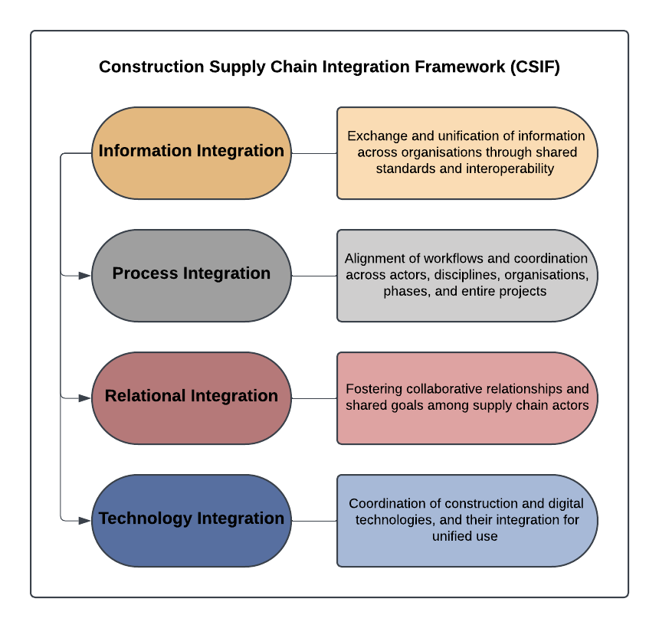
Figure 1. Construction Supply Chain Integration Framework (CSIF).

Process integration refers to the alignment of workflows and routines (Flager et al., 2009; Lu and Issa, 2005), both within discrete phases, such as design (Abrishami, Goulding and Rahimian, 2020) or production (Arashpour et al., 2016), and across disciplines, actors, organisations, supply chain phases, and entire projects (Cheng and Tsai, 2008; El-Gohary and El-Diraby, 2010; O'Connor and Dodd, 2000). It also encompasses overlaps between interlinked phases (Fischer et al., 2014), including design-fabrication (Ng, Graser and Hall, 2021), offsite-onsite coordination (Zeng, 2021), and design-construction integration (Tatum, 2018). Nevertheless, process integration alone is insufficient to improve performance without effective communication and information exchange, which are typically enabled by information and communication technologies (ICTs) (Dawood, Akinsola and Hobbs, 2002).
The construction supply chain constitutes a complex network of relationships (Almadhoob, 2020). Relational integration fosters collaboration and trust across phases (De Silva et al., 2017; Kumaraswamy, Anvuur and Smyth, 2010; Madhusanka et al., 2022), underpinned by shared goals and values (Smyth, Anvuur and Kusuma, 2017; Wong et al., 2014). It serves to align actors by linking organisational processes and systems (Smyth, Anvuur and Kusuma, 2017). One approach to achieving relational integration is through relational contracting (Palaneeswaran et al., 2003).
While digital technologies have enhanced decision-making and project performance, they have also contributed to increased fragmentation, underscoring the need for more integrated practices (Gielingh and Tolman, 1991; Larbi et al., 2025; Yu et al., 2022). Technology integration entails the alignment of construction technologies (e.g. design, materials, production), digital tools (e.g. BIM, Blockchain, AI, ML, IoT, VR, AR), and software/hardware systems (Brozovsky, Labonnote and Vigren, 2024). It also encompasses the integration of construction and digital technologies, such as BIM and 3D printing (Berawi et al., 2024; Gielingh and Tolman, 1991).
In addition to CSIF, this study draws on the BIM Integration Capability Framework (BICF) (Figure 2), developed through a prior systematic review (Gong, Broyd and Galera-Zarco, forthcoming). Whereas CSIF delineates the requisite integration types, namely, information, process, relational, and technology integration, BICF articulates how BIM contributes to fulfilling these requirements in construction projects. The framework comprises three components: BEIPs, BTMs, and CTMs. Aligned with the structure of CSIF, BICF provides a conceptual basis for analysing the role of BIM in addressing challenges related to SCI. In this study, it is applied specifically to OSC contexts.
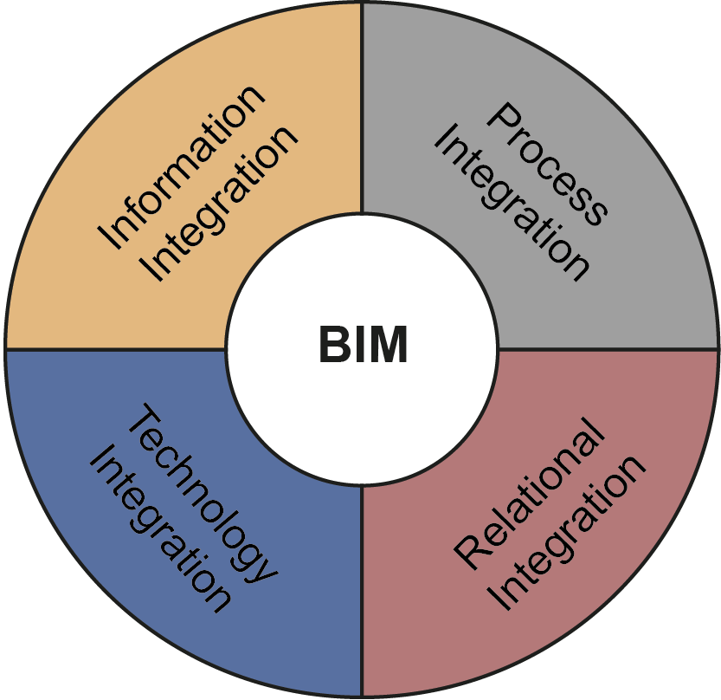
Figure 2: BIM Integration Capability Framework (BICF).

3. METHODOLOGY
3.1 Philosophical Position: Pragmatism
This study adopts a pragmatic stance, focusing on practical solutions to real-world challenges and generating actionable, context-specific insights (Creswell and Plano Clark, 2018; Johnson and Onwuegbuzie, 2004). This approach is well-suited to addressing the persistent fragmentation in construction supply chains and the need to foster integration through BEIPs.
Pragmatism also informed the methodological choices made, particularly the adoption of a qualitative, interview-based design. This design ensures alignment between research objectives, questions, and methods (Creswell and Creswell, 2023; Saunders et al., 2023).

3.2 Research Design and Interview Method
A qualitative, interview-based research design was employed to investigate how BIM facilitates SCI in OCPs. Semi-structured interviews were chosen for their balance of structure and flexibility, which is well suited to capturing detailed insights on BEIPs, BTMs, and CTMs (Berawi et al., 2024; Flick, 2014; Martin, Watson and Brooks, 2025; Pettigrew, 1997; Saunders, Lewis and Thornhill, 2023b). This format enabled a structured examination across the four dimensions of integration, while remaining open to the emergence of unanticipated, context-specific insights.
The interview protocol was explicitly informed by the study’s two conceptual frameworks: CSIF and BICF. These provided a structured lens through which expert reflections on BEIPs and technical mechanisms could be elicited and interpreted.

3.3 Participant Selection and Data Collection
Four experts were purposively sampled on the basis of their senior roles and extensive BIM experience within OSC contexts. Interviews were conducted remotely via Microsoft Teams between March and April 2025, with durations ranging from 30 to 60 minutes. All interviews focused on the use of BEIPs and associated technical mechanisms. Participants’ identities were anonymised, and their profiles are summarised in Table 1.

3.4 Data Analysis: Thematic Coding
Thematic analysis was applied to identify patterns across the interview data, thereby supporting the study’s pragmatic aim of generating practically relevant insights (Saunders, Lewis and Thornhill, 2023a). This analytic approach facilitated the interpretation of BEIPs and associated technical mechanisms while remaining anchored in the conceptual framing provided by the CSIF and BICF.
Following Braun and Clarke’s (2022) methodological guidelines, the analysis proceeded through familiarisation, initial coding, theme development, and theme refinement. Both inductive and deductive logics were employed: inductive coding enabled the identification of emergent insights, while deductive coding facilitated the mapping of integration capabilities against the established conceptual frameworks.
The analysis was conducted at two levels: first, to identify themes aligned with the CSIF and BICF; second, to surface novel, context-specific insights that extended or challenged these frameworks. This dual focus enabled conceptual fidelity while capturing situated experiences of integration practice within the industry.

Table 1: Interviewee Profile Summary

Participant ID | Profile Summary
P1 | Head of BIM at an owner organisation with 12 years of BIM experience and 5 years in OCPs.
P2 | Vice President of Client Innovation at a contractor with 15 years of BIM experience and 5 years in OCPs.
P3 | Architectural Manager at a manufacturer with 10 years of BIM experience and 3 years in OCPs.
P4 | Industrialised Construction Lead at a client organisation with 7 years of BIM experience and 6 years in OCPs.

4. FINDINGS
4.1 BIM-Enabled Integration Practices
This section presents expert insights into the application of BEIPs across the four phases of the OSCSC: planning and design, manufacture and pre-assembly, transportation, and onsite assembly and installation. BEIPs refer to BIM-enabled practices that address integration challenges across supply chain phases. Themes were identified through dual-level coding, informed by the BICF and CSIF.

Planning and Design: Parametric Content and Early Coordination
Participants emphasised the importance of early-stage design for downstream integration. A key BEIP was the use of manufacturer-specific parametric content to enhance coordination and model clarity. As P3 observed:
“If we’re better integrated from the start... you don’t get down the road and realise we didn’t actually use the right wall thickness.” (P3)
P1 described a transition from fragmented tools to integrated BIM-based processes, enabling issue tracking and procurement planning. Nonetheless, interoperability issues remain:
“Where it falls down is for manufacturers. If you issue them a Revit family... they’re not going to manufacture their piece of equipment from that. Normally they’ll convert it into a STEP file... it’s a complicated process.” (P1)
These insights point to early digital coordination, model authoring, and standardised content exchange as critical practices for enabling information and process integration, albeit constrained by software incompatibility.

Manufacture and Pre-assembly: Demand Forecasting and Data Continuity
BEIPs in this phase aim to align design data with production planning. P4 described real-time demand forecasting via BIM:
“We’re extracting procurement data from different models at the same time... to produce what our demand picture would look like over time... [so suppliers] don’t have to hold as much stock or storage space. They can business plan better.” (P4)
This practice supports factory synchronisation and supply planning through data lakes and visualisation tools. P2 underscored the importance of data consistency:
“Be able to have core data that will be designed correctly, then transformed in a correct manufacturing [workflow]... linking design, manufacturing, and installation ensures better outcomes than bespoke onsite construction.” (P2)
These accounts illustrate BIM’s role in bridging design and production, demonstrating value for both process and technology integration.

Transportation: QR Tagging and Lifecycle Tracking
Participants highlighted the use of QR tagging to track prefabricated components. As P2 explained:
“Attach QR codes... so we know where each single element is, if it’s transported, if it’s damaged, if it still needs to be fabricated, or has been installed on site.” (P2)
P4 discussed lifecycle integration through digital tracking:
“QR code individual components... go through factory, site delivery, construction, and into operation... so if there’s a failure, [the data] can trace back to the factory batch.” (P4)
These BEIPs facilitate transparency and traceability, reinforcing technology integration and digital continuity across the supply chain.

Onsite Assembly and Installation: Sequencing and Safety Coordination
Key BEIPs in this phase included clash detection, site planning, and 4D sequencing. P4 highlighted BIM’s function in planning safe and efficient site operations:
“It can be used to plan high-risk activities... to make it as safe and efficient as possible.” (P4)
P1 noted that BIM digitally integrates workflows previously handled through separate systems, supporting integrated issue and risk management. These practices promote both process and relational integration by enhancing team coordination.

Cross-Phase Insights and Integration Effects
Participants widely agreed that BEIPs primarily support information and process integration, with relational and technology integration emerging as secondary effects. As P2 noted:
“Information and process... must be the main enhancement across offsite manufacturing.” (P2)
P3 remarked:
“The big ones for me are information and technology... collaboration and process come with that... but they’re facilitated by it.” (P3)
P4 emphasised cumulative efficiency:
“It’s efficiency overall... lack of repeat work... and through to FM. If you’ve got a complete asset register... then those things don’t have to be repeated.” (P4)

4.2 BIM Technical Mechanisms (BTMs)
This section presents BTMs that underpin BEIPs and support the integration capabilities defined in the BICF. BTMs refer to BIM's internal functionalities that address integration challenges across supply chain phases. The findings are structured according to the four integration pillars of the CSIF.

Automated Quantity Takeoff and Data-Driven Planning
Automated quantity takeoff was frequently identified as a BTM supporting both information and process integration. P4 described its use across federated models:
“Automated quantity takeoff… that ability to measure from the model or from, in my case, several different models, and have the intelligence to know which bits to take where.” (P4)
P2 noted its application in logistics planning:
“We are able to automatically understand the quantities, the elements… then relate to the cost… [and plan] how to transport on site, where they have to be stored and how to install on site on specific timeline.” (P2)
This BTM facilitates data consistency and synchronisation across design and manufacturing stages.

4D Scheduling and Logistics Coordination
4D scheduling, which integrates time data into BIM models, was recognised as facilitating logistics coordination and adaptive planning. P4 commented:
“A supplier that supplies many sites can amend his or her delivery schedule to be in line with the site that is sort of the most forward-thinking.” (P4)
Both P2 and P4 acknowledged its dynamic planning potential, although P4 expressed concerns:
“From my experience… there’s been the idea that we would have this link and have that real-time data exchange etcetera, but it just hasn’t really happened in real life.” (P4)
This highlights a gap between the expected and actual maturity of BIM in supporting process and technology integration.

Information Delivery and Exchange Protocols
Standards for information delivery, such as client requirements and BIM Execution Plans (BEPs), were regarded as essential. P1 emphasised their foundational role:
“An information delivery standard accompanied by robust set of client requirements, followed by a robust BIM execution plan… and then the subcontractor inputting into that… would be what really underpins success.” (P1)
These protocols promote transparency, coordination, and information integration across project stages. P3 noted the benefits of shared BIM inputs for improving interoperability:
“Currently we have to develop it manually… having a BIM input will make it a lot easier… you can put it in and see, OK, yeah, that’s how it’s working.” (P3)

Real-Time Data Exchange and Interoperability Challenges
Real-time data exchange was considered beneficial for early-stage design coordination. As P4 explained:
“Real-time data exchange… is really important in early-stage design… so you don’t have MEP designers designing over here, structural guys over there, an architect somewhere else.” (P4)
However, implementation remains uneven. P3 noted continued reliance on manual updates and questioned its relevance to manufacturing:
“Scheduling… I don’t know that it will make as much of an impact, at least on us… but really it’s just about how information’s being passed around and how things can be added to it, imported, etc.” (P3)
These findings illustrate inconsistencies in implementation across stakeholders and integration types.

4.3 Complementary Technical Mechanisms (CTMs)
Beyond BIM’s internal mechanisms, participants identified several CTMs, that is, external tools, platforms, and systems, that enhance the effectiveness of BEIPs across the OSCSC.

Cloud-Based Common Data Environments
All participants highlighted the significance of cloud-based common data environments (CDEs) in enabling real-time, shared access to project information. P2 described the CDE as fundamental to BIM’s functionality:
“At the end of the day, BIM is a process and it's management information and needs a shared place like a common data environment to do [it]… it's a fundamental aspect to be able to deliver a project.” (P2)
CDEs were considered essential for information integration, improving coordination across teams, models, and time zones. P4 noted their role in promoting transparency in managing federated models.

RFID-Based Material Tracking
Radio-Frequency Identification (RFID) was cited by P2 and P4 as key to tracking component status and movement:
“RFID… is a process on how to link information to a specific code. We know exactly when someone’s [component is] designed, built, manufactured, transported on site.” (P2)
RFID was seen to support traceability and real-time tracking, thereby facilitating both process and technology integration across manufacturing, transport, and installation stages.

Open Standards and Interoperability Formats
P1 pointed to Industry Foundation Classes (IFC) and other open formats as enablers of software interoperability:
“IFC is more of like a mechanism to take one file to another file format… [It] helps to reduce the amount of rework… or change it into a usable information format for the offsite manufacturer.” (P1)
These standards were viewed as supporting both information and technology integration by enabling data exchange across disparate software systems and reducing conversion errors.
Manufacturing Software Suites
P3 described MiTek, a manufacturing tool used for estimating and fabricating components, as reliant on accurate BIM data:
“It’s not something that an architect would ever use… but we use it up front and at the end to do estimating… [then] get our cost information… and feedback to [designers].” (P3)
Such tools enable iterative feedback between design and manufacturing, contributing to process integration.

AI-Driven Site Monitoring and Analytics
P4 discussed AI tools used to assess site conditions in relation to BIM models for safety and progress tracking:
“It looks at what’s actually there and… what is gonna be built. Then assesses any hazards and… sends health and safety people out.” (P4)
“[It can] look at the progress of a build against the programme and then recast… the programme.” (P4)
These tools were considered to support process and technology integration by enabling real-time diagnostics and adaptive planning.

Blockchain-Enabled Smart Contracts
Although not yet in use, P4 saw potential in blockchain for automating payments:
“If that can be solved, then that’ll be really, really powerful… But [the challenge is] the quality of workmanship. It’d be quite hard to create project milestones and digital verification… which would satisfy the quality aspect.” (P4)
While promising for process and relational integration, adoption was hindered by unresolved quality assurance concerns.

5. DISCUSSION
The findings indicate that BEIPs are applied variably across OSCSC phases yet collectively support SCI by aligning with the four integration dimensions defined in the CSIF. These practices are underpinned by BTMs (e.g. quantity take-off, 4D scheduling) and extended through CTMs (e.g. CDEs, RFID, open standards), which together constitute the operational foundation of the BICF.

5.1 BEIPs and Cumulative Integration Effects
BEIPs are most prevalent in the Planning and Design phase, where early coordination and parametric modelling align design intent with manufacturing requirements, advancing information and process integration. Nonetheless, limited interoperability between design and fabrication systems remains a persistent challenge.
In the Manufacture and Pre-assembly phase, practices such as demand forecasting and real-time visualisation support just-in-time production and waste reduction. However, these outcomes are contingent on the quality and compatibility of upstream data.
In the Transportation phase, QR-based tracking and logistics coordination enhance traceability and establish continuity between upstream design and downstream delivery, contributing to a digital ‘golden thread’.
During Onsite Assembly and Installation, 4D sequencing, clash detection, and safety planning facilitate process and relational integration through improved coordination and risk mitigation. These outcomes depend not only on digital tools but also on sustained collaborative engagement.
Participants highlighted integration effects across phases, such as data continuity and shared situational awareness. These insights suggest that BEIPs, when supported by BTMs and CTMs, operate as cumulative enablers of integration across OSCSC, rather than discrete or isolated interventions.

5.2 Technical Mechanisms and Interdependencies
BTMs underpin BEIPs by supporting planning, coordination, and communication. However, their effectiveness is constrained by ongoing interoperability issues and the persistence of proprietary data environments, particularly at the interface between BIM and manufacturing tools.
CTMs help mitigate these limitations. CDEs enhance model accessibility and collaboration; RFID enables traceability at the component level; AI applications support safety management and progress tracking.
BTMs and CTMs interact asymmetrically. For instance, 4D BIM requires robust CDEs to function effectively. Conversely, BIM lacks the adaptability for advanced uses such as AI or blockchain, which depend on external infrastructures and tailored rule sets.
Accordingly, BIM’s integrative capacity is best realised within a broader digital ecosystem in which complementary tools bridge technical boundaries and support sustained integration across the OSCSC.

6. CONCLUSIONS
This study examined how BIM facilitates SCI in OCPs by identifying BEIPs, the underlying technical mechanisms embedded in BIM (BTMs), and external tools and technologies that interact with or extend BIM integration capabilities (CTMs). Guided by the CSIF and BICF, the study addressed two research questions: (1) to identify BEIPs that support SCI in OCPs, and (2) to uncover the technical mechanisms through which these practices operate.
Findings indicate that BEIPs span all OSCSC phases, with the highest concentration in planning and design. Practices such as parametric modelling, forecasting, QR logistics, and 4D sequencing facilitate both information and process integration. Their integration effects often extend across phases, generating cumulative benefits such as data continuity, traceability, and improved lifecycle transparency. While relational and technology integration appeared less explicitly, they frequently emerged as secondary outcomes of well-coordinated BEIPs.
BTMs, such as automated quantity take-off, 4D scheduling, real-time exchange protocols, and information delivery standards, support planning and coordination but encounter interoperability challenges, particularly with downstream tools. CTMs, including cloud-based CDEs, RFID tracking systems, open standards (e.g. IFC), and AI-driven site monitoring tools, help address these limitations and extend BIM’s integrative capacity. Their interdependence highlights the need for a broader digital ecosystem to support effective SCI.
Theoretically, this study contributes to the emerging literature on the role of BIM in facilitating SCI by conceptualising BIM integration capabilities as layered. It delineates between BIM’s core digital functionalities, referred to as BTMs, and external, complementary tools and technologies (CTMs), and explicates how these mechanisms are mobilised through BEIPs to address the multifaceted requirements of SCI. Practically, the findings offer a structured account of how BEIPs can be deployed across phases of OSCSC, and identify the specific mechanisms critical to each phase. The analysis underscores the significance of early-stage design alignment, the maintenance of continuous data flow, and the orchestration of digital tools as foundational elements for achieving effective integration.
Simultaneously, the findings highlight persistent limitations in the current implementation of BIM in OSC. Participants identified ongoing challenges, including software interoperability issues, partial real-time data integration, and inconsistent adoption of standardised digital workflows. These constraints indicate that, although BIM functions as a key enabler of SCI, its potential remains contingent upon the maturity and coherence of the broader digital infrastructure within which it is embedded.
Additionally, the study’s qualitative insights are derived from a limited number of expert interviews, which may constrain the generalisability of the findings. Although the purposive sampling of senior professionals enhances the depth and relevance of the data, future research should seek to broaden the sample to validate and refine the proposed frameworks across a wider range of contexts.
Future research could build on these insights by exploring how BIM-enabled integration is realised across a broader range of OSC contexts and delivery models. Comparative studies encompassing diverse project types, geographical locations, and levels of digital maturity would enhance the applicability and robustness of the proposed frameworks. Additionally, further examination of the relational and behavioural dynamics underpinning SCI, particularly in their interaction with digital practices, would offer valuable contributions to the field.
In conclusion, BIM does not function as a standalone solution but operates as an orchestrator of SCI in OSC when mobilised through targeted practices and underpinned by both internal and complementary technical mechanisms. Realising its full integrative potential necessitates not only the strategic deployment of BEIPs and the enhancement of BTMs, but also system-level planning aimed at cultivating a digitally connected, interoperable, and collaborative project environment.

REFERENCES
Abrishami, S., Goulding, J. and Rahimian, F. (2020). 'Generative BIM workspace for AEC conceptual design automation: prototype development'. Engineering, Construction and Architectural Management, 28 (2), 482-509.
Almadhoob, H. (2020). 'At the interface: when social network analysis and supply chain management meet'. In S. Pryke (Ed.), Successful construction supply chain management : concepts and case studies (2nd ed.). Hoboken, NJ: JohnWiley & Sons.
Arashpour, M., Wakefield, R., Abbasi, B., Lee, E. W. M. and Minas, J. (2016). 'Off-site construction optimization: sequencing multiple job classes with time constraints'. Automation in Construction, 71 (2), 262-270.
Bakhtiarizadeh, E., Shahzad, W. M., Poshdar, M., Khalfan, M. and Rotimi, J. O. B. (2021). 'Blockchain and information integration: applications in New Zealand’s prefabrication supply chain'. Buildings, 11 (12), 608.
Berawi, M. A., Sari, M., Oktaviani, A. D., Miraj, P., Susantono, B. and Woodhead, R. (2024). 'Impact of BIM and 3D printing technologies on production process and productivity of precast concrete in construction project'. International Journal of Construction Management, 25 (6), 650-660.
Braun, V. and Clarke, V. (2022). Thematic analysis: a practical guide. Thousand Oaks: SAGE Publications Ltd.
Brozovsky, J., Labonnote, N. and Vigren, O. (2024). 'Digital technologies in architecture, engineering, and construction'. Automation in Construction, 158, 105212.
Cheng, M.-Y. and Tsai, M.-H. (2008). 'Cross-organization process integration in design–build team'. Automation in Construction, 17 (2), 151-162.
Cheng, Z., Tang, S., Liu, H. and Lei, Z. (2023). 'Digital technologies in offsite and prefabricated construction: theories and applications'. Buildings, 13 (1), 163.
Creswell, J. W. and Creswell, J. D. (2023). Research design: qualitative, quantitative, and mixed methods approaches. (6th ed.). Los Angeles: SAGE.
Creswell, J. W. and Plano Clark, V. L. (2018). Designing and conducting mixed methods research. (3rd ed.). Thousand Oaks, California: SAGE.
Dainty, A. R. J., Briscoe, G. H. and Millett, S. J. (2001). 'Subcontractor perspectives on supply chain alliances'. Construction Management and Economics, 19 (8), 841-848.
Dawood, N., Akinsola, A. and Hobbs, B. (2002). 'Development of automated communication of system for managing site information using internet technology'. Automation in Construction, 11 (5), 557-572.
De Silva, N., Weerasinghe, R. P. N. P., Madhusanka, H. W. N. and Kumaraswamy, M. (2017). 'Relationally integrated value networks (RIVANS) for total facilities management (TFM)'. Built Environment Project and Asset Management, 7 (3), 313-329.
Doran, D. and Giannakis, M. (2011). 'An examination of a modular supply chain: a construction sector perspective'. Supply Chain Management, 16 (4), 260-270.
Dulaimi, M. F., Ling, F. Y. Y., Ofori, G. and Silva, N. D. (2002). 'Enhancing integration and innovation in construction'. Building Research & Information, 30 (4), 237-247.
El-Gohary, N. M. and El-Diraby, T. E. (2010). 'Dynamic knowledge-based process integration portal for collaborative construction'. Journal of Construction Engineering and Management, 136 (3), 316-328.
Ezcan, V., Isikdag, U. and Goulding, J. S. (2013, May 5-9). BIM and off-site manufacturing: recent research and opportunities. Paper presented at the 19th CIB World Building Congress. Brisbane, Australia.
Fischer, M., Reed, D., Khanzode, A. and Ashcraft, H. (2014, June 25-27). A simple framework for integrated project delivery. Paper presented at the 22nd Annual Conference of the International Group for Lean Construction. Oslo, Norway.
Flager, F., Welle, B., Bansal, P., Soremekun, G. and Haymaker, J. (2009). 'Multidisciplinary process integration and design optimization of a classroom building'. Journal of Information Technology in Construction, 14 (38), 595-612.
Flick, U. (2014). An introduction to qualitative research. (5th ed.). London: SAGE.
Gielingh, W. F. and Tolman, F. P. (1991). 'Information integration in the building and construction industries'. Computer-Aided Civil and Infrastructure Engineering, 6 (4), 329-334.
Gong, Y., Broyd, T. and Galera-Zarco, C. (forthcoming, July 14-17). Building Information Modelling (BIM) integration capabilities for supply chain integration in construction: a systematic review. Paper presented at the 2025 European Conference on Computing in Construction. Porto, Portugal.
Green, S. D. (2022). 'Modern methods of construction: reflections on the current research agenda'. Buildings and Cities, 3 (1), 653-662.
HM Government. (2015). Digital Built Britain Level 3 Building Information Modelling - Strategic Plan. London, UK: HM Governmnet.
ISO (2018). ISO 19650-1:2018 Organization and digitization of information about buildings and civil engineering works, including building information modelling (BIM) - Information management using building information modelling - Part 1: Concepts and principles.
Jiang, S., Jiang, L., Han, Y., Wu, Z. and Wang, N. (2019). 'OpenBIM: an enabling solution for information interoperability'. Applied Sciences, 9 (24), 5358.
Jiang, Y., Liu, X., Wang, Z., Li, M., Zhong, R. Y. and Huang, G. Q. (2023). 'Blockchain-enabled digital twin collaboration platform for fit-out operations in modular integrated construction'. Automation in Construction, 148, 104747.
Johnson, R. B. and Onwuegbuzie, A. J. (2004). 'Mixed methods research: a research paradigm whose time has come'. Educational Researcher, 33 (7), 14-26.
Kang, Y., O’Brien, W. J. and O’Connor, J. T. (2015). 'Information-integration maturity model for the capital projects industry'. Journal of Management in Engineering, 31 (4), 04014061.
Koolwijk, J. S. J., van Oel, C. J., Wamelink, J. W. F. and Vrijhoef, R. (2018). 'Collaboration and integration in project-based supply chains in the construction industry'. Journal of Management in Engineering, 34 (3), 04018001.
Kumaraswamy, M. M., Anvuur, A. M. and Smyth, H. J. (2010). 'Pursuing “relational integration” and “overall value” through “RIVANS”'. Facilities, 28 (13/14), 673-686.
Larbi, J. A., Tang, L. C. M., Ababio, B. K. and Antwi-Afari, P. (2025). 'Developing an integrated digital delivery framework for designing and planning construction projects: a review of interoperable digital technologies'. International Journal of Construction Management, 25 (3), 347-362.
Lessing, J., Stehn, L. and Ekholm, A. (2015). 'Industrialised house-building – development and conceptual orientation of the field'. Construction Innovation, 15 (3), 378-399.
Lu, H. and Issa, R. R. A. (2005). 'Extended production integration for construction: a loosely coupled project model for building construction'. Journal of Computing in Civil Engineering, 19 (1), 58-68.
Madhusanka, N., Kumaraswamy, M. M., Pan, W. and Chan, S. Y. S. (2022). 'Relationally integrated value networks for total asset management in project portfolios'. Infrastructure Asset Management, 9 (3), 123-134.
Martin, H., Watson, C. and Brooks, T. (2025). 'Synergizing BIM and RIBA in architectural practice - technology workflow efficiencies, challenges, and insights'. Architectural Engineering and Design Management, 21 (1), 35-59.
Masood, R., Lim, J., González, V., Roy, K. and Khan, K. I. A. (2022). 'A systematic review on supply chain management in prefabricated house-building research'. Buildings, 12 (1), 40.
Mitropoulos, P. and Tatum, C. B. (2000). 'Management-driven Integration'. Journal of Management in Engineering, 16 (1), 48-58.
Molad, C. and Back, W. E. (1995). 'EDI's role as an enabler for electronic commerce and information integration'. Engineering, Construction and aAchitectural Management, 2 (2), 93-104.
Ng, M. S., Graser, K. and Hall, D. M. (2021). 'Digital fabrication, BIM and early contractor involvement in design in construction projects: a comparative case study'. Architectural Engineering and Design Management, 19 (1), 39-55.
Nguyen, D. T. and Le, P. L. (2022). 'Twenty-year application of logistics and supply chain management in the construction industry'. Construction Management and Economics, 40 (10), 796-834.
O'Connor, J. T. and Dodd, S. C. (2000). 'Achieving integration on capital projects with enterprise resource planning systems'. Automation in Construction, 9 (5), 515-524.
Palaneeswaran, E., Kumaraswamy, M., Rahman, M. and Ng, T. (2003). 'Curing congenital construction industry disorders through relationally integrated supply chains'. 38 (4), 571-582.
Pan, W., Gibb, A. G. F. and Dainty, A. R. J. (2007). 'Perspectives of UK housebuilders on the use of offsite modern methods of construction'. Construction Management and Economics, 25 (2), 183-194.
Pan, W., Pan, M. and Yang, Y. (2023). 'A dialectical system framework for enhancing the modular construction supply chain'. Proceedings of the Institution of Civil Engineers - Engineering Sustainability, 177 (4), 187-199.
Pettigrew, A. M. (1997). 'What is a processual analysis?'. Scandinavian Journal of Management, 13 (4), 337-348.
Power, D. (2005). 'Supply chain management integration and implementation: a literature review'. Supply Chain Management, 10 (4), 252-263.
Saunders, M. N., Lewis, P. and Thornhill, A. (2023a). 'Analysing data qualitatively'. In M. N. K. Saunders, P. Lewis and A. Thornhill (Eds), Research methods for business students (9th ed., pp. 650-712). Harlow, United Kingdom: Pearson Education Limited.
Saunders, M. N., Lewis, P. and Thornhill, A. (2023b). 'Collecting primary data using interviews and diaries'. In M. N. K. Saunders, P. Lewis and A. Thornhill (Eds), Research methods for business students (9th ed., pp. 440-505). Harlow, United Kingdom: Pearson Education Limited.
Saunders, M. N., Lewis, P., Thornhill, A. and Bristow, A. (2023). 'Understanding research philosophy and approaches to theory development'. In M. N. K. Saunders, P. Lewis and A. Thornhill (Eds), Research methods for business students (9th ed., pp. 128-174). Harlow, United Kingdom: Pearson Education Limited.
Smyth, H., Anvuur, A. M. and Kusuma, I. (2017). 'Integrated solutions for total asset management through “RIVANS”'. Built Environment Project and Asset Management, 7 (1), 5-18.
Tatum, C. B. (2018). 'Construction engineering research: integration and innovation'. Journal of Construction Engineering and Management, 144 (3), 04018005.
Tezel, A. and Koskela, L. (2023). 'Off-site construction in highways projects: management, technical, and technology perspectives from the United Kingdom'. Construction Management and Economics, 41 (6), 475-499.
Viljamaa, E. and Peltomaa, I. (2014). 'Intensified construction process control using information integration'. Automation in Construction, 39, 126-133.
Vrijhoef, R. (2011). Supply chain integration in the building industry: the emergence of integrated and repetitive strategies in a fragmented and project-driven industry. Amsterdam, Netherlands: IOS Press.
Wong, K. K. W., Kumaraswamy, M., Mahesh, G. and Ling, F. Y. Y. (2014). 'Building integrated project and asset management teams for sustainable built infrastructure development'. Journal of Facilities Management, 12 (3), 187-210.
Wuni, I. Y. and Shen, G. Q. (2020). 'Critical success factors for modular integrated construction projects: a review'. Building Research & Information, 48 (7), 763-784.
Wuni, I. Y. and Shen, G. Q. (2023). 'Exploring the critical success determinants for supply chain management in modular integrated construction projects'. Smart and Sustainable Built Environment, 12 (2), 258-276.
Wuni, I. Y., Shen, G. Q. P. and Mahmud, A. T. (2022). 'Critical risk factors in the application of modular integrated construction: a systematic review'. International Journal of Construction Management, 22 (2), 133-147.
Yang, R., Wakefield, R., Lyu, S., Jayasuriya, S., Han, F., Yi, X., Yang, X., Amarasinghe, G. and Chen, S. (2020). 'Public and private blockchain in construction business process and information integration'. Automation in Construction, 118, 103276.
Yu, Y., Yazan, D. M., Junjan, V. and Iacob, M.-E. (2022). 'Circular economy in the construction industry: a review of decision support tools based on Information & Communication Technologies'. Journal of Cleaner Production, 349, 131335.
Zeng, N. (2021). BIM-enabled construction supply chain integration: bridging on-site and off-site processes. Ruhr-University Bochum, Bochum.

