End-of-Life as a Process Innovation Challenge in the Built Environment
A Paradigm Shift from Linear to Adaptive Systems
Habib Sadri*, Peter Johansson, Rahel Kebede, Annika Moscati

Department of Construction Engineering and Lighting Science, Jönköping School of Engineering, Gjuterigatan 5, 551 11 Jönköping, Sweden
*Corresponding email: habib.sadri@ju.se

ABSTRACT
This study conceptualizes product end-of-life (EoL) in the built environment as a production and process innovation challenge rather than a purely operational concern. While earlier lifecycle stages are supported by structured systems, EoL activities remain fragmented, reactive, and weakly integrated with digital infrastructures. Drawing on an interpretive and abductive research design, the study synthesizes insights from industry observations, expert interviews, site visits, and interdisciplinary dialogues. The findings reveal a persistent gap between the availability of digital data and its effective use in decision-making, highlighting that data alone does not enable circularity or efficiency without structured processes. Key challenges include fragmented workflows, lack of standardized process architecture, socio-technical complexity, and insufficient lifecycle integration. Building on these insights, the paper proposes a conceptual reframing of EoL as a structured production system characterized by integrated information flows, feedback mechanisms, and adaptive decision-making. It emphasizes the importance of aligning digital technologies with process design and organizational structures. The study contributes to the literature by shifting the focus from technology adoption to system structuring, offering a foundation for developing data-driven, circular, and adaptive production systems in the built environment.

- INTRODUCTION
Process innovation, also referred to in academic literature as production innovation, represents a significant change in the way an organization uses its resources to produce outputs (Qerimi et al., 2024). Unlike product innovation, which focuses on “what” is delivered to the external customer, process innovation concerns “how” products are produced and delivered. It involves introducing new components into a firm’s operations, more efficient workflows and information flows, or advanced equipment (Kurkkio et al., 2011). The key characteristics of process innovation set it apart from other forms of innovation through its internal orientation and its focus on improving efficiency. While product innovations are visible outcomes that attract attention in the market, process innovations are often less noticeable to end users, as they take place within the “black box” of a firm’s operational core (Damanpour & Gopalakrishnan, 2001).
The contemporary approach to process innovation is increasingly shaped by two major trends: the adoption of Industry 4.0 technologies and the shift toward sustainability-oriented innovation (Liu & De Giovanni, 2025; Ortiz‐Avram et al., 2024).
In the context of the built environment, Industry 4.0 refers to the integration of enabling technologies, including but not limited to the Internet of Things (IoT), cloud and edge computing, big data analytics, artificial intelligence (AI), machine learning (ML), blockchain, virtual reality (VR), and digital twin technologies (Pachouri et al., 2024).
Alongside these technological developments, the concept of green process innovation has gained increasing attention. Green process innovation in the built environment can be defined as the integration of the aforementioned digital tools, among others, into sustainability-oriented practices to enable resource-efficient, low-carbon, and adaptable environments. This perspective is supported by policy frameworks and a growing body of research that highlight the close interdependence between digitalization and sustainability (Kassem et al., 2025).
1.1 Problem Definition and objectives
The end-of-life (EoL) phase of products in the built environment remains largely unstructured and inefficient (Ossio et al., 2023). While earlier lifecycle stages such as design and production are supported by well-defined systems and processes, EoL activities, such as maintenance and replacement, are often handled in an ad-hoc manner (Akbarieh et al., 2020). This challenge suggests that the problem is not the absence of data, but the absence of a structured system to organize and use that data (Bellini et al., 2024).
This study aims to conceptually reframe the EoL phase as a process innovation problem, rather than a purely operational or maintenance issue. Accordingly, it seeks to identify key gaps in current EoL practices, interpret these gaps through a production and process innovation lens, and propose a conceptual understanding of EoL as a structured production system. In addition, the study aims to clarify the role of data infrastructures and tools in enabling this transformation.
- THEORETICAL LENS
The study adopts a production and process innovation perspective, where innovation is defined as changes in how processes and systems are organized to create value. The focus is not on introducing new technologies, but on structuring workflows, information flows, and decision-making. From this perspective, EoL can be analysed as a missing or underdeveloped system.
The study also draws on circular economy principles, emphasizing value retention through reuse and repair. However, it argues that circularity requires structured processes, not just data availability (Ranasinghe et al., 2024). Furthermore, this study is grounded in the principles of Socio-Technical Systems (STS), which emphasize the joint optimization of technological and social elements through stakeholder involvement and interdisciplinary collaboration, thereby enabling more effective and human-centred implementation of digital innovations (Guest et al., 2022).
Within this approach, inputs consist of existing assets and their associated data, processes include inspection, diagnosis, and decision-making activities, and outputs result in repaired, reused, or replaced components. While these elements are already present, they are not yet fully structured into a coherent and integrated system. Consequently, decision-making remains largely reactive and experience-based rather than being guided by a system-driven logic. From a process innovation point of view, the key challenge is therefore to design and formalize this system by structuring information flows, enabling feedback through the use of historical data, and integrating decision-making processes into a consistent and systematic framework.
- METHOD
This study adopts a qualitative and interpretive research design aimed at developing a conceptual understanding of process innovation in the built environment. Because this position paper seeks to conceptually reframe EoL rather than test a predefined model, an interpretive approach (Babones, 2016) was combined with abductive reasoning to iteratively connect patterns from complementary empirical sources with process-innovation and socio-technical theory.
The empirical basis of the study is derived from multiple complementary sources collected between January and April 2026. First, insights were collected through three site/lab visits to innovation-intensive enterprises in Sweden, including firms working with automation, manufacturing, and digital transformation, enabling direct observation of ongoing digitalization practices in real-world industrial contexts. Second, participation in two industrial events and conferences, provided exposure to current industry challenges, trends, and practitioner perspectives related to digitalization, circularity, sustainability, and process innovation. Third, the study draws on interdisciplinary research dialogues among scholars from diverse engineering domains, facilitating the integration of multiple theoretical and technical viewpoints. In addition, the study draws on insights from semi-structured interviews previously conducted as part of a broader research project. These interviews involved industry professionals working with digitalization and asset management within the built environment. The interviews were used as a complementary source of insight to support and critically reflect upon observations and discussions from other empirical sources, providing perspectives on current EoL practices, data utilization challenges, and barriers to implementing feedback-driven processes.
The analysis followed an iterative and abductive logic, moving back and forth between empirical insights and theoretical concepts. To identify missing pieces of the puzzle and establish connections between heterogeneous empirical insights, recent literature was also explored and utilized to support the analysis. Through this process, recurring themes related to linear process structures, data fragmentation, and the lack of integrated feedback mechanisms were identified and synthesized. These themes informed the development of a conceptual framework that reinterprets digitalization as a transition from control-oriented, sequential processes toward adaptive, data-driven systems characterized by continuous feedback and recursive decision-making. Figure 1 illustrates the study’s roadmap, depicting the overall research process and its key stages.
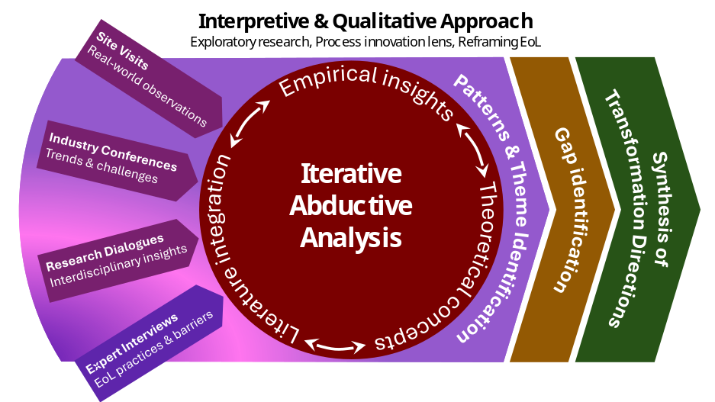
Figure 1: The research process from empirical inputs to abductive analysis and conceptual synthesis.
- EXPLORATORY OBSERVATIONS
Drawing on the empirical data analysed in this study, this section synthesizes key observations that provide a foundation for understanding the EoL phase as a process innovation challenge. While these observations are not derived from a single case study, they collectively reveal recurring patterns across multiple industrial contexts, particularly in relation to digitalization, circularity, and system-level transformation. These patterns are structured in the following subsections to highlight key challenges, systemic gaps, and emerging transformation directions.
4.1 Fragmentation of EoL-Related Activities
A consistent observation across different industrial sectors is the fragmented and unstructured nature of activities associated with resource recovery, reuse, and maintenance. Interview insights also confirm that such activities are often handled through disconnected documentation systems and rely heavily on individual experience rather than standardized procedures. Although many of the core elements of EoL processes, such as inspection, repair, and material recovery, are present in practice, they are not organized into coherent and integrated systems. Instead, these activities are often performed in an ad-hoc and context-dependent manner, with limited traceability of previous interventions or maintenance history at the component level, lacking standardized workflows and clearly defined process logic. From a process innovation perspective, this reflects a structural gap, where the absence of system design limits the ability to create consistent and scalable value.
4.2 Data-Structure Gap in Circular Systems
Another key observation is the widespread availability of data across industrial systems, contrasted with a limited ability to systematically utilize it for decision-making. Companies generate extensive technical and sustainability data (e.g., LCA and EPD), while advanced monitoring technologies, sensor systems, and digital platforms enable detailed tracking of processes and resource flows. Yet decision-making often remains reactive and experience-based rather than data-driven (Colombari et al., 2023), due to fragmented data ownership, limited interoperability, and unclear responsibilities across lifecycle stages. This highlights a critical gap between digitalization and value creation: data alone does not improve outcomes unless embedded within structured processes and decision rules. The gap is particularly evident in circular economy initiatives, where challenges are often structural rather than technological. Despite the technical feasibility of reusing waste streams such as industrial heat, by-products, and organic waste, implementation remains difficult to scale because of weak system integration, reverse logistics challenges, limited coordination across value chains, and the absence of lifecycle-based business models.
From this perspective, circularity can be understood as a production system challenge, where value retention depends on process design and coordination rather than solely on the availability of materials or technologies.
4.3 Socio-Technical Complexity
A further recurring pattern is the strong dependency on multi-stakeholder collaboration. Many sustainability and circularity initiatives require coordination among industry actors, public institutions, research organizations, and local communities. Interview data also highlights complexities related to data ownership, access rights, and responsibility allocation across stakeholders.
These observations emphasize the inherently socio-technical nature of EoL systems. Technical solutions alone are insufficient; successful implementation depends on aligning organizational structures, incentives, and stakeholder interests (Kompella, 2020), particularly where regulatory frameworks, such as data protection rules, constrain lifecycle information flows. Regulatory constraints, public perception, and economic feasibility often emerge as critical barriers, sometimes outweighing technical considerations (Chau et al., 2025). This reinforces the relevance of an STS perspective, in which system performance depends on the joint optimization of technological and social components.
4.4 Shift Toward System-Level and Lifecycle Thinking
The insights also indicate a broader shift from process-level optimization toward system-level and lifecycle-oriented thinking. This trend is reflected in growing attention to product traceability, lifecycle transparency, and the integration of design, production, use, and EoL phases through shared data infrastructures. Increasing focus on value chain emissions further highlights the need to understand production systems beyond individual firms and industries. As a result, value creation and sustainability performance are increasingly distributed across interconnected processes and actors. Consequently, EoL can no longer be treated as an isolated phase but must be integrated into a broader production ecosystem (Mathur et al., 2023), where information continuity and lifecycle feedback become critical enablers of system performance.
4.5 Toward Adaptive and Data-Driven Production Systems
Finally, multiple observations point to a growing need for flexibility, speed, and adaptability in industrial systems. Rapid technological change, geopolitical uncertainty, and sustainability pressures are driving a shift toward more reconfigurable and data-driven production models. This transformation is enabled by digital technologies such as AI, simulation tools, and real-time monitoring systems (Jeong, 2023). However, their effectiveness depends on integration into structured production systems with clearly defined processes and feedback mechanisms, which is often hindered by fragmented architectures and the lack of closed-loop data flows. Viewed through a process innovation lens, future EoL systems should therefore be designed as adaptive and learning systems, capable of continuously incorporating new data and responding to changing conditions. This would support a transition from reactive, experience-based practices to systematic and feedback-driven decision-making.
Table 1 presents a comparative synthesis of the identified patterns and insights across multiple perspectives, highlighting key industrial challenges, built environment observations, and their implications from a process innovation perspective.
Taken together, the observations outlined in this section support a reinterpretation of EoL as a process innovation problem. The key challenges identified (fragmentation, underutilized data, lack of process structure, and socio-technical complexity) are not isolated issues, but interconnected aspects of an underdeveloped system. This reinforces the central argument that improving EoL performance requires not only technological solutions but also a structured production system that systematically integrates information flows, decision-making, and stakeholder interactions.
Table 1: An overview of patterns and insights across multiple perspectives on EoL system transformation.
Key Patterns and Transformation Dynamics | Industrial Challenges | Built Environment Insights | Process Innovation Takeaway
Fragmented EoL Processes | - EoL activities fragmented and ad-hoc  - Lack of standardized workflows  - No integrated system structure | - Reactive, experience-based practices  - No formal workflows or traceability | - Missing process architecture  - Lack of standardization limits scalability  - EoL not formalized as a production system
Data-Structure Gap in Circular Systems | - Data available but underutilized  - Structural barriers (coordination, logistics)  - Circularity limited by system design | - Data fragmented and not decision-oriented  - Weak link between data and action  - Limited feedback from use phase | - Data not embedded in processes  - Lack of decision-support structures  - Absence of feedback integration  - Circularity as process design challenge
Socio-Technical Complexity | - Multi-stakeholder dependency  - Barriers: regulation, incentives  - Need for STS alignment | - Unclear data ownership  - Organizational misalignment | - Need for role clarity and governance  - Alignment of social and technical systems  - Coordination as core process requirement
System-Level and Lifecycle Integration Shift | - Interconnected value chains  - EoL must be integrated | - Disconnected lifecycle phases  - Lack of information continuity | - Need for end-to-end process integration  - EoL as part of continuous production system  - Lifecycle-wide information flows
Adaptive and Data-Driven Production Shift | - Need for flexible, adaptive systems  - Enabled by AI and monitoring  - Requires structured processes | - Systems remain linear  - Limited use of feedback and data loops  - Potential of digital tools | - Shift from linear to feedback-driven systems  - Importance of closed-loop processes  - Adaptive and learning system design

- DISCUSSION
Building on the exploratory observations presented in the previous section, this section moves beyond the identification of empirical patterns to provide a deeper interpretative discussion of the underlying systemic, organizational, and conceptual dynamics shaping EoL systems, examined through multiple complementary perspectives, as presented in the following subsections.
5.1 Circular Business Models as the Missing Operational Layer
While the findings of this study highlight structural and process-related deficiencies in the EoL phase, a deeper interpretation suggests that these challenges stem not only from technological or organizational limitations, but also from the absence of appropriate business logic (Ibarra et al., 2026). Current EoL practices in the built environment remain largely embedded within linear business models (Izquierdo Ruben Salazar et al., 2024), where value creation is concentrated in production and delivery, while the end-of-life stage is often treated primarily as a cost. Consequently, there is little economic incentive to invest in structured processes for reuse, repair, or recovery.
From this perspective, circular business models represent the missing operational layer linking process innovation to value creation. Without mechanisms that allow actors to capture value from extended product lifecycles, structured EoL systems remain economically difficult to sustain. The transformation of EoL into a production system is therefore not only a process design challenge but also a business model innovation challenge, requiring the alignment of incentives, revenue streams, and cost structures with circular flows.
5.2 Product-Service Systems and the Death of Ownership
A critical but often overlooked dimension of EoL inefficiencies lies in the prevailing ownership structures that underpin current production systems. In traditional models, ownership is transferred to the end-user at the point of sale, effectively disconnecting manufacturers from the operational phase of the product (Jensen & Remmen, 2017). This separation limits the availability of lifecycle data, reduces accountability for long-term performance, and weakens incentives for designing products that are repairable, reusable, or adaptable over time.
Product-Service Systems (PSS) challenge this paradigm by shifting the focus from ownership to access and performance. Rather than selling products, producers deliver them as services and retain control over assets throughout their lifecycle (McAloone & Andreasen, 2002). This reconfiguration transforms EoL processes from reactive maintenance activities into integral elements of continuous value creation. From a process innovation standpoint, PSS enables the closure of feedback loops by aligning economic incentives with lifecycle performance and supporting the integration of data, decision-making, and process control across lifecycle phases.
5.3 Temporal Misalignment: Long Lifetimes vs. Short Data Cycles
Another underexplored challenge in the built environment is the temporal mismatch between the long lifespans of physical assets and the much shorter lifecycles of digital systems and data infrastructures. Buildings and their components are designed to last for decades, whereas digital technologies, software platforms, and data standards evolve rapidly and may become obsolete within a few years (Marsh, 2017; Sawhney et al., 2020). As a result, data generated during earlier lifecycle stages may become inaccessible, incompatible, or less relevant over time, limiting its value for EoL decision-making. In process innovation terms, this challenge highlights the need for data infrastructures that can withstand technological change while ensuring long-term information continuity. Addressing this temporal gap is essential for enabling feedback-driven and adaptive EoL systems that operate effectively over extended time horizons.
5.4 Standardization vs. Innovation Paradox
The transition toward structured and data-driven EoL systems may also give rise to a fundamental tension between the need for standardization and the desire for innovation (Kim, 2025). From one perspective, standardization is essential for enabling interoperability, ensuring data consistency, and supporting scalable system architectures across multiple actors and platforms. Without common standards for data formats, identification systems, and information exchange, the integration required for lifecycle-wide processes remains difficult to achieve. From another perspective, excessive standardization may constrain flexibility and limit the capacity for innovation, particularly in rapidly evolving technological environments. As companies experiment with new materials, digital tools, and business models, rigid standards can become barriers rather than enablers.
This creates a paradox in which the very structures needed to enable system-level coordination may simultaneously restrict the adaptive capabilities required for innovation (Eriksson et al., 2026; Kim, 2025). Addressing this tension requires a balanced approach, where standards are designed to be modular, evolvable, and open-ended, allowing for both interoperability and experimentation within EoL systems.
Figure 2 synthesizes observed industry patterns presented in Section 4 to identify a core systemic gap in EoL systems and, based on the discussions in this section, outlines key transformation directions to address it.
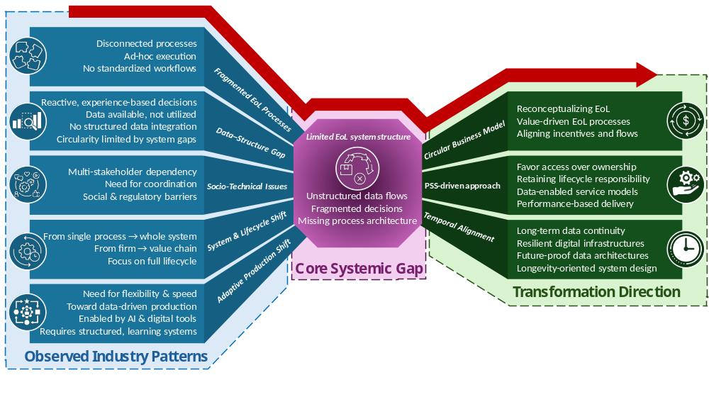
Figure 2: Linking industry patterns to systemic gaps and transformation directions in EoL systems
- CONCLUSION
This study set out to reconceptualize the EoL phase of products in the built environment through the lens of production and process innovation. The findings demonstrate that the core challenge is not the lack of data or technological capability, but the absence of a structured system that integrates processes, information flows, and decision-making across lifecycle stages. Current EoL practices remain fragmented, reactive, and heavily dependent on individual experience, limiting their scalability and effectiveness. By synthesizing empirical observations and theoretical perspectives, the study identifies several interconnected systemic gaps, including the fragmentation of EoL activities, the disconnect between data availability and its operational use, and the socio-technical complexity of multi-stakeholder environments. These challenges collectively point to the need for a paradigm shift from linear, control-oriented processes toward adaptive, feedback-driven production systems.
Achieving this transformation requires coherent process architectures, the integration of lifecycle data into decision-making, and the alignment of organizational and business models with circular value creation. In this context, circular business models and product-service systems emerge as critical enablers, providing the conditions needed to sustain structured EoL systems. This transformation also aligns with emerging Industry 5.0 perspectives that emphasize human-centricity, resilience, and sustainability, highlighting that digital technologies should augment human capabilities within well-designed and responsibly governed systems.
Moreover, the study highlights two key tensions: balancing standardization with innovation and aligning long-lived assets with rapidly evolving digital systems. Addressing them requires flexible, modular, and future-proof designs based on a shared process logic for stage-specific technologies and decisions, rather than a uniform lifecycle solution. Reframing EoL as a production system problem shifts attention from isolated technologies to integrated system design, providing a conceptual foundation for more sustainable, data-driven, and adaptive built environment systems consistent with other industries.
Acknowledgements
This study is supported by the Pass4Sustainability project, co-funded by the Knowledge Foundation (KK-stiftelsen), Sweden. The authors would like to thank Professor Anna Öhrwall Rönnbäck and Professor Kerstin Johansen for their valuable feedback, support, and encouragement throughout the development of this work.
REFERENCES
Akbarieh, A., Jayasinghe, L. B., Waldmann, D., & Teferle, F. N. (2020). BIM-based end-of-lifecycle decision making and digital deconstruction: Literature review. Sustainability, 12(7), 2670.
Babones, S. (2016). Interpretive Quantitative Methods for the Social Sciences. Sociology, 50(3), 453–469. https://doi.org/10.1177/0038038515583637
Bellini, A., Andersen, B., Klungseth, N. J., & Tadayon, A. (2024). Achieving a circular economy through the effective reuse of construction products: A case study of a residential building. Journal of Cleaner Production, 450, 141753. https://doi.org/10.1016/j.jclepro.2024.141753
Chau, H.-W., Abuseif, M., Geng, S., & Jamei, E. (2025). Key Barriers and Challenges to Green Infrastructure Implementation: Policy Insights from the Melbourne Case. Land, 14(5), 961. https://doi.org/10.3390/land14050961
Colombari, R., Geuna, A., Helper, S., Martins, R., Paolucci, E., Ricci, R., & Seamans, R. (2023). The interplay between data-driven decision-making and digitalization: A firm-level survey of the Italian and U.S. automotive industries. International Journal of Production Economics, 255, 108718. https://doi.org/10.1016/j.ijpe.2022.108718
Damanpour, F., & Gopalakrishnan, S. (2001). The Dynamics of the Adoption of Product and Process Innovations in Organizations. Journal of Management Studies, 38(1), 45–65. https://doi.org/10.1111/1467-6486.00227
Eriksson, H., Stehn, L., & Nilsson Vestola, E. (2026). Standardization as a cross-project connector: Loose couplings and connectivity in construction innovation. Construction Management and Economics, 1–16. https://doi.org/10.1080/01446193.2026.2632877
Guest, D., Knox, A., & Warhurst, C. (2022). Humanizing work in the digital age: Lessons from socio-technical systems and quality of working life initiatives. Human Relations, 75(8), 1461–1482.
Ibarra, D., Nieto Cerezo, O., & Mendoza, J. M. F. (2026). Circular business models and value chains for wind turbine blade end-of-life management: A roadmap for turning waste into value. Renewable and Sustainable Energy Reviews, 226, 116382. https://doi.org/10.1016/j.rser.2025.116382
Izquierdo Ruben Salazar, Soliu Idris, & Migliaccio Giovanni C. (2024). Enablers and Barriers to Implementation of Circular Economy Practices in the Built Environment: An Exploratory Study. Journal of Legal Affairs and Dispute Resolution in Engineering and Construction, 16(2), 05023009. https://doi.org/10.1061/JLADAH.LADR-1094
Jensen, J. P., & Remmen, A. (2017). Enabling Circular Economy Through Product Stewardship. 14th Global Conference on Sustainable Manufacturing, GCSM 3-5 October 2016, Stellenbosch, South Africa, 8, 377–384. https://doi.org/10.1016/j.promfg.2017.02.048
Jeong, Y. (2023). Digitalization in Production Logistics: How AI, Digital Twins, and Simulation Are Driving the Shift from Model-based to Data-driven Approaches. Int. J. Precis. Eng. Manuf.-Smart Tech., 1(2), 187–200. https://doi.org/10.57062/ijpem-st.2023.0052
Kassem, M., Najafi, M., & Rahimian, F. (2025). Editorial: Digital innovation for climate adaptation and sustainable development: Emerging solutions for the built environment. Smart and Sustainable Built Environment, 14(7), 2025–2030. https://doi.org/10.1108/SASBE-12-2025-571
Kim, D. (2025). The paradox of standards and innovation: Reconceptualising standards and standardisation with the help of Niklas Luhmann. Systems Research and Behavioral Science, 42(2), 338–347. https://doi.org/10.1002/sres.3068
Kompella, L. (2020). Socio-Technical Transitions and Organizational Responses: Insights from E-Governance Case Studies. Journal of Global Information Technology Management, 23(2), 89–111. https://doi.org/10.1080/1097198X.2020.1752082
Kurkkio, M., Frishammar, J., & Lichtenthaler, U. (2011). Where process development begins: A multiple case study of front end activities in process firms. Technovation, 31(9), 490–504.
Liu, B., & De Giovanni, P. (2025). Green process innovation through Industry 4.0 technologies and supply chain coordination. Annals of Operations Research, 349(2), 767–802.
Marsh, R. (2017). Building lifespan: Effect on the environmental impact of building components in a Danish perspective. Architectural Engineering and Design Management, 13(2), 80–100. https://doi.org/10.1080/17452007.2016.1205471
Mathur, N., Last, N., & Morris, K. C. (2023). A process model representation of the end-of-life phase of a product in a circular economy to identify standards needs. Frontiers in Manufacturing Technology, Volume 3-2023. https://doi.org/10.3389/fmtec.2023.988073
McAloone, T., & Andreasen, M. M. (2002). Defining product service systems.
Ortiz‐Avram, D., Ovcharova, N., & Engelmann, A. (2024). Dynamic capabilities for sustainability: Toward a typology based on dimensions of sustainability‐oriented innovation and stakeholder integration. Business Strategy and the Environment, 33(4), 2969–3004.
Ossio, F., Salinas, C., & Hernández, H. (2023). Circular economy in the built environment: A systematic literature review and definition of the circular construction concept. Journal of Cleaner Production, 414, 137738. https://doi.org/10.1016/j.jclepro.2023.137738
Pachouri, V., Singh, R., Gehlot, A., Pandey, S., Vaseem Akram, S., & Abbas, M. (2024). Empowering sustainability in the built environment: A technological Lens on industry 4.0 Enablers. Technology in Society, 76, 102427. https://doi.org/10.1016/j.techsoc.2023.102427
Qerimi, D., Demeter, K., & Losonci, D. (2024). Unravelling the definition of business process innovation: A systematic literature review. International Journal of Innovation Science, 18(2), 308–332. https://doi.org/10.1108/IJIS-02-2024-0038
Ranasinghe, N., Domingo, N., & Kahandawa, R. (2024). Enhancing building material circularity: A systematic review on prerequisites, obstacles and the critical role of data traceability. Journal of Building Engineering, 98, 111136. https://doi.org/10.1016/j.jobe.2024.111136
Sawhney, A., Riley, M., Irizarry, J., & Riley, M. (2020). Construction 4.0. Sawhney, A., Riley, M., Irizarry, J., Eds.

