Evaluating LLM Effectiveness for BAS Point Classification
Mohamed S. Kandil¹, J.J. McArthur ^{1, *}

¹ Toronto Metropolitan University, Toronto, Canada
*Corresponding email: jennifer.mcarthur@torontomu.ca

ABSTRACT
Data mapping is a critical step in Digital Twin development but is challenging in unstandardized contexts. Building automation system (BAS) naming is one such example. While these are generally consistent within a building, significant variation exists across building owners, vendors, and even programmers on the same project. BAS point mapping is further complicated by inconsistent formatting, rendering them non-machine-readable. As a result, mapping is traditionally manual, which requires a high level of effort, or rules-based, which has limited transferability between buildings.
To address this challenge, this paper evaluates both the potential for a single-turn large language model (LLM) to undertake this mapping and its accuracy. A manual labelling benchmark, rule-based mapper, and 13 LLMs — 12 of them on the name-based corpus — are compared against a fixed vocabulary for central chilled-water plants, using a multi-vendor corpus of 271 point names, 28% of which are out-of-scope signals included to test against over-claiming. Accuracy was measured by exact match: the rule mapper achieved 41%, while open- and closed-weight LLMs ranged from 87-94%, with no systematic relationship to cost, which varied by a factor of up to 43x. To test robustness, a second test omitted descriptive information from point names to reflect the most challenging case. While name-based prompts had near-zero accuracy, augmenting with time-series statistics improved LLM performance to up to 81%, vs 8% for rule-based approaches. This approach is not system-specific and has potential across HVAC twinning applications.

INTRODUCTION
HVAC system analytics, fault detection, and digital twins all rely heavily on Building Automation System (BAS) data, which can be either batch exported into tables with each point in its own column or streamed as {timestamp, point name, value} tuples. Translating these into schema or semantic models such as Brick (Balaji et al., 2018) and Project Haystack (Project Haystack Organization, 2026) is complicated by the lack of industry standardization with names and lack of machine-readable nomenclature (Balaji et al., 2018; Pritoni et al., 2021). To ingest this data, manual mapping is commonly used and is an accurate - but high-effort, low-transferability – solution. A common alternative to manual mapping is the use of a rule- or dictionary-based mapper that matches keywords and tokens in the point name. While fast and low-cost, they are also brittle; a new naming convention or unknown abbreviation either returns the wrong type or a null value (Wang et al., 2018).
This paper explores the extent to which LLMs can resolve this challenge. Two distinct investigations were undertaken. First, a multi-vendor corpus was used to compare the performance of 13 open- and closed-weight LLMs (12 of which were run on this corpus) against expert manual labelling (ground truth) and a rule mapper. The second explored the extreme and deliberately challenging case where the point names are deliberately uninformative (e.g. “BLDG.AI01”) forcing the LLMs to analyse the time-series data itself. The case of chiller plant data was used but the underlying approach is applicable across applications.

STATE OF THE ART
Several ontologies and schemas exist for structuring BAS data (Pritoni et al., 2021; Quinn & McArthur, 2021), most notably Brick and Haystack. Brick (Balaji et al., 2018) defines an RDF ontology of equipment, points, and relationships while Haystack (Project Haystack Organization, 2026) provides a tag dictionary; both can be used to structure the BAS data but only after each point is identified. To support this, points must first be mapped. Doing so manually is recognized as a key bottleneck in building analytics (Wang et al., 2018) with recent work highlighting the need for semi-automatic schema generation from BAS identifiers (Chamari et al., 2023).
Several alternatives to manual BAS point mapping have been proposed, including statistical and distributional single-point (Hulsebos et al., 2019) and joint (Zhang et al., 2020) point name prediction, and deep learning approaches including CNN & LSTM (El Mokhtari & McArthur, 2021) and autoencoders (Almashor et al., 2023). Each handled uninformative names well but all required training on a fixed-type vocabulary. Language models have also been explored to a degree. Doduo (Suhara et al., 2022) annotates point names from a few tokens using a pre-trained LM, while LLMs such as ChatGPT reached competitive point-type accuracy with no task-specific training (Korini & Bizer, 2023), drawing on in-context learning (Brown et al., 2020). However, LLM point classification is sensitive to prompt wording and accuracy remains low (Meng et al., 2025). LLMs have been tried on entity matching (Peeters et al., 2023), schema matching (Liu et al., 2025), and general data preparation (Narayan et al., 2022), trading training for prompting in each case. In construction IT specifically, LLMs have been used to link cost-domain descriptions to IFC objects (Gatto et al., 2024) and to extract structured data for building energy modelling (Jia et al., 2026).
There exists a paucity of work exploring the challenge of automated schematic mapping using LLMs; Gatto et al. (2024) is the notable exception but tests a single small model on a description-to-IFC task and does not include cross-model cost, strict accuracy, or value-augmented results. This paper therefore addresses a significant gap in the academic literature, testing both the accuracy and the robustness of LLM approaches.

METHODOLOGY
This study investigates the effectiveness of LLMs for accurately labelling BAS points, using a rules-based approach and an expert-labelled ground truth for comparison. LLMs used are single-turn, non-agentic classifiers using a single prompt and response, no tool use, and no iterative loop. No retrieval, web search or external tool invocation of any kind was used in any reported result; each measurement is a single completion call per batch.
Two cases are considered, each with its own corpus. Corpus A is used for name-based labelling tests and consists of 271 human-readable point names (275 authored, minus four consistency-check duplicates) spanning 11 vendor naming conventions (BACnet, Project Haystack, Trane, Siemens, JCI Metasys, ALC/Schneider, Carrier, owner/custom, MQTT/IoT, OPC-UA, Honeywell Niagara) across 20 style sub-groups. The ground truth is a single-expert labelling against the vocabulary; in this, 28% of point names are out-of-scope signals whose correct label is “UNMAPPED” to ensure that the mapper can identify and decline to label points outside the plant scope. Corpus B consists of non-descriptive point names and is used to test the potential for time-series analysis using LLMs. It consists of 54 columns from a single synthetic plant, each representing a full year of hourly data (8760 rows) from a single BAS point. These signals are given semantics-free register labels (AI_07, BI_03, AO_12), of which 36 are mappable and 18 are out-of-scope. Each renamed column's value vector is compared against the known canonical columns after normalizing to the coarsest stored precision, with nulls mapped to a single placeholder. An exact value match identifies the signal; a column that matches nothing is labelled UNMAPPED. Two deterministic rule baselines are used, one for each corpus. On Corpus A the baseline is a production column mapper for chilled-water plant data. It lowercases and strips punctuation from each point name, matches the resulting tokens against a hand-maintained alias table of 1,157 patterns across 170 signal groups, resolves an equipment index when the name provides one, and returns UNMAPPED when no pattern matches. The mapper was developed for production data ingestion rather than for this comparison, and is maintained independently of it. It remains a small hand-written rule base with known coverage gaps: it carries no alias for un-indexed, tower-centric naming such as CW_Supply_Temp. It should therefore be read as a representative rule-based mapper, not as an upper bound on what further rule engineering could achieve. On Corpus B, where the names carry no semantic information, a separate deterministic baseline classifies columns from their trend statistics using fixed physical rules. Figure 1 summarises the comparison process.

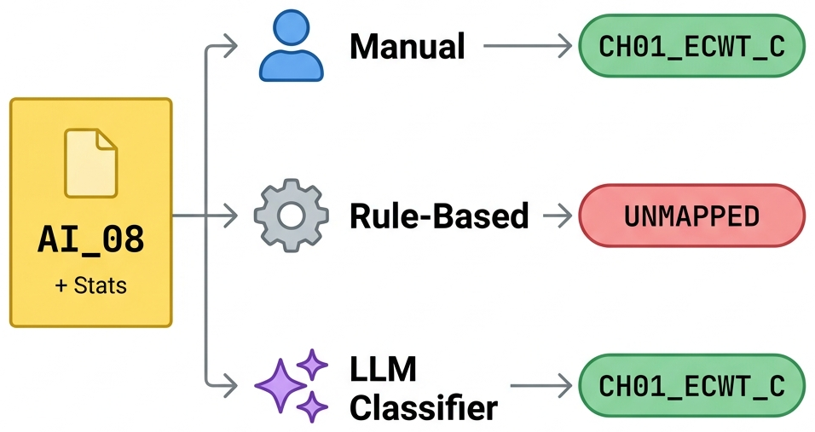
Figure 1: Schematic of the semantic point typing workflow comparing manual labelling, a rule-based mapper, and an LLM classifier. Note that stats are used for the Corpus B investigation only.
The target vocabulary (Table 1) is a controlled point grammar for chilled-water plants. In addition to equipment class, the signal name incorporates an ID tag (e.g. CH01, CT02) while the signal suffixes serve as token names (e.g. ECWT, CHWS) representing the measured quantity, and the unit suffix fixes the representation (e.g. _C, _kW).
Table 1: Canonical target vocabulary.
Equipment class | Signal + unit suffixes
Chiller (CH) | ECWT_C, LCWT_C, CHWS_C, CHWR_C, CHWS_SP_C, PWR_kW,  LOAD_kW, LOAD_TON, COP, PLR, PLR_PCT, FLOW_LPS,  DT_CHW_K, DT_CW_K, DP_EVAP_kPa, DP_COND_kPa, RUN_STS, START_CMD, STAGE
Cooling tower (CT) | CWT_IN_C, CWT_OUT_C, APPROACH_C, RANGE_C, CWT_SP_C,  FAN_SPD_PCT, FAN_SPD_FRAC, FAN_CMD_PCT, FAN_PWR_kW,  QREJ_kW, RUN_STS, CELL_CNT
Primary pump (PP) | SPD_PCT, PWR_kW, FLOW_LPS, FLOW_GPM, HEAD_kPa, RUN_STS
Secondary pump (SP) | SPD_PCT, PWR_kW, FLOW_LPS, HEAD_kPa, RUN_STS
Condenser pump (CP) | SPD_PCT, PWR_kW, FLOW_LPS, HEAD_kPa, RUN_STS
Weather (WX, no index) | TDB_C, TWB_C, TDP_C, RH_PCT, RH_FRAC, PRESSURE_kPa
Plant aggregate (PLANT, no index) | LOAD_kW, PWR_kW, COP, CHWS_C, CHWS_SP_C, ECWT_SP_C
Non-equipment | TIMESTAMP, UNMAPPED

Interchangeable unit variants are included to represent real-world datasets (e.g. (PLR/PLR_PCT, LOAD_kW/LOAD_TON, FLOW_LPS/FLOW_GPM). “Strict accuracy” is scored based on an exact string match to the ground truth while “lenient accuracy” forgives formatting differences, unit variances, or the inclusion of setpoint flags (e.g. CHWS_SP_C vs CHWS_C) but requires correct equipment and signal type identification.
Prompting (Figure 2) is few-shot chain-of-thought where the system prompt supplies the vocabulary, the UNMAPPED policy, an abbreviation legend, a small set of worked contrastive examples, and a step-by-step reasoning instruction. Two prompt settings were used, one per corpus. The name-only setting (Corpus A) sends the point names alone. The value-augmented setting (Corpus B) appends point data statistics, namely data type, percentiles, inter-quartile range, and null fraction, for each point name, so the model can map based on time-series data alone.
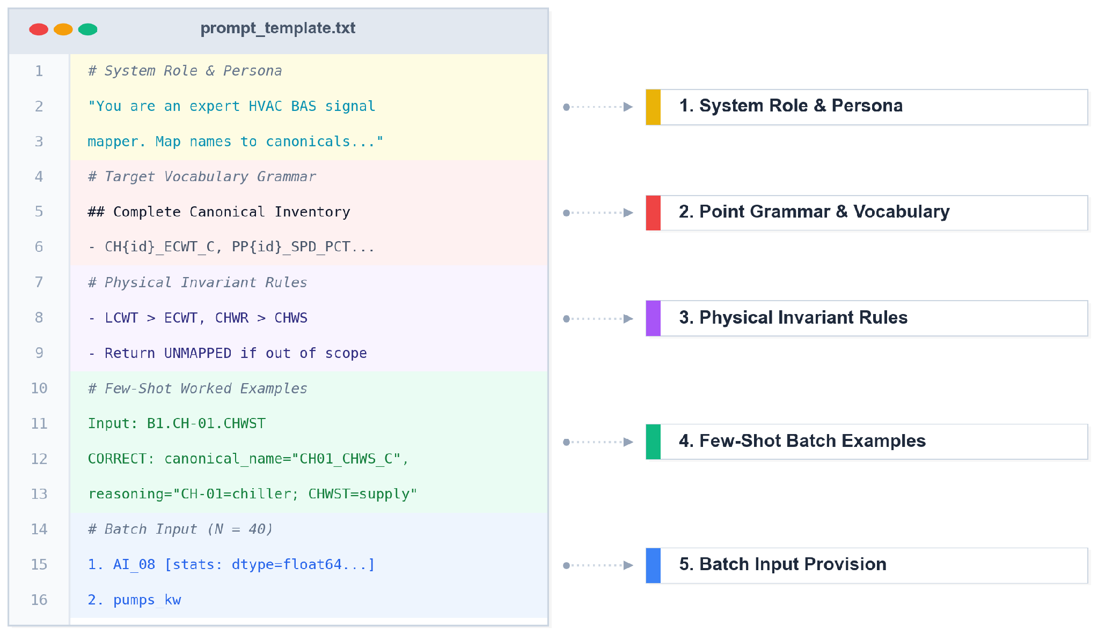
Figure 2: Prompt Structure for Corpus B (Corpus A prompts are similar but omit step 5)
Twelve models were tested on both corpora with Kimi-K2.7 added for Corpus B (Table 2), representing both open- and closed-weight models, multiple labs, and a broad range of costs. Model selection protocol required that models be current, not deprecated, expose a publicly pinnable identifier, and emit valid JSON for batch classification. Prompt, vocabulary, temperature (set to 0) and output format were held constant across models. Each provider's reasoning control remained at its default setting for the reported runs. Two models were additionally checked at their highest available reasoning setting, to test whether the refusal behaviour observed on Corpus B reflected insufficient reasoning effort. For the Corpus A investigation, point names were classified in batches of 40 while for Corpus B, all values were provided simultaneously to maximize available context. The system prompt included a confidence guide: the model was instructed to return UNMAPPED whenever its confidence in a mapping fell below 0.50, biasing the classifier toward declining an uncertain point rather than committing a possibly-incorrect label.
Prior to scoring, null, empty, or UNMAPPED responses were changed to “UNMAPPED” to map the ground truth; everything else was kept verbatim. Accuracies are reported with Wilson 95% confidence intervals (n = 271 on Corpus A; n = 36 mappable columns on Corpus B) based on three Corpus A and 3-8 Corpus B runs, with the latter to separate within-model variance from the ceiling. The rule-versus-LLM difference is treated as established only where the intervals don't overlap. On Corpus B the intervals are wide, so per-model results are reported as behaviour tiers rather than exact ranks. Corpus B is further tracked with respect to “engagement” – the degree to which the model commits mappings (at least 15 of the 54 points are not null/UNMAPPED) – and strict accuracy. A model that both engages and refuses across repeated runs is called bimodal; for those we report the best-engaged and mean-over-engaged results separately.
Token usage, including reasoning tokens where reported by the provider, was recorded per call and cost was computed on a single uniform basis using the current OpenRouter (2026) list price multiplied by the recorded prompt and completion tokens for the 271 point type corpus. Note that this cost differs from the final billed amount, which varies with caching, routing, and account terms.

Table 2: Benchmarked models
Model | Lab | Access | On-prem deployable
Gemini-3.5-Flash | Google | API | No
GPT-5.5 | OpenAI | API | No
GPT-5.4-mini | OpenAI | API | No
Claude-Opus-4.8 | Anthropic | API | No
Claude-Haiku-4.5 | Anthropic | API | No
Grok-4.3 | xAI | API | No
DeepSeek-V4-Pro | DeepSeek | API / open weights | Yes
DeepSeek-V4-Flash | DeepSeek | API / open weights | Yes
Qwen3.7-Plus | Alibaba | API / open weights | Yes
GLM-5.2 | Zhipu | API / open weights | Yes
MiMo-v2.5-Pro | Xiaomi | API / open weights | Yes
MiniMax-M3 | MiniMax | API / open weights | Yes
Kimi-K2.7 (Corpus B only) | Moonshot | API / open weights | Yes

RESULTS
For the human-readable corpus, the rule baseline achieved 41.0% strict accuracy while LLMs performed much better, from 87.1% (GPT-5.4-mini) to 94.3% (Gemini-3.5-Flash), (Table 3, Figure 3). The separation is unambiguous: the rule-based Wilson 95% interval is [35.3, 46.9], the best LLM’s is [91.0, 96.4], and even the weakest LLM's lower bound clears the baseline's upper bound.
The strongest open-weight model (DeepSeek-V4-Pro, 91.3%) is within three points of the accuracy of the strongest closed model, and a cheap open-weight model (DeepSeek-V4-Flash, 90.9%) is within four. Accuracy plateaus well below the frontier. An on-premises open-weight deployment, the relevant option for data-sensitive buildings, gives up little. Surprisingly, accuracy did not vary with cost; for example, DeepSeek-V4-Flash costs $0.012 vs $0.40–$0.52 for GPT-5.5 and Claude-Opus-4.8, a spread of 33 to 43 times (Table 3).

Table 3: Corpus A, name-only, strict accuracy (all models n=3). Cost is the price of typing the sample building of about 271 columns at June-2026 list prices.
Model | Strict accuracy | $/building
Rule baseline | 41.0% | $0.00
Gemini-3.5-Flash | 94.3% | $0.11
Grok-4.3 | 91.8% | $0.07
DeepSeek-V4-Pro | 91.3% | $0.05
GPT-5.5 | 91.1% | $0.40
DeepSeek-V4-Flash | 90.9% | $0.01
Qwen3.7-Plus | 90.9% | $0.05
Claude-Opus-4.8 | 90.8% | $0.52
MiMo-v2.5-Pro | 89.4% | $0.02
MiniMax-M3 | 89.3% | $0.03
GLM-5.2 | 88.9% | $0.09
Claude-Haiku-4.5 | 88.6% | $0.07
GPT-5.4-mini | 87.1% | $0.08

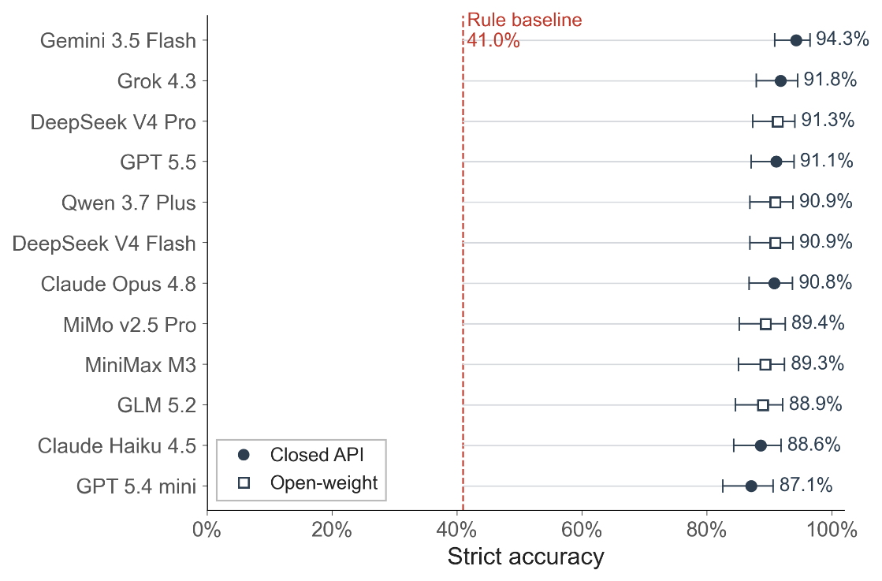
Figure 3: Strict exact-match accuracy of benchmarked models on Corpus A (n=271) showing Wilson 95% confidence intervals, relative to the 41.0% rule baseline.

For Corpus B, name-only accuracy was effectively zero for both the rule baseline and all LLMs, which was expected. However, the inclusion of point data statistics increased the accuracy significantly, from 0% to 8% for rule-based and as high as 81% strict accuracy and 92% lenient accuracy for LLMs, though this differed significantly across models (Table 4; Figure 4).

Table 4: Corpus B, name + statistics, per model.
Model | Access | Engaged | Best strict | Best lenient | Mean strict | Behaviour
Rule-Based | open | 4/4 | 8% | 8% | 8% | stable engage
GPT-5.5 | closed | 4/4 | 81% | 92% | 67% | stable engage
Gemini-3.5-Flash | closed | 5/5 | 75% | 86% | 72% | stable engage
DeepSeek-V4-Pro | open | 8/8 | 64% | 75% | 35% | stable engage
Claude-Opus-4.8 | closed | 4/4 | 47% | 58% | 35% | stable engage
DeepSeek-V4-Flash | open | 5/5 | 47% | 58% | 29% | stable engage
GPT-5.4-mini | closed | 3/3 | 31% | 42% | 22% | stable engage
Claude-Haiku-4.5 | closed | 4/4 | 17% | 28% | 15% | stable engage
GLM-5.2 | open | 3/4 | 64% | 75% | 56% | bimodal
Kimi-K2.7 | open | 1/7 | 56% | 67% | 56% | bimodal
MiniMax-M3 | open | 1/4 | 53% | 64% | 53% | bimodal
Qwen3.7-Plus | open | 1/4 | 25% | 36% | 25% | bimodal
MiMo-v2.5-Pro | open | 2/4 | 22% | 33% | 22% | bimodal
Grok-4.3 | closed | 0/6 | — | — | — | stable refuse

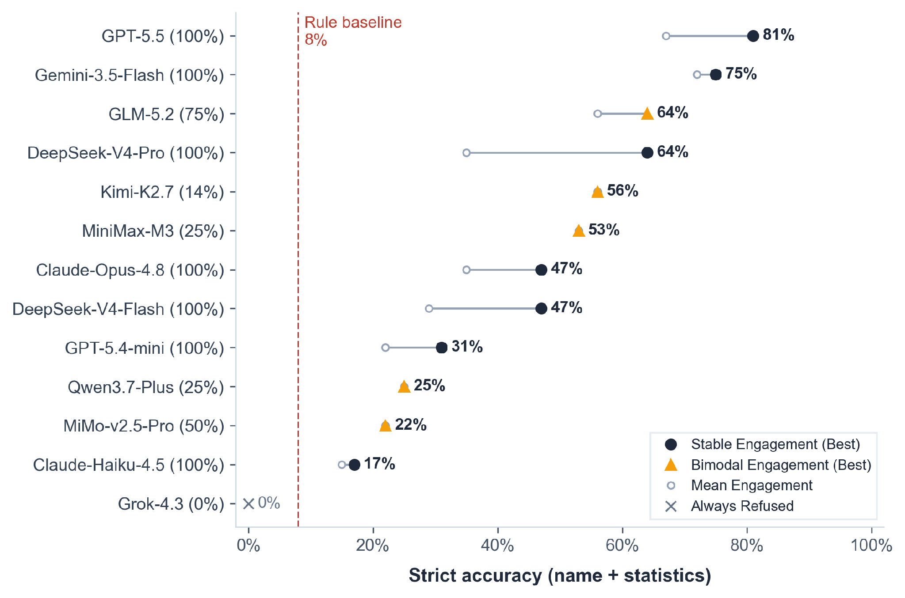
Figure 4: Best and mean strict exact-match accuracies (n=36 mappable columns) alongside engagement rates on Corpus B
Among the models that engage, best-run strict accuracy ranges from 17% (Haiku) to 81% (GPT-5.5), with lenient scoring adding an average of 11% across models. Within-model variance is large: DeepSeek-V4-Pro reaches 64% on its best run but averages 35% over its engaged runs, we report both. The higher reasoning setting produced no evidence of improvement. In single-run spot checks, DeepSeek-V4-Flash correctly mapped one of the 36 mappable columns at its highest setting, within the range it already spans at its default setting, and Grok-4.3 returned UNMAPPED for every column at both settings. These checks were not a systematic sweep and cannot separate a reasoning effect from the within-model variance reported above; they provide only limited evidence, but none of it supports the claim that additional reasoning improves performance here. For non-descriptive names as for human-readable ones, the evidence base remains the best investment, rather than increased reasoning or computational cost.
Precision on the 18 out-of-scope columns is preserved by the strong engagers. GPT-5.5 keeps all 18 out-of-scope columns as UNMAPPED while still mapping well. Kimi-K2.7 does the same, though in only one engaged run of seven, so that result should be read cautiously. Gemini, DeepSeek-V4-Flash, and GLM mis-map two or three. Grok-4.3 is the limiting case: in every retained run, at both the default and the highest reasoning setting, it returned UNMAPPED for all 54 columns and declined the task outright. For on-premises use, the DeepSeek family are the reliable open-weight engagers while the other open models are bimodal.

DISCUSSION
Although no LLM was perfectly accurate, the strongest models greatly reduced the amount of manual mapping required. At about 90% strict accuracy, roughly 25 to 35 of the 271 columns per building still carry an incorrect label. That is an error count, not the size of the review set: these errors are not limited to points the model declined as UNMAPPED. Across the models sampled for per-column error analysis, false negatives, meaning mappable points incorrectly declined as UNMAPPED, were the smallest error category at just under one third of all errors. Most errors were silent misclassifications, where either an out-of-scope point was assigned a confident label or an in-scope point was mapped to the wrong canonical. As a result, review cannot focus only on declined points. This breakdown is measured on the three models for which per-column predictions were retained; the remaining Corpus A runs recorded aggregate accuracy only. A domain expert must therefore still review the committed mappings, but confirming a proposed label is generally less work than deriving one from scratch.
Regarding cost, open-weight models match closed ones to within a few points at a fraction of the cost, with the least expensive costing about a penny (as of June 2026). These further allow the mapping to occur on premises, which is a significant advantage as it ensures data privacy. Further, on Corpus A the performance of the cheapest LLMs models match that of the most expensive; for such models the additional investment is better redirected to enhancing the evidence provided to the model. On Corpus B, some otherwise capable models refuse to map from statistics, even when the prompt explicitly asks them to try. In these runs, that behaviour held across prompt variants and reasoning settings, for both open-or-closed approaches. Where point names are not human-readable, additional care and testing is required for model selection.
Lenient accuracy was substantially higher than strict accuracy for the LLMs, increasing by about eleven points when unit variants and setpoint flags are treated as equivalent. The rule baseline gains nothing from the same relaxation: its strict and lenient scores coincide, because the mapper resolves equipment indices and returns either the exact canonical label or none, rather than the near-misses that lenient scoring rescues. The scoring rule therefore changes the apparent size of the gap, and comparisons reporting parity between LLMs and rule-based mappers (Meng et al., 2025) should state explicitly whether they use exact canonical matching or broader signal-level equivalence. Under exact-match scoring on this corpus, LLMs outperform the rule baseline significantly.

CONCLUSION AND FUTURE WORK
This study suggests that LLMs can be a helpful enabler of BAS data preparation for digital twin mapping but are not a perfect solution – they cannot replace engineering review and the remaining errors are too frequent for unattended use. They are, however, much better than a small rule base at turning raw vendor names into a controlled label set. On a human-readable corpus, that difference is large enough to change the manual task from labelling almost everything to checking a much smaller candidate set. On a non-descriptive name corpus, the results indicate the need for caution. With limited context available from names, time-series data analysis becomes increasingly important for classification but is more computationally intensive and several LLMs declined to perform the task. Model choice for this use case therefore must be empirical and local, especially if data sensitivity requires on premises deployment.
Corpus A is a stress corpus, not a sample of buildings in the field. It is useful for comparing methods under known ground truth, but the per-vendor slices are small and should not be read as vendor rankings. Its labels also come from one expert, so there is no inter-annotator agreement estimate. Corpus B is narrower still: one synthetic plant, clean statistics, and only 36 mappable opaque columns. Real sensors drift, fail, clip, and report at awkward precisions; those effects are not in this test. The wide intervals mean the model-level numbers are directional. The runs are also single-turn, English-language, and tied to a June-2026 model and price snapshot. Inference was routed through hosted gateways without pinning a specific upstream endpoint, and the endpoint serving each request was not recorded. The numeric precision at which each model was served is therefore unknown and uncontrolled, and no observed variance is attributed to it.
Future work is needed to test this approach on real building BAS exports, which can include noisy sensor data, a mix of both human-readable and non-human readable labels, non-English naming conventions, and, for open-weight deployment, whether combining several weaker local models can make the statistics-based case less erratic. Future extensions could also use the name-based classification as a starting step and incorporate time-series analysis where name alone is insufficient to map BAS points.

DATA AVAILABILITY
The benchmark corpus, the full prompt set, the reference scorer, the rule-baseline implementation, and the retained per-column model predictions are currently being protected as part of a patent submission; they will be released at https://github.com/mokandil/bas-point-mapping-benchmark upon completion of this procuess.

ACKNOWLEDGEMENTS
This research was funded by the Natural Sciences and Engineering Research Council of Canada (ALLRP-580958-22) and H. H. Angus and Associates.

REFERENCES
Almashor, M., Rana, M., McCulloch, J., Rahman, A. and Sethuvenkatraman, S., 2023, November. What's The Point: AutoEncoding Building Point Names. In Proceedings of the 10th ACM International Conference on Systems for Energy-Efficient Buildings, Cities, and Transportation. Istanbul, Turkey, November, 256-260.
Balaji, B. et al., 2018. Brick: Metadata schema for portable smart building applications. Applied Energy, p. 1273–1292. DOI: 10.1016/j.apenergy.2018.02.091
Brown, T. et al., 2020. Language models are few-shot learners. Vancouver, Canada, Curran Associates, Inc., pp. 1877-1901.
Chamari, L. et al., 2023. Metadata schema generation for data-driven smart buildings. In 11th Linked Data in Architecture and Construction Workshop, LDAC 2023, Matera, Italy, June, 139-150.
El Mokhtari, K. & McArthur, J.J., 2021. A data-driven approach to automatically label BAS points. In Proc. of the Conference CIB W78, Vol. 2021, Luxembourg, October, 11-15.
Gatto, C., Cassandro, J., Mirarchi, C. & Pavan, A., 2024. LLM based automatic relation between cost domain descriptions and IFC objects. Marrakesh, Morocco, CIB W78, pp. 1-10.
Hulsebos, M. et al., 2019. Sherlock: a deep learning approach to semantic data type detection. In Proceedings of the 25th ACM SIGKDD International Conference on knowledge discovery & data mining. Anchorage, AK, USA, August.
Jia, Y., Fu, X. & Zhang, L., 2026. BEMEval-Doc2Schema: benchmarking large language models for structured data extraction in building energy modeling. arXiv preprint arXiv:2602.16926.
Korini, K. & Bizer, C., 2023. Column type annotation using ChatGPT. arXiv preprint arXiv:2306.00745.
Liu, Y. et al., 2025. Magneto: combining small and large language models for schema matching. Proceedings of the VLDB Endowment, 18(18), pp. 2681 - 2694.
Meng, H., Cao, J. & Pottinger, R., 2025. Robust LLM-based column type annotation via prompt augmentation with LoRA tuning. arXiv preprint arXiv:2512.22742.
Narayan, A. et al., 2022. Can foundation models wrangle your data?. arXiv preprint arXiv:2205.09911.
OpenRouter, 2026 Models. [Online] Available at: https://openrouter.ai/models[Accessed 25 June 2026].
Peeters, R., Steiner, A. & Bizer, C., 2023. Entity matching using large language models. arXiv preprint arXiv:2310.11244.
Pritoni, M. et al., 2021. Metadata schemas and ontologies for building energy applications: A critical review and use case analysis. Energies, 14(7), p. 2024.
Project Haystack Organization, 2026. Project Haystack: an open-source data model for building equipment systems. [Online] Available at: https://project-haystack.org[Accessed 24 June 2026].
Quinn, C. and McArthur, J.J., 2021. A case study comparing the completeness and expressiveness of two industry recognized ontologies. Advanced Engineering Informatics, 47, p.101233. DOI: 10.1016/j.aei.2020.101233
Suhara, Y. et al., 2022. Annotating columns with pre-trained language models. Proceedings of the 2022 International Conference on Management of Data.
Wang, W. et al., 2018. Automated point mapping for building control systems: recent advances and future research needs. Automation in Construction, Volume 85, pp. 107-123. DOI: 10.1016/j.autcon.2017.09.013
Zhang, D. et al., 2020. Sato: contextual semantic type detection in tables. Proceedings of the VLDB Endowment, 13(11), pp. 1835-1848.

