Coupling Compound Flood Simulation with a Semantic City Model
Architecture of the Resilient Hydro Twin
Özgün Balaban^{1,*}, Ranjith K. Soman², Pieter Pauwels¹

¹ Eindhoven University of Technology, Eindhoven, The Netherlands
² Delft University of Technology, Delft, The Netherlands
* Corresponding email: o.balaban@tue.nl

ABSTRACT
Hydrodynamic solvers produce accurate inundation fields, but their outputs are expressed as raster surfaces that are difficult for non-specialists to interpret and act upon, while most urban digital twins remain visualisation-centric and weakly coupled to simulation. This paper aims to bind those two, and so it presents the Resilient Hydro Twin (RHT), a participatory urban digital twin for flood resilience. The article focuses on its architecture and methods as the principal contribution. The platform follows a layered, container-native design in which the simulation engine is a pluggable component: it currently integrates a reduced-physics compound-flood solver (SFINCS), a full hydrodynamic urban-flood model (MIKE+) and a microscopic traffic simulator (SUMO) for mobility impacts, all coupled to a semantic city model and a knowledge-graph layer that re-expresses simulation outputs as planning-relevant, queryable knowledge such as expected damage per neighbourhood. A scenario abstraction makes interventions and hazard conditions named, reproducible objects that stakeholders author through a web client. We describe the design requirements, the architecture, and the methods that translate inundation rasters into a queryable damage layer, and we report on two contrasting delta pilots, Rotterdam and Chennai, that test transferability across data-rich and data-scarce contexts.
Keywords: urban digital twin; flood resilience; participatory planning; knowledge graph; compound flood modelling; FAIR research software.

- INTRODUCTION
Flooding is the most frequent and among the most costly of natural hazards, and the exposure of urban deltas is rising under the combined pressure of climate change, sea-level rise and continued urbanisation. In low-lying, densely built environments the problem is rarely driven by a single mechanism: pluvial, fluvial, tidal and surge-driven processes interact to produce compound flooding, the joint behaviour of which cannot be reconstructed from any single driver in isolation. Managing this risk is therefore not only a hydrological problem but a built infrastructure, citizen and governance problem, in which interventions, land-use choices and infrastructure investments must be weighed by actors who do not share a common technical vocabulary.
Over the past decade, reduced-physics hydrodynamic solvers have made it computationally feasible to simulate compound flooding at useful resolutions and at a fraction of the cost of full-physics models (Leijnse et al., 2021). In parallel, automated and reproducible model-building toolchains have lowered the barrier to constructing such models from open geodata (Eilander et al., 2023). These advances make scenario exploration tractable. Yet the outputs of these tools, typically water-depth rasters, remain expert artefacts: a flood-depth surface answers the question where does the water go, but not the questions a planner asks, such as which neighbourhoods are most affected, how much building damage results, which critical facilities lose function, and how intervention A compares with intervention B.
Urban digital twins have been proposed as the integrative layer that could close this loop between simulation and decision-making (Batty, 2018; Ketzler et al., 2020). Data-rich city twins increasingly combine 3D city models, sensor feeds and simulation, and flood-specific tools already let users run scenarios and view their impacts (van den Bout et al., 2023; Deltares, 2024a). The remaining challenge is to bridge those simulation outputs with urban data and with the needs of non-expert stakeholders: results are mostly delivered as maps and aggregated indicators, rather than as linked records that connect a scenario, its assumptions and its consequences for specific buildings, neighbourhoods and facilities (Shahat et al., 2021; Lehtola et al., 2022).
This paper addresses that challenge through the Resilient Hydro Twin (RHT), a participatory digital twin for urban flood resilience that treats the twin as a queryable, simulation-grounded knowledge system. RHT builds on established simulation engines rather than advancing flood modelling itself. Its contributions are:
- a knowledge-graph layer that links per-building simulation outcomes to scenarios and to authoritative city data, so that planning questions such as damage by neighbourhood or scenario comparisons become graph queries;
- a scenario model that treats hazard conditions and interventions as named, stored objects with provenance, supporting participatory authoring and side-by-side comparison; and
- a set of design requirements derived with stakeholders in two contrasting deltas, and an architecture that realises them with interchangeable engines and expert control over simulation.
The validity of these contributions is shown through a working implementation in data-rich Rotterdam and data-scarce Chennai. Section 2 reviews related work. Section 3 defines the participatory digital twin, reports the stakeholder input and derives design requirements. Section 4 presents the architecture and Section 5 the methods. Section 6 reports results from the two pilots, Section 7 discusses them together with the limitations, and Section 8 concludes.
- RELATED WORK
Relevant work is situated in urban and flood digital twins, in simulation engines and reproducible model building, in knowledge graphs for the built environment, and in participatory planning for flood resilience.
2.1 Urban and flood digital twins
The notion of a digital twin, originating in manufacturing, has been adopted enthusiastically in the urban domain (Batty, 2018). Reviews characterise city digital twins as spanning a spectrum from static three-dimensional models to dynamic, data-integrated decision-support systems (Ketzler et al., 2020; Shahat et al., 2021; Lehtola et al., 2022). For flooding, several tools already move simulation close to users. FastFlood provides near-instant flood simulation in a web environment (van den Bout et al., 2023), and FloodAdapt combines SFINCS with the Delft-FIAT impact model so that non-modellers can evaluate adaptation measures (Deltares, 2024a). These works show that simulation-backed scenario exploration is feasible for non-specialists. Their results are typically reported as maps and aggregated indicators, however, and the link between an outcome, the scenario assumptions that produced it and external urban data is seldom kept as an explicit, reusable structure that other actors and tools can query.
2.2 Simulation engines and reproducible model building
Reduced-physics solvers such as SFINCS (Super-Fast INundation of CoastS) represent the fluvial, pluvial, tidal, wind- and wave-driven processes of compound flooding while running orders of magnitude faster than full-physics alternatives (Leijnse et al., 2021). Constructing such models has historically required substantial manual effort. The HydroMT toolchain automates the path from catalogued geodata to a runnable model instance through declarative, version-controllable recipes, and compound-flood hazard modelling has been made globally applicable through standardised workflows (Eilander et al., 2023). Impact models such as Delft-FIAT translate inundation depth into damage per asset using depth-damage functions (Deltares, 2024b; Huizinga et al., 2017). Different questions call for different engines: reduced-physics solvers for rapid compound-flood screening, full hydrodynamic packages such as MIKE+ for detailed urban drainage, and microscopic traffic simulators such as SUMO for mobility impacts. Integrating such engines behind one interface is therefore a practical concern for any flood twin.
2.3 Semantic models and knowledge graphs in the built environment
Semantic web technologies have a long history in the architecture, engineering and construction domain, where linked data representations (Resource Description Framework – RDF) support integration across heterogeneous sources and lifecycle stages (Pauwels et al., 2017). At city scale, encodings such as CityGML and CityJSON have matured (Ledoux et al., 2019), and GeoSPARQL allows geometry to participate in graph queries. Ontologies have also been used to integrate flood-risk knowledge, including concepts selected together with stakeholders (Scheuer et al., 2013), and observation vocabularies such as SOSA describe measured or simulated properties of features. Less attention has been paid to using a knowledge graph as the store in which per-asset simulation outcomes of many scenarios are recorded together with their provenance, so that comparing scenarios becomes a query rather than a GIS post-processing step.
2.4 Participatory planning for flood resilience
Participatory flood-risk planning commonly relies on workshops in which experts present hazard information and stakeholders discuss, sketch and prioritise measures, often structured by scenario-based approaches such as adaptation pathways (Haasnoot et al., 2013). Interactive and game-like tools have been shown to improve understanding of mitigation options (Khoury et al., 2018), but they commonly rely on pre-computed outcomes, which limits discussion to scenarios prepared in advance. What makes such processes participatory is less the interface than the scenario-based engagement they enable, and the value of that engagement depends on whether the assumptions, decisions and outcomes discussed can be traced and revisited afterwards.
- THE RESILIENT HYDRO TWIN: CONCEPT AND REQUIREMENTS
We define a participatory digital twin for flood resilience as a simulation-grounded, semantically integrated representation of an urban area in which multiple actors author hazard-and-intervention scenarios, obtain physically meaningful outcomes, and interrogate those outcomes in planning terms, while the assumptions and decisions behind each scenario are recorded in the same structure (RHT, 2025). Compared with data-rich twins that already couple simulation, two properties are distinctive: outcomes are stored as queryable knowledge linked to urban entities rather than as rasters and indicators, and scenarios, their assumptions and their results form a single, traceable thread that participants can revisit.
The requirements were not derived from literature alone. A User Requirements Document was compiled in 2025 with the eight work packages of the RHT consortium, drawing on a first consortium workshop with hydrological modellers, transport modellers, and participatory-planning and governance researchers from the Dutch and Indian partners. It identified the intended user groups, namely municipal and provincial government (e.g., the Municipality of Rotterdam and the Province of South Holland), operators such as water authorities and emergency responders, and community organisations, together with their expected technical skills (medium, medium-to-high and low-to-medium, respectively). The requirements were consolidated with the partners at a consortium meeting in India in January 2026. Table 1 lists the resulting design requirements and the stakeholder input from which each was derived.
Table 1: Design requirements and their stakeholder sources (URD = User Requirements Document).
ID | Requirement | Rationale | Stakeholder source
R1 | Simulation-grounded | Outcomes come from hydrodynamic and impact models, not stylised lookups. | Hydrological modellers: integrate hydro models; predictive and historical scenarios (URD 4.1–4.3).
R2 | Responsive inspection | Results can be inspected and compared interactively during a planning session. | Consortium workshop: scenario comparison and feedback collection (URD 2.2, 3.1).
R3 | Semantic queryability | Results are expressed per building, road, neighbourhood and facility. | Transport modellers: critical infrastructure and its attributes, flood impact on traffic (URD 2.1, 2.3).
R4 | Scenario management | Hazards and interventions are comparable, reproducible objects. | Hydrological and governance partners: user-set parameters, multiple scenario configurations (URD 4.2, 6.3).
R5 | Participation | Non-experts author and inspect scenarios through a guided interface. | Governance and participatory-planning partners: guided non-expert participation, blue measures (URD 6.1, WP5).
R6 | Reproducibility and transferability | Model building, data and scenarios are traceable and work with uneven data. | URD constraints: data availability and quality; no CityGML-like data for Chennai (URD 1.2, 2.3).
Two contrasting pilots test these requirements: Rotterdam, a data-rich European delta with national elevation and building registries and a validated compound-flood model, and Chennai, a rapidly urbanising, monsoon-driven South Asian delta in which authoritative high-resolution data are scarcer.
- SYSTEM ARCHITECTURE
RHT is organised as a set of cooperating, containerised services arranged in five layers (Fig. 1). The layering separates physical computation from planning interpretation: the simulation layer only produces physical outputs (inundation fields, per-asset damage), while the semantic layer turns those outputs into queryable planning knowledge. This separation allows engines and planning vocabulary to evolve independently. Coordination between scenario authoring and simulation is carried out by a domain expert (Section 4.2), which is a deliberate design choice.
4.1 Presentation layer
The client is a web application built with SvelteKit, with maps rendered through MapLibre GL. It offers a planning interface for authoring interventions and scenarios (Fig. 2), a Flood Impact Explorer that queries the knowledge graph and compares two scenarios side by side (Fig. 3), and map-based inspection of time-varying depth rasters. The client holds no simulation logic and communicates with the rest of the system exclusively through the backend API.
4.2 Scenario coordination (human-in-the-loop)
A Django REST backend exposes the scenario lifecycle and persists every scenario, with its parameters, intervention geometries and metadata, in a PostgreSQL database. Creating a scenario flags it as awaiting simulation. A domain expert reviews flagged scenarios, runs the appropriate engines and uploads the outputs, which the backend links to the scenario. Parts of this workflow are scripted; for example, damage is computed by pointing a prebuilt Delft-FIAT model at the maximum-depth raster of a new run. The decision to release results, however, stays with the expert. Flood models require judgement in set-up and quality control, and results that inform planning decisions should remain under expert responsibility.
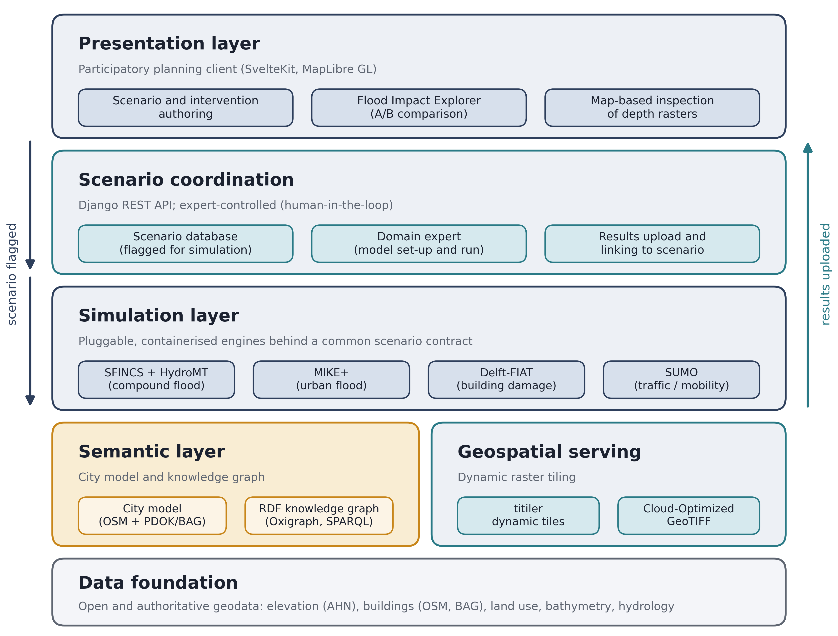
Figure 1: Layered architecture of the Resilient Hydro Twin.
4.3 Simulation layer
Each engine is packaged in its own container and exposed through a common scenario contract: a scenario goes in, gridded or per-asset results come out, so that engines can be added or swapped without changing the rest of the platform. SFINCS provides compound-flood simulation for Rotterdam; its model is built with HydroMT-SFINCS on a 25 m computational grid with a 0.5 m subgrid, from national AHN elevation data and Rijkswaterstaat bathymetry. Delft-FIAT computes damage per building from the maximum inundation depth. MIKE+ provides urban-flood modelling in the Chennai pilot, and SUMO estimates mobility impacts such as disrupted routes under a given inundation.
4.4 Geospatial serving
Simulation outputs are stored as Cloud-Optimized GeoTIFFs and served to the map through titiler, which generates raster tiles on demand. This avoids pre-rendering every visualisation, keeps the storage footprint modest and preserves street-scale inspection.
4.5 Semantic layer
The semantic layer holds the city model and the knowledge graph. In Rotterdam, building footprints come from OpenStreetMap, as used in the Delft-FIAT exposure data, and are enriched with the official Dutch building registry (BAG) retrieved through PDOK (PDOK, 2024). The graph is stored in an Oxigraph triplestore and queried with SPARQL through a read-only endpoint. Section 5 describes how simulation outputs enter the graph. Table 2 maps the requirements to the components that satisfy them.
Table 2: Mapping of design requirements to components and technologies.
Req. | Realised by | Key technology
R1 | Pluggable simulation layer | SFINCS + HydroMT, Delft-FIAT, MIKE+, SUMO (containerised)
R2 | Presentation layer and dynamic tiling | SvelteKit, MapLibre GL, titiler, Cloud-Optimized GeoTIFF
R3 | Semantic layer and damage-query layer | RDF, SOSA, GeoSPARQL WKT, Oxigraph, SPARQL; OSM + BAG
R4 | Scenario coordination and store | Django REST API, PostgreSQL, provenance records
R5 | Planning interface, Flood Impact Explorer | Intervention catalogue, scenario builder, A/B comparison
R6 | Reproducible build and containerisation | HydroMT recipes, fixed FIAT model template, Docker Compose
- METHODS
The methods most central to the contributions are the translation of simulation outputs into graph entities (Section 5.2), the damage-query layer (Section 5.3) and scenario management (Section 5.4). Section 5.1 addresses reproducibility and Section 5.5 the participatory workflow.
5.1 Reproducible model construction
Reproducibility is pursued at the level of each engine and of the scenario contract that binds it to the platform. For SFINCS, model instances are constructed through a HydroMT recipe that names its input datasets in a version-controlled data catalogue and lists the build steps in order, so that a third party can rebuild the model. For Delft-FIAT, the exposure and vulnerability data are built once and reused for every run; only the hazard input changes, so differences between scenarios stem from the hazard and the interventions alone. Engines without an equivalent automated builder, such as MIKE+, are reproduced through documented project files and pinned containers. In all cases the platform records, per scenario, which engine, configuration and input versions produced a result (R6).
5.2 From inundation rasters to a semantic city model
Delft-FIAT samples the maximum inundation depth at each building and applies depth-damage functions (Huizinga et al., 2017) to estimate damage. A graph builder reads these per-scenario results and emits, for every wet building, an rht:FloodImpact, typed as a sosa:Observation, that links the building (rht:onBuilding) to the scenario (rht:inScenario) and carries the inundation depth and the estimated damage. Buildings are geo:Features with WKT footprints, and their identifiers are namespaced by city and keyed by a stable object identifier, so that all scenarios refer to the same building entities. The raw depth is stored, which makes the flooding threshold a query parameter rather than a modelling decision. Each building is further linked to its BAG counterpart (rht:matchesPand), which adds construction year, status and use function. The same pattern is applied to roads: OpenStreetMap road segments are sampled every 25 m against the maximum-depth surface, producing road impacts with maximum and mean depth that can feed mobility analyses.
5.3 The knowledge-graph damage-query layer
Once outcomes are graph entities linked to urban features, planning questions become graph queries rather than raster post-processing scripts. With a SPARQL query one can get the number of flooded buildings and their total damage in one scenario; the implementation splits it into smaller queries for performance. Replacing the scenario identifier, adding a join on neighbourhood, or filtering by BAG use function yields damage per neighbourhood, exposed schools, or the difference between two scenarios, all on the same building entities. The shift is representational: a result that was locked inside an expert raster becomes an interoperable structure expressed in the vocabulary of planning, which lets the twin serve as a boundary object between specialists and stakeholders.
5.4 Scenario management and metadata
A scenario is a first-class object comprising a hazard specification (return period, rainfall, river discharge, storm surge, sea-level rise) and a set of interventions drawn as polygons, together with metadata recording its author, creation time and description. Simulation runs are recorded separately from scenario definitions, so the same scenario can be re-run with a different engine or resolution. Each run is linked to a model-configuration record (elevation and bathymetry sources, grid resolution, solver settings and boundary conditions), which is also represented in the graph with the W3C PROV-O vocabulary (Lebo et al., 2013). Scenarios are therefore comparable, because they share a schema; reproducible, because their metadata pins the inputs; and discoverable, because the metadata can be queried. This supports both participation (R5) and FAIR practice (R6).
5.5 Participatory workflow
The workflow casts the user in a planner-like role: the user places measures from an intervention catalogue on the map, sets hazard conditions and saves the scenario (Fig. 2); after the expert has run the engines, the user inspects and compares outcomes (Fig. 3). The user never configures a simulation. Because each step is stored with the scenario, the reasoning that led to a scenario and its outcome can be revisited in later sessions, which is where the participatory value of the twin lies.
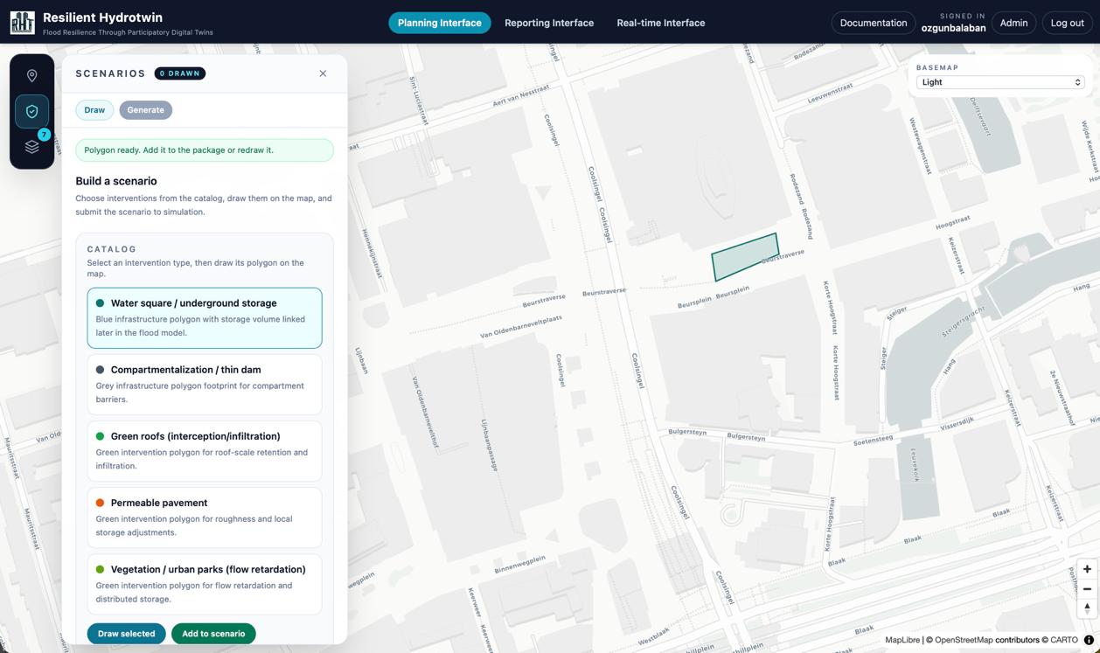
Figure 2: Planning interface with intervention catalogue and scenario builder (Rotterdam).
- RESULTS
The pipeline of Sections 4 and 5 is implemented and deployed as a web-accessible prototype on the SURF Research Cloud, with the full stack reproducible through container composition. In Rotterdam, project partners in the hydrodynamic work package developed the SFINCS compound-flood model, forced by rainfall, river discharge, and storm surge, with return periods of about 1/10, 1/100 and 1/300 years, and with interventions such as storage basins and barrier closure. For scenarios with Delft-FIAT results, per-building impacts are loaded into the knowledge graph. Table 3 reports four scenarios, obtained with SPARQL queries at a depth threshold of 0.1 m, and Fig. 3 shows the base scenario in the Flood Impact Explorer.
Table 3: Knowledge-graph query results for four Rotterdam scenarios (depth > 0.1 m).
Scenario | Rainfall; storm surge | Flooded buildings | of which > 1 m | Damage (M€)
1 Base (~1/10 yr) | 63 mm/24 h; 3.20 m | 1,901 | 221 | 81.25
5 Base + storage basins | 63 mm/24 h; 3.20 m | 1,897 | 221 | 81.15
6 Compound ~1/100 yr | 99 mm/24 h; 3.64 m | 16,265 | 1,931 | 745.96
7 ~1/100 yr + storage basins | 99 mm/24 h; 3.64 m | 16,161 | 1,931 | 744.80
Moving from the ~1/10-year to the ~1/100-year compound event increases the number of flooded buildings about 8.6-fold and the estimated damage about 9-fold. Storage basins reduce the affected buildings by 4 in the base event and by 104 in the ~1/100-year event (−0.6%), with a damage reduction of €1.16 million. All of these reductions occur in the 0.1–1 m depth classes, while the number of buildings flooded above 1 m is unchanged, which suggests that the basins attenuate shallow, rainfall-driven flooding but not the deeper inundation associated with river discharge and surge. Such findings follow from a handful of queries on the same building entities, without handling rasters.
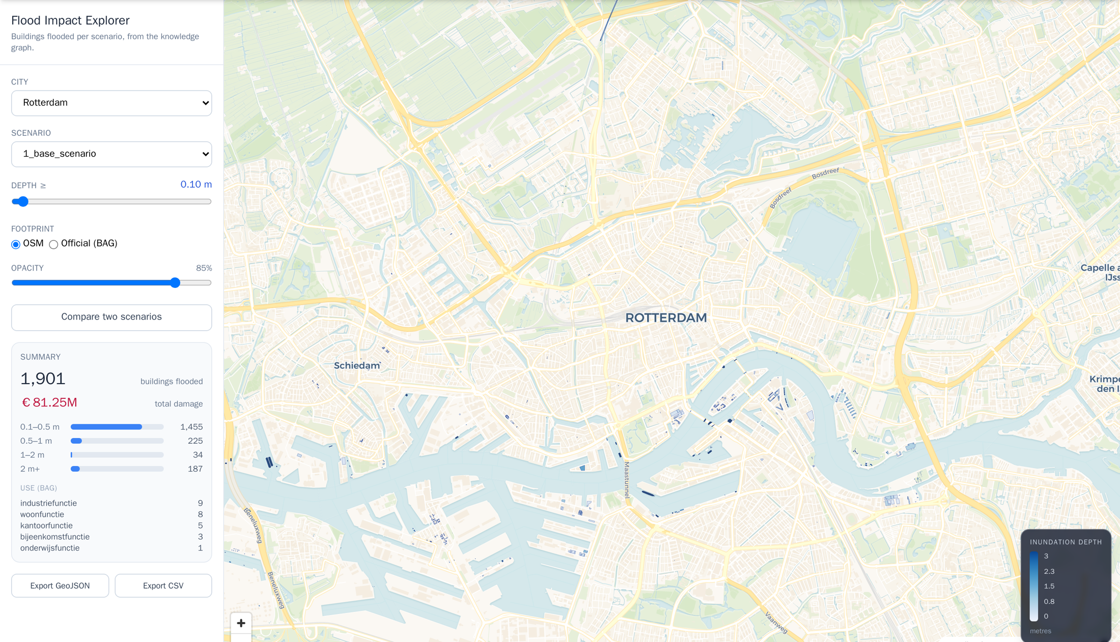
Figure 3: Flood Impact Explorer showing flooded buildings in the Rotterdam base scenario.
A typical session in the prototype proceeds as follows. A user selects Rotterdam, chooses water squares and underground storage from a catalogue of five measure types derived from the compound-flood modelling study, draws them in a neighbourhood and saves the scenario with its hazard settings (Fig. 2). The expert runs SFINCS and Delft-FIAT for the flagged scenario and uploads the results. In the Flood Impact Explorer the user selects the scenario, sets the depth threshold, switches between OpenStreetMap and official BAG footprints, and reads the number of flooded buildings per depth class, their use functions and the total damage (Fig. 3). The compare function places two scenarios side by side, such as scenarios 6 and 7 in Table 3, and the selection can be exported as GeoJSON or CSV.
In Chennai, the same client, scenario store and serving layers host a 1/100-year compound-flood scenario provided by the Indian project partners, which the planning interface animates as a sequence of 119 depth frames. The per-building damage layer is currently populated for Rotterdam only, because exposure data comparable to the BAG registry are not yet available for Chennai. The Chennai pilot thus demonstrates that the scenario contract and serving layers are independent of the European data environment, while extending the damage-query layer depends on an open exposure dataset.
- DISCUSSION
The principal contribution of RHT is the explicit decoupling of physical simulation from planning semantics through a knowledge-graph layer. Flood-specific tools already make scenario simulation accessible, but they mostly report maps and indicators; RHT keeps per-asset outcomes, scenario definitions and provenance in one graph that other actors and tools can query. Because this layer is independent of the solver, the same pattern can in principle wrap a different hazard model, or a different city, with limited change. Table 3 illustrates the benefit: an intervention effect of 0.6% would be difficult to read from two depth maps, yet follows directly from querying the same building entities under two scenarios.
Expressing outcomes as a knowledge graph yields interoperability and meaning simultaneously. Interoperability follows from standard vocabularies (RDF, SOSA, GeoSPARQL) and a SPARQL endpoint; meaning follows from binding outcomes to the entities planners reason about, such as registered buildings and neighbourhoods. By constructing models from declarative recipes, containerising the engines and attaching provenance to every run, RHT aligns with FAIR principles (Wilkinson et al., 2016) at the level of models and scenarios, not merely source code. This matters for resilience planning, where decisions must remain auditable over long horizons.
Several limitations delimit these claims. First, simulation is expert-controlled by design, so a newly authored scenario is evaluated only after an expert has run the engines. Responsive inspection (R2) is nevertheless met, because results that are available can be explored and compared interactively, and we intend to keep the expert in the loop to safeguard result quality and decision control. Second, the coverage of the knowledge graph depends on the underlying urban data, which is uneven: per-building damage is currently available in Rotterdam but not in Chennai. Third, stakeholder input shaped the requirements, but the participatory value of RHT itself has not yet been evaluated: the engagement evidence so far comes from requirement workshops and planning meetings held without the system. Fourth, the figures in Table 3 inherit the uncertainties of the hydrodynamic model and the depth-damage functions and have not been validated against observed damage.
- CONCLUSION
This paper presented the Resilient Hydro Twin, a participatory digital twin for urban flood resilience. Its requirements were derived with stakeholders in the Netherlands and India. Its architecture couples interchangeable simulation engines with a semantic city model and a knowledge graph that re-expresses inundation and damage as queryable, planning-relevant knowledge. In Rotterdam, the working pipeline answers questions such as how many buildings flood, how deeply and at what cost, and how much an intervention changes this, directly from the graph. The Chennai pilot shows that the scenario and serving layers transfer to a different engine and data context, and that open exposure data are the bottleneck for transferring the damage layer.
Several steps would benefit the research community. Structured user studies are needed to test whether graph-based scenario comparison leads to better-informed decisions than map-based workflows. Shared vocabularies for flood impacts, interventions and scenario provenance would allow results from different twins and engines to be compared. Finally, open exposure and vulnerability data for rapidly urbanising regions are a precondition for per-asset impact analysis where compound-flood exposure grows fastest.
ACKNOWLEDGEMENTS
This research was funded by the Dutch Research Council (NWO) and the Department of Science and Technology, Government of India (DST) through the NWO-DST Merian Fund, grant number 482.482.302.
REFERENCES
Batty, M., (2018). Digital twins. Environment and Planning B: Urban Analytics and City Science, 45(5): p. 817-820.
Deltares, (2024a). FloodAdapt. [Online], Available: https://github.com/Deltares/FloodAdapt.
Deltares, (2024b). Delft-FIAT: Fast Impact Assessment Tool. [Online], Available: https://github.com/Deltares/Delft-FIAT.
Eilander, D., Couasnon, A., Leijnse, T., Ikeuchi, H., Yamazaki, D., Muis, S., Dullaart, J., Haag, A., Winsemius, H.C. & Ward, P.J., (2023). A globally applicable framework for compound flood hazard modeling. Natural Hazards and Earth System Sciences, 23(2): p. 823-846.
Haasnoot, M., Kwakkel, J.H., Walker, W.E. & ter Maat, J., (2013). Dynamic adaptive policy pathways: A method for crafting robust decisions for a deeply uncertain world. Global Environmental Change, 23(2): p. 485-498.
Huizinga, J., de Moel, H. & Szewczyk, W., (2017). Global flood depth-damage functions: Methodology and the database with guidelines. JRC Technical Report EUR 28552 EN. Publications Office of the European Union. DOI: 10.2760/16510
Ketzler, B., Naserentin, V., Latino, F., Zangelidis, C., Thuvander, L. & Logg, A., (2020). Digital Twins for Cities: A State of the Art Review. Built Environment, 46(4): p. 547-573.
Khoury, M., Gibson, M.J., Savic, D., Chen, A.S., Vamvakeridou-Lyroudia, L., Langford, H. & Wigley, S., (2018). A serious game designed to explore and understand the complexities of flood mitigation options in urban-rural catchments. Water, 10(12): 1885. DOI: 10.3390/w10121885
Lebo, T., Sahoo, S. & McGuinness, D., (2013). PROV-O: The PROV Ontology. W3C Recommendation. [Online], Available: https://www.w3.org/TR/prov-o/.
Ledoux, H., Arroyo Ohori, K., Kumar, K., Dukai, B., Labetski, A. & Vitalis, S., (2019). CityJSON: A compact and easy-to-use encoding of the CityGML data model. Open Geospatial Data, Software and Standards, 4: 4.
Lehtola, V.V., Koeva, M., Oude Elberink, S., Raposo, P., Virtanen, J.-P., Vahdatikhaki, F. & Borsci, S., (2022). Digital twin of a city: Review of technology serving city needs. International Journal of Applied Earth Observation and Geoinformation, 114: 102915.
Leijnse, T., van Ormondt, M., Nederhoff, K. & van Dongeren, A., (2021). Modeling compound flooding in coastal systems using a computationally efficient reduced-physics solver: Including fluvial, pluvial, tidal, wind- and wave-driven processes. Coastal Engineering, 163: 103796.
Pauwels, P., Zhang, S. & Lee, Y.-C., (2017). Semantic web technologies in AEC industry: A literature overview. Automation in Construction, 73: p. 145-165.
PDOK, (2024). Publieke Dienstverlening Op de Kaart: Dutch national open geodata services. [Online], Available: https://www.pdok.nl.
RHT, (2025). Resilient Hydro Twin. [Online], Available: https://www.resilienthydrotwin.com.
Scheuer, S., Haase, D. & Meyer, V., (2013). Towards a flood risk assessment ontology – Knowledge integration into a multi-criteria risk assessment approach. Computers, Environment and Urban Systems, 37: p. 82-94.
Shahat, E., Hyun, C.T. & Yeom, C., (2021). City Digital Twin Potentials: A Review and Research Agenda. Sustainability, 13(6): 3386.
van den Bout, B., Jetten, V.G., van Westen, C.J. & Lombardo, L., (2023). A breakthrough in fast flood simulation. Environmental Modelling & Software, 168: 105787.
Wilkinson, M.D., Dumontier, M., Aalbersberg, I.J., et al., (2016). The FAIR Guiding Principles for scientific data management and stewardship. Scientific Data, 3: 160018.

