A Multi-Task Framework for 2D Scene Parsing and 3D Reconstruction in Indoor Space Documentation
SERDAR ERİŞEN^{,1, 2} MANSOUR MEHRANFAR^{,1} ANDRÉ BORRMANN^{,1}

¹Chair of Computing in Civil and Building Engineering, TUM Georg Nemetschek Institute,
Technical University of Munich
² Hacettepe University, Ankara, Türkiye

ABSTRACT:
Smart indoor environments with recognition technologies that prioritise human comfort and well-being necessitate accurate spatial information. Laser scanners and photogrammetry technologies have become essential for creating accurate as-built digital building models by capturing high-quality point clouds with precise geometry, yet they often lack proper semantic annotations. This limitation necessitates developing methods to improve 2D and 3D scene understanding. To address this, a multi-task learning framework is proposed combining depth estimation and semantic segmentation techniques to enhance 2D scene parsing for effective 3D reconstruction from single images by generating and learning 3D surface masks. The results on the selected TUM CMS Indoor Point Clouds dataset demonstrate the effectiveness of the proposed framework in 3D reconstruction, achieving 81.55% mIoU accuracy, which supports multiple applications for indoor digital twinning, automated 3D object recognition, and simulation tasks in indoor spaces.

KEYWORDS:
Indoor Environments, Semantic Segmentation, Point Clouds, Digital Twinning, 3D Reconstruction

1. INTRODUCTION
Digital documentation and modelling of indoor built environments are increasingly critical for tasks such as asset monitoring, cultural heritage preservation, and the design of smart systems that enhance human comfort and well-being. These applications require precise spatial and semantic information about the location, parameters, and material properties of objects within the built environment (Erişen, S., 2023; Mehranfar, M., et.al., 2024). The goal of this research, hence, is to develop a multi-task learning framework for generating 3D surface reconstruction techniques facilitated by 2D scene parsing to be applied in real-world use cases and task-oriented applications in indoor environments, missing 3D sensor data and annotations.
The process of digital documentation and creating digital models from built environment assets involves two key stages: data capture and data processing. During the data capture phase, raw visual and spatial data, including RGB images and point clouds, are gathered using technologies like laser scanning and photogrammetry, effectively capturing the geometric details of the objects. In the data processing phase, this raw data and imagery are analysed to extract valuable, understandable information for both humans and machines, ultimately leading to the creation of digital models of the target objects.
While 3D point cloud datasets generated from laser scanners or photogrammetry technologies provide valuable spatial-geometric data, they often lack the detailed semantic annotations needed for comprehensive scene understanding and object recognition. In this context, integrating 2D semantic segmentation with 3D spatial data can significantly enhance the built environment digitalisation process by improving the semantic understanding and adding contextual and material information.
This research proposes a pipeline for single-shot surface reconstruction and generating 3D segmentation masks from 2D scene parsing methods to facilitate domain adaptation between 2D and 3D scenes, enhancing 3D surface reconstruction techniques. Thus, a multi-task learning framework is developed, integrating 2D and 3D segmentation networks for depth estimation and semantic segmentation, generating the 2D scene parsing. The experiments are conducted on the selected datasets, such as TUM CMS Indoor Point Clouds offering 3D spatial data and 2D images, to validate the robustness of the developed documentation methods (Mehranfar, M., et.al., 2024b). Building on this research context, the proposed framework provides inputs and outputs of 3D reconstruction for real-world simulations and digital twinning of indoor environments.
To the best of our knowledge, this research is unique in developing a multi-task learning framework that encapsulates 2D and 3D segmentation networks alongside large language models (LLMs), facilitating the generation and utilisation of precise 2D scene parsing and 3D surface reconstruction techniques for indoor environments. The derived framework enables the training of 2D and 3D learning networks through the outcomes of the pipeline, from which real-life applications can benefit. The subsequent sections will present more details about the related works, the proposed pipeline with its implementation details, and the discussion of the research outcomes.

2. BACKGROUND AND RELATED WORK
The advancement of digital documentation and simulation techniques for indoor spaces has played a crucial role in multiple domains, including architecture, construction, and facility management. As built environments become more complex, the demand for accurate and efficient 3D surface reconstruction methods has grown, enabling better spatial analysis, asset management, and automated decision-making. Traditional approaches to 3D modelling rely on labour-intensive processes that involve capturing spatial data through technologies such as photogrammetry and laser scanning, followed by extensive manual processing to generate structured digital models. While these methods provide high-precision reconstructions, they are often time-consuming and require specialised expertise, limiting their scalability for large-scale or real-time applications.
Creating valuable digital building models tailored to specific use cases requires substantial human effort. This process typically consists of two major steps: data capturing and processing (Noichl, F., et.al., 2024). In the data capturing step, raw visual and spatial data, such as RGB images and point clouds, are collected using laser scanning and photogrammetry, efficiently acquiring geometric information about the built environment. The data processing step then involves manually interpreting the raw data to create digital models of target objects. Due to the complexity and unstructured nature of the raw data, extracting and reconstructing even basic 3D models for components like columns, slabs, and walls from input point clouds is significantly more time-consuming than the data acquisition itself, making the modelling process highly labour-intensive.
Recent advancements in computer vision and computational modelling have led to the development of various methods for automated data processing. These innovative approaches enable the interpretation of images and point cloud data, facilitating the extraction of meaningful information and structured data to identify objects of interest and reconstruct geometric digital models automatically (Mehranfar, M., et.al., 2024b). Deep learning techniques, particularly those leveraging convolutional neural networks (CNNs) and transformer-based architectures, have remarkably improved 2D scene parsing tasks, allowing for more accurate segmentation and recognition of spatial elements (Erişen, S., 2024). Integrating these 2D parsing results with 3D reconstruction workflows has opened new possibilities for enhancing volumetric modelling techniques, reducing the need for extensive manual intervention (Pan, Y. et.al., 2022).
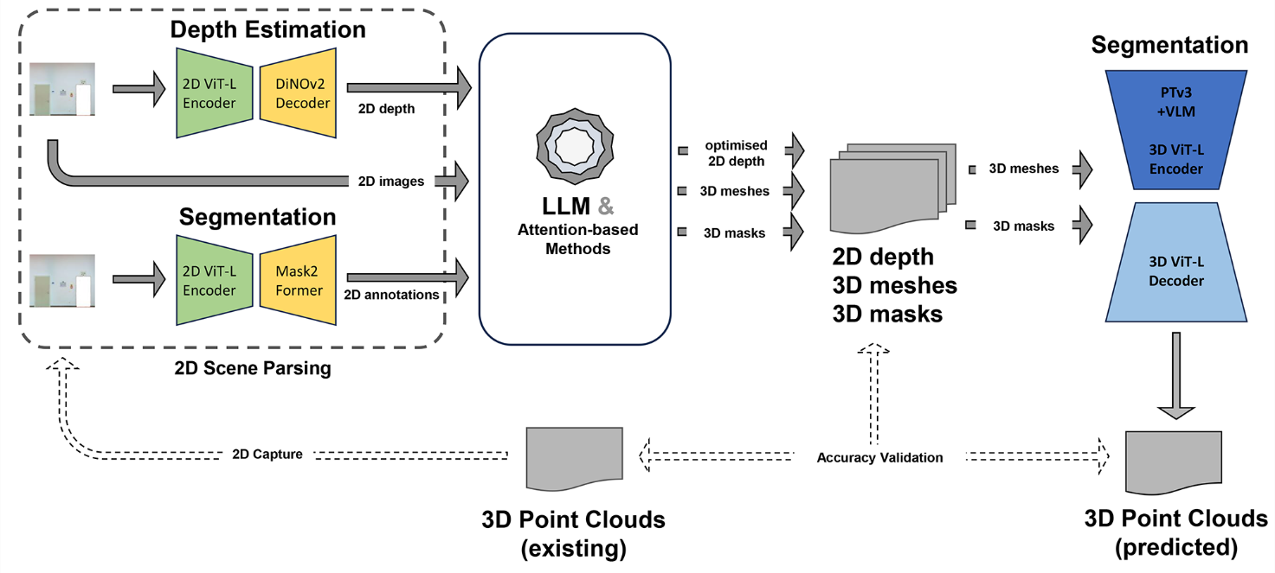
3D surface reconstruction has advanced significantly over the last decade, enhancing multi-scale civil and infrastructure project analyses by integrating deep learning methods to better recognise objects, actions, and spatial occupancy in the built environment (Lu, Y., et.al., 2024). For instance, Neural Radiance Fields (NeRF) were introduced to synthesise photorealistic novel views of complex scenes using volumetric rendering from sparse images. Accordingly, Mildenhall, B., et.al. achieved state-of-the-art peak signal-to-noise ratio (PSNR) scores of 31.01 dB on Blender synthetic data and 26.50 dB on real-world scenes (Mildenhall, B., et.al., 2020). Zhang, J., et.al. developed a voxel-based method for 3D reconstruction capturing the movements of construction workers using 3D data by combining spatial and temporal information to categorise worker actions that enhance safety and efficiency through automated monitoring (Zhang, J., et.al., 2025).
Figure 1: The general framework of multi-task learning models in the generation and usage of 2D Scene Parsing.

Another research focusing on real-time data integration in indoor environments for comfort control and well-being underscores the need for effective management of volumetric information (Erişen, S., 2022; 2023). To address these challenges, creating a point cloud environment integrated with advanced smart sensor systems or enhancing state-of-the-art learning models for improved 3D surface reconstruction techniques becomes essential. Thus, this research has been found useful in developing surface reconstruction techniques using 3D segmentation masks from 2D scene parsing methods to be applied in environments requiring 3D spatial information.

3. METHODS AND MODELS
This research employs the method of developing a multi-task learning framework designed to enhance 3D surface reconstruction and annotation by deploying advanced 2D scene parsing techniques. The derived outputs of 2D scene parsing are applied to generate 3D spatial meshes and segmentation masks for 3D surface reconstruction, validated through available point cloud datasets (Fig. 1). These data sources serve both to enhance the robustness of the proposed methods and to validate the framework’s outputs for deployment in environments without 3D sensors. This approach is particularly significant for challenging tasks, such as single-shot 3D reconstruction in environments with numerous unknowns that lack 3D spatial information.
The 2D scene parsing techniques applied in this research include depth estimations and semantic segmentation predictions, which are acquired by the pre-trained neural network models based on ViT-based encoder-decoder architectures. Therefore, a multi-tasking learning framework has been developed for 3D surface reconstruction that can also be applied in different research contexts by implementing networks to learn and predict 3D spatial data extracted from the 2D scene parsing.
Combining the depth estimations with the corresponding images allows the generation of surface meshes for a fundamental understanding of the 3D scene. 2D semantic segmentation results are also crucial in introducing multiple classes projected to spatial meshes, recognised as 3D segmentation masks. The generated masks for surface reconstruction make it possible to support cross-domain learning between different datasets from 2D to 3D, such as classes from the ADE20K dataset to S3DIS or ScanNet.
In optimising 3D segmentation masks from 2D scene parsing, Large Language Models (LLMs) are implemented in the multi-tasking learning framework to generate algorithms that are run to correct the surface reconstruction outcomes. The generated surface meshes from 2D scene parsing are validated through existing datasets, such as TUM CMS Indoor Point Clouds. Acquiring precise and validated 3D surface inputs and their annotations also makes it possible to train 3D segmentation networks that are crucial for learning the outputs, predicting and validating the labels of 2D scene parsing outcomes. The outcomes of the applied framework are found applicable to single-image-based surface recognition in real-life applications and task-oriented simulations.

3.1. The general framework of multi-task learning pipeline
The framework employs various neural network architectures optimized for specific tasks:
Depth Estimation Network: Utilizes an encoder-decoder structure with ViT-L as the encoder backbone and DiNOv2 as the decoder network, pre-trained on benchmark datasets like SUN-RGB-D for metric depth estimation tasks (Oquab, M., et.al., 2024).
Semantic Segmentation Network: Implements another encoder-decoder structure comprising a ViT-L encoder and Mask2Former decoder. This model, pre-trained on the ADE20K dataset, achieves high accuracy in semantic segmentation tasks involving detailed scene understanding.
Scaled depth estimations and semantic segmentation masks are integrated within the framework. LLMs are subsequently employed, based on explicit user prompts, to generate specialized algorithms aimed at refining these outputs. The algorithms incorporate transformer-based decoder mechanisms and machine learning techniques to accurately transform depth and segmentation results into 3D surface meshes and annotated masks.
To finalize the pipeline, a dedicated 3D segmentation network built upon the PointTransformerV3 backbone, and a ViT-based decoder is introduced (Wu, X., et.al., 2024). This network leverages the Vision Language Model (VLM) to effectively incorporate diverse 3D datasets (such as S3DIS and ScanNet), improving cross-domain learning and ensuring optimal performance of the resulting 3D reconstruction across multiple segmentation tasks.

3.2. 2D Scene Parsing Techniques
The purpose of applying advanced 2D scene parsing methods, depth estimation and semantic segmentation, is to generate accurate intermediate representations from image inputs, crucial for subsequent 3D reconstruction that enables training 3D networks enhancing the ability to validate results. In pursuit of improving depth perception in computer vision, a new method has been introduced that utilises a large-scale Vision Transformer (ViT-L) alongside an innovative depth augmentation strategy.
For semantic segmentation, the pipeline combines ViT-L with a variant of Mask2Former decoder architecture, used as the decoder backbone (Fig. 1). Tailored for intricate scene parsing tasks across 2D and 3D, this configuration is fine-tuned on large-scale datasets featuring diverse environmental scenes. The model excels in segmenting and identifying multiple objects and their precise boundaries within a scene, providing a granular understanding of the image contents. The fusion of ViT-L with this segmentation architecture facilitates detailed and accurate scene analysis, proving critical for applications requiring high-level visual comprehension.
To improve the use of semantic data from 2D scenes, the methods applied in the SERNet-Former architecture, such as Attention-based Modules to extract local features from the global context of input spatial information, are encapsulated within the multi-task learning framework (Erişen, S., 2024). Using the pre-trained encoder-decoder networks model on the SUN-RGB-D dataset, depth estimations are generated on the images and 3D surface projections from the existing point clouds. Similarly, 2D segmentation networks are deployed on the same inputs to derive segmentation masks to be applied to generate 3D surface masks.

3.3. 3D mesh and surface mask generation from 2D Scene Parsing
2D scene parsing techniques, applied on selected datasets such as TUM CMS Indoor Point Clouds with 2D inputs from 3D surface projections, provide pairs of 2D depth and segmentation masks. Based on the 2D scene parsing outcomes, 3D point clouds are aimed to be generated, and the input pairs are used to derive RGB and coordinate information in 3D. Respectively, depth estimations provide data in projecting metric 3D coordinates from a 2D scene. The overlapping content of pairs enables the generation of coordinates that are also projected by depth estimations in 3D. RGB inputs and 2D segmentation masks include feature-rich properties of objects in the scene that are projected through these coordinates, respectively. Thus, the input-depth pairs are deployed for 3D surface mesh generation by defining the default camera calibration parameters and input features to the network. Similarly, depth-segmentation mask pairs are used to derive 3D surface masks with annotations of the meshes, which are found to be useful in detecting objects in 3D from 2D scenes.
Large Language Models leverage a vast corpus of text to generate coherent and contextually relevant content, understand nuanced human languages, and perform complex reasoning tasks (Google, 2024). Their capabilities extend beyond text generation, encompassing language understanding, sentiment analysis, and code generation. In this regard, LLMs are also employed to optimise the algorithms for generating surface meshes and 3D segmentation masks. The algorithms derived from the attention-based methods and LLMs are executed in a PyTorch virtual environment and encapsulated within the multi-task learning framework integrated into the running code, along with inputs, derived outcomes, and applied models.

3.4. Optimisation and error correction of depth estimations
In generating 3D point clouds from 2D inputs, the camera features and the complementary data from TUM CMS Indoor Point Clouds are paramount in deciding on the robustness of the applied techniques. Respectively, the coordinate information from the existing point clouds is used to optimise the depth estimations for single-shot surface reconstruction. The filtering methods, including the scalar values and thresholding, are applied to depth estimations for error correction in the predictions, based on the original surface meshes. Moreover, the pairs of depth-segmentation masks are used to determine the surface of objects to optimise the depth information at certain coordinates.
Based on user prompts, large language models also generate algorithms for optimising depth information at certain coordinates. The information from 2D segmentation masks is also used in the optimisation of depth predictions, re-applied for generating 3D surface meshes and masks. Thus, the pairs of optimised depth information and 2D image inputs are introduced to the learning framework to create exact 3D surface meshes. Similarly, segmentation masks are applied with depth inputs and 2D segmentation masks to derive exact 3D surface masks, providing ground truth for 3D segmentation networks.

3.5. Training and inference through 3D segmentation networks by surface meshes and masks from 2D Scene Parsing
The validation of surface meshes and the generated 3D segmentation masks by the selected point cloud datasets is crucial for precise surface reconstruction, which can then be deployed to train 3D segmentation networks that can recognise and define annotations for surface masks. Based on the original datasets, the derived 3D surface meshes and segmentation masks are introduced to the 3D segmentation network using PointTransformerV3 backbone with Vision Language Model (VLM), pre-trained on the S3DIS and ScanNet datasets. PointTransformerV3 applies self-attention mechanisms and ViT-based encoders specifically adapted to 3D data, enabling dynamic feature learning directly from unstructured point clouds (Wu, X., et.al., 2024). It is particularly adept at tasks requiring detailed 3D spatial understanding, such as object classification, part segmentation, and scene segmentation in 3D environments. Moreover, the network enables the introduction of multiple datasets during training, such as S3DIS and ScanNet. Thus, due to the limited amount of generated surface meshes and masks, the PointTransformerV3 architecture is used to learn surface masks, which are then combined with the S3DIS and ScanNet datasets.
The network outcomes are also significant to learn and validate the 3D surface reconstruction inputs to be deployed in different contexts without 3D sensor data and surface annotations. Therefore, the multi-task learning framework is developed to generate, learn, and optimise 3D spatial data from 2D inputs. The framework supports the error correction and optimisation of 2D and 3D estimations throughout the 2D and 3D segmentation models applied in conjunction with large language models and the algorithms generated by them.

4. EXPERIMENTS AND RESULTS
This section summarises the datasets, evaluation metrics, and experiment results regarding the methods described in generating 3D surface meshes and masks based on the 2D Scene Parsing of TUM CMS Indoor Point Clouds.

4.1. Datasets and evaluation metrics used in the multi-task learning framework
The ADE20K dataset is a comprehensive resource for semantic segmentation and scene parsing algorithms that are applied in this research (Zhou, B., et.al., 2017). This dataset encompasses a rich collection of images annotated with dense pixel-wise labels across diverse scenes. The ADE20K dataset, comprising over 20,000 photographs, covers a variety of indoor and outdoor environments, each meticulously labelled with objects and elements across multiple categories. This dataset presents a significant challenge to state-of-the-art models in computer vision.
The Stanford 3D Indoor Spaces Dataset (S3DIS) is an extensive collection of 3D scan data to enhance indoor scene understanding in computer vision (Armeni, I., et.al., 2016). Collected from six large-scale indoor areas within three different buildings, this dataset consists of over 215 million points, each annotated with one of thirteen semantic categories, such as walls, floors, and furniture. The S3DIS dataset encompasses a diverse range of room types and intricate architectural details, offering a challenging testbed for developing methods in 3D semantic segmentation, object detection, and classification. The dataset's high-resolution RGB-D scans enable researchers to develop and benchmark algorithms capable of processing complex 3D data, pushing the boundaries of how machines interpret indoor spaces. S3DIS is utilised to train the 3D segmentation network.
ScanNet is another richly annotated dataset for training 3D segmentation networks (Dai, A., et.al., 2017). It serves as a cornerstone for developing computer vision techniques for 3D environments. The dataset comprises 2.5 million views from over 1,500 scans, structured to support a variety of tasks, including semantic segmentation, object recognition, and scene completion. Each scan in ScanNet is annotated with instance-level semantic segmentation in a volumetric scene representation, providing a precise interpretation of indoor environments. This dataset challenges existing methodologies and encourages the development of novel approaches that leverage deep learning to interpret and reconstruct 3D spaces effectively. By offering a large-scale benchmark with a consistent framework for evaluation, ScanNet plays a pivotal role in advancing research in 3D computer vision.
The SUN-RGB-D dataset is essential for research in depth-enhanced scene understanding (Song, S., et.al., 2015). It combines RGB images with corresponding depth information, capturing various indoor scenes using depth-sensing technology. This dataset contains about 10,000 RGB-D images, each annotated with semantic labels. These annotations are crucial for developing and testing algorithms integrating RGB and depth data, leading to a better grasp of three-dimensional spaces. The SUN-RGB-D dataset promotes a deeper investigation into the relationship between geometry and semantics, fostering significant progress in object detection and scene classification, which addresses more intricate, spatially aware computational perception issues.
The TUM CMS Indoor Point Cloud Dataset comprises raw and refined RGB point clouds from five distinct indoor settings within two buildings at the Technical University of Munich (Mehranfar, M., et.al., 2024). The buildings primarily serve educational purposes and include offices, meeting rooms, hallways, and utility areas. The data was captured using the NavVis VLX laser scanner, which provided high-quality and dense point cloud representations saved as *.las files. This comprehensive dataset is extremely valuable for researchers aiming to enhance algorithms to understand real-world built environments.
Evaluation of Learning Models: The accuracy of visual recognition models is assessed using the mean Intersection over Union (mIoU) method to determine the precision of predictions. The mean Intersection over Union (mIoU) metric quantitatively assesses the accuracy of semantic segmentation models by measuring the overlap between the predicted and ground truth segments across all semantic categories.
mIoU in 2D: For each semantic class, the IoU is computed as the ratio of the intersection of the predicted segmentation and the ground truth to their union in 2D, as shown in Equation (1). Mathematically, it can be expressed as:

${IoU}_{i} = \frac{E_{i} ∩ T_{i}}{E_{i} ∪ T_{i}}$ (1)

where i – each class in a dataset;
$E_{i}$– the estimation or prediction;
$T_{i}$ – ground truth.

Accordingly, the mIoU is calculated as the average of the IoU scores over all classes as in Equation (2):

$mIoU =\frac{1}{N} \sum_{i=1}^{N}{{IoU}_{i}}$(2)

where N - the number of classes.

mIoU in 3D: In 3D segmentation, much like in the 2D case, the IoU for each class is determined by the ratio of the volume of intersection to the volume of union between the predicted segments and the ground truth segments, illustrated in Equation (3).

${IoU}_{i} = \frac{V_{e} ∩ V_{t}}{V_{e} ∪ V_{t}}$ (3)

where $V_{e}$ – volume or voxels of estimations;
$V_{t}$ – volume of voxels of ground truth.

Respectively, the mIoU in 3D segmentation is computed by averaging the IoU scores for each class as in Equation (2).

4.2. Experiments and results of 2D Scene Parsing of TUM CMS Indoor Point Clouds
Regarding the existing datasets and foundational research aimed at enhancing the recognition of the TUM Campus's built environment, the initial experiments focus on generating segmentation classifications of objects and depth information. 2D scene parsing of TUM CMS Indoor Point Clouds enabled the extraction of raw annotations and depth information using state-of-the-art networks pre-trained on challenging datasets like ADE20K and SUN-RGB-D. The accuracy results of the pre-trained neural networks that are used in 2D scene parsing methods in the multi-task learning framework are reported in Table 1.

Table 1: The accuracy results of the pre-trained 2D Neural Networks deployed in the main framework.

Dataset | Model | mIoU
ADE20K | ViT-L+Mask2Former | 62.85
SUN-RGB-D | ViT-L+DiNOv2 | 52.65

2D segmentation and depth estimation are conducted on 219 images of varying sizes provided by the TUM CMS Indoor Point Clouds dataset. For 2D segmentation, the ViT-L+Mask2Former baseline architecture, pre-trained on the ADE20K dataset together with methods applied in SERNet-Former, is deployed (Cheng, B., et.al, 2022; Dosovitskiy, A., et.al., 2021; Erişen, S., 2024). The ADE20K dataset format, with 150 classes, is applied in the model's inference. The predictions are completed in 3 minutes and 59 seconds in a PyTorch virtual environment using NVIDIA A100 GPU hardware. Similarly, depth predictions are conducted using the ViT-L+DiNOv2 network, which is pre-trained on the SUNRGB-D dataset. The predictions are completed in 44 seconds in the PyTorch virtual environment with NVIDIA A100 GPU hardware resources. The examples from the 2D Scene Parsing dataset are presented in Fig. 2 (Erişen, S., Mehranfar, M., & Borrmann, A., 2025).

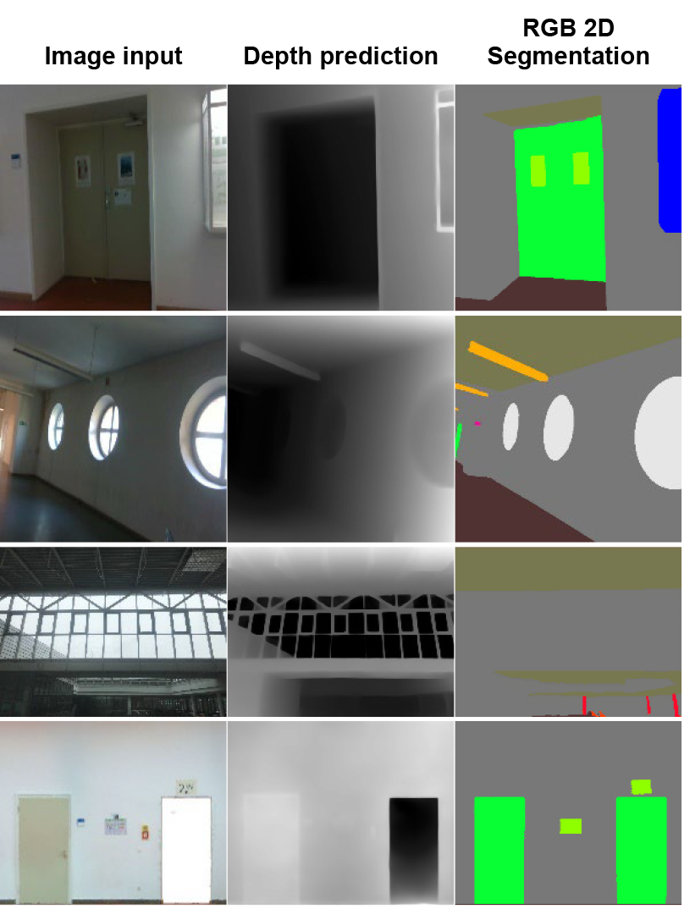
Figure 2: 2D Segmentation and Depth Predictions from TUM CMS Indoor Point Clouds dataset.
4.3. Experiments on 3D mesh and surface mask generation from 2D Scene Parsing
Default camera calibration parameters for the imaging devices used in the experiments on TUM CMS Indoor Point Clouds are presented, along with the point cloud generation techniques. Corner detection algorithms are investigated to deal with distortions and enhance point cloud generation based on the input pairs from the generated 2D Scene Parsing dataset (Fig. 3(a)).

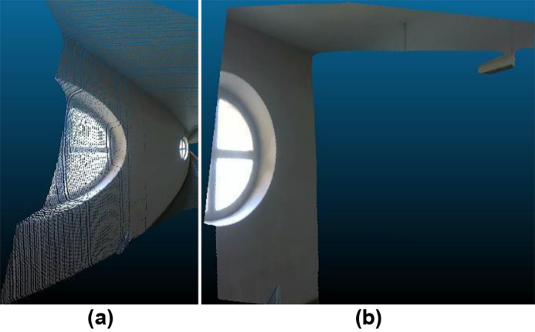Figure 3: 3D surface meshes from 2D Scene Parsing dataset. (a): The initial 3D mesh reconstruction. (b): 3D mesh reconstruction optimisation by filtering.

4.4. Experiments on optimising depth estimations and surface masks
The distortions in surface meshes are addressed by applying scalar thresholding values to filter depth estimations, resulting in smooth metric results for 3D reconstruction (Fig. 3(b)). Based on user prompts, LLMs and attention-based methods are deployed using segmentation masks from the 2D Scene Parsing dataset to define surfaces, thereby augmenting the precision of depth predictions (Table 2) (Fig. 4).

Table 2: LLM-based depth optimisation based on user prompts.

User prompt:
“The values below 160, identified as door, indicate void…”
LLM response: “…your existing code goes here…
for i in range(depth_np.shape[0]):
for j in range(depth_np.shape[1]):
if 0 <= doorMask[i, j] <= 160:
new_doorMask[i, j] = 0 …”
User prompt:
“The surface that is identified as wall is flat…”
LLM: Response: “…your existing code goes here…
if 150 <= wallMask[i, j] <= 210 :
new_wallMask[i, j] = 199 …”

The modified depth predictions are applied with images and segmentation masks as pairs for 3D reconstruction of surface meshes and annotated 3D masks (Fig. 5). The generated surface mesh is validated with 81.55% point-wise accuracy (mIoU) based on the evaluation metrics with regard to the existing point clouds as the ground truth (Fig. 5(c)).

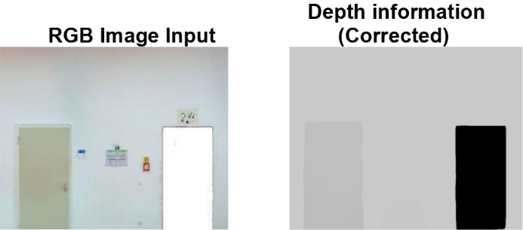Figure 4: Corrected depth information by the large language model.

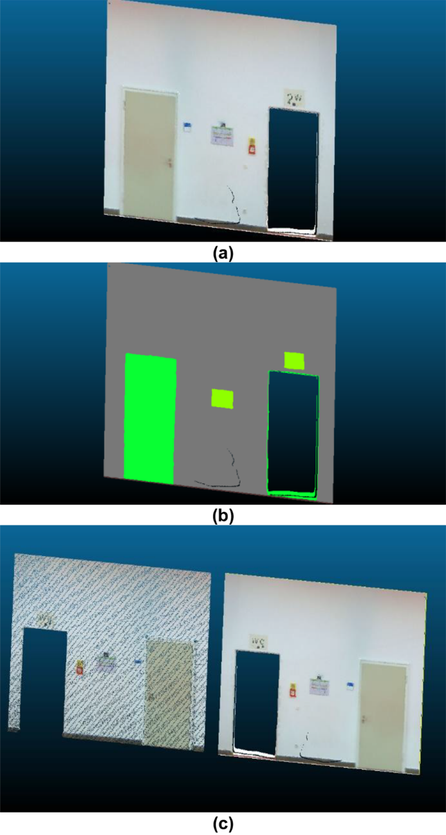Figure 5: Qualitative analyses of the generated 3D surfaces from 2D Scene Parsing. (a): The generated 3D surface mesh. (b): The generated 3D segmentation mask. (c): Comparison of the generated mesh (right) with the original point cloud (left).
4.5. Experiments on training and inference of 3D segmentation networks
The derived meshes and segmentation masks are also introduced to PTv3, PointTransformerV3 backbone, as training inputs together with the S3DIS and ScanNet datasets. Depending on the evaluation metrics, the 3D segmentation networks are found useful in learning and validating the outcome of the 3D reconstruction techniques. During training, the Vision Language Model (VLM) is employed with the PTv3 backbone to identify the concatenated dataset by collecting different and common classes. Consequently, the constructed network is trained for 100 epochs with a mini-batch size of 6, utilising the AdamW optimiser with a momentum of 0.9. The trained network is also tested on the selected datasets and meshes in S3DIS format, and the results are presented in Table 3. NVIDIA A100 GPU serves as the hardware resource during the training and testing.

Table 3: Performance results of 3D segmentation networks.

Dataset | Model | mIoU
Scannet | PTv3_RPE | 77.57
 | PTv3+VLM (ours) | 78.18
S3DIS | PTv3_RPE | 73.58
 | PTv3+VLM (validation, ours) | 73.87
 | PTv3+VLM (test, ours) | 74.86

Based on the improved results, the trained network is also used to re-annotate the TUM CMS Indoor Point Clouds Dataset, based on the S3DIS dataset format (Fig. 6).

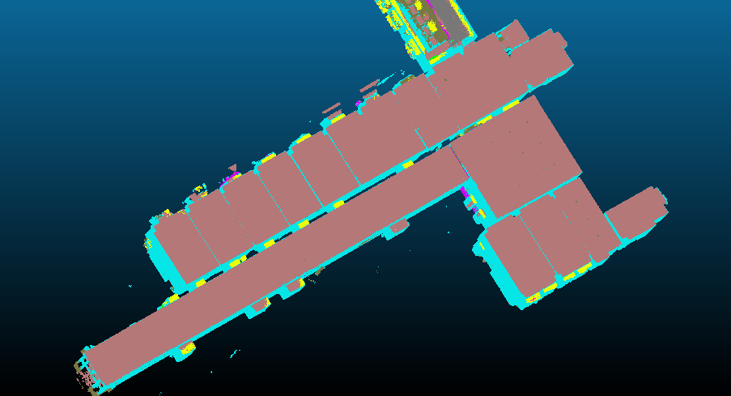
Figure 6: 3D annotations of TUM CMS Indoor Point Clouds by the trained segmentation networks.

5. DISCUSSION
The developed multi-task framework enables the generation of 3D reconstruction techniques from images and captures of point clouds by the 2D scene parsing methods. 2D scene parsing of TUM CMS Indoor Point Clouds facilitates the generation of valuable data applicable to 3D surface reconstruction, cross-validated using the annotated point clouds. The multi-task learning framework extracts 3D spatial information and enables the learning and application of 3D spatial data from 2D inputs, employing error correction and performance optimisation techniques by LLM (Fig. 1). Therefore, the 2D Scene Parsing dataset is generated based on the validation using richly annotated TUM CMS Indoor Point Clouds (Fig. 2). The results of the applied scene parsing methods provide both synthetic and raw 2D annotations and depth predictions through semantic segmentation for the documentation of indoor environments.
The outcomes of 2D scene parsing enhance the existing point clouds, enabling the knowledge transfer and cross-modal adaptability between 2D and 3D spatial data and various types of inputs. Consequently, the findings appear promising for developing robust 3D segmentation techniques, such as generating 3D segmentation masks of objects and surfaces derived from 2D annotations, depth images, and point clouds (Fig. 3). 3D point cloud projections are also defined as the ground truth to validate key annotations regarding doors, walls, windows, floors, and ceilings. Moreover, 2D segmentation tasks help recognise objects' exact shapes and borders in 2D and 3D scenes, complementing the information extracted by the bounding boxes in generating 3D segmentation masks. Recognising the complexity of surfaces like glasses, mirrors, and voids, 2D segmentations support depth predictions in error correction and augment synthetic datasets (Fig. 2 and Fig. 4).
Optimising focal depth and 3D reconstruction increases depth estimation's focus and precision based on the applied filtering techniques, making accurate 3D surface mesh generation possible, validated with strong quantitative results and qualitative analyses (Fig. 5). The generation of 2D Scene Parsing data of point clouds, including the 2D segmentation techniques, is paramount in extracting the surface feature of each distinct object that segmentation masks and filtering techniques could identify. The derived outcomes are augmented with the help of large language models, which are applied to correct depth images and surface mask generation by the user definitions of the overlapping content (Table 2).
Based on the generated surface meshes and masks, 3D segmentation networks are trained to recognise 3D spatial data derived from RGB and depth inputs of indoor scenes (Fig. 6). In this context, implementing the developed networks in environments lacking precise 3D spatial data, such as 3D point clouds and digital models, also becomes feasible. As a result, the research outcomes are expected to aid the development of innovative deep-learning methods for predicting spatial data in indoor environments lacking 3D sensory information and annotations.
Consequently, 3D surface meshes are generated from an indoor space without 3D sensor data by the multi-task framework applied with techniques of corner capture and LLM-based surface description, which are integrated into vision language models and segmentation networks (Fig. 7). The applied framework enabled the implementation of single-shot 3D reconstruction and provided promising initial results in recognising tiny objects with their annotations within the indoor space to improve the task-oriented simulations for well-being and user occupancy (Fig. 7).

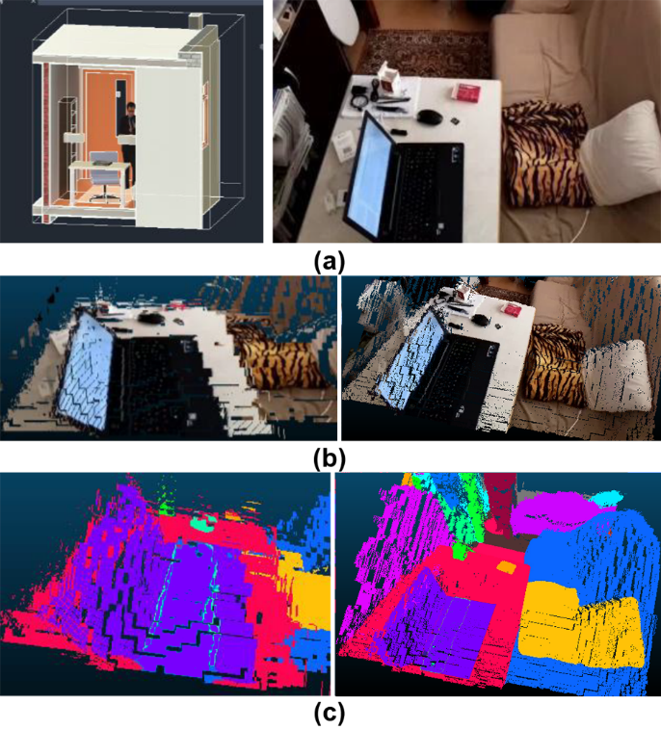Figure 7: Single-shot 3D reconstruction for real-time monitoring and simulations. (a): BIM rendering (left) and camera view of indoor space (right). (b): 3D mesh reconstruction of tiny objects by the applied framework with 2D scene parsing techniques. (c): 3D segmentation masks.

The applied techniques for optimising surface detection, depth prediction tasks, and generating 3D segmentation masks facilitate computational modelling and simulation of objects and indoor environments. Based on the BIM model developed for the simulation of comfort control and well-being in a smart house project, the goal is to enhance the multi-task framework for processing BIM data into point clouds and surface masks (Erişen, S., 2023) (Fig. 7). This enhancement aims to optimise design parameters and monitor selected research contexts in future work. The applied framework would enable the creation of annotations and 3D surface masks for BIM models, assisting moving agents and automation systems in recognising objects and actions in 3D for task-oriented and real-time simulations in the selected research contexts lacking 3D sensor data.

6. CONCLUSION
This research presents a novel multi-task learning framework bridging 2D scene parsing and 3D surface reconstruction, addressing key limitations often encountered in the digital documentation of indoor environments. The methods applied in this research enabled the generation of a 2D Scene Parsing dataset of TUM CMS Indoor Point Clouds, which served as a benchmark to validate the reconstruction pipeline that achieved 81.55% mIoU accuracy. This performance highlights the framework’s sensitivity to fine details, successfully identifying small-scale objects, such as pillows, mouse, or laptops, that often elude traditional 3D segmentation models.
Accordingly, the proposed method supports the training of 3D networks for real-life applications, including single-image-based reconstruction and adaptive simulations for user-centric environments. By enriching the semantic layer of geometric data, the framework contributes significantly to digital modelling workflows, even in sensor-limited or annotation-sparse settings. Overall, the applied framework lays the foundation for intelligent and responsive built environments, ultimately promoting human comfort and enhancing overall well-being by applying vision recognition technologies.

ACKNOWLEDGEMENTS
The research presented has been funded by Hacettepe University and TUM Georg Nemetschek Institute Artificial Intelligence for the Built World (GNI), which are thankfully acknowledged.

REFERENCES
Armeni, I., et.al., (2016). 3D semantic parsing of large-scale indoor spaces. In 2016 IEEE Conference on Computer Vision and Pattern Recognition (CVPR). Las Vegas, NV, USA, June 27-30.
Cheng, B., et.al., (2022). Masked-attention Mask Transformer for Universal Image Segmentation. In CVPR. New Orleans, Louisiana, USA, June 19-24.
Dai, A., et.al., (2017). ScanNet: Richly-Annotated 3D Reconstructions of Indoor Scenes. In 2017 IEEE Conference on Computer Vision and Pattern Recognition (CVPR). Honolulu, HI, USA. July 21-26.
Dosovitskiy, A., et.al., (2021). An Image is Worth 16x16 Words: Transformers for Image Recognition at Scale. In ICLR. Virtual Only Conference, May 3-7.
Erişen, S., (2022). Real-Time Learning and Monitoring System in Fighting against SARS-CoV-2 in a Private Indoor Environment. Sensors, 22(18): p. 7001. https://doi.org/10.3390/s22187001
Erişen, S., (2023). A Systematic Approach to Optimizing Energy-Efficient Automated Systems with Learning Models for Thermal Comfort in Indoor Spaces. Buildings, 13(7): p. 1824.
Erişen, S., (2024). SERNet-Former: Segmentation by Efficient-ResNet with Attention-Boosting Gates and Attention-Fusion Networks. In 2024 IEEE CVMI. Prayagraj, India, October 19-20.
Erişen, S., Mehranfar, M., & Borrmann, A., (2025). 2D Scene Parsing Dataset of TUM CMS Indoor Point Clouds [Dataset]. Available: https://doi.org/10.14459/2025mp1779501 [5 May 2025]
Google, (2024). Gemini [Large language model]. Available: https://gemini.google.com [24 March 2025].
Lu, Y. et.al., (2024). Image-based 3D reconstruction for multi-scale civil and infrastructure projects: A review from 2012 to 2022 with new perspective from deep learning methods. Advanced Engineering Informatics, 59: 102268.
Mehranfar, M., et.al., (2024a). Automated data-driven method for creating digital building models from dense point clouds and images through semantic segmentation and parametric model fitting. Advanced Engineering Informatics, 62: p. 102643.
Mehranfar, M., Braun, A., & Borrmann, A., (2024b). From dense point clouds to semantic digital models: End-to-end AI-based automation procedure for Manhattan-world structures. Automation in Construction, 162: p. 105392.
Mildenhall, B., et.al., (2020). NeRF: Representing Scenes as Neural Radiance Fields for View Synthesis. In ECCV. Online, August 23-28.
Noichl, F., et.al., (2024). From Purpose to Technology: A Requirements-Driven Approach to Designing Digital Twin Implementations. In Jebelli, H., Asadi, S., Mutis, I., Liu, R. & Cheng, J. (eds.) Digital Twins in Construction and the Built Environment. Reston, VA: American Society of Civil Engineers, p. 91-130.
Oquab, M., et.al., (2024). DINOv2: Learning Robust Visual Features without Supervision. Transactions on Machine Learning Research Journal, 2024: p. 1-31.
Pan, Y., et.al., (2022). Enriching geometric digital twins of buildings with small objects by fusing laser scanning and AI-based image recognition. Automation in Construction, 140: p. 104375.
Song, S. et.al., (2015). Sun RGB-D: A RGB-D scene understanding benchmark suite. In CVPR. Boston, Massachusetts, USA, June 8-12.
Wu, X., et.al., (2024). Point Transformer V3: Simpler, Faster, Stronger. In 2024 IEEE Conference on Computer Vision and Pattern Recognition (CVPR). Seattle, WA, USA. June 17-21.
Zhang, J. et.al., (2025). A voxel-based 3D reconstruction and action recognition method for construction workers. Advanced Engineering Informatics, 65: p. 103203.
Zhou, B. et.al., (2017). Scene Parsing through ADE20K Dataset. In CVPR. Honolulu, Hawaii, USA, July 21-26.

