AI-Driven Construction Scheduling: Extraction of Mini Schedules and Their Quality Assessment Using Knowledge Graphs and SLMs
Shrijit Banerjee¹, Sayan Biswas¹, Akarsth Kumar Singh², Aritra Pal^{3,}* and Shang-Hsien Hsieh²

¹ Department of Civil Engineering, Jadavpur University, INDIA
² Department of Civil Engineering, National Taiwan University, TAIWAN
³ Department of Civil Engineering, Indian Institute of Technology Madras, INDIA
*Corresponding email: aritrapal@civil.iitm.ac.in

ABSTRACT
Construction schedules are essential for effective project delivery, yet their scale and complexity make detailed analysis and quality assessment challenging. This study aims to develop and evaluate an automated framework combining knowledge graphs (KGs) and small language models (SLMs) to extract and assess mini schedules, defined as focused subsets of a master schedule representing related activities and dependencies for a specific building element or construction phase. The framework comprises three phases. First, Primavera P6 schedules are transformed into Neo4j knowledge graphs that preserve Work Breakdown Structure hierarchies, task attributes, and predecessor-successor relationships, with level-wise and sequence-wise embeddings used to capture structural and procedural context. Second, mini schedules are retrieved using SLM-generated Cypher queries and embedding-based similarity search. Third, their quality is assessed using criteria adapted from the GAO Schedule Assessment Guide, including completeness, sequencing, and duration validity. The framework was evaluated using five construction project schedules. For the second-floor slab case, the highest composite assessment score was 53.8% at an embedding threshold of 0.80. Retrieval performance was separately evaluated against human-labelled task relevance; at a threshold of 0.70, KG plus embedding retrieval achieved a precision of 0.72 and recall of 1.00, compared with 0.48 precision and 0.66 recall for substring-based filtering. These results show that semantic retrieval improves identification of relevant activities beyond exact keyword matching. This composite score represents an internal quality assessment metric rather than retrieval accuracy or absolute schedule correctness. The proposed framework provides a practical basis for construction schedule analysis, monitoring, and delay assessment, with future work extending the approach to resources, risk, and real-time schedule updates.

- INTRODUCTION
Construction projects frequently experience schedule delays and cost overruns. A McKinsey report indicates that 98% of the projects examined experienced cost overruns or delays (S. Changali, et.al., 2015). Studies indicate that poor schedule management is a significant contributor to project delays (Tariq, J. & Gardezi, S.S.S., 2023). Construction schedules are typically developed with substantial expert input to organize activities, dependencies, and project timelines. Poor-quality schedules are vulnerable to inefficiencies and delays. Therefore, assessing construction schedule quality is necessary to identify potential schedule weaknesses (P. Srinath and K. Varghese, 2023). Existing schedule quality assessment methods commonly evaluate the complete project schedule and require substantial expert input. The manual assessment process is time-consuming. Additionally, analyzing an entire schedule can be challenging due to its scale, complexity, and the heterogeneity of activities. This study proposes an automated method for extracting and evaluating the quality of mini schedules, which facilitates the analysis of large and complex project schedules by breaking them down into manageable components. For example, a mini schedule may contain all activities associated with third-floor slab construction. Breaking down an entire schedule into mini schedules with homogeneous details helps analyze and improve scheduling details, such as the completeness of task descriptions, sequencing, and consistency in duration. Improved mini schedules can be further combined to create more realistic project master schedules. The quality assessment evaluates whether the extracted mini schedules are complete, logically sequenced, and duration valid. It verifies that each mini schedule is accurate and usable for planning, monitoring, and decision-making.
However, extracting mini schedules from the master schedule using text-based filtering available in commercial scheduling software may be insufficient, because keyword matching may omit semantically related activities and may not preserve predecessor, successor, hierarchical, and location-dependent relationships. Knowledge graphs provide a structured representation of hierarchical, temporal, and dependency relationships among tasks, enabling machine-readable schedule reasoning (A. Pal, et al., 2025). Embedding construction knowledge into graph form allows schedulers to move beyond static methods toward automated, explainable, and adaptive solutions that align with dynamic project conditions. This makes KGs suitable for extracting targeted mini schedules, validating sequencing logic, and supporting decision-making in complex projects. Advances in query languages (e.g., Cypher) and embedding models have further enhanced KG-based reasoning, making them effective in domains such as NLP, recommendation, and construction (F. Pfitzner, et al., 2024). These methods address the challenges of incomplete or noisy data and are increasingly applied in contexts that require complex relational reasoning, positioning them as a promising foundation for construction scheduling (Singh, A.K. & Hsieh, S.H., 2026).
To address this gap, this study proposes an integrated KG and language-model-assisted framework for construction schedule analysis, integrating schedule-to-KG transformation with embeddings, automated natural language query translation for mini schedule extraction, and GAO-based (U. S. GAO) quality assessment of mini schedules to enable context-aware, explainable, and scalable schedule analysis. The remainder of this paper is organized as follows: Section 2 reviews related studies on KGs, embedding-based retrieval, and schedule quality assessment; Section 3 details the proposed methodology; Section 4 outlines the experimental setup; Section 5 presents results on mini schedule retrieval, schedule quality assessment, and parametric analysis; and Section 6 concludes with contributions, implications, and future research directions.
- RELATED WORKS

2.1 Advances in Knowledge Graph-Based Learning Frameworks
Knowledge graphs (KGs) provide structured representations of entity relationships, supporting reasoning, learning, and prediction within construction scheduling and planning. (Hong, Y., et al., 2022) proposed a graph-based method that encodes the textual, numerical, and graphical features of historic construction schedules to identify time-efficient task sequences, validating the approach on 353 real project schedules obtained from industry practice. Their results showed that graph representations can uncover productivity patterns, such as inefficient earthwork sequencing, that remain hidden in conventional schedule formats. Building on this direction, (Hong, Y., et al., 2023) developed a graph-based automated scheduling framework that applies graph convolutional networks over activity and sequence graphs to classify activity types and generate schedules directly from graph-encoded relationships, eliminating dependence on BIM inputs. Extending KG applications beyond scheduling, Johansen et al. (2025) introduced an ontology-based knowledge graph that integrates BIM, schedule, and safety information into a single queryable structure, enabling cross-domain querying that reveals how planning and scheduling decisions propagate into site safety outcomes. Collectively, Hong et al. (2022), Hong et al. (2023), and Johansen et al. (2025) illustrate the expanding role of KGs in construction scheduling, from mining sequence patterns and automating schedule generation to enabling structured, query-based reasoning across planning and safety domains. However, component-level semantic retrieval combined with standardized quality assessment of extracted mini schedules remains underexplored in construction scheduling research.

2.2 Information acquisition from Knowledge Graphs through Cypher Queries and Embedding-Based Retrieval
Knowledge graphs are increasingly applied in construction scheduling, with information retrieval carried out through Cypher queries or embedding-based similarity search. A schedule-derived KG (Amer, F. & Golparvar-Fard, M., 2021) uses Cypher queries to extract structured data, such as task IDs, dates, and dependencies, ensuring mini-schedules align with the work breakdown structure. Embedding-based retrieval (Zhang, Y. & Yang, X., 2025) represents tasks by level- and sequence-wise vectors; cosine similarity enables retrieval of semantically related tasks even with differing names. A combined method integrates both approaches: Cypher queries enforce rule-based accuracy, while embedding captures implicit task relationships, yielding richer, more coherent mini-schedules (S. Sun, et al., 2020). Collectively, these studies suggest that explicit graph queries provide structurally constrained retrieval, whereas embeddings improve semantic retrieval when equivalent activities use different terminology.

2.3 Review of schedule quality assessment approaches
Earlier schedule quality assessment approaches mainly relied on rule-based methods (P. Srinath and K. Varghese, 2023). Recent research integrates Building Information Modelling (BIM) and Machine Learning (ML) to enhance schedule generation, optimization, and ranking in construction. (B.S. Abdulfattah, et al., 2023) used ML to predict the impacts of design changes, ranking alternatives by time–cost trade-offs. (S. Mulero-Palencia, et al., 2021) applied decision trees in deep renovation projects, classifying pathologies and ranking Energy Conservation Measures (ECMs) by compliance and energy performance. (M.A. Al-Sinan, et al., 2024) introduced a BIM-ML framework for automated scheduling, where models learned dependencies and resources from past data to rank activities by feasibility and project similarity. (Braun, A. & Borrmann, A., 2019) employed CNN-based progress monitoring, ranking construction states by comparing as-planned and as-built conditions to flag delays. Collectively, these studies show that ranking in BIM and ML applications can arise through predictive modelling (B.S. Abdulfattah, et al., 2023), diagnostic classification (S. Mulero-Palencia, et al., 2021), ML-driven sequencing (M.A. Al-Sinan, et al., 2024), and image-based assessment (Braun, A. & Borrmann, A., 2019), positioning ranking as a central decision-support mechanism for schedule optimization and resource allocation.
- METHODOLOGY
The proposed methodology, as illustrated in Figure 1, comprises three sequential phases designed to transform raw project schedules into structured, analysable, and quality-assessed mini-schedules. Language models are employed for query generation and sequence refinement within the proposed framework. Phase 1 converts conventional project schedules into a knowledge graph enriched with embeddings to capture hierarchical structure and local dependency relationships among activities. Phase 2 enables mini-schedule generation through two complementary approaches: Cypher query retrieval, guided by small language models (SLMs), and embedding-based similarity search. Phase 3 introduces a quality assessment framework that evaluates extracted mini schedules against the GAO Schedule Assessment Guide, assessing completeness, logical sequencing, and duration validity. Together, these phases establish an end-to-end pipeline that supports context-aware mini-schedule extraction, semantic reasoning, and systematic quality assessment. To implement this pipeline, the first step is to transform conventional project schedules into a structured knowledge graph. This representation preserves both the hierarchical breakdown of activities and their logical dependencies, providing a foundation for semantic retrieval and quality assessment. In this study, SLM is used operationally to denote locally deployable language models with comparatively modest parameter and computing requirements relative to frontier LLMs; Mistral 7B and TinyLlama 1.1B are therefore referred to consistently as SLMs.

3.1 Schedule-to-Knowledge Graph Transformation and Embedding
Project schedules are transformed into a knowledge graph in Neo4j using the MPXJ library, which extracts tasks, WBS, and dependencies. Schedule entities are separated into WBS elements representing hierarchical groupings and Task nodes representing executable activities. Two node types are created: WBS nodes, which encode the hierarchy, and Task nodes, which store attributes such as dates, duration, float, and criticality. Hierarchy is preserved with HAS relationships, while logical dependencies are encoded as directed SUCCESSOR edges with type and lag values. To add semantic context, two embeddings are introduced. Level-wise embeddings represent a node’s hierarchical path (e.g., Project → Superstructure → 1st Floor → Columns → Column Concreting), capturing structural proximity. Sequence-wise embeddings combine the target task with its immediate predecessors and successors (e.g., Formwork → Rebar → Concreting → Curing → De-shuttering) with its WBS path, capturing procedural continuity. Together, these embeddings represent both hierarchical placement and local workflow continuity. The enriched graph then supports mini-schedule generation through a combination of SLM-guided Cypher queries and embedding-based similarity search, enabling retrieval of task clusters aligned with user-specified construction elements.

3.2 Mini-Schedule Generation through Cypher Queries and Embedding-Based Retrieval
In this phase, natural language inputs such as “first floor slab” or “second floor slab” are processed by the Mistral 7B language model, which generates corresponding Cypher queries for the Neo4j knowledge graph. The generated queries are executed on the graph to retrieve task attributes and dependencies associated with the specified construction element. The extracted output constitutes a mini schedule for that construction element, preserving both hierarchical context and logical sequencing within the overall project network. For the embedding-based retrieval, cosine similarity is used to retrieve tasks in the knowledge graph that align with a user’s query. Each task node is represented by two embeddings: a level-wise embedding, which captures its hierarchical placement in the Work Breakdown Structure, and a sequence-wise embedding, which reflects its position within the local dependency chain.
User queries are encoded into embedding vectors using the Microsoft E5-Large embedding model and compared with stored task embeddings through cosine similarity. Tasks whose similarity scores a similarity threshold τ are identified as matches, and their names, durations, and similarity values are recorded for both level-based and sequence-based results. Through this process, a mini schedule is generated for the specified construction element, with relevant tasks retrieved based on semantic similarity rather than exact name matching. The extracted mini schedules must then be evaluated to ensure they are complete, logically consistent, and practically useful. Phase 3 addresses this by assessing the retrieved schedules against the GAO Schedule Assessment Guide, enabling systematic comparison and identification of the most reliable alternatives.
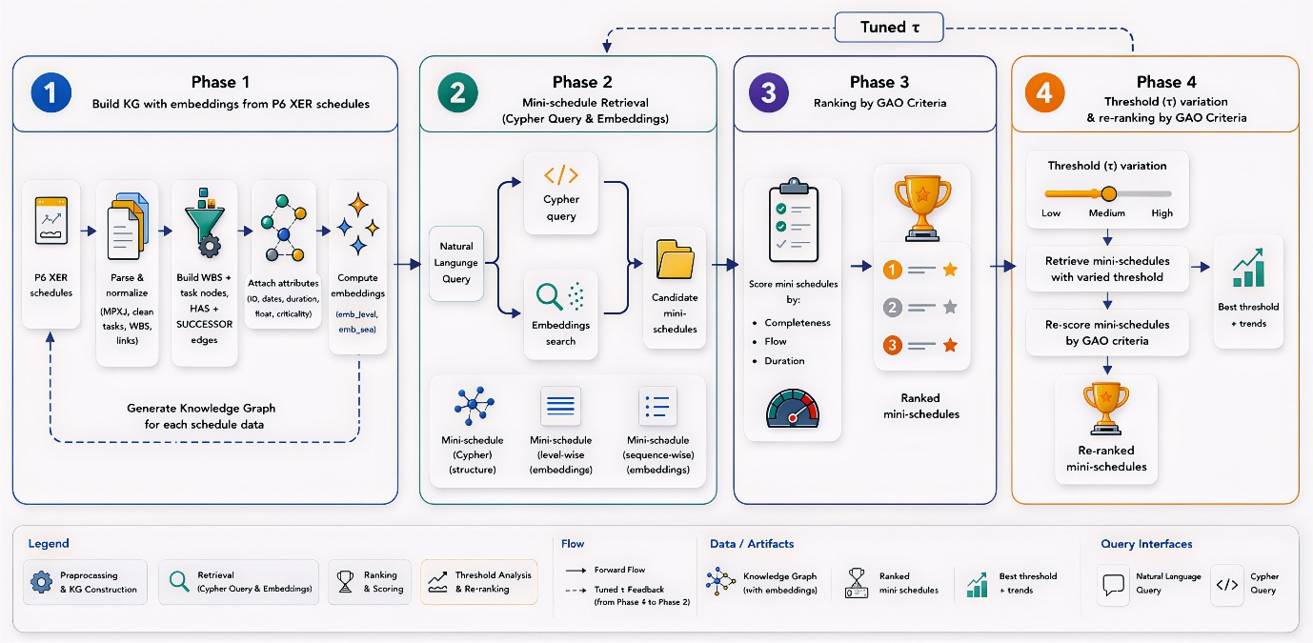
Figure 1: Detailed Sequence Workflow of Methodology

3.3 Quality Assessment of Construction Schedules Using the GAO Schedule Assessment Guide
A quality assessment framework was developed to evaluate construction schedules in accordance with the GAO Schedule Assessment Guide. This approach combines rule-based heuristics with an SLM to assess three quality dimensions: task-description completeness based on location, element, and action; logical task flow; and duration validity. The framework normalizes the raw schedule text files and extracts task attributes using regular expression-based patterns and canonical mappings. Action precedence is inferred through a precedence graph derived from multiple schedules, refined using TinyLlama 1.1B to improve logical ordering. A reference schedule is then generated by combining recurring construction elements, observed location levels, and the inferred action flow. Each schedule is scored for completeness, flow index, and duration validity, with each parameter having a particular weighted contribution that is aggregated into a final quality assessment score. The output provides both the inferred reference schedule and a ranked list of candidate schedules, enabling a systematic and reproducible comparison across alternative mini schedules.
In summary, the proposed methodology establishes an end-to-end pipeline that transforms raw project schedules into enriched knowledge graphs, retrieves mini-schedules using query and embedding-based approaches, and assesses them according to standardized assessment criteria. By integrating structural representation, semantic retrieval, and objective evaluation, the framework provides a structured basis for assessing the contextual coherence and quality of the extracted mini schedules. This foundation sets the stage for the experimental evaluation, where the proposed approach is tested across diverse project datasets to demonstrate its effectiveness and generalizability.
- EXPERIMENTAL SETUP

4.1 Data Collection
In this study, five diverse project schedules were used to generate mini-schedules and evaluate their
quality. All schedules were prepared in Primavera P6 and exported in .xer format, covering various types of construction projects, including general building, residential, hotel and apartment, and educational projects. Relevant schedule information, including Activity ID, Activity Name, WBS information, dates, durations, and dependencies, was extracted for subsequent processing. The different datasets used in this study are presented in Table 1, providing a diverse basis for evaluating the proposed method across projects of varying scales and complexities. For retrieval evaluation, relevant tasks in the tested mini-schedule cases from the Hotel Apartment, School Program, and Egyptian Residential Building datasets were manually labelled and used as ground truth for precision and recall.
Table 1. Dataset Overview: Task and WBS Element Distribution in Projects
Dataset | Number of tasks | Number of WBS elements
Building Project I | 6536 | 675
Building Project II | 12339 | 437
Residential Building Project | 7666 | 536
Hotel and Apartment Project | 9964 | 822
School Project | 8976 | 632

4.2 Materials and Methods
The project schedules were extracted and parsed using the MPXJ 1.1.14 library, while the knowledge graph was constructed and hosted in Neo4j 2.0.1. Information retrieval from the graph was performed using Cypher queries, and Mistral 7B was executed locally through Ollama to generate Cypher queries used for mini-schedule retrieval.. For semantic enrichment, both level-wise and sequence-wise embeddings were produced with the Microsoft E5-Large model. All models and processes were run locally on a system with 16 GB RAM and an Intel i5 11th-generation CPU, with the entire pipeline implemented in Python 3.11. To support the quality assessment of the generated mini-schedules, TinyLlama-1.1B-Chat-v1.0 was used to refine activity precedence when constructing the reference schedule.

4.3 Prompt Template for Cypher Query and Mini Schedule Generation
Prompts served as the primary interface to the small language model (SLM), guiding it to generate Cypher queries for graph retrieval and to structure semantic representations using embeddings. These instructions enabled the language model to interpret natural language inputs such as references to specific construction elements and translate them into precise graph queries. In the embedding-based approach, the user query was encoded and compared with stored task embeddings to retrieve activities aligned with the project hierarchy and sequence context. Sample prompts are shown in Table 2.
- RESULTS AND DISCUSSIONS

5.1 Visualization of Task Information in Knowledge Graph
The knowledge graph generated from the project’s schedule data is illustrated in Figure 2. The graph representation organizes tasks hierarchically with parent-child relationships depicted as node-edge connections. The metadata associated with each task include the unique task identifier (UID), work breakdown structure (WBS) code, duration, total float, and critical path status, is also shown. Temporal attributes, such as start and finish dates, are stored as task properties, enabling visualization of schedule timing. In addition, the knowledge graph encodes path embeddings that represent the hierarchical path (path_embedding_level) and local activity sequence (path_embedding_sequence) of the task within the overall schedule. By integrating these attributes, the knowledge graph provides a unified view that links hierarchical, temporal, and sequence-related information shown in the figure.

Table 2. Overview of Prompt Template
Prompts for Extraction through Cypher Query | Prompts for Extraction through Embedding
Third-floor slab details | Give me the details of the 1st floor slab
Beam details | Provide information about foundation concreting
Column Reinforcement Schedule | Retrieve information on floor finishing
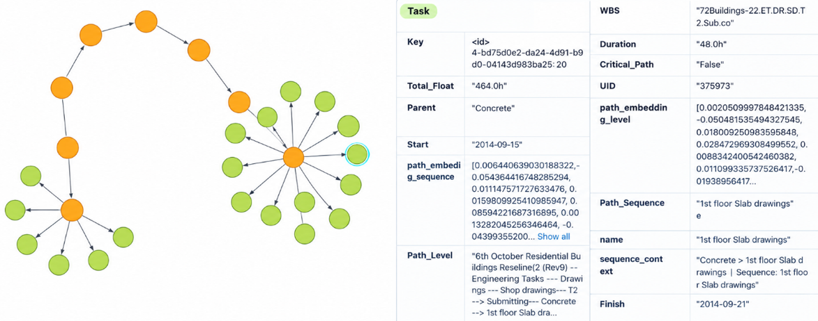

Figure 2: Knowledge graph of project tasks showing hierarchical relationships, schedule metadata, and path embedding

5.2 Assessment of Mini-Schedules Using GAO Schedule Assessment Criteria
The mini schedules were assessed per the GAO Schedule Assessment Guide's Best Practices 1, 2, and 4—completeness, sequencing, and duration validity—each translated into a quantitative score and weighted 0.4, 0.3, and 0.3, respectively, reflecting the importance of complete task information alongside logical flow and realistic durations. Completeness checked whether each task description contained the three required components—location, element, and action—detected via regex patterns and synonym mappings, with partial weights of 0.4, 0.3, and 0.3 assigned to these attributes and averaged across the schedule. Sequencing compared the order of actions against a learned reference schedule built from precedence graph analysis and optionally refined by an LLM, factoring in both compliances with this learned order and the presence and connectivity of critical construction actions. Duration validity checked task durations against benchmark ranges for typical construction activities using a threshold of 0.6 as the upper validity limit, scoring each task 1.0, 0.5, or 0.0 for valid, partially valid, or invalid, then averaging across tasks. The final composite score was calculated as
Final Assessment Score = 0.4×C + 0.3×F + 0.3×D
where C, F, and D denote completeness, flow (sequencing), and duration validity. Completeness was weighted highest (0.4) as fundamental to task scope and context, while sequencing and duration validity were equally weighted (0.3 each) as assessable through engineering knowledge and practical experience. Duration validity is inherently context-dependent—shaped by resources, productivity, construction methods, and site conditions—so generic benchmarks serve mainly as validity checks rather than strong discriminators of quality. These weighting coefficients are heuristic rather than empirically optimized, and were not calibrated against independent expert ratings in this study; the slightly higher location sub-weight was meant to distinguish repeated element-action combinations across floors or zones, with element and action weighted equally. The composite score therefore functions as an internal comparative indicator rather than an absolute measure of schedule correctness.
Figure 3 compares second-floor slab mini schedules from three projects—Hotel Apartment (30 tasks), Egyptian Residential Building (36 tasks), and School Program (34 tasks)—using this framework. Completeness was highest for Hotel Apartment (30.7%), followed by Egyptian Residential Building (28.9%) and School Program (28.8%), while all three scored 100% on duration validity. Flow scores were 21.7%, 22.2%, and 20.6% respectively. Hotel Apartment ranked highest on final assessment score (48.8%), closely followed by Egyptian Residential Building (48.2%) and School Program (47.7%). Duration validity did not differentiate the three cases; Hotel Apartment's slightly higher final score stemmed from its completeness and flow performance, while the uniform 100% duration result indicates the current duration criterion offers limited discrimination among these schedules and functions mainly as a validity screen.
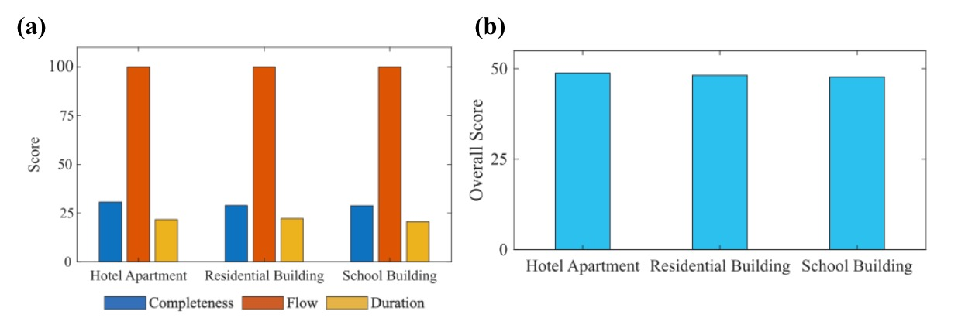
Figure 3: Quality assessment of mini schedules of the 2nd floor slab of various project schedules. (a) shows the comparison for each parameter: completeness, flow index, and duration, where (b) shows the final score by weighting each of these parameters

5.3 Parametric Study: Variation of threshold value for embeddings
A parametric study was conducted by varying the embedding threshold, τ, from 0.70 to 0.80 (0.70, 0.75, 0.78, and 0.80) across the Hotel Apartment, School Program, and Egyptian Residential Building datasets, with the retrieved mini-schedules evaluated against human-labelled ground truth. Across all three datasets, recall remained high (approximately 100%) up to τ=0.78, while precision increased as the number of retrieved tasks decreased; at τ=0.80, however, recall began to decline as relevant tasks were excluded. The consistent trend across the three datasets suggests that the precision-recall trade-off is associated with the retrieval threshold rather than a single project schedule. Precision was calculated as the proportion of retrieved tasks labelled relevant, whereas recall was calculated as the proportion of all labelled relevant tasks that were retrieved.
For example, in the second-floor slab case, increasing τ from 0.70 to 0.80 reduced the retrieved tasks from 162 to 22 and increased the completeness score from 20.5% to 44.1%, with the final assessment score improving from 42.9% to 53.8%; the intermediate thresholds of 0.75 and 0.78 yielded 110 and 50 tasks, with final scores of 46.0% and 50.6%, respectively. These results show that increasing the threshold improved schedule compactness and the assessed completeness score, while reducing recall at the highest threshold. To benchmark retrieval performance, the KG+embedding approach was further compared with substring-based text filtering at identical thresholds. At τ=0.70, embedding retrieval achieved perfect recall (1.00) and higher precision (0.72) compared with the baseline (0.66 and 0.48, respectively). Although the precision gap narrowed at higher thresholds (0.85 versus 0.67 at τ=0.78), baseline recall declined sharply to 0.42 at τ=0.80, compared with 0.73 for embedding retrieval. Overall, the results indicate that KG plus embedding retrieval achieved better precision-recall performance than substring-based filtering, particularly for relevant tasks lacking exact keyword matches, while the threshold controls the trade-off between retrieval completeness and schedule conciseness. Accordingly, τ = 0.80 should not be interpreted as universally optimal merely because it yields the highest composite score. In the tested datasets, tau = 0.78 provides a more balanced operating point because recall remains approximately 100% while precision improves.
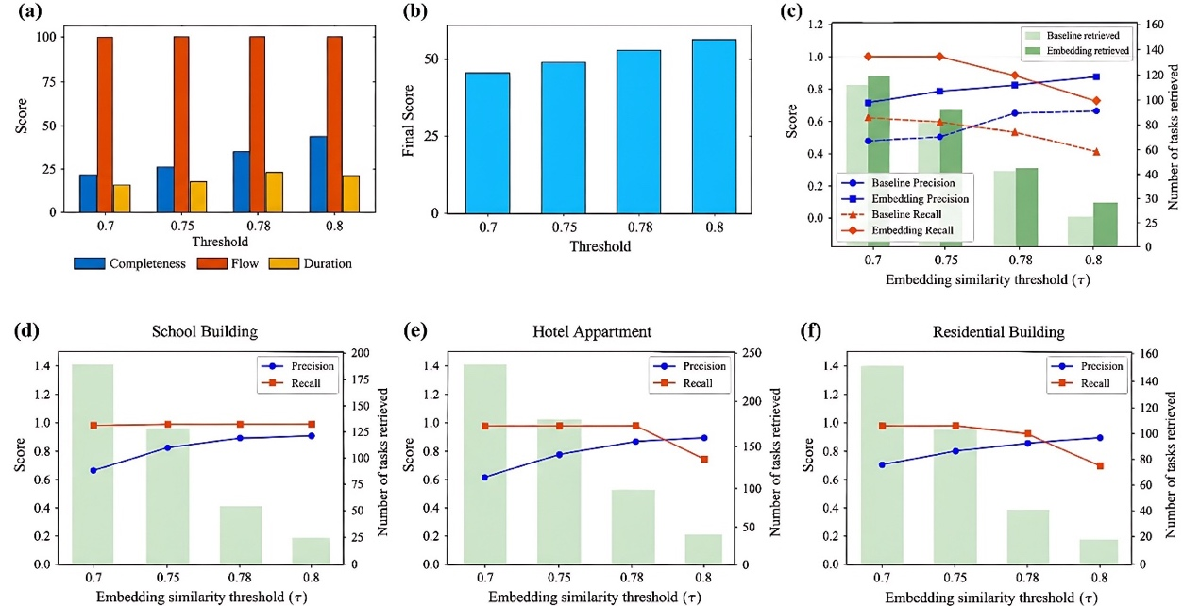

Figure 4: (a) Completeness/flow/duration sub-scores vs. threshold. (b) Final assessment score vs. threshold. (c) Baseline vs. embedding retrieval — precision/recall comparison. (d) School Program — precision/recall/retrieved count. (e) Hotel Apartment — precision/recall/retrieved count. (f) Egyptian Residential Building — precision/recall/retrieved count.

5.4 Practical Implementation and Use Case
Practical deployment requires structured schedule data—activity IDs and names, WBS hierarchy, dependencies, dates, and durations. Although the local implementation runs on modest hardware, KG construction, embedding generation, and similarity indexing scale with schedule size and may require greater resources for larger portfolios. For example, a planner can query second-floor slab activities in natural language, retrieve candidates through graph and semantic methods, and assess completeness, sequencing, and duration validity to flag missing context or weak sequencing before progress monitoring or delay analysis. Thus, the framework supports decision-making rather than autonomous schedule approval.

CONCLUSION

This study developed a knowledge graph (KG) and small language model (SLM) framework for generating and evaluating construction mini-schedules by converting schedules into embedding-enriched KGs, retrieving component-specific schedules through SLM-generated Cypher queries and semantic similarity, and assessing them using GAO Schedule Assessment Guide criteria. Tests on five project datasets showed that KGs effectively represent hierarchies and dependencies, while embedding-based retrieval captures semantically related tasks beyond exact keyword matches. In the threshold study, completeness reached 44.1%, duration validity remained 100%, and the final assessment score increased from 42.9% to 53.8% as the threshold rose from 0.70 to 0.80. Ground-truth evaluation showed better precision-recall balance than substring filtering, although threshold selection should consider recall alongside the composite score. Overall, the framework enables explainable, component-level schedule analysis and supports planning, monitoring, delay assessment, and project-control decisions through coherent, context-specific schedules and standardized comparisons. Deployment requires structured data on activities, WBS, dependencies, dates, and durations, while scalability is constrained by the computational demands of KG construction and embedding generation for larger projects. For comparable projects with historical data, it can compare component-level task durations and sequencing across projects and identify incomplete or poorly sequenced activities for targeted monitoring and delay assessment. Future work will expand datasets, incorporate resource and risk assessment, explore real-time deployment, calibrate assessment weights and composite scores against multiple independent construction-planning experts, and test duration-criterion sensitivity to improve robustness and industry adoption.

REFERENCES
Changali, S., Mohammad, A. and van Nieuwland, M., 2015. The construction productivity imperative. McKinsey Quarterly, (June), pp.1-10.
Tariq, J. and Gardezi, S.S.S., 2023. Study the delays and conflicts for construction projects and their mutual relationship: A review. Ain Shams Engineering Journal, 14(1), p.101815.
Srinath, P. and Varghese, K., 2023. Identifying and analysing the root causes of quality non-conformance in construction project baseline schedules. Journal of The Institution of Engineers (India): Series A, 104(2), pp.397-416.
Pal, A., Murguia, D. and Middleton, C., 2025, July. AI-POWERED APPLICATION FOR CONSTRUCTION SCHEDULE MANAGEMENT USING NATURAL LANGUAGE. In EC3 Conference 2025 (Vol. 6, pp. 0-0). European Council on Computing in Construction.
Pfitzner, F., Braun, A. and Borrmann, A., 2024. From data to knowledge: Construction process analysis through continuous image capturing, object detection, and knowledge graph creation. Automation in Construction, 164, p.105451.
Singh, A.K. and Hsieh, S.H., 2026. Multi-LLM-based augmentation and synthetic data generation of construction schedules and task descriptions with SLM-as-a-judge assessment. Advanced Engineering Informatics, 69, p.103825.
U.S. GAO, “GAO Schedule Assessment Guide: Best Practices for Project Schedules.” Accessed: Oct. 12, 2025. [Online]. Available: https://www.gao.gov/products/gao-16-89g
Hong, Y., Xie, H., Hovhannisyan, V. and Brilakis, I., 2022. A graph-based approach for unpacking construction sequence to evaluate schedules. Advanced Engineering Informatics, 52, p.101625.
Hong, Y., Xie, H., Agapaki, E. and Brilakis, I., 2023. Graph-based automated construction scheduling without use of BIM. Journal of Construction Engineering and Management, 149(2), p.05022020.
Johansen, K.W., Schultz, C. and Teizer, J., 2025. Knowledge graph exploitation to enhance usability of risk assessment in construction safety planning. Advanced Engineering Informatics, 65, p.103305.
Amer, F. and Golparvar-Fard, M., 2021. Modeling dynamic construction work template from existing scheduling via sequential machine learning. Advanced Engineering Informatics, 47, p.101198.
Zhang, Y. and Yang, X., 2025, April. Constructa: Automating commercial construction schedules in fabrication facilities with large language models. In Proceedings of the 2025 Conference of the Nations of the Americas Chapter of the Association for Computational Linguistics: Human Language Technologies (Volume 3: Industry Track) (pp. 156-172).
Sun, S., Sun, X., Che, Y., Luo, Q. and He, B., 2020. Rapidmatch: A holistic approach to subgraph query processing. Proceedings of the VLDB Endowment, 14(2), pp.176-188.
Abdulfattah, B.S., Abdelsalam, H.A., Abdelsalam, M., Bolpagni, M., Thurairajah, N., Perez, L.F. and Butt, T.E., 2023. Predicting implications of design changes in BIM-based construction projects through machine learning. Automation in Construction, 155, p.105057.
Mulero-Palencia, S., Álvarez-Díaz, S. and Andrés-Chicote, M., 2021. Machine learning for the improvement of deep renovation building projects using as-built BIM models. Sustainability, 13(12), p.6576.
Al-Sinan, M.A., Bubshait, A.A. and Aljaroudi, Z., 2024. Generation of construction scheduling through machine learning and BIM: A blueprint. Buildings, 14(4), p.934.
Braun, A. and Borrmann, A., 2019. Combining inverse photogrammetry and BIM for automated labeling of construction site images for machine learning. Automation in Construction, 106, p.102879.

