Concept for Large-Scale Evaluation of Spatial Relations for Road Infrastructure Management
A Graph-Based Federated Digital Twin Approach for Comprehensive Querying of Heterogeneous Infrastructure Datasets
Ina Heise¹, Anne Göbels², André Borrmann¹, Jakob Beetz²

¹ TUM Georg Nemetschek Institute, Technical University of Munich, Germany
² Design Computation, RWTH Aachen University, Germany

ABSTRACT:

The maintenance of road infrastructure is particularly challenging due to the various heterogeneous subsystems usually considered in an isolated fashion. This separate examination hinders factoring in effects arising from the interaction of the subsystems. To enable analysis of mutual influences between elements of different infrastructure assets, this paper presents a graph-based approach aiming for scalable evaluation of spatial relations. Focusing on relations between elements associated with differently directed assets, a mapping of spatial references between different linear reference systems is proposed. This mapping approach allows for the analysis of qualitative spatial relations between components of different assets, like roads and bridges, particularly in overpass situations, thus enabling consideration of mutually influencing effects between them. For validation, we use real-world data from German infrastructure management and showcase how winter maintenance data can be associated with bridge damage documentation.

KEYWORDS:

Road Bridge Interaction, Graph-based Methods, Cross-system Analysis, Contextual Linking, System of Systems

1. INTRODUCTION
Road infrastructure plays a crucial role in society, making its functionality both now and in the future a matter of significant concern. This infrastructure is a complex system composed of various subsystems, such as roads and bridges, that interact across multiple scales. Of particular interest are the spatial interactions, as they facilitate the consideration of functional dependencies between impacts and condition developments associated with different asset types. Consequently, a system that captures all subsystems and their interactions across various scales contributes significantly to a comprehensive decision-making foundation, thereby enhancing the management of road infrastructure.
Digital representations of real-world systems in their various states can be considered Digital Twins, in line with the definition provided by (VanDerHorn & Mahadevan, 2021). Consequently, applying a federated Digital Twin representing road infrastructure with its subsystems, conditions, and spatial relations seems promising.
The current state of road infrastructure management systems, however, is characterised by multiple distributed, non-interacting systems (Broo & Schooling, 2023). This siloed data storage allows comprehensive evaluation only on a very small scale, if at all. Furthermore, the lack of geometric models hinders the analysis of spatial relations.
In previous research concepts were developed to open the existing data silos in the digital representation by converting legacy data into graphs. Approaches have been introduced to represent and evaluate spatial relations based on textual descriptions of locations contained in the legacy data. As a result, data sets, damages, and building elements are described as referenced on the road or bridge axis, allowing for evaluating spatial relations within one asset.
Furthermore, linear reference elements are introduced to capture spatial relations between assets. By combining the spatial information both within and among assets, the range of evaluable spatial relations is further expanded. By superimposing various spatial references onto a shared reference element, it becomes possible to assess spatial relations across different scales and, consequently, between components of diverse assets. However, a shared reference element only exists in cases of similarly directed assets.
If bridges overpassing roads, elements of both assets are referenced on differently directed reference elements, as illustrated in Figure 1. Thus, no shared reference element exists that can be used for superposition as approaches from previous work require. To address this gap, we propose extending existing approaches to evaluate elements' spatial relations even when they are associated with differently directed assets.

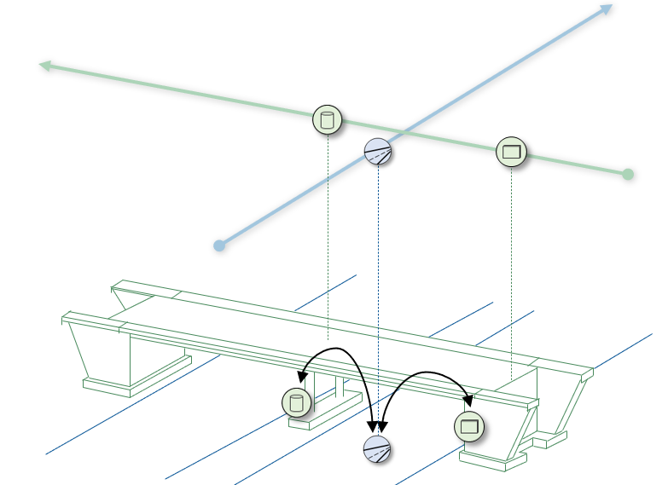
Figure 1 Infrastructure Elements referenced to differently directed Reference Systems
First, we provide a concise overview of the existing methods utilized for spatial structuring, detailing their graph-based representation and integration in a background chapter. Expanding on these existing approaches, we introduce an additional network-level scale designed to capture spatial relations among reference elements. An approach for modeling these spatial relations in a graph is presented.
Subsequently, the method for superimposing spatial references is extended by including the newly introduced network level for the advanced evaluation of relations between components of different assets.
A case study demonstrates the applicability of the developed methodology to real-world data from German infrastructure management. The data sets contain information on over 30.000 bridges and 40.000 road kilometers. We outline how winter maintenance data can be associated with documentation of structural damages on bridge substructures based on the spatial relation between the road lane on which the winter maintenance took place and the bridge substructure element located next to it.

2. RELATED RESEARCH
(Ammar et al., 2022), (Naderi & Shojaei, 2023), and (Taherkhani et al., 2024) explore the potential of digital twins in road infrastructure management and highlighting the advantages of a comprehensive digital representation. However, even though a comprehensive approach is promising, the research on digital twin methodologies for entire infrastructure systems is still in its infancy.
The required combination of heterogeneous data models is already well known from research in the field of Building Information Modelling (BIM) – Geoinformation Systems (GIS) integration. (F. Beck et al., 2020) describe the main challenges in the granularity, coverage, and perspectives differences.
Graph-based methods are frequently proposed to address these challenges. Numerous studies implement direct linking. (Vilgertshofer et al., 2017) apply this approach to link Industry Foundation Classes (IFC) with CityGML using the example of tunnel models. In the "okstraOWL" project presented in (Beetz & Borrmann, 2018), the German object catalogue for the road and traffic data (OKSTRA) is linked to another (international) information model, the Dutch OTL (RWS-OTL). In both cases, ontologies representing the different data structures are utilized, and similar elements are identified and defined. Although the authors successfully prove the general suitability of graph-based methods for linking heterogeneous data models, their findings also underscore the limitations of direct linking due to the inherent heterogeneity of the data models involved. This goes in line with the findings of (Herle et al., 2020) who discuss different approaches for linking heterogeneous data models.
Alternatively, (S. F. Beck et al., 2021) discuss context-based linking, based on the assumption that the required links vary according to the use case to be answered. Instead of identifying similar elements in both data structures and defining fixed same-as relations, the context is considered. Thus, elements are directly associated only at the instance level.
(Heise & Borrmann, 2024) apply context-based linking for modelling spatial relations between road infrastructure assets. The relations of different elements to a common reference system are explicitly modelled, thereby implicitly including a wide range of spatial relations between the elements. Depending on the use case, the spatial relation in question can then be determined utilizing appropriate queries. In (Heise et al., 2024), this approach is combined with the concept of modelling spatial relations specifically in bridges based on axes initially introduced in (Göbels et al., 2023). The work showed promise for applying graph-based methods in combination with context-based linking to deal with spatial relations in road infrastructure. Our work takes these approaches and extends them by another dimension to enhance the range of possible spatial relationships to be evaluated.

3 BACKGROUND
To deal with road infrastructure as a complex system, the system of systems approach, introduced by (Ackoff, 1971) is applied. Accordingly, the representation of road infrastructure is divided into subsystems with homogeneous characteristics, and further subsystems capture the relations between them. The integration of subsystems follows a hierarchical approach, with each subsystem being incorporated into the overall system by assigning it to the next higher super-system, resulting in a tree structure displayed in Figure 2. A distinct graph represents every subsystem. The approaches used within the different subsystem graphs are briefly explained below.

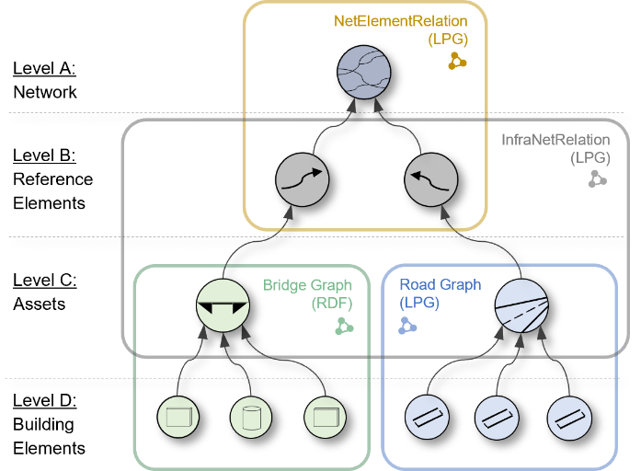
Figure 2 Subsystems tree
3.1 Spatial Structuring within Bridge Data
The bridge data originates from a relational database, SIB-Bauwerke (WPM-Ingenieure GmbH, 2019), which stores both construction and maintenance data based on the national data model, ASB-ING (Bundesministerium für Verkehr, 2013).
The database does not contain a three-dimensional bridge representation but uses textual descriptions to determine component and damage locations (e.g., front, back, right, left, etc.). The reference system for these descriptions is based on a documented bridge direction, which is the direction of the longitudinal bridge axis. In addition, the fields of the bridge are numbered in ascending order, with the first field being at the front of the bridge.
A length is documented for each field. However, the first field (number ‚0‘) has no length, but is rather to be understood as a starting point.
The respective substructure components (abutments, piers) are each linked to a field, whereby the frontmost substructure element is linked to field ‚0‘, and the next to field ‚1‘, and so on. This allows for precisely positioning the substructure elements in the longitudinal direction.
Other spatial references for components and damage areas are less precise and often only use directional terms, e.g., “left cap”, “3rd component from the right”, “damage in the lower area”.
To process this information further, the database entries were translated into an RDF graph using previously developed conversion processes (Göbels & Beetz, 2021). In this process, the textual location descriptions are also translated into explicit spatial links using the RELOC (Göbels & Beetz, 2024) Ontology.

3.2 Spatial Structuring within Road Data
In the realm of road management, various systems are employed across Germany. However, the standard “Anweisung Straßeninformationsbank Kernsystem” (ASB) establishes a uniform spatial structuring to be utilized among these different systems. As per this standard, all locations within road sections must be described in relation to the road axis.
For implementation, the ASB essentially allows two types of location description in the transversal direction: One option is a zone approach, building on a definition of different road cross-section areas with well-defined qualitative location terms. Localizing elements is achieved by assigning them to these zones. In addition to the zone-based approach, quantitative location descriptions are possible. In this case, the elements’ distance to the axis in the cross-section is specified.
The implementation of these spatial structuring concepts may vary between the different road management systems used in Germany. For our study, we analyze data from BAYSIS, the road management system used in Bavaria, comprising both spatial structuring methods.
By applying the generic approach presented in (Heise, 2024), the data contained in BAYSIS can be converted into a Labeled Property Graph (LPG). The resulting graph contains nodes representing the spatially located datasets. The localization information provided in the original data is represented through an edge to a node containing a location key that can be translated into a qualitative location description. Alternatively, the element nodes themselves have properties holding the distance of the respective element from the road axis as a numeric value.

2.3 Spatial Structuring on Asset Level
Linear reference elements are used to capture spatial relations at the asset level. Relations between the respective infrastructure element and the reference element are modeled explicitly as localization in the longitudinal direction and positioning in the transverse direction, as described in (Heise & Borrmann, 2024).
The localization of an element is modeled based on the principle of absolute linear referencing as per (DIN EN ISO 19148). Positioning is achieved by using qualitative descriptions.
All infrastructure elements are represented as nodes in the LPG called InfraNetRelation (Figure 3). Furthermore, this graph contains nodes representing reference, localization, and positioning elements. The infrastructure elements are connected to their corresponding reference elements through the localization and positioning nodes, which define the spatial relations between the infrastructure element and the reference element.

3.3 Cross-System Evaluation of Spatial Relations
In (Heise et al., 2024), the authors investigate the evaluation of spatial relations across different subsystems and scales by combining the spatial information of levels B to D (Figure 2). To facilitate a combined assessment of the distinct subsystem graphs, the same infrastructure element is represented across multiple subsystem graphs. These different representations of the same element serve as connection points among the distinct graphs. The association of these related representations to one another is enabled by employing unique, consistent IDs across all subsystem graphs.
Furthermore, the cross-scale evaluation of spatial relations requires mapping the spatial structuring systems involved. Hence, relations to different linear reference elements (bridge and road axes, for instance) are projected on a common reference element (linear reference element connecting both assets). Based on this projection, superimposing of spatial references of the different subsystems is enabled. Thus, a common reference system in the same direction as the spatially related assets facilitates the cross-asset evaluation of spatial relations.
In this paper, we build on the approaches presented in (Heise et al., 2024). However, we do not assume a common direction for the assets to be related. This case occurs in road infrastructure whenever spatial relationships between bridges and underpassing roads need to be evaluated.
.
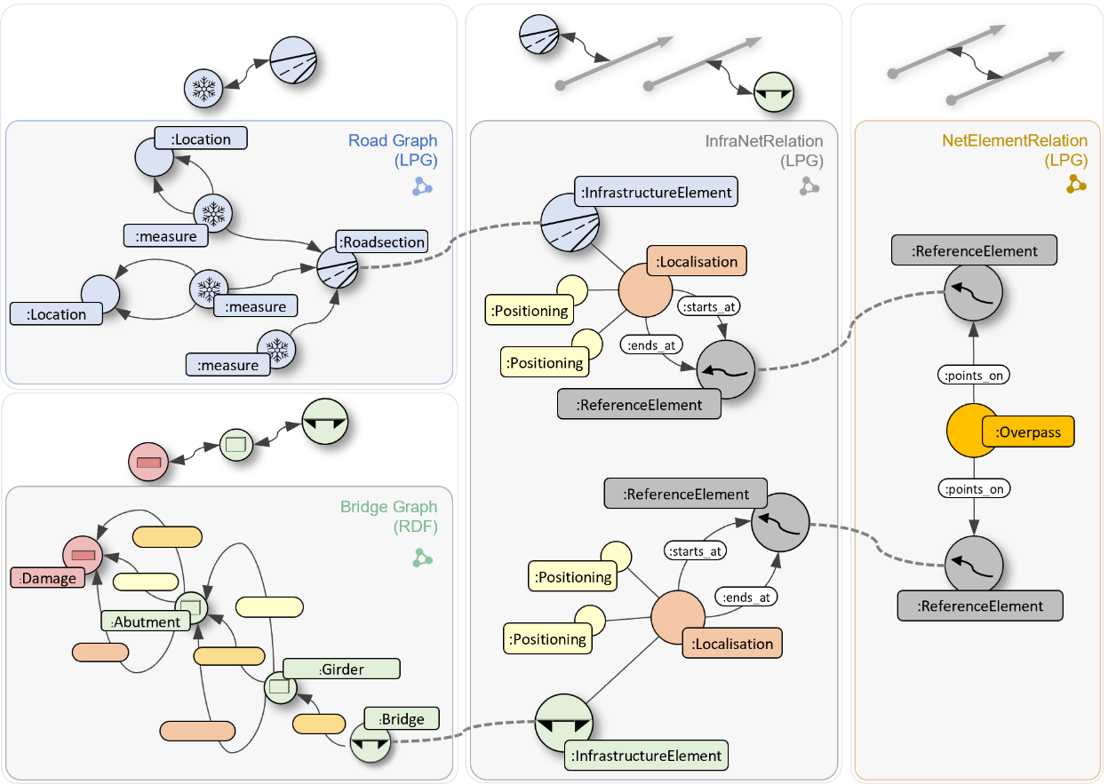
Figure 3 Different Subsystem Graphs

4. METHOD
The spatial relation between elements assigned to different assets is derived from the combination of information stored at the individual levels (Figure 2). The combination of Level C and D provides information about the location of an element within the asset related to the asset's axis. Levels B and C contain the relation between the assets and the corresponding reference element.
To facilitate the analysis of spatial relations between assets, even though they are differently directed, spatial relations between reference elements are required. Thus, an additional level, the network level, is added above the reference elements level as shown in Figure 2.
Figure 3 shows the graphs capturing spatial relations within the different subsystems and the approach used from previous work to link them. Thus, the spatial relation between elements of two differently directed assets is described by a combination of different subsystem graphs and can be evaluated as such.
In the following, we first particularly outline the added approach for capturing spatial relations between reference elements. Subsequently, we elaborate on combining the different spatial structuring approaches to facilitate their comprehensive evaluation.

4.1 Spatial Relations between Reference Elements
The combination of all reference elements can be considered a road network. Accordingly, relations between reference elements are captured in the subsystem representing the network corresponding to Level A in Figure 2.
Typically, road networks represent traffic relations. Thus, relations between network edges usually arise from network nodes as common points in all directions (x,y,z) of at least two network edges, representing real intersection situations. However, in the case considered in this paper, there is most likely no traffic relation between the reference elements and no common point in x-, y-, and z-direction. Instead, the intersection point of the reference elements' projections in the xy-plane is required as an overpass point.
The method of absolute linear referencing, defined in (DIN EN ISO 19148), is used for locating the overpass point on the respective reference element. Therefore, the distance to the starting point of the reference element is specified. This distance, together with the angle between the global north and the reference element (under consideration of the direction of the reference element), characterizes the relation between the reference element and the overpass point.
To capture this spatial relation in the corresponding subgraph, both the reference elements and the overpass points are represented as nodes with corresponding labels, as illustrated in Figure 4. Furthermore, a connecting edge labeled with :points_on from the respective :Overpass node to the corresponding :ReferenceElement node specifies the relation between the respective overpass point and the reference element.

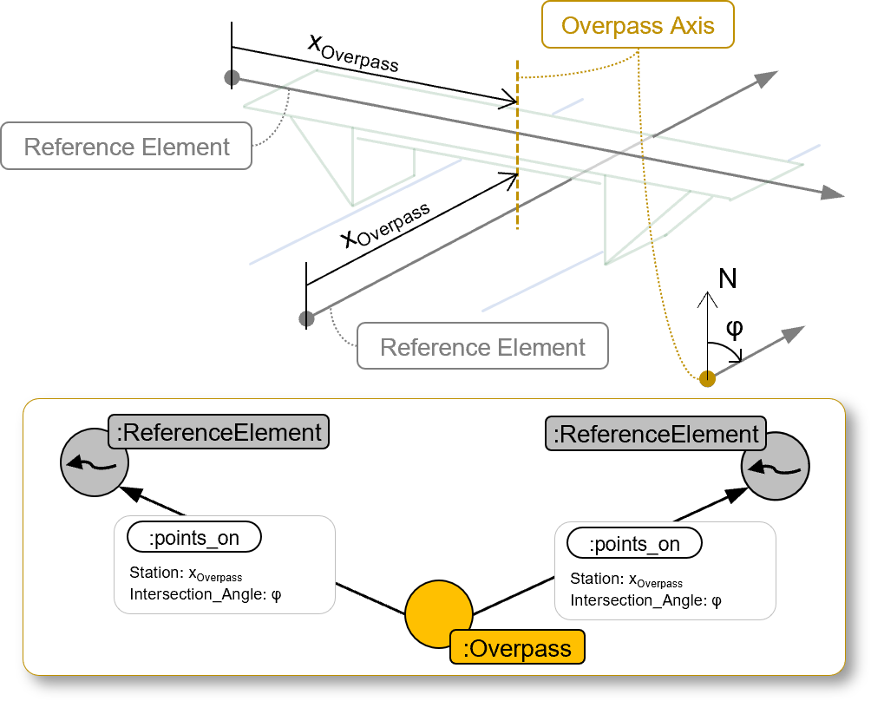
Figure 4 Graph Representation of the Overpass-Relation (Subsystem Network, Level A)
4.2 Mapping of the Spatial Structuring Systems
Combining different subsystems employing different spatial structuring systems requires a mapping between the reference systems contained. Based on this mapping, the conversion of spatial information is facilitated, resulting in location descriptions all related to a common reference system. Spatial relations between the different elements referenced to the same reference element can then be superimposed to derive spatial relations between the respective elements as presented in previous work.
Due to the large longitudinal extent of infrastructure assets, spatial structuring is typically based on linear reference elements. The conversion of spatial references between subsystems thus transforms location descriptions between different linear reference elements. Furthermore, qualitative spatial relationships are determined rather than quantitative distances being calculated. This simplification reduces the required accuracy, allowing the assumption of straight linear reference elements.
Using these simplifications, in the mapping process, two basic types of relations between the reference elements can be distinguished:
(1) Similarly directed reference elements: (Heise et al., 2024) describe the superposition of spatial relations between elements of different assets referenced to a common linear reference element. The presented approach can be generalized for converting location descriptions between similarly directed reference elements and is adopted accordingly. The resulting formulas for converting the quantitative location descriptions are shown in a summarized manner in Figure 5. The signs within the equations vary according to the orientation of the individual reference elements.

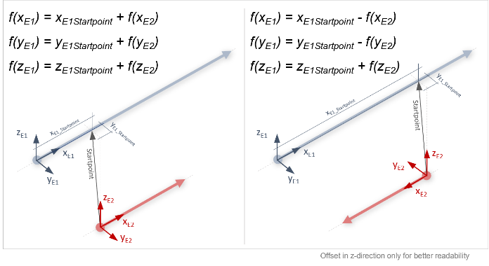
Figure 5 Mapping between the same directed Reference Elements following (Heise et al., 2024)
(2) Differently directed reference elements: If the reference elements differ in direction, the conversion of location descriptions requires integrating relations of the reference elements to each other, respectively, their relation to the overpass point. The resulting calculation based on trigonometric dependencies is illustrated in Figure 6.

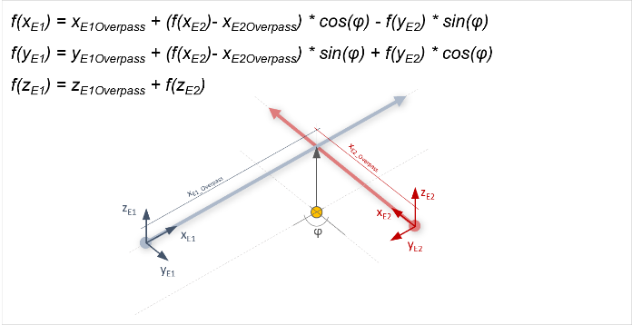
Figure 6 Mapping between differently directed Reference Elements
All values necessary for the calculation can be extracted from the network graph (Level A in Figure 2). According to the graph structure illustrated in Figure 4, the edges between the respective :ReferenceElement node and the :Overpass node hold the relevant information: The Station property contains the values for x_{E1_Overpass} and x_{E2_Overpass} and the angle between the two reference elements, φ, results from the difference of the values of the Intersection_Angle properties.
Thus, the combination of spatial relations from different subsystems and approaches for their conversion provides information on spatial relations between elements of different assets.

4.3 Comprehensive Querying of Spatial Relations
For the evaluation of the spatial relations, pattern matching is applied. Thereby, the graph representations are searched for matches with a pattern graph representing a specific spatial relation. Figure 7 shows a possible pattern graph enabling the extraction of road section elements located under a corresponding bridge.
The respective pattern graph consists of two segments in the InfraNetRelation graph and the NetElementRelation graph. Furthermore, the distance value of the road element in the transverse direction is converted to the longitudinal direction of the bridge axis (C3 in Figure 7). Using the conversion allows for checking whether the road section referenced to the road axis is within the longitudinal extent of the bridge.
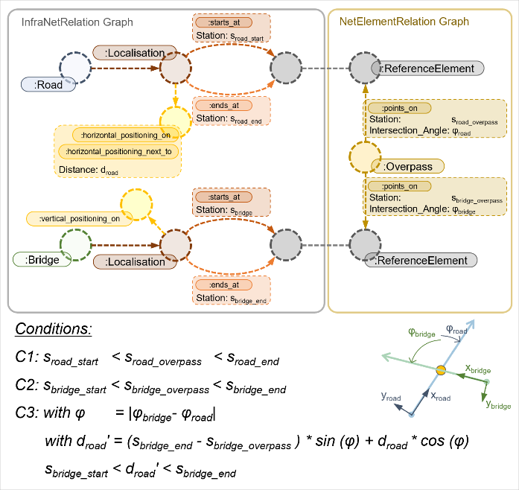
Figure 7 Pattern Graph for Bridge – Road Interaction
Finally, the pattern matching across different graphs requires sequential querying due to the distribution of subsystems. Accordingly, the pattern graph representing the spatial relation in question must be subdivided into sequences.
For the example displayed in Figure 7, this results in first analyzing the NetElementRelation graph for reference elements with an overpass relation. Secondly, the InfraNetRelation graph is examined for assets related to these reference elements by searching for the pattern sequence corresponding to this relation. The required identification of the different representations of the same element in the distinct graphs is enabled by using IDs as proposed in (Heise et al., 2024).

5. CASE STUDY
The methodology presented is applied to real-world data from German infrastructure management. The data sets stem from different, unconnected infrastructure management systems currently in use, each based on relational database systems.
By applying existing approaches introduced in Chapter 3, graph representations of the legacy data are created. Furthermore, the InfraNetRelation graph is generated using the references to the ASB net contained in the legacy data. To create the NetElementRelation graph, the defined ASB net is utilized again. However, since the ASB network represents the traffic network, the overpass relations to be represented in the NetElementRelation graph could not be directly derived. To determine these overpass relations, the geometry of the network elements was analyzed, and the overpass points were calculated. The resulting graphs are stored in distinct graph database instances according to Figure 3.
A Python script serves as middleware to connect the different graph database instances by sending queries to the corresponding endpoints and processing the answers to generate and send the subsequent queries.
In this setup, the following use case is implemented:
To ensure road safety at any time, roads are cleared and gritted in winter. Road salt is often used for this purpose. It can be assumed that this use of road salt significantly increases the chloride load, both in the area of the road itself and resulting from splash water in the adjacent area of the road.
An increased chloride load in concrete elements is generally associated with faster carbonation and damage resulting from reinforcement corrosion. In the context of road infrastructure, especially in the area of highway overpasses, bridge substructures are often located directly next to roads (see Figure 8).

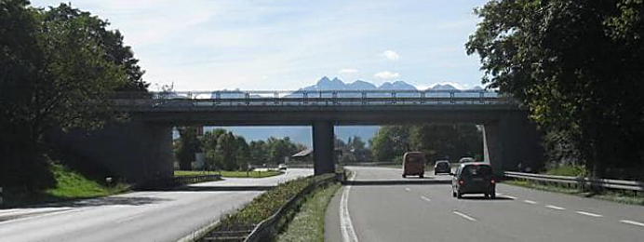
Figure 8 Example situation of a highway overpass in Bavaria (Source: Bridge Book (Bauwerksbuch))
Due to their location directly next to the road, these bridge substructures are in the splash water area and likely to be affected by increased chloride contamination in the lower area.
By assigning winter maintenance data and the structural damage of bridge components to one another, correlation analysis based on existing German infrastructure management data is facilitated. However, this assignment requires evaluating the spatial relation between the winter maintenance data associated with lanes on road sections and the structural damage data related to the lower area of bridge components located next to the corresponding road. An illustration of the spatial relation in question is displayed in Figure 9.

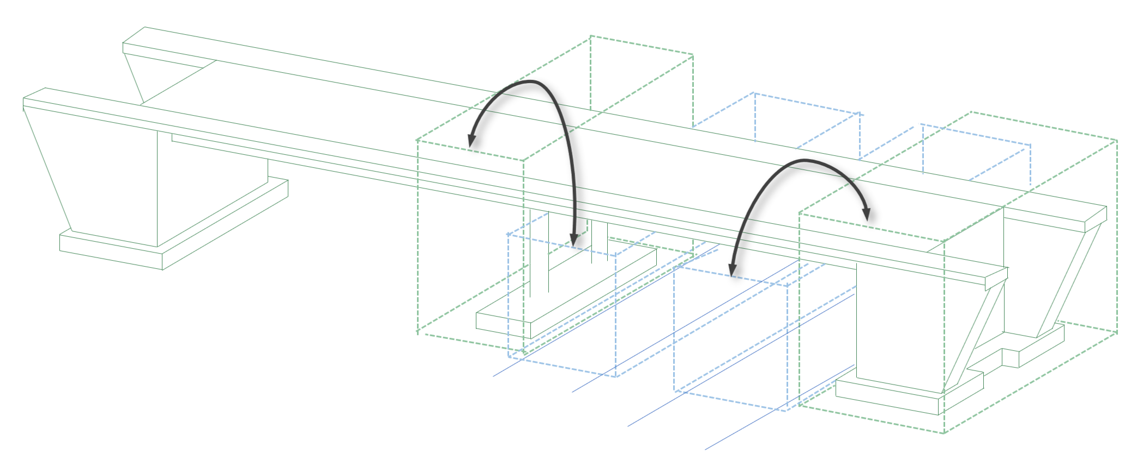
Figure 9 Example situation
For implementation, the distinct graphs are queried as illustrated in Figure 10. Starting from the winter maintenance documentation, the road sections and lanes corresponding to a certain grid use can be evaluated by sending a CYPHER query to the respective database instance (Road data graph).
Based on the returned ID, the location of the road section on the first reference element can be extracted by sending a subsequent CYPHER query to the InfraNetRelation graph database endpoint. As a result, the area relevant for a potential overpass on the first reference element is identified.
A follow-up CYPHER query is generated based on the returned reference element ID and the area under consideration given by the start and end points. Directing this query to the NetElementRelation graph gives overpasses located within the road section area. Detected overpass relations are returned as IDs of the affected reference elements and the information on the relation, specifically location on both reference elements and angles of the reference elements at the overpass point.
Using this information, the conversion of the road axis relation of the winter maintenance data into a location description based on the second, potentially bridge-related, reference element can be processed. This relation, converted to the second reference element, forms the basis for querying the InfraNetRelation graph again. However, this time, bridges referenced on the second reference element intersecting the area under consideration, defined by the overpass point and the converted road data location, are to be extracted.
Lastly, the returned bridge IDs combined with the information on potential orientation differences between the bridge axis and the reference element, and the other spatial information collected, allow for the definition of the SPARQL query to extract the bridge-related data. Through the conversion of the road-related location information, the area in question related to the bridge axis can be derived. Accordingly, a corresponding SPARQL query can extract the bridge elements located in these areas in question. Proceeding from the bridge elements, associated damages can be determined. This finally enables the association of damages on bridge elements with the splash water area in which they are located.

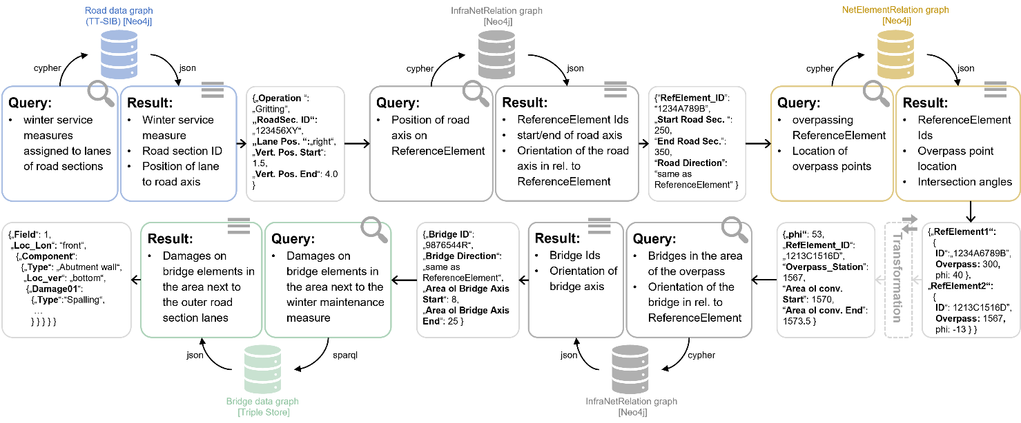
Figure 10 Case Study: Correlation of road section lane assigned winter maintenance data with chloride-induced damages

6. RESULTS AND DISCUSSION
Although geometric models are available neither for roads nor bridges, spatial relations between their building elements can be evaluated. The case study demonstrates this by associating bridge element conditions with winter maintenance data. Evaluating this spatial relation, in particular, could reveal the causes of varying condition developments among elements of the same bridge. A better understanding of possible causes of damage then supports selecting the most suitable repair or rehabilitation measure in the next step.
Additionally, the findings can be used to identify components exposed to particularly high chloride levels. Thus, bridge inspectors' awareness of specific damage to certain components or areas during inspections can be raised, thereby increasing the likelihood of early detection of damage.
Another advantage of the proposed method relates to its scalability. This scalability allows for evaluation of qualitative spatial relations of components, not only for individual asset elements and their correlated datasets, but for all spatial constellations occurring in the road network. As existing infrastructure management data already contains documentation of damage developments on a large number of bridges, as well as winter maintenance measures over a long period of time, the prerequisites are given to use this data as a basis for a correlation analysis.
Limitations of the approach presented lie in the availability of road infrastructure data in the form of graphs. The infrastructure management currently practiced mostly uses systems based on relational databases. Therefore, initially, a transformation of the original data into graphs is required. Even though this transformation can be automated, it happens at a specific point in time. Thus, updates of the original data made by the authorities pose challenges to ensuring consistency between the original data and its graph representation. A similar problem occurs when the same elements are represented in different sub-systems. Although the IDs used enable the efficient updating of graphs if the changed elements are known, beyond that, an extensive comparison of the entire graphs would be necessary.
Furthermore, the conversion of spatial references between differently directed reference elements assumes straight reference elements. This assumption implies that the conversion results become less accurate the less linear the reference elements under consideration are. These emerging inaccuracies are currently not taken into account, as it is assumed that their influence on qualitative spatial relationships can be neglected. However, it should be noted that the presented approach is only suitable to a very limited extent for the evaluation of quantitative spatial relations like distances.

7. CONCLUSION
This paper presents a graph-based approach to enable the analysis of qualitative spatial relations between legacy data sets associated with elements of different road infrastructure assets. To this end, the legacy data and its spatial relations on different scales are represented in distinct graphs, creating a comprehensive representation of road infrastructure. Spatial relations can be evaluated by searching for the occurrence of a specific subgraph representing the spatial relation in question. Hence, a flexible cross-scale evaluation of distributed road infrastructure data is enabled.
The approach presented provides an alternative to deriving qualitative spatial relationships through complex geometric analyses. Hence, the analysis of spatial relations between components of different assets is facilitated, despite the lack of geometric models for either individual or constellations of multiple assets.
Nevertheless, an extension of the presented approach with data models containing more precise geometric descriptions, such as IFC, is conceivable. In this case, the representation of spatial relations at different scales through distinct graphs facilitates the system's scalability. The comprehensive evaluation of the different graphs would then serve as a preliminary step to identify elements in a particular qualitative spatial relationship, whose quantitative geometric relations could then be calculated precisely in a second step.
Furthermore, applying the presented approach to combining a GIS-based description of roads with a BIM-based description of the overpass bridges would contribute to context-based linking in the field of BIM-GIS integration.
And lastly, although the approach presented in this paper primarily focuses on overpass situations, applying the principle presented to general crossing situations is conceivable.

ACKNOWLEDGEMENTS
The presented research is part of the project Digital twin for operating road infrastructure funded by the Bavarian Ministry for Housing, Construction, and Transport and part of the SPP 100+ Spacelink Project funded by the Deutsche Forschungsgemeinschaft (DFG, German Research Foundation) – Project number 501812634.

REFERENCES
Ackoff, R. L. (1971). Towards a System of Systems Concepts. Management Science, 17(11), 661–671. https://doi.org/10.1287/mnsc.17.11.661
Ammar, A., Nassereddine, H., & Dadi, G. (2022). Roadmap to a Holistic Highway Digital Twin: A Why, How, and Why Framework. In Critical Infrastructure - Modern Approach and New Developments. IntechOpen. https://doi.org/10.5772/intechopen.108546
Anweisung Straßeninformationsbank Kernsystem (2018).
Beck, F., Borrmann, A., & Kolbe, T. H. (2020). The need for a differentiation between heterogeneous information integration approaches in the field of “BIM-GIS Integration”: a literature review. ISPRS Annals of the Photogrammetry, Remote Sensing and Spatial Information Sciences, VI-4/W1-2020, 21–28. https://doi.org/10.5194/isprs-annals-VI-4-W1-2020-21-2020
Beck, S. F., Abualdenien, J., Hijazi, I. H., Borrmann, A., & Kolbe, T. H. (2021). Analyzing Contextual Linking of Heterogeneous Information Models from the Domains BIM and UIM. ISPRS International Journal of Geo-Information, 10(12), 807. https://doi.org/10.3390/ijgi10120807
Beetz, J., & Borrmann, A. (2018). Benefits and Limitations of Linked Data Approaches for Road Modeling and Data Exchange. Proceedings of EG-ICE 2018, 245–261. https://doi.org/10.1007/978-3-319-91638-5_13
Broo, D. G., & Schooling, J. (2023). Digital twins in infrastructure: definitions, current practices, challenges and strategies. International Journal of Construction Management, 23(7), 1254–1263. https://doi.org/10.1080/15623599.2021.1966980
DIN EN ISO 19148. https://www.iso.org/obp
Göbels, A., & Beetz, J. (2021). Conversion of legacy domain models into ontologies for infrastructure maintenance. 9. Linked Data in Architecture and Construction Workshop.
https://doi.org/10.18154/RWTH-2021-07330
Göbels, A., & Beetz, J. (2024). Relative Location Ontology: An ontological model for representing directional topological relationships between spatial entities in oriented space. Proceedings of 12th Linked Data in Architecture and Construction Workshop.
Göbels, A., Rivadeneyra, F., & Beetz, J. (2023, July 10). Transfer of implicit semi-formal textual location descriptions in three-dimensional model contexts. https://doi.org/10.35490/EC3.2023.268
Heise, I., & Borrmann, A. (2024). infraspatialOT: An ontology for the representation of spatial relationships in road infrastructure. LDAC 2024 - Linked Data in Architecture and Construction.
Heise, I., Göbels, A., Borrmann, A., & Beetz, J. (2024, October). Enabling Comprehensive Querying of Road and Civil Structure Data using Graph-based Methods. Proceedings of the 41st International Conference of CIB W78. http://itc.scix.net/paper/w78-2024-18
Heise Ina. (2024). Automatic conversion of real-world data from a German road infrastructure management system into a labelled property graph. Proceedings of the 35th Forum Bauinformatik 2024, 448–455. https://doi.org/https://doi.org/10.15480/882.13486
Herle, S., Becker, R., Wollenberg, R., & Blankenbach, J. (2020). GIM and BIM. PFG – Journal of Photogrammetry, Remote Sensing and Geoinformation Science, 88(1), 33–42. https://doi.org/10.1007/s41064-020-00090-4
Naderi, H., & Shojaei, A. (2023). Digital twinning of civil infrastructures: Current state of model architectures, interoperability solutions, and future prospects. Automation in Construction, 149, 104785. https://doi.org/10.1016/j.autcon.2023.104785
Taherkhani, R., Ashtari, M. A., & Aziminezhad, M. (2024). Digital Twin-Enabled Infrastructures: A Bibliometric Analysis-Based Review. Journal of Infrastructure Systems, 30(1). https://doi.org/10.1061/JITSE4.ISENG-2323/SUPPL_FILE/SUPPLEMENTAL
VanDerHorn, E., & Mahadevan, S. (2021). Digital Twin: Generalization, characterization and implementation. Decision Support Systems, 145. https://doi.org/10.1016/j.dss.2021.113524
Vilgertshofer, S., Amann, J., Willenborg, B., Borrmann, A., & Kolbe, T. H. (2017). Linking BIM and GIS Models in Infrastructure by Example of IFC and CityGML. Computing in Civil Engineering 2017, 133–140. https://doi.org/10.1061/9780784480823.017
WPM-Ingenieure GmbH. (2019). SIB-Bauwerke Dokumentation 1.93. https://sib-bauwerke.de/downloads/v1_932/Dokumentation%20SIB-Bauwerke.pdf
Bundesministerium für Verkehr, Bau- und Stadtentwicklung (2013). Anweisung Straßeninformationsbank Segment Bauwerksdaten ASB-ING, https://www.bast.de/DE/Ingenieurbau/Fachthemen/b4-bauwerksdaten.html

