C147

Size Guide
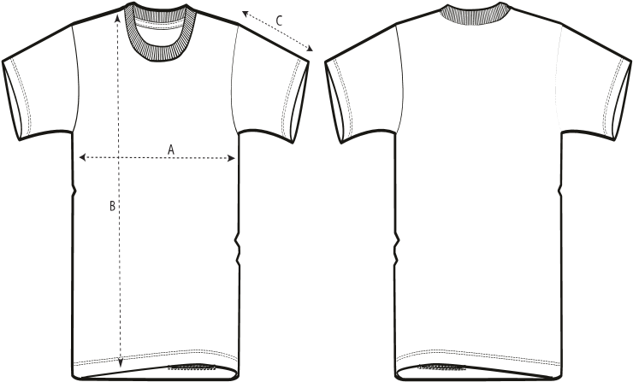
Sizes |  | XXS |  | XS |  | S | M | L | XL | XXL | 3XL | 4XL | 5XL
A Half Chest |  | 44 |  | 46 |  | 48 | 52 | 55 | 58 | 62 | 66 | 71 | 76
B Body Length |  | 61 |  | 64 |  | 68 | 72 | 74 | 76 | 78 | 80 | 82 | 83
C Sleeve Length |  | 17.5 |  | 18.5 |  | 20 | 21.5 | 22 | 22.5 | 23 | 23.5 | 23.5 | 23.5
Packing  Sizes | XXS |  | XS |  | S |  | M | L | XL | XXL | 3XL | 4XL | 5XL
Pieces/bag | 1 |  | 1 |  | 1 |  | 1 | 1 | 1 | 1 | 1 | 5 | 5
Pieces/box | 50 |  | 100 |  | 100 100 |  |  | 100 | 100 | 100 | 50 | 50 | 50

New style Crafter VintageSTTU976
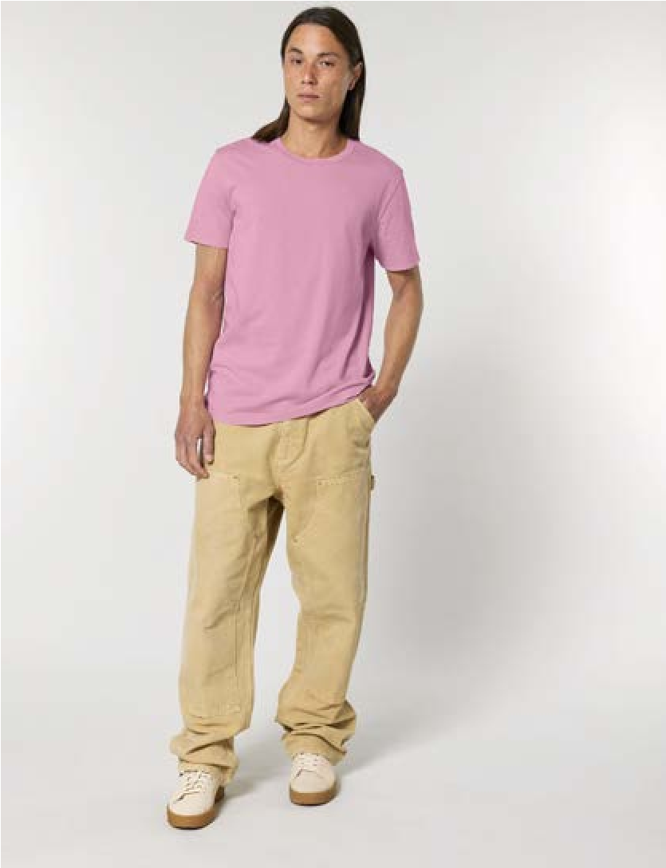
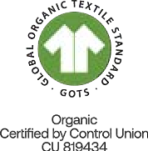
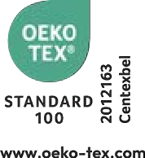


The Unisex Garment Dyed Mid-Light T-Shirt
Details
C
are
.
.
.
.
.
.
.

Medium Fit XXS > 3XL 155 GSM
Set-in sleeve
1x1 rib at neck collar
Inside back neck tape in self fabric Twin needle topstitch at sleeve cuff and hem
Slight shading on seams to give washed look.
Garment dyed product, each garment may vary in appearance, colour may bleed, follow our care label
Read carefully print recommendations

Composition
Shell - Single Jersey
100% Cotton - Organic Ring Spun Combed - , 155.0 GSM
Garment dyed
Wash and dry separately, colour bleeds, do not iron on print, wash and iron inside out. This is a garment dyed item. Each garment may vary in appearance. Faded effect will become stronger over time. Colour may transfer by rubbing onto light coloured materials. Use mild detergent which contains no bleach.

Country of origin
Weaving : Bangladesh
Dyeing : Bangladesh Assembly : Bangladesh
more information on the next page →
New style Crafter VintageSTTU976

Colors
Rock C140 |  | Pink  C130 |  | Blue  C103 |  | Ochre  C141 |  | C102 |  | C109
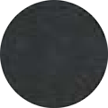
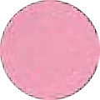

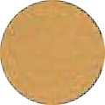
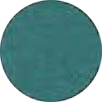
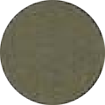
G. DyedG. DyedG. DyedG. DyedG. DyedG. Dyed
BlackBubbleSwimmerGoldHydroKhaki

Size Guide
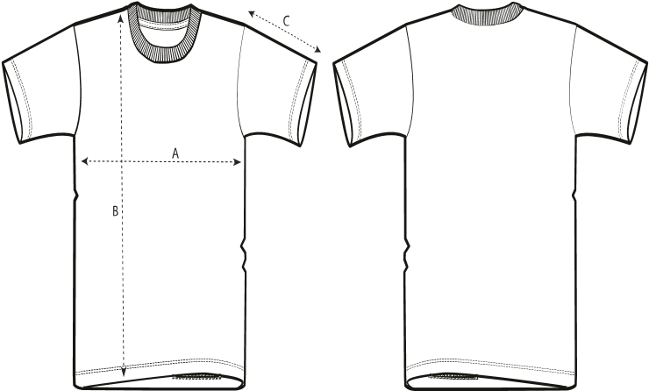
 |  |  |  | FRONT |  |  |  | BACK
Sizes |  | XXS |  | XS |  | S | M | L | XL | XXL | 3XL
A Half Chest |  | 44 |  | 46 |  | 48 | 52 | 55 | 58 | 62 | 66
B Body Length |  | 61 |  | 64 |  | 68 | 72 | 74 | 76 | 78 | 80
C Sleeve Length |  | 17.5 |  | 18.5 |  | 20 | 21.5 | 22 | 22.5 | 23 | 23.5
Packing  Sizes | XXS |  | XS |  | S |  | M | L | XL | XXL | 3XL
Pieces/bag | 5 |  | 5 |  | 5 |  | 5 | 5 | 5 | 5 | 5
Pieces/box | 50 |  | 100 |  | 100 |  | 100 | 100 | 100 | 100 | 50

