EuroSun2026
HIGH-TEMPERATURE HEAT PUMPS FOR INDUSTRIAL PROCESS HEAT DECARBONIZATION IN CHILE: NATIONAL POTENTIAL AND AN INDUSTRIAL CASE STUDY

Diego Naranjo, Francisco Fuentes, Cristobal Doña, Pablo Castillo, Carlos Felbol
Affiliation(s) Fraunhofer Chile Research
Email(s) cristobal.dona@fraunhofer.cl
Summary
This study assesses the potential of high-temperature heat pumps (HTHPs) to decarbonize industrial process heat in Chile at national and plant levels. The national assessment combines the ANCESTRAL geospatial screening framework with a database of commercially mature HTHPs at technology readiness levels 8-9. The analysis identifies 84 representative processes across 21 industrial subsectors, corresponding to an estimated useful-heat demand of 51.76 TWhth·yr⁻¹. This value is equivalent in magnitude to approximately 40% of the total final-energy consumption reported for Chile’s industrial and mining sectors in 2022. However, this comparison should be interpreted as indicative because the national energy balance reports final energy, whereas the present assessment quantifies useful process heat. The four subsectors with the highest demand account for 80.8% of the identified potential. A detailed industrial case study evaluates the integration of an HTHP in an anonymized Chilean grape-juice concentration plant using an annual TRNSYS model. Three operating scenarios were considered to address uncertainty in plant utilization: intensive, seasonal, and fuel-calibrated operation. Depending on the scenario, the HTHP supplies 1.57-3.89 GWhth·yr⁻¹ with a seasonal performance factor (SPF) of 3.1-3.3, displacing 1.07-2.70 GWhth·yr⁻¹ of fossil steam. Avoided emissions range from 223 to 565 tCO₂·yr⁻¹ using grid electricity and from 328 to 813 tCO₂·yr⁻¹ using renewable electricity. The baseline plant-level cost of heat is 51.6 USD·MWhth⁻¹, compared with 54.4-60.6 USD·MWhth⁻¹ after HTHP integration. The results demonstrate substantial technical and emissions-reduction potential, while highlighting plant utilization, electricity price, and electricity carbon intensity as the main determinants of economic and environmental performance.
Keywords: high-temperature heat pumps; industrial decarbonization; process heat; waste-heat recovery; agro-industry; Chile
Field of application for the findings: Industrial process heat electrification and agro-industrial decarbonization strategies.
Addressed audience: Policy makers, energy consultants, industrial process engineers, and thermal energy researchers.

- Introduction

Industrial process heat remains a major challenge for deep decarbonization because it is predominantly supplied by fossil-fuel combustion and encompasses widely varying temperature levels, production schedules, and process constraints. This challenge is particularly relevant in Chile, where the Climate Change Framework Law establishes the national objective of achieving greenhouse-gas neutrality by 2050 (Ambiente, 2025). Although the increasing penetration of renewable electricity creates favorable conditions for process electrification, the technical and economic feasibility of replacing industrial steam and hot-water systems depends on the characteristics of each process and cannot be established from the electricity supply alone.
Electrically driven high-temperature heat pumps (HTHPs) can reduce fossil-fuel consumption by upgrading low-temperature waste heat to useful process-temperature levels. Commercial and near-commercial systems cover a growing range of heating capacities and supply temperatures, creating opportunities in food processing, paper production, chemical processing, and other heat-intensive industries (Arpagaus, 2018); (A. Marina, 2021)). Nevertheless, HTHP performance and feasibility depend strongly on the temperature lift between the heat source and heat sink, the temporal coincidence of source availability and process demand, annual operating hours, and the selected integration architecture. Consequently, sector-level estimates of technical potential must be complemented by process-level analyses that explicitly represent source and sink conditions, heat-exchanger constraints, operating schedules, auxiliary equipment, and control strategies (Zühlsdorf, 2024).
Agro-industrial processes are particularly relevant because heating, evaporation, pasteurization, and cooling demands may coexist within the same facility. This creates opportunities to recover low-temperature process heat and upgrade it for steam generation. However, seasonal production and batch-dependent operation can limit HTHP utilization and materially affect annual energy performance and levelized heat costs. Evaluating these interactions therefore requires a time-resolved system model rather than a single steady-state operating point.
This work investigates whether and under which operating conditions an HTHP can be integrated into an anonymized Chilean grape-must concentration plant to recover secondary vapor from evaporation and supply heat indirectly to desulfitation, the process used to remove sulfur dioxide (SO₂) from sulfited grape must. The study combines two complementary scales. First, a national screening identifies industrial subsectors and representative processes with temperature requirements compatible with commercially mature HTHPs. Second, an annual dynamic model implemented in TRNSYS represents the industrial process, waste-heat recovery, HTHP, indirect steam generation, auxiliary boiler, and relevant control logic using a 10-minute time step. Three operating scenarios (intensive, fuel-calibrated, and seasonal) are evaluated to quantify the influence of plant utilization on HTHP heat production, electricity consumption, fossil-steam displacement, greenhouse-gas emissions, and levelized cost of heat. The analysis is positioned as a simulation-based process-integration and techno-economic pre-feasibility assessment rather than an experimentally validated plant design.
- Methodology
2.1 National HTHP Screening and Subsector Matching
The national useful-heat demand was obtained from the ANCESTRAL framework, whose RETC-based estimation methodology is described (Naranjo, 2025). The specific contribution of the present work was to combine this demand baseline with representative process-temperature requirements and a database of commercially relevant high-temperature heat pumps (HTHPs).
Two process datasets with different structures and nomenclatures were standardized by aligning industrial-subsector labels, process names, required supply temperatures, and steam-use classifications, and then combined. The resulting dataset comprised 84 representative processes across 21 industrial subsectors. For each process, the required supply temperature and the use of steam were identified. A temperature margin of 10 K was applied to non-steam processes, while 40 K was applied to processes requiring steam or operating at supply temperatures of at least 100 °C. The HTHP database, derived from IEA HPT Annex 58 (Zühlsdorf, 2023), was restricted to technologies at TRL 8-9. A process was classified as technically compatible when at least one HTHP could reach the required temperature, including the corresponding margin.
The results were aggregated by industrial subsector. Process coverage was calculated as the fraction of representative processes with at least one compatible HTHP, while the associated useful-heat demand was assigned through normalized six-digit industrial activity codes. The resulting indicator provides a first-order estimate of the temperature-compatible HTHP potential within the assessed RETC-based demand. This estimate relies on representative process assignments, fixed temperature requirements and safety margins, and the availability of at least one compatible TRL 8-9 technology. It should therefore be interpreted as a screening-level technical potential rather than immediately deployable or economically feasible capacity, since site-specific heat-source availability, capacity matching, temporal coincidence, integration constraints, and project economics were not assessed.The results were aggregated by industrial subsector. Process coverage was calculated as the fraction of representative processes with at least one compatible HTHP, while the associated useful-heat demand was assigned through normalized six-digit industrial activity codes.
2.2 Industrial Case Study and Simulation Framework
The industrial case study corresponds to an anonymized Chilean agro-industrial facility producing concentrated grape must. The modeled boundary includes desulfitation, pre-concentration and concentration, regenerative pasteurization, concentrate cooling, process-vapor recovery, conventional steam supply, and the proposed HTHP integration. Operating schedules and demand profiles were constructed from the available plant production records.
Desulfitation is the first modeled process stage. Sulfited must flows downward through a packed stripping column, while steam is injected counter-currently from the bottom. The base operating conditions are a must flow rate of 8.5 m³ h⁻¹, an inlet temperature of 20 °C, an operating temperature of 80 °C, a soluble-solids concentration of 20 °Brix, and a pH of 3.6. The model evaluates the reduction of SO₂ from 1000 to 50 mg L⁻¹ using the height-of-transfer-unit and number-of-transfer-units method. The gas and liquid mass-transfer coefficients and wetted packing area were calculated using the correlations (ONDA, 1968), following conventional packed-column design principles (Towler, 2020):
$$N_{OG}=\ln\left(\frac{C_{SO_{2},in}}{C_{SO_{2},out}}\right)$$ | eq. 1
$$Z_{calc}=H_{OG}N_{OG}$$ | eq. 2
$$η_{col}=\min\left(1,\frac{H_{pack}}{Z_{calc}}\right)$$ | eq. 3
where $H_{OG}$ is the overall gas-phase height of a transfer unit, $N_{OG}$ is the required number of transfer units, $H_{pack}$ is the installed packing height, and $η_{col}$ represents the utilization of the available packing. The sensible heat demand and corresponding steam requirement are calculated as:
$${\dot{Q}}_{des}={\dot{m}}_{must}{\overline{c}}_{p,must}\left(T_{op}-T_{in}\right)$$ | eq. 4
$${\dot{m}}_{s,des}=\frac{{\dot{Q}}_{des}}{η_{col}h_{fg}}$$ | eq. 5
The desulfited must subsequently enters a four-effect falling-film evaporator. The effects operate at approximately 78, 68, 58, and 48 °C, while the first effect is supplied with saturated steam at approximately 120 °C and 1.7 bar absolute. Two operating phases were represented: pre-concentration from 15 to 30 °Brix for 14 h and final concentration from 30 to 60 °Brix for 6 h. Under the assumed equal heat duty across the effects, the evaporated water and live-steam demand are calculated as:
$$α_{i}=\frac{1/λ_{i}}{\sum_{j=1}^{4}{1}/λ_{j}}$$ | eq. 6
$${\dot{W}}_{i}=α_{i}{\dot{W}}_{tot}$$ | eq. 7
$${\dot{Q}}_{stage}=\frac{{\dot{W}}_{tot}}{3600\sum_{j=1}^{4}{1}/λ_{j}}$$ | eq. 8
$${\dot{m}}_{s,evap}=\frac{3600{\dot{Q}}_{stage}}{λ_{s}}$$ | eq. 9
where ${\dot{W}}_{tot}$ is expressed in kg h⁻¹, $λ_{i}$ is the latent heat at effect $i$, and $λ_{s}$ is the latent heat of the live steam. Water and steam properties were evaluated using CoolProp (Bell, 2014)).
The pasteurizer was represented as a sequence of plate heat exchangers. Concentrated grape must enters at approximately 10 °C, is preheated in a product-to-product regenerative exchanger, and subsequently reaches a pasteurization temperature of 90 °C. The pasteurized product transfers heat to the incoming stream before being cooled using cooling-tower water and a chiller to approximately 20 °C. The heat capacity correlation implemented in the final TRNSYS model was calibrated in this work to reproduce the dependence on soluble-solids concentration and temperature reported for fruit juices and concentrated grape must (Magerramov, 2007), (MORESI, 1984).
$$c_{p}\left(B,T\right)=4.18-0.025B+0.0013\left(T-20\right)$$ | eq. 10

where $c_{p,must}$ is expressed in kJ kg⁻¹ K⁻¹, $B$ is the soluble-solids concentration in °Brix, and $T$ is expressed in °C.
The individual process models were dynamically coupled through operating schedules and storage-volume controls. Desulfitation and pre-concentration can operate simultaneously, whereas desulfitation is bypassed when the evaporator operates in final-concentration mode. Concentrated grape must accumulates in an intermediate buffer, and pasteurization is activated only when sufficient product is available to sustain 16 h of operation at the nominal flow rate.
The HTHP is dedicated exclusively to supplying the desulfitation process. On the source side, the unit recovers secondary vapor from the evaporator at approximately 40 °C and 0.07 bar through a heat exchanger. On the sink side, the HTHP heats a recirculating water loop, which supplies an indirect steam generator connected to the desulfitation column. Consequently, HTHP does not produce process steam directly. The TRNSYS implementation couples a water-to-water heat-pump component with a heat-recovery steam generator and PID-based temperature control. Its operating envelope was defined using the SPH ThermBooster as the technological reference (SPH, 2022), while the existing boiler continues supplying the remaining evaporation and pasteurization steam loads.
2.3 Dynamic Simulation Framework and Operating Scenarios
The complete process was implemented in TRNSYS 18 as a modular dynamic system-level model (Klein, 2017). The simulation connects the desulfitation column, four-effect evaporator, concentrate storage, regenerative pasteurizer, cooling equipment, HTHP, indirect steam generator, and remaining boiler loads. Thermodynamic properties of water and steam were calculated using CoolProp (Bell, 2014). Each annual simulation covered 8760 h with a 10 min time step, allowing the batch sequence, thermal storage state, equipment activation, and transient energy flows to be resolved.
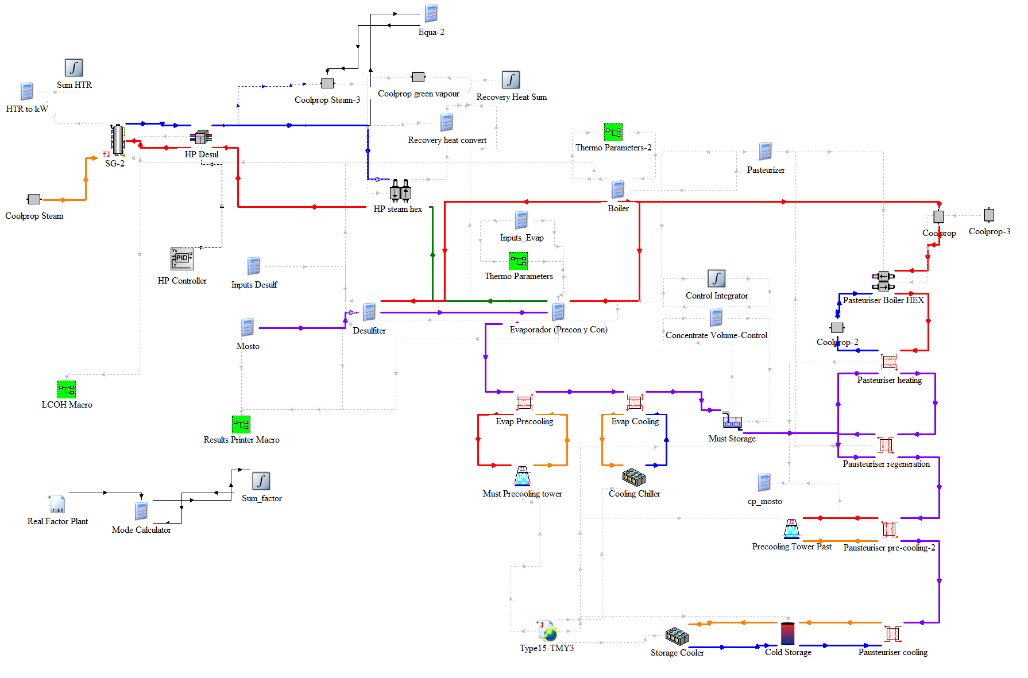
Figure 1: TRNSYS 18 implementation of the integrated process and HTHP system
The HTHP was represented using the TRNSYS Type 927 normalized water-to-water heat-pump model. This component determines heating capacity and electrical power from performance maps as functions of the source and load inlet temperatures and flow rates (Thermal Energy System Specialists, s.f.). The map was scaled to a rated heating capacity of 1.28 MWth and a rated electrical input of 270 kW. Therefore, COP was not imposed as a constant value but calculated at each time step from the simulated operating conditions. The low-temperature source loop recovers heat from secondary vapor generated during evaporation at approximately 40 °C. The HTHP load loop was connected to a counterflow indirect steam generator represented by Type 636, using a minimum pinch-point temperature difference of 15 K. The steam generator attempts to satisfy the desulfitation steam enthalpy requirement subject to the available HTHP outlet temperature and flow rate (Thermal Energy System Specialists, s.f.). The existing boiler supplies the remaining heat demand from evaporation and pasteurization.
The principal TRNSYS component types used to represent the physical and control subsystems are summarized in Table 1. Components instantiated multiple times are listed only once, while components used exclusively for online visualization or data export are omitted.
Table 1: TRNSYS component types used in the dynamic plant model.
TRNSYS type | Component name in TRNSYS | Library/source | Model function
Type 5 (Type5b) | Counter Flow Heat Exchanger | Standard TRNSYS, Hydronics | Counterflow heat exchange in pasteurization, regeneration, precooling and cooling
Type 9 (Type9e) | Generic Data File Reader, Expert Mode, Free Format | Standard TRNSYS, Utility | Import of the plant operating-profile correction factor
Type 15 (Type15-TMY3) | Weather Data Reader and Processor, Standard Format, TMY3 | Standard TRNSYS | Import and processing of meteorological data
Type 23 | PID Controller | Standard TRNSYS, Controllers | Control of the HTHP operating signal
Type 24 | Quantity Integrator | Standard TRNSYS, Utility | Integration of thermal power, electricity and other time-dependent variables
Type 25 (Type25b) | Unformatted Printer, User-Supplied Units | Standard TRNSYS, Output | Export of simulation results
Type 39 | Variable Volume Tank | Standard TRNSYS, Thermal Storage | Variable-volume grape-must storage
Type 65 (Type65d) | Online Plotter Without File | Standard TRNSYS, Output | Online monitoring of simulation variables
Type 158 | Constant Volume Liquid Storage, Vertical Tank, No Heat Exchanger | Standard TRNSYS, Thermal Storage | Cold-storage tank representation
Type 161 | Simple Single-Speed Cooling Tower with Setpoint Control | Standard TRNSYS, HVAC | Cooling-tower operation
Type 635 (Type635a_v2a) | Steam-to-Steam Heat Exchanger, Counterflow Configuration | TESS Cogeneration Library | Steam-side heat recovery and indirect heat exchange
Type 636 (Type636a) | Heat Recovery Steam Generator, Steam Flow Known, Counter Flow | TESS Cogeneration Library | Indirect steam generation for desulfitation
Type 655 (Type655_v2a) | Stand-Alone Air-Cooled Chiller | TESS HVAC Library | Cooling of grape must and storage streams
Type 927 (Type927_v2a) | Single-Stage Water-Source-to-Water Heat Pump | TESS HVAC Library | High-temperature heat-pump representation
Type 4016 | CoolProp | External CoolProp component | Calculation of water and steam thermophysical properties
Type 5556 | LCOE Calculator | Project-specific component | Calculation of levelized energy or heat costs
Table 1lists each TRNSYS component type only once, although several types were instantiated multiple times to represent different process stages. Component names correspond to the TRNSYS, TESS, and CoolProp library nomenclature rather than to the user-defined labels shown in the simulation workspace. EQUATIONS blocks used for process-specific mass and energy balances are not assigned a TRNSYS Type number and are therefore not included.
The operating controller reproduces the 20 h concentration cycle described in Section 2.2, consisting of 14 h of pre-concentration followed by 6 h of final concentration. The HTHP is enabled only when the plant is operating and recoverable evaporation heat is available during the pre-concentration period. Concentrate is accumulated in the storage tank, and pasteurization begins when its volume reaches 240 m³. Each pasteurization batch operates for 16 h at a nominal concentrate flow rate of 15 m³ h${}_{​}^{-1}​$. This control structure preserves the temporal dependence between evaporation, waste-heat availability, HTHP operation, storage, and downstream pasteurization.
Three annual operating scenarios were evaluated using the same equipment configuration and control logic. The intensive scenario assumes continuous plant availability and represents an upper operating bound based on the maximum-load process data supplied by the company. The fuel-calibrated scenario applies an hourly correction profile to reconcile the simulated annual thermal demand with the plant fuel-consumption information. The seasonal scenario restricts operation to the production campaign and represents a lower annual utilization case. These scenarios should be interpreted as operating envelopes rather than measured annual histories.
Instantaneous and annual HTHP performance were calculated as:
$$COP_{t}=\frac{{\dot{Q}}_{HP,t}}{P_{el,t}}$$ | eq. 11
$$SPF=\frac{\sum_{t}{{\dot{Q}}_{HP,t}}Δt}{\sum_{t}{P_{el,t}}Δt}$$ | eq. 12
where ${\dot{Q}}_{HP,t}$ and $P_{el,t}$ are the HTHP thermal output and electrical power at time step $t$, respectively. Annual HTHP heat, electricity consumption, useful process heat, and residual boiler demand were obtained by integrating their corresponding time series. Model verification included checking mass and energy-balance consistency, operating-temperature limits, and continuity between consecutive process stages. The main model assumptions were supported by published packed-column correlations for desulfitation (Onda et al., 1968; Sinnott and Towler, 2020), thermophysical-property models for water, steam, and grape must (Bell et al., 2014; Magerramov, 2007; Moresi and Spinosi, 1984), and the documented formulations of TRNSYS Types 927 and 636 (Thermal Energy System Specialists, n.d.). Type 927 used the generic normalized performance maps supplied with TESS, scaled to the heating capacity of 1.28 MWₜₕ and electrical input of 270 kW reported for the SPH ThermBooster reference case (SPH, 2022). These references support the model structure and input assumptions but do not constitute experimental validation. Consequently, the results represent a simulation-based pre-feasibility assessment requiring confirmation through plant measurements and vendor-specific HTHP performance maps.
2.4 Techno-Economic and Emissions Framework
The techno-economic assessment was performed using two system boundaries. At the process level, the HTHP system was compared with the LPG-fired steam production displaced in the desulfitation unit. At the plant level, the same retrofit was evaluated together with the remaining boiler demand from evaporation and pasteurization. The existing boiler was treated as a sunk asset, whereas the retrofit investment comprised the HTHP and the indirect steam generator. This distinction allows the specific cost of electrifying desulfitation to be evaluated without obscuring its effect on the overall plant heat cost.
Annual electricity and fuel expenditures were calculated from the energy flows integrated over the TRNSYS simulation. The final model used an electricity price of 188 USD MWh${}_{​}^{-1}​$, an an LPG price of 43.9 USD MWh${}_{LHV}^{-1}​$, corresponding to a useful-heat cost of 51.6 USD MWh${}_{th}^{-1}​$ for the existing boiler efficiency of 85%.. Fixed operation and maintenance costs were assumed to be 3% of the HTHP investment per year. A project lifetime of 20 years and a real discount rate of 7% were considered. Equipment-cost assumptions were based on the steam-generating heat-pump cost ranges reported (Klute, 2024)
The levelized cost of useful heat was calculated using the standard capital-recovery formulation:
$$CRF=\frac{r{\left(1+r\right)}^{N}}{{\left(1+r\right)}^{N}-1}$$ | eq. 13
$$LCOH=\frac{CRF\left(I_{HP}+I_{SG}\right)+C_{O\&M}+C_{el}+C_{fuel}}{Q_{useful}}$$ | eq. 14
where $r$ is the real discount rate, $N$is the project lifetime, $I_{HP}$ and $I_{SG}$ are the investments in the HTHP and indirect steam generator, respectively, and $Q_{useful}$ is the annual useful heat supplied within the selected system boundary. For the process-level assessment, $Q_{useful}$ corresponds to the desulfitation heat demand. For the plant-level assessment, it includes the useful heat supplied to desulfitation, evaporation, and pasteurization.
Operational CO₂ emissions were evaluated from the fossil heat displaced by the HTHP and the electricity consumed by its compressor:
$$m_{CO_{2},ref}=\frac{Q_{disp}}{η_{b}}EF_{f}$$ | eq. 15

$$m_{CO_{2},HP}=E_{HP}EF_{el}$$ | eq. 16
$$Δm_{CO_{2}}=m_{CO_{2},ref}-m_{CO_{2},HP}$$ | eq. 17
where $Q_{disp}$ is the useful boiler heat displaced, $E_{HP}$ is the annual HTHP electricity consumption, and $EF_{f}$ and $EF_{el}$ are the fuel and electricity emission factors, respectively. Fuel emissions were calculated following the stationary-combustion methodology (Darío R. Gómez, 2006), while the electricity factor corresponds to the Chilean National Electricity System (Chile, 2017). A second case assumes renewable electricity with $EF_{el}=0$, representing avoided operational emissions only. Embodied emissions, refrigerant leakage, and equipment end-of-life impacts were outside the assessment boundary.
- Results
3.1 National HTHP Compatibility and Priority Subsectors

The national screening identified 84 representative thermal processes across 21 industrial subsectors, accounting for an estimated process heat demand of 51.76 TWh year⁻¹ over a process supply-temperature range of 25–200 °C. After applying the temperature approach margins defined in the screening methodology, the corresponding required HTHP supply temperatures ranged from 35 to 240 °C. Under the temperature-matching criterion described in Section 2.1, all screened processes could be supplied by at least one commercially available HTHP model. This result indicates broad temperature compatibility within the analyzed demand range. However, the reported coverage should not be interpreted as directly deployable potential, since heat-source availability, capacity matching, site-specific constraints, operating schedules, and economic feasibility were not considered at this screening stage.
Figure 2 shows that the estimated useful-heat demand was strongly concentrated in a limited number of subsectors. Fruit and vegetable processing accounted for 15.59 TWhₜₕ yr⁻¹, equivalent to 30.1% of the total screened useful-heat demand of 51.76 TWhₜₕ yr⁻¹. It was followed by mineral and bottled-water production (13.53 TWhₜₕ yr⁻¹, 26.1%), food products and beverages (7.90 TWhₜₕ yr⁻¹, 15.3%), and copper extraction and processing (4.83 TWhₜₕ yr⁻¹, 9.3%). Together, these four subsectors represented 80.8% of the screened demand and therefore constitute priority candidates for subsequent site-specific HTHP integration assessments based on demand magnitude. These estimates were calculated in this work by applying the ANCESTRAL methodology to 2023 RETC point-source emissions data (Naranjo, 2025)
Although temperature compatibility was obtained throughout the screened sample, the number of suitable HTHP alternatives decreased as the required supply temperature increased. Low and medium-temperature processes could be matched with a broad range of commercial systems, whereas processes requiring supply temperatures above approximately 180-200°C were limited to a smaller group of technologies. The national assessment therefore identifies both the magnitude of the potentially addressable heat demand and the subsectors in which subsequent source-sink integration studies should be prioritized.
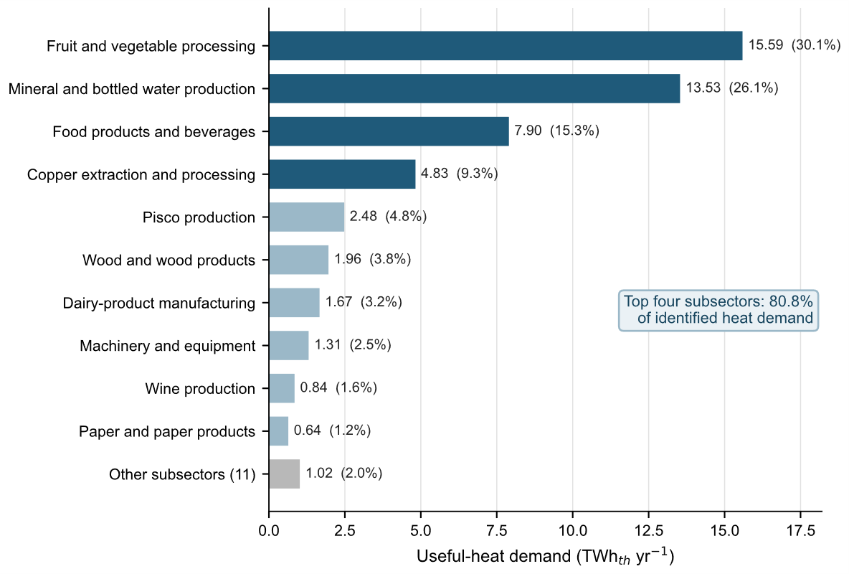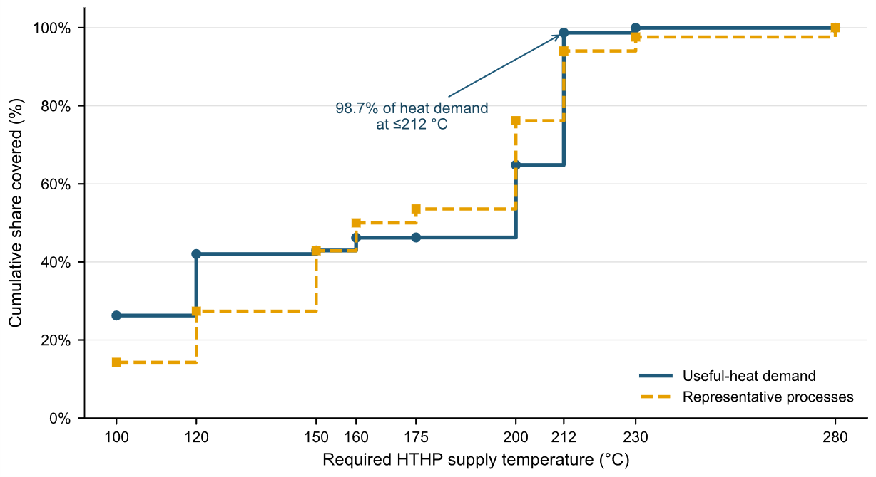
Figure 2: (left) Distribution of the identified useful-heat demand among industrial subsectors. Figure 3: (right) Cumulative shares of useful-heat demand and representative processes according to the required HTHP supply temperature.
The concentration of heat demand in food-related activities motivated the selection of grape-must concentration as the industrial case study. This process belongs to the highest-ranked subsector and combines recoverable secondary vapor from evaporation with a steam demand in desulfitation, providing a representative source-sink pair for HTHP integration. The following analysis therefore moves from national temperature screening to a site-specific evaluation of operating behavior, energy performance, costs, and emissions.
3.2 Annual Energy Performance of the Industrial HTHP Integration
The annual simulations indicated technically consistent operation of the proposed heat-recovery configuration under all three operating scenarios. The HTHP upgraded heat recovered from the evaporation process to the temperature required by the indirect steam generator. Despite substantial differences in annual utilization, the SPF remained between 3.14 and 3.27. HTHP heat output ranged from 1.57 to 3.89 GWhₜₕ·yr⁻¹, while electricity consumption ranged from 0.50 to 1.19 GWhₑₗ·yr⁻¹.
Table 2 summarizes the annual energy balance, utilization, and operational-emissions performance of the HTHP integration. The reported SPF is calculated as the ratio between the HTHP heat output and compressor electricity consumption integrated over the complete annual simulation.

Table 2: Annual energy, utilization, and operational-emissions performance of the HTHP integration under the three operating scenarios
Operating scenario | HTHP heat supplied (GWh${}_{th}^{​}​$ yr${}_{​}^{-1}​$) | Electricity consumption (GWh${}_{el}^{​}​$ yr${}_{​}^{-1}​$) | Annual SPF | Equivalent full-load hours (h yr${}_{​}^{-1}​$) | Recovered source heat${}_{​}^{a}​$ (GWh${}_{th}^{​}​$ yr${}_{​}^{-1}​$) | Avoided CO₂, grid electricity${}_{​}^{b}​$ (tCO₂ yr${}_{​}^{-1}​$) | Avoided CO₂, renewable electricity${}_{​}^{c}​$ (tCO₂ yr${}_{​}^{-1}​$)
Intensive | 3.89 | 1.19 | 3.27 | 3,039 | 2.70 | 565 | 813
Fuel-calibrated | 3.30 | 1.05 | 3.14 | 2,578 | 2.25 | 470 | 689
Seasonal | 1.57 | 0.50 | 3.14 | 1,227 | 1.07 | 223 | 328
${}_{​}^{a}​$ Recovered source heat is calculated as the difference between useful HTHP heat output and compressor electricity consumption. It represents the thermal energy recovered from the secondary-vapor stream.
${}_{​}^{b}​$Avoided operational emissions relative to the existing LPG-fired system, including emissions associated with electricity consumption from the Chilean grid.
${}_{​}^{c}​$Avoided operational emissions assuming renewable electricity with zero operational emission factor. Embodied emissions and refrigerant leakage are excluded.

The SPF remained within a narrow range of 3.14-3.27, despite the substantial differences in annual heat production. This stability indicates that the HTHP operates under similar temperature-lift and full-load conditions whenever the plant is active. Electricity accounted for approximately 30.6-31.8% of the HTHP heat output, while the remaining 68.2-69.4% originated from recovered process heat. Therefore, the lower annual heat output of the fuel-calibrated and seasonal scenarios is attributable to fewer operating hours rather than to a deterioration in thermodynamic efficiency.
For the rated HTHP capacity of 1.28 MW${}_{th}^{​}​$, the annual heat production corresponds to 3,039 equivalent full-load hours in the intensive scenario, 2,578 h in the fuel-calibrated scenario, and 1,227 h in the seasonal scenario. These values are equivalent to annual capacity-utilization factors of 34.7%, 29.4%, and 14.0%, respectively. During active production periods, the seasonal and fuel-calibrated cases reach the same operating capacity as the intensive case. Their lower annual output results from complete production shutdowns during parts of the year.
The effect of the electricity source is also significant. With grid electricity, avoided operational emissions range from 223 to 565 tCO₂ yr${}_{​}^{-1}​.$Assuming renewable electricity increases this range to 328-813 tCO₂ yr${}_{​}^{-1}​$, since compressor-related emissions are eliminated. Nevertheless, the emissions intensity per unit of HTHP heat remains relatively stable across the scenarios because their SPF values are similar. Annual production schedules therefore determine the absolute emissions reduction, while electricity carbon intensity determines the environmental benefit of each unit of heat supplied.
3.3 Techno-Economic Performance
The existing fossil-fired heat-supply system resulted in a baseline LCOH of 51.6 USD MWh${}_{th}^{-1}​$. This baseline represents the actual cost of heat production at the anonymized plant, calculated from site-specific LPG expenditures, fuel properties, and the operating efficiency of the existing boiler, rather than from a generic literature benchmark. At the desulfitation-process boundary, the HTHP integration reached LCOH values of 64.9, 71.2, and 77.1 USD MWh${}_{th}^{-1}​$ for the intensive, fuel-calibrated, and seasonal scenarios, respectively. These values represent increases of 25.8%, 38.0%, and 49.4% relative to the plant’s current heat-generation cost. The process-level comparison includes the complete investment in the HTHP and indirect steam generator, whereas the existing boiler is treated as a sunk asset.
When the assessment boundary was extended to the complete plant, the economic impact of the retrofit was substantially reduced. Plant-wide LCOH values were 54.4 USD MWh${}_{th}^{-1}​$ for intensive operation, 57.4 USD MWh${}_{th}^{-1}​$ for the fuel-calibrated scenario, and 60.6 USD MWh${}_{th}^{-1}​$ for seasonal operation. These values correspond to increases of 5.4%, 11.2%, and 17.4%, respectively, compared with the fossil baseline. The lower plant-wide differences arise because the HTHP investment and operating costs are distributed across the total useful-heat supply, while the existing boiler continues to serve evaporation, pasteurization, and residual steam demand.
The economic trend is primarily governed by annual utilization. Since the HTHP operates at approximately the same full-load capacity and COP during active production periods, fewer operating hours reduce annual heat production without proportionally reducing capital-related costs. Consequently, the intensive scenario presents the lowest LCOH, whereas extended shutdown periods penalize the seasonal case. The plant-wide result should nevertheless be interpreted carefully because it dilutes the specific investment burden of the HTHP retrofit within the larger thermal-energy balance.
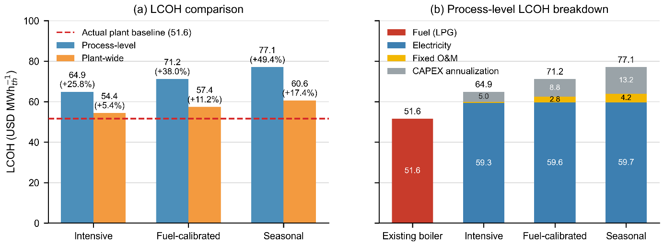
Figure 4: Techno-economic results of the industrial HTHP integration. (a) Process-level and plant-wide LCOH under the intensive, fuel-calibrated, and seasonal operating scenarios. (b) Process-level LCOH breakdown into electricity, fixed O&M, and annualized capital costs.
The cost breakdown shows that electricity remains the dominant component of the process-level HTHP cost and varies only slightly among scenarios because the unit operates at a similar full-load capacity and COP whenever production is active. The increase in LCOH from intensive to seasonal operation is therefore mainly caused by the allocation of fixed O&M and annualized investment costs over a smaller amount of useful heat. At the plant boundary, this effect is diluted because the retrofit costs are distributed across the total thermal output of the facility. These results confirm that annual utilization is the principal economic constraint for the proposed integration. The comparison is also conservative from an investment perspective, since the existing boiler is treated as a sunk asset, while the complete HTHP and indirect steam-generator investment is assigned to the retrofit.
The fuel-calibrated scenario should be regarded as the central estimate, while the intensive and seasonal scenarios define the upper and lower bounds of expected annual performance. Since the integrated configuration has not been experimentally validated, the reported energy, economic, and emissions results represent a pre-feasibility range. Further development should confirm simultaneous heat-source and process-demand availability through site measurements and incorporate vendor-specific HTHP performance data at the selected operating temperatures.
- Discussion
The national screening indicates that temperature-compatible HTHP demand in Chile is concentrated in a limited number of industrial subsectors, particularly food-related activities. This finding agrees with previous assessments identifying the food, paper, and chemical industries as promising sectors for industrial heat-pump deployment (Arpagaus et al., 2018; Marina et al., 2021). The present study extends this evidence by linking an ANCESTRAL-derived national useful-heat baseline with representative process temperatures and commercially mature HTHP supply limits. Nevertheless, the resulting potential is a first-order estimate of temperature compatibility rather than deployable capacity. As emphasized by Marina et al. (2021), implementation also requires compatible source and sink capacities, physical proximity, and simultaneous temporal availability.
The plant-level results demonstrate the importance of these integration constraints. The relatively stable SPF across the three scenarios indicates that the HTHP operates at a similar thermodynamic point whenever production is active. Differences in annual heat supply are therefore governed primarily by plant availability and operating hours rather than by deterioration of heat-pump performance. This result is consistent with the dependence of industrial heat-pump performance on source temperature, sink temperature, and temperature lift reported in the literature (Arpagaus et al., 2018; Marina et al., 2021). For seasonal agro-industrial facilities, temperature compatibility alone is consequently insufficient: recoverable secondary vapor and process heat demand must occur simultaneously and for enough hours to justify the investment.
The economic results reinforce this interpretation. Reduced annual utilization distributes fixed O&M and annualized investment costs over a smaller useful-heat output, which increases the LCOH despite similar operating SPF values. This behavior is consistent with previous HTHP assessments identifying annual operating hours, equipment scale, and electricity price as central determinants of competitiveness (Zühlsdorf et al., 2019). The difference between process-level and plant-wide LCOH further demonstrates the importance of the assessment boundary, while treating the existing boiler as a sunk asset produces a conservative retrofit comparison. Similarly, the emissions benefit depends on electricity carbon intensity because useful boiler heat is replaced by HTHP heat while compressor electricity is accounted for separately.
The fuel-calibrated scenario is considered the central estimate, while the intensive and seasonal scenarios represent upper and lower bounds of annual utilization. Because the integrated configuration has not been experimentally validated and the HTHP model relies on scaled performance data, the results should be interpreted as a simulation-based pre-feasibility assessment. Plant measurements, vendor-specific performance maps, equipment quotations, and detailed engineering are required before establishing technical performance and investment feasibility.
- Conclusions
This study combined a national temperature-based screening with a dynamic industrial case study to assess the potential for HTHP deployment in Chile. The national assessment identified 84 representative processes across 21 industrial subsectors, corresponding to an estimated useful-heat demand of 51.76 TWhₜₕ yr⁻¹. The concentration of 80.8% of this demand in four subsectors identifies a limited number of priority areas for subsequent site-specific assessments. Nevertheless, this result represents a first-order estimate of temperature-compatible potential rather than immediately deployable capacity.
At the plant level, the simulations showed that heat recovered from secondary vapor can be upgraded to supply the indirect steam-generation system used for desulfitation. Across the evaluated operating scenarios, the HTHP supplied 1.57–3.89 GWhₜₕ yr⁻¹ with an SPF of 3.14–3.27, while recovering 1.07–2.70 GWhₜₕ yr⁻¹ from the process stream. The relatively stable SPF indicates that differences in annual performance are governed primarily by plant availability and operating hours rather than by changes in the thermodynamic operating point.
The results therefore demonstrate that temperature capability is a necessary but insufficient condition for viable industrial HTHP integration. Simultaneous heat-source and process-demand availability, sufficient annual utilization, electricity price, and electricity carbon intensity ultimately determine the technical, economic, and environmental performance. The principal contribution of this work is a multiscale methodology that connects national opportunity screening with dynamic plant-level pre-feasibility assessment. For seasonal industrial processes, the decisive question is not only whether an HTHP can reach the required temperature, but whether it can operate sufficiently often under simultaneous and low-carbon conditions.

- References
Arpagaus, C., Bless, F., Uhlmann, M., Schiffmann, J., Bertsch, S.S., 2018. High temperature heat pumps: Market overview, state of the art, research status, refrigerants, and application potentials. Energy. 152, 985-1010. https://doi.org/10.1016/j.energy.2018.03.166.
Bell, I.H., Wronski, J., Quoilin, S., Lemort, V., 2014. Pure and pseudo-pure fluid thermophysical property evaluation and the open-source thermophysical property library CoolProp. Industrial & Engineering Chemistry Research. 53, 2498-2508. https://doi.org/10.1021/ie4033999.
Gómez, D.R., Watterson, J.D., 2006. Stationary combustion, in: Eggleston, H.S., Buendia, L., Miwa, K., Ngara, T., Tanabe, K. (Eds.), 2006 IPCC Guidelines for National Greenhouse Gas Inventories, Volume 2: Energy. Institute for Global Environmental Strategies, Hayama, Japan, pp. 2.1-2.47. https://www.ipcc-nggip.iges.or.jp/public/2006gl/pdf/2_Volume2/V2_2_Ch2_Stationary_Combustion.pdf (accessed 19 August 2026).
IEA HPT TCP, 2023. High-Temperature Heat Pumps: Task 1 - Technologies. IEA HPT Annex 58 Task Report, Report No. HPT-AN58-2. Heat Pump Centre, Borås, Sweden. https://heatpumpingtechnologies.org/annex58/wp-content/uploads/sites/70/2023/09/annex-58-task-1-technologies-task-report.pdf (accessed 19 August 2026).
IEA HPT TCP, 2024. High-Temperature Heat Pumps: Task 2 - Integration Concepts. IEA HPT Annex 58 Task Report, Report No. HPT-AN58-3. Heat Pump Centre, Borås, Sweden. https://heatpumpingtechnologies.org/content/uploads/sites/70/2024/04/annex-58-task-2-integration-concepts-report.pdf (accessed 19 August 2026).
Klein, S.A., et al., 2017. TRNSYS 18: A transient system simulation program. Solar Energy Laboratory, University of Wisconsin-Madison, Madison, WI, USA. https://trnsys.org/ (accessed 19 August 2026).
Klute, S., Budt, M., van Beek, M., Doetsch, C., 2024. Steam generating heat pumps: Overview, classification, economics, and basic modeling principles. Energy Conversion and Management. 299, 117882. https://doi.org/10.1016/j.enconman.2023.117882.
Magerramov, M.A., 2007. Heat capacity of natural fruit juices and of their concentrates at temperatures from 10 to 120 °C. Journal of Engineering Physics and Thermophysics. 80, 1055-1063. https://doi.org/10.1007/s10891-007-0138-1.
Marina, A., Spoelstra, S., Zondag, H.A., Wemmers, A.K., 2021. An estimation of the European industrial heat pump market potential. Renewable and Sustainable Energy Reviews. 139, 110545. https://doi.org/10.1016/j.rser.2020.110545.
Ministerio de Energía, n.d. Indicadores ambientales: Factor de emisiones GEI del Sistema Eléctrico Nacional. Gobierno de Chile. https://www.energia.gob.cl/indicadores-ambientales-factor-de-emisiones-gei-del-sistema-electrico-nacional (accessed 19 August 2026).
Ministerio del Medio Ambiente, 2022. Ley No. 21.455, Ley Marco de Cambio Climático. Diario Oficial de la República de Chile, 13 June 2022. https://www.bcn.cl/leychile/navegar?idNorma=1177286 (accessed 19 August 2026).
Moresi, M., Spinosi, M., 1984. Engineering factors in the production of concentrated fruit juices. II. Fluid physical properties of grape juices. International Journal of Food Science & Technology. 19, 519-533. https://doi.org/10.1111/j.1365-2621.1984.tb01869.x.
Naranjo, D., Fuentes, F., Muñoz, I., 2025. Industrial solar heat potential in Chile: A technical-economic analysis. Solar Energy Advances. 5, 100082. https://doi.org/10.1016/j.seja.2024.100082.
Onda, K., Takeuchi, H., Okumoto, Y., 1968. Mass transfer coefficients between gas and liquid phases in packed columns. Journal of Chemical Engineering of Japan. 1, 56-62. https://doi.org/10.1252/jcej.1.56.
Sinnott, R., Towler, G., 2020. Chemical Engineering Design, sixth ed. Butterworth-Heinemann, Oxford. https://doi.org/10.1016/C2017-0-01555-0.
SPH Sustainable Process Heat GmbH, 2022. Industrial heat pumps: ThermBooster technical datasheet. https://spheat.de/neu/wp-content/uploads/2022/09/3981_Datenblatt_EN.pdf (accessed 19 August 2026).
Thermal Energy System Specialists, n.d. TESS Component Libraries Version 18: General Descriptions. Thermal Energy System Specialists, Madison, WI, USA. https://www.trnsys.com/tess-libraries/GeneralDescriptions_TESSLibs18.pdf (accessed 19 August 2026).
Zühlsdorf, B., Bühler, F., Bantle, M., Elmegaard, B., 2019. Analysis of technologies and potentials for heat pump-based process heat supply above 150 °C. Energy Conversion and Management: X. 2, 100011. https://doi.org/10.1016/j.ecmx.2019.100011.

