COMPARATIVE DESIGN, TECHNO-ECONOMIC AND ENVIRONMENTAL ANALYSIS OF A DC-COUPLED SOLAR PHOTOVOLTAIC KILN WITH THERMAL ENERGY STORAGE FOR POTTERY SMEs IN GHANA
Emmanuel Kobina Payne^{1,4} (corresponding author), Mercy Abaka-Attah², Laud Christian Aninoo³
¹ Dept. of Electrical and Electronic Engineering, Takoradi Technical University, Takoradi (Ghana)
² Dept. of Ceramics, Takoradi Technical University, Takoradi (Ghana)
³ Minerals Commission, Accra (Ghana)
⁴ PelkTec Ltd, Takoradi (Ghana)
Corresponding author: mypaynegm@gmail.com; emmanuel.payne@ttu.edu.gh
Summary
Ghanaian pottery fires earthenware in wood-burning kilns, consuming about 28 MJ per kilogram and causing deforestation and health risks. The study explores a Solar PV kiln with Basalt TES as an alternative and cost-effective. It models a 30 kWₚ PV array, a 2.1-ton Basalt TES bed, and a 2.0 m³ firing chamber, simulating thermophysical and economic factors based on Ghana data. Basalt's TES max temperature is set at 800 °C, with the Chamber operational temperature ceiling at 1200 °C, dividing the process into preheat and PV array DC resistance heating phases. An insulated enclosure cuts standby losses from 8.2 kW to 2.2 kW, reducing energy waste by 73%. The system can perform 80 firings annually, with a 99% solar fraction and 82% PV array utilisation. Costing around USD 35,575, it yields a net present value of USD 22,445, an IRR of 23.8%, and a 3.94-year payback period. Key benefits include higher product yield, fuel savings, and lower CO₂ emissions. Carbon revenue is minimal for a pilot kiln, but results-based financing is recommended for scaling.

Keywords: DC-coupled Solar PV, Industrial decarbonization, SMEs pottery kilns, Techno-Economic analysis; Thermal energy storage (TES)
Field of application for the findings: Industrial process heat in Sub-Saharan Africa; Solar energy and low-medium-high-temperature TES design, sizing and financing; Batch ceramic firing in SMEs pottery
Addressed audience: Developers of Solar process heat and TES, SME pottery practitioners, development financiers, and Energy policymakers.
1. Introduction
Pottery in Ghana, especially in Vume, Mfensi, Ahwiaa, and Mpraeso, is a key rural activity that provides income for women. Most pots are fired in open pits or simple kilns with fuelwood and residues. Ghana uses about 14.9 Mt of wood annually, with 2.4 Mt for small industry, and 15% of wood demand exceeds forest growth (World Bank, 2022; Bailis et al., 2015; Energy Commission of Ghana, 2024). Traditional firing relies on non-renewable wood, with kilns consuming 20-40 MJ per kg of ware, much more than the 1.5 MJ thermodynamic need. Firing is hazardous, and wood-burning kitchens in peri-urban Ghana have particulate levels of 271 µg/m³, with personal exposure of 89.4 µg/m³, well above WHO’s 5 µg/m³ guideline (Williams et al., 2025; WHO, 2021; Jetter et al., 2012). Breakages of 20-35% occur due to uncontrollable heating (Carty & Senapati, 1998).
DC-coupled Solar PV heating offers an attractive route to industrial process heat due to falling module prices, with the global average utility-scale PV cost dropping to USD 691/kW in 2024 IRENA, (2025). For resistance heater loads, DC-coupled solutions omit inverters. Instead, an MPPT DC–DC stage and solid-state switches drive the elements. PV-driven resistance heating surpasses solar thermal collectors above 150–250 °C because resistive heating is temperature-insensitive while collector efficiency declines (Meyers et al., 2018; Schoeneberger et al., 2020). Since solar supply is intermittent while firing schedules are fixed, TES is essential. Packed rock beds are the most cost-effective in temperatures above 200 °C Kuravi et al., (2013), and electrically charged firebrick storage is now commercial above 100 MWh at over 1000 °C (Stack et al., 2019; Rondo Energy, 2025). Its viability at a single-kiln scale, however, unproven.
The concept proposes a 30-kW DC-coupled PV kiln with a Basalt TES operating at a maximum temperature of 1200 °C, with 72 hours of autonomy and carbon-credit support. Evidence shows Basalt rock is safe up to 800 °C as TES (Tiskatine et al., 2017; Becattini et al., 2017; and Jemmal et al., 2017), as the stored energy can sustain multi-day high-temperature operations. Reducing non-renewable biomass use per kiln by an order of magnitude makes carbon monitoring viable (UNFCCC, 2020; BeZero Carbon, 2023). This paper models and pilots the design by analyzing Basalt TES, defining a safe operating window, sizing the system with a bed-fed preheat to 700 °C and resistance heating to 1150 °C in an insulated enclosure, quantifying standby-loss, and presenting thermocline, energy, exergy, and techno-economic results with a pilot pathway and analysis based on Ghanaian data (Ghana Government, 2011, 2020; EPA, 2022). Figure 1 shows the concept development contrary to existing practice.
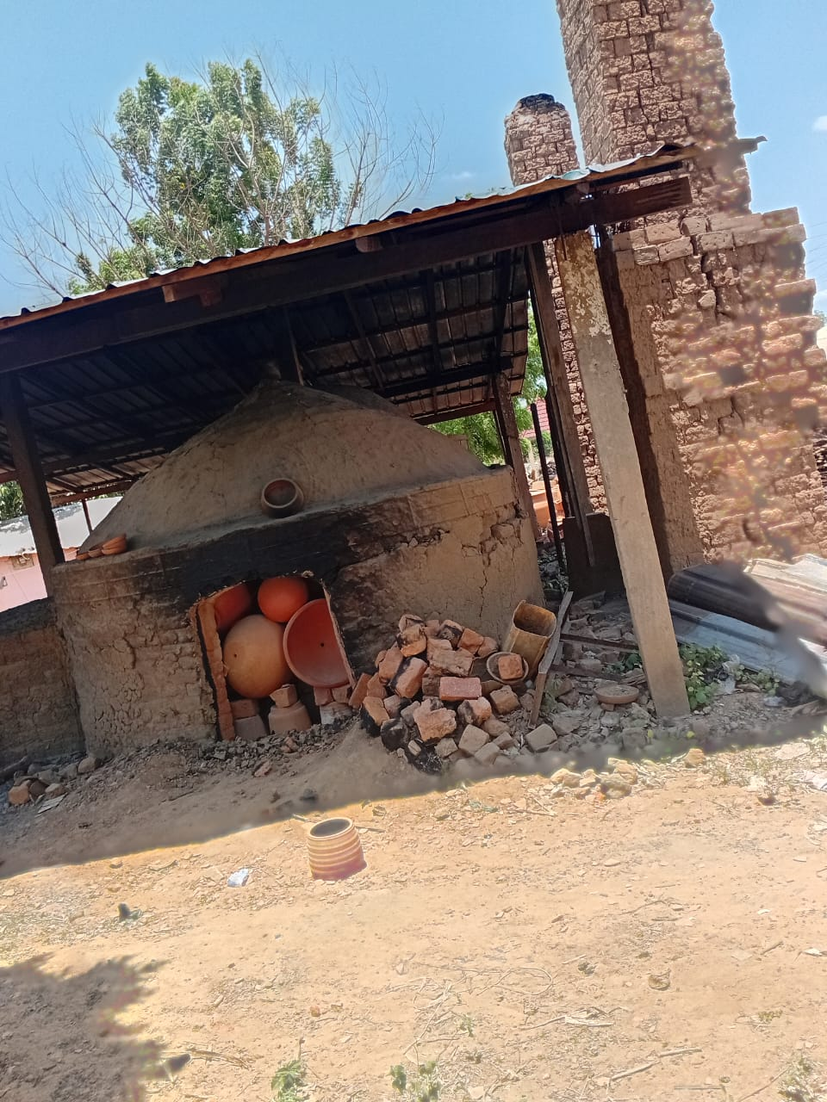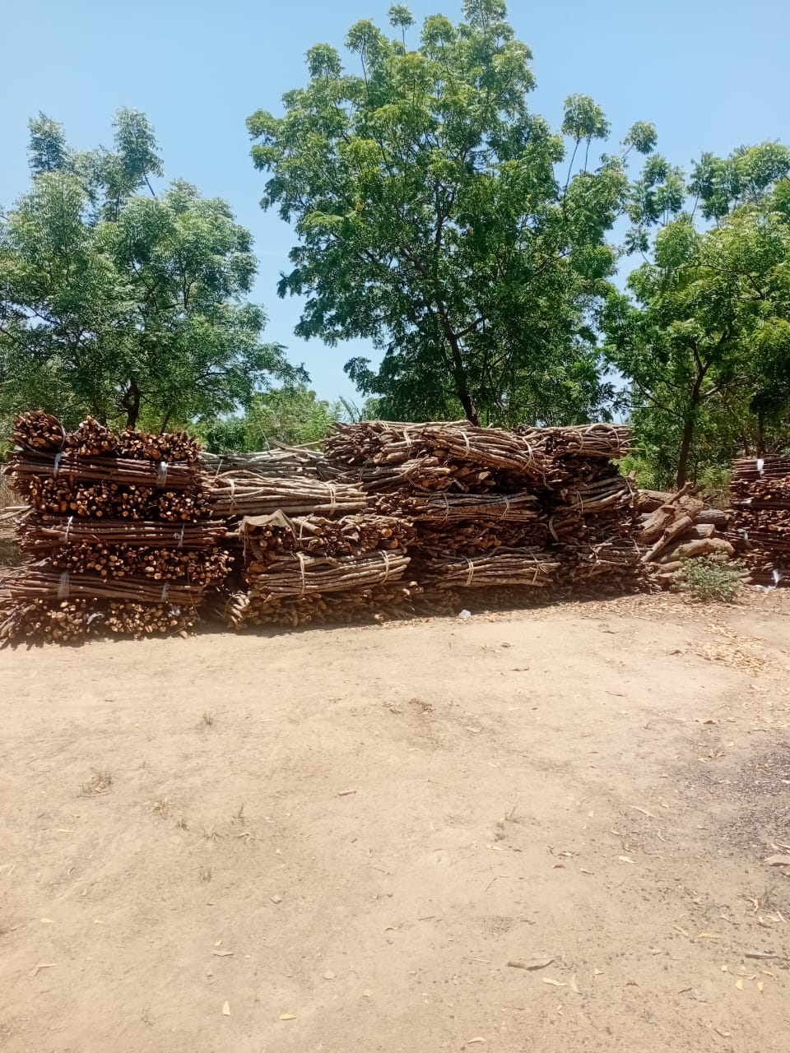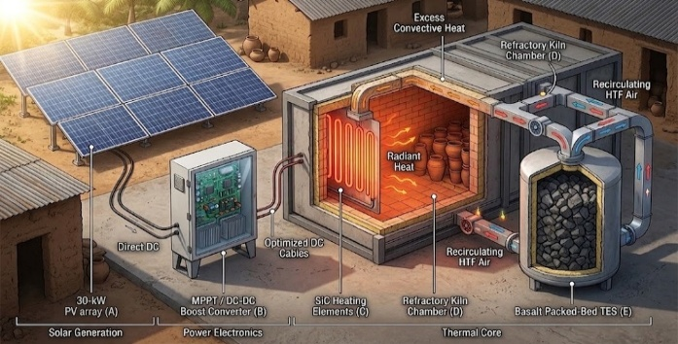
(a) (b) (c)
Fig. 1: SMEs pottery firing system architecture development (a) existing process of pottery firing, (b) stacked accumulated firewood for firing, (c) innovative DC-Coupled Solar PV and Basalt TES concept
2. Methods and Materials
2.1 Design basis and system architecture
The design basis encompasses a single pottery enterprise that fires 300 kg of green ware per batch within a 2.0 m³ setting space, reaching a peak temperature of 1150 °C (with a design ceiling of 1200 °C), located at an SME pottery site in Ghana. Ghana experiences a global horizontal irradiation of 1885 kWh m⁻² per year and a specific Solar PV yield ranging from 4.3 to 4.6 kWh kWp⁻¹ per day (World Bank Group and Solargis, 2019). Table 1 outlines the principal parameters. As illustrated in Fig. 2, a 30 kWp crystalline silicon photovoltaic array supplies an MPPT DC–DC stage (efficiency ηdc = 0.975) and two solid-state switching zones. The first zone energises FeCrAl elements embedded in a packed bed, while the second operates molybdenum disilicide elements within the firing chamber; both are housed in a single insulated enclosure. During preheating, a blower circulates air through the bed into the chamber, and during controlled cooling, part of the stored heat in the chamber is returned to the bed Jouhara et al., (2018). The system does not incorporate an inverter or electrochemical battery.
Tab. 1: Principal design-basis parameters.
Parameter | SymbolUnit | Value | Unit
Green ware charge per firing | m_{w} | 300 | kg
Setting space/kiln mass | V_{ch} / m_{f} | 1.00 / 85 | m³ / kg
Peak firing temperature (design ceiling) | T_{p} | 1150 (1200) | °C
Reference ambient temperature | T₀ | 28 | °C
Phase I/Phase II/soak/cooling duration | t₁ / t₂ / t_{s} / t_{c} | 8 / 9 / 1 / 31 | h
Array capacity | P_{STC} | 30 | kWₚ
Annual global horizontal irradiation | H | 1885 | kWh m⁻² yr⁻¹
DC efficiency/soiling and mismatch derate | η_{dc} / f_{s} | 0.975 / 0.035 | –
Bed maximum/cut-off temperature | T_{max} / T_{min} | 780 / 700 / 180 | °C
Bed void fraction/equivalent particle diameter | ε / d_{p} | 0.39 / 30 | – / mm
Installed/deliverable store capacity | E_{inst} / E_{del} | 389 / 280 | kWhₜₕ
Planned firings per year/project life/discount rate | N / n / i | 80 / 15 / 12 | yr⁻¹ / yr / %
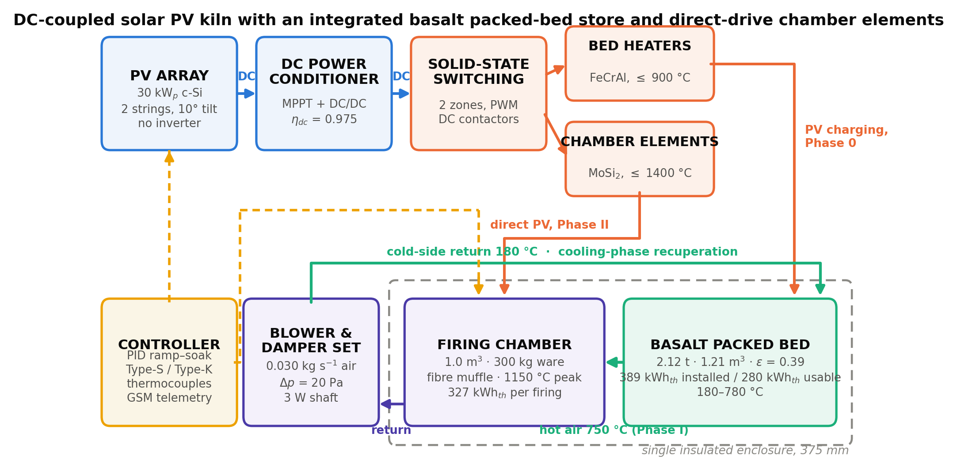
Fig. 2: System block architecture of the DC-coupled Solar PV kiln with an integrated Basalt packed-bed and firing chamber. The dashed boundary marks the single insulated enclosure containing both the storage and firing chambers.
2.2 Basalt storage medium, refractory set and enclosure
Basalt rock was characterised in accordance with the established measurement procedures. The specific heat capacity was described using a Maier–Kelley model, which was fitted via least squares to the differential-scanning calorimetry data provided by Tiskatine et al. (2017) and Jemmal et al. (2017):

c_{p,b}(T) = a + bT − c/T², a = 1079.6 J kg⁻¹ K⁻¹, b = 0.0978 J kg⁻¹ K⁻², c = 2.508 × 10⁷ J K kg⁻¹ (1)

The fitting process produces operating schemes of 827 J kg⁻¹ K⁻¹ at 25 °C, 1113 J kg⁻¹ K⁻¹ at 500 °C and 1176 J kg⁻¹ K⁻¹ at 900 °C with an accuracy of 4 J kg⁻¹ K⁻¹. Thermal conductivity was characterised as kb(T) = 1.95 − 8.2 × 10⁻⁴ T + 2.6 × 10⁻⁷ T² W m⁻¹ K⁻¹, whereas T is expressed in °C or K, and the bulk density was taken as 2870 kg m⁻³ (Tiskatine et al., 2017; Grirate et al., 2014). The design ceiling is based on thermomechanical considerations rather than calorimetric measurements. Basalt has undergone 150 thermal cycles up to 650 °C without detectable deterioration Tiskatine et al., (2017). In contrast, microcracking and strength reduction in mafic rocks typically commence well below 1000 °C Becattini et al., (2017), and basaltic glass exhibits a glass transition near 650-700 °C, beyond which viscous sintering effectively reduces pore volume within the bed. A conservative continuous operating ceiling of 800 °C has been adopted, with the bed engineered to operate effectively within 180-780 °C, as depicted in Table 2. The closest significant sources are scattered volcanic parts within Ghana, consisting of fine-grained Basalt rocks and basaltic andesite of low-grade greenschist facies, obtained from aggregate quarries including pottery cluster sites. These materials contain secondary carbonate and hydrous phases that necessitate calcination at 800 °C (Jones, 1990; Agyei Duodu et al., 2009).

Tab. 2: TES sensible heat storage media at the kiln duty. Costs are delivered prices in Ghana, 2026.
Medium | ρ (kg m⁻³) | c_{p} at 500 °C (J kg⁻¹ K⁻¹) | ρc_{p} (MJ m⁻³ K⁻¹) | k at 500 °C (W m⁻¹ K⁻¹) | T_{max} (°C) | Cost (USD t⁻¹)
Basalt, local quarry | 2870 | 1110 | 3.19 | 1.55 | 800 | 18
Granite, local | 2640 | 1015 | 2.68 | 2.20 | 600 | 25
Quartzite, local | 2620 | 1050 | 2.75 | 3.10 | 573 | 22
Magnetite ore, regional | 3800 | 880 | 3.34 | 2.60 | 800 | 45
Fireclay grog, regional | 2100 | 1080 | 2.27 | 1.10 | 1300 | 190
Mullite–corundum, imported | 2450 | 1140 | 2.79 | 1.90 | 1500 | 620
Alumina (>90 %), imported | 3200 | 1160 | 3.71 | 4.50 | 1750 | 1450
Silicon carbide, imported | 2650 | 1050 | 2.78 | 18.0 | 1500 | 2900

The enclosure was specified using an ASTM-classified set of insulating firebrick, ceramic fibre, and calcium silicate products characterised by temperature-dependent conductivities, as constant-k assumptions underestimate heat loss by a factor of two or more across the temperature range (ASTM, 2017, 2019). A ceramic-fibre-board hot face was preferred over insulating firebrick because the envelope's thermal mass, rather than envelope loss, predominantly influences the batch energy of a storage-fed kiln. Replacing 100 mm of Group 26 firebrick with fibre board of equivalent resistance eliminates about 55% of the stored wall enthalpy, at the expense of durability, which is mitigated by silicon-carbide supports and a sacrificial hearth. The chosen lining comprises 200 mm of fibre board 1430, 125 mm of blanket 1260, and 50 mm of calcium silicate. Figures 3 and 4 depict the characteristics of the storage-medium selection map.
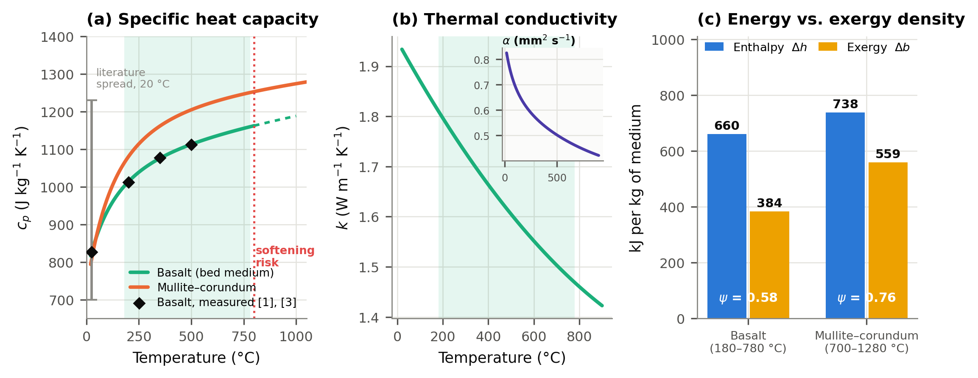
Fig. 3. Basalt thermophysical behaviour: (a) specific heat capacity - Temp. operating window = 180–780 °C; (b) thermal conductivity and diffusivity; (c) energy & exergy density of Basalt of the mullite–corundum alternative, with exergy factor ψ.
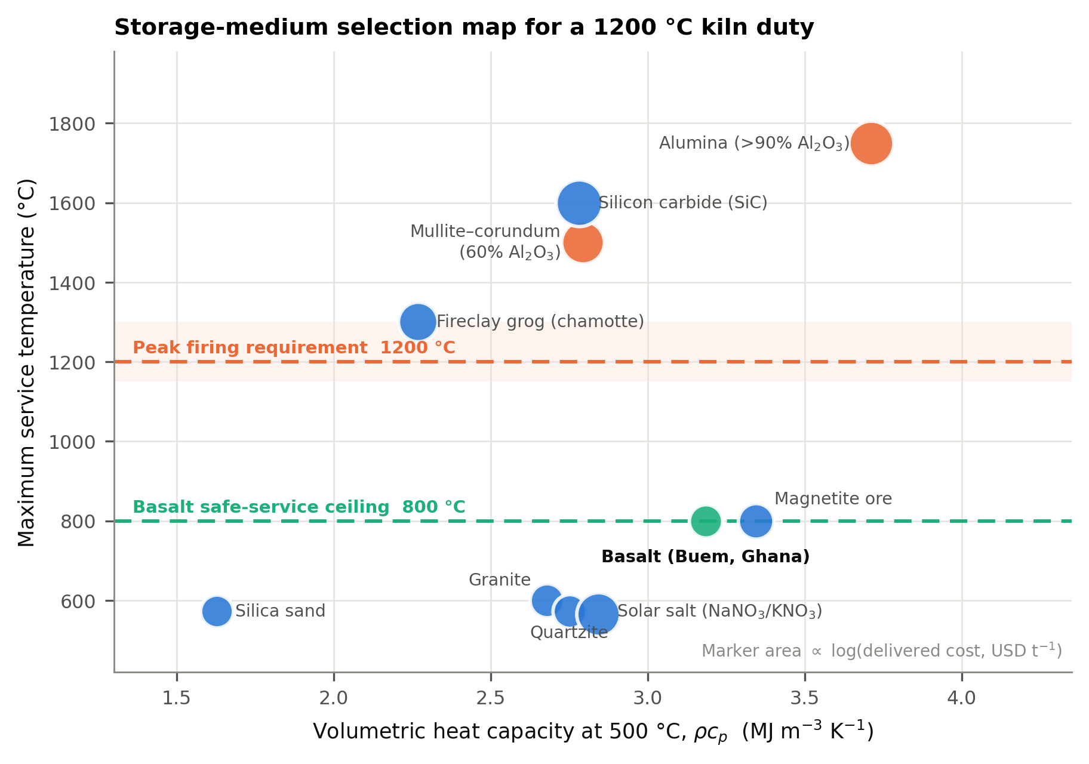
Fig. 4. Storage-medium selection map. Basalt volumetric heat capacity and operating temperature with imported aluminosilicates; 1200 °C temperature ceiling.
2.3 Thermal-load and envelope models
The energy reaching the chamber in one firing sums the ware enthalpy and reaction enthalpy, the fittings, muffle and enclosure sensible terms, the envelope loss over ramp and soak, and an 8 % parasitic allowance:
Q_{cyc} = Q_{w} + Q_{f} + Q_{m} + Q_{e} + Q_{loss,f} + Q_{par}, Q_{w} = m_{w} ∫ c_{p,w}(T) dT + m_{w} Δh_{chem} (2)

c_{p,w}(T) = 800 + 0.42T J kg⁻¹ K⁻¹ for an earthenware body and Δh_{chem} = 0.30 MJ kg⁻¹ covering dehydroxylation of kaolinite, carbonate decomposition and the quartz inversion (Carty & Senapati, 1998). Envelope loss follows a one-dimensional multilayer solution with temperature-dependent conductivity and a combined outside film:

q″ = (T_{i} − T₀)/[ Σ_{j} t_{j}/k_{j}(T̄_{j}) + 1/(h_{c} + h_{r}) ], h_{c} = 1.42 |T_{s} − T₀|^{0.25}, h_{r} = ε_{s} σ (T_{s}⁴ − T₀⁴)/(T_{s} − T₀) (3)

ε_{s} = 0.90 for a painted steel casing, solved by successive substitution on the node temperatures until the flux converges to 10⁻⁴ W m⁻²; the same routine returns the stored enthalpy of the wall.

2.4 Solar Photovoltaic, packed-bed and dispatch models
Hourly generation was simulated over an entire year at 5.6° N using solar geometry principles and adjusted by a stochastic monthly clearness index calibrated to the seasonal patterns observed in West Africa (notably a monsoon minimum and a Harmattan dust minimum). This index was subsequently rescaled to 1885 kWh m⁻² per year, based on data from the World Bank Group and Solargis (2019), with plane-of-array irradiance for a fixed south-facing tilt of 10° being calculated as 1.02 times the horizontal irradiance:

P_{pv}(t) = P_{STC} · G_{POA}(t)/1000 · [1 + γ(T_{c}(t) − 25)] · (1 − f_{s}) · η_{dc} (4)

Where γ = −0.0035 K⁻¹, a nominal-operating-cell-temperature model for Tc, with fs = 0.035 and ηdc = 0.975, yields a simulated specific energy output of 4.56 kWh per kWp per day. The charge and discharge processes of the bed were modelled using the two-phase Schumann model Schumann, (1929). Given that the volumetric heat capacity of air is four orders of magnitude lower than that of the packing, the fluid phase is considered quasi-steady below:
G c_{p,f} (dT_{f}/dz) = − h_{v} (T_{f} − T_{s}), (1 − ε) ρ_{s} c_{p,s}(T_{s}) (∂T_{s}/∂t) = h_{v} (T_{f} − T_{s}) + k_{eff} (∂²T_{s}/∂z²) (5)

The fluid equation is integrated analytically across a cell, yielding the unconditionally stable marching solution T_{f}(z + Δz) = T_{s} + [T_{f(z)} − T_{s}]. Conversely, the solid equation is advanced explicitly with a time step Δt = 15 seconds over 160 axial nodes. The volumetric heat transfer coefficient employs the Coutier–Farber correlation hv = 700 (G/d_{p}){0.92} W m⁻³ K⁻¹ (Coutier & Farber, 1982). The effective axial thermal conductivity is thrice the solid conductivity to account for contact conduction and radiation across voids Hänchen et al., (2011); Esence et al., (2017). The Number of Transfer Units (NTU) is defined as NTU = hv L Ac/(ṁ cp,f), and the utilisation factor is η_{u} = E_{del}/E_{inst}. The pressure drop is modelled according to the Ergun equation, assuming a sphericity of 0.82 (Ergun, 1952; Allen et al., 2015):
Δp/L = 150 μ (1 − ε)² u/(ε³ d_{e}²) + 1.75 (1 − ε) ρ_{f} u²/ (ε³ d_{e}) (6)

Where d_{e} = φd_{p} and blower shaft power P_{fan} = ṁΔ_{p}/ (ρf η_{fan}), with η_{fan} = 0.45. The storage, array, and firing schedule were integrated within an event-driven hourly simulation spanning one year. A firing scheduled for a day commences at 01:00 if the hot system maintains at least 85% of its achievable capacity. Otherwise, it is deferred by 24 hours, up to a maximum of eight days. Phase-II demand is prioritised from direct array output, while Phase-I demand is supplied from the TES storage. Charging is permissible solely within a designated window preceding the subsequent planned firing. Standby losses are derived from the converged envelope solution and scaled according to the bed’s mean temperature as P_{sb} = q_{full} [0.20 + 0.80 SOC/E_{cap}], where q_{full} = 2199 W at a steady temperature of 780 °C, with a portion of the chamber enthalpy recovered into the bed six hours into the cooling process Jouhara et al. (2018).

2.5 Energy, exergy, techno-economic and environmental models
Dincer & Rosen (2021), Rosen (1992), and Bejan (2016) discuss the thermal exergy of sensible storage between T_{lo} and T_{hi}, the dead state T₀, the exergy factor of a stream, and the entire-system efficiencies referenced to the DC output array:

B = ΔH − T₀ ΔS = m ∫ c_{p}(T) dT − m T₀ ∫ c_{p}(T)/T dT, ψ = B/ΔH, η_{en} = Q_{ware}/E_{PV}, η_{ex} = B_{ware}/E_{PV} (7)

Reporting both aspects is essential: energy efficiency rewards heat transfer, whereas exergy efficiency reveals the cost of storing high-grade electricity as moderate-grade sensible heat and subsequently upholding it for efficacy. Capital costs were meticulously analysed per item at 2026 delivered prices in Ghana, including an 8% contingency. Operating costs include maintenance at 1.2% of capital, insurance at 0.8%, a controls allowance, and a sinking fund for element replacement. Four benefit streams are acknowledged: avoided firewood expenditure, recovered yield from reduced breakage, monetised labour savings, and carbon emissions reduction and net revenue. The LCOH is calculated using a common ware-referenced denominator of 1.475 MJ/kg of fired ware, enabling comparison of fuels and electricity per identical production (Short et al., 1995):

LCOH = (CRF · C₀ + C_{om})/Q_{ref}, CRF = i(1+i) ^{n}/[(1+i) ^{n} − 1]; NPV = − C₀ + Σ CF_{t}/ (1 + i) ^{t} (8)

Where i = 12 %, n = 15 yr and cash flow degraded at 0.6 % yr⁻¹ to follow array output. Baseline emissions follow the IPCC energy-sector method with the Clean Development Mechanism default emission factor for wood (UNFCCC, 2020; IPCC, 2006); ER = B_{y} · NCV · EF · f_{NRB} · (1 + u) (9)
Whereas B_{y} is the annual wood displaced, NCV = 0.015 TJ t⁻¹, EF = 81.6 tCO₂ TJ⁻¹ and u = 0.11 covers methane and nitrous oxide from incomplete combustion. Two fNRB values are used throughout: the post-2020 universal default of 0.30 (UNFCCC, 2020) and the legacy Ghana default rate of 0.87, which suggests a much higher non-renewable share (BeZero Carbon, 2023). Embodied emissions are credited at 550 kg CO₂e kW_{p}⁻¹ for modules and standard factors for the balance.

3. Results and Discussion
3.1 Enclosure design and operating window
Basalt is an attractive and competitive storage medium, with a volumetric heat capacity of 3.19 MJ/m³ K, second only to magnetite and alumina. Priced at USD 18/ton, it is 34-161 times cheaper than imported aluminosilicates. Its temperature ceiling of 800 °C restricts applications needing an extra 400 K. Only materials like mullite–corundum, alumina, and silicon carbide, which withstand over 1200 °C, are suitable. These are imported and cost USD 620–2900/ton. From 180 °C to 780 °C, basalt stores 708 kJ/kg at 0.58 porosity, while mullite–corundum stores 738 kJ/kg at 0.76 porosity between 700–1280 °C. The concern extends beyond energy storage capacity to whether these materials can store energy at the required grade. Similar limitations exist for other mafic and metamorphic rocks in solar applications Jemmal et al., (2016). The enclosure has an 11.8 m² internal box with 375 mm lining. Figure 5 (a) shows the temperature profile with the bed at 780 °C. The hot face drops from 780 °C to 457 °C, with a 178 °C drop across the blanket and 48 °C at the casing. Standby heat loss rises from 805 W at 400 °C to 2199 W at 780 °C, and to 4416 W at 1150 °C. The optimal insulation thickness is around 394 mm, slightly above the selected 375 mm, which is close to the optimum and standard. Thinner lining (185 mm) increases energy use by 21%. Figure 5 (b) compares a dual-vessel Basalt bed at 780 °C with a mullite–corundum stage at 1280 °C, with the former losing 8.2 kW (53% of capacity) daily, and the latter only 2.2 kW (73% reduction). The combined setup offers the highest efficiency.

Tab. 3: Characterisation of two-vessel cascade of standby and integrated enclosure performance at equal deliverable capacity.
Attribute | Two-vessel cascade | Integrated enclosure
Storage media | Basalt 1.24 t + mullite–corundum 0.71 t | Basalt 2.12 t
Media cost (USD) | ≈ 460 | ≈ 40
Maximum medium temperature (°C) | 1280 | 780
Hot external area (m²) | 27.2 | 11.8
Standby loss at rated temperature (kW) | 8.21 | 2.20
Standby loss (% of installed capacity per day) | 53 | 14
Route to 1150 °C | Topping stage discharge | Direct PV resistance heating
Verdict | Rejected: standby loss exceeds useful throughput | Selected
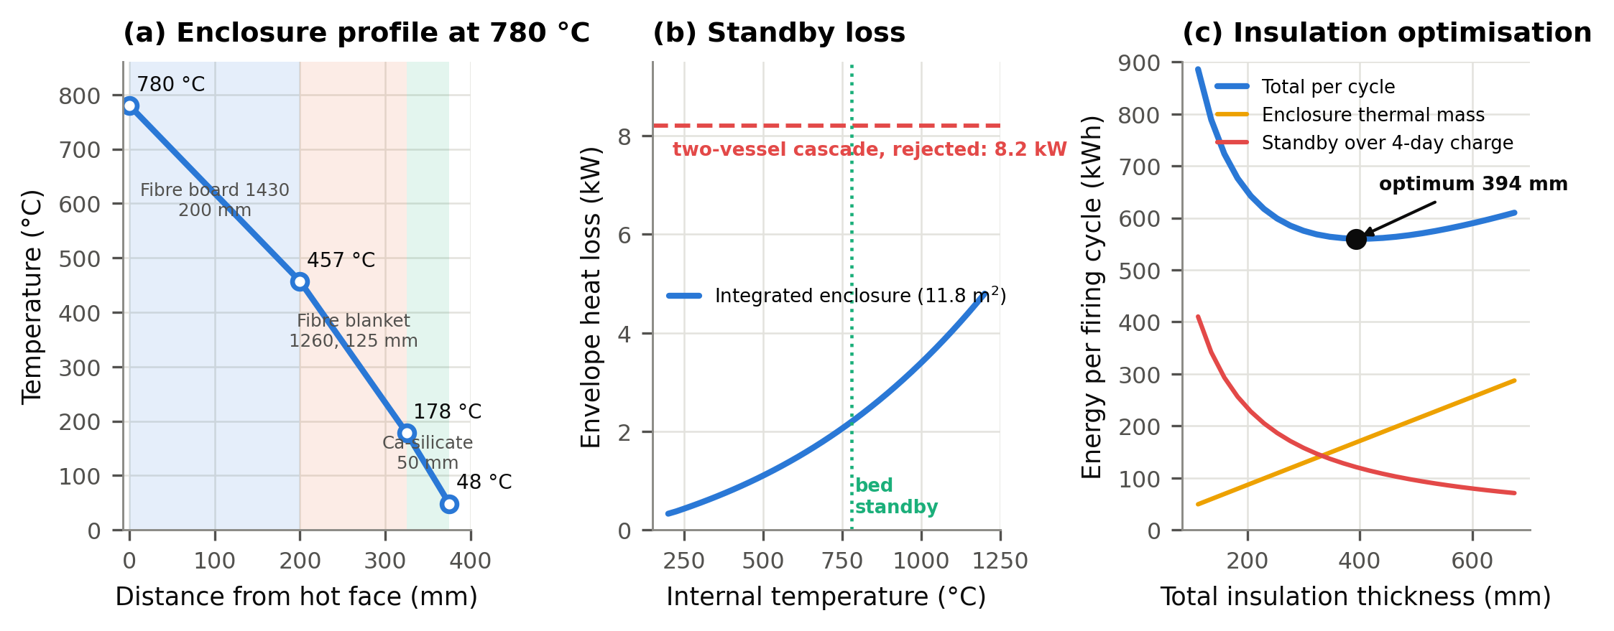
Fig. 5: Enclosure design: (a) converged temperature profile with the bed at 780 °C; (b) standby loss against internal temperature, compared with the rejected two-vessel cascade; (c) optimisation of total insulation thickness against per-cycle energy.

3.2 Thermal load, firing schedule, and thermocline behaviour
The firing schedule has three phases: Phase 0 pre-heats the Basalt TES bed using the PV array; Phase I heats the chamber to 700 °C in 8 hours at 84 K/h with hot air from the TES bed, completed before array productivity; Phase II raises temperature to 1150 °C, over 9 hours at 50 K/h with PV output, including solar peak and TES charging, ending with a soak and cooling. The total demand per firing is 327 kWh_{th}, with 56% in Phase I and a peak of 29.4 kW. Table 4 shows load distribution, highlighting insulation (40%) and ware decomposition (31%), with temperature components. This asymmetry is typical of small-batch kilns due to low-mass fibre lining. The TES bed measures 0.87 m in diameter and 2.04 m long, holding 2.12 tons of 30 mm Basalt at 0.39 void fraction. It provides 389 kWh_{th} capacity, delivering 280 kWh_{th} at a 0.72 utilisation factor. With an airflow rate of 0.030 kg/s, superficial velocity is 0.108 m/s, Reynolds number of 58, heat transfer coefficient of 1132 W/m³ K, and NTU 42, causing a distinct thermocline as shown in Figures 6 and 7. The 10 to 90% zone covers 0.24 of the bed after 2 hours, growing with the square root of time to 0.64 at 9.5 hours. An 180°C cutoff results in 0.72 utilisation, aligning with typical values for similar beds reported in various studies. The Ergun pressure drop is 20 Pa, and the blower shaft power is 2.9 W, suitable for a cost-effective single-phase blower.

Tab. 4: Thermal load decomposition per firing, referenced to the chamber.
Term | Energy (kWhₜₕ) | Share (%)
Ware sensible enthalpy, 28 → 1150 °C | 97.9 | 24.6
Ware reaction enthalpy (dehydroxylation, carbonates, quartz inversion) | 25.0 | 6.3
Kiln furniture (shelves and props) | 31.4 | 7.9
Fibre muffle | 20.5 | 5.1
Enclosure insulation sensible enthalpy | 160.5 | 40.4
Envelope loss during ramp and soak | 32.9 | 8.3
Parasitic allowance (8 %) | 29.4 | 7.4
Total per cycle | 397.6 | 100.0
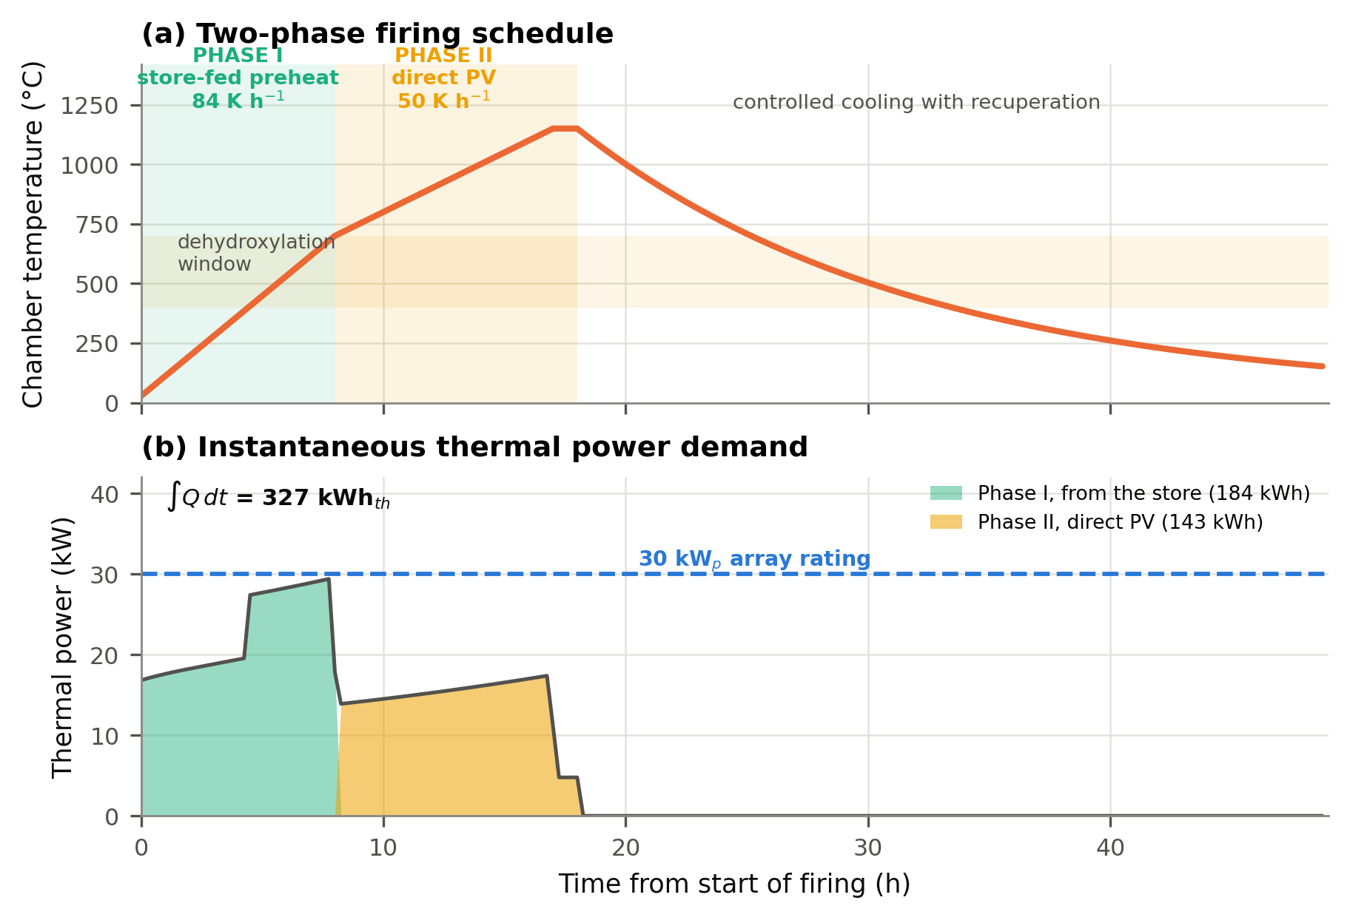
Fig. 6: Thermal load decomposition per firing rate, referenced to the chamber
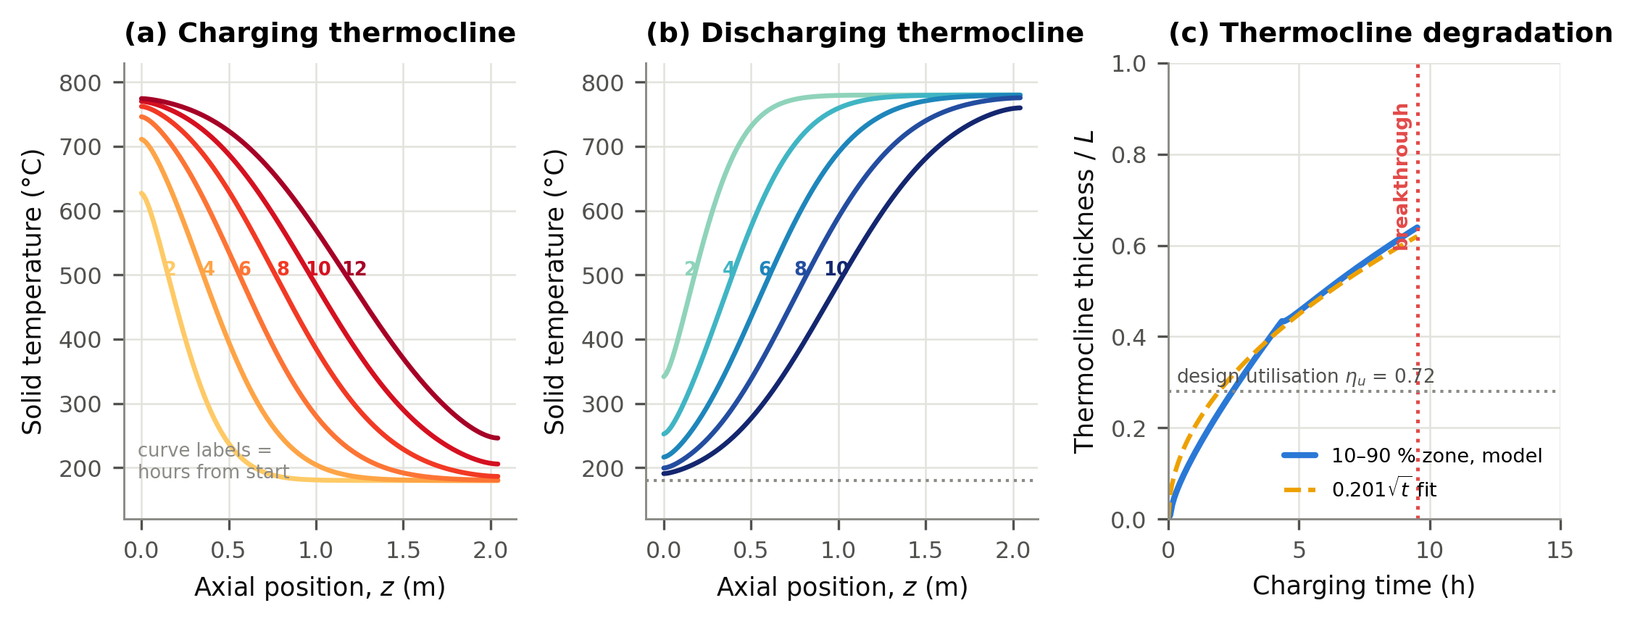
Fig. 7: Schumann model results: (a) charging (b) discharging solid-temperature profiles at two-hourly intervals; (c) growth of the 10–90 % thermocline zone and the breakthrough time.

3.3 Annual dispatch, energy and exergy balance
The 30 kWp PV array produces 49.9 MWh annually, with 80 firings completed, ensuring 100% schedule reliability. Solar PV supplied 99.1% of chamber demand, with 82.3% utilisation and 8.8 MWh curtailed. Standby energy for temperature control amounted to 15.6 MWh, partially offset by 3.6 MWh recovered from cooling. The TES storage completes 61 cycles yearly at 0.49 efficiency. Reliability is maintained beyond 300 kWh_{th} capacity and 35 kWp curtailment, with the system enduring a 99% reliability contour. Out of 51.2 MWh, 1.3 MWh is lost in DC conditioning, 8.8 MWh is curtailed, and 41.1 MWh is charged into the hot system. After losses, 25.7 MWh reach the chamber, with 11.7 MWh absorbed by the enclosure and muffle, 7.1 MWh consumed by other components, leaving 7.9 MWh as useful heat absorbed by the ware. The ware efficiency η_{en}=0.155 and η_{ex}=0.094, with a total heat delivery efficiency of 0.50. Electricity is pure exergy and causes immediate exergy destruction, while stored heat carries ψ = 0.58, reflecting the thermodynamic cost of storage. Table 5 and Figure 8 present the characteristics of the illustrated performance.

Tab. 5: Annual energy and exergy balance at the design point (80 firings).
Stream | Energy (MWh yr⁻¹) | Exergy (MWh yr⁻¹) | Exergy factor ψ
Array DC output | 51.19 | 51.19 | 1.00
Charged into the hot system | 41.08 | 23.86 | 0.58
Delivered to the chamber | 25.71 | 14.72 | 0.57
Absorbed by the ware | 7.95 | 4.82 | 0.61
—DC conditioning loss | 1.28 | — | —
— Curtailment | 8.83 | — | —
— Store standby loss, net of recuperation | 12.00 | — | —
— Enclosure and muffle thermal mass | 11.70 | — | —
— Flue, envelope, fittings, duct and blower | 7.09 | — | —
Efficiency (ware-referenced) | η_{en} = 0.155 | η_{ex} = 0.094 | —
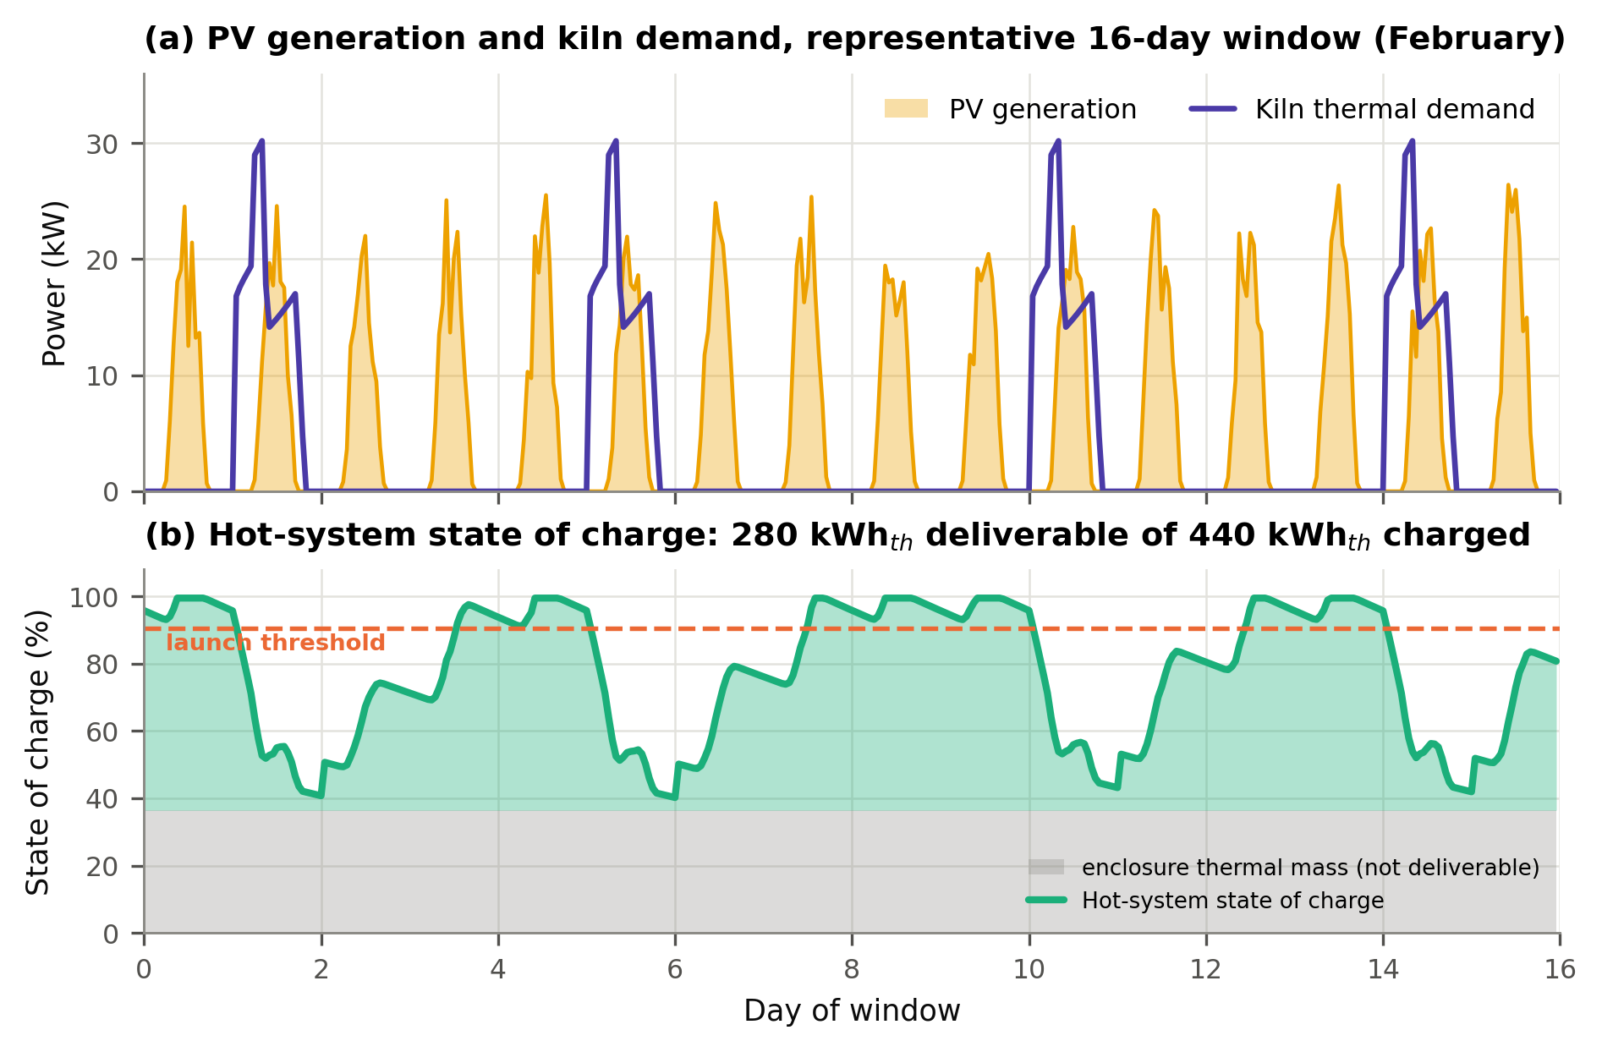
Fig. 8. Annual dispatch over a representative window: (a) PV array output against kiln thermal demand; (b) state of charge of the integrated hot system, with enclosure thermal mass shown separately.
Figure 9 shows the demand and operational design with reference to established data. Reliability increases with larger PV arrays and storage but saturates around 300 kWh_{th}. Beyond this, the constraint shifts from storage to PV energy, and over 35 kWₚ causes curtailment. The chosen setup of 30 kWₚ / 280 kWh_{th} is on the 99% reliability contour at 82% use, minimising costs within feasible performance.
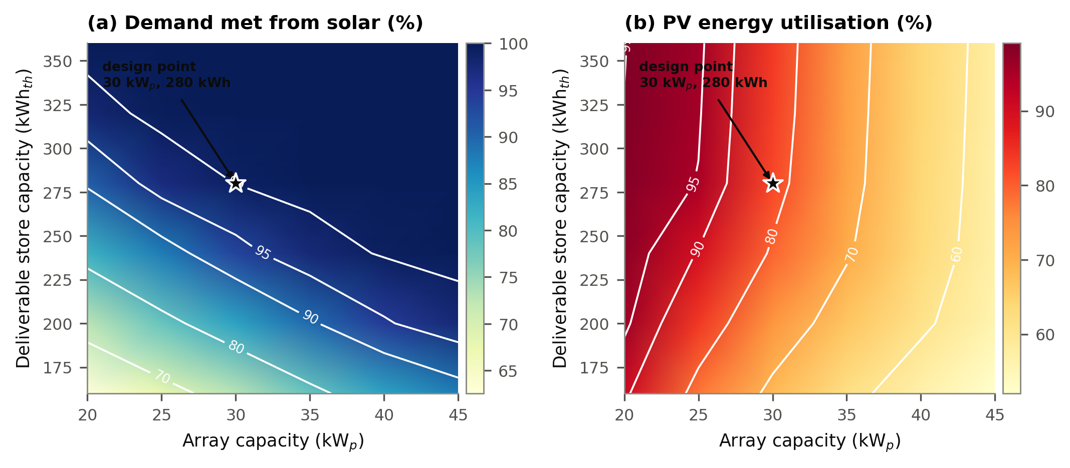
Fig. 9. Design map over array capacity and deliverable store capacity: (a) fraction of demand met from solar; (b) array energy utilization. The star marks the selected design point.

3.4 Techno-economic and comparative results
Table 6 and Fig. 10 present an installed capital cost of USD 35,575 and a cumulative discounted cash flow synthesis, including the PV array, integrated kiln-TES storage elements, and balance of system, representing a benchmark within the design criteria. Thus, installation, civil works, and controls account for the remaining costs as the TES material is sourced locally. Annual operating cost is USD 1,278 against a year-one benefit stack of USD 8,722: recovered yield from lower breakage USD 4,896 (56 %), avoided firewood USD 2,520 (29 %), and monetised labour saving of USD 1,306 (15 %), with a net carbon revenue, all giving a net present value of USD 15,543 over 15 years.
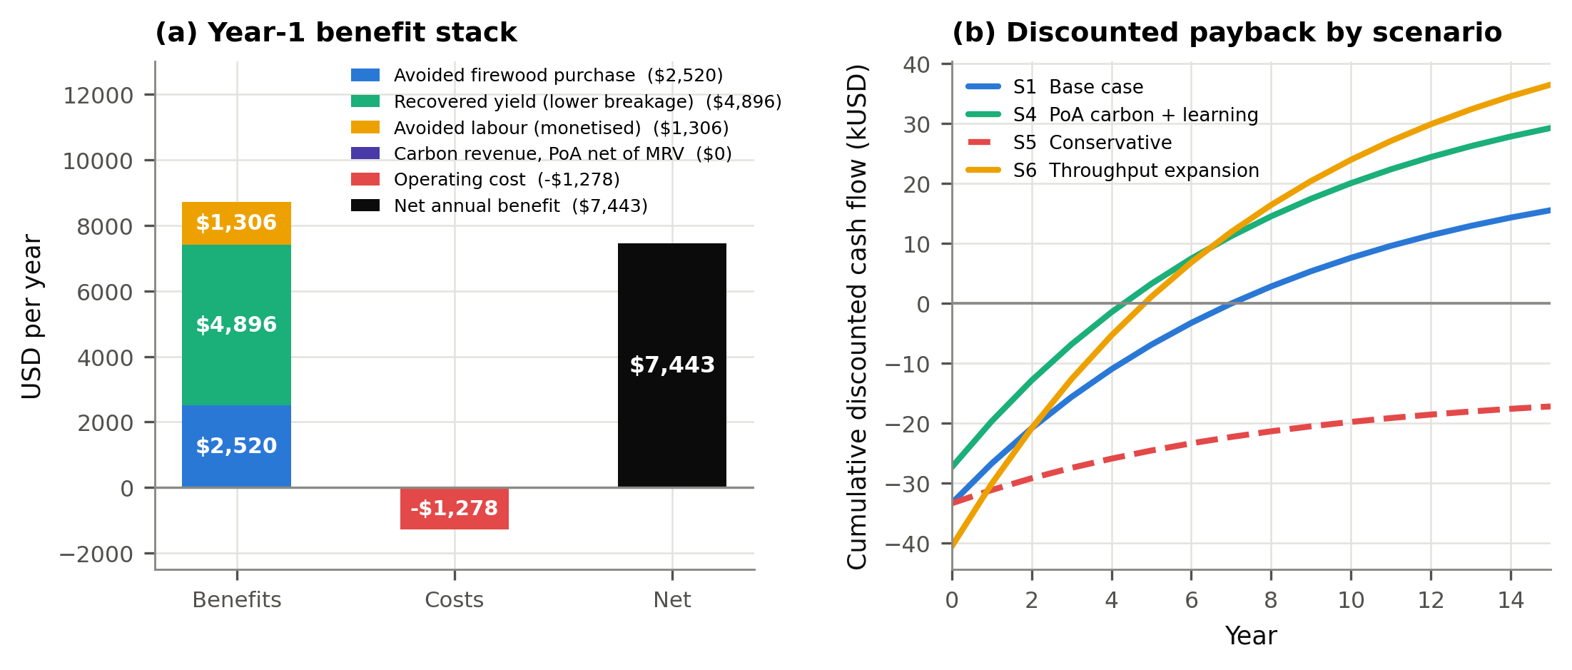
Fig. 10. (a) Year-one benefit stack and net annual benefit; (b) cumulative discounted cash flow for four scenarios.

Tab. 6: Capital cost breakdown, first-of-a-kind unit, 2026 USD delivered in southern Ghana.
Item | Cost (USD) | Share (%)
PV modules (30 kWₚ, delivered) | 4,800 | 14.14
Mounting structure, civil anchoring, foundation and weather shelter | 4,600 | 13.55
DC cabling, isolators, surge protection, earthing; freight and duties | 3,000 | 8.84
DC power conditioning (MPPT/DC–DC, solid-state relays, contactors) | 3,100 | 9.14
Control system and instrumentation | 1,700 | 5.01
Integrated kiln-store shell, 375 mm insulation, muffle | 6,400 | 18.86
Heating elements (FeCrAl bed + MoSi₂ chamber) and holders | 2,600 | 7.66
Basalt media (2.1 t, crushed and graded locally) | 1400 | 7.07
Bed internals, blower, ducting, dampers, recuperation valve | 2,600 | 7.66
Installation, commissioning, operator training | 2,740 | 8.07
Subtotal / contingency (8 %) / total installed cost | 32,940 / 2,715 / 35,575 | 100.0

Table 7 compares five kiln options on a common ware-referenced basis. The PV kiln has the lowest fuel cost (zero) and breakage rate, but its LCOH for process heat is USD 181 GJ⁻¹, higher than the traditional kiln (USD 120 GJ⁻¹) and the improved wood kiln (USD 80 GJ⁻¹), yet lower than LPG and grid electricity. Per ton of saleable ware, the Solar PV kiln costs USD 281, compared with USD 226 for the traditional kiln. However, it remains attractive because it produces more saleable output from the same green input, due to a massive reduction in breakage compared with the traditional kiln firing process.
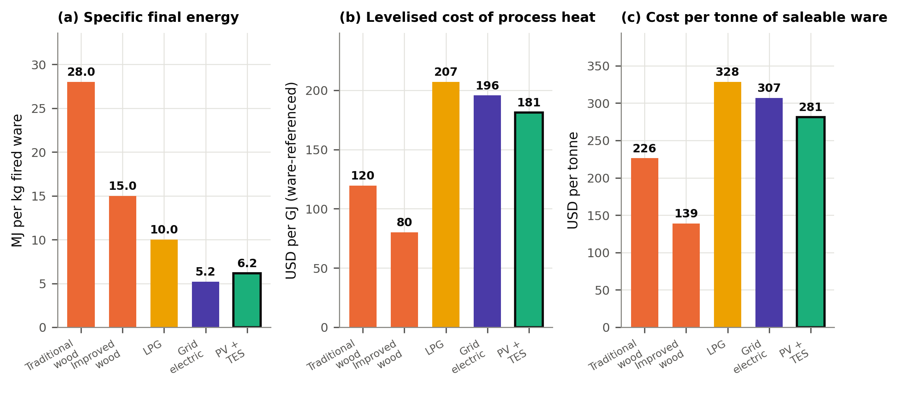
Fig. 11. Comparison of the five kiln options: (a) specific final energy; (b) levelised cost of process heat on a ware-referenced denominator; (c) cost per tonne of saleable ware.
The investment remains attractive, as shown in Fig. 11, which highlights key variables such as specific Energy consumption in terms of emissions and impact on baseline breakage rate, ware price, and yield and throughput, not just fuel costs. Using regulated electric firing reduces breakage from 22% to 5%, converting 4.1 tons of ware into USD 4,896 worth of products 56% of first-year benefits and twice the value of avoided firewood. Focus goes beyond fuel substitution to process control that requires no fuel, making yield and throughput key innovations for pottery. Yield improvements impact a USD 1,200 per ton ware price and a 17-percentage-point breakage reduction, both tied to the ability to sell more output.
Tab. 7: Comparative technical and economic profile of five kiln options, 24 t of green ware.
Attribute | Traditional wood | Improved wood | LPG | Grid electric | PV + basalt TES
Specific final energy (MJ kg⁻¹ ware) | 28.0 | 15.0 | 10.0 | 5.2 | 6.2
Annual fuel or electricity | 44.8 t wood | 24.0 t wood | 5.2 t LPG | 34.7 MWh | 0
Annual fuel cost (USD) | 2,520 | 1,350 | 6,000 | 5,200 | 0
Labour (h yr⁻¹) | 3200 | 2080 | 800 | 640 | 480
Breakage rate (%) | 22 | 15 | 7 | 6 | 5
Capital cost (USD) | 600 | 2,200 | 5,200 | 7,800 | 33,415
Levelised cost of heat (USD GJ⁻¹) | 120 | 80 | 207 | 196 | 181
Cost per tonne saleable ware (USD) | 226 | 139 | 328 | 307 | 281
Operator smoke exposure | Severe | High | Low | None | None

3.5 Environmental, carbon-finance and uncertainty results
The system displaces 44.8 tons of fuelwood annually, resulting in emissions of 54.8 tCO₂. It achieves an abatement of 18.3 tCO₂e at a default fNRB of 0.30, or 53.0 tCO₂e at 0.87. Embodied emissions total 24.3 tCO₂e, resulting in a net abatement of 16.6 tCO₂e per year and a carbon payback period of 1.3 years. Emission intensity decreases from 761 to 68 kg CO₂e per ton, a 91% reduction. Grid firing emits 556 kg CO₂e per ton; however, abatement is achieved through solar photovoltaic (PV) firing, not electrification. Non-climate co-benefits increase as in-firing exposures are eliminated, as indicated by Williams et al. (2025). Emissions and financing outcomes per kiln are detailed in Table 8 and Figure 12.

Tab. 8: Emissions and carbon-finance outcomes per kiln.
Quantity | f_{NRB} = 0.20 | f_{NRB} = 0.30 (CDM default) | f_{NRB} = 0.50 | f_{NRB} = 0.87 (legacy)
Annual abatement (tCO₂e) | 12.2 | 18.3 | 30.4 | 53.0
Break-even carbon price, stand-alone (USD t⁻¹) | 288 | 192 | 115 | 66
Break-even carbon price, 50-unit PoA (USD t⁻¹) | 23.0 | 15.3 | 9.2 | 5.3
Net PoA revenue at USD 12 t⁻¹ (USD yr⁻¹) | −134 | −61 | 85 | 355
Net PoA revenue at USD 25 t⁻¹ (USD yr⁻¹) | 24 | 177 | 481 | 1044
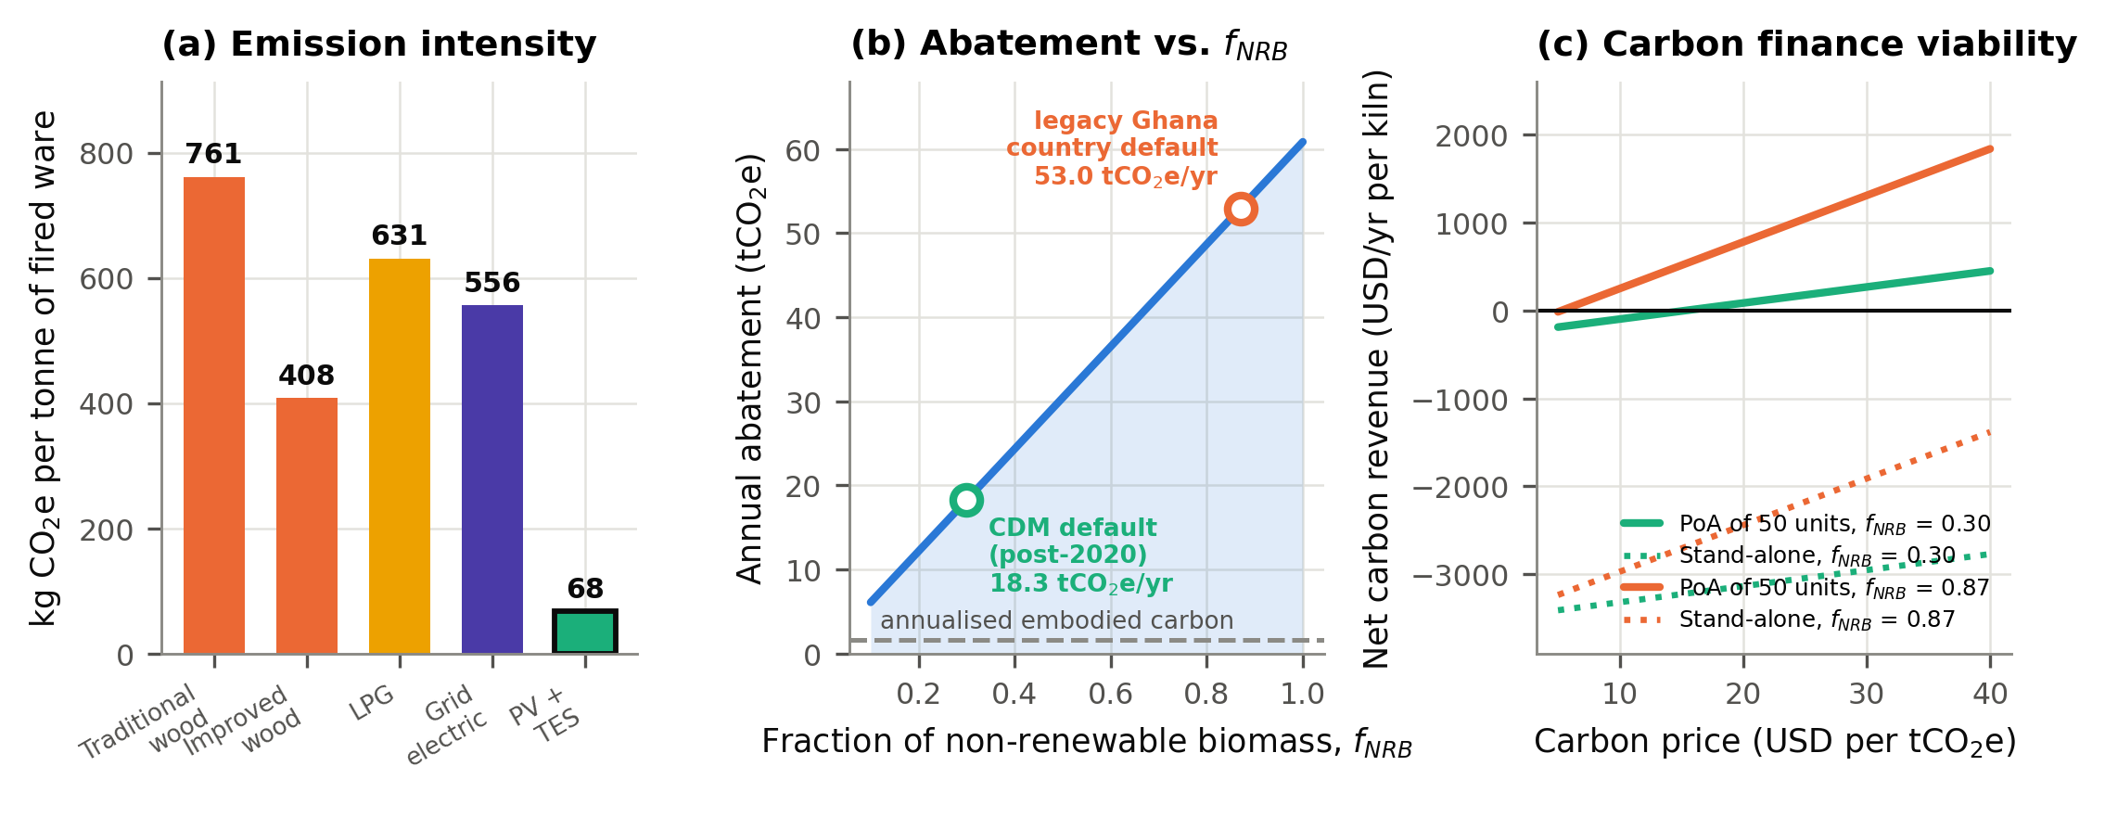
Fig. 12. Environmental results: (a) emission intensity per ton of fired ware; (b) annual abatement as a function of the fraction of non-renewable biomass; (c) net carbon revenue against carbon price for stand-alone aggregated crediting.
Table 8 explicitly shows the position of carbon finance. For a standalone activity incurring approximately USD 3,500 annually for monitoring, reporting, and verification, the break-even carbon price at the default fNRB is USD 192 per ton, an order of magnitude above any observable market rate. When aggregating fifty kilns, the USD 14,000 monitoring cost is distributed across the fleet, thereby reducing the break-even price to USD 15.3 per ton. Under aggregation, the fNRB also makes carbon revenue significant at USD 1,044 per kiln annually, or USD 25 per ton. The study emphasises the importance of the baseline breakage rate, ware price, annual firings from firewood, and discount rate. The carbon price and fNRB exert minimal influence on the net present value, shifting it by less than USD 3,000 across different ranges. The probability of realising a positive net present value is 89.1%, and the likelihood of surpassing a 12% hurdle stands at 92.6%. The median internal rate of return (IRR) is 21.0%, with a payback period of 4.4 years. Six cumulative scenario analyses, presented in Table 9 at an aggregation level of fNRB and USD 25 per ton, elevate the net present value to USD 22,445. An 18% reduction in capital costs at the tenth unit yields comparable results. An analysis from scenario S2 indicates an IRR of 23.8% and a payback period of 3.94 years, accompanied by a low levelized cost of hydrogen (LCOH) of USD GJ⁻¹ 175.

Tab. 9: Scenario matrix.
Scenario | CAPEX (USD) | NPV (USD) | IRR (%) | Payback (yr) | LCOH (USD GJ⁻¹) | Abatement (tCO₂e yr⁻¹)
S1 Base (stand-alone, f_{NRB} 0.30, USD 12 t⁻¹) | 35,575 | 15,543 | 20.3 | 4.49 | 175 | 18.3
S2 PoA aggregation (f_{NRB} 0.87, USD 25 t⁻¹) | 35,575 | 22,445 | 23.8 | 3.94 | 175 | 53.0
S3 Tenth unit (learning, CAPEX −18 %) | 30,400 | 22,377 | 26.1 | 3.62 | 146 | 18.3
S4 S2 + S3 combined | 30,400 | 29,279 | 30.2 | 3.18 | 146 | 53.0
S5 Conservative (low wood price, low yield gain) | 33,415 | −17,231 | 0.6 | 13.44 | 225 | 14.2
S6 Throughput expansion (45 kWₚ, 120 firings) | 40,615 | 36,516 | 27.5 | 3.47 | 139 | 27.4
4. Conclusions
Models from thermophysical, envelope, Schumann thermocline, photovoltaic, dispatch, exergy, and techno-economic were developed to evaluate rock properties and Ghanaian costs and policies, supporting the PV array kiln for pottery production with the following outcome:
- Basalt (TES) is a cost-effective storage medium for 800°C projects, but requires specific design techniques for the firing regime beyond the operating temperature of 800 °C as feasible.
- The thermal duty can be met by segmenting the process; a bed-fed preheat system reaches 700°C, and photovoltaic resistance heating adds up to 1150°C during peak solar periods.
- A 30 kWp system completes 80 firing cycles yearly, with 99% solar fraction, delivering 327 kWhth per cycle, with an energy efficiency of 0.16 and exergy of 0.09.
- The project costs about USD 35,575 in the pilot stage. However, in aggregation, it will yield benefits of a net present value of USD 22,445, an IRR of 23.8%, and a 3.94-year payback.
- Significant annual emission reductions with a positive impact on the health of practitioners and boosting the revenue generation of women entrepreneurs, and also could project Ghana on the positive path of Climate resilience practice and the course of SDGs realisation.
6. References
Agyei Duodu, J., et al., 2009. Geological Map of Ghana 1:1,000,000. Geological Survey Department, Accra.
Allen, K.G., von Backström, T.W., Kröger, D.G., 2015. Rock bed pressure drop and heat transfer: simple design correlations. Solar Energy 115, 525–536.
Anderson, R., Shiri, S., Bindra, H., Morris, J.F., 2014. Experimental results and modelling of energy storage and recovery in a packed bed of alumina particles. Applied Energy 119, 521–529.
ASTM, 2017. Standard Classification of Insulating Firebrick, ASTM C155. ASTM International, West Conshohocken, PA.
ASTM, 2019. Standard Test Method for Thermal Conductivity of Refractories, ASTM C201-93(2019). ASTM International, West Conshohocken, PA.
Bailis, R., Drigo, R., Ghilardi, A.,, 2015. The carbon footprint of traditional woodfuels. Nature Climate Change 5, 266–272.
Becattini, V., Motmans, T., Zappone, A., Madonna, C., Haselbacher, A., Steinfeld, A., 2017. Experimental investigation of the thermal and mechanical stability of rocks for high-temperature thermal-energy storage. Applied Energy 203, 373–389.
Bejan, A., 2016. Advanced Engineering Thermodynamics, fourth ed. Wiley, Hoboken, NJ.
BeZero Carbon, 2023. fNRB: The Critical Factor Driving Over-Crediting Risk in Cookstove Projects. BeZero Carbon Insights.
Bhattacharya, S.C., Salam, P.A., 2002. Low greenhouse gas biomass options for cooking in the developing countries. Biomass and Bioenergy 22, 305–317.
Carty, W.M., Senapati, U., 1998. Porcelain raw materials, processing, phase evolution, and mechanical behavior. Journal of the American Ceramic Society 81, 3–20.
Coutier, J.P., Farber, E.A., 1982. Two applications of a numerical approach of heat transfer process within rock beds. Solar Energy 29, 451–462.
Dincer, I., Rosen, M.A., 2021. Thermal Energy Storage: Systems and Applications, third ed. Wiley, Chichester.
Energy Commission of Ghana, 2024. National Energy Statistics 2015–2024. Energy Commission, Accra.
Environmental Protection Agency, 2022. Ghana's Framework on International Carbon Markets and Non-Market Approaches: Operational Guideline for Article 6.2 Cooperative Approaches, Vol. 1. Carbon Market Office, Accra.
Ergun, S., 1952. Fluid flow through packed columns. Chemical Engineering Progress 48, 89–94.
Esence, T., Bruch, A., Molina, S., Stutz, B., Fourmigué, J.-F., 2017. A review on experience feedback and numerical modeling of packed-bed thermal energy storage systems. Solar Energy 153, 628–654.
Fu, R., Feldman, D., Margolis, R., 2018. U.S. Solar Photovoltaic System Cost Benchmark, NREL/TP-6A20-72399. National Renewable Energy Laboratory, Golden, CO.
Gil, A., Medrano, M., Martorell, I., Lázaro, A. et al., 2010. State of the art on high temperature thermal energy storage for power generation. Part 1 — concepts, materials and modellization. Renewable and Sustainable Energy Reviews 14, 31–55.
Government of Ghana, 2011. Renewable Energy Act, 2011 (Act 832). Parliament of the Republic of Ghana, Accra.
Government of Ghana, 2020. Renewable Energy (Amendment) Act, 2020 (Act 1045). Parliament of the Republic of Ghana, Accra.
Grirate, H., Agalit, H., Zari, N., Elmchaouri, A., Molina, S., Couturier, R., 2014. Characterization of several Moroccan rocks used as filler material for thermal energy storage in CSP power plants. Energy Procedia 49, 810–819.
Hänchen, M., Brückner, S., Steinfeld, A., 2011. High-temperature thermal storage using a packed bed of rocks — heat transfer analysis and experimental validation. Applied Thermal Engineering 31, 1798–1806.
IPCC, 2006. 2006 IPCC Guidelines for National Greenhouse Gas Inventories, Volume 2: Energy. IGES, Hayama.
IRENA, 2025. Renewable Power Generation Costs in 2024. International Renewable Energy Agency, Abu Dhabi.
Jemmal, Y., Zari, N., Maaroufi, M., 2016. Thermophysical and chemical analysis of gneiss rock as low cost candidate material for thermal energy storage in concentrated solar power plants. Solar Energy Materials and Solar Cells 157, 377–382.
Jemmal, Y., Zari, N., Maaroufi, M., 2017. Experimental characterization of siliceous rocks to be used as filler materials for air-rock packed beds TES systems in concentrated solar power plants. Solar Energy Materials and Solar Cells 171, 33–42.
Jetter, J., Zhao, Y., Smith, K.R et al., 2012. Pollutant emissions and energy efficiency under controlled conditions for household biomass cookstoves and implications for metrics useful in setting international test standards. Environmental Science and Technology 46, 10827–10834.
Jones, W.B., 1990. The Buem volcanic and associated sedimentary rocks, Ghana: a field and geochemical investigation. Journal of African Earth Sciences 11, 373–383.
Jouhara, H., Khordehgah, N., Almahmoud, S et al., 2018. Waste heat recovery technologies and applications. Thermal Science and Engineering Progress 6, 268–289.
Kuravi, S., Trahan, J., Goswami, D.Y., Rahman, M.M., Stefanakos, E.K., 2013. Thermal energy storage technologies and systems for concentrating solar power plants. Progress in Energy and Combustion Science 39, 285–319.
Laing, D., Bahl, C., Bauer, T., Fiss, M., Breidenbach, N., Hempel, M., 2012. High-temperature solid-media thermal energy storage for solar thermal power plants. Proceedings of the IEEE 100, 516–524.
McTigue, J.D., Markides, C.N., White, A.J., 2018. Performance response of packed-bed thermal storage to cycle duration perturbations. Journal of Energy Storage 19, 379–392.
Meyers, S., Schmitt, B., Vajen, K., 2018. Renewable process heat from solar thermal and photovoltaics: the development and application of a universal methodology to determine the more economical technology. Applied Energy 212, 1537–1552.
Modi, A., Pérez-Segarra, C.D., 2014. Thermocline thermal storage systems for concentrated solar power plants: one-dimensional numerical model and comparative analysis. Solar Energy 100, 84–93.
Norton, F.H., 1968. Refractories, fourth ed. McGraw-Hill, New York.
Rondo Energy, 2025. Rondo powers up world's largest industrial heat battery. Press release, October 2025. https://www.rondo.com/news-press (accessed 20 August 2026).
Rosen, M.A., 1992. Appropriate thermodynamic performance measures for closed systems for thermal energy storage. Journal of Solar Energy Engineering 114, 100–105.
Saltelli, A., Ratto, M., Andres, T., Campolongo, F., Cariboni, J., Gatelli, D., Saisana, M., Tarantola, S., 2008. Global Sensitivity Analysis: The Primer. Wiley, Chichester.
Schoeneberger, C.A., McMillan, C.A., Kurup, P., Akar, S., Margolis, R., Masanet, E., 2020. Solar for industrial process heat: a review of technologies, analysis approaches, and potential applications in the United States. Energy 206, 118083.
Schumann, T.E.W., 1929. Heat transfer: a liquid flowing through a porous prism. Journal of the Franklin Institute 208, 405–416.
Short, W., Packey, D.J., Holt, T., 1995. A Manual for the Economic Evaluation of Energy Efficiency and Renewable Energy Technologies, NREL/TP-462-5173. National Renewable Energy Laboratory, Golden, CO.
Stack, D.C., Curtis, D., Forsberg, C., 2019. Performance of firebrick resistance-heated energy storage for industrial heat applications and round-trip electricity storage. Applied Energy 242, 782–796.
Steinmann, W.-D., 2015. Thermal energy storage systems for concentrating solar power (CSP) technology, in: Cabeza, L.F. (Ed.), Advances in Thermal Energy Storage Systems. Woodhead, Cambridge, pp. 511–531.
Tiskatine, R., Oaddi, R., Ait El Cadi, R., Bazgaou, A., Bouirden, L., Aharoune, A., Ihlal, A., (2017). Suitability and characteristics of rocks for sensible heat storage in CSP plants. Solar Energy Materials and Solar Cells 169, 245–257.
UNDP, 2021. Ghana, Vanuatu and Switzerland Launch World's First Projects under Article 6.2 of the Paris Agreement. Press release, Geneva.
UNFCCC, 2020. Methodological Tool 30: Calculation of the Fraction of Non-Renewable Biomass, Version 04.0. Clean Development Mechanism Executive Board, Bonn.
WHO, 2021. WHO Global Air Quality Guidelines: Particulate Matter, Ozone, Nitrogen Dioxide, Sulfur Dioxide and Carbon Monoxide. World Health Organization, Geneva.
Williams, H., et al., 2025. Multinational modelling of PM2.5 and CO exposures from household air pollution in peri-urban Cameroon, Ghana and Kenya. Scientific Reports 15, 6856.
World Bank, 2022. Analysis of the Woodfuel Sector in Ghana: With Options for Demand Reduction, Supply-Side Measures, Fuel Switching and Governance Changes, Report P175989. World Bank, Washington, DC.
World Bank Group, Solargis, 2019. Global Solar Atlas 2.0 Technical Report. ESMAP, Washington, DC.
Zanganeh, G., Pedretti, A., Zavattoni, S. et al., 2012. Packed-bed thermal storage for concentrated solar power — pilot-scale demonstration and industrial-scale design. Solar Energy 86, 3084–3098.
Zavattoni, S.A., Barbato, M.C., Pedretti, A., et al., 2014. High temperature rock-bed TES system suitable for industrial-scale CSP plant — CFD analysis under charge/discharge cyclic conditions. Energy Procedia 46, 124–133.

