EuroSun2026
BUILDING ENVELOPE DESIGN AND COOLING DEMAND IN HIGH-RISE RESIDENTIAL BUILDINGS: A COMPOSITE CLIMATE CASE FROM THE GLOBAL SOUTH
Kedar Mehta^{1*}, Pushpendra Chaturvedi², Bhoomika³, Priyanka Kumawat², Ravita Lamba⁴, Rune Andersen⁵, Jørn Toftum⁵, Nand Kumar²
¹ Campus Mainburg, Deggendorf Institute of Technology, Deggendorf (Germany)
² Department of Architecture and Planning, Malaviya National Institute of Technology, Jaipur (India)
³ CEPT University, Ahmedabad (India)
⁴ Department of Hydro and Renewable Energy, Indian Institute of Technology, Roorkee (India)
⁵ Department of Environmental and Resource Engineering, Indoor Environment, Technical University of Denmark, Kongens Lyngby (Denmark)

*Corresponding author: kedar.mehta@th-deg.de
Summary
Rapid urbanisation across the Global South is expanding high-rise residential construction at the same time as household cooling demand is increasing. This creates a dual challenge: new urban housing must provide acceptable thermal comfort under increasingly severe summer conditions while avoiding long-term dependence on high electricity consumption. This paper develops an empirical envelope-cooling-net-zero framework using field-survey data from 128 high-rise residential buildings in Jaipur, India. The dataset combines annual electricity consumption, built-up area, Energy Performance Index (EPI), building height, window-to-wall ratio (WWR), façade orientation and appliance-level electricity use. Annual electricity use ranges from approximately 1,000 to more than 13,000 kWh, while most EPI values fall between 20 and 50 kWh/m²·yr. Air conditioning represents approximately 40% of total electricity consumption and is the largest individual end use. WWR is concentrated mainly between 6% and 12%, but varies substantially between buildings of similar height and floor area, demonstrating that façade design is not determined by building scale alone. Orientation analysis shows the highest mean glazing on north-facing façades, with substantial glazing also present on south, east and west orientations. The results are translated into a four-stage pathway for Jaipur: reduce heat gains through climate-responsive envelope design; satisfy residual comfort demand with efficient cooling and air movement; match remaining electricity demand with rooftop or shared solar PV and, where suitable, solar thermal cooling; and improve the temporal match between solar generation and cooling through control, thermal mass and storage. The study demonstrates that net-zero high-rise housing in hot composite climates should be treated as a demand-reduction and solar-integration problem rather than a renewable-generation problem alone.
Keywords: high-rise residential buildings; building envelope; cooling demand; window-to-wall ratio; EPI; passive cooling; solar cooling; net-zero energy; Jaipur; Global South.
Field of application for the findings: Climate-responsive high-rise residential design, building energy efficiency, passive cooling, solar-integrated cooling, net-zero building development, and urban energy planning in hot and composite climates.
Addressed audience: Researchers in building energy and solar energy, architects, urban planners, HVAC and building-services engineers, housing developers, policy makers, local authorities, and stakeholders involved in low-energy and net-zero residential development.
- Introduction
The rapid growth of space cooling is becoming a major challenge for building-sector decarbonisation, particularly in rapidly urbanising regions of the Global South. Buildings account for approximately 30% of global final energy consumption, while space cooling already represents a substantial and rapidly growing component of building electricity demand. Globally, around 2 billion air-conditioning units are currently in operation, and the number is expected to increase considerably toward 2050 as population, income, urbanisation and thermal-comfort expectations rise [1] This transition is particularly important for India, where a large share of the building floor area required by mid-century is still to be constructed and household air-conditioning ownership is expected to increase substantially. Decisions made today regarding building form, façade design and cooling systems will therefore influence urban electricity demand for several decades[2]. The challenge is especially pronounced in hot and composite climates. Jaipur, located in northwestern India, experiences a composite climate with summer temperatures frequently exceeding 40 °C, intense solar radiation, a monsoon season and comparatively cool winter conditions. Cooling demand is consequently driven not only by outdoor air temperature but also by solar gains through roofs and façades[3]. At the same time, Rajasthan has one of India's strongest solar resources, with annual solar irradiation commonly around 2,000 kWh/m² or higher. Solar radiation therefore has a dual role: it contributes to unwanted building heat gains while simultaneously providing a substantial renewable-energy resource that can support cooling and other electricity demand. This makes Jaipur an appropriate case for investigating how demand reduction and solar-energy utilisation can be considered together[4].
High-rise residential buildings add another dimension to this challenge. Vertical development provides increasing residential floor area on a limited urban footprint, but roof area available for conventional photovoltaic (PV) generation does not increase proportionally with building height. As the number of floors increases, the ratio of available roof area to total residential floor area progressively decreases. Consequently, achieving net-zero energy performance in high-rise buildings cannot rely exclusively on adding rooftop PV to an otherwise energy-intensive building. Reducing the underlying demand, particularly cooling demand, becomes increasingly important before renewable-energy systems are sized [5,6].
The building envelope represents the first line of intervention. Window-to-wall ratio (WWR), façade orientation, external shading, glazing properties and roof and wall performance influence solar and conductive heat gains and therefore the cooling load that must subsequently be handled by mechanical systems. WWR is particularly important because windows must simultaneously provide daylight and visual access while controlling unwanted heat gain [7]. However, WWR cannot be evaluated independently of orientation. An identical glazing fraction can have very different thermal consequences on north-, south-, east- and west-facing façades. West-facing glazing can be particularly critical in hot climates because low-angle afternoon solar radiation coincides with periods of high ambient temperature, whereas north-facing glazing generally experiences lower direct solar exposure. A climate-responsive façade strategy should therefore address where glazing is located, rather than prescribing a single WWR value for the entire building [4].
Previous studies have extensively investigated WWR, orientation, shading, insulation and glazing using building-energy simulation and parametric optimisation. These studies provide a strong understanding of how individual envelope parameters affect cooling loads under controlled conditions [8]. In parallel, building-energy benchmarking studies use indicators such as the Energy Performance Index (EPI, kWh/m²·yr) to compare the performance of existing buildings, while net-zero building research increasingly examines PV, storage and efficient HVAC technologies for balancing residual energy demand. However, these three perspectives are frequently treated separately. Simulation studies typically optimise a representative building; benchmarking identifies high- and low-energy buildings but provides limited information on the physical characteristics behind this variation; and renewable-energy studies can focus on offsetting existing demand without first determining how much of that demand could be avoided through passive and envelope measures[9,10].
Against this background, the present study investigates 128 high-rise residential buildings in Jaipur, India, using field-survey information on annual electricity consumption, built-up area, building height, façade orientation, WWR and appliance-level electricity use. The study addresses three questions: (i) how does energy performance vary across high-rise residential buildings after accounting for differences in building size; (ii) how are WWR and façade orientation distributed across the surveyed stock and what do these characteristics imply for climate-responsive cooling design; and (iii) how can these empirical observations be translated into practical priorities for improving the net-zero readiness of high-rise residential buildings? Rather than proposing another building optimisation model, the study connects building-stock evidence with an intervention pathway. The resulting framework follows an Avoid–Reduce–Supply–Synchronise sequence: avoid unnecessary thermal loads through climate-responsive envelope design; reduce the remaining cooling requirement through efficient comfort systems; supply the residual electricity demand using solar energy; and synchronise cooling demand with solar availability through appropriate controls and flexibility. In this way, the study positions envelope design and cooling-demand reduction not as isolated efficiency measures, but as enabling steps for solar-supported net-zero high-rise residential development in Jaipur and, more broadly, in rapidly urbanising cities of the Global South.
- Data and Methodology
The study is based on a field survey of 128 high-rise residential buildings in Jaipur, India, selected to provide an empirical representation of energy use and façade characteristics under a common composite climatic context. The dataset combines building-level energy and morphological information, including annual electricity consumption, built-up area, building height expressed as number of floors, façade orientation, window-to-wall ratio (WWR), and appliance-level electricity use. These variables enable the analysis to move across three connected dimensions: overall building energy performance, cooling-related electricity demand, and envelope configuration. The analysis is intentionally based on observed building-stock characteristics rather than a simulated reference building. This distinction is important because the surveyed buildings differ in size, height, façade configuration and household energy use, allowing the variability present in the existing residential stock to be examined directly. At the same time, the dataset does not contain continuous indoor-temperature measurements, hourly cooling loads, detailed occupancy schedules, glazing solar heat-gain coefficients, wall and roof U-values, or detailed HVAC operating profiles. The analysis therefore identifies stock-level patterns and associations rather than causal cooling-load sensitivities. For example, a relationship between WWR and energy use should not be interpreted as the isolated effect of glazing because solar exposure, shading, construction properties, cooling operation and occupant behaviour can also influence electricity consumption.
2.1 Energy-performance assessment
Two complementary indicators are used to characterise building energy performance. Annual electricity consumption represents the absolute electricity demand of each building, while the Energy Performance Index (EPI) normalises this demand according to built-up floor area. EPI is expressed in kWh/m²·yr and enables comparison across buildings of different sizes. Both indicators are retained because they answer different questions: annual electricity consumption indicates the magnitude of demand that must ultimately be supplied, whereas EPI indicates how intensively energy is used relative to building size. EPI is not treated as a direct measure of thermal efficiency. Residential electricity consumption can also be influenced by occupancy, appliance ownership, cooling-system operation and the proportion of the dwelling that is actively conditioned. A low EPI may therefore indicate an efficient building, but it may also reflect restricted cooling use. EPI is consequently interpreted together with absolute electricity consumption and appliance-level energy use rather than as a stand-alone performance criterion. The distributions of annual electricity consumption and EPI are evaluated using frequency and cumulative distributions. Percentile positions are additionally used to characterise the internal performance range of the surveyed stock. These percentile values are used as empirical benchmarks within the present dataset, rather than as regulatory thresholds for Jaipur.
2.2 Building morphology and envelope assessment
The envelope analysis focuses primarily on WWR, building height, built-up area and façade orientation. WWR is defined as the ratio of glazed opening area to the corresponding gross external wall area and is expressed as a percentage. It provides a simple geometric indicator of façade transparency and is particularly relevant in a hot composite climate because windows simultaneously influence daylight, ventilation and solar heat gain. Three aspects of WWR are examined. First, its frequency distribution is analysed to establish the range of glazing configurations represented within the building stock. Second, WWR is compared with building height and built-up area to investigate whether increasing building scale or vertical development is systematically associated with greater façade transparency. Third, WWR is disaggregated by façade orientation to examine whether glazing is distributed differently across north, south, east, west and intermediate orientations. Orientation is considered explicitly because an equivalent WWR does not imply equivalent thermal exposure. The cooling implication of glazing depends on the amount and timing of incident solar radiation as well as shading and glazing properties. The orientation analysis is therefore used to identify potentially important façade configurations, rather than to calculate orientation-specific cooling loads. This distinction avoids interpreting WWR alone as a direct proxy for cooling energy.
2.3 Cooling and appliance-level electricity use
Appliance-level electricity use is analysed to determine which end uses contribute most strongly to residential electricity demand. The available categories include air conditioning, fans, lighting, refrigeration, pumps, water heating and other household appliances. The contribution of each category is expressed relative to total electricity use, providing an end-use profile of the surveyed residential stock. Particular attention is given to air conditioning and other thermal-comfort-related appliances because the study investigates cooling-demand reduction as a pathway toward net-zero readiness. This analysis allows the envelope results to be interpreted in relation to the part of electricity demand that is most directly affected by Jaipur's summer climatic conditions. However, appliance-level consumption is used to identify the relative importance of cooling within the energy balance, rather than to derive a building-specific thermal cooling load.
2.4 Analytical workflow and framework development
The analytical workflow consists of four sequential stages. First, annual electricity consumption and EPI distributions are analysed to establish the magnitude and heterogeneity of energy performance across the 128-building sample. Second, electricity consumption and EPI are compared with built-up area to distinguish the influence of building scale from energy intensity. Third, WWR is analysed in relation to building height, built-up area and façade orientation to characterise the envelope morphology of the surveyed stock. Fourth, appliance-level electricity shares are evaluated to identify the energy end uses that offer the greatest potential for demand-side intervention. The individual analyses are subsequently combined rather than interpreted in isolation. Energy-performance distributions identify where demand reduction is most relevant; appliance-level analysis identifies which loads should be prioritised; and WWR and orientation analysis identifies where envelope interventions can potentially reduce solar-driven heat gains. These relationships form the empirical basis for the proposed Envelope–Cooling–Solar transition framework, which follows an Avoid–Reduce–Supply–Synchronise sequence. In this framework, avoidable envelope heat gains are addressed first, the remaining cooling requirement is met more efficiently, residual electricity demand is increasingly supplied using solar energy, and cooling operation is better coordinated with periods of solar availability. The methodological emphasis is deliberately placed on transparent and interpretable building-stock analysis. No high-accuracy predictive or AI/ML model is developed from the 128-building cross-sectional dataset. Such methods would add model complexity without addressing the principal objective of the present study, which is to identify interpretable relationships between building energy use, morphology and façade characteristics and translate them into practical design priorities. More extensive predictive modelling would require either a substantially larger building-stock dataset or high-frequency measurements incorporating weather conditions, indoor thermal conditions, occupancy and HVAC operation. The present methodology therefore maintains a direct connection between the available field evidence and the conclusions that can be supported by it.
- Results
3.1 Electricity consumption, EPI and cooling dominance
Figure 1 presents the overall energy-performance characteristics of the 128 high-rise residential buildings surveyed. Annual electricity consumption ranges from approximately 1,000 to 13,000 kWh/yr, with most buildings concentrated between 3,000 and 5,000 kWh/yr and remaining below approximately 6,000 kWh/yr (Fig. 1a). The distribution is distinctly right-skewed, with a smaller group extending beyond 8,000 kWh/yr. This indicates substantial variation in absolute electricity demand and suggests that a relatively small number of high-consuming buildings can contribute disproportionately to stock-level demand. Normalisation by floor area confirms that this variation is not explained by building size alone. Most EPI values lie between approximately 20 and 50 kWh/m²·yr, with the main concentration around 35–45 kWh/m²·yr (Fig. 1b). Several buildings exceed 70 kWh/m²·yr, while a small number approach 100 kWh/m²·yr. The EPI–area relationship (Fig. 1c) remains highly dispersed: buildings with similar built-up areas can exhibit markedly different energy intensities, while larger dwellings do not systematically show higher EPI. Building scale therefore influences absolute consumption but is insufficient to explain the observed differences in energy intensity.
The distribution also provides useful internal benchmarks. Approximately 10% of the sample lies below 22 kWh/m²·yr, the lower quartile is around 28 kWh/m²·yr, and the central performance range is approximately 35–40 kWh/m²·yr, while around 80% of buildings remain below 50 kWh/m²·yr. These values are treated as empirical performance classes rather than regulatory thresholds. Importantly, low EPI should not automatically be interpreted as high thermal performance, since restricted air-conditioning use may reduce electricity consumption without necessarily maintaining adequate summer comfort. The appliance-level analysis provides the clearest indication of the principal intervention opportunity (Fig. 1d). Air conditioning accounts for approximately 40% of electricity use, making it the largest individual end use, while fans represent another substantial thermal-comfort-related load. Lighting and refrigeration follow, whereas pumps, water heating, televisions, coolers and other appliances contribute smaller individual shares. Cooling-related electricity use is therefore central to the energy profile of the surveyed stock rather than a secondary load.

Taken together, the results reveal three important characteristics: large variation in absolute electricity demand, persistent differences in EPI after floor-area normalisation, and a strong dominance of cooling-related energy use. These findings support a cooling-first approach to net-zero development, in which reductions in envelope heat gains and improvements in cooling efficiency are prioritised before renewable-energy systems are sized.
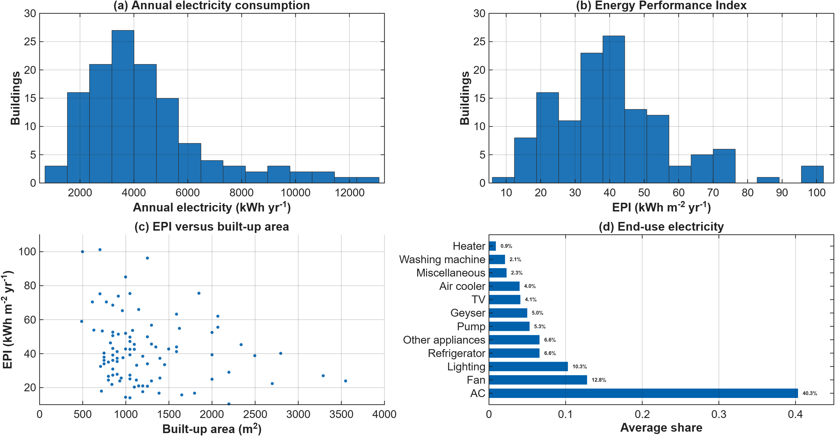
Fig. 1 Energy-performance characteristics of the 128 surveyed high-rise residential buildings in Jaipur: (a) distribution of annual electricity consumption; (b) distribution of the Energy Performance Index (EPI); (c) relationship between EPI and built-up area; and (d) average appliance-level electricity consumption shares.
3.2 Building size is not a sufficient predictor of energy performance
Figure 2 examines whether differences in energy use can be explained primarily by building size. Annual electricity consumption generally increases with built-up area (Fig. 2a), which is expected because larger dwellings typically contain more conditioned space and appliances. However, the relationship shows considerable scatter. Buildings within similar floor-area ranges can differ by several thousand kWh/yr, indicating that floor area explains only part of the variation in absolute electricity demand. This becomes clearer when electricity use is normalised by floor area (Fig. 2b).

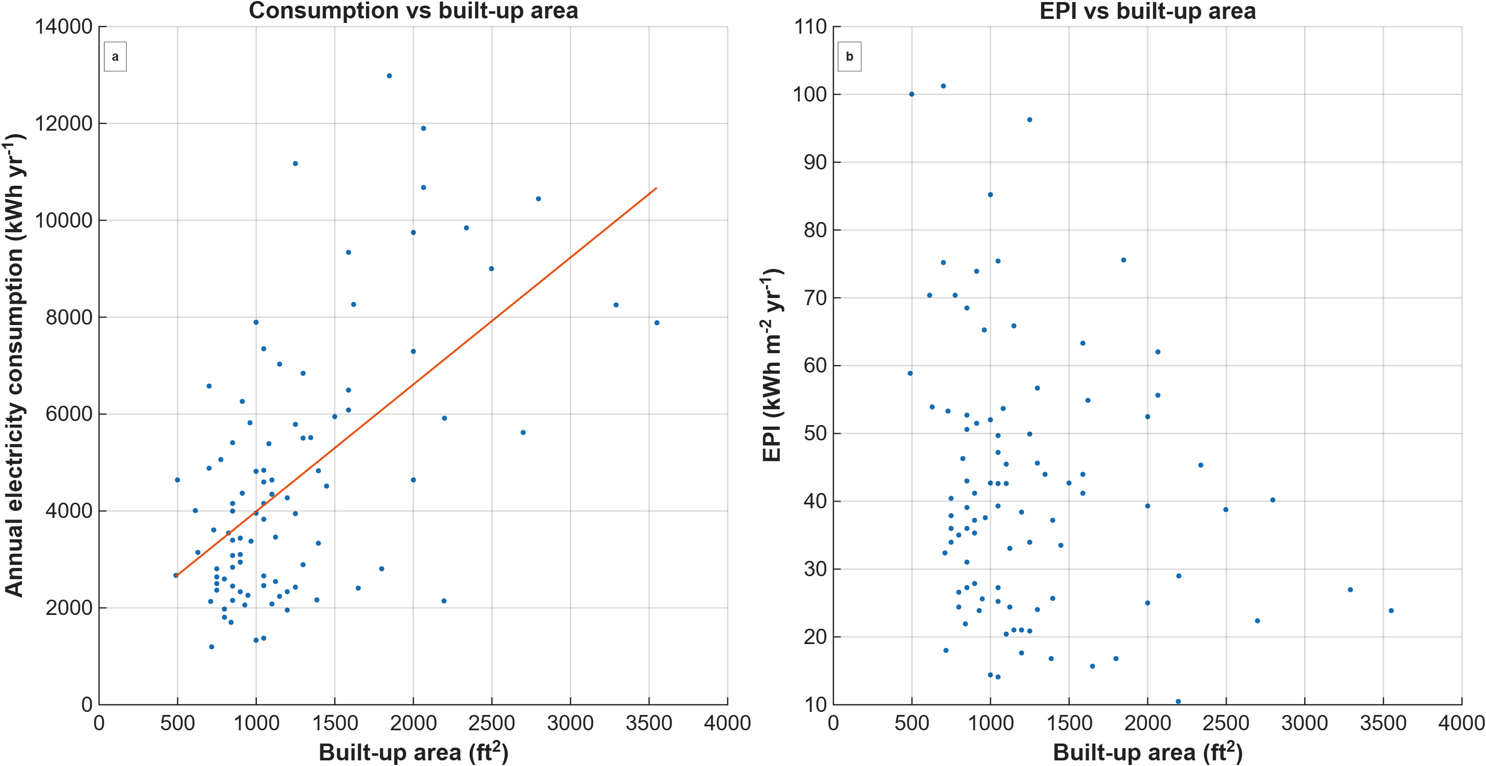
Fig 2 Relationship between building scale and energy use: (a) annual electricity consumption versus built-up area; (b) EPI versus built-up area.

Several larger buildings maintain comparatively low EPI values, whereas some smaller and medium-sized buildings reach approximately 60–100 kWh/m²·yr. Thus, increasing floor area does not translate proportionally into increasing energy intensity. The contrast between the two panels is important: building size influences the magnitude of electricity demand, but does not independently determine energy performance. The remaining variation is likely associated with differences in cooling operation, appliance use, occupancy and building-envelope characteristics, although their individual effects cannot be isolated from the available dataset. From a building-design perspective, the result is relevant because it suggests that larger or more vertically developed residential buildings are not inherently energy intensive on a floor-area basis. Their performance depends on how effectively cooling demand, envelope heat gains and building systems are managed. This provides the basis for examining façade and glazing characteristics in the subsequent analysis.
3.3 Influence of Building Morphology on Window-to-Wall Ratio
The WWR distribution in Figure 3a is considerably narrower than the observed variation in EPI. Most surveyed buildings have WWR values between approximately 6% and 12%, with the highest concentration around 8–10%, while only a small number extend toward 15–18%. The surveyed high-rise stock is therefore not characterised by extensively glazed façades. Nevertheless, even moderate glazing can contribute to cooling demand in Jaipur when exposed to intense solar radiation, particularly where external shading or solar-control measures are limited. Figure 3b shows no clear systematic relationship between building height and WWR. Buildings with similar numbers of floors exhibit a wide range of glazing ratios, and both relatively low and high WWR values occur among taller buildings. This indicates that increased building height does not inherently require greater façade transparency. Rather, the observed heterogeneity suggests that glazing configuration is influenced more strongly by individual architectural and façade-design choices than by building height itself. This is relevant for future high-rise development because climate-responsive façade design can be introduced without necessarily constraining vertical urban development. The relationship between WWR and built-up area (Fig. 3c) shows a somewhat more visible tendency, with larger dwellings appearing more frequently toward the upper WWR range, although substantial dispersion remains. Larger apartments may accommodate greater glazing to provide daylight, external views and spatial quality; however, the dataset does not allow these design motivations to be confirmed directly. The energy implication is therefore not that larger glazing areas should be avoided universally, but that their orientation and solar exposure need to be considered together with WWR. This motivates the orientation-specific analysis presented in the following section.
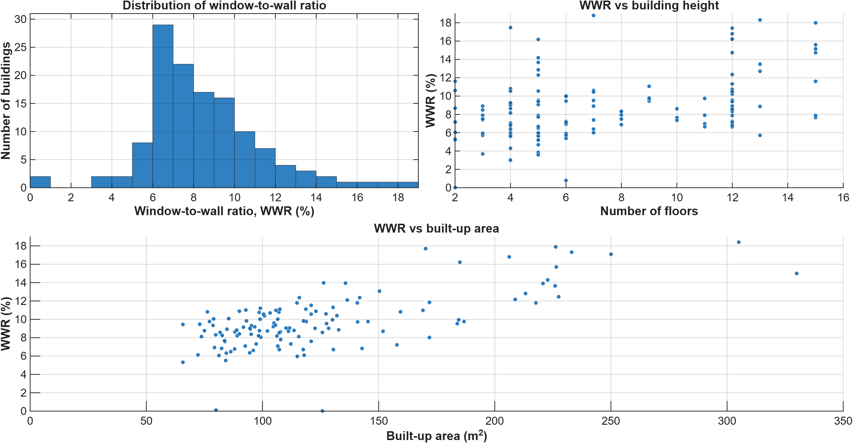
Fig. 3 Window-to-wall ratio and building morphology
3.4 Orientation matters more than WWR alone
Figure 4a demonstrates that mean WWR varies by façade direction. North-facing façades have the highest mean WWR, around 10%, while east, south and west orientations are also substantial. Northeast, northwest and southeast directions show lower mean values. The error bars indicate considerable variation within orientations, again reinforcing the heterogeneity of the surveyed stock. The directional heatmap (Figure 4b) and the simplified cardinal-orientation comparison (Figure 4c) make the design implication easier to interpret. North has the highest average glazing dominance, followed by south and east, with west lower in the simplified comparison. A high north-facing WWR can be thermally less problematic because north façades generally receive more diffuse daylight and less intense direct solar radiation. West glazing, even when its mean area is lower, remains critical because low-angle afternoon solar radiation coincides with high outdoor temperatures and often with residential occupancy. The data therefore do not support a universal statement that 'higher WWR equals higher cooling demand' without qualification. A more defensible conclusion is that WWR should be treated as an orientation-sensitive design variable. A moderate WWR on a well-shaded or north-facing façade may perform better than a smaller unshaded west-facing window. This distinction is essential if the survey results are to inform practical design rather than simplistic glazing limits.
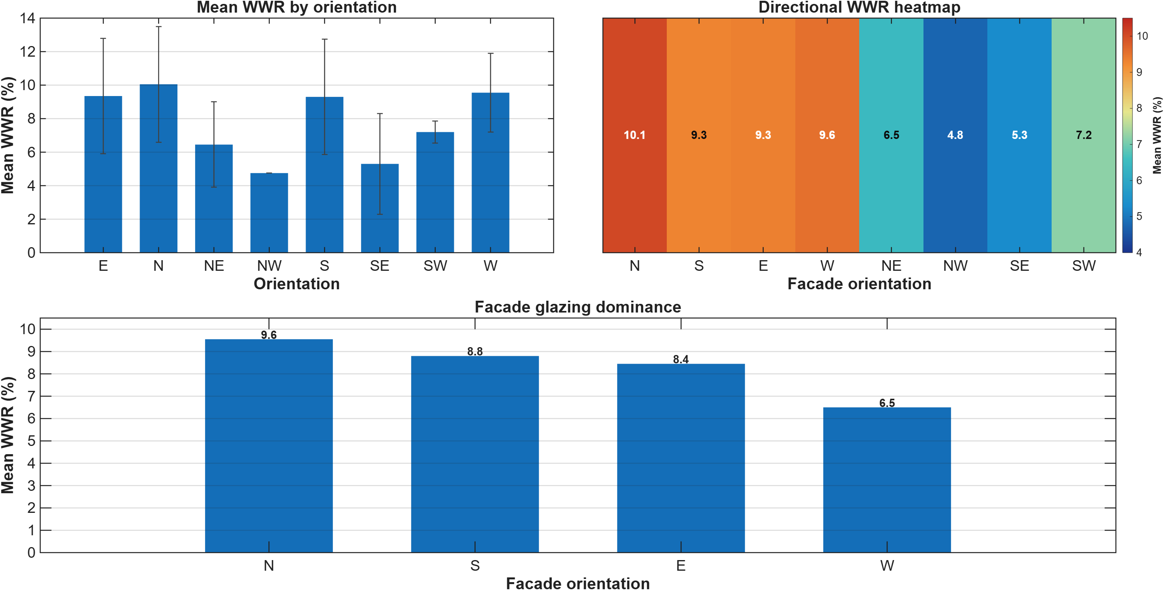
Fig. 4 Orientation-specific glazing characteristics
- From Data Analysis to a Solution-Oriented Net-Zero Framework
The empirical findings provide a basis for translating the observed energy and envelope characteristics into a structured pathway toward net-zero-ready high-rise residential buildings. The results support a demand-first strategy, particularly because cooling represents the dominant individual electricity end use, EPI varies considerably among buildings of similar size, and WWR is not systematically determined by building height. These observations suggest that substantial opportunities exist to improve energy performance within the existing high-rise morphology. The proposed framework therefore integrates envelope optimisation, efficient cooling, solar-energy supply and demand flexibility.
4.1 Climate-Responsive Envelope Strategies
The first intervention level is to reduce external heat gains before mechanical cooling is required. For new buildings, orientation, massing, orientation-sensitive glazing, external shading and improved roof and wall performance should be considered together. For existing buildings, where orientation is fixed, practical measures include external shading, solar-control glazing where appropriate, cool roofs, roof insulation and improved ventilation management. The observed 6–12% WWR range represents the prevailing condition of the surveyed stock rather than an optimum design range [11]. Since glazing properties, shading geometry and detailed envelope characteristics were not consistently available, an optimum WWR cannot be derived from the present dataset. The more relevant implication is that WWR should be considered together with orientation and solar exposure, with particular attention to controlling low-angle solar gains on east- and west-facing façades [12].
4.2 Energy-Efficient Thermal Comfort
Passive measures can reduce cooling loads but are unlikely to eliminate active cooling during Jaipur's extreme summer conditions. The remaining thermal-comfort demand should therefore be met using efficient cooling systems, appropriate equipment sizing and effective controls. This is particularly important because air conditioning accounts for approximately 40% of electricity use in the stock surveyed. Ceiling fans also represent an important component of the comfort strategy. Air movement can extend acceptable comfort conditions at higher indoor temperatures and thereby reduce dependence on compressor-based cooling. The appropriate objective is therefore not simply efficient air conditioning, but efficient thermal-comfort delivery combining passive measures, air movement and mechanical cooling [13].
4.3 Solar Integration and High-Rise Net-Zero Potential
After reducing cooling and other avoidable loads, solar energy can address a larger fraction of residual electricity demand. Jaipur's high solar availability provides favourable conditions for PV-powered cooling, particularly because solar generation and cooling requirements broadly coincide seasonally. PV-powered high-efficiency vapour-compression cooling is likely to provide the most straightforward solution for individual residential buildings, while solar-thermal cooling may be relevant for larger centralised systems. High-rise morphology, however, creates an important constraint [14]. Total residential floor area increases with the number of floors, whereas rooftop area does not increase proportionally. Consequently, available rooftop PV area per unit of floor area decreases as building height increases. Energy-demand reduction therefore becomes increasingly important for taller buildings, where rooftop PV may need to be complemented by façade-integrated PV, shared solar or neighbourhood-scale renewable-energy systems.
4.4 Temporal Coordination of Cooling and Solar Generation
Annual net-zero balance does not necessarily imply an effective temporal match between demand and generation. PV production peaks during daylight hours, while residential cooling can continue into the evening. Smart thermostat control, fan-assisted cooling, controlled pre-cooling and appropriate use of building thermal mass can shift part of the cooling demand toward periods of higher solar availability [15]. Storage can provide additional flexibility where technically and economically justified. The objective is therefore to improve both annual renewable-energy contribution and temporal compatibility between cooling demand and solar generation, thereby increasing PV self-consumption and reducing cooling-related peak electricity demand [16].
4.5 EPI-Based Differentiation of Transition Pathways
The observed EPI distribution indicates that a uniform net-zero strategy is unlikely to be appropriate for the entire building stock. Buildings below approximately 28 kWh/m²·yr, representing the lower-energy quartile, may require comparatively limited efficiency intervention before solar integration, provided acceptable thermal comfort is maintained. Buildings between approximately 28 and 50 kWh/m²·yr represent the principal group for combined envelope, cooling-efficiency and solar interventions. Buildings above approximately 50 kWh/m²·yr require more detailed diagnosis before renewable systems are sized, particularly those reaching 70–100 kWh/m²·yr. Potential causes include intensive cooling operation, inefficient equipment, high solar exposure, inadequate shading and other appliance or operational loads. These ranges are empirical classifications of the surveyed stock rather than regulatory thresholds, but they demonstrate how EPI can support differentiated intervention priorities [2].
- Discussion
5.1 Implications of the regional suitability pattern
The main contribution of this study lies in connecting three characteristics that are often considered independently: the dominance of cooling-related electricity use, the substantial variation in energy intensity among buildings of comparable size, and the variability of façade glazing among buildings of similar height. Together, these findings indicate that high-rise morphology alone does not determine energy performance. Instead, envelope design, cooling systems and building operation create considerable performance variation within the same residential typology. The findings reinforce the importance of climate-responsive envelope design promoted in Indian residential building-energy guidance. While previous simulation studies have demonstrated the sensitivity of cooling loads to WWR, orientation, shading and envelope properties, the present field analysis shows that these parameters also vary considerably within an existing high-rise building stock. This heterogeneity creates practical opportunities for targeted interventions rather than a uniform design or retrofit strategy. The implications extend beyond Jaipur. Many rapidly urbanising cities in the Global South combine increasing cooling demand, high solar availability and growing multi-family high-rise development. In such contexts, increasing renewable generation alone may be insufficient, particularly because rooftop solar area becomes increasingly constrained relative to floor area as buildings become taller. The proposed demand-first approach reducing heat gains and cooling requirements before solar integration—therefore provides a transferable framework, although numerical EPI and WWR benchmarks should remain climate- and context-specific. Thermal comfort is an important consideration when interpreting these results. Low EPI should not automatically be considered evidence of superior building performance, as lower electricity consumption may also reflect restricted cooling use. Future net-zero assessment should therefore evaluate energy consumption together with indoor temperature, humidity, air movement and occupant comfort. The objective should be low-energy provision of acceptable thermal conditions, rather than minimum electricity consumption alone. Advanced predictive methods are not necessary for the present analysis. The 128-building dataset is appropriate for descriptive statistics and targeted correlation analysis, while meaningful AI/ML applications would require either a larger building-stock sample or richer time-series measurements. Future monitoring could provide such data and enable more detailed analysis of interactions between climate, envelope characteristics, cooling operation and occupant behaviour.
5.4 Limitations
The analysis covers 128 surveyed buildings and does not represent Jaipur’s complete residential stock. The dataset also lacks several variables needed to isolate envelope effects, including glazing SHGC, detailed U values, shading, infiltration, occupancy, and thermostat settings. Appliance shares indicate cooling dominance but cannot replace measured hourly loads. Future work should combine the survey with sub-hourly monitoring of indoor conditions, AC and fan electricity use, outdoor weather, and solar radiation in representative low, medium, and high EPI buildings. Calibrated thermal models could then quantify envelope measures and future heatwave impacts. Further analysis should combine rooftop area, PV yield, dwelling numbers, and electricity demand to calculate building-level solar offset ratios and identify where rooftop PV must be complemented by shared, façade-integrated, or off-site renewable generation.
- Conclusion
The 128 high-rise residential buildings provides an empirical overview of Jaipur’s cooling-energy challenge. Annual electricity consumption ranges from about 1,000 to more than 13,000 kWh, while most EPI values lie between 20 and 50 kWh/m²·yr. Air conditioning accounts for approximately 40% of electricity use and therefore represents the largest intervention opportunity. Most buildings have WWR values of 6–12%, although glazing varies more with orientation and design than with building height. The results support orientation-sensitive façade design rather than a universal WWR target. A practical net-zero pathway should first reduce solar and conductive heat gains, then meet residual demand through fans and efficient cooling, and finally use solar energy, thermal mass, storage, and controls to improve renewable matching. This sequence is particularly important in high-rise housing, where rooftop solar area per dwelling decreases with height. Overall, net-zero development in hot cities requires an integrated combination of envelope improvement, efficient cooling, and renewable energy rather than reliance on solar generation alone.
- References
[1] I. Staffell, S. Pfenninger, N. Johnson, A global model of hourly space heating and cooling demand at multiple spatial scales, Nat Energy 8 (2023) 1328–1344. https://doi.org/10.1038/s41560-023-01341-5.
[2] B.N. Jørgensen, Z.G. Ma, Energy Efficiency and Decarbonization Strategies in Buildings: A Review of Technologies, Policies, and Future Directions, Applied Sciences 15 (2025) 11660. https://doi.org/10.3390/app152111660.
[3] A. Baniassadi, J. Heusinger, N. Meili, P. Izaga Gonzalez, H. Samuelson, Urban heat mitigation through improved building energy efficiency, Energy and Climate Change 3 (2022) 100078. https://doi.org/10.1016/j.egycc.2022.100078.
[4] P.Kr. Chaturvedi, N. Kumar, J. Toftum, R.K. Andersen, R. Lamba, K. Mehta, Exploring influential parameters affecting residential building energy use: advancing energy efficiency through machine learning, Clean Techn Environ Policy 27 (2025) 6975–6996. https://doi.org/10.1007/s10098-025-03301-x.
[5] S. Dimitrov, M. Iliev, B. Borisova, S. Petrov, I. Ihtimanski, L. Todorov, I. Ivanov, S. Valchev, K. Georgiev, Large-Scale Modeling of Urban Rooftop Solar Energy Potential Using UAS-Based Digital Photogrammetry and GIS Spatial Analysis: A Case Study of Sofia City, Bulgaria, Urban Science 10 (2026) 210. https://doi.org/10.3390/urbansci10040210.
[6] T. Pino-Gallardo, P. Bastida-Molina, T. Gómez-Navarro, C. Montagud-Montalvá, Towards realistic urban rooftop solar photovoltaic large-scale planning: integrating artificial intelligence-based roof detection, 3D geometry, and energy modelling, Engineering Science and Technology, an International Journal 80 (2026) 102437. https://doi.org/10.1016/j.jestch.2026.102437.
[7] V. Gupta, C. Deb, Envelope design for low-energy buildings in the tropics: A review, Renewable and Sustainable Energy Reviews 186 (2023) 113650. https://doi.org/10.1016/j.rser.2023.113650.
[8] A.W. Ayoobi, A. Mehdizade, Climate responsive simulation of passive shading strategies for seasonal optimization of building energy demand, Discov Sustain 6 (2025) 1263. https://doi.org/10.1007/s43621-025-02178-6.
[9] Y. Sun, R. Liang, Y. Wu, R. Wilson, P. Rutherford, Development of a comprehensive method to analyse glazing systems with Parallel Slat Transparent Insulation material (PS-TIM), Applied Energy 205 (2017) 951–963. https://doi.org/10.1016/j.apenergy.2017.08.041.
[10] P.Kr. Chaturvedi, N. Kumar, R. Lamba, K. Mehta, Multi-objective optimization of glazing and shading configurations for visual, thermal, and energy performance of cooling dominant climatic regions of India, Clean Techn Environ Policy 27 (2025) 4909–4932. https://doi.org/10.1007/s10098-024-03114-4.
[11] V.K. Thakur, P.K.S. Rathore, S. Roy, V. Kumar, R.R. Sahoo, R.K.S. Gautam, An up-to-date analysis of passive cooling strategies for buildings in hot climate: Achieving sustainable and net-zero targets, Next Energy 13 (2026) 100869. https://doi.org/10.1016/j.nxener.2026.100869.
[12] A.I. Yaro, O.S. Asfour, O. Mohsen, Improving Energy Efficiency of Mosque Buildings Through Retrofitting: A Review of Strategies Utilized in the Hot Climates, Eng 7 (2026) 52. https://doi.org/10.3390/eng7010052.
[13] K. Sun, W. Zhang, Z. Zeng, R. Levinson, M. Wei, T. Hong, Passive cooling designs to improve heat resilience of homes in underserved and vulnerable communities, Energy and Buildings 252 (2021) 111383. https://doi.org/10.1016/j.enbuild.2021.111383.
[14] D.R. Chaudhary, T. Sharmin, Evaluating the Impact of Jaali Façades on Building Energy Demand in Jaipur’s Hot Semi-Arid Climate, Sustainability 18 (2026) 3876. https://doi.org/10.3390/su18083876.
[15] M. Eksi, R.T. Akarsu, M. Ozcan, Net-zero energy building transformation: Techno-economic and environmental evaluation in the Mediterranean Region, Environ Dev Sustain (2025). https://doi.org/10.1007/s10668-025-06389-9.
[16] Z. Duan, S. Attia, H. Omrany, R. Chang, J. Zuo, Spatiotemporal supply-demand matching in residential building rooftop photovoltaics (PV) under climate change: a cross-climate zone assessment, Applied Energy 421 (2026) 128210. https://doi.org/10.1016/j.apenergy.2026.128210.

Acknowledgement
This work was supported by the SPARC programme under the project “A Framework of Net-Zero Energy Building Design in the Composite Climate of India.”
AI Statement

During the preparation of this work, the authors used ChatGPT to refine the language and correct grammatical errors. After using this tool/service, the authors reviewed and edited the content as needed and take full responsibility for the content of the published article.

